Original Research Article
Natural infestation of Coelaenomenodera lameensis (Coleoptera: Chrysomelidae-Hispinae) by entomopathogenic fungi in oil palm groves in the southern part of Côte d’Ivoire

ABSTRACT
In Côte d'Ivoire, oil palms generate approximately 3.15% of GDP. They provide a livelihood for more than 2 000.000 people, generating 200.000 regular jobs. Despite its importance, oil palms are exposed to numerous pests, the most significant of which is the leaf miner Coelaenomenodera lameensis (Coleoptera, Chrysomelidae: Hispinae). The fight against this pest is mainly based on the use of chemical insecticides. In the current context of sustainable agriculture and environmental preservation, biological control is a less dangerous and more environmentally friendly alternative. The overall objective of this study is to inventory the entomopathogenic fungi responsible for the death of C. lameensis under natural conditions on oil palm tree. The study was conducted in oil palm production areas in the southern part of Côte d'Ivoire, in village and industrial plantations. The diagnosis, based on the assessment of C. lameensis larval and adult indexes and the counting of dead individuals on leaflets, revealed a very high adult index at CNRA-Divo with 62.59 ± 8.41 adults per palm and, to a lesser extent, at Palmafrique-Anguédédou (4.54 ± 1.86 adults per palm) and Palmci-Boubo (Divo) in industrial plantations (4.99 ± 0.67 adults per palm). However, larval indexes remained low overall. In village plantations, the level of larval infestation was generally low, but the highest was 3.63 ± 1.34 larvae per palm at Palmci-Boubo (Divo). The rate of fungal infestation of the pest was higher in Palmafrique-Anguédédou (60.99 ± 5.79%) in village plantations, while in industrial plantations it was observed at CNRA-Dabou with 26.92 ± 12.48% of C. lameensis adults parasitized. Five entomopathogenic fungi were isolated from dead C. lameensis adults with fungal mycelium on their bodies. These include Aspergillus niger, Aspergillus sp., Cordiceps sp., Isaria sp., Metarhizium sp., and Penicillium sp. For better use of these fungi against this pest, it seems wise to conduct pathogenicity tests to confirm their actual responsibility for the death of the pest in plantations and use as potential microbial agents.

Keywords: Coelaenomenodera lameensis, entomopathogenic fungus, infestation rate, oil palm, pest
1. INTRODUCTION
The oil palm (Elaeis guineensis Jacq.) is a perennial crop of major economic importance for many tropical countries, particularly in West Africa, where it is a crucial source of vegetable oil for food, industry, and biofuel production (FAO, 2020; Kouassi et al., 2019). As a long-standing producer, Côte d'Ivoire relies heavily on this crop for its agricultural development and the livelihoods of many rural communities. With an annual production of 80.436 million tons of oil, this agricultural crop is the world's leading oilseed (USDA, 2025). In order to diversify its export crops, Côte d'Ivoire has promoted the cultivation of oil palms, which have quickly become an important part of the country's economy. The palm oil industry employs more than 200 people and sustains more than 2 million people (Cumunel, 2020). With 600.000 tons of crude palm oil produced annually, Côte d'Ivoire ranks ninth in the world, just behind Brazil, and is the second largest producer of crude palm oil in Africa, behind Nigeria (USDA, 2025). In Côte d'Ivoire, the coverage rate is approximately 330,000 hectares, of which 80.000 hectares are classified as industrial plantations (IP), representing 25% of the orchard, and 250.000 hectares are classified as village plantations (VP), constituting the majority with 75% of the total area (USDA, 2024). Village plantations are the largest producers of bunches, yielding around 6 to 7 tons per hectare, while industrial plantations produce around 14 tons per hectare (USDA, 2024). Côte d'Ivoire must therefore increase its production to meet its own needs and help fill the oilseed deficit in the West African sub-region. To this end, it aims to increase its production to 800,000 tons by 2025 (N’Guessan et al., 2021). However, productivity and sustainability of oil palm plantations are constantly threatened by various biotic factors, including insect pests that can cause significant yield losses and compromise the economic viability of farms (Mariau et al., 1981). Among these, C. lameensis (Coleoptera: Chrysomelidae-Hispinae) poses a major phytosanitary threat to oil palms in West Africa. It is an insect endemic to oil palm-producing regions of Côte d’Ivoire. Its larvae burrow tunnels into the leaflets, causing necrosis of the leaf tissue and thus reducing the plant's photosynthetic surface area (Kouassi et al. 2021a). Massive infestations can cause widespread wilting of palm trees, stunted growth, a drastic reduction in fruit production, and, in the most severe cases, the death of young palm trees (Konan et al., 2017). Traditional control methods, often based on the use of chemical insecticides (Evisect-S 50), raise environmental and health concerns, inciting search for more ecological and sustainable alternatives for managing this pest (Charles et Bernard, 2001). In this context, entomopathogenic fungi are appearing as a potentially promising and environmentally friendly solution for the biological control of insect pests (Vega et al., 2018). These microorganisms, such as Beauveria bassiana, Metarhizium anisopliae, Isaria fumosorosea, etc., infect insects through contact and then cause their death (Lacey et al., 2015). Their host specificity, low impact on non-target organisms, and ability to be integrated into integrated pest management programs make them attractive biocontrol agents (Goettel et al., 2010). Recent studies demonstrated the potential of these fungi against various agricultural pests, and their application against Coelaenomenodera lameensis could offer a viable alternative to chemical approaches (Aby et al., 2025; N’Guessan et al., 2025).
This study aims to inventory entomopathogenic fungi of C. lameensis in order to develop sustainable biological control strategies in oil palm plantations in production areas.
Specifically, it involved:
- Determining the level of infestation of palm groves by C. lameensis in the southern zone;
- Determining infestation rate of C. lameensis by entomopathogenic fungi in these areas;
- Collecting and identifying these entomopathogenic fungi responsible for the death of the pest in plantations.

2. MATERIALS AND METHODS
2.1 Study Sites
The study was conducted in oil palm industrial plantations (IP) and village plantations (VP) in southern Côte d'Ivoire, spread across five (05) locations (Table 1, Fig.1).

Table 1: Geographical location and climatic characteristics of the study areas
Localities | Geographical coordinates | Temperature (°C) | Rainfull (mm)
Eloka (Palmafrique) | 5°28'N, 3°48'W | 27 °C - 28°C | 1,500 - 2,300 mm
Anguédédou (Palmafrique) | 5°24'N, 4°12'W | 23°C - 32°C | 1,600 mm <
Dabou (CNRA) | 5°22'N, 4°08W | 23°C - 32°C | 1,466.4 mm
Divo (CNRA) | 5°50'N, 5°22'W | ~ 26.1°C | 1,069.4 mm
Divo (Palmci Boubo) | 5°39'N, 5°19'W | 25°C – 30 °C | ~ 1,070 mm

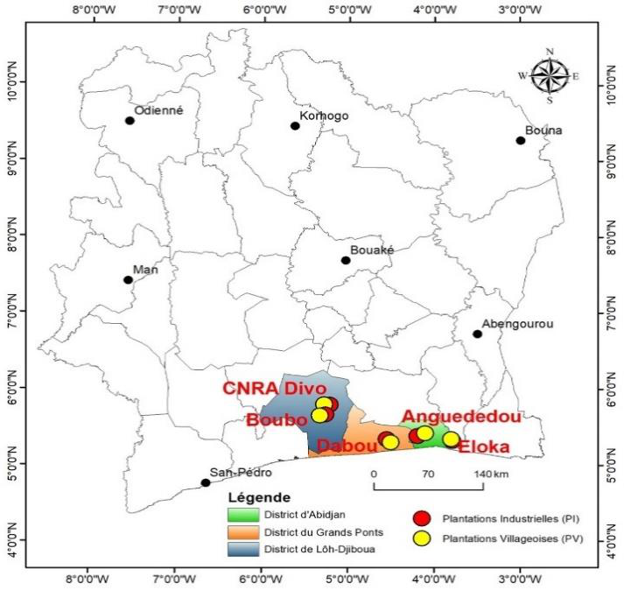

Fig. 1. Mapping of study sites

2.2 Plant Material
The plant material used is the oil palm, Elaeis guineensis, tenera variety, category C1001F, vulgarized in Côte d'Ivoire through CNRA.

2.3 Animal Material
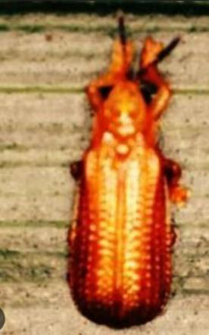
The animal material consists of adults of Coelaenomenodera lameensis, a Chrysomelidae-Hispinae beetle (Fig.2), the most destructive pest of oil palm in Côte d'Ivoire.

Fig. 2. Adult of C. lameensis

2.4. Assessment of the Infestation Level of C. lameensis in Production Areas
The activity was carried out in traditional oil palm growing areas, i.e., in village plantations (VP) and industrial plantations (IP) with a production area of 7 ha. In the different locations selected, five plantations naturally infested by the pest were chosen in PV and five plantations in PI. These plantations underwent regular monitoring.
The surveys were conducted in two-hour time slots, i.e., from 7 a.m. to 9 a.m. At these times, C. lameensis individuals are less mobile and easily spotted on the palm fronds. For each plot, surveys were conducted in a north-south, east-west direction. Thus, 18 trees were selected per row (6 trees in the north, 6 trees in the center, and 6 trees in the south), and on each tree, a palm frond of rank 17 and a lower palm frond of rank 33 were lowered or cut using a sickle. The underside of this frond was carefully inspected to observe and count the number of C. lameensis individuals present. This allowed assessment of the average index of adult C. lameensis, estimated as follows:
Average adult index (Imd) = Σad / N, where ad: Number of C. lameensis adults, N: Number of palms inspected.
On these same palms, when larval galleries were found, they were opened to count the larvae inside and estimate the average larval index as follows:
Average larval index (Iml) = Σla / N, where la: Number of C. lameensis larvae, N: Number of fronds checked.
The population index of C. lameensis was assessed according to the severity of attacks based on the following criteria (Kouassi et al., 2021b):
- Very low attack (Imd ˂ 0.5 or Iml ˂ 0.5);
- Low attack (0.5 ˂ Imd ˂ 1 or 0.5 ˂ Iml ˂ 1);
- Medium attack (1 ˂ Imd ˂ 5 or 1 ˂ Iml ˂ 5);
- High attack (Imd ˃ 5 or Iml ˃ 5).
with Iml: Average larval index and Imd: Average adult index

2.5 Inventory of Entomopathogenic Fungi of C. lameensis
2.5.1 Collection of dead C. lameensis
During regular monitoring, the selected palms (palm tree row 17 and palm tree row 33) were carefully observed to collect dead C. lameensis adults with fungal hyphae on their bodies (Fig. 3). The samples collected and counted were then stored in petri dishes containing filter paper moistened with sterile distilled water to spray the fungal colonies and preserve their effectiveness and purity. Each petri dish was labeled with the sample references (the name of the locality, the name of the plot, the tree number, the palm row, and the date of collection). One to two days after collection, all samples were transferred to the Phytopathology Laboratory at Robert Michaux Research Station in Dabou for isolation and identification of any entomopathogenic fungi. The geographical coordinates of the different plots were recorded in order to identify the collection sites of dead C. lameensis.
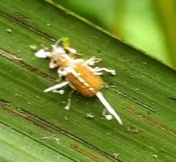

Fig 3. Dead C. lameensis on a leaflet showing fungal hyphae
2.5.2 Isolation of fungi from collected dead C. lameensis

2.5.2.1 Seeding of collected dead C. lameensis
In the Phytopathology Laboratory, dead C. lameensis adults were disinfected with alcohol (70%) and then placed in petri dishes containing PDA medium. After inoculation, the petri dishes were sealed with paraffilm and incubated under incubator conditions at a temperature of 26°C to 27°C for 3 to 5 days until fungi develop properly on the culture medium. Daily observations were made over three days from the date of incubation to monitor the germination of entomopathogenic fungal spores. The entire process was carried out under aseptic conditions in a fume cupboard. The colonies obtained underwent successive purifications.
2.5.2.2 Incubation of seeded plates
The seeded petri dishes were incubated at a temperature between 25 and 28°C for 3 days. At the end of this period, the conidia of each fungus observed were transferred using a sterile Pasteur pipette to petri dishes containing PDA culture medium.

2.5.3 Purification of fungal colonies
The purification of the fungal isolates obtained involved successive subcultures on PDA medium under aseptic conditions until a pure isolate was obtained. This was then confirmed by macroscopic and microscopic observations. This transplanting consisted of removing a few fungal mycelia and then transferring or implanting them onto PDA medium in new petri dishes under aseptic conditions, repeating this process successively until pure isolates were obtained for morphological identification.

2.5.4 Morphological identification of isolates
The fungi were identified using a binocular magnifying glass or optical microscope in the phytopathology laboratory. For this, the conidia or spores of each isolated strain were compared with those described in the identification key by Mathur & Kongsdal (2003). The comparison focused on macroscopic characteristics based on coloration, the appearance of the mycelium, and the presence or absence of septa. Mycelial fragments in fruiting were collected and mounted between the slide and cover slip of an optical microscope. The shape and color of the spores and the presence or absence of septa in them were the microscopic characteristics analyzed.

2.6 Data Analysis
Excel Office 2021 software was used to enter the data and create the diagrams. After verifying normality of the data and homogeneity of variances using Levene's test, an analysis of variance (ANOVA) was performed using SAS (Statistical Analysis System) software version 9.4. The LSD test was used to separate the means at a 5% significance level.

3. RESULTS
3.1 Infestation Levels of C. lameensis in Village Plantations (VP) in Different Localities
The results of the assessment of C. lameensis infestation levels in village plantations are presented in Table II. It can be seen that larval indices were highest in village plantations in the locality of Palmci-Boubo, with 0.86 ± 0.31 larvae per palm. Average indices were observed in Palmafrique-Eloka, with 0.39 ± 0.22 larvae per palm. The lowest levels of infestation were found in the localities of CNRA (Divo), Palmafrique-Anguédédou, and CNRA-Dabou. Larval indices ranged from 0.00 ± 0.00 larvae per palm to 0.12 ± 0.12 larvae per palm. Analysis of variance showed significant differences (P = .01) between localities in terms of the level of infestation of village plantations by C. lameensis larvae (Table 2).
Regarding C. lameensis adults, the highest infestation levels were observed in Palmci-Boubo (Divo) with 3.63 ± 1.34 adults per palm. Average infestation levels were observed in Palmafrique-Anguédédou with 2.73 ± 1.32 adults per palm. Infestation levels were low in Palmafrique (Eloka) and CNRA-Divo. Adult indices in these two localities were 0.88 ± 0.31 adults per palm and 0.52 ± 0.06 adults per palm. The lowest infestation levels were observed at CNRA-Dabou, with an adult index of 0.05 ± 0.03 adults per frond. These results are statistically significant (P = .03) (Table 2).

Table 2. Level of infestation of C. lameensis in village plantations
Localities VP | Index of C. lameensis larvae | Index of C. lameensis adults
Palmci Boubo (Divo) | 0.86 ± 0.31 ª | 3.63 ± 1.34 ª
Palmafrique (Anguédédou) | 0.00 ± 0.00 ^{b} | 2.73 ± 1.32 ^{ab}
Palmafrique (Eloka) | 0.39 ± 0.22 ^{ab} | 0.88 ± 0.31 ^{bc}
CNRA (Divo) | 0.00 ± 0.00 ^{b} | 0.52 ± 0.06 ^{bc}
CNRA (Dabou) | 0.12 ± 0.12 ^{b} | 0.05 ± 0.03 ^{c}
p | 0.01 | 0.03
Averages with the same letter in the same column are not significantly different (LSD test, α = 5%).

3.2 Infestation Level of C. lameensis in Industrial Plantations (IP) in Different Locations
Results of the assessment of the infestation level of industrial plantations by C. lameensis are shown in Table 3. Larval infestation levels were highest in industrial plantations in the Palmafrique-Anguédédou area, with 0.63 ± 0.170 larvae per palm tree. Low levels of larval infestation were observed in the other localities of CNRA (Divo) and CNRA-Dabou. Larval indexes ranged from 0.00 ± 0.00 larvae per palm to 0.04 ± 0.04 larvae per palm. Analysis of variance showed significant differences (P < .001) between localities with regard to the infestation level of industrial plantations by C. lameensis larvae (Table 3). As for the infestation levels of industrial palm groves by adult C. lameensis, they were higher at CNRA-Divo. The adult index recorded was 62.59 ± 8.41 adults per palm tree. Between the industrial plantations of Palmci-Boubo (Divo), Palmafrique-Anguédédou, Palmafrique (Eloka) and CNRA (Dabou), infestation levels were almost identical (between 4.99 ± 0.67 adults per palm and 0.46 ± 0.11 adults per palm). Analysis of variance showed significant differences (P < .001) between locations with regard to the infestation level of industrial plantations by C. lameensis adults (Table 3).

Table 3. Infestation level of C. lameensis in industrial plantations
Localities IP | Index of C. lameensis larvae | Index of C. lameensis adults
Palmafrique-Anguédédou | 0.63 ± 0.17 ª | 4.54 ± 1.86 ^{b}
Palmafrique-Eloka | 0.04 ±0.04 ^{b} | 2.17 ± 0.38 ^{b}
Palmci-Boubo (Divo) | 0.03 ± 0.03 ^{b} | 4.99 ± 0.67 ^{b}
CNRA-Divo | 0.00 ± 0.00 ^{b} | 62.59 ± 8.41 ª
CNRA-Dabou | 0.00 ± 0.00 ^{b} | 0.46 ± 0.11 ^{b}
p | 0.0001 | 0.0001
Averages with the same letter in the same column are not significantly different (LSD test, α = 5%).

3.3 Infestation Rate of C. lameensis by Entomopathogenic Fungi in Oil Palm Plantations
The rate of infestation of C. lameensis by entomopathogenic fungi in oil palm plantations was compared between village plantations (VP) and industrial plantations (IP). The results obtained are recorded in Table 4. At the village plantation level, the highest rate of C. lameensis infestation by fungi was recorded at Palmafrique-Anguédédou (60.99 ± 5.79%). Populations of C. lameensis were weakly infested in the respective localities of Palmci-Boubo (Divo), Palmafrique-Eloka, CNRA-Divo, and CNRA-Dabou. These different localities recorded almost identical infestation rates, ranging from 0.00 ± 0.00% to 9.17 ± 0.04%. However, analysis of variance showed significant differences (P < .001) between the different localities regarding the infestation rate of C. lameensis by entomopathogenic fungi (Table 4, Fig. 4).
In industrial plantations, the highest rates of C. lameensis infestation by entomopathogenic fungi were observed at CNRA-Dabou (26.92 ± 12.48%). Infestation rates were average at Palmafrique-Eloka, with 17.58 ± 5.67% of C. lameensis infested by these fungi. Low infestation rates were observed in the industrial plantations of Palmafrique-Anguédédou, Palmci-Boubo (Divo), and CNRA-Divo, with 5.89 ± 2.44%, 1.89 ± 0.98%, and 0.73 ± 0.18% of C. lameensis populations infested, respectively. These results are statistically different (P = .03) (Table 4, Fig 4).

Table 4. Infestation rates of C. lameensis by entomopathogenic fungi Plantations
Infestation rate (%) | Village plantations | Industrial plantations
Palmafrique (Anguédédou) | 60.99 ± 5.79 ª | 5.89 ± 2.44 ^{b}
Palmci Boubo (Divo) | 9.17 ± 0.04 ^{b} | 1.89 ± 0.98 ^{b}
Palmafrique (Eloka) | 3.51 ± 2.38 ^{b} | 17.58 ± 5.67 ^{ab}
CNRA (Divo) | 0.00 ±0.00 ^{b} | 0.73 ± 0.18 ^{b}
CNRA (Dabou) | 0.00 ± 0.00 ^{b} | 26.92 ± 12.48 ª
p | 0.0001 | 0.03
Averages with the same letter in the same column are not significantly different (LSD test, α = 5%).
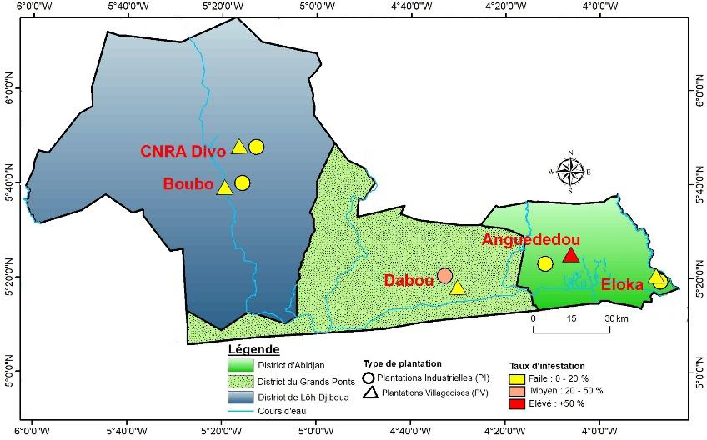

Fig 4. Infestation rate of C. lameensis by entomopathogenic fungi in village and industrial plantations

3.4 Overall Situation Regarding Infestation Rate of C. lameensis by Fungi Between Village Plantations and Industrial Plantations
Generally, infestation rate of C. lameensis by entomopathogenic fungi in oil palm plantations was 14.74 ± 4.97 in village plantations and 10.60 ± 3.28 in industrial plantations. However, statistical analysis revealed no significant difference between the two types of plantations (p = 0.49) (Fig. 5).
F= 0.48
P = 0.49

Bars marked with the same letter are not significantly different (Student's t-test, α = 5%).
Fig. 5. Overall fungal infestation rates between industrial and village plantations
3.4 Entomopathogenic Fungi Identified
The results of the isolation and identification of entomopathogenic fungi from naturally dead adults of Coelaenomenodera lameensis on oil palm leaflets collected in the localities revealed the presence of five species of entomopathogenic fungi. These are Aspergillus niger, Aspergillus sp., Cordyceps sp., Isaria sp., Metarhizium sp., and Penicillium sp. These fungi are divided into three classes. They are, respectively, the Ascomycetes and Deuteromycetes classes and an unidentified Oomycetes fungus.
Table 4. Description of fungi identified
Entomopathogenic fungi identified | Microscopic aspect |  | Macroscopic aspect
Aspergillus niger | 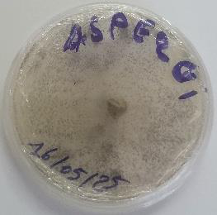  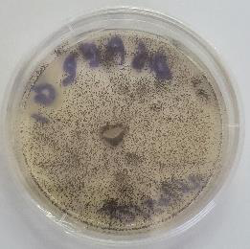 | Blackish colonies with a powdery texture scattered throughout the Petri dish | 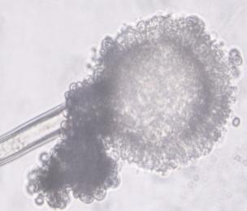  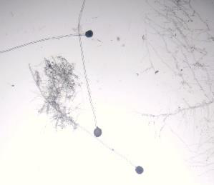 | A septate mycelium from which long hyaline conidiophores develop, ending in a vesicle bearing pear-shaped phialides that produce dark, globular conidia.
Aspergillus sp. | 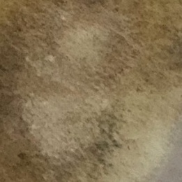  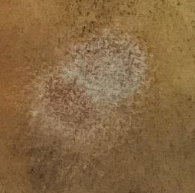 | Colonies or whitish growths with a powdery texture scattered throughout the petri dish | 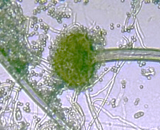  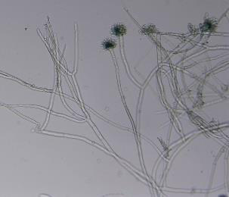 | A septate mycelium from which long hyaline conidiophores develop, ending in a vesicle bearing pear-shaped phialides that produce translucent globular conidia.
Cordyceps sp. | 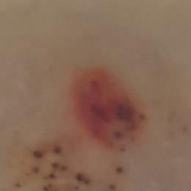  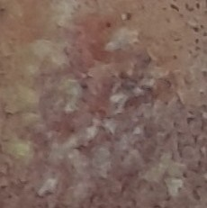 | Whitish colonies with a cottony texture and reddish undersides | 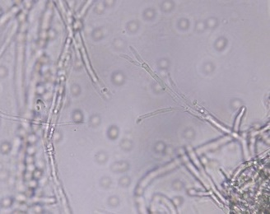  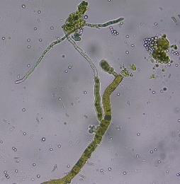 | Branched, septate mycelium bearing cylindrical phialides that taper towards the apex, producing cylindrical or slightly elongated conidia.
Isaria sp. | 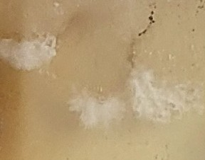  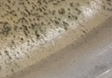 | Small, whitish colonies with a cottony texture | 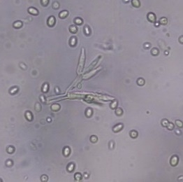  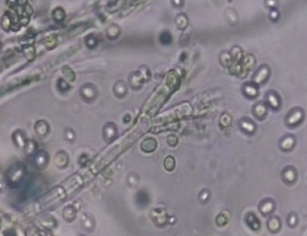 | A septate mycelium from which long, straight conidiophores develop, bearing several compact whorls of phialides, producing translucent conidia that are oblong or elliptical in shape.
Metarhizium  sp. | 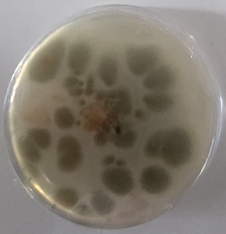  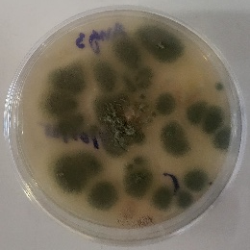 | Quasi-circular colonies with an olive green colour and a powdery texture | 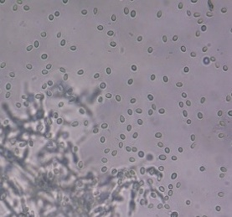  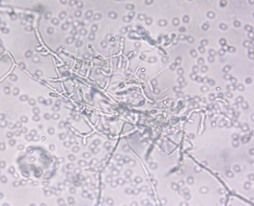 | Septate mycelium with irregularly branched conidiophores of varying sizes bearing thin cylindrical phialides at the apex and producing elongated, translucent conidia
Penicillium  sp. | 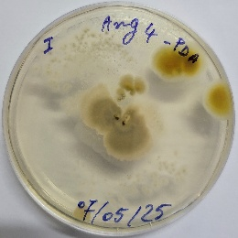  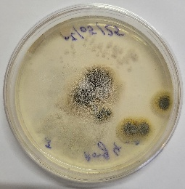 | Quasi-circular blue-green colonies with greyish or yellowish edges and a cottony texture | 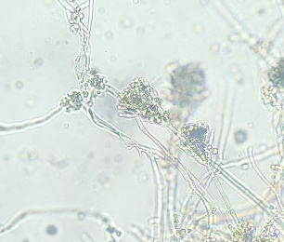  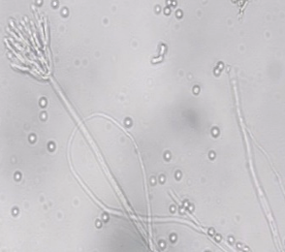 | Septate mycelium from which conidiophores develop, bearing clustered phialides, taking on the appearance of a brush, and producing globular, translucent conidia
Unidentified oomycete | 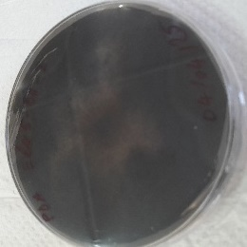  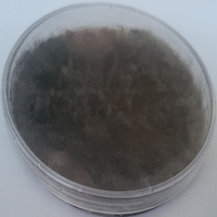 | Blackish circular colony with a cottony texture and aerial hyphae | 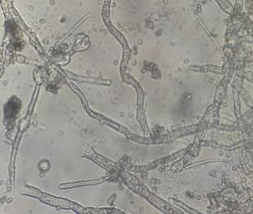  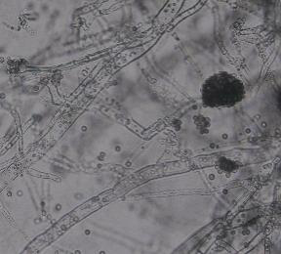 | Tightly packed, branched filamentous thallus on which outlet tubes develop with numerous branches of different sizes, ending in vesicles

4. DISCUSSION
The infestation level of palm groves by C. lameensis larvae and adults in oil palm production areas varied significantly from one location to another. This was revealed by the average indices for larvae and adults obtained in these different locations. In fact, overall, the level of infestation of plantations by C. lameensis was low, well below 5 individuals per palm tree, which is the threshold for triggering treatment.
However, low levels of larval infestation and moderate levels of adult infestation were observed in village plantations in the Palmci Boubo area (Divo) and, to a lesser extent, in the Palmafrique-Anguédédou area, where adult infestation levels were higher. In industrial plantations, the level of infestation was higher among adults than in other localities. Coelaenomenodera lameensis, which is the most destructive pest of oil palms in Côte d'Ivoire, has many natural enemies that regulate its population. According to Kouassi et al. (2021b) and N'Guessan et al. (2020), numerous Formicidae hymenoptera such as Oecophylla longinoda, Crematogaster sp. and Tetramorium sp. help to reduce the populations of this pest in Ivorian palm groves. Kouassi et al. (2021b) indicated that the variation in C. lameensis from one location to another could be linked to the palm grove production area. Similarly, Tchetangni et al., 2019 reported that infestation by Eteoryctis gemoniella (Lepidoptera: Gracillariidae) in cashew plantations varies according to agroecological zones. These authors therefore stipulated that high infestation rates in production areas are linked to the geographical location of the crop.
The results obtained showed a high infestation level of this pest in the CNRA-Divo industrial plantations compared to other locations. This location appears to be endemic to C. lameensis, and therefore favorable to its development. In addition, poor application of technical procedures also seems to favor the proliferation of the pest in these plantations. Soro et al. (2020) indicated that in cashew trees, the frequency and type of orchard maintenance have an impact on their health. Very few producers clean their plantations; this negligence on the part of planters is thought to encourage the proliferation of insect pests.
Furthermore, the significant variations in larval and adult indexes observed between the localities visited could also be due to the effect of climatic factors (temperature and precipitation) on insects. Kouamé et al. (2014; 2015) showed that temperature and rainfall are responsible for cyclical variations in mirid populations on cocoa trees. Furthermore, as insects are ectothermic organisms, climatic factors govern both their distribution and the evolution of their populations over time (Caetano, 2019).
During this study, individuals of C. lameensis that had died naturally on oil palm leaflets due to certain entomopathogenic fungi were encountered. The results revealed the presence of these entomopathogenic fungi in almost all locations in village and industrial plantations. This is due to the spread of spores from these fungi by wind, insects, birds, etc., infecting C. lameensis and causing their death on the leaflets. Imperfect fungi generate countless spores that are spread passively. Infection occurs through the integument after the mycelium has developed. The insect dies within a few days or weeks, depending on the size of the host (Hamoudi, 2021). In the locality of Palmafrique-Aguédédou, a very large number of C. lameensis individuals were parasitized by these entomopathogenic fungi. The latter are mostly soil-dwelling and are thought to be very numerous in the soil in this locality.
The results obtained during this study showed that, generally speaking, infestation rates of C. lameensis by entomopathogenic fungi were the same in village and industrial plantations. This would seem to be due to the proximity of the two types of plantations. On the one hand, as C. lameensis are flying insects, they could be contaminated by the spores of these fungi in village plantations and then carry these spores to industrial plantations, infecting insects living there. On the other hand, as these fungi are soil-borne and present in most oil palm plantations, they would similarly infect insects hosted by this plant.
The study conducted on the inventory of entomopathogenic fungi was based on the identification of the macroscopic and microscopic aspects of fungal isolates found on dead Coelaenomenodera lameensis. Thus, five (05) species of entomopathogenic fungi were identified and an unidentified oomycete was also observed. These entomopathogenic fungi identified were Aspergillus sp., Aspergillus niger, Cordiceps sp., Isaria sp., Metarhizium sp., and Penicillium sp. In fact, entomopathogenic fungi were most often isolated from certain dead insects in plantations. Thus, Aspergillus sp. and Metarhizium sp. were identified from the mango mealybug (Nebié et al., 2022). Penicillium sp. and Aspergillus niger were isolated from adults of Bratchytrupes megacephalus (Lakhdari et al., 2015). Similarly, the work of Saiah et al. (2011) highlighted the isolation of six fungal species from Phyllocnistis citrilla larvae, and that of N'Guessan et al. (2021) highlighted the isolation of three fungal species from Spodoptera frugiperda larvae, including Penicillium sp., Aspergillus niger, Metarhizium sp., Cladosporium sp., Alternaria sp. and Fusarium sp. The genus Cordyceps was isolated from Helicoverpa (cotton) and a Noctuidae lepidopteran from maize (Glover et al., 2023), etc.
Among the entomopathogenic fungi identified, some have proven their pathogenic effects on certain insects. This is the case with Metarhizium sp., which was used against the desert locust during the 2019-2021 outbreak in the Horn of Africa (Mullié et al., 2023). In Côte d'Ivoire, Aby et al. (2010; 2025) and Hala (2020) demonstrated the effectiveness of Metarhizium anisopliae var BME2 on Cosmopolites sordidus (Coleoptera; Curculionidae), Prosoestus spp (Coleoptera; Curculionidae) and C. lameensis, all three of which are insects of the order Coleoptera. Also, the fungus Aspergillus niger has proven effective on Citrus leaves infested with Phyllocnistis citrella larvae (Saiah et al., 2011). The CCM8367 strain of Isaria sp. is a promising biological control agent that has been used against the immature stages of Leptinotarsa decemlineata. For greater effectiveness, this strain is recommended in combination with an entomopathogenic nematode (Hany et al., 2016).

5. CONCLUSION
Controlling Coelaenomenodera lameensis, the main pest of oil palm in Côte d'Ivoire, represents a major challenge for oil palm production and sustainability. This study showed that C. lameensis infests both village and industrial plantations, with infestation levels varying from one locality to another and from one plantation to another. The results also showed the presence of fungal pathogens that naturally regulate C. lameensis populations in Ivorian palm groves, the rate of infestation of the pest by these fungi being higher in the village plantations of Palmafrique-Anguédou (60.99 ± 5.79%) and in the industrial plantations of CNRA-Dabou (26.92 ± 12.48%). However, these rates were generally identical between the two types of plantations. Finally, this work enabled us to identify the following entomopathogenic fungi: Aspergillus niger, Aspergillus sp., Cordiceps sp., Isaria sp., Metarhizium sp. and Penicillium sp. and an unidentified fungus. Not all fungi of these genera can be used indiscriminately. Species-level identification is necessary to assess their effectiveness and role in regulating C. lameensis populations. Some of them have already shown an effect against this pest. These results open up promising prospects for biological control of this pest.

CONSENT
Not applicable.

ETHICAL APPROVAL
Not applicable to this paper.
Disclaimer (Artificial intelligence)

Author(s) hereby declare that NO generative AI technologies such as Large Language Models (ChatGPT, COPILOT, etc.) and text-to-image generators have been used during the writing or editing of this manuscript.

REFERENCES
Aby N., Bamba V.M., Gouamene C., Assienan H., Hala N et N'goran M.O. (2025). Efficacité Biologique De Metarhizium Anisopliae isolat Bme2-cnra contre Coelaenomenodera Lameensis (Coleoptera : Chrysomelidae) ravageur des feuilles du palmier à huile (ELAEIS Guineensis) En Côte D’Ivoire. International journal of Advenced Research. 13(06). 1071-1085. DOI 10.21474/IJAR01/21171
Aby N., Kobénan K., Kéhé M., Gnonhouri P., Koné D. & Zouzou M. (2010). Metarhizium anisopliae: a parasite of the black banana weevil Cosmopolites sordidus in Ivorian banana plantations. Journal of Animal and Plant Sciences, 7 (1): 729-741.
Cactano J.A.F. (2019). Impacts of climate change on the development and oviposition site preference of the belted hoverfly (Episyrphus balteatus (De Geer). Master's thesis in organismal biology and ecology, in-depth. University of Gembloux, Faculty of Science, 63 p.
Charles V. et Bernard P (2001). Les méthodes de lutte physique comme alternatives aux pesticides, VertigO - la revue électronique en Sciences de l'environnement [En ligne], 2-2 | Octobre 2001, mis en ligne le 01 octobre 2001, consulté le 03 novembre 2025. DOI : 10.400n 0/vertigo.4093
Cumunel M. (2020). The oil palm sector in Côte d'Ivoire: a summary of sustainable development issues. Note 13, FARM Foundation, 20 p.
FAO (Food and Agriculture Organization of the United Nations). (2020). The State of Food and Agriculture 2020: Overcoming water challenges in agriculture. Rome: FAO. https://doi.org/10.4060/cb1447en
Glover J.P., Nufer M., Perera P.O., Portilla M., and George T. (2023). Entomopathogenicity of the ascomycete fungus Cordyceps militaris on the worm of the cotton boll, Helicoverpa Zea (Boddie) (Lepidoptera: Noctuidae). Journal of fungi; 9(6):614. doi: 10.3390/jof 9060614.
Goettel, M. S., Koike, M., Kim, J. J., Maatoofi, N., Shimazu, M., & Fan, X. (2010). Fungi as microbial control agents. Biological Control, 55(S1), S1-S14.
Hala K.A. (2020). Bioecology, damage, distribution of Prosoestus sculptilis and Prosoestus minor (Coleoptera, Curculionidae) in the main oil palm (Elaeis guineensis Jacq.) production areas in Ivory Coast and research into control methods to improve the fruit set rate. Doctoral Thesis, Entomology and Management of Ecosystems Félix Houphouët Boigny University, Abidjan Cocody, 236p.
Hamoudi Z. (2021). Entomopathogenic fungi and their use in biological control. Master's thesis in Natural and Life Sciences. Mentouri Brothers University, Constantine, Algeria; 46 p.
Hany M.H, Oxana S.H, Vladimir P, and Rostislav Z. (2016). Laboratory evolution of Isaria fumosorasea CCM8367 and steinernema feltiae ustinov against immature stages of the Colorado potato beetle, PIoS One. 11(3). Doi: 10.1371/journal. pone. 0152399.
Konan, K., Kouamé, D. K., Kouadio, D. J., & Kouassi, B. (2017). Impact of the palm leaf miner oil beetle, Coelaenomenodera lameensis (Coleoptera: Chrysomelidae) on growth and bunch production. Ivorian Journal of Science and Technology, 30(2), 15–25.
Kouame NN, N'Guessan KF, N'Guessan AH, N'Guessan WP & Tano Y. (2014). Seasonal variations in cocoa mirid populations in the Indénié-Djuablin region of Côte d'Ivoire. Journal of Applied Biosciences, 83: 7595-7605.
Kouame, N. N., N'Guessan, K. F., N'Guessan, A. H., N'Guessan, W. P., & Tano, Y. (2015). Seasonal variations in cocoa mirid populations in the Haut-Sassandra region of Côte d'Ivoire. Journal of Animal and Plant Sciences, 25 (1): 3787-3798.
Kouassi A. C., Akpesse A. M., N'guessan A. H., Hala N., Koua K. H., Kouassi K. P. (2021) a. Study of some biological parameters of the oil palm leaf miner, Coelaenomenodera lameensis (Coleoptera: Chrysomelidae, Hispinae) in a semi-controlled environment. International Journal of Biological and Chemical Sciences. 15 (6): 2314-2326.
Kouassi A.C., Akpesse A.A.M., HALA N., N’Guessan A.H., Koua K.H. & Kouassi K.P., (2021) b. Spatial distribution of Coelaenomenodera lameensis (Coleoptera: Chrysomelidae, Hispinae), in the main oil palm tree production areas in Côte d'Ivoire. International Journal of Agriculture, Environment and Bioresearch; 6 (5): 207-219.
Kouassi A.C., Hala N., Hala K.A., Kouassi P. (2019). Impact des fourmis rouges Oecophylla longinoda Latreille (Hymenoptera : Formicidae) sur la dynamique des populations de Coelaenomenodera lameensis Berti & Mariau (Coleoptera : Chrysomelidae), principal ravageur du palmier à huile Elaeis guineensis JACQ en Côte d’Ivoire. Journal of Animal & Plant Sciences; 41 (1): 6757-6766
Lacey, L. A., Grzywacz, D., Shapiro-Ilan, D. I., Frutos, R., Brownbridge, M., & Goettel, M. S. (2015). Insect pathogens as biological control agents: Do they have a future? Journal of Invertebrate Pathology, 132, 2-19.
Lakhdari W, Doumandji M.B., Doumandji S., Bouchikh Y., M’lik R., Soud A., and Hammi H. (2015). Attempts to biologically control Brachytrrupes megacephalus, Lefebre, 1827 (Orthoptera, Gryllinae) using entomopathogenic fungi. Revue des bioressources. 5: 37-49.
Mariau D., Desmier De Chenon R., et Julia J.F. (1981). Les ravageurs du palmier à huile et du Cocotier en Afrique occidentale. Oléagineux, 36 (4) : 169-228.
Mathur SB., Kongsdal O. (2003). Common laboratory seed health testing methods for detecting fungi. International Seed Testing Association, Bassendorf, Switzerland, 425 p.
Mullié W.C, Prakash A, Müller A, and Lautkaite E. (2023). Insecticide use against desert locusts in the Horn of Africa (2019–2021) reveals an urgent need for change. Agronomy, 13, 819.
N’Guessan A.H., Gogoue D.O., Anougba B.D., Dembélé I. et Allou K. (2021). Evaluation de Différents Types de Substrats sur Le Développement des Plantules de Palmiers À Huile (Elaeis Guineensis Jacq.) en Côte d’Ivoire. European Scientific Journal, ESJ, 17(37),1.
N’Guessan A. H., Kouassi N’G.A., Konan K. J-N., Gogoue D. O., Diabaté S., Niamketchi G. L. & Gouai A. W. (2020). Effect of Biojadi Organic Fertilizer on Insect Populations Visiting Oil Palm. African Agronomy; 32 (1): 113-119.
N’Guessan A.H., N’Da H.A., Essis B.S., Hala N. and Kouassi N.A. (2021). Biologycycle and Natural Enemies of Spodoptera frugiperda (Lepidoptera: Noctuidae) in Maize Crops in Côte d’Ivoire. Journal of Entomology, 18 (1): 37-46. DOI: 10.3923/je.2021.37.46.
N'Guessan, A. P., Djè K.C., N'Guessan Y et Dao, H. (2025). Effet de la transmission horizontale de deux champignons entomopathogènes (Metarhizium anisopliae et Beauveria bassiana) sur les adultes de Coelaenomenodera lameensis. Afrique Science, 26(2), 143–155.
Nébié K, Dianda Z.O, Ido B, Dabiré A.R. (2022). Inventory of entomopathogenic fungal species associated with the mango mealybug Rastrococcus invadens Williams (Homoptera: Pseudococcidae) in the South Sudanian zone of Burkina Faso. Journal of Applied Biosciences; 172: 17849–17870.
Saiah F., Bendahmane B.S., Benkadda M.Y., Berkani A., Lakhdari W., & Kolai N. (2011). Isolation of entomopathogenic fungi from Phyllocnistis citrella Stainton (Lepidoptera: Gracillariidae). Faunistic Entomology; 63 (3): 199-202.
Soro S., Sanogo SO, Gniré M., Nakpalo KD & Kouadio YJ. (2020). Descriptive analysis and cutting-edge agronomic factors of the health status of cashew orchards (Anacardium occidentale L.) in Côte d'Ivoire. European Scientific Review, 16 (30): 72-86.
Tchetangni YA, Afouda LCA & Ouinsavi CAIN. (2019). Assessment of Eteoryctis gemoniella (Lepidoptera: Gracillariidae) damage in cashew plantations in Benin. European Scientific Review, 15(12): 286–299.
USDA (2024). World Agricultural Production: Foreign Agricultural Service Foreign Agricultural Service, Circular Series WAP 12-24; 38 p.
USDA. (2025). Palm oil 2025-word production. Available at: https://ipad.fas.usda.gov/cropexplorer/cropview/ChartSummary.aspx?cropid=4243000&year=2025&subrgnid=wafrica_CIV000. Online updated 05/2025. Consulted on 02/06/2025 at 11 p. mr.
Vega, F.E. (2018). The use of fungal entomopathogens as endophytes in biological control: A review. Mycology. 110(1), 4–30. https://doi.org/10.1080/00275514. 2017.1418.

