Preliminary study of fish communities in an estuarine environment: the Ouladine lagoon (Côte d'Ivoire)

.
ABSTRACT

This work aimed to provide the first data on the structure and organization of the fish population in Ouladine lagoon. The ichthyofauna of the Ouladine lagoon was sampled monthly from November 2022 to February 2023 using artisanal and commercial fishing. Catches were taken using a wide range of fishing gear (creels, gillnets, harpoons and cast net) over the entire exploitable surface of the Ouladine lagoon ecosystem. A total of 25 species belonging to 17 families and 9 orders were identified. The orders with the highest number of families and species are the Perciformes (5 families and 12 species), followed by the Characiformes (3 families and 3 species) and the Gobiiformes (2 families and 3 species). The best represented family is the Cichlidae with 8 species. The main species are Sarotherodon melanotheron (41.6%), Coptodon guineensis (16.92%), Coptodon zillii (10.23%) and Chrysichthys nigrogitatus (7.78%). Sixteen (16%) marine species and one vulnerable species (Sardinella maderensis) were recorded among all the catches. The Shannon-Weaver diversity and equitability indices calculated over the entire study period were 1.97 bits/individual and 0.61 respectively, reflecting a diversified and organized environment. These results will serve as a reference for future investigations into the monitoring and conservation of species in the lagoon.

Keywords: Biodiversity, Fish, Structure, Organization, Ouladine Lagoon.

1. INTRODUCTION

Coastal zones offer innumerable goods and services such as the fishery resources, transport and trade. All these goods and services provided by coastal zones encourage a vast human population settlement in these areas [12]. Approximately three billion people live within 200 km of the coastline, and projections indicate that this figure could double by 2025 [6]. Côte d'Ivoire, a coastal country in West Africa, is not immune to this reality. Its 550 km coastline has a wide range of coastal towns including Jacqueville, Assinie, Grand-Bassam, Grand-Lahou, Grand-Béréby and others. Located in the south-east of the Ivorian coastline, Grand-Bassam is part of the coastal towns experiencing strong demographic growth due to its proximity to Abidjan and its natural environment predisposed to a tourist economy [22]. Owing to its location, Grand-Bassam has a 12 km stretch of coastline bordered to the south by the Atlantic Ocean and includes the Ouladine lagoon, an extension of the Ebrié lagoon system.
As part of the Grand-Bassam wetland classified as a RAMSAR site of international importance on October 18, 2005, the Ouladine lagoon represents an essential space for the development of biological cycles and a suitable habitat for numerous aquatic species, particularly fish [2,12]. For some species, lagoons and estuaries fulfil an extremely important "nursery" function, sometimes essential for the completion of the life cycle [4,8,26,28,31]. From an economic point of view, the Ouladine lagoon offers a favorable environment for fishing and tourism. Fish products from this ecosystem are the main source of animal protein for the local population. Despite its ecological and economic importance, the Ouladine lagoon is subject to all kinds of disturbances caused by human activities. Located in the urban area of Grand-Bassam, the lagoon is polluted by household waste, pesticides and fertilizers used in the market, gardening, waste from car garages, hotels and other activities such as sand dredging. These anthropogenic activities in particular, the discharge of wastewater, household refuse and dredging, are likely hurt biological communities in general, and on fish fauna in particular. The Ouladine lagoon ecosystem is also being invaded by aquatic plants, notably water hyacinth, which amplifies the increase in suspended matter, a source of degradation for water quality and aquatic life. According to Yao et al. 2019, the state of ichthyological populations is one of the quality elements used to assess the ecological status of water courses.
Despite its small size, the Ouladine lagoon is home to a large fish community, hence the presence of a large number of fishermen operating throughout the lagoon. The increasing invasion of this lagoon by aquatic plants, due to the closure of the Bassam mouth, is creating a major ecological problem. Apart from the work of [14] on the diversity of molluscs and a few studies on the physico-chemical characterization of the lagoon's waters [12,13], no study of the fish population has been carried out on the Ouladine lagoon, making it a priority for conservation purposes. The present work aims to study the structure and organization of the fish populations in the Ouladine lagoon.

2. material and methods

2.1. Materials

2.1.1. Study area

The Ouladine lagoon is a small lagoon located near the Rosier district and the suburb of Mockeville in the department of Grand-Bassam (south-eastern Côte d'Ivoire) (Fig. 1). With a surface area of 4.35 km², it runs parallel to the barrier beach over a length of 10 km in a west-east orientation [12]. It extends from Modest to the west, passes through the village of Azurreti and meets the river-lagoon complex (Comoé, Ebrié, Potou and Aghien) at its eastern end, which supplies it with freshwater. It is bordered to the south by the Atlantic Ocean, from which it is separated by a sandy barrier between 110 and 545 meters wide [12]. Since the closure of the Bassam Grau in 2001, the hydrological balance of the Ouladine lagoon is mainly controlled by the river-lagoon complex (Comoé, Ebrié, Potou and Aghien) and seasonal rainfall.

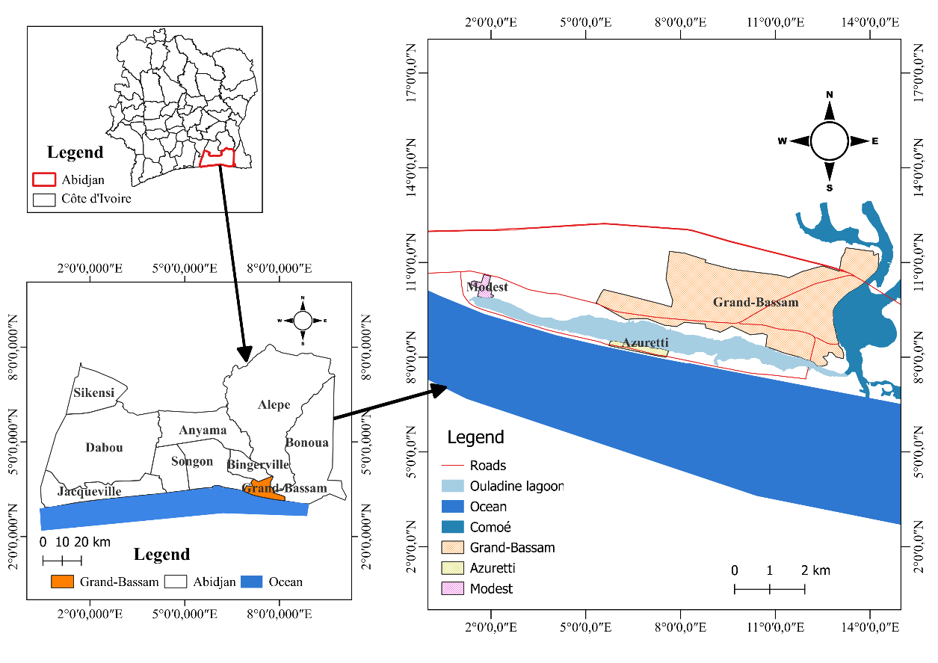
Fig. 1. The location map of the Ouladine lagoon

2.1.2. Equipment used by fishermen to catch fish

- 8, 10, 12,15,20 and 25 mm mesh gillnets used throughout the lagoon by artisanal and commercial fishermen;
- Cast net, which are cone-shaped nets (more or less circular when spread out) mounted on sinker weights attached to the rear edge. A throw rope at the top edge of the net corresponds to the center of the net, allowing it to be cast in and out of the water. An additional mesh system creates a sort of pocket in which the fish are trapped;
- A motorized tray for navigation on the water.

2.2. Methods

2.2.1. Methods for collecting fish fauna
The fish fauna was sampled by artisanal and commercial fishing from November 2022 to February 2023. Catches were taken with a range of fishing gear (creels, gillnets, harpoons and hawks) over the entire exploitable surface of the Ouladine lagoon (Fig. 1).

2.2.2. Identification of collected species

In the laboratory, collected species are photographed and then identified using the identification keys [23] and [18]. After identification, morphometric parameters such as total length (Lt), standard length (Ls), individual weight (Pi) and total weight (Pt) of the species were recorded.

2.2.3. Statistical Analysis

The following indices were used to characterize the ichthyofauna of the Ouladine lagoon.

Numerical percentage (N): This is the ratio of the number ($n_{i}$) of individuals in a taxonomic group (order, family and species) to the total number ($nt$) of individuals in a sample:

$$N=\frac{n_{i}}{nt}×100$$

Frequency of occurrence (F): This reflects the number of samples in which a species is found in relation to the total number of samples [7]. It quantifies the degree of ubiquity of different species. It is calculated as follows:

$$F=\frac{sⅈ}{st}×100$$

With: $sⅈ$ = Number of samples where species $ⅈ$ was observed and $st$ = Total number of samples. The following classification was used to characterize species according to their frequency in the samples: Constant Species (F ≥50%); Accessory Species (25% ≤F< 50%); Accidental Species (F < 25%).

Shannon-Weaver index [19]: measures the species composition of a stand, taking into account species richness and relative abundance. It is determined by the following relationship:

$$H^{'}=-\sum_{i=1}^{s}{pi ×ln pi}$$

With: $H^{'}$ = Shannon diversity index, $ⅈ$= a species in the study environment, $pi$ = proportion per species $i$ (taxon), Σ: Greek symbol meaning "sum", $ln$: neperian logarithm. For [7], all individuals belong to the same species if $H^{'}$= 0, a little diversified if $H^{'}$ < 1.5 and diversified if $H^{'}$> 1.5.
Piélou equitability index: This index was used to assess the quality of the distribution of individuals within the species of the environment. It was calculated using the formula:

$$E=\frac{H^{'}}{\ln\left(S\right)}$$

With: $E$ = Piélou equitability index, $H^{'}$ = Shannon-Weaver index; S = Specific richness, $ln$ = neperian logarithm. The value of $E$ lies between 0 and 1. It approaches 0 when almost all populations are concentrated in a single species, and approaches 1 when all species are abundant [7,3]. Seasonal variations in the Shannon $H^{'}$ and Piélou $E$ indices were compared using the Kruskal-Wallis test. Differences are considered significant at p < 0.05. All analyses were performed with the RStudio software.

3. results and discussion

3.1 Results

3.1.1. Qualitative inventory of ichthyofauna

3.1.1.1. Specific richness

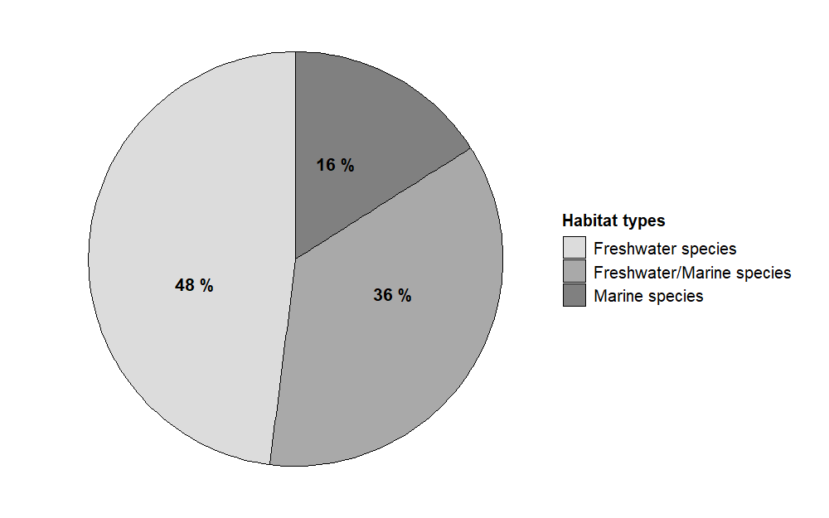
A total of twenty-five (25) fish species (including one hybrid) divided into nine (9) orders and seventeen (17) families were sampled in the Ouladine lagoon from November 2022 to February 2023. This fish population includes twelve (12) freshwater species (Brycinus nurse, Distichodus rostratus, Hepsetus odoe, Labeo coubie, Heterotis niloticus, Hybride (Coptodon zillii x Coptodon guineensis), Coptodon zillii, Hemichromis bimaculatus, Hemichromis fasciatus, Thysochromis ansorgii, Clarias ebriensis and Chrysichthys nigrodigitatus), four (4) species with a marine affinity (Strongylura senegalensis, Sardinella maderensis, Trachinotus teraia and Polydactylus quadrifilis) and nine (9) species capable of living in both environments (Elops lacerta, Eleotris senegalensis, Eleotris vittata, Sicyopterus lagocephalus, Coptodon guineensis, Sarotherodon melanotheron, Pomadasys jubelini, Monodactylus sebae and Tylochromis jentinki) (Fig. 2). The order of Perciformes (5 families and 12 species) is the most diverse. It is followed by the Characiformes (3 families and 3 species), the Gobiiformes (2 families and 3 species) and the Siluriformes (2 families and 2 species). The most diverse family is the Cichlidae comprising of eight (8) species. It is followed by the Eleotridae with two (2) species (Table 1). Over the entire Ouladine lagoon ecosystem, 23 species were sampled during the rainy season and 14 species during the dry season.

Fig. 2. Habitats types of species
3.1.1.2. Frequency of occurrence of fish species

The different species collected from the Ouladine lagoon were classified into constant, accessory and accidental species. The constant species obtained are 36% of all catches. For the accessory species recorded, they are 24% and 40% species are accidentally collected from the catches (Fig. 3).
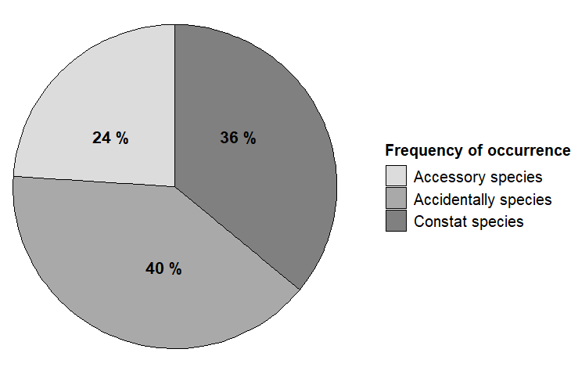

Fig. 3. Frequency of occurence

3.1.1.3. IUCN conservation status

The IUCN conservation status of the species collected during our work indicates 24 species classified as Least Concern (LC) and one species, Sardinella maderensis, classified as Vulnerable (VU). The official IUCN website (https://www.iucnredlist.org/ ) was consulted to check the conservation status (Fig. 4).

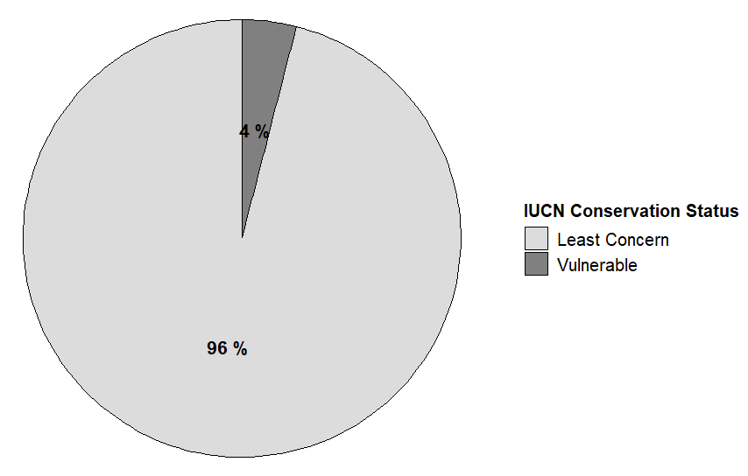

Fig. 4. IUCN conservation status

Table 1: Species distribution, occurrence and IUCN conservation status

Orders | Family | Species | % F | C0 | UICN
Beloniformes | Belonidae | Strongylura senegalensis** (Valenciennes, 1846) | 14,29 | ACS | LC
Characiformes | Alestidae | Brycinus nurse* (Rüppel, 1832) | 14,29 | ACS | LC
Characiformes | Distichodontidae | Distichodus rostratus* Günther, 1864 | 14,29 | ACS | LC
Characiformes | Hepsetidae | Hepsetus odoe* (Bloch, 1794) | 28,57 | AS | LC
Clupeiformes | Clupeidae | Sardinella maderensis** (Lowe, 1841) | 42,86 | AS | VU
Cypriniformes | Cyprinidae | Labeo coubie* (Rüppel, 1832) | 14,29 | ACS | LC
Elopiformes | Elopidae | Elops lacerta*/** Valenciennes, 1846 | 28,57 | AS | LC
Gobiiformes | Eleotridae  Gobiidae | Eleotris senegalensis*/** Steindachner, 1870  Eleotris vittata*/** Duméril, 1858  Sicyopterus lagocephalus*/** (Pallas, 1770) | 14,29  14,29  28,54 | ACS ACS  AS | LC  LC  LC
Osteoglossiformes | Osteoglossidae | Heterotis niloticus* (Cuvier, 1829) | 100 | CS | LC
Perciformes | Carangidae | Trachinotus teraia** Cuvier, 1832 | 14,29 | ACS | LC
Perciformes | Cichlidae | Coptodon guineensis*/** (Bleeker, 1862) | 100 | CS | LC
Perciformes | Cichlidae | Hybrid (C. guineensis × C. zillii)* | 100 | CS | LC
Perciformes | Cichlidae | Coptodon zillii* (Gervais, 1848) | 100 | CS | LC
Perciformes | Cichlidae | Hemichromis bimaculatus* Gill, 1862 | 14,29 | ACS | LC
Perciformes | Cichlidae | Hemichromis fasciatus* Peters, 1852 | 100 | CS | LC
Perciformes | Cichlidae | Sarotherodon melanotheron*/** Rüppell, 1852 | 100 | CS | LC
Perciformes | Cichlidae | Thysochromis ansorgii* (Boulenger, 1901) | 14,29 | ACS | LC
Perciformes | Cichlidae | Tylochromis jentinki*/** (Steindachner, 1895) | 28,57 | AS | LC
Perciformes | Haemulidae | Pomadasys jubelini*/** (Lacépède, 1802) | 14,29 | ACS | LC
Perciformes | Polynemidae | Polydactylus quadrifilis** (Cuvier, 1829) | 28,57 | AS | LC
Perciformes | Monodactylidae | Monodactylus sebae*/** (Cuvier, 1829) | 71,43 | CS | LC
Siluriformes | Clariidae | Clarias ebriensis* Pellegrin, 1920 | 71,43 | CS | LC
Siluriformes | Claroteidae | Chrysichthys nigrodigitatus* (Lacépède, 1803) | 100 | CS | LC
9 | 17 | 25

CO = Class of Occurrence; % F = Percentage of occurrence; * = Freshwater species; ** = Marine species; */**= Freshwater/Marine species; CS = Constant Species; AS = Accessory Species; ACS = Accidental Species; LC = Least Concern; VU = Vulnerable; Hybrid (Coptodon guineensis × Coptodon zillii)

3.1.2. Quantitative inventory of ichthyofauna

3.1.2.1. Numerical abundance and population structure

Of all the fish caught (a total of 1466 individuals) in the Ouladine lagoon, the order Perciformes (84.51%) is the most abundant. This is followed by Siluriformes (9.89%) and Clupeiformes (2.52%). The other orders account for only 3.08% of catches (Fig. 5). Cichlidae (82.26%) and Claroteidae (7.78%) accounted for over 90% of all catches. They are followed by Clupeidae (2.52%) and Clariidae (2.11%). All other families account for barely 5% of samples (Fig. 6). The species Sarotherodon melanotheron (41.61%) is the most abundant in the captures. It is followed respectively by Coptodon guineensis (16.92%), Coptodon zillii (10.23% individuals) and Chrysichthys nigrodigitatus (7.78%). Other species are Coptodon Hybride (6.48%) and Hemichromis fasciatus (4.98%). All other species accounted for 12% of the catches (Fig. 7).

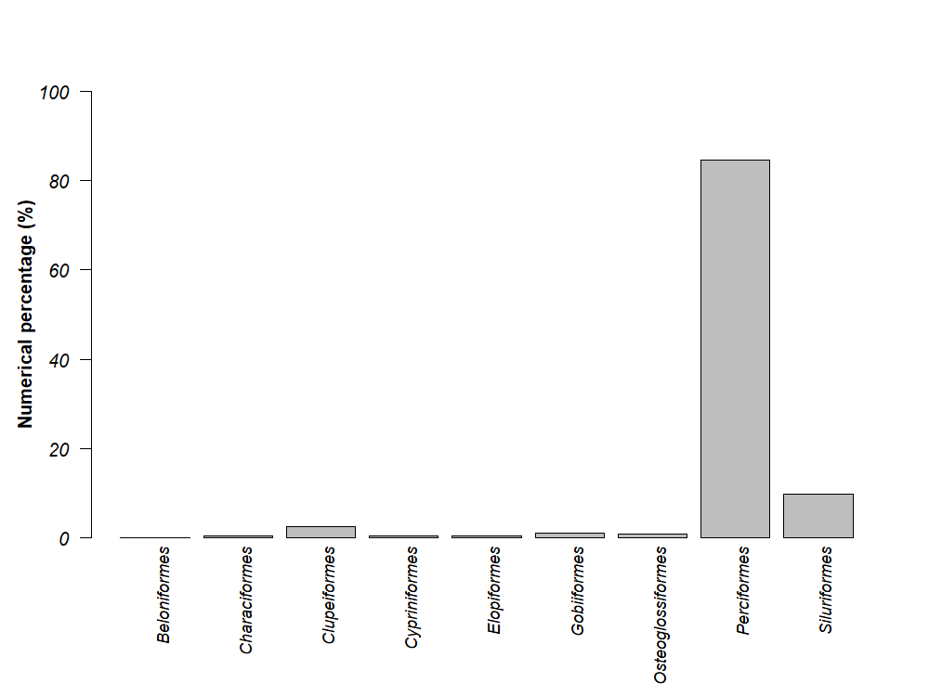
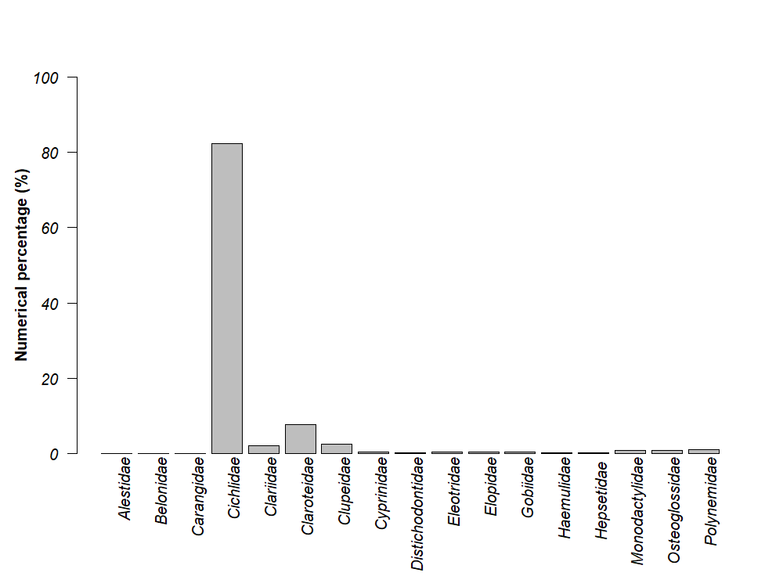
Fig. 5. Numerical percentage of fish orders sampled in the Ouladine lagoon
Fig. 6. Numerical percentage of fish families sampled in the Ouladine lagoon
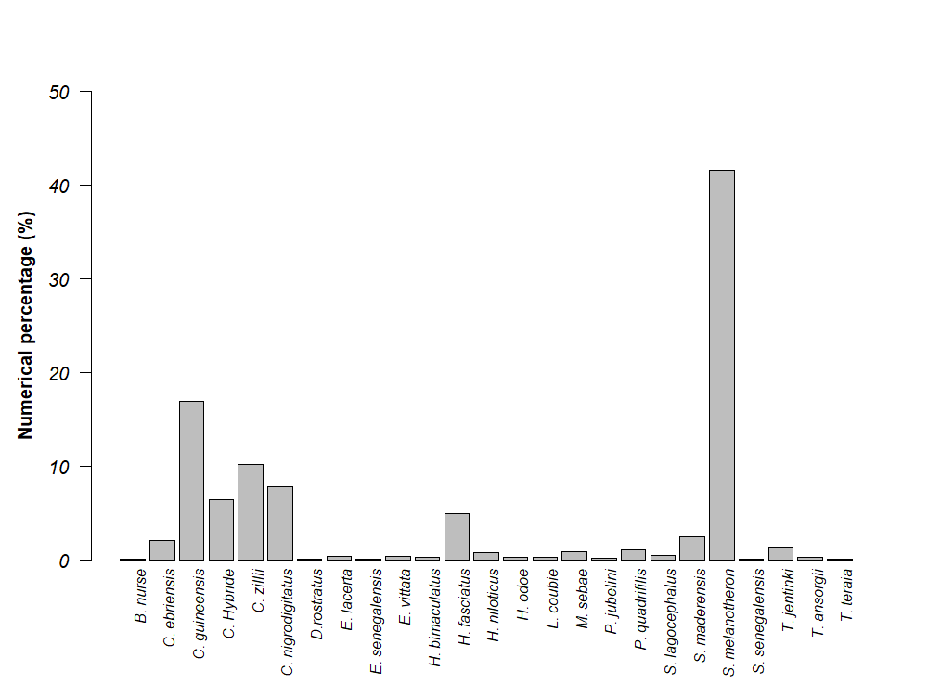
Fig. 7. Numerical percentage of fish species sampled in the Ouladine lagoon

3.1.2.2. Diversity index

The recorded indexes of specific diversity (H') and equitability (E) were relatively high, with values of 1.97 bits per individual and 0.61, respectively (Fig. 8). Seasonally, the Shannon-specific diversity and Piélou equitability indices showed no significant variation (Kruskal-Wallis test: p > 0.05). In the rainy season, the Shannon diversity index obtained was 2.12, for an equitability index of 0.67. In dry season, the Shannon and equitability indices are 1.67 and 0.63, respectively.

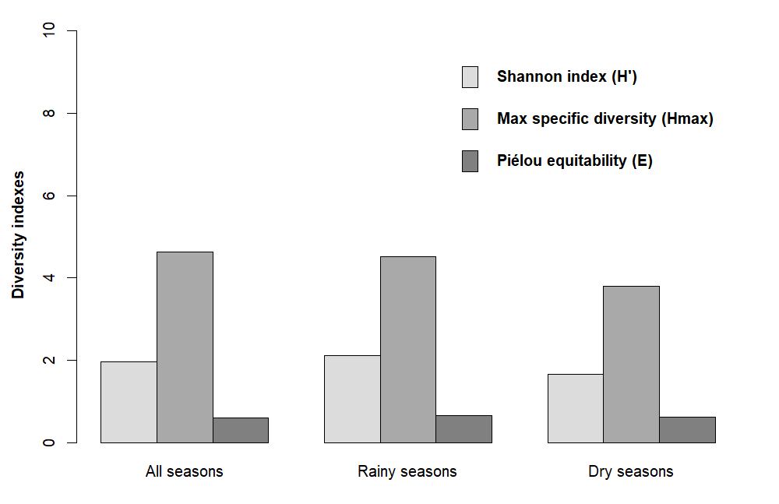

Fig. 8: Shannon diversity index (H'), Max specific diversity (Hmax) and Piélou equitability (E)

3.2. Discussion

A study of the composition and structure of the fish population in the Ouladine lagoon yielded twenty-five (25) species divided into nine (9) orders and seventeen (17) families. Despite its small size, the Ouladine lagoon ecosystem has a fairly diverse fish fauna. This specific richness of the Ouladine lagoon is the result of the adaptation of certain species to environmental conditions. There is currently no other existing literature on the fish fauna of this lagoon which otherwise, would have been used for a comparative analysis. In fact, since the closure of the Bassam Grau, the Ouladine lagoon has been heavily colonized by aquatic macrophytes, accounting for 50% of the water body. According to Eyi et al. (2016) and Ottersen et al., (2010), aquatic macrophytes, particulary Echinochloa pyramidalis, have ecological characteristics that offer a mosaic of specific biotopes capable of hosting and sheltering different ichthyological populations. The richness of the fish fauna in the Ouladine lagoon may also be explained by the fact that this lagoon is in direct contact with the river-lagoon system (Comoé, Ebrié, Potou and Aghien). Based on quantitative analyses, species such as Sarotherodon melanotheron (41.61%), Coptodon guineensis (16.91%), Coptodon zillii (10.23%) and Chrysichthys nigrogitatus (9.8%) are the most represented in terms of numbers. Given the short duration of our work, this study cannot confirm the totality of species present in this lagoon. Tilapia (Sarotherodon melanotheron, Coptodon zilii, Coptodon guineensis) and Chrysichthys nigrodigitatus are the most commonly caught fish in the study area, and therefore the most commercialized. These results are similar to those of [1], who asserted that Sarotherodon melanotheron is a taxon of great economic interest due to its high contribution to fisheries catches in Côte d'Ivoire. The results of [25] estimated this contribution at over 50% of commercial production in Lake Ayamé. The abundance of this species proves that the Ouladine lagoon ecosystem contributes to the stocking of Grand-Bassam's fisheries. It helps preserve fish biodiversity reduces the economic vulnerability of riverside populations in this context of climate change. Cichlidae dominates the Ouladine lagoon population in terms of both quality and quantity, corroborating those reported by [11], [21], [16] and [17] in lakes Ayamé 1 (Côte d'Ivoire), Hlan (Benin) and Higa Sahelian (Burkina Faso) respectively. Cichlidae followed by Claroteidae, Clupeidae and Clariidae are the most represented families in terms of numbers of individuals. This is due to the easy accessibility and capture of species these families. Note that this order is not maintained on all water bodies. On the other hand, this species richness is lower than that of other Ivorian lagoons. For example, Bédia et al. 2017 counted 38 species in the Potou lagoon. The sampling in the present study only took place over four (4) months, whereas that of Bédia et al. 2017 was carried out over two (2) years. Also, in the Betsiboka estuary in northwest Madagascar, 63 distinct species were collected following a two years sampling period [24]. In other words, sampling remains the cornerstone of fish studies. Catches are dominated by freshwater species representing 48% of catches. 16% of species have marine affinity and 36% are capable of living in both ecosystems. The presence of freshwater and/or marine species is because the Ouladine lagoon was in contact with the Atlantic Ocean before the Bassam Grau was closed. The lagoon's geographical location favors the upwelling of species from this brackish environment that need to migrate upstream at some point in their life cycle. In addition, [15] and [9] point out that migratory species from brackish environments head upstream to spawn during flood periods. Analysis of the seasonal variation in species richness shows a decrease in the number of species in the dry season. This may be due to the migration of taxa from the Comoé River to the Ouladine lagoon during flood periods. More than 50% of the species collected in the rainy season are accidental and freshwater species. For all seasons combined, the Shannon (H') and equitability (E) indices are 1.97 and 0.61 respectively. These indices are 2.12 and 0.67 respectively in the rainy season and 1.67 and 0.63 in the dry season. Our Shannon diversity indices (H') are greater than 1.5 each time, proving that the fish fauna of the Ouladine lagoon is diverse, whatever the season. The equitability indices (E) calculated in this study is all close to 1, proving that the fish population of Ouladine lagoon is well organized. Among the species collected, Sardinella maderensis is classified as vulnerable by the IUCN. This is probably due to the massive use (86.85%) of non-regulatory mesh fishing gear and sustained fishing effort, resulting in a fishing mortality rate (F = 2.88 yr⁻¹) higher than the natural mortality rate (M = 2.22 yr⁻¹) [20]. Urgent measures must be taken to ensure the survival of this species.

4. Conclusion

At the end of this study, we counted twenty-five (25) fish species divided into nine (9) orders and seventeen (17) families. Among these species, Sarotherodon melanotheron, Coptodon guineensis, Coptodon zillii, and Chrysichthys nigrogitatus have been the most abundant. One vulnerable species (Sardinella maderensis) was reported among those collected. About fish distribution, the Shannon and Equitability indices calculated indicate diversified and organized populations. Consequently, ongoing monitoring of the state of the fish fauna is necessary to develop the appropriate measures to be taken to avoid a loss of biodiversity. Given the above, the Ouladine lagoon represents one of the potential resources the villages bordering the town of Grand-Bassam can rely on to reduce their vulnerability to climate change. The results of these investigations will serve as reference data for the ichthyofauna of the Ouladine lagoon, and will enrich the national directory of the ichthyological fauna of Côte d'Ivoire. In the present study, we have limited ourselves to commercial and artisanal fishing. It would be advisable to use experimental fishing in future studies of the fish fauna of Ouladine lagoon. In addition, it would be a good idea to extend the sampling of the fish fauna in the said lagoon over a year to better appreciate the diversity of fish and, if possible, that of macro-invertebrates. It would also be important to study the impact of human activities on the biological diversity of the Ouladine lagoon ecosystem.

Disclaimer (Artificial intelligence)
Option 1: Author(s) hereby declare that NO generative AI technologies such as Large Language Models (ChatGPT, COPILOT, etc) and text-to-image generators have been used during writing or editing of manus++cripts.

References

- Adepo-Gourene B, Gourene G. Morphological differentiation of natural populations of a tilapia subspecies Sarotherodon melanotheron Rüppell, 1852 (Teleostei; Cichlidae) from Côte d'Ivoire. Science et Nature. 2008 ; 5(1) : 15 – 27.

- Akadje LMC, Kangah A, Boussougou Boussougou G, Célestin HA, Brou Y. Prospective modelling of land use in an area of high anthropogenic pressure: the case of the Grand-Bassam RAMSAR site (south-east Côte d'Ivoire). Cahiers Du CBRST. 2017 ; 11 : 11–33.

- Barbault R. General ecology: structure and functioning of the biosphere. 5e édition.Paris: DUNOD; 2000.

- Beckley LE. The ichthyofauna of the Sundays estuary, South Africa, with particular reference to the juvenile marine component. Estuaries. 1984 ; 7 : 248-258.

- Bédia AT, Etilé RND, Blahoua GK, N'douba V. Diversity, Ichthyological Population Structure and Production of a West African Tropical Lagoon: Lagune Potou (Côte d'Ivoire). International Journal of Innovation and Applied Studies.2017; 19 (2): 449-461.

- Creel L. Ripple Effects: population and Coastal Regions. Washington DC: Population Reference Bureau; 2003.

- Dajoz R. Précis d’écologie. 7ème Edition. Paris: Dunod 2000.

- Day JW, Hall CA, Kemp WM, Yaiiez-Arancibia A. Estuarine ecology. New York: Wiley and Sons; 1989.

- De Mérona B. The river, the dam and the fish: The Sinnamary and Petit-Saut dams in French Guiana. Paris : Éditions IRD ; 2005.

- Eyi AJ, Konan KJ, Tano K, Da KN, Atse BC. Assessment of fish diversity in a West African basin after dam construction. Journal of Applied Biosciences.2016;104: 9894–9903.

- Gourène G., Teugels GG, Hugueny B, Dirk FET. Assessment of fish diversity in a West African basin after dam construction. Cybium.1999; 23 (2): 147-160.

- Keumean KN, Ahoussi KE, Bamba SB, Traoré A, Djadé OPJ. Influence of anthropogenic activities on the degradation of sediment quality in the Ouladine Lagoon (South-East Ivory Coast). European Scientific Journal.2020 ;16 (15) : 378-392.

- Keumean KN, Bamba BS, Soro M, Soro N. Distribution of nitrogen and phosphorus compounds in the Ouladine lagoon (southeastern Côte d'Ivoire). Afrique SCIENCE. 2010; 6 (2): 84-92.

- Koffi BKF, Kouassi KA, Yao NE. Diversity of Molluscs in a West African Lagoon, the Ouladine Lagoon in Grand-Bassam (Ivory Coast). Journal of Applied Biosciences. 2022 ; 24 : 7365–7374.

- Lévêque C, Paugy D. c (Lévêque C. & Paugy D., Eds). Paris : IRD ; 1999.

- Montchowui CA, Kogbeto MJ, Lalèyè P. Biodiversity and structure of fish communities in Lake Hlan, Benin. International Journal of Biological and Chemical Sciences. 2008; 2 (2): 196-206.

- Ouedraogo R, Soara AE, Oueda A. Description of the fish population of the Sahelian Lake Higa, a Ramsar site in Burkina Faso, West Africa. Journal of Applied Biosciences.2015; 95: 8958-8965.

- Paugy D, Lévêque C, Teugels GG. The Fresh and Brackish Water Fishes of West Africa, vols 1 & 2. Paris : Muséum national d'Histoire naturelle (Faune et Flore tropicales ; 40).2003.

- Shannon CE. A mathematical theory of communication. Bell System Technical Journal. 1948 ; 27: 379-423.

- Sossoukpe E, Hoto G, Djidohokpin, G, & Fiogbe ED. Fishing of the flat sardinella (Sardinella maderensis, Pisces, Lowe 1838) in Benin (West Africa) nearshore waters: production, typology of fishing gear and current status of its stock. Agricultural Sciences. (2022); 13(10) : 1136-1150.

- Tah L, DA Costa KS, Kouassi NJ, Moreau J. Fishing effort and exploited production at Lake Ayamé 1 (Bia Basin; Côte d'Ivoire) after the departure of the "Bozos" fishermen. Agronomie Africaine. 2009; 21(1) : 103-115.

- Tapé Bidi J. Mapping of tourism developments on the Grand-Bassam barrier beach.Cahiers Nantais.1999 ; 51(1) : 39-46.

- Teugels GG, Lévêque C, Paugy D, Traoré K. State of knowledge on the fish fauna of the coastal basins of Côte d'Ivoire and western Ghana. Revue d’Hydrobiologie tropicale.1988; 21 (3) :221- 237.

- Tsirilaza B, Andriamirado RGA, Rasoloariniaina JR, Jean-Michel YM & Félicitée RF. Diversity and Distribution of the Ichtyofauna Population in the Betsiboka Estuary, Northwest Madagascar. ESI Preprints. (2024); 20(9): 162-179.

- Vanga AF, Gourène G & Ouattara M. Impact of fishing on fish availability in the Ayamé and Buyo lake regions (Côte d'Ivoire). Archaeological Science. 2002 ;22(2) : 1-12.

- Wootton RJ. Fish ecology. Glasgow: Blackie and Son; 1992.

- Yao AA, Koffi MK, Doumbia L, Ouattara A & Gourene G. Diversity and Structure of the Ichthyological Population of the Lower Comoé River Basin (Côte d'Ivoire). European Scientific Journal. 2019; 15 (6): 244–268.

- Charles , Niyonkuru, Ntakirutimana Remy, and Ntakimazi Gaspard. 2023. “Population Dynamics and Exploitation Level of Stolothrissa Tanganicae Regan, 1917 and Limnothrissa Miodon (Boulenger, 1906), Two Clupeid Fish Species of Commercial Interest of Burundian Waters Northeast of Lake Tanganyika”. Asian Journal of Fisheries and Aquatic Research 24 (6):28-36. https://doi.org/10.9734/ajfar/2023/v24i6650.
- Ottersen G, Kim S, Huse G, Polovina JJ, Stenseth NC. Major pathways by which climate may force marine fish populations. Journal of Marine Systems. 2010 Feb 10;79(3-4):343-60.
- Sissenwine MP. Why do fish populations vary?. InExploitation of Marine Communities: Report of the Dahlem Workshop on Exploitation of Marine Communities Berlin 1984, April 1–6 1984 (pp. 59-94). Springer Berlin Heidelberg.
- Mondal, Md. Atiqul Islam, Md. Rashed-Un-Nabi, Naina Islam, Md. Matiur Rahman, and Mohammad Alamgir Kabir. 2024. “Population Dynamics of Gudusia Chapra (Hamilton, 1822) from Lake Kaptai, Bangladesh”. Asian Journal of Biology 20 (1):12-25. https://doi.org/10.9734/ajob/2024/v20i1382.

