Investigation of Rhizoctonia Aerial Blight in Soybean: Onset, Progression and Sclerotia Development

Abstract
Soybean crops worldwide can be affected by numerous harmful plant pathogens. Aerial blight caused by Rhizoctonia solani Kuhn is a severe disease that affects soybean production worldwide. Incessant soybean cultivation and other factors have led to an upsurge in the incidence of aerial blight in major soybean-growing regions of India. In the present investigation, various aspects of aerial blight, i.e., initiation timing, rapid progression phase, and development of survival structures, were studied in a field trial on 10 different soybean genotypes at J.N.K.V.V., Jabalpur, during Kharif 2022. The per cent disease index and sclerotia per trifoliate leaves were recorded at regular intervals. The symptoms of aerial blight started from 50.5 to 68.0 days after sowing. The highest aerial blight severity was noticed in JS 20-29 (29.2%). Aerial blight progression was rapid during late reproductive stages (R5 and R6) (September 10 to 23) that coincided with the moderate range of weekly maximum temp (29.8 - 30.5⁰C), minimum temp (23.6 - 24.2⁰C), morning Rh (90.6 - 92.4 %), evening Rh (79.0 - 79.4 %) and rainfall (39.3 - 118.0 mm) at experimental location. After 21 days of symptoms, sclerotia development was noticed in all the varieties, ranging from scattered (>10- 25/trifoliate leaf) to high (≥50 sclerotia/ trifoliate leaf). The study indicated that high sclerotia were formed in all varieties affected by aerial blight at a later stage of disease development. These sclerotia may be crucial for initiating disease in other host crops or in soybeans next season. This study may also facilitate the suitable implementation of management strategies to decrease disease severity of aerial blight in central Indian conditions.

Key words: Aerial blight, Progression, Sclerotia, Rhizoctonia solani, Soybean

Introduction
Soybean (Glycine max L.) is among the five most important crops grown worldwide (Bandara et al., 2020). According to recent data (2022-23), Brazil (158.0 MT), the USA (116.2 MT), Argentina (25.0 MT), China (20.28 MT), India (12.4 MT), Paraguay (9.0 MT), Canada (6.5 MT), and Russia (6.0 MT) are significant contributors of soybean to the world (USDA, 2023). The protein (42.8%) and edible oil (20.2 %) content is very high in soybean seed in comparison to any crop field crop, making it one of the most calorific valued crops (Uikey et al., 2022; Banerjee et al., 2023). “India is not an oil seed-sufficient country; hence, to fulfil its domestic demand, the country imports edible oil from another country. India is the largest soybean oil importer (around 25%)” (Sagarika et al., 2023; Amrate et al., 2024). “The productivity of soybean is comparatively lower (about 0.9 tons) compared to most of the developed countries like the USA, Brazil and Argentina (3.0 to 3.5 tons)” (Amrate et al., 2024). Due to the rainy season, soybean crops face numerous production constraints that significantly reduce their yield potential (Dupare et al., 2014; Amrate et al., 2021; Bhamra & Borah, 2022; Amrate and Shrivastava, 2021; Rajput et al., 2021; Patidar et al., 2023).
Among this, “Rhizoctonia aerial blight incited by Rhizoctonia solani Kuhn constantly has been infecting soybean crop in different parts India” (Wrather et al., 2010; Mathpal & Singh, 2017; Amrate et al., 2021; Amrate et al., 2023). “Aerial or foliar blight is also a significant disease that infects the soybean crop globally” (Jones & Belmar, 1989; Wan et al., 2005; Williamson et al., 2006; Weather et al., 2010). “The disease is highly prevalent in Madhya Pradesh, wherein about 50 per cent of soybean production has occurred” (Wrather et al., 2010; Amrate et al., 2021). “It affects most soybean genotypes, including varieties, germplasm and exotic collections” (Amrate et al., 2018; Amrate et al., 2020; Amrate et al., 2023). Its symptomatic identification includes the dull greenish appearance of the affected portion followed by a greyish brown water-soaked lesion with web-like development of the pathogen’s mycelium on affected plant parts (Sinclair, 1984; Amrate et al., 2021). It can reduce the yield by about 41 % in India (Amrate et al. 2023) and up to 60% yield loss in Brazil conditions (Fenille et al. (2002). The pathogen of aerial blight is a polyphagous necrotrophic soil-borne fungus that infects several crops other than soybean (Ajayi-Oyetunde & Bradley, 2017; Senapati et al., 2022). Rhizoctonia passes a more extended period of survivability in the form of sclerotia, even in odd conditions (Sinclair, 1984; Manian & Manibhushan, 1990; Ajayi-Oyetunde & Bradley, 2017). Initially, the survival body germinates, produces a germ tube and causes infection usually on leaves or plant parts douching to soil; after that, depending on weather and canopy, the disease spreads quickly on affected plants and between (Yang et al., 1990; Amrate et al., 2021).
Only a few pieces of literature exhibit aerial blight progression under the current genotype growth scenario. As far as our knowledge is concerned, little literature shows the formation of the survival body (sclerotia) on aerial blight-affected plants and the extent of the number of them formed. The data on the epidemiology of aerial blight disease could help minimize disease severity by altering current practices and deriving new management practices. Hence, looking at these facts, the present field study was undertaken to explore the epidemiological aspect of aerial blight in central Indian conditions. This manuscript could be valuable to the scientific community as it offers thorough insights into the epidemiology of Rhizoctonia aerial blight in soybean. It examines the timing of disease onset, progression, and survival bodies (i.e., sclerotial formation) under field conditions in the examined soybean genotypes. Data on the timing of increased disease progression and the peak period of development of survival structures under central Indian conditions can help formulate more effective integrated disease management strategies.
Materials and methods
Isolation and identification of the pathogen
Plants showing typical field symptoms of aerial blight were identified in the research field of J.N.K.V.V., Jabalpur, during Kharif 2022 (Amrate et al., 2021) (Figure 1) (Latitude: 23º14 N, Longitude: 79º56 E, Altitude: 411.5m). The pathogen was isolated from infected leaves as well as from sclerotia. Infected leaves were cut into small pieces, surface sterilized (2.0% sodium hypochlorite for 30 seconds), blotted dried, inoculated on sterile potato dextrose agar (P.D.A.) and incubated in an incubator at 27±1ºC. The plates were observed for mycelium growth and sclerotia formation. A single sclerotium was picked up and transferred to medium plates for purification. The mycelium arising from single sclerotium was again shifted to a fresh medium for further purification. The pathogenicity of the pathogen was proved by inoculating mycelia bit on soybean leaves in plastic trays.
Field experiment
A Field experiment was conducted to determine the appearance of aerial blight disease, its progression and the number of sclerotia formation in the aerial blight affected plants in the field of All India Coordinated Research Project (A.I.C.R.P.) on Soybean at J.N.K.V.V., Jabalpur (Latitude: 23º14 N, Longitude: 79º56 E, Altitude: 411.5m) during Kharif 2022. Ten soybean varieties, namely JS 97-52, JS 20-29, JS 335, JS 20-94, JS 23-05, JSM-259, RVS 2001-04, RVS 2001-18, JS 20-34, JS 22-05 were sown on 30/06/2022 in two replications in randomized block design. The varieties chosen for the experiment were moderate susceptible in previous screening at Jabalpur conditions (Amrate et al., 2018; Amrate et al., 2023). The varieties were planted in two-row plots with 3-meter row lengths and row-to-row distances of 30 cm. At the time of sowing seeds were treated with thiamethoxam 30% FS @ 10 ml/kg to avoid initial attack by insect pests. Moreover, other recommended agronomic practices were adopted to grow the varieties across the season.
Recording aerial blight severity
Varieties were regularly monitored for RAB appearance, sclerotia formation and progress of aerial blight. Ten plants per cultivar were randomly selected to record aerial blight. Visual observations on aerial blight intensity were recorded from three leaves on the bottom, middle and top trifoliate. Numerical grades were assigned to the amount of disease observed by applying a 0-9 disease rating scale (Mayee & Datar, 1986; Amrate et al.,2018 and Anonymous, 2019), and per cent disease intensity/index (PDI) was computed by applying the formula (Wheeler, 1969) as given below.
PDI = | Sum of numeric rating |  |  | × 100
PDI = | No. of leaves Observed | × | Maximum ratings | × 100

Sclerotial formation and their density
Sclerotia formation in affected plants in the same set of varieties was recorded at the time of disease appearance and regular intervals. For this, the number of sclerotia on trifoliate leaves was recorded (Amrate et al., 2021). The total number of sclerotia from three trifoliate leaves (bottom, middle and upper) was observed from each plant. Ten such plants were observed for sclerotia number from each plot, and their average was computed.
Results and discussions
Cultural characters of isolated fungus
The isolated and purified causal agent produced a white colony on the PDA medium. Sclerotia formation started after ten days of culture growth (figure 1). The sclerotia formation was dense, and the crust of sclerotia was formed in the cultural plates. In microscopic view, hyphae branched at a right angle, multinucleate, no conidia or spores, septation and constriction in hyphae at the origin of the branch, and the cross wall within the hyphae (dolipore septum) were noticed. Based on all these, the causal agent was identified as Rhizoctonia solani (Ogoshi, 1975; Ajayi-Oyetunde & Bradley, 2017).
Initiation of Rhizoctonia aerial blight
The first appearance/ initiation of aerial blight disease in ten soybean varieties varied significantly (Table 1). The first symptom of aerial blight started on JS 20-29 (50.5 DAS), followed by JS 355 (51.5 days after sowing), RVSM 2011-35 (51.5 DAS) and JSM 259 (54.5 DAS). The symptoms of aerial blight appeared in the last in JS 21-05 (68.0 DAS) (Table 1, Figure 2). During the appearance of the symptoms in most of the varieties (Aug 27–Sept 2), the maximum (31.3⁰C), minimum temperature (24.1⁰C), morning (90.0 %), and evening (67.9) relative humidity were slightly higher, and rainfall occurred (97.5 mm). Amrate et al. (2023) previously indicated that symptoms of aerial blight usually appeared between the first to second weeks of August at bloom initiation (R1) to full bloom (R2) stage and reported up to 46.8 % severity at the Jabalpur location. Aerial blight symptoms can appear on leaves, stems, and pods at the age of 45 to 60 days old crop (Prasad, 2005).
Progression of aerial blight and sclerotia density
Varieties were observed for the progression of aerial blight. The per cent disease index (PDI) of Rhizoctonia aerial blight was low in all the varieties at 60 DAS. At 75 DAS, aerial blight severities among the varieties were significant. The high severity of the disease was observed in JS 20-29 (11.1%). The lowest severity was recorded in the case of JS 23-05 (0.8%) (Table 1). At 90 DAS, aerial blight severity and the presence of sclerotia in affected plants increased sharply at the time of maturity of the crop. The severity of disease on the affected plant varied significantly among the varieties. The maximum aerial blight severity was recorded in JS 20-29 (29.2%), followed by JS 97-52 (23.4%), PS 1660 (22.0%) and RVSM 2011-35 (21.4%). At the same time, the lowest severity of aerial blight was recorded in JS 21-05 (5.5%). Data revealed that aerial blight progression was rapid during late reproductive stages (R5 and R6) (September 10 to 23). During this period, weekly maximum temp (29.8 - 30.50C), minimum temp (23.6 - 24.20C), morning Rh (90.6 - 92.4 %), evening Rh (79.0 - 79.4 %) and rainfall (39.3 - 118.0 mm) were ranged moderately at the experimental location. In a previous study, aerial blight initiation varied in different regions. Aerial blight starts appearing during the first fortnight of August at the age of 35-40 days old crop, and its severity increases sharply between 63-84 days old crop (Amrate et al. 2021). Our findings of rapid progression of aerial blight during moderate temperature and higher rainfall conditions corroborated with Amrate et al. (2021) study, wherein they noticed “low severity of aerial blight under hot, less humid and less rainfall conditions and high severity under wet, moderate temperature and high rainfall conditions”. “Highly humid field conditions also favour Aerial blight in soybeans” (Yang et al., 1990).
Sclerotia formation in aerial blight affected plant
During observation, it was noticed that white soft fungal aggregation appeared on affected tissue in the form of a small visible dot. Upon these, white fungal dot sclerotia formation started in a few days (2-3 days). Later, these sclerotia on the affected plant become dark brown to black and remain attached to the portion of the plant (Figure 1). At the time of symptom appearance (at 0 days), no sclerotia was observed in the affected plants of all varieties (Table 1). Similarly, seven days after symptoms appeared, no sclerotia was noticed in all the varieties. Sclerotia presence was recorded after 14 days of symptom appearance in most varieties. However, their count varied in different varieties. In JS 23-05, sclerotia formation was absent even at 14 days of symptom appearance. Whereas in varieties, i.e. JS 20-69 and PS 1660 scanty and in JS 21-05, JS 20-94 and JS 97-52, scattered sclerotia were formed after 14 days of symptoms appearance (Figure 3). In the case of JS 20-29, JS 335, and RVSM 2011-35, many sclerotia were present in affected plants. After 21 days of symptoms, sclerotia was noticed in all the varieties, ranging from scattered to high. In most of the verities, a high number of sclerotia (≥50 sclerotia/ trifoliate leaf) were observed (table 1 and Figure 1). The number of matured sclerotia in soybean plants varied from 21.5 (JS 20-69) to 94.5 per plant (JS 20-29). Previous to this, Amrate et al. (2021) recorded about 60 to 200 mature sclerotia on trifoliate leaves of soybean during the reproductive stage (R-7) of the crop. Similarly, sclerotia formation was also noticed in other crops, such as rice (Gonzalez Garcia et al., 2006).
Conclusion
The investigation revealed that the first symptom of aerial blight started appearing about 50 days crop. The progression of aerial blight was rapid during the late reproductive stages (R5 and R6) in most affected varieties. The progression of the disease is favoured by moderate to high temp, high Rh and scattered to high rainfall. The disease severity was higher in the case of JS 20-29 (29.2%). The present observation indicated that many survival structures were formed in all the varieties affected with aerial blight at a later stage of disease development. These sclerotia may play a crucial role in disease initiation to the next cropping season or other host.

Disclaimer (Artificial intelligence)

Option 1:
Author(s) hereby declare that NO generative AI technologies such as Large Language Models (ChatGPT, COPILOT, etc.) and text-to-image generators have been used during the writing or editing of this manuscript.

References
Ajayi-Oyetunde, O.O., Bradley, C.A. (2017). Identification and Characterization of Rhizoctonia species associated with soybean seedling disease. Plant Disease, 101, 520–33.
Amrate, P. K., Pancheshwar, D.K., Shrivastava, M.K. (2018). Evaluation of soybean germplasm against Charcoal rot, Aerial blight and Yellow mosaic virus disease in Madhya Pradesh. Plant Disease Research, 33(2): 185–190.
Amrate, P.K. and Shrivastava, M.K. (2021). Yield response and pathological characterization of promising genotypes of soybean against major diseases in Madhya Pradesh. Journal of Oilseeds Research, 38(4): 380-384.
Amrate, P.K., Chaukikar, K., Kharte, S., Pancheshwar, D.K., Marabi, R.S., Shrivastava, M.K. and Bhale, M.S. (2024). Distribution of Charcoal Rot of Soybean, its Influencing Factors and Pathogenic Variabilities in Different Regions of Madhya Pradesh. Legume Research, 1, 11. doi: 10.18805/LR-5262.
Amrate, P.K., Shrivastava, M.K. and Singh, G. (2023). Identification of Sources of Resistance and Yield Loss Assessment for Aerial Blight and Anthracnose/Pod Blight Diseases in Soybean. Legume Research, 46(11), 1534-1540. doi: 10.18805/LR-4452.
Amrate, P.K., Shrivastava, M.K., Pancheshwar, D.K. (2021). Crop-weather based relation and severity prediction of Aerial blight incited by Rhizoctonia solani Kuhn in soybean. Journal of Agrometeorology, 23(1), 66–73.
Amrate, P.K., Shrivastava, M.K., Singh G. (2020). Screening of genotypes to identify the resistance source against major diseases of soybean under high disease pressure conditions. International Journal of Current Microbiology and Applied Sciences, 9(5), 1739-1745. https://doi.org/10.20546/ijcmas.2020.905.195.
Anonymous. (2019). 49th Annual Group Meeting Birsa Agricultural University, Ranchi. In: Proceedings and Technical Programmes (2018-19). ICAR-Indian Institute of Soybean Research. March 16-18, 59.
Bandara AY, Weerasooriya DK, Bradley CA, Allen TW, Esker PD. (2020). Dissecting the economic impact of soybean diseases in the United States over two decades. PLoS ONE, 15(4), e0231141. https://doi.org/10.1371/journal. pone.0231141.
Banerjee, J., Shrivastava, M.K., Singh, Y. Amrate, P.K. (2023). Estimation of genetic divergence and proximate composition in advanced breeding lines of soybean (Glycine max (L.) Merrill. Environment and Ecology, 41(3C), 1960–1968. https://doi.org/10.60151/envec/VYWE5744.
Bhamra, G.K., Borah M. (2022). A Review on Collar Rot Disease of Soybean Caused by Sclerotium rolfsii Sacc. International Journal of Economic Plants, 9(3), 235-239. Doi: HTTPS://DOI.ORG/10.23910/2/2022.0470
Dupare, B.U, Billore, S.D., Sharma, A.N. and Joshi O.P. (2014). Contribution of area, productivity and their interaction towards changing oilseeds and soybean production scenario in India. Legume Research, 37(6), 635-640.
Gonzalez G. V., Portal Onco, M. A., & Rubio Susan, V. (2006). Review. Biology and systematics of the form genus Rhizoctonia. Spanish Journal of Agricultural Research, 4(1), 55–79. https://doi.org/10.5424/sjar/20060 41-178.
Jones, R.K. and Belmar, S.B. (1989). Characterization and pathogenicity of Rhizoctonia spp. Isolated from rice, soybean and other crops grown in rotation with rice in Texas. Plant Disease, 73(12):1004-1010.
Kim, W. G., Hong, S. K., & Han, S. S. (2005). Occurrence of Web Blight in Soybean Caused by Rhizoctonia solani AG-l (IA) in Korea. The Plant Pathology Journal, 21(4), 406-408.
Manian, S. and Manibhushanrao, K. (1990). Influence of some factors on the survival of Rhizoctonia solani in soil. Tropical Agric., 67(3): 207-208.
Mathpal, M. and Singh, K.P. (2017). Prevalence and severity of Rhizoctonia aerial blight of soybean in Uttarakhand. Indian Journal of Ecology, 44(2):417-419.
Mayee, C.D. and Datar, V.V. (1986). Phytopathometry technical bulletin-1 (Special bulletin-3). Marathwada Agricultural University, Parbhani, 34–37.
Ogoshi. (1975). Studies on the anastomosis groups of Rhizoctonia solani Kühn. Japan Agricultural Research Quarterly, 9(4): 198-203.
Patidar, S., Yadav, V.K., Amrate, P. K., Lovewanshi, L.S., Karoda, C., Kharte, S., Kurmi, S. (2023). Integrated Management of Charcoal Rot and Its Influence on Seed Yield and Quality in Soybean. International Journal of Environment and Climate Change, 13(12), 830–842. https://doi.org/10.9734/ijecc/2023/v13i123745.
Prasad, R. (2005). In vitro, screening of different fungicides and antifungal antibiotics against Rhizoctonia solani causing aerial blight of soybean. J. Pl. Dis. Sci., 2(1), 54-56
Rajput, L., Nataraj, V., Kumar, S., Amrate, P.K., Jahagirdar, S., Huilgol S.N., Chakruno, P., Singh, A., Maranna, S., Ratnaparkhe, M. B., Borah, M., Singh, K. P., Gupta, S., Khandekar, N. (2021). WAASB index revealed stable resistance sources for soybean anthracnose in India. Journal of Agricultural Science, 159(9-10), 710-720. doi:10.1017/S0021859622000016.
Sagarika, M., Amrate, P.K., Yadav, V.K., Shrivastava, M.K. (2023). Exploring potential of new generation fungicides as seed dresser in combating early infection of Macrophomina phaseolina in Soybean. Indian Phytopathology, (76), 1045–1053 https://doi.org/10.1007/s42360-023-00680-3.
Senapati, M., Tiwari, A., Sharma, N., Chandra, P., Bashyal, B.M., Ellur, R.K., Bhowmick, P.K., Bollinedi, H., Vinod, K.K., Singh, A.K., Krishnan, S.G. (2022). Rhizoctonia solani Kühn Pathophysiology: Status and Prospects of Sheath Blight Disease Management in Rice. Frontiers of Plant Science, 13, 881116. doi: 10.3389/fpls.2022.881116.
Sinclair, J.B. (1984). Compendium of Soybean disease. 2nd ed. by American Phytopathology Society, USA.
Stetina, K. C., Stetina, S. R., and Russin, J. S. (2006). Comparison of severity assessment methods for predicting yield loss to Rhizoctonia foliar blight in soybean. Plant Disease, 90, 39-43.
Uikey, S., Sharma, S., Amrate, P.K., Shrivastava, M.K. (2022). Identification of Rich Oil-Protein and Disease Resistance Genotypes in Soybean [Glycine max (L.) Merrill]. International Journal of Bio-resource and Stress Management, 13(5): 497–506. doi: https://doi.org/10.23910/1.2022.2478.
USDA. (2023). Foreign Agricultural Service, U.S. Department of Agriculture. https://fas.usda.gov/data/production/commodity/2222000.
Wheeler, B.E.J. (1969). An Introduction to Plant Diseases. John Wiley and Sons Ltd., London, 301.
Williamson, M.R., Rothrock, C.S. and Muellar J.D. (2006). First report of foliar blight of soybean in South Carolina. Plant Health Progress, 3:1-3.
Wrather, A., Shannon, G., Balardin, R. (2010). Effect of diseases on soybean yield in the top eight producing countries in 2006. Plant Health Progress, 11:1. https://doi.org/10.1094/PHP-2010-0102-01-RS.
Yang, X.B., Snow, J.P., and Berggren, G.T. (1990). Analysis of epidemics of Rhizoctonia aerial blight of soybean in Louisiana. Phytopathology, 80:386-392.

Table 1: Progression of Rhizoctonia aerial blight (RAB) and sclerotia formation in varieties of soybean during kharif 2022.
Varieties | Symptom appearance (DAS) | Progression of RAB  (PDI) |  | Sclerotia formation day after symptoms appearance (Sclerotia/ trifoliate leaf)
Varieties |  | 75 DAS | 90 DAS | 0 days | 7 days | 14 days | 21 days
JS 97-52 | 58.5 | 9.0 (17.5) | 23.4 (28.8) | - | - | ++ | ++++
JS 20-29 | 50.5 | 11.1(19.3) | 29.2(32.6) | - | - | ++++ | ++++
JS 335 | 51.5 | 7.4(15.7) | 16.3(23.7) | - | - | ++++ | ++++
JS 20-94 | 57.5 | 2.7(9.4) | 6.7(14.9) | - | - | ++ | ++++
JS 23-05 | 66.0 | 0.8(3.6) | 6.2(14.3) | - | - | - | +++
JSM 259 | 54.5 | 8.0(16.4) | 7.4(15.6) | - | - | +++ | ++++
PS 1660 | 56.0 | 7.7(15.9) | 22.0(27.9) | - | - | + | ++++
RVSM 2011-35 | 51.5 | 9.5(17.9) | 21.4(27.5) | - | - | ++++ | ++++
JS 21-05 | 68.0 | 3.6(10.9) | 5.5(13.4) | - | - | ++ | +++
JS 20-69 | 64.0 | 2.1(8.3) | 7.1(15.5) | - | - | + | ++
SE(m)± | 1.5 | 2.0 | 1.7 | - | - | - | -
CD(p=0.05) | 5.0 | 6.4 | 5.7 | - | - | - | -
*(-) = Sclerotia absent, (+) = Scanty sclerotia present (<10/trifoliate leaf)
(++) = Sclerotia present in scattered manner (>10- 25/trifoliate leaf)
(+++) = Sclerotia present in moderate number (>25- 50/trifoliate leaf)
(++++) = Sclerotia present in high number (>50/trifoliate leaf)
*Values in parenthesis are angular transformation
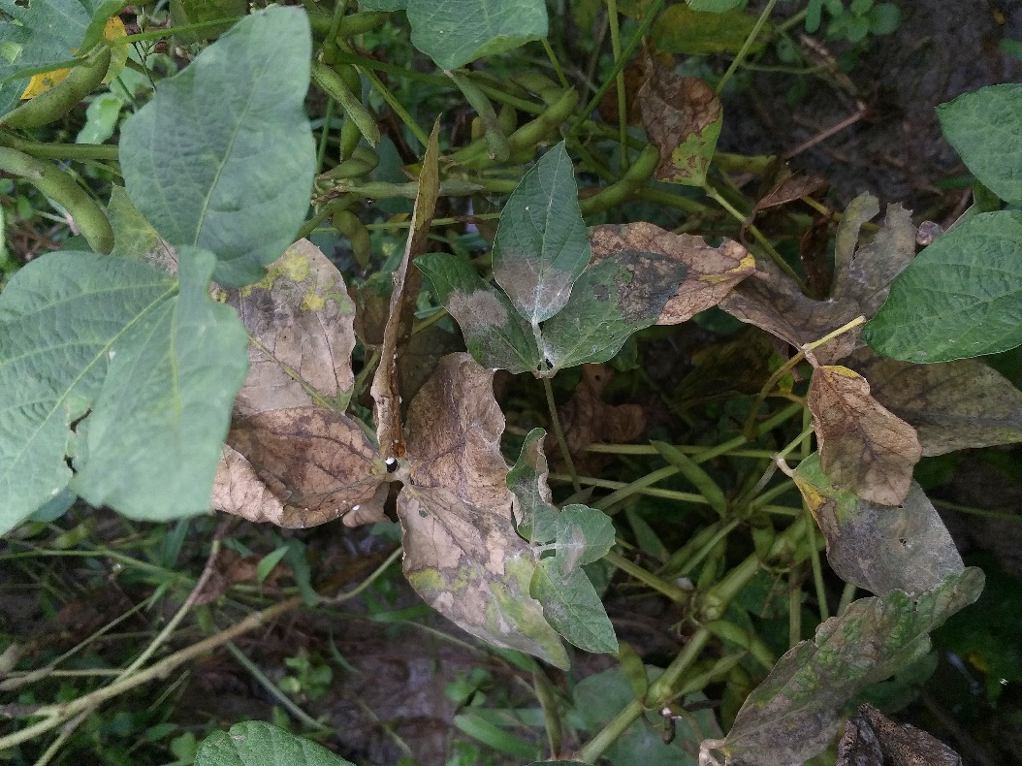  A | 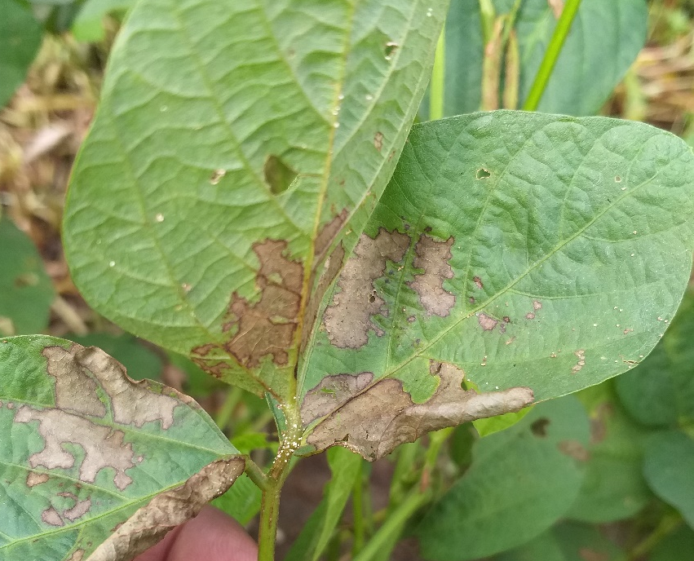  B
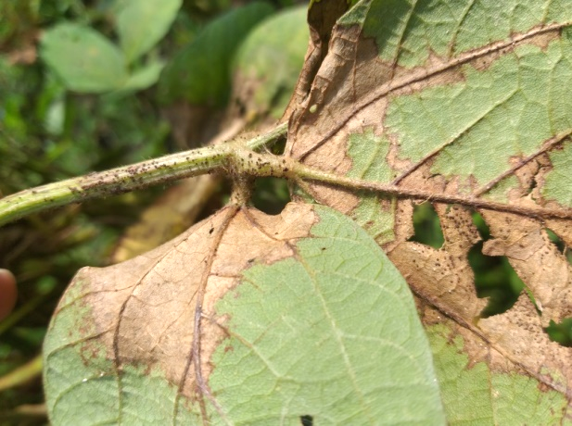  C | 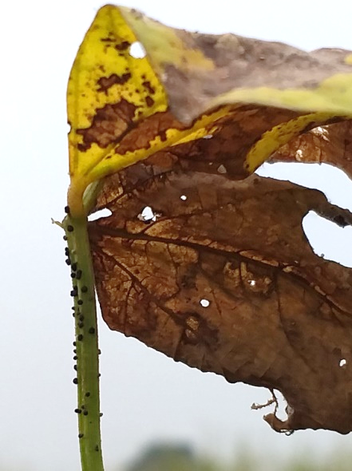  D
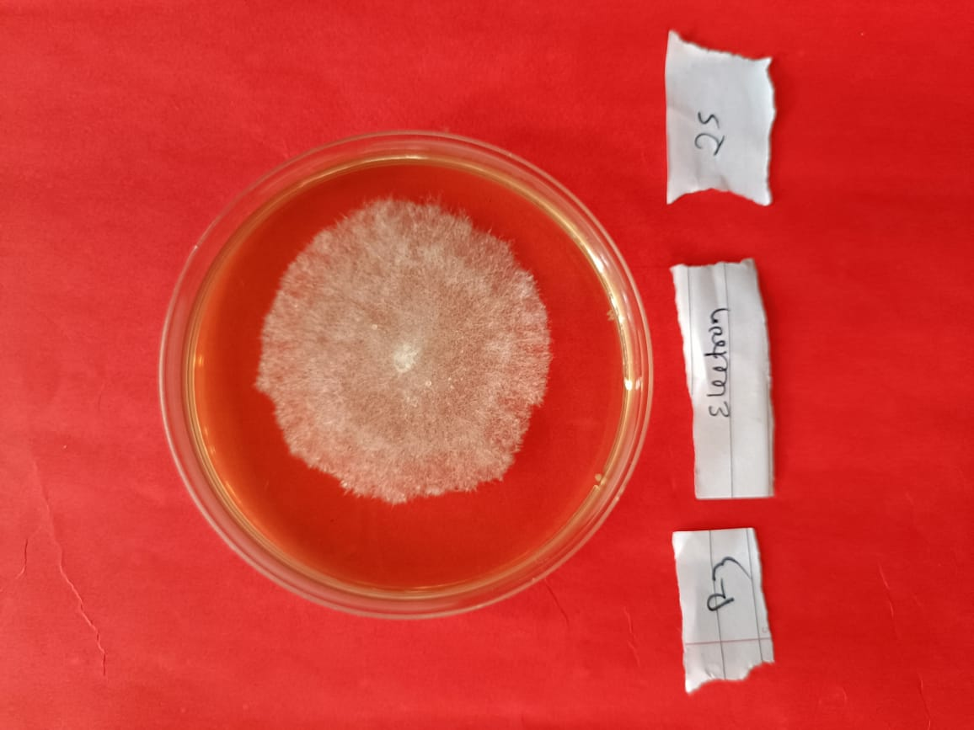  E | 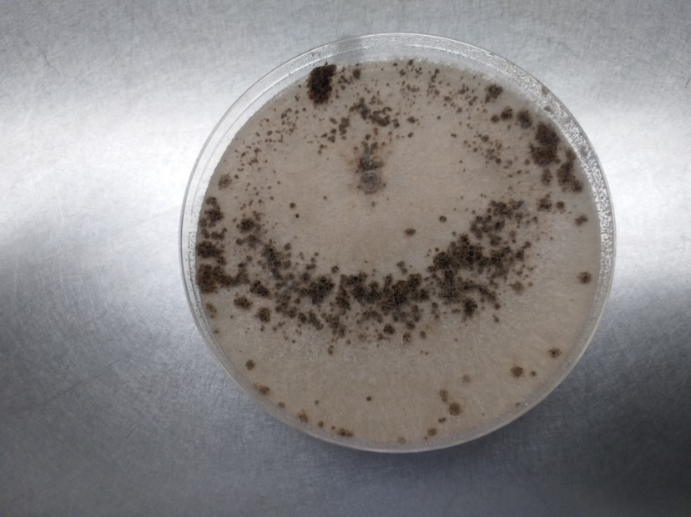  F
Figure 1: Symptoms of aerial blight (A), initiation of sclerotia formation (B), dark brown mature sclerotia on trifoliate leaves (C), and on petioles (D), 3rd day mycelial growth of R. solani (E) and formation of sclerotia at 10 days growth in PDA (F)

Figure 2: Appearance of aerial blight in varieties of soybean

Figure 3. Formation of sclerotia in varieties of soybean

