Javanese Cosmology in Folk Dance: The Significance of the Kiblat Papat Lima Pancer in the Jaranan Dance of Gandon Hamlet, Gandu Village, Tembarak District, Temanggung Regency

.
ABSTRACT

Aims: This study aims to examine the representation of Javanese cosmology in the Jaranan Dance, with a particular focus on the significance of the kiblat papat lima pancer concept as a philosophical foundation shaping the dance’s structure, symbolism, and meaning.
Study design: This study employs an ethnocoreological approach, relying on qualitative data.
Place and Duration of Study: The research was conducted in Gandon Hamlet, Gandu Village, Tembarak District, Temanggung Regency, with a research duration of approximately two years.
Methodology: Within the ethnochoreological approach, research involves both fieldwork and non-field studies. This study combines ethnographic methods to explore the form, meaning, and social role of the Jaranan Dance with a literature study that examines its philosophical and historical dimensions in Javanese culture.
Results: The Jaranan Dance, widely practiced in rural Java, is preserved as an integral part of local cultural traditions. Beyond entertainment, it embodies the Javanese worldview and value system, particularly through the expression of Javanese cosmology in the concept of kiblat papat lima pancer. In Gandon Hamlet, four dancers represent the four human desires linked to the kiblat papat, whose energies must remain in balance. The combat segment symbolize this self-control, positioning the dance as both an artistic expression and a symbolic enactment of Javanese cosmological and ethical principles.
Conclusion: This phenomenon highlights that the Jaranan Dance represents a multidimensional cultural text that integrates aesthetics, philosophy, and cultural identity. It embodies a philosophical meaning related to cosmic balance, reflected in its performative style from the Javanese cultural perspective. Thus, the Jaranan Dance not only conveys a cosmological worldview but also serves as a medium for preserving local values and constructing collective identity within Javanese rural communities.

Keywords: Jaranan Dance, Javanese Jathilan, Javanese Cosmology, Kiblat Papat Lima Pancer

1. INTRODUCTION

Folk dance represents a form of cultural expression that emerges and develops within community life, particularly outside the palace environment. Its existence reflects social dynamics, collective values, and cultural functions closely intertwined with the daily lives of the supporting community. This characteristic fundamentally distinguishes folk dance from court dance, which develops within the palace environment under the patronage of aristocrats or royal authorities. Alkaf (2012) emphasizes that folk dance is a cultural expression that originates organically from the community itself, while Naselia and Daryusti (2024) explain that folk dance is grounded in the concept of community participation, following the principle of “by the people, from the people, and for the people” in both its management and preservation. Their study on the Kejei Dance demonstrates the community’s active involvement in contributing ideas, labor, and direct participation in ensuring the continuity of the dance. Thus, folk dance inherently maintains a close connection to the identity and collective aspirations of the community and can be understood as an art form that is fully owned, managed, and transmitted by the people through a participatory and communal cultural system.

Folk dance, which emerges and develops within community life, is a cultural product that forms an integral part of the lifestyle of its supporting society. Its existence functions as a medium for collective expression, representing the identity, aspirations, and social dynamics of a community. Because it is managed directly by the community, folk dance reflects the value systems, norms, and worldview upheld and practiced by its supporters. This aligns with the perspective of Mustika, Sinaga, and Sunarti (2022), who assert that as a cultural product, folk dance maintains an inseparable relationship with the lifestyle of its community. Purnomo and Jaja (2020) further add that the development of folk dance is always linked to the geographical and social context of the community, emphasizing its social function and collective expression. Meanwhile, Ramlan, Bahar, and Gunawan (2018) explain that folk dance serves as both a reflection of local identity and a cultural practice independently managed by the community. Therefore, folk dance can be understood as a manifestation of cultural expression that reinforces the close connection between art and social life while simultaneously representing the continuity of cultural values that are lived and transmitted communally.

The Jaranan Dance, as a form of folk dance that emerges and becomes embedded within the life of its supporting community, maintains a close relationship with the worldview and cultural ideas of its proprietors. This dance functions as a collective expression, representing the social, spiritual, and cultural values that thrive within the community. One variant of the Jaranan Dance that has developed locally is the Jaranan Dance of Gandon Hamlet, Gandu Village, Tembarak District, Temanggung Regency. Its existence reflects a strong connection with the people of Gandon, who are part of the Javanese community, such that Javanese cultural values strongly influence the dance’s form, performance style, and symbolic meaning. Among these values, the Javanese cosmological perspective plays a crucial role, serving as the foundational framework for understanding the relationship between humans, nature, and transcendental forces, which is subsequently actualized through various artistic elements within the Jaranan Dance.

This article aims to conduct an in-depth examination of the representation of Javanese cosmology in the Jaranan Dance of Gandon Hamlet, Temanggung, with a focus on the significance of the kiblat papat lima pancer concept as a philosophical foundation shaping the dance’s structure, symbolism, and meaning. The study seeks to reveal how the Javanese community’s cosmological perspective on the balance between the four cardinal directions and the center (pancer) is reflected in the Jaranan Dance of Gandon Hamlet. In addition, the research aims to explore the relationship between these cosmological values and the cultural identity and belief systems of the supporting community, demonstrating that Javanese cosmology not only persists within the spiritual realm but is also manifested in folk art practices as a form of local knowledge (local wisdom) that continues to be preserved. Accordingly, this study is expected to make a conceptual contribution to understanding the interplay between cosmology, performing arts, and the construction of cultural identity among the Javanese community.

2. methodology

This study employs an ethnocoreological framework based on qualitative data, focusing on the analysis of Javanese cosmology as represented in the Jaranan Dance in Gandon Hamlet, Temanggung, particularly concerning the significance of the kiblat papat lima pancer concept. This framework was selected to explore the relationship between the form, movement structure, spatial utilization, and symbolism of the dance with the cultural value system of its supporting community. From an ethnocoreological perspective, dance is understood as a cultural product inseparable from the worldview and ideas of the community that owns it; thus, every movement and symbolic element of the dance reflects the norms, values, and perspectives upheld by the community. The primary data were obtained through ethnographic methods, complemented by a literature study. Ethnography was applied to understand the form, meaning, and social position of the Jaranan Dance within the community, while the literature study focused on exploring its philosophical significance and historical context within Javanese culture. The literature study encompassed a variety of sources, including scholarly articles, research reports, books, and ethnographic documentation relevant to folk dance and Javanese cosmology. Each source was critically analyzed with attention to its socio-cultural context and data authenticity, ensuring the objectivity and interpretive validity of the study.

The analysis was conducted through a process of reduction, interpretation, and symbolic meaning extraction to reveal how the kiblat papat lima pancer concept is represented in the aesthetic expression and symbolic structure of the Jaranan Dance in Gandon Hamlet. The researcher also employed reflections on cultural experience as an interpretive instrument to enhance contextual understanding of the phenomenon under study. Accordingly, this method enables a comprehensive identification of the relationship between Javanese cosmology and folk art forms, while simultaneously elucidating how the philosophical values of the Javanese community are manifested in the practice and aesthetics of the Jaranan Dance.

3. results and discussion

3.1 The Jaranan Dance as a Folk Dance Heritage in Rural Java

The Jaranan Dance is a form of traditional art that maintains a strong connection with Javanese culture and has widely developed across various rural areas of Java, particularly in Central and East Java. Its distribution across different regions demonstrates the vitality of this tradition within the social life of Javanese communities. Slamet (2019), through his research in Temanggung Regency, Central Java, noted that the Jaran Kepang variant can be found in nearly every village, each exhibiting diverse local characteristics. Similarly, Jaya and Sugito (2025), in their ethnographic study in Trenggalek Regency, revealed that Jaranan Turonggo Yakso has grown within agrarian communities, with movements reflecting local agricultural activities. Musaptiyah and Putri (2025) found that in Gebudan Hamlet, Gentinggunung Village, Kendal, Jaran Kepang constitutes an integral part of village cultural life, while Pramestiwi and Sinduwiatmo (2024) showed that Jaranan Branasti Putro in Kediri involves active community participation in both rituals and performances, emphasizing its role in rural social life. Meanwhile, Ferdian, Rusman, and Asrori (2022) recorded the emergence of Jaranan Pegon in Surabaya, which carries strong religious and moral educational values, and Faizin, Ardana, and Sudiarta (2024) described Jaranan Buto in Banyuwangi with its distinctive characteristics. Yahya and Sekti (2025) additionally noted the presence of the Jaranan Sentherewe variant in Tulungagung, East Java. These diverse findings illustrate that the Jaranan Dance has widely developed with various forms and cultural meanings, becoming an integral part of the social and cultural dynamics of Javanese communities across different regions.

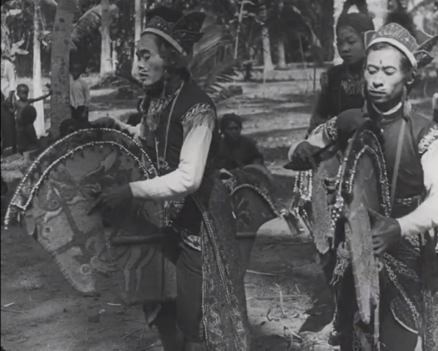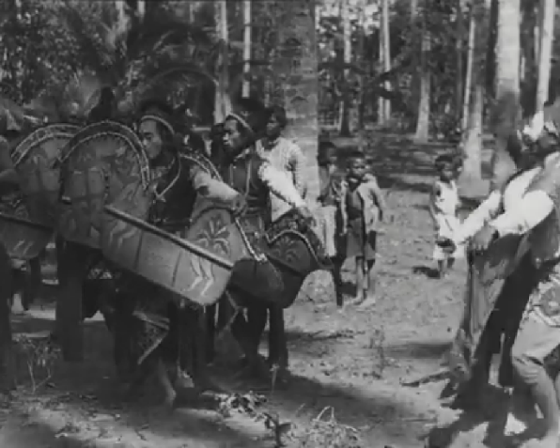
Fig. 1. A snapshot of the Jaranan Dance from Tassilo Adam’s documentary video illustrates the close connection between the dance performance practice and the life of rural Javanese communities (Source: Screenshot from https://youtu.be/gihtDEZXC2k?si=17R3U2YdtIDoJpax)

The origins of the Jaranan Dance, which has emerged and developed within Javanese communities, are not precisely known. Nevertheless, there is a strong assumption that this dance has existed for a long time and was once one of the most popular forms of cultural expression among rural Javanese communities. To date, the exact origins of its creation or the figures who first introduced it cannot be historically confirmed. Despite this, traces of the Jaranan Dance as a form of folk dance can be traced through visual documentation created by Tassilo Adam in the 1930s in a documentary film series titled Java Reel. In Java Reel number 9, a Jaranan Dance performance is recorded taking place amidst a gathering of rural community members, indicating that the dance had already become an integral part of social life in Javanese villages at that time. According to the documentary, the performance occurred in the Bantul area of Yogyakarta, reinforcing the notion that the Jaranan Dance has long been alive and deeply rooted within Javanese rural communities.

The Jaranan Dance, as a form of traditional Javanese art, is a cultural product of rural communities that reflects the worldview, values, and symbolic systems inherent within its supporting social environment. The dance is deeply rooted in Javanese community life and constitutes an essential part of collective cultural practices passed down through generations (Jaya & Sugito, 2025; Rahayu, 2022; Slamet, 2020). In this context, the Jaranan Dance can be categorized as an ethnic dance, a form of cultural expression that emerges, develops, and holds meaning within a specific ethnic community. Hanna (1973) views ethnic dance as a form of cultural communication imbued with contextual meaning and functioning within the social system of its community, while Zhang (2023) emphasizes that ethnic dance represents the identity of a group shaped by geographic, cultural, and customary factors. Therefore, the Jaranan Dance not only comprises various artistic components that form the work of art but also embodies philosophical values intrinsic to Javanese rural communities as its proprietors.

As a cultural manifestation of Javanese rural communities, the Jaranan Dance functions not only as entertainment or artistic expression but also as a medium representing the values, worldview, and social relations of its community. Pramutomo and Sriyadi (2023) emphasize that ethnic dance, as a cultural product, entails a close relationship between its artistic form and the value system that governs it. In line with this, Narawati (2013) asserts that ethnic dance reflects a community’s perspective on various social and cultural contexts surrounding it. Accordingly, the Jaranan Dance can be understood as a multidimensional cultural text—a form of expression inseparable from the social structure, belief system, and collective identity of the Javanese community. From this perspective, the Jaranan Dance represents a tangible embodiment of the cultural identity of Javanese rural society, where values, viewpoints, and ideas are expressed through the art of dance.

3.2 The Kiblat Papat Lima Pancer Concept in the Perspective of Javanese Cosmology

The Javanese community possesses a worldview regarding the order of nature, known as Javanese cosmology, which is a concept that explains the order and balance between the universe and humans as an integral part within it. In this perspective, Javanese cosmology is divided into two main dimensions: the macrocosm and the microcosm. The macrocosm, also referred to as jagad ageng, denotes the universe or the entirety of reality perceivable by humans, whereas the microcosm, called jagad alit, refers to the essence of humans as a smaller representation of the universe (Kartika, 2007; Magnis-Suseno, 1984). According to Javanese mystical teachings (kebatinan), the jagad ageng is understood as the natural order of the cosmos, serving as the source of all sensory experiences stored in human subconsciousness, referred to as pancamaya (Astiyanto, 2006). Meanwhile, the jagad alit is understood not only as the physical human body but also as the subtle body related to the inner dimension and human passions (hawa nafsu) (Pramudita, Pratama, & Sarwanto, 2019). These two dimensions maintain an inseparable hierarchical and symbolic relationship; the jagad ageng serves as a reflection and paradigm for humans as the jagad alit in understanding cosmic order and existential harmony (Mulder, 1983).

Within this framework, the Javanese community believes that the balance between the jagad ageng and jagad alit forms the foundation for achieving cosmic and social harmony. Heine-Geldern (1982) explains that the Javanese hold a belief in the existence of cosmic forces originating from nature—such as the cardinal directions, stars, planets, and other natural elements—that influence the order of human life. These natural forces can bring either blessings or misfortune, depending on humans’ ability to align themselves with the order of the universe. Consequently, the correspondence between the macrocosm and microcosm serves as both an ethical and spiritual principle, guiding humans to maintain inner balance, control their passions (hawa nafsu), and regulate behavior in accordance with cosmic laws. From this perspective, harmony between humans and nature is understood not only as an ecological relationship but also as a moral and metaphysical foundation for establishing a balanced and civilized way of life according to the Javanese worldview.

In relation to the cosmological perspective of the Javanese community, there exists a life-value conception known as the kiblat papat lima pancer, a worldview system emphasizing balance between humans and the universe through the symbols of the four cardinal directions (kiblat papat) and a single center (pancer). Wahyu Santoso Prabowo explains that this conception points to the four cardinal directions—north, east, south, and west—with a central point serving as the axis of cosmic harmony (Sriyadi & Prabowo, 2018). Each direction is associated with a natural element: north with earth, east with water, south with fire, west with wind, and the center functioning as the axis that unites the four (Kartika, 2007). Within this perspective, cosmic alignment is considered a fundamental principle, as humans are believed to be unable to live without the equilibrium of natural energies. Disharmony among these elements is thought to result in chaos and cosmic destruction, which in turn impacts human life.

In alignment with the microcosm concept in Javanese cosmology, the kiblat papat lima pancer is also interpreted as a representation of the four human passions (hawa nafsu), which are closely linked to the four elements of the universe. Earth represents the aluamah passion, associated with thirst, hunger, and drowsiness; this passion is centered in the stomach, originates from the mouth, and is depicted as a black-glowing heart. Fire reflects the amarah passion, encompassing anger, envy, and hatred; it is centered in the gallbladder, manifests through the ears, and glows red. Wind symbolizes the sufiah passion, relating to longing, desire, and pleasure; it is centered in the spleen, emerges through the eyes, and glows yellow. Meanwhile, water represents the mutmainah passion, reflecting tranquility, virtue, and inner balance; it is centered in the bones, manifests through the nose, and radiates light (Kartika, 2007). These four passions are believed to require governance by reason and intellect in order to achieve balance between the human body and soul. Accordingly, the kiblat papat lima pancer not only represents the external cosmic order but also serves as an ethical and spiritual guide for Javanese individuals in regulating behavior, maintaining inner harmony, and aligning themselves with the order of the universe.

The value system of the kiblat papat lima pancer is not only alive within palace environments but also deeply rooted in the life of rural communities. In the palace context, Aminah and Alam (2024) demonstrate that the spatial arrangement of the Masjid Pathok Negara within the Yogyakarta Sultanate reflects the cosmological structure of the kiblat papat lima pancer as a manifestation of harmony between the center of spiritual authority and worldly directions. Meanwhile, ethnographic research by Priyanto, Priyatiningsih, and Deswijaya (2020) in Kedungwungkal, Karangrayung, shows that the sesajen sedulur papat lima pancer tradition continues to be practiced in rural communities as a form of respect toward cosmic forces and ancestors. Similarly, Rohmatunnisa (2022) found that the values of the kiblat papat lima pancer are applied by artisan communities in Adipala Village, Cilacap, as moral guidance integrated with Islamic teachings. Accordingly, the conception of the kiblat papat lima pancer, deeply rooted in Javanese spirituality, functions as a philosophical foundation that unites cosmological, religious, and social dimensions within community life, both in palace and rural settings.

3.3 The Philosophical Representation of Kiblat Papat Lima Pancer in the Jaranan Dance of Gandon Hamlet

The Jaranan Dance developed in Gandon Hamlet, Gandu Village, Tembarak District, Temanggung Regency, is a traditional art form that utilizes the jaran kepang as the main prop in its performances. This art form is also commonly referred to as jaran kepang or Javanese Jathilan, a term that highlights the use of woven bamboo horse-shaped props as the central element of the dance. The distinctive feature of the Gandon Jathilan lies in the relatively larger size of its jaran kepang compared to other Jaranan variants, as well as the predominant use of black, which gives a strong and masculine visual impression. In addition, the dancers also employ a supplementary prop called a benthak, a short stick that functions as a symbolic weapon within the dramatic structure of the performance. The combination of the jaran kepang and benthak not only enriches the visual and dramatic aspects of the dance but also reinforces the heroic character and movement dynamics that are characteristic of the Gandon Jaranan.

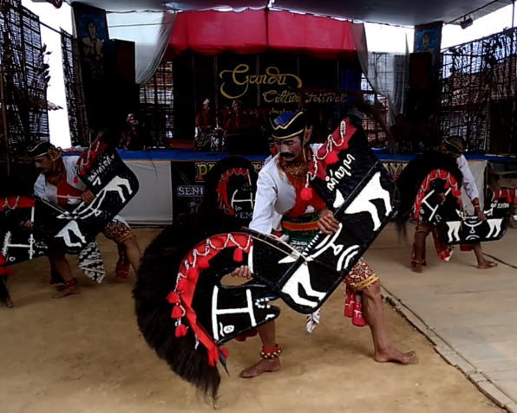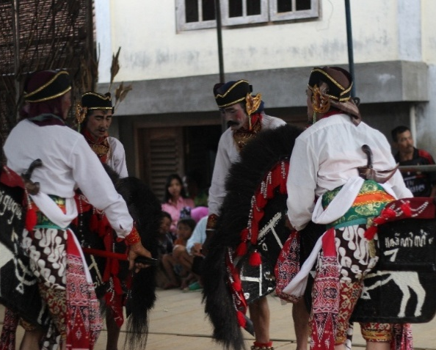
Fig. 2. Jaranan or Javanese Jathilan Dance, developed in Gandon Hamlet, Gandu Village, Tembarak District, Temanggung Regency (Source: Sriyadi, 2017)

The Jaranan Dance in Gandon Hamlet occupies a significant position within the cultural life of the local community and is believed to be the oldest form of art in the area. Its longstanding presence has led the Gandon Jaranan to be regarded as a sacred dance with high spiritual value. This sacredness is reflected in various forms of reverence that continue to be observed, such as the requirement to present the Jaranan Dance as the opening performance in every artistic event in the village. Furthermore, the performance is always preceded by the preparation of offerings (sesaji) as a form of respect for the supernatural forces and ancestors believed to protect the performance. The sacred value is also manifested in the qualifications of the dancers, as the Jaranan Dance is permitted to be performed only by male dancers who are residents of Gandon Hamlet and have grandchildren. There is even a strict prohibition against male dancers without grandchildren mounting the jaran kepang, as it is believed that doing so could cause spiritual imbalance and violate the customary order that has been passed down through generations.

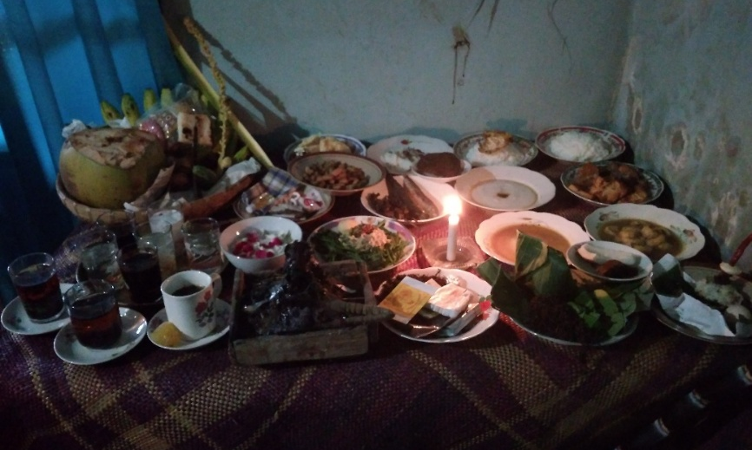
Fig. 3. Offerings (sesaji or sajen) that must be prepared prior to presenting the Jaranan or Javanese Jathilan Dance in Gandon (Source: Sriyadi, 2017)

The Jaranan Dance holds a central role in the village purification in Gandon Hamlet, functioning as an integral part of the community’s spiritual and cultural practices. In line with other Javanese agrarian traditions, the residents of Gandon maintain pepunden, sacred sites believed to house ancestral spirits, often taking the form of a spring or water source. These water sources are sacralized as a form of reverence for supernatural powers and ancestors, and within the context of the village purification, the Jaranan Dance is performed at these locations as part of the ceremonial sequence. The presence of the dance affirms its role not merely as an artistic performance but also as a means of homage and a medium of symbolic communication between the community, nature, and ancestors. As an expression of folk culture, the Jaranan Dance functions not only as entertainment or ritual performance but also as a medium representing the social, spiritual, and cosmological values of its supporting community. Its deep roots in rural life reflect the lived experiences of agrarian societies that uphold harmony between humans, nature, and transcendental forces, making the Jaranan Dance a significant symbol of Javanese cultural identity.

The Jaranan Dance, which occupies a significant position in Gandon Hamlet, is performed by four male dancers, each representing one of the four forces in the kiblat papat lima pancer concept. These four dancers symbolize the four human passions, while the pancer, or center, represents the core of the human self. Thus, within the framework of Javanese cosmology, the Jaranan Dance functions as a symbolic medium that visualizes the internal order of humans as well as their connection to the cosmic order. The emphasis on the role of male dancers and cosmological representation underscores that the Jaranan Dance is not merely an artistic expression but also a means of conveying the social, spiritual, and cosmological values embedded within the Gandon rural community.

Within the performance structure of the Jaranan Dance, there is a perangan segment (combat segment) that employs the benthak as a weapon, where four male dancers execute paired movements to depict the struggle between competing human passions, each striving to assert its dominance. This pattern symbolizes internal human conflict, which is associated with cosmological balance in the Javanese worldview. A similar concept can also be found in court dances, such as the Srimpi Dance, which is often interpreted in relation to Javanese cosmology, particularly the values of the kiblat papat lima pancer. In the Yogyakarta style of Srimpi, the combat segment is performed by four female dancers divided into two pairs, engaging in a symbolic choreography that reflects cosmic balance (Sriyadi & Prabowo, 2018). Although there are similarities in the depiction of conflict and the division of dancers into pairs, there are significant differences between the two dances. The Srimpi Dance is a formal court dance performed by female dancers, whereas the Jaranan Dance is a folk dance born as a collective expression of rural communities and performed by male dancers, highlighting the distinct social and cultural character of each dance form.

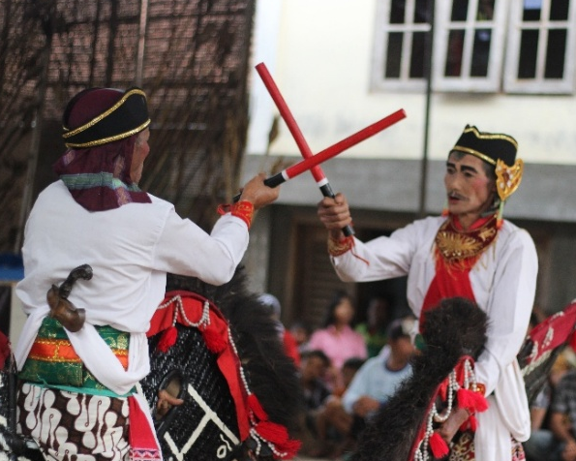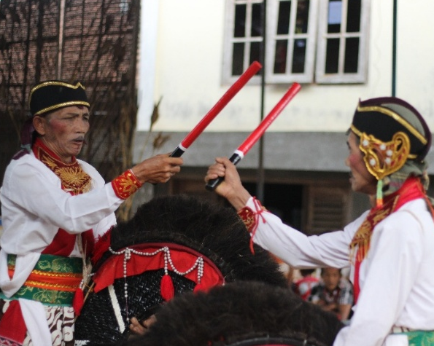
Fig. 4. The combat (perangan) or benthak segment in the Jaranan or Javanese Jathilan Dance in Gandon (Source: Sriyadi, 2017)

The combat segment within the performance structure of the Jaranan Dance constitutes a central element that characterizes the style of the performance, particularly in variants passed down through generations. Historical evidence from documentary footage by Tassilo Adam indicates that the combat segment was already present in Jaranan performances in the 1930s, serving as the climax of the overall structure. In the footage, two opposing groups of horse riders are depicted engaging in combat while invoking assistance from higher powers, underscoring the symbolic meaning of the combat segment as both a dramatic expression and a representation of cosmological values. This phenomenon is reminiscent of the Bedhaya and Srimpi dances, both of which fundamentally express the value of self-control from the perspective of Javanese cosmology; in these court dances, the combat segment similarly represents the process of self-regulation as a symbol of hierarchy and cosmic balance (Sriyadi, Imama, & Adiwendro, 2024; Sriyadi & Prabowo, 2018). Although the Bedhaya, Srimpi, and Jaranan dances cannot be equated due to their distinct cultural backgrounds, all three express Javanese cosmology through their movement structures and symbolic values.

In the context of Javanese performing arts, the Jaranan Dance—as a form of folk performance—exhibits a stylistic character that markedly differs from court dances such as Bedhaya and Srimpi. This distinction is most evident in the inclusion of trance or possession elements, which form an integral part of Jaranan performances. Based on an examination of Tassilo Adam’s documentation, the trance phenomenon in Jaranan is a common occurrence and is regarded as a defining feature of folk dance traditions. His records indicate that rural communities believe in the presence of spiritual forces during the performance, making trance states an accepted and even anticipated aspect of the ritual. Similar manifestations can be observed in other Javanese folk performances such as Barongan, Reog, Jaranan Sentherewe, and Jaranan Buto. Even in the performances held in Gandon Hamlet, the trance element remains an inseparable part of the performance structure. This, indeed, distinguishes Jaranan from court dances, which seldom incorporate trance elements due to their meticulously composed and highly controlled presentation techniques.

In the combat segment of the Jaranan Dance, the concept of winning or losing does not exist, as the four dancers are positioned with equal strength. This pattern reflects the principle of cosmic balance in Javanese cosmology, which emphasizes that the four human passions must be controlled and harmonized rather than destroyed or conquered. Thus, the symbolic combat in the dance aims to affirm the internal harmonization of each passion, illustrating self-control and the alignment between the human physical and spiritual dimensions. A similar phenomenon is evident in the Bedhaya and Srimpi dances, where the combat segments display movement dynamics that emphasize self-regulation and cosmic balance; in these court dances, no dancer assumes a winning or losing role, reinforcing the principle of harmony and equilibrium that lies at the core of cosmological expression (Sriyadi et al., 2024; Sriyadi & Prabowo, 2018).

4. Conclusion

Based on the findings presented, it can be concluded that the Jaranan Dance represents a distinctive manifestation of folk performance art that has developed and taken root within the rural communities of Java, particularly in Gandon Hamlet, Temanggung. As a form of collective expression, this dance not only embodies entertainment or artistic beauty but also conveys the cosmological values embedded in the worldview of its supporting community. Through its performative structure, the use of properties such as jaran kepang and benthak, as well as its symbolic movement patterns, the Jaranan Dance reflects the Javanese cosmological concept of kiblat papat lima pancer—a principle emphasizing the balance between the four human desires and the spiritual center. The combat segment of the performance highlights the internal harmony of human nature without privileging victory or defeat, aligning with the cosmic equilibrium that underpins the Javanese worldview. Thus, the Jaranan Dance can be understood as a multidimensional cultural text that integrates aesthetics, philosophy, and cultural identity, while simultaneously demonstrating how traditional folk performances function as a medium for preserving local values and constructing collective identity.

Furthermore, the study indicates that Jaranan in Gandon Hamlet holds a significant position as a representation of cosmological values within the Javanese cultural perspective and serves as an important marker of Temanggung’s regional identity. However, in the contemporary context, there has been a growing phenomenon of newly emerging Jaranan forms that tend to adopt elements from Balinese dance. This dynamic illustrates processes of adaptation and innovation within traditional performing arts, yet also raises critical questions regarding the alignment between artistic renewal and the preservation of local cultural identity. This phenomenon should not be seen as a rejection of cultural diversity or intercultural exchange but rather as a reflective stance on the importance of maintaining authenticity and the continuity of cultural heritage amid modernization and globalization. Nevertheless, this study has certain limitations, particularly in its lack of in-depth exploration of the mechanisms of cultural inheritance and transformation in the midst of social change. Therefore, further research is necessary to examine strategies for safeguarding cultural identity, the role of local communities in sustaining tradition, and the ways in which cultural negotiation occurs within the evolving landscape of contemporary performing arts.

COMPETING INTERESTS DISCLAIMER:
Authors have declared that they have no known competing financial interests OR non-financial interests OR personal relationships that could have appeared to influence the work reported in this paper.
Disclaimer (Artificial intelligence)
Option 1:
Author(s) hereby declare that NO generative AI technologies such as Large Language Models (ChatGPT, COPILOT, etc.) and text-to-image generators have been used during the writing or editing of this manuscript.

References
Alkaf, M. (2012). Dance as a Cultural Phenomenon: A Study of the Existence of Folk Dance in Boyolali. Komunitas: International Journal of Indonesian Society and Culture, 4(2), 125–138. https://doi.org/10.15294/komunitas.v4i2.2401
Aminah, & Alam, L. (2024). The Meaning of Kiblat Papat Lima Pancer at Pathok Negara Mosque as an Expression of the Spirituality of the Ngayogyakarta Sultanate. Humanika: Scientific Study of General Courses, 24(1), 1–18. https://doi.org/10.21831/hum.v24i1.55126
Astiyanto, H. (2006). Javanese Philosophy: Exploring the Elements of Local Wisdom. Yogyakarta: Warta Pustaka.
Faizin, A. N., Ardana, I. G. N. S., & Sudiarta, I. W. (2024). The Form and Function of Face Art in the Jaranan Buto Performing Arts in Jambewangi Village, Banyuwangi Regency. Undiksha Fine Arts Education Journal, 14(1), 1–13. https://doi.org/10.23887/jjpsp.v14i1.78042
Ferdian, A., Rusman, & Asrori. (2022). Philosophy, Education, and Religious Values ​​in Pegon Jaranan Dance Culture. Nazhruna: Journal of Islamic Education, 5(2), 852–863. https://doi.org/10.31538/nzh.v5i2.2064
Hanna, J. L. (1973). Ethnic Dance Research Guide: Relevant Data Categories. CORD News, 6(1), 42–44. https://doi.org/10.2307/1477574.
Heine-Geldern, R. (1982). Conceptions of the State and Kingship in Southeast Asia (D. Noer, Trans.). Jakarta: Rajawali.
Jaya, R., & Sugito, B. (2025). The Jaranan Turonggo Yakso Dongko District, Trenggalek District in an Ethnographic Approach. Solah, 11(2), 1–15. https://doi.org/10.26740/vt.v1n1.p1xx-1xx
Kartika, D. S. (2007). Nusantara Culture: A Study of the Mandala and Triloka Concepts of the Tree of Life in Classical Batik. Bandung: Rekayasa Sains.
Magnis-Suseno, F. (1984). Javanese Ethics: A Philosophical Analysis of Javanese Life Wisdom. Jakarta: Gramedia.
Mulder, N. (1983). Inner Self and Everyday Life of the Javanese: Cultural Continuity and Change (A. A. Nugroho, Trans.). Jakarta: Gramedia.
Musaptiyah, K., & Putri, N. A. (2025). The Existence of the Jaran Kepang Dance in the Community of Gebudan Hamlet, Gentinggunung Village, Sukorejo District, Kendal Regency. Sosiolium: Journal of Social Studies Learning, 7(1), 10–18. https://doi.org/10.15294/sosiolium.v7i1.2200
Mustika, I. W., Sinaga, T., & Sunarti, I. (2022). Tracing the History of the Serai Serumpun Dance Form as a Cultural Identity of Mesuji Regency, Lampung Province. Mudra: Journal of Arts and Culture, 37(4), 436–445. https://doi.org/10.31091/mudra.v37i4.2143
Narawati, T. (2013). Ethnochoreology: Study of Ethnic Dance & Its Use in Arts Education. International Conference on Language and Arts. Presented at the International Conference on Language and Arts.
Naselia, B. & Daryusti. (2024). Community Participation in Conserving the Existence of the Rejang Tribe Kejei Dance through the Arts Community in Selupu Rejang, Bengkulu. Pakis, 4(2), 127–136. https://doi.org/10.20527/pakis.v4i2.12213
Pramestiwi, D. A., & Sinduwiatmo, K. (2024). Unveiling Mysticism and Community Engagement in Indonesian Ritual Performances. Indonesian Journal of Cultural and Community Development, 15(3). https://doi.org/10.21070/ijccd.v15i3.1083
Pramudita, P., Pratama, D., & Sarwanto. (2019). Jagad Ageng and Jagad Alit in Traditional Kayons. Dewa Ruci: Journal of Art Creation and Study, 14(2), 13–26. https://doi.org/10.33153/dewaruci.v14i2.2850
Pramutomo, R. M. & Sriyadi. (2023). Tayub Dance at Tambakromo, Gunung Kidul Regency: An Ethnochoreological Perspective. SPAFA Journal, 7, 41–62. https://doi.org/10.26721/spafajournal.l39ha579p5
Priyanto, A. I. K. P., Priyatiningsih, N., & Deswijaya, R. A. (2020). The Symbolic Meaning of the Sesajen Sedulur Papat Lima Pancer Ing Dhusun Kedungwungkal, Karangrayung District, Grobogan Regency (A Case Study of the Cipto Tukiman-Gami Family). Kawruh: Journal of Language Education, Literature, and Local Culture, 2(2), 139–144. https://doi.org/10.32585/kawruh.v2i2.1509
Purnomo, R. O. & Jaja. (2020). Gaplek Dance Repertoire: Creativity in Folk Dance Presentations. Makalangan, 7(1), 104–115. https://doi.org/10.26742/mklng.v7i1.1292
Rahayu, F. (2022). Developing Children's Creativity Through the 4P Strategy (Person, Press, Process, Product). Mandala Education Scientific Journal, 8(3), 2406–2414. http://dx.doi.org/10.58258/jime.v8i3.3768
Ramlan, P. M., Bahar, M., & Gunawan, I. (2018). Skin Dance as an Identity of the Community Life of Merangin Regency. Titian: Journal of Humanities, 2(2), 253–268. https://doi.org/10.22437/titian.v2i02.6094
Rohmatunnisa. (2022). The Value of Islamic Education in the Papat Kiblat Lima Pancer Ideology in the Brick Crafts Community of Adipala Village, Cilacap (Bachelor's thesis). IAIN Purwokerto.
Slamet. (2019). The Development of Jaranan Temanggungan as Indonesian Intangible Heritage. Arts and Design Studies, 77, 45–54.
Slamet. (2020). Supporting Jaranan Margowati as an Icon of Temanggung and the Designation of Intangible Cultural Heritage. Servants of the Arts, 11(1), 33–44. https://doi.org/10.33153/abdiseni.v11i1.3125
Sriyadi, Imama, Y. N., & Adiwendro, F. (2024). Bedhaya Anglirmendhung, a Sacred Dance at Mangkunegaran: The Study of Aesthetic Authority and Characteristics. Arts and Design Studies, 111, 33–49.
Sriyadi, & Prabowo, W. S. (2018). Aesthetic Value of the Srimpi Pandhelori Dance at Pura Mangkunegaran. Greget, 17(1), 28–42. https://doi.org/10.33153/grt.v17i1.2295
Yahya, L., & Sekti, R. P. (2025). The Existence of Jaranan Sentherewe Turonggo Safitri Putro Tulungagung (A Diachronic Study). Solah, 11(2), 1–10. https://doi.org/10.26740/vt.v1n1.p1xx-1xx
Zhang, c. (2023). Exploration of ethnic dance education and the development pathways for dance culture inheritance. Frontiers in art research, 5(17), 67–71. Https://dx.doi.org/10.25236/far.2023.051712

