Minireview Article
Huxiang Calligraphy: Its Cultural Value, Contemporary Challenges, and Developmental Trajectories
__________________________________________________________________________________________

Abstract: Huxiang calligraphy, as a significant school of Chinese calligraphy, has a solid foundation in Huxiang cultural history and geography. It is both traditional and innovative. Existing studies predominantly address historical views, calligraphers' styles, teaching methods, or cultural dissemination, but are mostly fragmented and without systematic analysis. This article uses the literature review approach, drawing on sources retrieved from CNKI and Google Scholar, to categorize and integrate existing research. Results indicate that its value primarily resides in the creation of educational models, historical context, artistic innovation, and Cultural Significance and Identity. Despite some development, problems such as the failure of integrating regional culture, the homogenization of creative style, and the absence of a theoretical basis continue to persist. Development paths must accomplish breakthroughs through educational deepening, technological empowerment, and industrial integration. The "education-technology-industry" synergy model offers fresh insights into protecting and fostering traditional arts in contemporary society, serving as a valuable reference for both calligraphy research and development nationwide. Future research should incorporate fieldwork and cross-cultural perspectives to provide a more comprehensive understanding.

Keywords: Huxiang Calligraphy, value, contemporary status, development pathways

___________________________________________________________________________
1. Introduction

Due to the large scale of China, there appear to be different cultural spheres in different areas (as shown in Figure 1). They are the Wu-Yue culture sphere (Southern Jiangsu and Zhejiang), Huxiang culture sphere (Hunan), Bashu culture sphere (Sichuan Basin), and Lingnan culture sphere (Guangdong and Guangxi). Those different cultural spheres are individually independent in certain aspects, but also mixed and impacted with each other, forming the complicated system of Chinese culture(Munsterberg, 2011). Hunan culture formed in the history of cultivating fertile land, and the special geography of Hunan is impacted by Chu cultural romanticism. Hunan culture is also formed by the integration of Confucian and Taoist teachings and shows a magnanimous and syncretic air in people and in arts, which shows a deep influence on the calligraphy of the Hunan people. Huxiang calligraphy absorbs the unrestrained mind of Chu culture and the profound wisdom of Confucian and Taoist teachings into a new style. It absorbs different traditions (studies of steles, Ouyang style, Yan style, and post studies) and forms a holistic artwork by gradually integrating them(Ledderose, 2000). Ouyang Xun formed a strict and stern "Ouyang style" regular script in the Tang Dynasty; Huaisu shocked the world of calligraphy with his wild cursive script; now Qi Baishi shocked people by breaking rules to combine painting and calligraphy; then followed by masters in sequence. From vigorous and stern Ouyang Xun to the intermixture of stele and scroll forms by He Shaogui, Mao Zedong's unfettered and forceful calligraphy, to the eclectic experiments of modern artists, Huxiang calligraphy has always been bold to break conventions and boldly seek innovation, always been at the forefront with the master's spirit of "breaking conventions and boldly seeking innovation". Huxiang calligraphy is a leading school in Chinese calligraphy with both antique traditions and modern innovation, so Huxiang calligraphy is a leading school in Chinese calligraphy with both antique traditions and modern innovation.
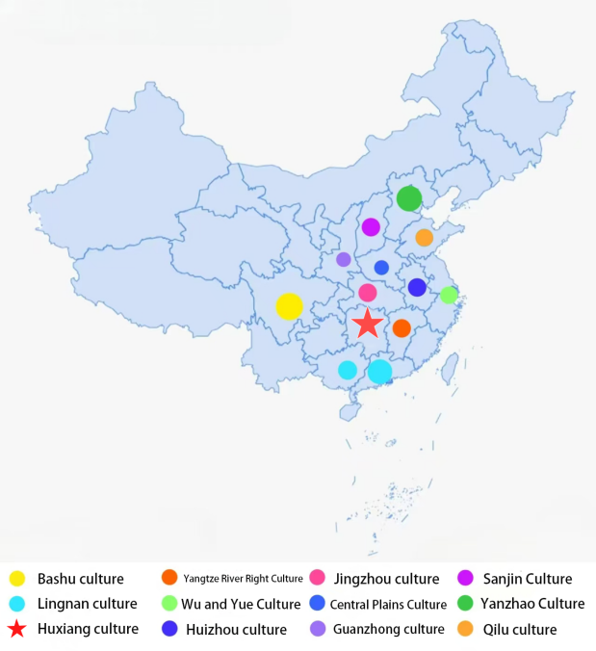
Figure 1: Map of Regional Cultural Distribution in China

As for the previous studies on Huxiang calligraphy, they focused on its origins, historical aspects, artistic preferences, teaching function, cultural creativity, and conduction, etc. Some studies are devoted to summarizing the literature and archaeological information(Yan, 2025), and some tend to talk about the styles of excellent calligraphers(Cao, 2025). There are also a few studies discussing teaching activities or the formation of cultural tours(Shen & Ji, 2025). Generally, these studies have different focuses but are scattered. But there is no systematic review about the worth, status, and development paths of Huxiang calligraphy. This research takes part in a desk survey. It reviews the worth of Huxiang calligraphy from the perspectives of education, historical culture, artistic innovation, and cultural identity. It reviews its development status from contemporary education, artistic creation and production, development of policy and popularization, and formation of popular culture and development directions in the fields of education promotion, digital technology, cultural tourism, and creative industries. It is expected that this systematic review can provide new ideas and suggestions for the inheritance and innovation of Huxiang calligraphy in the new era. After the introduction to the background, the paper explains the research methodology, the presentation of the findings, and the conclusion.

2. Research Methodology

This study adopted the “Literature Review Synthesis Process” proposed by Masiran et al. (2020) (Ibrahim & Mustafa Kamal, 2018). This method, grounded in an independent typology of literature reviews, establishes the research context and theoretical framework through the early-stage induction and systematization of relevant literature(Rousseau et al., 2008; Templier & Paré, 2015). Concurrently, drawing upon Ibrahim's (2011, 2020) research question (RQ) structural classification method, the research questions were explicitly categorized into three types—“WHO,” “WHAT,” and ‘HOW’—to establish the research themes and logical framework. This paper selected highly relevant literature related to “the value of Huxiang calligraphy,” “the contemporary state of Huxiang calligraphy,” and “development paths for Huxiang calligraphy” through Google Scholar and the CNKI database. After reviewing abstracts or full texts of selected literature, the study focuses on analyzing core perspectives from prior research, outlining their contributions to Huxiang calligraphy studies, and identifying remaining issues requiring further exploration. This paper synthesizes each theme, integrates findings through cross-analysis, and proposes development strategies for Huxiang calligraphy in education, culture, art, and social practice. These insights aim to enhance calligraphy education quality and advance traditional cultural inheritance. The synthesis process itself was rigorously documented using the EAGLE online system.

3. Results
This section outlines the value, Contemporary status, and future development paths of Huxiang calligraphy

3.1 Value of Huxiang Calligraphy

Huxiang calligraphy has unique significance and value in multiple fields such as education, historical culture, artistic innovation, and cultural identity. It has a rich development track(as shown in Figure 2).

3.1.1 Educational Value

Huxiang calligraphy has unique significance in the field of scholarship and education. Zeng Guofan and other Huxiang scholars promoted the revival of Han studies and the revival of Confucianism, and then the status of Confucianism was restored in the field of academic thought. Among the four levels of “principles and reasoning, textual research, literary composition, and statecraft” he proposed, the study of literary composition raised calligraphy to the level of an essential part of scholarly cultivation for literati(Yan, 2005). This not only shows the relationship between Huxiang calligraphy and scholarly cultivation, but also reflects that calligraphy has an important role in cultivating moral character in education.

At the educational level, the growth experiences and stories of inheritance of Xiang embroidery artisans are similar to those of Huxiang calligraphy education to some extent. For example, Li Yihui invented the mixed-needle embroidery technique and created it bit by bit through repeated attempts (just as willpower is cultivated in Huxiang calligraphy education). Yang Shizhuo studied embroidery, taught in schools, and cultivated talents (as calligraphy teachers teach in Huxiang in a master-student relationship). Hunanese people are generally open to the study of calligraphic aesthetics and techniques; they copy ancient treatises on calligraphy and teach their children to write (L. Li, 2016).A “one family, multiple calligraphers” phenomenon occurs as a result of this.The correspondence of Huxiang celebrities not only reflects various styles and techniques of calligraphy, and the skills of writing in terms of aesthetic appreciation and technique, but also reflects the cultivation and erudition of the writers. It plays a positive role in the cultivation of moral character and cultural literacy, and provides calligraphy education and humanities education with rich resources. Zeng Guofan’s Calligraphic Practice and Family Influence as Examples of Calligraphy Education Methods(Z. Li, 2021).He Shaoji, a Huxiang celebrity born in a famous Huxiang family in the Qing dynasty, mastered stele inscription after receiving his father’s teaching and achievements in the study of stele inscriptions(Y. Chen, 2023). His achievements not only promoted the integration of stele research and rubbing study, but also laid the direction for the development of the study of steles in the late Qing dynasty. With the development of times, the functions of calligraphy education are still being explored. As a cultural form, calligraphy education has a reciprocal effect on the overall calligraphic culture and has great significance. Calligraphy can be used to alleviate psychological problems in young people, to promote the formation of a learning spirit, and to improve aesthetic taste as an important part of quality education(Xu, 2022).In addition, in higher education, the integration of interdisciplinary strength based on curriculum development provides new ideas for Huxiang calligraphy education(S. Li et al., 2024). Since the new century, in terms of education and theory, Huxiang calligraphy circles have made some achievements. Higher education in calligraphy has formed a chain from undergraduate to master’s degree, published a series of theoretical books, and promoted professional education (Zhou & Peng, 2022).

3.1.2 Historical and Cultural Value

Archaeological artifacts discovered in the Huxiang area can trace back the origin of the development of calligraphy. The brushes found in the Chu tomb at Zuojia Gongshan in Changsha in 1954, the silk manuscripts unearthed from the Warring States-period Chu tomb at Zidan Ku in 1942, and the large number of bamboo slips with inscriptions discovered in Changsha, Changde, Liyé, and other places since 1949, show that Huxiang calligraphy has a long history and strong influence. Ouyang Xun’s famous stele in the early Tang dynasty continued the calligraphic style of the Sui dynasty and initiated the tradition of Huxiang calligraphy masters(Yan, 2005). Changsha and other cities in Hunan are an important origin place of the Yangtze River culture and the Chu culture. The archaeological discoveries, such as the Qin bamboo slips from Liyé, the Wu bamboo slips from Zoumalou, and the Mawangdui Han tombs, show that calligraphers of the Huxiang area have made significant contributions to the development of calligraphy throughout history, from famous calligraphers of the Tang Dynasty, such as Ouyang Xun and Huaisu, to calligraphers of the Qing Dynasty, such as He Shaogui, and to famous calligraphers and painters of the 20th century, such as Mao Zedong and Qi Baishi (He, 2003). The development history of Huxiang calligraphy is closely connected to the culture of this region. Huxiang calligraphy reflects the Huxiang spirit, such as the patriotic spirit and the Huxiang spirit of self-improvement that is not easily bent. With the process that Huxiang culture developed from the edge to mainstream, Huxiang calligraphy was also widely spread. Creating Chinese character cultural and creative designs based on Huxiang calligraphy can not only show the cultural uniqueness, but also enhance the regional identity of the masses(S. Li et al., 2024).In Republican Calligraphy, Huxiang calligraphy is inherited from previous calligraphy traditions. In view of mass calligraphic exchange in the country, Hunan calligraphers and preserved calligraphic stele inscriptions played important roles (Li D., 2009). From the late Qing dynasty to the present, Huxiang calligraphy experienced the process from tradition to modernity. In terms of theory and practice, the Qian-Jia scholarly style and the eastward transmission of Western learning had influenced Huxiang calligraphy. Cheng-Zhu Neo-Confucianism promoted the tradition of emulating Yan Zhenqing in Huxiang calligraphy(Zhou & Peng, 2022).

Huxiang calligraphy was also greatly influenced by the romantic spirit of Han Dynasty Chu Ci poetry and the shamanic culture’s influence. Pre-Qin Chu silk manuscripts and bamboo slips had their own kind of beauty; Liyé Qin bamboo slips were outstanding in composition; He Shaogui absorbed stele inscriptions and rubbings; The late Qing-early Republican revival of Tang Dynasty calligraphic methods also had a great influence(Y. Chen, 2023). As historical documents, Huxiang's famous person’s letters record the cultural lineage and current Huxiang from the Southern Song Dynasty to the present, which are basic evidence for studying the historical and cultural exchanges (Z. Li, 2021). For example, in Wang Fuzhi’s “Song Lun: Guangzong”, experience and calligraphic sentiment are combined into one, which shows the connection between Huxiang calligraphy and certain historical periods (L. Li, 2016).

3.1.3 Innovation in Artistic Style Value

Huxiang calligraphy is always exploring and innovating in style.The dozens of stone inscriptions in the south of Mount Heng contain philosophical thoughts and cultural connotations; the style is majestic and deep with aesthetic(Meiye & Khiatthong, 2024) .Huaisu took the essence of Zhang Xu’s running script and developed his own style; He Shaogui absorbed various elements of calligraphy and created his own style; Qi Baishi broke through the traditional calligraphy of the Qing dynasty, which was rigidly attached to stele and rubbing through his freehand painting method, which pushed calligraphy to a revolutionary development (Y. Chen, 2023; He, 2003).In the Republican era, calligraphers broke through the traditional calligraphy of the late Qing dynasty, which was rigidly attached to stele and rubbing, absorbed free creation and stele and rubbing influence to develop their own style, which pushed calligraphy to further development(Li D., 2009). Modern Huxiang calligraphy has various styles; stele studies are mainstream, coexisting with Ouyang Xun style, Yan Zhenqing style, and scroll studies (Zhou & Peng, 2022).

3.1.4 Cultural Significance and Identity Value

Huxiang calligraphy is diverse in style, reflecting profound cultural meanings. Hu Linyi’s strict research on famous scripts, Peng Yulin’s heavy and strange strokes, and Zuo Zongtang’s imposing and dignified momentum reveal the temperament of the region’s culture. They add more styles to Chinese calligraphy art and enhance the cultural identity of the people in Huxiang(Z. Li, 2021). The works of Huxiang masters inspire the modern “Hanyu Bamantii” font. It reflects the Huxiang spirit more accurately and enhances the cultural identity even more (S. Li et al., 2024). Huaisu’s cursive script reflects the spirit of innovation in the art of learning from nature and pursuing individuality(Yan, 2005). The unique “BaQi” (dominant spirit) in Hunanese calligraphy and painting reflects Huxiang culture. They are closely related to the spirit of the people, and thus enhance the cultural identity of Huxiang residents (L. Li, 2016). Therefore, Huxiang calligraphy has gradually become an important symbol of regional culture and promotes its development.
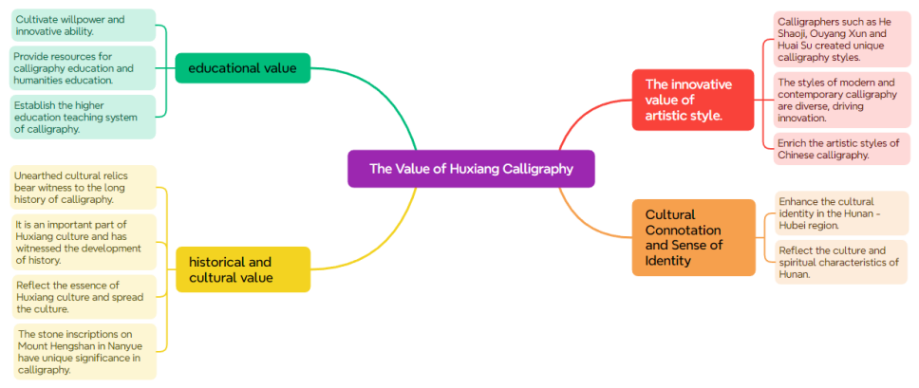
Figure 2: The Value of Huxiang Calligraphy

3.2 Contemporary status of Huxiang calligraphy

Huxiang calligraphy has its roots and missions in the development of contemporary Chinese calligraphy. It created its own path in the process of inheritance and innovation and popularization, and refinement. This article analyzes the current situation of Huxiang calligraphy from three aspects of higher education, contemporary creation and theory, and policy support.

3.2.1 The status of calligraphy education in higher education institutions

In recent years, higher education institutions in Hunan have made new progress in the teaching of calligraphy. Some universities have explored innovations in teaching evaluation and content. For example, Hunan University of Humanities and Science constructed a process evaluation system and advanced diversified evaluation stakeholders of teaching assessment stakeholders. The teaching and research office became active in quality supervision to enhance teaching level and instruction quality effectively (Peng & Yi, 2021). The research results of Hunan University of Science and Technology indicated that Huxiang regional culture could be further introduced into calligraphy teaching to improve students’ confidence and professional ability (Xu, 2022). As for curriculum construction, the regional culture has also been introduced into calligraphy courses. Hunan Normal University set up “History of Huxiang Calligraphy”. The course traced the development of calligraphy from past to present; “Special Topics in Ming-Qing Huxiang Calligraphy” was provided by Hunan University of Science and Technology; “Bamboo Slips and Silk Scroll Calligraphy” and “Huxiang Calligraphy” were offered by Changsha Normal University; “Research on Huxiang Calligraphy Culture” and “Qin-Han Bamboo Slips and Silk Scroll Calligraphy” were provided by Hunan First Normal University. The above courses fully displayed the obvious characteristics of Huxiang calligraphy. At the same time, universities attached importance to inheriting Huxiang culture. For example, Hunan Normal University introduced regional culture into teaching by setting up specialized courses and holding exhibitions. These measures improved students’ practical ability and cultural quality(Zhou & Peng, 2022). Taking into account how Huxiang culture is introduced into university calligraphy teaching, this paper compiles related courses provided by Hunan Normal University, Hunan University of Science and Technology, Changsha Normal University, and Hunan First Normal University (see Table 1). These universities generally offered Huxiang calligraphy courses in required courses, elective courses, and general education courses. It showed that universities attached importance to regional culture.

Table 1: Overview of Huxiang Culture in Calligraphy Courses at Hunan Universities

University Name | Offers Huxiang Calligraphy Course | Course Name
Hunan Normal University | Yes | "History of Huxiang Calligraphy"
Hunan University of Science and Technology | Yes | "Studies on Huxiang Calligraphy in the Ming and Qing Dynasties"
Changsha Normal University | Yes | "Silk and Bamboo Calligraphy", "Huxiang Calligraphy"
Hunan First Normal University | Yes | "Research on Huxiang Calligraphy Culture", "Qin and Han Bamboo and Silk Documents"

However, the calligraphy education in Hunan universities still has some deficiencies. On the one hand, the teaching evaluation mechanism of the calligraphy major in some universities is not very mature, and there are no unified textbooks and mature teaching programs. Therefore, the teaching purpose and requirements are relatively arbitrary(Xue & Zhou, 2020). On the other hand, some calligraphy courses do not deeply explore and make full use of the calligraphic cultural resources in the region in the process of teaching, and the unique value of Huxiang culture cannot be well exerted(Yuan, 2018). According to the statistics of the Department of Education, in the calligraphy programs of Hunan universities, few will consciously absorb the regional calligraphic culture. For example, Hunan University of Science and Technology has set up an optional course, “History of Huxiang Calligraphy”, and the class hours of this course take up less than 5% of the total course hours, so it is hard to pass on the regional characteristics to students. Yield University of Humanities and Science attaches importance to popularizing Huxiang calligraphy, but there are no courses yet. All in all, while higher education is trying to improve the quality of talent training, it should further make full use of the regional cultural resources and play the leading role of Huxiang culture in calligraphy teaching.

3.2.2 Current Status of Creation and Theory

Hunan calligraphy creation is flourishing. In terms of stylistic expression, artistic conception, creative strength, senior, middle-aged, and young calligraphers of Hunan open up new situations, new realms, and new horizons continuously and constitute the firm “Hunan Calligraphy Army with Huxiang Features”. Hunan calligraphers have achieved a lot of achievements in national exhibitions and competitions. For example, in 2014, Chen Hua and He Zongguo got an award in the Fifth China Calligraphy Lanting Prize. It is the first time that Hunan has the successful in this competition. In 2014, He Ziwen’s project got funding from the National Art Fund, and Tan Biqing’s project also got funding from the National Art Fund. It means that the young talents are blooming.The above-mentioned prosperity of Huxiang calligraphy is based on the traditional foundation and innovation, constantly. From Huaisu’s cursive script and Ouyang Xun’s regular script in the Tang Dynasty to He Shaogui’s running script in the Qing Dynasty, calligraphers in Hunan are constantly absorbing the classic nourishment and exploring the unique style. In contemporary times, Mao Zedong and Qi Baishi brought new vitality to the Huxiang calligraphy and positioned it in the calligraphic field. After that, Zhou Zhaoyi, Yan Jialong, Li Li, and other calligraphers brought new vitality to Huxiang calligraphy and created a thriving scene (Chi, 2015). The recent fluctuation in the number of Hunan artists selected in national exhibitions is empirical evidence of the above-mentioned development trend.

As shown in Figure 3, from 2017 to 2024, the total number of Hunan calligraphers selected for exhibitions organized by the China Calligraphers Association presented a “peak-decline-rebound” pattern: a recent high of 138 in 2017, then consecutive decreases to a low of 4 in 2021; From 2022, the number gradually rebounded, and reached 14 in 2024. Although they have not yet reached the previous peak, it shows a clear trend of recovery. This is because after the peak period, Hunan calligraphy has made adjustments and regained momentum. Specifically (see Figure 4), 2017 is the year when the number of Hunan calligraphers participating in exhibitions reached a recent high: there were 35 Hunan artists selected in the “11th National Calligraphy and Seal Carving Exhibition” alone. In the following years, the number generally decreased to a single digit in 2021. From 2022, the number of exhibitors increased slightly. Notably, 14 Hunan artists were selected in the preliminary review for the 13th National Exhibition, showing early signs of recovery. In terms of exhibition types, most of the Hunan calligraphers participate in high-level events organized by the China Calligraphers Association, such as the “National Calligraphy and Seal Carving Exhibition”, “Lanting Prize Exhibition”, and “National Youth Calligraphy and Seal Carving Exhibition”, including both traditional and contemporary categories.In the 7th New Artists and New Works Exhibition, the 12th National Exhibition, and the 7th Lanting Award, Hunan calligraphers ranked first in the country in both the enthusiasm and number of entries displayed, reflecting that Hunan was good at both the overall cultivation of young talents and the professional creation. From the analysis of the data chart, it can be seen that the young artists have made excellent performances in the number of exhibition entries, reflecting that Hunan has been making continuous efforts in the past few years in the construction of a youth calligraphy talent cultivation mechanism, and achieved systematic advancement in the development of young calligraphy talents. This also shows that the “new generation of Hunan calligraphy” is constantly improving. However, in this spring of calligraphy, there is also a phenomenon of “homogenization” of traditional techniques and a lack of individual breakthroughs. Among the middle-aged and young calligraphers, there is a phenomenon of “homogenization” of styles. For example, Chen Hua’s “Chu Style” got people’s praise for its technique, but also “could not break through the traditional concepts of Huxiang calligraphy”, which showed that Chen Hua’s creation was stuck in a “dead end”. How to cross the “threshold” of a “strong calligraphy province” from a “big calligraphy province”, breaking the “homogenization” of styles is very important.
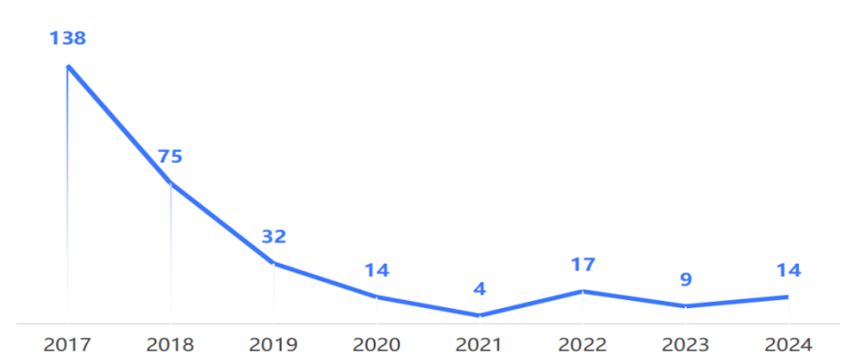
Figure 3: Annual Selection of Hunan Calligraphers for China Calligraphers Association Exhibitions
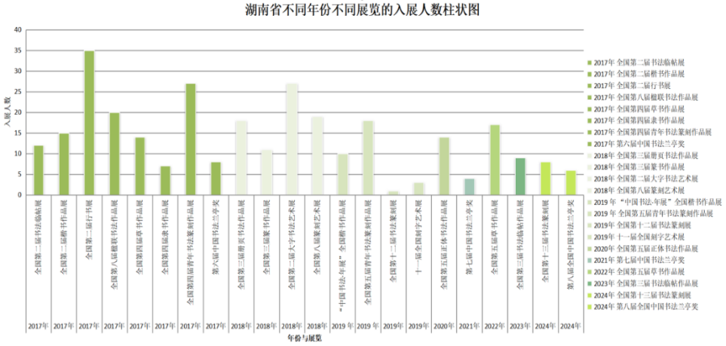
Figure 4: Number of Entries Accepted in Hunan Exhibitions Across Years

In theoretical research, Hunan scholars have formed a research pattern based on historical documents, excavated relics, style and form, and transmission, which support their creative practice and education. For example, some studies focus on representative individuals. Research on Zeng Guofan’s calligraphy and cultural environment involves his life, ideology, works, and education. This research extends calligraphy studies from multiple perspectives(Long & Liu, 2021). Archaeological discoveries are also used to support theoretical research. The archaeological records from the Mawangdui Han Tombs and the Qin bamboo slips from Liyé have promoted the integration of ancient philology and calligraphy history and laid the foundation for the historical positioning of Huxiang calligraphy (S. Chen, 2025). In addition, scholars from Hunan Normal University engaged in in-depth research on the regional characteristics and cultural connotations of Huxiang calligraphy, proposing the concept of the “Huxiang Calligraphy Cultural Circle,” which enriched the theoretical research space of Huxiang calligraphy(Zhou & Peng, 2022). In terms of institutional construction, the Hunan Calligraphers Association initiated the “Calligraphy Path of Huxiang” public lecture series, inviting famous calligraphers across the country to come to Hunan for creation, theory, aesthetics, and literature lectures every month, which enhanced the academic exchanges and research activities. The platform offers cultural support for building the theoretical system of Huxiang calligraphy.

3.2.3 Policy Status

Hunan Province attaches great importance to the construction of calligraphy art, and protects and promotes its inheritance and innovation through policies and institutions. In terms of government departments, the Department of Culture and Tourism and the Department of Education formulated a series of plans. The Department of Culture and Tourism set up a special fund to support creation in calligraphy, exhibitions, and exchanges in calligraphy; the Department of Education promoted the construction of calligraphy teaching in primary and secondary schools, trained teachers in calligraphy, developed textbooks in calligraphy, and promoted the systematization and standardization of calligraphy teaching. These measures provided institutions to popularize the teaching of calligraphy and laid the foundation for cultivating calligraphic literacy among teenagers. The Hunan Calligraphers Association is a link between policies and practices. In recent years, under the theme of “Promoting the Grand Spirit of ‘Calligraphy in Hunan’” (Fig. 5), the calligraphers' association organized creative activities, exhibitions, theoretical lectures, and training in the form of activities, which significantly improved the overall level. In addition, the “4th National Exhibition of Cursive Script” and the “12th National Exhibition of Calligraphy and Seal Carving: Regular and Clerical Scripts” were held by the Hunan Calligraphers Association. The association also organized academic forums and exchange activities in the provinces, so that Hunan calligraphy has greater influence in terms of national strength. To consolidate its own talents and creative forces in calligraphy, the Hunan Calligraphers Association adopted a multi-level strategy in calligraphy training. The calligraphy training centers were established by combining social education resources, forming training bases such as the “Zhang Xiliang Calligraphy Institute” (Fig. 6) and the “Chen Ximing Calligraphy Academy”. The training centers focus on cultivating young and middle-aged calligraphers, improving their creative forces and artistic quality. At the same time, the association adopts a “tiered and categorized” management mechanism and gives differentiated support to stimulate the creativity of talents.

At the social level, calligraphy associations and cultural museums in Hunan promote calligraphy. For example, Changsha Calligraphers Association often comes to school for “Calligraphy Lecture in Schools”, and calligraphers give lectures and skills to students, and stimulate students’ interest in calligraphy (Fig. 7). Xiangtan City promotes Hunan Calligraphy Culture and Arts Festival, such as “Qi Baishi Culture and Arts Festival”, which enriches people’s cultural identity.
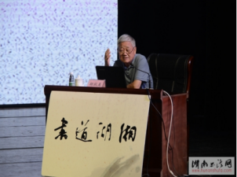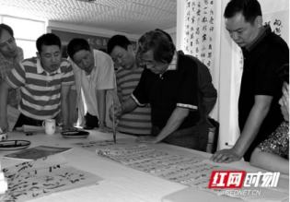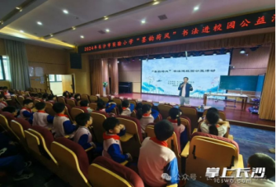
Figure 5: Shu Dao Lecture Figure 6: Calligraphy Workshop Figure 7:Calligraphy Enters Schools

3.3 The Development Path of Huxiang Calligraphy

The development of Huxiang calligraphy has not been smooth sailing. In fact, it has gradually explored a unique development road through the synergistic effect of education, culture, technology, and industry. This article takes the development road of Huxiang calligraphy as an example to explore the development mechanism and achievement from three aspects: education and culture, technology and culture, and tourism and creativity industry. Reveal the logic of inheritance and development in the new era.

3.3.1 Educational and Cultural Integration

On the level of education, some universities explored the path of systematic inheritance of Huxiang calligraphy through teaching and research, and built a complete set of teaching and research system from top to bottom (Xu, 2022). Hunan First Normal University not only opened the course of Huxiang calligraphy, but also constructed the “Huxiang Calligraphy Culture Research” team to combine theory and practice, cultivating more and more calligraphy education talents. Under the guidance of Changsha Normal University, students gradually formed a correct understanding of Huxiang calligraphers’ calligraphy through elective courses, improving their humanistic quality and aesthetic taste. The “Qi Baishi Works Research Institute” was founded in Hunan University of Science and Technology, “Qi Baishi Art College”. The research on master style was carried out, and the institute was built (Fig. 8). Yuelu Academy took the Lushansi Stele as the basis and constructed the curriculum, combining calligraphy and traditional cultural education, which greatly improved the students’ creative ability (Fig. 9) (Liu, 2016). In the basic education, Mao Zedong's Calligraphic Work “Qin Yuan Chun: Changsha” was published in the secondary school textbook (Fig. 10) (Huo, 2021).They also reflect the Ministry of Education’s 2013 calligraphy education policy(Ministry of Education, 2013).
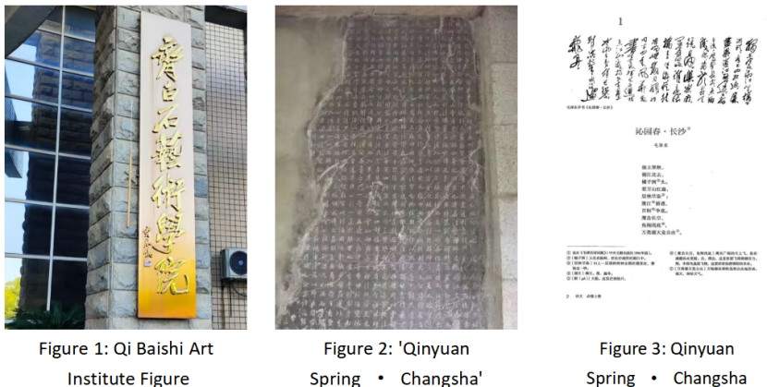
Figure 8:Qi Baishi Art Institute Figure 9:Stele of Lushan Temple Figure 10:Qin Yuan Chun · Changsha

In the case of cultural institutions, the success of the Hunan Museum lies in its promotion of public appreciation and understanding through exhibitions like “The Elegance of Chu,” which featured works by calligraphers such as Ho Shao-chi, Wang Fuzhi, and Tao Runai (Fig. 11) (Zhang X., 2024). The Hunan Provincial Institute of Cultural Relics and Archaeology and the Changsha Bamboo Slips Museum have made remarkable progress in bamboo slip conservation research. They have advanced preservation and restoration methods, offering important support for the proper long-term preservation and study of calligraphic objects (G. Zhang & Dai, 2025). With the combination of exhibition, research, and education, these institutions promote Huxiang calligraphy jointly and sustainably.

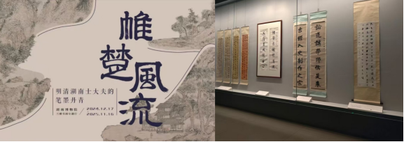
Figure 11: Grace of Chu: Hunan Painting and Calligraphy Exhibition

3.3.2 Digital Empowerment

In the digital age, Huxiang calligraphy has reached a wider audience through digital means. The Changsha Bamboo Slips Museum has held nearly a thousand events like the “Bamboo Slips Knowledge Workshop,” and more than 50,000 copies of the AR picture book The World of Wu Bamboo Slips have been circulated, extending its influence to the public (Fig. 12) (G. Zhang & Dai, 2025). “The Great Way is Simple: The Chinese Spirit in Bamboo Slips” exhibition uses multimedia technology to allow visitors to appreciate artifacts more easily through virtual tours and interactive devices. The AR exhibitions at the Changsha Bamboo Slips Museum show how digital tools support calligraphy dissemination(Chunlan et al., 2025). Ma Daizhong suggested building a “China Bamboo Slips Center” to combine images, transcriptions, and research results using a big data platform that would push scholarship into the digital realm (Hu & Ren, 2025).
In terms of media dissemination, China Media Group produced “Chinese Calligraphy Grand Assembly,” featuring works such as Huaisu’s “Autobiographical Scroll” in its “Homage to Classics” segment (Fig. 13)(Zhang X., 2024). Digital technology allows Huxiang calligraphy to find new spaces and pathways between the virtual world and the physical world, thus achieving a collision between traditional culture and modern technology.

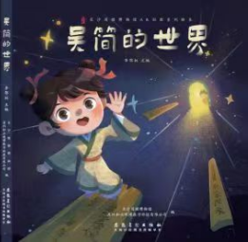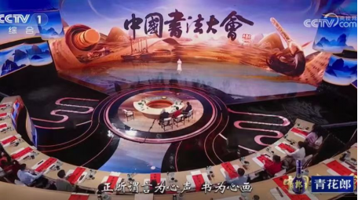
Figure 12: The World of Wu Jian: An Figure 13: China Calligraphy Conference
AR Educational Picture Book

3.3.3 Cultural Tourism and Creative Industries

Huxiang calligraphy has also gained wider dissemination in the process of cultural tourism and the creative industry. In the field of cultural tourism, Hunan is rich in historical relics and calligraphic resources. Yongzhou’s Wuxi Stele Forest retains 507 steles inscribed with poetry and prose written by famous people from the Tang Dynasty to the Republican era in terms of seal, clerical, regular, running, and cursive scripts, and by figures like Yan Zhenqing, Huang Tingjian, and Mi Fu. The artistic value of “Ode to the Revival of the Great Tang” and “Postscript to the Cliffside Stele” is indisputable. Stele art is an important way to transmit calligraphy (Fig. 14). In addition, Hunan holds a large quantity of bamboo and wooden slips, including Chu slips, Liyé Qin slips, Zoumalou Wu slips, and Chenzhou Jin slips. The bamboo and wooden slips are important sources for studying the history of calligraphy and the development of Chinese characters. Representing Hunan in terms of cultural relics and tourism, Liyé National Archaeological Site Park possesses rich cultural relics and develops tourism in a scientific way to create nationally influential cultural brands (Fig. 15). As China’s only museum of Qin bamboo slips, Liyé Qin Bamboo Slips Museum, located in the park, has become an important base for popularizing the culture of bamboo slips (Hu & Ren, 2025). This kind of model, which transforms cultural resources into tourism destinations, develops cultural tourism in a virtuous cycle. That is, the cultural tourism economy promotes cultural dissemination, and meanwhile, culture improves the tourism industry. Some scholars believe that combining cultural resources with tourism resources not only expands the reach of dissemination and influence in terms of culture, but also brings new vitality and interest to the tourism industry, which is a win–win situation for both culture and tourism.

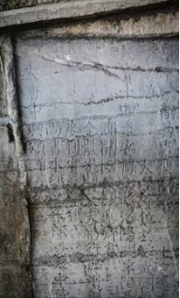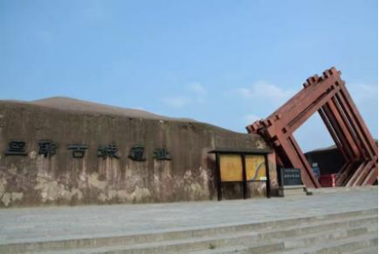
Figure 14: Ode to Tang Revival Figure 15: Liye National Archaeological Site Park

In the field of the creative industry, there are diversified calligraphy-based cultural and creative products created in Hunan. Mao Zedong Poetry Calligraphy Series combines poems, calligraphy type, and artifact form to produce folding screens, fans, phone cases, handbags, etc. These products are both useful and rich in culture. If red tourism is overlaid on these products, they will possess the connotation of three layers (Fig. 16)(X. Zhang & Xu, 2022). In addition, Hunan’s unique Nüshu culture has also become an important theme of cultural and creative development. Suppose it is in the form of culture, in the Nüshu History Museum. In that case, the souvenir based on it develops stationery, badges, accessories, etc. to improve the visitor’s experience and extend the sustainability of culture (Fig. 17). By intensively connecting with the cultural tourism and creative industry, Huxiang calligraphy broadens its channels for transmission. It connects ancient culture and the modern market. It paves a new space for the living transmission of calligraphy.

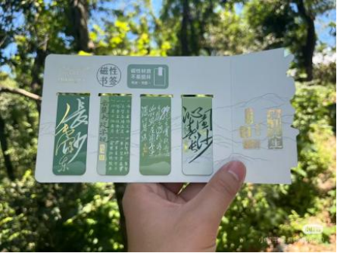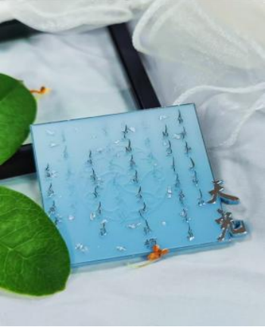
Figure 16: Bookmarks Featuring Mao Zedong’s Figure 17: Women's Script Badge
Poetry and Calligraphy

4 Discussion

Value, status, and development of Huxiang calligraphy are multidimensional. Multidimensional value indicates that, in addition to technical training, Huxiang calligraphy is closely linked to character cultivation and the construction of humanistic literacy. This shows that calligraphy in Huxiang has gone beyond technical training in calligraphy cultivation, and it has become an important part of humanistic education. Historical and cultural relics and achievements of calligraphers in Huxiang throughout the ages show that calligraphic culture in Huxiang is continuous and accumulative, and it provides a solid historical and cultural basis for innovation in Huxiang calligraphy as well as rich resources for the construction of Huxiang tourism. In terms of artistic innovation, Huxiang calligraphy holds the attitude of “tradition-innovation”. It shows that creation in this era should also be technically diversified while retaining the essence of styles in this form of art. In addition, Huxiang calligraphy has gone beyond an art form and become the representation of the spirit of the Huxiang people and an important carrier in building Huxiang culture. From the status, Huxiang calligraphy education has made certain achievements in universities, while there are still challenges in popularization at the grass-roots level and the establishment of an evaluation system. Although creation is prosperous and homogenization is obvious, theoretical research is relatively weak. It shows that the overall dissemination and academic accumulation of Huxiang calligraphy are still imbalanced, and it is necessary to coordinate the overall situation of education creation theory. Policy safeguards provide institutional guarantees for Huxiang calligraphy, while the implementation and integration are still weak. As for development pathways, institutions in education and culture provide the institutional basis for the transmission of Huxiang calligraphy. Digital technology provides new ways of dissemination, and traditional calligraphy in Huxiang can remain active in modern society. In addition, cultural tourism and the creation industry provide new space for expression in contemporary calligraphy, and the cooperation between culture and market makes the “education-technology-industry” present a new situation in Huxiang calligraphy in this era. This study also has certain limitations. Firstly, the literature used in this study is mainly from domestic journals, and the international perspective is relatively weak. Secondly, there is no empirical research record. Thirdly, the range of the study is also limited. There are not enough studies on popularization at the grass-roots level, folk calligraphy groups, and calligraphic culture at the community level, and they cannot reflect the overall situation of Huxiang calligraphy. Therefore, in the future, the empirical study should be strengthened. By using the method of questionnaire and interview, the primary data for the development of Huxiang calligraphy in education-creation-dissemination should be collected, and then the effectiveness of Huxiang calligraphy should be scientifically evaluated. In addition, by expanding the range of research, paying attention to the grassroots education, community culture, and folk calligraphy groups, and adopting an interdisciplinary method, a more authentic and comprehensive calligraphic ecosystem will be presented.

5 Conclusion
This paper discusses and analyzes the value, current situation, and development path of Huxiang calligraphy. The study finds out the academic system construction value, education and cultivation value, historical cultural inheritance value, and innovation value of Huxiang calligraphy. It reviews its development situation in current educational promotion, creation, theory, and policy. The study identifies its current problems, such as insufficient regional culture integration, the same creative style, a weak theoretical basis, and less grassroots resources utilization. As for the path of development, the study believes that Huxiang calligraphy can achieve breakthroughs in education, technology, and industry, and promote the creation, transformation, and innovation development of Huxiang calligraphy in the new era. The study has an important significance for the future inheritance and innovation of Huxiang calligraphy. It can promote education innovation, digital construction, and industry integration. It provides a reference for protecting and developing China's excellent traditional culture and calls for the modernization, diversification, and sustainable development of calligraphy art.

COMPETING INTERESTS DISCLAIMER:

Authors have declared that they have no known competing financial interests OR non-financial interests, OR personal relationships that could have appeared to influence the work reported in this paper.

Disclaimer (Artificial intelligence)
The author hereby declares that generative artificial intelligence (AI) technologies, including ChatGPT (GPT-5, OpenAI, 2025)
Details of the AI usage are given below:
1. Purpose: To optimize logical structure and refine writing style.
2. Input: Only the author’s original text was provided for language editing; no confidential or unpublished data were used.
3. Responsibility: The author takes full responsibility for the content and conclusions of this manuscript.

References

Cao, S. (2025). The Manifestation of Huxiang Culture in Wei Yuan’s Calligraphic Spirit. New Horizon, 56–58.
Chen, S. (2025). The calligraphic historical value of the Yunmeng Qin bamboo slips. Chinese Calligraphy, 06(434), 97–107.
Chen, Y. (2023). Analysis of Hunan Calligraphy from the 19th to the 20th Century. Chinese Calligraphy, 3, 167–169.
Chi, M. (2015, May 11). Yan Fuchu, the chairman of the Hunan Calligraphers Association: “The ‘Hunan Calligraphy’ trend is surging like a tide.” Hunan Daily. https://news.artron.net/20150511/n739863.html
Chunlan, Y., Tengku Wook, T. S. M., & Rosdi, F. (2025). Advancing cultural heritage: A decadal review of digital transformation in Chinese museums. Npj Heritage Science, 13(1), 189. https://doi.org/10.1038/s40494-025-01714-x
He, M. (2003). Analysis of the Calligraphy Style in Hunan. Theory and Creation, 3, 58–61.
Hu, Z., & Ren, B. (2025). Why does Hunan have the qualifications to build the “China Bamboo Slips Center”? Changsha Daily.
Huo, J. (2021). Wrist waves create a pair of wonders, Mao Zedong’s calligraphy appreciation of “Qinyuan Chun—Changsha.” Words Vision, 21–23.
Ibrahim, R., & Mustafa Kamal, R. (2018). Templates for Thinking. Unpublished Literary. Copyright MYIPO LY2018002437.
Ledderose, L. (2000). Ten Thousand Things: Module and Mass Production in Chinese Art. Princeton University Press.
Li D. (2009). Research on Calligraphy in Hunan Province During the Republic of China Period [Master’s Thesis, Shanxi Normal University]. https://kns.cnki.net/kcms2/article/abstract?v=tQ02qvqxHS-i5tXTtBy0FBOZkQkvRL8Y4GJjXwn0LJpa6pIL3RADaMsgLlax5GPLvr54DTzEeGP46wNq2U4w2PgCJto__yLyb5GbmEwVfjVVJ6eqTjnNjIhw2imd9T2hzGvwsuPv7y_BvmraH4dbSTHdC3KXtZoFINhS_6oJOzmrdYXw9HmxJWYLv_NdAp0ckIi-grRKIeo=&uniplatform=NZKPT&language=CHS
Li, L. (2016). Hunan has its own cultural vein, with calligraphy as its soul. An interpretation of the calligraphy and ink traces of famous Hunanese figures. Collector, 5, 9–17.
Li, S., Zhou, Z., & Liu, Y. (2024). The Value, Current Situation and Development Path of Huxiang Chinese Character Cultural and Creative Design. Literary and Art Forum, 2, 94–100. https://doi.org/10.14039/j.cnki.cn43-1515/i.2024.02.012
Li, Z. (2021). Judging the Spirit of Hunan Culture from Hunan Calligraphy. Chinese Calligraphy, 6, 130–137.
Liu, F. (2016). Researching on the Course of Yuelu Academy upon Yuelu Academy’s Regulation. Hunan Normal University.
Long, X., & Liu, J. (2021). The Progress of Research on Zeng Guofan’s Calligraphy over the Past Two Decades——Based on Visualized Document Analysis. New Realities · Cultural Communication, 10, 92–96.
Meiye, W., & Khiatthong, T. (2024, Subtitle). Yan Fuchu, the chairman of the Hunan Calligraphers Association: “The ‘Hunan Calligraphy’ trend is surging like a tide.” Edelweiss Applied Science and Technology, 6600–6615.
Ministry of Education. (2013). The State Council of the People’s Republic of China. https://english.www.gov.cn/
Munsterberg, H. (2011). Arts of China. Tuttle Publishing. https://books.google.com/books?hl=en&lr=&id=CAfRAgAAQBAJ&oi=fnd&pg=PP8&dq=The+Arts+of+China&ots=kCbFpqhY71&sig=Fk-wEb2aSx6NBjhE_kvbyNxma3s
Peng J., & Yi Q. (2021). Reform and Practice of Teaching Evaluation in Calligraphy Programs at Higher Education Institutions in the New Era: A Case Study of Hunan University of Humanities and Science. Journal of Hunan University of Humanities and Science, 38(6), 124–128.
Rousseau, D. M., Manning, J., & Denyer, D. (2008). 11 Evidence in Management and Organizational Science: Assembling the Field’s Full Weight of Scientific Knowledge Through Syntheses. Academy of Management Annals, 2(1), 475–515. https://doi.org/10.5465/19416520802211651
Shen, Y., & Ji, Y. (2025). An Exploration of Regional Cultural Elements in Liquor Packaging: Taking Huxiang Cultural Elements as an Example. China Pachaging, 92–96.
Templier, M., & Paré, G. (2015). A framework for guiding and evaluating literature reviews. Communications of the Association for Information Systems, 37(1), 6.
Xu, B. (2022). Research on Countermeasures for the Inheritance and Promotion of Hunan Calligraphy Culture. Artistic Life (Art China), 11, 135–139.
Xue Z., & Zhou H. (2020). The Value Orientation of Calligraphy Education in Higher Education Institutions. Calligraphy, 8, 76–77. https://doi.org/10.16769/j.cnki.31-1067/j.2020.08.008
Yan, F. (2005). Huxiang Calligraphy Concept. Journal of Hunan University of Humanities, Science and Technology, 1, 50–55.
Yan, F. (2025). Decoding Jianbo Calligraphy, Empowering Cultural Heritage. The Allure of Hunan, 3, 126–128.
Yuan P. (2018). Optimization of Talent Development Programs for Calligraphy Majors in Higher Education Institutions: A Case Study of Hunan Province. Comparative Study of Cultural Innovation, 2(10), 130–131.
Zhang, G., & Dai, B. (2025). Changsha Bamboo Slips Museum: Rare but Not Forgotten, Lost Arts Continue.
Zhang X. (2024). Exploring Innovation Paths and Development Directions of Calligraphy Variety Shows through “Chinese Calligraphy Competition.” Northern Media Studies, 5, 42–46. https://doi.org/10.19544/j.cnki.bmyj.2024.0043
Zhang, X., & Xu, S. (2022). Heritance and application of Mao Zedong’s poetry and calligraphy in cultural creativity. A Hundred Prose Masters.
Zhou, Z., & Peng, Z. (2022). On Contemporary Calligraphy in Hunan. Literary and Art Forum, 5, 115–121. https://doi.org/10.14039/j.cnki.cn43-1515/i.2022.05.009

