Nigeria’s Energy Transition: Challenges, Policy Initiatives, and Prospects for Sustainability

Abstract
This paper critically assesses Nigeria's energy transition from a fossil fuel-dependent energy system to a renewable energy sources. The topic is significant in the field of energy security as it offers valuable insights to government officials, civil society organizations, academics, and other relevant stakeholders in the area of energy studies. The primary aim is to identify challenges, policy initiatives, and future opportunities with regard to Nigeria's energy transition. The research utilizes the qualitative research approach, through the usage of analysis in the presentation and interpretation of data. The research concludes that Nigeria possesses an abundance of renewable energy sources in her domain which could be used to achieve carbon neutrality by 2060.

Keywords: Renewable Energy, Energy Transition, Fossil Fuels.

- Introduction
The transition from a fossil fuel-based system to renewable energy sources has become the new norm for many countries worldwide. Having affordable and clean energy is one of the Sustainable Development Goals (SDGs), the 7th goal. One of the factors that made Nigeria to establish a commission on energy transition is the 2021 United Nations Climate Change Conference, more commonly referred to as COP26. This was the 26th United Nations Climate Change Conference, held at the SEC Centre in Glasgow, Scotland, United Kingdom, from 31st October to 13th November 2021 (United Nations, 2021). One of the aims of COP26 was to make countries fully committed to the reduction of greenhouse gas emissions to manage climate impact. Different countries aim to achieve carbon neutrality in the coming years. For instance, China aims to become carbon neutral by 2060, the European Union by 2050, and India by 2070 (Frayer, 2021).
At the COP26, the former President of Nigeria, Muhammadu Buhari announced Nigeria’s commitment to carbon neutrality by 2060. After outlining the efforts to achieve this program by 2060, the Nigerian parliament signed the Climate Change Act of 2021 which resulted in the unveiling of the national Energy Transition Plan (ETP) (Nigeria Energy Transition Plan, 2022). This national Energy Transition Plan (ETP) is a gateway to a reduction of carbon emissions and power development. The Nigeria ETP sets out a timeline and framework for the attainment of emissions reduction across five key sectors; power, cooking, oil and gas, transport, and industry.
Nevertheless, various literature has been published in this area in which some vital ones will be discussed. One relevant article is “Global Energy Transition and its Implications on Energy Security in Nigeria” by Isah Samaila Nitte. The paper discusses the need for energy diversification, due to Nigeria’s abundant renewable energy potential, while emphasizing the need for energy equity as the country improves the adoption of natural gas as its transition fuel (Nitte, 2023). Also, Nwozo et al (2021) undertake a systematic appraisal of the subsisting opportunities, pitfalls, and dilemmas surrounding Nigeria's quest for alternative clean energy development.
In addition, in the course of this research, the qualitative method of research was employed, through the usage of policy analysis in the presentation and interpretation of data. Moreover, the gathered information underwent rigorous data analysis, a technique for an objective, systematic, and qualitative examination of the acquired data.
- Overview of Energy in Nigeria
Nigeria, due to its abundance of natural resources, is considered one of the energy giants in Africa. According to Enerdata, Nigeria accounts for 3% of Liquefied Natural Gas exports worldwide, is the second crude oil producer in Africa, and possesses the ninth proven gas reserve in the world. Nigeria produces other energy such as lignite, bitumen, tar sands hydroelectric power, and biomass. As a result, the country has been able to generate significant revenue from energy exports and the development of local industries. However, despite the abundance of these energy resources, Nigeria faces energy supply crises. This is the inability of the country to provide energy to its population; in the area of electricity supply, only 45% of Nigeria's population is connected to the energy grid whilst power supply difficulties are experienced around 85% of the time and almost non-existent in certain regions (Aliyu et al, 2013). This means that the citizens resort to sourcing it from the usage of generators powered by diesel.

Fig 1: Share of population with access to electricity in Nigeria from 2011-2021.
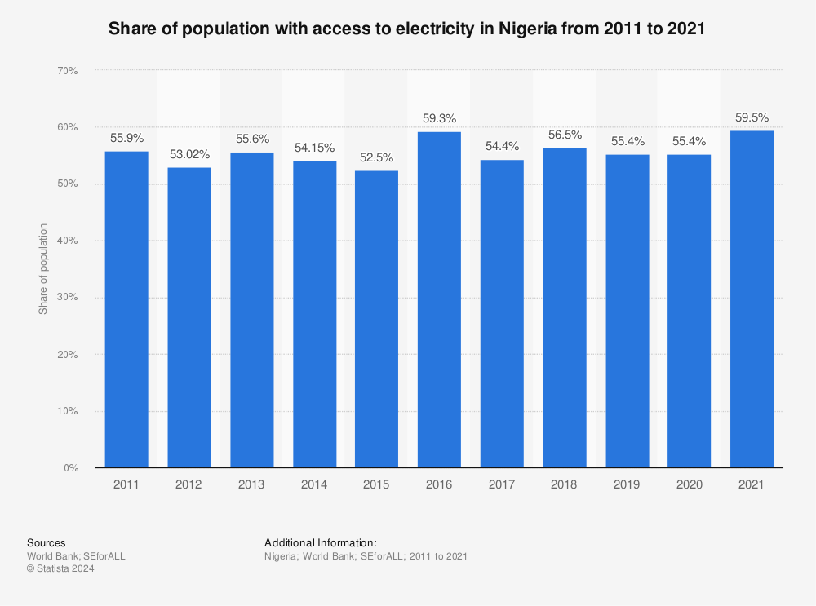
Source: (Statista, 2024).
Fig 1. shows the share of Nigeria's populace that had access to electricity from 2011 to 2021. Over these eleven years, the percentage of the number with access to electricity fluctuated from 52.5% to 59.5; the lowest was in 2015 at 52.5% while the highest was in 2021 with 59.5% having access to electricity. According to Macrotrend, Nigeria's population in 2011 was 165,463,745 while in 2021 was 213,401,323. This clearly shows an increase in the populace that had access to electricity in the country as shown above.
The energy situation in rural areas is particularly dire, with more than 70% of rural dwellers relying on fuel wood (firewood) as their primary energy source particularly in cooking . This has led to deforestation and desertification of the arid zone, and erosion in the Southern zone, where firewood is used for domestic and commercial purposes (Abdallah and Odeleke, 2023).
Fig 2: Direct Normal Irradiation (DNI) across Nigeria (1994-2018).
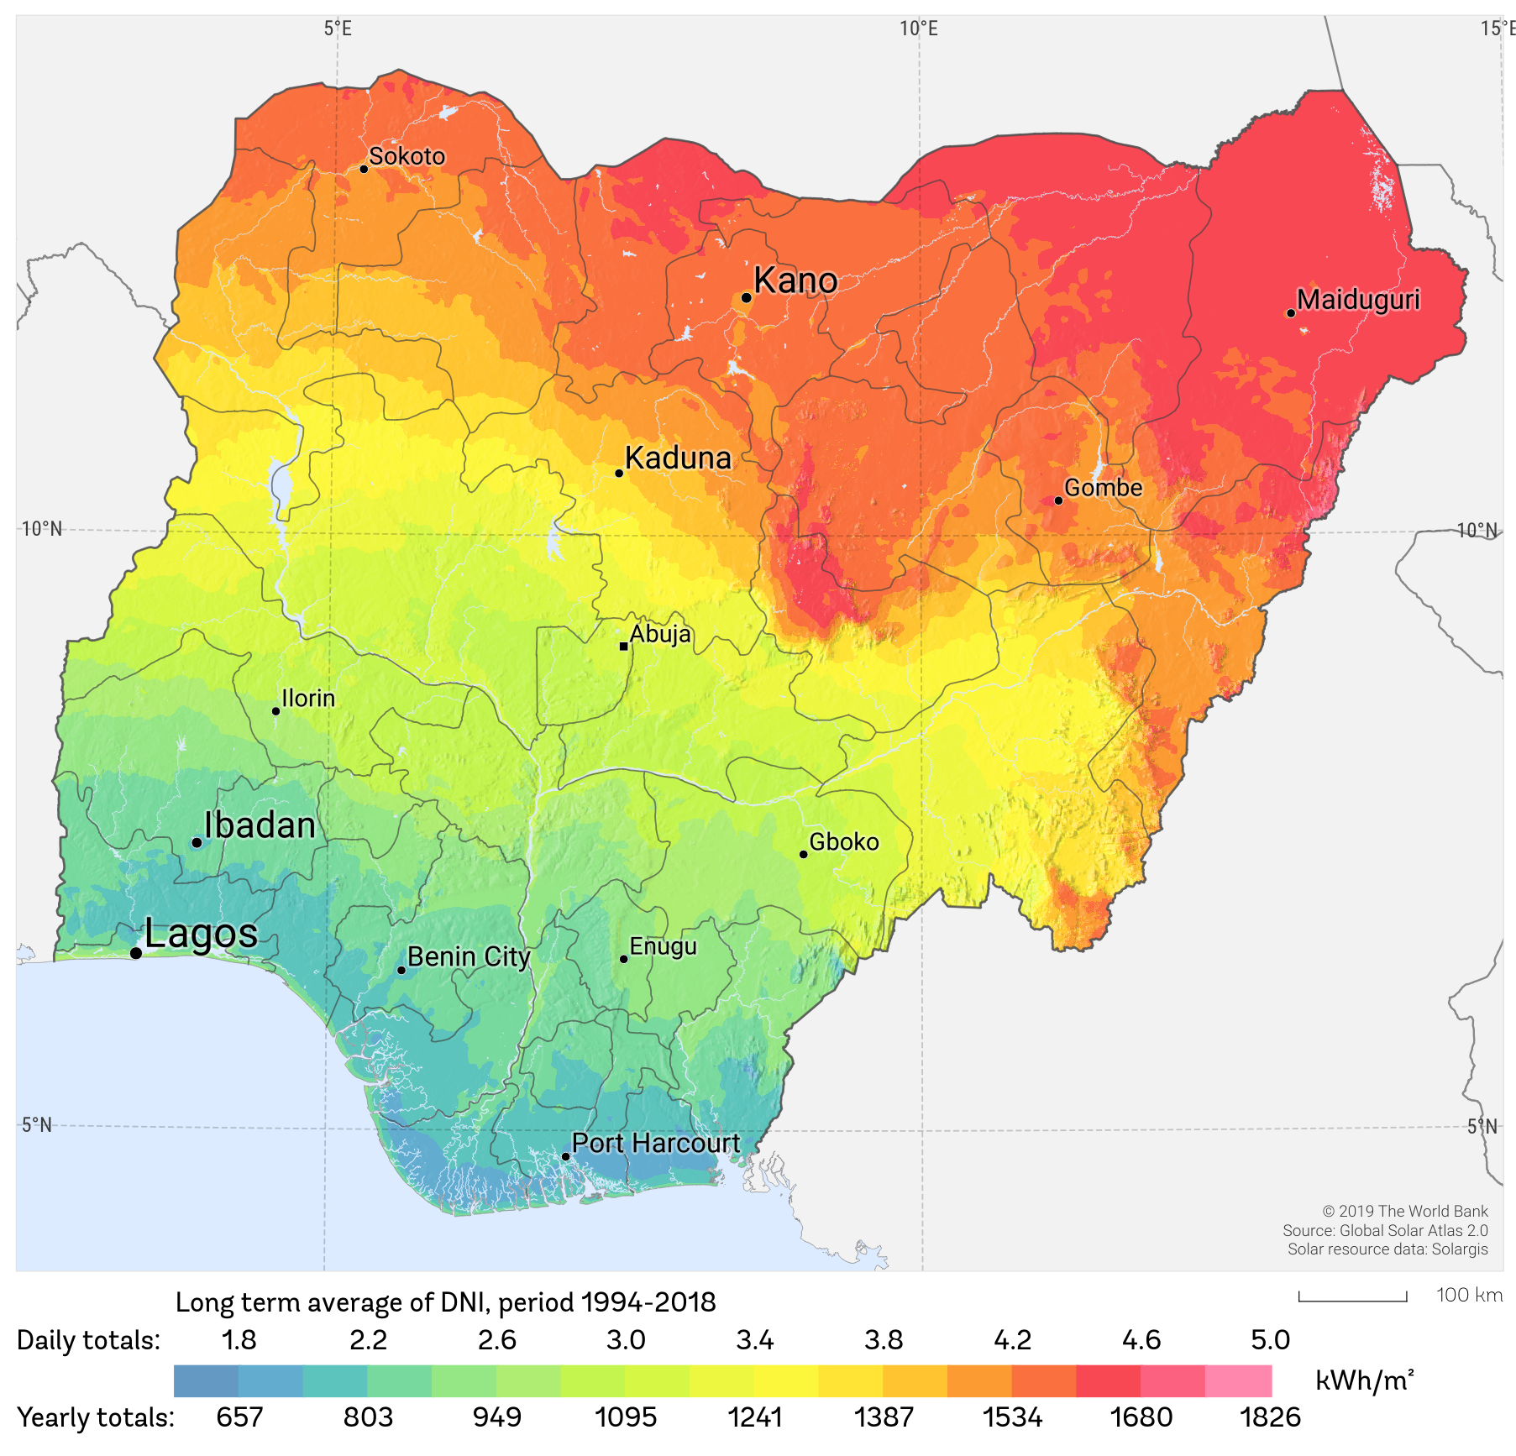
Source: Global Solar Atlas 2.0 in conjunction with The World Bank and Solargis.
The above map illustrates the long-term average Direct Normal Irradiation (DNI) from 1994 to 2018 in the Federal Republic of Nigeria. As the map indicates, the Northern part of the country; Sokoto, Kano, and Maiduguri; indicate higher DNI values and automatically show solar energy potential. These areas are the best places in Nigeria to set up solar power plants. However, this also indicates the uneven distribution of solar resources. The map clearly shows that Nigeria has Solar Energy potential, particularly in the Northern part of the country which receives more direct sunlight, unlike the Southern part which experiences more diffuse radiation because of the cloud.
Fig 3: Dual axis chart on renewable energy.
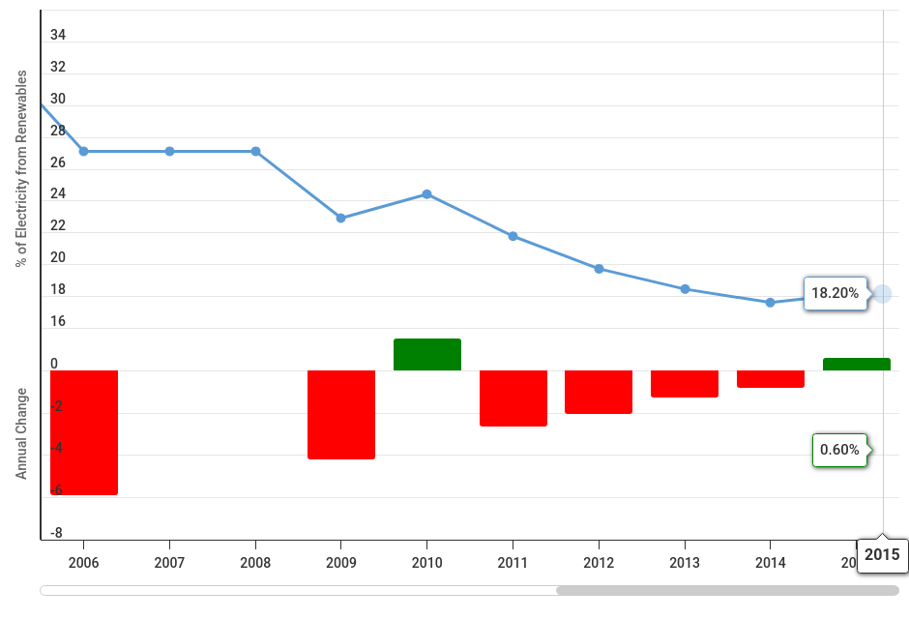
Source: Macrotrend (2025).
Fig 3. represents a dual-axis chart clearly showing the percentage of electricity from renewable sources in a line chart and the annual change in renewable electricity share in a bar chart from 2006 to 2015. During these years, the share of renewable energy declined from 28% to 18.2% suggesting a decline in reliance on renewable energy. The red bar indicates a yearly decrease while the green bar indicates an increase.
- Challenges in Nigeria's Energy Transition
One of the challenges of energy transition in Nigeria is inadequate funds. The state and domestic private investors lack the funds to realise this transition. The transition from a fossil fuel source form of energy to a renewable source form of energy is expensive and requires huge funding. According to the United Nations Conference of Trade and Investments (UNCTD), achieving the energy transition cost about $5.8 trillion annually from 2023 to 2030 for the 48 developing economies studied, equalling 19% of their GDP. According to Nigeria’s Energy Transition Plan (ETP), $1.9 Trillion is required to get to net zero emissions by 2060, including $410 Billion above projected usual spending. This additional cost translates to about $10 billion annually. Nevertheless, in the 2024 budget of Nigeria with a total expenditure of ₦27.50 trillion, only ₦20 million was budgeted for the development and management of the Energy Transition Plan (ETP) and the Net Zero Emissions (Budget Office, 2024). Insufficient funding for such important organizations, despite the paucity of funds, means that the country needs to raise more funds for these agencies for a smooth transition by the target date.
Another key challenge is the lack of technological know-how and expertise to produce the necessary equipment to transition to renewable energy. The tools and equipment are mostly produces in industrialized nations, forcing Nigeria to import these equipment and tools which poses a significant challenge to the country (Hachimenum & Onyebuchi, 2024). The technological know-how deficit in Nigeria is due to a lack of Research and development (R&D), though this is a general problem in most global southern countries. Because Nigeria cannot develop the technological tools needed in this transition, the next option is to seek technological transfer from industrialized nations. This option is a barrier because these industrialized nations will not transfer their technology to another country unless they have great interests in the other state.
Lack of policy continuity also poses a key challenge to Nigeria’s Energy Transition Plan (ETP) with the lack of implementation by a successive government. The key target is to achieve net-zero emissions by 2060, however, a president who does not prioritize the transition plan as part of the country’s agenda might abandon the transition plan in the future. Or in another case, be dealing with the transition effort issue with less relevance which will surely undermine the effort in realizing the goal of the agenda.
Furthermore, according to Worldometers, Nigeria’s population as of 2024 was 228,394,504. The Worldometers’ analysis of the latest United Nations data places the population an equivalent of 2.78% of the world’s population with a 2.4% growth rate per annum. This data places Nigeria as population powerhouse in Africa and globally. Meanwhile, in transitioning to renewable energy, Nigeria must, as a matter of importance, be conscious of her population growth rate which is a barrier to the transition, because more population equals more provision of resources.
- Policy initiatives
There are various policy initiatives by the government of Nigeria, one in particular is the Climate Change Act. On , November 18, 2021, former President Muhammadu Buhari signed the Climate Change Act (CCA). According to Udoma & Osagie (2021), the main aim of the CCA is to develop and implement mechanisms that will foster low carbon emissions and ensure a sustainable environment in the country. The CCA established the National Council on Climate Change, a council vested with the powers to implement policies and make decisions on all matters concerning climate change in Nigeria. In addition, the Act is expected to provide ways to ensure that climate change policies and actions are integrated with related policies to promote economic, political, social, and environmental development.
According to Article 4 of the Paris Agreement, there is a requirement for all attending states to prepare and communicate their plans for climate change mitigation and greenhouse gas emissions reduction. Nigeria prepared and communicated its first plan in 2015, and later updated it in 2021. It outlined measures, plans, strategies, and actions of the Federal Government of Nigeria towards greenhouse gas emissions reduction and climate change mitigation (Dike, 2023).
The Nigerian government, in 2015, released the National Renewable Energy & Energy Efficiency Policy (NREEEP). This national policy aims to improve energy supply across the country and promote utilization of renewable energy sources, shifting from the thought and consideration that rural areas are remote with little demand for power and depend on off-grid energy solutions. This is because the economies of on-grid deployment do not favor rural electrification. Moreover, the policy acknowledges that Nigeria is endowed with abundant renewable energy resources such as an average of 9 hours of sunlight daily, hydro, biomass, and, to a lesser degree, wind, energy (Avwioroko, 2023).
Furthermore, in August 2022, Nigeria launched the Nigeria Energy Transition Plan (NETP). This plan supports the country’s pathway to achieving net-zero GHG emissions by 2060. The 2060 timeline is significant as it portrays a midpoint of the 2050 to 2070 timeline set by the 2021 Climate Change Act. The plan further demonstrates Nigeria’s readiness to facilitate a just and equitable climate future for Africa, particularly in articulating the transition strategy and mobilizing climate financing for the country and the rest of Africa. In addition, the NETP has been described as a home-grown, data-backed, multi-dimensional strategy to achieve net-zero emissions by 2060 (NETP, 2024). It succinctly articulated Nigeria’s climate change commitment and the decarbonisation pathway. The plan identifies the power, cooking, oil and gas, transport, and industry sectors to drive Nigeria’s unconditional decarbonisation agenda through energy consumption adjustment (Dike, 2023).
Additionally, there is the energy education initiative. The energizing education program is a program of the federal government of Nigeria launched in 2018 under the Rural Electrification Agency (REA, 2024). The goal is to provide a sustainable and reliable electricity supply to federal universities and teaching hospitals. The program aims to use solar hybrid-mini grids in most of the institutions, excluding the Ile-Ife Teaching Hospital in Osun state and the University of Lagos which are to benefit from the gas power plant (Ibid). This was implemented to ensure energy security for educational institutions and teaching hospitals. The program’s target is to provide clean energy to 37 federal universities and 7 federal university teaching hospitals over the years, targeting approximately 100 Megawatts (REA, 2024). One of the beneficiaries of this program is Bayero University Kano in Kano State (BUK, 2019). The former Vice President Yemi Osibanjo, during the commissioning, said that the hybrid solar power plant will provide clean and sustainable energy to over 58,000 students and the university staff (Ibid).

5. Conclusion and Future Prospects
Nigeria has the necessary resources needed in the area of energy transition, the key fuel to be used is Liquefied Natural Gas (LNG) which is also a fossil fuel, but it’s cleaner and produces lesser sulfur and carbon dioxide into the atmosphere (NETP, 2024). Nigeria has an abundance of LNG in its domain, hence, Nigeria should, as a matter of fact, develop and harness its LNG for its local usage. With the help of the solar energy potential due to sunshine intensity, the country can use this natural opportunity to provide more energy to the citizens by investing in solar power plants.
The mass adoption and production of renewable energy technologies such as solar panels, batteries, inverters, and wind energy are becoming less expensive. Hence, this is an opportunity for Nigeria to purchase the necessary tools for its energy transition. Another prospect for Nigeria is taking advantage of the conflicts. Due to the Russian military operation in Ukraine and the subsequent sanctions against Russia, some European states are diversifying from purchasing Russian fossil fuel. As one of the top producers of fossil fuel, Nigeria can leverage its resources by exporting to these countries and acquiring the required tools, techniques, and expertise for energy transition.
In addition, energy transition is an important issue in the global arena, and through the assessment of loans and grants from international organizations and foreign countries (Ikenweji & Tijjani, 2025), Nigeria can apply to ensure a smooth transition. Apart from the loans and grants, Nigeria as a state adhering to American capitalism should encourage private investment in renewable energy such as solar power plants.

Disclaimer (Artificial intelligence)
Option 1:
Author(s) hereby declare that NO generative AI technologies such as Large Language Models (ChatGPT, COPILOT, etc.) and text-to-image generators have been used during the writing or editing of this manuscript.
Option 2:
Author(s) hereby declare that generative AI technologies such as Large Language Models, etc. have been used during the writing or editing of manuscripts. This explanation will include the name, version, model, and source of the generative AI technology and as well as all input prompts provided to the generative AI technology
Details of the AI usage are given below:
1.
2.
3.

References
- Aliyu, A., Ramli, A., & Saleh, M. (2013). Nigeria Electricity Crisis: Power Generation Capacity Expansion and Environmental Ramifications. Energy Journal, Vol 61, p. 354-367.
- Abdallah, A.A. & Odeleke, O.B. (2023) Energy Security in NIgeria. Journal of Arid Zone Economy. Vol 1. Pg 101-111
- Avwioroko, A. (2023). The Potential, Barriers and Strategies to Upscale Renewable Energy Adoption in Developing Countries: Nigeria as A Case Study. Engineering Science & technology Journal. Vol 4. p. 46-55.
- Bayero University Kano (2019). VP Osibanjo commissions solar hybrid power plants in BUK. https://buk.edu.ng/sites/default/files/bulletin/2019/september_6th_friday_2019_no_38.pdf. Accessed on 12 February, 2025.
- Budget Office (2024). https://www.budgetoffice.gov.ng/index.php/2024-appropriation-bill. Accessed on 11 October 2024.
- David, I. & Tijjani, A. (2025). Enhancing Energy Security in Nigeria: An Analysis of International Efforts (2015-2024). South Asian Journal of Social Studies and Economics. 22. p. 29-37.
- Dike, O.C. (2023). Framing Nigeria’s Energy Transition Strategy: Imperative of an Overarching Policy Direction, The Nigerian Economic Summit Group. https://www.nesgroup.org/researchdocument/framing-nigeria%E2%80%99s-energy-transition-strategy--imperative-of-an-overarching-policy-direction. Accessed on 10 November 2024.
- Enerdata (2024). Nigeria Energy information. https://www.enerdata.net/estore/energy-market/nigeria. Accessed on 10 November 2024.
- Energy transition Plan (2024). Nigeria's Pathway To Achieve Carbon Neutrality By 2060. https://www.energytransition.gov.ng/#Plan. Accessed on 10 October 2024.
- Frayer, L. (2021). India pledges net-zero emissions by 2070 but also wants to expand coal mining. https://www.npr.org/2021/11/03/1051805674/modi-india-cop26-coal-renewable-energy?t=1636899927203. Accessed on 11 October 2024.
- Hachimenum, A. & Onyebuchi, I. (2024). Renewable Energy in Nigeria: Prospects and Challenges. European Journal of Advance in Engineering and Technology. Vol 11 (4) p. 51-60.
- Macrotrends (2024). Nigeria Population 1950-2025. https://www.macrotrends.net/global-metrics/countries/NGA/nigeria /population. Accessed on 11 December 2024.
- Macrotrends (2025) Nigeria Renewable Energy 2006-2015. https://www.macrotrends.net/global-metrics/countries/NGA/nigeria/renewable-energy-statistics. Accessed on 11 February 2025.
- Nitte, S. I. (2023). Global Energy Transition And Its Implications On Energy Security In Nigeria: A Critical Review. International Journal of Climate and Resource Economic Review. Vol 11 p. 1-9
- Nwozor, A., Oshewolo S., Owoeye, G., & Okidu, O. (2021). Nigeria's Quest For Alternative Clean Energy Development: A Cobweb Of Opportunities, Pitfalls And Multiple Dilemmas. Energy Policy Vol 149.
- Rural Electrification Agency (2024). Energizing Education: REA Secures Universities’ Commitment to EEP Sustainability. https://rea.gov.ng/energizing-education-rea-secures-universitys-commitment. Accessed on 12 February 2025.
- Solargis (2025). Solar Source maps in Nigeria. Solar resource maps & GIS data for 200+ countries | Solargis. Accessed on 11 February 2025.
- Statista, (2024). Share of population with access to electricity in Nigeria from 2012 to 2022 https://www.statista.com/statistics/1307416/total-population-access-to-electricity-in-nigeria/. Accessed on 11 December 2024.
- Udoma, U. & Osagie, B. (2021). The Climate Change Act 2021: Key Points For Consideration. https://uubo.org/wp-content/uploads/2023/01/THE-CLIMATE-CHANGE-ACT-2021-KEY-POINTS-FOR-CONSIDERATION.pdf. Accessed on 11 December 2024.
- United Nations (2021) Theme report on Energy transition towards the achievement of SDG7 and Net Zero Emissions. https://www.un.org/sites/un2.un.org/files/2021-twg_2-exesummarie-061721.pdf. Accessed on 11 October 2024.
- United Nations Conference on Trade and Development (UNCTAD) (2024). https://unctad.org/sdg-costing/energy transition. Accessed on 15 November 2024.
- Worldometers (2024). Nigerian Population https://www.worldometers.info/world-population/Nigeria-population /. Accessed on 11 November 2024.

