Original Research Article

Chromatographic profiling and assessment of in vitro anti-diabetic potential of Chromolaena odorata (L.) R.M. King and H. Robinson

ABSTRACT
Diabetes mellitus characterized by hyperglycemia, alteration in the metabolism of lipids, carbohydrates and proteins. One of the possible approaches to prevent dietary carbohydrate absorption, is the regulation of postprandial blood glucose level by intake of some naturally available anti-diabetic potential plant extracts. Chromolaena odorata is one of the potential anti-diabetic plants and belonging to family Asteraceae. However, there is no scientific report on anti-diabetic activity of leaf extracts of C. odorata. The present study was aimed to assess the in vitro anti-diabetic potential of various solvent based leaf extracts of C. odorata along with their chromatographic profiling. The inhibitory effect of various solvent based leaf extracts of C. odorata were examined for alpha amylase and alpha glucosidase enzymes. All the plant extracts were subjected to both TLC and HPTLC for chromatographic profiling. Cytotoxicity activities of methanolic extract were assessed on L6 skeletal muscle cell lines. Among various leaf extracts, methanolic extract showed significant (P<0.05) inhibitory activity against alpha amylase and alpha glucosidase enzymes (IC₅₀ 3.03±0.18 µg mL⁻¹ and 4.97±0.21 µg mL⁻¹, respectively). During chromatographic profiling, methanolic extract only had more phytocompounds. Better cytotoxicity was shown by methanolic extract compared to other extracts. Leaf methanolic extract exhibited potential in vitro anti-diabetic activity that mainly could be regulated by high phenolic acids and flavonoid contents which confirmed through HTPLC profiling. These findings support the traditional use of C. odorata in the management of diabetes and suggest that its bioactive constituents could serve as promising leads for the development of novel anti-diabetic agents.
Keywords: Chromolaena odorata, in vitro anti-diabetic activity, TLC, HPTLC, L6 skeletal muscle cell lines

INTRODUCTION
“Diabetes mellitus is a chronic metabolic disorder characterized by enhanced levels of glucose in the blood. It is one of the rapid increasing health challenges in middle and low-income countries. According to the International Diabetes Federation (IDF), India currently has an estimated 77 million adults aged 20–79 living with diabetes. A figure is projected to rise to 134.2 million by 2045 which leads to India to face more socioeconomic burden of diabetes compared to other countries” [1]. “Of two types of diabetes, type 2 is more predominant than type 1 with more than 90% of the total diabetic patients suffering from it. Type 2 diabetes (T2D) is a disease produced by an imbalance between blood sugar uptake and insulin secretion. Postprandial hyperglycemia plays a significant role in the development of T2D” [2]. “Regulating plasma glucose level is important for preventing T2D. The capacity of a drug or diet to delay the absorption of glucose by hindering carbohydrate hydrolyzing enzymes such as alpha amylase and alpha glucosidase which is one of the therapeutic methods for declining postprandial hyperglycemia” [3]. “Chief factors like stressful lifestyle and poor diet including high glycemic and trans-fat with low-fiber and phytonutrients [4] and increasing environmental pollution” [5-7] contribute to the widespread of diabetes.
“Technological advancements in the isolation, purification, and structural elucidation of natural compounds have enabled the development of various strategies for the analysis and standardization of plant-based medicines” [8]. “Chromatographic profiling plays an important role in the quality control of multifaceted natural medicines” [9]. “Thin layer chromatography (TLC) is the primary step to identify the phytochemical compounds in a sample” [10]. “High performance thin layer chromatography (HPTLC) can offer an electronic image of the chromatographic fingerprint and a densitogram to detect the presence of active compounds in a plant sample. HPTLC is an improved and more efficient version of traditional TLC, designed to provide better accuracy and faster results. High-Performance Thin-Layer Chromatography (HPTLC) is a powerful modern analytical technique that is well-suited for both qualitative and quantitative analysis. Its high-throughput capability, sensitivity, and reliability enable accurate quantification of analytes at nanogram levels” [11].
“Skeletal muscle is the chief insulin target tissues responsible for postprandial glucose utilization. Since they are the most prevalent tissues in the whole body, glucose homeostasis is essential for their proper function” [12]. “The MTT (3-(4, 5-dimethylthiazol-2-yl)-2, 5-diphenyltetrazolium bromide) assay is a sensitive, quantitative, and reliable colorimetric method that measures viability, proliferation, and activation of cells” [13]. “The finding of toxicity in medicinal plant extracts is an important requisite for application of traditional medicine into public health programmes” [14]. “The capability of the cells to withstand under toxic condition has been the basis of most cytotoxicity analysis. Toxicity is determined by the number of viable cells and the mitochondrial dehydrogenase enzymatic activity of cells” [15].
“In recent years, drug medications have been in use for the treatment of diabetes. Some of the regularly used synthetic drugs for the management of diabetes are sulfonylureas, biguanides, α-glucosidase inhibitors, glinides, etc. These drugs cause various side effects such as nausea, vomiting, abdominal pain, diarrhoea, head ache, abnormal weight gain, allergic reaction, low blood glucose, dark urine, fluid retention and swelling. Moreover, they are very expensive and advised not to take during pregnancy” [16]. “Because of these reasons, low side effects, easy availability and cost-effective plant based anti-diabetic drugs are now-adays become popular” [17,18]. “Chromolaena odorata (L.) R.M. King and H. Robinson, belonging to family Asteraceae. This flowering shrub considered as one of the world’s worst weeds” [19] because it affects the establishment of other flora [20, 21]. C. odorata has been reported to have anti-bacterial, anti-plasmodic, anti-protozoal, anti-trypanosomal, anti-fungal, anti-hypertensive, anti-inflammatory, astringent, diuretic, hepatotropic [22-27] (, immunomodulatory [28], anti-cancer properties [29-35] and antidote properties [36]. “Traditionally, fresh leaves or a decoction of C. odorata have been used in various tropical countries to cure leech bites, soft tissue wounds, burn wounds, skin infections, rashes, diabetes and periodontitis” [22, 23, 36-38].
“Essential oil derived from aerial of C. odorata was assessed for anti-malarial, anti-inflammatory and anti-bacterial activities” [39-40]. Analgesics and anti-pyretic effects were shown by various solvent based whole plant extracts [41] and antioxidant and wound healing properties are exhibited by different solvent based leaf extracts [24, 29, 42 ]. “The leaf, stem and root extracts were evaluated for their effect on platelet activating factor receptor binding inhibitory activity” [43]. Recently, anti-diabetic effect of methanolic root extract has been reported using in vitro and in vivo models [44]. Leaves have been reported to contain various phytocompounds such as alkaloids, saponins, tannins, flavonols, flavonones, chalcones and phenolic acids [23] which are traditionally used to manage diabetes and various eye problems [45]. So far, there is no detailed research report on the efficacy of leaf extracts of C. odorata with respect to diabetes mellitus. Therefore, the present study was aimed to assess the in vitro anti-diabetic potential of various solvent based leaf extracts of C. odorata along with their chromatographic profiling.
MATERIALS AND METHODS
Chemicals, reagents and cell lines
Alpha amylase, 3,5-dinitrosalicylic acid, alpha glucosidase, p-nitrophenyl-α-D glucopyranoside, acarbose, 3-(4, 5-dimethyl thiazol-2-yl)-5–diphenyl tetrazolium bromide (MTT), Dulbecco’s Modified Eagle’s Medium (DMEM), Metformin and standards for HPTLC such as rutin, catechin, coumarin, quercetin and caffeic acid were procured from Sigma Aldrich Co, St Louis, USA. Pre coated silica gel G TLC plates (5×20 cm, 0.25 mm thickness), toluene, ethyl acetate, formic acid, methanol, pre coated silica gel 60F₂₅₄ aluminium sheets (3×10 cm) for HPTLC were purchased from Merck Ltd., Mumbai, India.
Plant material collection, authentication and extraction
C. odorata leaves were collected from the Mother Teresa Women’s University campus, Kodaikanal and authenticated by Dr. N. Jayaraman, Director, National Institute of Herbal Science, Plant Anatomy Research Centre, Tambaram (Voucher no: PAARC/2014/2052). The leaves were washed thoroughly with distilled water, air-dried at room temperature and pulverized to obtain a fine powder. About 50 g of pulverized material was extracted with 500 mL of solvents such as petroleum ether, chloroform, methanol and water using Soxhlet extractor (Buchi, Japan) at a 1:10 (w/v) ratio. The extracts were filtered using Whatman no. 1 filter paper and then dried in a rotary evaporator. The extract obtained was weighed and stored in sterile airtight bottles in the refrigerator until used [46]. Mokaizh et al., 2024).
In vitro inhibition of alpha amylase
The alpha amylase (0.5 mg/mL) was premixed with various solvent based leaf extracts at various concentrations (100-500 µg mL⁻¹) and starch was added as a substrate (0.5%) to start the reaction. The reaction was carried out at 37°C for 5 min and terminated by addition of 2 mL of DNS (3,5-dinitrosalicylic acid) reagent. The reaction mixture was heated for 15 min at 100°C and diluted with 10 mL of distilled water in an ice bath. Alpha amylase activity was determined by measuring spectrum at 540 nm [47]. Percentage of alpha amylase inhibitory activity was calculated by the following formula:
% Inhibition = (Control OD-Sample OD / Control OD) × 100
The concentration (standard acarbose and various solvent based leaf extracts) required to inhibit 50% of α-amylase activity was defined as the IC₅₀ value.
In vitro inhibition of alpha glucosidase
The enzyme alpha glucosidase inhibitory activity was determined by premixing alpha glucosidase (0.07 Units) with 100-500 µg mL⁻¹ of various solvent based leaf extracts. Then 3mM p-nitrophenyl glucopyranoside was added as a substrate. This reaction mixture was incubated at 37˚C for 30 min and the reaction was terminated by the addition of 2 mL of sodium carbonate (5% w/v). The alpha glucosidase activity was determined by measuring the p-nitrophenyl released from p- nitrophenyl glucopyranoside at 400 nm [48]. Percentage of alpha glucosidase inhibitory activity was calculated by the following formula:
% Inhibition = (Control OD-Sample OD / Control OD) × 100
The IC₅₀ value was defined as the concentration of the sample extract to inhibit 50% of alpha glucosidase activity under assay condition which was determined graphically.
Chromatographic profiling using TLC
TLC was performed by following the method of Harbone (1998) [49]. For separating different phytochemical compounds present in the various solvent based leaf extracts of C. odorata, the extracts were spotted separately using a capillary tube on pre coated silica gel G TLC plates (5×20 cm size and 0.25 mm thickness). The spotted plates were kept in different solvent systems to determine a suitable mobile phase. Various phytochemical constituents were separated using the determined specific mobile phase. The separated phytocompounds were visualised and identified by spraying different reagents such as Dragendorff, 10% sulphuric acid in ethanol, 10% sulphuric acid, 5% ferric chloride, Kedde, vanillin phosphoric acid, NP/PEG and vanillin sulphuric acid. Rf values were calculated for each identified band.
Chromatographic profiling using HPTLC
HPTLC studies were carried out as per the method of Wagner et al. (1996) [50]. HPTLC precoated, silica gel G60 F₂₅₄ plates (5X10 cm size; 250 µm thickness) were used for the application of sample. A small quantity of leaf extract dissolved in respective solvent and applied on precoated plate with the help of Linomat 5 applicator and Toluene: ethyl acetate: formic acid: methanol (3:6;1.6;0.4) was used to develop HPTLC chromatographic profile. After development of chromatogram, plates were air-dried and images were captured at visible light, UV 366 nm and UV 254 nm (Camag Reprostar 3). The peak number with its height, area and Rf values of chromatographic profile were observed by WIN CATS (1.3.4 version) software.
Cytotoxicity analysis
Among various leaf extracts, only methanolic extract showed more number of phytocompounds during chromatographic profiling. Therefore, it was selected and used for further cytotoxicity analysis.

Cell lines and Culture medium
L6 (Rat, Skeletal muscle) cell culture was purchased from National Centre for Cell Sciences (NCCS), Pune, India. Stock cells of L6 were cultured in DMEM augmented with 10% inactivated Foetal Bovine Serum (FBS), penicillin (100 IU/mL), streptomycin (100 µg mL⁻¹) and amphotericin B (5 µg mL⁻¹) in a humidified atmosphere of 5% CO₂ at 37°C till confluent. The cells were separated with TPVG solution (0.2% trypsin, 0.02% EDTA, 0.05% glucose in PBS). The stock cultures were grown in 25 cm² culture flasks and all experiments were performed in 96 microtiter plates. For in vitro studies, test sample was dissolved in DMEM appended with 2% inactivated FBS to attain a stock solution of 1 mg/mL concentration and sterilized by filtration. Sequential two fold dilutions were prepared from this stock to carry out cytotoxic studies.
Determination of cell viability by MTT Assay
“The monolayer cell culture was trypsinized and the cell count was attuned to 1.0 x 10⁵ cells/mL using DMEM containing 10% FBS. To each well of the 96 well microtiter plate, 0.1 mL of the diluted cell suspension (approximately 10,000 cells) was poured. After 24 h, when a partial monolayer was formed, the supernatant was discarded, washed once with medium and 100 μl of each concentration of methanolic leaf extract was added onto the partial monolayer in microtiter plates. The plates were then incubated at 37º C for three days in 5% CO₂ atmosphere and microscopic examination was made at 24 h interval and then, the drug solutions in the wells were discarded and 50 μl of MTT in PBS was added to each well. The plates were slightly shaken and incubated for three h at 37º C in 5% CO₂ atmosphere. The supernatant was flicked off and 100 μl of propanol was added and the plates were gently shaken to solubilize the formed formazan. The absorbance was determined using a microplate reader at a wavelength of 540 nm. The percentage growth inhibition was calculated using the following formula and concentration of test solutions needed to inhibit cell growth by 50% (CTC₅₀) values is generated from the dose-response curves” [51].
Mean OD of treated sample
% Growth Inhibition = 100 –
X 100
Mean OD of control sample
Statistical analysis
All the data were subjected to one-way ANOVA and the difference between samples was analysed by Duncan’s Multiple Range Test which were expressed as the mean ± standard deviation. Values were considered significant at p < 0.05. For all statistical analysis, SPSS software, version 26.0 (SPSS Inc., Chicago, IL, USA) was used.
RESULTS
Percentage yield
For extraction of phytocompounds from C. odorata leaves, various solvents such as petroleum ether, chloroform, methanol and water in series of increasing polarity were used. Among various solvent used, methanol showed the highest extraction yield (17.8%) followed by water (Table 1).
Table 1. Yield percentage of various solvent-based leaf extracts
Sl. No | Solvents | Yield (%)
1 | Petroleum ether | 6.6
2 | Chloroform | 6.8
3 | Methanol | 17.8
4 | Aqueous | 13.8

Alpha amylase inhibitory activity
All the leaf extracts of C. odorata exhibited strong alpha amylase inhibitory activity at the tested concentrations (100, 200, 300, 400 and 500 µg mL⁻¹) in a dose dependent manner (Table 2). The percentage inhibition ranged from 55.62±0.83 to 80.62±0.83 for petroleum ether, from 54.71±1.13 to 70.65±0.25 for chloroform, from 70.11±1.88 to 88.37± 0.65 for methanol and from 59.24± 0.54 to 80.09± 0.72 for water in all the concentrations tested. However, the percentage of inhibition was found high at the concentration of µg mL⁻¹ compared to other concentrations. The highest significant inhibitory effect (p<0.05) towards alpha amylase was observed with methanolic extract (IC₅₀ 3.03±0.18 µg mL⁻¹) followed by aqueous extract (IC₅₀ 3.59±0.25 µg mL⁻¹).
Table 2. In vitro inhibitory effects of different solvent extracts of C. odorata on alpha amylase
Concentration  (µg/mL) | % Inhibition of alpha amylase ± SEM
Concentration  (µg/mL) | Pet ether | Chloroform | Methanol | Aqueous | Acarbose
100 | 55.62±0.83e | 54.71±1.13e | 70.11±1.88e | 59.24±0.54e | 81.54±0.15e
200 | 60.69±1.37^{d} | 63.77±0.63^{d} | 74.82±1.66^{d} | 66.30±1.09^{d} | 86.17±0.43^{d}
300 | 65.94±0.31^{c} | 65.40±0.83^{c} | 81.52±1.96^{c} | 74.46±0.54^{c} | 89.35±0.75^{c}
400 | 76.09±1.09^{b} | 68.48±0.54^{b} | 85.87±0.54^{b} | 77.17±0.96^{b} | 91.08±0.93^{b}
500 | 80.62±0.83ª | 70.65±0.25ª | 88.37±0.65ª | 80.09±0.72ª | 94.81±0.27ª
IC₅₀ (µg/mL) | 4.15±0.32 | 3.72±0.23 | 3.03±0.18 | 3.59±0.25 | 2.52±0.12

Values are expressed as mean ± SD of three replicates. Values which are statistically significant (p ˂0.05) different according to Duncan’s Multiple Range Test, where a > b > c > d> e.
Alpha glucosidase inhibitory activity
The in vitro inhibitory effect of alpha glucosidase of C. odorata leaf extract is shown in Table 3. The result showed that the methanolic extract had significant inhibition (p<0.05) on alpha glucosidase activity with an IC₅₀ value of 4.97±0.21 µg mL⁻¹ at 500 µg mL⁻¹. The IC₅₀ value of alpha glucosidase activity of other extracts of petroleum ether, chloroform and aqueous were 8.74±0.40 µg mL⁻¹, 7.08±0.28 µg mL⁻¹ and 5.41±0.29 µg mL⁻¹, respectively.

Table 3. In vitro inhibitory effects of different solvent extracts of C. odorata on alpha glucosidase
Concentration  (µg/mL) | % Inhibition of alpha glucosidase ± SEM
Concentration  (µg/mL) | Pet ether | Chloroform | Methanol | Aqueous | Acarbose
100 | 28.48±0.67e | 32.58±0.87e | 45.42±0.61e | 40.56±0.65e | 62.46±0.83e
200 | 33.74±0.54^{d} | 37.66±0.44^{d} | 50.59±0.53^{d} | 41.74±0.43^{d} | 68.71±0.70^{d}
300 | 37.11±0.52^{c} | 42.68±0.74^{c} | 55.24±0.57^{c} | 43.32±0.65^{c} | 74.09±0.51^{c}
400 | 43.48±0.52^{b} | 47.55±0.67^{b} | 61.79±0.67^{b} | 47.65±0.60^{b} | 77.43±0.30^{b}
500 | 47.96±0.55ª | 51.13±0.61ª | 65.62±0.43ª | 50.62±0.23ª | 83.54±0.39ª
IC₅₀ (µg/mL) | 8.74±0.40 | 7.08±0.28 | 4.97±0.21 | 5.41±0.29 | 3.45±0.27
Values are expressed as mean ± SD of three replicates. Values which are statistically significant (p ˂ 0.05) different according to Duncan’s Multiple Range Test, where a > b > c > d > e.
Chromatographic profiling
TLC analysis
All the solvent-based leaf extracts of C. odorata were used to develop TLC chromatographic profile using silica gel G pre coated TLC plates. For this, five different solvent systems were tried, but good fractionation of phytocompounds was obtained in the solvent system comprising Toluene: ethyl acetate: formic acid: methanol (3:6:1.6:0.4). TLC profiling results are summarized in Table 4. Bands were visualized with the help of UV chamber and observed at UV 254 and 366 nm. TLC analysis revealed the development of six bands for methanolic and three bands for aqueous extract. Based on the colour of the spot, Rf values were calculated. Methanolic extract showed the presence of flavonoids with the Rf values of 0.14, 0.36 and 0.85 and for phenolic acids it showed the Rf values of 0.47, 0.58 and 0.77. Aqueous extract also showed the presence of flavonoids with the Rf values of 0.34, 0.45 and 0.61 (Fig. 1).

Table 4. TLC analysis of phytocompounds using leaf extracts of C. odorata
Extract | Mobile phase | Spraying reagent | Spot | Rf value
Pet ether | Toluene: ethyl acetate: formic acid: methanol (3:6:1.6:0.4) | Dragendorff reagent  Dragendorff reagent | --- | --
Chloroform | Toluene: ethyl acetate: formic acid: methanol (3:6:1.6:0.4) | Dragendorff reagent  Dragendorff reagent | -- | --
Methanol | Toluene: ethyl acetate: formic acid: methanol (3:6:1.6:0.4) | FeCl₃  reagent | Orange, Green | 0.14, 0.36, 0.47, 0.58, 0.77, 0.85
Aqueous | Toluene: ethyl acetate: formic acid: methanol (3:6:1.6:0.4) | FeCl₃  reagent | Orange | 0.34, 0.45, 0.61

HPTLC analysis
Based on TLC analysis results, methanolic and aqueous extracts were selected and further subjected to HPTLC analysis to identify the phytocompounds. HPTLC analysis of methanolic and aqueous leaf extracts of C. odorata was run in a mobile phase of Toluene: Ethyl acetate: Formic acid: Methanol (3:6:1.6:0.4) and the plate was visualized in day light, UV spectra of 254 nm and 366 nm. Orange color spot at visible light was observed in the chromatogram after derivatization which confirmed the presence of flavonoid in the methanolic extract on par with standard of rutin, catechin and coumarin. Phenolic acids in the methanolic extract on par with the standard (caffeic acid) with green color band at visible light was observed in the chromatogram after spraying the FeCl₃ reagent. For aqueous extract, only orange colour spot was observed which confirmed the presence of flavonoids on par with the standards quercetin and coumarin (Fig. 2). Total nine compounds were separated in methanolic extract and of which three were flavonoids with Rf values ranged from 0.25 to 0.98. Flavonoid and phenolic acid profiles of methanolic extract were presented in Table 5. The highest peak area was 37247.5 Absorbance units (AU) with Rf value 0.98 which was identified as coumarin. The lowest peak area with AU 1357.8 was found to one unknown compound (Rf value 0.60). Other than coumarin, rutin and catechin were also identified in the methanolic extract with Rf value (0.25 and 0.72, respectively). The peak with 11444.6 AU with Rf value of 0.74 was identified as one of the phenolic acids, i. e. caffeic acid. Totally eleven bands were identified in aqueous extract (ranged from Rf value of 0.14 to 0.97) and two were found to be flavonoids with Rf values 0.76 and 0.97, respectively (Table 6). The highest peak area was 19868.5 AU with Rf value of 0.97 (coumarin) and that of the lowest peak area was 175.8 AU with Rf value of 0.38 (unknown). In addition to coumarin, quercetin was also present with the area of 4564.7 AU. The presence of phytocompounds such as flavonoids and phenolic acids in methanolic and aqueous extracts of C. odorata was confirmed by densitogram (Fig. 3).

Table 5. HPTLC profile of methanolic leaf extract of C. odorata
Peak | Rf | Height (mm) | Area (AU) | Assigned substance
1 | 0.25 | 85.4 | 9259.4 | RUTIN
2 | 0.32 | 17.9 | 2971.8 | unknown *
3 | 0.42 | 1.0 | 2731.0 | unknown *
4 | 0.52 | 0.1 | 9102.3 | unknown *
5 | 0.60 | 39.4 | 1357.8 | unknown *
6 | 0.72 | 264.0 | 10737.6 | CATECHIN
7 | 0.74 | 221.4 | 11444.6 | CAFFEIC ACID
8 | 0.81 | 146.0 | 4386.9 | unknown *
9 | 0.98 | 7.0 | 37247.5 | COUMARIN

Table 6: HPTLC profile of aqueous leaf extract of C. odorata
Peak | Rf | Height (mm) | Area (AU) | Assigned substance
1 | 0.14 | 13.3 | 310.2 | unknown
2 | 0.26 | 8.4 | 9204.8 | unknown
3 | 0.33 | 1.1 | 1117.7 | unknown
4 | 0.38 | 0.8 | 175.8 | unknown
5 | 0.42 | 0.5 | 279.6 | unknown
6 | 0.54 | 0.7 | 3603.4 | unknown
7 | 0.61 | 10.5 | 1639.8 | unknown
8 | 0.71 | 115.0 | 7190.2 | unknown
9 | 0.76 | 53.7 | 4564.7 | QUERCETIN
10 | 0.84 | 95.6 | 4703.7 | unknown
11 | 0.97 | 0.1 | 19868.5 | COUMARIN

Cytotoxicity analysis
Determination of cell viability by MTT assay
During HPTLC analysis methanolic extract showed more phytocompounds compared to aqueous extract. Therefore, methanolic extract was taken for further cytotoxicity analysis. Methanolic leaf extract of C. odorata with various concentrations (62.5, 125, 250, 500 and 1000 µg mL⁻¹) was subjected to cytotoxicity determination using L6 skeletal muscle cell line by MTT assay. Percentage cytotoxicity was found to be 2.16±1.6 at 62.5 µg mL⁻¹ followed by 5.50±2.2 at 125 µg mL⁻¹, 10.43±1.9 at 250 µg mL⁻¹, 15.37±1.7 at 500 µg mL⁻¹ and 30.06±2.0 at 1000 µg mL⁻¹. The percent toxicity was increased with increasing concentration of methanolic leaf extract (Table 7 & Fig. 4.). Methanolic leaf extract did not exhibit any significant toxicity to the healthy L6 cell line with CTC₅₀ value greater than 572.37±1.56 µg mL⁻¹ which confirms the harmless nature of the extract.
Table 7: Cytotoxic effect of C. odorata methanolic leaf extract on L6 cell line
Sl. No | Name of test sample | Test Conc. | % Cytotoxicity | CTC₅₀ ( µg mL⁻¹)
1 | Concentration of  extract ( µg mL⁻¹) | 1000 | 30.06±2.0 | 572.37±1.56
1 | Concentration of  extract ( µg mL⁻¹) | 500 | 15.37±1.7 | 572.37±1.56
1 | Concentration of  extract ( µg mL⁻¹) | 250 | 10.43±1.9 | 572.37±1.56
1 | Concentration of  extract ( µg mL⁻¹) | 125 | 5.50±2.2 | 572.37±1.56
1 | Concentration of  extract ( µg mL⁻¹) | 62.5 | 2.16±1.6 | 572.37±1.56

DISCUSSION
In the present study, four solvents such as petroleum ether, chloroform, methanol and aqueous have been used to extract phytocompounds from C. odorata leaves. “The determination of extractive value refers to the amount of constituents present in given amount of raw material extracted with suitable solvents. These extractive values are representative of the presence of polar and non-polar extractable compounds in a plant material” [52]. “In the present study, the percentage of extractive value was found maximum in methanol which plays a major role for establishing the standard of any drug” [53]. “The variation of yield extract recovery is due to different polarity of the solvents used for plant extraction” [54]. Our observation is in consistent with the results of Euphorbia acalyphoides, Francoeuria crispa, Grewia tenax, Cissus quadrangularis where higher percentage of extract recovery was obtained using methanol [55].
“Over the years, there has been an increasing search for natural products having
potent bioactive compounds with low toxicity and possess ability to oxidize fats,
control appetite, regulate levels of hormones related to obesity and inhibit digestive
enzymes involved in the absorption of carbohydrates and lipids” [56, 57] when compared with synthetic compounds. “The α-amylase inhibitors act as an anti-nutrient that obstructs the digestion and absorption of carbohydrates. The results indicated that among the four extracts, methanolic extract showed increased α-amylase and α-glucosidase inhibitory activities with increased concentration in a dose dependent manner” [58]. “The α-amylase inhibitors are also called as starch blockers as they prevent or slows the absorption of starch into the body mainly by blocking the hydrolysis of 1,4-glycosidic linkages of starch and other oligosaccharides into maltose, maltriose and other simple sugars” [59]. “α-glucosidase is the enzyme that catalyses the key step of carbohydrate digestion and glucose release. Therefore, glucosidase inhibitors are therapeutic agents that can reduce the level of postprandial blood glucose by preventing the hydrolysis of glucose by carbohydrate metabolizing enzymes” [60]. In the present study, the highest significant inhibitory effect towards α-amylase, and α-glucosidase was observed with methanolic extract followed by aqueous extract. “A number of studies have reported that some medicinal plants possess α-amylase, and α-glucosidase inhibitory activities” [61,62]. “Kedrostis africana its abilities to inhibit α-amylase, α-glucosidase activities” [63]. “Different scientific reports have shown that there is a positive correlation between the effects of flavonoids and polyphenols content on inhibitory potentials of alpha amylase and alpha glucosidase” [64-66].

In the present investigation, the methanolic and aqueous extracts showed the presence of phenols and flavonoids with different Rf values. “The medicinal plants are rich in secondary metabolites and among the vast array of bioactive compounds alkaloids, flavonoids, glycosides, saponins and terpenoids are in high interest. Of the several methods are available for separating plant constituents, the chromatographic procedure is the most commonly used techniques for general application” [67]. “Also, in the present study, HPTLC confirmed the presence of four flavonoids such as rutin, catechin, caffeic acid and coumarin in the methanolic extract whereas it confirms the presence of coumarin and quercetin in the aqueous extract. HPTLC fingerprint analysis can be used as a diagnostic tool for the correct identification of plant bioactive components” [68].
“Over the years, different approaches have been employed and are still in use, individually or in combination, in the treatment of cancer such as chemotherapy, radiotherapy, surgery, and immunotherapy” [69]. “Chemotherapeutic agents are cytotoxic to other than cancer cells and proliferate them into cancer cells, including those localized in the gastrointestinal tract, hair, and bone marrow, thus eliciting the gastrointestinal side effects such as nausea and vomiting, alopecia, and myeloid suppression” [70]. “Plants have a long history of use in the treatment of cancer” [71-72] and the interest in nature as a source of potential chemotherapeutic agents continues. Recently, researchers put steps forward at herbal plants for the discovery of new antiproliferative agents with safety and efficacy. In the present study, we evaluated in vitro cytotoxicity potential of medicinal plant C. odorata on L6 cell line by MTT assay. “The percentage viability was increased with increasing concentration of methanolic extract. The MTT assay is a sensitive, quantitative, and reliable colorimetric method used to measure cell viability, proliferation, and activation. It relies on the ability of mitochondrial dehydrogenase enzymes in living cells to convert the yellow, water-soluble MTT substrate into a dark blue formazan product” [73].
CONCLUSION
The present study efficiently demonstrated that methanolic leaf extract of C. odorata possess high phenolic acids and flavonoids, as revealed by chromatographic profiling, which may contribute to its pharmacological activities. Data obtained from various in vitro assays confirmed C. odorata’s significant anti-diabetic potential. These findings support the traditional use of C. odorata in the management of diabetes and suggest that its bioactive constituents could serve as promising leads for the development of novel anti-diabetic agents. However, further in vivo studies and clinical evaluations are necessary to validate these effects and determine the safety and efficacy of the plant in therapeutic applications.
Data availability
The data will made up on request.
Disclaimer (Artificial intelligence)
Option 1:
Author(s) hereby declare that NO generative AI technologies such as Large Language Models (ChatGPT, COPILOT, etc.) and text-to-image generators have been used during the writing or editing of this manuscript.
REFERENCES
- IDF Diabetes Atlas [Internet]. Vol 9. IDF: 2019. Available from: https://www.diabetesatlas.org/upload/resources/material/20200302_133351_IDFATLAS9e-final-web.pdf
- A. D. Baron, Postprandial hyperglycaemia and α-glucosidase inhibitors, Diabetes Res. Clin. Pract. 40 (1998) S51-S55.
- A. K. Tiwari, J. M. Rao, Diabetes mellitus and multiple therapeutic approaches of phytochemicals: Present status and future prospects, Curr. Sci. (2002) 30-38.
- R. F. Horton, E. Barrett-Connor, E. Bray, G. A. Christophi, E. Venditti, Factors affecting the decline in incidence of diabetes in the Diabetes Prevention Program Outcomes Study (DPPOS), Diabetes 64 (2015) 989-998.
- Y. W. Chen, C. Y. Yang, C. F. Huang, D. Z. Hung, Y. M. Leung, S. H. Liu, Heavy metals, islet function and diabetes development, Islets 1 (2009) 169-176.
- J. Edwards, C. Ackerman, A review of diabetes mellitus and exposure to the environmental toxicant cadmium with an emphasis on likely mechanisms of action, Curr. Diabetes Rev 12 (2016) 252-258.
- M. N. Hasan, F. Sabrin, B. Rokeya, M. S. H. Khan, M. U. Ahmed, A. Matondo, S. Akter, Glucose and lipid lowering effects of Enhydra fluctuans extract in cadmium treated normal and type-2 diabetic model rats, BMC Complement Altern Med 19 (2019) 278.
- R. Balabhaskar, K. Vijayalakshmi, High-performance thin layer chromatography fingerprint profile of Bauhinia tomentosa Linn. Leaves, Asian J Pharm Clin Res, 11 (2018) 344-349.
- F. Gong, B. Wang, F. T. Chau, Y. Z. Liang, Data preprocessing for chromatographic fingerprint of herbal medicine with chemometric approaches, Anal. Lett. 38 (2005) 2475-2492.
- A. C. Moffat, M. D. Osselton, B. Widdop, J. Watts, Clarke's analysis of drugs and poisons London: Pharmaceutical press, 2011.
- R. N. Kulkarni, R. B. Pandhare, V. K. Deshmukh, P. B. Mohite, A. R. Pawar, High-performance thin layer chromatography: A powerful analytical technique in pharmaceutical drug discovery, Journal of Pharmaceutical and Biological Sciences (JPBS) 9 (2021) 7.
- M. Ishiki, A. Klip, Minireview: recent developments in the regulation of glucose transporter-4 traffic: new signals, locations, and partners, Endocrinology, 146 (2005) 5071-5078.
- G. Prasanna, R. Devi, G. Ishwarya, In vitro evaluation of antidiabetic and cytotoxicity potentials of the rhizome extract of Drynaria quercifolia (L.) J. Smith, Asian J Pharm Clin Res, 12 (2019).
- I. J. Sagbo, M. van de Venter, T. Koekemoer, G. Bradley, In vitro antidiabetic activity and mechanism of action of Brachylaena elliptica (Thunb.) DC, Evid. Based Complement. Alternat. Med. 1 (2018) 4170372.
- A. Asokan, M. Thangavel, In vitro cytotoxic studies of crude methanolic extract of Saraca indica bark extract, IOSRJPBS 9 (2014) 26-30.
- N. Anbu, M. Musthafa, V. Velpandian, Anti-Diabetic Activity of Polyherbal Formulation Aavaraiyathi Churnamin Alloxan Induced Diabetic Rats, IJTPR 4 (2012) 77-80.
- S. Venkatesh, G. D. Reddy, B. M. Reddy, M. Ramesh, A. A. Rao, Antihyperglycemic activity of Caralluma attenuate, Fitoterapia 74 (2003) 274-279.
- H. Nasri, H. Shirzad, Toxicity and safety of medicinal plants, J Herb Med Plarmacol 2 (2013) 21-22.
- F. A. Bamisaye, E. O. Ajani, I. O. Nurain, J. B. Minari, Medico-botanical investigation of siam weed (Chromolaena odorata) used among the “ijebu” people of Ogun state, Nigeria, J Med Med Sci, 5 (2014) 20.
- O. Warea, Chromolaena (Siam) weed. Pest Advisory Leaflet no. 43. Secretariat of the Pacific Community, 2004.
- G. Bani, Status and management of Chromolaena odorata in congo, 2002.
- T. T. Phan, J. Allen, M. A. Hughes G. Cherry, F. Wojnarowska, Upregulation of adhesion complex proteins and fibronectin by human keratinocytes treated with an aqueous extract from the leaves of Chromolaena odorata (Eupolin), Eur J Dermatol. 10 (2000) 522-527.
- T. T. Phan, L. Wang, P. See, R. J. Grayer, S. Y. Chan, S. T. Lee, Phenolic compounds of Chromolaena odorata protect cultured skin cells from oxidative damage: implication for cutaneous wound healing, Biol. Pharm. Bull. 24 (2001) 1373-1379.
- A. C. Akinmoladun, E. O. Ibukun, I. A. Dan-Ologe, Phytochemical constituents and antioxidant properties of extracts from the leaves of Chromolaena odorata, Sci. Res. Essays. 2 (2007) 191-194.
- G. Rejitha, Diuretic activity of Eupatorium odoratum L inn, J Pharm Res. 2 (2009) 844–846.
- P. G. Vital, W. L. Rivera, Antimicrobial activity and cytotoxicity of Chromolaena odorata (L. f.) King and Robinson and Uncaria perrottetii (A. Rich) Merr. extracts, J. Med. Plants Res. 3 (2009) 511-518.
- T. T. H. Hanh, D. T. T. Hang, C. Van Minh, N. T. Dat, Anti-inflammatory effects of fatty acids isolated from Chromolaena odorata, Asian Pac. J. Trop. Med. 4 (2011) 760-763.
- S. H. Taleb‐Contini, A. Kanashiro, L. M. Kabeya, A.C.M. Polizello, Y. M. Lucisano‐Valim, D. C. R. D. Oliveira, Immunomodulatory effects of methoxylated flavonoids from two Chromolaena species: structure‐activity relationships. Phytotherapy Research: An International Journal Devoted to Pharmacological and Toxicological Evaluation of Natural Product Derivatives 20 (2006) 573-575.
- P. T. Thang, L. S. Teik, C. S. Yung, Anti-oxidant effects of the extracts from the leaves of Chromolaena odorata on human dermal fibroblasts and epidermal keratinocytes against hydrogen peroxide and hypoxanthine–xanthine oxidase induced damage, Burns 27 (2001) 319-327.
- S. Nanasombat, N. Teckchuen, Antimicrobial, antioxidant and anticancer activities of Thai local vegetables. J. Med. Plants Res 3 (2009) 443-449.
- R. D. Torrenegra, O. E. Rodríguez, Chemical and biological activity of leaf extracts of Chromolaena leivensis, Nat. Prod. Commun. 6 (2011) 947-950.
- F. B. Harun, S. M. Syed Sahil Jamalullail, K. B. Yin, Z. Othman, A. Tilwari, P. Balaram, Autophagic Cell Death Is Induced by Acetone and Ethyl Acetate Extracts from Eupatorium odoratum In vitro: Effects on MCF‐7 and Vero Cell Lines, Sci. World J. 1 (2012) 439479.
- A. Subramoniam, V. V. Asha, S. A. Nair, S. P. Sasidharan, P. K. Sureshkumar, K. N. Rajendran, K. Ramalingam, Chlorophyll revisited: Anti-inflammatory activities of chlorophyll a and inhibition of expression of TNF-α gene by the same, Inflammation, 35 (2012) 959-966.
- L. P. Nudo, E. S. Catap, Anti-immunosuppressive effects of Chromolaena odorata (Lf.) King & Robinson (Asteraceae) leaf extract in cyclophosphamide-injected Balb/C mice, Philipp. J. Sci. 141 (2012) 35-43.
- P. B. K. Kouamé, C. Jacques, G. Bedi, V. Silvestre, D. S. Loquet, Barillé‐Nion, I. Tea, Phytochemicals isolated from leaves of Chromolaena odorata: impact on viability and clonogenicity of cancer cell lines, Phytother. Res. 27 (2013) 835-840.
- A. Suksamrarn, A. Chotipong, T. Suavansri, S. Boongird, P. Timsuksai, S. Vimuttipong, A. Chuaynugul, Antimycobacterial activity and cytotoxicity of flavonoids from the flowers of Chromolaena odorata, Arch. Pharm. Res. 27 (2004) 507-511.
- M. N. Vaisakh, A. P. Anima Pandey, The invasive weed with healing properties: a review on Chromolaena odorata, 2012.
- L. Wang, B. Waltenberger, E. M. Pferschy-Wenzig, M. Blunder, X. Liu, C. Malainer, A. G. Atanasov, Natural product agonists of peroxisome proliferator-activated receptor gamma (PPARγ): a review, Biochem. Pharmacol. 92 (2014) 73-89.
- V. B. Owoyele, J. O. Adediji, A. O. Soladoye, Anti-inflammatory activity of aqueous leaf extract of Chromolaena odorata, Inflammopharmacology 13 (2005) 479-484.
- N. Pisutthanan, S. Liawruangrath, J. Bremner, B. Liawruangrath, Chemical constituents and biological activities of Chromolaena odorata, J Sci Fac Chiang Mai Univ. 32 (2005) 139-148.
- B. V. Owoyele, S. O. Oguntoye, K. Dare, B. A. Ogunbiyi, E. A. Aruboula, A. O. Soladoye, Analgesic, anti-inflammatory and antipyretic activities from flavonoid fractions of Chromolaena odorata, J. Med. Plants Res. 2 (2008) 219-225.
- H. Pandith, X. Zhang, J. Liggett, K. W. Min, W. Gritsanapan, S. J. Baek, Hemostatic and wound healing properties of Chromolaena odorata leaf extract, Int Sch Res Notices. 1 (2013) 168269.
- S. K. Ling, M. A. Nor Azah, M. Mastura, M. G. H. Khoo, S. Saidatul Husni, M. Salbiah, A. B. Siti Asha, Chemical constituents and therapeutic potential of the leaf extract from Chromolaena odorata (L.) King and Robinson, FRIM 2005 52109.
- O. O. Omonije, A. N. Saidu, H. L. Muhammad, Anti-diabetic activities of Chromolaena odorata methanol root extract and its attenuation effect on diabetic induced hepatorenal impairments in rats, Clin. phytosci. 5 (2019) 23.
- T. Pullaiah, K. C. Naidu, Antidiabetic plants in India and herbal based antidiabetic research, Daya Books, 2003.
- A. A. B. Mokaizh, A. H. Nour, M. Y. Alazaiza, S. E. Mustafa, M. S. Omer, D. E. Nassani, Extraction and characterization of biological phytoconstituents of Commiphora gileadensis leaves using Soxhlet method, Processes. 12 (2024) 1567.
- C. P. Malik, M.B. Singh, Plant Enzymology and Histo enzymology, Kalyani Publishers, New Delhi, 1980.
- S. Krishnaveni, B. Theymoli, S. Sadasivam, Food Chem. 15 1984 229.
- J. B. Harborne, Phylochemical Methods A Guide to Modern techniques of Plant Analysis (Edn. III), Chapman and Hall, U.K, 1998 45.
- F. Denizot, R. Lang, Rapid colorimetric assay for cell growth and survival: modifications to the tetrazolium dye procedure giving improved sensitivity and reliability, J. Immunol. Methods. 89 (1986) 271-277.
- H. Wagner, S. Bladt, Plant drug analysis: a thin layer chromatography atlas. Berlin, Heidelberg: Springer Berlin Heidelberg, 1996.
- C. N. Shri, J. Balaji, S. Venkatramanan, K. L. Madhumathi, Pharmacognostical and preliminary phytochemical screening of the root and rhizome of Corallocarpus epigaeus, Int J Pharm Biomed Res. 1 (2010) 24-27.
- G. I. Jenkins, A. M. Kenevel, F. E Digangi, Quantitative Pharmaceutical Chemistry, 6th Edition, CBC Publishers and Distributors, Pvt.Ltd., New Delhi, 2008.
- D. H. Truong, D. H. Nguyen, N. T. A. Ta, A. V. Bui, T. H. Do, H. C. Nguyen, Evaluation of the use of different solvents for phytochemical constituents, antioxidants, and in vitro anti‐inflammatory activities of Severinia buxifolia, J. Food Qual, 1 (2019) 8178294.
- O. A. O. Adam, R. S. M. Abadi, S. M. H. Ayoub, The effect of extraction method and solvents on yield and antioxidant activity of certain sudanese medicinal plant extracts, J Phytopharmacol, 8 (2019) 248-252.
- A. S. Cho, S. M. Jeon, M. J. Kim, J. Yeo, K. I. Seo, M. S. Choi, M. K. Lee, Chlorogenic acid exhibits anti-obesity property and improves lipid metabolism in high-fat diet-induced-obese mice, Food Chem. Toxicol 48 (2010) 937-943.
- T. M. Rains, S. Agarwal, K. C. Maki, Antiobesity effects of green tea catechins: a mechanistic review, J. Nutr. Biochem. (2011) 221e7.
- S. Odeyemi, J. Dewar, Repression of acetaminophen-induced hepatotoxicity in HepG2 cells by polyphenolic compounds from Lauridia tetragona (Lf) RH Archer, Molecules 24 (2019) 2118.
- B. Dineshkumar, A. Mitra, M. Manjunatha, A comparative study of alpha amylase inhibitory activities of common anti-diabetic plants at Kharagpur 1 block, IJGP. 4 (2010).
- C. S. Shreedhara, V. P. Vaidya, H. M. Vagdevi, K. P. Latha, K. S. Muralikrishna, A. M. Krupanidhi, Screening of Bauhinia purpurea Linn. for analgesic and anti-inflammatory activities, Indian J. Pharmacol. 41 (2009) 75-79.
- A. Shirwaikar, K. Rajendran, I. S. R. Punitha, Antidiabetic activity of alcoholic stem extract of Coscinium fenestratum in streptozotocin-nicotinamide induced type 2 diabetic rats, J. Ethnopharmacol, 97 (2005) 369-374.
- R. R. Ortiz-Andrade, S. García-Jiménez, P. Castillo-España G. Ramírez-Avila R. Villalobos-Molina, S. Estrada-Soto, Alpha Glucosidase inhibitory activity of the methanolic extract from Tournefortia hartwegiana: an anti-hyperglycemic agent, J Ethnopharmacol. 109 (2007) 48-53.
- J. O. Unuofin, G. A. Otunola, A. J. Afolayan, In vitro α-amylase, α-glucosidase, lipase inhibitory and cytotoxic activities of tuber extracts of Kedrostis africana (L.) Cogn, Heliyon 4 (2018).
- D. F. Pereira, L. H. Cazarolli, C. Lavado, V. Mengatto, M. S. R. B. Figueiredo, A. Guedes, F. R. M. B. Silva, Effects of flavonoids on α-glucosidase activity: potential targets for glucose homeostasis, Nutrition 27 (2011) 1161-1167.
- S. Adisakwattana, T. Ruengsamran, P. Kampa, W. Sompong, In vitro inhibitory effects of plant-based foods and their combinations on intestinal α-glucosidase and pancreatic α-amylase, BMC Complement Altern Med 12 (2012) 110.
- A. Kam, K. M. Li, V. Razmovski‐Naumovski, S. Nammi, J. Shi, K. Chan, G. Q. Li, A comparative study on the inhibitory effects of different parts and chemical constituents of pomegranate on α‐amylase and α‐glucosidase. Phytother. Res. 27 (2013) 1614-1620.
- P. Alphonso, A. Saraf, Chemical profile studies on the secondary metabolites of medicinally important plant Zanthoxylum rhetsa (Roxb.) DC using HPTLC, Asian Pac. J. Trop. Biomed, 2 (2012) S1293-S1298.
- G. S. Sushma, B. A. Devi, C. Madhulatha, K. U. Kumar, P. Harathi, N. S. Subramanian, Ramadevi, Preliminary phytochemical screening and HPTLC fingerprinting of leaf extracts of Ficus nervosa Heyne ex Roth, 2013 98-104.
- S. Akkın, G. Varan, E. Bilensoy, A review on cancer immunotherapy and applications of nanotechnology to chemoimmunotherapy of different cancers, Molecules 26 (2021) 3382.
- A. Remesh, Toxicities of anticancer drugs and its management, Int J Basic Clin Pharmacol 1 (2012) 2-12.
- G. M. Cragg, D. J. Newman, Antineoplastic agents from natural sources: achievements and future directions, Expert Opin Investig Drugs, 9 (2000) 2783-2797.
- D. J. Newman, G. M. Cragg, K. M. Snader, Natural products as sources of new drugs over the period 1981− 2002, J. Nat. Prod. 66 (2003) 1022-1037.
- M. Ghasemi, S. Liang, Q. M. Luu, I. Kempson, The MTT assay: a method for error minimization and interpretation in measuring cytotoxicity and estimating cell viability, In Cell viability assays: Methods and protocols, New York, NY: Springer US, 2023.

Figure captions:
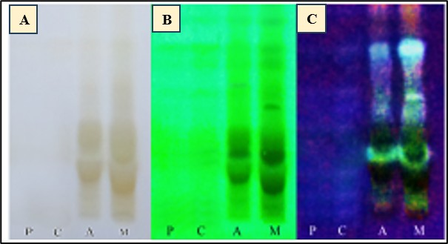
Fig. 1. TLC plate visualized under A) visible light, B) UV-254 nm and C) UV-366 nm.
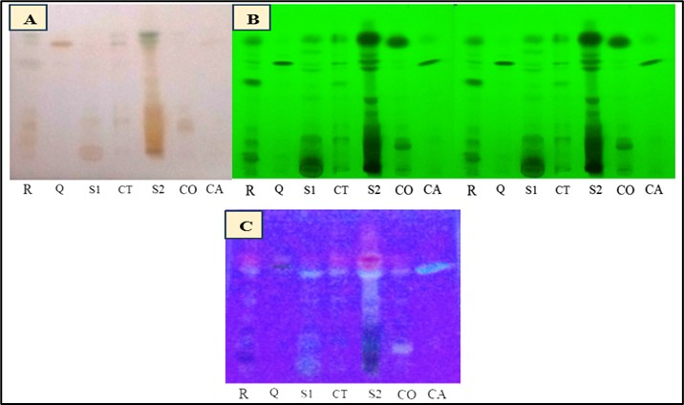
Fig. 2. Chromatogram obtained from separation of Standards R-Rutin, Q-Quercetin, S1-Aqueous extract of C. odorata, CT-Catechin, S2-Methanolic Leaf extract of C. odorata, CO-Coumarin, CA-Caffeic acid. Visualization under A) visible light, B) under UV 254 nm and C) under UV 366 nm.
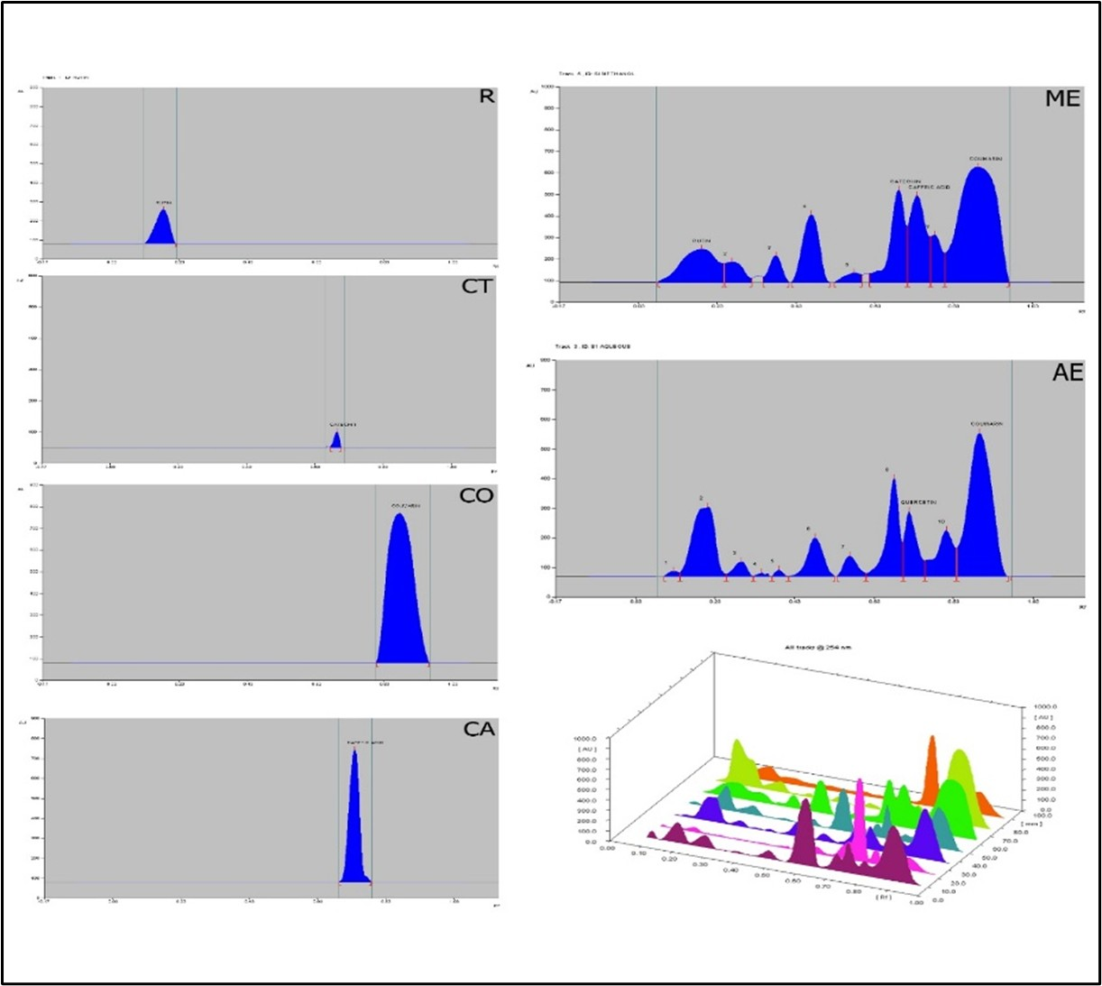
Fig. 3. HPTLC densitogram for standards R-Rutin, CT-Catechin, CO-Coumarin, CA-Caffeic acid, ME-methanolic extract and AE-aqueous extract of C. odorata and 3D display of all tracks.
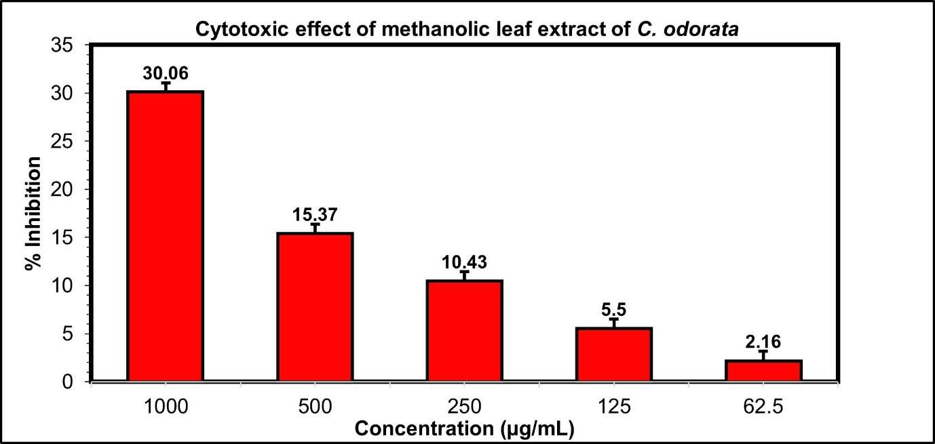
Fig. 4. Effect of methanolic leaf extract on L6 cell line inhibition percentage.

