“Thyroid Dosimetry in Breast Cancer Patients Receiving Post- Mastectomy Radiotherapy: A Retrospective Analysis”.

ABSTRACT
Background: Breast cancer is the most frequently diagnosed cancer in women and continues to be a significant contributor to cancer-related deaths worldwide. The management of advanced stages generally involves a combination of treatment modalities such as surgery, chemotherapy, and adjuvant radiotherapy. During post-mastectomy chest wall and supraclavicular irradiation, a portion of the thyroid gland may inadvertently receive radiation exposure, potentially leading to hypothyroidism. This study aimed to evaluate thyroid gland dosimetry in patients undergoing post-mastectomy radiotherapy using 3D-CRT.
Materials and Methods: Thirty patients with histologically confirmed breast carcinoma who had undergone MRM were included. All patients received PMRT to the chest wall and supraclavicular region using the 3D conformal radiotherapy technique, with a total prescribed dose of 50 Gy delivered in 25 fractions. The thyroid gland was delineated for each patient.
and dosimetric parameters—thyroid volume, mean, minimum, and maximum doses, and percentage volume receiving 30 Gy were calculated and analyzed.
Results: The patients ranged in age from 37 to 71 years. The mean thyroid gland volume was 15.63 cc. The mean dose to the entire thyroid gland was 19.05 Gy, with mean minimum and maximum doses of 0.676 Gy and 52.67 Gy, respectively. The mean thyroid V30 was 32.98%, while the ipsilateral thyroid V30 averaged 66.36%.
Conclusion: Post-mastectomy radiotherapy involving the supraclavicular region exposes the thyroid gland to significant radiation doses, increasing the risk of hypothyroidism. The thyroid gland should be recognized as an organ at risk during radiotherapy planning, and periodic assessment of thyroid function is essential for the early detection and timely management of radiation-induced hypothyroidism.
KEY WORDS: Post Mastectomy Radiation Therapy, Supraclavicular region RT, Thyroid gland dosimetry, 3D conformal radiation therapy.
INTRODUCTION:
With an estimated 2.26 million new cases (11.7%) and around 0.68 million deaths worldwide in 2020, breast carcinoma has emerged as the most frequently diagnosed cancer globally. It continues to be the leading cause of cancer-related mortality in women and the fifth leading cause of cancer death overall.⁽¹⁾ In India, breast cancer accounts for approximately 0.17 million new cases annually, representing 13.5% of all newly diagnosed cancers and 10.6% of all cancer-related deaths. ⁽¹⁾

Based on evidence from randomized trials conducted by the Danish Breast Cancer Cooperative Group and the British Columbia Cancer Agency, the role of post-mastectomy chest wall radiotherapy for patients with node-positive or high-risk node-negative disease has evolved significantly in recent years.^{(2,3)} These studies have indicated that Post Mastectomy Radiation Therapy boosted survival and diminished locoregional recurrences (LRR’s). Radiotherapy was found to reduce the 10-year recurrence risk from 35.0% to 19.3% (P < 0.0001). Furthermore, a meta-analysis conducted by the EBCTCG reinforced the beneficial impact of post-mastectomy radiotherapy on both local disease control and overall survival.^{(4,5)}

The probability of a lone Supraclavicular Fossa recurrence was 4.5–7% in those who did not undergo RT but had affected axillary nodes. In axillary node positive patients receiving RT, this incidence has been reduced to 0-1%.^{(6,7)}

In patients with breast cancer receiving adjuvant radiotherapy to the chest wall and supraclavicular region, a portion of the thyroid gland may inadvertently be exposed to radiation.
Evidence now available from Joensuu H et al, Bruning P et al, Reinertsen KV et al, has established that thyroid function decreased following supraclavicular field irradiation.⁽⁸⁻¹⁰⁾ The impact on thyroid function in all of these patients is therefore a concern.

The thyroid gland is generally not considered a critical organ during radiotherapy planning for breast cancer patients. Limited research exists regarding its significance as an OAR in radiotherapy among Indian breast cancer patients. The present study aimed to retrospectively evaluate the radiation doses received by the thyroid gland in breast cancer patients treated at our institution with post-mastectomy chest wall radiotherapy, including irradiation to the supraclavicular region.

MATERIAL AND METHODS:
a. General study details
This retrospective study was carried out in the Department of Radiotherapy at a tertiary cancer center between January 10, 2020, and June 15, 2022. Approval for the study was obtained from the Institutional Ethics Committee (IEC) on January 18, 2023. As there was no direct interaction with patients, the IEC granted a waiver of informed consent. Owing to its retrospective design, the study was not registered in a public clinical trial registry, and no external funding was required. All procedures were conducted in accordance with the ethical principles of the Declaration of Helsinki, Good Clinical Practice (GCP) guidelines, and the Indian Council of Medical Research (ICMR) standards.
b. Participants
This retrospective study included 30 randomly selected patients with histologically confirmed carcinoma of breast who had undergone Modified Radical Mastectomy (MRM) and were planned for adjuvant chest wall radiotherapy (RT) along with supraclavicular lymph node irradiation between January 2020 and June 2022.Patients aged 18–80 years with an Eastern Cooperative Oncology Group (ECOG) performance status of 0–2 who received adjuvant radiotherapy to the chest wall and supraclavicular region following modified radical mastectomy (MRM) were included in the study. Patients with a history of thyroid surgery, prior thoracic irradiation, bilateral breast carcinoma, or evidence of distant metastasis at presentation were excluded.

c. Objectives
To evaluate radiotherapy treatment plans of breast cancer patients receiving supraclavicular field radiotherapy (RT) along with chest wall irradiation, with specific focus on thyroid gland dose distribution and thyroid gland volume.

d. Materials and methods
This study included 30 patients with histologically confirmed breast carcinoma who underwent modified radical mastectomy (MRM) and subsequently received adjuvant radiotherapy (RT) to the chest wall and supraclavicular region between January 2020 and June 2022.
Patients were positioned supine on an inclined breast board, with the ipsilateral arm elevated above the head and the head turned contralaterally. Thermoplastic moulds were used for immobilization, and patients were instructed to maintain a consistent position throughout treatment. Planning CT scans were acquired with a slice thickness of 5 mm. Target volumes were delineated in accordance with Radiation Therapy Oncology Group guidelines from the Breast Cancer Atlas for Radiation Therapy Planning using the Varian Eclipse Treatment Planning System (version 13). The mastectomy scar, marked with a radio-opaque wire, was included within the target volume.
All patients received adjuvant radiotherapy with a total prescribed dose of 50 Gy delivered in 25 fractions (2 Gy per fraction, five fractions per week) using the three-dimensional conformal radiotherapy technique on a 6 MV photon linear accelerator.
The chest wall was treated with parallel opposed tangential fields, and the supraclavicular region was treated using a single anterior field via a 3D portal.
The thyroid gland was retrospectively contoured, and relevant dose–volume parameters, including thyroid volume and radiation dose distributions, were derived from the dose–volume histogram (DVH) for detailed analysis.
e. Statistical analysis
A minimum of 30 patients were included in the study, determined based on the average number of eligible admissions in the institution during the study period.Data were compiled and organized using Microsoft Excel and statistical analyses were conducted using the Statistical Package for the Social Sciences version 23.0. Categorical variables were presented as percentages and frequencies, while continuous variables were summarized as mean ± standard deviation.The data were appropriately tabulated for analysis and interpretation.

RESULTS:
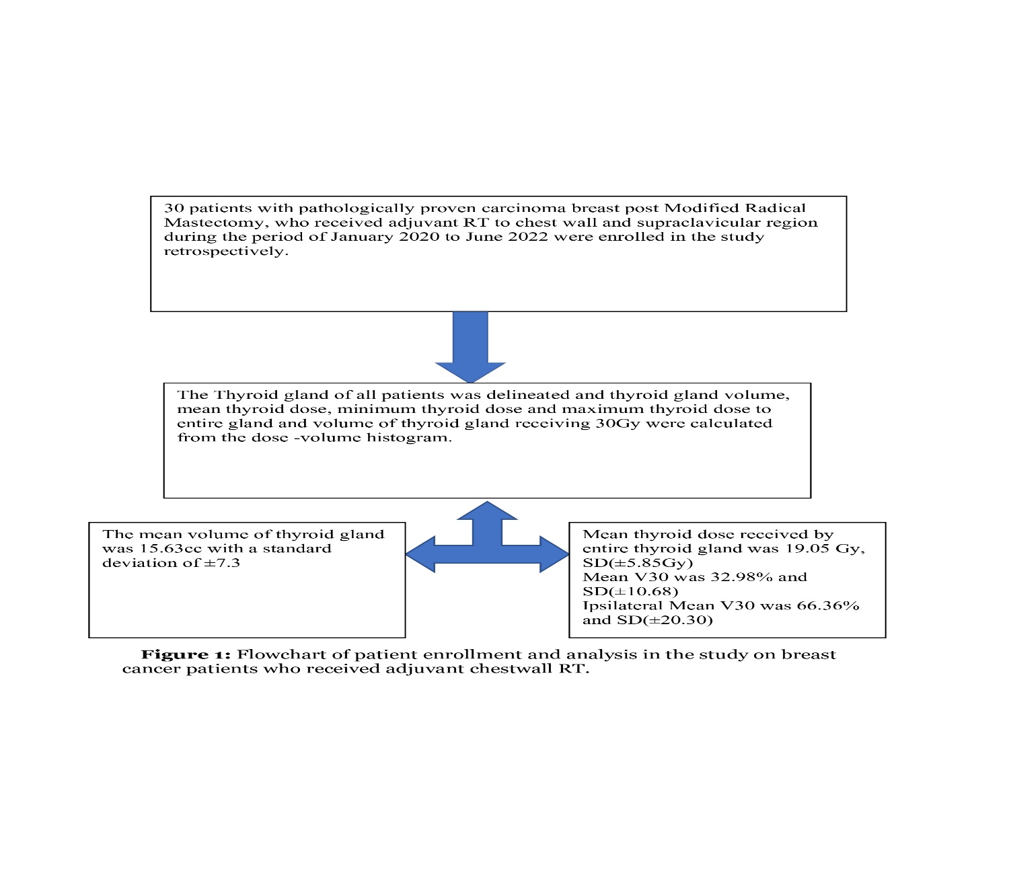

A total of thirty post-mastectomy breast cancer patients who received adjuvant radiotherapy to the chest wall and supraclavicular region were included in the present analysis. The patients’ ages ranged from 37 to 71 years, with a mean of 49.93 years. Of these, 23.3% (n = 7) were classified as Stage II and 66.7% (n = 23) as Stage III disease. All patients underwent modified radical mastectomy followed by adjuvant 3D conformal radiotherapy (3D-CRT) with a prescribed dose of 50 Gy in 25 fractions.
The thyroid gland was contoured retrospectively for each patient, and dose–volume parameters were extracted from the dose–volume histogram (DVH). The mean thyroid volume was 15.63 ± 7.29 cc. The mean dose to the entire thyroid gland was 19.05 ± 5.85 Gy, while the minimum and maximum doses were 0.67 ± 0.33 Gy and 52.67 ± 1.51 Gy, respectively. The mean V30 (volume of thyroid receiving ≥30 Gy) was 32.98 ± 10.68%, and the ipsilateral thyroid V30 averaged 66.36 ± 20.30%.
These results indicate that even with standard 3D-CRT techniques, a significant proportion of the thyroid gland receives moderate-to-high radiation doses, particularly on the irradiated side, underscoring the importance of considering the thyroid as an organ at risk (OAR) during radiotherapy planning.

Table 1: Patients Characteristics and Dosimetry
Patient Characteristics
Variables |  | All patients (n=30)
Age |  | 49.93years(37-71)
Surgery |  | Modified Radical Mastectomy
Stage Grouping | II | 7(23.3%)
Stage Grouping | III | 23(66.7%)
Treatment Received |  | Adjuvant Radiotherapy
Radiotherapy Dose |  | 50Gy / 25 fractions
Radiotherapy Technique |  | 3D conformal radiation therapy
Mean Thyroid Volume in cc |  | 15.63cc, SD(±7.29)
Mean thyroid dose received by entire gland |  | 19.05Gy, SD(±5.85)
Mean value of minimum dose to thyroid gland |  | 0.67Gy, SD(±0.33)
Mean value of maximum dose to thyroid gland |  | 52.67Gy, SD(±1.51)
Mean V30 |  | 32.98%, SD(±10.68)
Ipsilateral Mean V30 |  | 66.36%, SD(±20.30)
SD- Standard Deviation, Gy- Gray, cc- Cubic Centimetres

DISCUSSION:
It is evident that post-mastectomy radiation therapy is a crucial aspect among patients receiving combination therapy for breast cancer, suggesting that patients who receive adjuvant RT had decreased rates of local recurrence and mortality risk.

The fact that RT lowers the chance of local and regional recurrence as well as overall mortality is undeniable, however, it may also lead to long-term adverse effects, including cardiac toxicity, pneumonitis, and radiation-induced hypothyroidism.
As the thyroid gland is generally not regarded as a major organ at risk during breast cancer radiotherapy and planning limits are frequently not imposed, this study was done to evaluate the thyroid dose volume parameters in patients undergoing RT to supraclavicular area.

In individuals receiving adjuvant RT, where the treatment fields cover the supraclavicular region and thyroid gland, there is documented evidence of post-RT hypothyroidism. Over a 9-year follow-up period, Joensuu et al found that 21% of the study subjects recruited had hypothyroidism post RT.⁽⁸⁾ According to Reinertsen et al., the incidence of hypothyroidism in the general population was 6%, compared to 18% among patients receiving combined treatment modalities. Similarly, Akyürek et al. reported that 21% of patients developed hypothyroidism following therapy, with a mean thyroid dose of ≥36 Gy identified as a significant contributing factor.⁽¹¹⁾

Considering the observed incidence of hypothyroidism, further research is warranted to evaluate the thyroid gland as an organ at risk and to determine the prevalence of radiation-induced hypothyroidism in the Indian patient population.

In our study, the mean thyroid dose was 19.05 Gy, which is below the tolerance limits described by Emami et al., who reported that exposure of the entire thyroid gland to 45 Gy resulted in hypothyroidism in approximately 8% of patients five years after radiotherapy completion. Previous studies have also indicated that mean thyroid doses ranging from 26 Gy to 36 Gy are associated with a significantly higher risk of hypothyroidism, which is notably greater than the mean dose observed in our study.^{(11,13,14)}

A thyroid volume receiving more than 30 Gy to over 50% of its total volume (V30 > 50%) has been identified as a significant risk factor for the development of hypothyroidism
in patients undergoing supraclavicular RT in the study by Tunio MA et al, and 15% of patients developed hypothyroidism. the mean V30 observed in our study was 32.98%, and none of the patients had V30 >50% in our study.⁽¹⁵⁾
This indicated that the study participants in our research were at lower risk for developing hypothyroidism. In a subset analysis the mean V30 of ipsilateral thyroid gland was found to be 66.36%, which is significantly high.

Unnikrishnan AG et al, in his cross sectional epidemiological multi centre study reported in Indian population the risk of hypothyroidism is for 1 adult in every 10 adults, and female gender and old age as high risk factors.⁽¹⁶⁾
Hence it is justified to follow up patients receiving supraclavicular RT and set constraints for thyroid gland as Organ at Risk while planning RT.

Limitations and future direction:
The present study has several limitations that warrant consideration. First, its retrospective design limits the ability to establish a direct causal relationship between thyroid dosimetric parameters and the development of radiation-induced hypothyroidism. As baseline and post-treatment thyroid function tests were not available, the study could not correlate dosimetric findings with biochemical or clinical outcomes, which would have provided a more comprehensive evaluation of thyroid injury.
Second, the sample size (n = 30) was relatively small and derived from a single tertiary care institution, potentially limiting the generalizability of the findings to broader populations. Inter-patient variations in body habitus, thyroid volume, and field geometry could also influence the absorbed thyroid dose and were not stratified in the current analysis. Furthermore, only the 3D conformal radiotherapy (3D-CRT) technique was evaluated; advanced modalities such as IMRT or VMAT, which might reduce thyroid dose exposure, were not included for comparison.
Lastly, the short follow-up period precluded assessment of late radiation-induced effects, as hypothyroidism often manifests months to years post-therapy. Future prospective, multicentric studies incorporating baseline thyroid function, serial biochemical monitoring, and longer follow-up are essential to accurately define the dose–response relationship and establish validated thyroid dose constraints in the Indian clinical context.

Clinical Implications:
The findings from this study underscore the importance of recognizing the thyroid gland as a critical organ at risk (OAR) in breast cancer patients undergoing post-mastectomy radiotherapy with supraclavicular field inclusion. Although the mean thyroid dose in this cohort was below conventional tolerance limits, a significant proportion of the gland received moderate radiation exposure, indicating a potential risk for subclinical or overt hypothyroidism during long-term follow-up.
Incorporating thyroid contouring into the standard radiotherapy planning workflow and applying appropriate dose constraints—such as maintaining the mean thyroid dose below 20 Gy and V30 below 50%—can substantially minimize unnecessary exposure without compromising target coverage. With advancements in radiation delivery, modern techniques such as IMRT or VMAT can be optimized to achieve better conformity and sparing of the thyroid gland while preserving locoregional control.
Given the high baseline prevalence of hypothyroidism in the Indian population, routine thyroid function monitoring should be integrated into post-treatment surveillance protocols for patients receiving supraclavicular irradiation. Early detection and prompt management of thyroid dysfunction can prevent long-term morbidity, improve fatigue and metabolic profiles, and enhance the overall quality of survivorship in breast cancer patients.
Moreover, these findings highlight the need for institutional policy development and inclusion of thyroid dose reporting as a standard quality parameter in radiotherapy audits. A multidisciplinary approach involving radiation oncologists, endocrinologists, and medical physicists is vital to establish safe and evidence-based practice guidelines for thyroid protection in breast cancer radiotherapy.

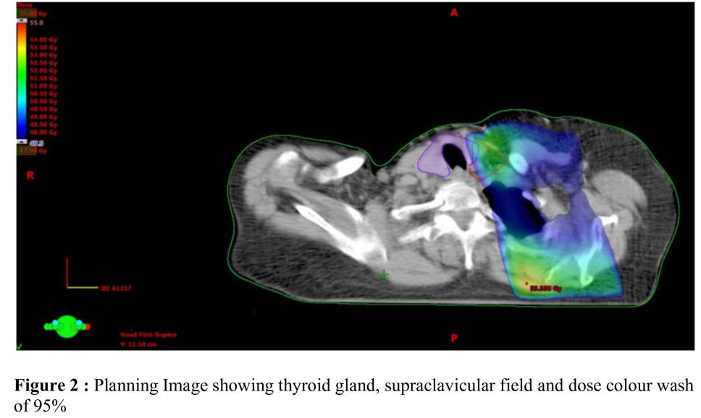

CONCLUSION:
Findings from our study suggest that post-radiation hypothyroidism is a recognized complication among breast cancer patients undergoing supraclavicular radiotherapy with three-dimensional conformal radiotherapy (3D-CRT) techniques. Therefore, the thyroid gland should be regarded as an organ at risk (OAR) during treatment planning. Careful and optimized radiotherapy planning is essential to minimize thyroid exposure and maintain radiation doses as low as reasonably achievable. Furthermore, regular thyroid function monitoring should be incorporated into post-treatment follow-up to enable early detection and management of radiation-induced hypothyroidism.

Competing interests disclaimer:
Authors have declared that they have no known competing financial interests OR non-financial interests OR personal relationships that could have appeared to influence the work reported in this paper.
Disclaimer (Artificial intelligence):
Author hereby declare that NO generative AI technologies such as Large Language Models (ChatGPT, COPILOT, etc.) and text-to-image generators have been used during the writing or editing of this manuscript.

REFERENCES:
1.Ferlay J, Ervik M, Lam F, Colombet M, Mery L, Piñeros M et al., viewed
03 September 2021. Global Cancer Observatory: Cancer Today. Lyon, France:
International Agency for Research on Cancer.[online]. Available from: https://gco. iarc.
fr/today. 2020.
2.Overgaard M, Hansen PS, Overgaard J, Rose C, Andersson M, Bach F et al.,
Postoperative radiotherapy in high-risk premenopausal women with breast cancer who
receive adjuvant chemotherapy. New England Journal of Medicine. 1997 Oct
2;337(14):949-55.
3.Overgaard M, Jensen MB, Overgaard J, Hansen PS, Rose C, Andersson M et al., Postoperative
radiotherapy in high-risk postmenopausal breast-cancer patients given adjuvant tamoxifen:
Danish Breast Cancer Cooperative Group DBCG 82c randomised trial. The Lancet. 1999 May
15;353(9165):1641-8.
4.Early Breast Cancer Trialists' Collaborative Group. Early Breast Cancer Trialists'
Collaborative Group (EBCTCG): Effect of radiotherapy after breast-conserving surgery on 10-
year recurrence and 15-year breast cancer death: Meta-analysis of individual patient data for
10,801 women in 17 randomised trials. Lancet. 2011;378(9804):1707-16.
5.McGale P, Correa C, Cutter D, Duane F, Ewertz M, Gray R et al., Effect of radiotherapy after
mastectomy and axillary surgery on 10-year recurrence and 20-year breast cancer mortality:
meta-analysis of individual patient data for 8135 women in 22 randomised trials. The Lancet.
2014 Jun 21;383(9935):2127-35.
6.Leibel SA, Phillips TL. Textbook of radiation oncology. London: WB Saunders, 1998; 1998
Sep 20.
7.Fisher B, Redmond C, Fisher ER, Bauer M, Wolmark N, Wickerham DL et al., Ten-year
results of a randomized clinical trial comparing radical mastectomy and total mastectomy with
or without radiation. New England Journal of Medicine. 1985 Mar 14;312(11):674-81.
8.Joensuu H, Viikari J. Thyroid function after postoperative radiation therapy in patients
with breast cancer. Acta Radiologica: Oncology. 1986 Jan 1;25(3):167-70.
9.Bruning P, Bonfrer J, Jong-Bakker D, Nooyen W, Burgers M. Primary hypothyroidism in
breast cancer patients with irradiated supraclavicular lymph nodes. British journal of
cancer. 1985 May;51(5):659-63.
10.Reinertsen KV, Cvancarova M, Wist E, Bjøro T, Dahl AA, Danielsen T et al., Thyroid
function in women after multimodal treatment for breast cancer stage II/III: comparison
with controls from a population sample. International Journal of Radiation Oncology*
Biology* Physics. 2009 Nov 1;75(3):764-70.
11.Akyurek S, Babalioglu I, Kenan KO, GOKCE SC. Thyroid dysfunction following
supraclavicular irradiation in the management of carcinoma of the breast. International
Journal of Hematology and Oncology. 2014 Jan 1;32(4):139-44.
12.Emami B, Lyman J, Brown A, Coia L, Goitein M, Munzenrider JE, et al.
Tolerance of normal tissue to therapeutic irradiation. Int. J. Radiat.
Oncol. Biol. Phys. 1991 May 15;21(1):109-122.
13.Akın M, Ergen A, Unal A, Bese N. Irradiation doses on thyroid gland during the
postoperative irradiation for breast cancer. Journal of cancer research and therapeutics.
2014 Oct 1;10(4):942-4.
14.Yoden E, Maruta T, Soejima T, Nishimura H, Sasaki R, Yamada K, Sugimura K.
Hypothyroidism after radiotherapy to the neck. International Journal of Radiation
Oncology, Biology, Physics. 2001 Nov 1;51(3):337-8.

15.Tunio MA, Al Asiri M, Bayoumi Y, Stanciu LG, Al Johani N, Al Saeed EF. Is thyroid gland
an organ at risk in breast cancer patients treated with locoregional radiotherapy? Results of a
pilot study. Journal of cancer research and therapeutics. 2015 Oct 1;11(4):684-9.
16.Unnikrishnan AG, Kalra S, Sahay RK, Bantwal G, John M, Tewari N. Prevalence of
hypothyroidism in adults: An epidemiological study in eight cities of India. Indian J
Endocrinol Metab. 2013 Jul;17(4):647-52. doi: 10.4103/2230-8210.113755. PMID:
23961480; PMCID: PMC3743364.

