Review Article
AI-optimized, organic, and microbial nutrient formulations for higher efficiency and sustainability in hydroponics: A Review

Abstract
Hydroponics presents an alternative to soil-based farming for efficient use of resources, to attain high yield and minimizing environmental impact. Nonetheless, its success depends on the accurate nutrient management, which balance the nutrition of the plants. The new possibilities are associated with artificial intelligence (AI), Internet of Things (IoT), and microbial biotechnology which are recent developments that can be optimized to improve hydroponic nutrient management. This is a literature review on the use of integrated AI-optimized and microbial nutrient formulations to enhance the hydroponic sustainability. Machine learning and hybrid optimization algorithms, allow real-time monitoring and adaptive nutrient dosing with the use of IoT. Compost extracts, fish emulsions are also organic sources of nutrients that increase the plant growth by enhancing the release of nutrients, increase the phytochemical content and improve the quality of the produce. Integrally, Bacillus, and mycorrhizal fungi are growth-promoting microorganisms that enhance solubilization of nutrients and synergistic inoculant-organic systems lead to stable nutrient cycling and an improved root architecture. With the integration of AI-based decision support hydroponics will be able to move towards closed-loop resource-efficient systems that impact the environment less, as well as satisfy global needs of high-quality foods.

Keywords – Hydroponics, Artificial Intelligence (AI), Sustainable Agriculture, Microbial Bioformulations, Nutrient Management.

- Introduction
The rising global population coupled with climate change and depleting the water and arable land resources puts an urgent pressure on farm systems in producing more food with less expenditure yet maintain environmental sustainability. Growing in soilless methods such as hydroponics and analogues such as aeroponics and vertical farming are potential solutions to provide such solutions through enabling specific regulation of nutrient delivery, minimized water consumption, and year-round manufacturing. These advantages may be maximized by optimizing the growth parameters (i.e. pH, electrical conductivity, temperature, humidity, and nutrient solution constitution). More recent developments in artificial intelligence (AI), Internet of Things (IoT), sensor networks, and microbial inputs (including Plant Growth-Promoting Microorganisms, PGPMs) have demonstrated the possibility of being more efficient, yielding more, and resilient in hydroponic systems.
The latest systematic review, A Systematic Literature Review on Parameters Optimization of Smart Hydroponic Systems. (Shareef et al., 2024), reported on 131 determined papers and identified that most of the studies are studies on technological descriptions (approx.38.5 percent) and artificial illumination (approx.26.2 percent) whilst preciseness of nutrient solution composition and growth parameters (including EC, pH, temperature, humidity) are comprising of about 13.8 percent of the literature. This highlights the gains and the shortcomings (Shareef et al., 2024).
In parallel, the contributions of the role of the PGPMs to the improvement of nutrient uptake, stress tolerance, and biomass of the soilless systems have also experienced a growing number of studies. The free review publication Plant-microbe interactions: PGPM as microbial inoculants/ biofertilizers to maintain crop productivity and soil fertility reveals that there are various ways in which plant growth (microbial fixation of nitrogen, solubilization of phosphorus, etc.) can promote growth, and it addresses their applications in regulated environment agriculture. (Laishram et al., 2025).
Furthermore, hydroponic and aeroponic greenhouse are being connected to an IoT-based monitoring and automation able to deliver real-time feedback and regulate important growth variables. In the case of Internet of Things based smart automated indoor hydroponics and aeroponics greenhouse in Egypt (2024), the system describes a system that monitors and controls environmental and nutrient parameters and enhances the uniformity of the growth under new ambient conditions. (Sadek et al., 2024).
Although these advancements are there, there exists challenges. These are high start up cost of technology, integration complexity, inconsistency of organic or microbes input efficiency and lack of long term field gleaning particularly in business. To respond to them, it is necessary to perform strict quantification of system responses, standardization of monitoring procedures, and integration of digital technologies and biological approaches. The synthesis in this paper contributes to the development of AI-controlled hydroponics, the roles of the PGPM, and the issues related to integrations and required research to achieve sustainable farming.

- AI-Optimized Nutrient Formulations in Hydroponics
As a combination of AI-based algorithms and IoT sensor networks, this technology allows to dose the nutrients in hydroponics accurately, eliminating the human factor and increasing the stability of yield. Predictive analytics and optimization models optimize the utilization of nutrients and reduce the environment effects which improve AI as a revolutionary solution in sustainable hydroponic systems. (Dhal et al., 2024);(Woźniak & Ijaz, 2024).
  - Machine Learning Models for Nutrient Prediction and Control

Complex machine learning technologies have transformed accurate control of nutrients in hydroponic plants by forecasting patterns of nutrient uptake in plants and real-time resource optimization. Random Forest algorithms can be used to predict 81 percent and Support Vector Regression models can be used to predict using multiple parameters of soybean hydroponic systems. (Dhal et al., 2024);(Woźniak & Ijaz, 2024). Artificial Neural Networks also minimize the percentage of manual interventions in tomato production by 55% and the percentage of resources used by 65% with automated feedback control systems. (Baraskar et al., 2025). Convolutional Neural Networks classify plant diseases and detect nutrient deficiency with 98 percent accuracy, which can be used as a preventive intervention measure. (Woźniak & Ijaz, 2024);(Khan et al., 2023). The addition of IoT sensors networks would enable continuous monitoring of multi-parameters and real-time changes in nutrient solutions increasing the level of responsiveness and accuracy of the system.

2.2 IoT Integration and Sensor Network Architecture
IoT platforms help collect extensive data on the basis of multi-parameter sensor networks, which monitor pH, electrical conductivity, dissolved oxygen, temperature, humidity, and light intensity in real-time. (Abdelhamid et al., 2025). The sensor fusion algorithms are advanced that combine data streams of various type to give a holistic assessment of the system state to allow the prediction analytics to predict nutrient demand and to optimize the environment. (Woźniak & Ijaz, 2024). Receiving long times in decision-making processes are minimized using edge computing architecture, costs of transmitting data are minimized and the systems are more reliable. Cloud-based analytics systems allow comparison between several production facilities to result in continual improvement due to learning algorithms. (Abdelhamid et al., 2025);(Woźniak & Ijaz, 2024).
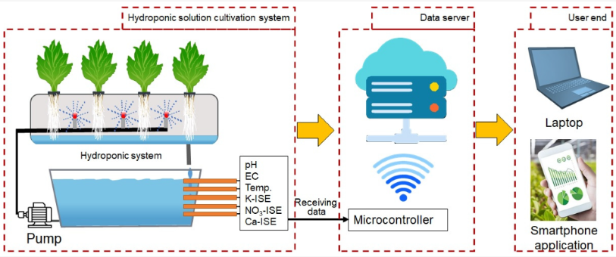
Fig 1: The system architecture of IoT-based hydroponics solution cultivation, highlighting the interconnection between various components, including sensors, microcontrollers, data servers, and user-end devices for real-time monitoring and automated nutrient management.
[Source: (Reza et al., 2025)]

Table 1. Technologies Enhancing Nutrient Management in Hydroponic Systems:

Technology | Role | Benefits | References
Artificial Intelligence (AI) | Predicts nutrient needs via growth and environment data | Increases efficiency, yield, and quality; reduces labor | (Dhal et al., 2024); (Baraskar et al., 2025).
Internet of Things (IoT) Sensors | Real-time monitoring of pH, EC, temp, humidity | Ensures precise nutrient control and quick adjustments | (Abdelhamid et al., 2025).
Predictive Analytics | Forecasts nutrient demands and dosing schedule | Prevents deficiencies, optimizes resources, stabilizes growth | (Woźniak & Ijaz, 2024); (Abdelhamid et al., 2025).
Edge/Cloud Computing | Local and cloud data processing for faster decisions and multi-site analytics | Improves system responsiveness and scalability | (Abdelhamid et al., 2025).

  - Predictive Analytics and Decision Support Systems
Predictive modeling technologies use past production data, weather projections, as well as crop phenological data to optimize farming schedules of nutrient applications and control nutrient levels. (Woźniak & Ijaz, 2024). The algorithms used in time-series analysis uncover seasonal trends and the needs relating to growth stages, which is used to conduct proactive nutrient management control to avoid deficiencies before affecting the crop performance. (Abdelhamid et al., 2025). Multi objective optimization routines are used to optimize yield, quality, resource efficiency and profitability together by carrying out advanced trade-off analysis. (Woźniak & Ijaz, 2024).
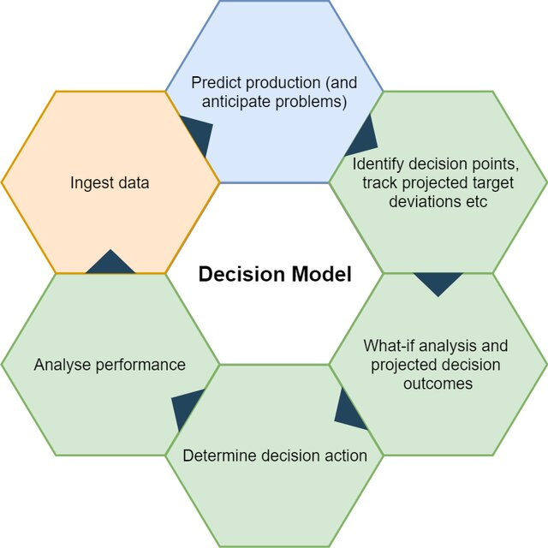
Fig 2: Iterative, data-driven decision process as applied in advanced hydroponic management, enabling predictive, real-time optimization of nutrient and crop parameters.
[Source: (Ghandar et al., 2021)]

- Organic Nutrient Formulations for Hydroponics
Slow-release nutrients like seaweeds extracts, compost teas, fish emulsions, etc. are organic sources of nutrients in crops that improve crop quality and phytochemicals. Biochar carriers and encapsulation also enhance stability of solutions and hence organic formulations can be used as alternatives to synthetic inputs in hydroponic agriculture. (Hooks et al., 2022);(Alneyadi et al., 2024).
  - Sources and Composition of Organic Nutrients
Hydroponic usages embrace the adoption of different organic sources of nutrient like compost teas, manure extracts, vermicompost leachates and organic liquid fertilizers. The humic matter in forest soils or peat excites the root enzyme activities and increases nutrient uptakes, boosts the photosynthetic capacity and plant metabolism. (Carlos Rodríguez Ortiz, 2020);(Park & Williams, 2024). Fish emulsions and seaweed extracts contain the necessary phytohormones, which stimulate cell division and cell extension, contribute to plant enlivening and productivity. (Dasgan et al., 2023). Organic formulations are chemically complicated to release nutrients slowly and in a sustained rate typically depending on microbial degradation. This gradual release system is able to dodge instant availability of nutrients but stretches effective nutrient provision, which fosters consistent development during the plant cycle of existence. (Carlos Rodríguez Ortiz, 2020).

  - Nutrient Release Dynamics and Solution Stability

The rate of mineralization of nutrients in the organic hydroponic nutrient solution is strongly influenced by the microbial activity, temperature, pH, and dissolved oxygen, and, therefore, to ensure nutrient homogeneity, strict control over the nutrient solution is required. (Alneyadi et al., 2024);(Abdelhamid et al., 2025). Buffering systems that use organic acids and microbial metabolites help stabilize variations in pH and maintain the solubility of nutrients. (Hooks et al., 2022). Regulated-release formulations that involve encapsulation technology of slow-release carriers have been devised to increase the availability of the nutrient thus limiting the number of applications and labor demanded. (Amalia et al., 2023);(Woźniak & Ijaz, 2024). Also, carriers built of biochar have been found to be more effective in nutrient retention and as a beneficial surface to colonization of microbes, which further promotes stability of solutions. (Alneyadi et al., 2024);(Abdelhamid et al., 2025).

  - Impact on Crop Quality and Phytochemical Enhancement

The use of organic nutrient regimes has been shown to have the best output of crops into antioxidant capacity, polyphenols and essential oils. (Hooks et al., 2022);(Alneyadi et al., 2024). Organic-microbial formulations on lettuce result in 30% increments in the antioxidants content yet there is competitive harvest. (Hooks et al., 2022). Controlled studies demonstrate 15-25% improvements in vitamin C content, phenolic compounds, and mineral density compared to synthetic nutrient controls (Alneyadi et al., 2024);(Woźniak & Ijaz, 2024). Flavor profile enhancement through organic nutrition contributes to premium market positioning and consumer preference, particularly in high-value specialty crops (Woźniak & Ijaz, 2024). Reduced nitrate accumulation in leafy greens improves food safety and nutritional value.

  - Economic Considerations and Cost-Benefit Analysis

Economic analysis reveals competitive production costs for organic hydroponic systems when productivity benefits and premium pricing are considered (Abdelhamid et al., 2025; Amalia et al., 2023);(Alneyadi et al., 2024). Initial infrastructure investments are offset by reduced fertilizer costs and improved market positioning within 18-24 months for medium-scale operations. Labor efficiency gains through reduced monitoring requirements and automated AI-enabled systems further contribute to overall economic viability (Woźniak & Ijaz, 2024). Additionally, value-added marketing opportunities through organic certification and sustainability branding provide significant revenue streams for producers in high-value niche markets (Alneyadi et al., 2024).

- Microbial Nutrient Formulations and Their Role in Hydroponics Plant growth
PGPM including Azospirillum, Bacillus, and arbuscular mycorrhizal fungi improve nutrient solubilization, nitrogen fixation, and stress tolerance. Inoculation enhances biomass, nutrient density, and pathogen resistance in hydroponic crops, particularly when co-inoculation strategies are applied (Mourouzidou et al., 2023);(Dhawi, 2023).

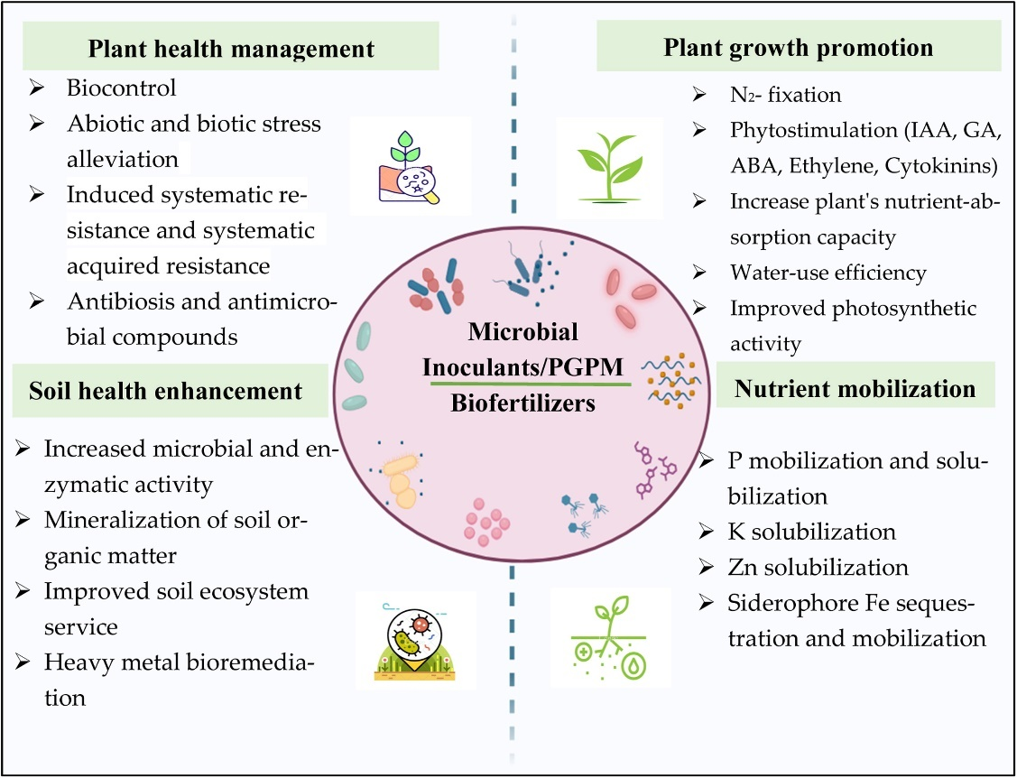
Fig 3: Mechanism of PGPM/microbial inoculants as biofertilizers
[Source: (Laishram et al., 2025)]

  - Mechanisms of PGPM Action

PGPM exert a variety of beneficial effects on plants through several mechanisms. Beneficial bacteria such as Azospirillum, Bacillus, and Pseudomonas species are capable of fixing atmospheric nitrogen, thereby increasing the availability of this essential nutrient. They also solubilize phosphates, chelate micronutrients, and produce growth–enhancing hormones that stimulate root gravimetric expansion and nutrient absorption . In parallel, arbuscular mycorrhizal fungi (AMF) form symbiotic associations with plant roots, dramatically increasing the effective root surface area and thereby improving the uptake of water and mineral nutrients under diverse environmental conditions (Mourouzidou et al., 2023).

  - Efficacy of PGPM in Hydroponic Systems

Substantial experimental evidence demonstrates that inoculation of hydroponic systems with PGPM leads to significant improvements in plant biomass, yield, and nutrient content. For example, studies on hydroponically grown lettuce and tomato have reported increased leaf area, higher fresh weight, and improved nutrient profiles when PGPM such as Bacillus subtilis and Azospirillum brasilense are applied (Mourouzidou et al., 2023);(Dhawi, 2023). Co–inoculation strategies, wherein multiple microbial species with complementary functions are introduced together, have been shown to further enhance nutrient solubilization, promote synergistic phytohormone production, and offer better biocontrol against microbial pathogens than single–strain inoculations (Mourouzidou et al., 2023).

4.3 Integration of Microbial Inoculants with Organic Nutrient Formulations

Considering overall aerobic nutrient formulation plus microbial inoculants has proved to be a very viable strategy in realization of high nutrient use efficiency in hydroponic environment. In these systems, organic amendments are a rich substrate content in the presence of co-inoculated PGPM which trigger the breakdown of the organic molecules in the substrates to readily available nutrients. This synergized process does not only make the supply of nutrients more stable and consistent over time but also lowers nutrient initial dosages of nutrients, thus alleviates risks of over-nutrient therapy and leaching. Combination of organic inputs and use of PGPM has also been linked to enhanced root structure and increase in the reactions against abiotic conditions, yet again supporting the prospects of this combined nutrient approach. (Park & Williams, 2024);(Ikiz et al., 2024).

Table 2. Effects of Organic and Microbial Nutrient Inputs on Hydroponic Crop Performance:

Input Type | Mechanism | Effects | References
Organic Nutrients (e.g., compost, fish emulsions) | Provide nutrients and phytohormones | Boost antioxidants, flavor, vitamins, sustained growth | (Hooks et al., 2022); (Dasgan et al., 2023); (Alneyadi et al., 2024)
Plant Growth-Promoting Microorganisms (PGPMs) | Fix nitrogen, solubilize phosphate, enhance root growth | Increase biomass, nutrient uptake, and stress tolerance | (Mourouzidou et al., 2023); (Dhawi, 2023); (Alori & Babalola, 2018)
Combined Organic-Microbial Systems | Support nutrient mineralization and root health | Improve nutrient use and crop resilience | (Ikiz et al., 2024).
Controlled-release Organic Carriers | Slow nutrient release and aid microbes | Reduce nutrient loss and stabilize supply | (Amalia et al., 2023); (Alneyadi et al., 2024).

- Integration of AI, Organic, and Microbial Approaches
The combination of AI-controlled decision models with natural inputs and microbial inoculants leads to nutrient usage, crop production, and sustainability. It is possible to proactively manage nutrients using digital twin simulations and hybrid optimization algorithms and case studies have reported yield increase and minimized nutrient waste in tomato and lettuce hydroponic agriculture. (H. Chowdhury et al., 2023);(Dhal et al., 2024).

  - Synergistic Benefits and System Integration

The nutrient management systems based on AI utilize real-time sensor data to modify the nutrient formulation depending on the physiological needs of plants, environmental changes and variations in the growth phases. These systems sustain the optimum conditions of nutrients when used with organic nutrient formulations and microbial consortia without the presence of problems such as excess fertilization and nutrient imbalances. (H. Chowdhury et al., 2023). The models of digital twins model the biogeochemical processes in the hydroponic system and allow proactive changes in nutrient dose. (Ghandar et al., 2021). The method is a guarantee of the accurate nutrition constituent, saves on water and fertilizer usage, lowers operating expenses, and diminishes adverse effects on the environment. The total advantages create greater efficiencies in its system and better production of the crop and a decrease in the ecological footprint. (H. Chowdhury et al., 2023).

  - Hybrid Optimization Algorithms and Resource Allocation

Hybrid optimization methods have been alike the way to optimize nutrient and water inputs in dynamic hydroponic systems on multiple crops. These algorithms adopt various methods such as decision-tree dosing, Integer Linear Programming (ILP), and genetic algorithms to come up with the best way of allocating resources during certain growth cycles. To solve the problem which can be found to be NP-hard, they use global search of the genetic algorithms, coupled with local search techniques to obtain near-optimal solutions. These models provide maximum yield, reduced inputs waste, and lower negative environmental impacts by bringing in the economic and environmental parameters. The pilot studies of the deployment of these hybrid models have demonstrated that AI-based resource allocation can enhance the assertiveness of nutrient utilization. (H. Chowdhury et al., 2023);(Ghandar et al., 2021).

5.3 Practical Applications and System Demonstrations
The case studies of recent years demonstrate the feasibility of the operation of integrated systems incorporating AI optimization with organic and microbial nutrient formulations in practice. The systems have minimized the use of nutrient solutions by up to 57 percent with no decrease in crop yield and quality in case of hydroponic soybean and lettuce cultures. (Dhal et al., 2024). This method will both save on operating costs and environmental problems and is also a solution to the intricate problems of contemporary controlled-environment agriculture. The effective combination of AI-based predictive models, sensor networks, and hybridized optimization algorithms, as well as organic formulations and PGPM, also testifies to the transformational opportunity of such a solution. (H. Chowdhury et al., 2023).

- Case Studies and Commercial Applications

  - AI Optimized Lettuce Production Systems
Extensive case studies of AI-driven nutrient modelling under the influence of IoT monitoring systems using the example of controlled environmental lettuce production prove an 18-percent increase in biomass and a 25-percent decrease in nitrogen consumption using AI. Machine learning algorithms ensure optimality of harvest timing, and also higher quality of the leaves and reduced wastage of resources. (Woźniak & Ijaz, 2024);(Dhal et al., 2024). A consistent outcome of commercial realization of vertical farming facilities is depicted over several crop cycles where ROI can be achieved within a 24-month term through decreased labor expenses and a better yield per planting. With automated pH and EC regulation systems, optimum growing requirements are kept and minimal operators are required to attend to them. (Abdelhamid et al., 2025);(Ram, 2024);(Sharma & Shivandu, 2024).
  - Organic-Microbial Integration in Herb Production
Growing basil with organic nutrients with enriched-PGPR shows 15 percent more output and 25 percent more essential oil content than synthetic controls. The measures of quality such as flavor intensity as well as shelf life improve considerably with an increase in the production of plant secondary metabolites. (Sun et al., 2024);(Khan et al., 2023);(M. Chowdhury et al., 2024);(Hooks et al., 2022). The economic prospect is that premium pricing opportunities are compensated by the increased costs of production and net profitability improvements by 20-30 in the high-value herb markets. Coherent parameters in quality will allow the establishment of trusting supply relationships with the commercial buyers. (Bhattacharya et al., 2025);(Abdelhamid et al., 2025);(Wang et al., 2025).
6.3 Large-Scale Tomato Production with AI-Organic Systems
Commercial plant greenhouse tomato farms practicing AI-based nutrient management of organic cultivation show 35 percent nutrient use improvement and same yields as at conventional plants. Nutrient concentrations are adjusted after real-time monitoring uses vegetative phenological stage and environment to change nutrient concentration.
Optimal environmental control facilitates the saving of energy, which leads to the overall sustainability and the minimization of the costs of operations. Since the disease pressure will be decreased by means of the increased immunity of the plants, the pesticide needs and expenditures will be lowered. (Rajendran et al., 2024);(Abdelhamid et al., 2025).

- Challenges and limitations
Regardless of the encouraging developments, there are still a number of issues to overcome in the creation and the extensive implementation of AI-optimized, organic, and microbial formulations of nutrients to be used in hydroponics. The dependability and calibration of sensor technologies is also one of the challenges. Precise pH, EC and single ion concentration sensors, and environmental measurements and indicators should be supported and regularly tested to ensure they can feed the AI algorithms with correct input. Any noise or error in readings of sensors will result in inappropriate dosing of nutrients and may also jeopardize plant health. (Putra et al., 2024);(Park & Williams, 2024).
There is also a lack of data and reproducibility of models. Neural networks and a variety of ensemble models are all AI models that demand considerable amounts of data to be trained on. In most hydroponic systems and in particular the small or new ones, the historical sensor data may be inadequate to achieve the full potential of advanced ML algorithms. These shortcomings might have to be overcome with the creation of universalized data gathering codes or the implementation of artificial data enrichment schemes. (Dennison et al., 2025).
The other difficulty is in the natural variability of the origin of organic nutrients, the inorganic molecules, and microbial inoculants. Formulations of organic nutrients can be vastly different in composition as well as the rate of mineralization of nutrients is subject to numerous factors such as temperature, pH, microbial activity, etc. In addition, microbial populations might change throughout time, and they may not necessarily form strong communities within the sterile conditions that are found in many hydroponic systems. All of the mentioned aspects require the creation of powerful AI models that can withstand non-linear, time-varying data and respond to unforeseen variations. (Fussy & Papenbrock, 2022);(Dhawi, 2023).
The first is the energy consumption and initial capital investment of AI-enabled infrastructure, which are also another hindrance to adoption. The upfront costs related to complex sensor networks, data processing hardware, and cloud-based services are still very high when advanced AI and IoT-based systems have important long-term cost-saving and sustainability. The future studies can be done on creating cost-efficient, low power divisions of sensors and edge computing systems that do not entail the reliance on costly centralized processing devices. (Dennison et al., 2025).

- Future Prospects
Some trends can bring the AI-integration into organic nutrition sources and microorganism-formulations hydroponics in the future. Prediction and dosing of nutrient will be enhanced as the deep learning and the reinforcement learning applied to develop AI algorithms will result in the enhanced accuracy. Moreover, the progress in ion-selective electrode to detect the individual nutrient ions and improved optical sensors to detect the nutrient quickly will enhance the feedback mechanism that is needed to achieve optimum nutrition. (Reza et al., 2025).
There is also an increasing interest in digital twin technology that can develop virtual models of hydroponic systems to recreate various strategies that can be used to manage nutrients before these processes are applied into actual systems. These simulations could be useful in streamlining supply chain management, anticipating a system failure, and coming up with contingencies in the event of an unexpected nutrient imbalance or a change of the microbial composition. (Reza et al., 2025);(Gourshettiwar & Reddy, 2024).
Last but not least, further development of this area requires interdisciplinary cooperation between agronomists, Computer scientists, microbiologists and engineers. With its data, model refinement, and joint development of integrated nutrient management solutions, the agricultural community can speed up the commercialization of these technologies out of the research laboratories. The key to addressing the existing challenges and making AI-optimized, organic, and microbial nutrient formulations a usual practice in sustainable hydroponic manufacturing will come across collaborative efforts. (Gourshettiwar & Reddy, 2024);(Almusawi et al., 2025).

- Conclusion
The combination of artificial intelligence, organic nutrient formulations, and plant growth-promoting microorganisms (PGPM) is a new milestone of a sustainable approach towards hydroponic agriculture. This can be achieved through AI-assisted nutrient management systems, enabled by IoT-based sensor networks and predictive analytics to make real-time growth adjustments that improve the precision, lessen yield input, and increase yield stability. (Dhal et al., 2024);(Woźniak & Ijaz, 2024). These systems are able to maintain plant growth and provide enrichment to crop phytochemical, flavour and nutritional value when used together with other organic amendments like seaweed extracts, humic substances and fish emulsions. (Hooks et al., 2022);(Alneyadi et al., 2024). Additionally, not only do the Azospirillum, Bacillus and arbuscular mycorrhizal fungi support nutrient solubilization, fixation of nitrogen and even tolerance to stress, but also increase the resilience of the system and minimizes the use of synthetic inputs. (Mourouzidou et al., 2023);(Dhawi, 2023).
Case studies across lettuce, basil, soybean, and tomato production confirm the synergistic benefits of integrating AI, organic, and microbial strategies, with reported gains in yield, nutrient-use efficiency, and profitability, alongside reductions in fertilizer consumption and environmental impact (H. Chowdhury et al., 2023);(Abdelhamid et al., 2025). However, widespread adoption is challenged by sensor calibration needs, variability in organic inputs, microbial community stability, and the high upfront costs of digital infrastructure (Putra et al., 2024);(Dennison et al., 2025). Addressing these issues will require the development of cost-effective sensor technologies, standardized data protocols, and robust AI models capable of adapting to non-linear, dynamic conditions.
Looking forward, digital twin simulations, deep learning algorithms, and synthetic data augmentation offer promising avenues to overcome current limitations (Reza et al., 2025);(Gourshettiwar & Reddy, 2024). Interdisciplinary collaborations between agronomists, computer scientists, and microbiologists will be essential to translate laboratory advances into scalable, commercial applications. By uniting AI-based optimization with organic and microbial nutrient inputs, hydroponic systems can move closer to closed-loop, resource-efficient production models that not only secure high yields but also ensure food quality, economic viability, and ecological sustainability.

Data Availability
No new data were generated or analyzed in this study.
Disclaimer (Artificial intelligence):

Author(s) hereby declare that NO generative AI technologies such as Large Language Models (ChatGPT, COPILOT, etc.) and text-to-image generators have been used during the writing or editing of this manuscript.

- References
Abdelhamid, M. A., Mahmoud, S. M., El-Nasr, M. K. A., Zhang, Z., & Hendy, Z. M. (2025). Sustainable hydroponic production using solar energy and treated greywater within the water-energy-food-environment nexus. Scientific Reports, 15(1), 1–18. https://doi.org/10.1038/s41598-025-16030-4
Almusawi, M., Hussein, A. H. A., & Raju, V. S. P. (2025). Advanced Hydroponic Nutrient Management Systems for Vertical Farming Efficiency with IoT and Model Predictive Control to Enhance Sustainable Crop Growth. SHS Web of Conferences, 216, 01058. https://doi.org/10.1051/shsconf/202521601058
Alneyadi, K. S. S., Almheiri, M. S. B., Tzortzakis, N., Di Gioia, F., & Ahmed, Z. F. R. (2024). Organic-based nutrient solutions for sustainable vegetable production in a zero-runoff soilless growing system. Journal of Agriculture and Food Research, 15(October 2023), 101035. https://doi.org/10.1016/j.jafr.2024.101035
Alori, E. T., & Babalola, O. O. (2018). Microbial inoculants for improving crop quality and human health in Africa. Frontiers in Microbiology, 9(SEP), 1–12. https://doi.org/10.3389/fmicb.2018.02213
Amalia, A. F., Waris, A., Rahayu, H. S. P., Rahardjo, Y. P., Hutahaean, L., & Rohaeni, E. S. (2023). Revista Brasileira de Engenharia Agrícola e Ambiental Artificial intelligence for small hydroponics farms employing fuzzy logic systems and economic analysis 1 Inteligência Artificial para pequenas fazendas hidropônicas empregando sistemas de lógica fuzzy. Brazilian Journal of Agricultural and Environmental Engineering, 27(9), 690–697. https://www.scielo.br/j/rbeaa/a/tSGkQMRKRZd8FrHxNqsqLyR/?format=pdf&lang=en
Baraskar, P. T., Khatri, V., Kolhe, P., Katyarmal, M., & Khedekar, S. (2025). AI-powered automated hydroponic system for smart agriculture. MethodsX, 15(August), 103579. https://doi.org/10.1016/j.mex.2025.103579
Carlos Rodríguez Ortiz, J. (2020). Nutritive Solutions Formulated from Organic Fertilizers. Urban Horticulture - Necessity of the Future. https://doi.org/10.5772/intechopen.89955
Chowdhury, H., Argha, D. B. P., & Ahmed, M. A. (2023). Artificial Intelligence in Sustainable Vertical Farming. http://arxiv.org/abs/2312.00030
Chowdhury, M., Samarakoon, U. C., & Altland, J. E. (2024). Evaluation of hydroponic systems for organic lettuce production in controlled environment. Frontiers in Plant Science, 15(August), 1–12. https://doi.org/10.3389/fpls.2024.1401089
Dasgan, H. Y., Yilmaz, D., Zikaria, K., Ikiz, B., & Gruda, N. S. (2023). Enhancing the Yield, Quality and Antioxidant Content of Lettuce through Innovative and Eco-Friendly Biofertilizer Practices in Hydroponics. Horticulturae, 9(12), 1–19. https://doi.org/10.3390/horticulturae9121274
Debasruti Bhattacharya,Suchismita Tripathy, D. K. S. &Adinpunya M. (2025). No Title Evaluating enriched vermitea as a sustainable alternative to inorganic nutrient solutions in hydroponic systems. International Journal of Vegetable Science, 31, 272–287. https://doi.org/10.1080/19315260.2025.2462641
Dennison, M. S., Kumar, P. S., Wamyil, F., Meji, M. A., & Ganapathy, T. (2025). The role of automation and robotics in transforming hydroponics and aquaponics to large scale. In Discover Sustainability (Vol. 6, Issue 1). Springer International Publishing. https://doi.org/10.1007/s43621-025-00908-4
Dhal, S. B., Mahanta, S., Moore, J. M. C., & Kalafatis, S. (2024). Machine learning-based analysis of nutrient and water uptake in hydroponically grown soybeans. Scientific Reports, 14(1), 1–15. https://doi.org/10.1038/s41598-024-74376-7
Dhawi, F. (2023). The Role of Plant Growth-Promoting Microorganisms (PGPMs) and Their Feasibility in Hydroponics and Vertical Farming. Metabolites, 13(2). https://doi.org/10.3390/metabo13020247
Fussy, A., & Papenbrock, J. (2022). Techniques — Chances , challenges and the neglected question of sustainability. Plants, 11(1153), 1–32. https://doi.org/ 10.3390/plants11091153
Ghandar, A., Ahmed, A., Zulfiqar, S., Hua, Z., Hanai, M., & Theodoropoulos, G. (2021). A decision support system for urban agriculture using digital twin: A case study with aquaponics. IEEE Access, 9, 35691–35708. https://doi.org/10.1109/ACCESS.2021.3061722
Gourshettiwar, P., & Reddy, K. (2024). Advancements in Hydroponics: A Review of Machine Learning and IoT Innovations. https://doi.org/10.20944/preprints202409.0226.v1
Hooks, T., Masabni, J., Sun, L., & Niu, G. (2022). Effects of organic fertilizer with or without a microbial inoculant on the growth and quality of lettuce in an NFT hydroponic system. Technology in Horticulture, 2(1), 1–8. https://doi.org/10.48130/tih-2022-0001
Ikiz, B., Dasgan, H. Y., & Gruda, N. S. (2024). Utilizing the power of plant growth promoting rhizobacteria on reducing mineral fertilizer, improved yield, and nutritional quality of Batavia lettuce in a floating culture. Scientific Reports, 14(1). https://doi.org/10.1038/s41598-024-51818-w
Khan, A., Singh, A. V., Gautam, S. S., Agarwal, A., Punetha, A., Upadhayay, V. K., Kukreti, B., Bundela, V., Jugran, A. K., & Goel, R. (2023). Microbial bioformulation: a microbial assisted biostimulating fertilization technique for sustainable agriculture. Frontiers in Plant Science, 14(December), 1–22. https://doi.org/10.3389/fpls.2023.1270039
Laishram, B., Devi, O. R., Dutta, R., Senthilkumar, T., Goyal, G., Paliwal, D. K., Panotra, N., & Rasool, A. (2025). Plant-microbe interactions: PGPM as microbial inoculants/biofertilizers for sustaining crop productivity and soil fertility. Current Research in Microbial Sciences, 8(December 2024), 100333. https://doi.org/10.1016/j.crmicr.2024.100333
Mourouzidou, S., Ntinas, G. K., Tsaballa, A., & Monokrousos, N. (2023). Introducing the Power of Plant Growth Promoting Microorganisms in Soilless Systems: A Promising Alternative for Sustainable Agriculture. Sustainability (Switzerland), 15(7). https://doi.org/10.3390/su15075959
Park, Y., & Williams, K. A. (2024). Organic hydroponics: A review. Scientia Horticulturae, 324, 112604. https://doi.org/https://doi.org/10.1016/j.scienta.2023.112604
Putra, S. D., Heriansyah, H., Cahyadi, E. F., Anggriani, K., & Imron S Jaya, M. H. (2024). Development of Smart Hydroponics System using AI-based Sensing. Jurnal Infotel, 16(3), 474–486. https://doi.org/10.20895/infotel.v16i3.1190
Rajendran, S., Domalachenpa, T., Arora, H., Li, P., Sharma, A., & Rajauria, G. (2024). Hydroponics: Exploring innovative sustainable technologies and applications across crop production, with Emphasis on potato mini-tuber cultivation. Heliyon, 10(5), e26823. https://doi.org/10.1016/j.heliyon.2024.e26823
Ram, B. (2024). Precision Farming With Iot: Soil Nutrient Analysis And Fertilization Recommendation System. African Journal of Biomedical Research, 27(4), 9335–9345. https://doi.org/10.53555/ajbr.v27i4s.5436
Reza, M. N., Lee, K. H., Karim, M. R., Haque, M. A., Bicamumakuba, E., Dey, P. K., Jang, Y. Y., & Chung, S. O. (2025). Trends of Soil and Solution Nutrient Sensing for Open Field and Hydroponic Cultivation in Facilitated Smart Agriculture. Sensors, 25(2). https://doi.org/10.3390/s25020453
Sadek, N., kamal, N., & Shehata, D. (2024). Internet of Things based smart automated indoor hydroponics and aeroponics greenhouse in Egypt. Ain Shams Engineering Journal, 15(2), 102341. https://doi.org/10.1016/j.asej.2023.102341
Shareef, U., Rehman, A. U., & Ahmad, R. (2024). A Systematic Literature Review on Parameters Optimization for Smart Hydroponic Systems. AI (Switzerland), 5(3), 1517–1533. https://doi.org/10.3390/ai5030073
Sharma, K., & Shivandu, S. K. (2024). Integrating artificial intelligence and Internet of Things (IoT) for enhanced crop monitoring and management in precision agriculture. Sensors International, 5(July), 100292. https://doi.org/10.1016/j.sintl.2024.100292
Sun, W., Shahrajabian, M. H., & Soleymani, A. (2024). The Roles of Plant-Growth-Promoting Rhizobacteria (PGPR)-Based Biostimulants for Agricultural Production Systems. Plants, 13(5), 1–37. https://doi.org/10.3390/plants13050613
Wang, O., Deaker, R., & Van Ogtrop, F. (2025). A systematic review of food-waste based hydroponic fertilisers. Agricultural Systems, 223(November 2024), 104179. https://doi.org/10.1016/j.agsy.2024.104179
Woźniak, M., & Ijaz, M. F. (2024). Editorial: Recent advances in big data, machine, and deep learning for precision agriculture. Frontiers in Plant Science, 15(February), 1–4. https://doi.org/10.3389/fpls.2024.1367538

