Original Research Article

Soil Physicochemical Properties and Nutritional Quality of Worowo (Senecio biafrae) in Soils Treated with Neem-Enriched Cow Dung/Sawdust Compost

ABSTRACT
Aims: This study examined the dynamics of soil nutrients and nutritional quality of worowo (Senecio biafrae) using cow dung/sawdust compost enriched with neem meal.
Study Design: The experimental design was Randomized Complete Block Design (RCBD).
Place and Duration of Study: The study site was the Teaching and Research Farm of Ekiti State University, Ado-Ekiti, Nigeria, between March and October, in years 2020 and 2021.
Methodology: In two seasons, 20 cm worowo vines were planted in 8m² beds, with six treatments replicated four times. NPK 15-15-15 at 60 kg N/ha was contrasted with CDSNM (60 g N/kg) applied at 0, 10, 20, 30, and 40 t/ha. The organic treatments were applied at two weeks before planting, and NPK applied two weeks after planting. Soil’s attributes and nutritional contents of worowo were measured at 180 days after planting in the two seasons. Soil and vegetable sample were collected, prepared, and taken to the laboratory for analysis.
Results: Soil’s attributes were enhanced by the addition of CDSNM. The SOM, N, P and K quantities in the first season were 15.5 g/kg, 1.4 g/kg, 15.5 mg/kg and 0.5 cmol/kg, which increased to 19.5 g/kg, 2.7 g/kg, 24.4 mg/kg and 1.3 cmol/kg respectively, in the second season. Worowo’s quality improved by the addition of the organic source. Vines produced by CDSNM applied at 40 t/ha had higher Crude-fibre (CF), protein, moisture, ash, and mineral contents than NPK and the other treatments, at both seasons. The CF contents were in the order: 40 t/ha-12.00±0.59> NPK-11.20±0.59> 30 t/ha-11.00±0.59> 20 t/ha-10.62±0.59>Control-10.50±0.59> 10 t/ha-10.45±0.59, which followed the same order at the second season.
Conclusion: The organic-N-enriched compost positively impacted the soil and nutritional quality (CF in particular), of worowo vegetables. Application of 40 t/ha of CDSNM could therefore be adopted for optimal production of more nutritious worowo vines.

Keywords: Organic fertilizer, Compost-Enrichment, Soil nutrient restoration, Nutritional qualities, Senecio biafrae

1. INTRODUCTION
“Worowo's domestication for regular cultivation is being prompted by growing awareness of its potential in terms of yield, nutrient compositions, and nutritional health roles that are comparable to or better than those of commonly grown leaf vegetables” (Obi 2011; Olumurewa 2011; Adeyemi 2023). However, despite their valued potential, they are frequently in short supply in the majority of urban marketplaces, a sign that their extinction is imminent. Therefore, it becomes imperative to establish management strategies that farmers will be encouraged to follow in order to maximize output and, consequently, enhance the availability of these indigenous vegetables in our markets at affordable and achievable costs.
Worowo [(Sierra Leone ‘bologi’: Crassocephalum biafrae (Oliv. and Hiern) S. Moore); Syn. Senecio biafrae (Oliv. and Hiern)] belongs to the family Asteraceae. It has its origin in West Africa, probably from Sierra Leone or Guinea (Adebooye, 2004). Worowo (plate 1) is a perennial climbing plant which is about 3 m long, and usually consists of a cylindrical, succulent, and heavily branched stem (vine) that is usually braced by a trellis or a semi-permanent stick or rod (Adebooye, 2004). Worowo is commonly found growing in dry highland forests and lowland rainforests of Nigeria, particularly in the southwest (Bello et al. 2018; Adeyemi 2023). Being a shade-loving plant, it is usually found as understory plant in cocoa plantations. Worowo production is being threatened by extinction as a result of the drop in cocoa production brought on by Nigeria's national economy's reliance on petroleum resources, and the destruction of plantations by seasonal wildfires. Due to this decrease, the vegetable is now rare and frequently more expensive than vegetables from Amaranthus species, Celosia argentea, or Corchorus olitorius (Adebooye, 2004; Adeyemi, 2023). However, the ability and effectiveness of organic fertilizers, particularly organic N-enriched cow dung/sawdust compost, for sustained worowo production have been demonstrated by current agronomic research focused on indigenous vegetables (Adeyemi 2023, 2024, 2025).
“Farmers have increased land use to meet food needs without relying on external nutrient inputs because inorganic fertilizers are costly and difficult to get” (Sudip et al. 2023, Gumindoga et al. 2024). “The problem of nutrient depletion needs to be addressed to keep the rapidly declining agricultural output from jeopardizing sustainable economic growth. Additionally, the decline in soil organic matter content is a significant contributing cause to soil deterioration, particularly in Nigeria. It has been concluded from the numerous studies that compared the amount of nitrogen (N) provided by organic and inorganic fertilizers, that organic fertilizers are more effective at enhancing the physicochemical properties of soil and, in turn, the nutritional value of crops and vegetables” (Fawole, 2015, Brempong and Addo-Danso, 2022). Composts, manures, and organic fertilizers may be effective ways to increase soil fertility for worowo production in a sustainable manner (Adeyemi (2024, 2025).
“Compost, is an effective organic fertilizer, so applying compost enhances the nutritional, physical, and biological properties of soils by increasing the amount and quality of soil organic matter as well as the number, variety, and activity of soil organisms” (Rodale, 2012). “Using synthetic fertilizers alone on the other hand could boost crop yields for the initial years, after which yields decrease because of induced increase in soil acidity, which undoubtedly contributes to nutrient imbalance and potential toxicity” (Sudip et al. 2023). However, N-quantity in composts can only enhance crop performance to a certain extent; hence additional N input is required. Therefore, it is necessary to supplement composts with nitrogen-rich organic wastes. Cattle bones, hooves, blood, and horn can be gathered, dried, and made into meals for composts’ enrichment (Fawole et al. 2019; 2021). Additionally, dried neem and sunflower leaves can be made into N-rich meals for composts’ enrichment (Fawole et al. 2019, 2021).
This study:
- examined the dynamics of soil nutrients, and variations in the distribution of soil particles brought about by applying the enhanced compost at various rates;
- evaluated the effects of the nutrient sources, and the various rates of the enriched compost on the nutritional quality of worowo (Senecio biafrae);
- evaluated the residual effects/aftermath of the enriched compost on soil’s physicochemical properties, as well as on the nutritional quality of worowo (Senecio biafrae).

2. MATERIALS AND METHODS
2.1 The Study site
This research project was executed at Ekiti State University’s farms, Iworoko Ekiti, Nigeria, which is strategically placed on latitude 7º31’N and longitude 5º13’E in south-western Nigeria between March and October, in the years 2020 and 2021. The site is situated inside the rain forest zone, with tropical climate; which is characterized by definite wet and dry seasons. November to March, are the dry months while rains are experienced between March and October but with a brief arid period around the middle of August. Recorded annual rainfall of the study area is roughly 1,367 mm, spread out over 112 days. A nearly-constant temperature is experienced all through the year, but variations from 27ᵒC, which is the reported annual temperature, could also be sometimes observed. Mean annual temperatures of 28°C and 27°C were recorded for the assumed hottest months; February and March, respectively. The average sunshine hours per day are about 5 hours, per year, while the mean annual radiation is about 130 k cal/cm²/year (Fasina et al. 2005). The major soil types identified are Iregun, Apomu and Ondo Series (Fasina et al. 2005), derived “from the dominating crystalline igneous and metamorphic rocks, evolving from the pre-Cambrian cellar complex of south western Nigeria. Arable and cash crops, such as maize, yam, cassava, cocoa and kola, are the major parts of the agricultural economy of the area”.

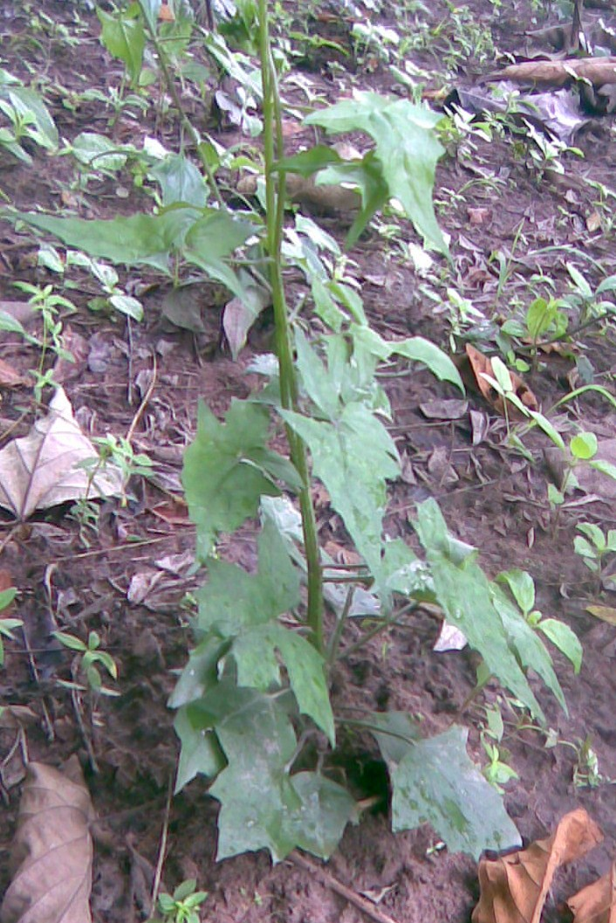

Plate 1: Senecio biafrae (Worowo) on the field, before staking

2.2 Chemical analysis of compost (CDS)
The compost (CDS) reportedly had an alkaline pH of 8.3, and its total N and K contents were 6.4 and 6.1 g/kg, respectively (Adeyemi, 2023, 2024). However, neem leaf meal was used to increase the N content to 60 g N/kg.

2.3 Preliminary soil analysis
The experimental site's soils were sampled for analysis; they were randomly selected at a surface layer of 0 to 15 cm, dried in an open air, and sieved through a 2 mm sieve. The distribution of soil particles, water pH, total nitrogen, organic matter, accessible phosphorus, potassium, sodium, calcium, and magnesium were all measured. Sizes of particles were determined through the hydrometer method of Bouyoucos (Sheldrick and Hand Wang, 1993). Determination of pH of soils was done in distilled water at ratio 1:2 of soils in water, through the electrometric method (IITA 1982). The macro-Kjeldahl digestion method was used to estimate total nitrogen (Bremner 1996) while the organic matter content was evaluated with the wet oxidation procedure (Nelson and Sommers 1996). Quantity of phosphorus available in soils was evaluated using Bray’s p1 procedure (IITA 1982). Neutral, 1 N NH₄0AC was used to extract the exchangeable metals: potassium, calcium, magnesium and sodium (Hendershot and Lalande 1993), after which flame photometer was employed for quantifying K and Na, while estimation of calcium and magnesium contained in filtrates was with Atomic Absorption Spectrophotometer. The effective acidity, extracted, using 1 N KCl, was thereafter measured by titrating with 0.05 N NaOH (Thomas 1982), and phenolphthalein as an indicator. The exchangeable metals and acidity were summed to compute the effective cation exchange capacity (ECEC).

2.4 Planting of worowo vegetables in soils treated with neem-enriched compost (CDSNM)
After planting with the varied rates; 0, 10, 20, 30 and 40 t/ha of cow dung/sawdust compost enriched with neem (CDSNM), 400 kg/ha of NPK 15-15-15 was used for comparison. Six treatments which were in four replicates were used for the investigation which had a total of twenty-four beds of 2 m x 4 m size. The study ran through March and October 2020, and the residual experiment was conducted same period in the year 2021. The five different CDSNM levels were randomly placed in the assigned beds (figure 1), thoroughly mixed with the topsoil, and left to cure for two weeks prior to the planting of worowo stems. The stems were defoliated, cut into 20-cm lengths, and then positioned on the beds at a planting distance of 40 x 60 cm, to form 30 stands per bed. To create artificial shade for the crops, poles draped with palm fronds were erected. Additionally, trellises were constructed to support the vegetables, being a climbing type. The worowo vines were trained to climb on the trellises, and staking was completed at 30 DAP (plate 2). Weeding was initiated at 30 DAP, and repeated at 90 and 150 DAP. At 180 DAP, the edible shoots were sampled, air-dried and prepared for laboratory analysis of the nutritional content. The experiment was repeated in 2021 between March and October.

2.5 Main and residual effects of compost enriched with neem (CDSNM) on the nutritional quality of worowo
Samples of worowo leaves, after harvesting at 180 DAP in the two seasons, were prepared for proximate examination. Evaluation of protein, moisture, ash, crude fibre, fat and carbohydrate; likewise, K, Ca, Mg, Na, Fe, Zn and Cu was done. Protein content was calculated by determination of N using the micro-Kjeldahl procedure and N was thereafter converted by multiplying with 6.25, as a constant. Moisture quantity was detected through drying method; where samples were heated in line with the drying procedure and the weight loss was thereafter used to calculate amount of moisture contained. The fat content was determined by digestion of the protein component with boiling hydrochloric acid in order to break the strong bonds of lipids and protein compounds. Product of digestion was then filtered and the resulting fat, after drying was squeezed out with petroleum ether. The residue, after evaporation and distillation of solvent, was dried and weighed. Determination of crude fibre was done using fibre bag (Gerhardt method). Evaluation of K and Na was through flame photometry and Ca, Mg, Fe, Zn, Cu were detected through Atomic Absorption Spectrophotometer (AAS) (AOAC 2005).

3. RESULTS
3.1 Chemical properties and particle size distribution of soils at the experimental site
Table 1 reveals selected attributes of soils for the studies. The soil was sparingly acidic with pH of 5.8 and 6.6 in KCl and water, respectively. It was a sandy loam with organic matter content at 14.6 g/kg. Soil N was 0.8 g/kg; P was 13.0 mg/kg and the interchangeable cations; K, Ca, Mg and Na were sequentially recorded, as 0.3, 7.0, 1.8 and 0.1cmol/kg (Adeyemi 2025).

RI RII RIII RIV
E
B
D
F

A
E
D
B

1 m
D
F
C
D

29 m
F
C
C
F

C
A
A
B

4m
E
B
A
C

2m 1 m
11m
Figure 1: Experimental Layout for the field trial
Legend CD = Cattle dung
A = CONTROL SD = Sawdust
B = NPK 15-15-15 NM= Neem
C = CDSNM at 40 t/ha RI = Replicate 1
D = CDSNM at 30 t/ha RII= Replicate 2
E = CDSNM at 20 t/ha RIII = Replicate 3
F = CDSNM at 10 t/ha RIV = Replicate 4

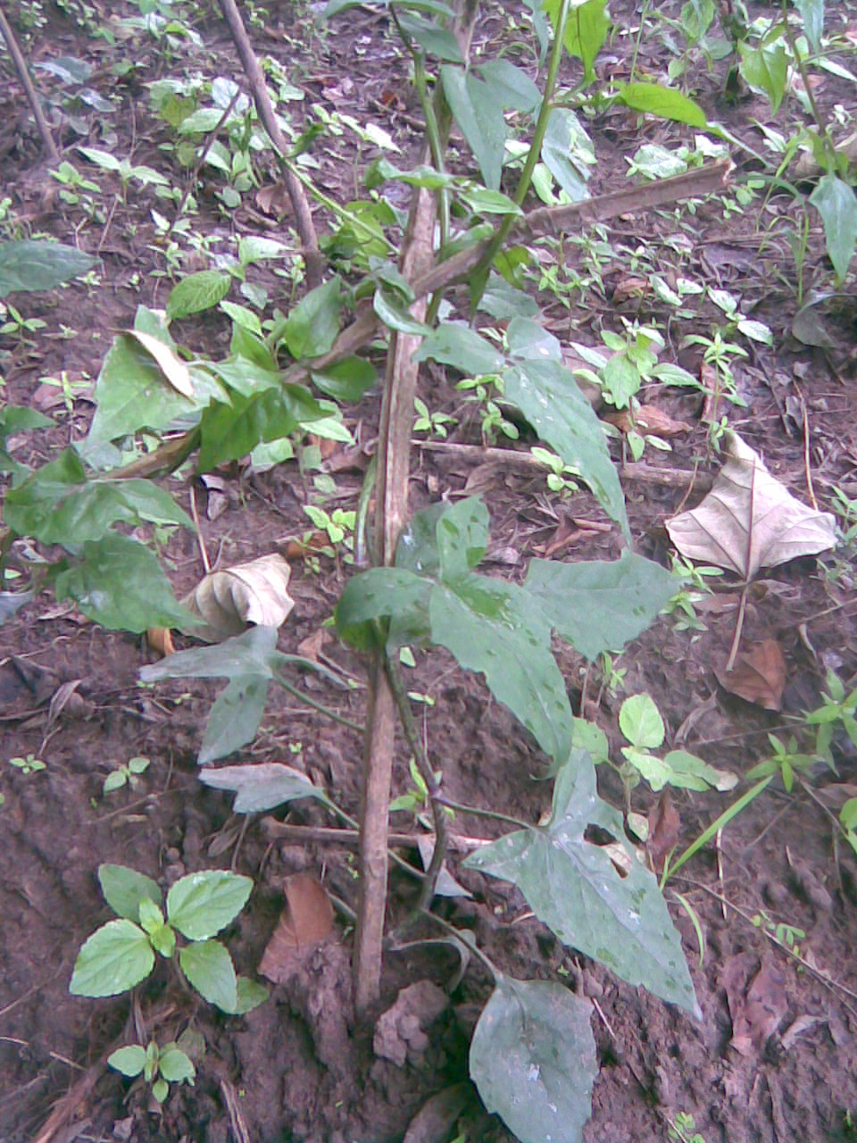
Stake
Worowo

Plate 2: Worowo on the field, as a climbing plant

Table 1: Chemical attributes and particle distribution of experimental soils
Factors | Values
pH (1:1 KCl) | 5.80
pH (H₂O) | 6.60
Total Nitrogen (g/kg) | 0.80
Organic matter (g/kg) | 14.60
Available P (mg/kg) | 13.00
Exchangeable cations (cmol/kg)
Calcium | 2.80
Magnesium | 1.80
Potassium | 0.30
Sodium | 0.10
Exchangeable Acidity | 0.60
ECEC | 5.60
Base saturation (g/kg) | 893
Particle Distribution (g/kg)
Sand | 799
Silt | 132
Clay | 69
Textural Class (USDA) | Sandy Loam

3.2 Residual effects of the neem-enriched compost (CDSNM) on some soil attributes
Attributes of soils of the study sites for the study seasons were highlighted in table 2. The soils of the experimental site were positively impacted by the organic nutrients’ source, both in the first and second season of the study. Notable residual effects of the enriched composts on the soils of the study site could be observed, as the soils were higher in pH value, organic matter content, available N, P, K and exchangeable bases, hence base saturation.

Table 2: Chemical properties and particle size distribution of soils of the study site for the two planting seasons
Parameters | Preliminary | Season 1 | Season 2 (Residual)
pH (KCl) 1:1 | 5.8 | 6.5 | 7.0
pH (H₂O) 1:1 | 6.6 | 7.0 | 7.2
Organic matter (g/kg) | 14.6 | 15.5 | 19.5
Total Nitrogen (g/kg) | 0.8 | 1.4 | 2.7
Available P (mg/kg) | 13.4 | 15.5 | 24.4
Exchangeable cations (cmol/kg)
Calcium ,, | 2.8 | 3.2 | 4.5
Magnesium ,, | 1.8 | 1.9 | 2.27
Potassium ,, | 0.3 | 0.5 | 1.3
Sodium ,, | 0.09 | 0.1 | 0.2
Exchangeable Acidity ,, | 0.6 | 0.1 | 0.13
ECEC ,, | 5.59 | 5.8 | 8.4
Base saturation (g/kg) | 893 | 983 | 985
Particle Distribution (g/kg)
Sand ,, | 799 | 797 | 795
Silt ,, | 132 | 133 | 134
Clay ,, | 69 | 69 | 72
Textural Class (USDA) | Sandy loam | Sandy loam | Sandy loam

3.3 Nutritional quality of worowo (Senecio biafrae) as affected by application of neem- enriched compost (CDSNM)
Table 3 highlights the effect of the enriched composts on worowo’s nutritional quality in the year 2020. All the parameters measured increased with the rates of the enriched compost. The CDSNM applied at 40 t/ha was higher in protein (6.54 %) than CDSNM applied at 30 t/ha (6.20 %). CONTROL plots were least in protein (5.3 %). Plots treated with CDSNM both at 40 and 30 t/ha gave the same value of 66.0 % which was the highest value observed for moisture content. The same moisture content value of 65.0 was observed for vegetables from the CDSNM-treated plots at 10 t/ha and the NPK plots, but the CONTROL plots were the least moistured. Similar trend continues in ash content as the highest ash value of 8.70 %

Table 3: The nutritional quality of worowo (Senecio biafrae) as affected by CDSNM in the first planting season
Parameters | A | B | Treatments  C | D | E | F | Mean | SD
Protein (%) | 5.32 | 6.00 | 6.54 | 6.20 | 5.41 | 5.30 | 5.80 | 0.53
Moisture content (%) | 63.5 | 65.0 | 66.0 | 66.0 | 65.2 | 65.0 | 65.10 | 0.92
Ash | 8.10 | 8.45 | 8.70 | 8.61 | 8.25 | 8.16 | 8.38 | 0.25
Crude fibre | 10.50 | 11.2 | 12.00 | 11.00 | 10.62 | 10.45 | 10.96 | 0.59
Fat | 2.53 | 3.20 | 3.10 | 2.85 | 2.62 | 2.55 | 2.81 | 0.29
Carbohydrate | 10.05 | 6.15 | 3.66 | 5.34 | 7.90 | 8.54 | 6.94 | 2.33
Nitrogen (g/kg) | 2.00 | 8.00 | 5.00 | 3.50 | 3.00 | 2.40 | 3.98 | 2.23
Potassium (mg/100g) | 500.00 | 501.20 | 510.20 | 505.54 | 502.46 | 501.10 | 503.42 | 3.83
Calcium | 230.50 | 232.06 | 236.00 | 233.64 | 233.50 | 232.91 | 233.62 | 1.83
Magnesium | 322.52 | 323.50 | 330.50 | 327.22 | 324.60 | 323.65 | 325.48 | 3.00
Sodium | 12.57 | 12.70 | 14.40 | 14.25 | 13.50 | 12.95 | 13.40 | 0.79
Iron | 3.58 | 3.70 | 4.00 | 3.82 | 3.74 | 3.70 | 3.76 | 0.14
Zinc | 2.65 | 2.64 | 3.25 | 3.00 | 2.86 | 2.52 | 2.82 | 0.27
Copper | 0.51 | 0.50 | 0.52 | 0.51 | 0.50 | 0.50 | 0.51 | 0.01
Legend
CDSNM = Cattle dung + saw dust enriched with neem.
A = CONTROL
B = NPK 15-15-15
C = CDSNM at 40 t/ha
D = CDSNM at 30 t/ha
E = CDSNM at 20 t/ha
F = CDSNM at 10 t/ha

was observed in CDSNM-treated plots at 40 t/ha and CDSNM-treated plots at 30 t/ha followed closely, with 8.61 % ash, while the lowest value of 8.10 % was recorded from the CONTROL plots. The crude fibre content was highest in CDSNM-treated plots at 40 t/ha which gave 12.00 % fibre and was followed by the NPK plots which gave 11.20 % fibre. The lowest crude fibre of 10.45 % was given by the plots treated with CDSNM at 10 t/ha. The fat content of the NPK-treated plots was the highest (3.20 %), CDSNM-treated plots at 40 t/ha follows (3.10 %). The lowest fat content of 2.53 % was recorded from vegetables harvested from the plots assigned to CONTROL. Carbohydrates values were lowered as the enriched composts’ utilization rates increased. The CONTROL plot gave the highest carbohydrate value of 10.05 % followed by CDSNM applied at 10 t/ha (8.54 %) while CDSNM at 40 t/ha contained the least carbohydrate (3.66 %). The NPK plots contained highest N (8.00 g/kg), followed by CDSNM applied at 40 t/ha (5.00 g/kg) and the plots allotted to CONTROL, contained the least N (2.00 g/kg). The bases; K, Ca, Mg, Na, Fe, Zn and Cu, gotten from the various treatments, were highest in plots treated with CDSNM applied at 40 t/ha. The values recorded for the metals were respectively; 510.20, 236.00, 330.50, 14.40, 4.00, 3.25 and 0.52 mg/100g. The CONTROL-assigned plots contained least quantities of the measured metals. Plots with (CDSNM) at 40 t/ha had best values in most measured parameters, except in fat and N values where NPK was best by having 3.20 % fat and 8.00 g/kg N. It was followed closely by CDSNM applied at 40 t/ha. The CONTROL plot gave the lowest values in all the parameters measured except in carbohydrate where it gave the highest value (10.05 %) and in crude fibre where the plots treated with the enriched compost (CDSNM) at 10 t/ha presented the lowest crude fibre of 10.45 %.
Residual effect of the enriched compost (CDSNM) was also noticed on the nutritive attributes of worowo vegetables at second planting (Table 4). The values for all the parameters measured increased across the treatments with CDSNM applied at 40 t/ha giving the highest values in all the parameters measured except in carbohydrate where it gave the lowest value (2.47 %). The carbohydrate content of worowo decreased with increasing rates of the CDSNM with plots assigned to CDSNM at 40 t/ha having the least carbohydrate (2.47 %) while the CDSNM-treated plots at 10 t/ha contained the highest (7.53 %). The CONTROL-treated plots contained least quantities of most parameters measured but for crude fibre, where CDSNM applied at 10 t/ha was least, as it was in the first planting season (2010) and in carbohydrate where the CONTROL plot gave the highest value (9.61 %).

Table 4: The nutritional quality of worowo (Senecio biafrae) as affected by CDSNM in in the second planting season
Parameters | A | B | Treatments  C | D | E | F | Mean | SD
Protein (%) | 5.34 | 6.02 | 6.60 | 6.30 | 5.60 | 5.50 | 5.89 | 0.50
Moisture content (%) | 63.60 | 65.40 | 66.00 | 64.00 | 65.50 | 65.40 | 64.98 | 0.95
Ash ,, | 8.15 | 8.48 | 8.80 | 8.72 | 8.58 | 8.30 | 8.51 | 0.25
Crude fibre ,, | 10.75 | 11.65 | 12.60 | 12.20 | 11.00 | 10.65 | 11.48 | 0.81
Fat ,, | 2.55 | 3.52 | 3.53 | 3.02 | 2.68 | 2.62 | 2.99 | 0.45
Carbohydrate ,, | 9.61 | 4.93 | 2.47 | 5.76 | 6.64 | 7.53 | 6.16 | 2.42
Nitrogen (g/kg) | 2.50 | 3.00 | 7.50 | 4.50 | 3.45 | 3.10 | 4.01 | 1.84
Potassium (mg/100g) | 500.60 | 501.75 | 512.00 | 507.25 | 504.30 | 502.40 | 504.72 | 4.26
Calcium ,, | 231.00 | 233.22 | 240.00 | 236.52 | 234.80 | 233.02 | 234.76 | 3.17
Magnesium ,, | 323.20 | 323.51 | 333.00 | 330.60 | 326.40 | 324.50 | 326.87 | 4.05
Sodium ,, | 12.80 | 12.82 | 14.52 | 14.30 | 13.65 | 13.00 | 13.52 | 0.76
Iron ,, | 3.62 | 3.75 | 4.18 | 4.00 | 3.85 | 3.83 | 3.87 | 0.20
Zinc ,, | 2.68 | 2.72 | 4.01 | 3.65 | 3.01 | 2.92 | 3.17 | 0.54
Copper ,, | 0.51 | 0.50 | 0.53 | 0.52 | 0.51 | 0.50 | 0.51 | 0.01
Legend
CDSDNM = Cow dung + saw dust enriched with neem.
A = CONTROL
B = NPK 15-15-15
C = CDSNM at 40 t/ha
D = CDSNM at 30 t/ha
E = CDSNM at 20 t/ha
F = CDSNM at 10 t/ha

4. DISCUSSION
The organic matter and nutritive qualities of experimental soils resultantly affect the performance, productivity and sustainability of soils (Zingore et al. 2003). At the end of the first season of the study, increase in the physical, chemical and the particle size
distribution of soils from study site was observed, when compared to values obtained at the commencement of the study. The soil analysis at the close of the second planting season further confirmed that the application of CDSNM had improved the physical and chemical properties of the soil. The organic effects on soil properties would greatly impact its fertility and hence, crops quality, including nutritional. This is in line with the findings of Fawole (2015) who investigated the main and residual effects of broiler droppings on soil properties and the growth and yield of leaf amaranth (Amaranthus hybridus). The study found that broiler droppings, when used as a soil amendment, improved both the physical and chemical characteristics of the soil. Specifically, the application of broiler droppings increased the levels of essential nutrients like nitrogen and phosphorus in the soil, leading to enhanced growth and marketable yield of leaf amaranth, both at main and residual trials. This would not have been made possible with the application of NPK due to the non-residual effect of the inorganic fertilizers. The inorganic fertilizer (NPK), due to its toxicity and unfriendly nature to the microorganisms, might have killed some of the microorganisms which could have helped to improve the physicochemical properties of the soil and thereby aid plant growth. The ability of the organic source to improve the soil attributes at the end of the first season might also be due to the possibility that microbial activity was improved, thus making more nutrients to be mineralized, and thus, made available to the crops, for uptake and utilization, which would definitely affect the performance, and nutritional contents of the vegetable. More still, organic fertilizers and composts possess the ability to ameliorate the physical and chemical properties of soils such as the plastic limit, water retention, aeration, and aggregate stability. The improvement of these parameters would lead to enhanced growth of crops, higher yield (Mba et al. 2024), and subsequently, improved nutritional quality.
The better soil attributes during the second planting season (Residual planting) can also be attributed to improvements in the physical and chemical characteristics of the site's soils brought about by the addition of enriched composts during the first planting season, which increased fertility (Mbah and Mbagwu 2006). This is a reaffirmation of the submission that by properly and consistently adding different organic wastes, such as plants and animal manure, particularly poultry droppings, degraded soils can be regenerated to their maximum level of productivity (Omolayo et al. 2011). Adeyemi (2025) reported that inorganic fertilizer (NPK) showed minimal residual ability, when compared with different rates of neem-enriched composted mixture of cow dung and sawdust, thus reinforcing the advantage of organic compost for soil fertility management and maintenance.
The nutritional values of worowo were positively affected by the addition of the enriched composts, an indication of the general improvement in the quality of crops to which composts are applied (Age et al. 2010; Rodale 2004). The nutritional values of worowo increased with the different rates of the enriched compost. The values observed for all the treatments were higher than the nutritional value of worowo given by Adebooye (1996). Michael et al. (2012) had observed that chicken manure levels significantly (P < 0.05) affected growth, yield and nutritional quality of lettuce with the best values attained at 60 t/ha which was recommended for a more productive enterprise. Ojetayo et al. (2011) submitted that organo-mineral fertilizers (Pacesetter > Sunshine > Alesinloye) were comparable to NPK (15:15:15) in terms of leaf yield and enhanced optimum nutritional compositions of cabbage varieties before and after storage. Mofunanya et al. (2014) also found that organic fertilizer produced higher nutritional values in Amaranthus spinosus whole plant (leaf, stem, inflorescence and root) when compared with inorganic fertilizer.
The lower value of N observed for the vegetables produced from the plots treated with the enriched compost in the first planting season in year 2020 might be due to the fact that the rate of decomposition was insufficient to release N rapidly enough to meet the needs and uptake of a fast-growing leaf vegetable (Adeyemi et al, 2021; Onyango et al. 2011). The higher N values recorded for the vegetables from the organically-treated plots in the second planting season in 2021 affirms that composts enriched with organic N sources had more residual effects than the NPK fertilizer (Adeyemi, 2025). Makinde et al. (2010) studied the effects of organic, organo-mineral and NPK fertilizers on the nutritional quality of leaf amaranth in Lagos, Nigeria and submitted that NPK gave the least values of the measured parameters on residual basis compared to organic materials.

5. CONCLUSION
If appropriate agronomic techniques are used, more nutritious worowo can be produced all year round. The soils in tropical regions are deficient in organic matter and accessible nutrients as a result of continuous cultivation, which causes a gradual loss in sustainability, nutritional value and production. Fertilizers are thus necessary for more permanent cropping systems in order to supply soils’ nutrients required to maintain high crop yields, and improved nutritional contents. Research is concentrating on promoting inexpensive, locally accessible organic sources of plant nutrients, particularly composts, due to the scarcity and high cost of artificial fertilizers, coupled with the environmental friendliness of composts and other organic nutrient sources. However, there is a limit to how much crop performance can be supported by the N content of composts, and extra N source input is unavoidable. Thus, the need arose for more in-depth research to determine the organic substances which would increase the N content of composts at a reasonable cost, and enhance soil fertility, for nutrient-rich worowo production.
To achieve the study's goals, the dynamics of soil nutrients caused by applying the enriched compost at different rates was investigated. The main and residual impacts of different N-enriched compost rates on the nutritional quality of worowo (Senecio biafrae) were also investigated, and the best N-enriched compost rate for sustainable production of more nutritious worowo (Senecio biafrae) was identified.
The study demonstrated and supported the following:
1. The application of neem-enriched cattle dung+sawdust compost promoted good nutrient release in the soil.
2. Soil organic matter, N, P, K, and exchangeable bases
were enhanced by the application of CDSNM.
3. The N-enriched compost, applied at 40 t/ha, produced more nutritious worowo (Senecio biafrae) than other compost rates and the inorganic fertilizer used in the study.
4. The N-enriched CDS had better influence on the nutritional quality of the vegetable than the NPK, despite its quick releasing ability.
The nutritional content of worowo (Senecio biafrae) was also improved by the neem-enriched compost (CDSNM), as evidenced by the fact that all the vegetable's nutritional quality indices rose as the rates of the N-enriched compost increased. The study also indicated the residual effects of the enriched compost on worowo's nutritional value.
In both the first and second planting seasons on the field, the study found that the CDSNM applied at 40 t/ha produced the highest vine yield and nutritional quality parameters, but that it did not differ substantially from the CDSNM utilized at 30 t/ha. For improved soil physicochemical attributes, worowo (Senecio biafrae) vine yield and production, and nutritional content, application of CDSNM at 30 t/ha is advised.

Disclaimer (Artificial intelligence)

Option 1:

Author(s) hereby declare that NO generative AI technologies such as Large Language Models (ChatGPT, COPILOT, etc.) and text-to-image generators have been used during the writing or editing of this manuscript.

6. REFERENCES
Adebooye, O. C. (1996). Proximate Composition and Nutrient Analysis of Six Selected Leaf Vegetables of Southwest Nigeria. Ife Journal of Agriculture, 18(1, 2), 56-62. http://www.academicjournals.org/AJB ISSN 1684–5315.

Adebooye, O. C. (2004). Solanecio biafrae (Oliv.& Hiern) C.Jeffrey. In: Grubben, G. J. H. and Denton, O. A. Eds. In Plant Resources of Tropical Africa (PROTA): Vegetables: 2: 469-471. https://www.researchgate.net/publication/262562212.
Adeyemi, F. O., Kehinde-Fadare, A. F. & Olajide, O. O. (2021). Germination, growth and yield responses of leaf amaranth (Amaranthus hybridus) to rates and times of poultry manure application. Sustainable Agriculture Research, 10(4), 40-50. https://ccsenet.org/journal/index.php/sar/article/view/0/46328. DOI:10.5539/sar.v10n4p40.
Adeyemi, F. O. & Omotoso, S. O. (2023). Responses of leaf amaranth (Amaranthus hybridus L.) Amaranthaceae to composts enriched with organic nitrogen sources. Journal of Agricultural, Food Science and Biotechnology, 1(2), 74-82. https://www.researcggate.net/publication/370040607.
Adeyemi, F. O. (2024). Improving Worowo [Senecio biafrae (Oliv. & Hiern.) S. Moore] Production with Cattle Dung/Sawdust Compost Enriched with Neam Leaf Meal. Asian Science Bulletin, 2(3), 192-199. https://doi.org/10.3923/asb.2024.192.199.
Adeyemi, F. O. (2025). Growth and Shoot Yield of Worowo [Senecio biafrae (Oliv. & Hiern.) S. Moore] Influenced by Neem-Enriched Cow Dung/Sawdust Compost. Science Digest, 1(1), 43-53. ISSN: 2618-0936 (Print) https://doi.org/10.17311/sd.2025.43.53.
Age, A. I, Unongo, E. A. & Shaakaa, C. K. (2010). An assessment of organic farming practices among rural farmers in Benue State, Nigeria. In: Proceedings of the 24th Annual Conference of Farm Management Association of Nigeria. Pp105–109. https:// earch.worldcat.org/title/An-assessment-of-organic-farming-practices-among-rural-farmers-in-Benue-State-Nigeria/oclc/1042342232.

Bello , O. A, Ayanda, O. I, Aworunse, O. S, Olukanmi, B. I, Soladoye, M. O, Esan, E.B. & Obembe, O. O (2018). Solanecio biafrae: An underutilized nutraceutically- important African indigenous vegetable. Pharmacognosy Review, 12: 128-132. DOI:10.4103/phrev.phrev_43_17.
Bremner, J. S. (1996). Nirogen-total. Method of Soil Analysis. Sparks D. I. Ed. 2nd ed. Book Series No 5, Madison, Wisconsin: Soil Science Society of America. Pp 1085- 1121. https://www.scirp.org/reference/referencespapers?referenceid=1234500
Brempong, M. B. & Addo-Danso, A. (2022). Improving Soil Fertility with Organic Fertilizer. IntechOpen. DOI: http://dx.doi.org/10.5772/intechopen.103944.
Fasina, A. S, Aruleba, J. O., Omolayo, F. O., Omotoso, S. O., Shittu, O. S. & Okusami, T. A. (2005). Properties and classification of five soils formed on granitic parent material of humid southwest Nigeria. Nigerian Journal of Soil Science, 15(2), 21-29.
Fawole, F. O. (2015). Main and residual effects of broiler droppings on some soil’s physical and chemical properties and on the growth and marketable yield of leaf amaranth (Amaranthus Cruentus (Hybridus) L) Amaranthaceae. International Journal of Research in Agriculture and Forestry, 2(9): 23-30. https://www.researchgate.net/publication/376856171_.
Fawole, F. O., Ayodele, O. J., & Adeoye, G, O. (2019). Soil nitrogen contents as affected by composts enriched with organic nitrogen sources. Journal of Experimental Agriculture International, 4(3), 1-11. Article no.JEAI.24960 ISSN: 2457-0591.
Fawole, F. O., Ayodele, O.J. & Adeoye, G. O. (2021). Available phosphorus in soils amended with organic N-enriched composts during periods of incubation. Journal of Plant Studies, 10 (2), 20-29. ISSN 1927-0461 E-ISSN 1927-047X.
Gumindoga, B. M., Ruponga, N. & Sakwa, L. (2024). Factors Influencing the Use of Inorganic and Organic Fertilizers by Smallholder Farmers in Zimbabwe. International Journal of Research and Innovation in Applied Science, IX(V), 444-454. DOI : https://doi.org/10.51584/IJRIAS.2024.905039
Hendershot, W. H. & Lalande H. (1993). Ion exchange and exchangeable cations. In: Carter, M. R. (Ed) Soil Sampling and Methods of Analysis. Lewis Publishers, London. 19: 167-176.
International Institute of Tropical Agriculture (IITA). 1982. Selected Methods for Soil Analysis. International Institute of Tropical Agriculture, Ibadan, Nigeria. I.I.T.A. series, No 7.53-56. https://biblio.iita.org/documents/U78ManJuoSelectedNothomNodev.pdf- 4a9e26f45b5e559a13e83712bf41d90a.pdf
Makinde, E. A., Ayeni, L. S, Ojeniyi, S. O & Odedina, J. N. (2010). Effect of organic, organomineral and NPK fertilizer on nutritional quality of Amaranthus in Lagos, Nigeria. Researcher 2 (12). http://www.sciencepub.net/researcher.
Mba, P. C., Opegbemi, M. B, Ajayi, J. T., Njoku, J. N., Nwakanma, C. I. Asem-Hiablie, S. Mallipeddi, R. Park, T. Uyeh, D. D. (2024). Estimation of physico-chemical properties of soil using machine learning. Smart Agricultural Technology 9, 100679. ISSN 2772-3755. https://doi.org/10.1016/j.atech.2024.100679.
Mbah, C. N. and Mbagwu, J S C. 2006. Effects of animal wastes on physicochemical properties of a Dystric Leptosol and maize yield in south-eastern Nigeria. Nigerian Journal of Soil Science, 16, 96-103. https://scispace.com/papers/effect-of-animal-waste-on-physicochemical-properties-of-a- 3jong088r7
Michael, T. M, Phiwokwakhe,. D., Wahome, P. K. & Oseni, T. O. (2012). Effects of Chicken Manure on Growth, Yield and Quality of Lettuce (Lactuca sativa L.) ‘Taina’ Under a Lath House in a Semi-Arid Sub-Tropical Environment. American-Eurasian Journal of Agriculture and Environmental Science, 12 (3): 399-406. ISSN 1818-6769.
Mofunanya, A. A. J., Ebigwai, J. K., Bello, O. S. Egbe, A. O. (2014). Comparative study of the effects of organic and inorganic fertilizer on nutritional composition of Amaranthus spinosus L. American- Eurasian Journal of Agriculture & Environmental Sciences, 14(9), 824-830.
Nelson, D. W & Sommers L. E. Sparks D. L (Ed). (1996). Total carbon, organic carbon and organic matter. Methods of Soil Analysis: (2nd ed). Book Series No.5. Madison: Soil Science Society of America. 961-1010. https://www.scirp.org/reference/referencespapers?referenceid=2017439.

Obi, R. K. (2011). Antiviral Potential of Vegetables: Can They be Cost-Effective Agents for Human Disease? Research gate publication. DOI: 10.1007/978-1-60761-308-4_16.
Ojetayo, A. E, Olaniyi, J. O, Akanbi, W. B. & Olabiyi, T. I. (2011). Effects of fertilizer types on nutritional quality of two cabbage varieties before and after storage. Journal of Applied Biosciences, 48, 3322– 3330. www.m.elewa.org.
Olumurewa, J. A. V. (2011). An assessment of physicochemical properties of worowo (Senecio biafrae); emphasis on common drying methods. Jour of Food Processing and Preserv 35(3), 327-330. DOI: 10.1111/j.1745-4549.2009.00466.x.
Omolayo, F. O., Ayodele, O. J., Fasina, A. S. & Godonu, K. (2011). Effects of poultry manure from different sources on the growth and marketable yield of leaf amaranth (Amaranthus cruentus (hybridus) l) amaranthaceae. International Research Journal of Agricultural Sciences, 1(2), 29-34. http://www.interesjournals.org/IRJAS.

Onyango, C. M, Harbinson, J., Shibairo, S.I. & Imungi, J. K. (2011). Effects of organic and inorganic fertilizers on yield and quality of amaranth in sub-Saharan Africa. African Crop Science Conference Proceedings Vol10. Pp 489-494. http://hdl.handle.net/11295/42954.
Rodale, J. I. (2004). Farming and Gardening with Composts. Journey to Forever Living. Retrieved Sept. 15, 2012, from http://org/farm_library/paydirt/paydirt_2d.html.
Rodale, J. I. (2012). Composting and Plant Nutrition. Retrieved September 15, 2012, from www.ibiblio.org/rge/course/compost.html.
Sheldrick, B. & Hand-Wang, C. (1993). Particle size distribution. In: Carter, M. R. (Ed). Soil Sampling and Methods of Analysis. Canadian Society of Soil Science: Lewis Publishers: 499-511. https://eclass.uoa.gr/modules/document/file.science.pdf.

Sudip, G., Bidhya, P. C. & Jiban, S. (2023). Efficacy of different organic and inorganic nutrient sources on the growth and yield of bitter gourd (Momordica charantia L.). Heliyon, 9(11), e22135. ISSN 2405- 8440. https://doi.org/10.1016/j.heliyon.2023.e22135.
Thomas, G. W. (1982). Exchangeable Cations. Methods of Soil Analysis, Part 2, Chemical and Microbiological Properties, Second Edition. A.L. Page (editor). Agronomy, No. 9, Part 2, American Society of Agronomy, Soil Science Society of America, Madison, Wl: 159-165. https://www.scirp.org/reference/referencespapers?referenceid=480443.
Zingore, S. P., Mafongoya, P., Myamagafota & Giller, K. F. (2003). Nitrogen mineralization and maize yield following application of tree pruning to a sandy soil in Zimbabwe. Agroforestry Systems, 57(3), 199 211. DOI: 10.1023/A:1024887225450

