Case Report
A case of primary mesenteric myxoid liposarcoma in a young Female: Diagnostic Evaluation and Management

Abstract
Background:
Primary mesenteric myxoid liposarcoma is an exceedingly rare malignant tumour arising from mesenteric adipose tissue. It poses diagnostic challenges due to its nonspecific clinical presentation and imaging resemblance to other intra-abdominal masses such as gastrointestinal stromal tumours or mesenteric cysts.
Case Presentation:
We report the case of a 23-year-old woman who presented with dull aching abdominal pain, nausea, and a palpable lower abdominal mass for six months. Imaging with ultrasonography and contrast-enhanced CT revealed a large, well-defined mixed solid-cystic lesion arising from the transverse mesocolon, suggestive of a soft tissue sarcoma. The patient underwent complete surgical excision of the tumour via midline laparotomy. Histopathological examination confirmed the diagnosis of myxoid liposarcoma (FNCLCC Grade 1). The postoperative course was uneventful, and the patient remained asymptomatic during follow-up with no evidence of recurrence.
Conclusion:
Primary mesenteric myxoid liposarcoma, though rare, should be considered in the differential diagnosis of large intra-abdominal masses. Cross-sectional imaging assists in preoperative assessment, but histopathology remains definitive. Complete surgical excision with negative margins is the mainstay of treatment, and long-term follow-up is essential due to the potential for late recurrence.
Keywords: Myxoid liposarcoma, Mesenteric tumour, Soft tissue sarcoma, Abdominal mass, Surgical excision, Case report

Introduction
Myxoid liposarcomas are soft tissue sarcomas that show lipomatous differentiation. They are distinct from other subtypes of liposarcoma due to their characteristic morphology, which includes a prominent myxoid stroma and areas of fat cell differentiation, as well as their unique clinical behaviour. These tumours typically develop as slow-growing, deep-seated masses, most commonly in the lower extremities. Despite their gradual growth, myxoid liposarcomas have a marked tendency to metastasize to unusual soft tissue sites, such as the retroperitoneum and other extremities. [1]
Patients with gastrointestinal sarcomas typically present with nonspecific gastrointestinal symptoms, the nature of which depends on the location of the primary tumour. Establishing a preoperative diagnosis of gastrointestinal sarcoma is often challenging. Radiologic evaluation, particularly abdominal and pelvic CT scans, can be helpful in assessing the anatomic location, size, and extent of the tumour. Patients with localized disease commonly present with a large intra-abdominal mass. Unlike adenocarcinomas of comparable size and location, regional lymph node metastases are typically absent on imaging. In advanced cases, CT may reveal multiple disseminated intra-abdominal masses, with or without associated ascites and evidence of invasion into adjacent tissue planes. [1]
Case Presentation
A 23-year-old nulliparous woman presented to the surgical outpatient department with generalized abdominal pain, nausea and anorexia persisting since six months. The pain was dull aching, non-radiating, and exacerbated by food intake. She denied fever, weight loss, rectal bleeding, diarrhea, constipation, or urinary symptoms. Menstrual cycles were normal. She had no comorbidities or history of gynaecological or surgical procedures. Patient was taking mixed diet with decreased appetite, normal bowel and bladder movement and no habits.
Clinical Examination:
General physical and systemic examinations were within normal limits. Per abdominal examination revealed approx. 15x10 cm, firm, nontender, mobile lump with well defined margin extending from hypogastric region to umbilicus and was non pulsatile. Digital rectal was normal. Per vaginal examination was normal.
Laboratory Investigations:
Routine haematological and biochemical tests were normal. Tumour markers including carcinoembryonic antigen (CEA), CA 19-9, and CA-125 were within reference limits.
Radiological Imaging:
After clinical and blood investigations to confirm the diagnosis radiological investigation was done which is mentioned as below:
USG ABDOMEN - PELVIS
Liver: Appears normal in size and echo pattern.
No evidence of focal or diffuse lesion. IHBR appears normal.
Portal vein: Appears normal.
Gall bladder: Appears distended.
No evidence of calculus, mass lesion or changes of cholecystitis.
CBD: Appears normal.
Pancreas: Visualized pancreas appears normal.
Spleen: Appears normal in size and echo pattern.
Both kidneys: Appear normal in size with normal cortical echogenicity & preserved cortico-medullary differentiation.
A Tiny concretion/ calculus is noted in mid calyx of right kidney.
No evidence of hydronephrosis or mass lesion on either side
Urinary bladder: Appears distended.
No evidence of calculus or mass lesion.
Uterus: Appears normal in size, position and echo texture.
Endometrial thickness measures 6 mm.
Both ovaries appear normal.
Approx 91x 130x 140 mm sized mixed echoic lesion, predominantly hyperechoic (solid component) lesion with multiple anechoic cystic area is noted in pelvic cavity and lower abdomen crossing midline and pushing bowel loops. Lesion shoes vascularity in colour doppler.
There are multiple dilated and tortuous venous collaterals is noted surrounding the lesion in lower mesentery.
The lesion is seen causing compression over IVC and Aorta in posterior aspect.
Visualized small and large bowel loops shows normal peristalsis. No evidence of ascites or significant lymphadenopathy in abdomen.

CECT ABDOMEN-PELVIS
Plain and Post-contrast images of the Abdomen are taken.
Study reveals Approx 9 x 16 x 15 cm (AP × TR x CC) sized Well-defined intraperitoneal mixed solid-cystic heterogeneously enhancing lesion with internal non-enhancing necrotic areas noted in pelvis more towards right side.
No obvious evident internal calcification or fat density areas within the lesion.
Anteriorly, the lesion is reaching up to abdominal wall.
Superiorly, reaching up to umbilical region.
Posteriorly, the lesion is abutting right ovary, L5-S1 Vertebral bodies, rectosigmoid junction and adjacent sigmoid colon with preserved fat planes.
It compress and displace adjacent uterus toward left side with preserved fat plans.
Inferiorly, the lesion is indenting the dome of urinary bladder.
The lesion is seen displacing adjacent bowel loops laterally without obvious evident wall thickening or dilatation.
Uterus and both ovaries seen separately from the lesion.
Multiple venous collaterals are noted surrounding the lesion in right pelvic cavity.
Mild free fluid is noted in right pelvic cavity.
Few sub-centimeter sized homogeneously enhancing lymph nodes in mesentery of central abdomen and RIF region
Liver: Normal attenuation of parenchyma. No obvious evident focal mass lesion
Gallbladder: Well-distended. No obvious evident radio-dense calculus. Normal Peri-GB fat.
CBD & IHBR: No obvious evident dilatation.
Pancreas: Normal. No obvious evident pancreatic duct dilatation, mass lesion or oedema. No obvious evident peri-pancreatic fat stranding / fluid collection.
Spleen: No obvious evident focal mass lesion.
Portal venous system: Normal Caliber & Opacification.
IVC & Major Draining Veins: Unremarkable.
Aorta & Major Branches: Normal Caliber & Opacification.
Both Adrenal Glands: Unremarkable. No obvious evident mass lesion.
Approx. 4.7 x 5 mm sized radio-dense (CT density: + 585 HU) calculus is noted in middle calyx of Right kidney.
Both Kidneys: Normal size, shape & position. No obvious evident calculus on left side. No obvious evident focal or diffuse mass lesion on either side.
Urinary Bladder: Well distended. No obvious evident vesical mass lesion / calculus. Normal Peri vesical fat planes.
Uterus: Normal Size. No obvious evident mass lesion at present.
Approx. 26 x 23 mm sized dominant follicle is noted in right ovary.
Mild free fluid is seen in endometrial cavity and Endometrial thickness measures 12 mm.
Bowel Loops: Unremarkable Visualised small & large bowel loops. No obvious evident abnormal bowel wall thickening / abnormal dilatation. Unremarkable Appendix.
Peritoneum: No obvious evident focal / diffuse abnormal peritoneal thickening.
No obvious evident pleural effusion on either side. Unremarkable Visualised lung fields.
-Above mentioned findings suggestive of neoplastic aetiology soft tissue sarcoma appears more likely.
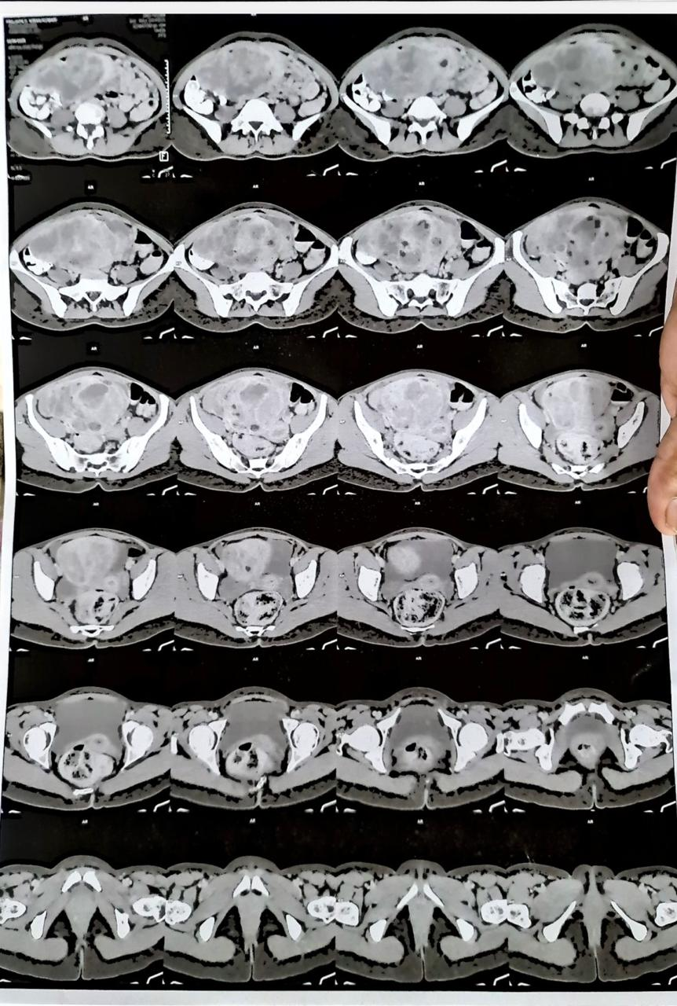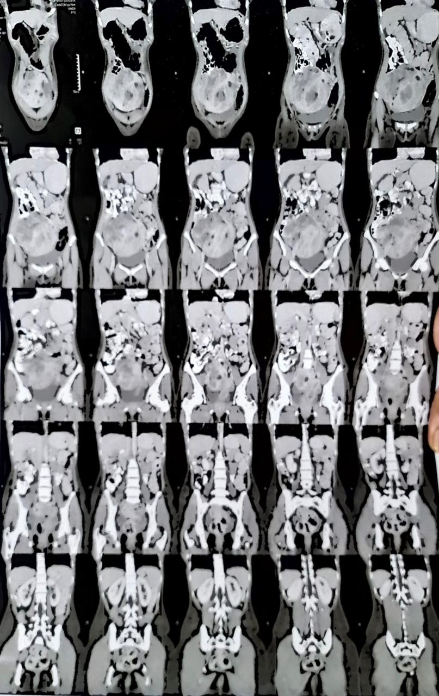

Table 1: Summary table of investigations
Investigation | Findings
USG abdomen pelvis | • Large mixed-echoic lesion measuring 91 × 130 × 140 mm in pelvic cavity/lower abdomen  • Predominantly hyperechoic solid component with multiple anechoic cystic areas  • Internal vascularity on Colour Doppler  • Multiple dilated and tortuous venous collaterals in lower mesentery  • Lesion compressing IVC and aorta posteriorly  • Right renal mid-calyx tiny calculus
CECT abdomen pelvis | • Large well-defined mixed solid–cystic enhancing lesion measuring 9 × 16 × 15 cm  • Internal non-enhancing necrotic areas  • Lesion located predominantly in pelvis toward right side  • Mass effect: displacement of bowel loops, uterus shifted to left, indentation of urinary bladder dome  • Abutting L5–S1 vertebrae, right ovary, rectosigmoid junction, and sigmoid colon with preserved fat planes  • Multiple venous collaterals in right pelvic cavity  • Mild free fluid in right pelvic cavity  • Few sub-centimeter mesenteric lymph nodes  • Right renal calculus (4.7 × 5 mm, 585 HU)  • Endometrial fluid with thickened endometrium (12 mm)

Preoperative Preparation:
Multidisciplinary planning was conducted involving surgery, anaesthesiology, and radiology. The size and location of the lesion indicated a open abdominal surgical approach.
Surgical Procedure:
After taking consent for surgery, under general anaesthesia midline laparotomy was kept and peritoneum was reached and opened. Intra operatively approx. 15x14cm sized large solid mass was found in lower abdomen with dilated multiple collaterals and was arising from transverse mesocolon. All collaterals were ligated separately using silk 1-0 free tie suture and tumour was devascularized, removed and sent for histopathological examination. Peritoneal fluid was sent for cytological examination. Haemostasis achieved and drain was placed in pelvic cavity and abdominal wall closure was done and surgery was uneventful.

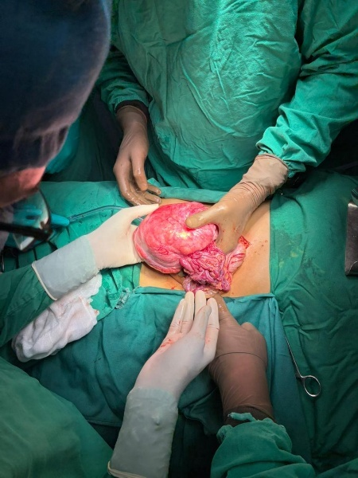 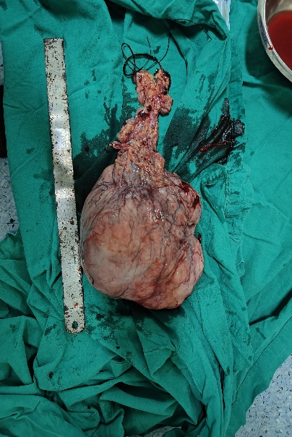 Image1: intra operative Image 2: excised mass

Postoperative Course:
The patient recovered uneventfully. Oral intake was resumed on day 3, and the drain was removed on day 5. She was discharged on postoperative day 6. Follow-ups at one and three months showed no recurrence or complications. Patient has no complaint of abdominal pain, nausea, vomiting, anorexia.

Histopathological Findings:
Gross Examination:
Received specimen consists of single greyish brownish encapsulated soft tissue structure measuring 14x12x8cm.
In cut section it is whitish, variegated in appearance and firm
In cut section many cystic areas are identified with largest one measuring 3x2.5cm. O cutting open clear fluid came out.
On cut section few haemorrhagic and necrotic areas are also identified.
Sections taken:
A, B, C, D: Circumferential margins
E, F: Solid cystic area
G: Solid area
H: Necrotic area and haemorrhagic area
I: Vessel with solid part
J: (?)Vessel
K: 3 Vessels
Diagnosis: Myxoid Liposarcoma.
(FNCLCC Grade-G1)

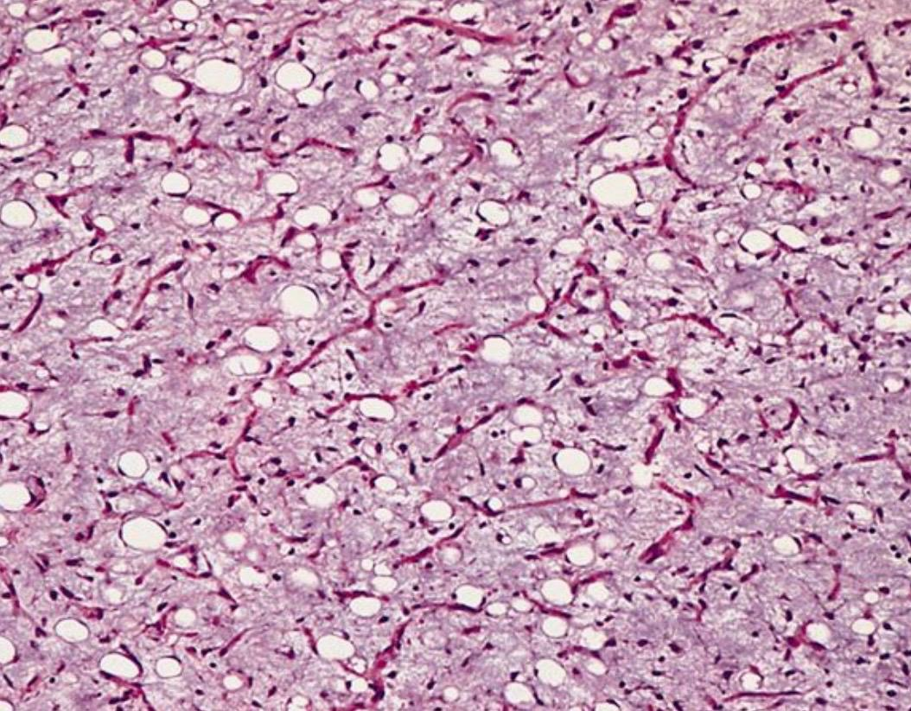

Image 3. Histopathology image showing characteristic multivacuolated / signet ring like cells with scalloped nuclei.

Discussion
Epidemiology and Clinical Presentation
Primary mesenteric liposarcoma is an extremely rare entity compared to its retroperitoneal counterpart. The mainstay of treatment is aggressive surgical excision with wide margins in the absence of distant metastasis. Among malignant mesenteric tumours, lymphoma is the most common, followed by leiomyosarcoma. These neoplasms typically occur in the fifth to seventh decades of life, with a slight male predominance but in our case it was occurred in young female patient (2).
Clinically, patients often present with gradual abdominal distension, abdominal pain, weight loss, early satiety, and a freely mobile intra-abdominal mass. Less frequently, these tumours may cause intestinal perforation, obstruction, intussusception, acute appendicitis, or symptoms mimicking prostatism (3).

Diagnostic Challenges
Diagnosis can be challenging, as the clinical and imaging features often overlap with other intra-abdominal malignancies. In the present case, diagnostic confusion arose due to the finding of a mass originating from pelvis. The provisional diagnosis of mesenteric cyst conflicted with contrast-enhanced CT (CECT) findings, which demonstrated a Well-defined intraperitoneal mixed solid-cystic heterogeneously enhancing lesion with internal non-enhancing necrotic areas noted in pelvis more towards right side and Multiple venous collaterals were noted surrounding the lesion in right pelvic cavity.

Radiologic Evaluation
CT and MRI are indispensable in assessing tumour size, tissue characteristics, and involvement of adjacent structures (4). The typical CT features of liposarcoma include:
(i) inhomogeneous attenuation,
(ii) infiltration or poor margination,
(iii) CT density higher than that of normal fat, and
(iv) variable contrast enhancement (5).
The pattern and degree of enhancement on CT often correlate with the histologic grade of the tumour (6). On MRI, well-differentiated liposarcomas usually appear hyperintense on T2-weighted images, showing minimal or no post-contrast enhancement (7).
Although not routinely employed, gastrointestinal angiography may assist in preoperative planning. According to Hirakoba et al., liposarcomas are generally avascular to moderately vascular, causing displacement of major vessels; in moderately hyper vascular cases, irregular tumour vessels and early venous filling may be observed (8).

Histopathological Features and Prognosis
Among all histologic subtypes, the myxoid variant is the most common, accounting for approximately 50% of cases. The well-differentiated subtype encompasses several histologic variants—inflammatory, lipoma-like, sclerosing, dedifferentiated, and the more recently proposed lymphocyte-rich subtype (4,9).
According to Evans (1979), median survival for patients with well-differentiated, myxoid, dedifferentiated, and pleomorphic types was 119, 113, 59, and 24 months, respectively, indicating a strong correlation between histologic subtype and prognosis (10). Intracytoplasmic fat droplets (Oil Red O positive) are nonspecific, and S-100 immunostaining may be negative in poorly differentiated tumours. Nevertheless, S-100 positivity remains an important marker in differentiating liposarcoma from malignant fibrous histiocytoma (11).
A closely related differential diagnosis is mesenteric lipodystrophy, which may mimic mesenteric neoplasms and occasionally present as cystic masses on imaging (12).

Treatment and Outcome
The treatment of choice for mesenteric liposarcoma is complete surgical excision with adequate margins, followed by radiotherapy and, in selected high-risk patients, adjuvant chemotherapy. Preoperative chemotherapy—most commonly with doxorubicin, dacarbazine, and ifosfamide—has been reported to successfully reduce tumour size in select cases, thereby facilitating complete excision and improving the likelihood of negative margins (13). However, these results have not been consistently reproduced in larger studies.
In a reported case, despite negative surgical margins and absence of lymph node involvement, the patient developed recurrence after 26 months, suggesting the potential benefit of routine adjuvant chemoradiotherapy. Pleomorphic liposarcomas, being high-grade lesions, carry a particularly poor prognosis; even with complete resection, tumour size >20 cm is associated with unfavorable outcomes (14).

Conclusion
Primary mesenteric myxoid liposarcoma is an exceptionally rare malignant tumour that poses significant diagnostic challenges due to its nonspecific clinical presentation and overlapping radiologic features with other intra-abdominal masses. Cross-sectional imaging with CT and MRI plays a crucial role in identifying tumour characteristics, delineating its extent, and planning the surgical approach. Histopathological examination remains the gold standard for definitive diagnosis and subtype classification. Complete surgical excision with adequate margins remains the cornerstone of treatment and offers the best chance for long-term disease control. Adjuvant radiotherapy and chemotherapy may be considered in high-risk or recurrent cases, although their roles remain to be clearly defined. Early diagnosis, meticulous surgical management, and close postoperative surveillance are essential to improve outcomes and reduce the risk of recurrence.

Conflicts of Interest: None declared
Consent: Written informed consent obtained from the patient

Learning Points
- Primary mesenteric liposarcoma is an extremely rare malignant tumour that can mimic other intra-abdominal masses such as mesenteric cysts, GISTs, or lymphomas.
- CT and MRI are invaluable for preoperative assessment, helping to determine tumour size, extent, and relationship to adjacent structures, although definitive diagnosis requires histopathological evaluation.
- Complete surgical excision with negative margins remains the mainstay of treatment and is the most important prognostic factor.
- Adjuvant chemoradiotherapy may be beneficial in select high-risk cases or recurrences, though its role remains under investigation.
- Long-term clinical and radiologic follow-up is essential due to the potential for delayed recurrence or metastasis.
Disclaimer (Artificial intelligence)
Option 1:
Author(s) hereby declare that NO generative AI technologies such as Large Language Models (ChatGPT, COPILOT, etc.) and text-to-image generators have been used during the writing or editing of this manuscript.

References:
- Schwartz’s principles of surgery, 11th edition, chapter no. 36, page no. 1582-1583, https://accessmedicine.mhmedical.com/book.aspx?bookid=2576

- Burgohain J, Kathiresan N, Satheesan B. Dumbbell-shaped mesenteric liposarcoma: A case report with review of the literature. The Internet Journal of Surgery 2008;15. [Google Scholar], https://ispub.com/IJS/15/2/12010

- Horiguchi H, Matsui M, Yamamoto T, et al. A case of liposarcoma with peritonitis due to jejunal perforation. Sarcoma. 2003;7:29-33 [DOI] [PMC free article] [PubMed] [Google Scholar]

- Kim T, Murakami T, Oi H, et al. CT and MR imaging of abdominal liposarcoma. AJR Am J Roentgenol. 1996;166:829-833 [DOI] [PubMed] [Google Scholar], https://ajronline.org/doi/10.2214/ajr.166.4.8610559

- Ciraldo A, Thomas D, Schmidt S. Giant Abdominal liposarcoma: A Case Report. The Internet Journal of Urology 2000;1. [Google Scholar]

- Friedman AC, Hartman DS, Sherman J, Lautin EM, Goldman M. Computed tomography of abdominal fatty masses. Radiology. 1981;139:415-429 [DOI] [PubMed] [Google Scholar]

- Waligore MP, Stephens DH, Soule EH, McLeod RA. Lipomatous tumors of the abdominal cavity: CT appearance and pathologic correlation. AJR Am J Roentgenol. 1981;137:539-545 [DOI] [PubMed] [Google Scholar]

- Hirakoba M, Kume K, Yamasaki M, Kanda K, Yoshikawa I, Otsuki M. Primary mesenteric liposarcoma successfully diagnosed by preoperative imaging studies. Intern Med. 2007;46:373-375 [DOI] [PubMed] [Google Scholar]

- Argani P, Facchetti F, Inghirami G, Rosai J. Lymphocyte-rich well-differentiated liposarcoma: Report of nine cases. Am J Surg Pathol. 1997;21:884-895 [DOI] [PubMed] [Google Scholar]Wu, J.S., 2007. Rectal cancer staging. Clinics in colon and rectal surgery, 20(03), pp.148-157.

- Evans HL. Liposarcoma: a study of 55 cases with a reassessment of its classification. Am J Surg Pathol. 1979;3:507-523 [DOI] [PubMed] [Google Scholar]

- Hashimoto H, Daimaru Y, Enjoji M. S-100 protein distribution in liposarcoma. An immunoperoxidase study with special reference to the distinction of liposarcoma from myxoid malignant fibrous histiocytoma. Virchows Arch A Pathol Anat Histopathol. 1984;405:1-10 [DOI] [PubMed] [Google Scholar]

- Núñez Fernández MJ, García Blanco A, López Rodríguez A, et al. Primary mesenteric liposarcoma of jejunum: presentation like a cystic mass. Minerva Med. 2005;96:425-428 [PubMed] [Google Scholar]

- Ishiguro S, Yamamoto S, Chuman H, Moriya Y. A case of resected huge ileocolonic mesenteric liposarcoma which responded to pre-operative chemotherapy using doxorubicin, cisplatin and ifosfamide. Jpn J Clin Oncol. 2006;36:735-738 [DOI] [PubMed] [Google Scholar]

- Sato T, Nishimura G, Nonomura A, Miwa K. Intra-abdominal and retroperitoneal liposarcomas. Int Surg. 1999;84:163-167 [PubMed] [Google Scholar]

- Jain, S. K., Mitra, A., Kaza, R. C., & Malagi, S. (2012). Primary mesenteric liposarcoma: An unusual presentation of a rare condition. Journal of gastrointestinal oncology, 3(2), 147–150. https://doi.org/10.3978/j.issn.2078-6891.2011.051

- Meher, S., Mishra, T. S., Rath, S., Sasmal, P. K., Mishra, P., & Patra, S. (2016). Giant dedifferentiated liposarcoma of small bowel mesentery: a case report. World journal of surgical oncology, 14(1), 250. https://doi.org/10.1186/s12957-016-1007-1

- Park, N., Kuk, J. C., Shin, E. J., & Lim, D. R. (2022). Surgery of intraabdominal giant dedifferentiated liposarcoma of ascending colon mesentery: A rare case report. International journal of surgery case reports, 98, 107482. https://doi.org/10.1016/j.ijscr.2022.107482.

- Dhakal, S., & Prajapati, I. (2022). Dedifferentiated liposarcoma of small bowel mesentery: a rare case report. Journal of surgical case reports, 2022(1), rjab599. https://doi.org/10.1093/jscr/rjab599

- Schallenberg, S., Schulte, M., Dragomir, M. P., Jarosch, A., Hartmann, W., & Wardelmann, E. (2025). From benign appearance to malignant truth: a case report of mesenteric dedifferentiated liposarcoma with inflammatory myofibroblastic tumor-like features. Diagnostic pathology, 20(1), 39. https://doi.org/10.1186/s13000-025-01640-3

- Khanduri, A., Bansal, N., Singh, A., Gupta, J., & Gupta, R. (2021). Multifocal Dedifferentiated Liposarcoma of the Jejunal Mesentery. Cureus, 13(11), e19780. https://doi.org/10.7759/cureus.19780

- Papalia, G. F., De Marco, G., Luciano, C., Sisca, L., Farsetti, P., Vincenzi, B., & Papalia, R. (2025). Evaluation of Prognostic Factors in Myxoid Liposarcoma Treated with Combined Neoadjuvant Radiotherapy and Surgical Excision: Systematic Review. Diseases (Basel, Switzerland), 13(6), 177. https://doi.org/10.3390/diseases13060177

- Alemu, S., Mulatu, B., Kedir, A., Minka, M., Tesfaye Deme, W., & Demissie, W. R. (2025). A rare case of abdominal (lesser sac) myxoid liposarcoma: A case report. International journal of surgery case reports, 130, 111275. https://doi.org/10.1016/j.ijscr.2025.111275

- Ogut Z, Tuncer A, Dalda Y, Gozukara Bag HG, Bozan MB. Clinicopathological Characteristics and Survival Analysis of Primary Mesenteric Liposarcoma: A Retrospective Study. Medicina. 2025; 61(11):1984. https://doi.org/10.3390/medicina6111198

- Ahire P, Myrthong A L, Mahankudo S, et al. (April 30, 2023) A Rare Case of Primary Mesenteric Liposarcoma. Cureus 15(4): e38329. doi:10.7759/cureus.38329

- Kamehama, F., Kinjo, T., Miyagi, Y., Furugen, T., Teruya, T., Tamaki, T., Wada, N., & Takatsuki, M. (2023). Laparoscopic resection of a metastatic myxoid liposarcoma in the mesentery of the small intestine: a case report. Surgical case reports, 9(1), 133. https://doi.org/10.1186/s40792-023-01715-7

