Rare Spontaneous Rupture of a Hepatic Hydatid Cyst into the Peritoneal Cavity: A Case Report

Abstract
Hydatid disease is an infection caused by the larval stage of the animal tapeworm Echinococcus. The larvae inhabit the liver and lungs, creating fluid-filled cysts with multiple chambers. A rupture into the abdominal cavity is an uncommon yet severe complication of hydatid disease
We present the case of a 57-year-old male patient, who was diagnosed with an intra-peritoneal rupture of a hydatid cyst. The patient was managed with surgical resection and postoperative care, with favorable clinical evolution. This case highlights the importance of early diagnosis and the challenges in managing hydatid cyst rupture.
Keywords:
Hydatid cyst, intra-peritoneal rupture, Echinococcus, peritoneal infection, surgery,

INTRODUCTION:
Hydatid disease, caused by Echinococcus granulosus, is a zoonotic infection primarily affecting the liver and lungs. It remains endemic in rural regions of countries such as Morocco, where livestock farming and direct contact with dogs facilitate the transmission of the parasite.
The rupture of a hydatid cyst can lead to life-threatening complications, including peritoneal infection, septic shock, and organ failure. Timely diagnosis and appropriate surgical management are critical to improving patient outcomes.
We present a case of intra-peritoneal rupture of a hydatid cyst in a 57-year-old male, emphasizing the clinical presentation, diagnostic challenges, and surgical approach.

Observation:
A 57-year-old male patient from the rural region of Morocco, presented to the emergency department of CHU Ibn Sina with acute generalized abdominal pain lasting for one day. The patient had no significant medical history and was not known to have any prior abdominal issues. He was a resident of an area endemic to Echinococcus, which predisposes him to hydatid disease.
On examination, the patient was conscious and hemodynamically stable, with normal respiratory function. He was afebrile and did not exhibit signs of systemic infection. Abdominal examination revealed generalized tenderness with no signs of peritoneal irritation.
The patient's laboratory workup showed mild leukocytosis 10,600/mm³ and a C-reactive protein (CRP) level of 11 mg/L, which indicated a mild inflammatory response. Liver function tests were normal.
Abdominal CT scans revealed two hepatic masses suggestive of hydatid cysts, classified as Gharbi III and V, with evidence of a ruptured subcapsular collection into the peritoneal cavity. This finding was highly suggestive of an intra-peritoneal rupture of a hydatid cyst.(Figure1)
During surgery, the patient was found to have a large amount of purulent peritoneal fluid, with false membranes indicating a recent rupture. The hydatid cyst was located in the posterior segment of the liver (segment IV) and was associated with another cyst in the anterior segment (segment III). The rupture had resulted in a significant peritoneal infection, as evidenced by the purulent fluid.
The patient underwent surgical management, beginning with a pericystectomy of the ruptured cyst located in segment IV of the liver. A cholecystectomy was also performed due to the anatomical proximity of the cyst to the gallbladder. In addition, the dome of the cyst in segment III was resected to remove the remaining infected tissue. Finally, the peritoneal cavity was thoroughly irrigated with hypertonic saline to eliminate infectious material.Wide drainage of the peritoneal cavity to prevent re-accumulation of fluid and facilitate recovery.
The patient had an uneventful recovery with clinical improvement. His laboratory parameters normalized, and the postoperative period was marked by stable hemodynamics. Peritoneal fluid cultures returned positive for hydatid cyst fluid, confirming the diagnosis. The patient was closely monitored for complications, and no further issues arose in the immediate post-operative period.

DISCUSSION:

“Hydatid disease is a zoonotic disease caused by the echinococcus parasite, which is a member of the Taeniidae family. Most common echinococcus species that cause hydatid disease in humans are Echinococcus granulosus (cystic echinococcosis) and Echinococcus multilocularis (alveolar echinococcosis) ” [1,2]. “ Hydatid disease remains a significant health concern in rural regions of Morocco, where Echinococcus transmission is common.
Hydatid diseases can develop in almost all organs and tissues of the human body, but the most frequently involved organs are the liver (50%-77%), lungs (15%-47%), spleen (0.5%-8%), and kidneys (2%-4%)” [3].

“Usually, asymptomatic patients are diagnosed incidentally by radiological evaluations that are performed for other reasons. Nevertheless, some patients have signs and symptoms, including mild or severe abdominal pain, nausea, vomiting, jaundice due to size, location, and/or involvement of the adjacent structures and organs of the cystic lesions” [4].
“The most common complications associated with hydatid cysts include superinfection, cysto-biliary fistula , allergic reactions, rupture into the gastrointestinal tract ,gastric outlet obstruction,, broncho-biliary and bronchopleural fistulas, as well as intrapericardial, intrapleural, and intraperitoneal ruptures” [7].
“Rupture into the free peritoneum is a complication that occurs in 2-7% of cases.Rupture of hydatid cyst of the liver is an unusual complication. Rupture can occur because of trauma or relentless expansion of the hydatid cyst causing pressure necrosis with resultant rupture into the peritoneal cavity.Sometimes, iatrogenic hydatid cyst rupture may occur during elective surgery” [5,6].
“Rupture of a hepatic hydatid cyst into the abdominal cavity is an uncommon but potentially catastrophic complication of hydatid disease. This event can lead to a range of severe and life-threatening outcomes, most notably anaphylactic shock and acute peritonitis. In cases of free intraperitoneal rupture, the release of hydatid fluid into the peritoneal cavity may induce chemical peritonitis, characterized by early onset of peritoneal irritation and pronounced clinical symptoms.Moreover, anaphylaxis and even sudden death have been reported in up to 25% of patients following cyst rupture, underscoring the urgency of prompt recognition and management. In addition to acute complications, sclerosing peritonitis secondary to the rupture of a hepatic hydatid cyst has been described as a late sequela, further complicating the clinical course” [3,8,9].
“The diagnosis of a ruptured hydatid cyst must be made promptly, as it necessitates urgent medical intervention. Imaging techniques play a crucial role in establishing the diagnosis.
Ultrasound and CT-scan are useful for identifying intra abdominal fluid and a cyst with a detached membrane” [10,11]. “The CT is used as the golden standard to verify the diagnosis and to identify co-existing complication that may alter the operative plan” [12,13]

“ Immediate medical treatment against allergic reactions should be initiated, and emergency surgery should be performed after diagnosing rupture of hydatid cysts. The goal of the surgical treatment is to prevent complications, to eliminate local disease, and to minimize morbidity, mortality, and recurrence rates” [14].The surgical treatment can be radical (pericystectomy and hepatic resection) or conservative methods (unroofing with various procedures to treat the residual cavity) [15,16]. “Radical procedures have a higher operative risk than conservative procedures, and can be difficult under emergency conditions. Conservative procedures are much easier, faster and safer and are more appropriate for patients requiring urgent treatment” [3]

“The peritoneal cavity should be washed with scolicidal solutions such as formaldehyde, hypertonic saline (3%-10%-15%-30%), silver nitrate (0.5%), cetrimide, chlorhexidine, cetrimide plus chlorhexidine (1.5%/0.15%), hydrogen peroxide (1.5%-3%), povidone iodine (10%-50%), or ethyl alcohol (70%-95%). Each solution has a different time frame for possible scolicidal effects” [17,18]

“Albendazol treatment is effective for preventing recurrence and secondary hydatidosis, but there is no agreement on the duration of use of the medication for cyst sterilization. The efficacy and safety of albendazole treatment have been demonstrated in various studies.
albendazole therapy is mandatory. It should be started immediately and given for a prolonged period of time” [19,20].

Conclusion

Hydatid disease remains a significant health concern, particularly in endemic regions, due to its potential for severe complications. Rupture of hepatic hydatid cysts into the peritoneal cavity, though rare, is life-threatening, causing acute peritonitis and anaphylaxis. Prompt diagnosis through imaging and emergency surgical intervention, combined with peritoneal lavage and postoperative albendazole therapy, is essential to reduce morbidity, mortality, and recurrence. Early recognition and comprehensive management are key to improving outcomes in affected patients.

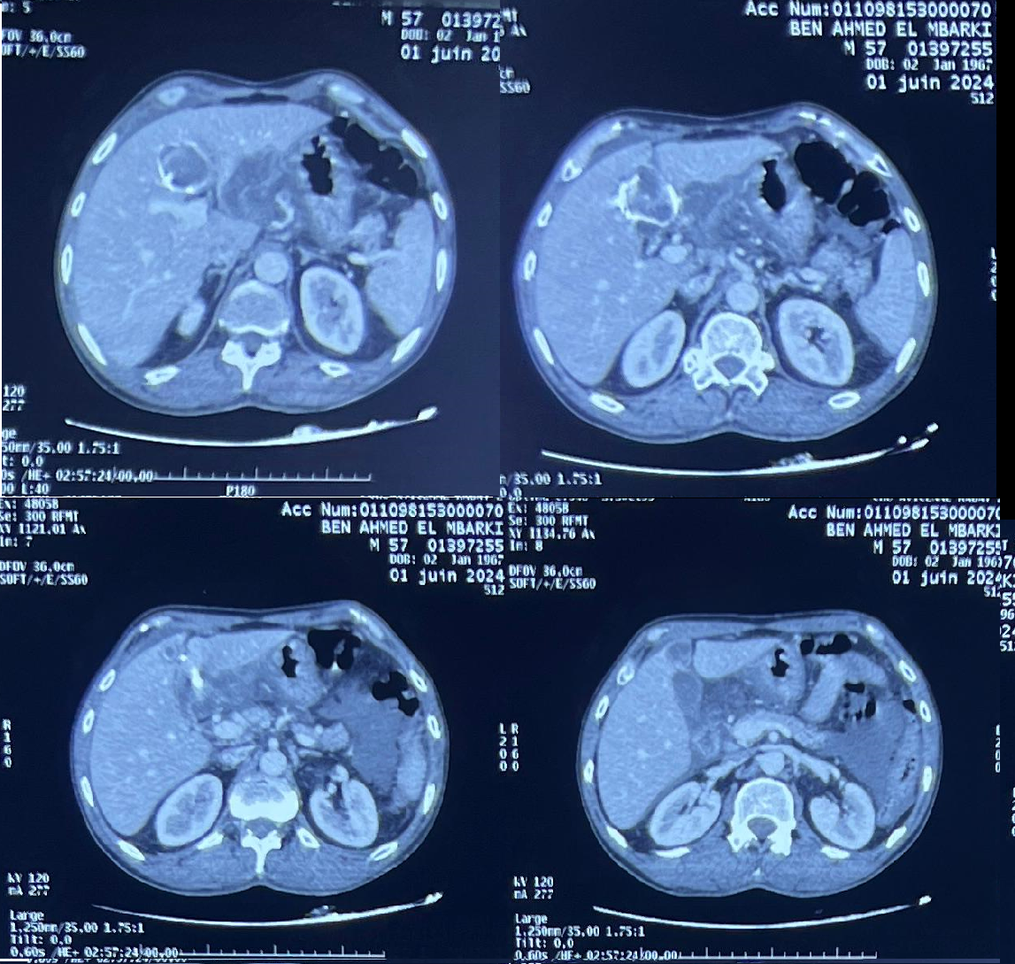

Figure 1 : Abdominal CT scans revealed two hepatic masses suggestive of hydatid cysts, classified as Gharbi III and V, with evidence of a ruptured subcapsular collection into the peritoneal cavity. This finding was highly suggestive of an intra-peritoneal rupture of a hydatid

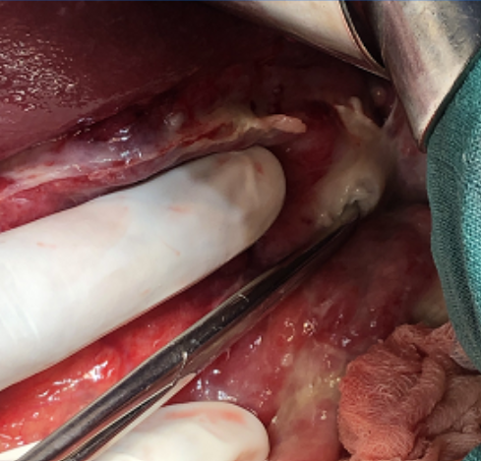

Figure 2: Image showing Rupture of a Hepatic Hydatid Cyst into the Peritoneal Cavity From our patient

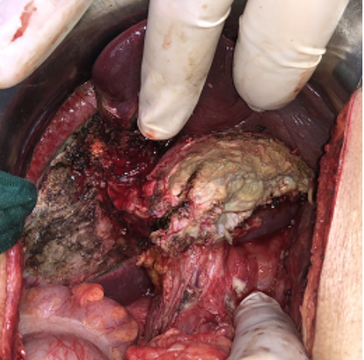
Figure 3 : image after the resection of Hepatic Hydatid Cyst from our patient

Ethical Approval:
As per international standards or university standards written ethical approval has been collected and preserved by the author(s).

Consent
As per international standards or university standards, patient(s) written consent has been collected and preserved by the author(s).

Disclaimer (Artificial intelligence)
Option 1:
Author(s) hereby declare that NO generative AI technologies such as Large Language Models (ChatGPT, COPILOT, etc.) and text-to-image generators have been used during the writing or editing of this manuscript.
Option 2:
Author(s) hereby declare that generative AI technologies such as Large Language Models, etc. have been used during the writing or editing of manuscripts. This explanation will include the name, version, model, and source of the generative AI technology and as well as all input prompts provided to the generative AI technology
Details of the AI usage are given below:
1.
2.
3.

REFERENCES:

1.Yilmaz M, Akbulut S, Kahraman A, Yilmaz S. Liver hydatid cyst rupture into the peritoneal cavity after abdominal trauma: case report and literature review. Int Surg. 2012;97:239–244. doi: 10.9738/CC116.1.
2.Akbulut S, Sogutcu N, Eris C. Hydatid disease of the spleen: single-center experience and a brief literature review. J Gastrointest Surg. 2013;17:1784–1795. doi: 10.1007/s11605-013-2303-5.
3. Toumi O, Noomen F, Salem R, Rabeh H, Jabra SB, Korbi I, Bannani S, Nasr M, Zouari K, Mondher G, Hamdi A. Intraperitoneal rupture of hydatid cysts. Eur J Trauma Emerg Surg. 2017;43:387–391. doi: 10.1007/s00068-016-0662-9.
4.Akbulut S, Ozdemir F. Intraperitoneal rupture of the hydatid cyst: Four case reports and literature review. World J Hepatol. 2019 Mar 27;11(3):318-329. doi: 10.4254/wjh.v11.i3.318. PMID: 30967909; PMCID: PMC6447420.
.
5.Nunnari, G., Pinzone, M. R., Gruttadauria, S., Celesia, B. M., Madeddu, G., Malaguarnera, G., ... & Cacopardo, B. (2012). Hepatic echinococcosis: clinical and therapeutic aspects. World journal of gastroenterology: WJG, 18(13), 1448.

6.Akcan, A., Akyildiz, H., Artis, T., Ozturk, A., Deneme, M. A., Ok, E., & Sozuer, E. (2007). Peritoneal perforation of liver hydatid cysts: clinical presentation, predisposing factors, and surgical outcome. World journal of surgery, 31, 1286-1293.

7.Tinsley B, Abbara A, Kadaba R, Sheth H, Sandhu G. Spontaneous intraperitoneal rupture of a hepatic hydatid cyst with subsequent anaphylaxis: a case report. Case Reports Hepatol. 2013;2013:320418. doi: 10.1155/2013/320418.

8.Derici, H., Tansug, T., Reyhan, E. et al. Acute Intraperitoneal Rupture of Hydatid Cysts. World J. Surg. 30, 1879–1883 (2006). doi.org/10.1007/s00268-005-0699-0

9.El Malki, Hadj Omar, et al. "Rupture intrapéritonéale du kyste hydatique du foie." Gastroentérologie clinique et biologique 30.10 (2006): 1214-1216.

10.Tinsley B, Abbara A. Spontaneous intraperitoneal rupture of a hepatic hydatid cyst with subsequent anaphylaxis: a case report. Case Reports Hepatol. 2013;2013:320418.

11.Ray S, Das K. Spontaneous intraperitoneal rupture of hepatic hydatid cyst with biliary peritonitis: a case report. Cases J. 2009;2:6511.

12.Ray S, Das K. Spontaneous intraperitoneal rupture of hepatic hydatid cyst with biliary peritonitis: a case report. Cases J. 2009;2:6511.

13.Aeberhard P, Fuhrimann R, Strahm P, etal: Surgical treatment of hydatid disease of the liver: an experience from outside the endemic area. Hepatogastroenterology. 1996, 43: 627-636

14.Dziri C, Haouet K, Fingerhut A. Treatment of hydatid cyst of the liver: where is the evidence? World J Surg. 2004;28(8):731–6.

15.Arikanoglu Z, Taskesen F, Aliosmanoglu I, Gul M, Cetincakmak MG, Onder A, et al. Spontaneous intraperitoneal rupture of a hepatic hydatid cyst. Int Surg. 2012;97(3):245–8.

16. Aeberhard P, Fuhrimann R, Strahm P, etal: Surgical treatment of hydatid disease of the liver: an experience from outside the endemic area. Hepatogastroenterology. 1996, 43: 627-636.

17.Tinsley B, Abbara A, Kadaba R, Sheth H, Sandhu G. Spontaneous intraperitoneal rupture of a hepatic hydatid cyst with subsequent anaphylaxis: a case report. Case Reports Hepatol. 2013;2013:320418. doi: 10.1155/2013/320418.

18.Puryan K, Karadayi K, Topcu Om, etal: Chlorhexidine gluconate: an ideal scolicidal agent in the treatment of intraperitoneal hydatidosis?. World J Surg. 2005, 29: 227-230. 10.1007/s00268-004-7587-x.

19.Jover R, Gutierrez A, Zarate V, etal: Reduction of abdominal hydatid disease with prolonged treatment. Am J Gastroenterol. 1997, 92: 1231-1232.

20.Pedrosa, I., Saíz, A., Arrazola, J., Ferreirós, J., & Pedrosa, C. S. (2000). Hydatid Disease: Radiologic and Pathologic Features and Complications 1: (CME available in print version and on RSNA Link). Radiographics, 20(3), 795-817.

