Case report
Isolated splenic hydatid cyst: A rare case report and review of the literature

.
ABSTRACT

The hydatid disease is a public health problem in endemic countries. the liver and lungs are the common organs involved, while the spleen is rarely involved. This is a case report of a case of a hydatid cyst of the spleen in a patient of sixty years of age, without any particular history. The patient presented with symptoms of pain in the left upper quadrant of the abdomen, which had lasted four months preceding admission. The patient was admitted to the hospital for abdominal trauma; investigations showed a splenic hydatic cyst. Treatment consisted of resection of the protruding dome, after the intake of albendazole to prevent complications. Follow-up was uneventful. This case highlights the rarity and clinical significance of recognizing splenic hydatid cysts, as well as the importance of post-treatment follow-up.

Key words: Isolated splenic hydatid cyst, liver, lungs, tumors, pulmonary cyst

1. INTRODUCTION

Hydatid disease, also known as cystic echinococcosis, is an infection caused by the Echinococcus granulosus parasite[1]. It is a public health problem in endemic areas such as Morocco, particularly in rural regions where livestock breeding and close contact with dogs are common [2]. The disease mostly affects the liver with a 60–70% rate, followed by the lungs (20–30%), due to the filtering role of these organs in the portal and systemic circulations [3].
Even though the spleen is a very important haematological organ, splenic involvement by this parasite is rare, accounting for only 2–5% of all hydatid disease cases [4]. This low incidence is thought to be due to the spleen’s anatomical position and the filtering effect of the liver and lungs, which usually trap most parasites before reaching the systemic circulation [5]. Because of its rarity, splenic hydatid disease often poses a diagnostic challenge, as it can mimic other cystic or tumorous lesions of the spleen, especially tuberculosis and malignant haematological tumors [5]. Moreover, its management remains controversial, with treatment options ranging from medical therapy and percutaneous approaches to conservative or radical surgery, depending on cyst size, location, and complications [6].

2. CASE PRESENTATION
Our patient is a 60-year-old female from an endemic region, having a surgical history of a resection of a pulmonary cyst 28 years ago; pathological examination showed a bronchogenic cyst. The patient presented four months before her admission to the hospital, with symptoms of left upper quadrant pain, without fever or palpable mass, without consulting. The patient came to our hospital for an abdominal trauma with the impact point located in the right abdominal quadrant. the clinical examination showed a stable patient without significant signs in the right abdominal quadrant; therefore a splenomegaly, tenderness, and a firm mass in the left hypochondrium were found, leading to investigations.
Laboratory findings were normal, except for an eosinophilia of 800 cells/mm³ and a positive hydatid serology.
A CT scan was performed, showing no signs of abdominal trauma; therefore, a cystic lesion was located in the spleen, with a calcified wall and exotic development, measuring 125x100mm, classified CE5 of the World Health Organisation classification[7], without hepatic, pulmonary, or peritoneal associated locations.
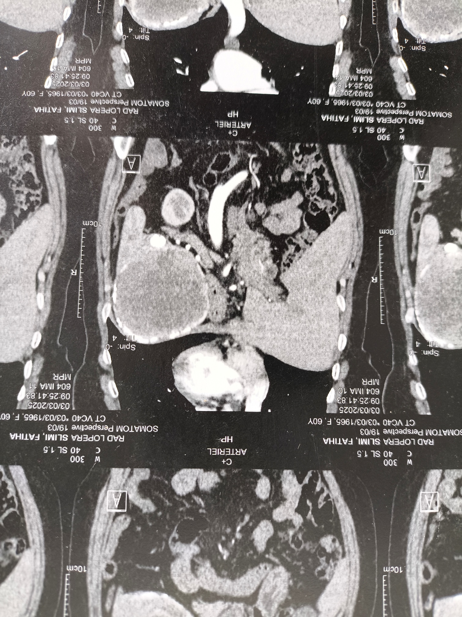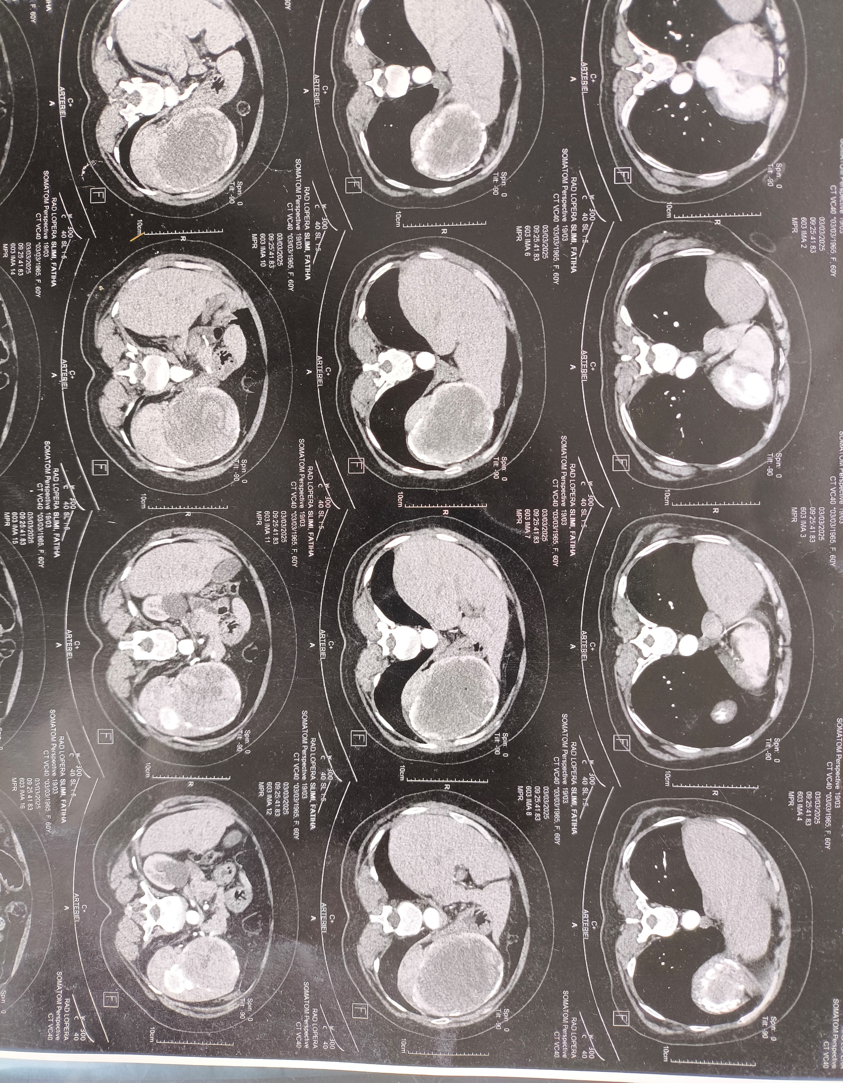
B
A
Figure 1: CT scan images showing an immense hydatic cyst in the spleen.
A : A coronal view of the CT scan showing the splenic hydatic cyst in red arrow
B : A horizontal view of the CT scan showing the splenic hydatic cyst in blue arrow
Surgery was indicated. The patient received albendazole to reduce cyst viability and minimize recurrence risk after surgery, at a dose of 15 mg/kg/day for 3 cycles of 28 days, with a 7-day interval, and monthly liver and haematological laboratory monitoring.
The Surgical approach was a left subcostal incision. For a better exposure, a ligation and sectioning of the round ligament of the liver, and a release of adhesions between the cyst and surrounding organs (left liver, greater omentum, and diaphragm) were performed. Operative exploration showed a large hydatid cyst in the lower pole of the spleen, without peritoneal or hepatic-associated lesions. Since Morocco is an endemic region of hydatidosis, and given our department's expertise in this type of surgical technique and the possibility of being conservative, a dome resection surgery was performed using a Devé trocar. The intraoperative precautions to prevent dissemination of cysts were isolation of the operative field with hydrogen peroxide, controlled aspiration before cyst opening, and avoidance of excessive manipulation to minimize the risk of anaphylaxis or secondary seeding. An Omentoplasty and a large drain were placed next to the residual cavity.

A sample was obtained for microbiological and anatomopathological study, which confirmed the presence of Echinococcus granulosis. The postoperative course was uneventful, and the patient was dismissed after 4 days. Albendazole was prescribed 2 months postoperatively.

3. Discussion
Epidemiology
Hydatid disease, caused by Echinococcus granulosus, is a major zoonotic infection in endemic regions. The infection targets especially the liver and lungs, while splenic involvement is rare, representing only 2–5% of all cases. Splenic hydatidosis can occur secondarily from systemic or peritoneal dissemination following rupture of hepatic cysts, or primitive, representing a rare entity estimated at approximately 2,04% of abdominal hydatid disease[8], which is the case of our patient.[9]
Pathogenesis
The spleen contamination usually occurs through hematogenous dissemination of oncospheres, bypassing hepatic and pulmonary filters [3]. Alternatively, retrograde spread via the splenic vein or portal system has been discussed in the literature[10]. In secondary cases, peritoneal seeding after rupture or surgical manipulation of hepatic hydatid cysts is the likely mechanism.
Clinical Presentation
Clinical manifestations of splenic hydatidosis are variable and often non-specific, explaining frequent diagnostic delays. Many patients remain asymptomatic for years. When symptoms occur, they usually include left upper quadrant pain, abdominal distension, or a palpable mass. Compression of nearby organs can lead to early satiety or dyspnea, and complications such as rupture, infection, or hypersplenism may cause acute presentations[6], [11]. In our case, although the patient was symptomatic, the diagnosis was incidental after the abdominal trauma.
Differential Diagnosis
The difficulty in differential diagnosis lies especially in patients with no history of liver or peritoneal hydatid cysts, or associated lesions in the mentioned organs. The imaging features of splenic hydatid cysts overlap with those of other cystic lesions, including epidermoid cysts, post-traumatic pseudocysts, abscesses, and lymphoma [12]. However, the presence of daughter cysts, detached membranes, or peripheral calcifications is highly suggestive of hydatid disease.
Diagnosis
Imaging represents the cornerstone of diagnosis. Ultrasound is the first-line tool and allows preliminary cyst staging according to the World Health Organisation classification [7]:
- CE1–CE2: Active cysts (unilocular or with daughter cysts)
- CE3a–CE3b: Transitional cysts (detached membranes or partially solidified contents)
- CE4–CE5: Inactive or calcified cysts
This classification is essential for predicting cyst evolution, choosing the most appropriate treatment, and planning personalized management based on cyst size, location, and viability [9,10]. For instance, active (CE1–CE2) cysts have a higher risk of growth or rupture, requiring surgical or medical intervention, whereas inactive (CE4–CE5) cysts may be managed conservatively with close follow-up. In our case, the surgery was indicated in the presence of a symptomatic lesion, and its large size; nevertheless, other indications may be justified in inactive cysts: diagnostic uncertainty, superinfection, rupture or risk of rupture, coexistent pathology requiring surgery, and unreliable follow-up.[6], [13]
CT scanning provides superior anatomical definition and helps in evaluating wall calcification, internal septations, and proximity to the splenic hilum or diaphragm, all of which are critical for surgical planning [3].
Serological tests, such as ELISA or indirect hemagglutination, may assist diagnosis, but false negatives can occur, especially in isolated splenic disease [12].
Treatment Options
Surgery remains the gold standard for splenic hydatid cysts. The choice of approach depends on cyst characteristics, patient age, and immunologic considerations.
- Total splenectomy is indicated for large, centrally located, or complicated cysts, ensuring complete eradication and minimizing recurrence risk. Post-splenectomy antibiotics and vaccinations are to be initiated according to the standard protocols. [14].
- Partial splenectomy or spleen-preserving surgery is recommended for peripherally located cysts, especially in younger patients, to maintain splenic immune function[15].
- Conservative procedures, which was the case with our patient, such as cystectomy, deroofing, or omentoplasty, the inconvenience lies in carrying a higher recurrence risk.[16]
- Medical therapy with albendazole (10–15 mg/kg/day) is administered for at least 4 weeks before and 2–3 months after surgery to sterilize cysts and prevent secondary seeding [10].
- PAIR (Puncture–Aspiration–Injection–Reaspiration), though used in hepatic hydatidosis, is contraindicated in splenic cysts due to the risk of rupture and anaphylaxis [17].
Prognosis
The prognosis is favorable following complete cyst excision and adequate anti-parasitic therapy. Recurrence is rare when surgery is performed meticulously and adjunct medical therapy is properly administered [5]. Long-term follow-up with imaging and serological testing is advised to detect late recurrence.[18]
Prevention
Prevention depends on public health interventions; measures need to be instituted, aiming to eradicate and/or break the parasite’s life style, such as regular dog deworming with praziquantel, proper disposal of infected viscera from livestock, and improving public education on hygiene and food safety[13].
Conclusion
Splenic hydatidosis is a rare presentation of cystic echinococcosis necessitating individualized treatment. Although the splenectomy is still required for a large and complicated cyst, spleen-preserving surgery has been proven to be safe and effective in the peripheral and uncomplicated lesion, with the advantage of preserving immune function. In conjunction with perioperative albendazole therapy and meticulous surgical technique, the above methods achieve excellent results while reducing recurrence.

Consent
As per international standards or university standards, patient(s) written consent has been collected and preserved by the author(s).

CONSENT (WHERE EVER APPLICABLE)
All authors declare that ‘written informed consent was obtained from the patient for publication of this case report.

COMPETING INTERESTS DISCLAIMER:
Authors have declared that they have no known competing financial interests OR non-financial interests OR personal relationships that could have appeared to influence the work reported in this paper.

Disclaimer (Artificial intelligence)
Option 1:
Author(s) hereby declare that NO generative AI technologies such as Large Language Models (ChatGPT, COPILOT, etc.) and text-to-image generators have been used during the writing or editing of this manuscript.
Option 2:
Author(s) hereby declare that generative AI technologies such as Large Language Models, etc. have been used during the writing or editing of manuscripts. This explanation will include the name, version, model, and source of the generative AI technology and as well as all input prompts provided to the generative AI technology
Details of the AI usage are given below:
1.
2.
3.

REFERENCES :

[1] Moro P, Schantz PM. (2009). Echinococcosis: a review. IJID, 13(2):125-133.
[2] J. Eckert and P. Deplazes, “Biological, epidemiological, and clinical aspects of echinococcosis, a zoonosis of increasing concern,” Clin. Microbiol. Rev., vol. 17, no. 1, pp. 107–135, Jan. 2004, doi: 10.1128/CMR.17.1.107-135.2004.
[3] I. Pedrosa, A. Saíz, J. Arrazola, J. Ferreirós, and C. S. Pedrosa, “Hydatid disease: radiologic and pathologic features and complications,” Radiogr. Rev. Publ. Radiol. Soc. N. Am. Inc, vol. 20, no. 3, pp. 795–817, 2000, doi: 10.1148/radiographics.20.3.g00ma06795.
[4] K. Rasheed, S. A. Zargar, and A. A. Telwani, “Hydatid cyst of spleen: a diagnostic challenge,” North Am. J. Med. Sci., vol. 5, no. 1, pp. 10–20, Jan. 2013, doi: 10.4103/1947-2714.106184.
[5] K. Rasheed, S. A. Zargar, and A. A. Telwani, “Hydatid Cyst of Spleen: A Diagnostic Challenge,” North Am. J. Med. Sci., vol. 5, no. 1, pp. 10–20, Jan. 2013, doi: 10.4103/1947-2714.106184.
[6] C. Eris et al., “Surgical Approach to Splenic Hydatid Cyst: Single Center Experience,” Int. Surg., vol. 98, no. 4, pp. 346–353, 2013, doi: 10.9738/INTSURG-D-13-00138.1.
[7] “International classification of ultrasound images in cystic echinococcosis for application in clinical and field epidemiological settings
[8] Mejri, A., Arfaoui, K., Ayadi, M.F. et al., “Primitive isolated hydatid cyst of the spleen: total splenectomy versus spleen saving surgical modalities.,” BMC Surg 21, 46 (2021).
[9] “Update on the Seroepidemiology of Human Cystic Echinococcosis and Associated Risk Factors in Iran: A Systematic Review and Meta-Analysis - PubMed.” Accessed: Oct. 31, 2025. [Online]. Available: https://pubmed.ncbi.nlm.nih.gov/40260044/
[10] T. Hakimi et al., “Complicated Giant Splenic Hydatid Cyst: Case Report and Literature Review,” Int. Med. Case Rep. J., vol. 18, pp. 1099–1103, 2025, doi: 10.2147/IMCRJ.S527730.
[11] B. A. Wani, M. A. Khan, T. Baweja, O. J. Shah, A. Sumrani, and T. Rashid, “Case Report: Primary splenic hydatid cyst,” Front. Med., vol. 12, p. 1605050, 2025, doi: 10.3389/fmed.2025.1605050.
[12] T. Dumitrascu, “An Isolated Hydatid Cyst of the Spleen with High Serum Levels of CA 19-9—A Meaningful Association or Just a Challenge for Diagnosis? A Case Report,” Medicina (Mex.), vol. 61, no. 2, p. 182, Jan. 2025, doi: 10.3390/medicina61020182.
[13] “WHO guidelines for the treatment of patients with cystic echinococcosis.” Geneva: World Health Organization, 2025. [Online]. Available: Licence: CC BY-NC-SA 3.0 IGO
[14] M. Mansour et al., “A massive primary hydatid splenic cyst was successfully managed through open total splenectomy: a case report and review article,” Ann. Med. Surg. 2012, vol. 85, no. 10, pp. 5208–5213, Oct. 2023, doi: 10.1097/MS9.0000000000001217.
[15] Meimarakis, G., Grigolia, G., Loehe, F. et al., “Surgical management of splenic echinococcal disease.,” Eur J Med Res 14, 165, 2009.
[16] A. Menif, W. Riahi, M. R. Khelili, and H. Zebda, “Diagnosis and Treatment of a Primary Splenic Hydatic Cyst: A Case Report,” Asian J. Case Rep. Surg., vol. 7, no. 2, pp. 457–463, Oct. 2024, doi: 10.9734/ajcrs/2024/v7i2567.
[17] M. Gargouri et al., “Percutaneous treatment of hydatid cysts (Echinococcus granulosus),” Cardiovasc. Intervent. Radiol., vol. 13, no. 3, pp. 169–173, 1990, doi: 10.1007/BF02575469.
[18] “A Rare Case Report- An Incidental Finding of Isolated Unilocular Splenic Hydatid Cyst | Journal of Pharmaceutical Research International.” (2025)

