URETERO- APPENDICULAR FISTULA WITH COMPLETE PROXIMAL URETERIC STRICTURE: A RARE CASE REPORT

ABSTRACT: Uretero appendicular fistula is a very rare finding. It is seen in cases of ureteric injury or in retrocaecal appendicitis or appendicular rupture. In this case , following rectopexy patient complained of right sided abdominal pain, either due to undetected ureteric injury during surgery or post operative appendicitis and rupture causing retroperitoneal or periappendiceal collection and inflammation which in turn compressed the right ureter which gradually caused stricture formation and later ureteroappendicular fistula. This was identified only after attempted insertion of DJ stent in order to reduce the hydroureteronephrosis when DJ stent went through fistula into the appendix due to proximal complete stricture. This case was managed by initial ureteroscopy followed by diagnostic laparoscopy which later got converted to open mini laparotomy with excision of fistula and appendicectomy from base of appendix and ureteric stricture resection and end to end anastomosis. Post operatively DJ stent was insitu for 1 month which helped to resolution of hydroureteronephrosis. Postoperative 6 month followup CTurography scans showed no signs of ureteric stricture or hydronephrosis or urine leak in abdomen. This case outlines ureteric and appendicular injury as a potential complications of abdominal surgeries as such as rectopexy and the minimally invasive approach to its management.
KEYWORDS: Fistula, Ureteric stricture, Double J Stent, Hydroureteronephrosis, Laparoscopy , Appendicular rupture
INTRODUCTION: There has only been a handful of cases recorded of ureteroappendicular fistula.[6] Due to the proximity between appendix ,ascending colon to ureter any injury or inflammation in either organs may cause irritation and inflammation of the other. In this case appendicular injury and rupture or ureteric injury or both serves as the trigger factor for formation of collection , inflammation and fistula formation. This case report also provides detailed information regarding management of the complication in a minimally invasive method combining both diagnostic and therapeutic approach by ureteroscopy followed by laparoscopy followed by minilaparotomy . It also informs us about the followup strategy needed in this including the timeline for followup , the imaging modalities for followup and what to ruleout during followup which is restructure and recurrence of fistula.
CASE REPORT:
A 32 Year old male patient presented with right sided flank pain and burning micturition of 2 weeks duration. Patient gave history of rectal prolapse for which he underwent abdominal rectopexy in october 2024 at a private hospital . Post operatively patient started experiencing mild pain in right lumbar and iliac fossa region after day 10.
Usg abdomen and pelvis done showed mild right hydroureteronephrosis due to pressure effect from a 10.6x9.1 cm sized multiloculated cystic lesion with thick septations and low internal echoes. On colour doppler septations shows vascularity. CT abdomen and pelvis showed loculated collection in right iliac fossa, involving right psoas muscle with inseparable appendix with surrounding inflammation and fat stranding. Collection was seen compressing right ureter with mild proximal hydroureteronephrosis which was suggestive of infective collection, possible secondary to ruptured appendix. Patient was managed conservatively at present with IV antibiotics.
In december 2025, Needle aspiration of collection was also done which on investigation suggested presence of urine suggesting urinoma formation too.This raised suspicion of ureteric injury and leak . Retrograde pyelogram and DJ stenting was done . Post procedure CT abdomen showed displacement of DJ stent with caudal migration in distal right ureter with associated coiling of upper margin in a tubular structure mostly appendix at L5 verterbral level , other tip of DJ stent seen in urinary bladder lumen, also with contrast opacification of appendix. Patient was suspected to have right uretero-colic/ uretero-appendicular fistula.
Figure 1: Imaging showing displaced DJ Stent into Appendix
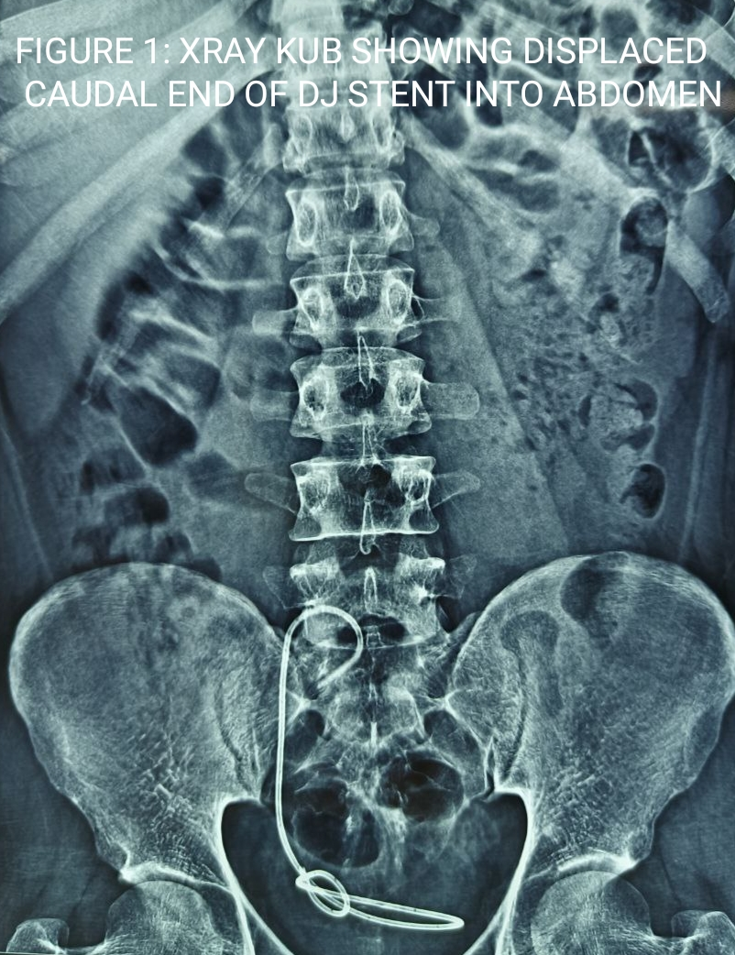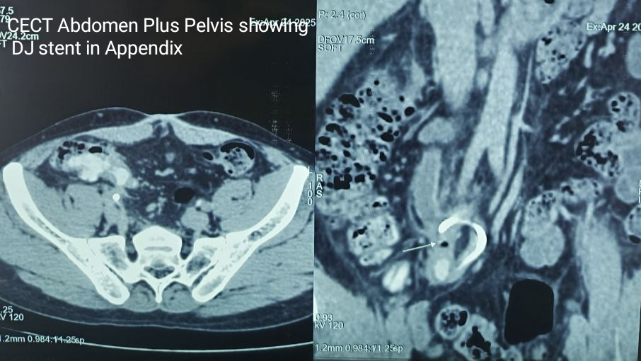
However patient was lost to followup for 3 months .Patient was then referred to our hospital under urology department by April 2025. On examination patient was afebrile , vitals were within normal limit. On abdominal examination, abdomen was soft, tenderness in right lumbar and iliac fossa , no guarding, rigidity, distension. No evidence of any swelling on palpation or skin changes.Patient was evaluated further with CT Abdomen Plus Pelvis which showed the same finding such as proximal hydroureteronephrosis and displacement of proximal DJ stent into appendix / colon. Patient was planned for ureteroscopy followed by diagnostic laparoscopy and proceed.
On table after general anaesthesia, in lithotomy position patient initially underwent cystoscopy and ureteroscopy . It showed distal displacement of DJ stent in right ureter and stricture at ureter at upper two third and lower one third of ureter with sudden turning of DJ stent below the stricture.Dj stent was not removed. Patient was then turned to left Jack knife position and diagnostic laparoscopy was done. It showed peritoneal adhesions and omental thickening over right iliac fossa.
After careful dissection right ureter was identified at right retroperitoneal region just below the kidney and was appearing dilated and was traced downwards. At right iliac fossa, ureter was appearing to be attached to appendix. Careful dissection of mesocolon and mesoappendix showed a 10mm long and 7mm wide fistulous connection between lower ureter at the upper 2/3rd and lower 1/3rd junction and base of appendix which was retrocaecal in location. Fistulous tract was cut opened from ureteric end which showed DJstent coiling into the distal appendix from the base.
Figure 2: Intraop image of the fistulous opening from the base of appendix
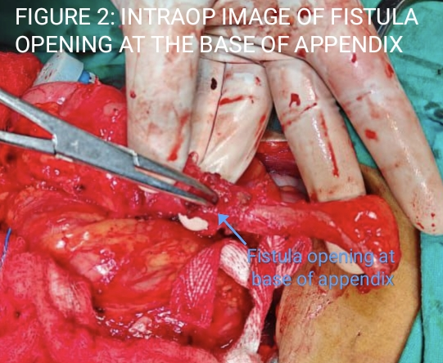
Laparoscopic approach was then converted to open approach with a lanz incision over right iliac fossa with patient in same position. Abdominal cavity was reached and site of fistula identified. Initially proximal part of DJ stent going from base of appendix into distal appendix was removed and appendix was ligated below the fistula and transfixed and cut. Previous DJ stent was removed and Upper margin of ureteric stricture above fistula was traced and ureter was cut 0.5 cm above it and likewise ureter was also cut 0.5 cm below the fistulous orifice after confirming patency of ureter on both margins. Then anastomosis of the patent ureteric ends was done after insertion of a new DJ stent into the proximal and distal ureteric parts from the patent ureteric ends.[8] This was followed by drain insertion and closure of abdomen.
Figure 3: Intraop image post resection of ureteric stricture and end to end anastomosis of ureter
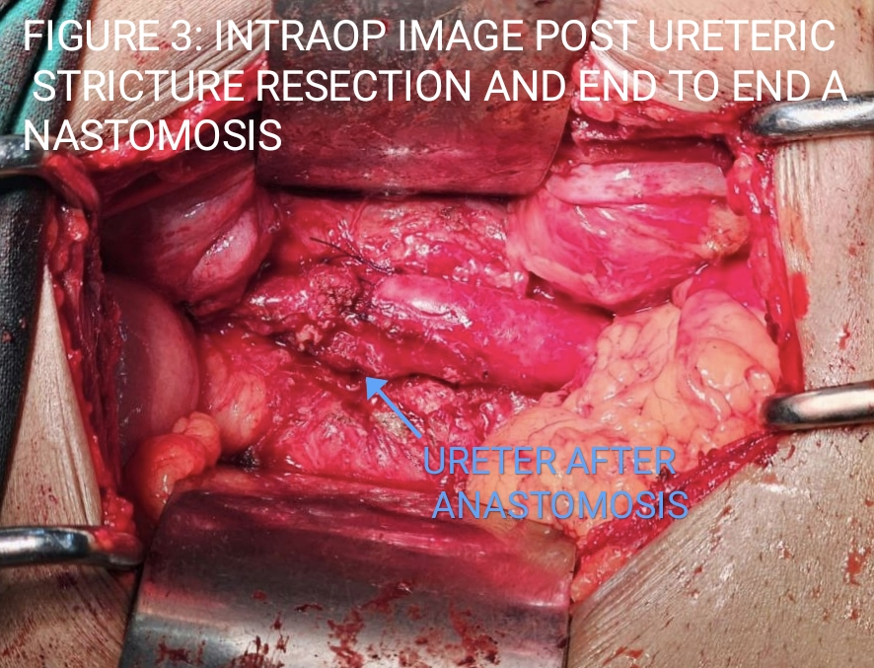
Postoperative period was uneventful.Foleys catheterization was removed on day 2. Daily Drain output was within 20-30 ml serosanguinous. Patient was discharged on post operative day 8 after drain removal. Routine followup of patient was done to see any right sided pain, or discharge. Patient was symptomatically better and right DJ stent was removed after 4 weeks postop. Patient came for followup 1 months later to DJ stent removal showed and ureteroscopy showed completely patent ureter. Patient was followed upto 6 months with repeat USG KUB showing no evidence of any hydroureteronephrosis . Patient felt satisfactorily treated and was asymptomatic at 6 months follow up

DISCUSSION
Fistulas are abnormal connection between two organs. It is primarily caused due to inflammation and infection leading to abscess or collection that drain abnormally. Contributing factors include injury, infection, complications from surgery[1]. In this case the contributing factors were appendicular rupture.
The pathophysiology of this case is unclear. Most probable pathologies include
1. Ureteric injury intraoperative during rectopexy surgery probably during mobilization of right colon which might have caused urinoma formation and appendicitis in postoperative period along with ureteric stricture and during forceful DJ stenting due to ureteric stricture guide wire might have passed from inflammed ureter into adjacent inflammed appendix from its base. [2]
2. Intraoperative concurrent ureteric and appendicular injury during colonic mobilisation causing inflammation , collection and fistula formation. [7]
3.Appendicitis with base of appendix perforation in postoperative period leading to localised right iliac fossa abscess/collection followed by ureteric compression , stricture formation and fistula formation with ureter.[3]
CECT Abdomen and Pelvis was critical in evaluation and diagnosis which showed collection in right iliac fossa in initial scan and then in later scan after DJ stent insertion indicated position of caudal end of DJ stent in appendix through fistula.[4]
Position of the patient is important for clear access to retroperitoneum and retrocaecal appendix. Lateral JackKnife position allows clear visualization of kidney and tracing of ureter which in turn help in identifying fistula.[5]
Confirmation of diagnosis was done by diagnostic ureteroscopy and diagnostic laparoscopy. [9]It was the most minimally invasive approach that could be adopted in this case. Surgical management was done by laparoscopy of initially identifying the fistula and cut opening it and confirming diagnosis with presence of dj stent in fistula. However due to difficulty in separating the appendix from the adhesions and thickened mesentry and omentum conversion to open with minimal length 5cm vertical incision in right iliac fossa to removed appendix.[6]
Proper postoperative care of wound and patient counselling is important. Dj stent should be insitu for atleast 1 month and maybe exchanged for another month to prevent recurrence of stricture. Post dj stent removal CT urography is essential to rule out any stricture or hydronephrosis [10]. Serial followup scans are also essential at 6 months , 1 year and 2 year is also needed in this case.
CONCLUSION
Ureteroappendicular fistula is a very rare postoperative complication in open laparotomy surgeries of bowel like rectopexy or hemicolectomy due to intraoperative injury to ureter or appendix. However symptoms are not specific and is difficult to diagnose many times. If left untreated it can cause pyelonephritis and acute kidney injurywhich may eventually lead to end stage renal disease. Multipronged approach should be used in management of these cases including ureteroscopy and diagnostic laparoscopy with further proceedings including excision of fistulous opening with stricture region of ureter followed by anastomosis and appendicectomy. Laparoscopic approach provides better visibility and precision in dissection. Patient followup is also important in this to rule out recurrence of stricture or any fistula.
Consent
As per international standards or university standards, patient(s) written consent has been collected and preserved by the author(s).

Disclaimer (Artificial intelligence)
Author(s) hereby declare that NO generative AI technologies such as Large Language Models (ChatGPT, COPILOT, etc.) and text-to-image generators have been used during the writing or editing of this manuscript.

REFERENCES
1.Ureteral Injury During Colorectal Surgery: Two Case Reports and a Literature Review; J Anus Rectum Colon. 2018 Jul 30;2(3):71–76. doi: 10.23922/jarc.2017-052
2.Peritoneal perforation and peritonitis after antegrade double‐J stent insertion: A case report and review of the literature Clin Case Rep. 2022 Feb 10;10(2):e05436. doi: 10.1002/ccr3.5436
3.An extremely rare case of appendiceal abscess causing extrinsic ureteric compression and secondary hydronephrosis doi: 10.5348/100095Z12TC2021CI
4.Urinoma https://doi.org/10.53347/rID-21472
5.Langenbecks Arch Surg. 2025 Jan 4;410(1):25. doi: 10.1007/s00423-024-03595-3 Left-lateral decubitus jackknife position for laparoscopic resection of right posterior liver tumors: A safe and effective approach
6.Uretero-appendicular fistula Medical Journal of Dr. D.Y. Patil University 8(1):p 101-102, Jan–Feb 2015. | DOI: 10.4103/0975-2870.148867
7.Int J Urol. 2008 Feb;15(2):180-1. doi: 10.1111/j.1442-2042.2007.01952.x. Uretero-appendiceal fistula
8.Urethral stricture excision and primary end-to-end anastomosis: a single-tertiary center long-term experience Transl Androl Urol. 2025 Jun 26;14(6):1645–1651. doi: 10.21037/tau-2025-175
9.Dadhich CP, Mehta N, Dadhich T, et al. Laparoscopic Ureteric Reimplantation in Distal Ureteric Injury Post-total Laparoscopic Hysterectomy: A Case Series. J South Asian Feder Obst Gynae 2020;12(5):291–294.
10.Avc, Emran & Demirli Atici, Semra & Kamer, Erdinc. (2022). Stentless repair of left urethral defect with appendiceal interposition: A case report. International Journal of Surgery Case Reports. 91. 106805. 10.1016/j.ijscr.2022.106805

