Original Research Article

Clinician Perspectives on Overactive Bladder Management: A Focus on Mirabegron Prescribing Practices in India

.
ABSTRACT
Objective: The survey aims to gather clinicians’ perspectives on managing overactive bladder (OAB), with a special focus on the prescribing practice of mirabegron in Indian settings.
Methodology: A cross-sectional, multi-response survey was conducted among clinicians specialized in OAB management. Participants completed a 19-item questionnaire distributed via email or online platforms. The survey explored prescription practices, clinical observations, and preferences regarding mirabegron in OAB management. Data analysis involved descriptive statistics, with responses presented as frequencies and percentages.
Results: More than half (58.82%) of respondents reported that patients aged 40-50 most commonly present with OAB in routine practice. The majority (88.24%) of the participants identified frequent urination, leakage, and nocturia as the prevalent symptoms in OAB patients. Approximately 65% of participants preferred mirabegron for managing OAB, and about 71% of clinicians rated mirabegron a 5 on a scale of 1-5 in terms of effectiveness for controlling OAB symptoms. Over half (58.82%) of the participants noted that mirabegron improves mean volume voided per micturition compared to antimuscarinics. Around 53% of respondents reported that dry mouth, constipation, and urinary retention are among the fewer side effects of mirabegron. All (100%) of the participants favored shifting patients from solifenacin to mirabegron when symptomatic relief was inadequate. Approximately 41% of participants preferred mirabegron for managing OAB in patients with predominant nocturia.
Conclusion: The survey highlighted mirabegron as the preferred treatment for OAB, especially for patients with nocturia or inadequate relief from solifenacin. Clinicians noted its significant benefits, including better symptom control and quality of life, fewer side effects, and enhanced efficacy when combined with solifenacin, making it a valuable treatment option.

Keywords: Mirabegron, silodosin, overactive bladder, nocturia

1. INTRODUCTION

Overactive bladder (OAB) is a widespread condition affecting millions of people around the world, impacting both men and women with notable frequency [1]. It can significantly influence physical and mental health and overall quality of life [2]. Studies reveal that OAB has a global prevalence rate of 17% [3]. In Asia, the condition affects 29.9% of men and 53.1% of women [4]. Generally, the prevalence ranges from 10 to 15%, with higher rates seen in males compared to females. Those at the extremes of the age spectrum are more commonly affected [5].
Mirabegron, a potent and selective beta-3 adrenergic receptor agonist, is used to treat symptoms associated with OAB, including urgency, urinary incontinence, and increased urinary frequency [6]. By activating beta-3 receptors, mirabegron induces relaxation of the detrusor smooth muscle during the storage phase of the bladder, which enhances bladder capacity and reduces urgency and frequency. It was reported to offer better tolerance and compliance among patients compared to antimuscarinics [7].
Silodosin is an antagonist of α1-adrenoceptors, with a strong selectivity for the α1A-adrenoceptor subtype. By inhibiting α1A-adrenoceptor signaling, silodosin facilitates relaxation of the prostatic and urethral smooth muscle, thereby alleviating lower urinary tract symptoms such as difficulty with voiding. Additionally, silodosin affects afferent nerves in the bladder, helping to relieve bladder overactivity and storage symptoms [8].
Although there are clinical studies regarding the efficacy and safety, studies among clinicians on their prescription practice are scarce. So, this study aims to gather clinicians' opinions on managing OAB and the prescription practices of mirabegron in Indian settings. The findings may assist in clinical decision-making, understanding the trends in the clinical use of mirabegron, and developing standardized protocols for OAB management in India.

2. materialS and methods

We carried out a cross-sectional, multiple-response questionnaire-based study involving clinicians with expertise in managing OAB in the major Indian cities from June 2023 to December 2023.
2.1 Questionnaire
The questionnaire booklet named MARBLE (Mirabegron in the treatment of overactive bladder) study was sent to the clinicians who were interested in participating in this study. The MARBLE study questionnaire included 19 questions that focused on current prescription practices, clinical observations, and preferences related to mirabegron alone with OAB, as well as experiences with OAB in routine practice. The study was conducted after getting approval from Bangalore Ethics, an Independent Ethics Committee which was recognized by the Indian Regulatory Authority, Drug Controller General of India.

2.2 Participants

An invitation was sent to leading clinicians in treating OAB in March 2023 for participation in this Indian survey. About 17 doctors from major cities of all Indian states representing the geographical distribution shared their willingness to participate and provided necessary data. Participants were asked to complete the questionnaire without discussing it with their peers. A written informed consent was obtained from each physician before initiation of the study.

2.3 Statistical Methods

Descriptive statistics were employed for data analysis with categorical variables presented as percentages. The frequency of each variable and its corresponding percentage was calculated to illustrate its distribution. Graphs and pie charts were created using Microsoft Excel 2013 (version 16.0.13901.20400) to visually depict the distribution of categorical variables.
3. results

Out of the 17 clinicians surveyed, the majority (70.59%) reported diagnosing over 20 OAB cases per month in clinical settings. More than half (58.82%) of the participants indicated that patients in the 40–50-years age group more commonly present with OAB in routine settings (Fig. 1).

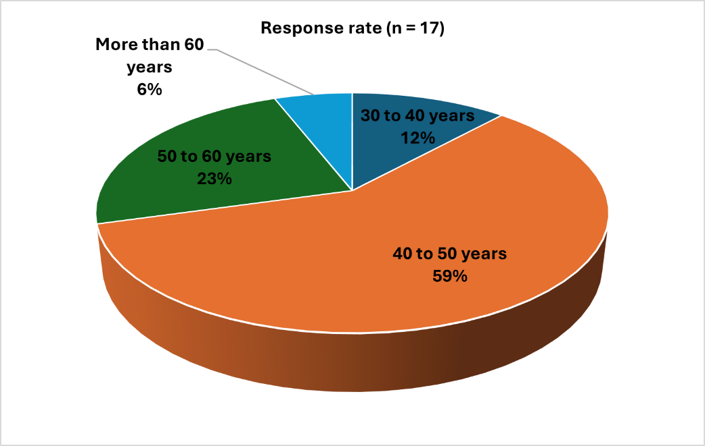

Fig. 1: Distribution of response to the age group of OAB patients reporting to the clinic

About 53% of the respondents noted that chronic kidney disease (CKD) is a prevalent co-morbid condition associated with OAB patients. Most (88.24%) of the respondents identified frequent urination, leakage, and nocturia as the common symptoms observed in OAB patients (Table 1).

Table 1: Distribution of response to common symptoms observed in OAB patients

Symptoms | Response rate (n = 17)
Frequency in urination | 11.76%
Leakage of urination | 0%
Nocturia | 0%
All of the above | 88.24%

Nearly half (47.06%) of the participants mentioned that uroflowmetry is a commonly used diagnostic test for OAB. Approximately 65% of the respondents preferred mirabegron for managing OAB (Table 2). About 71% of the clinicians rated the effectiveness of mirabegron as 5 on a scale of 1-5 for controlling OAB symptoms (Fig. 2).

Table 2: Distribution of response to preferred medication for managing OAB

Preference | Response rate (n = 17)
Mirabegron | 64.71%
Solifenacin | 0%
All of above | 35.29%

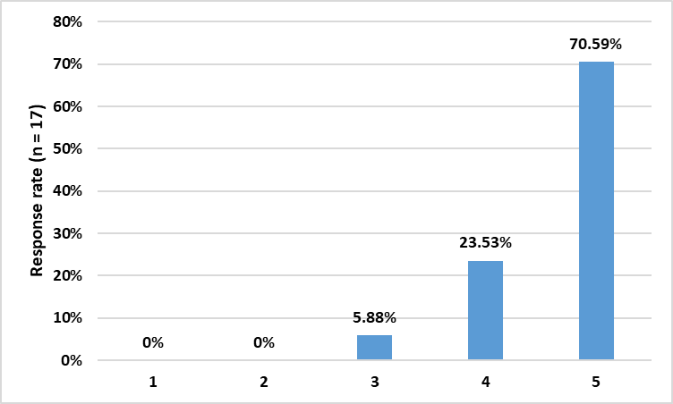

Fig. 2: Distribution of response to the effectiveness of mirabegron in controlling OAB symptoms on a scale of 1-5

Around 59% of the participants reported that 26-50% of patients require combination therapy for BPH management. About 88% of the clinicians preferred silodosin as a combination therapy with mirabegron for BPH management. Over half (58.82%) of the participants noted that mirabegron offers better improvements in mean volume voided per micturition compared to antimuscarinics (Table 3). Approximately 53% of the respondents identified dry mouth, constipation, and urinary retention as fewer side effects of mirabegron (Fig. 3).

Table 3: Distribution of response to the benefits of mirabegron as an alternative to antimuscarinics

Benefits | Response rate (n = 17)
Better improvements in micturition frequency | 17.65%
Better improvements in urgency incontinence | 17.65%
Better improvements in mean volume voided/micturition | 58.82%
All of the above | 5.88%

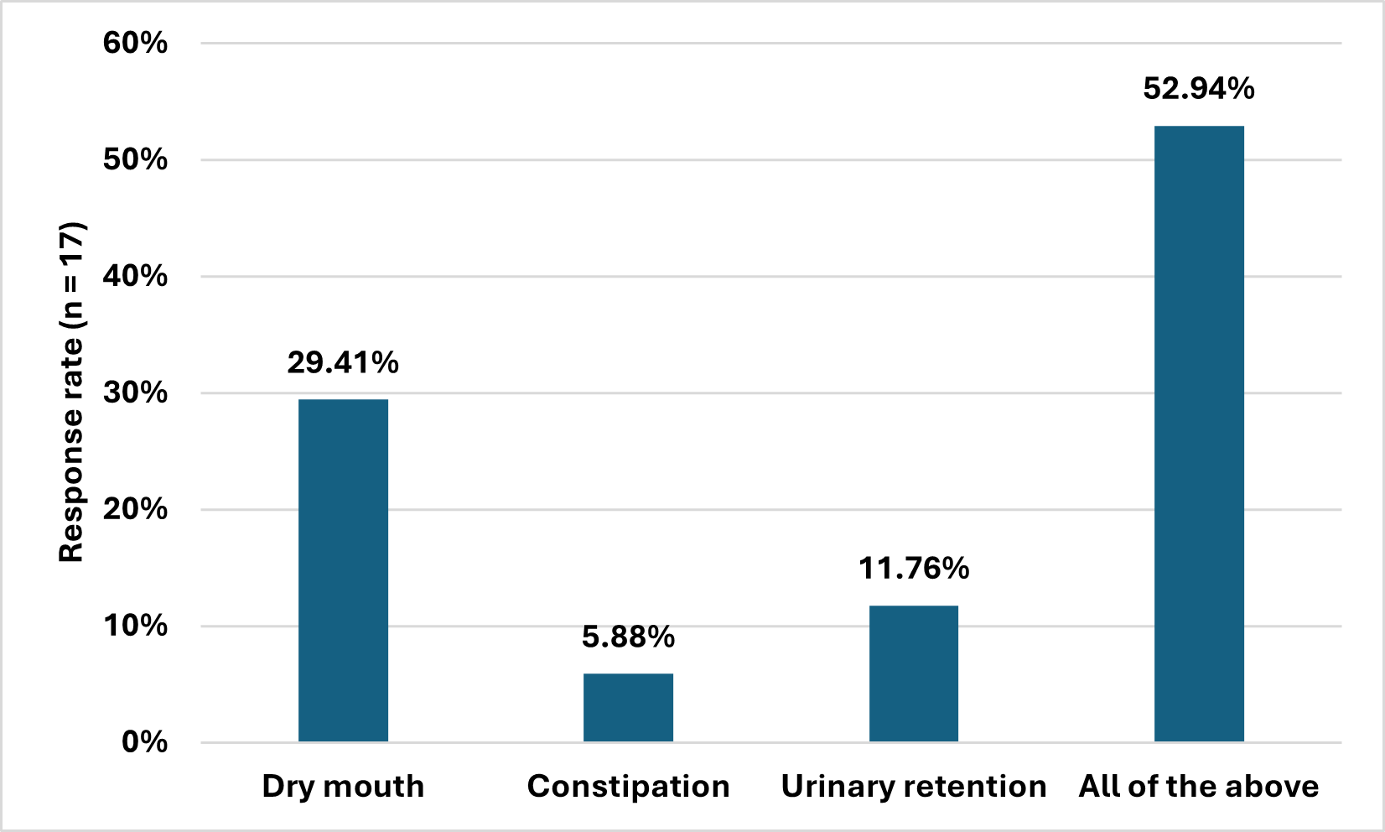

Fig. 3: Distribution of response to fewer side effects of mirabegron

Most (88.24%) of the respondents recommended a 3-month duration for mirabegron therapy. All of the (100%) participants preferred transitioning patients from solifenacin to mirabegron when symptomatic relief was insufficient. About 64% of the clinicians noted a prevalence of 11-20% for urge and stress urinary incontinence. Around 35% of the respondents recommended using a bladder diary for patients aged 36-50 years. Approximately 59% of the participants reported that 16-20% of patients adhere to lifestyle modifications. About 59% of the clinicians indicated that 40-60% of patients tolerate mirabegron therapy. Around 41% of the respondents preferred mirabegron for managing OAB in patients with predominant nocturia (Fig. 4). About 48% of the respondents observed urgency, frequency, urge incontinence, and nocturia as the most common symptoms in OAB patients (Table 4).
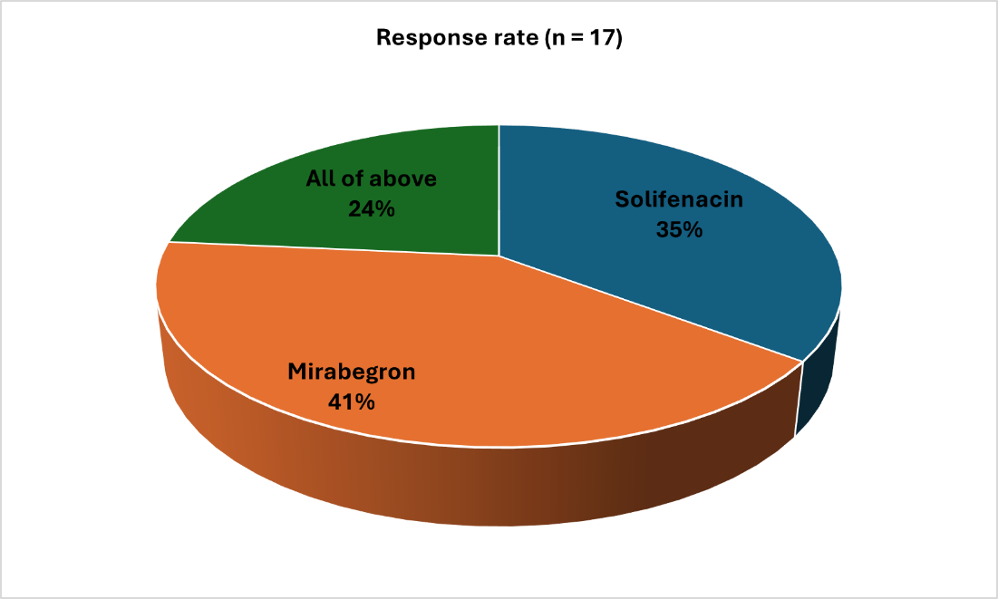

Fig. 4: Distribution of response to preferred medication for managing OAB in patients with predominant nocturia

Table 4: Distribution of response to most common symptoms observed in OAB patients
Symptoms | Response rate (n = 17)
Urgency in urination | 29.41%
Frequency in urination | 17.65%
Urge incontinence in urination | 0%
Nocturia in urination | 5.88%
All of the above | 47.06%

4. discussion

The survey results highlight several key clinical implications for managing OAB in Indian settings. According to the findings, mirabegron alone and in combination with silodosin are highly effective medications for managing OAB and BPH, respectively.
Many survey participants noted that patients in the 40-50 years age range frequently visit the clinic in routine practice. In line with this finding, Jingzhen et al. found that the severity of OAB generally increases between the ages of 40 and 49 years [9]. Additionally, Huang et al. reported that in central Taiwan, female community residents aged 40 and older experienced high annual rates of incidence, remission, and persistence of OAB [10]. Leron et al. noted that although OAB can impact children and young adults, it is most frequently observed in individuals over 40 years of age [11].
Most of the participants identified frequent urination, leakage, and nocturia as the common symptoms observed in OAB patients. Chess-Williams and Sellers described OAB as a collection of storage symptoms, including urgency, frequency, nocturia, and urge urinary incontinence. They noted that the most prevalent symptoms of OAB are urinary urgency and frequency, which may be linked to involuntary contractions of the detrusor smooth muscle [12]. Leron et al. reported that OAB is characterized by symptoms of urinary urgency, often accompanied by frequency and nocturia, with or without urgency incontinence, and occurs in the absence of urinary tract infection or other apparent pathology [11].
Most of the current survey respondents preferred mirabegron for managing OAB. O'Kane et al. noted that clinical trials have demonstrated that mirabegron, a selective β3-adrenoceptor agonist, delivers notable clinical benefits and maintains high adherence rates over 12 months. Moreover, due to its unique mechanism of action, it is anticipated to have a more favorable tolerability profile than antimuscarinic agents, potentially enhancing long-term adherence to treatment. From an economic perspective, despite its higher acquisition cost, mirabegron is deemed cost-effective, as it provides a greater increase in quality-adjusted life-years compared to antimuscarinic drugs [13].
The majority of the current survey clinicians rated mirabegron as 5 in terms of its effectiveness in controlling OAB symptoms. In a post-marketing study, Takahashi et al. reported that mirabegron is a well-tolerated and effective treatment for patients with OAB symptoms, regardless of whether they also had BPH [14], Makhani et al. reported that mirabegron was effective in treating OAB, showing a greater reduction in incontinence episodes—0.44 episodes per day more than the placebo—as well as a decrease in daily micturition and episodes of urgency [15]. Sharaf and Hashim noted that the research demonstrates mirabegron as an effective and well-tolerated drug, although it may have some adverse effects of concern [16].
Over half of the survey participants observed that mirabegron provided superior improvements in the mean volume voided per micturition compared to antimuscarinics. O’Kane et al. found that mirabegron led to significant enhancements in various measures, including the average amount of micturition per 24 hours, incontinence episodes per 24 hours, urgency episodes per 24 hours, mean volume voided, and storage function, which includes the first desire to void and maximum cystometric capacity [13]. Similarly, Sharaf and Hashim reported that mirabegron significantly reduced the mean volume voided per micturition, the number of incontinence episodes, nocturia episodes, urgency incontinence episodes, and urgency episodes per 24 hours [16]. Nitti et al. observed that efficacy endpoints across three studies were assessed by changes from baseline to the final visit in the mean volume voided per micturition, and from baseline to week 4 in the mean number of incontinence episodes and micturition per 24 hours [17]. Kuei et al. noted that mirabegron at daily doses of 25 mg, 50 mg, and 100 mg demonstrated significant improvements in micturition frequency, urgency incontinence, and mean volume voided per micturition as early as the first assessment, with these benefits sustained throughout the treatment period [18].
Many survey respondents noted dry mouth, constipation, and urinary retention as less frequent side effects of mirabegron. Hou et al. reported that side effects such as nasopharyngitis, dry mouth, hypertension, constipation, headache, dyspepsia, urinary tract infection, dizziness, blurred vision, nausea, cardiovascular events, influenza, prolonged QT interval on electrocardiogram, upper respiratory tract infection, and high blood pressure [19]. Dawood and El-Zawahry noted that adverse drug reactions to mirabegron are generally mild and well-tolerated, with common side effects including hypertension, nasopharyngitis, and urinary tract infection. Dry mouth, a frequent side effect of antimuscarinics, occurs six times less often with mirabegron due to its minimal impact on muscarinic receptors in the salivary glands. Other reported side effects include tachycardia, headache, back pain, dizziness, palpitations, atrial fibrillation, urticarial reactions, joint pain, and swelling [6]. Wang et al. found that, based on drug instructions and randomized controlled studies, common adverse effects of mirabegron are nausea, headache, hypertension, constipation, dizziness, tachycardia, and nasopharyngitis [20].
The majority of the current survey experts favored mirabegron for managing OAB in patients with nocturia as the primary condition. Yoshida et al. found that mirabegron reduced nocturnal voiding frequency by increasing nocturnal bladder capacity, which, in turn, improved quality of life by enhancing sleep quality in female patients with OAB and nocturia [21]. Additionally, Nitti et al. reported that in several phase III trials, mirabegron effectively improved urgency, urgency incontinence, urinary frequency, and nocturia episodes compared to both placebo and active antimuscarinic agents [17].
Most of the respondents reported urgency in urination, frequency in urination, and nocturia in urination are the most common symptoms observed in OAB patients. Dijk et al. noted that urgency is a key indicator for diagnosing OAB and is closely associated with frequent daytime urination, nocturia, and incontinence. They found that nocturia is frequently reported as the most bothersome symptom [22]. Araklitis et al. described OAB as characterized by urinary urgency, often accompanied by frequency and nocturia, with or without urgency incontinence, and occurring in the absence of a urinary tract infection [23].
The survey provides valuable insights into the management of OAB and the use of mirabegron among clinicians. The key strength is its focus on a targeted population, specifically, clinicians experienced in managing OAB, ensuring relevant insights from practical experience. However, the relatively small sample size may limit the generalizability of the results. Additionally, the cross-sectional design provides only a snapshot of clinician opinions, which may not capture long-term trends or outcomes. Clinician familiarity with specific treatments might also influence reported preferences and experiences, potentially skewing the results. Future research with larger sample sizes and longitudinal studies could offer more comprehensive insights into the long-term efficacy and safety of mirabegron, as well as examine how evolving treatment practices and clinician experiences affect OAB management strategies.
5. Conclusion

The survey underscores mirabegron as a preferred treatment for OAB, especially in patients with nocturia and those unresponsive to solifenacin. Clinicians noted significant benefits, including improved symptom control, quality of life, and enhanced efficacy when combined with solifenacin. Most reported that mirabegron was well-tolerated with fewer side effects than antimuscarinics. Overall, mirabegron was favored for its effectiveness and is recommended as a valuable alternative or adjunct to traditional treatments.

Disclaimer (Artificial intelligence)
Option 1:
Author(s) hereby declare that NO generative AI technologies such as Large Language Models (ChatGPT, COPILOT, etc.) and text-to-image generators have been used during the writing or editing of this manuscript.
Option 2:
Author(s) hereby declare that generative AI technologies such as Large Language Models, etc. have been used during the writing or editing of manuscripts. This explanation will include the name, version, model, and source of the generative AI technology and as well as all input prompts provided to the generative AI technology
Details of the AI usage are given below:
1.
2.
3.
Ethical Approval:

As per international standards or university standards written ethical approval has been collected and preserved by the author(s).

Consent
As per international standards or university standards, Participants’ written consent has been collected and preserved by the author(s).

References

- Irwin DE, Milsom I, Hunskaar S, Reilly K, Kopp Z, Herschorn S, et al. Population-based survey of urinary incontinence, overactive bladder, and other lower urinary tract symptoms in five countries: results of the EPIC study. Eur Urol. 2006 Dec;50(6):1306–14; discussion 1314-1315.
- Coyne KS, Wein AJ, Tubaro A, Sexton CC, Thompson CL, Kopp ZS, et al. The burden of lower urinary tract symptoms: evaluating the effect of LUTS on health-related quality of life, anxiety and depression: EpiLUTS. BJU Int. 2009 Apr;103 Suppl 3:4–11.
- Wang L, Deng S, Meng F, Zhang L, Min Z, Li J, et al. Comprehensive analysis of global research on overactive bladder: A scientometric approach. Front Surg. 2023 Jan 6; 9:1078052.
- Pal M, Bandyopadhyay S, Roy A. Overactive bladder symptom score - translation and linguistic validation in Bengali. J Family Med Prim Care. 2022 Jan;11(1):79-83.
- Overactive Bladder (OAB). Forbes India [Internet]. [cited 2024 Aug 10]. Available from: https://www.forbesindia.com/article/brand-connect/overactive-bladder-(oab)/76943/1
- Dawood O, El-Zawahry A. Mirabegron. In: StatPearls [Internet]. Treasure Island (FL): StatPearls Publishing; 2024 [cited 2024 Aug 10]. Available from: http://www.ncbi.nlm.nih.gov/books/NBK538513/
- Sharaf A, Hashim H. Profile of mirabegron in the treatment of overactive bladder: place in therapy. Drug Des Devel Ther. 2017 Feb 20;11:463-467.
- Jindan L, Xiao W, Liping X. Evolving Role of Silodosin for the Treatment of Urological Disorders - A Narrative Review. Drug Des Devel Ther. 2022 Aug 26;16:2861-2884.
- Zhu J, Hu X, Dong X, Li L. Associations Between Risk Factors and Overactive Bladder: A Meta-analysis. Female Pelvic Med Reconstr Surg. 2019 May/Jun;25(3):238-246.
- Huang L, Hu SW, Lu CJ, Chang CC, Chen GD, Ng SC. The three-year evolution of overactive bladder syndrome in community-dwelling female residents aged 40 years and above. Taiwanese Journal of Obstetrics and Gynecology. 2022 May 1;61(3):479–84.
- Leron E, Weintraub AY, Mastrolia SA, Schwarzman P. Overactive Bladder Syndrome: Evaluation and Management. Curr Urol. 2018 Mar;11(3):117–25.
- Kwon J, Kim DY, Cho KJ, Hashimoto M, Matsuoka K, Kamijo T, et al. Pathophysiology of Overactive Bladder and Pharmacologic Treatments Including β3-Adrenoceptor Agonists -Basic Research Perspectives. Int Neurourol J. 2024 Feb;28(Suppl 1):12-33.
- O’Kane M, Robinson D, Cardozo L, Wagg A, Abrams P. Mirabegron in the Management of Overactive Bladder Syndrome. Int J Womens Health. 2022 Sep 16; 14:1337–50.
- Takahashi S, Kato D, Tabuchi H, Uno S. Safety and effectiveness of mirabegron in male patients with overactive bladder with or without benign prostatic hyperplasia: A Japanese post‐marketing study. Low Urin Tract Symptoms. 2021 Jan;13(1):79–87.
- Makhani A, Thake M, Gibson W. Mirabegron in the Treatment of Overactive Bladder: Safety and Efficacy in the Very Elderly Patient. Clin Interv Aging. 2020 Apr 23;15:575-581.
- Sharaf A, Hashim H. Profile of mirabegron in the treatment of overactive bladder: place in therapy. DDDT. 2017 Feb 20; 11:463–7.
- Nitti VW, Khullar V, van Kerrebroeck P, Herschorn S, Cambronero J, Angulo JC, et al. Mirabegron for the treatment of overactive bladder: a prespecified pooled efficacy analysis and pooled safety analysis of three randomised, double-blind, placebo-controlled, phase III studies. Int J Clin Pract. 2013 Jul;67(7):619-32.
- Kuei CH, Peng CH, Liao CH. Perspectives on mirabegron in the treatment of overactive bladder syndrome: A new beta-3 adrenoceptor agonist. Urological Science. 2015 Mar 1;26(1):17–23.
- Hou J, Xu F, Du H, Li N. Adverse events associated with mirabegron 50 mg versus placebo: A systematic review and meta-analysis. Progrès en Urologie. 2021 Sep 1;31(11):627–33.
- Wang J, Zhang A, Ye M, Zhang C. Examining the safety of mirabegron: an analysis of real-world pharmacovigilance data from the US FDA adverse event reporting system (FAERS) database. Front Pharmacol. 2024 Mar 18;15:1376535.
- M Y, M G, S K, K K, Y M, M N, et al. Mirabegron Improves Nocturia, Nocturia-Associated Quality of Life, and Sleep Quality in Female Patients with Overactive Bladder. Austin J Urol. 2017; 4(1): 1054.
- Van Dijk MM, Wijkstra H, Debruyne FM, De La Rosette JJMCH, Michel MC. The role of nocturia in the quality of life of men with lower urinary tract symptoms. BJU Int. 2010 Apr;105(8):1141–6.
- Araklitis G, Baines G, da Silva AS, Robinson D, Cardozo L. Recent advances in managing overactive bladder. F1000Res. 2020 Sep 11;9:F1000 Faculty Rev-1125.

