Case report

Idiopathic Choroidal Neovascularization in Young Patients: Report of Two Cases

Abstract
Idiopathic choroidal neovascularization (ICNV) in young patients represents a rare but visually threatening condition characterized by the presence of subfoveal or juxtafoveal neovascular membranes in the absence of identifiable predisposing factors such as high myopia, inflammatory disorders, trauma, or hereditary retinal disease. The advent of anti-VEGF therapy has dramatically changed the visual prognosis of these patients. We report two cases of ICNV managed at the Department of Ophthalmology, Hôpital Militaire d’Instruction Mohamed V, Rabat, Morocco, emphasizing the role of multimodal imaging and the efficacy of intravitreal anti-VEGF therapy.
Keywords: Idiopathic choroidal neovascularization, young patients, anti-VEGF therapy, OCT, fluorescein angiography.

Introduction
“Choroidal neovascularization (CNV) is characterized by the proliferation of aberrant blood vessels that arise from the choroid and extend beneath the retinal pigment epithelium or into the subretinal space” [1]. “Among patients younger than 50 years, idiopathic CNV (ICNV) constitutes the second most frequent cause after pathological myopia. The underlying mechanisms remain incompletely elucidated but likely involve focal disruptions of Bruch’s membrane and alterations in the retinal pigment epithelium (RPE). ICNV generally presents unilaterally and, in the absence of timely intervention, may progress to severe and irreversible visual impairment” [2]. “Accurate diagnosis and disease monitoring rely on multimodal imaging, particularly fluorescein angiography (FA) and optical coherence tomography (OCT)” [5]. “The advent of intravitreal anti–vascular endothelial growth factor (anti-VEGF) therapy has profoundly transformed disease management, yielding substantial structural and functional improvement in the majority of affected individuals” [9,10].

Case presentation

Case 1

An 18-year-old female patient with no medical, surgical, or ocular trauma history presented with a sudden decrease in visual acuity in the left eye. Uncorrected visual acuity was 20/100 in the left eye (OS) and 20/20 in the right eye (OD), with no improvement after refraction. Anterior segment examination of both eyes was unremarkable. Fundus examination revealed the presence of a macular choroidal neovascular membrane associated with a serous retinal detachment. The vitreous was clear, and the peripheral retina appeared normal. luorescein angiography revealed an area of early hyperfluorescence followed by late leakage, indicative of an active choroidal neovascular membrane. Optical coherence tomography (OCT) demonstrated loss of the normal foveal contour, disruption of the retinal pigment epithelium (RPE), and an increased central macular thickness measuring 461 µm, findings consistent with active idiopathic choroidal neovascularization (ICNV).

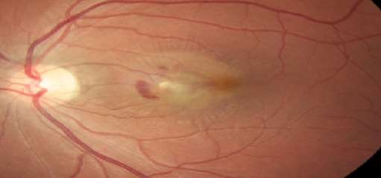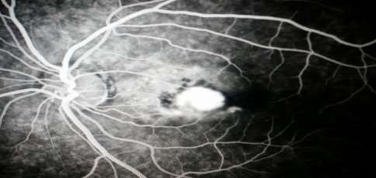
B
A
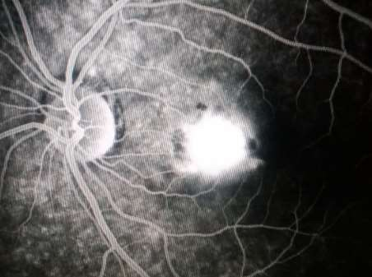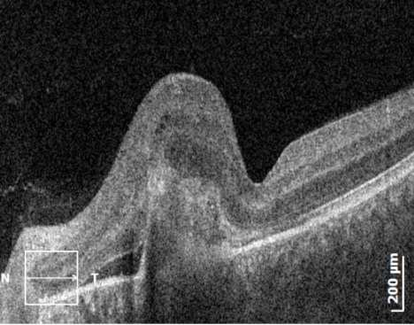
D
C
Figure 1A-D: Fundus photograph, fluorescein angiography, and OCT images showing active subfoveal ICNV in the left eye.

Case 2
A 39-year-old male patient with no medical, surgical, or ocular trauma history presented with decreased visual acuity in the right eye. Uncorrected visual acuity was 20/50 in the right eye (OD) and 20/25 in the left eye (OS), with no improvement after refraction. The anterior segment examination of both eyes was unremarkable. Fundus examination revealed the presence of a choroidal neovascular membrane. Fluorescein angiography revealed an area of early, intense hyperfluorescence followed by progressive late leakage of dye. Optical coherence tomography demonstrated a macular choroidal neovascular membrane associated with subretinal fluid. Comprehensive investigations ruled out inflammatory, infectious, and hereditary etiologies. Consequently, a diagnosis of idiopathic choroidal neovascularization was established.

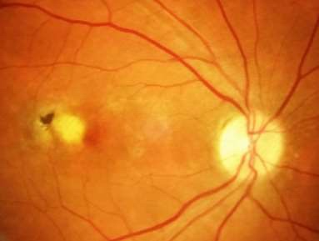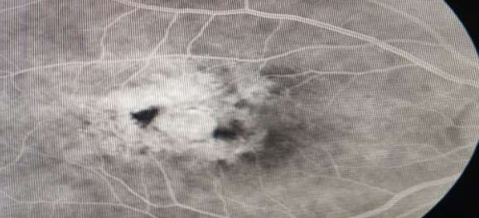
B
A
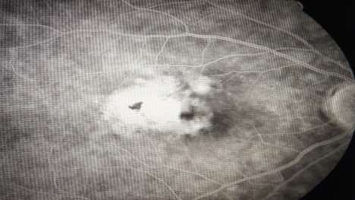 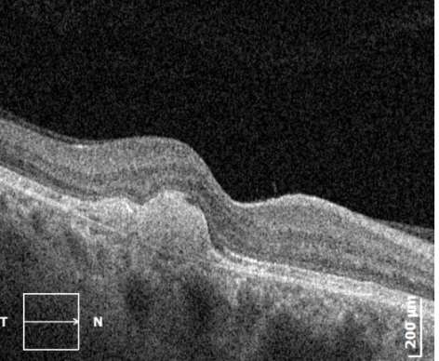Figure 2A-D: Fundus photograph, FA, and OCT images showing idiopathic macular CNV in the right eye.
D
C

Treatment and Follow-up

Both patients were treated with intravitreal bevacizumab injections (1.25 mg/0.05 mL) as the initial therapeutic approach. A pro re nata (PRN) protocol was implemented with monthly monitoring. Additional injections were administered when optical coherence tomography revealed persistent or recurrent subretinal fluid. Following the initial treatments, both patients demonstrated stabilization of visual acuity and a marked reduction of exudative activity.

Discussion
Idiopathic choroidal neovascularization (ICNV) is a distinct pathological entity that typically affects young adults with otherwise healthy eyes and no identifiable systemic or ocular predisposing factors (1,2). Although it is relatively uncommon—representing about 17% of choroidal neovascularization (CNV) cases in individuals younger than 50 years (1)—it remains diagnostically and therapeutically challenging. Its exact pathogenesis is still unclear, but it is thought to result from a multifactorial breakdown of Bruch’s membrane and dysfunction of the retinal pigment epithelium (RPE), which in turn stimulate the production of angiogenic mediators such as VEGF (6,9). Contributory mechanisms including local inflammation, oxidative damage, and mechanical stress at the RPE–Bruch’s membrane interface have also been suggested (6). The neovascular complexes that develop in this context often lead to subretinal exudation or hemorrhage, threatening central visual function.
The diagnosis of ICNV is based on multimodal retinal imaging. On fluorescein angiography, lesions typically appear as areas of early hyperfluorescence with late dye leakage (1,3), whereas optical coherence tomography (OCT) usually shows a hyperreflective subretinal complex accompanied by intra- or subretinal fluid (9,10). Accurate differentiation from secondary CNV—associated with high myopia, angioid streaks, trauma, or inflammatory disorders—is crucial (6,11), as these forms differ markedly in recurrence patterns and prognosis. Compared with secondary CNV, idiopathic forms generally follow a more benign course and exhibit a better response to anti-VEGF therapy (4–7).
Before anti-VEGF therapy became available, management options such as thermal laser photocoagulation and photodynamic therapy (PDT) were limited by high recurrence rates and permanent central scarring (3). The introduction of anti-VEGF agents transformed outcomes, allowing rapid resolution of leakage and significant recovery of vision in most patients (4,5). Multiple comparative studies have demonstrated similar efficacy between bevacizumab, ranibizumab, and aflibercept (7,12,13), although bevacizumab remains the most widely used due to its lower cost (4,7). Treatment strategies vary from fixed monthly dosing to pro re nata (PRN) or Treat-and-Extend (T&E) protocols (6,7). While PRN regimens decrease treatment burden, they require close monitoring, whereas T&E protocols tend to maintain stability with fewer relapses (13). In our cases, the PRN approach resulted in structural improvement and stabilization of visual acuity without adverse events.
Overall, ICNV carries a favorable long-term prognosis when recognized early and treated promptly (5,8,15). Nonetheless, recurrence may occur in up to 30% of patients—most often within a year after discontinuing therapy (15). Progressive fibrosis, macular atrophy, and rare bilateral involvement have been described, underscoring the need for continued follow-up even after clinical remission (4,6,11). Prognostic indicators include initial visual acuity, lesion dimensions and location, and the delay before treatment (5,7). Among these, early intervention prior to subfoveal scarring remains the key determinant of visual outcome (8,11,12).
In settings where access to OCT angiography or branded anti-VEGF agents is limited, bevacizumab offers a practical, effective, and affordable alternative (4,7,12). Our observations align with prior reports emphasizing that early diagnosis and individualized intravitreal anti-VEGF therapy can sustain excellent visual and anatomical results in young patients with ICNV (5,7,8,12,15). Future studies should aim to identify recurrence biomarkers, imaging-based predictors of treatment response, and standardized re-treatment protocols to optimize long-term management (14,15).

Conclusion

Idiopathic choroidal neovascularization (ICNV) in young adults remains an uncommon condition, yet it can seriously threaten vision if not recognized in a timely manner. When identified early and managed appropriately, the visual prognosis is generally favorable.
The combined use of multiple imaging modalities—particularly optical coherence tomography (OCT) and OCT angiography when available—along with the prompt initiation of anti-VEGF therapy, plays a crucial role in refining diagnosis, monitoring disease progression, and preserving central vision.
Among available treatments, bevacizumab stands out as an effective and affordable option, particularly suitable for resource-limited settings.
Long-term follow-up is essential to detect potential recurrences and to prevent fibrotic complications.
Beyond individual management, there is a need for prospective multicenter studies to establish evidence-based treatment guidelines specific to ICNV, identify predictive factors for recurrence, and optimize imaging-based monitoring strategies.
Ultimately, early detection, patient awareness, and ongoing surveillance remain the key elements for maintaining favorable visual outcomes in this young population.

Patient Consent and Conflict of Interest
Written informed consent was obtained from all patients for publication of their clinical data and accompanying images. The authors declare no conflicts of interest related to this publication.

Disclaimer (Artificial intelligence)
Option 1:
Author(s) hereby declare that NO generative AI technologies such as Large Language Models (ChatGPT, COPILOT, etc.) and text-to-image generators have been used during the writing or editing of this manuscript.
Option 2:
Author(s) hereby declare that generative AI technologies such as Large Language Models, etc. have been used during the writing or editing of manuscripts. This explanation will include the name, version, model, and source of the generative AI technology and as well as all input prompts provided to the generative AI technology
Details of the AI usage are given below:
1.
2.
3.

References

1. Cohen SY, Laroche A, Leguen Y, Soubrane G. Idiopathic choroidal neovascularization in young patients. Retina. 1996;16(6):438‑444.

2: Hampton GR, Kohen D, Bird AC. Visual prognosis of disciform degeneration in myopia. Ophthalmology 1983;90: 923-6.

3: Giansanti F, Virgili G, Varano M, Tedeschi M, Rapizzi E, Giacomelli G, Menchini U. Photodynamic therapy for choroidal neovascularization in pediatric patients. Retina. 2005 Jul-Aug;25(5):590-6.

4. Carneiro AM, Costa R, Falcão MS, Barthelmes D. Long‑term results of anti‑VEGF treatment for idiopathic CNV. Eye (Lond). 2013;27(10):1171‑1176.

5: Ghanchi, F.D., Fulcher, C., Madanat, Z. et al. Optical coherence tomography angiography for identifying choroidal neovascular membranes: a masked study in clinical practice. Eye 35, 134–141 (2021).

6: Yin, H., Fang, X., Ma, J. et al. Idiopathic Choroidal Neovascularization: Intraocular Inflammatory Cytokines and the Effect of Intravitreal Ranibizumab Treatment. Sci Rep 6, 31880 (2016)

7: Zhou P, Yang L, Jin X. Ranibizumab versus bevacizumab for the treatment of idiopathic choroidal neovascularization: 2-Year results. Eur J Ophthalmol. 2016 May-Jun;26(3):262-

8: Kim, Mirinae et al. Long-Term Analysis of Clinical Features and Treatment Outcomes of Inflammatory Choroidal Neovascularization.American Journal of Ophthalmology, Vol 233, 18 – 29

9. de Carlo TE, Bonini Filho MA, Chin AT, et al. Spectral‑domain OCT and OCT angiography in neovascular AMD and CNV. Ophthalmology. 2015;122(12):2435‑2447.

10: Kotsolis AI, Killian FA, Ladas ID, Yannuzzi LA. Fluorescein angiography and optical coherence tomography concordance for choroidal neovascularization in multifocal choroiditis. Br J Ophthalmol 2010;94:1506–8.

11: Spaide RF. Choroidal neovascularization in younger patients. Curr Opin Ophthalmol. 1999 Jun;10(3):177-81.

12: Kim JH, Chang YS, Kim JW, Kim CG, Lee DW. Long-Term Outcome and Recurrence of Idiopathic Choroidal Neovascularization Treated with Intravitreal Bevacizumab. J Ocul Pharmacol Ther. 2016 Sep;32(7):431-6

13: Tan CS, Sadda SR. Anti-vascular endothelial growth factor therapy for the treatment of myopic choroidal neovascularization. Clin Ophthalmol. 2017;11:1741-1746
14: Chen, Qin, Yu, Xiaobing, Sun, Zihan, Dai, Hong, The Application of OCTA in Assessment of Anti-VEGF Therapy for Idiopathic Choroidal Neovascularization, Journal of Ophthalmology, 2016, 5608250, 8 pages, 2016.
15: Wu Q, Chen X, Feng K, Liu Y, Zhang C, Zhao L. Evaluation of efficacy and recurrence for anti-vascular endothelial growth factor therapy in idiopathic choroidal neovascularization. BMC Ophthalmol. 2020 Mar 19;20(1):115.

