Case Report

Ileal Gastrointestinal Stromal Tumor (GIST) Masquerading as Primary Ovarian Malignancy: A Diagnostic Pitfall

.
ABSTRACT

Aims: To highlight an uncommon case of primary ileal Gastrointestinal Stromal Tumor (GIST) mimicking ovarian malignancy, emphasizing the importance of considering GIST in the differential diagnosis of abdomino-pelvic masses for accurate management.
Presentation of Case A 65-year-old woman presented with a six-month history of dull aching pain and a palpable pelvic mass (14-week size). Pre-operative work-up included an elevated CA-125 level (76.2 IU/mL) and CEMRI findings strongly suggestive of an ovarian neoplastic lesion, leading to a provisional diagnosis of ovarian malignancy and preparation for staging laparotomy. Intraoperatively, after lysing extensive adhesions, a large (14 *10 cm) variegated mass was found to be entirely separate from the adnexa, confirmed to be arising from the ileum. Wide resection of the tumor with 10 cm of adjacent small bowel was performed.
Discussion This case underscores the diagnostic challenge of exophytic ileal GISTs, which can descend into the pelvis and cause non-specific marker elevation like CA-125. The critical intraoperative finding of the mass being adnexa-free guided the correct surgical approach. Post-operative histopathology confirmed GIST with strong c-kit (CD117) positivity. Given the high-risk category (size and location), the patient was started on definitive adjuvant therapy with the tyrosine kinase inhibitor, Imatinib Mesylate.
Conclusion: GIST is a rare but critical visceral tumor that can precisely mimic ovarian tumors clinically and radiologically. Surgeons must be cognizant of this entity and include it in the differential diagnosis of abdomino-pelvic masses to ensure appropriate resection and subsequent targeted systemic therapy.
Keywords : Gastrointestinal Stromal Tumor, histopathological examination, Ovarian Malignancy, differential diagnosis
Abbreviation
GIST-gastrointestinal stromal tumour
HPE -histopathological examination
IHC- immunohistochemistry
CE MRI- contrast-enhanced magnetic resonance imaging

- INTRODUCTION

GIST is a rare tumour accounting for only 0.1% and 3% of all newly diagnosed gastrointestinal neoplasms. (1) The Average age of presentation is in the sixth decade with no gender predilection. The majority of GISTs are observed to originate from the stomach with an incidence of 50%-60% followed by small bowel, large bowel, and oesophagus with a reported incidence of 20%-30%, 10%, and 5% respectively (Radu et al., 2022; Elorriaga et al., 2023; Sweet et al., 2024 ). (2,6,7,8) GISTs are believed to arise from interstitial cells of Cajal or their stem cell precursors(3). Their diagnosis is based on histology and IHC. Its pathogenesis is defined by mutations within the KIT and PDGFRA gene, which constitutively activate KIT and PDGFRA oncoproteins and serve as crucial diagnostic and therapeutic targets.(4). They are IHC positive for KIT.(12)They exhibit spindle cell proliferation, which may / may not be present in a storiform pattern. GIST expresses the CD117 antigen (c-Kit) and gains functional mutations responsible for activating the growth of these tumours. (5) They are ckit-positive, vimentin-positive, desmin-negative, and smooth muscle actin-negative. Affected individuals with no family history of GIST typically have only one tumour (called a sporadic GIST). People with a family history of GISTs (called familial GISTs) often have multiple tumours. Our case presented masquerading as an ovarian malignancy (Zhang et al., 2022; Suri et al., 2021; Chen et al., 2022)(9-11). The vagueness and diversity in symptoms of both GIST and ovarian masses add to the clinical dilemma and raise the challenge.

2. Presentation of Case

A 65-year-old postmenopausal woman presented to the Gynecology Outpatient Department (OPD) with complaints of abdominal pain for six months. She described the pain as generalized, dull aching, insidious in onset, and intermittent, which was relieved on and off by medications. She reported no history of fever, nausea, vomiting, burning micturition, increased urinary frequency, vaginal discharge, postmenopausal bleeding, loss of appetite, weight gain or loss, constipation, diarrhoea, or haematochezia. She was a known case of hypertension for 10 years, well-controlled on triple drug therapy. Her obstetric history included three successful vaginal deliveries. On presentation, the patient was vitally stable. Abdominal examination revealed a palpable 14-week-sized mass with restricted mobility, smooth margins, and a firm consistency. On bimanual examination, the same 14-week mass was felt through the fornix, firm and nodular. On evaluation, her CA-125 level was elevated at 76.2 IU/L. An initial Ultrasonography (USG) showed a well-defined soft tissue mass in the pelvic region, suggestive of an ovarian mass with O-RADS 4 classification. Contrast-Enhanced Magnetic Resonance Imaging (CEMRI) showed a complex mass lesion in the pelvis with restricted diffusion, abutting bowel loops but with no obvious bowel wall thickening. It demonstrated intense post-contrast enhancement with cystic necrotic areas and no ascites or locoregional lymphadenopathy, with bilateral ovaries not separately visualized—all favouring a neoplastic lesion of ovarian origin. A provisional diagnosis of ovarian malignancy was made, and the patient was planned for staging laparotomy with total abdominal hysterectomy and bilateral salpingo-oophorectomy. × Intraoperative Findings: On exploration, the mass was found to be adherent to the bowel and omentum on all sides. After releasing the extensive adhesions, it was critically observed to have no attachment to any adnexal structure (uterus, fallopian tubes, or ovaries). A round mass of approximately 14*10 cm, variegated in consistency, was identified to be arising from the antimesenteric border of the ileum, 140 cm from the ileocecal junction. The stomach and the remainder of the small and large bowel appeared normal. The mass was resected along with 10 cm of adjacent small bowel on either side.
Postoperative Diagnosis and Management: The histopathological report showed spindle cell proliferation arranged in sheets, features suggestive of a low-grade spindle cell lesion, with the possibility of GIST, which was confirmed on IHC with strong c-kit (CD117) positivity. The postoperative period was uneventful, and the patient was discharged on postoperative day 9 with advice to follow up in a center with Gastrointestinal oncology facility.

3.discussion

The female abdomen is indeed a Pandora’s Box because one is not sure what will come out of it when one opens it. Even with the advent of advanced imaging modalities, the female abdomen defies them all and reveals its secret only when confronted by a surgeon’s scalpel. Abdominal pain ranks among the top three symptoms of patients presenting to the emergency. Pain is usually a feature, but it is not always the case. The differential diagnosis is extremely wide, and a definitive diagnosis is often difficult. In this case, a female patient presented with abdominal pain and a palpable mass with raised CA-125 values, pointing towards the provisional diagnosis of ovarian malignancy. GISTs are rare visceral neoplasms that frequently grow endophytically or exophytically. The size of these tumors can be variable, from 1 cm to 40 cm in diameter. GIST usually does not metastasize to regional lymph nodes but spreads hematogenously to the liver and peritoneum. Clinical presentation varies from an incidental radiological finding to cases of intestinal obstruction, upper or lower GI bleeding, or melena. As in the case being reported, some may present with a palpable abdominal lump. USG followed by CT or MRI is usually employed to investigate patients with abdominal pain or mass. Tumors are usually of varying density and show patchy enhancement after intravenous contrast. Varying degrees of necrosis may be frequently demonstrated within the mass. The biological behaviour of these tumours is unpredictable, but size and mitotic index are the best predictors of metastasis. A tumour less than 2 cms with < 5 mitosis/50 hpf classifies into the very low risk category, but it's peculiar to note that even these can metastasize. Tumour 2-5 cm big with 10 cm irrespective of the number of mitosis or any tumour size with mitosis>10/50hpf or size 5 10cm with mitosis 6-10/50hpf are classified as high risk category. Surgical resection is the treatment of choice for tumours that can be completely resected. They are typically resistant to standard chemotherapy and radiotherapy. These tumours are sensitive to the tyrosine kinase antagonist imatinib mesylate, approved for use in 2001. Tumours with mutations in exon 11 of c-kit are particularly sensitive to this drug at a dose of 400 mg daily. It is advocated for use in all patients with high and intermediate-risk GIST, and also where complete surgical resection is not feasible. Another breakthrough in GIST management has been sunitinib malate, which was approved by the FDA in 2006 as a second-line agent in those resistant to imatinib. The prognosis of advanced metastatic GISTs has been dramatically improved with imatinib chemotherapy, but resection of metastases, especially from the liver, still has an important role. 5-year overall survival ranges from 21-88% depending upon risk grading and completeness of surgical resection. In light of the tendency of these tumours to pursue an indolent clinical course with a significant risk of late relapse, brisk follow-up is advocated for all patients.

TABLES
TABLE 1: BLOOD INVESTIGATION

PARAMETERS | VALUE
HAEMOGLOBIN | 11.5G/DL
TLC | 11,000/MM3
PLATELET | 3.52lakh/mm3
LFT/KFT | WNL
SE | WNL
COAG PROFILE | WNL
BGT | O+
VIRAL MARKERS | NR
TSH | 0.5
TUMOUR MARKER | VALUE
CA 125 | 76.2
AFP | 4.98
BHCG | 7.72
LDH | 511

TABLE 2 : REVIEW OF LITERATURE

Author | AGE(yr) | SIZE (cm) | Mitotic  Rate  (/50hpf) | Residual disease | Adjuvant  Therapy | Follow up | outcome
yamaguchi | 53 | 23.4 *21.1cm | na | no | imatinib | 10 months | Disease free
dande | 50 | 10*12cm | <5/50hpf | no | Adj chemo | 15 days | Disease free
kobayashi | 79 | 15 cm | 36/10 | died | no | 2 weeks | Dead
shreshtha | 44 | 18*20 cm | 22 /hpf | no | imatinib | 6 months | Disease free
Our study | 65 | 10*14 | <2 | no | Referred-imatinib | 4 months | Disease free

FIGURES

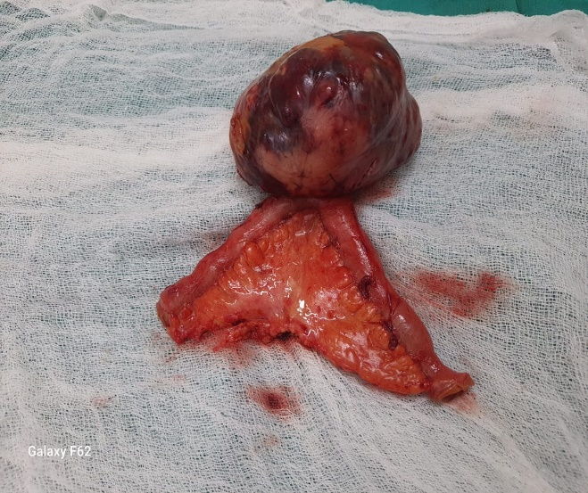

Fig.1. TUMOR MASS ALONGWITH 10 CM OF BOWEL ON EITHER SIDE. CUT SECTION SHOWING VARIEGATED APPEARANCE

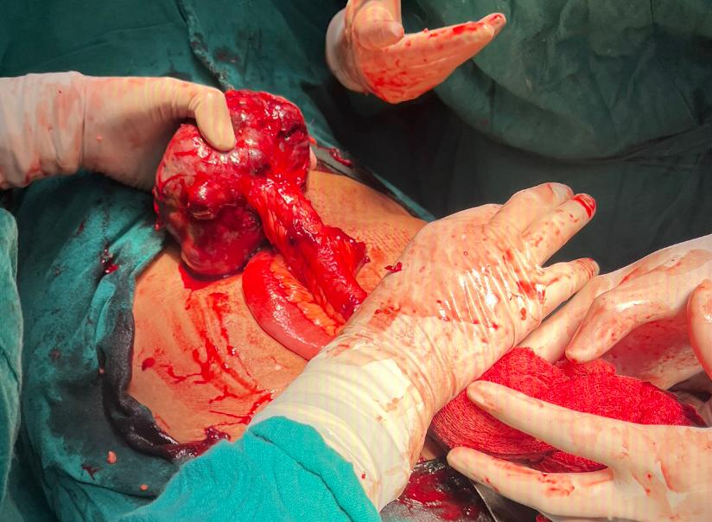

Fig. 2. INTRA OP PICTURE OF TUMOUR ARISING FROM THE ILEUM

4. Conclusion

The presence of pain and a mass in the abdomen alongside increased CA125 in a postmenopausal woman is a common indicator of ovarian malignancy. However, surprising findings can still occur despite modern abdominopelvic imaging. Therefore, one should be prepared to encounter unexpected results.

8. Consent

All authors declare that written informed consent was obtained from the patient for publication of this case report and accompanying images.

Ethical Approval:
As per international standards or university standards written ethical approval has been collected and preserved by the author(s).

COMPETING INTERESTS DISCLAIMER:
Authors have declared that they have no known competing financial interests OR non-financial interests, OR personal relationships that could have appeared to influence the work reported in this paper.

Disclaimer (Artificial intelligence)
The authors hereby declare that generative AI technologies, such as Large Language Models, etc., have been used during the editing of manuscripts. This explanation will include the name, version, model, and source of the generative AI technology, as well as all input prompts provided to the generative AI technology.

Details of the AI usage are given below:
1.
Name: Gemini (or Google Gemini)
Version/Model: Flash 2.5 (Built for Web)
Source/Developer: Google

9. References

- Kobayashi, M., Otsuki, Y., Kobayashi, H., Suzuki, T., Nakayama, S., & Adachi, H. (2022). Gastrointestinal Stromal Tumor with Repeated Multiple Cerebral Infarction Mimicking Ovarian Cancer with Trousseau’s Syndrome. Case Rep. Obstet. Gynecol., 2022, 5537990. https://doi.org/10.1155/2022/5537990 (PUBMED ID: 35432924)
- Dande, A., Pajai, S., Acharya, N., Joshi, K. S., Patel, D. J., & Gupta, A. (2024). Gastrointestinal Stromal Tumors Mimicking Ovarian Mass: A Case Report. Cureus, 16(4), e58320. https://doi.org/10.7759/cureus.58320 (PUBMED ID: 38752091)
- Shrestha, S., Shrestha, B. M., Kharel, S., Rijal, Y., Joshi, J. P., Tiwari, S. B., et al. (2021). Jejunal GIST masquerading as an ovarian mass: A case report. Int. J. Surg. Case Rep., 82, 105960. https://doi.org/10.1016/j.ijscr.2021.105960 (PUBMED ID: 33957597)
- Beham, A. W., Schaefer, I. M., Schüler, P., Cameron, S., & Ghadimi, B. M. (2012). Gastrointestinal stromal tumors. Int. J. Colorectal Dis., 27(6), 689-700. https://doi.org/10.1007/s00384-011-1353-y
- Yamaguchi, T., Kinoshita, J., Saito, H., Shimada, M., Terai, S., Moriyama, H., et al. (2021). Gastrointestinal stromal tumor metastasis to the ovary: A case report. SAGE Open Med. Case Rep., 9, 2050313X211012511. https://doi.org/10.1177/2050313X211012511 (PUBMED ID: 34017592)
- Radu, P., Zurzu, M., Paic, V., Bratucu, M., Garofil, D., Tigora, A., et al. (2022). Interstitial cells of cajal—origin, distribution and relationship with gastrointestinal tumors. Medicina (Kaunas), 59(1), 63.
- Elorriaga, V., Pierani, A., & Causeret, F. (2023). Cajal-retzius cells: Recent advances in identity and function. Curr. Opin. Neurobiol., 79, 102686.
- Sweet, T., Abraham, C. M., & Rich, A. (2024). Origin and development of interstitial cells of Cajal. Int. J. Dev. Biol., 68(3), 93-102.
- Zhang, R., Siu, M. K., Ngan, H. Y., & Chan, K. K. (2022). Molecular biomarkers for the early detection of ovarian cancer. Int. J. Mol. Sci., 23(19), 12041.
- Suri, A., Perumal, V., Ammalli, P., Suryan, V., & Bansal, S. K. (2021). Diagnostic measures comparison for ovarian malignancy risk in Epithelial ovarian cancer patients: a meta-analysis. Sci. Rep., 11(1), 17308.
- Chen, h., yang, b. W., qian, l., meng, y. S., bai, x. H., hong, x. W., et al. (2022). Deep learning prediction of ovarian malignancy at us compared with o-rads and expert assessment. Radiology, 304(1), 106-113.
- Furuya, K., Hada, M., Sugai, H., Miyasaka, Y., Nakagomi, H., Oyama, T., & Mitsui, T. (2012). Gastrointestinal stromal tumor arising in an ileal dupduplication: report of a case. Surg. Today, 42(12), 1234-1239. https://doi.org/10.1007/s00595-012-0135-7

