Influence of Habitat Chemical Characteristics on Aedes Mosquito Breeding Preferences and Larval Survivability in Natural Environments of Kalahandi, Odisha, India

ABSTRACT
This study investigated the influence of habitat chemical characteristics on Aedes mosquito breeding preferences and larval survivability in natural environments of Kalahandi, Odisha, through bi-monthly larval collections conducted between June and September 2025. A total of 1,127 breeding sites were surveyed across urban localities, with plastic containers identified as the most abundant (38.33%) and preferred breeding habitat, exhibiting larvae presence in 60.32 percent of cases and the highest Breeding Preference Ratio (BPR). Discarded tyres followed as significant breeding sites, accounting for 16.86 percent of habitats with a high BPR of 1.21. Chemical analysis of water from selected larval habitats (about 10%) revealed that average temperatures ranged from 29°C to 32°C, while pH values remained consistently slightly alkaline (7.21–7.92). Alkalinity was higher in natural habitats such as tree holes, whereas chlorinity was lowest in plastic containers and highest in tree holes. Dissolved oxygen (DO) levels varied widely, with the highest concentrations observed in discarded tyres. Larval abundance differed among container types, with plastic containers supporting the greatest mean larval density (32.2 ± 14.28), followed by glass containers, tyres, earthen pots, and tree holes. Analysis of variance (ANOVA) demonstrated no significant differences in adult emergence rates (F = 0.61, p = 0.66) or larval mortality (p = 0.116) across container types, indicating that container type did not significantly influence larval survival. These findings highlight the prominent role of artificial containers, particularly plastic and tyre habitats, in sustaining local Aedes populations and underscore the importance of targeted vector control strategies focusing on the management of such breeding sites. These findings can inform targeted community-based interventions to reduce artificial container habitats and control Aedes-borne diseases
Key Words: Aedes, ABDs,vector control,water quality, Bhawanipatna

INTRODUCTION
Development of vaccines against Aedes-borne diseases (ABDs), such as dengue and chikungunya, has not yet achieved significant success. Currently, the most effective strategy remains the control of the vector species, primarily Aedes (Stegomyia) albopictus and Aedes aegypti, which are the principal carriers of dengue virus to humans in many endemic regions worldwide (Neumayr et al., 2017). Although various insecticides have been employed in the past, their effectiveness has diminished due to the development of resistance among these mosquito populations. Consequently, the most viable method to reduce ABD transmission is the elimination of breeding sites—specifically, water-holding containers, both natural and artificial, where these mosquitoes lay their eggs (Kraemer et al., 2015).The disease is potentially fatal and has the capacity to overwhelm healthcare systems and disrupt economic stability (Soh et al., 2021). It is endemic in tropical and subtropical regions worldwide (Paz-Bailey et al., 2024), with approximately 3.9 billion people living in dengue-prone countries, primarily in Southeast Asia, South Asia, the Pacific Islands, and Latin America (Brady et al., 2012). According to the World Health Organization (WHO, 2023), global dengue cases have increased tenfold over the past two decades, rising from 500,000 reported cases in 2000 to 5.2 million in 2020.According to the National Centre for Vector Borne Disease Control (NCVBDC, 2025), between 2019 and 2024, dengue affected approximately 1,151,150 individuals across India, resulting in 1,653 deaths. During this period, chikungunya also affected thousands of individuals; however, no fatalities were reported due to this disease. This data underscores the significant public health impact posed by dengue in comparison to chikungunya over the five-year span. The coastal districts of Odisha bear a significant burden of dengue, as evidenced by the Annual Activity Report 2018-19 published by the Health and Family Welfare Department, Government of Odisha. Specifically, Khurda, Jagatsinghpur, and Cuttack districts reported 1,098, 1,010, and 786 dengue cases, respectively.Frequent travel between Cuttack and Bhawanipatna, the headquarters of Kalahandi district, exacerbates the risk of Aedes-borne diseases in these areas. Over the last two decades, urbanization in Bhawanipatna has intensified, leading to a proliferation of artificial breeding sites for Aedes mosquitoes, further increasing the risk of ABD transmission. Notably, the recent identification of Aedes lineatopennis in Bhawanipatna by Panigrahi et al. (2025) marks the first record of this species in Odisha, indicating that the local climate is becoming increasingly conducive to the spread of new vector species.
Due to their high adaptability, Aedes mosquitoes progressively colonize urban, semi-urban, and rural areas, ovipositing in a wide range of natural habitats such as leaf axils, small ponds, and tree holes, as well as various artificial habitats including discarded containers, earthen pots, tires, gutters, and cement tanks (Ferdousi et al., 2015). Understanding the biology, ecology, behavior, and breeding preferences of Aedes mosquitoes is crucial for effective vector management. Several chemical factors present in water bodies significantly influence female mosquitoes’ selection of oviposition sites, as well as the survival and development of their larvae (Iro et al., 2020). These factors affect key physiological and morphological traits of adult mosquitoes, including body size, fecundity, longevity, and vectorial capacity (Hery et al., 2021). A comprehensive understanding of the bioecological characteristics of mosquito vectors, together with the chemical properties of their breeding sites, is therefore essential for implementing targeted and efficient vector control strategies (Hessou-Djossouet al., 2022). The chemical parameters of breeding habitats also provide valuable insights into the ecological dynamics and distribution patterns of mosquito species (Nikookaret al., 2017).
Despite the recognized importance of these environmental factors, no studies to date have examined their role in mosquito breeding within the Kalahandi region. Accordingly, this study aims to evaluate the influence of the chemical characteristics of breeding sites on the breeding preference ratio (BPR) and larval survivability, and how these factors affect the distribution of Aedes mosquito species in Bhawanipatna.
MATERIALS AND METHODS
Study Areas: Data collection was conducted across various locations within Bhawanipatna Municipal Corporation, the district headquarters of Kalahandi. Bhawanipatna is situated at 19.9°N latitude and 83.17°E longitude (Fig. 1). The area experiences a tropical wet and dry climate, with an average annual rainfall of approximately 1300 mm. According to the 2011 Census of India, the municipality has a population of 69,045 residents, comprising 35,506 males and 33,539 females, residing in around 16,500 households.
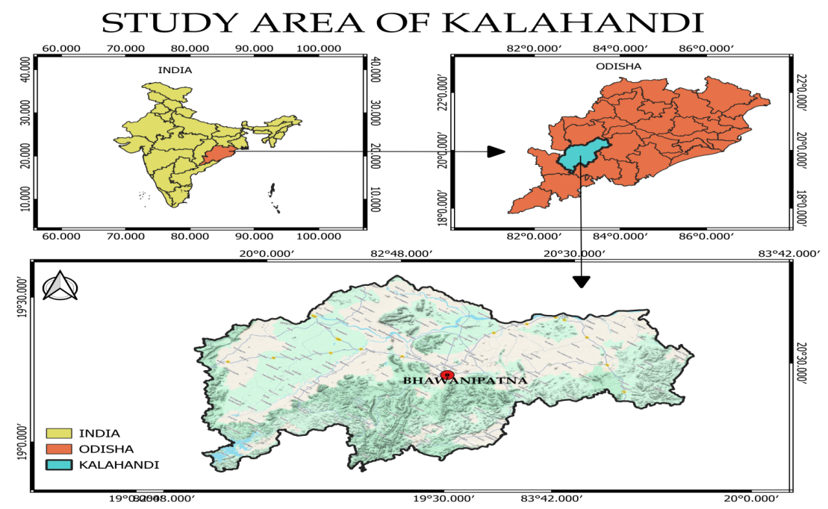
Fig. 1 Study area of Kalahandi, Odisha, India

Larval Survey: Bi-monthly collections of mosquito larvae were carried out in the town from June 2025 to September 2025. Screening of all available water-holding containers or habitats was conducted. The water-holding habitats included plastic containers, clay pots, flower pots, discarded tyres, tree holes, and other containers such as glass jars (Fig. 2). During each survey, the date, time, location, habitat type, and the number of larvae collected were meticulously recorded. Immature stages of mosquitoes were collected from each habitats, about 500 ml of habitat-water along with larvae, using an enamel-coated cup (volume 250 ml) fitted with a handle, and which was transferred to the laboratory in plastic containers. The habitats containing less than 500 ml of water that tested positive for Aedes larvae were excluded from water quality analysis. Larger water containers were sampled by dipping a water-collecting cup at various depths, starting from the top and continuing to the bottom, in a swirling motion to ensure sampling of all edges (Wongkoon et al., 2005). In the laboratory, the mosquito larvae were reared to maturity for species identification using the Aedes identification key (Rueda, 2004). All colonies were maintained in an insectary at a controlled temperature of 25 ± 1°C and relative humidity of 65 ± 5 percent, with a 12-hour light/dark cycle. Adult mosquitoes were fed on cotton pads soaked in a 10 percent glucose solution and raisins. Larvae were reared in white enamel trays on dog biscuits. During entomological experiments, parameters such as the number of larvae and pupae, the number of adult mosquitoes hatched, unhatched, and dead during rearing were recorded for analysis. Out of the containers testing positive for Aedes larvae, 10 percent of each type—plastic containers, clay pots/flower pots, tree holes, tyres, and glass jars/containers—were selected for chemical water analysis.
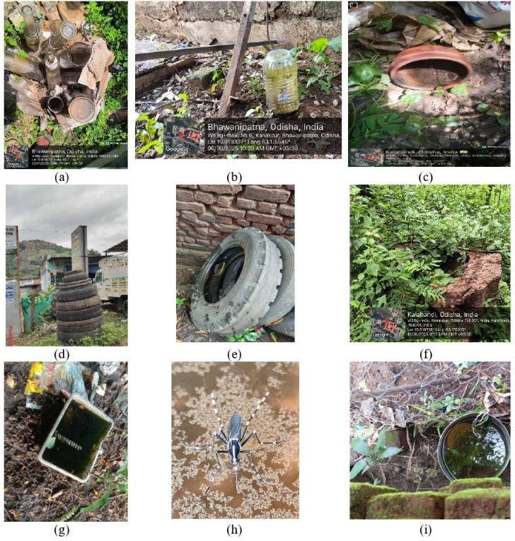
Fig. 2 Different types of Aedes mosquitoes’ habitats (a) glass jar, (b), (g) & (i) plastic container, (c) flower pot, (d) & (e) discarded tyres, (f) tree hole (h) Aedes mosquito taking rest insitu after hatching
Chemical Analysis of Water: The chemical parameters of water from Aedes larval habitats included pH, temperature, total alkalinity, chlorinity, and dissolved oxygen (DO). In situ measurements of pH and temperature were performed using a digital pH meter and thermometer, respectively. Dissolved oxygen (DO) was estimated through Winkler’s method, whereas chlorinity was determined by titration with silver nitrate. Total alkalinity was measured via acid-base titration, involving the addition of a known concentration of sulfuric acid (titrant) to the water samples in the laboratory.
Statistical Analysis: From 10 percent of the collected samples, mean values and standard deviations were calculated for all water parameters, with the exception of temperature, for which average values were determined. The Breeding Preference Ratio (BPR) was computed across all habitat types. Analysis of variance (ANOVA) was employed to assess differences in hatching and mortality rates among the various breeding habitats of Aedesmosquito species. Statistical analyses were conducted using SSP statistical software. The study locations map was made withArcGIS (Fig. 1).

RESULT AND DISCUSSION
The Breeding Preference Ratio (BPR) of Aedes mosquitoes in Bhawanipatna, Kalahandi, is presented in Table 1, providing valuable insights into the oviposition habits and breeding site preferences of Aedes species in the region. Among the 1,127 breeding sites surveyed, plastic containers represented the largest proportion (38.33%) and were the most preferred breeding sites, with larvae present in 60.32 percent of these containers. This resulted in the highest BPR of 1.57. These findings contrast with those of Herath et al. (2024) in Sri Lanka, where, despite the abundance of plastic containers, the breeding preference ratio was generally lower for Ae. albopictus in urban areas. However, our results align with the study by Islam et al. (2019) in Dhaka, Bangladesh, which highlighted plastic containers as key productive breeding habitats due to their widespread usage and ability to retain water. This suggests that Aedes species may exhibit locality- and species-specific preferences for breeding sites. Following plastic containers, discarded tyres accounted for 16.86 percent of breeding sites and demonstrated a high BPR of 1.21. Tyres provide ideal breeding environments by retaining water for extended periods and offering shaded, protected aquatic habitats favorable for larval development. The black color of tyres is also known to attract Aedes mosquitoes. Similar preferences for tyres have been reported in various regions, including Dehradun district in Uttarakhand (Haq and Singh, 2021), Ghana (Abdulai et al., 2024), southeastern Benin (Konkonet al., 2025), and the Southern Afar Region of Ethiopia (Seid et al., 2025).
Table 1. The Breeding Preference Ratio (BPR) for different types of containers from outdoor by Aedes mosquitoes at Bhawanipatna
Breeding Sites | Examined | X% | Ae. Larvae present | Y% | BPR = Y/X
Plastic containers | 432 | 38.33 | 260 | 60.32 | 1.57
Glass containers | 191 | 16.95 | 18 | 4.17 | 0.25
Clay pots/Flower pots | 213 | 18.9 | 56 | 13 | 0.69
Discarded tyres | 190 | 16.86 | 88 | 20.42 | 1.21
Tree holes | 54 | 4.79 | 5 | 1.16 | 0.24
Others (tin cans/metal drums/cement tanks etc.) | 47 | 4.17 | 4 | 0.93 | 0.22
Total | 1127 | 100 | 431 | 100 | 4.18

These studies collectively indicate that tyres are consistently preferred breeding sites for Aedes mosquitoes regardless of geographic location. Clay pots or flower pots accounted for 18.9 percent of potential breeding sites but had a moderate BPR of 0.69, indicating a lower preference relative to plastic containers and tyres, yet remaining significant as breeding habitats. A field study by Prasad et al. (2023) in Delhi reported clay pots as a preferred breeding site, surpassing plastic and other container types. This preference may be attributed to the thermoregulatory properties of clay pots, which soak up water and provide a cooler environment during hot sunlight, offering a more favorable microhabitat for larvae. Glass containers, tree holes, and other miscellaneous containers had lower percentages of larval presence and correspondingly low BPR values of 0.25, 0.24, and 0.22, respectively, suggesting a minimal contribution to Aedes breeding in the study area. Herath et al. (2024) similarly suggested that these habitats are less significant contributors unless breeding in artificial containers is reduced or eliminated. From a public health perspective, these findings have important practical implications. Community education initiatives should emphasize the removal or proper treatment of plastic containers and discarded tyres to effectively disrupt Aedes breeding sites. Additionally, solid waste management programs should prioritize the control of plastic litter and old tyres to reduce the risk of Aedes-borne diseases.
Table 2. Different chemical parameters of water from five different Aedes larval habitats
Breeding Habitats | Average Temperature in celcious | pH (Mean±SD) | Alkanity (Mean±SD) | Chlorinity (Mean±SD) | DO (Mean±SD)
Plasti container | 29.5 | 7.21±0.48 | 2.44±0.81 | 1.31±0.28 | 0.6±0.25
Glass container | 32.23 | 7.92±0.36 | 2.89±0.86 | 0.83±0.27 | 0.70±0.44
Earthen pot/Flower pot | 30.5 | 7.7±0.17 | 3.10±0.49 | 1.29±0.11 | 0.83±0.75
Discardedtyre | 29.6 | 7.65±0.37 | 2.28±1.14 | 4.99±5.00 | 1.13±0.17
Tree hole | 30.48 | 7.85±0.05 | 3.59±0.41 | 4.42±0.39 | 0.54±0.08

Table 2 presents the chemical parameters of water from five different Aedes larval habitats. Average water temperatures across these breeding sites generally ranged between 29°C and 32°C. Interestingly, the slightly cooler temperatures observed in plastic containers still supported high larval densities, suggesting a balanced interaction between temperature, water chemistry, and resource availability that favors mosquito development (Dalpadadoet al., 2022). The pH levels across all sites remained consistently within the slightly alkaline range, varying from 7.21 in plastic containers to 7.92 in glass containers. This aligns with the known preference of Ae. aegypti and Ae. albopictus for pH values between 6.5 and 8.5. Alkalinity values ranged from 2.28 to 3.59 units, with higher alkalinity observed in natural breeding habitats such as tree holes. Previous studies have indicated that neutral to mildly alkaline conditions are conducive to egg laying and larval survival, whereas extreme pH levels adversely affect viability (Dalpadadoet al., 2022). Chlorinity levels were lowest in plastic containers (1.31 mg/L) and highest in tree holes (3.59 mg/L). The elevated chlorinity found in natural habitats may reflect mineral accumulation; however, it does not appear to correlate with larval density since tree holes recorded the lowest larval counts. Dissolved oxygen (DO) values varied widely, from 0.54 mg/L in tree holes to 4.99 mg/L in discarded tyres. The higher DO levels found in tyres and other artificial containers were associated with greater larval abundance, supporting findings reported by Mbanzulu et al. (2022). The significantly greater larval productivity observed in artificial containers under optimal temperature and chemical conditions highlights the critical role these habitats play in sustaining local Aedes populations. These observations underscore the importance of vector control programs focusing on the removal or treatment of artificial containers to effectively reduce mosquito breeding. Furthermore, monitoring water quality parameters such as pH, dissolved oxygen (DO), and chlorinity can provide valuable predictive insights into breeding suitability, thereby guiding surveillance efforts and intervention strategies in endemic areas.
Table 3. The mean and standard deviation (SD) of the number of larvae and pupae present, number of hatched and unhatched individuals, and number of larvae that died during the study
Breeding Habitats | No of Larva Present (Mean±SD) | No. of Pupae Present (Mean±SD) | Hatched as Adult (Mean±SD) | Not Hatched (remained as larvae) (Mean±SD) | Dead (Mean±SD)
Plasti container | 32.2±14.28 | 6.8±4.20 | 16.8±8.28 | 5.2±8.89 | 17±8.22
Glass container | 27.8±6.68 | 7.4±5.50 | 18.8±8.67 | 2.2±1.92 | 14.2±5.45
Earthen pot/Flower Pot | 19.2±4.49 | 3.2±3.11 | 11±6.44 | 1.2±0.83 | 10.2±2.28
Discarded tyre | 23±13.91 | 6±5.56 | 12.85±4.74 | 2.4±2.07 | 8.6±6.95
Tree hole | 9±4.69 | 1.6±2.07 | 4.4±2.70 | 2.6±2.70 | 3.6±2.61

Table 3 presents the mean and standard deviation of the number of larvae and pupae present, as well as the number of hatched and unhatched individuals, along with larvae mortality recorded during the study. The average number of Aedes larvae varied across different breeding site types, with plastic containers exhibiting the highest mean larvae count (32.2 ± 14.28), followed by glass containers (27.8 ± 6.68), discarded tyres (23 ± 13.91), earthen/flower pots (19.2 ± 4.49), and tree holes showing the lowest mean count (9 ± 4.69). A similar pattern was observed for pupae counts and the number of adults hatched, reflecting greater mosquito productivity in artificial containers such as plastic and glass compared to natural habitats like tree holes.
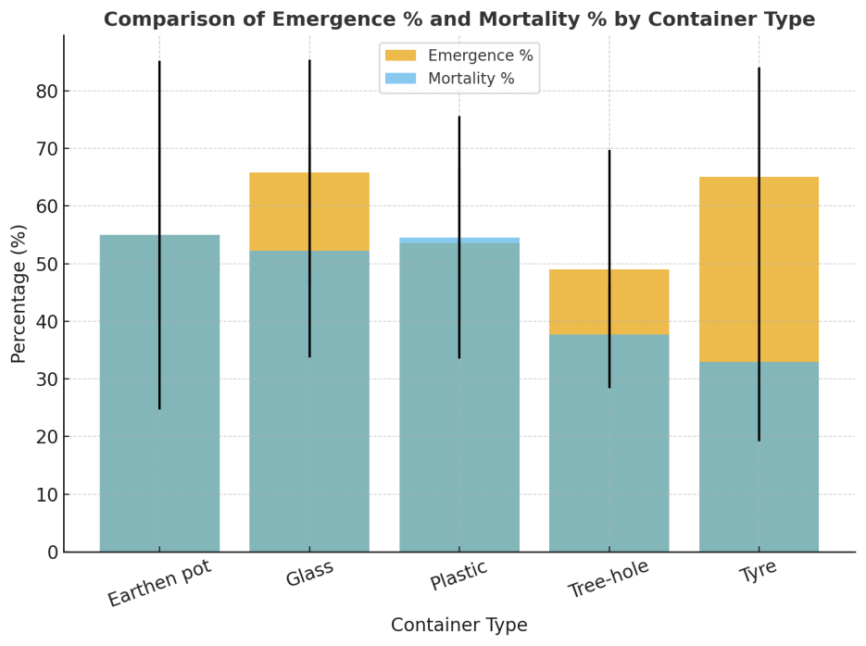
Fig. 3 Comparision of emergence percentage and mortality percentage by container types

The mean adult emergence rate varied from 49.03 percent in tree holes to 65.84 percent in glass containers. The highest larval mortality was observed in earthen pots and plastic containers, both around 55 percent, while tyres exhibited the lowest mortality rate at 32.94 percent. However, analysis of variance (ANOVA) results (F = 0.61, p = 0.66) indicated no statistically significant difference in emergence rates among the five container types (Fig. 3). Similarly, although mortality rates differed—with the highest in earthen pots and plastic containers and the lowest in tyres—the p-value (0.116) was greater than 0.05, signifying that these differences were not statistically significant (Fig. 3). Therefore, container type did not have a significant effect on larval mortality in this study. These findings contrast with those reported by Kumar et al. (2026), but align with the results of Pruszynski et al. (2025) and Pansri et al. (2025).
CONCLUSIONS
Aedes larvae showed a clear preference for artificial container habitats, with plastic containers and discarded tyres supporting higher larval productivity compared with natural habitats such as tree holes. The preferred microenvironments were characterized by temperatures ranging from 29.5 to 30.5°C and slightly alkaline pH values slightly above 7.00, while chlorinity spanned from low (0.83) to higher values (>4). Dissolved oxygen levels remained relatively low, with values up to 1.13, yet these conditions did not preclude substantial larval development in artificial containers. Importantly, despite the elevated productivity in artificial containers, container type did not exert a statistically significant effect on larval mortality in this study. Collectively, these findings underscore the role of artificial containers as key breeding habitats for Aedes, highlighting the need for targeted source reduction and community-based management of plastic and tyre containers to mitigate mosquito production and potential disease transmission. Further research should explore the interaction of container microhabitat characteristics with larval survival across different environmental contexts to refine control strategies.
Disclaimer (Artificial intelligence)
Author(s) hereby declare that NO generative AI technologies such as Large Language Models (ChatGPT, COPILOT, etc.) and text-to-image generators have been used during the writing or editing of this manuscript.

REFERENCES
Abdulai, A., Owusu-Asenso, C.M., Haizel, C., Mensah, S.K.E., Sraku, I.K., Halou, D., Doe, R.T., Mohammed, A.R., Akuamoah-Boateng, Y., Forson, A.O. and Afrane, Y.A. (2024) The role of car tyres in the ecology of Aedes aegypti mosquitoes in Ghana. Current Research in Parasitology & Vector-Borne Diseases, 5: 100176. doi.org/10.1016/j.crpvbd.2024.100176.
Brady, O.J., Gething, P.W., Bhatt, S., Messina, J.P., Brownstein, J.S., Hoen, A.G., Moyes, C.L., Farlow, A.W., Scott, T.W. and Hay, S.I. (2012). Refining the global spatial limits of dengue virus transmission by evidence-based consensus. PLoS Neglected Tropical Diseases, 6(8): e1760. doi:10.1371/journal.pntd.0001760.
Dalpadado, R., Amarasinghe, D., and Gunathilaka, N. (2022) Water quality characteristics of breeding habitats in relation to the density of Aedes aegypti and Aedes albopictus in domestic settings in Gampaha district of Sri Lanka. Acta Tropica, 229(2022): 106339. doi.org/10.1016/j.actatropica.2022.106339.
Dom N. C., Madzlan M. F., Nur S., Hasnan A. and Misran N. (2016) Water quality characteristics of dengue vectors breeding containers. International Journal of Mosquito Research, 3(1): 25-9.
Ferdousi F., Yoshimatsu S., Ma E., Sokel N. and Wagatsuma Y. (2015) Identification of essential containers for Aedes larval breeding to control dengue in Dhaka, Bangladesh. Tropical Medicine and Health, 43(4): 253–264. doi: 10.2149/tmh.2015-16.
Haq Iftikhar-ul. and Singh S. (2021) Container breeding preferences of Aedes mosquitoes in various localities of Dehradun district, Uttarakhand. International Journal of Mosquito Research, 8(1):141-144.
Health and Family Welfare Department Government of Odisha. (2023) Annual Activity Report 2018-19. Available from: https://nhmodisha.gov.in/wp-content/uploads/2023/09/ar201819.pdf/ (Accessed on 30 September, 2025).
Herath J. M. K., De Silva W. P. P., Weeraratne T. C. and Karunaratne S. P. (2024) Breeding habitat preference of the dengue vector mosquitoes Aedes aegypti and Aedes albopictus from urban, semiurban, and rural areas in Kurunegala District, Sri Lanka. Journal of Tropical Medicine, 2024(1): 4123543.doi.org/10.1155/2024/4123543.
Hery L., Boullis A. and Vega-Rua A. (2021) Les proprietesbiotiques et abiotiques des giteslarvairesd’Aedes aegypti et leur influence sur les traits de vie des adultes (synthesebibliographique). Biotechnology, Agronomy, Society and Environment, 25(1): 57–71.
Hessou-Djossou D., Djègbè I., Ahadji-Dabla K. M., Nonfodji O. M., Tchigossou G., Djouaka R., Cornelie S., Djogbenou L., Akogbeto M. and Chandre F. (2022) Diversity of larval habitats of Anopheles mosquitoes in urban areas of Benin and influence of their physicochemical and bacteriological characteristics on larval density. Parasites & vectors, 15(1): 207. doi.org/10.1186/s13071-022-05323-6.
Iro S.M., Seydou Y. A. and Doumma A. (2020) Mesures des indicateurs de proliferation des larves de moustiques au niveau des mares permanentes et semi permanentes de Saga, Niger. International Journal of Biological and Chemical Sciences, 14(4):1188–1202. doi.org/10.4314/ijbcs.v14i4.3.
Islam S., Haque C. E., Hossain S. and Rochon K. (2019) Role of container type, behavioural, and ecological factors in Aedes pupal production in Dhaka, Bangladesh: An application of zero-inflated negative binomial model. Acta Tropica, 193(2019): 50-59. doi.org/10.1016/j.actatropica.2019.02.019.
Konkon A.K., Zoungbédji D.M., Aïkpon R., Hoyochi I., Salako A.S., Konkon C., Lokossou A.S., Dangnon B., Baba-Moussa L., Akogbéto M.C. and Padonou G.G. (2025) Bionomics of the primary arbovirus vectors Aedes aegypti and Aedes albopictus in southeastern Benin. Tropical Medicine and Health, 53(1): 113. doi.org/10.1186/s41182-025-00794-6.
Kraemer M.U., Sinka M.E., Duda K.A., Mylne A.Q., Shearer F.M., Barker C.M., Moore C.G., Carvalho R.G., Coelho G.E., Van Bortel W. and Hendrickx G. (2015) The global distribution of the arbovirus vectors Aedes aegypti and Ae. albopictus. eLife, 4: e08347.doi.org/10.7554/eLife.08347
Kumar G., Singh R. K., Pande V. and Dhiman R. C. (2016) Impact of container material on the development of Aedes aegypti larvae at different temperatures. Journal of vector borne diseases, 53(2): 144-148.
Mbanzulu K.M., Mboera L.E., Wumba R., Engbu D., Bojabwa M.M., Zanga J., Mitashi P.M., Misinzo G. and Kimera S.I. (2022) Physicochemical characteristics of Aedes mosquito breeding habitats in suburban and urban areas of Kinshasa, Democratic Republic of the Congo. Frontiers in Tropical Diseases, 2: 789273. doi.org/10.3389/fitd.2021.789273.
National Center for Vector Borne Diseases Control (NCVBDC). (2025) Dengue situation in India. Ministry of Health & Family Welfare, Government of India. Available from: https://ncvbdc.mohfw.gov.in/index.php/(Accessed on 25 September, 2025).
Neumayr A., Muñoz J., Schunk M., Bottieau E., Cramer J., Calleri G., López-Vélez R., Angheben A., Zoller T., Visser L. and Serre-Delcor N. (2017) Sentinel surveillance of imported dengue via travellers to Europe 2012 to 2014: TropNet data from the DengueTools Research Initiative. Eurosurveillance, 22(1):30433.doi.org/10.2807/1560-7917.ES.2017.22.1.30433.
Nikookar S.H., Fazeli-Dinan M., Azari-Hamidian S., Mousavinasab S.N., Aarabi M., Ziapour S.P., Esfandyari Y. and Enayati A. (2017) Correlation between mosquito larval density and their habitat physicochemical characteristics in Mazandaran Province, northern Iran. PLoS Neglected Tropical Diseases, 11(8): e0005835. doi.org/10.1371/journal.pntd.0005835.
Panigrahi S. K. (2021) Research article survey of aedes mosquito breeding sites, density and pattern of distribution: An approach to manage dengue outbreaks in Bhawanipatna Town, Odisha, India. Research Journal of Pharmacy and Life Sciences, 2(3): 46-65.
Panigrahi S. K., Parida S. R., Das J., Patro S. P., Agrawal S., Behera R. K. and Nayak R. N. (2025) First Report on the Molecular Phylogenetics and Population Genetics of Aedes Lineatopennis (Ludlow) in the World. Research Square, doi.org/10.21203/rs.3.rs-6364616/v1
Pansri S., Ardpairin J., Subkrasae C., Dumidae A., Homkaew C., Wattanachaiyingcharoen W., Thanwisai A. and Vitta A. (2025) Heterorhabditisindica and Steinernemasiamkayai in central Thailand and their potential for controlling Aedes aegypti larvae in artificial container-breeding site. Acta Tropica, 266(2025):107636.doi.org/10.1016/j.actatropica.2025.107636.
Paz-Bailey G., Adams L.E., Deen J., Anderson K.B. and Katzelnick L.C. (2024) Dengue. The Lancet, 403(10427): 667-682.doi:10.1016/S0140-6736(23)02576-X.
Prasad P., Lata S., Gupta S. K., Kumar P., Saxena R., Arya D. K., and Singh H. (2023) Aedes aegypti container preference for oviposition and its possible implications for dengue vector surveillance in Delhi, India. Epidemiology and Health, 45: e2023073.doi.org/10.4178/epih.e2023073.
Pruszynski C. A., Wirsching E. A., Faucett S. E., Hribar L. J. and Leal A. L. (2025) Field Evaluation of Wide-Area Larvicide Spraying Effects on Aedes Aegypti Larvae in Oxitec Release Boxes. Journal of the American Mosquito Control Association,00(00):000–000.doi.org/10.2987/25-7236.
Rueda, L. M. (2004) Pictorial keys for the identification of mosquitoes (Diptera: Culicidae) associated with dengue virus transmission.Zootaxa, 589: 1–60.
Seid M., Aklilu E., Negash Y., Alemayehu D., Melaku K., Mulu A. and Animut A. (2025) Resting habitat, blood meal source and viral infection rate of Aedes aegypti (Diptera: Culicidae) in the Southern Afar Region of Ethiopia. BMC Infectious Diseases, 25(1): 346.doi.org/10.1186/s12879-025-10748-2.
Soh S., Ho S.H., Seah A., Ong J., Dickens B.S., Tan K.W., Koo J.R., Cook A.R., Tan K.B., Sim S. and Ng L.C. (2021) Economic impact of dengue in Singapore from 2010 to 2020 and the cost-effectiveness of Wolbachia interventions. PLOS Global Public Health, 1(10): e0000024. doi.org/10.1371/journal.pgph.0000024
WHO (2023) Dengue global situation. Available from: https://www.who.int/emergencies/disease-outbreak-news/item/2023-DON498/ (Accessed on 20 September, 2025).
Wongkoon S., Jaroensutasinee M. and Jaroensutasinee K. (2005) Larval infestation of aegypti and Ae. albopictus in Nakhon Si Thammarat, Thailand. Dengue Bulletin, 29: 169-75.

