A New Distribution of the Spider Genus Storenomorpha Simon, 1884 (Araneae: Zodariidae) in Chhattisgarh State, India

ABSTRACT
A new spider species Storenomorpha raghavai has been recorded for the first time in the Kulharighat forest region, Gariaband district of Chhattisgarh. This species belongs the family Zodariidae. This is the first Genus Storenomorpha Simon, 1884, species and Family which have been recorded for the first time in the state of Chhattisgarh. With its recording, a new species, genus and a family have been added to the Chhattisgarh spider fauna list.

Keywords: Araneae Chhattisgarh, Gariaband, Storenomorpha, Storenomorpha raghavai, Zodariidae.

INTRODUCTION
The genus Storenomorpha Simon, 1884 is a group of dwelling spiders in the family Zodariidae Thorell, 1881. The genus Storenomorpha was first introduced by Simon in 1884. Storenomorpha comottoi Simon, 1884 is the first recorded species, which Simon recorded in Myanmar in 1884 Simon (1884), WSC (2025). After this, other species were also discovered. As of now, there are 16 species found in the world, which are found only in South Asia like India and South East Asia China, Myanmar Thailand and Laos WSC (2025).

At present, only two species of Storenomorpha genus is identified in India namely S. joyaus (Tikader, 1970) and S. raghavai (Patel & Reddy, 1991). S. raghavai is an endemic spider species found in India, which was first recorded in Andhra Pradesh in 1991 (Patel et al, 1991). It was recorded in Gujarat in 2008 (Parikh et al., 2008) and again in Andhra Pradesh in 2021 (Sankaran et al.,2021 & Singh et al., 2022).

Chhattisgarh state is a very rich state in terms of flora and fauna diversity, where a wide variety of species are found (Nayak 2024 & Nayak et al., 2025d). Till now many spider species have been recorded from different regions of the state and some have been recorded like Stenaelurillus metallicus Caleb & Mathai, 2016, Meotipa sahyadri (Kulkarni, et al., 2017), Stenaelurillus jagannathae Das, Malik & Vidhel, 2015, Hamadruas hieroglyphica Thorell, 1887 (Nayak et al.,2025a, Nayak et al., 2025b, Nayak, 2025e & Nayak et al., 2025c) but spiders of Zodariidae family were not recorded till now. Recently in Chhattisgarh some new spider species Arachanura angura, Epocilla aura, have been recorded from Gariaband district (Nayak et al., 2025f & Nichat et al., 2025b).

MATERIAL AND METHODS
The Storenomorpha raghavai (Patel & Reddy, 1991) spider species has been collected from the Mainpur forest region of Gariaband district of Chhattisgarh. The collection site is located 17 km away from Mainpur in the east direction. It is surrounded by dense forest area. This spider was seen on the ground surface of the forest during the afternoon. As seen in this spider was collected by hand picking method and its live photography was done with INFINIX SMART HD MOBILE CAMERA. After completion of photography, it was preserved in 80% alcohol and deposit in Department of Zoology, Govt. D.B. Girls P.G. College Kalibadi Raipur, Chhattisgarh, India. The specimen is identified by its legs arrangement and pale median strips on cephalothorax. Spider species was identified by standard literature about Storenomorpha record in India (Sankaran, P. M. 2021).

RESULTS AND DISCUSSION
After identifying the specimen using morphological analysis, the specimen was determined to be Storenomorpha raghavai (Patel & Reddy, 1991), a spider species belonging to the family Zodariidae. This is a first recorded observation from Chhattisgarh State of a spider belonging to the family Zodaridae. Only female spiders were observed in the study and not the male. Two species of Storenomorpha are found in India which appear very similar in morphology. These can be identified only on the basis of their body markings. For example, in Storenomorpha raghavai (Patel & Reddy, 1991) the median yellow stripes and posterior yellow square mark are connected whereas in Storenomorpha joyaus (Tikader, 1970) the median yellow stripes and posterior yellow mark are not connected. Its full description is provided in this paper along with the figures (D-J).

Taxonomy
Family: Zodariidae Thorell, 1881
Storenomorpha Simon, 1884
Storenomorpha raghavai (Patel & Reddy, 1991)
Homalonychus raghavai Patel & Reddy, 1991

Type material
Two Adult specimens are collected from (Dev Dongar) Kulharighat, Mainpur Forest Region, Gariaband, Chhattisgarh India. Location 20°16’24”N 82°19’58”E Specimen was collected by Jashavant Nayak on 14.ix.2025. The collected specimens are examination and deposited in Department of Zoology, Govt. D. B. Girls College, Raipur, Chhattisgarh, India. Specimen no. DBZ83.
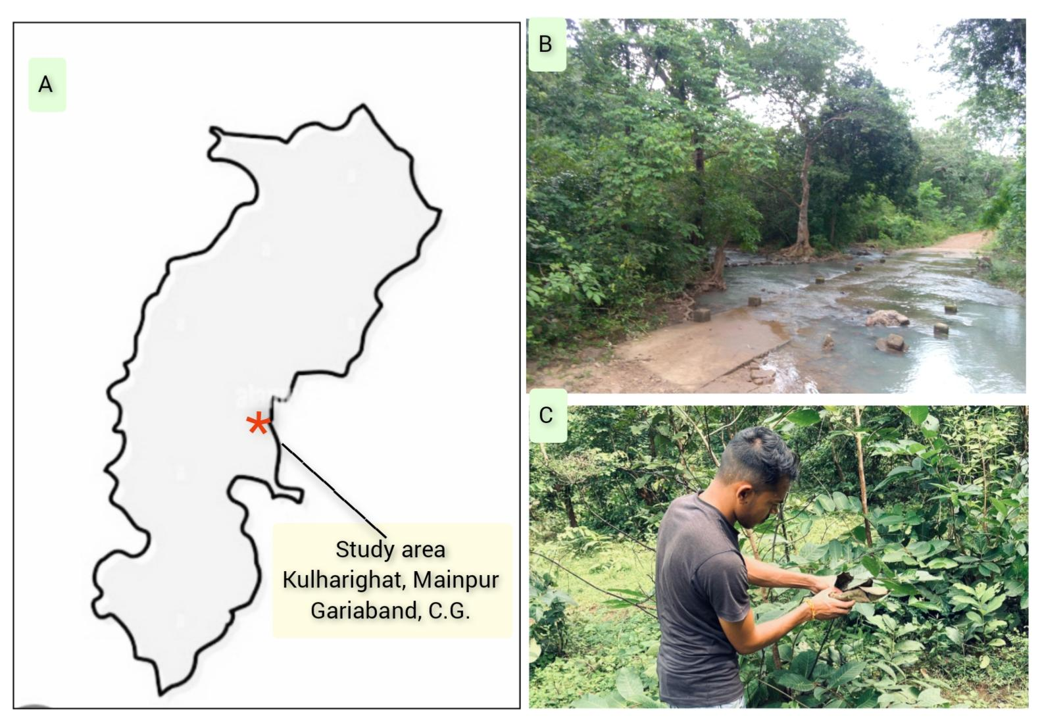
Figure 1: A. Map of Chhattisgarh that represent the location of sample Collection, B. Photograph of Dev Dongar Site, C. Specimen collection

Description
Cephalothorax
Small, one paler median and two dark black lateral strips on both side, eyes attached with lateral strips, sternum is oval.
Opisthosoma
Abdomen is larger than cephalothorax, covered with hairs, two lateral black stripes on both sides, a central yellow median stripe on dorsal carapace, Anterior median pale stripe and posterior square marks are connected. Spinnerets are terminal.
Legs
Leg I is longest, while leg III is shortest. The length of legs in descending order are (I > IV >II > III). The coxa is widen and small, Trochanter is small, Femurs are larger, thickened and pale in colour, Patella is dark and widened, Tibia is small and cylindrical, metatarsus is pale and small, and Tarsus is conical in shape with three tarsus claws.

Diagnosis
The specimen is diagnosed by important taxonomic keys and diagram illustration by Sankaran, P. M. (2021).

Distribution
Endemic in India, Andhra Pradesh (Patel & Reddy, 1991b; Sankaran, 2021), Gujarat (Parikh et al., 2008).

Habitat
In Forest region: Storenomorpha raghavai (Patel & Reddy, 1991) are commonly found under leaf litter, stones, or logs and barks of dry wood. They are adapted to warm and humid conditions for survival. They are Ground-dwelling spiders.

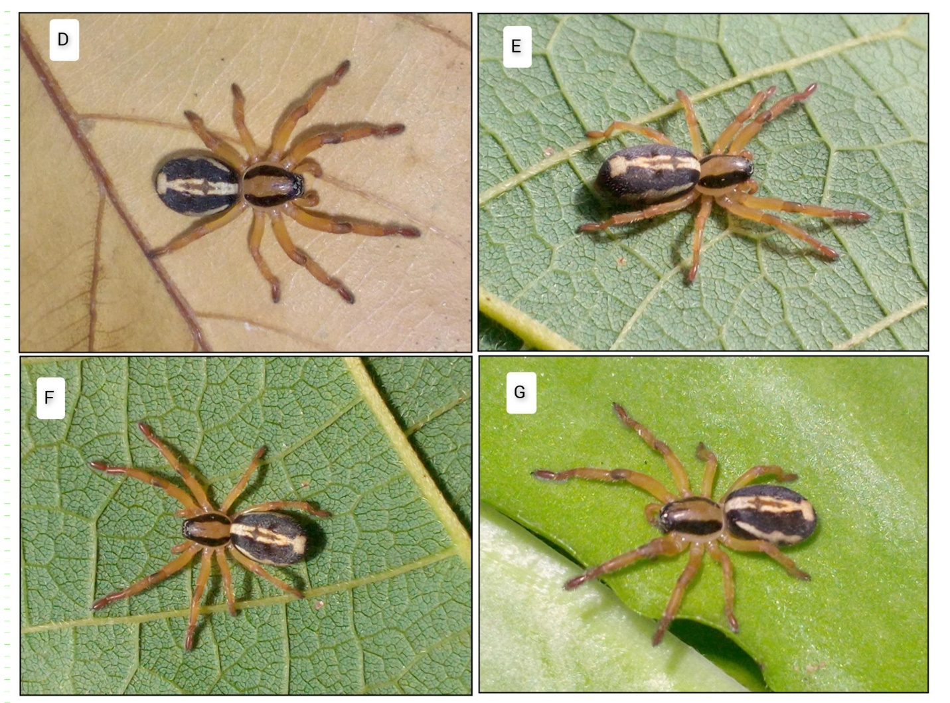
Figure 2 : Habitus- Storenomorpha raghavai (Patel & Reddy, 1991), D & F, dorsal view of the spider, E & G, lateral view.

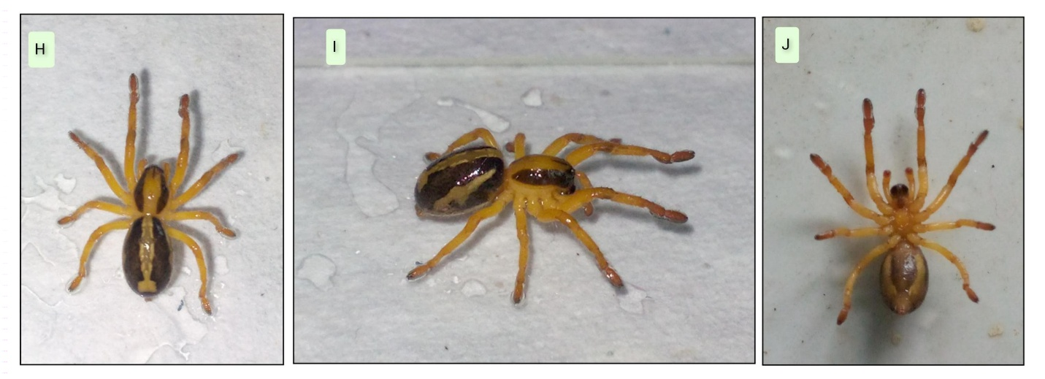
Figure-3: Habitus- Storenomorpha raghavai (Patel & Reddy, 1991): H, dorsal view, I, lateral view, and J, ventral view.

CONCLUSION
This spider has been recorded for the first time in Chhattisgarh state. Here the marking is a good identification key to distinguish Storenomorpha spider species. This spider species is highly predatory. Unlike other spiders, it doesn’t spin large webs or produce thick silk; instead, it produces very fine silk and preys on other insects and invertebrates. This behaviour maintains a balance in forest ecology and is a very important species. Its biodiversity is being better understood so that more new species of this family and genus can be discovered.

DISCLAIMER (ARTIFICIAL INTELLIGENCE)

Author(s) hereby declare that no AI technologies have been used during the writing or editing of manuscripts. All photographs and manuscript is real without used of any AI tools.

REFERENCES
Andreeva, E. M., & Tyshchenko, V. P. (2024). New data on species of Zodariellum Andreeva & Tyshchenko, 1968 (Araneae: Zodariidae) from Central Asia. Arachnology, 19(8), 1055–1064. https://doi.org/10.13156/arac.2024.19.8.1055
Basumatary, P., Caleb, J.T.D., Das, S., Jangid, A. K., Kalita, J. & Brahma, D. 2020a. First record of the genus Vailimia Kammerer, 2006 from India, with the description of two new species (Araneae: Salticidae: Plexippina). Zootaxa, 4790: 178–186.
Basumatary, P., Das, S., Caleb, J.T.D. & Brahma, D. 2020b. First record of the genus Chinattus Logunov, 1999 with the description Arachnol., 69: 127–129.
Benjamin, S. P. 2010. Revision and cladistic analysis of the jumping spider genus Onomastus (Araneae: Salticidae). Zoological J. Linn. Soc., 159: 711–745.
Cao, Q., Li, S.Q. & Żabka, M. 2016. The jumping spiders from Xi-shuangbanna, Yunnan, China (Araneae, Salticidae). ZooKeys, 630:
Dhali, D. C., Saha, S. & Raychaudhuri, D. (2017). Litter and ground dwelling spiders (Araneae: Arachnida) of reserve forests of Dooars, West Bengal. World Scientific News 63: 1-242. 43–104.
Grismado, C. J. & Ramírez, M. J. (2004). A new species of the genus Storenomorpha Simon from Vietnam (Araneae, Zodariidae). Zootaxa 453: 1-7. Doi:10.11646/zootaxa.453.1.1
Jäger, P. (2007). Spiders from Laos with descriptions of new species (Arachnida: Araneae). Acta Arachnologica 56(1): 29-58. Doi:10.2476/asjaa.56.29
Logunov, D. V. (2010d). New species of Zodariidae (Arachnida: Aranei) from Vietnam. Arthropoda Selecta 19(4): 249-260. Doi:10.15298/arthsel.19.4.05.
Nayak, J., Sori, P., & Sahu, L., (2024). Thanatosis Behaviour in the Indoxysticus minutus Tikader, 1960 (Aranae: Thomisidae) in Gariyaband, Chhattisgarh, India. International Journal of Research in Academic World. 3(12) 94-95. https://academicjournal.ijraw.com/media/post/IJRAW-3-12-24.1.pdf
Nayak J., Sori P., Sahu L., Bharti D. (2025a). A new observational record of jumping spider (Aranae: Salticidae: Aelurillini: Aelurillina) Stenaelurillus metallicus Caleb & Mathai, 2016 in Chhattisgarh, India . International Journal of Biology Research 10(1) 19-21. https://www.biologyjournal.in/assets/archives/2025/vol10issue1/10007-1740555118544.pdf
Nayak J., Sori. P., Bharti D. (2025b).Description of a New Spider Meotipa sahyadri Kulkarni, Vartak, Deshpande & Halali, 2017 (Aranae: Theridiidae) in Chhattisgarh, India. International Journal of Research Publication and Reviews 6(2) 4518-4521. https://doi.org/10.55248/gengpi.6.0225.1026
Nayak J. & Sori P. (2025c). Hamadruas hieroglyphica Thorell, 1887 (Aranae: Oxyopidae): First Description of a lynx Spider In Chhattisgarh, India. International Research Journal Of Modernization in Engineering Technology and Science: 7(3): 632-634. DOI: https://www.doi.org/10.56726/IRJMETS68434
Nayak J., Warte H.K., Sori P. & Sahu L. (2025d). Study on Jumping Spiders (Aranae: Araneomorphae: Salticidae) Diversity in Shraddha Public School Campus Gariaband, Chhattisgarh, India. International Journal Of Latest Technology In Engineering, Management & Applied Science : 14 (3): 350- 353 DOI :https://doi.org/10.51583/IJLTEMAS.2025.140300037
Nayak, J. (2025e). Stenaelurillus jagannathae Das, Malik & Vidhel, 2015: First Description in Chhattisgarh, India. Bioscience Discovery, 16(3):37-40. http://biosciencediscovery.com/Archive.html#
Nayak, J., Chaure, M., Majumdar, M., Nichat, A. R., & Harris, K. K. (2025f). Assessment of orb weaver spider (Araneidae Clerck, 1757) diversity in Gariaband forest region with a new endemic species in Chhattisgarh region, India. International Journal of Fauna and Biological Studies, 12(5), 61–67. https://www.doi.org/10.22271/23940522.2025.v12.i5a.1131
Nayak, J., Warte, H. K., Sahu, L., & Rajanikant, R. (2025g). First description of a Crabspiders species Stiphropus sangayus, barrion&litsinger, 1995(Aranae: Araneomorphae : Thomisidae) in Odisha, India. International Journal of Zoology, Environment and Life Sciences , 7(3), 7-10. https://doi.org/10.70604/
Nichat A. R., Warte HK., Nayak J., (2024). Spider diversity (Arachnida:Aranae) in Deobhog region Gariyaband Chhattisgarh India : International Journal of Innovation and Science and Engineering. : 11 (8) : 39 – 45 https://ijiset.com/vol11/v11s8/IJISET_V11_I08_03.pdf
Nichat A. R., Warte H.K., Shaffi S.A. & Nayak J., (2024). A study of biodiversity of spider species (arachnida : aranae : araneomorphae) in kokasara region, Kala-handi, Odisha, India : African Journal of Biological Sciences : 6 (15) : 9550- 9560. https://doi.org/10.48047/AFJBS.6.15.2024.9550-9560
Nichat A. R., Harris K.K., Warte H.K., Dubey M., Sori P. & Nayak J. (2025a). Spiders Diversity in North East Gariaband Forest Regions of Chhattisgarh, India. UTTAR PRADESH JOURNAL OF ZOOLOGY, 46(4):119-127. DOI: https://doi.org/10.56557/upjoz/2025/v46i44808
Nichat, A. R., Nayak, J., Sori, P., & Warte, H. K. (2025b). Description of new jumping spider species Epocilla aura (Aranae: Salticidae: Chrysillini) from Gariaband district, Chhattisgarh State, India. International Research Journal of Biological Sciences, 14(2), 1–4. International Science Community Association. http://www.isca.in
Parikh, P., Sonavanes, S. & Ahir, K. (2008). Spider fauna of Gir PA, Gujarat. Journal of Current Science, 12(2): 717-722.
Patel, B. H. & Reddy, T. S. (1991). A rare new species of Homalonychus Marx (Araneae: Homalonychidae) from coastal Andhra Pradesh, India. Records of the Zoological Survey of India 89: 205-207.
Paul, J., Prajapati, D.A., Joseph, M.M. & Sebastian, P.A. 2020. De-Scription of a new species of Colaxes Simon, 1900 (Araneae: Salti ccidae: Ballinae) from the tropical montane cloud forests of Western Ghats, India. Arthropoda Sel., 29: 244–250.
Piacentini, L. N., & Ramírez, M. J. (2019). Hunting the wolf: a molecular phylogeny of the wolf spiders (Araneae, Lycosidae). Molecular Phylogenetics and Evolution, 136, 227-240.
Sankaran, P. M. (2021). Transfer of HKo9malonychus raghavai Patel & Reddy, 1991 to Storenomorpha Simon, 1884 (Araneae: Zodariidae). Zootaxa 5039(2): 299-300. Doi:10.11646/zootaxa.5039.2.10
Sankaran, P. M., Caleb, J. T. D. & Sebastian, P. A. (2020c). A review of the Indian species formerly assigned to the genus Storena Walckenaer, 1805 (Araneae: Zodariidae) with the description of a new genus. European Journal of Taxonomy 707: 1-23. Doi:10.5852/ejt.2020.707
Sankaran, P. M., Jobi, M. J., Sebastian, P. A., & Sudhikumar, A. V. (2024). A new species of Asceua Thorell, 1887 (Araneae: Zodariidae) from India. Zootaxa 5492 (4): 596–599. https://doi.org/10.11646/zootaxa.5492.4.8
Sen, S., Dhali, D. C., Saha, S. & Raychaudhuri, D. (2015). Spiders (Araneae: Arachnida) of reserve forests of Dooars: Gorumara National Park, Chapramari Wildlife Sanctuary and Mahananda Wildlife Sanctuary. World Scientific News 20: 1-339.
Simon, E. (1884). Arachnides recueillis en Birmanie par M. le chevalier J. B. Comotto et appartenant au Musée civique d’histoire naturelle de Gènes. Annali del Museo Civico di Storia Naturale di Genova 20: 325-372.
Singh, R., & Sharma, A. (2022). Diversity of spider fauna (Arachnida: Araneae) in different districts of Andhra Pradesh, India. Serket, 18(3), 356–377.
Sudhin, P. P., Mali, S., Sarma, P. D., & Sen, S. (2025a). Two new species of the spider genus Psechrus Thorell, 1878 (Araneae: Psechridae) from northeastern India. Zootaxa, 5609(3), 419–429. https://doi.org/10.11646/zootaxa.5609.3.7
Sudhin, P. P., Sankaran, P. M., & Sen, S. (2025b). First record of the genus Piratula Roewer, 1960 from India, with the description of a new species (Araneae: Lycosidae: Zoicinae). Zootaxa, 5659(4), 593–598. https://doi.org/10.11646/zootaxa.5659.4.9
Sudhin, P. P., & Sankaran, P. M. (2025c). First record of the genus Epidelaxia Simon, 1902 (Araneae: Salticidae) from India, with the description of two new species from the Western Ghats. Zootaxa, 5680(2), 251–262. https://doi.org/10.11646/zootaxa.5680.2.6
Wishesh Kumar Sahu, and Surendra Kumar Gautam. 2025. “A Study of Spider Diversity and Habitat Distribution in Rajnandgaon Block, Chhattisgarh, India”. UTTAR PRADESH JOURNAL OF ZOOLOGY 46 (15):50–63. https://doi.org/10.56557/upjoz/2025/v46i155148.

Wijesinghe, D. C., & Benjamin, S. P. (2025). Five new species of the genus Mallinella Strand, 1906 (Araneae: Zodariidae) from Sri Lanka. Zootaxa, 5698(3), 299–314. https://doi.org/10.11646/zootaxa.5698.3.5
World Spider Catalog (2025). World Spider Catalog. Version 26. Natural History Museum Bern, online at http://wsc.nmbe.ch, accessed on {date of access}. Doi: 10.24436/2
Yin, C. M. & Bao, Y. H. (2008). Two new species of the spider genus Storenomorpha from China (Araneae: Zodariidae). Acta Arachnologica Sinica 17: 65-71.
Yin, C. M., Peng, X. J., Yan, H. M., Bao, Y. H., Xu, X., Tang, G., Zhou, Q. S. & Liu, P. (2012). Fauna Hunan: Araneae in Hunan, China. Hunan Science and Technology Press, Changsha, 1590
Yu, H., Jin, Z. Y., Liu, F. X. & Chen, J. (2009). Tow [sic] new species of the genus Storenomorpha from China (Araneae, Zodariidae). Acta Arachnologica Sinica 18: 11-17.
Zhang, B. S. & Zhu, M. S. (2010). Two new species of the genus Storenomorpha Simon from China (Araneae: Zodariidae). Acta Arachnologica 58(2, 2009): 91-95. Doi:10.2476/asjaa.58.91

