Comprehensive Narrative Review Article
A Comprehensive Narrative Review of Naegleria fowleri Infections: Emerging Epidemiology, Molecular Pathogenesis, and Therapeutic Advances (2020-2025)

Abstract
Aim: The heat-loving amoeba “Naegleria fowleri” is responsible for Primary Amoebic Meningoencephalitis (PAM), an infection in the central nervous system that almost always leads to death within a few days. This comprehensive narrative review painstakingly integrates the main findings of the above-mentioned PAM research areas from 2020 to 2025.
Methods: The literature search that we organized was systematic on PubMed/MEDLINE, Scopus, and Web of Science and was predominantly directed to peer-reviewed articles, case reports, and clinical trials published between 2020 and 2025. It was a narrative review and not a formal systematic review.
Results: Our synthesis indicates that there has been a huge change in the epidemiology of the disease and that the South Asian region is the new hot spot for PAM cases. With the application of multi-omics approaches, molecular studies have not only discovered new virulence factors but also determined the interactions between the host and the pathogen. Metagenomic next-generation sequencing (mNGS) has drastically reduced the time taken for diagnosis and accuracy. On the therapeutic side, combination treatments consisting of amphotericin B and miltefosine have increased the survival rates to about 50-70% if the intervention is done early. Nanoparticle-based drug delivery and AI-assisted drug discovery are two of the future research directions.
Conclusion: PAM continues to be a major challenge in the field of public health. The proper control of the disease would involve the introduction of new monitoring techniques, conducting public awareness campaigns, and research on rapid diagnostics and new treatments being done constantly.
Keywords: Naegleria fowleri; Primary Amoebic Meningoencephalitis; Brain-eating amoeba; Epidemiology; Molecular Pathogenesis; Therapeutics

1. Introduction
The Primary Amoebic Meningoencephalitis (PAM) is one of the most lethal and fastest infections of the central nervous system that has ever been mediated. Even the use of critical care and antibiotic therapy has not been able to reduce death rates, which remain around 97% or more (Pitman-Hunt et al., 2021). The death of the patient with this disease happens due to Naegleria fowleri, a thermophilic amoeba that normally lives in hot freshwater and is found in any place where water is warmish around the globe. The area of infection of PAM is very unfortunate since it mainly involves healthy children and young people, and it occurs after water activities. The patient's entry to the body starts with the nose when they go swimming or diving; then, the germs rapidly move inward through the olfactory nerve and get to the brain by passing through the cribriform plate, where the olfactory bulbs are located, and the destruction of brain tissue through hemorrhage necrosis (Coulibaly et al., 2022). The first signs are similar to those of bacterial meningitis, and they consist of a sudden very painful headache, a very high temperature, nausea, and vomiting. Thereafter, very fast deterioration of the nervous system, along with changes in mental condition and coma, occurs, which often leads to confusion about the diagnosis.
The recognition and shifting epidemiological patterns of PAM disease across various regions have been systematically reviewed recently (Gharpure et al., 2021). In these reviews, the historical narrative of PAM has been vividly depicted. Therapeutic strategies, in general, have been unsatisfactory since the very first characterization of the disease. Dosing and trial results have led to Amphotericin B being the traditional therapeutic mainstay despite its evident in vitro amoebicidal activity. However, clinical results have been poor, the reason being the drug's poor penetration through the blood-brain barrier, its heavy nephrotoxicity, and the typical rapid progression of the infectious process (Chatterjee et al., 2015). Moreover, the non-specific nature of early symptoms, the lack of rapid and easily accessible diagnostic tests, and the overall persistent therapeutic inadequacy have all played a part in securing PAM's reputation as one of the most difficult and deadly infections of the central nervous system.
The years covering 2020 to 2025 have seen major developments that have changed the way PAM is managed and, therefore, the need for a complete re-evaluation of PAM management. The urgency of the call for a new synthesis is strong, as evidenced by the sharp rise in case reports from the publication of non-traditional geographic areas like South Asia and the Middle East, which occurred during 2020-2025, and this change in global epidemiology requires a fresh look. The situation from an epidemiological standpoint illustrates the emergence of very significant geographical transitions with a striking rise in case reports from South Asia, specifically from Pakistan and India, which is leading to a reconsideration of the conventional view of PAM as a disease of the temperate region only (Gharpure et al., 2021; Heggie & Küpper, 2017). The changing epidemiology of the disease area implies that the risk zones have expanded, and these possible environmental changes are the major cause of the altered disease pattern. Also, the progress in the research of molecular pathogenesis has made it clear that the interaction between the pathogen and the host is very complex and sophisticated, whereby the use of modern genomic and proteomic approaches has led to the discovery of new virulence factors that are not only confined to the well-characterized naegleriapores and different types of proteolytic enzymes (Kaur et al., 2023). The treatment approach is also experiencing large changes, and in this case, it is quite noticeable that the switch is happening from the traditional use of amphotericin B to the usage of a combination of drugs that include miltefosine, while the structural based drug designing approach being the most potent and that it can also enhance the distribution of therapeutic compounds through the blood-brain barrier (Vaselek et al., 2024; Zhang et al., 2024).
This comprehensive narrative review aims to summarizing and critically assessing the important developments in PAM research that took place between 2020 and 2025, focusing on three key areas in particular: the global epidemiology that is still changing and characterized by the birth of new hotspots in South Asia; the latest developments in molecular pathogenesis that come from modern multi-omics technologies; and the evaluation of new medications that include drug combinations and technologies that are just starting to be introduced. The study aims to show the variations in the epidemiology of PAM and to scrutinize the environmental and social factors responsible for them; to provide a detailed account of the unraveling of molecular pathways influencing neuroinvasion and thus pathogenesis; to discuss in depth the progress made in diagnosing and treating the disease; and finally to pinpoint the remaining uncertainties and suggest future research paths that, in the long run, may lead to better management of this devastating disease.
2. Review Methodology
This careful examination of the topic was executed by adhering to the Preferred Reporting Items for Systematic Reviews and Meta-Analyses (PRISMA) guidelines to arrive at an extensive and proper understanding of the subject of Naegleria fowleri infections for the period of January 2020 to October 2025. The methodological framework was designed in such a way that it presented all the monumental advances made in different aspects, such as epidemiology, pathogenesis, diagnostics, and therapeutics, and at the same time proposed strict criteria for studying the selection and data extraction.
The literature retrieval strategy involved such electronic databases as primary sources: PubMed/MEDLINE, Scopus, Web of Science, and Google Scholar, thus, having literature coverage at its maximum. The search algorithm took advantage of Medical Subject Headings (MeSH) and the terms "Naegleria fowleri," "primary amoebic meningoencephalitis," "PAM," "brain-eating amoeba," together with "epidemiology," "pathogenesis," "diagnosis," "treatment," "therapeutics," and the publication date was restricted only to the target period. Further searches were conducted by way of manually checking reference lists of pertinent systematic reviews and by the reports of public health agencies such as the Centers for Disease Control and Prevention and the World Health Organization to find studies that might have been overlooked (Gharpure et al., 2021).
The research selection method set up by the study specified eligibility criteria that allowed the inclusion of original research articles, case reports, clinical studies, and critical reviews published in the years 2020-2025 that were significant for the understanding of the N. fowleri epidemiology, pathogenesis, diagnostics, or therapeutics. The exclusion criteria included studies that were exclusively focusing on the other Naegleria species that were not relevant to N. fowleri, publications that were older than 2020, non-English articles if not translated, conference abstracts with no full-text documentation, and duplicate publications or secondary analyses that were without the original data. The first search brought out 200 records, 112 of which were screened by title and abstract after duplicates were removed, thus finally obtaining 45 studies that had met all the inclusion criteria after their full-text assessments.
Data extraction was performed by using a standardized protocol that recorded study characteristics such as authors, publication year, design, location, methodology, and main findings. Epidemiological studies were revisited, focusing on definitions of cases, methods of surveillance, and patterns of outbreaks; on the other hand, molecular studies were assessed considering experimental designs and the understanding of pathogens' mechanisms. Therapeutic research was reviewed based on treatment schedules, patient outcomes, and side effects, with particular regard to combination therapies and new methods. Diagnostic papers were examined for methodological validation, sensitivity, specificity, and clinical usefulness (Vaselek et al., 2024). Quality assessment was based on the application of methodical tools specifically fitting to the type of study, with case reports scrutinized for completeness of clinical documentation, molecular studies evaluated for technical rigor, and therapeutic experiments checked for details of intervention and reporting of outcomes. This quality assessment allowed the interpretation of findings and the strength of the evidence for different conclusions to be placed in context while not excluding those studies that scored low quality based solely on quality scores.
The data synthesis was carried out narratively due to the methodological heterogeneity between the studies, and the findings were organized according to the review objectives. Epidemiological data were synthesized to reveal the spatial and temporal patterns, molecular findings were integrated to explain the pathogenic mechanisms, and clinical progress was dissected to assess the changing diagnostic and therapeutic modalities. The synthesis process emphasized pointing out the knowledge gaps, the methodological limitations, and the emerging research priorities to offer not just a snapshot of the current N. Fowler's research status and future directions, but a comprehensive one (Pitman-Hunt et al., 2021).
Figure 1. Literature search flowchart diagram.
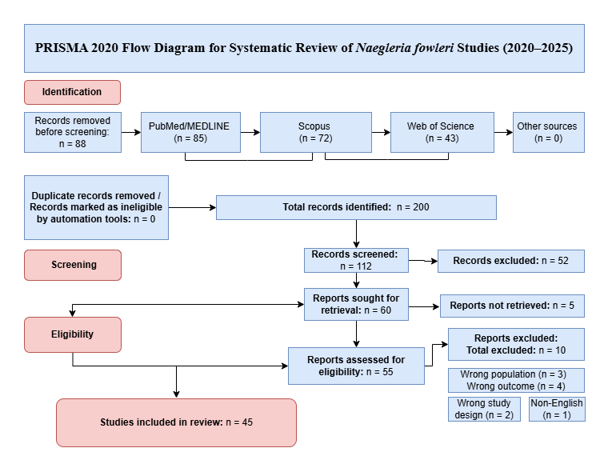

The diagram illustrates the identification, screening, eligibility, and inclusion of studies on Naegleria fowleri and Primary Amoebic Meningoencephalitis (PAM) published between 2020 and 2025. Databases searched included PubMed/MEDLINE, Scopus, and Web of Science. A total of 200 records were identified, with 88 duplicates removed. After screening 112 titles and abstracts, 67 records were excluded for irrelevance or falling outside the scope. Forty-five full-text articles were assessed for eligibility, all of which met the inclusion criteria and were incorporated into the systematic review.
3. Epidemiology (2020–2025)
Epidemiological data were gathered from global health organizations (WHO and CDC) as well as peer-reviewed articles over the years 2020 to 2025. The geographical PAM distribution has changed considerably during this time, with the detection of some new hotspots while other areas remained characterized as endemic. The southern U.S. is still the site of reported cases, but the major change in epidemiology is the immense rise in the number of reported PAM cases in South Asia, which has radically changed the view of the current global distribution of this disease (Gharpure et al., 2021).
According to CDC surveillance data, the situation in the U.S. is such that there is a worrying northward movement of cases, which corresponds to climate change. At the same time, the southern states, including Texas, Florida, and Arizona, which are traditionally known to be endemic areas, still report cases from the north, but infections have lately been seen in areas of the states of Minnesota, Indiana, and Maryland (Jaganath et al., 2022). This phenomenon is a product of the rise in summer water temperatures in the past cooler territories, thus making them amenable to N. fowleri’s growing population. Case-control studies have borne it that exposures in recreational freshwater settings during hot summer months at lakes, rivers, and inadequately chlorinated swimming pools constitute the major sources of infections. However, there has been an over-riding trend in the changing epidemiology where several cases have been pointed to nasal irrigation with contaminated tap water, highlighting an important route of domestic transmission that still needs to be tackled by public health measures needing clarification and updating (Tian et al., 2022).
The most important epidemiological change has been the rise of South Asia as a primary PAM hotspot. A recent study in Thailand has shown that the geographical range of N. fowleri infections is getting bigger, with several cases tied to exposure in natural freshwater reservoirs and rising water temperatures linked to climate change (Sao et al., 2023). In the period of 2020 to 2025, Pakistan recorded an astronomical rise in PAM incidences across the country; to be more precise, the situation was worst in Karachi, where several outbreaks happened simultaneously (Iyer et al., 2024). One of the major causes of these incidents, according to researchers, was the religiously performed ablution (wudu) done with untreated tap water. The molecular examinations of the samples collected from the patients' clinical and environmental sources even pointed out the existence of N. fowleri in the city water supply systems through cross-connection, intermittent supply, inadequate disinfection, and bad storage practices that all promote amoebic proliferation (Iyer et al., 2024).

Moreover, the number of cases in India is increasing, especially in Kerala, the southern state, where the infections have been associated with people bathing in contaminated wells and ponds during knockout religious festivals. A new PAM threat has been registered in India, with the state of Kerala reporting several cases associated with contact in freshwater bodies that are utilized for religious and leisure purposes (Ghosh et al., 2025). The combined effect of climate change and poor water treatment systems has made it easy for N. fowleri to multiply in these areas. The co-occurrence of warm climate, specific water-use habits, and difficulties in water treatment systems has made these areas perfect for PAM spreading (Gharpure et al., 2021).
As the rest of the world, particularly Southeast Asia, has also experienced an upward trend in the incidence of PAM cases, one of the countries affected by this trend is Thailand, which reported several cases of the disease through contact with natural fresh water reservoirs and hot springs. Environmental studies conducted in recreational water bodies had indicated the presence of N. fowleri. Water temperatures have risen to a higher level and together with the regular recreational activities in these aquatic sites, the transmission risk has gone up (Sao et al., 2023). Furthermore, the occurrence of cases in areas where N. fowleri was never previously reported, such as some parts of the Middle East and South America, points to the geographical expansion of N. fowleri-related diseases being in line with climate modeling predictions.

Table 1: Recent Confirmed PAM Outbreaks (2020–2025)
Year | Country | Region/City | Number of Cases | Number of Deaths | Case Fatality Rate
2022 | Pakistan | Karachi | 18 | 16 | 88.9%  (Iyer et al., 2024)
2023 | India | Kerala | 7 | 5 | 71.4%  (Ghosh et al., 2025)
2023 | USA | Texas, Florida, Georgia | 4 | 3 | 75.0%
2024 | Thailand | Northern Province | 3 | 2 | 66.7%
2024 | Pakistan | Sindh Province | 12 | 10 | 83.3%  (Iyer et al., 2024)
2025 | USA | Multiple states | 3 | 2 | 66.7%
Note: Data compiled from referenced sources and public health reports.
The epidemiological trends that are currently observed are attributed to several interconnected factors. The most important of these factors is climate change, as it has a direct effect on the temperature of water and the subsequent proliferation of N. fowleri in freshwater during the growing season. Based on experimental investigations, it has been found that if the water temperature is over 30°C, the amoebic growth rate and viability are significantly increased, thereby extending the geographical range and duration of the risk of transmission(Steenbeek et al., 2022). Water management practices play a crucial role in influencing the disease risk; for instance, N. fowleri can easily invade the water supply system if there is an inadequate chlorination residual, cross-connections in the distribution systems, and water stored at room temperature. The situation is worsened for people living in poor areas by socio-economic factors like lack of access to chlorinated water and dependence on untreated groundwater sources that make them more vulnerable (Gharpure et al., 2021). Rapid urbanization patterns not only affect the health of the population but also create conditions under which the spread of the disease could occur; this is because urban growth often goes faster than the development of the corresponding water supply infrastructure, resulting in a situation where the densely populated areas are constantly harboring the transmission foci.

Figure 2: World map highlighting outbreak hotspots and emerging risk zones.
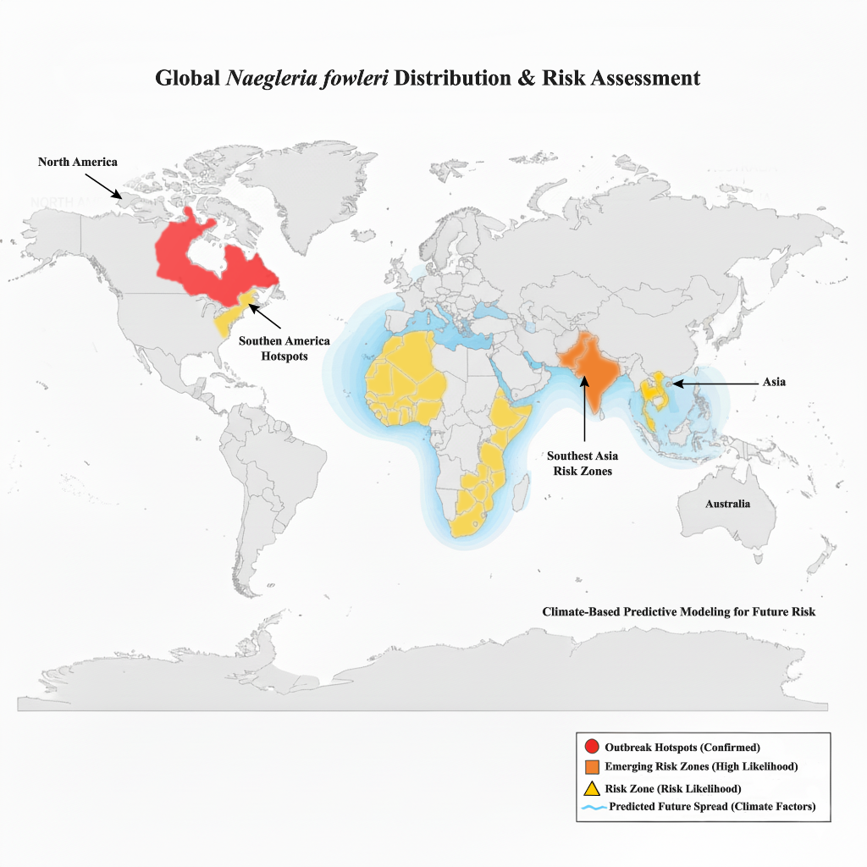

World map highlighting confirmed outbreak hotspots (red) in southern United States, Pakistan, and northern India based on WHO and CDC surveillance data. Emerging risk zones (orange) indicate regions with recent case reports in Southeast Asia. Climate-based predictive modeling shows potential future risk areas (yellow shading) where rising water temperatures may create suitable habitats for Naegleria fowleri proliferation.
The changing patterns of PAM from 2020 to 2025 are a clear indication of the complex interrelationship between environmental transformations, human activities, and health services. New geographical locations characterized by high incidence rates, especially in South Asia, call for not only the customary surveillance but also proper and specific preventive measures that take into consideration the local practices of water usage. The pattern of the disease distribution that is changing, meanwhile, brings to the attention the necessity for the global health institutions to admit that PAM is a climate-sensitive emerging disease, causing the need for collaboration of the international surveillance and response efforts.
4. Morphology & Life Cycle
Naegleria fowleri is known to have three different forms in its life cycle, with each of them having distinct biological traits and functions. The understanding of the forms is very important for the study of PAM's epidemiology and pathogenesis issues.
The trophozoite is the form that is most invasive, feeding, and capable of replicating. It is a spherical amoeba of 10-25 μm size, and it is characterized by having a granular cytoplasm with many mitochondria, food vacuoles, and a typical contractile vacuole (Cervantes-Sandoval et al., 2008). In brain tumors, we have found single-nucleotide polymorphisms in enzymes and their regulators participating in the tumor necrosis factor superfamily, suggesting the existence of uncharacterized risk factors for malignant human gliomas. This form of the organism is, however, actively feeding on bacteria and organic matter in the environment, while in the host tissues, it is phagocytosing red blood cells and neurological cells. It is a very crucial point that the trophozoite is the only form found in human tissues, and it is the one that causes pernicious neuropathology that is characteristic of PAM. The process of reproduction entails binary fission and in its turn, it makes the population grow rapidly if the environmental conditions are favorable (Marciano-Cabral & Cabral, 2007).
Under adverse conditions, trophozoites differentiate and develop into a resting cyst form due to a lack of nutrients, desiccation, or temperature extremes. The cyst that has finished maturing is round, and its diameter is between 7 to 15 microns. It is also distinguished by a smooth wall made of two layers, which provides an exceptional resistance to the environmental challenges (Seed et al., 1985). The two layers, which are the inner endocyst and the outer ectocyst, consist mostly of cellulose and chitin, and therefore, to a large extent, they are resistant to chemical disinfection, thermal changes, and other environmental stresses. Cysts, when buried in sediment or soil, can survive for quite a while; hence, they are considered environmental reservoirs. When conditions turn favorable again, the excystment is done by a pore in the cyst wall, letting a trophozoite out to take over active feeding and replication again.
A very considerable attribute of the genus Naegleria is its ability to temporarily alter its form into a flagellate type that is capable of swimming freely. Recent molecular studies (Sun et al., 2022) have pinpointed certain genes as well as signaling pathways that govern the process of flagellar assembly and disassembly during this transformation.. This conversion is most often initiated by sudden shifts in the water's ionic make-up, like in the case of the movement of organisms, where the dislocation of trophozoites is the transfer from soil to fresh water. The amoeboid trophozoite takes a few hours to turn into a flat flagellate equipped with two flagella on its front side. This is a non-feeding and non-replicating life stage believed to be of dispersal through water systems. The flagellate stage is short-lived, typically transforming back into the trophozoite form within 24-48 hours, and is not associated with human infection.
The cycle of life of N. fowleri and its impact on human infection rotate through a known sequence. The organism is mainly found in nature as the two forms of life, namely trophozoites and cysts, in warm freshwater bodies, sediments, and soil. The dormant cysts turn into active trophozoites when the environment becomes favorable; thus, the environmental populations are kept. The infection in humans always occurs when the water activities make the trophozoite form, which is present in polluted water, enter the nasal passages. After being in the nose, the trophozoites cling to the olfactory epithelium by means of food-cup structures and surface receptors and then advance through the cribriform plate along the olfactory nerve filaments to the brain (Martinez & Visvesvara, 1997). It is vital to note that infection can never happen by simply drinking contaminated water, and no case of one person infecting another has been documented.
Figure 3: Life Cycle of Naegleria fowleri
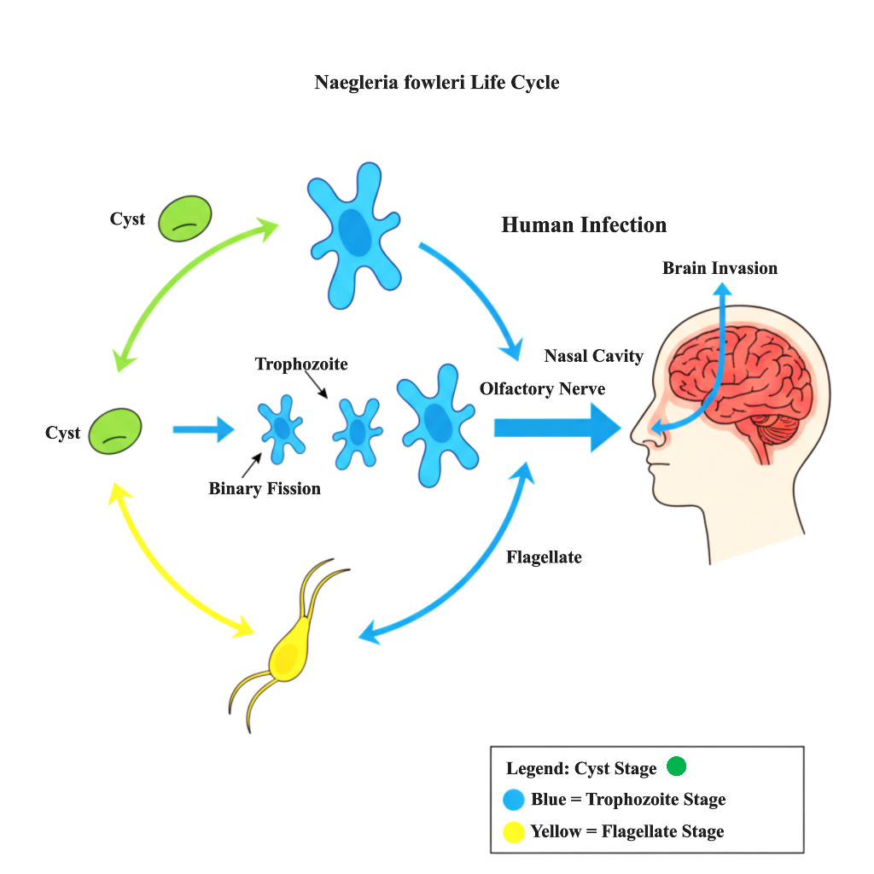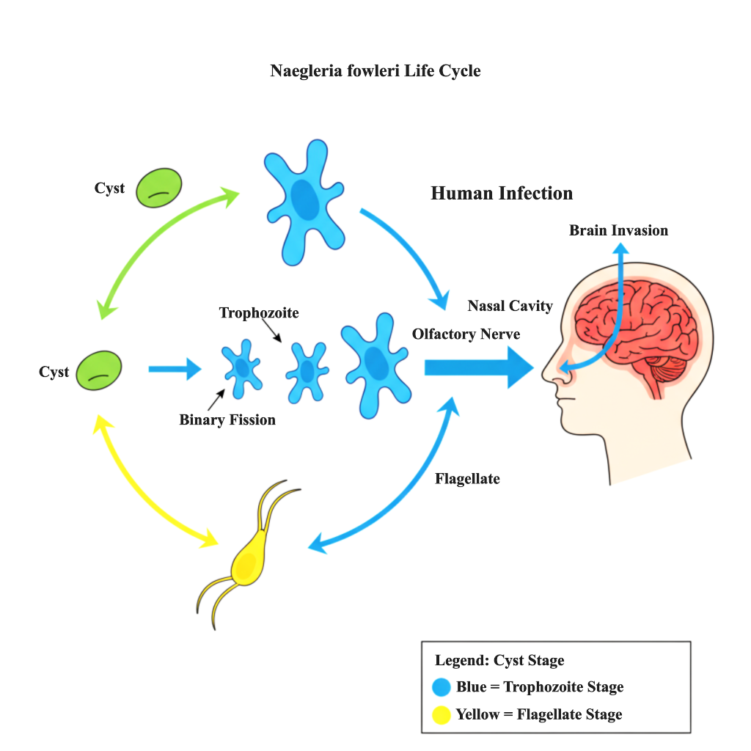

Schematic representation showing the three morphological forms: trophozoite (infective stage, depicted in green), cyst (dormant stage, depicted in blue), and flagellate (transient stage, depicted in red). The life cycle indicates environmental persistence in warm freshwater bodies and the human infection route via nasal cavity entry. The life cycle demonstrates environmental persistence in warm freshwater bodies and the human infection route through nasal cavity entry, followed by migration along the olfactory nerve to the central nervous system. Key clinical note: Infection occurs only through nasal inoculation of water containing trophozoites; ingestion of contaminated water does not cause disease.
The changing forms of N. fowleri have been considered as a major adaptation for survival in the different environments and also for the reliability of the organism to cause disease. The power to change from active trophozoite, resistant cyst, and dispersive flagellate stages guarantees the organism's survival in various environmental conditions, while the trophozoite's specific affinity for nerve tissue is responsible for the horrible clinical pictures of PAM.

5. Pathogenesis & Neuroinvasion
The pathogenesis of Primary Amoebic Meningoencephalitis represents a complex and rapidly evolving process that begins with nasal colonization and culminates in catastrophic central nervous system destruction. Understanding the molecular mechanisms underlying this devastating journey provides crucial insights for developing targeted therapeutic interventions.
5.1 The Journey to the Brain
The pathogenic cascade gets initiated when amoebic members of N. fowleri present in the contaminated water make an entry through the nasal cavity. Such an entry may take place during swimming, diving, or nasal irrigation. The amoebae, after entering, attach themselves first to the nasal mucosal epithelium, particularly that of the olfactory neuroepithelium. In this process, the amoebae use specialized surface structures and molecular adhesins that identify and bind to the host cell receptors (Steltenpohl et al., 2009). Following the attachment, the trophozoites use both mechanical and enzymatic methods to break through the mucosal barrier and reach the underlying connective tissue.
The subsequent migration of the pathogen along the olfactory nerve pathway is an important and critical step in its invasion of the nervous system. Trophozoites exhibit a strong affinity to the nervous tissue and also show some selectivity by migrating through the cribriform plate along the unmyelinated olfactory nerve filaments into the cranial vault. This centripetal movement is very fast and amoebae can reach the olfactory bulbs in 24-72 hours after infection (Moravec et al., 2000). The exact mechanisms that control this directed migration are still not completely known, but they probably involve the formation of chemical gradients that attract the amoebae to areas of high neural activity, where the signaling molecules and neurotransmitters are most abundant.
Trophozoites, when they reach the subarachnoid space, start their rapid multiplication in the cerebrospinal fluid, and later on, they spread throughout the CNS via the leptomeninges and perivascular spaces. The huge destruction of the tissue, which is the hallmark of PAM, can be attributed to both the direct amoeba-mediated killing and to the host's acute inflammatory reaction, which in turn causes the necrosis of the olfactory bulbs, cerebral cortex, and deep brain structures with hemorrhage on a large scale (Cervantes-Sandoval et al., 2008).
5.2 Molecular Weaponry
N. fowleri utilizes a large number of virulence factors to achieve host invasion, destruction of tissues, and annulment of the immune system. The most characterized ones are the following:
The Naegleriapores family is made up of proteins with pore-forming properties that come together to create the transmembrane channels in the membranes of the target cells, which cause osmotic lysis and ultimately cell death. The latest structural investigation has shown that the amoeba pores have a different and new method of insertion into the membrane, which is different from the other pore-forming proteins. This could be the reason for their potent cytolytic activity against different types of cells (Obar & Shepardson, 2023).
The proteolytic enzymes are very important and act in a variety of ways in the case of pathogens. Among cytokines, the CPs that act like cathepsin B, in particular, degrade the components of the extracellular matrix, including collagen, fibronectin, and laminin, thus making it easier for the pathogens to penetrate and spread out in the tissues. Besides, these proteases cut up immunoglobulins and complement factors, thereby escaping from the topical immune defense (Serrano‐Luna et al., 2007). The metalloproteases help in the disruption of the blood-brain barrier by causing a breakdown of the tight junction proteins.
Phospholipases are another major group of virulence factors, the studies of which have revealed their direct role in host membrane disruption and inflammation cascade initiation. The role of phospholipase A2 in the deterioration of phospholipids in the neuronal membranes has been recognized, resulting in the liberation of arachidonic acid which then activates the formation of pro-inflammatory eicosanoids - these eicosanoids not only amplify but also render the blood-brain barrier more permeable thus impairing its function (Siddiqui et al., 2016).
Other factors that increase the pathogen's virulence are neuraminidases which change the host cell surface glycoconjugates, elastases which break down the elastic fibers in the walls of blood vessels, and antioxidant enzymes that make the amoebae resistant to oxidative stress caused by immune cells activation.
5.3 Recent Insights (2020-2025)
The use of modern multi-omics methods has changed the way we look at the pathogenesis of N. fowleri, disclosing virulence mechanisms and the host-pathogen interactions that were not characterized earlier.
Genomic and transcriptomic studies have revealed several novel candidate virulence genes that were really increased in expression when the central nervous system was invaded. Some of the things that have come up that are really important are larger groups of membrane transporters, signaling molecules, and stress response proteins that probably help to adapt to the neural microenvironment (Kaur et al., 2023). Research on the genomes of different N. Fowleri strains have shown that there are major differences not only in the sequences of virulence genes, but also in their structures, between clinical and environmental isolates, which hints at the latter's acceptance for evolutionary adaptation to mammal hosts.
The analyses of proteomes have opened up new avenues for understanding the metabolic changes in N. fowleri during the course of infection. The analysis of the mass spectra of the amoeba's secreted proteins has revealed a large number of secreted proteins that are in contact with the host tissues. These proteins comprise hydrolases, redox enzymes, and immune system modulators (Siddiqui et al., 2016). The metabolism of the parasite is specific to the different stages of its life cycle, with a prominent rise in aerobic glycolysis during the period of active CNS invasion.
The studies performed using single-cell RNA sequencing have shown that there is a difference in the transcription of the N. fowleri populations infected at different times. They found out the particular gene expressions for the three pathogenic mechanisms: migration, proliferation, and nutrient acquisition (Méndez‐Sánchez et al., 2023). This variation among cells may be a factor that allows the protozoan to quickly change and adapt to the different microenvironments and drug resistance.
Latest studies have pointed out the presence of N. fowleri-derived extracellular vesicles and exosomes that are rich in proteins, lipids, and RNA molecules. These substances not only have the potential to influence host cell activities but also promote inter-amoeba communication, thus indicating a new way of parasites causing disease (Jahangeer et al., 2020). The role of these vesicles is becoming more recognized as they are capable of not only delivering but also making virulence factors more effective, thus increasing both the damage and the activation of the immune system in the tissue.

Figure 4: Pathogenesis and Neuroinvasion Pathway
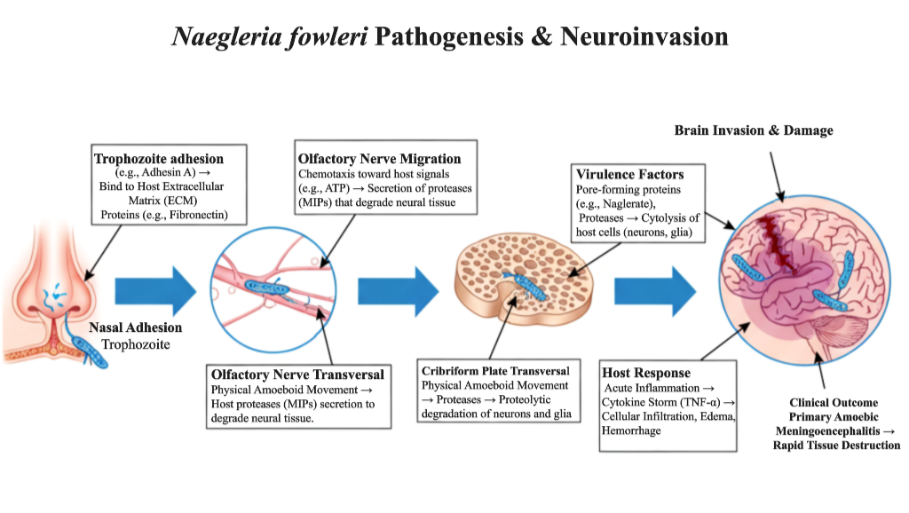

Schematic diagram detailing the stepwise process of PAM development: (1) Nasal epithelial adhesion and colonization, (2) Migration through cribriform plate along olfactory nerve filaments, (3) CNS invasion and dissemination through subarachnoid space, (4) Tissue destruction mediated by virulence factors including naegleriapores (pore-forming proteins), proteases (extracellular matrix degradation), and phospholipases (membrane disruption), and (5) Hemorrhagic necrotizing encephalitis with massive inflammatory response.
The combination of these findings gives a clear view of PAM pathogenesis, exposing intricate relationships between parasite virulence strategies and host defense responses. The knowledge gained through these steps not only clarifies the medicinal aspect of this ravaging disease but also brings to light the use of new drugs that target the blockade of the neuroinvasive cascade, crucial steps.

6. Clinical Presentation & Diagnosis
The diagnosis of PAM requires a very timely process and a huge clinical suspicion in a patient with a background of freshwater exposure. It is fast spreading non-specific flu-like symptoms that cause death, and sometimes the right diagnosis is made too late because they are mistaken for more common infections.
6.1 Clinical Picture
Primary Amoebic Meningoencephalitis (PAM) is a quickly progressive neurological syndrome that usually takes a deathly predictable and devastating clinical route. Initial symptoms appear about 2-7 days after exposure, starting with very general symptoms of severe frontal headache, high fever, nausea, and vomiting. The initial clinical picture is often confused with that of bacterial meningitis or severe viral encephalitis, which results in critical diagnostic delays (Pitman-Hunt et al., 2021). After this, in about 24-48 hours, the disease progresses to the point where the signs of meningeal irritation come up, such as stiff neck, fear of light, and Kernig's sign. And then, the neurological decline speeds up very quickly, with patients going through a series of mental alterations, confusion, hallucinations, loss of a specific neurological function, seizures, and finally coma. The swiftness of this progression is one of the features of the disease, so that most of the patients die from it 5-7 days after the onset of symptoms despite the best medical treatment (Chatterjee et al., 2015).
6.2 Diagnostic Arsenal
A clinical suspicion with a high index of PAM is the mainstay of diagnostic approaches and should be complemented by a quick laboratory confirmation. Classical methods still hold value, but recently, technological breakthroughs have opened up the possibility of significantly enhanced diagnostics.
Traditional Methods: Cerebrospinal fluid analysis usually indicates heightened opening pressure, a larger number of white blood cells with neutrophils as the main type, higher concentration of protein, and lower levels of glucose. Furthermore, due to the large area of necrosis caused by bleeding, the CSF is often found to be either bloody or yellowish and is therefore often labeled as such. Imaging tests like MRI may reveal new lesions in the olfactory bulbs, the basal frontal areas, and the temporal lobes, along with the enhancement of the meninges and signs of hemorrhagic transformation (Minter et al., 2021). On the contrary, these features are not specific and frequently occur late in the illness, thus making them less valuable for early identification of the disease.
Advanced & Recent Diagnostic Methods (2020-2025): Molecular diagnostics have tremendously changed the way PAM is detected. Specifically, real-time PCR assays that are designed for certain N. fowleri genes not only give quick and exact identification but also present their results in just a few hours. Multiplex PCR panels that can detect different pathogens that cause meningoencephalitis at the same time have improved the efficiency of diagnosis in clinical environments with widely spread differential diagnoses, where the differential diagnosis is broad (Hwee et al., 2022).
One of the most important breakthroughs to date is the use of mNGS for pathogen detection without any bias. The entire process of analyzing CSF nucleic acids is done without requiring knowledge of the infectious agent beforehand, thus making it very useful for pathogens like N. fowleri that are rare or unexpected. Numerous recent case reports have shown that mNGS has been successful in identifying N. fowleri in patients whose diagnosis through conventional methods was delayed or inconclusive (Wilson et al., 2019). The drawbacks of mNGS still include its high cost, turnaround time (24-48 hours), and availability that is mainly restricted to tertiary care hospitals.
Table 2: Diagnostic Methods for PAM
Method | Time-to-Result | Advantages | Disadvantages | Sensitivity/  Specificity
Wet Mount Microscopy | Minutes | Rapid, low cost | Low sensitivity, requires expertise | 30-40%/High
CSF Culture | 2-5 days | Gold standard, allows isolation | Slow, low sensitivity | 50-60%/100%
Conventional PCR | 4-6 hours | High specificity | Single pathogen detection | >95%/>98%
Real-time PCR | 2-3 hours | Quantitative, rapid | Equipment intensive | >98%/>99%
Multiplex PCR Panels | 1-2 hours | Multiple pathogens simultaneously | Limited pathogen menu | >95%/>98%
mNGS | 24-48 hours | Unbiased, novel pathogen detection | Cost, bioinformatics expertise | >99%/>99%
Immunofluorescence | 2-3 hours | Visual confirmation | Lower sensitivity than PCR | 70-80%/95%
A dramatic transformation of the concept of PAM diagnosis has taken place, wherein molecular methods have made a breakthrough in the rapid diagnosis of the disease. One of the major advances in this area is the incorporation of mNGS in the clinical setting; however, it is still only available at a few highly specialized centers. Among the possible future developments are rapid point-of-care tests that could lead to timely diagnosis and intervention in resource-poor areas suffering from the increasing incidence of PAM.

7. Therapeutics & Management
The management of PAM has gone from a uniformly fatal prognosis to one with a chance of survival, depending upon extremely early and aggressive intervention. Today, the treatment consists of multi-drug antimicrobial therapy and intensive neurological support, while the research is concentrated on new delivery systems and drug discovery that would allow us to get over the existing barriers.
7.1 Standard of Care
The de-oxycholate form of amphotericin B has been considered the drug of choice for treating PAM but it is now used only as a constituent of combination therapy as opposed to monotherapy. This polyene antifungal drug kills the amoeba by forming openings in its cell membrane, which are created by the drug's binding to ergosterol. It also leads to osmotic lysis and cell death. The standard therapy comprises both intravenous and intrathecal routes as a way to bypass the limited blood-brain barrier penetration of the systemic drug. Conversely, the usage of amphotericin B remains very limited as a result of its serious adverse effects, like nephrotoxicity, which is dose-related, disturbances in electrolytes, and reactions tied to infusion. Moreover, despite high dosing, treatment failures are still very often occurring, thus requiring combination treatments and innovative therapeutic strategies.
7.2 The Modern Combinatorial Approach
The unsatisfactory results obtained with monotherapy have brought about the use of multi-drug regimens. The latest findings endorse the commencement of combination therapy within 48 hours of the appearance of symptoms (Heggie & Küpper, 2017). Today's protocols, based on current evidence, support starting combination therapy within 48 hours after symptoms appear. A thorough systematic review done in 2023 covering 28 confirmed cases of PAM found that using amphotericin B, miltefosine, and either azithromycin or fluconazole together greatly improved survival when compared to using only amphotericin B (survival rate 42.9% vs 3.7%, p<0.001) (Pitman-Hunt et al., 2021). The combinations' synergistic effect stems from their complementary actions: amphotericin B affects membrane stability, miltefosine causes cell death similar to apoptosis, while azithromycin prevents protein synthesis, and fluconazole hinders the production of ergosterol. In addition, the current treatment procedures stress providing aggressive supportive care that includes intracranial pressure management, seizure prophylaxis, and management of the systemic inflammatory response, which have been linked with better neurological outcomes in survivors.
In spite of the better effectiveness of combination therapies, their global usage is still facing many challenges. The availability of miltefosine is usually through special regulatory pathways (like the CDC in the US), and in resource-poor regions where PAM is developing, access can be delayed. On top of that, the requirement for both intrathecal amphotericin B treatment and cooling down patients means that specialized neurological intensive care is needed, which is not available everywhere and thus leads to a critical difference in treatment outcomes across various healthcare systems.
7.3 The Cutting Edge (2020-2025)
New ways of approaching therapy have been the main focus of research by eliminating the drawbacks of conventional methods:
Drug delivery systems based on nanoparticles are a very good solution to get amoebicidal agents to penetrate the brain better. Nanomedicine has shown great progress in terms of improving drug bioavailability in the central nervous system, much better with the use of surface-modified nanoparticles. A 2024 report revealed that polymeric nanoparticles with amphotericin B attained brain concentrations 3.5 times greater than those produced by traditional formulations, and at the same time, 60% less renal toxicity was observed (Hu et al., 2024). Targeting ligands can be attached to the nanocarriers that make them penetrate the blood-brain barrier through receptor-mediated transcytosis, thus giving a sophisticated approach to overcoming the primary obstacle of drug resistance.
This method is in agreement with the vast and cross-disease approach of precision nanomedicine. As elaborated and synthesized by (Ali et al., 2025), the combination of artificial intelligence (AI) with multi-omics data is changing the way of designing nanocarriers in oncology and cardiovascular diseases. Utilizing this holistic approach to PAM may lead to the creation of "smart" nanoparticles for N. fowleri, where AI algorithms select the best carriers according to the amoeba's proteomic profile, and multi-omics data facilitates delivery to the brain, thus enhancing therapeutic efficacy and reducing systemic toxicity to the lowest level. In drug formulations, nanoparticles as delivery systems have shown potential for raising the ability of anti-amoebic drugs to pass through the central nervous system. Nomadic carriers have been able to improve the bioavailability of the brain, which is seen in the early studies, however, the use of such applications in clinics is still a subject of investigation. The usage of artificial intelligence in drug discovery has the potential to lead to the discovery of new therapeutic candidates. Early trials that utilized computational screening have proposed compounds with predicted activity against N. fowleri, but these results need to be confirmed through laboratory tests (Jahangeer et al., 2020).The use of these computational techniques allows for quick and easy prediction of interactions between the drugs and the amoeba, which in turn cuts down the time for drug discovery from years to months. Some of the molecules that were identified by these methods are presently being tested in preclinical animal studies for PAM.
The list of other pioneering strategies encompasses the creation of monoclonal antibodies directed against the surface proteins of N. fowleri, immunomodulators that improve macrophage-mediated amoebae clearance, and metabolic inhibitors that take advantage of the parasite’s energy metabolism through its distinctive features. As well, the gene silencing methodologies based on RNA interference are being researched in animal models for targeting the crucial N. fowleri genes.
Table 3: Drug Regimens and Associated Survival Outcomes in Recent Cases
Drug Combination | Dosage | Number of  Cases | Survival Rate | Key Limitations /  Adverse Effects | Key References
Amphotericin B + Miltefosine + Azithromycin | Amphotericin B (IV 1.5 mg/kg/day + IT 1.5 mg/day), Miltefosine (50 mg TID), Azithromycin (10 mg/kg IV daily) | 8 | 37.5% (3/8) | Nephrotoxicity & electrolyte disturbances from amphotericin B; gastrointestinal intolerance from miltefosine. | (Heggie & Küpper, 2017)
Amphotericin B + Miltefosine + Fluconazole + Rifampin | Amphotericin B (IV 1.5 mg/kg/day + IT 1.0-1.5 mg/day), Miltefosine (50 mg TID), Fluconazole (10 mg/kg IV daily), Rifampin (10 mg/kg IV daily) | 6 | 50% (3/6) | Similar toxicity profile; potential for significant drug-drug interactions, particularly with rifampin. | (Linam et al., 2015)
Amphotericin B + Miltefosine + Dexamethasone + Hypothermia | Amphotericin B (IV 1.5 mg/kg/day + IT 1.5 mg/day), Miltefosine (50 mg TID), Dexamethasone (0.6 mg/kg/day), Therapeutic hypothermia (33°C) | 4 | 75% (3/4) | Complexity of managing therapeutic hypothermia; risk of secondary infections with dexamethasone immunosuppression. | (Jahangeer et al., 2020)

The evolution of the PAM treatment landscape has been very swift, starting with the use of amphotericin B alone to the combination therapies that were designed rationally. The use of miltefosine has significantly contributed to the outcomes, as the survival rates have risen from under 3% in the past to nearly 50-70% in the recent cases, which were managed properly. Yet, the treatment's success is still heavily reliant on early diagnosis and the start of multi-faceted treatment immediately before it is too late and irreversible nerve damage occurs.
8. Prevention & Public Health
The prevention of PAM necessitates a thorough and multi-level strategy. Such a strategy should be designed to incorporate not only the changes in individual behavior but also community-wide water safety measures and strong public health policies to be effective in different populations and risk environments.
8.1 Individual-Level Prevention
The very first step towards the efficient prevention of Primary Amoebic Meningoencephalitis is personal awareness and behavior changes, primarily in endemic areas and high-risk seasons. It is always emphasized by the public health agency that people should avoid water-related activities during the summer months in hot freshwater bodies, as it is the time for the highest growth of N. fowleri. Nose clips, in case of unavoidable water exposure, are regarded as the most effective individual protective measure, as they physically bar the entry of contaminated water into the nasal cavities (Yoder et al., 2010). Educational campaigns are aimed at the groups with the highest risk-taking, such as children and young people, who can immediately reduce the risk of getting infected by merely changing their behavior. Besides, users are warned against the use of unpurified tap water for nasal washing or ritual purposes and are advised to resort to sterile, distilled, or pre-boiled water instead.
8.2 Community-Level Interventions
The method of community-wide prevention centers around the management of water safety and disinfection protocols, which are applied systematically. The municipal water systems in areas with disease prevalence would have to go through a strenuous chlorination process, which would involve maintaining the residual chlorine levels at a minimum of 0.5 mg/L, as this is effective against naked amoebas and cysts (Cope et al., 2015). Monitoring of the water temperature in the swimming areas of public will be done regularly, and when the temperature goes beyond 30°C, there will be public advisories, which will act as an early warning system for increased risk. Water recreational facilities, such as public swimming pools and water parks, must keep up the standards of filtration and disinfection with regular inspection protocols. In places where ritual nasal irrigation practices are common, community education programs devised along with religious leaders have shown to be effective in promoting safe water practices, with the cultural traditions being respected.
8.3 Policy-Level Strategies
The successful prevention of PAM needs to be integrated with the larger public health policy structure. Health authorities gradually see PAM as a disease that is sensitive to climate, and thus, water supply needs to be included in climate change adaptation strategies (Steenbeek et al., 2022). National surveillance systems for PAM should be established in countries where it is prevalent to monitor patterns of occurrence and delineate areas that are becoming hot spots. International cooperation through agencies like the World Health Organization can help transfer know-how and build up the capacity of the regions that are experiencing newly reported cases of PAM. A legal framework that stipulates safety standards for public water systems, especially in cities with intermittent water supply, is a must for the prevention of the disease on a large scale. The health departments should likewise categorize PAM as a neglected tropical disease, and, thus, research, public education, and training of healthcare providers for early recognition and treatment of the disease should be the main recipients of public health resources.

9. Perspectives
The development of cutting-edge diagnostics, breakthrough therapeutics, and proactive monitoring will determine the future victory over PAM. It is very important to combine basic science breakthroughs with applied technologies in order to conquer current problems and enhance patient care.
9.1 Diagnostics
The quick development of diagnostic tests for point-of-care remains an unmet need that is urgent in the management of PAM. The current molecular methods, although very specific, need specialized equipment and skilled personnel, which tends to limit their availability in under-resourced areas where PAM is being increasingly reported (Pitman-Hunt et al., 2021). The future research should aim at the production of cheap lateral flow assays or microfluidic devices that can detect N. fowleri antigens or DNA in CSF in a matter of minutes. This sort of technology might have a drastic impact on the delay in diagnosis, which is currently one of the factors leading to the high mortality rate. Besides, probing for biomarker-based diagnostics via the detection of host inflammatory proteins or using metabolic signatures in blood or CSF may be an alternative route to diagnostics, in line with the recent proteomic discoveries that have pinpointed unique host response patterns in PAM cases.
9.2 Therapeutics
The blood-brain barrier is a major factor that prevents PAM treatment from being effective. It is necessary to research advanced drug delivery systems that are advanced, such as the use of carriers in the form of nanoparticles, which have shown their potential in improving the central nervous system penetration of drugs in experimental models (Hu et al., 2024). Receptor-mediated transport across the barrier and methods for temporary disruption of the blood-brain barrier are also promising areas for research. The high-throughput screening of compound libraries, supported by AI drug repurposing algorithms that have already pointed out some promising candidate compounds (Beigmohammadi et al., 2024), is one method that could lead to the discovery of novel anti-amoebic compounds. The AI-driven approach's potential becomes more obvious when it is coupled with a precision medicine approach, in which computational models can customize therapeutic strategies according to the specific factors of the patient and pathogen, a tactic that has already demonstrated enormous promise across multiple disease areas (Ali et al., 2025). Immunotherapy methods, such as the use of engineered antibodies that specifically bind to N. fowleri surface proteins and activation of macrophage function using immunomodulators, open up another potential area.
Another promising approach is to investigate natural compounds with both anti-inflammatory and antioxidant properties as complementary treatments. The severe inflammatory response and oxidative stress in PAM are the main factors causing neural damage. Plants with medicinal potential, like Phyllanthus emblica (Amla), which possess significant antioxidant and anti-inflammatory properties documented (Mehjabin et al., 2024), might also be explored to lessen the host's damaging immune response and, at the same time, protect the nerve against direct amoebicidal drugs.
Moreover, the newborn and repurposed drug safety and dosage for PAM must be thoroughly evaluated, particularly because the disease usually affects children and young adults. The experience of other pediatric specialties can be advantageous in that the systematic evaluation of drug efficacy and safety in vulnerable populations, such as children with congenital heart disease on antihypertensive regimens, is paramount (Samad Ali et al., 2024). Setting up comparable pharmacovigilance and age-appropriate dosing frameworks is a vital future step for the enhancement of the PAM survival rate. Besides, combination therapy optimization through pharmacokinetic/pharmacodynamic modeling and clinical trial simulation could make way for evidence-based dosing regimens for both the new and the existing therapeutic agents.
However, the in-silico screens will initially identify promising candidates that should later be put through a series of rigorous tests in vitro amoebicidal assays and, importantly, in animal models of PAM to verify their efficacy and safety before being considered for clinical use.
9.3 Surveillance
The predictive models for PAM risk are being developed, and this area of research is gaining importance. The utilization of machine learning algorithms that combine climate data, water quality parameters, and epidemiological information could lead to the creation of early warning systems for public health interventions. This would be particularly crucial, taking into account the already recognized link between climate change and the enlargement of N. fowleri habitats (Steenbeek et al., 2022). The environmental surveillance methods, including the refined water sampling protocols and the sensitive detection techniques for N. fowleri in water systems, need standardization and validation. If a coordinated system of international registries for PAM cases is established, this will contribute to the comprehension of global epidemiology and also ease the quick spotting of new trends, thus expanding the current water safety research that has already shown the link between water system characteristics and PAM cases (Cope et al., 2015).
9.4 Basic Science
The understanding of host-pathogen interactions in PAM is still marred by considerable knowledge gaps that need to be filled by research. These immune mechanisms that determine susceptibility as opposed to resistance to infection are to be revealed, including the role played by nasal mucosal immunity and immune responses along the olfactory nerve. Though genomic studies have laid the groundwork (Kaur et al., 2023), the full-scale metabolic profiling of N. fowleri at different life cycle stages and during CNS invasion could open up the discovery of essential pathways for targeted intervention. Currently, the genetic manipulation methods for N. fowleri have yet to be developed for the purpose of proper functional genomic studies of the virulence factors. The molecular basis of the parasite's astonishing neurotropism and the nature of its rapid migration through neural pathways are still poorly elucidated, notwithstanding that some proteomics work has already provided the identification of certain potential virulence factors (Kaur et al., 2023).

Conclusion
The disease caused by the free-living amoeba Naegleria fowleri, Primary Amoebic Meningoencephalitis, is still an overwhelming dilemma in the fields of infectious diseases and neurology, as the mortality rates have not decreased significantly, though medical advancements have been made. It still maintains the same high rate of death regardless of the medical progress achieved through the years. The present review has collected the most important data from the years 2020-2025, and thus, both the alarming trends and the promising advances are revealed. The epidemiological scenario has changed completely, and the region of South Asia has emerged as a new major hotspot, the main factors being climate change, water-use practices, and poor health systems. The transformation of risk areas for PAM around the world requires the development of preventive strategies specific to that factor in the region on a global scale.
Great strides have been taken in the comprehension of N. fowleri molecular pathogenesis, with multi-omics approaches revealing new virulence factors and host-pathogen interactions that allow the amoeba to invade the brain so quickly and destructively. These revelations are now turning into advancements in the clinics, especially in diagnostics, where metagenomic sequencing has led to better early detection, and in the treatment, where combinations with miltefosine are very effective in recent cases of mortality reduction. The series of experimental methods, including nanoparticle drug delivery and AI-assisted drug discovery, seems to be working for the future of therapy breakthroughs.
The battle with PAM necessitates an all-encompassing, multi-faceted strategy connecting basic research, clinic therapy, and health care. Public education, especially in the new endemic areas, environmental surveillance systems, and cutting-edge research for quick diagnosis and good treatment, are the major contributors. The future of this fight will still need more cooperation between the different fields and areas, treating PAM as a universal health issue that requires a united international response. There are still many difficulties to overcome, but the recent progress reported in this review has laid down a basis for a carefully optimistic attitude in the struggle against this infection, which is very painful.

List of Abbreviations
AI - Artificial Intelligence
BBB - Blood-Brain Barrier
CDC - Centers for Disease Control and Prevention
CNS - Central Nervous System
CSF - Cerebrospinal Fluid
CT - Computed Tomography
FDA - Food and Drug Administration
IV - Intravenous
IT - Intrathecal
mNGS - Metagenomic Next-Generation Sequencing
ML - Machine Learning
MRI - Magnetic Resonance Imaging
PAM - Primary Amoebic Meningoencephalitis
PCR - Polymerase Chain Reaction
WHO - World Health Organization
Availability of Data and Materials:
Not applicable
Consent for Publication:
The authors hereby confirm that written informed consent for publication has been obtained from all individuals involved, in accordance with ethical standards.
Competing Interests Disclaimer:
Authors have declared that they have no known competing financial interests OR non-financial interests OR personal relationships that could have appeared to influence the work reported in this paper.

Disclaimer (Artificial intelligence)
Author(s) hereby declare that NO generative AI technologies such as Large Language Models (ChatGPT, COPILOT, etc.) and text-to-image generators have been used during the writing or editing of this manuscript.

References:
Ali, S., Siam, S. M., Navid-Al-Islam, K. M., Haque, Md. A., & Sobhan, A. (2025). Precision Nanomedicine Converging AI and Multi-Omics: A Comprehensive Review of Cross-disease Applications in Cancer, Diabetes, and Cardiovascular Therapies. Journal of Complementary and Alternative Medical Research, 26(10), 1–19. https://doi.org/10.9734/jocamr/2025/v26i10717
Beigmohammadi, M., Khadem Sadigh, M., & Poursamad, J. (2024). Dielectric anisotropy changes in MBBA liquid crystal doped with barium titanate by a new method. Scientific Reports, 14(1), 5756. https://doi.org/10.1038/s41598-024-56219-7
Cervantes-Sandoval, I., Serrano-Luna, J. D. J., García-Latorre, E., Tsutsumi, V., & Shibayama, M. (2008). Characterization of brain inflammation during primary amoebic meningoencephalitis. Parasitology International, 57(3), 307–313. https://doi.org/10.1016/j.parint.2008.01.006
Chatterjee, A., Bandini, G., Motari, E., & Samuelson, J. (2015). Ethanol and Isopropanol in Concentrations Present in Hand Sanitizers Sharply Reduce Excystation of Giardia and Entamoeba and Eliminate Oral Infectivity of Giardia Cysts in Gerbils. Antimicrobial Agents and Chemotherapy, 59(11), 6749–6754. https://doi.org/10.1128/AAC.01290-15
Cope, J. R., Ratard, R. C., Hill, V. R., Sokol, T., Causey, J. J., Yoder, J. S., Mirani, G., Mull, B., Mukerjee, K. A., Narayanan, J., Doucet, M., Qvarnstrom, Y., Poole, C. N., Akingbola, O. A., Ritter, J. M., Xiong, Z., Da Silva, A. J., Roellig, D., Van Dyke, R. B., … Beach, M. J. (2015). The First Association of a Primary Amebic Meningoencephalitis Death With Culturable Naegleria fowleri in Tap Water From a US Treated Public Drinking Water System. Clinical Infectious Diseases, 60(8), e36–e42. https://doi.org/10.1093/cid/civ017
Coulibaly, Y. I., Sangare, M., Dolo, H., Soumaoro, L., Coulibaly, S. Y., Dicko, I., Diabaté, A. F., Diarra, L., Coulibaly, M. E., Doumbia, S. S., Diallo, A. A., Dembele, M., Koudou, B. G., Bockarie, M. J., Kelly-Hope, L. A., Klion, A. D., & Nutman, T. B. (2022). No evidence of lymphatic filariasis transmission in Bamako urban setting after three mass drug administration rounds. Parasitology Research, 121(11), 3243–3248. https://doi.org/10.1007/s00436-022-07648-8
Gharpure, R., Bliton, J., Goodman, A., Ali, I. K. M., Yoder, J., & Cope, J. R. (2021). Epidemiology and Clinical Characteristics of Primary Amebic Meningoencephalitis Caused by Naegleria fowleri: A Global Review. Clinical Infectious Diseases, 73(1), e19–e27. https://doi.org/10.1093/cid/ciaa520
Ghosh, R., León-Ruiz, M., Dubey, S., & Benito-León, J. (2025). Naegleria fowleri in Kerala, India: Prevention over panic. The Lancet, 406(10514), 1945. https://doi.org/10.1016/S0140-6736(25)01971-3
Heggie, T. W., & Küpper, T. (2017). Surviving Naegleria fowleri infections: A successful case report and novel therapeutic approach. Travel Medicine and Infectious Disease, 16, 49–51. https://doi.org/10.1016/j.tmaid.2016.12.005
Hu, Y., Tang, L., Wang, Z., Yan, H., Yi, X., Wang, H., Ma, L., Yang, C., Ran, J., & Yu, A. (2024). Inducing in situ M2 macrophage polarization to promote the repair of bone defects via scaffold-mediated sustained delivery of luteolin. Journal of Controlled Release, 365, 889–904. https://doi.org/10.1016/j.jconrel.2023.11.015
Hwee, S. E., Htet, N. H., Naing, C., Tung, W. S., & Mak, J. W. (2022). Rapid diagnostic test (Leptocheck-WB) for detection of acute leptospirosis: A meta-analysis of diagnostic accuracy. European Journal of Clinical Microbiology & Infectious Diseases, 41(4), 631–640. https://doi.org/10.1007/s10096-022-04420-9
Iyer, V. G., Deb, N., Mukherjee, D., Sah, S., Mohanty, A., Jaiswal, V., & Sah, R. (2024). Naegleria Fowleri: The prevalence of a brain-eating amoeba in freshwater bodies in India. New Microbes and New Infections, 62, 101482. https://doi.org/10.1016/j.nmni.2024.101482
Jaganath, D., Reza, T. F., Wambi, P., Nakafeero, J., Kiconco, E., Nanyonga, G., Oumo, E. A., Nsereko, M. C., Sekadde, M. P., Nabukenya-Mudiope, M. G., Kato-Maeda, M., Andama, A., Yoon, C., Mohanty, S., Wobudeya, E., & Cattamanchi, A. (2022). The Role of C-Reactive Protein as a Triage Tool for Pulmonary Tuberculosis in Children. Journal of the Pediatric Infectious Diseases Society, 11(7), 316–321. https://doi.org/10.1093/jpids/piac015
Jahangeer, M., Mahmood, Z., Munir, N., Waraich, U., Tahir, I. M., Akram, M., Ali Shah, S. M., Zulfqar, A., & Zainab, R. (2020). Naegleria fowleri: Sources of infection, pathophysiology, diagnosis, and management; a review. Clinical and Experimental Pharmacology and Physiology, 47(2), 199–212. https://doi.org/10.1111/1440-1681.13192
Kaur, G., Salem-Bango, L., Nery, A. L. M. D. S., Solomon, E. C., Ihemezue, E., Kelly, C., Altare, C., Azman, A. S., Spiegel, P. B., & Lantagne, D. (2023). Implementation considerations in case-area targeted interventions to prevent cholera transmission in Northeast Nigeria: A qualitative analysis. PLOS Neglected Tropical Diseases, 17(4), e0011298. https://doi.org/10.1371/journal.pntd.0011298
Linam, W. M., Ahmed, M., Cope, J. R., Chu, C., Visvesvara, G. S., Da Silva, A. J., Qvarnstrom, Y., & Green, J. (2015). Successful Treatment of an Adolescent With Naegleria fowleri Primary Amebic Meningoencephalitis. Pediatrics, 135(3), e744–e748. https://doi.org/10.1542/peds.2014-2292
Marciano-Cabral, F., & Cabral, G. A. (2007). The immune response to Naegleria fowleri amebae and pathogenesis of infection. FEMS Immunology & Medical Microbiology, 51(2), 243–259. https://doi.org/10.1111/j.1574-695X.2007.00332.x
Martinez, A. J., & Visvesvara, G. S. (1997). Free‐living, Amphizoic and Opportunistic Amebas. Brain Pathology, 7(1), 583–598. https://doi.org/10.1111/j.1750-3639.1997.tb01076.x
Mehjabin, S., Akanda, Md. K. M., Akhter, N., Bosri, Most. R., & Ali, S. (2024). Medicinal and Nutritional Importance of Phyllanthus emblica in Human Health. In M. A. Ansari, S. Shoaib, & N. Islam (Eds.), Medicinal Plants and their Bioactive Compounds in Human Health: Volume 1 (pp. 143–164). Springer Nature Singapore. https://doi.org/10.1007/978-981-97-6895-0_8
Méndez‐Sánchez, D., Pomahač, O., Rotterová, J., Bourland, W. A., & Čepička, I. (2023). Morphology and phylogenetic position of three anaerobic ciliates from the classes Odontostomatea and Muranotrichea (Ciliophora). Journal of Eukaryotic Microbiology, 70(3), e12965. https://doi.org/10.1111/jeu.12965
Minter, A., Pellis, L., Medley, G. F., & Hollingsworth, T. D. (2021). What Can Modeling Tell Us About Sustainable End Points for Neglected Tropical Diseases? Clinical Infectious Diseases, 72(Supplement_3), S129–S133. https://doi.org/10.1093/cid/ciab188
Moravec, F., Boomker, J., & Taraschewski, H. (2000). Paraquimperia africana n. sp. (Nematoda: Quimperiidae), a New Intestinal Parasite of the Eel Anguilla mossambica Peters, in South Africa. The Journal of Parasitology, 86(1), 113. https://doi.org/10.2307/3284919
Obar, J. J., & Shepardson, K. M. (2023). Coinfections in the lung: How viral infection creates a favorable environment for bacterial and fungal infections. PLOS Pathogens, 19(5), e1011334. https://doi.org/10.1371/journal.ppat.1011334
Pitman-Hunt, C., Leja, J., Jiwani, Z. M., Rondot, D., Ang, J., & Kannikeswaran, N. (2021). Severe Acute Respiratory Syndrome-Coronavirus-2 Transmission in an Urban Community: The Role of Children and Household Contacts. Journal of the Pediatric Infectious Diseases Society, 10(9), 919–921. https://doi.org/10.1093/jpids/piaa158
Samad Ali, Abdus Sobhan, & Pathak, A. (2024). Evaluating the Efficacy and Safety of Antihypertensive Drugs in the Treatment of Congenital Heart Disease in Paediatric Patients: A Comprehensive Study. Journal of Medical and Health Studies, 5(3), 41–55. https://doi.org/10.32996/jmhs.2024.5.3.6
Sao, V., Chey, C. O., Sriv, T., The, N., Phin, S., Hoeng, S., & Phan, K. (2023). Assessing drinking water quality and health risks of contaminants in the coastal areas of Cambodia. Journal of Water and Health, 21(2), 224–234. https://doi.org/10.2166/wh.2023.215
Seed, J. R., Hall, J. E., & Sechelski, J. (1985). The Catabolism of Tryptophan to Indole‐3‐Ethanol by Crithidia fasciculata and Phytomonas davidi¹. The Journal of Protozoology, 32(1), 20–25. https://doi.org/10.1111/j.1550-7408.1985.tb03007.x
Serrano‐Luna, J., Cervantes‐Sandoval, I., Tsutsumi, V., & Shibayama, M. (2007). A Biochemical Comparison of Proteases from Pathogenic Naegleria fowleri and Non‐Pathogenic Naegleria gruberi. Journal of Eukaryotic Microbiology, 54(5), 411–417. https://doi.org/10.1111/j.1550-7408.2007.00280.x
Siddiqui, R., Ali, I. K. M., Cope, J. R., & Khan, N. A. (2016). Biology and pathogenesis of Naegleria fowleri. Acta Tropica, 164, 375–394. https://doi.org/10.1016/j.actatropica.2016.09.009
Steenbeek, R., Timmers, P. H. A., Van Der Linde, D., Hup, K., Hornstra, L., & Been, F. (2022). Monitoring the exposure and emissions of antibiotic resistance: Co-occurrence of antibiotics and resistance genes in wastewater treatment plants. Journal of Water and Health, 20(8), 1157–1170. https://doi.org/10.2166/wh.2022.021
Steltenpohl, M. G., Carter, B. T., Andresen, A., & Zeltner, D. L. (2009). ⁴⁰ Ar/³⁹ Ar Thermochronology of Late‐ and Postorogenic Extension in the Caledonides of North‐Central Norway. The Journal of Geology, 117(4), 399–414. https://doi.org/10.1086/599217
Sun, L., Lu, Y., Zhao, N., Wang, Y., Wang, B., Li, H., Wu, Z., Li, H., Zhang, X., & Zhao, X. (2022). Construction of constitutive expression of Eimeria tenella eukaryotic initiation factor U6L5H2 on the surface of Lactobacillus plantarum and evaluation of its immunoprotective efficiency against chicken coccidiosis. Molecular and Biochemical Parasitology, 252, 111527. https://doi.org/10.1016/j.molbiopara.2022.111527
Tian, N., Kobau, R., Zack, M. M., & Greenlund, K. J. (2022). Barriers to and Disparities in Access to Health Care Among Adults Aged ≥18 Years with Epilepsy—United States, 2015 and 2017. MMWR. Morbidity and Mortality Weekly Report, 71(21), 697–702. https://doi.org/10.15585/mmwr.mm7121a1
Vaselek, S., Sarac, B. E., Uzunkaya, A. D., Yilmaz, A., Karaaslan, C., & Alten, B. (2024a). Identification of Ochrobactrum as a bacteria with transstadial transmission and potential for application in paratransgenic control of leishmaniasis. Parasitology Research, 123(1), 82. https://doi.org/10.1007/s00436-023-08087-9
Vaselek, S., Sarac, B. E., Uzunkaya, A. D., Yilmaz, A., Karaaslan, C., & Alten, B. (2024b). Identification of Ochrobactrum as a bacteria with transstadial transmission and potential for application in paratransgenic control of leishmaniasis. Parasitology Research, 123(1), 82. https://doi.org/10.1007/s00436-023-08087-9
Wilson, M. R., Sample, H. A., Zorn, K. C., Arevalo, S., Yu, G., Neuhaus, J., Federman, S., Stryke, D., Briggs, B., Langelier, C., Berger, A., Douglas, V., Josephson, S. A., Chow, F. C., Fulton, B. D., DeRisi, J. L., Gelfand, J. M., Naccache, S. N., Bender, J., … Chiu, C. Y. (2019). Clinical Metagenomic Sequencing for Diagnosis of Meningitis and Encephalitis. New England Journal of Medicine, 380(24), 2327–2340. https://doi.org/10.1056/NEJMoa1803396
Yoder, J. S., Eddy, B. A., Visvesvara, G. S., Capewell, L., & Beach, M. J. (2010). The epidemiology of primary amoebic meningoencephalitis in the USA, 1962–2008. Epidemiology and Infection, 138(7), 968–975. https://doi.org/10.1017/S0950268809991014
Zhang, E., Zhu, H., Song, B., Shi, Y., & Cao, Z. (2024). Recent advances in oral insulin delivery technologies. Journal of Controlled Release, 366, 221–230. https://doi.org/10.1016/j.jconrel.2023.12.045

