Neonatal respiratory distress Pikine National Hospital Center: A review of epidemiological data
Original Research ArticleRefe
Abstract
Introduction: Respiratory distress in newborns is a common reason for admission to neonatology. The objective of our study was to investigate the epidemiological, clinical, therapeutic and prognostic aspects of neonatal respiratory distress at the Pikine National Hospital Center.
Methodology: This was a single-center, retrospective, and descriptive study conducted from January 1 to December 31, 2022. All newborns hospitalized for respiratory distress were included. Incomplete records were excluded. Data collection was done via a pre-established survey form and analysis with the software IBM SPSS.
Results: Among the 794 newborns hospitalized, 215 were hospitalized for respiratory distress, an incidence of 27.1%. The average age of the newborns was 0.48 days, the sex ratio was 1.34. Preeclampsia and premature rupture of membranes were found in 33.7% and 29.6%, respectively. Among our newborns, 53% were born prematurely and 59% presented respiratory distress in the delivery room. Almost all (92%) were hospitalized within the first 48 hours of life. Respiratory distress was severe with a mean Silverman score of 4.6 out of 10. The main etiologies found were neonatal infection (57.7%), hyaline membrane disease (12.1%), and perinatal asphyxia (9.8%). In terms of treatment, 93.4% of newborns were receiving oxygen and 94.9% received antibiotic therapy. The case fatality rate was 32%. The mean age at death was 6 days old and neonatal infection was the cause of death in 51.5% of cases.
Conclusion: Neonatal respiratory distress is common and is associated with high mortality in our settings. Regular monitoring from pregnancy to delivery by qualified personnel, availability of resuscitation equipment and upgrading of the technical platform are necessary to reduce mortality related to neonatal respiratory distress.

Keywords: Respiratory distress, newborn, Pikine National Hospital Center, neonatal mortality

Introduction :
The term "neonatal respiratory distress" refers to any breathing difficulty occurring before the age of 28 days, causing a disruption in alveolar-capillary gas exchange. It can be life-threatening and functional [1; 2 ]. Respiratory distress is one of the main reasons for hospitalization in neonatology departments with a high mortality rate. This neonatal mortality poses a major public health problem worldwide, particularly in developing countries. According to the report "Levels-and trends-in-child-mortality-IGME-English-2020" 5.2 million children under five (05) died worldwide. Among the deaths of children under five, 2.4 million or 47% occur during the first month of life [3; 4] . Globally, despite a clear and progressive reduction in the neonatal mortality rate, children remain most exposed to the risk of death during the first 28 days of life. The majority of these deaths occur during the first week of life. Sub-Saharan Africa had the highest neonatal mortality rate in 2019, with a total of 27 deaths per 1,000 births. In Senegal, according to the Continuous Demographic and Health Survey (DHSc), neonatal mortality is expected to be around 23 deaths per 1,000 live births in 2023. [4]. The causes of death are numerous and often result in neonatal respiratory distress. The causes of neonatal respiratory distress are multiple and medical causes are the most frequent, however surgical causes always remain the dread of pediatricians in the delivery room . The prevention and management of respiratory distress require a good organization of perinatal care in the form of integrated networks. In neonatal intensive care units, this management involves a minimal technical platform and skills in neonatal resuscitation, particularly in the different respiratory assistance techniques. Scientific data on respiratory distress in newborns in Senegal are quite limited. No study on respiratory distress has yet been carried out at the National Hospital of Pikine. It is with this in mind that we carried out this study whose main objective was to study the epidemiological, diagnostic and evolutionary aspects of neonatal respiratory distress at the National Hospital of Pikine (CHNP). The specific objectives were to evaluate the frequency of neonatal respiratory distress; to describe the management of neonatal respiratory distress in our contexts and to determine the factors associated with poor prognosis.

Methodology​
This was a retrospective and descriptive study from January 1 to December 31, 2022
All newborns aged 0 to 28 days hospitalized in the pediatric department of the National Hospital Center of Pikine (CHNP) for respiratory distress were included. All incomplete or lost files were excluded. Data were collected on a pre-established survey form after consulting the hospitalization records, the health record and the liaison sheet for referred newborns. For each file, maternal and neonatal data were collected. Data entry and analysis were done with KOBOTOOLBOX software and analyzed using IBM SPSS STATISTICS software, version 29.0.1.0. (171). During the descriptive analysis, qualitative variables were described by frequency tables, bar charts and pie charts from Excel IOS 2021 software. Quantitative variables were described by their position (mean, median and mode) and dispersion (standard deviation, extreme) parameters . Operational variables were defined as follows:
- Neonatal respiratory distress was considered in the presence of any abnormality in respiratory rate, whether associated or not, and the presence of signs of struggle and/or hypoxemia leading to an abnormality in the coloration observed in newborns from 0 to 28 days.
- Neonatal bacterial infection with pulmonary localization was retained in any symptomatic newborn with the existence of infectious risk factors associated with a C-reactive protein greater than 25 mg/l and/or hyperleukocytosis greater than 25,000 cells/mm3 with or without a positive blood culture.

RESULTS

EPIDEMIOLOGICAL DATA
Among the 794 newborns hospitalized during the study period, 215 were hospitalized for respiratory distress, an incidence of 27.1%. Among them, 198 of our children, or 92%, were hospitalized within the first 48 hours of life. The mean age of the newborns was 0.48 days, with extremes ranging from 0 to 21 days, and a standard deviation of 2.19. In our series, the sex ratio was 1.34. The socioeconomic level was specified in 188 cases. Among them, 75% (141 cases) had a level considered low , 22.4% (42 cases) medium, and 2.6% (5 cases) high. Geographical origin was specified in 182 cases and 159 of them came from the suburbs, i.e. 87.4%.
3,8%
8,8%

MATERNAL DATA
The mean age of the mothers was 27.52 years, standard deviation 6.5, with extremes ranging from 15 to 44 years.
The average number of prenatal consultations was 3 with extremes ranging from 0 to 8. Pregnancies were not well monitored in 58.2% or 125 cases. Pregnancies were singleton in 84% (180 cases) and 16% (35 cases) were multiple. Antenatal corticosteroid therapy was specified in 11.6% of newborns (25 cases). Among them, 16% (4 cases) had received at least one dose of corticosteroid therapy. Delivery was instrumental in 5.85% (12 cases) and 54% or (116 cases) of deliveries were vaginal. In our series, 99 parturients were caesarean and 31.3% of the indications were severe preeclampsia. Amniotic fluid was clear in 45.1%. Figure 1 shows the distribution according to the appearance of amniotic fluid.

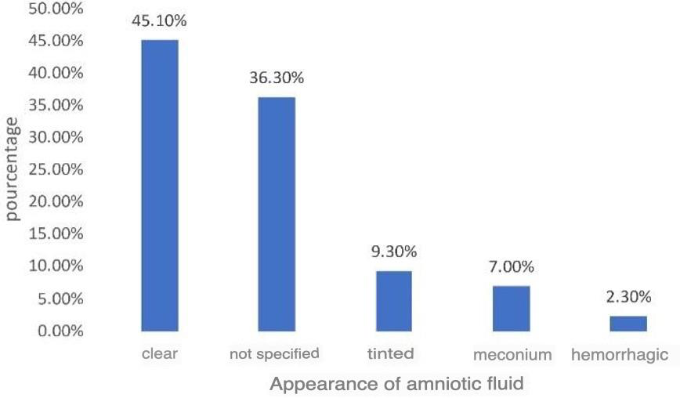

Figure 1: Distribution according to the appearance of amniotic fluid

NEONATAL DATA
In our series, 53.2% (115 cases) of newborns were premature, 42.8% were full-term, and 4% were postterm. The APGAR score was greater than 7 at the fifth minute in 87% of cases. Among our patients, 152 (71%) had intrauterine growth retardation and 2% were macrosomic. Respiratory distress in the delivery room was found in 84 newborns (59%) (n=142). In our series, 82 newborns (38%) (n=215) were resuscitated with a mean time of 9.18 min and extremes ranging from 2 to 40 min. In our series, 32 newborns (15%) (n=215) came from surrounding health facilities, and among them, 21 newborns came from health posts. The average transfer time from birth was 5.03 hours with extremes ranging from 1 to 24 hours. The transfer was performed without oxygen in 84.6% of cases (n=26) and the means of transfer was specified in 26 cases, including 19 or 59.3% by simple ambulance. Respiratory distress represented 78% of the reasons for transfer. Transfers were carried out by midwives in 70% of cases (n=32).

CLINICAL DATA
In our series, 107 newborns, or 49.7%, had a saturation less than or equal to 95% on room air upon arrival in the department. The average saturation was 89% with extremes ranging from 44 to 99% and 15% of newborns presented cyanosis. Hyperglycemia was found in 12% of cases on admission. Respiratory rate abnormalities were noted in 60 newborns, of which 23.8% presented tachypnea. Figure 2 shows the distribution according to respiratory rate abnormalities.
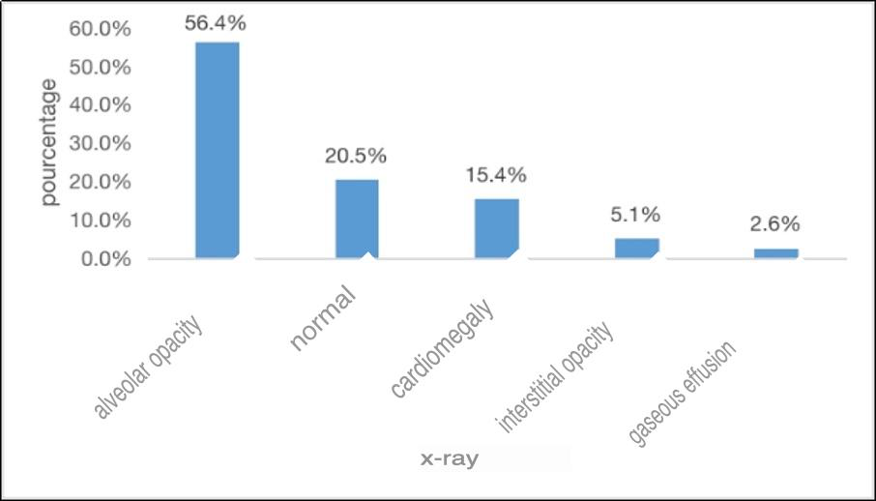

Figure 2: Distribution according to respiratory rate anomalies found
The mean score was 4.6/10 with extremes ranging from 2/10 to 9/10. In our series, 88 newborns presented other disorders associated with respiratory distress, of which anemia, dehydration, convulsions and hypotonia were the most represented.
On physical examination, respiratory distress syndrome was present in 212 newborns, or 98.6%. Table I shows us the distribution according to the results of the physical examination.

Table I : Distribution according to the objective syndrome

Objectified syndrome | Frequency | Percentage %
Distress respiratory | 212 | 98.6
Infectious syndrome | 76 | 35.3
Neurological distress | 38 | 17 , 7
Bronchial syndrome | 13 | 7.4
Polymorphic syndrome | 12 | 5.6
Dehydration​ | 10 | 4 , 6
Distress hemodynamics | 7 | 3.2
Pulmonary condensation | 5 | 2.3

Paraclinical data
Biology was requested in 198 newborns, 86 of which (43%) revealed abnormalities. Anemia, positive CRP, hyperleukocytosis and thrombocytopenia were found in 30%, 34.5%, 38% and 17.5% respectively.
The table represents the distribution of anomalies according to biology

Table II : Distribution according to biological anomalies

Signs organic | Frequency | Percentage %
Anemia | 26 | 30
Hyperleukocytosis | 33 | 38
Leukopenia | 3 | 3.5
Thrombocytopenia | 15 | 17.5
Thrombocytosis | 2 | 2.3
CRP positive | 30 | 34.5
Cytolysis hepatic | 9 | 10.5
Insufficiency renal | 12 | 14
Hypernatremia | 2 | 2.3
Hyponatremia | 6 | 7
Hyperkalemia | 9 | 10.5
Hypokalemia | 1 | 1.2

Among our patients, only the radiographic data of 39 newborns were specified, of which 56% showed alveolar opacity. Figure 3 represents the distribution according to the radiographic results.
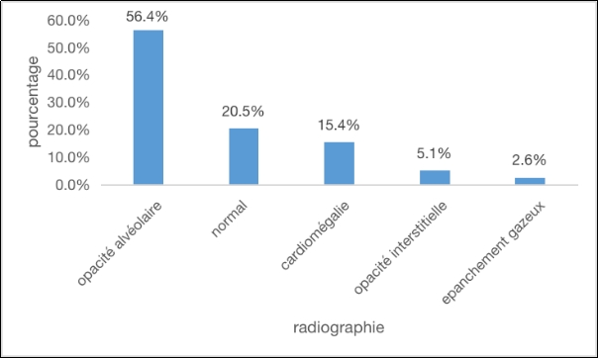
2,6%
5,1%
15,4%
20,5%
56,4%
Figure 3: Distribution according to chest X-ray results

Therapeutic data
Oxygen therapy was administered urgently in 92.1% of our newborns. Antibiotic therapy was initiated during hospitalization in 94.9% of our patients. Table III shows the distribution according to the treatments given during hospitalization.

Table III : Distribution according to treatment administered in hospital

Treatment | Frequency | Percentage %
Antibiotics | 204 | 94 , 9
Power supply n | 178 | 82 , 8
Antipyretics | 51 | 23.7
Passive hypothermia | 36 | 16.7
Anticonvulsants | 32 | 14.9
Magnesium sulfate | 26 | 12.1
Diuretics | 13 | 6
Exogenous surfactant | 0 | 0

Etiological data
In this series, neonatal infection with pulmonary localization was found in 124 newborns, or 57.7% of the etiologies. Table IV shows the distribution according to etiologies

Table IV : Distribution according to etiology
Etiologies | Frequency | Percentage %
Neonatal bacterial infection | 124 | 57.7
Hyaline membrane disease | 26 | 12.1
Perinatal asphyxia | 21 | 9.8
Inhalation of meconium fluid | 18 | 8.3
Transient tachypnea | 15 | 7
Pulmonary hypertension | 5 | 2 , 3
Congenital heart disease | 5 | 2,3​
Esophageal atresia | 1 | 0.5
Total | 215 | 100

Evolutionary data and forecasts
In our series, the outcome was favorable in 68% of newborns with neonatal respiratory distress. The average length of hospitalization was 11.58 days with extremes ranging from 1 hour to 90 days. In our series, 68 newborns or 32% died. The average age of our patients at the time of death was 6 days + 2 hours with extremes ranging from 2 hours to 18 days. Septic shock complicating maternal-fetal sepsis was found in 51.5% as the cause of death. Among the deceased newborns, 55 or 81% were premature.

DISCUSSION

Limitations of the study
Some parameters could not be assessed because most of the files and pregnancy monitoring logs were not correctly completed.
Lack of recent study on neonatal respiratory distress carried out in Senegal.

Epidemiological and sociodemographic data
In our series, the frequency of respiratory distress in newborns was 27.1%. A similar study carried out in 2020 over a period of 6 months in a university hospital in Mali found a frequency of 27% [5]. However, these data are significantly lower than those obtained at the CNHEAR concerning term newborns which was 34% in 2015 and according to a study carried out in Algeria in 2016 where the frequency was 43.6% [1; 6; 7]. The difference between these different studies is explained by the fact that the services are not comparable and their reception capacities are not the same.
We noted a male predominance with a sex ratio of 1.34. Several studies report a male predominance in neonatal respiratory distress. Indeed, American and French studies reported a sex ratio of 1.7 Papageorgiou et al, 1981[7]. Several hypotheses have been put forward to explain this male predominance, particularly regarding the mechanism. According to Nielson et al, cortisol levels were lower in the amniotic fluid of boys. For other authors, genetics seems to explain it. Indeed, according to a study by Children's National Health System featured in the Scientific reports, methylation differences on the X chromosome explain this male predominance [6; 8]
In our series, the average age of onset of respiratory distress was 0.48 days, or nearly 12 hours. Most of the newborns were received within the first 48 hours of life. As reported by other studies conducted in Africa, this reveals the early nature of respiratory distress [ 1; 6; 9] This is due to the fact that newborn problems are mainly linked to the immediate birth environment (risk of infection during pregnancy, difficulty adapting to extra-uterine life, poor delivery conditions, prematurity, etc.)

Diagnostic data
Respiratory distress was generally severe in newborns with an average Silverman score of 4.6. This severity was also found in another study conducted at CNHEAR where the average Silverman score was 4.8. Similar data were also found in other studies conducted in Africa [6;10]. This is explained by the predominance of premature babies, the absence of maternal antibiotic prophylaxis in the event of an infectious risk that could lead to severe neonatal infections, and the absence of antenatal corticosteroid therapy. This severity is inconsistent with the poor technical platform of our structures, which poses a real problem of management [6].
Etiological data
Medical causes represented almost all etiologies (213 newborns). Neonatal infection with pulmonary localization was the most frequent etiology, i.e. 57.7%, followed by MMH (12.1%), perinatal asphyxia (9.8%), inhalation of amniotic fluid (8.3%) and TTNN (7.0%). These results are almost similar to those obtained at CHNEAR where neonatal pulmonary infection, perinatal asphyxia and ILA were the most found [1;11]. On the other hand, in Togo, in the Fiawoo M series , asphyxia occupied (49,1%) [12].
The frequency of infection in our series is explained by the fact that the majority of pregnancies were not well monitored, some parturients had infections during pregnancy that were not or poorly treated, by the lack of notion of adequate antibiotic prophylaxis especially those who presented a premature rupture of membranes but also for some who did not have infectious risk factors but who did not have PV to know if it was positive or not, which means that all these newborns can develop an infection at birth explaining the respiratory distress. Similarly, the search for Strepto B carriage is not carried out in our context. The frequency of MMH was found in 16.7% of cases. These data are much higher than those obtained at CHNEAR (1.4%). The low frequency at CHNEAR is explained by the fact that the study concerned term newborns while MMH is often encountered in premature infants, hence the low frequency of MMH. The high incidence of MMH in our series is therefore linked to the high frequency of premature infants, particularly very preterm infants, and the lack of antenatal corticosteroid therapy and poor pregnancy monitoring. The high incidence of NNTT in Tunis and France is explained by the increased rate of cesarean sections. NNTT is often linked to difficulty adapting to extrauterine life.
In our series, we did not look for pulmonary surfactant protein deficiency. C. Delestrain, in Europe, they represent 20% of diffuse interstitial pneumonias [14]. This is due to the unavailability, in our country, of genetic analysis allowing the diagnosis of these pathologies.
Therapeutic data
Almost all of the newborns had received oxygen therapy, which was distributed as follows: 85% under CPAP and 15% under oxygen with glasses. No newborn was intubated. Unlike studies carried out in 2015 at CHNEAR where 21% of newborns with respiratory distress were intubated. The absence of a neonatal intensive care unit equipped with mechanical ventilation machines limits the cases of intubation in our department. If necessary, these newborns are often transferred to level 3 neonatology units. Antibiotic therapy was administered in almost all cases, 204, or 94%. It is almost similar to studies carried out in Mali in 2020 [5] which was 94% and significantly higher than another study done in Dakar in 2015 which was 71% [1; 11]. This broad antibiotic therapy could be explained by the frequent infectious risk in our context and the frequent association of infections with all neonatal pathologies likely to be the cause of respiratory distress.
Evolutionary and prognostic data
The main complications observed during the course of the disease were persistent pulmonary hypertension (PPH) with 2.8%. These results are lower than those obtained during the study carried out at Albert Royer in 2015 where PPH was 9.8%. The lethality associated with respiratory distress in our series was 32% (68 newborns). The main factors associated with this lethality were neonatal infection complicated by septic shock, perinatal asphyxia, persistent pulmonary hypertension, decompensated congenital heart disease. This lethality is similar to that obtained by a study carried out in Dakar in 2015 where it was 31.8%. This high lethality is explained by the severity of respiratory distress, poor monitoring of pregnancies responsible for premature deliveries.

Conclusion:
Neonatal respiratory distress is a common reason for hospitalization in neonatology at the Pikine Hospital Center. Its management requires a series of precautions before and after the birth of the babies.

Disclaimer (Artificial intelligence)
Option 1:
Author(s) hereby declare that NO generative AI technologies such as Large Language Models (ChatGPT, COPILOT, etc.) and text-to-image generators have been used during the writing or editing of this manuscript. Ok

Option 2:
Author(s) hereby declare that generative AI technologies such as Large Language Models, etc. have been used during the writing or editing of manuscripts. This explanation will include the name, version, model, and source of the generative AI technology and as well as all input prompts provided to the generative AI technology
Details of the AI usage are given below:
1.
2.
3.

Reference

- Faye, P.M., et al. (2016) Respiratory distress in term newborns in the neonatology department of the Albert Royer Children's Hospital in Dakar, Senegal. Médecine d’Afrique Noire, 63, 35-43.
- Kassim BO. Respiratory distress in newborns at the referral health center in commune V, Medical thesis University of Bamako 2019 https://www.bibliosante.ml/handle/123456789/4379
- United Nations Inter- agency Group for Child Mortality Estimation (UN IGME) levels and trends in child mortality, Report 2020. UNICEF. New York. 2020; p: 2-16
- Agency for Statistics and Demographics (ANSD) Continuous Demographic and Health Survey, Key Indicator Report. Dakar. 2023; p:18. https://www.ansd.sn/sites/default/files/2023
- Coulibaly A. Respiratory distress in term newborns: clinical, etiological and evolutionary aspects. Medical Memory University of Bamako 2022

- Zahiri K. Respiratory distress in term newborns in the neonatology department of the Albert Royer National Children's Hospital in Dakar. Thesis Med Cheikh Anta Diop University Dakar, 2015, No. 65
- Apostolos N. Papageorgiou ; Eleanor Colle ; Evangelia Farri-Kostopoulos ; Morrie M. Gelfand Incidence of Respiratory Distress Syndrome Following Antenatal Betamethasone: Role of Sex, Type of Delivery, and Prolonged Rupture of Membranes Available to Purchase
Pediatrics (1981) 67 (5): 614–617.
- Cesar L. Nini, Geovanny F. Perez et al. Characterization of sex-based DNA methylation signatures in the respiratory tract during infancy. Scientific articles. 2018; p: 1-4
- Kouyaté MM. Epidemiological and clinical study of respiratory distress at the reception of the pediatric department of the reference health center of the commune V. Medical thesis University of Bamako 2018
- G. Krim. Artificial ventilation of the newborn 2005. ITBM-RBM. 2005; 26 , 35-40.
- Gaultier CL . Cardio respiratory adaptation during sleep in infants and children. Pediatr Pulmonol.1995; 19:105-17105-17
- Fiawoo M, Hemou M, Guedenon KM, Agbéko F, Akolly DAE, Galinaba NF, Amblasso M, Kamaga M, Djadou KE, Gbadoe AD, Douti NK. Respiratory distress in newborns at the University Hospital of Lomé, Togo. West Afr J Med. 2023; 40: 32-33.
PMID: 38069826.
- Chemin A, Thionois S, Saliba E, Cantagrel S. Early management of infants born to mothers with meconium-stained amniotic fluid: a survey in French delivery rooms. Arch Pediatr. 2007 ;14(2):150-6. Doi: 10.1016/j.arcped.2006.08.015. Epub 2006 Oct 16.
- C. Delestrain, N. Nathan. Update on management of inherited disorders of surfactant metabolism. Outline from the recent French guidelines? Elsevier. 2022;5 (3), 173 - 178

