Cholera Outbreak in Chad in 2025: Epidemiological, Clinical, and Outcome Profile of the First Patients Managed in Cholera Treatment Centers

Abstract
Background: Cholera remains a public health emergency in sub-Saharan Africa, where access to safe drinking water and sanitation infrastructure is limited. Since July 2025, the eastern region of Chad has been facing a cholera outbreak. The objective of this study was to describe the epidemiological, clinical, and outcome profile of the first patients managed in cholera treatment centers.
Methods: This was a cross-sectional study based on data from the epidemiological situation report of the Ministry of Public Health, No. 34 dated August 30, 2025. All suspected cholera cases and those confirmed by microbiological tests were included in the study.
Results: During the study period (July–August 2025), 1,331 cholera cases were reported across three provinces in eastern Chad. The Chokoyane health district was the most affected, accounting for 46.2% of cases (n = 1,226). The median age was 23 years. The 5–14-year age group was the most represented (34.79%, n = 463). Females predominated (62.5%, n = 1,660), with a sex ratio of 0.4. Clinically, diarrhea was present in all patients, complicated by moderate to severe dehydration in 88% (n = 2,338). Vomiting occurred in 76% (n = 2,019). Laboratory analyses isolated Vibrio cholerae O1 Ogawa. The case fatality rate was 5.6% (n = 149). The response measures included case management in treatment centers, antibiotic prophylaxis for contacts, cholera vaccination, household disinfection, and chlorine distribution.
Conclusion: The current outbreak’s epidemiological and clinical profile is similar to that of previous years, with the particularity of a higher incidence among children. Its re-emergence is linked to the limited capacity of the health system and the massive influx of people displaced by armed conflict. Strengthening health system capacities and epidemiological surveillance is essential to control this epidemic.
Keywords: outbreak, cholera, public health, Ouaddaï, Sila, Chad

Introduction
Cholera is an acute diarrheal intestinal toxinfection that is both endemic and epidemic, highly contagious, and a notifiable disease caused by a Gram-negative bacillus, Vibrio cholera [1], [2], [3]. The bacterium secretes a toxin that causes hyperactivation of enterocytes, resulting in very strong and profuse diarrhea leading to severe dehydration. [4] However, when used as an adjuvant, it enhances immune responses against antigens administered via mucous membranes. [5], [6], [7], [8]
It remains a public health emergency and a persistent disease of global concern. Cholera is a severe illness with a high mortality rate in the absence of appropriate management [1], [9]. It is a vaccine-preventable disease and is among the notifiable diseases targeted by the Expanded Program on Immunization (EPI) [9], [10].
In 2022, WHO estimated approximately 535,321 cases and 4,007 deaths across 45 countries. Since 2021, there has been a resurgence in the number of cholera cases, along with an expanding geographical distribution. In 2021, 23 countries—mainly in the WHO African and Eastern Mediterranean Regions reported cholera outbreaks. This trend continued in 2022, with more than 29 countries reporting cases or outbreaks. As of November 30, 2022, 16 of these countries were experiencing prolonged outbreaks. Many reported higher case numbers or case fatality rates than in previous years. The global average cholera case fatality rate in 2021 was 1.9% (2.9% in Africa), well above the acceptable level (<1%) and the highest recorded in over a decade. Although cholera can be easily treated with oral rehydration salts, it remains a global threat due to its high morbidity and mortality among vulnerable populations with limited access to adequate healthcare.
Cholera outbreaks have been reported in Mali, Côte d’Ivoire, Niger, and Senegal. It is a fecal-oral disease that thrives in contexts of poverty, disasters (wars, floods), and refugee camps. It remains a public health problem in countries with low vaccination coverage and periodic epidemic peaks [11], [12], [13], [14], [15].
Chad, a Sahelian country facing chronic humanitarian instability, has experienced several previous cholera outbreaks (2010, 2017, 2021). A new epidemic was declared in mid-July 2025, with the first confirmed case reported on July 24 in Ouaddaï Province [16]. The epidemic then spread to two other eastern provinces bordering Sudan.
The objective of this study was to describe the epidemiological, clinical, bacteriological, and outcome profiles of the first patients managed in the various cholera treatment centers (CTCs).
Methodology
Description of Chad
Chad is a landlocked country in Central Africa bordered by Libya to the north, Sudan to the east, the Central African Republic to the south, Cameroon to the southwest, Nigeria to the west-southwest, and Niger to the west. Its capital, N'Djamena (formerly Fort-Lamy), is also its most populous city. The three provinces affected by the epidemic are located in the east, along the border with Sudan.
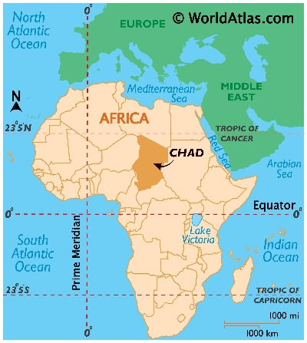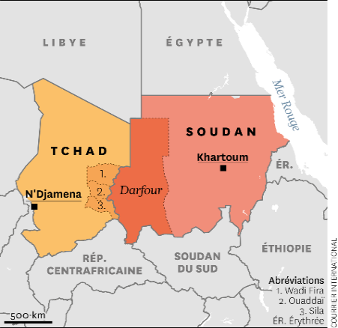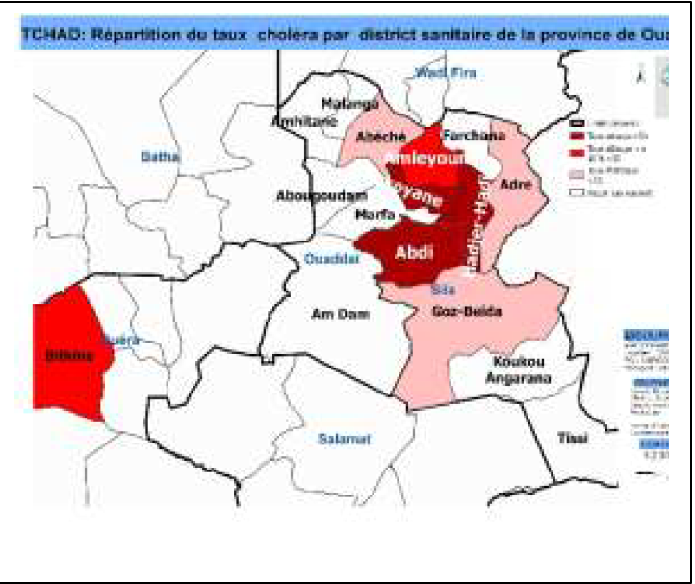
Fig. 1: Geographical location of Chad, Fig. 2: Darfour, Fig. 3: cholera infected districts
In 2024, the humanitarian context was marked by three types of shocks: conflict, climatic events, and health emergencies. Since the outbreak of armed conflict in Sudan in April 2023, the humanitarian situation in Chad—particularly in the east—has worsened, with the arrival of 712,288 refugees and 209,153 Chadian returnees as of November 2024. These populations arrived in areas where the health system was already fragile or overwhelmed by epidemics such as measles, chickenpox, hepatitis E, and yellow fever. Over 800,000 people lacked access to safe drinking water, compounded by a food crisis.
Study Design: this was a descriptive cross-sectional study including all cholera cases reported between July and August 2025 in the two affected provinces (Ouaddaï and Sila). Data were obtained from the national line list of notifiable diseases and the Ministry of Public Health situation report (SITREP) [16].
Case Definitions
- A suspected case was defined as acute watery diarrhea in a person aged >5 years in the context of an outbreak.
- A confirmed case was defined by isolation of V. cholerae through culture or a positive rapid diagnostic test (RDT).
Bacteriological Analysis: for each patient, stool samples were collected and analyzed according to standard bacteriological procedures. Stool samples were obtained either in sterile wide-mouth containers or via rectal swabs (sterile cotton swabs inserted 3–4 cm beyond the anal margin) and placed in alkaline peptone water. Samples were transported immediately under cold chain using the triple packaging system; if delayed, they were stored at ambient temperature for a maximum of 24 hours before transport in alkaline peptone water or Cary-Blair medium.
Microbiological analysis included direct Gram staining, culture, identification, serogrouping, and antibiotic susceptibility testing. The antibiogram was performed according to EUCAST 2024 recommendations using the disk diffusion method on agar medium [17]. Bacteriological results were communicated daily. In some cases, confirmation was established through rapid diagnostic testing.
Results
Patient characteristics: during the study period (July–August 2025), 1,331 cholera cases were reported in the two affected provinces (Ouaddaï and Sila). Among the seven affected districts, Chokoyane and Hadjer Haddid accounted for 57.3% (n = 763) and 34.2% (n = 455) of cases, respectively. The median age was 23 years. The 5–14-year age group was the most represented (34.8%, n = 463). Females predominated (69.1%, n = 920), with a sex ratio of 2.
Table I. Distribution of cholera cases by age group
Age group | n | %
0–11 months | 28 | 2.1
1–4 years | 118 | 8.8
5–14 years | 463 | 34.8
15–29 years | 233 | 17.4
30–44 years | 190 | 14.3
≥45 years | 299 | 22.4
Total | 1331 | 100

Table II. Distribution of cholera cases by district of origin
Health District | n | %
Abdi | 43 | 3.2
Abéché | 3 | 0.2
Adré | 33 | 2.5
Amleyouna | 26 | 1.9
Chokoyane | 763 | 57.3
Farchana | 5 | 0.4
Goz Beïda | 3 | 0.2
Hadjer Haddid | 455 | 34.2
Total | 1331 | 100

Clinical Findings
Table III. Clinical characteristics of cholera cases
Clinical features | n (1331) | %
Watery diarrhea | 1331 | 100.0
Vomiting | 1012 | 76.0
Muscle cramps | 313 | 23.5
Moderate to severe dehydration | 1211 | 91.0
Cardiovascular collapse | 562 | 42.2
Oligo-anuria | 690 | 51.8

Diarrhea was present in all patients, complicated by moderate to severe dehydration in 91%. Other symptoms included vomiting (76%), abdominal cramps (23.5%), cardiovascular collapse (42%), and oligo-anuria (51.8%).
Paraclinical Findings : microbiological confirmation was performed on 269 stool samples. Among the cultured samples (n = 84), 45 (53.6%) were positive. Of 356 RDTs performed, 224 were positive. Vibrio cholerae O1, serogroup Ogawa, was isolated from two samples and was sensitive to cyclins, fluoroquinolones and macrolides.

Figure 4 : Paraclinical data (RDT and culture)
Treatment and Outcomes : all patients received rehydration therapy according to national guidelines, adjusted to disease severity. Antibiotics were prescribed in most cases.
Complications included acute functional renal failure with oligo-anuria (51.8%, n = 690), cardiovascular collapse (42.2%, n = 562), and severe dehydration (34.2%, n = 433). The overall case fatality rate was 6.7% (n = 89).
Discussion
This study demonstrates that cholera remains an endemic-epidemic disease in Chad, predominantly affecting populations with low socioeconomic status, mainly in Chokoyane District, characterized by high population density and poor sanitation. Most affected individuals were indigenous populations living in unsanitary environments due to poverty or displacement linked to armed conflict.
The cholera outbreak that began in July 2025 in eastern Chad fits within a broader pattern of recent African epidemics associated with acute humanitarian and climatic vulnerability. The concentration of cases in Chokoyane and the predominance among women and children reflect a combination of structural and immediate determinants already reported in regional and global literature [14], [18], [19], [20], [21] .
Several factors explain the observed intensity of transmission. Poor WASH (Water, Sanitation, and Hygiene) conditions remain the primary determinant, closely correlated with cholera burden [3], [22]. Population movements (refugees and displaced persons from Sudan) weakened the local health system and created human networks conducive to V. cholerae dissemination, as shown in similar contexts [14], [23], [24]. The rainy season likely amplified transmission by contaminating unprotected water sources, consistent with analyses linking heavy rainfall events to outbreaks [14], [25], [26]. Informal food practices identified through case-control surveys and patient reports correspond to findings from other studies showing that street food contributes significantly to exposure in urban and peri-urban settings [27]. This combination made Chokoyane the epicenter of cholera in Chad.
Clinically, symptoms were typical of cholera, including watery diarrhea, vomiting, and occasionally muscle cramps. V. cholerae O1, biotype El Tor, was the pathogen isolated—similar to strains identified in previous epidemics in Chad and the subregion [20], [28], [29].
Therapeutically, patients were managed according to WHO-recommended oral and parenteral rehydration protocols (Plans A, B, and C) and received bactericidal antibiotic therapy.
The observed case fatality rate exceeded the WHO target (<1%), indicating delays in access to care, shortages of medical supplies, and lack of pre-hospital management—factors known to drive mortality according to systematic reviews and response evaluations. Experience shows that staff training and rapid establishment of cholera treatment centers (CTCs) can drastically reduce fatality when implemented promptly [30].
In terms of prevention, the inactivated oral cholera vaccine (OCV) remains a strategic tool. Recent studies show that a single dose confers substantial protection, especially among previously exposed populations, while the two-dose regimen provides longer-lasting protection and is preferred for preventive campaigns. The Chadian response took place amid a global vaccine shortage, prompting agencies to recommend a single-dose strategy for immediate outbreak response. The entry of new manufacturers and additional vaccines may soon alleviate supply constraints [31], [32], [33].
Genomic and microbiological surveillance remain underutilized tools in Chad. Comparative African studies show that integrating sequencing into surveillance helps identify introductions, track cross-border spread, and detect antimicrobial resistance markers [20], [21]. In Chad, the lack of effective environmental sampling limits source tracing, emphasizing the need to strengthen sampling methods and regional laboratory logistics.
This study also highlights the weaknesses of Chad’s health system. Persistent insecurity around the Lake Chad Basin—particularly linked to Boko Haram—has led to major population displacements toward Ouaddaï, which has hosted thousands of refugees from conflict zones [34]. These displacements have further weakened an already fragile health system, widening the gap between healthcare demand and supply [35]. Children in refugee camps have limited access to vaccination services [23]. In addition, the region faces migration of women—especially in Chokoyane District—who, accompanied by small children and engaged mainly in begging, may remain without vaccination for months or years [36]. The COVID-19 pandemic further disrupted healthcare delivery due to vaccine supply shortages caused by border closures and public reluctance to visit health facilities [37].
Conclusion
The cholera outbreak in eastern Chad illustrates the consequences of insufficient vaccination coverage. The optimal approach to preventing future epidemics lies in strengthening vaccination campaigns, improving access to healthcare, and increasing community awareness to significantly reduce cholera incidence and mortality in Chad. This outbreak underscores the country's persistent vulnerability to waterborne health emergencies. The high case fatality rate calls for urgent reinforcement of healthcare access, WASH infrastructure, OCV vaccination, and epidemiological surveillance.
Ethical and Deontological Considerations
This study was conducted in accordance with ethical and deontological principles, following authorization from the Ministry of Public Health and Prevention and bioethical committee of Chad.

Disclaimer (AI)
“This manuscript was translated from French to English with the assistance of a generative AI tool (ChatGPT 5.1). All scientific content was reviewed and validated by the authors.” The prompt used is : “Tu es un expert en anglais médical. J'aimerai que tu m'aides à traduire un article sur le choléra en anglais”

REFERENCES
- Bush Larry M, Maria T. Vazquez-Pertejo, Brenda L.Tesini. Choléra - Maladies infectieuses - Édition professionnelle du Manuel MSD., 2024. Consulté le 13 septembre 2025.
- Jacques MORVAN. Cas de choléra au Burkina Faso en provenance du Niger. Mes Vaccins,2023, Disponible sur: https://www.mesvaccins.net/web/news/17899. consulté le 13 septembre 2025.
- Jean-Michel Fournier, Marie-Laure Quilici. Choléra. La Presse Médicale, 2007;36 (4) : 727-739
- Choléra : symptômes, traitement, prévention - Institut Pasteur [Internet]. [cité 13 sept 2025].Disponible sur: https://www.pasteur.fr/fr/centre-medical/fiches-maladies/cholera
- E. C. Lavelle, E. McNeela, M. E. Armstrong, O. Leavy, S. C. Higgins, and K. H. G. Mills, “Cholera Toxin Promotes the Induction of Regulatory T Cells Specific for Bystander Antigens by Modulating Dendritic Cell Activation,” J. Immunol.,2023;171(5): 2384–2392, doi: 10.4049/jimmunol.171.5.2384.
- P.-H. Kim, L. Eckmann, W. J. Lee, W. Han, and M. F. Kagnoff, “Cholera Toxin and Cholera Toxin B Subunit Induce IgA Switching Through the Action of TGF-β1,” J. Immunol.,1998;160 (3): 1198–1203. doi:10.4049/jimmunol.160.3.1198.
- A. Fergany, K. M. Hassanein, A. M. Zahran, M. R. Abdel Hameed, and A. M. Kamel,
“Clinical significance of interleukin 10, interleukin 33, and interleukin 35 on induction
chemotherapy in acute myeloid leukemia patients,” Egypt. J. Haematol., vol. 50, no. 1,
pp. 125–132, Jan. 2025, doi: 10.4103/ejh.ejh_83_24.
- D. Mohammed, S. Khallaf, M. El-Naggar, M. Abdel-Hameed, and R. Bakry, “Interleukin-10: A Potential Prognostic Marker in Patients with Newly Diagnosed Multiple Myeloma,” Res. Oncol., vol. 17, no. 1, pp. 38–41, June 2021, doi: 10.21608/resoncol.2021.51503.1127.
- Choléra : symptômes, traitement et prévention - Institut Pasteur de Lille.” Accessed: Nov. 14, 2025. [Online]. Available: https://pasteur-lille.fr/centre-prevention-sante- longevite/vaccins-et-voyages/cholera/
- M. Ali, A. R. Nelson, A. L. Lopez, and D. A. Sack, “Updated Global Burden of Cholera in Endemic Countries,” PLoS Negl. Trop.
- Sophie-Amélie C, Pauline M, Motet C, Florence Q. Les nouvelles directives EUCAST pour l’interprétation des antibiogrammes, nos prescripteurs y sont-ils sensibles ? (En: New EUCAST Guidelines for Interpreting Antibiograms: Are Our Prescribers Aware?). 2024 févr; Namur, Belgique.
- Mengel MA, Delrieu I, Heyerdahl L, Gessner BD. Cholera outbreaks in Africa. Curr Top Microbiol Immunol. 2014;379:117‑44.
- Bwire G, Debes AK, Orach CG, et al. Cholera outbreak in Uganda, 2016: epidemiology and molecular characterization. PLoS Negl Trop Dis. 2018;12(3):e0006492.
- Cheung WA, Chiyangwa B, Mwaba J, et al. Genomic insights into the 2022–2023 Vibrio cholerae outbreak in Malawi. Nat Commun. 2024;15(1):4521.
- Mageto LM, Aboge GO, Mekuria ZH, Gathura P, Juma J, et al. Genomic characterization of Vibrio cholerae during the 2022–2023 outbreak in Kenya. Front Microbiol. 2025;16:1603736.
- Page AL, Alberti KP, Mondonge V, et al. Evaluation of a rapid test for the diagnosis of cholera. PLoS One. 2012;7(5):e37360.
- Ramadan M, Tappis H, Uribe MV, Brieger W. Access to primary healthcare Services in Conflict-Affected Fragile States: a subnational descriptive analysis of educational and wealth disparities in Cameroon, Democratic Republic of Congo, Mali, and Nigeria. Int J Equity Health. 11 déc 2021;20(1):253.
- Kohnert D. Sur l’impact socio-économique des pandémies en Afrique: Leçons tirées du COVID-19, de la trypanosomiase, du VIH, de la fièvre jaune, du choléra. 2021 [cité 13 sept 2025]; Disponible sur: https://mpra.ub.uni-muenchen.de/id/eprint/107573
- LEGEAS MM. Epidémies de choléra en Afrique: Analyse d’une étiologie multifactorielle. [cité 13 sept 2025]; Disponible sur: http://documentation.ehesp.fr/memoires/2004/igs/janny.pdf
- Boloweti DB. Analyse écologique des points chauds de choléra en Afrique. [Internet] [PhD Thesis]. Université Bourgogne Franche-Comté; Université de Kinshasa; 2021 [cité 13 sept 2025]. Disponible sur: https://theses.hal.science/tel-03630433/
- Heyerdahl LW. Anthropologie multisituée des économies du risque choléra. Savoirs, pratiques et technologies (Côte d’Ivoire) [Internet] [PhD Thesis]. Université de Lyon; 2019 [cité 13 sept 2025]. Disponible sur: https://theses.hal.science/tel-02612648/
- Sen Claudine Henriette Ngomtcho, Blaise Mboringong Akenji, Roland Ndip, Andrew S. Azman, Yanick Carolle Tayimetha, Etienne Guenou, and al. Continued T12 transmission and shared antibiotic resistance during 2018–2023 Vibrio cholerae outbreaks in Cameroon. PLOS Global Public Health, 2025;1(1):1-13. doi.org/10.1371/journal.pgph.0003763
- Moukénet A, Djona Atchénémou A. La gratuité des soins de santé au Tchad: évaluation https://medicalguidelines.msf.org/fr/viewport/CHOL/francais/6-1-centres-de-traitement-du-cholera-ctc-25296937.html et perspectives. 2016. Disponibles ur:https://www.torrossa.com/gs/resourceProxy?an=4837303&publisher=FZ2990
- Sougnabé P, Reounodji F. Mécanismes de prévention et de gestion des conflits dans les zones d’intervention du projet ACCEPT. Paris IRAMPlateforme Pastor Tchad Projet ACCEPT [Internet]. 2021 [cité 7 avr 2025]; Disponible sur: https://praps2niger.ne/wp-content/uploads/sites/26/2023/08/Rapport_iRAM-Etude_3-Version_definitive-1.pdf
- Centres de traitement du choléra (CTC) | Guides médicaux MSF [Internet]. [cité 13 sept 2025]. Disponible sur:
- Azman AS, Luquero FJ, Ciglenecki I, Grais RF, Sack DA, Lessler J (2015) The Impact of a OneDose versus Two-Dose Oral Cholera Vaccine Regimen in Outbreak Settings: A Modeling Study. PLoS Med 12(8): e1001867. doi:10.1371/journal. pmed.100186
- Ciglenecki I, Sakoba K, Luquero FJ, et al. Feasibility of mass vaccination with oral cholera vaccines in Guinea. PLoS Med. 2013;10(9):e1001512.
- Anh C, Philippe C, et al. Effectiveness of one dose of killed oral cholera vaccine in Uvira, DRC. Lancet Infect Dis. 2023;23(7):831‑9.
- P. Sougnabé and F. Réounodji, “Mécanismes de prévention et de gestion des conflits au Tchad:,” Afr. Contemp., vol. N° 274, no. 2, pp. 123–145, Dec. 2022, doi:10.3917/afco1.274.0123.
- MSF. Centres de traitement du choléra (CTC) | Guides médicaux MSF.” Accessed: Nov.14, 2025. [Online]. Available:https://medicalguidelines.msf.org/fr/viewport/CHOL/francais/6-1-centres-de-traitement-du-cholera-ctc-25296937.html
- JLE - Médecine - L’épidémiologie des maladies à prévention vaccinale en 2017.”Accessed: Nov. 14, 2025. [Online]. Available: https://www.jle.com/fr/revues/med/e docs/lepidemiologie_des_maladies_a_prevention_vaccinale_en_2017_309329/article.ph tml?tab=citer
- Qadri F, Wierzba TF, Ali M, et al. Efficacy of a single-dose, inactivated oral cholera vaccine in Bangladesh. N Engl J Med. 2016;374(18):1723‑32.
- UNHCR. Des milliers de nouveaux déplacés par Boko Haram au Niger [Internet]. HCR. [cité 9 mars 2025]. Disponible sur: https://www.unhcr.org/fr/actualites/stories/des-milliers-de-nouveaux-deplaces-par-boko-haram-au-niger
- Antarou L, Ridde V, Kouanda S, Queuille L. Health staff workload in a context of user fees exemption policy for health care in Burkina Faso and Niger. Bull Soc Pathol Exot 1990. oct 2013;106(4):264‑71.
- P. L. Dobbs;, “Des milliers de nouveaux déplacés par Boko Haram au Niger,” HCR.Accessed: Nov. 14, 2025. [Online]. Available:https://www.unhcr.org/fr/actualites/stories/des-milliers-de-nouveaux-deplaces-par-boko-haram-au-niger
- Doutchi Mahamadou, Adamou Bara Abdoul-Aziz, Lamine Mahaman Moustapha , Ibrahim Alkassoum , Souleymane Adoum Fils and al. Resurgence of epidemics in Zinder: effect of the decrease in vaccination coverage and the impacts of climate change. 2025; S2772-7076(25)00215-2 DOI: https://doi.org/10.1016/j.ijregi.2025.10078.
- Dubey S, Biswas P, Ghosh R, Chatterjee S, Dubey MJ, Chatterjee S, et al. Psychosocial impact of COVID-19. Diabetes Metab Syndr Clin Res Rev. 1 sept 2020;14(5):779‑88.

