Case report
“Clinical Overlap of Vitiligo and Psoriasis: A Histopathologically Confirmed Case Report.”

ABSTRACT
Vitiligo and psoriasis are highly prevalent chronic inflammatory dermatoses,usually described independently. Their concomitant presentation in the same patient represents a rare and clinically challenging entity. We report the case of a 50-year-old female patient with achrome macules in atypical locations (dorsum of both feet and the maleolar región),on which well-defined erythematous plaques with thick, adherent scales werw observed. Both pathologies share immunological mechanisms mediated by T lymphocytes (Th1, Th17 in psoriasis; CD8+ in vitíligo) and proinflammatory cytokines (Il-17, Il-23, TNF-α e IFN-γ, CXCL10), which contribute to to keratinocyte dysfunction and melanocytic destruction, respectively. The treatment was aimed at modulating the immune response using high-potency topical corticosteroids and calcineurin inhibitors (tacrolimus), with favorable evolution and partial repigmentation of the lesiones.

Keywords: Psoriasis, vitiligo, autoimmunity, overlap syndrome, inflammasomes.

Introduction
Psoriasis and vitiligo are characterised by multifactorial, complex mechanisms, which include genetic predisposition and environmental factors that trigger immune pathways. There is an increasing consensus suggesting that patients with both conditions are at a higher risk of having a family history of cardiovascular disease, experiencing inflammatory responses, and developing other autoimmune diseases (Wang & Zhang, 2023; Li et al., 2024). Some scholars argue that comorbidity may simply be a coincidental overlap without a substantial underlying connection between the two diseases (Orzan et al., 2025). This study aimed to explore a case report on the coexistence of vitiligo and psoriasis
Case Presentation
It is a 50-year-old female patient, from Tocuyito, a town in the state of Carabobo – Venezuela. Cutaneous phototype IV according to Fitzpatrick scale. With no family and personal history relevant to the case, she consulted for hypopigmented macules in the dorsal region of both feet and in the external malleolar region. In addition, it has erythematous plaques with scales on its surface, itchy for 9 months of evolution. She went to the local health center, being referred to the Dermatology service.
Physical examination revealed dermatosis located on the dorsum of both feet and in the bilateral and symmetrical external malleolar region. characterized by acromus macules of variable size, well-defined boundaries. Likewise, erythematous plaques were observed, with defined regular borders, covered with thick whitish scales adhered to their surface. (Figure 1).
A comprehensive diagnostic evaluation was carried out that included several complementary tools. Brocq's methodical scraping tested positive, while Wood's light revealed a characteristic chalk-white fluorescence. Dermoscopy revealed an erythematous background with thick whitish scales attached, accompanied by regular punctate vessels (Figures 2 and 3). Complementary studies, including complete hematology, renal and hepatic function, were requested, whose values were within normal limits. Evaluation of thyroid function within normal limits
The histopathological study of the skin stained with hematoxylin-eosin at 10x showed psoriasiform epidermal hyperplasia with hyperkeratosis, parakeratosis, areas of granulosis and hypogranulosis in the dermal papillae, with greater detail 40x absence of melanin and melanocytes in the basal layer (Figures 4 and 5). Through clinical findings, applied diagnostic techniques and histopathology, the diagnosis of vitiligo-psoriasis overlap syndrome was established.
A therapeutic scheme with high-potency corticosteroids was indicated, establishing the topical application of clobetasol at 0.05% once a day for 21 nights. As a complement, emollients with 10% urea were prescribed, along with the calcineurin inhibitor, tacrolimus 0.1%, applied on weekends for 3 months, antioxidant (Polypodium leucotomos). Clinical follow-up showed significant improvement, with resolution of psoriasis lesions and repigmentation in some acromic areas.

Discussion
Psoriasis and vitiligo are common chronic inflammatory dermatoses, usually described independently. Their coexistence in the same patient is a rare and clinically challenging finding. Psoriasis is characterized by erythematous desquamative plaques, resulting from an exacerbated inflammatory response mediated by T lymphocytes, particularly Th1 an Th17, and cytokines such as IL-17, IL-23, and TFN- α. Vitiligo, on the other hand, originates from the progressive destruction of melanocytes, mediated by CD8+ T lymphocytes and an inflammatory axis dominated by interferón- gamma and the chemikine CXCL10¹.
Both pathologies have immunogenic bases where they participate in major histocompatibility complex (HLA), which favors the predisposition to autoinmune phenomena and the activation of similar inflammatory pathways. Althogh there is no definitive cure for either disease, its evolution can be controlled through individualized therapeutic strategies. Its clinical presentation can be in flares or persistent, influenced by multiple triggers².
Although both vitiligo and psoriasis have multifactorial origins, the immune system plays a central role in their onset and progression³.
Several studieshave demonstrated the significant impact of genetic predisposition on the development of these conditions. A positive family history significantly increases the risk of developing psoriasis or vitiligo, underscoring the importance of ealy evaluation and the implementation of preventive strategies in individuals with a hereditary predispositio⁴.

The relationship between vitiligo and psoriasis can be explained, in part, by a shared genetic locus within the major histocompatibility complex, which favors a greater predisposition to autoimmunity and inflammation⁵. Akey element in the partnership between the two entities is the role of the
inflammasomes, multiprotein structures present in the cell cytoplasm that activate pro-inflammatory cytokines⁶.
Studies have identified genetic variants related to the inflammasome, which are linked to psoriasis in vitiligo patients, suggesting a common mechanism in susceptibility to both diseases^{7.}
Inflammasome- related genetic variants have bee identified in vitiligo patients who develop psoriasis, suggesting a common mechanism of susceptibility⁸. This connection is reinforced by the involvement of cellular immune pathways,in particular Th1 an Th17 lymphocyte mediated responses, which play a central role in the pathophysiology od both diseases⁹
In addition, this connection is reinforced by the involvement of cellular immune pathways, in particular responses mediated by Th1 and Th17 cells, which play a central role in both psoriasis and vitiligo¹⁰.

This clinical case highlights the complex interrelationship between psoriasis and vitiligo, evidencing the importance of a meticulous and multidisciplinary diagnostic approach. The overlap of both diseases in a patient with no family history suggests the influence of shared immunogenic mechanisms, reinforcing the central role of the locus of the major histocompatibility complex and the activation of inflammasomes in its pathogenesis.
The diagnosis was based on an exhaustive evaluation, which included dermoscopy, Wood's light and histopathological study, which confirmed the coexistence of both conditions and ruled out other pathologies of similar presentation. The favorable response to treatment with high-potency corticosteroids, calcineurin inhibitors and emollients, with signs of repigmentation in acromic areas, underscores the relevance of a personalized therapeutic strategy that simultaneously addresses skin inflammation and depigmentation.

Conclusion
This case report not only provides evidence on the immunological interaction between psoriasis and vitiligo, but also emphasizes the importance of early detection and comprehensive management, optimizing the prognosis and quality of life of affected patients. Understanding these shared mechanisms can guide future research on new therapeutic targets, paving the way for more effective and targeted strategies in clinical dermatology.

Disclaimer (Artificial intelligence)
Option 1:
Author(s) hereby declare that NO generative AI technologies such as Large Language Models (ChatGPT, COPILOT, etc.) and text-to-image generators have been used during the writing or editing of this manuscript.

References
1.Lowes MA, Suárez- Fariñas M, Krueger JG. Inmunology od psoriais. Annu Rev Inmunol. 2014;32 :227-225.

2. Coronado Aguilar A, Villanueva Quintero DG, Romo Sánchez C. Coexistence of vitiligo and psoriasis: a case report. CMQ Dermatología. 2010; 8(2):100-103.
3. Namadar AC, Sampagavi VV, Athanikar SB, Patil MN, Deshmukh NS. Vitiligo and psoriasis: coexistence with colocalization. Indian J Dermatol Venereol Leprol. 2001; 67:214-215.

4. Prignano F, Pescitelli L, Ricceri F, Lotti T. The importance of the genetic link in immune-mediated dermatoses: psoriasis and vitiligo. Int J Dermatol. 2008; 47(10):1060-1062.

- Mali V. Coexistence between psoriasis and vitiligo: a case report. Int J Sci Res. 2022; 13(3):1-5.
- Campanati A, Giuliodori K, Ganzetti G, et al. Patient with psoriasis and vitiligo treated with etanercept. Am J Clin Dermatol. 2010; 11(suppl 1):46–48.
- Sawchuk M, Spano F, Loo WJ, et al. The coexistence of psoriasis and vitiligo: a review. 2012; 16(5):300–305.
8. Wang L, Zhang, B. Psoriasis on lesions of vitiligo: A case report. Clinical, Cosmetic and Investigational Dermatology.2023:16 2005-2007.
9. Marie J, Kovacs D, Pain C, et al. Inflammasome activation and progression of vitiligo/nonsegmental vitiligo. Br J Dermatol. 2014; 170(4):816-823.
10. Li J, Shen Q, Wang Y, Guo C, Ma Y, & Zhang Y. The relationship between psoriasis and vitiligo: From a comprehensive study. Skin Research and Technology, 2024;30:e13868.
11 Orzan, O. A, Tutunaru, C. V, & Ianoși, S. L. Understanding the intricate pathophysiology of psoriasis and related skin disorders. International Journal of Molecular Sciences, 2025;26(2), 749.

Page skin
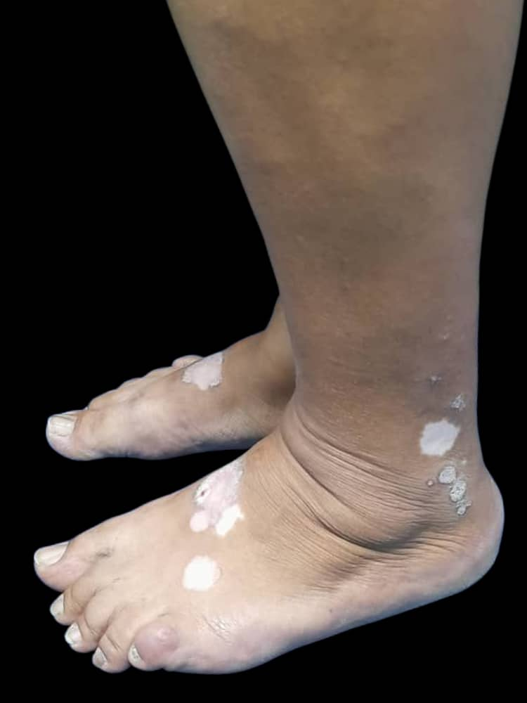
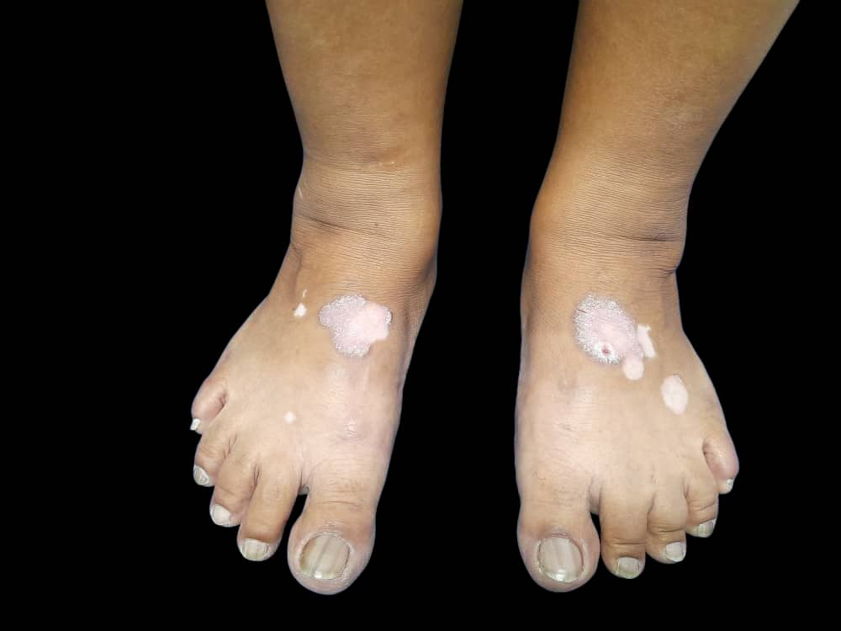
Figure 1: achromic macules of variable size, well-defined boundaries on which erythematous plaques are settled, with regular borders defined with thick whitish scales adhered to its surface.

Figure 2: Wood’s lamp, chaldk white fluorescence is observed.
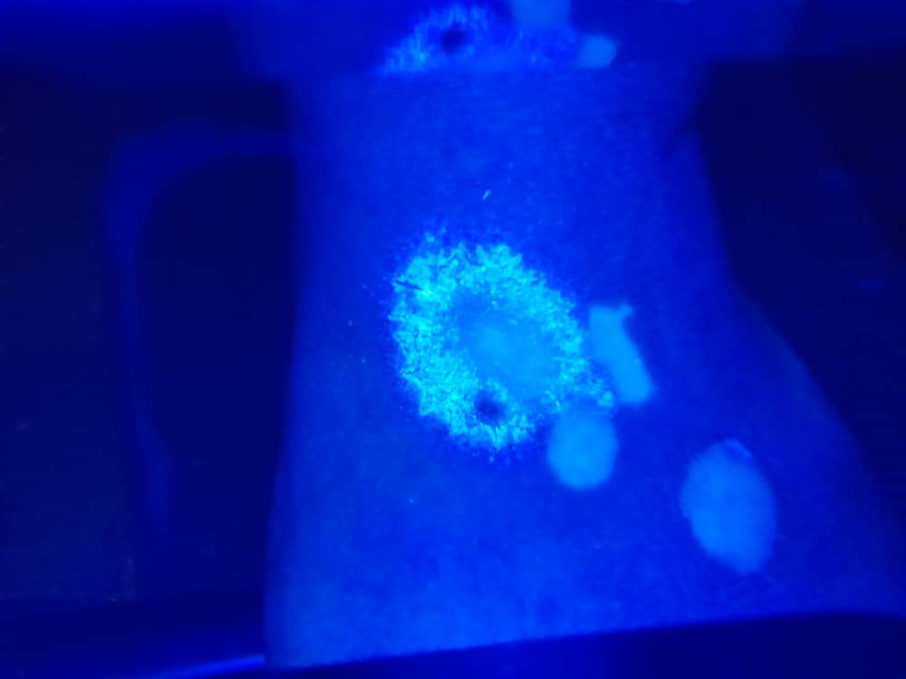

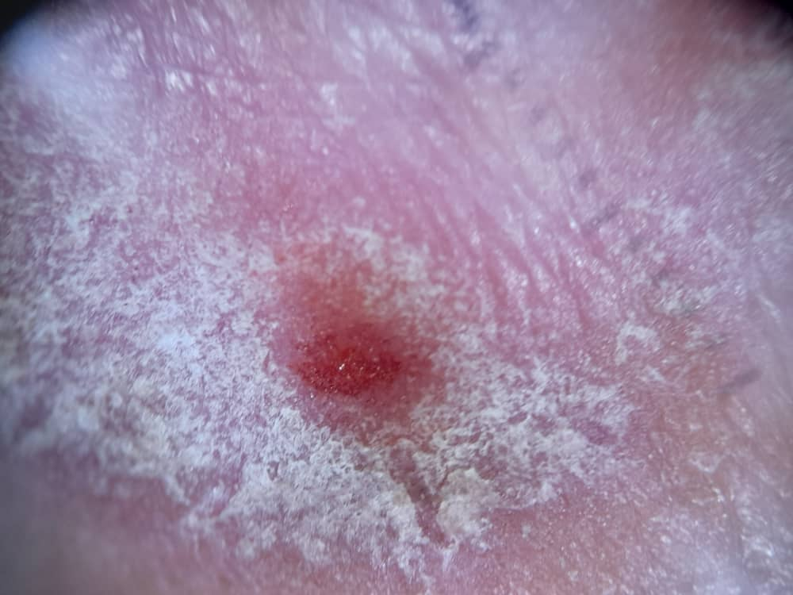
Figura 3: Dermatoscopy: erythematous background, punctate vessels, whitish scales adhered to its surface.
Figure 4 and 5:
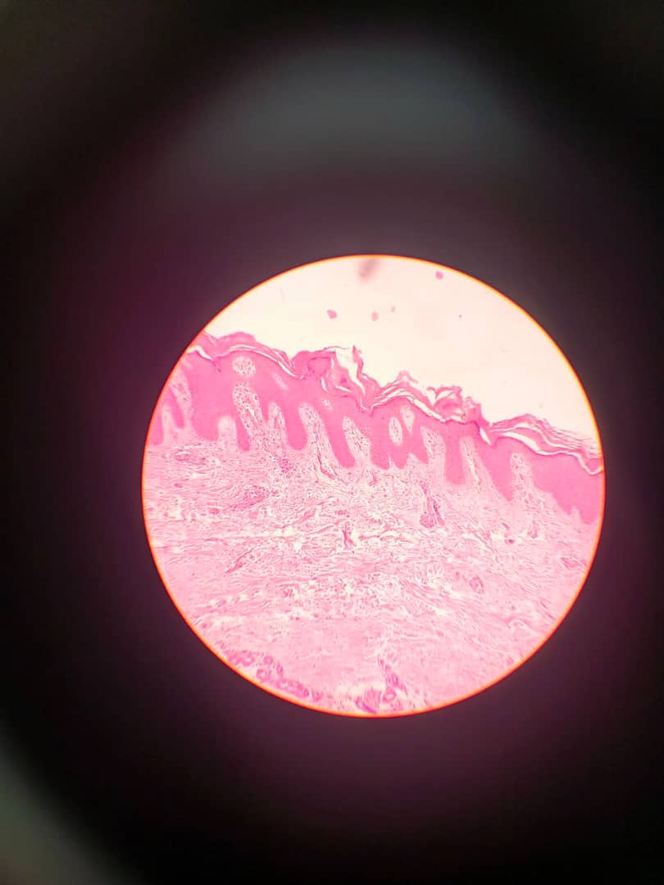
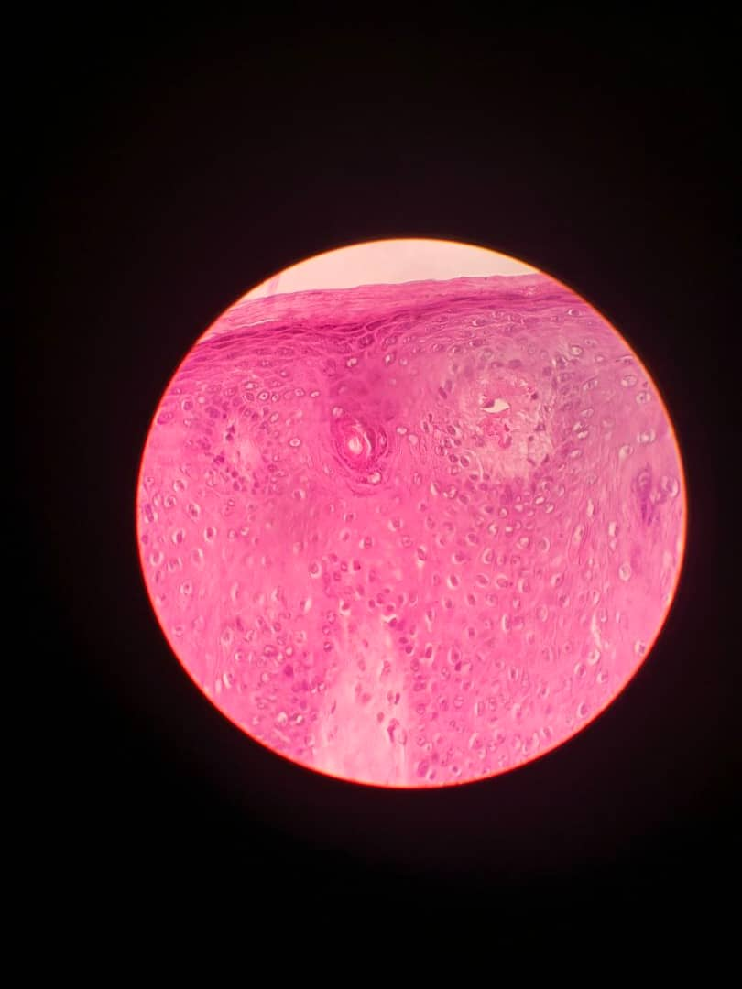
10x showed psoriasiform epidermal hyperplasia with hyperkeratosis, parakeratosis, areas of granulosis and hypogranulosis in the dermal papillae, with greater detail 40x absence of melanin and melanocytes in the basal layer.
10X
40X

