Case report

lymphangitic sporotrichosis in a florist: clinical, mycological and therapeutic correlation.

Abstract: Sporotrichosis is a subcutaneous mycosis caused by fungi of the Sporothrix complex *Schenckii* , with a worldwide distribution and higher prevalence in the tropical and subtropical regions of the Americas, is commonly acquired through traumatic inoculation with contaminated plant material and can manifest as a nodular lymphangitic syndrome , characterized by subcutaneous nodules arranged linearly along the lymphatic vessels. The objective of this study is to describe a clinical case of cutaneous lymphangitic sporotrichosis , highlighting its clinical presentation, diagnosis, and treatment. A 44-year-old male patient, with Fitzpatrick skin phototype V/VI, presented with a dermatosis located on the dorsum of his right hand, characterized by a single ulcer and multiple erythematous nodules arranged linearly that extended to the axillary region. The diagnosis was confirmed by clinical, epidemiological, and mycological findings. Antifungal treatment was initiated, with a favorable clinical outcome. This case highlights the importance of considering sporotrichosis in the differential diagnosis of linear nodular lesions, especially in endemic areas, since early recognition and timely treatment allow for a satisfactory recovery.
Keywords: Subcutaneous mycoses, tropical mycoses, Sporothrix , itraconazole.

Introduction
“Sporotrichosis is a fungal disease caused by fungi of the Sporothrix family. Six species of S. schenckii have been identified as causing the disease; the three most frequent are S. schenckii , Sporothrix brasiliensis (S. brasiliensis ) and Sporothrix globosa”. ¹ “It is considered mycosis subcutaneous plus common in Latin America, Africa and Asia. In Latin America, the estimated annual incidence is 48 to 60 cases per 100,000 inhabitants”. ²
“Occasional cases have been reported in Europe, specifically in Italy, Spain, Portugal, the United Kingdom, and Turkey. ³ Although This mycosis presents a wide distribution geographically, being mainly in countries like United States, Brazil, Colombia, Guatemala, Mexico, Peru, China, India, Japan and Australia” . ⁴
“For a long time time known as “ mycosis of the rose” or “ mycosis of the gardener" because the infection generally it turned out of the inoculation of fungus in the skin or the mucous membranes such as as a consequence of an injury caused by Contaminated plant matter . The fungus is found on various materials, such as wood chips, thorns, moss, straw, and soil. ⁵ Historically, the sapronotic transmission ( of a environmental source, such as the inoculation traumatic of plant material in the cutaneous tissues and subcutaneous of the individuals) was the source more common of human sporotrichosis ; however, the zoonotic infections through scratches or cat bites have returned each increasingly common”. ^{6.7}
“It should be noted that the factors of virulence of genus Sporothrix , as thermotolerance , the synthesis of melanin, the production of Ergosterol peroxide , etc., have allowed for increased infection and invasion of pathogens. In individuals immunocompetent, the majority of the cases They are characterized due to injuries cutaneous such as fixed plates or nodular lymphangitis . Furthermore, the infection may progress to an infection chronic skin disease, or can spread via hematogenous or lymphatic to muscles, bones and others organs, such as the lungs and the nervous system . In these cutaneous forms scattered or systemic usually partner with Cellular immunodeficiency” . ⁴
We present the case of a male patient with ascending nodular lesions on his upper extremity, of subacute evolution, and with a history of contact with vegetation, whose diagnosis was confirmed by mycological culture. This report aims to highlight a case of cutaneous lymphangitic sporotrichosis in a florist, underscoring the importance of integrating clinical and mycological information as a fundamental tool for achieving timely therapeutic intervention.
2. Case presentation
Clinical History: This is a 44-year-old male patient, born and residing in Valencia, Carabobo State, Venezuela. He has no relevant personal or family medical history and works as a florist. He reports the onset of his current illness in December 2024, characterized by the appearance of an erythematous papule on the back of his right hand, following trauma while handling flowers. The lesion progressively evolved into a crusted plaque and, finally, into an ulcer. For this reason, he went to a public health center, where he was prescribed antibiotic therapy for 14 days. Given the persistence and worsening of his clinical condition, he decided to consult the dermatology service of Dr. Henrique Tejera Hospital in the city in December 2024.

Physical examination: Fitzpatrick skin phototype IV/VI. The patient presented with a dermatosis located on the dorsum of the right hand, characterized by a single ulcer measuring 3 × 2 cm in diameter, with wavy borders, a granular base, and scant purulent drainage (Figure 1A). In addition, multiple erythematous nodules of varying sizes (0.5 to 1 cm) were observed, arranged linearly up to the axillary region, some with a tendency to ulcerate (Figure 1B). The lesions were not painful upon movement and were not accompanied by other systemic symptoms.
Paraclinical studies reported: hemoglobin 14.4 g/dl, hematocrit 44%, erythrocytes 4.48 M/μl, leukocytes 6300 cells/mm³ (neutrophils 42%, lymphocytes 31%, eosinophils 2%), platelets 282,000/mm³, glucose 185.6 mg/dl, urea 34.9 mg/dl, creatinine 1.0 mg/dl, SGOT 23.9 IU/L, SGPT 24.1 IU/L. Serologies for HIV and VDRL were negative.
sporotrichin smear was performed : 0.1 ml was injected intradermally into the left forearm using heat-inactivated yeast cells. Forty-eight hours later, a 30 × 35 mm papule was observed.
(Figure 2).
Direct mycological examination with 20% potassium hydroxide and physiological saline revealed basophilic asteroid bodies, round or oval, with a yeast-like appearance, 3 to 5 µm in diameter, consistent with Sporothrix . Mycological culture on Sabouraud agar, incubated at 28 °C, showed white, creamy, filamentous colonies with a yeast-like appearance and a dark brown center, phenotypic characteristics of the clade Sporothrix pathogen sp . (Figure 3). The microculture incubated at 28 °C showed thin (1 to 3 µm), hyaline, septate and branched hyphae.
The analyses laboratory They were normal, except mild hyperglycemia. The definitive diagnosis of lymphangitic cutaneous sporotrichosis was established by effectively correlating Clinical findings , phenotypic characteristics of the Sporothrix culture schenckii and epidemiological history. The patient received treatment with itraconazole (100 mg twice a day for three months) and local hyperthermia.
3. Discussion
Sporotrichosis, also known as "rose grower's disease," is a subacute or chronic fungal infection, first described by Benjamin Schenk in 1898. ¹ “It is caused by thermodimorphic fungi of the Sporothrix complex , being S. schenckii (62%) and S. globosa (38%) are the most prevalent species in Venezuela. Sporothrix species They live in vegetation, organic matter, and soil, which explains their high incidence among agricultural workers and those who work outdoors. It is considered an occupational disease among foresters, horticulturalists, gardeners, and agricultural personnel”. ^{7.8}
“It is the most common subcutaneous mycosis in Latin America, where environmental conditions (temperatures near 30 °C, soil pH between 3.5 and 9.4, and high humidity) favor its development. The fungi of the S. schenckii complex They exhibit dimorphism: in nature, they adopt a mycelial form with infective conidia, while in the host they transform into yeasts, responsible for chronic infection”. ⁹ “Although S. globosa is usually more common in Asia, Europe, and North America. A recent molecular study in Venezuela reported a high frequency of this species (30%), positioning it as the second most common after S. schenckii and the highest recorded in the Americas for this species”. ^{9,7}
According to Miranda et al. (2024), in a study conducted at the Dr. Manuel Gea González General Hospital (Mexico City), with 28 patients diagnosed with sporotrichosis, 64.28% were men and 35.71% were women. “The most affected age group was 41 to 60 years, with the upper extremity being the most frequently involved area (60%) and the lymphangitic form the most prevalent, coinciding with the case presented here”. ³
Similarly, De Flammineis D et al. (2022) observed that, despite no predilection for sex or age, the most affected patients were males between 30 and 41 years of age . “Regarding the patients' occupation, it was confirmed that farmers were the most affected due to their activities and contact with organic matter, these being risk factors for the disease, consistent with what has been reported in the literature. As for the clinical manifestations, the most frequent location was the upper and lower extremities, with the presence of unilateral ulcerated plaques and nodules following a lymphatic pathway, compatible with lymphocutaneous spontrichosis” . ¹²
On the other hand, Barreto et al. (2021) identified that “S. schenckii predominates in the lymphocutaneous form , while S. globosa is associated with the fixed cutaneous form”. These findings are related to host immunity, virulence, and genetic diversity of the strain. ¹²
“Based on clinical characteristics, sporotrichosis is classified as lymphocutaneous, fixed cutaneous, multiple, mucous membrane, and systemic. The lymphocutaneous form is the most common, followed by the fixed cutaneous form. <sup>” ¹¹ </sup> The lymphocutaneous form due to sporotrichosis represents approximately 50% of cases. It occurs after inoculation with the fungus due to minor trauma, with an incubation period of 7 days to 6 months. “The initial lesion is papulonodular , erythematous, painless, with a purplish or blackish dermal layer, which ruptures to form a small ulcer ( sporotrichous chancre ) with thickened borders, a granulomatous center, pain, and scant suppuration. Subsequently, lymphangitis develops with secondary nodules along the lymphatic tract ( sporotrichoid pattern ), which may also rupture and ulcerate. There is no impact on the general condition, and the evolution will depend on the host's immune response , the virulence of the strain, the size of the inoculum, and the depth of the lesion”. ¹³
“The diagnosis of sporotrichosis is based on clinical manifestations , with particular emphasis on the epidemiological characteristics of patients (origin, occupation, and traumatic events). This will allow for characterization of the disease in order to develop risk maps for future health interventions and public policy development. ¹² The diagnosis is confirmed through mycological culture since it has high sensitivity and specificity”¹².
Definitive diagnosis requires conversion from the mycelial to the yeast phase, achieved by subculturing on enriched media at 28–37 °C. In its saprophytic state (at 25–28 °C), it grows in its filamentous form , which, under microscopic examination, reveals the presence of thin, septate, hyaline hyphae. The conidiophores are long and thin, and from them arise simple, hyaline, oval or elongated conidia arranged in a flower-like pattern. Macroscopically, it appears as a creamy-white colony that darkens over time on media such as Sabouraud agar, requiring at least five to seven days for development. The yeast form is obtained by culturing on enriched media at 35–37 °C. In both its filamentous and yeast forms, Sporothrix is capable of producing melanin. ^{<sup>10</sup>}
The treatment of choice is itraconazole, up to 200 mg/day, for 2 to 4 weeks after complete resolution of the lesions. Therapy usually lasts between 3 and 6 months.<sup> ^{10</sup>} This antifungal acts by inhibiting ergosterol synthesis in the fungal cell wall and can be used in both immunocompetent and immunocompromised patients.
Itraconazole is used to treat sporotrichosis. According to the Infectious Diseases Society of America's Mycosis Study Group, itraconazole is considered the drug of choice for lymphocutaneous or fixed cutaneous sporotrichosis due to its good tolerability and low relapse rates. It is suggested that most patients would benefit from a dose of 100 to 200 mg/day and that a period of 3 to 6 months is sufficient to cure most cases. <sup> ^{14</sup>}
“Especially for patients with limited budgets and those with contraindications to itraconazole, effective treatment of sporotrichosis can be achieved with oral potassium iodide; however, this remains a subject of debate”. ¹⁴ Local hyperthermia consists of the daily application of warm compresses (42-43 °C) for 40-60 minutes. S. schenckii It is sensitive to heat: its growth slows down above 40 °C and it dies at 45 °C. ^{2, 14, 15}
After two months of treatment with oral itraconazole and local hyperthermia, the ulcer resolved and the nodules decreased in size. Three months later, complete improvement was observed, with residual post-inflammatory hyperpigmentation (Figure 4).
Conclusion
In conclusion, the study of ulcerative lesions requires a meticulous protocol aimed at determining their etiopathogenesis. The accurate identification of clinical manifestations is essential for their proper classification and, consequently, for choosing a timely diagnostic and therapeutic approach. Furthermore, mycological culture, with a sensitivity of 90–94% for the identification of Sporothrix, is also important. The use of the Schenckii test has become a valuable diagnostic tool. Itraconazole remains the first-line treatment, thanks to its good tolerability and low relapse rate, reinforcing its role in the effective management of this subcutaneous mycosis.

Figure 1. A. Single ulcer 3 cm x 2 cm in diameter, with wavy border, granular base and scant purulent secretion.
Figure 1. B. Multiple erythematous nodules, varying in size between 0.5 cm and 1 cm, following a linear path and extending to the axillary region; some have a tendency to ulcerate.
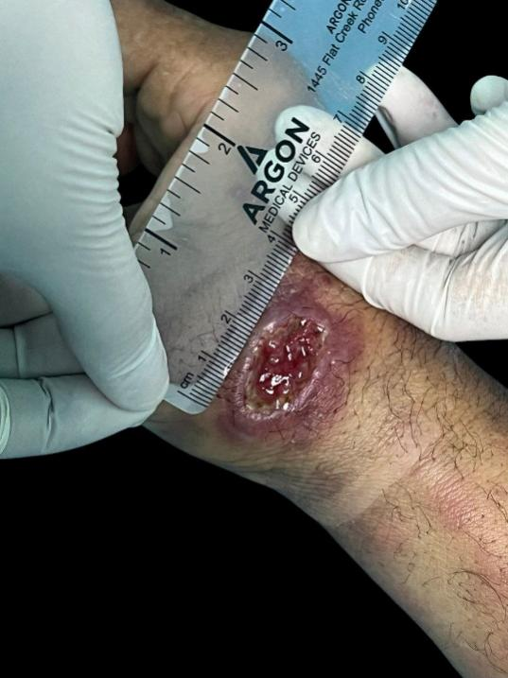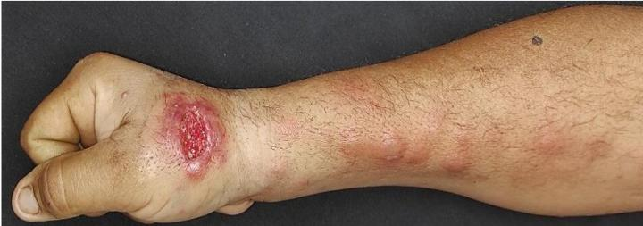

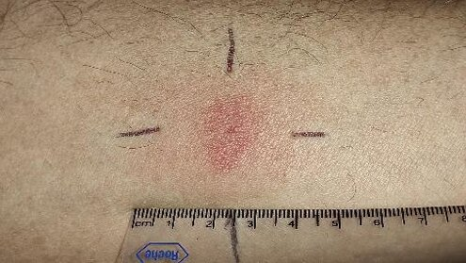

(Figure 2) Intradermal reaction test, 30 x 35 mm papule at 48 hours .

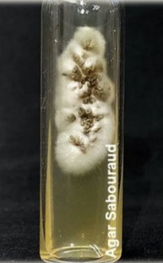
(Figure 3) Mycological culture White, creamy, yeast-like filamentous colonies with a center that turns dark brown .

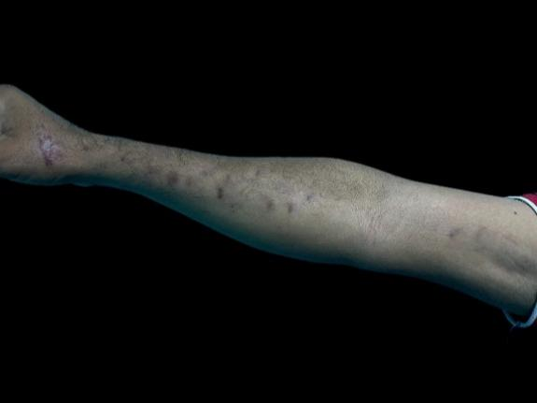

(Figure 4) After three months of treatment, complete improvement was observed with the presence of post-inflammatory hyperpigmentation .

LEGAL NOTICE (ARTIFICIAL INTELLIGENCE)
ETHICAL APPROVAL
This clinical case was managed in accordance with the ethical principles established in the Declaration of Helsinki. The patient provided written informed consent for the publication of clinical data and associated images, guaranteeing confidentiality and anonymity. Approval from the institutional ethics committee was not required, as this was a single case report without experimental intervention.
DATA AVAILABILITY
Clinical images are available in the manuscript and are published with the patient's informed consent.
CONFLICTING INTERESTS
The authors have declared that there are no conflicts of interest.

Disclaimer (Artificial intelligence)
Option 1:
Author(s) hereby declare that NO generative AI technologies such as Large Language Models (ChatGPT, COPILOT, etc.) and text-to-image generators have been used during the writing or editing of this manuscript.
Option 2:
Author(s) hereby declare that generative AI technologies such as Large Language Models, etc. have been used during the writing or editing of manuscripts. This explanation will include the name, version, model, and source of the generative AI technology and as well as all input prompts provided to the generative AI technology
Details of the AI usage are given below:
1.
2.
3.

References

1. Hernández Chacón, JR, Torres Morales, SA, & Hernández Chacón, EM (2021). Sporotrichosis: the most widespread subcutaneous mycosis in the world / Sporotrichosis : the most widely distributed subcutaneous mycosis in the world . Sinergia Medical Journal, 6(9), e714.
2. Silva A, Mena L, Giacamana P, Zapata S. Sporotrichosis, a reality still present in Chile: a case report. [REV. MED. CLIN. CONDES - 2021; 32(2) 240-245]. URL: https://www.elsevier.es/es-revista-revista-medica-clinica-las-condes-202-pdf-S0716864021000298
3. Ramírez-Soto MC, Arenas R, Bonifaz A. Sporotrichosis: report of 28 cases studied over 28 years at the Dr. Manuel Gea González General Hospital in Mexico City (1995–2023). Rev Mex Dermatol . 2024;68(2): 85-94 .
3. Pinto R, † Sandoval K, † Damián E 3, † Arenas R, Fuentes C, Zárate P, Martínez E and Rodríguez C. Relationship between sporotrichosis and patients infected with HIV-AIDS: a current systematic review. Revista de Hongos 2023, 9, 396. https://doi.org/10.3390/jof9040396 .
4. Bonifaz A, Vázquez-González D, Perusquía -Ortiz AM, Ramírez-Soto MC. Fixed cutaneous sporotrichosis transmitted by a cat: second case reported in Mexico. Rev Mex Dermatol . 2025;69(1): 29-33 .
5.Iacovone Basilico ML, Mantero MN, Caristia L, Della Giovanna P, Alfaro CT. Sporotrichosis transmitted by domestic cats: a case report. Arch Argent Pediatr . 2024;122(6 ):e 202310169.
6. Etchecopaz AN, Hermida Alava KS, Escarpa Miguel JA, Duchene A, García Re D , Cuestas ML. Feline sporotrichosis due to Sporothrix globosa in the Metropolitan Region of Buenos Aires: a case study. Rev Argent Microbiol . 2023 Jul ;55(3):227–232.
7. Santiso G, Messina F, Arechavala A, Marín E, et al. Sporotrichosis in Argentina: a clinical and epidemiological analysis. Biomédica 2023;43(Suppl.1):109-19 Sporotrichosis in Argentina doi : https://doi.org/10.7705/biomedica.6886 .
8. Miranda J, Vega D, Arenas R. Sporotrichosis. Report of 28 cases studied over 28 years at the Dr. Manuel Gea González General Hospital in Mexico City (1995-2023). DermatologíaCMQ 2024;22(2):146–150
9.Picollo M, Epelbaum C, Bustos A, Carnovale S, and Rosanova M. Lymphocutaneous sporotrichosis in a pediatric patient: a case report. Rev Chilean Infectol 2021; 38 (6): 811-815.
- Etchecopaz A, Alavaa K, Scarpac M, Duchenec A, Garcia D, Luján M. Feline sporotrichosis caused by Sporothrix globosa in the Buenos Aires Metropolitan Region: a case study. Revista Argentina de Microbiología 56 (2024) 4-7 . https://doi.org/10.1016/j.ram.2023.07.001 .
- De Flammineis D, Cachutt A, Alvarado P, Cavallera E. UPDATE ON THE EPIDEMIOLOGY OF SPOROTHRICOSIS IN VENEZUELA. Dermatol Venez h Vol.60 h N°2 h 2022.
- JE Carrasco- Zubera , * , C. Navarrete- Dechentb , A. Bonifazc , F. Fichb , V. Vial- Letelierby , D. Berroeta-Maurizianob , Cutaneous involvement in deep mycoses: a literature review. Part 1: subcutaneous mycoses. Actas Dermosiliogr . 2016;107(10):806-815.
- Silva-Vergara ML, Rodrigues AM, Lopes -Bezerra LM, Fichman V, de Camargo ZP. Itraconazole versus potassium iodide for cutaneous sporotrichosis: weighing the pros and cons. Rev Assoc Med Bras . 2021;67(11):1641 - 1642. doi:10.1590/1806-9282.20210694.
- Conti Díaz IA. Local thermotherapy as a treatment for cutaneous sporotrichosis: an update of the accumulated international experience. Rev Med Urug . 2011 Apr;27(1):44 - 58.
- Castro E, Pacheco H, Juárez D, Lozano Z. Fixed cutaneous sporotrichosis: case report. Dermatol Pediatrician Lat 2004; 2(1): 59-63. URL: https://sisbib.unmsm.edu.pe/bvrevistas/dpl/v02n01/pdf/a12.pdf

