Original Research Article
Community Knowledge, Attitudes and Perceptions Regarding Buruli Ulcer in Bafia Health District, Centre Region-Cameroon

ABSTRACT:
Aim: Buruli ulcer (BU), a neglected tropical disease, occurs in about thirty-three countries world-wide. Misconceptions about BU leads to poor health-seeking behaviors. We explored community knowledge, perceptions and attitudes regarding BU in a new endemic district.
Study design: It was a cross-sectional community-based survey.
Place and duration of study: Bafia Health District (BHD), Centre region of Cameroon, in between November 2023 and February 2024.
Methodology: We recruited 1341 participants through a three-stage cluster sampling design. A structured questionnaire was administered to 2 or 3 members aged 10-87 years of each household visited. Descriptive statistics were performed, chi-square tests used to assess associations, and forward stepwise binary logistic regression models used to identify independently associated factors attitudes.
Results: Of 1341 participants, 30.1% had heard of and 21.1% knew someone with BU. Only 17.2% correctly identified BU lesions, 2.3% knew its cause, and 19.2% believed BU was curable. Regarding attitudes towards persons with BU (PWBU) only 27.4% would show them respect, 19,5% would shake hands, and 16.4% would share the same plate with them. Additionally, only 17.3% approved of their participation, and 14.1% and 12.2% respectively would allow their child to play with or marry a PWBU. Positive attitudes towards PWBU were significantly associated with: head about BU, knowing a PWBU, and understanding that BU is curable. Negative attitudes were significantly associated with beliefs that: BU is caused by supernatural forces, poor hygiene, or living with a PWBU.
Conclusion: There were poor community knowledge and negative perceptions about BU in the BHD, which negatively influenced community attitudes towards PWBU. A community education intervention focusing on the natural occurrence, biological etiology, non-hereditary nature, the non-human-to-human transmission, and the curable nature of BU could improve upon the situation in BHD.
Keywords: Knowledge, perceptions, attitude, Buruli Ulcer, Bafia Health District.
- INTRODUCTION
Buruli ulcer (BU), a neglected tropical diseases (NTD) is caused by Mycobacterium ulcerans, a microorganism belonging to the same genus of bacteria as those responsible for tuberculosis and leprosy, ranking it the third most common human mycobacterial infection(1–3). BU occurs in remote areas of tropical Africa, Latin American, Southeast Asia, around aquatic environments characterized by stagnant or slow flowing water bodies or marshy areas(4–6). The exact mode of transmission is still unclear(7,8), although some studies have suggested the involvement of an animal reservoir or of insect vectors(1,9–12). No human-to-human transmission has been described(8). BU affects persons of both gender and of all ages, although children below 15 years of age are more vulnerable compared to adults(13,14). BU disease begins as a non-ulcerative and non-analgesic skin lesion (in the form of papule, nodule, plaque or oedema) after an incubation period of 21 to 90 days. Each lesion ulcerates and progresses to an extensive ulcer, if not detected and treated early(13–16). The extensive ulcers leads deformities, limitation of joint movement and eventually to functional disability, loss of economic productivity (17–20). The deformities and disabilities consequent to BU has led to fear of diseases in endemic communities as well as stimulating erroneous perceptions and poor attitudes like stigma and social exclusion BU victims and those affected by it (19,21,22). Although BU is curable through specific anti-biotherapy combined or not with limited surgery, physiotherapy, nutritional and psychosocial support(8,23–25), many affected persons in endemic communities still resort to non-conventional and traditional remedies as first means of treatment(21,22,26–29). As the exact mode of BU transmission remains elusive(7,8), early detection and adequate treatment remain the most effective measures to prevent BU and its damaging consequences(8,23,30,31). Effective implementation of these measures relies on proper mobilization and sensitization of populations living in endemic communities; to dissipate fear and change the erroneous perceptions and poor attitudes towards PWBU held in these communities and increase the community uptake of BU control interventions and services that are provided to them(15).
Cameroon, has been implementing BU control activities for over 25 years today(15,32). Over this period, new BU endemic health district have continued to emerge(15,33). The Bafia health district(BHD) in the Centre region of Cameroon was recently confirmed endemic for BU, within the frameworks of a project for integrated surveillance of skin neglected tropical diseases (Skin-NTDs) implemented there from August 2023 to November 2024. As a prelude to extending Buruli ulcer control activities to Bafia health district, we embarked on conducting a community-based study to assess the knowledge, perceptions and attitudes regarding BU there, with the aim of adapting interventions to the specific context of the district.

- METHODOLOGY
  - Study design
We conducted a cross-sectional descriptive and analytical community-based survey in which a structured questionnaire was administered face-to-face to two or three people in each household visited to assess knowledge, perceptions and attitudes regarding Buruli ulcer. This study conducted in between November 2023 and February 2024, was carried out within the framework of an ANESVAD sponsored project for integrated surveillance of skin-NTDs implemented from August 2023 to November 2024 in Bafia health district, Centre Region of Cameroon.
  - Study site
The Bafia health district (BHD) is situated some 130 km to the northwest of Yaounde, the capital city of Cameroon (Fig 1). It is found in the country's central plateau, with dense forest vegetation. The climate is equatorial, with two rainy seasons and two dry seasons. It is crossed by the Mbam and the Sanaga rivers and share borders with seven other health districts. The BHD is made up of 179 villages/communities, distributed into 19 health areas, 16 of which are rural; and had an estimated population 180 733 in 2024(34). The population is constituted of many tribal groups, with the major ones being: the Yambassa, Banen, Bafia, Nyokon, and Yambetta tribes(35).
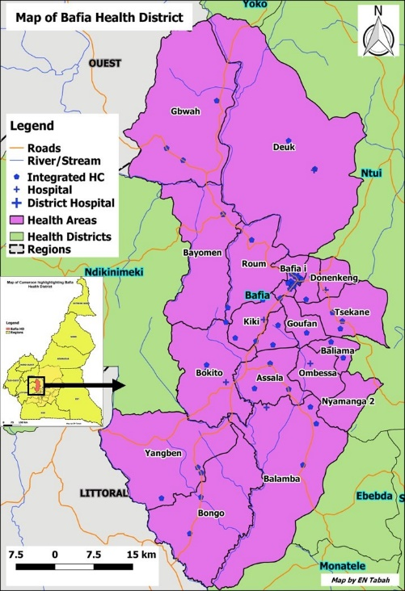
Fig 1. Map of the Bafia Health District (Source: CNLP2LUB-MISANTE)

  - Participants, sampling and data collection
    - Participants.
We included individuals of both sexes who were 10 years of age and older. People below 10 years of age, community health workers, health personnel and those who did not give their consent to participate in the study were excluded.
    - Sample size.
Based on the assumed proportion of good community knowledge of Buruli ulcer of 84.4% obtained in the southwest of Cameroon(21), and for a 95% confidence interval, an acceptable difference of 0.05 and an estimated non-response rate of 10%, for a cluster sampling with a design effect of 2, a minimum sample size of 404 participants was determined for the study.
    - Sampling.
A three-stage cluster sampling was used. The 19 health areas of BHD (Fig. 1) constituted the primary sampling units. The survey teams visited 3 villages (secondary sampling units), randomly selected within each of the 19 health areas. In each selected village, the survey teams introduced themselves to the village Chief, to whom they explained the study objective and procedures, and then sought for his approval to collect data for the study in his village. When approval was granted, the survey teams were then directed to the main square of the village. At this position, they tossed a pencil and then took the street in the direction pointed by the pencil. A systematic random sampling was then used to select households (tertiary sampling unit) along the street where every fifth household was selected. If a selected household was locked or did not consent to the study, the immediate next household was visited. This went on until 10 households were visited in each selected village. Within each selected household, informed consent was sought from the household head or any other adult member of the household present during the visit. The household head and two other persons randomly selected within the household who fulfilled the inclusion criteria and who gave their consent were recruited into the study. The household head gave consent for children under 18 years of age. Additionally, the child-participants assented to participate in the study.
    - Data collection.
Data was collected using a closed ended questionnaire designed to collect demographic data and to evaluate knowledge, perceptions and attitudes regarding Buruli ulcer, adapted from the one that was used for KAP-leprosy study in Ekondotiti and Mbonge health districts in the Southwest region of Cameroon(36). Excluding demographic data, the questionnaire had 11 questions on knowledge, 6 questions on attitudes and 4 questions on perceptions regarding Buruli ulcer (Table 1).

Table 1: List of study variables (questions)
Group of questions | Question Number | Question
Questions on Knowledge and perceptions regarding Buruli ulcer | Q1 | Have you heard about Buruli ulcer?
 | Q2 | If yes, by which means?
 | Q3 | Have you ever seen somebody suffering from Buruli ulcer?
 | Q4 | Do you know anybody suffering or who suffered from Buruli ulcer?
 | Q5 | Do you have a relative who's suffering or who suffered from Buruli ulcer?
 | Q6 | If yes, who is this person to you?
 | Q7 | How does Buruli ulcer manifest?
 | Q8 | What could be the cause of Buruli ulcer?
 | Q9 | If your relative is affected by Buruli ulcer, where would you advise her to go for treatment?
 | Q10 | Do you think there is a cure for Buruli ulcer?
 | Q11 | What can you do to prevent Buruli ulcer?
Attitudes questions | Q12 | Can you shake hands with somebody suffering from Buruli ulcer?
Attitudes questions | Q13 | Can you eat from the same plate with someone who has Buruli ulcer?
Attitudes questions | Q14 | Would you be ashamed of a family member suffering from Buruli ulcer?
Attitudes questions | Q15 | Would you be willing to let your relative/friend know if you had Buruli ulcer?
Attitudes questions | Q16 | Would you let your child play with a person affected by Buruli ulcer?
Attitudes questions | Q17 | Would you accept that your child gets married to someone with Buruli ulcer?
Attitudes questions | Q18 | Do you think a person with Buruli ulcer should take part in social activities in the community like any other person?
Attitudes questions | Q19 | Do you think a person with Buruli ulcer should be employed in the same way as anyone else?
Attitudes questions | Q20 | Do you think a person with Buruli ulcer should be respected in the community like any other person?
Attitudes questions | Q21 | What kind of difficulties do you think people with Buruli ulcer face in your community?

Four survey teams of three members each, fluent in the French language were trained on the questionnaire by the principal investigator. The training included full understanding of the questionnaire and techniques of face-to-face interviews. For the practical session of the training, the survey teams were dispatched to four quarters of a semi-urban health area in Yaounde, where they field-tested the questionnaire. Three questions were modified for better understanding after the field-testing exercise. The survey teams were then dispatched to Bafia health district for a period of ten days, where each team covered 4 to 5 health areas and 12 to 15 villages for the data collection phase of the survey.
    - Operational definitions
High community knowledge of Buruli ulcer: A “Yes” answer by 50% and above of the participants to each knowledge question was considered as good community knowledge of regarding Buruli ulcer. Otherwise, it was considered as poor community knowledge
Positive attitudes towards Buruli ulcer: A “Yes” answer by 50% and above of the participants to each attitude question was considered as positive community attitude regarding Buruli ulcer. Otherwise, it was considered as negative community attitude.
Erroneous perceptions: Participants who indicated the cause of Buruli ulcer to be any of the following: curse, divine punishment, witchcraft, heredity, bad food, bad blood; or who believed that BU is not curable; or that victims of BU should not be respected, nor participate in the society nor employed like anyone else, were considered as having erroneous perceptions towards BU
  - Data management and statistical methods
All filled questionnaires were checked for completeness and then anonymized and coded with a unique identifier. The data was then stored in a safe and secure manner until they were analyzed. There was strict observance of confidentiality in handling and analyzing the data. Data was entered on Microsoft Excel spreadsheet and cleaned before being exported into IBM SPSS statistics Processor Version 20 for analysis. Proportions were calculated and associations between variables were examined using the Chi-square test, with level of significance set at P-value<0.05. Binary logistic regression using a forward likelihood stepwise entry method was performed by inputting variables that were significant in univariate analyses, to determine predictors of attitudes.
- RESULTS
  - Characteristics of respondents
Five hundred and ten households were visited in 57 villages selected from 19 health areas of Bafia health district. In these households, 1710 individuals were approached and 1341 accepted to participate in the study, for a response rate of 78.42%. The median age was 31 (10 - 87) years. There were 708(52.8%) females, and 50.1% were married. Most of the respondents were of the Christian faith, with the most represented being: Catholics (44.7%) and Protestants (29.5%). Muslims constituted 8.4% while animist accounted for 4.2% of the respondents. Majority of the participants were of the Bafia (35.0%) tribe followed by the Yambassa (28.3%), and the smaller tribes regrouped as Mbamois (24.4%) respectively. Participants originating from tribes outside the district accounted for 12.4%. The majority had secondary (54.8%) and primary (35.0%) education levels respectively. The main occupation of the respondents was farming(45.4%) followed by schooling (27.1%).
  - Familiarity, knowledge, perceptions regarding BU.
The knowledge and familiarity of our respondents regarding BU were generally low as only 30.1% had heard about the disease, 21.1% knew and 16.8% had seen someone with the condition, and about 11% of respondents had relatives with BU (Table 2). For the 404 respondents who had heard about BU, their sources of information were from family members (29%) friends(21%) school(14%) , churches or mosques (5%), community health workers (5%) and radio or television (5%) (Fig 2). Familiarity with BU was influenced by age, religion occupation and marital status (Table 2). Older people were most likely to have heard about, knew or seen someone with BU (P<0.001). The same pattern was seen with Christians of the Pentecostal denomination (P<0.001 – 0.023), people having attained higher education (P<0.001), salaried workers (P<0.001) and singles (P<0.001).

Fig 2. Sources of community information on BU
Regarding knowledge of clinical manifestations BU, 515(38%) of our respondents attempted to cite, with 231(17.2%) of them citing the correct manifestations of BU including: ulcers(38.1%), oedema(11.3%), nodule(6.8%) and plaque(1.6%) (Table 2 and Fig 3a & b, correct manifestations heighted in red bars). Of the respondents, 451(34%) indicated the cause of BU, and as low as 2.3% knew that BU is caused by a microbe. Majority (54.8%) did not know any cause at all and many cited erroneous causes of BU that were probably based on cultural beliefs and misconceptions (Table 2 and Fig 3c & d). For instance, 9.8% cited poor hygiene, 8.0% cited witchcraft or supernatural forces, 5.3% spontaneous occurrence, 4.9% insect bite, as causes of Buruli ulcer (Fig 3c & d). Regarding knowledge of treatment and prevention of BU, only 19.2% of our respondents believed that BU was curable and a smaller proportion (10.8%) understood its correct preventive measures (Table 2). Of the 449(33.5) of respondents who gave their opinions on where to seek treatment for BU, 78.6% would advise PWBU to visit the hospital for treatment, and 8.2% and 0.9% would prefer traditional healers or prayer homes respective (Fig 4a & b). Elderly persons, those with a secondary or higher level of education and the male gender were more likely to have better Knowledge of manifestations, causes, correct source of treatment and preventive measures of BU among our respondents (P-value <0.05) (Table 2).

Table 2. Relationship between socio-demographic variables and knowledge of Buruli ulcer
Variable | Category | N | Q1 |  | Q3 |  | Q4 |  | Q5 |  | Q7 |  | Q8 |  | Q9 |  | Q10 |  | Q11
Variable | Category | N | Yes % | P-Value | Yes % | P-Value | Yes % | P-Value | Yes % | P-Value | Yes % | P-Value | Yes % | P-Value | Yes % | P-Value | Yes % | P-Value | Yes % | P-Value
 | Total | 1341 | 30.1% |  | 21.1% |  | 16.8% |  | 11.0% |  | 17.2% |  | 2.3% |  | 26.3% |  | 19.2% |  | 10.8%
Age | 10-19yrs | 373 | 15.0% | <0.001 | 10.5% |  | 9.1% |  | 6.7% |  | 7.2% |  | 0.8% |  | 14.7% |  | 11.5% |  | 4.6%
 | 20-29yrs | 263 | 31.9% |  | 23.2% |  | 20.5% |  | 12.2% |  | 17.5% |  | 3.0% |  | 31.9% |  | 21.7% |  | 10.3%
 | 30-39yrs | 186 | 34.4% |  | 28.0% | <0.001 | 21.5% | <0.001 | 16.7% | 0.001 | 17.2% | <0.001 | 2.7% | 0.159 | 27.4% | <0.001 | 18.3% | <0.001 | 14.0% | <0.000
 | 40-49yrs | 190 | 35.8% |  | 21.6% |  | 15.3% |  | 8.4% |  | 21.1% |  | 2.6% |  | 27.4% |  | 23.7% |  | 15.3%
 | 50-59yrs | 158 | 38.6% |  | 20.9% |  | 14.6% |  | 9.5% |  | 19.6% |  | 4.4% |  | 33.5% |  | 24.1% |  | 12.0%
 | 60yrs+ | 171 | 41.5% |  | 33.3% |  | 26.3% |  | 17.0% |  | 32.2% |  | 1.8% |  | 33.9% |  | 23.4% |  | 15.8%
Sex | Female | 708 | 27.8% | 0.052 | 19.4% | 0.096 | 15.4% | 0.152 | 9.2% |  | 15.0% |  | 1.7% | 0.112 | 23.3% |  | 16.1% |  | 8.5%
 | Male | 633 | 32.7% |  | 23.1% |  | 18.3% |  | 13.1% | 0.022 | 19.7% | 0.021 | 3.0% |  | 29.7% | 0.008 | 22.6% | 0.003 | 13.4% | 0.004
Religion | Animist/ No Religion | 56 | 21.4% |  | 8.9% |  | 8.9% |  | 8.9% |  | 8.9% |  | 1.8% | 0.681 | 19.6% | 0.010 | 14.3% | 0.004 | 7.1%
 | Catholic | 600 | 29.5% |  | 19.2% |  | 14.5% |  | 10.2% |  | 15.8% |  | 2.2% |  | 24.5% |  | 18.2% |  | 9.8%
 | Islam | 113 | 31.0% |  | 20.4% |  | 15.0% |  | 12.4% |  | 16.8% |  | 3.5% |  | 34.5% |  | 26.5% |  | 12.4%
 | Pentecostal | 177 | 41.8% | 0.003 | 33.3% | <0.001 | 27.1% | 0.001 | 18.1% | 0.023 | 28.2% | 0.001 | 3.4% |  | 34.5% |  | 27.1% |  | 18.6% | 0.006
 | Protestant | 395 | 26.8% |  | 20.5% |  | 17.2% |  | 9.1% |  | 15.7% |  | 1.8% |  | 24.1% |  | 15.7% |  | 8.9%
Education | None | 70 | 21.4% |  | 15.7% |  | 11.4% |  | 7.1% |  | 8.6% |  | 1.4% |  | 18.6% |  | 11.4% |  | 1.4%
 | Primary | 470 | 30.4% |  | 21.3% |  | 16.2% |  | 10.9% |  | 17.2% |  | 1.1% |  | 24.9% |  | 18.5% |  | 9.1%
 | Secondary | 735 | 27.9% |  | 19.0% |  | 15.9% |  | 10.3% |  | 15.8% |  | 2.0% |  | 25.2% |  | 17.8% |  | 10.9%
 | Higher | 66 | 62.1% | <0.001 | 48.5% | <0.001 | 36.4% | <0.001 | 24.2% | 0.004 | 42.4% | <0.001 | 15.2% | <0.001 | 57.6% | <0.001 | 47.0% | <0.001 | 31.8% | <0.001
Occupation | Pupil/Student | 363 | 17.4% |  | 12.1% |  | 9.9% |  | 6.9% |  | 8.5% |  | 1.1% |  | 16.5% |  | 13.2% |  | 5.5%
 | Unemployed | 124 | 31.5% |  | 20.2% |  | 15.3% |  | 6.5% |  | 19.4% |  | 4.0% |  | 27.4% |  | 14.5% |  | 15.3%
 | Hocker | 115 | 32.2% |  | 22.6% |  | 20.0% |  | 12.2% |  | 20.9% |  | 4.3% |  | 30.4% |  | 20.9% |  | 12.2%
 | Trader | 65 | 35.4% |  | 30.8% |  | 27.7% |  | 18.5% |  | 26.2% |  | 4.6% |  | 30.8% |  | 21.5% |  | 18.5%
 | Farmer | 609 | 33.0% |  | 22.5% |  | 17.7% |  | 12.3% |  | 17.9% |  | 1.3% |  | 27.4% |  | 20.5% |  | 9.9%
 | Salaried worker | 65 | 63.1% | <0.001 | 47.7% | <0.001 | 32.3% | <0.001 | 21.5% | 0.001 | 40.0% | <0.001 | 9.2% | <0.001 | 56.9% | <0.001 | 43.1% | <0.001 | 30.8% | <0.001
Marital status | Minor | 298 | 12.8% |  | 8.4% |  | 7.7% |  | 6.7% |  | 6.0% |  | 0.7% |  | 14.4% |  | 11.1% |  | 5.4%
 | Single | 301 | 38.5% | <0.001 | 27.9% | <0.001 | 22.9% | <0.001 | 13.0% | 0.050 | 22.3% | <0.001 | 3.3% | 0.061 | 33.2% | <0.001 | 25.6% | <0.001 | 13.0% | 0.006
 | Divorced/ Widowed | 70 | 30.0% |  | 15.7% |  | 12.9% |  | 10.0% |  | 17.1% |  | 0.0% |  | 24.3% |  | 14.3% |  | 10.0%
 | Married | 672 | 34.1% |  | 24.3% |  | 18.5% |  | 12.2% |  | 19.9% |  | 2.8% |  | 28.7% |  | 20.4% |  | 12.4%

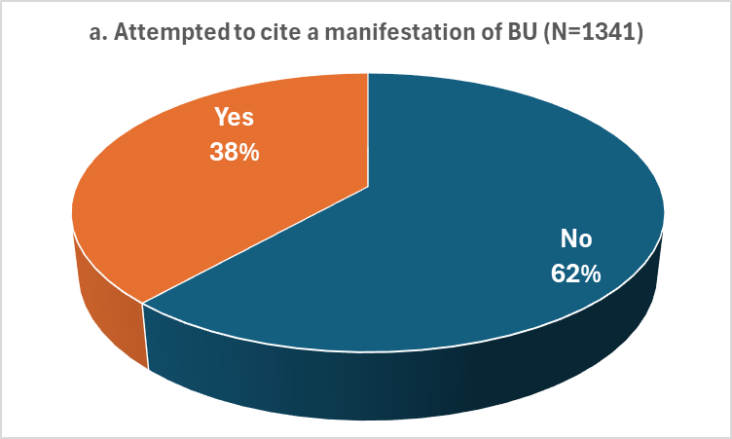 | 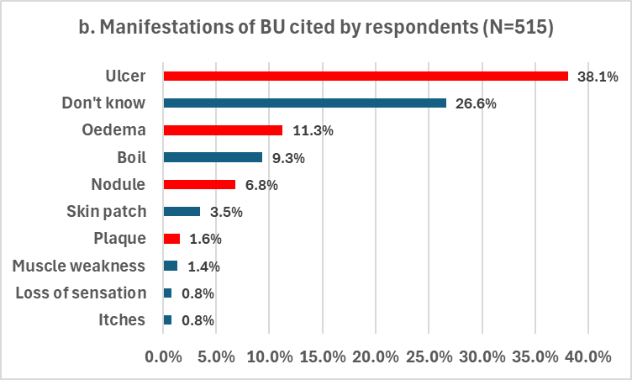
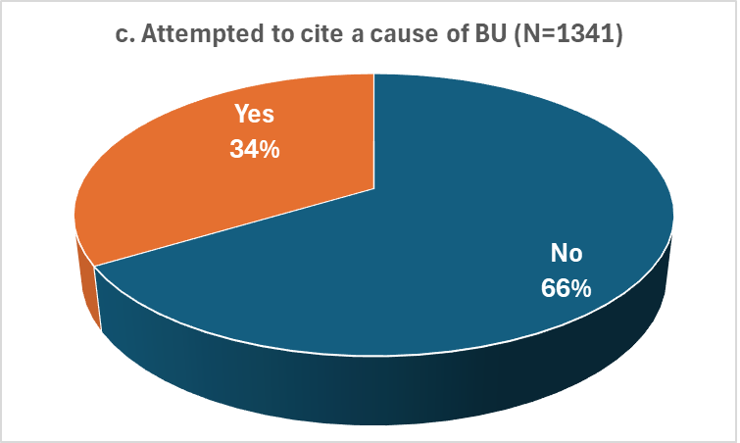 | 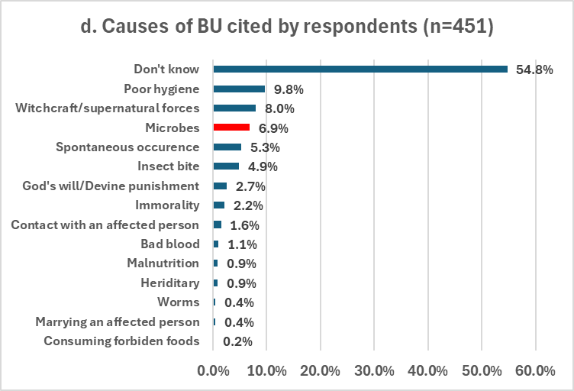
Fig 3. Community knowledge on the causes and manifestations of BU.
Thirty-eight percent of respondents attempted to cite the manifestations of BU (Fig 3a), of whom some correctly cited ulcers(38.1%), oedema(11.3%), nodule(6.8%) and plaque(1.6%) highlighted in red (Fig 3b). Equally, 34% attempted to cite the causes of BU (Fig 3c) and only 6.9% of rightly indicated microbes. The rest cited erroneous causes including witchcraft, poor hygiene, insect bite and spontaneous occurrence (Fig 3d).
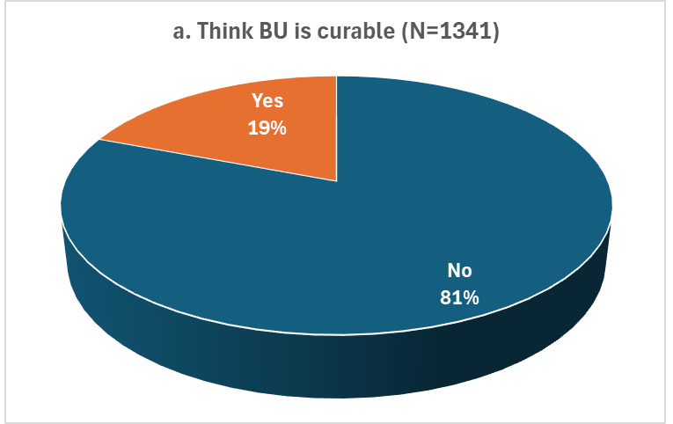 | 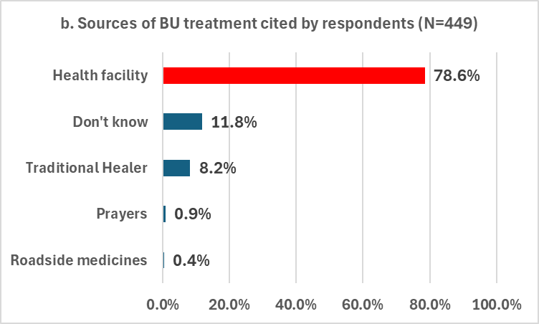
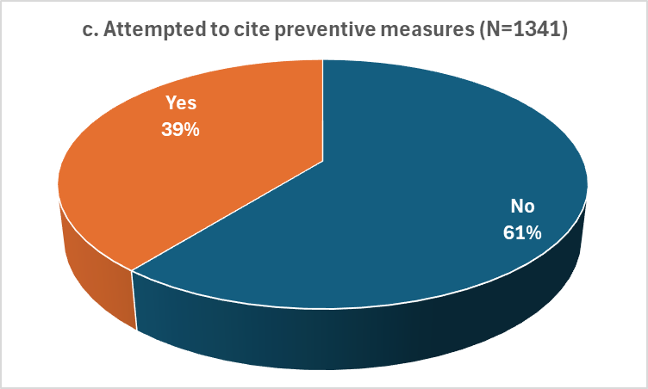 | 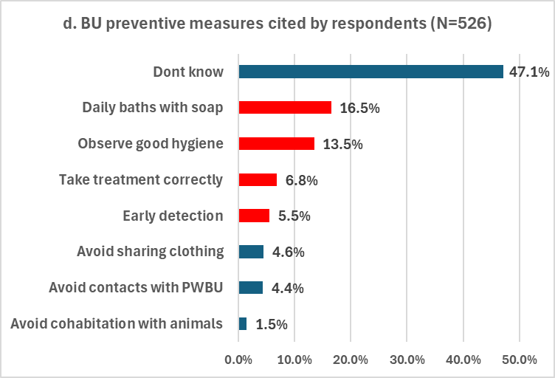
Fig 4. Community knowledge regarding treatment and prevention of BU.
Nineteen percent of respondents believed that BU is curable (Fig 4a). Of those who gave opinions on BU treatment source, 78.6% advised health facilities meanwhile, 8.2% and 0.9% preferred traditional healers and prayer homes respectively (Fig 4b). some 39% cited BU preventive measures, of whom 16.5% indicated daily baths with soap, 13.5% good hygiene, 5.5% advising early diagnosis and 6.8% correct treatment, that were deemed plausible and highlighted in red(Fig 4d).
  - Attitudes regarding BU
The attitudes of our respondents regarding BU were very poor (Table 3). Only 19.5% of respondents would shake hands and 16.4% would share the same plate with a PWBU; 23.7% would conceal from relatives or friends if they had BU; 14.1% would allow their children play with PWBU and 12.2% would accept their child marry someone who has or had BU. About 17% of our respondents would accept equal employment for PWBU or allow their participation in the community. Only 27.4% held that PWBU should be respected in the community. Attitudes of our respondents regarding BU were influenced by their socio-demographic characteristics as elderly persons, those of the male gender, widows or currently married persons, Christian of the Pentecostal denomination and those who had attained secondary and higher levels of education had better attitudes towards PWBU (P-values <0.05) (Table 3).
An analysis of the effect of knowledge and perceptions regarding BU on the attitudes of our respondents towards PWBU is shown in table 4. All the attitudes considered were positively influenced by high levels of familiarity with BU, knowledge of the correct cause and clinical manifestations of BU, the understanding that BU is curable, and treatable at the hospital, as well as the knowledge of BU preventive measures (P-values <0.05).

Table 3. Relationship between socio-demographic variables and attitudes and perceptions regarding Buruli ulcer
Variable | Category | N | Q12 |  | Q13 |  | Q14 |  | Q15 |  | Q16 |  | Q17 |  | Q18 |  | Q19 |  | Q20
Variable | Category | N | Yes % | P-Value | Yes % | P-Value | Yes % | P-Value | Yes % | P-Value | Yes % | P-Value | Yes % | P-Value | Yes % | P-Value | Yes % | P-Value | Yes % | P-Value
 | Total | 1341 | 19.5% |  | 16.4% |  | 5.9% |  | 23.7% |  | 14.1% |  | 12.2% |  | 17.3% |  | 17.2% |  | 27.4%
Age | 10-19yrs | 373 | 11.5% |  | 8.8% |  | 5.1% |  | 14.5% |  | 7.0% |  | 5.4% |  | 8.8% |  | 8.3% |  | 15.5%
 | 20-29yrs | 263 | 19.0% |  | 17.1% |  | 2.3% |  | 28.5% |  | 12.9% |  | 13.3% |  | 14.8% |  | 19.4% |  | 31.9%
 | 30-39yrs | 186 | 22.0% |  | 16.7% |  | 7.0% |  | 22.6% |  | 18.8% |  | 15.1% |  | 20.4% |  | 16.7% |  | 26.3%
 | 40-49yrs | 190 | 20.0% |  | 17.9% |  | 8.9% |  | 22.6% |  | 15.8% |  | 13.2% |  | 17.9% |  | 17.4% |  | 26.3%
 | 50-59yrs | 158 | 22.2% |  | 17.7% |  | 5.7% |  | 29.1% |  | 15.8% |  | 15.8% |  | 22.8% |  | 24.1% |  | 34.2%
 | 60yrs+ | 171 | 31.6% | <0.001 | 28.7% | <0.001 | 8.8% | 0.025 | 33.9% | <0.001 | 22.8% | <0.001 | 18.1% | <0.001 | 30.4% | <0.001 | 26.9% | <0.001 | 42.7% | <0.001
Sex | Female | 708 | 17.4% |  | 14.3% |  | 4.7% |  | 22.3% |  | 12.3% |  | 11.7% | 0.549 | 15.0% |  | 15.7% |  | 24.2%
 | Male | 633 | 21.8% | 0.041 | 18.8% | 0.025 | 7.3% | 0.043 | 25.3% | 0.203 | 16.1% | 0.044 | 12.8% |  | 19.9% | 0.017 | 18.8% | 0.130 | 31.1% | 0.004
Religion | Animist/ No Religion | 56 | 17.9% |  | 14.3% | 0.146 | 1.8% |  | 21.4% | 0.815 | 8.9% |  | 19.6% | 0.066 | 17.9% | 0.509 | 17.9% |  | 28.6% | 0.652
 | Catholic | 600 | 18.3% |  | 15.5% |  | 4.2% |  | 23.2% |  | 11.7% |  | 9.7% |  | 16.5% |  | 15.3% |  | 25.7%
 | Islam | 113 | 15.9% |  | 12.4% |  | 8.0% |  | 24.8% |  | 15.0% |  | 12.4% |  | 15.9% |  | 11.5% |  | 31.9%
 | Pentecostal | 177 | 28.2% | 0.034 | 22.6% |  | 13.0% | <0.001 | 27.1% |  | 21.5% | 0.014 | 15.3% |  | 22.0% |  | 24.9% | 0.021 | 29.4%
 | Protestant | 395 | 18.5% |  | 16.5% |  | 5.3% |  | 23.0% |  | 14.9% |  | 13.7% |  | 16.7% |  | 18.0% |  | 27.8%
Education | None | 70 | 8.6% |  | 11.4% |  | 2.9% |  | 17.1% |  | 11.4% |  | 8.6% |  | 14.3% |  | 11.4% |  | 20.0%
 | Primary | 470 | 19.1% |  | 14.9% |  | 7.0% |  | 23.2% |  | 14.9% |  | 13.4% |  | 17.2% |  | 16.4% |  | 26.2%
 | Secondary | 735 | 18.6% |  | 15.9% |  | 5.3% |  | 21.9% |  | 12.2% |  | 10.5% |  | 15.1% |  | 15.8% |  | 26.4%
 | University/ Professional | 66 | 42.4% | <0.001 | 37.9% | <0.001 | 7.6% | 0.386 | 54.5% | <0.001 | 31.8% | <0.001 | 27.3% | 0.001 | 45.5% | <0.001 | 43.9% | <0.001 | 56.1% | <0.001
Occupation | Pupil/Student | 363 | 13.8% |  | 9.9% |  | 5.2% |  | 17.1% |  | 8.3% |  | 6.6% |  | 10.5% |  | 11.0% |  | 17.1%
 | Unemployed | 124 | 20.2% |  | 16.1% |  | 4.0% |  | 23.4% |  | 13.7% |  | 12.9% |  | 17.7% |  | 21.0% |  | 33.1%
 | Hocker | 115 | 24.3% |  | 25.2% |  | 5.2% |  | 27.8% |  | 17.4% |  | 14.8% |  | 23.5% |  | 24.3% |  | 36.5%
 | Trader | 65 | 21.5% | 0.006 | 18.5% | <0.001 | 9.2% | 0.738 | 24.6% | 0.001 | 20.0% | 0.004 | 18.5% | 0.006 | 23.1% | <0.001 | 15.4% | 0.001 | 30.8% | <0.001
 | Farmer | 609 | 20.2% |  | 17.4% |  | 6.4% |  | 25.1% |  | 15.6% |  | 13.8% |  | 17.7% |  | 17.7% |  | 28.4%
 | Salaried worker | 65 | 32.3% |  | 26.2% |  | 6.2% |  | 40.0% |  | 21.5% |  | 16.9% |  | 33.8% |  | 27.7% |  | 46.2%
Marital status | Minor | 298 | 9.7% |  | 7.4% |  | 4.7% | 0.796 | 12.4% |  | 6.0% |  | 4.7% |  | 8.1% |  | 7.4% |  | 14.1%
 | Single | 301 | 21.9% |  | 20.9% |  | 6.3% |  | 28.6% |  | 17.6% |  | 15.6% |  | 20.3% |  | 21.3% |  | 31.2%
 | Divorced/ Widowed | 70 | 20.0% |  | 18.6% | <0.001 | 5.7% |  | 27.1% | <0.001 | 17.1% | <0.001 | 22.9% | <0.001 | 22.9% | <0.001 | 18.6% |  | 28.6%
 | Married | 672 | 22.6% | <0.001 | 16.7% |  | 6.3% |  | 26.2% |  | 15.8% |  | 12.9% |  | 19.5% |  | 19.5% | <0.001 | 31.5% | <0.001

  - Problems faced by people with Buruli ulcer (PWBU).
About a quarter (26%) of our respondents admitted that PWBU do face some challenges in society, at a personal level and/or with their families. The challenges included difficulties getting employment (53.2%), interacting with people (58.9%), getting married (27.9%), getting admission into school (15.8%) or even buying food (9.9%). At the level of family, the respondents held that PWBU have problems with their spouses (16.6%), are a source of problems (13.0%) and shame (8.2%) to their families, and the reason why their family members have difficulties getting married (17.7%) (Fig 5).

Fig 5. Difficulties faced by people with Buruli ulcer:
These difficulties were at two levels. At the individual level where PWBU were perceived to face challenges interacting with people, getting employment, getting married or getting admission to schools. The perceived challenges extended from the individual patient his/her family, bringing shame to family members and problems especially with spouses and with relatives getting married.

  - Independent predictors of attitudes towards PWBU
A binary logistic regression analysis inputting socio-demographic variables, familiarity, knowledge and perceptions that influenced attitudes of our respondents as independent variables, and each of the attitudes under evaluation as dependent variable; in a stepwise forward likelihood model was carried out to identify independent predictors attitudes regarding BU. Table 5 shows detail of the outcome. The prominent predictors of positive attitudes identified were: Having heard about BU, knowing that BU is treatable in the hospital, and thinking that BU occurs spontaneously, as they were predictors of 5 to 8 positive attitudes. Equally, the belief that BU is caused by supernatural forces, or poor personal hygiene or staying with a PWBU were identified as predictors of negative attitudes towards PWBU.

Table 4. Relationship between attitudes/perceptions and knowledge of Buruli ulcer
Knowledge question | Response | N | Q12 |  | Q13 |  | Q14 |  | Q15 |  | Q16 |  | Q17 |  | Q18 |  | Q19 |  | Q20
Knowledge question | Response | N | Yes % | P-value | Yes % | P-value | Yes % | P-value | Yes % | P-value | Yes % | P-value | Yes % | P-value | Yes % | P-value | Yes % | P-value | Yes % | P-value
 | Total | 1341 | 19.5% |  | 16.4% |  | 5.9% |  | 23.7% |  | 14.1% |  | 12.2% |  | 17.3% |  | 17.2% |  | 27.4%
Heard about BU | No | 937 | 1.5% |  | 1.2% |  | 0.9% |  | 2.8% |  | 0.6% |  | 0.9% |  | 1.7% |  | 1.7% |  | 5.4%
Heard about BU | Yes | 404 | 61.1% | <0.001 | 51.7% | <0.001 | 17.6% | <0.001 | 72.3% | <0.001 | 45.3% | <0.001 | 38.6% | <0.001 | 53.5% | <0.001 | 53.0% | <0.001 | 78.5% | <0.001
Has seen someone with BU | No | 1058 | 6.5% |  | 6.0% |  | 2.5% |  | 9.5% |  | 4.7% |  | 4.5% |  | 6.4% |  | 6.6% |  | 12.9%
Has seen someone with BU | Yes | 283 | 67.8% | <0.001 | 55.5% | <0.001 | 18.7% | <0.001 | 76.7% | <0.001 | 49.1% | <0.001 | 41.0% | <0.001 | 58.0% | <0.001 | 56.5% | <0.001 | 81.6% | <0.001
Know someone who had/has BU | No | 1116 | 9.1% | <0.001 | 7.8% | <0.001 | 3.3% | <0.001 | 12.9% | <0.001 | 6.6% | <0.001 | 5.6% | <0.001 | 9.1% | <0.001 | 8.7% | <0.001 | 16.0% | <0.001
Know someone who had/has BU | Yes | 225 | 71.1% |  | 59.1% |  | 18.7% |  | 77.3% |  | 51.1% |  | 44.9% |  | 58.2% |  | 59.1% |  | 84.0%
Has a relative who suffered BU | No | 1193 | 13.0% |  | 11.1% |  | 3.8% |  | 16.6% |  | 9.3% |  | 8.0% |  | 12.0% |  | 11.6% |  | 20.5%
Has a relative who suffered BU | Yes | 148 | 71.6% | <0.001 | 58.8% | <0.001 | 23.0% | <0.001 | 81.1% | <0.001 | 52.7% | <0.001 | 46.6% | <0.001 | 60.1% | <0.001 | 62.2% | <0.001 | 83.1% | <0.001
Knows how BU manifests | No | 1288 | 16.8% |  | 14.4% |  | 5.3% |  | 21.1% |  | 12.3% |  | 10.9% |  | 15.5% |  | 15.6% |  | 25.0%
Knows how BU manifests | Yes | 53 | 84.9% | <0.001 | 64.2% | <0.001 | 20.8% | <0.001 | 86.8% | <0.001 | 58.5% | <0.001 | 43.4% | <0.001 | 60.4% | <0.001 | 54.7% | <0.001 | 86.8% | <0.001
Knows the cause of BU | No | 1310 | 18.2% |  | 15.2% |  | 5.8% |  | 22.5% |  | 13.1% |  | 11.2% |  | 16.1% |  | 16.1% |  | 26.1%
Knows the cause of BU | Yes | 31 | 71.0% | <0.001 | 67.7% | <0.001 | 9.7% | 0.365 | 74.2% | <0.001 | 54.8% | <0.001 | 54.8% | <0.001 | 67.7% | <0.001 | 61.3% | <0.001 | 83.9% | <0.001
Know that BU is treatable at the hospital | No | 988 | 5.5% |  | 4.3% |  | 1.2% |  | 6.8% |  | 3.8% |  | 3.1% |  | 4.8% |  | 5.5% |  | 8.6%
Know that BU is treatable at the hospital | Yes | 353 | 58.6% | <0.001 | 50.4% | <0.001 | 19.0% | <0.001 | 71.1% | <0.001 | 42.8% | <0.001 | 37.7% | <0.001 | 52.4% | <0.001 | 49.9% | <0.001 | 80.2% | <0.001
Understands that BU is curable | No | 1084 | 10.1% |  | 8.8% |  | 2.8% |  | 11.9% |  | 6.9% |  | 6.2% |  | 9.1% |  | 9.5% |  | 14.8%
Understands that BU is curable | Yes | 257 | 59.1% | <0.001 | 48.6% | <0.001 | 19.1% | <0.001 | 73.5% | <0.001 | 44.4% | <0.001 | 37.7% | <0.001 | 51.8% | <0.001 | 49.4% | <0.001 | 80.9% | <0.001
Knows preventive measures of BU | No | 1284 | 17.8% |  | 14.3% |  | 5.1% |  | 21.7% |  | 12.7% |  | 10.9% |  | 15.5% |  | 15.6% |  | 25.2%
Knows preventive measures of BU | Yes | 57 | 57.9% | <0.001 | 63.2% | <0.001 | 22.8% | <0.001 | 70.2% | <0.001 | 45.6% | <0.001 | 42.1% | <0.001 | 57.9% | <0.001 | 52.6% | <0.001 | 78.9% | <0.001

Table 5: Predictors of attitudes regarding Buruli ulcer
Positive attitudes | Predictors | OR | 95%CI |  | P-value
Positive attitudes | Predictors | OR | Lower | Upper | P-value
Would shake hands with someone suffering from Buruli ulcer | Has attained secondary education | 3.92 | 1.17 | 13.16 | 0.027
Would shake hands with someone suffering from Buruli ulcer | Has attained Higher education | 5.40 | 1.38 | 21.19 | 0.016
Would shake hands with someone suffering from Buruli ulcer | Has head about BU | 33.14 | 16.61 | 66.12 | <0.001
Would shake hands with someone suffering from Buruli ulcer | Know someone with BU | 2.26 | 1.45 | 3.53 | <0.001
Would shake hands with someone suffering from Buruli ulcer | Think BU occurs spontaneously | 17.82 | 2.32 | 136.96 | 0.006
Would shake hands with someone suffering from Buruli ulcer | Know that BU is treatable in the hospital | 2.72 | 1.68 | 4.41 | <0.001
Would eat from the same plate with someone who has Buruli ulcer | Has head about BU | 40.51 | 19.79 | 82.9 | <0.001
 | Think BU is caused by supernatural forces | 0.04 | 0.01 | 0.54 | 0.015
 | Think BU occurs spontaneously | 2.69 | 1.02 | 7.11 | 0.046
 | Know that BU is treatable in the hospital | 2.86 | 1.76 | 4.45 | <0.001
Would not be ashamed of a family member suffering from Buruli ulcer | Being 50yrs or older | 0.39 | 0.16 | 0.98 | 0.044
 | Being a Pentecostal Christian | 2.36 | 1.13 | 4.92 | 0.022
 | Has head about BU | 8.65 | 3.31 | 22.6 | <0.001
 | Know that BU is treatable in the hospital | 5.54 | 2.46 | 12.51 | <0.001
Would be willing to let a relative/friend know about it if he/she had Buruli ulcer | Being 30-39yrs old | 0.41 | 0.19 | 0.88 | 0.022
 | Being 40-49yrs old | 0.44 | 0.21 | 0.92 | 0.030
 | Has head about BU | 24.72 | 13.98 | 43.69 | <0.001
 | Has a relative with BU | 1.97 | 1.15 | 3.38 | 0.014
 | Know that BU is treatable in the hospital | 3.33 | 2.06 | 5.4 | <0.001
 | Think BU is curable | 1.78 | 1.11 | 2.85 | 0.017
Would allow his/her child to play with a person affected by Buruli ulcer | Has head about BU | 76.13 | 30.9 | 187.58 | <0.001
 | Think BU occurs spontaneously | 2.67 | 1.08 | 6.61 | 0.034
 | Know that BU is treatable in the hospital | 1.99 | 1.23 | 3.23 | 0.005
Would accept his/her child marry someone who has/had Buruli ulcer | Being divorced | 5.12 | 1.75 | 14.99 | 0.003
 | Has head about BU | 29.77 | 12.64 | 70.12 | <0.001
 | Know someone with BU | 1.76 | 1.14 | 2.71 | 0.011
 | Think BU occurs spontaneously | 2.51 | 1.04 | 6.07 | 0.041
 | Think BU is caused by living with a PWBU | 0.08 | 0.01 | 0.71 | 0.023
 | Know that BU is treatable in the hospital | 2.26 | 1.34 | 3.81 | 0.002
Think that a person with Buruli ulcer should take part in social activities in the community like anyone else | Has head about BU | 25.99 | 13.97 | 48.36 | <0.001
 | Know that BU is treatable in the hospital | 3.07 | 1.93 | 4.87 | <0.001
 | Being 60 yrs or older | 2.34 | 1.18 | 4.67 | 0.015
 | Know the correct cause of BU | 3.07 | 1.93 | 4.87 | <0.001
Think that a person with Buruli ulcer should be employed like anyone else | Has head about BU | 30.74 | 16.89 | 55.95 | <0.001
 | Has a relative with BU | 1.93 | 1.23 | 3.01 | 0.004
 | Think BU is caused by supernatural forces | 0.23 | 0.06 | 0.99 | 0.049
 | Think BU is due to poor personal hygiene | 0.38 | 0.18 | 0.79 | 0.009
Think that a person with Buruli ulcer should be respected in the community like anyone else | Has head about BU | 13.08 | 7.94 | 21.56 | <0.001
 | Think BU occurs spontaneously | 3.62 | 1.05 | 12.46 | 0.041
 | Know that BU is treatable in the hospital | 5.51 | 3.34 | 9.07 | <0.001
 | Think BU is curable | 1.82 | 1.08 | 3.08 | 0.026

- DISCUSSION
  - Knowledge and perceptions regarding BU
This study has revealed low community knowledge and familiarity regarding BU in the Bafia Health District as only 30.1% had heard about the disease, 21.1% knew and 16.8% had seen someone with BU, and 11% declared having a relative with the condition. This contrasts with findings in the Southwest (21) and Centre (37) regions of Cameroon, and Obom district in Ghana(22) where 84.4%, 44.9% and 95.5% of respondents respectively had heard about BU, but comparable with findings in southern Nigeria where 35% of respondents knew of BU (38). The studies in the southwest of Cameroon and Ghana were carried out in known BU endemic health districts where some BU control activities including community awareness had been ongoing, unlike in our study setting in Bafia health district and study areas in southern Nigeria that were newly confirmed for BU and control activities had not begun. The major sources of BU information to our respondents were family members (29%), friends (21%) and schools (16%) rather than health personnel, community health workers (5%) and the media (5%) (Fig 2) often considered as traditional sources of health information. This corroborates with findings by Koka in Ghana where 60% of respondents got their information on BU from community members and only 6.3% and 4.6% got their information from health personnel and the media respectively(22). Having attained secondary education or higher, being elderly or being a male were associated with better knowledge of BU (p-value <0.05) (Table 2). The few respondents (17.2%) with good knowledge of BU manifestations in our study were aware of its early signs and symptoms, citing Ulcer, oedema, nodule and plaque (Fig 3b), which were consistent with clinical forms of the diseases(8,15,16,39). Information on the cause of BU was very unreliable and erroneous for the most part, as majority of respondents did not know the cause at all and some of them attributed BU to witchcraft, immorality, divine punishment, insect bite or spontaneous occurrence (Fig 3d). These findings corroborates with those in the southwest of Cameroon(21) and southern Nigeria(38,40) where majority of respondents did not know the cause of BU and those who attempted cited witchcraft, worms, poor hygiene, insect bites, with very few correctly indicating bacterial infection as cause. The erroneous causes of BU cited by respondents in our study correlates with low familiarity and awareness of BU, but were interestingly consistent with findings in known endemic areas where control activities are being implemented(21,22,28,38). These findings demonstrate deep entrenchment in cultural beliefs and perceptions regarding BU. In Bankim, an endemic health district of Cameroon, BU is said to have four origins, three of them being related to witchcraft, ancestral curse or some inborn supernatural power denoted as Mgbati (41,42). In Ayos and Akonolinga, health districts around the Nyong River valley in Cameroon, BU locally known as atom, is attributed to a spell or witchcraft affliction following transgression of social norms like stealing from someone’s farm(29). These beliefs have contributed to poor health-seeking behaviors among victims of BU in endemic communities, where a good proportion would prefer traditional healers or prayers as first source of BU treatment(21,28,29,38,42) leading to delays in correct diagnosis and adequate treatment(22,28,29,42).
About 19.2% of our respondents believed that BU was curable, and 78.6% of those who gave their opinion on where to seek BU treatment, would advise victims to go to a health facility, and 8.2% and 0.9% advised traditional healers and prayer homes (Fig 4b) for treatment of BU. These findings are poor compared to those in the southwest of Cameroon, where 87.1% of participants believed that BU was curable, but better than same study when considering treatment-seeking attitudes as 63%, 20% and 17% would respectively refer patients to the hospital, traditional healers and prayers homes(21). The belief in mystical origins of BU held in almost all BU endemic zones across Africa is one of the main drivers for seeking traditional or herbal medicine for BU treatment. This has been demonstrated in Ayos, Akonolinga(29) and Bankim(41) health districts, as well as in the southwest(21) of Cameroon, and also in Ghana(22,28) and southern Nigeria(38). The implications of low knowledge level and poor community perceptions regarding BU as revealed in this study for BU control in Bafia health district is enormous. Even though low, existing community knowledge could be a foundation upon which to develop a successful BU control intervention in the Bafia health district. The national control programme may however need to engage an in-dept anthropological exploration of cultural beliefs and practices regarding BU, and outcomes considered in the development of control strategies adapted to the district as was the case in Bankim health district(41).
  - Attitudes towards PWBU
The attitudes of our respondents towards PWBU were generally very negative (Table 3). Less than 20% would shake hands or share from the same plate with a PWBU. This could probably explain why 23.7% of our respondents declared that they would conceal it if they had BU. Similar attitudes were described in southern Nigeria and Ghana where community members would not interact with PWBU for fear of contamination(22,38). Close to 6% of our respondents admitted that they would be ashamed if they had a relative with BU, and 23.7% of them would conceal from relatives and friends if they had BU. These kinds of attitudes obviously take their root in cultural beliefs about the cause of BU (Fig 3d). In the Ayos and Akonolinga health districts of Cameroon where BU (Atom) is attributed to transgression of some social norms(29), victims of BU who fear to be tagged would prefer concealment. Our study also revealed that only 14.1% and 12.2% would respectively allow their child to play or marry someone with BU. The perceptions that BU was caused by poor hygiene, heredity, contact with an affected person or marrying an affected person (Fig 3d) could form the basis of these attitudes. Sensitization messages within the framework of a BU control strategy in Bafia health districts must take these into consideration, and package counter information focused on facts about BU including: its natural occurrence, biological etiology, its non-hereditary nature, the non-human-to-human transmission of BU, and its curable nature through early diagnosis and adequate biomedical management(7,43,44).
About 17% of our respondents approved of PWBU participating in normal social activities or being given equal employment like anyone else. In these aspects, attitudes towards PWBU in this study were worse compared to those reported in the south west of Cameroon and in southern Nigeria, where higher proportions of respondents would allow free interaction of PWBU as well as equal employment for them(21,38). Only 27.4% of our respondents felt that PWBU should be respected in the community. These depict the high level of community stigma PWBU could face in Bafia health district. In endemic zones where BU control activities are being implemented, community attitudes towards PWBU tend to be much more improved(21,38,45). In this study, community attitudes regarding BU were influenced by sociodemographic variables (Table 3) as well as knowledge of and familiarity with BU (P<0.05) (Table 4). The male gender, being elderly, having attained at least primary level of education, and being of the Pentecostal Christian denomination were more likely to portray positive attitudes towards PWBU (P<0.05).
Answering the question on what problems PWBU face, our respondents cited a litany of problems that could be grouped into individual level and family level problems (Fig 5). More than half of those who responded to this question indicated that PWBU face difficulties interacting with people in society or getting employment, and over a quarter said they face challenges getting married. These difficulties extended beyond the individual patients to affecting their families as respondents indicated that family members of PWBU do face problems including feeling ashamed, difficulties getting married themselves (Fig 5). Of course, these difficulties faced by PWBU correlate with community attitudes towards them. The consequences on PWBU would be self-stigma manifested by concealment, self-isolation, and delay in seeking treatment (22,46).
Our study evaluated nine attitudes altogether. Three to six independent predictors were identified for each of the nine attitudes. The beliefs that BU is caused by supernatural forces, or by living with someone with BU, or by poor personal hygiene, or being 30 years of age and older, were predictors of negative attitudes (Table 5). On the other hand: having heard of BU, knowing someone with BU, having a relative with BU, the beliefs that BU is curable and treatable at the hospital, and that BU occurs spontaneously, having attained at least secondary education, being a Christian, were identified as predictors of positive attitudes (Table 5). The implication of public health here is that a BU control intervention in Bafia health district with a strong component of education for behavior change that focuses on enhancing community knowledge on BU and using schools and churches and channels of communication could ensure its effectiveness.
- STUDY LIMITATIONS
Households were visited just once and only the household members who were present at moment of passage of the survey team were considered, and this could have introduced a selection bias, posing a problem of representativeness of the sample. Furthermore, our study recruited children as young 10 years for reasons that children are usually more affected by BU compared to adults. However, children could have lacked the capability to understand the survey questions and give clear answers. Although we tried to assess associations between variables, we could not establish causal relationships using a cross-sectional design. However, we believe that these limitations had little or no effect on the outcome of the study.
- CONCLUSION AND RECOMMENDATIONS
We conclude that familiarity with and knowledge of BU were low in Bafia health district. The major sources of BU information were family, friends and schools. The community knowledge of BU was marked by erroneous perceptions regarding its cause, manifestations. A relatively low proportion of respondents understood that BU is curable, of whom more than 2/3rd advised treatment at health facility. Attitudes regarding BU were equally poor among our respondents. Negative attitudes were independently associated with the beliefs that BU is caused by supernatural forces, or by living with someone with BU, or by poor personal hygiene, or being 30 years of age and older, meanwhile positive attitudes were driven by: having heard of BU, knowing someone with BU, having a relative with BU, the beliefs that BU is curable and treatable at the hospital, and that BU occurs spontaneously, having attained at least secondary education, being a Christian.
We recommend that a BU control intervention in Bafia health district must embed a strong component of education for behavior change that focuses on enhancing community knowledge on BU and using schools and churches and channels of communication, with information on: its natural occurrence, biological etiology, its non-hereditary nature, the non-human-to-human transmission of BU, and its curable nature through early diagnosis and adequate biomedical management. This could improve community knowledge and attitudes towards PWBU and ultimately lead to an effective and efficacious BU control intervention in the district.

Disclaimer
This paper is an extended version of a preprint document of the same author.
The preprint document is available in this link: https://www.medrxiv.org/content/10.1101/2025.08.14.25333658v1
[As per journal policy, preprint /repository article can be published as a journal article, provided it is not published in any other journal]

DISCLAIMER (ARTIFICIAL INTELLIGENCE)
Author(s) hereby declares that NO generative AI technologies such as Large Language Models (ChatGPT, COPILOT, etc) and text-to-image generators have been used during writing or editing of this manuscript.
CONSENT
An informed consent was gotten from each participant after the study objectives and the intended use of the outcome to guide BU control strategies in the Bafia Health District and for publication in scientific journal were explained and they had the chance to ask questions of clarifications. For minors (<18years), their parents or guardians consented and then assent sought from them.
ETHICAL APPROVAL
Ethical approval for the study was obtained from the Centre Regional Committee for Research in Human Health, Yaounde, Cameroon (CE Nº 0749/ CRERSHC/2023) and administrative authorization from the Regional Delegation of Public Health for the Centre Region.

COMPETING INTERESTS DISCLAIMER:
Authors have declared that they have no known competing financial interests OR non-financial interests OR personal relationships that could have appeared to influence the work reported in this paper.

REFERENCE
1. Doig KD, Holt KE, Fyfe JAM, Lavender CJ, Eddyani M, Portaels F, et al. (2012). On the origin of Mycobacterium ulcerans, the causative agent of Buruli ulcer. BMC Genomics,13(1).
2. Williamson HR, Benbow ME, Nguyen KD, Beachboard DC, Kimbirauskas RK, McIntosh MD, et al. (2008). Distribution of Mycobacterium ulcerans in Buruli ulcer endemic and non-endemic aquatic sites in Ghana. PLoS Negl Trop Dis, 2(3).
3. Walsh DS, Portaels F, Meyers WM. (2011). Buruli ulcer: Advances in understanding mycobacterium ulcerans infection. Dermatol Clin, 29(1):1–8.
4. Omansen TF, Erbowor-becksen A, Yotsu R, Werf TS Van Der, Tiendrebeogo A, Grout L, et al. (2019). Global Epidemiology of Buruli Ulcer , 2010 – 2017 , and Analysis of 2014 WHO Programmatic Targets, Emerg Infect Dis, 25(12):2183-2190
5. Ebong SMA, Eyangoh S, Marion E, Landier J, Marsollier L, Guégan JF, et al. (2012). Survey of water bugs in Bankim, a New Buruli ulcer endemic area in Cameroon. J Trop Med, 2012:1–8.
6. Ruf MT, Bolz M, Vogel M, Bayi PF, Bratschi MW, Sopho GE, et al. (2016). Spatial Distribution of Mycobacterium ulcerans in Buruli Ulcer Lesions: Implications for Laboratory Diagnosis. PLoS Negl Trop Dis.,10(6):1–11.
7. Evans MRW, Thangaraj HS, Wansbrough-Jones MH. (2000) Buruli ulcer. Curr Opin Infect Dis., 13(2):109–12.
8. Sizaire V, Nackers F, Comte E, Portaels F. (2006). Mycobacterium ulcerans infection: control, diagnosis, and treatment. Lancet Infect Dis, 6(5):288–96.
9. Portaels F, Chemlal K, Elsen P, Johnson PD, Hayman J a, Hibble J, et al. (2001) Mycobacterium ulcerans in wild animals. Rev Sci Tech, 20(1):252–64.
10. Bratschi MW, Ruf MT, Andreoli A, Minyem JC, Kerber S, Wantong FG, et al. (2014). Mycobacterium ulcerans Persistence at a Village Water Source of Buruli Ulcer Patients. PLoS Negl Trop Dis., 8(3):e2756. https://doi.org/10.1371/journal.pntd.0002756.
11. Marsollier L, Brodin P, Jackson M, Korduláková J, Tafelmeyer P, Carbonnelle E, et al. (2007). Impact of Mycobacterium ulcerans biofilm on transmissibility to ecological niches and Buruli ulcer pathogenesis. PLoS Pathog, 3(5):0582–94.
12. Stinear T, Johnson PDR. (2008). First isolation of Mycobacterium ulcerans from an aquatic environment: The end of a 60-year search? PLoS Negl Trop Dis, 2(3):2–3.
13. Bratschi MW, Bolz M, Minyem JC, Grize L, Wantong FG, Kerber S, et al. (2013). Geographic Distribution, Age Pattern and Sites of Lesions in a Cohort of Buruli Ulcer Patients from the Mapé Basin of Cameroon. PLoS Negl Trop Dis, 7(6): e2252. https://doi.org/10.1371/journal.pntd.0002252.
14. Capela C, Sopoh GE, Houezo JG, Fiodessihoué R, Dossou AD, Costa P, et al. (2015). Clinical Epidemiology of Buruli Ulcer from Benin (2005-2013): Effect of Time-Delay to Diagnosis on Clinical Forms and Severe Phenotypes. PLoS Negl Trop Dis, 9(9):1–17.
15. Tabah EN, Nsagha DS, Bissek ACZK, Njamnshi AK, Bratschi MW, Pluschke G, et al. (2016). Buruli Ulcer in Cameroon: The Development and Impact of the National Control Programme. PLoS Negl Trop Dis,10(1):e0004224.
16. Mensah-Quainoo E, Yeboah-Manu D, Asebi C, Patafuor F, Ofori-Adjei D, Junghanss T, et al. (2008). Diagnosis of Mycobacterium ulcerans infection (Buruli ulcer) at a treatment centre in Ghana: A retrospective analysis of laboratory results of clinically diagnosed cases. Trop Med Int Heal, 13(2):191–8.
17. Agbenorku P. (2011). Multicenter Study of Buruli Ulcer Disabilities in the Head and Neck Region. Plast Surg Int, 2011:1–5.
18. Asiedu K, Etuaful S. (1998). Socioeconomic implications of Buruli ulcer in Ghana: A three-year review. Am J Trop Med Hyg, 59(6):1015–22.
19. Grietens KP, Boock AU, Peeters H, Hausmann-Muela S, Toomer E, Ribera JM. (2008). “It is me who endures but my family that suffers”: Social isolation as a consequence of the household cost burden of buruli ulcer free of charge hospital treatment. PLoS Negl Trop Dis, 2(10):1–7.
20. Adamba C. (2011). Burden of Buruli Ulcer: How Affected Households in a Ghanaian District Cope. Afr Study Monogr, 32(1):1–23.
21. Akoachere JFKT, Nsai FS, Ndip RN. (2016). A community based study on the mode of transmission, prevention and treatment of buruli ulcers in Southwest Cameroon: Knowledge, attitude and practices. PLoS One, 11(5):1–18.
22. Koka E. (2018). Community Knowledge and Perceptions about Buruli Ulcers in Obom Sub-District of the Ga South Municipality in the Greater Accra Region of Ghana. Advances in Applied Sociology, 8(9): 621–45.
23. Paul J Converse; Eric L Nuermberger; Deepak V Almeida; Jacques H Grosset. (2011). Treating Mycobaterium ulcerans disease (Buruli ulcer): from surgery to antibiotics, is the pill mightier than the knife? Future Microbiol, 6(10):1185–98.
24. Almeida D, Converse PJ, Ahmad Z, Dooley KE, Nuermberger EL, Grosset JH, et al. (2018). Activities of Rifampin, Rifapentine and Clarithromycin Alone and in Combination against Mycobacterium ulcerans Disease in Mice. PLoS Negl Trop Dis, 5(1). e933
25. Fleischer B. (2013). The BuruliVac Project: Final Publishable Summary Report. [Internet]. Available from: https://www.cordis.europa.eu/docs/results/241500/final1-doc11-burulivac-final-publishable-summary-report.pdf
26. Alferink M, van der Werf TS, Sopoh GE, Agossadou DC, Barogui YT, Assouto F, et al. (2013). Perceptions on the Effectiveness of Treatment and the Timeline of Buruli Ulcer Influence Pre-Hospital Delay Reported by Healthy Individuals. PLoS Negl Trop Dis, 7(1): e2014. https://doi.org/10.1371/journal.pntd.0002014
27. Owusu-Sekyere E, Kwame OA, Kofi Nkuah J. (2013). Perceptions and Attitudes: The Challenge of Managing Buruli Ulcer Morbidity in Ghana. Int J Sci Res Artic, 2:2305–3925.
28. Ackumey MM, Gyapong M, Pappoe M, Weiss MG. (2011). Help-seeking for pre-ulcer and ulcer conditions of Mycobacterium ulcerans disease (Buruli ulcer) in Ghana. Am J Trop Med Hyg, 85(6):1106–13.
29. Grietens KP, Toomer E, Um Boock A, Hausmann-Muela S, Peeters H, Kanobana K, et al. (2012). What role do traditional beliefs play in treatment seeking and delay for buruli ulcer disease?-insights from a mixed methods study in cameroon. PLoS One, 7(5). e36954.
30. Mitjà O, Marks M, Bertran L, Kollie K, Argaw D, Fahal AH, et al.(2017). Integrated Control and Management of Neglected Tropical Skin Diseases. PLoS Negl Trop Dis, 11(1):1–13.
31. World Health Organization. (2020). Ending the neglect to attain the Sustainable Development Goals: A road map for neglected tropical diseases 2021 – 2030. World Health Organization.
32. Noeske R, Kuaban C, Rondini S, Sorlin P, Ciaffi L, Le A. (2004). Buruli Ulcer Disease in Cameroon Rediscovered. Am Soc Trop Med Hyg, 70(5):520–6.
33. Marion E, Landier J, Boisier P, Marsollier L, Fontanet A, Le Gall P, et al. (2005). Geographic Expansion of Buruli Ulcer Disease, Cameroon. Int J Syst Evol Microbiol, 55(4):1649–56.
34. Health Informations Unit. (2024). Priority target populations of 2024 in Cameroon: Country/regions/districts/health areas. Yaounde: Ministry of Public Health Cameroon.
35. Le Cercle Histoire, Geographie et Archeologie (CHAGA) U de YI. (2020). Decouvrez le Mbam et Inoubou: Sa cultrure et ses sites touristiques. [Internet]. Available from: https://web.facebook.com/Cercle.UYI/posts/decouvrez-le-mbam-et-inoubou-sa-culture-et-ses-sites-touristiques1-le-mbam-et-in/145464053648774/?_rdc=1&_rdr#
36. Tabah EN, Nsagha DS, Bissek ACZK, Njamnshi TN, Njih INN, Pluschke G, et al. (2018). Community knowledge, perceptions and attitudes regarding leprosy in rural Cameroon: The case of Ekondotiti and Mbonge health districts in the South-west Region. PLoS Negl Trop Dis, 12(2): e0006233
37. Kamga H, Assob N, Nsagha D, Njunda A, Njimoh D. (2012). A community survey on the knowledge of neglected tropical diseases in Cameroon. Int J Med Biomed Res. 1(2):131–40.
38. Nwafor CC, Meka A, Chukwu JN, Ekeke N, Alphonsus C, Mbah O, et al. (2019). Assessment of community knowledge, attitude, and stigma of Buruli ulcer disease in Southern Nigeria. Afri Heal Sci,19(2):2100–11.
39. Sakyi SA, Aboagye SY, Darko Otchere I, Yeboah-Manu D. (2016). Clinical and laboratory diagnosis of buruli ulcer disease: A systematic review. Can J Infect Dis Med Microbiol. 2016;2016. https://doi.org/10.1155/2016/5310718
40. Adeneye A, Akinwale O, Ezeugwu S, Olukosi Y, Adewale B, Sulyman M, et al. (2022). Knowledge and Perception of Buruli Ulcer in Communities of Two Endemic Local Government Areas of Ogun State, Nigeria. Ann Public Heal Epidemiol, 2(1):APHE.MS.ID.000526.
41. Awah PK, Boock AU, Mou F, Koin JT, Anye EM, Noumen D, et al. (2018). Developing a Buruli ulcer community of practice in Bankim, Cameroon: A model for Buruli ulcer outreach in Africa. PLoS Negl Trop Dis, 12(3): e0006238. https://doi.org/10.1371/journal.pntd.0006238
42. Tohnain KJ. (2023). Buruli ulcer in Bankim, Cameroon: Perceptions, aetiology and treatment among healers, patients and biomedical practioners. [Internet]. Foumban; 2023. Available from: https://revues.acaref.net/wp-content/uploads/sites/3/2023/10/16-Koin-Joseph-Tohnain.pdf
43. Roltgen, K and Pluschke G. (2015) Epidemiology and disease burden of Buruli ulcer : a review. Res Rep Trop Med, 6:59–73.
44. Berkowitz AL, Raibagkar P, Pritt BS, Mateen FJ. (2015). Neurologic manifestations of the neglected tropical diseases. J Neurol Sci, 349:20–32.
45. Koka E, Yeboah-Manu D, Okyere D, Adongo PB, Ahorlu CK. (2016). Cultural Understanding of Wounds, Buruli Ulcers and Their Management at the Obom Sub-district of the Ga South Municipality of the Greater Accra Region of Ghana. PLoS Negl Trop Dis, 10(7):1–20.
46. Tabah EN, Yepnjio F, Njamnshi AK. (2014). Stigma in neurological diseases in the tropics. In: Bentivoglio M, (Ed). Neglected Tropical Diseases and Conditions of the Nervous System. 1st ed. New York: Springer Science + Business Media; p. 45–63.

