Case report

Beyond the Skin: The Psychological Dimensions of Neurofibromatosis Type 1.

.
ABSTRACT

Aims: Illustrate the clinical and psychosocial characteristics of neurofibromatosis type 1 that impact the quality of life of patients.
Clinical case: A 29-year-old male patient, skin phototype V/VI, presents with a generalized, bilateral, and symmetrical dermatosis characterized by sessile and pedunculated papule-like neoplasms and soft, skin-colored nodules, well- demarcated, of varying numbers and sizes, some of which have been painful for years, and comes for evaluation and planning of surgical excision of lesions.
Discussion: Neurofibromatosis type 1 is a multisystem genetic disease characterized by benign tumors and neurocognitive disorders. Its psychosocial impact includes learning difficulties, behavioral disorders, and low self-esteem, which can lead to social isolation and risky behaviors.
Conclusion: Neurofibromatosis type 1 goes beyond its dermatological manifestations, profoundly affecting the lives of those who suffer from it. A comprehensive understanding of its manifestations allows for the development of supportive therapeutic strategies that address all aspects that promote a better quality of life.

Keywords: neurofibromatosis, skin, psychosocial, dermatology.

1. INTRODUCTION

Neurofibromatoses are a group of multisystem genetic diseases inherited in an autosomal dominant manner, with pathogenic involvement of the skin, nervous system, eyes, bones, and endocrine system, and a broad spectrum of hamartomas, malignant tumors, and congenital abnormalities (1).
Initially, in 1882, the German pathologist Friedrich Daniel von Recklinghausen described in a detailed report a series of patients with a combination of skin lesions and central nervous system (CNS) tumors. The "modern age" of neurofibromatosis began in 1981, with Ricciardi's detailed descriptions of the characteristics and natural history of von Recklinghausen disease, or neurofibromatosis type 1 (NF1), and the subsequent description of "central neurofibromatosis with bilateral acoustic neuroma," or neurofibromatosis type 2. Finally, in 1987, NF1 and NF2 were recognized as two distinct entities, with the genetic alterations that generate them located on chromosomes 17 and 22, respectively (2, 3, 4).
NF1 is a genodermatosis transmitted in 50% cases with a dominant inheritance pattern and a high incidence of de novo cases, including pathogenic variants of the gene. Complete penetrance occurs around the age of 8 years, and symptoms are usually present at birth or develop before the age of 10. The estimated prevalence is 1 case per 2,500–3,500 individuals, with no gender predilection (5, 6).
It should be noted that NF1 is a multisystemic but predominantly neurological disorder with evident clinical repercussions on the skin, which is why its approach and treatment must be multidisciplinary. It is characterized by cutaneous manifestations such as café-au-lait macules, neurofibromas, and Lisch nodules. Although its diagnosis is primarily based on classic clinical criteria established by the National Institutes of Health (NIH 1987; Table 1), the management of this condition goes beyond the physical manifestations and has a significant psychosocial impact on patients.
Visible dermatological lesions, particularly cutaneous neurofibromas, often generate social stigma, anxiety, and decreased self-esteem, affecting the quality of life of those suffering from this disease. Recent studies highlight that these patients face higher rates of depression, isolation, and difficulties in interpersonal relationships, especially during adolescence and young adulthood. However, in dermatological clinical practice, this aspect is often underestimated, focusing on the management of medical complications. The following case is presented in an adult who presented with generalized papules and nodules, the study of which led to diagnosis and medical and psychological therapy.

2. PRESENTATION OF CASE

This is a 29-year-old male patient, originally from Carabobo State, Venezuela. The patient’s condition began in early childhood, marked by the gradual development of multiple widespread papules and nodules that were not treated during that period. For this reason, he presented in July 2024 to the Dermatology Department of the Dr. Enrique Tejera Hospital City for evaluation and surgical excision of the lesions.
He reported a medical history of nocturnal epilepsy and conduct disorder treated with Carbamazepine 200 mg and Risperidone 2 mg respectively from the ages of 6 to 17. There was no relevant family history. His educational level was up to the first year of secondary school, which he dropped out of due to joining criminal groups, and he was occasionally deprived of his liberty. He attempted suicide on multiple occasions at age 12. He also had smoking, alcohol habits, and illicit drug use since childhood, which he stopped 5 years ago. He reported that the presence of his dermatosis influences his character and mood. When the lesions become irritated or inflamed, he experiences pain, anger, and discomfort, reporting that such feelings led him to commit aggression toward others, as well as a fear of interpersonal contact.
Physical examination revealed skin phototype V/VI according to the Fitzpatrick scale. He presented with a generalized, bilateral, and symmetrical dermatosis characterized by sessile and pedunculated papule-like neoplasia and soft, skin-colored nodules that are well-circumscribed, variable in number and size, mobile, and some painful, having developed over years (Figure 1). A work plan was established: paraclinical tests, evaluation by internal medicine, neurology, psychology, and psychiatry to plan surgical excision of the neurofibromas.
Laboratory tests were performed: complete blood count and blood chemistry results were within normal limits, and HIV and VDRL serology were negative. Abdominal ultrasound revealed a gallbladder polyp, with no abnormalities otherwise. The patient was evaluated by the Internal Medicine Department, who reported no abnormalities or contraindications for surgery. He was evaluated by the Neurology Department, who performed an EEG study, which reported no abnormalities and requested neuroimaging studies. The Psychology and Psychiatry departments evaluated the patient, concluding that he had post-traumatic stress disorder and intermittent explosive disorder. He is currently undergoing regular psychotherapy.
Surgical excision of a neurofibroma in the facial region was performed, which was sent for pathological analysis with daily dressings and suture removal during the office visit. The patient is also scheduled for subsequent surgical excision of the remaining neurofibromas (Figure 2).
Histopathology reported proliferation of spindle cells with ovoid and elongated nuclei, with heterogeneous chromatin, clear eosinophilic cytoplasm, some vacuolated, without atypia or mitotic activity, interspersed with collagen bundles, immersed in loose, fibromyxoid connective tissue among which proliferation of small blood vessels was observed, moderate lymphocytic inflammatory infiltrate, isolated nerve threads. Concluding spindle cell mesenchymal neoplasm compatible with neurofibroma (Figure 3).

3. discussion

Neurofibromatoses are a group of inherited, multisystem genetic diseases with pathogenic involvement in the skin and other organs (3,4). NF1 is characterized by the development of benign tumors in the nerves and wide clinical variability as a result of mutations in the NF1 gene, located on chromosome 17q11.2, which encodes neurofibromin, a protein involved in the regulation of various signaling chains responsible for cell proliferation and differentiation. Mutations in these genes cause uncontrolled cell growth with the development of tumors and abnormalities in learning and memory processes (5).
Diagnosis is primarily based on classic clinical criteria established by the National Institutes of Health (Table 1). Ninety-five percent of patients present with well-defined café-au-lait macules measuring 1–3 cm in diameter that appear in the first year of life and increase in number during childhood, decreasing in adulthood. In contrast, freckles are smaller (1–2 mm), appear later (3–5 years of age), and are located in areas of friction, primarily the axillary and inguinal regions (Crowe's sign), followed by the face, neck, and trunk (6,7). In the case presented, the patient meets two of the criteria: the presence of more than two neurofibromas and a first-degree relative diagnosed with NF1 (deceased father). The patient reported having café-au-lait macules in childhood prior to the appearance of the neurofibromas, which are currently not evident on physical examination.
Neurofibromas are divided into four types, which vary according to the location and characteristics of the lesion: cutaneous or intradermal neurofibromas, nodular neurofibromas, localized plexiform neurofibromas, and diffuse plexiform neurofibromas. The first two are the most common and are those reflected in the clinical case presented. They are soft, may or may not be painful, do not infiltrate surrounding tissues, but can cause compression (7,8).
Currently, there are no curative treatments; however, treatment is based on symptomatic management and surgical resection of neurofibromas. The indication for surgery will depend on the type of tumor, its location, the involvement of adjacent tissues, and whether there are associated complications, whether medical or cosmetic, that impact the patient's physical, mental, and social health. There are several techniques for the removal of neurofibromas, including excisional biopsy, which was the one adopted in our case due to the size and location of the lesions, which allowed for minor surgery. Chemotherapy, laser resection, and hydrodissection or perineural injection are also available (9).
It is important to highlight that studies are currently being carried out on the role of some drugs such as those in the MEK inhibitor family that can slow or reduce the growth of neurofibromas or prevent their appearance; especially those of plexiform neurofibromas and low-grade gliomas (10). As presented by Gross et. al. (2020) (11) in an open-label phase 2 clinical trial with selumetinib to determine the response rate in children with inoperable symptomatic plexiform neurofibromas and evaluate the clinical benefit; finding that the majority of children (68%) experienced a confirmed and lasting reduction in tumor size. Further trials are expected to be conducted in this population, with MEK inhibitors being a novel medical therapy for those patients with limited treatment options with adequate indication and monitoring of possible adverse effects due to the potential toxicity of these drugs.
It should be noted that, although most patients with NF1 have an IQ similar to that of the general population, 50–80% may have learning difficulties and behavioral disorders. Furthermore, the incidence of seizures is higher due to the presence of tumors or central nervous system infarcts, requiring the use of antiepileptic drugs (5). This is evident in this case, where the patient presented epilepsy and behavioral disorders that affected his development, leading to criminal acts and difficulties with interpersonal relationships. Therefore, it was crucial to provide the patient with regular psychological therapy, which allowed them to better manage their emotions, understand the disease, and adapt to society as a useful and functional member.
A systematic review and meta-analysis of attention-deficit and hyperactivity/impulsive disorder (ADHD) symptoms in children with NF1 provides strong evidence that these behavioral disorders are more severe in individuals with NF1 than in those without. This finding emphasizes the importance of early intervention and targeted support for patients with NF1 who show symptoms of behavioral disturbances from an early age, as these influence academic performance, daily functioning, and quality of life (12). Therefore, in practice, when a child is diagnosed with NF1, it would be prudent to include screening for ADHD symptoms; and not simply assume that attention problems are "just part of NF1" without exploring the possibility of indicating an appropriate diagnosis or treatment for these behavioral disorders.
Multiple studies have shown that in NF1, the visible presence of tumors and other physical alterations can generate anxiety, stress, depression, or anger, affecting patients' self-esteem and causing difficulties in social relationships (9). Lack of knowledge about the disease can contribute to discrimination and isolation, making it difficult for those with the condition to integrate into society and, in some cases, triggering maladaptive or risky behaviors.

4. Conclusion

NF1 goes beyond its dermatological and clinical manifestations. The clinical case presented demonstrates how this disease impacts the patient's life. Understanding NF1 in its entirety allows for the development of therapeutic and support strategies that address not only the physical aspects but also the psychological and social impact, promoting adaptation to the environment and a better quality of life for those affected.

Consent

All authors declare that ‘written informed consent was obtained from the patient for publication of this case report and accompanying images. A copy of the written consent is available for review by the Editorial office/Chief Editor/Editorial Board members of this journal.

Ethical approval

All authors hereby declare that "Principles of laboratory animal care" (NIH publication No. 85-23, revised 1985) were followed, as well as specific national laws where applicable. All experiments have been examined and approved by the appropriate ethics committee.

Disclaimer (Artificial intelligence)

All Authors hereby declare that NO generative AI technologies such as Large Language Models (ChatGPT, COPILOT, etc.) and text-to-image generators have been used during the writing or editing of this manuscript.

References

1.Hernandez Muela S, Ship Anaya M, De la Osa Langreo Gargallo P, Minor F, Zuñiga A,, et al. Neurofibromatosis type 1. Protoc diagn ter pediatr. [Internet] 2022 [cited 2 Apr 2025];1:341-352. Available at: https://www.aeped.en/sites/default/files/documents/34_0.pdf
2.Almuqbil M, Alshaikh FY, Altwaijri W, Baarmah D, Hommady RH, Alshaikh MY,, et al. Epidemiology and Outcomes of Neurofibromatosis Type 1 (NF-1): A Multicenter Tertiary Experience. J Multidiscip Healthc. [Internet] 2024 Mar 22 [cited 2 Apr 2025];17:1303-1314. Doi: 10.2147/jMDH.S454921.
3.Serra E, Fields B, Ring S, Rosell J. Neurofibromatosis. With Integral [Internet]. 2002 [cited 2 Apr 2025];39(6):247-54. Available at: https://www.elsevier.en/en-journal-of-integral-medicine-63-article-neurofibromatosis-13015324
4.Listernick R, Charrow J. Neurofibromatoses. In: Kang S, Amagai M, Bruckner AL, Enk AH, Margolis DJ, McMichael AJ, et al. Fitzpatrick's Dermatology, 9e. McGraw-Hill Education; 2019; 2465-2
5.Correa M, Pasik N. Neurofibromatosis types 1 and 2. Rev . Hosp. Ital. B. Aires [Internet] 2019 [cited 25 Apr 2025]; 39(4): 115-127. Available at: https://research.bvhealth.org/portal/resource/pt/library-1099709
6.Arbelaez-Eslait SA, Atehortua KE, Peluffo-Vergara S. Neurofibromatosis type 1 (NF1) or Von Recklinghausen disease. Rev Columbus Assoc Dermatol. 2020;28(1):82-8 DOI: https://doi.org/10.29176/2590843X.1493
7.Sardi JR. Segmental neurofibromatosis (type V): presentation of three cases. Venezuelan Dermatology Journal. [Internet] 1999 [cited 25 Apr 2025];37. Available at: https://journal.svderma.org/index.php/ojs/article/view/420
8.Bracho Arellano, M. C., Santiago Santiago, A. E., Gonzalez Hernandez, M. T., Perez Hernandez, E. E., Avendano, J. C., & Rojas Rivas, S. (2024). Local resection by hydro-dissection of giant neurofibroma. For the purpose of a case. Venezuelan Journal of Surgery, 77(1). https://doi.org/10.48104/RVC.2024.77.1.3
9.Castrillón N, Blanco I. Living with Neurofibromatosis type 1: A review of the literature. Psychooncology [Internet]. March 23, 2018 [cited May 7, 2025];15(1):37-48. Available at: https://doi.org/10.5209/PSIC.59173

10. Klesse LJ, Jordan JT, Radtke HB, Rosser T, Schorry E, Ullrich N, et. al. The Use of MEK Inhibitors in Neurofibromatosis Type 1-Associated Tumors and Management of Toxicities. Oncologist. 2020 Jul;25(7):e1109-e1116. doi: 10.1634/theoncologist.2020-0069.

11. Gross AM, Wolters PL, Dombi E, Baldwin A, Whitcomb P, Fisher MJ, et. al. Selumetinib in Children with Inoperable Plexiform Neurofibromas. N Engl J Med. 2020 Apr 9;382(15):1430-1442. doi: 10.1056/NEJMoa1912735.

12.Hou Y, Yu L, Liu D, et al. Systematic Review and Meta-Analysis: Attention-Deficit/Hyperactivity Disorder Symptoms in Children With Neurofibromatosis Type 1. J Am Acad Child Adolesc Psychiatry. 2025;64(4):447-462. doi:10.1016/j.jaac.2024.09.011

Table 1. Diagnostic criteria of the National Institutes of Health (NIH) of US (1987)

A diagnosis of NF1 can be made in an individual with 2 or more of the following:
- ≥6 café au lait macules (>5 mm in greatest dimension for prepubertal persons and >15 mm in greatest dimension for postpubertal persons)
- Axillary or inguinal freckles
- ≥2 neurofibromas (any type) or 1 plexiform neurofibroma
- Optic glioma
- ≥2 Lisch nodules
- Sphenoid dysplasia, tibial pseudoarthrosis, or other distinctive bone lesion
- First-degree relative with a diagnosis of NF1

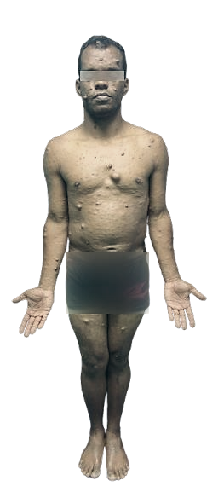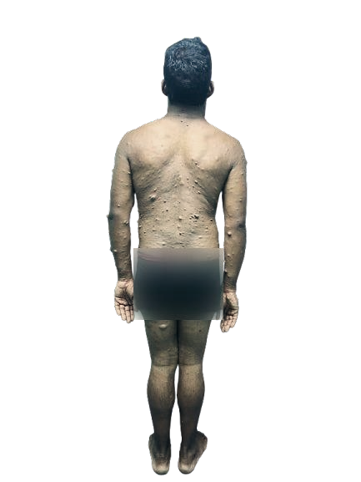

Figure 1. Anterior and posterior projection of the patient, showing multiple soft, skin-colored papules and nodules.

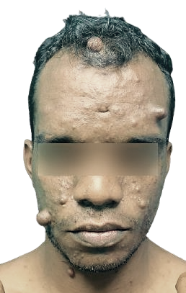
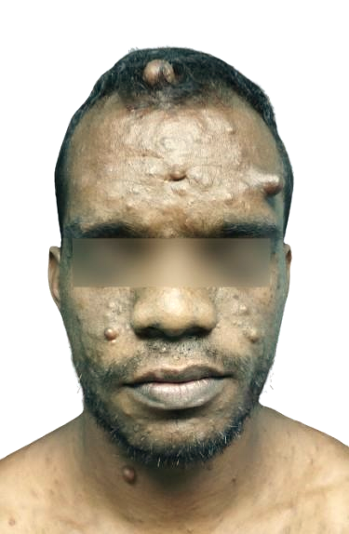

Figure 2. Clinical evolution after 4 months of the surgical procedure.
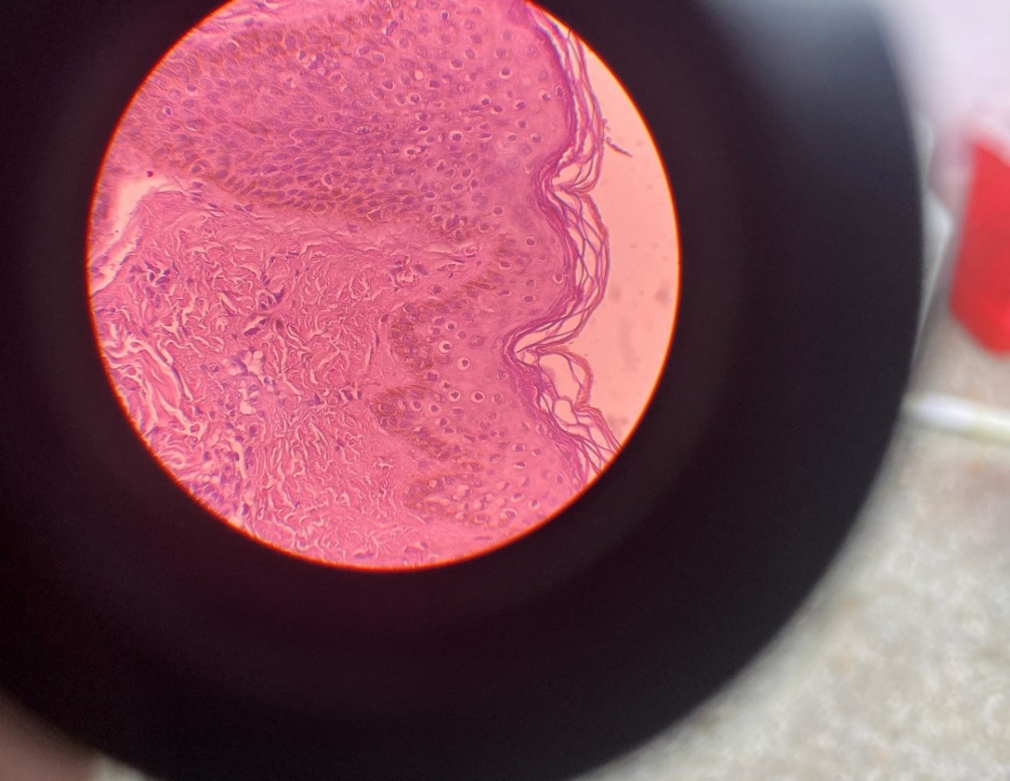
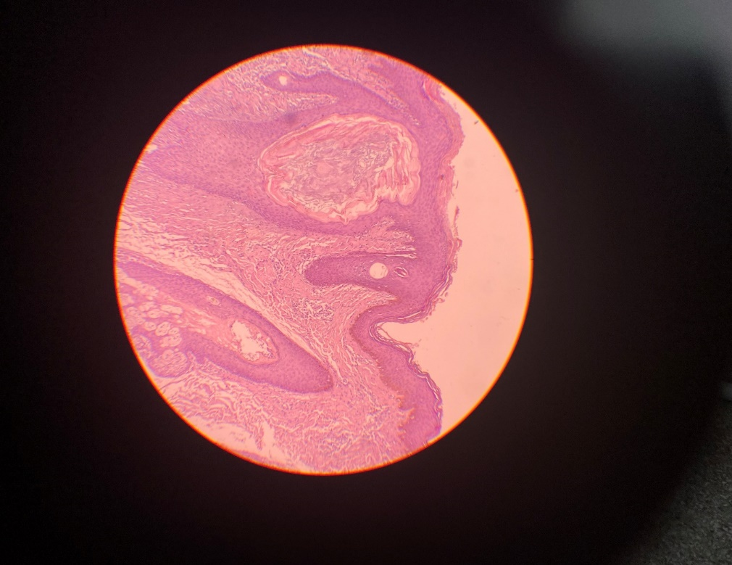
A)
B)

Figure 3. A) H-E staining at 10x shows stratified squamous epithelium with moderate hyperplastic changes, stroma with cutaneous appendages and a tumor lesion consisting of a proliferation of spindle-shaped cells, interspersed with collagen bundles, immersed in loose, fibromyxoid connective tissue. B) H-E staining at 40x shows a proliferation of spindle-shaped cells with ovoid and elongated nuclei, with heterogeneous chromatin, clear eosinophilic cytoplasm, some vacuolated, without atypia or mitotic activity.

