Enhanced Zonal Stable Election Protocol for Wireless Sensor Network
Review Article

.
ABSTRACT

Energy depletion in wireless sensor networks remains a concern for researchers in this emerging technology. However, several enhanced routing protocols are being designed to reduce the energy consumption in these networks and improve their lifetime. The Zonal Stable Election Protocol was carefully studied. It was observed that, no cluster head selection is done in zone 0 because of the nearest of some of the normal nodes to the Base station. This approach appeared effective for a short period of time, especially for the nodes that are really closer to the Base station. However, when some of the nodes in Zone 0 are a little farther away and the network operation is longer, the nodes are seen dying very quickly. Also, the existing scheme is observed to be transmitting captured data unnecessarily without considering the amount of data required by each node before transmission. In this research, a reactive heterogeneous routing scheme called the Enhanced Zonal Stable Election protocol (EZ-SEP) is proposed. The new scheme introduced clustering techniques in all the Zones. Cluster heads are selected based on their residual energy and relative distance from the base station. This is to ensure that the energetic heads that can transmit data to the Base station are selected. Furthermore, the new scheme introduced inter-cluster transmission and multi-hop communication to ensure effective energy distribution among the nodes while using hard and soft thresholds to reduce unnecessary data transmission to the Base station. Simulation was conducted to evaluate the performance of the new scheme using MATLAB R2018a, and the results showed that EZ- SEP outperformed Zonal SEP in terms of coverage, throughput approximately, 50%, stability period, residual energy and network lifetime.

Keywords: average distance, multi-hop, hostile, inter-cluster, Residual energy.

1. INTRODUCTION

“The presence of Wireless Sensor Networks (WSNs) has been a great relief to humanity due to their applications in various areas such as health, agriculture, and hostile or hazardous environments. This network is composed of several tiny sensor nodes that are equipped to sense, process, and transmit measured information from the sensing field to a destination node called Base Station (BS)” [1]. “These tiny devices rely on a replaceable and rechargeable battery as a source of energy. However, because of the hostile areas where they are usually positioned, battery replacement and recharging become practically impossible” [2]. “Therefore, strategies that aim at reducing energy consumption in these networks are explored, especially when the location of the BS is far from the sensing field. To achieve this, several techniques including clustering, energy-efficient cluster-based routing protocols, and multi-hop communication have been employed in these networks” [3]. The study of literature shows that several heterogeneous cluster-based routing protocols have been proposed.

Qing et al. [4] explained “a heterogeneous routing protocol for a wireless sensor network, Distributed Energy Efficient Clustering (DEEC). The DEEC selects the cluster heads based on the ratio between the residual energy of each node and the average energy of the network. The protocol uses two types of nodes: normal and advancedd nodes in its two-level hierarchy. The challenge in this scheme arises when the residual energy of the advancedd node becomes equal to that of the normal nodes in the network. In such a situation, the protocol continues to punish the advancedd nodes, and this has affected the performance of the scheme”.
An improved version of the DEEC protocol for a heterogeneous network has been suggested by Elbhiri et al. [5]. “DDEEC presented an answer to the main challenge noticed in DEEC. The algorithm introduced a threshold residual energy value, based on which the average probability of each node is determined. This gives equal opportunity to both normal and advancedd nodes to become cluster heads at any point in time. The scheme, however, uses single-hop communication” [4].
Authors in [6] explained another form of the “DEEC algorithm for heterogeneous networks, E-DEEC. The scheme introduced extra nodes called super nodes to the normal and advancedd nodes. Therefore, the scheme has three types of sensor nodes. The super nodes have the highest residual energy compared to the normal and advancedd nodes. The simulation results showed that the scheme outperforms DEEC in terms of stability period and network life enhancement. A challenge found in DEEC also occurs in this protocol”.
An enhanced version of the DEEC protocol, TDEEC algorithm, has been proposed by [7]. The scheme uses three-level of nodes, with slight modifications in their probability function. The simulation results showed that TDEEC performed better than DEEC in terms of stability period and network lifetime. The scheme, however, failed to use a multi-hop communication approach in transmitting data to the BS.
Jibreel [8] suggested “an improved form of the DDEEC for a heterogeneous wireless sensor network. The algorithm, iDDEEC altered the election probability of advancedd nodes whose residual energy is less than the threshold value (𝑻𝒉𝒓𝒆𝒗). The average probability of the advancedd nodes now depends on two factors, namely, the average distance of the nodes from the Base station and the residual energy of the nodes. This makes the advancedd nodes with high residual energy and closer to the Base station to have a better chance of being elected as heads. The simulation was performed using MATLAB 2017a and the results showed that the iDDEEC performed better than the DDEEC in terms of throughputs, residual energy and network lifetime. However, no multi-hop communication technique was used”.
“An improved form of E-DEEC has been proposed by the author in [9]. iE-DEEC considered the distance of supernodes and the average distance of all the nodes to the Base station (BS) in choosing the cluster heads (CHs). The scheme also implemented different amplification energy levels to minimize energy consumption during communications between the CHs and BS and between inter and intra clusters. MATLAB 2017a was used for simulation to assess the performance of the scheme. The simulation results showed that the proposed protocol performed better than E-DEEC in terms of throughputs, residual energy, and network lifetime” [9].
The author in [10] proposed “a modified version of TDEEC for a heterogeneous wireless sensor network. The model, G-TDEEC, introduced a gateway node at the center of the deployment area and then installed the BS far away from the sensing field. The cluster heads forward their data to the gateway node, which aggregates the data and then sends the final report to the BS. The simulation was performed to evaluate the effectiveness of the scheme in MATLAB 2017a, and results showed that the new protocol performed better than TDEEC in terms of stability period, throughput, residual energy, and network lifetime”.
Smaragdakis et al. [11] described “the Stable Election Protocol (SEP) for a heterogeneous wireless sensor network. The algorithm uses the weighted election probabilities of each node as a criterion to select a cluster head, which depends on their respective energy. SEP utilizes two types of nodes: normal and advancedd nodes. The normal nodes have the lowest energy compared to the advancedd nodes. The simulation results showed that, SEP protocol has extended the lifetime of the network. However, positioning of the BS at the centre makes the protocol not suitable for deployment in areas where the BS must be away from the network”.
Another version of SEP has been discussed by [12]. M-SEP (Modified Stable Election Protocol) elects cluster heads in two, three, and up to ninth level hierarchical wireless sensor networks. The protocol improved SEP schemes significantly in terms of network lifetime, energy consumption, and data transmission to the BS. However, distance was not taken into account in selecting the heads.
The author in [13] presented “an improved version of the SEP protocol called I-SEP (Improved Stable Election Protocol). I-SEP has two main characteristics: reactive routing and uses three levels of heterogeneity. To reduce energy depletion due to data transmission, the scheme introduced a specific threshold. Once this threshold is reached, data communication in the network begins. The outcome of the experiment revealed that the I-SEP prolongs the stability period and network lifetime compared to the SEP, LEACH, and ZSEP”.
Divya et al. [14] described “a modified form of SEP for heterogeneous wireless sensor networks. EE-SEP (Energy Efficient Stable Election Protocol) introduced a new threshold value, which tends to reduce the number of cluster heads during operation. As the number of CHs is reduced, there is a corresponding increase in the number of alive nodes. The existence of more alive nodes in the network enhances the stability period and network lifetime. Simulation results show that EE-SEP algorithm performs better than SEP”.
Aderohunmu and Deng [15] discussed “the results of the Enhanced-SEP clustering algorithm. The scheme is a three-tier node scenario consisting of advancedd, intermediate, and normal nodes. Simulation results showed that the Enhanced-SEP achieves better performance in this respect, compared to other existing clustering algorithms in both heterogeneous and homogenous environments”.
Jibreel et al. [16] presented “a modified form of SEP called Gateway–SEP(G-SEP) for a wireless sensor network. The G-SEP modified the SEP in two ways. First, the election probability of the advancedd nodes has been modified to consider the distance, average distance and residual energy of the advancedd nodes. Secondly, the scheme introduced a gateway node at the centre of the network and then installed the BS outside the field. Simulation results using MATLAB R2017a showed that, the G-SEP performs better than the Zonal-Stable Election protocol (ZSEP) in terms of coverage, stability period, throughput and network lifetime. However, the scheme uses a gateway node, which can increase the cost of implementing this protocol”.
Khan et al. [17] proposed “an advancedd zonal stable election protocol (AZ-SEP). The scheme introduced a new cluster head selection on the basis of residual energy and distance from the base station. The new scheme was evaluated by taking different evaluation scenarios and was compared with the traditional ZSEP through simulation using MATLAB 20214a. The results show that the scheme performed better than Z-SEP in terms of stability period, packet delivery ratio and optimizes the average energy consumption”.
Khan et al. [18] examined “the Z-SEP protocol regarding cluster head selection and communication of cluster head with the base station and introduced a new mechanism of cluster head selection on the basis of residual energy and distance from the base station. The communication between nodes with the base station occurs in a multi-hop fashion. Furthermore, AZSEP is evaluated by considering various evaluation scenarios, such as changing the position of the base station, skewed nodes, and variable node energy, to compare it with the parent protocol. The scheme was compared with the traditional routing protocols like Z-SEP and SEP protocol, and simulation results show that the proposed protocol performed better in terms of stability period, packet delivery ratio, and optimizes average energy consumption”.
Mohamed et al.[19] presented “three proactive routing protocols; the first protocol is a circle zone stable election protocol (CZSEP), which is a two-level heterogeneous energy protocol with a circle zone located at the centre of the network field. The algorithm deployed the normal nodes and with advancedd nodes that are randomly distributed around the circle zone. The scheme performed better than the conventional ZSEP. The authors further presented an improved form of CZSEP, named CZSEP with helper nodes (CZSEP-HN) which is a three-level heterogeneous energy protocol. In CZSEP-HN, they introduced helper nodes in certain places in the network field to reduce energy consumption in the network. Besides these two protocols, a third scheme was again proposed by the same authors, which is a modified form of CZSEP-HN. MCZSEP-HN is a four-level heterogeneous energy protocol with two circle zones, one for normal nodes and the other for intermediate nodes. The obtained results showed that the MCZSEP-HN outperforms the other protocols in terms of network lifetime, throughput, stability, instability period, and energy consumption in WSNs”.
Ashwin et al. [20] proposed a routing protocol with sleep/wake scheduling and VANET broadcasting. The scheme was compared with existing schemes, Z-Stable Election Protocol and Stable Election Protocol, and simulation results showed that the proposed scheme outperformed the existing ones in terms of energy consumption and throughput.
Benelhouri et al. [21]also introduced “a three-level Heterogeneous Zonal Stable Election Protocol for Energy Efficiency in Wireless Sensor Networks. The network model is divided into five zones based on the nodes' initial energy and distance to the base station. For data communication, the proposed model relies on two types of communications: Direct and Multi-Hop. The choice of the type of communication is made according to the nodes' initial energy and their distance to the base station. The clustering scheme is used only in zones that contain nodes with higher energies. The simulation of the proposed scheme is performed using MATLAB simulator, and the results are compared to the conventional heterogeneous routing protocols, 3-level heterogeneous Stable Election Protocol, and 3-level Modified Low Energy Adaptive Clustering Hierarchy, and it was found to perform better”.
Severin et al. [22] proposed “an enhanced clustering protocol consists of normal nodes and advancedd nodes. The normal nodes send data directly to the base station, while the advancedd nodes use a clustering technique to send data to the base station. The residual energy in cluster election is also enhanced in order to increase the lifetime of the network. The authors reduced the number of zones in Z-SEP to only two zones, which has extended the lifetime of the network better than Z-SEP”.
Kumar et al. [23] presented “ZSGEEHCP: Zonal Stable Gateway Based Energy Efficient Heterogeneous Clustering Protocol for a WSN-Based IoT. The scheme divided the geographical location into three zones, advancedd, intermediate, and normal zones, and employed a gateway node. The advancedd nodes transmit data through the gateway node to the base station, normal nodes communicate directly to the base station, and intermediate nodes use a clustering algorithm. The election protocol probabilities of each node elected as a cluster head are based on the residual energy”.

The remainder of this work is arranged as follows: In Section 2, the Materials/Methods are explained, while the Simulation Results and Analysis are discussed in Section 3, and the conclusion is drawn in Section 4
2. material and methods

MATLAB R2018a was employed to measure the effectiveness of the proposed algorithm and the existing algorithm.
2.1 THE EXISTING SCHEME
Faisal et al. [24] proposed a modified form of SEP called Zonal-Stable Election Protocol (ZSEP) for Wireless Sensor Networks. ZSEP divided the network into three zones: Zone 0, Head Zone 1, and Head Zone 2 on the basis of energy levels. The nodes with lesser energy are deployed in Zone 0 near the Base Station, which is located at the centre. These nodes adopted a single-hop communication approach in sending their reports to the BS, while the advancedd nodes closer to the boundaries relay their data to the BS through the elected cluster heads (CHs).
Assume an optimal number of clusters $K_{opt}$ and $n$ is the number of advanced nodes. According to SEP protocol, the optimal probability of cluster head is given in equation (1)
$P_{opt}$ = $(\frac{K_{opt}}{(n)})$ (1)
Z-SEP threshold equation is given in equation (2)
$T(n_{ } )$ = $\left\{\begin{aligned} \frac{P_{opt} }{1-P_{opt}(r mod(\frac{1}{ P_{opt}}))} if n ϵ G \\ 0, otherwise\end{aligned}\right.$ (2)
Where $G$ is the set of nodes which have not been cluster heads in the last 1/$P_{opt}$ rounds.
Probability for advanced nodes to become cluster head is proposed in [4] which is given in equation (3)
$P_{adv}$ = $(\frac{P_{opt}(1+a)}{(1+am)})$ (3)
While the threshold for advanced nodes is given in equation (4)
$T(adv)$ = $\left\{\begin{aligned} \frac{P_{adv} }{1-P_{adv}(r mod(\frac{1}{ P_{adv}}))} if adv ϵ G^{1} \\ 0, otherwise\end{aligned}\right.$ (4)
$G^{1}$ is the set of advanced nodes that have not been the cluster head in the last $\frac{1}{ P_{adv}}$ rounds
When the cluster head is chosen, the cluster formation phase begins. This is where the cluster head broadcasts an advertisement message to the nodes. Based on the received signal strength, nodes respond to the cluster head and join as members of that cluster. To prevent unnecessary collisions and transmission of data to the head, the head assigns a TDMA schedule to each node during which the node can send its report to the head. When the head receives the report from the nodes, it aggregates the data and forwards it to the Base station for further analysis.

2.2 PROPOSED SCHEME
In this section, the proposed scheme called the Enhanced Zonal Stability Election Protocol (EZ-SEP) is explained. The new scheme works similarly to the scheme of the authors in [18] in terms of how the network is divided into Zones. The proposed algorithm first and foremost relocated the Base station away from the deployment region to allow applications that need such services to use it. The new scheme introduced the selection of the cluster head (CH) in all the Zones. In Zone 0, when the distance between the nodes and the cluster heads (CHs) in Zone 1 is beyond a certain threshold, the CH selection is conducted in Zone 0 based on residual energy and the average distance of the nodes from the CHs in Zone 1. This enhancement allows normal nodes that have higher residual energy at the same time, closer to the CHs in Zone 1, to become cluster heads. As a result, the elected cluster heads use less energy in sending their reports to the CHs in Zone 1. Also, the cluster CHs selections in both the Zone 1 and Zone 2 are modified to base on the residual energy of the nodes and their average distance from the BS. This is to avoid weak and distant nodes from becoming CHs since they cannot transmit data to the BS effectively. Inter-cluster transmission and multi-hop communication are employed in all the Zones as explained by the authors in [17]. Finally, to avoid unnecessary transmission of data by the nodes, hard and soft thresholds suggested by [25] have been introduced in all the Zones. This makes the proposed system a reactive heterogeneous routing protocol. The EZ-SEP model is shown in Figure

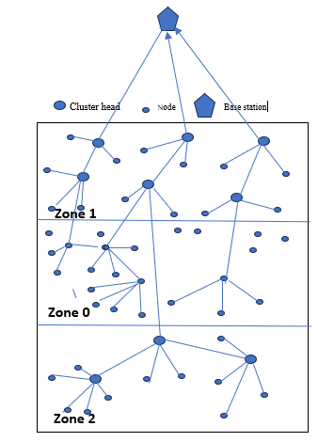
Figure 1: EZ-SEP Model

The election probabilities of both normal ($p_{nrm}$) and the advanced nodes ($p_{adv}$) are given respectively by (5) and (6)
$P_{nrm}$ = $\frac{P_{opt}}{1+am}$* $\frac{E(i)}{d _to_BS}$* $\frac{d_av(i)}{E(0)}$ (5)

$P_{adv}$ = $\frac{P_{opt}(1+a)}{1+am}$*$\frac{E(i)}{d _to_BS}$* $\frac{d_av(i)}{E(0)}$ (6)
Where $m$ is a percentage of the advanced nodes which are equipped with $a$ times more energy resources than the normal sensor nodes in the network,$d_av(i)$ is the average distance of all the nodes from the BS, $d _to_BS$ , distance of each nodes from the BS, $E(i)$ is the residual energy of the node and $E(0)$ is the initial energy of the node.
Thresholds for the normal and advancedd nodes are respectively given by (7) and (8)
$T(n_{nrm})$ = $\left\{\begin{aligned} \frac{P_{nrm} }{1-P_{nrm}(r mod(\frac{1}{ P_{nrm}})} if n_{nrm} ϵ G^{1} \\ 0 otherwise\end{aligned}\right.$ (7)
$T(n_{adv})$ = $\left\{\begin{aligned} \frac{P_{adv} }{1-P_{adv}(r mod(\frac{1}{ P_{adv}})} if n_{adv} ϵ G^{11} \\ 0 otherwise\end{aligned}\right.$ (8)
Where $G^{1}$ is the set of normal nodes that have not become cluster head in the past $\frac{1}{ P_{nrm}}$ round r.
Where $G^{11}$ is the set of advancedd nodes that have not become cluster head in the past $\frac{1}{ P_{adv}}$ round r.

3. results and discussion

To evaluate the performance of the proposed reactive heterogeneous routing protocol EZ-SEP and ZSEP, the two schemes were simulated in MATLAB R2018a. The experiment was conducted with a network composed of 100 nodes randomly distributed in an area of dimension 100m x 100m. We assume that 20% of the sensor nodes will be advancedd nodes (m=0.2 where 10 of them are deployed in Zone 1 and the other 10 nodes in Zone 2. The BS was placed outside the field (50m, 160m). All nodes are stationary after deployment. Table 1 shows the simulation parameters used in this research work.

Table 1: Simulation Parameters
Parameters | Values
Network field | (100,100)
Number of nodes | 100
Number of normal nodes | 80
Number of advancedd nodes | 20
Initial energy of normal nodes($E_{0}$) | 0.5J
Message size | 4000 bits
$$E_{elec}$$ | 50Nj/bit
$$E_{fs}$$ | 10Nj/bit/$m^{2}$
$$E_{mp}$$ | 0.0013Pj/ bit/$m^{2}$
$$P_{opt}$$ | 0.1
$$m$$ | 0.2
$$a$$ | 1

The following metrics are used to assess the two protocols.

  - Network Lifetime
Figure 2 shows the number of alive nodes during each transmission per round for the ZSEP and the proposed routing protocol. From the graph, the network lifetime is improved significantly in the EZ-SEP compared to the ZSEP scheme. It is observed that, immediately after 500 rounds, the number of alive nodes in the ZSEP begins to decline at a faster rate, with very few alive nodes sustaining the network up to 1000 rounds. This is because the normal nodes in Zone 0 use a direct transmission approach to report their data to the distant BS. Therefore, a lot of energy is being used. Also, the advancedd nodes in Zone 2 are far from the BS and will require energy to send their data to the BS. This also depleted their energies,which resulted in the death of the nodes. However, in the proposed scheme, more alive nodes were observed even after 300 rounds and were sustained up to 4000 rounds. This clearly shows that nodes live a longer time in EZ-SEP than in the ZSEP. The extension of the lifetime in the proposed protocol is a result of the inter-cluster and multi-hop transmission approach employed in all the Zones. Also, the hard and soft thresholds that were introduced in the scheme reduce unnecessary data transmission, thereby conserving the energy of the nodes.

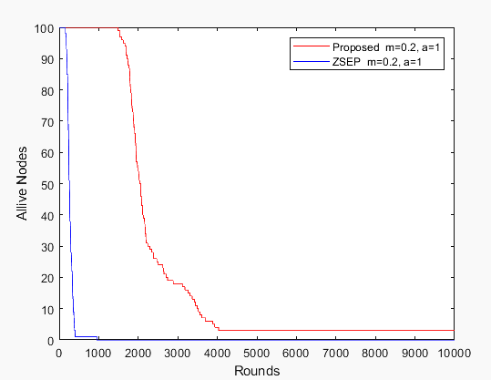
Fig. 2: Number of Alive Nodes per Number of rounds

Figure 3 displays the number of dead nodes during each transmission per round for the ZSEP and the proposed routing protocol. From the graph, the network lifetime is improved significantly in the new scheme because of the lower death rate recorded in the new scheme compared to that of the ZSEP protocol. This is due to energy conservation techniques such as clustering, inter-cluster and multi-hop communication, and introduction of soft and hard thresholds that were deployed in all the zones. As a result, the death rate is reduced, stability period has improved, and life time of the network is prolonged as seen in Figure 3.

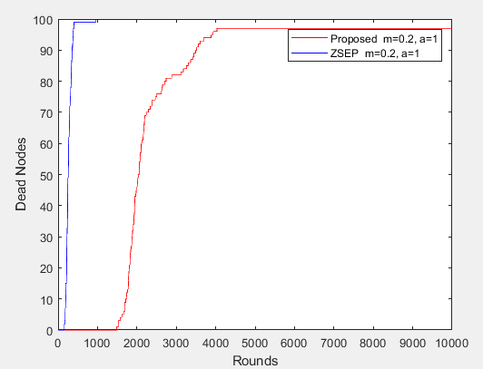
Fig. 3: Number of dead Nodes per Number of rounds

  - Throughput
Figure 4 also shows the amount of data transmitted to the BS per round in ZSEP and the proposed scheme. It was realised that a huge amount of data is sent to the BS in the EZ-SEP protocol compared to the ZSEP protocol. ZSEP performed well at the beginning of the experiment up to 500 rounds and maintains the same transmission after 1000 rounds. This is because of the direct transmission technique used in Zone 0. However, this technique did not help the protocol for long. In the new algorithm, the transmission increases linearly from the start of the experiment and remains constant after 4000 rounds. This shows that the new system has better throughput than the existing scheme.

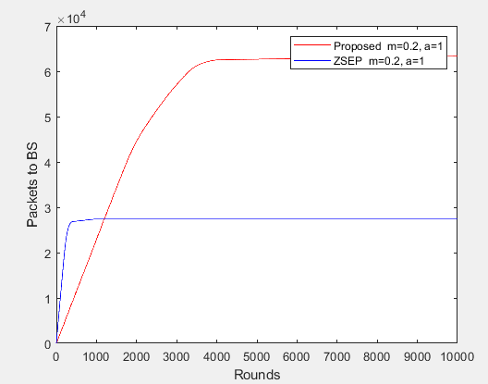
Fig. 4: Throughput per number of rounds
  - Residual Energy
Figure 5 shows the residual energy of the networks per round of the two protocols. It was realised that the proposed protocol reduces its energy consumption better than ZSEP. As explained earlier, there was high energy consumption in ZSEP immediately the experiment started. This resulted in lower residual energy and a high death rate. Also, the lower residual energy seen in ZSEP is a result of placing the BS far from the sensing area, and such a placement of the Base Station is necessary in a hostile environment. The EZ-SEP, on the other hand, deployed energy efficient strategies such as the clustering approach and hard and soft thresholds technique in all the Zones. This has reduced energy depletion of the nodes in all the regions, thereby enhancing its residual energy in the network, as shown in Fig4.

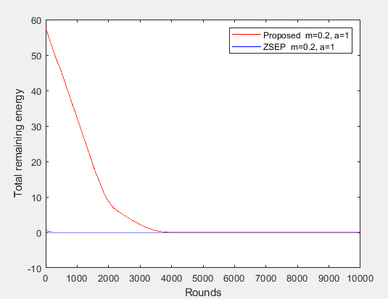
Fig. 5: Residual energy per number of rounds

4. Conclusion

In this work, a reactive heterogeneous cluster-based routing protocol called EZ-SEP is proposed. The new protocol introduced a clustering technique in all three Zones with a modified Cluster head selection approach. This lowers energy consumption in the network. The new scheme further introduced an inter-cluster and multi-hop communication approach coupled with hard and soft thresholds in all the Zones. The approach has enhanced the throughputs and stability period. The proposed protocol was simulated with the ZSEP protocol using MATLAB 2018a, and the results showed that EZ-SEP outperformed the ZSEP protocol in terms of stability period, throughputs, residual energy, and network lifetime

COMPETING INTERESTS DISCLAIMER:
Authors have declared that they have no known competing financial interests OR non-financial interests OR personal relationships that could have appeared to influence the work reported in this paper.

Disclaimer (Artificial intelligence)
Option 1:
Author(s) hereby declare that NO generative AI technologies such as Large Language Models (ChatGPT, COPILOT, etc.) and text-to-image generators have been used during the writing or editing of this manuscript.
Option 2:
Author(s) hereby declare that generativ AI technologies such as Large Language Models, etc. have been used during the writing or editing of manuscripts. This explanation will include the name, version, model, and source of the generative AI technology and as well as all input prompts provided to the generative AI technology
Details of the AI usage are given below:
1.
2.
3.

References
[1] Heinzelman, W.R., Chandrakasan, A. P. (2000). Energy efficient Communication Protocol for Wireless Microsensor Networks, In: IEEE Computer Society Proceedings of the 33rd Hawaii International Conference on System Sciences (HICSS '00),Vol. 8, pp. 8020.

[2] Heinzelman, W.R., Chandrakasan, A. P., Balakrishnan H. (2002).An application-specific protocol architecture for wireless microsensor networks, IEEE Trans on Wireless Communications, Vol. 1, No. 4, pp. 660-670.
[3] Panda, H., Das, M., Sahu, B. (2021). Multi-Hop Communication in Wireless Underground Sensor Network. International Conference in Advanceds in Power, Signal, and Information Technology (APSIT), IEEE, pp. 1-5
[4] Qing, L., Zhu, Q. and Wang, M. (2006 ). Design of a distributed energy-efficient clustering algorithm for heterogeneous wireless sensor networks. Computer Communications, vol. 29, no.12, pp.2230-2237.
[5] Elbhiri, B., R, Saadane, R., S. El Fkihiand , S. & D. Aboutajdine, D.(2010). Developed Distributed Energy-Efficient Clustering (DDEEC) for heterogeneous wireless sensor networks. I/V Communications and Mobile Network (ISVC), 5th International Symposium on, vol., no., 2010, pp.1-4
[6] Saini, P., & Sharma, A. K.(20210). E-DEEC- Enhanced Distributed Energy Efficient Clustering Scheme for heterogeneous WSN. 1st International Conference on Parallel, Distributed and Grid Computing, pp. 205-210.
[7] Saini, P., & Sharma, A. K.(20210). Energy Efficient Scheme for Clustering Protocol Prolonging the Lifetime of Heterogeneous Wireless Sensor Networks. International Journal of Computer Applications 6(2), pp. 30-36.
[8] Jibreel, F. (2018). Improved Developed Distributed Energy-Efficient Clustering Scheme (iDDEEC). International Journal of Innovative Science and Research Technology, Volume 3, Issue 12, pp. 564-567.
[9] Jibreel, F. (2019). Improved Enhanced Distributed Energy Efficient Clustering (iE-DEEC) Scheme for heterogeneous Wireless Sensor Network. International Journal of Engineering Research and Advancedd Technology (IJERAT), Volume.5, Issue 1, pp. 6-11.
[10] Jibreel, F. (2019). Gateway–based Threshold Distributed Energy Efficient Clustering (G-TDEEC). International Journal of Computer Applications, Volume 182 – No. 42, pp.43-46
[11] Smaragdakis G, Matta I, Bestavros A. SEP(2004). A Stable election protocol for clustered heterogeneous wireless sensor networks. Second International Workshop on Sensor and Actor Network Protocols and Applications. pp 1-11.
[12] Arya, G., Chauhan, DS.(2013). Modified stable election protocol (M-SEP) for hierarchical WSN. International Journal of Computer Applications (0975 – 8887), 79(16): 35-39.
[13] Sharma S.(215). Improved stable election protocol for heterogeneous wireless sensor network. International Journal of Science and Research (IJSR), 4(4): 1370-1374.
[14] Divya1, C., Krishnan N., Gandhimathy T.(2013). Energy efficient stable election protocol for clustered heterogeneous wireless sensor networks. IOSR Journal of Computer Engineering (IOSR-JCE), 12(5):55-61
[15] Aderohunmu , F. A. & Deng, J.D. (2009). An Enhanced Stable Election Protocol (SEP) for Clustered
Heterogeneous WSN”, Discussion Paper Series, No. 2009/07, Department of Information No. 2009/07, Department of Information Science. University of Ontago, Dunedin New Zealand, , pp. 1-16.
[16] Jibreel F. (2019). Extended Threshold Stable Election Protocol for Wireless Sensor Networks. North American Academic Research, 2(3):131-140
[17] Khan , F. A., Khan, M., Asif, M., Khalid, A., Ulhaq, I. (2019). Hybrid and Multi-Hop Advancedd Zonal-Stable Election Protocol for Wireless Sensor Networks. IEEE Trans. Mobile Comput., vol. 7, pp. 25334–25346
[18] Khan1, F.A., Khan, M., Asif, M., Khan, A. , and Khan, I. (2018). Hybrid and Multi-hop Advancedd Zonal-Stable Election Protocol for Wireless Sensor Networks. IEEE TRANSACTIONS, Volume 4, pp. 1-13.
[19] Mohamed, F.A,Hassan, E.S. , Elsafrawey, A.S., Dessouky,M.I. (2019). Energy-efficient circle zones stable election protocol with helper nodes for heterogeneous WSNs. IET Wireless Sensor Systems, Vol. 9 Iss. 5, pp. 313-322.
[20] Ashwin S., Bharanidharan A., Harish A., Mohamed Afreez M. (2020). Optimized Zonal Stable Election Protocol. International Journal of Engineering Applied Sciences and Technology, Vol. 5, Issue 1, Pages 413-416.

[21] Benelhouri, A., Idrissi-Saba1,H., and Ntarir, J. (2021). Three Level Heterogeneous Zonal Stable Election Protocol for Energy Efficiency in Wireless Sensor Networks. E3S Web of Conferences 297, 01075 (2021) ICCSRE’2021. https://doi.org/10.1051/e3sconf/202129701075

[22] Severin, N., Isabelle,M., Iragena, Z. (2022). Enhanced Clustering Protocol in Zonal-Stable Election Protocol for WSN. International Journal of Scientific Research and Modern Technology, Volume 2, Issue 2, pp. 14-18.
[23] Kumar, B., Kumar, R. Varadarajan, V. (2024). ZSGEEHCP: Zonal Stable Gateway Based Energy Efficient Heterogeneous Clustering Protocol For WSN- Based IoT. Journal Electrical Systems, 39-54

[24] Faisal, S., Javaid, N., Javaid , A., Khan , M. A., Bouk ,S. H., & Khan , Z. A. (2013). Z-SEP: Zonal-stable election protocol for wireless sensor networks. pp. 1-9. ’’ [Online]. Available: https://arxiv.org/abs/1303.5364
[25] Manjeshwar, A., Agrawal , D. (2001). TEEN: A Routing Protocol for Enhanced Efficiency in Wireless Sensor Networks. In Proc. 15th International Parallel and Distributed Processing Symposium (IPDPS‟01) Workshops, USA, California, pp. 2009-2015.

