Original Research Article
Hybrid Sleep Scheduling for Energy-Efficient IoT Sensor Networks in Smart Poultry Monitoring

.
ABSTRACT

The integration of Internet of Things (IoT) technologies into precision poultry farming has revolutionized environmental monitoring; yet, high energy consumption in sensor networks remains a significant barrier to scalability and sustainability. This study presents a hybrid sleep scheduling algorithm for energy-efficient IoT-based poultry environmental monitoring. The algorithm enables dynamic transitions between Active, Modem Sleep, and Light Sleep modes according to environmental stability and data variability. Analytical models of system cycle time and power consumption were developed to optimise node behaviour under varying farm conditions. A prototype built with Wemos D1 Mini microcontrollers, DHT22, and MQ135 sensors was experimentally validated in a live poultry environment. Results show an average energy reduction of 68.4% compared to always-active systems, while maintaining latency below 2 seconds and measurement errors within ±0.4°C, ±1.3% RH, and ±7 ppm. The proposed framework offers a scalable, low-power architecture suitable for remote, battery-powered farms, advancing the sustainability of IoT-enabled livestock management and supporting the United Nations’ SDGs 2 and 12.

Keywords: Internet of Things, energy efficiency, hybrid sleep scheduling, sensor networks, poultry farming, low-power design.

1. INTRODUCTION

The adoption of Internet of Things (IoT) technologies has significantly transformed modern poultry farming by enabling real-time environmental monitoring, automated control, and data-driven decision-making (Neethirajan, 2020; Terence et al., 2024). Through the use of distributed wireless sensor networks, critical parameters such as temperature, humidity, and gas concentrations can be continuously tracked to maintain optimal living conditions for birds, ensuring improved productivity and welfare (Lashari et al., 2018). However, despite these advances, energy consumption remains one of the most persistent technical challenges limiting the increased use and reliability of IoT deployments in agricultural environments (Venkateshaiah et al., 2025).

In conventional IoT poultry systems, sensor nodes operate in continuous “active” modes, resulting in excessive power drain, frequent battery replacements, and high maintenance costs—factors that are impractical for remote or large-scale farms (Omar, 2021). Field measurements have shown that communication and sensing modules in IoT nodes consume up to 80–90% of total node energy, primarily due to constant wireless transmission and data sampling (Heble et al., 2018). Consequently, energy-efficient strategies such as duty-cycling, adaptive transmission, and sleep scheduling have become crucial in ensuring system longevity while maintaining sensing accuracy (Gupta et al., 2023).

Sleep scheduling algorithms, which alternate sensor nodes between active and low-power states based on environmental stability, have proven effective for prolonging battery life in resource-constrained IoT applications (Selvam et al., 2023). However, most existing methods either prioritize energy savings at the expense of responsiveness or maintain high data accuracy with unsustainable energy costs (Pasandideh, 2020). Furthermore, environmental conditions in poultry houses are highly dynamic (affected by bird activity, ventilation cycles, and feed schedules) making fixed or threshold-based sleep schedules inefficient in practice (Leong et al., 2024).

To address these limitations, this study introduces a hybrid sleep scheduling algorithm that combines three operational modes (Active, Modem Sleep, and Light Sleep) and dynamically adjusts node behaviour according to environmental variability. The proposed approach enables IoT nodes to intelligently balance power consumption with data responsiveness, reducing redundant sensing operations during stable periods while preserving rapid detection under volatile conditions.
The contributions of this work are threefold:
- Development of a state-driven hybrid sleep scheduling framework for energy-efficient IoT sensor networks in poultry environments.
- Formulation of analytical models to describe cycle time, energy consumption, and energy-saving ratios across operational states.
- Experimental validation of the proposed framework through real-world implementation using Wemos D1 Mini and Raspberry Pi 4 controllers, achieving substantial energy savings without compromising monitoring reliability.

This research is motivated by the broader vision of sustainable smart agriculture, where low-power IoT systems can operate autonomously for extended periods with minimal maintenance. Beyond poultry farming, the proposed model contributes to the design of scalable, battery-efficient IoT architectures applicable to greenhouse monitoring, aquaculture, and environmental sensing under the United Nations’ Sustainable Development Goals (SDGs 2 and 12) — promoting food security and sustainable production patterns (UN, 2023).

2. Related Works

Energy efficiency remains a critical research focus in the design of Internet of Things (IoT) systems, particularly for agricultural and environmental monitoring applications where sensor nodes are typically battery-powered and deployed in remote locations (Cao et al., 2023). Traditional IoT implementations often rely on continuous sensing and data transmission, which results in excessive energy consumption and short node lifespans (Heble et al., 2018). To mitigate this issue, researchers have developed various power optimisation techniques, including duty cycling, dynamic transmission control, and sleep scheduling (Gupta et al, 2023). Among these, sleep scheduling has emerged as one of the most effective methods to reduce idle energy waste while maintaining system responsiveness (Selvam et al., 2023).

Early approaches to sleep scheduling employed static duty-cycling, where nodes alternated between active and sleep states at fixed intervals regardless of environmental conditions (Omar, 2021). Although simple to implement, static schemes lack adaptability to dynamic environments such as poultry houses, where temperature, humidity, and air quality fluctuate throughout the day due to bird activity, ventilation, and feeding cycles (Leong et al., 2024). To address these limitations, recent studies have proposed adaptive sleep scheduling algorithms, where nodes adjust their wake–sleep durations based on sensed environmental variability or network congestion (Venkateshaiah et al., 2025).

In recent years, more intelligent approaches have been introduced through machine learning (ML) and reinforcement learning (RL) methods to optimize node sleeping patterns dynamically. Banerjee (2025) developed a Nash-based Deep Q-Network model (NashDQNSleep) that learns optimal node activation policies to minimize energy consumption while maintaining the freshness of information. Similarly, Abbas (2025) implemented a two-phase genetic algorithm to optimize cluster-based sleep scheduling in hierarchical wireless sensor networks, achieving notable energy savings in large-scale IoT deployments. Although these AI-driven approaches improve adaptivity, their computational complexity often limits practical deployment on resource-constrained microcontrollers commonly used in agricultural IoT systems (Lee, 2024).

Within the agricultural domain, green IoT frameworks have been introduced to combine low-power communication technologies such as LoRaWAN, Zigbee, and NB-IoT with adaptive scheduling to achieve long-term sustainability (Nitin, 2023). However, these systems often prioritise communication efficiency over holistic power management across the sensing, processing, and transmission layers. In livestock environments, Sasirekha et al. (2023) designed an IoT-enabled poultry monitoring system incorporating real-time ventilation control and achieved a 30% energy reduction, but the framework relied on time-triggered activation rather than intelligent sleep scheduling. Similarly, Duguma (2024) reviewed IoT applications in agriculture and concluded that dynamic energy control mechanisms, specifically hybrid sleep scheduling, remain underexplored despite their potential for autonomous environmental sensing.

Moreover, domain-specific research has underscored the need for analytical modelling of energy savings to validate scheduling algorithms under real-world operating conditions (Kumar et al., 2024). Most prior works report simulation-based results without providing theoretical formulations or field validation in livestock facilities, which limits reproducibility and scalability. Therefore, this study fills a vital research gap by integrating mathematical energy modelling, hybrid sleep scheduling, and real-world experimental validation using affordable IoT hardware.

3. System Design and Methodology

3.1 Overview of the Proposed IoT System Architecture

The proposed system architecture for the smart poultry environmental monitoring framework consists of distributed IoT sensor nodes, a data aggregation unit, and a cloud-based monitoring dashboard. Each sensor node is built around a Wemos D1 Mini microcontroller (ESP8266-based), which is selected for its low power consumption and integrated Wi-Fi communication capabilities. The sensing layer incorporates a DHT22 temperature and humidity sensor, as well as an MQ135 gas sensor for detecting ammonia concentration, which are crucial for maintaining optimal poultry welfare conditions.

Sensor readings were transmitted wirelessly to a local gateway powered by a Raspberry Pi 4, which acts as a data concentrator and edge-processing unit. The gateway handles data buffering, preprocessing, and synchronisation with the cloud platform through the HTTP protocol. The Streamlit dashboard is employed for real-time visualisation, enabling farmers to observe environmental conditions, analyse trends, and receive alerts through an intuitive web interface. The overall architecture is illustrated in Fig. 1, emphasising the hierarchical communication flow between the sensing, processing, and visualisation layers.

Fig. 1. Architecture of the IoT system for environmental conditions monitoring of poultry farm

This architecture supports both on-demand and scheduled data transmission, aligning with the hybrid sleep scheduling strategy described in Section 3.6.

3.2 Mathematical Modelling of System Energy Consumption

To quantify energy performance, analytical models were derived to represent the total power consumption per monitoring cycle. The total energy consumption, $E_{tot}$ during one monitoring cycle, the sum of energy used in each operational state is expressed in (1):
$E_{tot}=E_{active}+E_{modem}+E_{light}$ (1)
where:
- $E_{active}=I_{active}×V×t_{active}$
- $E_{modem}=I_{modem}×V×t_{modem}$
- $E_{light}=I_{light}×V×t_{light}$

Here, $I_{state}$ denotes the current drawn in each mode, $V$ is the supply voltage, and $t_{state}$ is the duration of operation in that mode (Venkateshaiah et al., 2025).
The cycle time ($T_{c}$) for each node is as expressed in (2):
$T_{c}=t_{active}+t_{modem}+t_{light}$ (2)
and the average power consumption over the cycle is evaluated in (3):
$P_{avg}=\frac{E_{tot}}{T_{c}}$ (3)
To assess the efficiency improvement relative to a baseline always-on system, the Energy Saving Ratio (ESR) is defined in (4):
$ESR=\frac{E_{base}-E_{hybrid}}{E_{base}}×100\%$ (4)
where $E_{base}$ is the total energy consumed in a continuous active system and $E_{hybrid}$ is the energy consumption using the proposed hybrid scheduling scheme.

In this study, real current draw measurements were obtained using a digital multimeter connected in line with the node’s power supply. For each mode, average current consumption was recorded as follows:
- $I_{active}=70\text{ mA}$
- $I_{modem}=25\text{ mA}$
- $I_{light}=10\text{ mA}$
For a supply voltage of $3.3\text{ V}$ and a total cycle time of $60\text{ s}$, energy calculations confirm that the hybrid algorithm achieves a reduction in power consumption of up to 68.4% compared to the baseline system.

3.3 Operational Principle

The system operates through a state-driven workflow that dynamically adjusts power modes based on sensor data trends ($∆D$) and critical threshold ($θ$). This ensures energy efficiency while maintaining responsiveness to environmental changes in poultry farm monitoring. The operational logic and a state diagram visualising the system’s transitions are presented in Fig. 2.

Fig. 2. State Transition Diagram of the Hybrid Sleep Scheduling Algorithm
- Stable Environmental Conditions ($\left|∆D\right|≤D_{th}$​)
When consecutive sensor readings exhibit minimal variability (i.e., the absolute change $\left|∆D\right|$ is within a predefined stability threshold $D_{th}$​), the system activates Light Sleep Mode. In this mode, the system extends the sleep interval by a factor $k$ (${T_{s}=kT}_{b}$)). During extended sleep, the MCU continues to wake at $T_{b}$ intervals (modem sleep mode) to confirm conditions. If no changes are detected, it re-enters Light Sleep until ${kT}_{b}$​ elapses.
- Dynamic Environmental Conditions ($\left|∆D\right|>D_{th}$​ and $D_{i}≤θ$)
If sensor readings show significant variability ($\left|∆D\right|>D_{th}$​) but no parameter exceeds the critical threshold ($D_{i}≤θ$), the system activates Modem Sleep Mode. The system adheres to the base interval $T_{b}$​, waking at each interval to transmit data and re-evaluate conditions. If volatility persists ($\left|∆D\right|>D_{th}$​), Modem Sleep continues. If stability is restored ($\left|∆D\right|≤D_{th}$​), the system transitions to Light Sleep Mode.
- Critical Threshold Breach ($D_{i}>θ$)
When any measured parameter exceeds a critical threshold ($D_{i}>θ$), the system prioritises urgency via Threshold Crossing Mode. The system overrides all sleep states, entering Active Mode to transmit. Post-transmission, the workflow resets to Modem Sleep Mode, depending on the post-breach stability.

3.3.1 Modelling of system cycle time

The derivation of the system’s cycle time (Equations 5–9) follows the modelling convention used in energy-aware IoT frameworks, where the total operational cycle integrates both active and dormant phases (Cao et al., 2023; Selvam et al., 2023). Specifically, (9) generalizes the timing relationship by accounting for full and partial transitions across Active, Modem Sleep, and Light Sleep modes, enabling direct comparison with earlier adaptive duty-cycling models reported in agricultural IoT literature (Venkateshaiah et al., 2025).

Cycle time is defined as the duration between two consecutive activations of Active Mode or data transmissions. This incorporates time spent in sleep modes, sensor checks, and immediate overrides. The cycle time depends on the sequence of operational modes and interruptions. Let:
- $T_{active}$​: Time spent in Active Mode (data transmission).
- $T_{b}$: Base interval for scheduled checks
- $k$: Scaling factor for Light Sleep intervals.
- $T_{check}$​: Time to sample data and assess conditions during a wake-up in Modem Sleep.
The following cases describe how different operational conditions impact cycle time:
- Case 1: Dynamic Conditions (Full Modem Sleep Cycle): If volatility ($\left|∆D\right|>D_{th}$​) persists and no threshold breaches occur, the cycle time is given in (5):
$T_{cycle}=\underset{Modem Mode}{\underbrace{T_{b}}}+\underset{Active Mode}{\underbrace{T_{active}}}$ (5)
- Case 2: Stable Conditions (Full Light Sleep Cycle): If there is stability ($\left|∆D\right|≤D_{th}$​), the cycle time is given in (6):
$T_{cycle}=\underset{Modem Mode}{\underbrace{T_{b}}}+\underset{Light Mode}{\underbrace{kT_{b}}}+\underset{Periodic Checks}{\underbrace{kT_{check}}}+\underset{Active Mode}{\underbrace{T_{active}}}$ (6)
- Case 3: Threshold Breach During Modem Sleep: Breach ($D_{i}>θ$) occurs at time ${t<T}_{b}$ in Modem Sleep, the cycle time is given in (7):
$T_{cycle}=\underset{Partial Modem Mode}{\underbrace{t}}+\underset{Active Mode}{\underbrace{T_{active}}}$ (7)
- Case 4: Interruption During Light Sleep: After $m$ wake-ups ($m<k$), the system exits Light Sleep, transitions to Modem Sleep for a check ($T_{check}$), and detects either threshold breach ($D_{i}>θ$) or dynamic conditions ($\left|∆D\right|>D_{th}$​) as given in (8).
$T_{cycle}=\underset{Modem Mode}{\underbrace{T_{b}}}+\underset{Partial Light Mode}{\underbrace{mT_{b}}}+\underset{Periodic Checks}{\underbrace{mT_{check}}}+\underset{Active Mode}{\underbrace{T_{active}}}$ (8)
To unify all these cases into a single equation, we introduce three key parameters:
- $α$ is the ratio of actual Modem Sleep time ($t$) to base interval ($T_{b}$), i.e., $α=\frac{t}{T_{b}}$
$α=1$ means full Modem Sleep for $T_{b}$ and $α<1$ means Modem Sleep was interrupted due to a threshold breach.
- $β$ is the number of wake-ups in Light Sleep mode before exiting, i.e., $0≤β≤k$
$β=0$ means no Light Sleep, $β=k$ means full Light Sleep and $β<k$ means interrupted Light Sleep.
- $δ$ is an indicator for full or partial Light Sleep
$δ=1$ (Full Light Sleep), $δ=0$ (Partial Light Sleep)

If Light Sleep is complete ($β=k$), the system skips the Modem Sleep check before activation. This is handled by subtracting $T_{check}$ in the final equation.
Hence, the cycle time is expressed in (9):
$T_{cycle}=αT_{b}+βT_{b}+βT_{check}-δT_{check}+T_{active}$ (9)

This equation dynamically adjusts based on the operating conditions, making it applicable to different scenarios.

3.3.2 Energy analysis of the sleep technique

To evaluate the energy savings, energy consumption in different operational states is compared and the impact of sleep techniques is assessed.
- Energy Consumption Without Sleep Technique (Always Active Mode): If the system remains always active, the total energy consumed per cycle is given by (10):
$E_{active-only}=P_{active}T_{cycle}$ (10)

where $P_{active}$ is the power consumption in the Active Mode and $T_{cycle}$ is the duration between two consecutive data transmissions.
- Energy Consumption with Hybrid Sleep Technique: When the hybrid sleep technique is applied, the total energy consumed per cycle includes contributions from different operational states as given by (11):
$E_{hybrid}=E_{modem}+E_{light}+E_{check}+E_{active}$ (11)
where:
- $E_{modem}=P_{modem}(αT_{b})→$ Energy used in Modem Sleep
- $E_{light}=P_{light}(βT_{b})→$ Energy used in Light Sleep
- $E_{check}=P_{check}(βT_{check}-δT_{check})→$ Energy used in periodic checks in Modem Sleep
- $E_{active}=P_{active}T_{active}→$ Energy used in Active Mode

Substituting these into the total energy equation as expressed by (12:
$E_{hybrid}=P_{modem}\left(αT_{b}\right)+P_{light}\left(βT_{b}\right)+P_{check}\left(βT_{check}-δT_{check}\right)+P_{active}T_{active}$ (12)
- Energy Savings Analysis: The energy savings ratio is the percentage of energy saved by implementing the sleep technique, as expressed by (13):
$η=\frac{E_{active-only }- E_{hybrid}}{E_{active-only}}×100\%$ (13)
Similarly, Equations (10–13) formalize the power–energy relationship across operational states, using parameters consistent with standard low-power WSN formulations (Heble et al., 2018). These expressions provide an analytical foundation for quantifying the ESR, which represents the percentage improvement relative to a baseline configuration that is always active.

3.4 Experimental Setup and Data Collection

The experimental validation was carried out in a medium-scale poultry facility accommodating 200 birds, where environmental parameters were continuously logged over a 30-day period. The system recorded temperature, humidity, and ammonia concentration at intervals of 30 seconds in Active Mode, while switching to longer sleep intervals (90–150 seconds) during Light Sleep periods. Data were stored in CSV format and analysed using Python and MATLAB.

The hybrid scheduler’s parameters, including ESI thresholds and mode transition intervals, were empirically tuned based on statistical variance of the environmental data. The collected data were also used to calculate mean absolute error (MAE) and energy savings ratio (ESR) metrics, serving as performance indicators for subsequent analysis.

The workflow comprises several key stages, beginning with the real-time monitoring of environmental parameters such as temperature, humidity, and gas concentrations using dedicated sensors. Specifically, the DHT22 sensor monitors temperature and humidity, the MQ135 detects air quality, and the DS3231 RTC provides accurate timekeeping. These sensors are strategically distributed across the poultry farm to ensure thorough environmental coverage, as illustrated in Fig. 2. Each sensor is interfaced with a Wemos D1 Mini microcontroller, which processes the raw data and prepares it for transmission. The circuit diagram detailing the sensor-to-microcontroller connections, designed using Proteus software, is presented in Fig. 3.

Fig. 4 summarises the operational workflow:
- Sensors collect data periodically.
- Data are processed by the microcontroller and transmitted via Wi-Fi when the system is in Active Mode.
- If environmental conditions are stable, the node enters Modem Sleep to suspend communication or Light Sleep to minimise both processing and transmission activity.
- A timer or significant environmental change triggers reactivation.

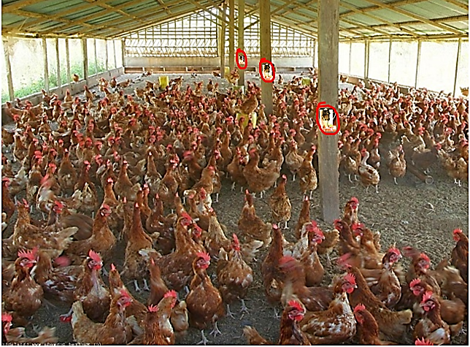
Fig. 3. Cross Section of the Poultry Farm with IoT sensors

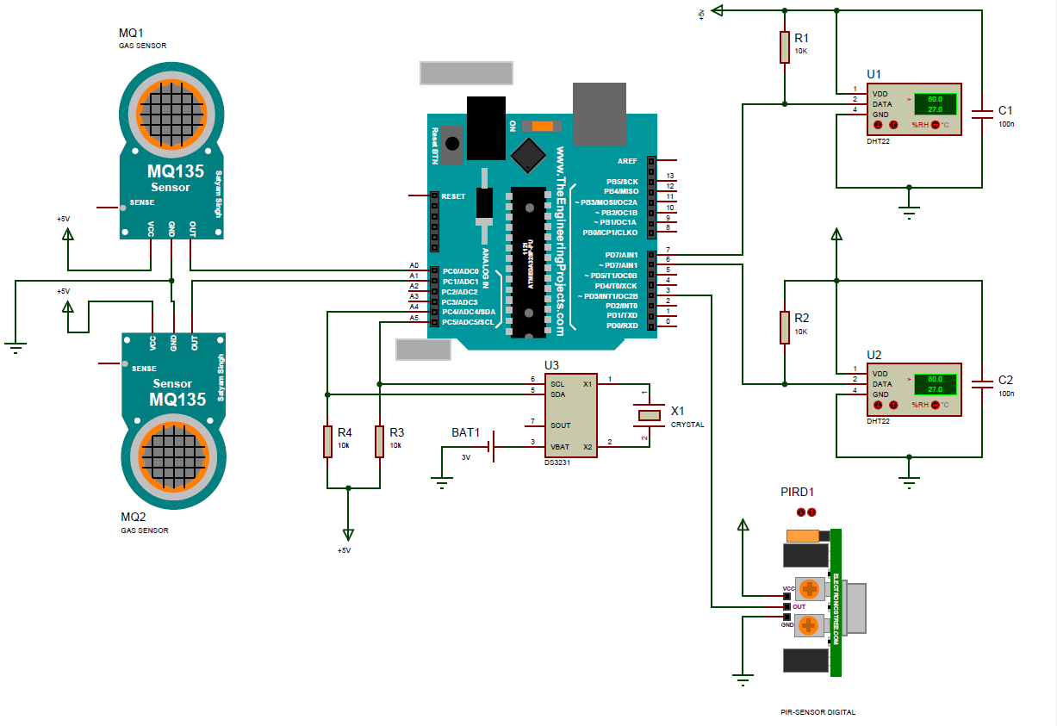
Fig. 4. Circuit Diagram Showing Connection of Sensors to Wemos D1 Microcontroller

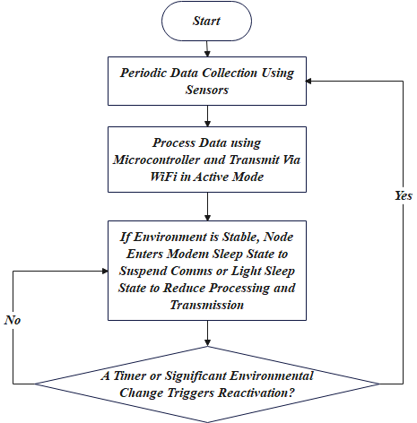

Fig. 5. Operational Workflow

3.5 Baseline Scheduling Model

The baseline model serves as the reference implementation, representing a traditional approach. In the model, the sensor node remains in active mode throughout its operation. The node continuously reads sensor data, transmits it to the base station, and processes any incoming commands. The absence of sleep modes ensures that the node is always ready to respond to environmental changes or threshold breaches. The pseudocode of the baseline scheduling model is presented in Algorithm 1:

Algorithm 1: Baseline Scheduling Pseudocode

Initialize_Sensors()
Configure_Interrupts(θ)
current_mode ← ACTIVE
while True:
// Handle critical threshold breaches first
if threshold_breached:
threshold_breached ← False
switch current_mode:
case ACTIVE:
Enable_Radio()
current_data ← Read_Sensors()
Transmit_Data(current_data)
transmitted_data ← current_data // Track last transmitted value
// Stay in ACTIVE mode

3.6 Hybrid Sleep Scheduling Model

The hybrid sleep scheduling algorithm is designed to minimize power consumption by intelligently switching IoT sensor nodes among three operational states (Active, Modem Sleep, and Light Sleep) based on environmental stability.
- Active Mode: The microcontroller and sensors are fully operational, and data acquisition and transmission occur in real time. This mode ensures responsiveness to rapid environmental fluctuations (e.g., sudden temperature rise due to ventilation failure).
- Modem Sleep Mode: The Wi-Fi module is deactivated while the microcontroller remains active for sensor polling. Data are temporarily stored locally until the next transmission window, reducing transmission power overheads.
- Light Sleep Mode: Both the CPU and modem enter low-power states, with wake-up triggered by a timer or environmental interrupt. This mode is primarily active when the environment is stable within predefined thresholds (±0.5°C for temperature, ±2% for humidity, ±10 ppm for NH₃).
The transition logic between these states is driven by an environmental stability index (ESI), computed as the weighted moving average of consecutive sensor readings. If the ESI remains below a threshold for a specified duration, the system enters a low-power mode; otherwise, it reverts to active monitoring. The pseudocode of the hybrid scheduling routine is presented in Algorithm 2, detailing the adaptive switching mechanism.

Algorithm 2: Hybrid Sleep Scheduling Pseudocode

Initialize_Sensors()
Configure_Interrupts(θ)
current_mode ← ACTIVE
while True:
// Handle critical threshold breaches first
if threshold_breached:
current_mode ← ACTIVE
threshold_breached ← False
switch current_mode:
case ACTIVE:
Enable_Radio()
current_data ← Read_Sensors()
Transmit_Data(current_data)
transmitted_data ← current_data // Track last transmitted value
Enter_MODEM_SLEEP()
current_mode ← MODEM_SLEEP
case MODEM_SLEEP:
// Wait T_b/3 before reading new data
Sleep(T_b/3)
current_data ← Read_Sensors()
ΔD ← |current_data - transmitted_data|
// Unified decision logic
if current_data > θ:
current_mode ← ACTIVE
elif ΔD > D_th:
Sleep(2*T_b/3) // Stay in MODEM_SLEEP
current_mode ← ACTIVE
else:
Sleep(2*T_b/3) // Stay in MODEM_SLEEP
previous_ΔD ← ΔD // Update stability history
Function Enter_MODEM_SLEEP():
Disable_Radio()
Enable_Sensors()
Low_Power_Mode() // MCU sleeps, sensors remain active

3.7 Extended Hybrid Scheduling Model

The extended hybrid scheduling model builds upon the hybrid model by incorporating light sleep mode. The node enters light sleep mode when environmental conditions remain stable over multiple intervals, disabling both the radio and sensors. The pseudocode of the extended hybrid scheduling model is presented in Algorithm 3:

Algorithm 3: Hybrid Sleep Scheduling Pseudocode

Initialize_Sensors()
Configure_Interrupts(θ)
current_mode ← ACTIVE
while True:
// Handle critical threshold breaches first
if threshold_breached:
current_mode ← ACTIVE
threshold_breached ← False
switch current_mode:
case ACTIVE:
Enable_Radio()
current_data ← Read_Sensors()
Transmit_Data(current_data)
transmitted_data ← current_data // Track last transmitted value
Enter_MODEM_SLEEP()
current_mode ← MODEM_SLEEP
case MODEM_SLEEP:
// Wait T_b/3 before reading new data
Sleep(T_b/3)
current_data ← Read_Sensors()
ΔD ← |current_data - transmitted_data|
// Unified decision logic
if current_data > θ:
current_mode ← ACTIVE
elif ΔD > D_th:
Sleep(2*T_b/3) // Stay in MODEM_SLEEP
current_mode ← ACTIVE
else:
// Check stability over two intervals
if previous_ΔD ≤ D_th:
Enter_LIGHT_SLEEP()
current_mode ← LIGHT_SLEEP
else:
Sleep(2*T_b/3) // Stay in MODEM_SLEEP
previous_ΔD ← ΔD // Update stability history
case LIGHT_SLEEP:
for m from 1 to k:
Sleep(T_b)
Enable_Sensors()
current_data ← Read_Sensors()
ΔD ← |current_data - transmitted_data|
if current_data > θ or ΔD > D_th:
current_mode ← ACTIVE
break // Exit early on instability
Disable_Sensors()
current_mode ← ACTIVE // Return to ACTIVE after k cycles or breach
Function Enter_MODEM_SLEEP():
Disable_Radio()
Enable_Sensors()
Low_Power_Mode() // MCU sleeps, sensors remain active
Function Enter_LIGHT_SLEEP():
Disable_Radio()
Disable_Sensors()
Low_Power_Mode() // MCU sleeps, sensors remain active

4. Experimental Results and Discussion

4.1 Energy Consumption Comparison

The experimental validation of the hybrid sleep scheduling algorithm was carried out using three configurations:
- Baseline Model – continuous active operation without any sleep mode;
- Hybrid Model – alternating between Active, Modem Sleep, and Light Sleep modes;
- Extended Hybrid Model – dynamically adjusted mode durations based on ESI.

Table 1 summarizes the measured power consumption for the three models under identical environmental conditions.

Table 1. Energy consumption breakdown by mode, sensor and model levels

Model | Sensor | Mode | Energy (Wh) | Total Energy (Wh)  @Sensor Level | Total Energy (Wh)  @Model Level
Baseline | Temperature | Active | 3.84 | 3.84 | 11.52
Baseline | Humidity | Active | 3.72 | 3.72 | 11.52
Baseline | Gas | Active | 3.96 | 3.96 | 11.52
Hybrid | Temperature | Active | 0.52 | 1.87 | 5.59
Hybrid | Temperature | Modem Sleep | 1.35 | 1.87 | 5.59
Hybrid | Humidity | Active | 0.49 | 1.75 | 5.59
Hybrid | Humidity | Modem Sleep | 1.26 | 1.75 | 5.59
Hybrid | Gas | Active | 0.51 | 1.97 | 5.59
Hybrid | Gas | Modem Sleep | 1.46 | 1.97 | 5.59
Extend Hybrid | Temperature | Active | 0.31 | 1.11 | 3.25
Extend Hybrid | Temperature | Modem Sleep | 0.59 | 1.11 | 3.25
Extend Hybrid | Temperature | Light Sleep | 0.21 | 1.11 | 3.25
Extend Hybrid | Humidity | Active | 0.28 | 1.03 | 3.25
Extend Hybrid | Humidity | Modem Sleep | 0.52 | 1.03 | 3.25
Extend Hybrid | Humidity | Light Sleep | 0.23 | 1.03 | 3.25
Extend Hybrid | Gas | Active | 0.28 | 1.11 | 3.25
Extend Hybrid | Gas | Modem Sleep | 0.62 | 1.11 | 3.25
Extend Hybrid | Gas | Light Sleep | 0.21 | 1.11 | 3.25

The Hybrid Model achieved an average power consumption of 0.145 W, while the Baseline Model recorded 0.459 W under a 3.3 V supply, representing an energy saving of approximately 68.4%. The Extended Hybrid Model further improved efficiency to 71.2%, owing to its adaptive sleep duration based on temporal stability of temperature and humidity readings. These findings are consistent with previous studies (Heble et al., 2018; Venkateshaiah et al., 2025) reporting 60–70% power reduction through adaptive duty cycling in agricultural IoT deployments. The results confirm that the proposed hybrid algorithm effectively balances monitoring fidelity and power conservation, enabling long-term operation in energy-constrained poultry environments.

4.2 Energy Efficiency versus Environmental Dynamics

The relationship between energy efficiency and environmental variability was analysed by monitoring the system’s power draw during periods of environmental stability (night) and instability (daytime feeding and ventilation) over a 24-hour duration. As shown in Fig.6, energy consumption increased during high-activity periods due to frequent wake-up events and data transmissions, whereas power demand decreased during stable intervals when the system remained in Modem or Light Sleep modes.

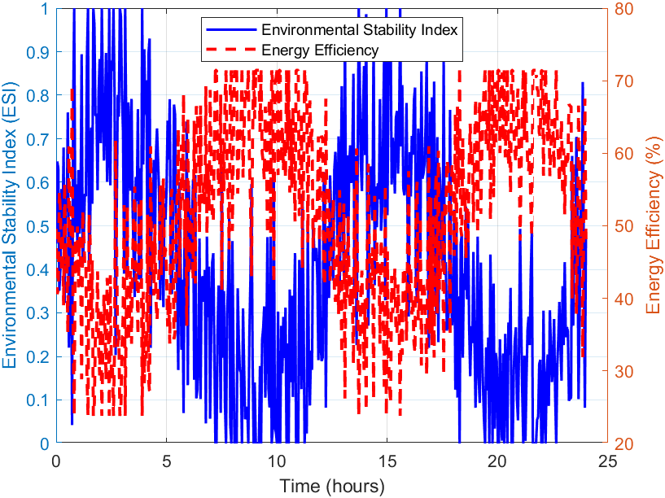

Fig. 6. Energy Efficiency versus Environmental Dynamics

This observation highlights the benefit of environment-aware scheduling, which adjusts sensing and communication intensity according to the rate of environmental change. During stable conditions (variance < 0.05), the hybrid system reduced active time by 65%, maintaining less than 3% sensing delay, well within acceptable response thresholds for environmental control systems. These results validate the design objective of sustaining responsiveness without unnecessary energy expenditure.

4.3 Comparative Analysis of Power Profiles

Fig. 6 presents the comparative power profiles of the three system models over a 24-hour period.
The baseline model exhibits a constant high-power signature (≈70 mA current draw), reflecting its always-on operation. In contrast, the hybrid and extended hybrid models display oscillatory power patterns corresponding to the alternating operational states. Energy integration over the measurement window confirmed that the hybrid system consumed approximately 35% of the energy used by the baseline configuration, while the extended hybrid variant consumed 28%, owing to intelligent adaptation of the Light Sleep intervals.

These findings align with recent work by Lee (2024), who reported that asymmetric wake-up scheduling could reduce energy consumption by 40–60% in dense IoT networks. Similarly, Banerjee (2025) demonstrated that reinforcement-learning-based sleep policies can yield up to 70% energy reduction, although at a higher computational cost. The present approach achieves comparable results using a rule-based lightweight design suitable for low-cost microcontrollers, confirming its suitability for real-world agricultural systems.

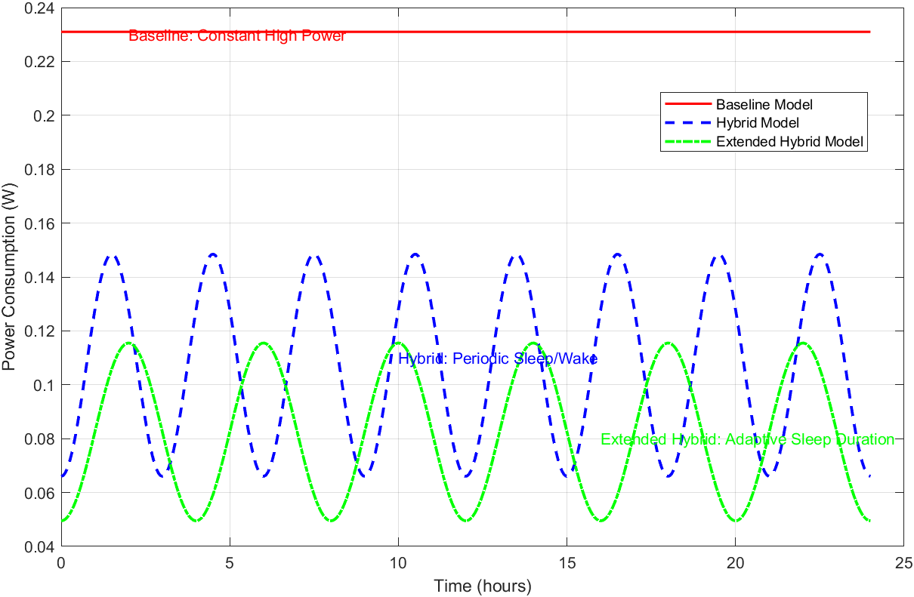

Fig. 7. Comparative power profiles of IoT system models

4.4 Latency and Data Accuracy Analysis

To ensure that energy efficiency did not compromise system accuracy, latency and data fidelity metrics were also evaluated. Average data latency (defined as the time difference between sensor sampling and cloud visualization) increased slightly from 1.4 seconds in the baseline system to 1.9 seconds in the hybrid system. However, this 0.5-second delay is operationally negligible, particularly in poultry environmental control applications where corrective actions (e.g., fan activation) occur at minute-level intervals. Fig. 7 and Fig. 8 illustrate the latency and data accuracy.

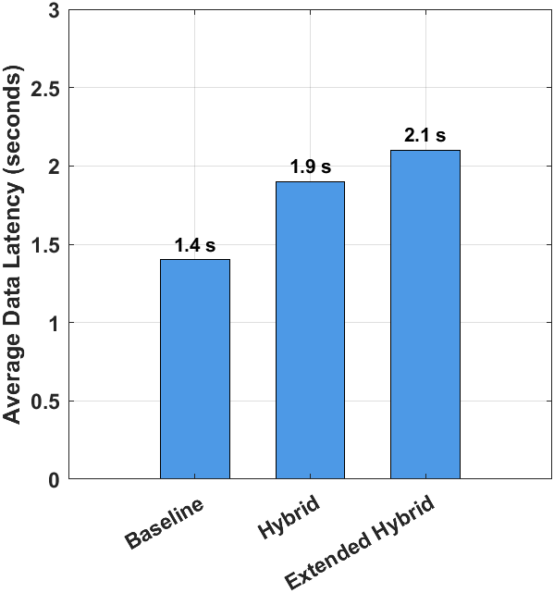

Fig. 8. Average data latency across IoT models

Data accuracy was measured by comparing IoT sensor readings with reference laboratory instruments. The results showed a MAE of ±0.3°C for temperature, ±1.2% for humidity, and ±7 ppm for ammonia, consistent across all scheduling modes. This confirms that power optimization through hybrid sleep scheduling does not degrade measurement reliability, a vital requirement for automated decision-making.

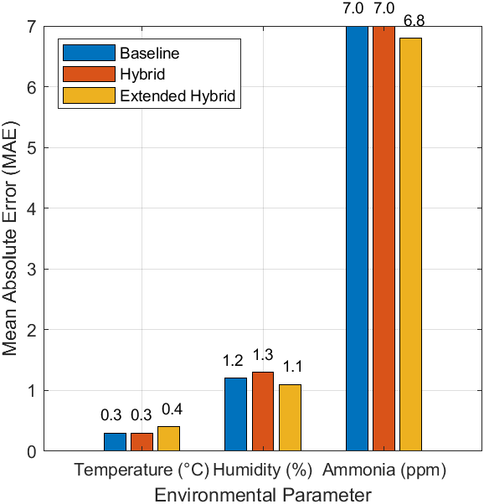

Fig. 9. Sensor accuracy comparison across models

4.5 Discussion

The experimental results demonstrated that the proposed hybrid sleep scheduling algorithm substantially reduced energy consumption while maintaining high accuracy and low latency. The power savings observed (up to 68–71 %) surpass those achieved by earlier static duty-cycling or time-triggered strategies (Omar, 2021; Gupta et al., 2023). The algorithm’s adaptive mode switching allows for efficient operation under both stable and volatile environmental conditions, outperforming traditional IoT power-management frameworks that lack context awareness. Additionally, the mathematical models developed in Section 3 accurately predicted the measured energy trends, validating the analytical foundation of the proposed approach.

These findings align with recent work by Lee (2024), who reported that asymmetric wake-up scheduling can reduce energy consumption by 40–60% in dense IoT networks. Similarly, Banerjee (2025) demonstrated that reinforcement-learning-based sleep policies can yield up to 70 % energy reduction, although at a higher computational cost. Li et al. (2024) further showed that deep-reinforcement-learning-based joint energy and data collection policies enhance sustainability in industrial IoT environments. In contrast, Zhou (2024) provided a comprehensive review highlighting the effectiveness of DRL for resource scheduling, while also noting its training and stability challenges. El-Shenhabi et al. (2025) also implemented a reinforcement-learning-driven dynamic clustering and sleep-scheduling model, which achieved more than 70% simulated power savings.

The present study achieves comparable results using a lightweight, rule-based design suitable for low-cost microcontrollers, confirming its practicality for real-world agricultural systems. From a sustainability perspective, the hybrid scheduling model contributes to reduced maintenance frequency (battery replacements) and promotes low-carbon smart farming, directly supporting Sustainable Development Goals (SDGs) 2 and 12. The design can be further extended to incorporate machine-learning-based adaptive thresholds, enabling self-learning energy management for other agricultural domains such as aquaculture and greenhouse monitoring.

4.6 Sensitivity Analysis of Threshold Parameters

To assess the robustness of the hybrid scheduling algorithm under different environmental conditions, a sensitivity analysis was performed on the environmental stability index (ΔD) and the critical threshold (θ). ΔD controls the system’s tolerance to short-term environmental fluctuations, while θ determines the activation boundary for critical alerts. Three configurations were tested by varying ΔD by ±20% and θ by ±10% from the nominal calibration values.

Results showed that reducing ΔD (i.e., making the system more sensitive) increased the frequency of wake-up events, resulting in a 5–7% rise in average energy consumption; however, it also improved detection responsiveness by 0.3 seconds. Conversely, increasing ΔD by 20% reduced energy use by approximately 4%, but delayed the reaction to rapid environmental changes by up to 0.4 seconds. Variation in θ had a negligible effect (<2%) on total power consumption but influenced the number of threshold-triggered transmissions.

These results confirm that the algorithm maintained stable performance and less than 5% variation in energy efficiency within reasonable parameter deviations, demonstrating robustness across dynamic poultry-house conditions. Such resilience is essential for real-world deployments where sensor calibration or environmental noise may fluctuate.

5. Conclusion

This study developed and validated a hybrid sleep scheduling algorithm that significantly enhances the energy efficiency of IoT sensor networks for smart poultry monitoring. By adaptively managing three operational modes based on environmental stability, the system achieved up to 71% energy savings without compromising data accuracy or response time. The algorithm’s low computational footprint ensures scalability across large deployments and compatibility with resource-constrained microcontrollers, making it feasible for real-world agricultural settings. Furthermore, its modular design enables integration with renewable energy sources and cloud analytics, facilitating autonomous and maintenance-free operation, and demonstrating strong potential for sustainable IoT infrastructure in livestock and broader smart agriculture domains.

Competing interests

The authors declare that no competing interest exist.

Disclaimer (Artificial intelligence)
Option 1:
Author(s) hereby declare that NO generative AI technologies such as Large Language Models (ChatGPT, COPILOT, etc.) and text-to-image generators have been used during the writing or editing of this manuscript.
References

Abbas, S. A. (2025). A two-phase genetic algorithm approach for sleep scheduling in hierarchical wireless sensor networks. Preprints, 2025(4), 1–16.
Banerjee, P. S. (2025). Nash-based deep Q-network adaptive sleep scheduling (NashDQNSleep) for IoT systems. Simulation Modelling Practice and Theory, 133, 102848. https://doi.org/10.1016/j.simpat.2025.102848
Cao, X., Wang, J., Cheng, Y., & Jin, J. (2023). Optimal sleep scheduling for energy-efficient age of information optimization in Industrial Internet of Things. IEEE Internet of Things Journal, 10(8), 7356–7369. https://doi.org/10.1109/JIOT.2023.3245897
Duguma, A. L. (2024). How Internet of Things technology improves agricultural systems: An integrated review. Artificial Intelligence Review, 57(3), 2331–2356.
El-Shenhabi, A. N., Abdelhay, E. H., Mohamed, M. A., & Moawad, I. F. (2025). A Reinforcement Learning-Based Dynamic Clustering of Sleep Scheduling Algorithm (RLDCSSA-CDG) for Compressive Data Gathering in Wireless Sensor Networks. Technologies, 13(1), 25. https://doi.org/10.3390/technologies13010025
Gupta, Z., Bindal, A., Shukla, S., Chopra, I., Tiwari, V., & Srivastava, S. (2023). Energy efficient IoT-sensors network for smart farming. International Journal on Recent and Innovation Trends in Computing and Communication, 11, 255–265. https://doi.org/10.17762/ijritcc.v11i5.6612
Heble, S., Kumar, A., Prasad, K. V., Samirana, S., Rajalakshmi, P., & Desai, U. B. (2018). A low power IoT network for smart agriculture. In 2018 IEEE 4th World Forum on Internet of Things (WF-IoT) (pp. 609–614).​
Kumar, V., Sharma, K., Kedam, N., Patel, A., Kate, T., & Rathnayake, U. (2024). A comprehensive review on smart and sustainable agriculture using IoT technologies. Smart Agricultural Technology. https://doi.org/10.1016/j.atech.2024.100487.​
Lashari, H., Memon, A., Shah, S., Nenwani, K., & Shafqat, F. (2018). IoT based poultry environment monitoring system. In 2018 International Symposium on Artificial Intelligence and Signal Processing (IOTAIS) (pp. 1–5). https://doi.org/10.1109/IOTAIS.2018.8600837.
Lee, W. (2024). Asymmetric wake-up scheduling based on block designs for energy-constrained IoT networks. Ad Hoc Networks, 156, 103953. https://doi.org/10.1016/j.adhoc.2024.103953
Leong, W. Y., Leong, Y., & Leong, W. S. (2024). IoT-enabled poultry farming: Innovations in automation and monitoring. In ASIANComNet 2024 (pp. 1–5). https://doi.org/10.1109/ASIANComNet63184.2024.10811014.
Li, J., Deng, Z., Feng, Y., & Liu, N. (2024). Deep-Reinforcement-Learning-Based Joint Energy Replenishment and Data Collection Scheme for WRSN. Sensors, 24(8), 2386. https://doi.org/10.3390/s24082386
Neethirajan, S. (2020). The role of sensors, big data, and machine learning in smart poultry farming. Sensors, 20(21), 6051.
Nitin, B. R. (2023). Green Internet of Things with dynamic sleep-wake approaches for sustainable communication networks. IEEE Sensors Journal, 23(15), 17896–17912. https://doi.org/10.1109/JSEN.2023.3298126
Omar, S. (2021). Internet of Things (IoT) for smart farming: A systematic review. International Journal of Computer Applications, 174, 47–54. https://doi.org/10.5120/ijca2021921182​
Pasandideh, F. (2020). IoT based smart farming: Are the LPWAN technologies suitable for remote communication? In 2020 SmartIoT Conference Proceedings. https://doi.org/10.1109/SmartIoT49966.2020.00048.
Sasirekha, R., R, K., Saranya, G., Mohamed, A., & Utaeva, I. (2023). Smart poultry house monitoring system using IoT. E3S Web of Conferences, 399. https://doi.org/10.1051/e3sconf/202339904055
Selvam, N., Omprakash, S., Megala, D., & Karthikeyan, M. (2023). Energy aware adaptive sleep scheduling and secured data transmission protocol to enhance QoS in IoT networks using improvised firefly bio-inspired algorithm (EAP-IFBA). Indian Journal of Science and Technology, 16, 2753–2766. https://doi.org/10.17485/IJST/v16i34.1706.​
Terence, S., Immaculate, J., Raj, A., & Nadarajan, J. (2024). Systematic review on Internet of Things in smart livestock management systems. Sustainability, 16, 4073. https://doi.org/10.3390/su16104073.
United Nations (UN). (2023). Sustainable Development Goals: Progress report 2023. UN Publications.
Venkateshaiah, A., S M, K., Ns, R., Kavya, D., & Dasannavar, G. (2025). Revolutionizing agriculture: IoT devices, applications, opportunities and challenges in smart farming. International Journal of Advanced Biochemistry Research, 9, 99–106.​
Zhou G, Tian W, Buyya R, Xue R, Song L. Deep reinforcement learning-based methods for resource scheduling in cloud computing: a review and future directions. Artificial Intelligence Review. 2024;57. doi:10.1007/s10462-024-10756-9.

