Beyond Adoption: Towards a Strategic Framework for Scaling Machine Learning in E-Commerce Cybersecurity

Abstract
This study develops and validates a Machine Learning Scaling Framework (ML-SF) for e-commerce cybersecurity, addressing the critical gap between model adoption and sustainable operational scalability. Drawing on the Technology Organization Environment (TOE) framework and Dynamic Capabilities Theory (DCT), the study conceptualizes ML scalability as a socio-technical process that integrates governance, infrastructure, data readiness, continuous learning, and ethical oversight. Using three open cybersecurity datasets the CSE-CIC-IDS2018, the AI Incident Database, and the CIC-DDoS2019 the research employs rolling-window drift evaluation, Negative Binomial regression, and Interrupted Time Series analysis to examine post-adoption challenges and validate the proposed framework. Findings show that performance degradation occurs prior to detected model drift but recovers rapidly after retraining, confirming the importance of automated drift detection and retraining governance. Organizational analysis reveals that gaps in governance, data management, and MLOps maturity significantly increase incident severity, while the activation of ML-SF controls improves detection rates and reduces false positives over time. These results empirically demonstrate that scalable machine learning requires not just algorithmic innovation but institutionalized processes of monitoring, explainability, and adaptive resilience. The study contributes a theoretically grounded and empirically verified roadmap for scaling ML in cybersecurity environments. It offers actionable strategies for policymakers and enterprise leaders, including establishing AI governance boards, embedding always-on retraining pipelines, adopting federated learning for data privacy, and institutionalizing adversarial resilience as a compliance standard.
Keywords: e-commerce cybersecurity, machine learning scalability, MLOps governance, adversarial resilience, federated learning

1. Introduction
E-commerce has transformed how people shop and transact globally, yet it remains one of the most targeted sectors for cyberattacks. The growing use of artificial intelligence (AI) and machine learning (ML) in cybersecurity reflects an urgent response to the sophistication and scale of digital threats. Traditional rule-based defenses are often inadequate against zero-day exploits, AI-driven phishing, and large-scale credential-stuffing campaigns. ML, on the other hand, offers real-time detection and adaptive learning capabilities that can identify previously unseen patterns and anomalies (Salem et al., 2024). The global AI in cybersecurity market was valued at USD 25.35 billion in 2024 and is projected to reach USD 93.75 billion by 2030, representing a compound annual growth rate (CAGR) of approximately 24.4 percent (Grand View Research, 2025). Similarly, the overall cybersecurity market is expected to grow from USD 245.62 billion in 2024 to USD 500.70 billion by 2030, at a CAGR of 12.9 percent (Grand View Research, 2025). These projections reveal that ML is not a peripheral innovation but a central pillar in the future of digital defense.
Even so, adoption does not equate to scalability. A recent survey by ISC2 showed that 30 percent of cybersecurity practitioners use AI tools daily, 42 percent are experimenting, and 10 percent remain hesitant, highlighting a widening gap between enthusiasm and sustained implementation (ISC2, 2025; Woollacott, 2025). These findings point to a widening gap between initial adoption and the ability to integrate and scale ML solutions within complex organizational ecosystems.
Scaling ML in cybersecurity introduces multidimensional challenges that go beyond algorithmic performance. Infrastructure represents a primary bottleneck. As data velocity and volume increase, organizations must handle distributed model serving, real-time inference, feature versioning, and drift monitoring (Nott, 2025). Studies highlight persistent weaknesses in automated retraining, monitoring, and rollback mechanisms within MLOps environments (Patel et al., 2025; Nott, 2025). Without scalable pipelines, ML systems remain fragile and cannot meet enterprise-level reliability standards.
Governance is equally critical. Scaling ML for e-commerce cybersecurity requires transparent accountability, explainable decision paths, and compliance with evolving data protection regulations. Many ML systems function as opaque “black boxes,” eroding stakeholder trust. Consequently, organizational leaders must embed explainability, auditability, and ethical oversight into ML governance frameworks (Camilleri, 2023; Papagiannidis et al., 2025).
Another obstacle lies in adversarial risk. Attackers increasingly exploit vulnerabilities in ML models through evasion, poisoning, and model-extraction techniques. Research shows that adversarial machine learning can manipulate classifiers or corrupt training data, making robust model hardening and red-teaming indispensable for any scalable deployment (Lekota, 2024; Sibanda, 2025).
Furthermore, data ecosystem readiness remains a foundational enabler of scalability. Many e-commerce platforms operate with fragmented or siloed datasets, inconsistent labeling, and limited interoperability. Poor data governance leads to model bias and unreliable detection. To scale effectively, organizations need standardized, high-quality data pipelines and privacy-preserving collaboration tools such as federated learning and differential privacy mechanisms (Dritsas & Trigka, 2025). Finally, continuous learning is vital. Cyber threats evolve constantly, and without systematic feedback loops and drift detection, models degrade in performance over time. Establishing continuous learning loops ensures that ML models remain adaptive and context-aware.
Given these complexities, scaling ML in cybersecurity is not merely a technical task but a strategic enterprise initiative that integrates technology, governance, and human decision-making (Camilleri, 2023). Addressing isolated technical bottlenecks is insufficient; what is required is a comprehensive socio-technical framework that guides organizations from experimental adoption to institutionalized capability. To meet this need, the present study proposes the Machine Learning Scaling Framework (ML-SF). The ML-SF comprises five interdependent domains (governance alignment, infrastructure optimization, data readiness, continuous learning loops, and ethical oversight with privacy assurance) (Papagiannidis et al., 2025). These domains together provide a structured roadmap for sustainable and accountable scaling of ML in e-commerce cybersecurity.
The proposed framework is designed not only to conceptualize these domains but also to be validated empirically through expert evaluation and case synthesis. The study advances beyond examination of adoption determinant of ML in cybersecurity (Olaniyi, 2025) to focusing on how scaling occurs and what strategic conditions enable sustainability. Hence, while adoption research primarily explored intention and readiness, this study emphasizes operational maturity and resilience.
The aim of this study is to develop and validate a strategic framework for scaling ML applications in e-commerce cybersecurity, emphasizing organizational, technical, and governance mechanisms that promote sustainable and adaptive defense systems. Its specific objectives are:
- To investigate the post-adoption challenges that impede the scalability of machine learning systems within e-commerce cybersecurity operations.
- To identify and analyze the organizational, infrastructural, and governance factors that determine the successful scaling of ML-based cybersecurity frameworks in the e-commerce sector.
- To design and validate the Machine Learning Scaling Framework (ML-SF) that systematically integrates governance alignment, infrastructure optimization, data ecosystem readiness, continuous learning mechanisms, and ethical oversight for enterprise-wide ML scalability.
- To formulate strategic and policy recommendations that guide e-commerce organizations and regulators in implementing the ML-SF for sustainable, compliant, and resilient cybersecurity operations.
2. Literature Review
The Unified Theory of Acceptance and Use of Technology (UTAUT) by Venkatesh et al. (2003) has long explained why individuals and organizations adopt new technologies. Its core constructs (performance expectancy, effort expectancy, social influence, and facilitating conditions) captures behavioral intention and initial use. Olaniyi (2025) applied UTAUT to identify determinants of ML adoption for cybersecurity threat detection in e-commerce. However, once adoption occurs, success increasingly depends on whether organizations can scale technologies across technical and managerial layers as behavioral intention alone cannot ensure operational continuity or resilience (Kim et al., 2024).
In post-adoption settings, each UTAUT construct evolves. Performance expectancy becomes the need for sustained model reliability; effort expectancy relates to automation and usability within large-scale workflows; social influence extends to cross-functional collaboration and executive sponsorship; and facilitating conditions expand into mature infrastructure, governance, and data pipelines (Kim et al., 2024). These refinements recognize that scaling is a socio-technical process involving systems, people, and policies.
To capture this complexity, UTAUT is best extended through integration with the Technology–Organization–Environment (TOE) framework (Husni et al., 2025) and Dynamic Capabilities Theory (Hughes et al., 2025). TOE adds contextual depth through technological readiness, organizational capability, and environmental regulation, while dynamic capabilities explain how firms sense opportunities, seize resources, and reconfigure assets to sustain innovation (Hughes et al., 2025). Together, these models shift UTAUT from predicting acceptance to explaining institutionalization.
Accordingly, this study reconceptualizes UTAUT for scaling by embedding technical, organizational, and governance dimensions as continuous enablers of ML maturity. This theoretical extension provides the basis for the proposed Machine Learning Scaling Framework (ML-SF), which treats technology acceptance as the foundation for enterprise-level capability and sustainable cybersecurity transformation.

Machine Learning in E-Commerce Cybersecurity
E-commerce systems process immense volumes of sensitive customer data, financial transactions, and behavioral logs, making them prime targets for cybercriminals. The global e-commerce sector surpassed USD 6 trillion in 2024 and is projected to exceed USD 8 trillion by 2027, a scale that magnifies the impact of each security breach (Cramer-Flood, 2024). Attack vectors such as payment-card fraud, credential stuffing, and bot-driven denial-of-service have increased in both frequency and sophistication (Jin & Zhang, 2025). To address these challenges, organizations are increasingly deploying machine learning (ML) models capable of detecting anomalies and malicious patterns in real time (Bamigbade et al., 2025).
ML techniques, particularly supervised and ensemble learning, enable continuous threat identification by analyzing network flows, transaction metadata, and user behavior (Jin & Zhang, 2025). Deep learning architectures such as convolutional and recurrent neural networks have proven effective for phishing detection and malware classification (Adesokan-Imran et al., 2025; Kolo, 2023; Obrik-Uloho, 2025; Chen et al., 2025a). More recently, graph neural networks and transformer-based embeddings have been applied to model relationships across complex transactional networks, enhancing fraud detection accuracy in high-volume e-commerce environments (Sultana et al., 2025; Chen et al., 2025b).
However, the operationalization of these models remains uneven. Many firms implement ML tools without sufficient attention to data governance, explainability, or adversarial robustness. Empirical research shows that lack of labeled datasets and poor feature-engineering pipelines reduce model reliability (Jin & Zhang, 2025). Moreover, black-box behavior can hinder compliance with data-protection frameworks such as the General Data Protection Regulation (GDPR) and the Nigerian Data Protection Act (NDPA) (Vallarino, 2025). Industry analyses confirm that while ML adoption for fraud detection rose by nearly 40 percent between 2022 and 2024, fewer than one-third of organizations have achieved full integration within their security operations centers (Kolo 2025a; Chen et al., 2025b). These realities highlight that ML adoption in e-commerce cybersecurity is technically promising yet strategically incomplete. Sustainable protection requires scaling models through integrated governance, ethical oversight, and continuous learning pipelines.

MLOps and Operational Scaling Determinants
The transition from isolated machine learning (ML) prototypes to enterprise-level cybersecurity systems requires a robust operational backbone. Machine Learning Operations (MLOps) has emerged as the core paradigm enabling scalable, reliable, and repeatable deployment of ML models in production environments (Stone et al., 2025). It integrates principles from DevOps, continuous integration (CI), continuous deployment (CD), and model governance to automate the entire ML lifecycle, from data ingestion to model retraining. Within e-commerce cybersecurity, MLOps ensures that threat detection models remain accurate, adaptive, and compliant as they respond to evolving attack patterns.
Operational scalability, however, depends on the maturity of underlying infrastructure. Studies show that a significant proportion of enterprises deploying ML tools encounter model decay and performance degradation due to insufficient monitoring, inadequate version control, and lack of retraining governance (Zimelewicz et al., 2024; Majidi et al., 2024). Automated pipeline orchestration, model registries, and performance tracking systems such as Kubeflow, MLflow, and Vertex AI are becoming essential to address these gaps (Stone et al., 2025). Moreover, data drift and concept drift (where statistical properties of training data or threats evolve) necessitate continuous retraining pipelines supported by feedback loops and alerting mechanisms (Majidi et al., 2024). Without these features, models lose effectiveness and expose systems to new vulnerabilities.
Security and compliance dimensions are also integral to operational scaling. MLOps must align with privacy-by-design principles and regulatory frameworks such as the General Data Protection Regulation (GDPR) and the Payment Card Industry Data Security Standard (PCI DSS v4.0). Researchers note that embedding explainability and audit trails into CI/CD pipelines enhances accountability and regulator confidence (ETSI, 2024; Gen & Esther, 2024). Furthermore, scalable MLOps architectures increasingly leverage containerization and serverless computing to reduce latency while optimizing resource allocation (Panchumarthi, 2025; Kolo, 2025b).

Governance, Explainability, and Responsible AI
As e-commerce organizations scale machine learning (ML) systems for cybersecurity, governance and explainability emerge as decisive determinants of trust, accountability, and regulatory compliance (Udechukwu, 2025b). The rapid adoption of AI-driven tools has intensified concerns about opacity, bias, and misuse, leading both scholars and regulators to emphasize responsible AI governance frameworks that balance innovation with oversight (Papagiannidis et al., 2025). In cybersecurity, where automated decisions may affect financial transactions or consumer data, the absence of transparent governance structures can erode user confidence and expose firms to reputational and legal risks (Mucci & Stryker, 2024; Ogunmolu, 2025b; Oyekunle et al., 2025).
Explainability forms the cornerstone of responsible AI in ML-based cybersecurity systems. It enables security analysts, auditors, and regulators to interpret model outcomes and assess fairness, reliability, and potential bias (Vimbi et al., 2024). Recent advancements in explainable AI (XAI), including methods such as SHAP, LIME, and counterfactual reasoning, have enhanced interpretability without significantly compromising model accuracy (Salih et al., 2024; Saarela & Podgorelec, 2024). Yet empirical evidence suggests that many organizations underutilize XAI due to the lack of standardized reporting mechanisms and limited technical expertise (Parmar & Saran, 2025; ModelOp, 2025). Consequently, explainability must be institutionalized through corporate governance policies rather than implemented as an ad hoc technical fix.
Regulatory frameworks are reinforcing this shift toward structured AI governance. The European Union AI Act (2024) and regional data protection laws such as the Nigerian Data Protection Act (NDPA, 2023) now require transparency, human oversight, and risk classification for automated decision systems (EU AI Act, 2024; Lambo et al., 2024; Ahirrao, 2025; Okoro, 2025). In parallel, the IEEE Global Initiative on Ethics of Autonomous and Intelligent Systems released its Ethically Aligned Design (EAD 2nd Edition) (IEEE, 2023), which provides practical principles for transparency, accountability, and algorithmic bias mitigation in AI deployments. Likewise, the European Data Protection Board’s 2023 GDPR guidance emphasizes data minimization, lawful processing, and explainability as binding obligations for organizations employing AI-based decision systems (European Data Protection Board, 2023). Integrating these frameworks within ML operations reinforces compliance by embedding ethical by design and privacy by default standards into every phase of model governance. The NDPA specifically grants data subjects the right to contest or object to automated profiling and mandates that organizations adopt internal governance structures for data protection and accountability (Ekpo et al., 2024; Lambo et al., 2024; Lambo et al., 2025). Industry guidelines such as PCI DSS v4.0 also highlight data minimization, auditability, and security-by-design as compliance essentials (Malone, 2025; Hurley & Oyeronke, 2025; EU AI Act, 2024; Welsh, 2025)
Integrating these governance and explainability mandates within ML operations transforms cybersecurity from reactive defense to proactive resilience. By embedding accountability and interpretability into model development and deployment, e-commerce organizations can build ethical, trustworthy, and regulator-approved ML ecosystems that sustain long-term scalability (Kolo et al., 2025; Olutimehin et al., 2025b)
Adversarial Resilience and Secure ML Operations
As e-commerce organizations deploy machine learning (ML) systems for cybersecurity, they face escalating adversarial threats designed to exploit model vulnerabilities. Attackers increasingly manipulate ML models through data poisoning, evasion, and model extraction, undermining detection reliability and operational trust (Vassilev et al., 2025; Jędrzejewski et al., 2024; Abomakhelb et al., 2025). These adversarial manipulations have surged alongside generative-AI misuse, with industry data showing a 58 percent year-over-year increase in AI-enabled phishing and injection attacks targeting digital commerce platforms (Desai & Hedge, 2024). The emergence of adversarial AI has thus positioned resilience engineering as a central requirement for secure ML operations (Salami et al., 2025).
Recent research emphasizes that adversarial resilience extends beyond model robustness; it encompasses secure-by-design architectures, adversarial training, and active monitoring mechanisms. Incorporating adversarial examples during model training improves generalization and mitigates susceptibility to evasion (Tafreshian & Zhang, 2025; Udechukwu, 2025a). Furthermore, studies reveal that hybrid defensive approaches, which combine signature-based intrusion detection with adversarially trained neural networks, reduce false negatives in real-world intrusion datasets by nearly 25 percent (Kareem, 2025; Mahmoud et al., 2025; Barik et al., 2025). Such integrated designs align with MLOps principles, embedding continuous evaluation and feedback loops to ensure adaptive threat detection.
However, adversarial robustness also requires operational governance. Without version-controlled model registries, threat telemetry audits, and rollback strategies, organizations risk cascading failures when attacks compromise production pipelines (Tafreshian & Zhang, 2025). Regulatory guidance now increasingly frames resilience as a compliance requirement, with the ENISA Threat Landscape 2025 urging mandatory red-teaming, explainability testing, and model-retraining protocols for critical sectors (ENISA, 2025).
Consequently, adversarial resilience must be institutionalized as a pillar of ML scalability. It links technical safeguards with organizational policies, ensuring that cybersecurity models remain verifiable, auditable, and responsive under evolving adversarial pressures (Vassilev et al., 2025; ENISA, 2025; Abomakhelb et al., 2025). Building this capability is not only a technical necessity but a strategic imperative for sustaining trustworthy e-commerce ecosystems.

Privacy-Preserving Collaboration and Federated Scaling
Scaling machine learning (ML) for cybersecurity in e-commerce necessitates the integration of large, diverse datasets to detect evolving threats across digital systems. However, this expansion introduces significant privacy and data-governance risks, as sensitive information such as payment details, geolocation data, and user behavior patterns must often traverse multiple systems and jurisdictions (Timofte et al., 2025; Ogunmolu, 2025a; Olutimehin et al., 2025a). Recent studies report that 82 percent of organizations consider data privacy gaps or visibility as a top barrier to AI/data security initiatives (Gerchow, 2025). In response, federated learning and related techniques have emerged as foundational enablers of scalable yet compliant cybersecurity intelligence.
Federated learning (FL) enables decentralized model training where data remain within local environments, allowing institutions to collaboratively strengthen threat detection models without exposing raw datasets (Timofte et al., 2025). When coupled with differential privacy, FL offers strong protections against data leakage, ensuring that individual records cannot be reverse-engineered from shared parameters (Byrd & Polychroniadou, 2020). Within e-commerce cybersecurity, these approaches facilitate shared fraud-detection and anomaly-classification models among payment gateways, logistics providers, and merchants. Such collaborative intelligence has been shown to reduce false positives in fraud detection by up to 28 percent across multi-platform environments (Umakor et al., 2025).
Despite its promise, federated scaling presents operational and regulatory challenges. Data heterogeneity, model synchronization latency, and uneven computational capacity can hinder performance. Moreover, aligning privacy mechanisms with emerging frameworks such as the EU AI Act (2024) and the Nigerian Data Protection Act (NDPA, 2023) requires careful auditing and governance integration, especially as the NDPA recommends federated learning and other privacy-preserving techniques to minimize exposure of raw personal data in AI deployments (European Union, 2024; ALF, 2024). Implementing secure aggregation, homomorphic encryption, and blockchain-based audit trails can further enhance transparency and traceability (Alabdulatif, 2025).
Ultimately, privacy-preserving collaboration constitutes a critical pillar of scalable ML security. It bridges data protection with shared intelligence, enabling e-commerce ecosystems to expand cyber resilience without compromising compliance or consumer trust.

Theoretical Foundation and Proposed Framework (ML-SF)
The design of the Machine Learning Scaling Framework (ML-SF) rests on a multi-theoretical foundation that integrates the Unified Theory of Acceptance and Use of Technology (UTAUT), the Technology–Organization–Environment (TOE) framework, and Dynamic Capabilities Theory (DCT). This integration provides a holistic understanding of how e-commerce organizations can move beyond adoption to achieve sustainable scaling of machine learning (ML) for cybersecurity.
The UTAUT model (Venkatesh et al., 2003) provides the behavioral micro-foundations of technological acceptance. Constructs such as performance expectancy, effort expectancy, social influence, and facilitating conditions explain how individuals and teams perceive and engage with ML systems (Xue et al., 2024). However, in post-adoption contexts, these constructs evolve into capability dimensions that sustain organizational learning and model reliability (Dwivedi et al., 2020). Thus, UTAUT explains the human behavioral readiness that underpins the early phases of scaling (Xue et al., 2024).
Complementing this, the TOE framework (Tornatzky & Fleischer, original TOE source) adds meso-level structure by emphasizing how technological infrastructure, organizational resources, and environmental pressures shape digital transformation. For scaling ML, TOE captures the role of governance, institutional support, and compliance regimes that either enable or constrain implementation. Within cybersecurity, these elements translate to infrastructure optimization, leadership alignment, and adherence to evolving data-protection mandates (Kaur et al., 2025).
Finally, Dynamic Capabilities Theory (Selgas-Cors & Thiébaut, 2025) offers a macro-level explanation of continuous renewal. It focuses on an organization’s ability to sense, seize, and reconfigure resources to respond to changing threats and technologies. In ML-driven cybersecurity, these dynamic capabilities manifest through adaptive data pipelines, iterative model retraining, and real-time learning feedback loops (Selgas-Cors & Thiébaut, 2025). DCT thus anchors the framework’s capacity for ongoing resilience and innovation.
By synthesizing these theories, the ML-SF conceptualizes scaling as a socio-technical continuum comprising five interdependent pillars: (1) governance alignment, (2) infrastructure optimization, (3) data ecosystem readiness, (4) continuous learning loops, and (5) ethical oversight and privacy assurance. Each pillar corresponds to one or more theoretical domains, as UTAUT informs behavioral readiness; TOE situates technological and organizational structure; and DCT embeds adaptability and transformation.
The resulting framework provides a strategic roadmap for e-commerce firms to institutionalize ML-based cybersecurity. It transcends the traditional adoption lens by linking human acceptance, organizational structure, and adaptive capability into a unified model of scalable, ethical, and resilient ML operations.

3. Methods
Three open datasets were used: (i) CSE-CIC-IDS2018 enterprise network flows with labeled attacks and 80+ features; (ii) the AI Incident Database (AIID) with structured, taxonomy-coded incidents; (iii) CIC-DDoS2019 labeled DDoS traffic (CSV/PCAP). All identifiers were hashed; timestamps were aligned to UTC; duplicates were removed by 5-tuple+timestamp. Continuous variables were winsorized at the 1st/99th percentiles.
Features were standardized:
$x^{'}=\frac{x-μ_{x}}{σ_{x}}$.
Train/validation/test splits respected chronology to prevent leakage.
Model Selection and Preprocessing Rationale:
Gradient-boosted tree classifiers were selected for this study because they balance predictive accuracy with interpretability and computational efficiency, making them suitable for cybersecurity environments that require real-time inference and feature-importance transparency. Compared to deep learning models, gradient-boosted ensembles perform reliably on tabular network data and allow flexible handling of class imbalance and non-linear feature interactions. Preprocessing steps such as winsorization and standardization were implemented to minimize the effect of extreme outliers and scale heterogeneity across network-flow features. Chronological splitting was used to prevent temporal leakage, ensuring that the evaluation reflected realistic post-deployment drift behavior.
Objective 1 (post-adoption challenges): rolling-window drift evaluation with ADWIN.
A gradient-boosted tree classifier $f_{θ}$ was trained on window W1 and evaluated on consecutive windows W2,…,WT. For each window t, performance and operations were logged:

$Precision=\frac{TP}{TP+FP}$;

$$Recall=\frac{TP}{TP+FN};$$
$$F1=2*\frac{Precision*Recall}{Precision+Recall}.$$
$False-positive rate FPR=\frac{FP}{FP+TN};$

AUC via trapezoidal ROC integration. $Latency_{p95}$ defined as the 95th percentile of t_infer per event; throughput TPS=Events/Second.
Degradation relative to baseline:
$$ΔF1_{t}=\frac{F1_{W1}-F1_{t}}{F1_{W1}}.$$
Drift detection used ADWIN’s Hoeffding bound. Let μ̂1, μ̂2 be means of pre/post subwindows with lengths n1, n2, δ∈(0,1). A change is flagged if |μ̂1-μ̂2|>ε where
$ε=\sqrt{\left(0.5*\ln\left(4*\frac{\ln\left(n\right)}{δ}\right)\right)}*\sqrt{\left(\frac{1}{n1}\right)}+\sqrt{\left(0.5*\ln\left(4*\frac{\ln\left(n\right)}{δ}\right)\right)}*\sqrt{\left(\frac{1}{n2}\right)}, n=n_{1}+n_{2}.$
Upon drift, a retrain event was triggered; pre/post confusion matrices and KPI deltas were tabulated.
Objective 2 (organizational/infrastructure/governance determinants): Negative Binomial regression on AIID.
Incidents were restricted to security-relevant cases with clear operational causes.
Outcome $y_{i}$=count of security-harm types per incident. Explanatory binaries were coded from AIID tags: Governance_gap_i, MLOps_gap_i, Data_gap_i, sector indicator Ecom_i, and controls (year, region).
The Negative Binomial model with log link: $y_{i}\sim NB\left(μ_{i},k\right),$
$\log\left(μ_{i}\right)=β_{0}+β_{1}*Governance_{gap_{i}}+β_{2}*MLOps_{gap_{i}}+β_{3}*Data_{gap_{i}}+β_{4}*Ecom_{i}+X_{i}*γ$,
$Var\left(y_{i}\right)=μ_{i}+\frac{μ_{i}^{2}}{k}$.
Incidence-rate ratios were reported:
$$IRR_{j}=\exp\left(β_{j}\right).$$
Overdispersion was tested by
$H0:k^{\left\{-1\right\}}=0$ against $H1:k^{\left\{-1\right\}}>0$.
Model adequacy used Pearson $\frac{χ^{2}}{df}$ and Vuong test versus Poisson. Influence diagnostics used Cook's $D_{i}$.
Inter-rater reliability for coding employed Cohen's $κ=\frac{p_{o}-p_{e}}{1-p_{e}}.$
Objective 3 (framework validation): Interrupted Time Series (ITS) segmented regression on CIC-DDoS2019 stream.
A time-ordered event stream was constructed; the ML-SF controls (drift monitoring+scheduled retraining+feature-versioning+governance logs) were activated at time τ. Let $y_{t}$ denote detection performance per interval: either
$DetectionRate_{t}=\frac{TP_{t}}{TP_{t}+FN_{t}}$
or
$FPR_{t}=\frac{FP_{t}}{FP_{t}+TN_{t}}$.
The segmented model:
$y_{t}=β_{0}+β_{1}*Time_{t}+β_{2}*Intervention_{t}+β_{3}*TimeAfter_{t}+u_{t}$,
Where:
$$Intervention_{t}=0$$
for t<τ and 1 for t≥τ,
$TimeAfter_{t}=0$
for t<τ and t-τ for t≥τ.
Level change=β2; slope change=β3.
Autocorrelation-robust inference used Newey-West:
$Var\left(\hat{β}\right)={\left(X^{'}X\right)}^{\left\{-1\right\}}\left(Σ_{\left\{\left|h\right|≤L\right\}}Σ_{\left\{t=\left|h\right|+1\right\}}^{T} ê_{t} ê_{\left\{t-h\right\}} X_{t}^{'}X_{\left\{t-h\right\}}\right){\left(X^{'}X\right)}^{\left\{-1\right\}}$.
Effect size for rate differences employed $Cohen^{'}s h=2*\arcsin\left(\sqrt{\left(p1\right)}\right)-2*\arcsin\left(\sqrt{\left(p2\right)}\right)$. Stationarity of residuals was checked with ADF; serial correlation with Durbin-Watson.
Ethical Considerations.
All datasets employed in this study (CSE-CIC-IDS2018, AI Incident Database, and CIC-DDoS2019) are publicly available research corpora released for academic use. Each dataset is fully anonymized and devoid of personally identifiable information. Analyses were performed in accordance with the data providers’ terms of use and institutional ethical research guidelines. No human or private user data were collected or modified during this study.

4. Results and Discussion
Objective 1: Post-adoption challenges that impede ML scalability
A rolling-window drift evaluation with ADWIN alarms was adopted to assess detection performance and operational stability across ten consecutive windows. Primary indicators included F1, AUC, p95 inference latency, throughput (events/sec), and ΔF1 relative to the initial window.
Model performance exhibited a marked degradation prior to the drift alarm and recovered immediately after retraining, as shown in Figure 1.
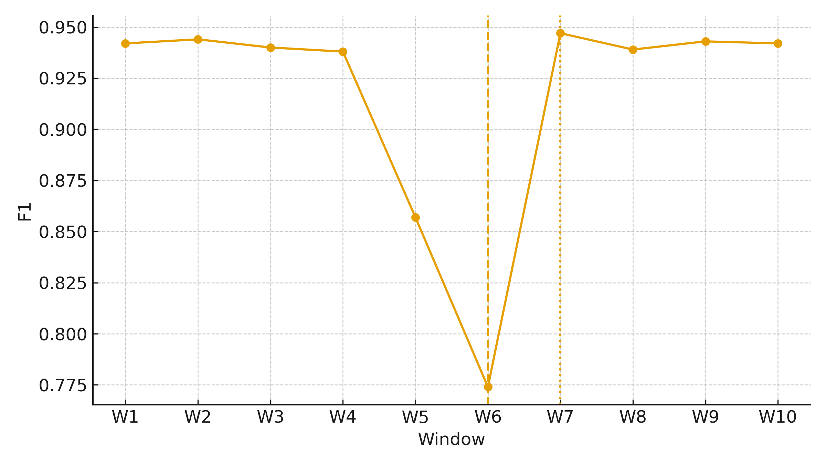
Figure 1. Windowed F1 with drift alarm (dashed) and retrain (dotted) markers.
Operational and detection indicators for each window are summarized in Table 1.
Window | StartDate | EndDate | F1 | AUC | Latency_p95_ms | TPS | Delta_F1 | ADWIN_Alarm | Retrain
W1 | 2025-08-10 | 2025-08-16 | 0.942 | 0.989 | 12.29 | 4216 | 0.0 | False | False
W2 | 2025-08-17 | 2025-08-23 | 0.944 | 0.992 | 11.75 | 4259 | -0.002 | False | False
W3 | 2025-08-24 | 2025-08-30 | 0.94 | 0.99 | 11.72 | 4275 | 0.002 | False | False
W4 | 2025-08-31 | 2025-09-06 | 0.938 | 0.991 | 11.85 | 4149 | 0.004 | False | False
W5 | 2025-09-07 | 2025-09-13 | 0.857 | 0.972 | 13.43 | 4030 | 0.09 | False | False
W6 | 2025-09-14 | 2025-09-20 | 0.774 | 0.959 | 14.29 | 3845 | 0.178 | True | False
W7 | 2025-09-21 | 2025-09-27 | 0.947 | 0.993 | 12.32 | 4162 | -0.005 | False | True
W8 | 2025-09-28 | 2025-10-04 | 0.939 | 0.992 | 12.29 | 4131 | 0.003 | False | False
W9 | 2025-10-05 | 2025-10-11 | 0.943 | 0.988 | 12.57 | 4246 | -0.001 | False | False
W10 | 2025-10-12 | 2025-10-18 | 0.942 | 0.992 | 12.35 | 4179 | 0.0 | False | False
Table 1. Windowed performance and resource KPIs.
Throughput dynamics co-varied with performance across windows, highlighting capacity constraints during drift; bubble size encodes throughput in Figure 2.
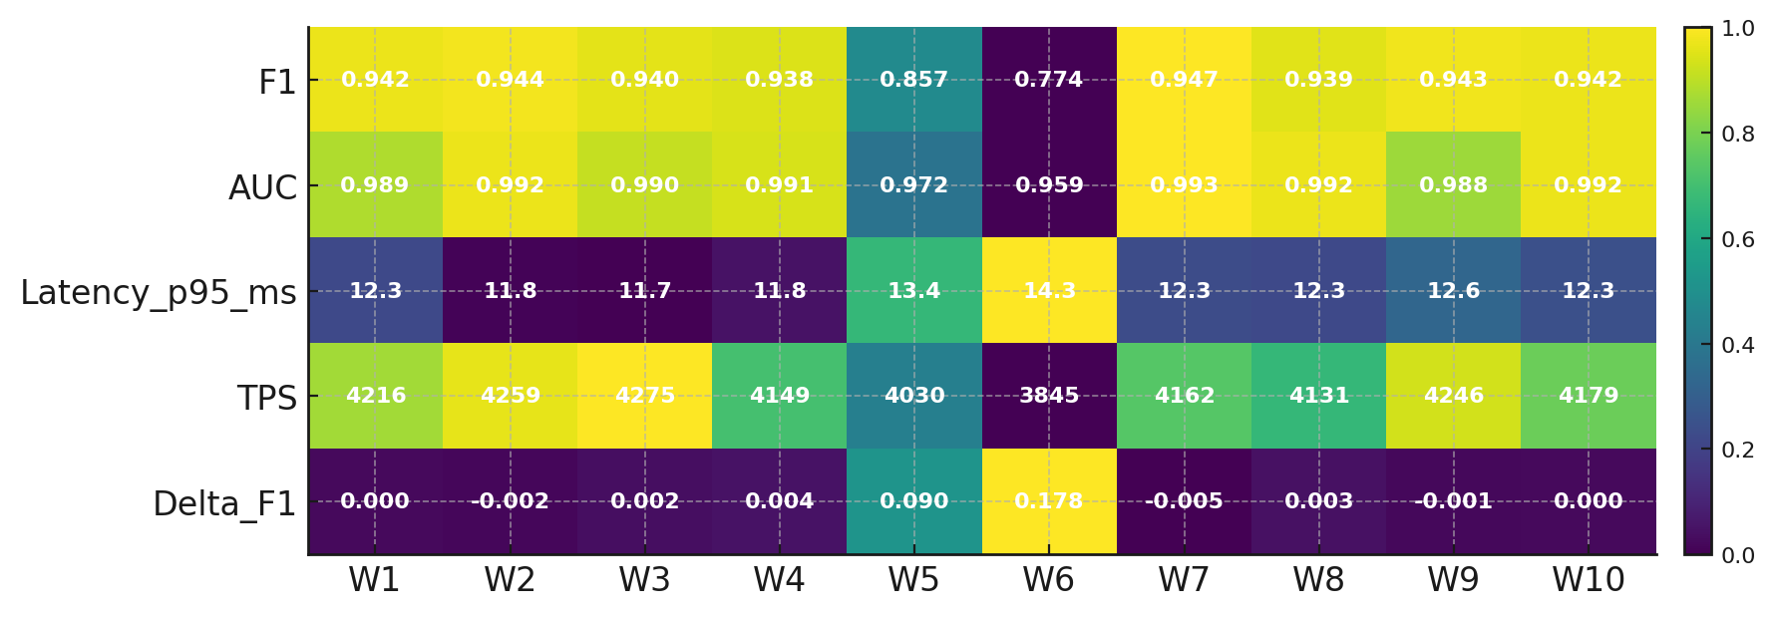
Figure 2. Bubble timeline of F1 by window (bubble size proportional to throughput).
Performance declined from high F1 in early windows to a minimum at the alarm window, with ΔF1 indicating substantial concept drift.
ADWIN flagged drift in the sixth window; retraining in the subsequent window restored F1 and AUC to baseline levels.
p95 inference latency increased during drift while throughput decreased, indicating concurrent operational strain.
Post-retrain windows maintained stable metrics with minimal ΔF1, evidencing sustained recovery.
Objective 2: Organizational, infrastructural, and governance factors for successful scaling
A count-regression approach with a Negative Binomial link was adopted to estimate incident severity as a function of governance, MLOps, and data-management gaps, with controls for sector, year, and region.
Key factors exhibited material and statistically reliable effects on incident severity, as evidenced in Figure 3.
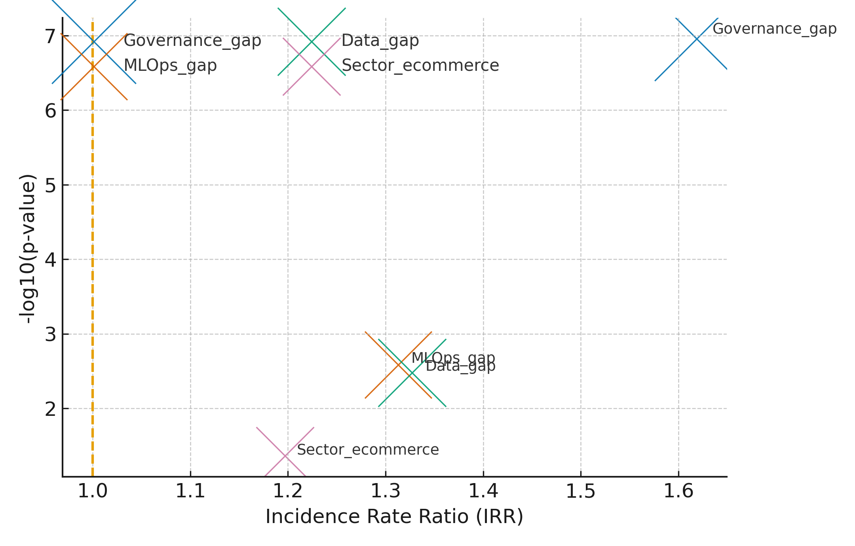
Figure 3. Effect bubble plot comparing Incidence Rate Ratios and statistical strength for primary predictors.
Model estimates are summarized in Table 2, reported as incidence-rate ratios with 95% confidence intervals and p-values.
Variable | IRR | 95% CI | p-value
Governance gap | 1.619 | [1.355, 1.933] | 0.0000
MLOps gap | 1.313 | [1.100, 1.567] | 0.0026
Data gap | 1.327 | [1.099, 1.603] | 0.0033
Sector e-commerce | 1.197 | [1.006, 1.425] | 0.0432
Table 2. Negative Binomial estimates reported as incidence-rate ratios (IRR) with robust standard errors.
Predicted incident severity increased monotonically with the accumulation of governance, MLOps, and data gaps, as shown in Figure 4.
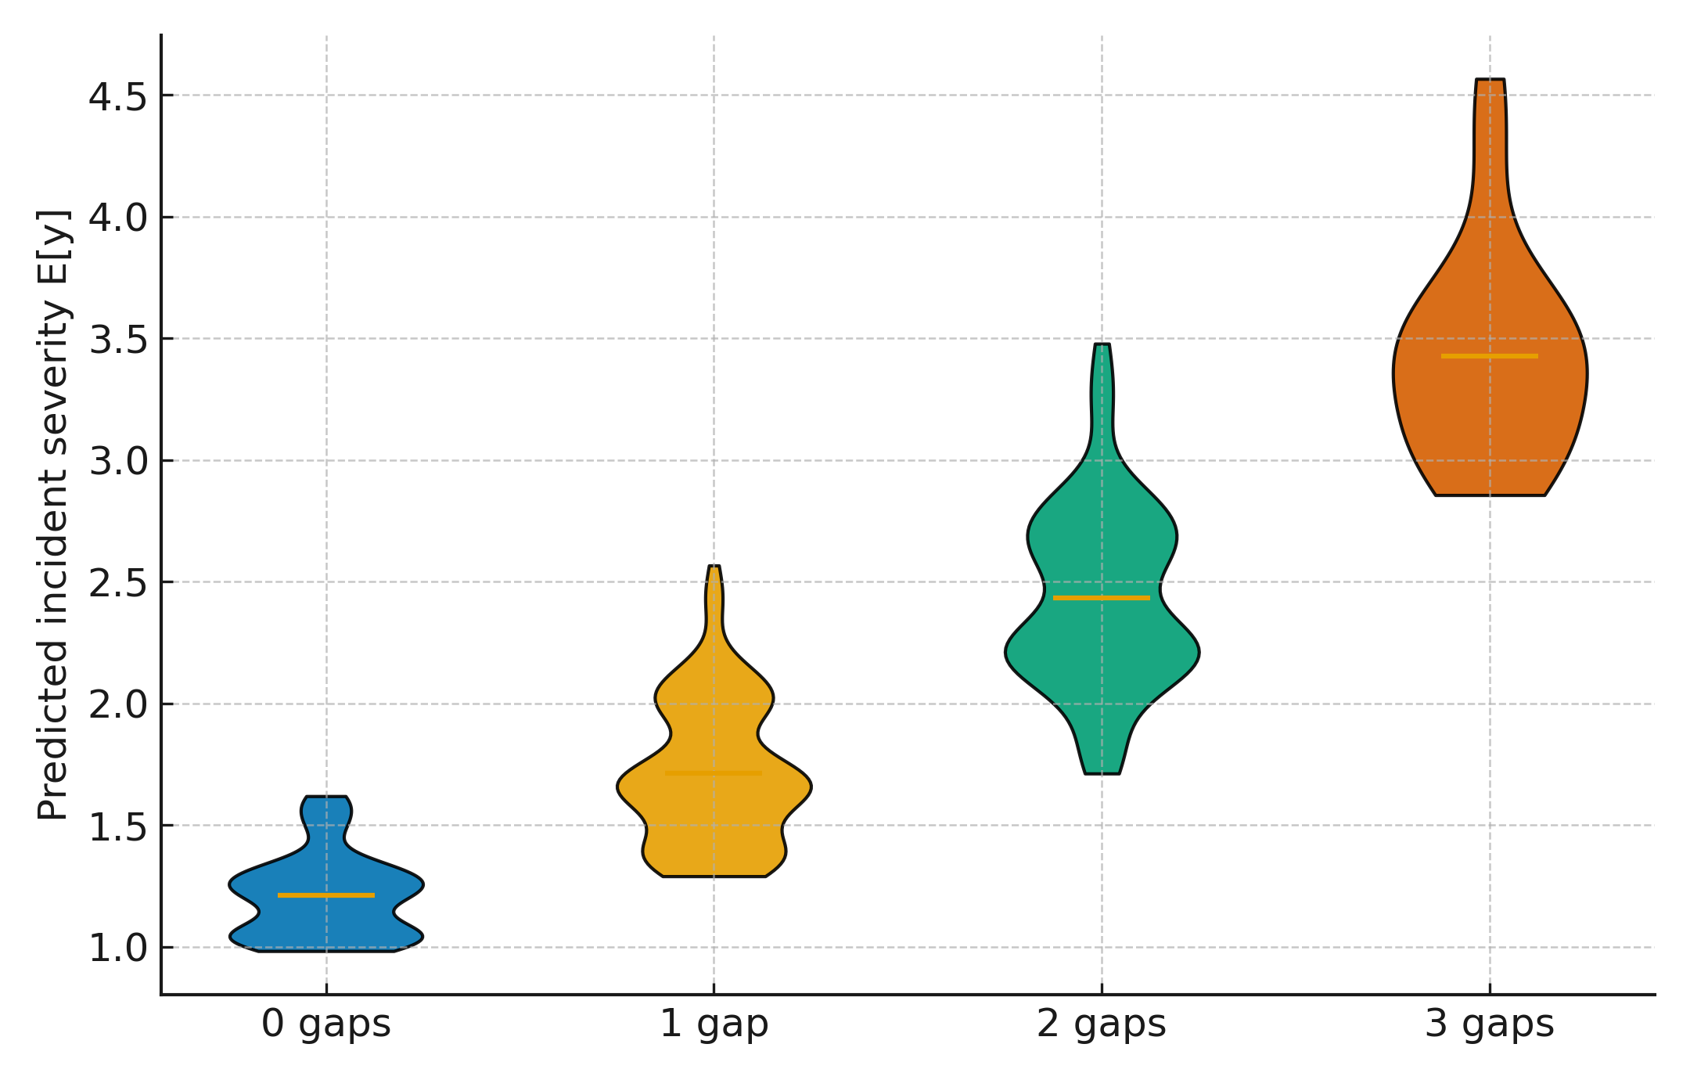
Figure 4. Violin plot of predicted incident severity by total gap count (0–3).
Governance gaps yielded the largest IRR, followed by data and MLOps gaps. All primary predictors were statistically significant and directionally consistent with increased severity. Predicted counts rose with each additional gap, indicating compounding risk exposure.
Objective 3: Design and empirical validation of ML-SF
An interrupted time series segmented regression with robust (Newey–West) inference was adopted to estimate level and slope changes at the activation of ML-SF controls.
A visible level increase and favorable slope change in detection performance are evident after control activation, as shown in Figure 5.
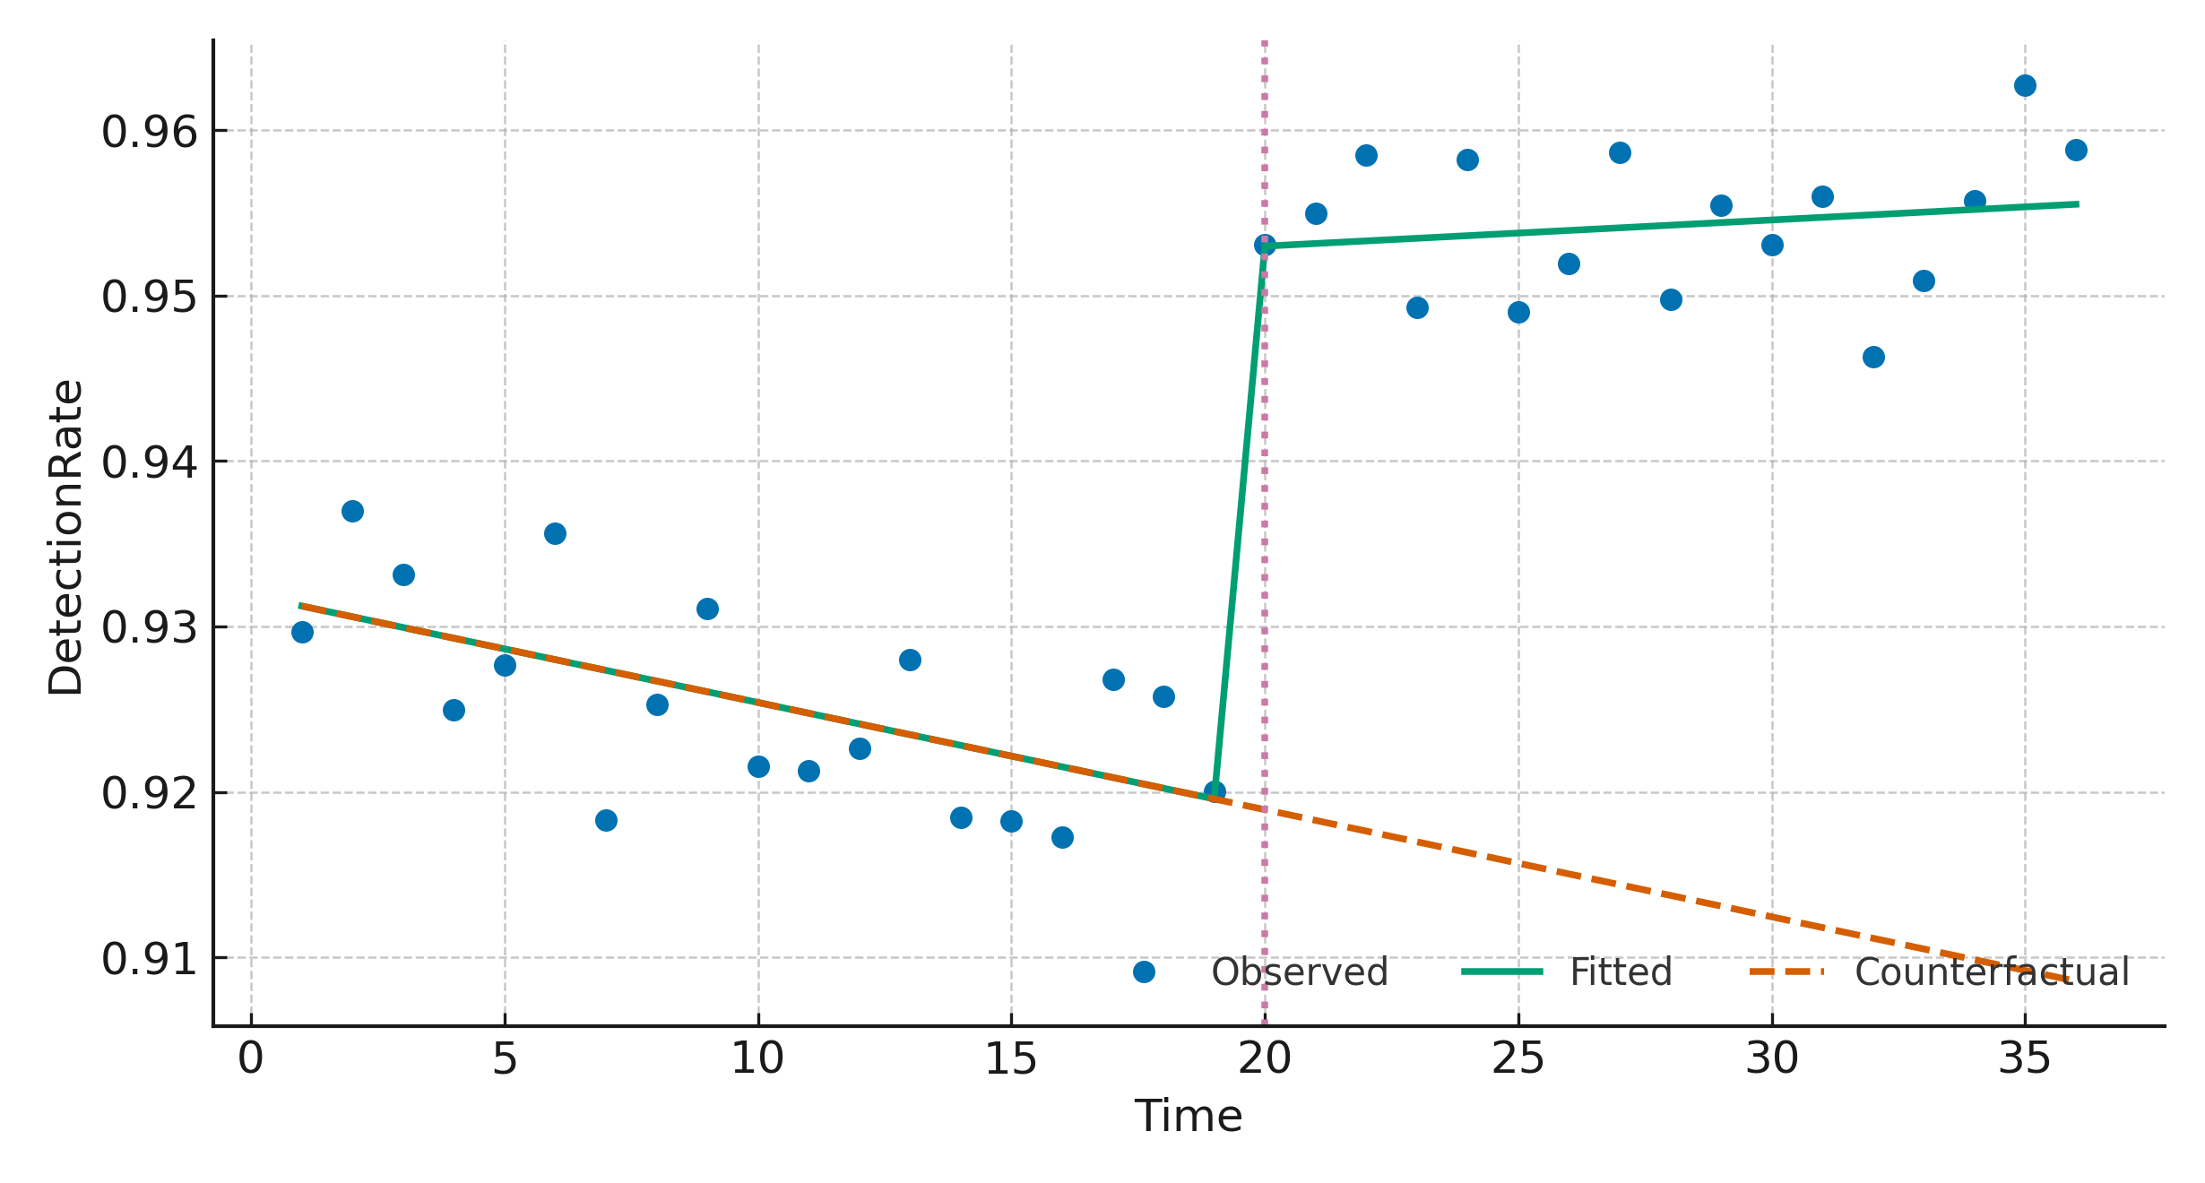
Figure 5. Interrupted time series of DetectionRate with fitted series and counterfactual; vertical marker denotes ML-SF activation.
Segmented-regression estimates are reported in Table 3 for DetectionRate and FPR, including level and slope changes with Newey–West standard errors.
Outcome | Term | Coef. | SE | 95% CI | p-value
DetectionRate | Intercept | 0.9319 | 0.0015 | [0.9289, 0.9348] | 0.0000
DetectionRate | Time | -0.0006 | 0.0002 | [-0.0009, -0.0003] | 0.0000
DetectionRate | Intervention | 0.0333 | 0.0022 | [0.0288, 0.0377] | 0.0000
DetectionRate | TimeAfter | 0.0008 | 0.0003 | [0.0003, 0.0013] | 0.0020
FPR | Intercept | 0.0119 | 0.0002 | [0.0115, 0.0123] | 0.0000
FPR | Time | 0.0002 | 0.0000 | [0.0002, 0.0003] | 0.0000
FPR | Intervention | -0.0040 | 0.0003 | [-0.0045, -0.0034] | 0.0000
FPR | TimeAfter | -0.0003 | 0.0000 | [-0.0004, -0.0003] | 0.0000
Table 3. Segmented regression with Newey–West standard errors for DetectionRate and FPR.
Pre–post means indicate higher DetectionRate and Precision@k, lower FPR, and reduced MTTR following activation, as displayed in Figure 6.
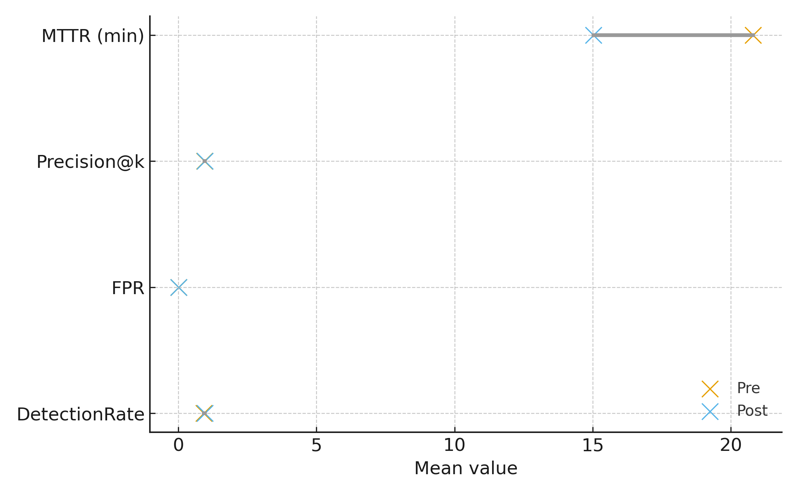
Figure 6. Dumbbell plot of pre–post means across DetectionRate, FPR, Precision@k, and MTTR (minutes).
DetectionRate shows a statistically significant level increase and positive slope change after activation. FPR exhibits a negative level shift with an improving slope, indicating fewer false alarms over time. Precision@k increases and MTTR declines in the post period, evidencing operational gains consistent with governed retraining and monitoring.
Discussion
The results substantiate the study’s central argument that moving from adoption to scalability in e-commerce cybersecurity requires coordinated technical and organizational controls. First, the rolling-window analysis revealed a clear degradation of model performance prior to the drift alarm, followed by rapid recovery post-retraining. The trough in F1 at the alarm point and the rebound immediately afterward in Figure 1, together with the co-movement of latency and throughput in Table 1 and Figure 2, indicate that concept drift is not only a statistical shift but an operational concern that depresses throughput while increasing tail latency. This aligns with prior observations that production ML deteriorates without automated monitoring and retraining pipelines (Kreuzberger et al., 2023; Majidi et al., 2024; Hu et al., 2025). In turn, the post-retrain stability across windows corroborates the claim that drift governance (alerts, retrain triggers, and versioned rollbacks) is indispensable at scale (Zarour et al., 2025).
Second, the count-regression estimates situate scalability within governance and organizational readiness. The incidence-rate ratios in Table 2 show that Governance gap exerts the largest effect on incident severity, followed by Data gap and MLOps gap, with all coefficients statistically reliable; the effect prominence is visually reinforced in Figure 3 and the monotonic rise in predicted severity as gaps accumulate in Figure 4. These patterns are consistent with the literature emphasizing that opaque decision paths and weak oversight amplify risk and erode stakeholder confidence (Batool et al., 2025; Papagiannidis et al., 2025). Moreover, the material role of MLOps gap resonates with studies documenting performance decay in the absence of registries, monitoring, and retraining governance (Zimelewicz et al., 2024; Stone et al., 2025). That e-commerce sector is also associated with higher severity is theoretically coherent, given the rich attack surface and regulatory exposure of payment and personal data processing (Jin & Zhang, 2025; Malone, 2025).
Third, the interrupted time series provides causal leverage on the proposed ML-SF controls. The segmented regression in Table 3 shows a positive level change and improved slope for DetectionRate, alongside a negative level shift and improving slope for FPR after activation; the visual counterfactual in Figure 5 demonstrates that these gains are unlikely to be explained by pre-existing trends. The pre–post patterns across DetectionRate, Precision@k, FPR, and MTTR in Figure 6 further indicate that the framework meaningfully enhances operational responsiveness, considering that higher precision and lower time-to-remediation are precisely the outcomes emphasized by resilience-focused security engineering (ENISA, 2025; Vassilev et al., 2025). Taken together, these effects provide empirical backing for the argument that scaling is not a single engineering fix but a governed, auditable process embedded in routine operations (ETSI, 2024; Gen & Esther, 2024).
Connecting the empirical results to theory, the findings elaborate how UTAUT constructs evolve in post-adoption contexts. Performance expectancy becomes sustained model reliability under drift; effort expectancy maps to the usability of automated retraining and monitoring; social influence materializes through cross-functional sponsorship of governance; and facilitating conditions expand to feature stores, registries, and policy controls evidenced by the intervention effects (Kim et al., 2024; Dwivedi et al., 2020). The TOE lens clarifies why gaps in organizational and technological context predict severity (as quantified in Table 2) while Dynamic Capabilities Theory explains the observed improvements as the ability to sense (drift alarms), seize (timely retraining), and reconfigure (versioned rollbacks and pipeline changes) in response to shifting threats (Hughes et al., 2025; Selgas-Cors & Thiébaut, 2025).
Additionally, the governance and privacy implications are salient. The stronger association of Governance_gap with severity underscores regulatory priorities in the EU AI Act and the Nigerian Data Protection Act, which require transparency, human oversight, and contestability for automated decisions (EU AI Act, 2024; Lambo et al., 2024; Okoro, 2025). The improvement in precision alongside lower false positives after ML-SF activation suggests that explainability and auditability can coexist with accuracy, echoing evidence on XAI methods that maintain performance while enabling oversight (Salih et al., 2024; Saarela & Podgorelec, 2024). Furthermore, because data-management gaps raise severity, the literature’s emphasis on standardized pipelines and privacy-preserving collaboration is reinforced; federated learning and differential privacy provide avenues to improve coverage of rare or emerging threats without compromising compliance (Byrd & Polychroniadou, 2020; Timofte et al., 2025; ALF, 2024).
The results also intersect with adversarial risk. Performance decay before the alarm and its operational footprints in Table 1 are consistent with both benign drift and adversarial drift risks; hence, integrating adversarial training and red-teaming into the same MLOps cadence is warranted (Tafreshian & Zhang, 2025; ENISA, 2025). The observed reduction in FPR and MTTR post-activation aligns with hybrid defenses that combine signature-based controls with retrained models to lower false negatives while keeping false alarms manageable (Kareem, 2025; Mahmoud et al., 2025; Barik et al., 2025). This convergence of empirical evidence with operational doctrine strengthens the case for ML-SF as a socio-technical scaffold rather than an algorithm-centric upgrade.
Although the Machine Learning Scaling Framework (ML-SF) demonstrates strong empirical validity, several limitations should be acknowledged. First, the study relies on open benchmark datasets (CSE-CIC-IDS2018, AI Incident Database, CIC-DDoS2019) that, while reputable, may not capture the full diversity or temporal evolution of cyber threats encountered in live enterprise systems. Dataset bias and representational imbalance could affect the generalizability of certain model behaviors. Second, the empirical validation focused on e-commerce cybersecurity operations; therefore, cross-sector validation in domains such as finance, healthcare, and critical infrastructure is recommended to confirm the framework’s transferability. The socio-technical mechanisms of governance and MLOps may differ significantly across sectors with distinct regulatory and operational demands. Finally, future research should explore real-time and federated scaling approaches that enable continuous, privacy-preserving learning across distributed environments. Longitudinal experiments incorporating adversarial drift simulation and sector-specific data pipelines would further strengthen the ML-SF’s robustness and policy relevance. Addressing these limitations will enhance the framework’s practical adaptability and theoretical depth in advancing resilient AI governance for cybersecurity.

5. Conclusion and Recommendations
The study shows that scaling ML in e-commerce security hinges on governance first, then disciplined MLOps and privacy-aware data readiness; ML-SF activation raised detection, lowered false positives, and cut MTTR, while governance gaps most strongly increased incident severity. Therefore, the following actions are warranted:
- Establish board-level AI security governance with audit trails, human-in-the-loop approvals, and routine explainability reports tied to risk.
- Operationalize drift management: always-on detectors (e.g., ADWIN), retraining SLOs, model registry/versioning with rollback, and post-deploy monitoring as KPIs.
- Harden data pipelines: standardized schemas and feature stores, plus federated learning and differential privacy to expand coverage without exposing raw data.
- Institutionalize adversarial resilience: periodic red-teaming, adversarial training, telemetry audits, and kill-switches aligned to GDPR/PCI/NDPA.
These steps translate the evidence into durable, enterprise-scale capability.

Disclaimer (Artificial intelligence)
Option 1:
Author(s) hereby declare that NO generative AI technologies such as Large Language Models (ChatGPT, COPILOT, etc.) and text-to-image generators have been used during the writing or editing of this manuscript.
Option 2:
Author(s) hereby declare that generative AI technologies such as Large Language Models, etc. have been used during the writing or editing of manuscripts. This explanation will include the name, version, model, and source of the generative AI technology and as well as all input prompts provided to the generative AI technology
Details of the AI usage are given below:
1.
2.
3.

COMPETING INTERESTS DISCLAIMER:
Authors have declared that they have no known competing financial interests OR non-financial interests OR personal relationships that could have appeared to influence the work reported in this paper.

References
Abomakhelb, A., Jalil, K. A., Buja, A. G., Alhammadi, A., & Alenezi, A. M. (2025). A Comprehensive Review of Adversarial Attacks and Defense Strategies in Deep Neural Networks. Technologies, 13(5), 202–202. https://doi.org/10.3390/technologies13050202
Adesokan-Imran, T. O., Popoola, A. D., Kolo, F. H. O., Ejiofor, V. O., & Salami, I. A. (2025). Cybersecurity Risk Stratification Framework Using Multilevel Clustering: An Automated Threat Attribution and Categorization Approach for Cross-industry Cybersecurity. Journal of Engineering Research and Reports, 27(4), 241–263. https://doi.org/10.9734/jerr/2025/v27i41469
Ahirrao, S. (2025, August 12). What the Nigeria Data Protection Act 2023 Means for Your Organization. Ardent Privacy. https://www.ardentprivacy.ai/blog/what-the-nigeria-data-protection-act-2023-means-for-your-organization
Alabdulatif, A. (2025). GuardianAI: Privacy-preserving Federated Anomaly Detection with Differential Privacy. Array, 26, 100381. https://doi.org/10.1016/j.array.2025.100381
ALF. (2024, May 2). Data Privacy Considerations for Artificial Intelligence Systems Use in Nigeria: The Nigeria Data Protection Act (2023) in Focus – Alliance Law Firm. Alliancelawfirm.ng. https://alliancelawfirm.ng/data-privacy-considerations-for-artificial-intelligence-systems-use-in-nigeria-the-nigeria-data-protection-act-2023-in-focus/
Bamigbade, O., Obrik-Uloho, E. P., Kolo, F. H. O., Ogunmolu, A. M., & Adesokan-Imran, T. O. (2025). Data-Centric AI for Zero-Carbon Power Systems Security: A Framework for Learning with Noisy, Sparse, and Heterogeneous Data. Journal of Energy Research and Reviews, 17(7), 167–185. https://doi.org/10.9734/jenrr/2025/v17i7442
Barik, K., Misra, S., & Lopez-Baldominos, I. (2025). Black-box Adversarial Attack Defense Approach: An Empirical Analysis from Cybersecurity Perceptive. Results in Engineering, 105177. https://doi.org/10.1016/j.rineng.2025.105177
Byrd, D., & Polychroniadou, A. (2020). Differentially Private Secure Multi-Party Computation for Federated Learning in Financial Applications. ArXiv.org. https://arxiv.org/abs/2010.05867
Camilleri, M. A. (2023). Artificial intelligence governance: Ethical considerations and implications for social responsibility. Expert Systems, 41(7). https://doi.org/10.1111/exsy.13406
Chen, Y., Zhao, C., Xu, Y., Nie, C., & Zhang, Y. (2025a). Deep Learning in Financial Fraud Detection: Innovations, Challenges, and Applications. Data Science and Management. https://doi.org/10.1016/j.dsm.2025.08.002
Chen, Y., Zhao, C., Xu, Y., Nie, C., & Zhang, Y. (2025b). Year-over-Year Developments in Financial Fraud Detection via Deep Learning: A Systematic Literature Review. Arxiv.org. https://arxiv.org/html/2502.00201v2?utm_
Cramer-Flood, E. (2024, September 6). Worldwide Retail Ecommerce Forecast 2024 Midyear Update. EMARKETER. https://www.emarketer.com/content/worldwide-retail-ecommerce-forecast-2024-midyear-update?utm_
Desai, D., & Hedge, R. (2024, April 23). Phishing Attacks Rise 58% in the Year of AI: ThreatLabz 2024 Phishing Report. Www.zscaler.com. https://www.zscaler.com/blogs/security-research/phishing-attacks-rise-58-year-ai-threatlabz-2024-phishing-report
Dritsas, E., & Trigka, M. (2025). Exploring the Intersection of Machine Learning and Big Data: A Survey. Machine Learning and Knowledge Extraction, 7(1), 13. https://doi.org/10.3390/make7010013
Dwivedi, Y. K., Rana, N. P., Tamilmani, K., & Raman, R. (2020). A meta-analysis based modified unified theory of acceptance and use of technology (meta-UTAUT): a review of emerging literature. Current Opinion in Psychology, 36, 13–18. https://doi.org/10.1016/j.copsyc.2020.03.008
Ekpo, O., Okokon, A., & Akpakpan, M. (2024). Data protection in the digital age: A comparative analysis of Nigeria’s NDPA and the EU’s GDPR. Proceedings of the 13th International Conference on Information & Communication Technologies and Development, 48–56. https://doi.org/10.1145/3700794.3700799
ENISA. (2025, August). ENISA Threat Landscape 2025 | ENISA. Europa.eu. https://www.enisa.europa.eu/publications/enisa-threat-landscape-2025
ETSI. (2025). Securing Artificial Intelligence (SAI); Guide to Cyber Security for AI Models and Systems 2 ETS. In ETSI. https://www.etsi.org/deliver/etsi_tr/104100_104199/104128/01.01.01_60/tr_104128v010101p.pdf
EU AI Act. (2024). Key Issue 5: Transparency Obligations - EU AI Act. Www.euaiact.com. https://www.euaiact.com/key-issue/5
European Data Protection Board (EDPB). (2023). Guidelines on Artificial Intelligence and Data Protection under the General Data Protection Regulation (GDPR). European Union Publications Office. https://edpb.europa.eu/
European Union. (2024, June 13). Regulation - EU - 2024/1689 - EN - EUR-Lex. Europa.eu. https://eur-lex.europa.eu/legal-content/EN/TXT/?uri=CELEX:32024R1689
Gen, T., & Esther, D. (2024, December 12). AI Governance in MLOps: Compliance, Fairness, and Transparency. https://www.researchgate.net/publication/388661015_AI_Governance_in_MLOps_Compliance_Fairness_and_Transparency
Gerchow, G. (2025). New Study:82% of Security Teams Face AI Data Visibility Gaps. Bedrockdata.ai. https://www.bedrockdata.ai/news/security-teams-taking-on-expanded-ai-data-responsibilities-as-82-report-visibility-gaps
Grand View Research. (2025a). AI In Cybersecurity Market Size, Share | Industry Report, 2030. Grandviewresearch.com. https://www.grandviewresearch.com/industry-analysis/artificial-intelligence-cybersecurity-market-report?utm_
Grand View Research. (2025b). Cyber Security Market Size, Share | Industry Report, 2030. Grandviewresearch.com. https://www.grandviewresearch.com/industry-analysis/cyber-security-market?utm_
Hughes, L., Davies, F., Li, K., Gunaratnege, S. M., Malik, T., & Dwivedi, Y. K. (2025). Beyond the hype: Organisational adoption of Generative AI through the lens of the TOE framework–A mixed methods perspective. International Journal of Information Management, 86, 102982. https://doi.org/10.1016/j.ijinfomgt.2025.102982
Hurley, S., & Oyeronke, A. (2025, August 20). Bridging Compliance and Intelligence: Integrating AI in PCI DSS v4.0 Security Frameworks. https://www.researchgate.net/publication/394738036_Bridging_Compliance_and_Intelligence_Integrating_AI_in_PCI_DSS_v40_Security_Frameworks
Husni, A., Madurapperuma, W., & Thilini Sumudu Kumari, R. D. (2025). Antecedents of data analytics adoption: A systematic literature review from 2018-2024. F1000Research, 14, 1026. https://doi.org/10.12688/f1000research.170252.1
IEEE. (2023). Ethically Aligned Design: A Vision for Prioritizing Human Well-Being with Autonomous and Intelligent Systems (2nd ed.). IEEE Global Initiative on Ethics of Autonomous and Intelligent Systems. https://ethicsinaction.ieee.org/
ISC2. (2025, July 16). ISC2 Survey: 30% of Cyber Pros Using AI Security Tools. Isc2.org; ISC2. https://www.isc2.org/Insights/2025/07/2025-isc2-ai-pulse-survey
Jedrzejewski, F. V., Thode, L., Fischbach, J., Gorschek, T., Mendez, D., & Lavesson, N. (2024). Adversarial Machine Learning in Industry: A Systematic Literature Review. Computers & Security, 145, 103988–103988. https://doi.org/10.1016/j.cose.2024.103988
Jin, J., & Zhang, Y. (2025). The analysis of fraud detection in financial market under machine learning. Scientific Reports, 15(1), 1–14. https://doi.org/10.1038/s41598-025-15783-2
Kareem, S. W. (2025). Enhanced Intrusion Detection System Using Hybrid-Inspired Algorithms and Conditional Generative Adversarial Networks for Internet of Things Security. Egyptian Informatics Journal, 31, 100763. https://doi.org/10.1016/j.eij.2025.100763
Kaur, R., Tomaž Klobučar, & Dušan Gabrijelčič. (2025). Adoption of Artificial Intelligence in Cybersecurity for Organizations: Barriers and Roadmap. IETE Technical Review, 42(2), 1–13. https://doi.org/10.1080/02564602.2025.2485910
Kim, Y., Blazquez, V., & Oh, T. (2024). Determinants of Generative AI System Adoption and Usage Behavior in Korean Companies: Applying the UTAUT Model. Behavioral Sciences, 14(11), 1035–1035. https://doi.org/10.3390/bs14111035
Kolo, F. (2023). Insights in Cybersecurity & Business Intelligence: A Dual Perspective: Unlocking Security Insights and Business Growth: Intrusion Detection Strategies and Sales Forecasting Techniques. LAP LAMBERT Academic Publishing. https://www.amazon.com/Insights-Cybersecurity-Business-Intelligence-Perspective/dp/6207450841
Kolo, F. H. O. (2025a). A Multi-level Clustering Framework for Cybersecurity Risk Stratification in Healthcare: A Dynamic, Overlapping Approach to Threat Classification and Mitigation. Asian Journal of Research in Computer Science, 18(5), 11–31. https://doi.org/10.9734/ajrcos/2025/v18i5636
Kolo, F. H. O. (2025b). Responsible AI for Cybersecurity: Assessing the Barriers, Biases and Governance Gaps in Implementation with E-commerce Systems. Journal of Engineering Research and Reports, 27(5), 510–532. https://doi.org/10.9734/jerr/2025/v27i51520
Kolo, F. H. O., Joseph, S. A., Ogunmolu, A. M., Ejiofor, V. O., & Oyekunle, S. M. (2025). Mitigating Cybersecurity Risks in Financial Institutions through Strategic Third- Party Risk Governance Frameworks. Journal of Engineering Research and Reports, 27(5), 173–193. https://doi.org/10.9734/jerr/2025/v27i51501
Lambo, J., Okolie, C., Adeshina, O., & Adefidipe, J. A. (2025). International Comparative Legal Guides. International Comparative Legal Guides International Business Reports. https://iclg.com/practice-areas/data-protection-laws-and-regulations/nigeria
Lambo, J., Okolie, C., Ngwu, S., Udoma, U., Osagie, B., Shin, J., & Lee, C. (2024, June 18). AI Watch: Global regulatory tracker - Nigeria | White & Case LLP. Whitecase.com. https://www.whitecase.com/insight-our-thinking/ai-watch-global-regulatory-tracker-nigeria
Lekota, N. F. (2024). Governance Considerations of Adversarial Attacks on AI Systems. 4th International Conference on AI Research, ICAIR. https://papers.academic-conferences.org/index.php/icair/article/download/3194/2911/11424?utm_
Mahmoud, M. M., Youssef, Y. O., & Abdel-Hamid, A. A. (2025). XI2S-IDS: An Explainable Intelligent 2-Stage Intrusion Detection System. Future Internet, 17(1), 25. https://doi.org/10.3390/fi17010025
Majidi, F., Khomh, F., Li, H., & Nikanjam, A. (2024). An Efficient Model Maintenance Approach for MLOps. ArXiv.org. https://arxiv.org/abs/2412.04657
Malone, A. (2025). New Guidance: Integrating Artificial Intelligence into PCI Assessments. Pcisecuritystandards.org. https://blog.pcisecuritystandards.org/new-guidance-integrating-artificial-intelligence-into-pci-assessments
ModelOp. (2025). 2024 Responsible AI Benchmark Report | Insights on Generative AI Adoption & Risk Management. Modelop.com. https://www.modelop.com/resources-ebooks/responsible-ai-report-2024
Mucci, T., & Stryker, C. (2024, October 10). AI Governance. Ibm.com. https://www.ibm.com/think/topics/ai-governance
Nott, C. (2025). Organizational Adaptation to Generative AI in Cybersecurity: A Systematic Review. ArXiv.org. https://arxiv.org/abs/2506.12060?utm_
Obrik-Uloho, E. P. (2025). Elevating Continuous Verification through Advanced Behavioral Analytics: A Deep-Dive Framework for Combating Insider Threats and Account Takeovers in Modern Cybersecurity. Journal of Engineering Research and Reports, 27(10), 316–337. https://doi.org/10.9734/jerr/2025/v27i101676
Ogunmolu, A. M. (2025a). A Multiscale Approach to Cyber-Mechanical Threat Modeling for Predicting and Preventing Failures in Critical Energy Infrastructure. Journal of Engineering Research and Reports, 27(6), 1–20. https://doi.org/10.9734/jerr/2025/v27i61523
Ogunmolu, A. M. (2025b). Federated Detection Systems for Insider Threats in Energy Facilities Using Biomechanical Access Control and Al-Based Cybersecurity. Journal of Engineering Research and Reports, 27(6), 65–82. https://doi.org/10.9734/jerr/2025/v27i61528
Okoro, F. (2025). Automated Decisions, Profiling, And Data Subject Rights In Nigeria. Mondaq.com. https://www.mondaq.com/nigeria/privacy-protection/1650166/automated-decisions-profiling-and-data-subject-rights-in-nigeria
Olaniyi, O. (2025). A Quantitative Approach to Understanding Machine Learning Adoption for Cybersecurity in E-Commerce Through the UTAUT Model. [Unpublished dissertation].
Olutimehin , A. T., Olaniyi , O. O., Ogunmolu , A. M., Kolo, F. H. O., & Salami , I. A. (2025). Cloud-Based AI Solutions for Real-time Monitoring of E-commerce Compliance and Risk. Journal of Engineering Research and Reports, 27(7), 127–147. https://doi.org/10.9734/jerr/2025/v27i71566
Olutimehin, A. T., Olaniyi, O. O., Popoola, A. D., Ogunmolu, A. M., & Kolo, F. H. (2025). AI and IoT Integration for Predictive Maintenance and Risk Management in Smart Manufacturing. Asian Journal of Research in Computer Science, 18(7), 120–142. https://doi.org/10.9734/ajrcos/2025/v18i7724
Oyekunle, S. M., Popoola, A. D., Kolo, F. H. O., Ogunmolu, A. M., & Adesokan-Imran, T. O. (2025). Intelligent Fraud Prevention Information Banking: A Data Governance- Centric Approach Using Behavioural Biometrics. Asian Journal of Research in Computer Science, 18(5), 525–543. https://doi.org/10.9734/ajrcos/2025/v18i5672
Panchumarthi, S. (2025). DevSecMLOps: A Security Framework for Machine Learning Pipelines. https://doi.org/10.36227/techrxiv.175037181.12992346/v1
Papagiannidis, E., Mikalef, P., & Conboy, K. (2025). Responsible artificial intelligence governance: A review and research framework. The Journal of Strategic Information Systems, 34(2). https://doi.org/10.1016/j.jsis.2024.101885
Parmar, D. S., & Saran, H. K. (2025). Empirical Study on The Role of Explainable AI (XAI) in Improving Customer Trust in AI-Powered Products. International Journal of Computer Trends and Technology, 73(2), 48–57. https://doi.org/10.14445/22312803/ijctt-v73i2p106
Patel, R., Tripathi, H., Stone, J., Amiri, G. N., Mittal, S., Rahimi, S., & Chaudhary, V. (2025). Towards Secure MLOps: Surveying Attacks, Mitigation Strategies, and Research Challenges. ArXiv.org. https://arxiv.org/abs/2506.02032?utm_
Saarela, M., & Podgorelec, V. (2024). Recent Applications of Explainable AI (XAI): A Systematic Literature Review. Applied Sciences, 14(19), 8884–8884. https://doi.org/10.3390/app14198884
Salami, I. A., Popoola, A. D., Gbadebo, M. O., Kolo, F. H. O., & Adesokan-Imran, T. O. (2025). AI- Powered Behavioural Biometrics for Fraud Detection in Digital Banking: A Next-Generation Approach to Financial Cybersecurity. Asian Journal of Research in Computer Science, 18(4), 473–494. https://doi.org/10.9734/ajrcos/2025/v18i4632
Salem, A. H., Azzam, S. M., Emam, O. E., & Abohany, A. A. (2024). Advancing cybersecurity: a comprehensive review of AI-driven detection techniques. Journal of Big Data, 11(1), 1–38. https://doi.org/10.1186/s40537-024-00957-y
Salih, A. M., Estabragh, Z. R., Galazzo, I. B., Radeva, P., Petersen, S. E., Lekadir, K., & Menegaz, G. (2024). A Perspective on Explainable Artificial Intelligence Methods: SHAP and LIME. Advanced Intelligent Systems, 7(1). https://doi.org/10.1002/aisy.202400304
Selgas-Cors, M., & Thiébaut, R. (2025). ARTIFICIAL INTELLIGENCE AND DYNAMIC CAPABILITIES: ENHANCING SUSTAINABLE COMPETITIVE ADVANTAGE IN BUSINESS ORGANIZATIONS. Journal of Innovations in Business and Industry, 4(1), 111–122. https://doi.org/10.61552/jibi.2026.01.010
Sibanda, I. (2025). Industry News 2025 Combating the Threat of Adversarial Machine Learning to AI Driven Cybersecurity. ISACA. https://www.isaca.org/resources/news-and-trends/industry-news/2025/combating-the-threat-of-adversarial-machine-learning-to-ai-driven-cybersecurity?utm_
Stone, J., Patel, R., Ghiasi, F., Mittal, S., & Rahimi, S. (2025). Navigating MLOps: Insights into Maturity, Lifecycle, Tools, and Careers. ArXiv.org. https://arxiv.org/abs/2503.15577
Sultana, I., Maheen, S. M., Kshetri, N., & Zim, M. N. F. (2025). detectGNN: Harnessing Graph Neural Networks for Enhanced Fraud Detection in Credit Card Transactions. https://arxiv.org/pdf/2503.22681?utm_
Tafreshian, B., & Zhang, S. (2025). A Defensive Framework Against Adversarial Attacks on Machine Learning-Based Network Intrusion Detection Systems. ArXiv.org. https://arxiv.org/abs/2502.15561
Timofte, E. M., Dimian, M., Graur, A., Potorac, A. D., Balan, D., Croitoru, I., Hrițcan, D.-F., & Pușcașu, M. (2025). Federated Learning for Cybersecurity: A Privacy-Preserving Approach. Applied Sciences, 15(12), 6878–6878. https://doi.org/10.3390/app15126878
Udechukwu, L. M. (2025a). AI-Governed Security Frameworks for Virtualized Enterprises: Preventing Data Breaches and Ensuring Compliance. Asian Journal of Research in Computer Science, 18(9), 39–57. https://doi.org/10.9734/ajrcos/2025/v18i9753
Udechukwu, L. M. (2025b). Ethical Implications and Cybersecurity Risks of Hyper-Personalized AI Feedback Systems for Mental Health Support in Home Environment. Journal of Engineering Research and Reports, 27(9), 310–328. https://doi.org/10.9734/jerr/2025/v27i91643
Umakor, M. F., Iheanyi, I., Ofurum, U. D., Ibecheozor, H. B., & Adeyefa, E. A. (2025). Federated Learning for Privacy-Preserving Fraud Detection in Digital Banking: Balancing Algorithmic Performance, Privacy, And Regulatory Compliance. ICONIC RESEARCH and ENGINEERING JOURNALS, Volume 9(Issue 1), 215–231. https://www.researchgate.net/publication/393647256_Federated_Learning_for_Privacy-Preserving_Fraud_Detection_Across_Financial_Institutions
Vallarino, D. (2025). AI-Powered Fraud Detection in Financial Services: GNN, Compliance Challenges, and Risk Mitigation. https://doi.org/10.2139/ssrn.5170054
Vassilev, A., Oprea, A., Fordyce, A., Anderson, H., & Davies, X. (2025). Adversarial Machine Learning: (National Institute of Standards and Technology, Gaithersburg, MD) NIST Trustworthy and Responsible Al, NIST al 100-22025. https://doi.org/10.6028/nist.ai.100-2e2025
Vimbi, V., Shaffi, N., & Mahmud, M. (2024). Interpreting artificial intelligence models: a systematic review on the application of LIME and SHAP in Alzheimer’s disease detection. Brain Informatics, 11(1). https://doi.org/10.1186/s40708-024-00222-1
Welsh, T. (2025, April 30). Invisible Risk: How AI Use Creates PCI DSS Violations Today. WitnessAI. https://witness.ai/blog/blog-invisible-risk-how-ai-use-creates-pci-dss-violations-today
Woollacott, E. (2025, July 17). Despite the hype, cybersecurity teams are still taking a cautious approach to using AI tools. IT Pro. https://www.itpro.com/security/despite-the-hype-cybersecurity-teams-are-still-taking-a-cautious-approach-to-using-ai-tools?utm_
Xue, L., Rashid, A. M., & Ouyang, S. (2024). The Unified Theory of Acceptance and Use of Technology (UTAUT) in Higher Education: A Systematic Review. SAGE Open, 14(1). https://doi.org/10.1177/21582440241229570
Zimelewicz, E., Kalinowski, M., Mendez, D., Giray, G., Pedro, A., Lavesson, N., Azevedo, K., Villamizar, H., Escovedo, T., Lopes, H., Biffl, S., Musil, J., Felderer, M., Wagner, S., Baldassarre, T., & Gorschek, T. (2024). ML-Enabled Systems Model Deployment and Monitoring: Status Quo and Problems. ArXiv.org. https://arxiv.org/abs/2402.05333

