Original Research Article
Comparative Analysis of Bamboo Growth and Carbon Sequestration Across Major Forest Types in Cambodia

.
ABSTRACT

This study investigated bamboo growth and carbon sequestration across three major forest types in Cambodia: deciduous, evergreen, and semi-evergreen forests. Structural attributes (diameter, height, clump size, stem density, and mortality) and biomass-related variables (volume, carbon (Mg ha⁻¹), and CO₂ (Mg ha⁻¹)) were analyzed using descriptive statistics, ANOVA, correlation analysis, and principal component analysis (PCA). Results revealed significant variation among forest types. Bamboo in deciduous forests exhibited the largest mean diameter (5.03 cm) and highest median volume (17 m³), contributing to greater but variable carbon stocks (median ≈ 8 Mg ha⁻¹; range = 3–15). Evergreen forests displayed moderate and more stable growth, with average diameters of 4.18 cm, volumes around 11 m³, and carbon stocks between 4–6 Mg ha⁻¹. Semi-evergreen forests were dominated by smaller bamboo clumps (mean diameter = 2.97 cm; median volume ≈ 8 m³) and consistently lower carbon accumulation (median ≈ 4 Mg ha⁻¹), though occasional tall outliers (> 20 m) were recorded. Correlation analysis showed strong positive relationships between diameter, volume, and carbon/CO₂ stocks (r = 0.50–1.00), whereas clump density and dead stems were only weakly associated with biomass. PCA indicated that PC1 (46.5%) represented size and biomass gradients, while PC2 (21.7%) captured height and mortality, together explaining 68.2% of total variation. Overall, the findings demonstrate that forest type strongly influences bamboo structural growth and carbon storage, with deciduous forests holding the highest potential for carbon sequestration, followed by evergreen and semi-evergreen forests.
Keywords: Comparative analysis; bamboo growth; carbon sequestration; forest types

1. INTRODUCTION
Bamboo is one of the fastest-growing plants on Earth, capable of growing up to 91 cm per day due to its unique rhizome system (Ahmad et al., 2021; Emamverdian et al., 2020). This remarkable growth capacity, combined with its ability to survive in degraded or infertile soils, makes bamboo a promising method for reforestation, carbon sequestration, and climate change mitigation (Pan et al., 2023; Singh et al., 2020). Recent studies have indicated that bamboo has a diverse role as a Nature-based Solution (NbS) for sustainable development (Dutta et al., 2025; Kim et al., 2023). Pan et al. (2023) also noted that bamboo is primarily beneficial as a biomass carbon sink, providing products that can store carbon for a long time and can be an important component of carbon credit systems. Despite this opportunity, research worldwide has focused on a few bamboo species, notably Phyllostachys pubescens and Bambusa vulgaris, and has been concentrated mainly in Asia, with little research in Africa and South America (Pan et al., 2023). Field studies have shown that bamboo has a high capacity to sequester carbon (Yiping et al., 2010). Despite these opportunities, global research remains disproportionately focused on a limited number of species—particularly Phyllostachys pubescens and Bambusa vulgaris—and is geographically concentrated in Asia, with limited representation from Africa and South America (Pan et al., 2023). In southwestern Ethiopia, tall bamboo (Oldeania alpina) has an above-ground biomass of between 150 and 191 megatons per hectare (Mg ha⁻¹) and a carbon stock of 87.5 to 111.6 megatons per hectare (Mg C ha⁻¹), depending on the management type (land near the house and riverine land) (Jember et al., 2023). In Cambodia, despite the diversity of ecosystems such as deciduous forests, evergreen forests, semi-deciduous forests, and bamboo forests, bamboo systems have been understudied for carbon measurement and the development of emission reduction and reduction of greenhouse gas emissions (REDD+) projects (Kaam et al., 2023; Sasaki et al., 2016). Because bamboo has unique structural and carbon sequestration properties, understanding its growth and carbon sequestration capacity in different forest types is important for natural resource management and climate mitigation strategies (Sarun et al., 2025; Yiping et al., 2010).
This research paper aims to conduct a comparative analysis of the structural and carbon sequestration capacity of bamboo in three major forest types in Cambodia: deciduous forests, evergreen forests, and semi-deciduous forests. Measurements include structural parameters (diameter, height, canopy size, number of stems, and mortality) and organic carbon parameters (amount of biomass, carbon, and CO₂ content). Statistical analysis methods for the study included descriptive analysis, ANOVA/Kruskal–Wallis test, correlation analysis, and Principal Component Analysis (PCA) to determine what affects the growth capacity and carbon sequestration of bamboo. The results obtained will help support forest management that includes bamboo and are an important part of developing effective climate policies.

2. MATERIALS AND METHODS
2.1 Study Area
The study was conducted across three major forest types in Cambodia: deciduous, evergreen, and semi-evergreen forests. These forest types represent the dominant vegetation cover in the country and differ markedly in their structural characteristics, species composition, and ecological functions. Sampling sites were selected to ensure the inclusion of area dominated by bamboo within each forest type, where bamboo forms a significant component of both the understory and canopy structure.

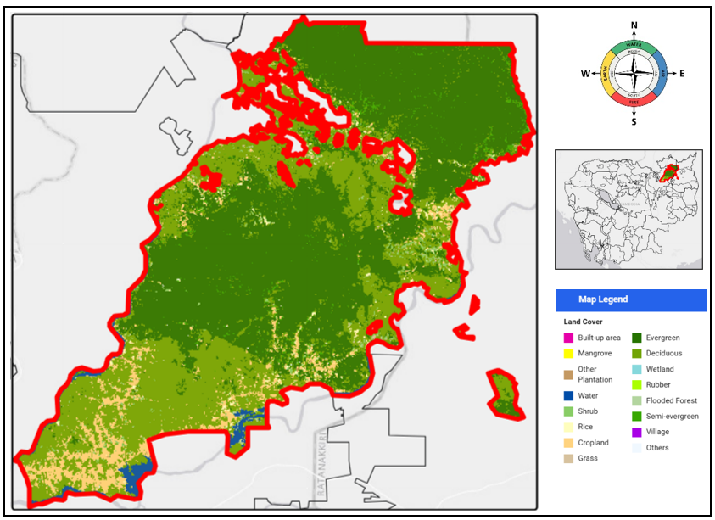
Fig. 1 Map of research area at Veun Sai–Siem Pang National Park
2.2 Data Collection
Field data collection was carried out in Veun Sai–Siem Pang National Park, located in Stung Treng Province, northeastern Cambodia (13°49′–14°08′N and 106°13′–106°41′E). A total of fourteen (14) plots were established, consisting of three (3) plots in deciduous forest, six (6) plots in semi-evergreen forest, and five (5) plots in evergreen forest, to represent bamboo growth dynamics and carbon stock variations across these major forest types. Within each forest type, 15 x 30 m plots were established. In each plot, bamboo clumps were identified and measured for key structural variables as follows:
- Diameter at Breast Height (DBH, cm): Measured at 1.3 m above ground level for representative culms.
- Height (m): Recorded for dominant culms within each clump.
- Clump Diameter (cm): Measured across the widest point at the base of the clump.
- Number of Stems per Clump: Counted directly to assess clump density.
- Number of Dead Stems per Clump: Counted to estimate mortality rates.
From these measurements, secondary variables were derived as follows:
- Aboveground biomass (Kilogram): Estimated using the formula:
AGB = 1.04 ÷ 0.06 x d x GWbamboo
Gwbamboo = -1.11+0.36 x d² (bamboo diameter > 3 cm)
Gwbamboo = -1.11 + 0.36 x 3.1² (bamboo diameter ≤ 3 cm)
where GW is the Global wood density and d is the diameter (Muchiri and Muga, 2013).
- Carbon Stock (C, Mg ha⁻¹): Calculated as
C = 0.5 x biomass
following the IPCC (2006) default value for bamboo and woody biomass.
- CO₂ Equivalent (CO₂, Mg ha⁻¹): Derived by multiplying the carbon stock by 3.67.
2.3 Data Analysis
All collected data were compiled and analyzed Python statistical software (version 3.13). The following analyses were performed:
- Descriptive Statistics: Mean, median, range, and standard deviation were computed for all structural and biomass-related variables within each forest type.
- Comparative Tests: One-way ANOVA was applied to test differences among forest types. When assumptions of normality or homogeneity of variance were not met, the non-parametric Kruskal–Wallis test was used.
- Correlation Analysis: Pearson’s correlation coefficients were calculated to examine relationships among structural variables (DBH, height, and clump diameter) and biomass variables (volume, carbon, and CO₂).
- Principal Component Analysis (PCA): Conducted to identify major axes of variation and determine which structural and biomass attributes contributed most to differentiation among forest types.
- Visualization: Boxplots, pair plots, correlation heatmaps, and PCA biplots were generated to illustrate the distribution patterns and relationships among forest types.
2.4 Ethical Considerations
All fieldwork was conducted with prior permission from local forestry authorities and in full compliance with national forestry regulations. Data collection was entirely non-destructive, and no bamboo clumps were cut or harvested during the study.
3. results
3.1 Descriptive & Statistical Assumptions of variables
Table 1. Summarizes the results of variance and non-parametric tests for growth and carbon variables across forest types (n = 14).
Variable | F (ANOVA) | p (ANOVA) | p (Levene) | H  (Kruskal–Wallis) | p (Kruskal–Wallis) | Sig.
Number of dead stems in clump | 2.378 | 0.139 | 0.269 | 8.008 | 0.018 | *
Diameter (cm) | 2.312 | 0.145 | 0.652 | 3.947 | 0.139 | ns
Volume (m³) | 1.135 | 0.356 | 0.439 | 0.876 | 0.645 | ns
CO₂ (Mg ha⁻¹) | 1.134 | 0.357 | 0.437 | 0.876 | 0.645 | ns
C (Mg ha⁻¹) | 1.134 | 0.357 | 0.429 | 0.876 | 0.645 | ns
Total number of stems in clump | 1.041 | 0.386 | 0.432 | 2.835 | 0.242 | ns
Height (m) | 0.215 | 0.810 | 0.475 | 1.119 | 0.571 | ns
Diameter of clump (cm) | 0.079 | 0.924 | 0.838 | 0.535 | 0.765 | ns
Note: ns = not significant (p > 0.05); sig = significant

The results of one-way ANOVA and Kruskal–Wallis tests (Table 1) were summarized to assess the differences in growth and carbon-related variables of bamboo in the three forest types (n = 14). Before performing ANOVA, normality tests and equality of residuals were performed using Shapiro–Wilk and Levene methods, respectively. For several variables, including the number of dead bamboo stems per plot, stem diameter (cm) and plot diameter (cm), the Shapiro–Wilk test showed significant differences away from normality (p < 0.05). Therefore, the non-parametric Kruskal–Wallis test was used as a more robust alternative to ANOVA in this situation. The ANOVA results showed that there were no statistically significant differences for all variables between forest types (p > 0.05). For example, diameter (F = 2.312, p = 0.145), volume (F = 1.135, p = 0.356), and height (F = 0.215, p = 0.810) did not show any statistically significant differences. Similarly, carbon content (C, Mg ha⁻¹) and CO₂ equivalent carbon content (Mg ha⁻¹) also showed no statistically significant differences (p > 0.05), indicating that biomass and carbon accumulation were equal between the different forest types. The Levene test results showed that the equality of residuals was maintained for all variables (p > 0.05), indicating that the assumption of equal residuals in the ANOVA was met. However, in cases where normality was waived, the results from the Kruskal–Wallis test were allowed to be used as the main results. Of all the variables, only the number of dead bamboo stems per stand showed a statistically significant difference between forest types (H = 8.008, p = 0.018), indicating differences in the mortality or turnover rate of bamboo stems. Overall, the results of the statistical analysis showed that the main structural and organic characteristics, such as diameter, height, volume, and carbon content, did not differ statistically significantly between forest types, indicating similarities in bamboo structure across forest types. The only exception was the bamboo mortality rate, which had a statistically significant difference and could be related to ecological conditions, site management, or environmental factors that influenced bamboo survival in each forest type.
3.2 Descriptive Analysis of Clump Diameter Across Forest Types
The descriptive statistics of bamboo clump diameter (cm) across the three major forest types in Cambodia are presented (Table 2). Noticeable differences were observed in the size distribution of bamboo clumps among forest type.
Table 2. Descriptive statistics of clump diameter (cm) across different forest types.
Forest Type | n | Mean | SD | Min | Max (cm) | Median
Deciduous Forest | 3 | 5.03 | 0.75 | 4.3 | 5.8 | 5.0
Evergreen Forest | 5 | 4.18 | 1.53 | 3.0 | 6.6 | 3.3
Semi-evergreen Forest | 6 | 2.97 | 1.54 | 1.6 | 5.6 | 2.6
Note: n = number of samples; SD = standard deviation.

Bamboo stands in deciduous forests showed the largest mean diameter (5.03 cm) and low variability (SD = 0.75), indicating uniform growth conditions and structural stability. Bamboo diameters in this type of forest had a small range of variation from 4.3 to 5.8 cm, indicating uniformity in size between individual bamboo trees. In contrast, evergreen forests showed a smaller mean diameter (4.18 cm) but a higher variation (SD = 1.53), with diameters ranging from 3.0 to 6.6 cm. This wide range of variation indicates a high diversity of bamboo structures, which may be due to differences in bamboo species composition or differences in microenvironmental conditions. In semi-deciduous forests, bamboo had the smallest mean diameter (2.97 cm) and showed high variability (SD = 1.54), with a diameter range of 1.6 to 5.6 cm. This result suggests that bamboo in this type of forest has less growth, and its size distribution is affected by environmental factors or competition with surrounding plants. Overall, the results show a trend in bamboo size across forest types, with deciduous forests having consistently large bamboo trees and high stability, evergreen forests having medium size and moderate variability, and semi-deciduous forests being smaller and highly diverse. These differences may be due to environmental conditions such as sunlight access, soil fertility, and water retention capacity in each ecosystem.
3.3 Comparative Analysis of Variables Across Forest Types
Boxplots comparing key structural and biomass-related variables—carbon stock, CO₂ equivalent, height, diameter, and volume across three major forest types in Cambodia are presented (Fig.1). Distinct patterns were observed, indicating variation in growth and carbon accumulation potential among forest types.
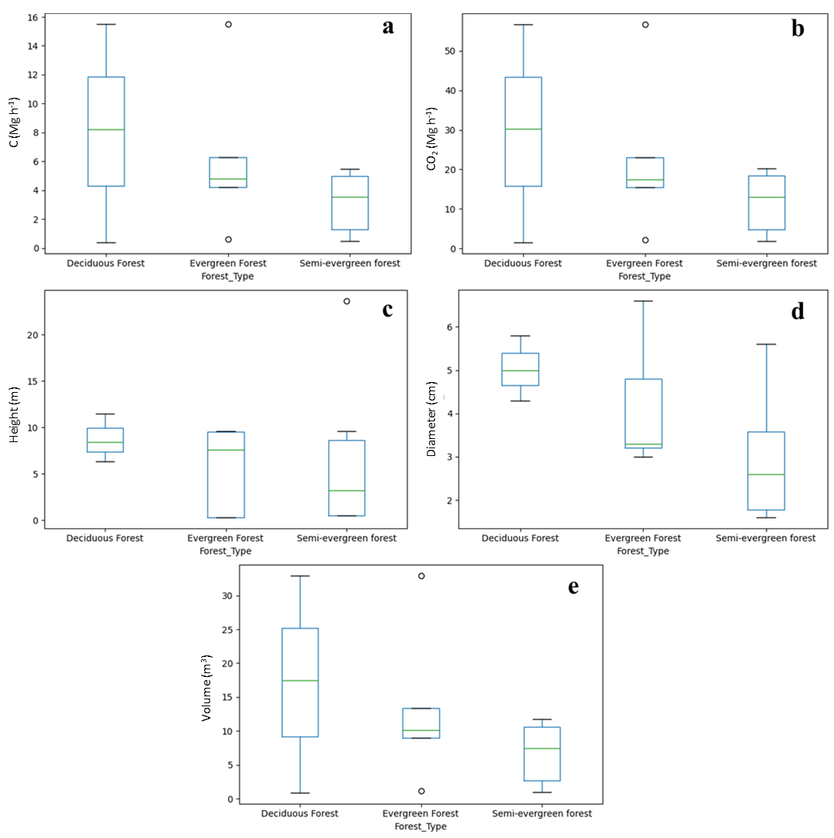
Fig.2. Boxplots comparing key bamboo growth and carbon-related variables across forest types: (a) carbon stock (Mg ha⁻¹), (b) CO₂ equivalent (Mg ha⁻¹), (c) height (m), (d) diameter (cm), and (e) volume (m³).
3.3.1 Carbon Stock (C, Mg ha⁻¹)
The distribution of carbon stock varied noticeably among forest types (Fig. 2a). Deciduous forests exhibited the highest and most variable carbon stocks, with values extending up to approximately 15 Mg ha⁻¹ and a median around 8 Mg ha⁻¹. This indicates both greater carbon accumulation and substantial variability among plots. Evergreen forests showed a narrower distribution, with most values clustered between 4–6 Mg ha⁻¹ and a median near 5 Mg ha⁻¹, suggesting more stable yet moderate carbon storage. Semi-evergreen forests displayed the lowest median (approximately 4 Mg ha⁻¹) and a relatively narrow range, reflecting consistently lower carbon stocks. Overall, these results suggest that deciduous forests possess the greatest potential for carbon sequestration, albeit with higher spatial variability, while evergreen and semi-evergreen forests exhibit more uniform but lower carbon storage capacity.
3.3.2 CO₂ Equivalent (Mg ha⁻¹)
The pattern of CO₂ equivalent mirrored that of carbon stock (Fig. 2b), as both metrics are directly related. Deciduous forests again recorded the highest CO₂ levels (up to 50 Mg ha⁻¹), followed by evergreen forests with moderate but consistent values, and semi-evergreen forests with the lowest storage potential.
3.3.3 Tree Height (m)
Tree height distributions differed notably among forest types (Fig. 2c). Deciduous forests exhibited relatively consistent heights, typically between 6 and 11 m, with a median around 9 m, indicating uniform and stable growth. Evergreen forests showed greater variability, with heights ranging from near 0 to about 10 m and a median close to 9 m, suggesting heterogeneous stand structure. Semi-evergreen forests recorded the lowest median height (~3 m) but displayed the widest variability, including an extreme outlier exceeding 20 m, likely representing sporadic growth of tall individuals within otherwise shorter stands. Overall, deciduous forests maintained taller and more uniform bamboo growth, whereas semi-evergreen forests exhibited stunted yet heterogeneous structures.
3.3.4 Diameter (cm)
As shown in Fig. 2d, deciduous forests had the largest mean diameters, ranging mostly between 4.5–6.0 cm, reflecting mature and vigorous culms. Evergreen forests exhibited a broader distribution (approximately 3–6 cm), indicating greater size heterogeneity. Semi-evergreen forests, in contrast, contained the smallest and most variable culms, mostly below 4 cm, consistent with less favorable growth conditions.
3.3.5 Volume (m³)
The distribution of bamboo volume followed a similar trend to diameter and height (Fig. 2e). Deciduous forests supported the highest and most variable volumes, ranging from near zero to above 30 m³, with a median around 17 m³. Evergreen forests showed moderate and consistent volumes (median ≈ 11 m³) with limited outliers, while semi-evergreen forests had the smallest volumes (median ≈ 8 m³; range = 1–12 m³). These findings indicate that deciduous forests promote the most productive bamboo growth, evergreen forests maintain moderate biomass, and semi-evergreen forests sustain lower but more variable growth performance.
Overall, the boxplot analysis demonstrates a consistent ecological gradient in bamboo productivity, with deciduous forests exhibiting superior structural development and carbon storage, followed by evergreen and semi-evergreen forests, which exhibit progressively lower biomass accumulation and growth uniformity.
3.4 Correlation Analysis Among All Variables
Correlation heatmaps show the relationships between structural and organic variables of bamboo in the three forest types (Fig. 3). Different patterns of relationships were found, indicating the interdependence between growth characteristics and biomass accumulation. Diameter (cm) showed a moderate positive correlation with canopy diameter (r = 0.61), volume (r = 0.50), and carbon and CO₂ content (r = 0.50). This result suggests that bamboo with larger diameters have larger canopy area and are able to accumulate more biomass, thus contributing more to total carbon sequestration. In contrast, height showed a lower correlation with structural and organic variables (r < 0.40), indicating that height alone is not a good predictor of biomass accumulation in these forests. The total number of bamboo plants per site was positively correlated with the number of dead bamboo plants (r = 0.56), suggesting a possible density-dependent mortality effect, with more bamboo plants having higher mortality rates than normal. Plant diameter showed low correlation with other variables (r < 0.40), indicating that the site structure was highly heterogeneous and not directly related to bamboo plant size or organic accumulation. As expected, the amount of carbon (C, Mg ha⁻¹) and the amount of CO₂ equivalent (Mg ha⁻¹) were perfectly correlated (r = 1.00), indicating that these variables represented the same organic source and were directly calculated. Overall, the compositional analysis showed that plant diameter and size were the most important structural variables, which were the main influences on the organic content and carbon sequestration capacity of bamboo. While the density and mortality of bamboo plants indicated ecological activity and environmental pressures, but were not directly related to growth capacity. These results indicate that basal diameter is a reliable indicator for measuring the productivity and carbon sequestration capacity of bamboo in different forest types.
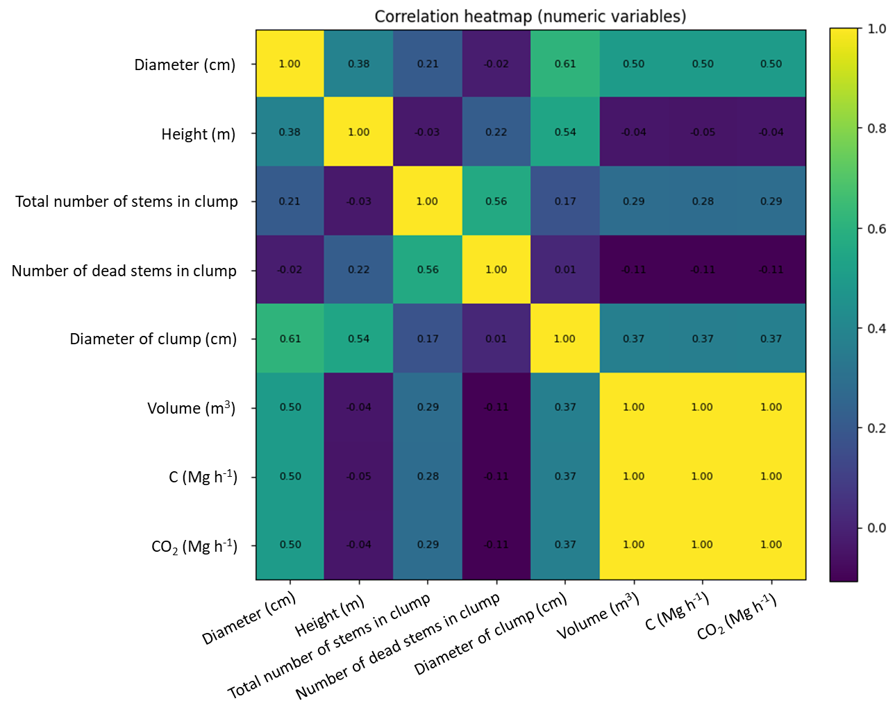
Fig. 3. Correlation heatmap showing relationships among structural and biomass variables of bamboo across three forest types. The strength of correlation is indicated by color intensity, with yellow representing strong positive correlations and dark tones indicating weak or negative relationships.
3.5 Principal Component Analysis (PCA) of Structural and Biomass Variables
The results of Principal Component Analysis (PCA) were used to explore the relationships between structural and organic variables and to assess the changes in bamboo stands across the three forest types (Fig. 4). The first two principal components showed a large amount of total variation, with PC1 accounting for 46.5% and PC2 accounting for 21.7%, which together accounted for approximately 68.2% of the total variation in the data. Deciduous forests are distributed along the positive axis of PC1, indicating a strong relationship with bamboo with large diameters, high biomass content, and greater carbon storage capacity (Fig. 4a). Evergreen forests are concentrated near the origin and on the slightly negative side of PC1, indicating moderate and uniform structural characteristics. In contrast, semi-deciduous forests show a wide distribution along the PC2 axis, mainly indicating high differences in structural characteristics such as height and mortality. Overall, this pattern shows clear differences between forest types, indicating that deciduous forests have high growth and carbon storage capacity, evergreen forests are moderately stable, and semi-deciduous forests show structural diversity and smaller bamboo stems. The percentage of variation explained by the two principal components (Fig. 4b). PC1, which explains about half of the total variation (46.5%), represents the pattern of bamboo size change and organic accumulation based on diameter, site size, and biomass. PC2 (21.7%) identifies the dominant variation related to bamboo height and mortality, indicating differences in vertical structure and site survival activity. The combination of PC1 and PC2 indicates that these two components cover the overall significant differences between forest types. Variables such as diameter (cm), plant diameter (cm), and total number of bamboo plants per site have strong positive weights on PC1, indicating that this component represents the structural size and density of bamboo (Fig. 4c). Similarly, volume (m³), carbon content (C, Mg ha⁻¹), and CO₂ equivalent (Mg ha⁻¹) also have high weights on PC1, indicating their close relationship with structural variables and their role in determining the capacity to store organic matter and carbon. In contrast, height (m) and number of dead bamboo plants per site have high weights on PC2, indicating that this axis represents the variation in vertical growth patterns and normal mortality activity rather than total organic production. Overall, the PCA results indicate that PC1 represents a structural-organic switching pattern that links bamboo size and site characteristics with carbon storage capacity, while PC2 shows variations related to height and survival of bamboo plants. These results indicate that bamboo carbon sequestration in Cambodian forest systems is primarily affected by structural variables such as stem diameter and site size, while height and mortality rate contribute to internal site variability.
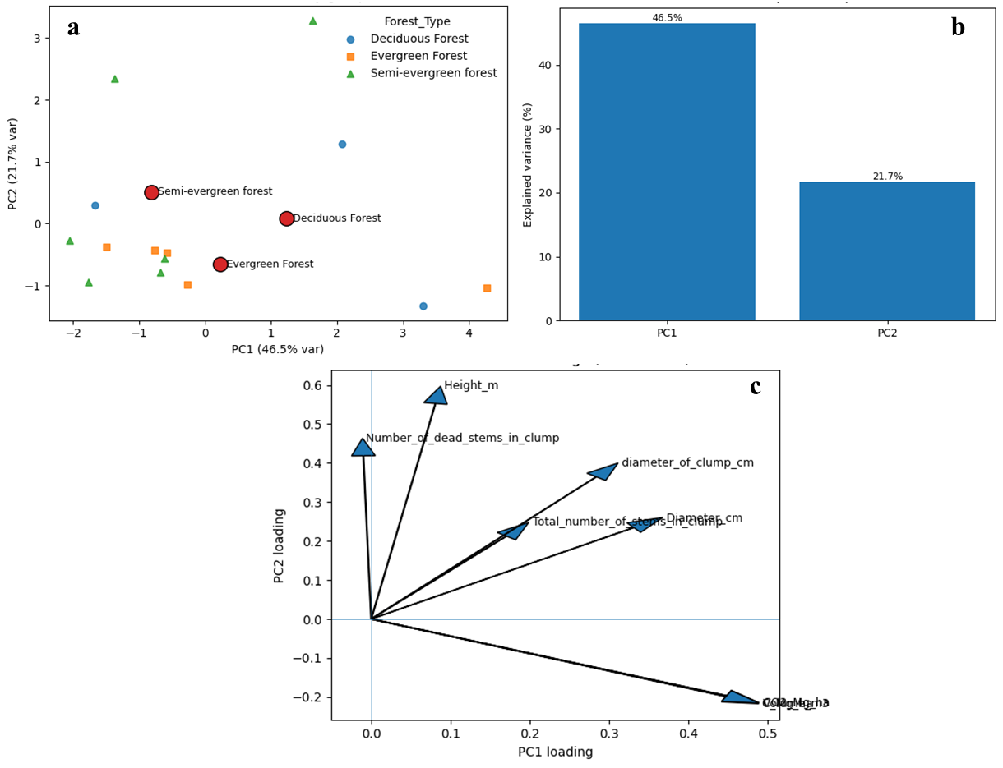
Fig. 4. Principal Component Analysis (PCA) of bamboo structural and biomass variables across three forest types. (a) PCA ordination plot showing forest-type separation along PC1 and PC2; (b) Scree plot showing the proportion of variance explained by the first two components; (c) PCA variable loadings plot illustrating contributions of individual structural and biomass variables to PC1 and PC2.

4. DISCUSSION
The results of this study revealed significant differences in the structural characteristics and carbon sequestration capacity of bamboos across deciduous, evergreen, and semi-deciduous forests in Cambodia. Bamboos in deciduous forests have the largest diameter and volume, which corresponds to the highest carbon content but are highly variable. In contrast, evergreen forests exhibit moderate and stable structural characteristics and carbon values, while semi-deciduous forests are characterized by smaller stands and consistently low carbon content, although some tall bamboos occur. These results are consistent with the study by Yiping et al. (2010), who reported that the carbon sequestration capacity of bamboos varies depending on forest type, stand structure, and management context. Similarly, Yuen et al. (2017) estimated that the total carbon content in bamboo ecosystems can range from 94 to 392 Mg C ha⁻¹ depending on bamboo species composition and environmental conditions, indicating the high capacity of bamboos as natural carbon sinks. This study also supports the results of Devi and Singh (2021), who reported that soil organic matter can be as high as 150 Mg ha⁻¹ and carbon content can be as high as 65 Mg ha⁻¹ for bamboo species in northeastern India. These results show that bamboo can sequester carbon in large quantities, especially when structural features such as stem diameter, density, and age structure are optimal. Correlation analysis in this study also confirmed the broad pattern that diameter and stand size are strongly positively correlated with carbon content and CO₂ content (r = 0.50–1.00), while stem density and mortality rate show lower correlations. This pattern is consistent with results from other forest systems, which show that basal root area and stem diameter are effective indicators in predicting organic matter and carbon storage (Ahirwal et al., 2021; Kothandaraman et al., 2020). PCA results further confirmed this pattern. The first principal component (PC1), which explained 46.5% of the total variation, was dominated by variables related to size and organic matter, while the second component (PC2, 21.7%) was found to be strongly influenced by variables related to height and mortality. These two axes clearly show ecological differences between forest types. Deciduous forests have high organic matter accumulation and uniform structure, while semi-deciduous forests show high structural diversity, possibly due to disturbance or differences in growing conditions (Souza et al., 2023). The variability observed in semi-deciduous forests—with some tall bamboo stands interspersed with small stands—may reflect differences in resources, microenvironments, or growth stages. Such contextual structural variation has also been reported in other bamboo systems, where site conditions and management practices can influence stand structure and carbon distribution (Jember et al., 2023). More importantly, these results have practical implications for forest management and carbon accounting in Cambodia, in line with the proposal of Yuan et al. (2023). Because the carbon sequestration capacity of bamboo varies depending on the forest type, management strategies should be tailored to each forest type. For example, in deciduous forests, protection and sustainable logging can help increase existing carbon stocks, while in semi-deciduous forests, measures that promote stand development and vigor can help unlock unused carbon capacity. Such targeted management approaches are in line with Zhou et al. (2011), who highlighted the importance of flexible forest management to maximize carbon benefits under different ecological conditions. Overall, this study suggests that bamboo plays a diverse but important role in carbon mobility in Cambodia’s major forest systems. By highlighting the structural differences and carbon sequestration capacities between forest ecosystems, these results contribute to a deeper understanding of the ecological role of bamboo and provide concrete evidence supporting its inclusion in climate-smart forest management strategies and global carbon accounting systems.

5. CONCLUSION
This study shows clear differences in the structural characteristics and carbon storage capacity of bamboo in different forest types, including deciduous, semi-evergreen, and evergreen forests in Cambodia. Bamboo in deciduous forests has the largest diameter, highest volume, and highest carbon stock, but there is considerable variation between study areas. Evergreen forests show moderate but stable structural characteristics and carbon storage capacity, while semi-evergreen forests have smaller bamboos and lower carbon stocks but also some tall bamboos, which are part of the structural diversity. The results of correlation analysis and principal component analysis (PCA) showed that diameter and head size were the main variables influencing live weight and carbon sequestration, while height and mortality showed broader structural characteristics than specific carbon sequestration. These results indicate that forest type plays an important role in determining the growth pattern and carbon sequestration capacity of bamboo trees. Overall, the finding means that the management and use of bamboo resources should consider the specific ecological context of the area. By demonstrating the structural and carbon-rich properties of bamboo across key forest types in Cambodia, this study provides valuable evidence to support the inclusion of bamboo in sustainable forest management strategies and climate mitigation.

DISCLAIMER (ARTIFICIAL INTELLIGENCE)
Authors hereby declare that NO generative AI technologies such as Large Language Models (ChatGPT, COPILOT, etc.) and text-to-image generators have been used during the writing or editing of this manuscript.

REFERENCES
Ahirwal, J., Nath, A., Brahma, B., Deb, S., Sahoo, U. K., & Nath, A. J. (2021). Patterns and driving factors of biomass carbon and soil organic carbon stock in the Indian Himalayan region. Science of the Total Environment, 770, 145292. https://doi.org/10.1016/j.scitotenv.2021.145292
Ahmad, Z., Upadhyay, A., Ding, Y., Emamverdian, A., & Shahzad, A. (2021). Bamboo: Origin, habitat, distributions and global prospective. In Z. Ahmad, Y. Ding, & A. Shahzad (Eds.), Biotechnological advances in bamboo: The “Green Gold” on the earth (pp. 1–31). Springer Singapore. https://doi.org/10.1007/978-981-16-1310-4_1
Devi, A. S., & Singh, K. S. (2021). Carbon storage and sequestration potential in aboveground biomass of bamboos in North East India. Scientific Reports, 11(1), 837. https://doi.org/10.1038/s41598-020-80887-w
Dutta, S., Gorain, S., Roy, J., Das, R., Banerjee, S., Gorai, S. K., Choudhury, M. R., & Das, S. (2025). Bamboo for global sustainability: A systematic review of its environmental and ecological implications, climate action, and biodiversity contributions. Environmental Reviews, 33, 1–26. https://doi.org/10.1139/er-2025-0032
Emamverdian, A., Ding, Y., Ranaei, F., & Ahmad, Z. (2020). Application of bamboo plants in nine aspects. The Scientific World Journal, 2020, 7284203. https://doi.org/10.1155/2020/7284203
Jember, A. A., Taye, M. A., Gebeyehu, G., Mulu, G., Long, T. T., Jayaraman, D., & Abebe, S. (2023). Carbon stock potential of highland bamboo plantations in northwestern Ethiopia. Carbon Balance and Management, 18(1), 3. https://doi.org/10.1186/s13021-023-00224-2
Kaam, R., Nfornkah, B. N., Chimi, C. D., Nguefack, J. A., Tchamba, M., & Zapfack, L. (2023). Bamboo biomass: A strategy for climate change mitigation and adaptation, and forest landscape restoration (FLR) in Cameroon. In F. L. Palombini & F. M. Nogueira (Eds.), Bamboo science and technology (pp. 397–428). Springer Nature Singapore. https://doi.org/10.1007/978-981-99-0015-2_14
Kim, S., Horn, S., Sok, P., Sien, T., & Yorn, C. (2023). Ecosystem carbon stock assessment in upland forest: A case study in Koh Kong, Mondulkiri, Preah Vihear, and Siem Reap Provinces. International Journal of Environmental and Rural Development, 14(2), 61‒67. https://doi.org/10.32115/ijerd.14.2_61
Kothandaraman, S., Swamy, P. S., Sundarapandian, S. M., & Chandrasekaran, S. (2020). Ecosystem-level carbon storage and its links to diversity, structural attributes, and environmental factors in tropical forests of the Western Ghats. Scientific Reports, 10(1), 13444. https://doi.org/10.1038/s41598-020-70313-6
Muchiri, M.N.& Muga, M.O. (2013). Preliminary yield model for natural Yushania Alpina bamboo in Kenya. Journal of Natural Sciences Research,3 (10), 77‒84.
Pan, C., Zhou, G., Shrestha, A. K., Chen, J., Kozak, R., Li, N., Li, J., He, Y., Sheng, C., & Wang, G. (2023). Bamboo as a nature-based solution (NbS) for climate change mitigation: Biomass, products, and carbon credits. Climate, 11(9), 175. https://doi.org/10.3390/cli11090175
Sarun, H., Chanra, R., Meta, H., Linan, H., Pang, T., & Savvong, C. (2025). Assessment of species diversity, biomass, and carbon stock in mangrove forests of Prey Nop District, Preah Sihanouk Province, Cambodia. Journal of Agriculture and Technology, 1(1), 30-40. https://doi.org/10.6084/M9.FIGSHARE.28407929.V2
Sasaki, N., Chheng, K., Mizoue, N., Abe, I., & Lowe, A. J. (2016). Forest reference emission level and carbon sequestration in Cambodia. Global Ecology and Conservation, 7, 82–96. https://doi.org/10.1016/j.gecco.2016.05.004
Singh, L., Sridharan, S., Thul, S. T., Kokate, P., Kumar, P., Kumar, S., & Kumar, R. (2020). Eco-rejuvenation of degraded land by microbe-assisted bamboo plantation. Industrial Crops and Products, 155, 112795. https://doi.org/10.1016/j.indcrop.2020.112795
Souza, R. R. de, Cargnelutti Filho, A., Toebe, M., & Bittencourt, K. C. (2023). Sample size and genetic divergence: A principal component analysis for soybean traits. European Journal of Agronomy, 149, 126903. https://doi.org/10.1016/j.eja.2023.126903
Yiping, L., Yanxia, L., Buckingham, K., Henley, G., & Guomo, Z. (2010). Bamboo and climate change mitigation: A comparative analysis of carbon sequestration. International Network for Bamboo and Rattan (INBAR). https://www.inbar.int/wp-content/uploads/2020/05/1489457789.pdf
Yuan, N., Wang, E., Lv, S., Tang, X., Wang, T., Wang, G., Zhou, Y., Zhou, G., Shi, Y., & Xu, L. (2023). Degradation reduces greenhouse gas emissions while weakening ecosystem carbon sequestration of Moso bamboo forests. Science of the Total Environment, 877, 162915. https://doi.org/10.1016/j.scitotenv.2023.162915
Yuen, J. Q., Fung, T., & Ziegler, A. D. (2017). Carbon stocks in bamboo ecosystems worldwide: Estimates and uncertainties. Forest Ecology and Management, 393, 113–138. https://doi.org/10.1016/j.foreco.2017.03.015
Zhou, G., Meng, C., Jiang, P., & Xu, Q. (2011). Review of carbon fixation in bamboo forests in China. The Botanical Review, 77(3), 262–270. https://doi.org/10.1007/s12229-011-9082-z

