Time Series Modeling of Nigerian Monthly Demand Deposits: Evidence of White Noise Behaviour
Abstract
This paper investigated the model performances and the features of monthly demand deposits in Nigeria during the period of economic diversification from the year 2016 to 2022 and the data set used in the study were originally collected from the Central Bank of Nigeria (CBN) database. However, the study applied the Box-Jenkins methodology and Augmented Dickey-Fuller (ADF) test statistics for stationarity. The AIC, BIC, R² and Adj.R² were considered when determining the adequacy of the models and checking the fitness of the GARCH and ARIMA models on the monthly Nigerian demand deposits. The GARCH (1, 1) and ARIMA (2, 1, 2 ) models were estimated accordingly using diagnostic tests and results were obtained. The result of the fitted plot clearly identified a linear pattern with an upward trend and non-stationarity. The result of the differenced plot also identified heteroscedasticity data with a regular pattern of variation of an error term. According to the results from the stationarity test. The first stationarity test failed because the p-value is greater than the significance level 0.5 then exhibits trend and seasonality while the p-value of the second stationarity test is less than the significance level 0.5 implying stationary, which means it has a constant mean, variance and autocovariance over the time. The estimation of GARCH (1, 1) and ARIMA (2,1,2) have a small R²and AdjR², indicating poor model fit which exposed that the models did not capture the underlying patterns in the data . From the estimation of GARCH(1,1) and ARIMA(2,1,2), the AIC and BIC values were close , meaning that they are intertwined with strong autocorrelation and volatility cluster in Nigerian Monthly Demand Deposits. The results indicate that the series is unpredictable, exhibiting characteristics of a white noise process, with data varying randomly around the mean and variance. Policy implication of this study is that the demand deposits might make it challenging for the Central Bank of Nigeria (CBN) to predict and manage liquidity in the financial system which will make them adjust the interest rate more frequently to accommodate strategies to account for unpredictability of demand deposits.
Keywords: Modeling, ARIMA, GARCH, Monthly, Demand deposits
Introduction
Bank liabilities that are paid out on demand are central elements of monetary systems. They constitute a significant portion of narrow money (M1) in Nigeria and hence an insight into the transactional aspect of the economy, financial intermediation, and trust of the economy in the banking system. Precise determination and prediction of demand deposits are thus significant in the short run liquidity management and conduct of the monetary policy, oversight and macro prudential control of the banks (Central Bank of Nigeria (CBN]). Nigeria’s financial environment has undergone pronounced structural change over the last decade. Episodes such as the 2015 oil-price shock and naira adjustment, banking consolidation and regulatory episodes, the COVID-19 economic shock of 2020, and subsequent exchange-rate and subsidy reforms have altered deposit behavior and the transmission of macroeconomic shocks to bank liabilities. These regime shifts increase the difficulty of unconditional time-series forecasting and emphasize the need for careful structural diagnostics. Empirically, Nigerian monetary series often display mixed dynamics. Some monetary aggregates and reserve series fit well with Box–Jenkins ARIMA specifications, providing reasonable short-term forecasts (e.g., external reserves modeling), while other aggregates show volatility clustering that GARCH-type models capture better (Umoh et al., 2023; Bolarinwa & Bolarinwa, 2022). Work focused specifically on demand deposits finds that they can respond to domestic macro conditions and to foreign interest-rate differentials — foreign deposit substitutes have tangible effects on domestic deposit behavior in Nigeria. This suggests that demand deposits may be jointly determined by domestic policy variables and external financial incentives, and that univariate forecasting may miss important drivers. The autoregressive model specifies that the output variable depends linearly on its own value and on a stochastic term(an imperfectly predictable term); thus, the model is in the form of stochastic difference equation or recurrence relation which should not be confused with differential equation.AR model predicts future behavior based on pass behavior it is used for forecasting when there is correlation between values in a time series and the values that precede and succeed them. Moving average model is a common approach of measuring univariate time series. It specifies that the output variable depends linearly on the current and various past values of a stochastic term. Given a time series of data X_{t}, the ARMA model is a tool for understanding and, perhaps, predicting future values in the series. The AR part involves regressing the variable on its own lagged values. The MA parts involves modeling the error term as a linear combination of error terms according contemporaneously and add at various times in the past. The model is usually referred to as the ARMA (p, q) model where p is the order of the AR part and q is the order of the MA part. Autoregressive moving average ARMA or autoregressive integrated moving average ARIMA models is use to find, the best fitted model to series. This paper investigates the time-series properties of monthly Nigerian demand deposits (Jan 2016–Mar 2022) and evaluates a parsimonious forecasting strategy. Because demand deposits may combine high short-frequency noise with occasional structural shifts tied to policy events or crises, the study employs a modelling strategy that emphasizes diagnostic testing: stationarity and unit-root checks, autocorrelation diagnostics, ARCH effects testing, and structural-break detection. Interpretation of results where possible is based on macroeconomic events and previous empirical results of the monetary aggregates in Nigeria.
Objectives
- To fit in GARCH and ARIMA models that would model the Nigerian Monthly Demand Deposits
- To test the adequacy of the model and investigate the monthly and future activities of the Nigerian Monthly Demand Deposits.
Related Literatures
Teriba (2006) broke down M1 to examine demand-deposit behavior and discovered that demand deposits react greatly to the foreign interest differentials both in the short and long term. Manasseh et al. (2021) used the Autoregressive Distributed Lag (ARDL) technique to study money demand in Nigeria, focusing on short and long run determinants such as income, interest, and price levels. The analysis found cointegration (a consistent long-run link) between broad money demand, income, interest rates, real exchange rates, and inflation (1981Q1-2018Q4). The ECM/short-run adjustment term is negligible, thus short-run correction to disequilibrium is limited; nonetheless, the velocity of money is predictable, signaling that money-supply targeting might be useful for policy.
Akinlo (2024) investigated the asymmetric impacts of the global uncertainty index on money demand in Nigeria, employing both linear and nonlinear ARDL (NARDL) to demonstrate asymmetric short- and long-run effects. The study discovered that uncertainty is a long-run phenomenon for Nigeria's money demand, that drops in uncertainty are more important than increases (that is, negative and positive shocks have unequal long-run implications), and that money demand is unstable in both linear and nonlinear frameworks. According to Doguwa et al. (2014) investigated structural breakdowns, cointegration, and money demand in Nigeria, finding that real money balances are cointegrated with real GDP, real monetary policy rate, and exchange rate indicators, although there is a structural break in 2007Q1. Approximately 23.4% of a disequilibrium is rectified within a quarter. CUSUM/CUSUMSQ tests show parameter instability during the global financial crisis, but stability before and after the crisis; generally, the long-run money-demand relationship remains (with regime transitions accounted for).
Oyadeyi (2025) researched financial innovation and money demand, and his findings demonstrated that fintech/digital payments affect money-demand linkages (lowering cash demand and altering volatility).Umoh et al. (2023) applied GARCH models to the narrow money in Nigeria to measure volatility and found out that there is conditional heteroscedasticity. Bolarinwa and Bolarinwa (2022) showed that ARIMA models can be used to predict the external reserves of Nigeria. According to Ogoke (2024) demonstrated, demand deposits have a significant effect on the GDP growth in Nigeria. As a recent study on demand-deposit contracts (2024) emphasizes, the bank-run risk can prevail in the dynamics of deposit’s Data and other foreign providers verify that there are high swings in money aggregates in Nigeria over the past few years.
Methodology
The data included monthly demand deposits between 2016 to 2022 and the data set was originally obtained from the official website of the Central Bank of Nigeria (CBN).This was accomplished using the time plot and the graph of the sample Autocorrelation Function and PACF acquired from the series. The Box-Jenkins method of analysis was adopted to detect the non-randomness in the data. The ACF measures the linear connection between a value in a time series and previous values at various delays. The ACF at lag k of a stationary time series is determined by dividing the autocovariance at lag k by the series variance
$ρ_{k}=\frac{γ_{k} }{γ_{0} }$ (3.1)
where
$ρ_{k}$ is the autocorrelation coefficient at lag k. This number ranges from -1 to 1, where 1 represents a perfect positive correlation, -1 shows a perfect negative correlation, and 0 means no connection.
$γ_{k}$is the autocovariance at lag k. This calculates the covariance of the series and its lagged version.
$γ_{0}$is the variance of the time series, which is the autocovariance at lag 0
The PACF on the other hand measures the correlation between an observation k period in the past and the present observation. The PACF is given by
$ϕ_{kk}=\frac{ρ_{k}-\sum_{j=1}^{k-1 }{ϕ_{k-1,j }ρ_{k-j}}}{1-\sum_{j=1}^{k=1}{{ ϕ}_{k,-1 ,j}ρ_{j}}}$ (3.2)
where${\begin{aligned} \\ ϕ\end{aligned}}_{kk}$ is The partial autocorrelation coefficient at lag k
$ρ_{k}$is the autocorrelation function at lag k
$ϕ_{k-1,j }$ is the partial autocorrelation coefficients from the previous lag k-1
Checks performed on diagnosing showed that the series did not have any pronounced autocorrelation and deterministic components. Rather, it was most aptly described as a white noise process, i.e. variations were basically random and could not be forecasted through historical trends.. Suppose Y_{t} is non-stationary in mean, the idea is to build an ARMA model on the series X_{t} definable as the result of the operation of differencing the series of d times (in general d= 1). In ARIMA model, we express X_{t} as a function of past value of x and 1 or past error as well as present time.
The general ARIMA model is given by
X_{t} = $∅$₁ X_{t-1} + $∅$₂X_{t-2} + $∅$₃X_{t-p} + $∅$₁$ε$_{t-1} + $∅$₂ $ε$_{t-2} +$∅$₃ $ε$_{t-p} (3.3)
A GARCH (Generalized Autoregressive Conditionally Heteroscedastic) model uses values $μ$of the past squared observations and past variances to model the variance at time t. This is a non-linear model used for predicting future variance using past variances and predictions of variances as the predictors. According to Eagle R. F. (1982), the general GARCH model in terms of (1,1) is written as
$σ_{t}^{2}=α_{0}+α_{1}X_{t-1}^{2}+β_{1}σ_{t-1}^{2}$ (3.4)
The ARMA (p,q) model can be written as
X_{t}$=δ+ ε_{t}\sum_{i=1}^{p}{∅_{i}}X_{1}+\sum_{j=1}^{q}{θ_{j}ε_{t-1} }$(3.5)
$X_{t}=σ_{t}Z_{t}, { as Z}_{t}\sim N(0,1)$.$σ$_{t}²is the dependent variable, $α$_{0,}$α$_{1…}$α$_{p}are parameters to be estimated and β₁… β_{q} are explanatory variables.

Results and Discussion
FIGURE 1: Time plot of Nigerian Monthly Demand Deposits
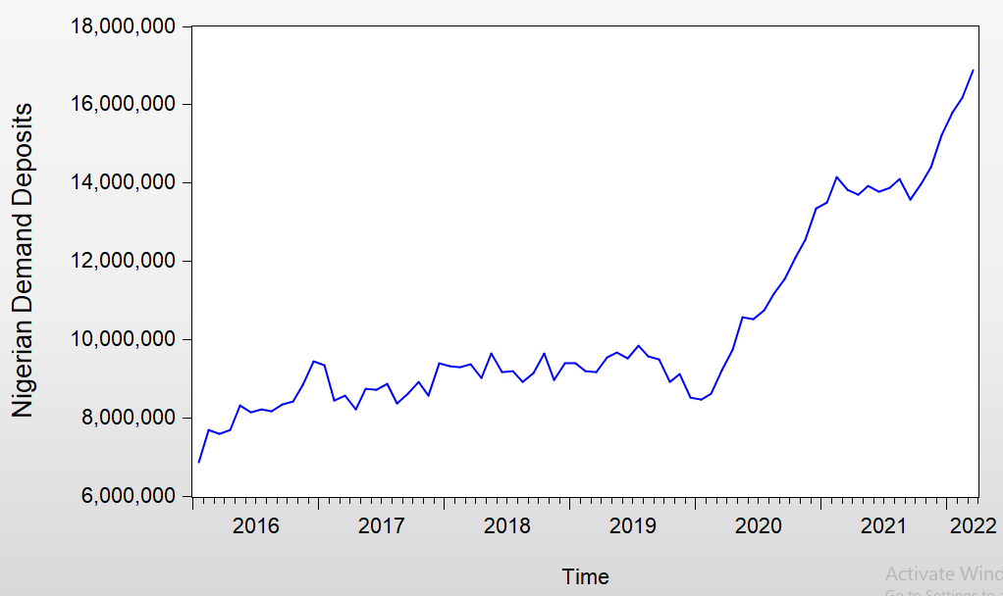

TABLE 1: Stationarity Test 1 for NGDD
Section/Statistic | Detail | Value | Related Statistic | Related value
ADF Test Statistics | ADF test statistics | 1.350604 | Prob.* | 0.9987
Critical Values | 1% level | -3.521579
 | 5% level | -2.9012117
 | 10% level | -2.587981
ADF Regression | NGDD(-1) coefficient | 0.027686 | NGDD(-1) t-statistic | 1.350604
(Dependent Variables :D(NGDD)) | NGDD(-1) Std. Error | 0.020499 | NGDD(-1) Prob. | 0.1811
 | C(constant) coefficient | -146731.2 | C(constant) t-statistics | -0.685983
 | C(constant) Std. Error | 213992.6 | C(constant) prob. | 0.4951
Regression Statistics | R-Squared | 0.024709 | Mean dependent variable | 135453.2
 | Adjusted R-Squared | 0.011163 | S.D dependent variable | 400209.2
 | S.E of regression | 397969.1 | Akaike Info Criterion | 28.65279
 | Sum squared residue | 1.14E +13 | Schwarz Criterion | 28.71506
 | Log likelihood | -1058.153 | Hannan-Quinn Criterion | 28.67763
 | F-Statistics | 1.824130 | Durbin-Watson statistics | 2.096589
 | Prob (F-Statistics) | 0.181052

FIGURE 2: First Difference of Nigerian Demand Deposit (NGDD)
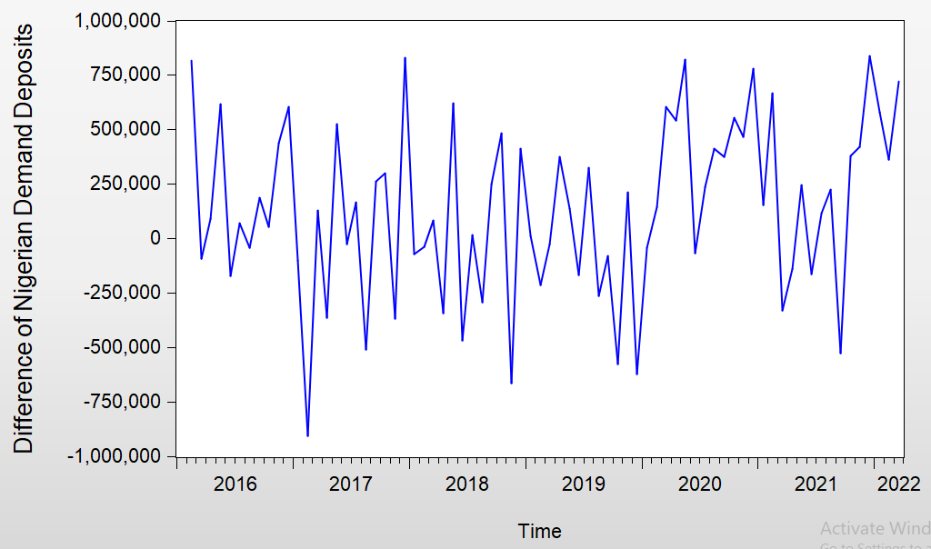
TABLE 2: Stationarity Test 2 for DNGDD
Sections/Statistics | Detail | Value | Related Statistics | Related value
ADF Test Statistics | ADF test statistics | -4.603148 | Prob.* | 0.0003
Critical Values | 1% level | -3.524233
 | 5% level | -2.902358
 | 10% level | -2.588587
ADF Regression | D(NGDD(-1) ) coefficient | -0.794498 | D(NGDD(-1)) t-statistic | -4.603148
(Dependent Variables :D(D(NGDD))) | D(NGDD(-1)) Std. Error | 0.170470 | D(NGDD(-1) ) Prob. | 0.0000
 | D(NGDD(-2)) coefficient | -0.223011 | D(NGDD(-2)) t-statistic | -1.908631
 | D(NGDD(-2)) Std. Error | 0.116843 | D(NGDD(-2)) t-statistic | 0.0605
 | C(constant) coefficient | 102349.2 | C(constant) t-statistics | 2.022414
 | C(constant) Std. Error | 50607.46 | C(constant) prob. | 0.0470
Regression Statistics | R-Squared | 0.526715 | Mean dependent variable | 11283.11
 | Adjusted R-Squared | 0.512996 | S.D dependent variable | 561941.7
 | S.E of regression | 392154.6 | Akaike Info Criterion | 28.63747
 | Sum squared residue | 1.06E +13 | Schwarz Criterion | 28.73233
 | Log likelihood | -1027.949 | Hannan-Quinn Criterion | 28.67524
 | F-Statistics | 38.39474 | Durbin-Watson statistics | 2.021634
 | Prob(F-Statistics) | 0.000000

Figure 3: ACF and PACF of an ARIMA (2, 1, 2) Fit.
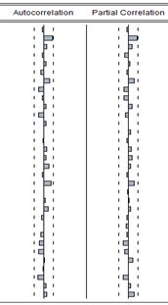

Table 3: ACF and PACF of an ARIMA (2, 1, 2) Fit.
S/N | AC | PACF | Q-Stat | Prob
1 | -0.029 | -0.029 | 0.0642 | 0.800
2 | 0.216 | 0.215 | 3.7094 | 0.156
3 | 0.070 | 0.085 | 4.0971 | 0.251
4 | -0.047 | -0.094 | 4.2755 | 0.370
5 | 0.065 | 0.028 | 4.6154 | 0.865
6 | -0.073 | -0.047 | 5.0541 | 0.537
7 | 0.142 | 0.137 | 6.7549 | 0.455
8 | -0.0127 | -0.113 | 8.1327 | 0.421
9 | 0.042 | -0.102 | 8.2840 | 0.506
10 | 0.057 | 0.086 | 8.5675 | 0.574
11 | -0.136 | -0.068 | 10.211 | 0.512
12 | 0.058 | 0.007 | 10.516 | 0.571
13 | -0.007 | 0.046 | 10.521 | 0.651
14 | -0.022 | -0.044 | 10.565 | 0.720
15 | 0.070 | 0.076 | 11.034 | 0.750
16 | 0.043 | 0.083 | 11.216 | 0.796
17 | 0.116 | 0.053 | 12.551 | 0.766
18 | -0.031 | -0.029 | 12.644 | 0.812
19 | 0.186 | 0.142 | 16.195 | 0.644
20 | -0.005 | -0.014 | 16.197 | 0.704
21 | 0.035 | 0.013 | 16.324 | 0.751
22 | 0.110 | 0.061 | 17.621 | 0.728
23 | 0.050 | -0.041 | 17.892 | 0.763
24 | -0.007 | -0.055 | 17.897 | 0.808
25 | -0.075 | -0.043 | 18.550 | 0.818
26 | -0.106 | -0.0131 | 19.760 | 0.803
27 | -0.136 | -0.097 | 21.982 | 0.738
28 | 0.010 | -0.102 | 21.994 | 0.782
29 | -0.011 | -0.004 | 22.009 | 0.820
30 | -0.142 | -0.130 | 24.599 | 0,744
31 | 0.055 | 0.052 | 25.000 | 0.768
32 | 0.076 | 0.145 | 25.773 | 0.774

TABLE 4: Estimation of ARIMA Model for DNGDD
Section/Statistic | Detail | Value | Related Statistic | Related value
Coefficients | AR(1) coefficient | 0.418595 | AR(1) t-statistics | 0.83695
 | AR(1) Std. Error | 0.500355 | AR(1) Prob. | 0.4057
 | AR(2) coefficient | 0.261203 | AR(2) t-statistics | 0.53481
 | AR(2) Std. Error | 0.492389 | AR(2) Prob. | 0.5975
 | MA(1) coefficient | -0.402141 | MA(1) t-statistics | -0.808461
 | . MA(1) Std. Error | 0.497415 | MA(1) Prob. | 0.4216
 | MA(2) coefficient | 0.021076 | MA(2) t-statistics | 0.045337
 | MA(2) Std. Error | 0.464865 | MA(2) Prob. | 0.9640
 | SIGMASQ coefficient | 1.58E+11 | SIGMASQ t-statistics | 5.040540
 | SIGMASQ Std. Error | 3.13E+10 | SIGMASQ prob. | 0.0000
Regression Statistics | R-Squared | 0.002249 | Mean dependent variable | 135453.2
 | Adjusted R-Squared | -0.055592 | S.D dependent variable | 400209.2
 | S.E of regression | 411182.9 | Akaike info. Criterion | 28.76021
 | Sum squared residue | 1.17E+ 13 | Schwarz Criterion | 28.91589
 | Log likelihood | -1059.128 | Hannan-Quinn Criterion | 28.82232
 | Durbin-Watson stat | 1.936878
Inverted Roots | Inverted AR Roots | .76
 | Inverted MA Roots | .34

TABLE 5: Estimation of GARCH (1, 1) Model for DNGDD
Section/Statistic | Detail | Value | Related Statistic | Related value
Variance Equation Coefficients | C coefficient | 8.96E +10 | C t-statistics | 0.625140
 | C Std. Error | 1.44E+11 | C Prob. | 0.5319
 | RESID (-1) ^2 coefficient | -0.116679 | RESID (-1) ^2 t-statistics | -0.796875
 | RESID (-1) ^2 Std. Error | 0.146090 | RESID (-1) ^2 Prob. | 0.4245
 | GARCH(-1) coefficient | 0.597809 | . GARCH(-1) t-statistics | 0.784153
 | . GARCH(-1) Std. Error | 0.762362 | . GARCH(-1)Prob. | 0.433 0
Regression Statistics | R-Squared | -0.116122 | Mean dependent variable | 135453.2
 | Adjusted R-Squared | -0.101039 | S.D dependent variable | 400209.2
 | S.E of regression | 419941.1 | Akaike info. Criterion | 28.80416
 | Sum squared residue | 1.30E+13 | Schwarz Criterion | 28.89757
 | Log likelihood | -1062.754 | Hannan-Quinn Criterion | 28.84142
 | Durbin-Watson stat. | 1.781675

Teriba (2006) carried out a research on the demand deposits behavior using a time series model, the AIC and SIC was used to determine the effectiveness of the models. The results show that the demand deposits reacted very high to the foreign differentials on both short and long term. Another scientist who used GARCH models to determine the demand deposits was Ugoke in 2024, according to him that the demand deposits had a significant effect on the GDP growth in Nigerian economic activities but this study also used a time series model to estimate the activities of the Nigerian monthly demand deposits and to determine the efficient model that captured the dataset. The data used for this study is adopted from the Central Bank of Nigeria (CBN) statistical bulletin from 2016 to 2022, the study also applied the method of Box-Jenkins and Augmented Dickey-Fuller test to estimation specific models in order to assess the volatility of the Nigerian Monthly Demand Deposits. The original GARCH (1,1) and ARIMA(1,2,1) models was successfully applied for proper estimation of parameters using AIC, SIC, R² and AdjR². The results displayed in figure 1 represent a time plots of the Nigerian Demand Deposits without differencing. The plots clearly identified linear pattern with upward trend and a non-stationarity. The time plots revealed that the series is non-stationary as it tends to posse a general upward trend almost every. Table 2 which represent the first differencing of the Nigerian Demand Deposits observed the presence of the heteroscedasticity as there is no presence of linear pattern. It was found that the behavior of the Nigerian monthly demand deposits between 2016 and 2022 was like a white noise process which implies the previous values did not have any predictive ability on future movements. Stationarity test was conducted in Table 1 and 2 respectively using Augmented Dickey-Fuller test method but Table 3 and 5 respectively took the estimation of ARIMA (2,1,2) and GARCH (1,1) as their AIC and SIC model adequacy measures where compared to determine the efficient model to the series. The first stationarity test with Augmented Dickey-Fuller test 1.350604 with p-value (0.9989) fail because the p-value (0.9987) is greater than the significance level 0.05 which exhibits trend and seasonality, while the Augmented Dickey-Fuller test (-4.603148) of the second stationarity test with p-value(0.003) is less than the significance level 0.05 and the test is stationary, meaning it has a constant mean ,variance and autocovariance over time. The estimation of R² and AdjR² have negative values, it indicates poor model fit, meaning that they are intertwined and have a strong autocorrelation and volatility cluster. The results displayed that ARIMA (2,1,2) and GARCH (1,1) on Table 1 ,2 ,3 and 4 respectively have close related value, meaning they are intertwined and have strong autocorrelation and volatility cluster. The results also indicate that the Nigerian Monthly Demand Deposits is unpredictable as the data varied randomly around the mean and variance. One of the policy implications of this study is that the Nigerian Monthly Demand Deposits might make it challenging for the Central Bank of Nigeria to predict and manage liquidity in the financial system. Again, the Central Bank of Nigeria (CBN) will make some adjustment on the interest rate frequently to accommodate strategies to account for unpredictability of Monthly Demand Deposits. Then, the study conclude that the Monthly Demand Deposits in Nigerian are not efficiently predictable over the period of time indicating that variation might be caused not by pure time series process but by structural ones. However, changes are more likely to be caused by external shocks, policy measures and structural economic events. The time plot of monthly demand deposits most likely exhibited random ups and downs, with no continuous upward or negative trend. This visual impression corroborated the diagnostic test findings, indicating that the series behaved like a white-noise process, which means that the data varied randomly around a mean value, with no recognizable pattern from month to month. Any apparent movements were the result of external shocks or policy changes, not internal time series dynamics. When differencing was performed to Nigerian monthly demand deposit data, no obvious autocorrelation pattern emerged, implying that the data was already stable or behaved randomly, confirming that the differencing did not disclose any underlying predictability which means there was no structure. Essentially, the series was white noise, and differencing did not enhance stationarity since there was no intrinsic pattern to remove. The diagnostic tests and ocular inspection both indicated a white-noise process, which implies unpredictability. As a result, no ARIMA model could improve predictions the best forecast was just the latest observed number {₦16,896,282.81)..The ARIMA model failed because all AR and MA parameters were statistically insignificant, with GARCH effect, implying that there was no volatility clustering, deposit variance did not change over time, and the data behaved like homoscedastic white noise (constant variance).For the Nigerian monthly demand deposits, the fitted model is expressed as:
Yₜ = 16,896,282.81 + ε. This implies that the monthly variations in demand deposits are purely random around a mean level of ₦16,896,282.81. Hence, the best forecast for any future period is simply the most recent observed value. This observation has significant policy implications especially in the case of Central Bank of Nigeria, it might not be effective depending on mechanical time-series predictions of deposits. Rather, more focus should be directed to structural modeling which involves the macroeconomic drivers of interest rates, inflation and changes in regulation. The series turned out to be white noise meaning that it is uncertain to make a short-term forecast and the best way to do it is to use the latest observation. Nigeria demand deposits change randomly from month to month and the past values do not predict future values (ARIMA failed). Shock effects do not persist, and there is no volatility pattern (GARCH failed). The following are the proposed fitted GARCH and ARIMA models that would model the Nigerian Monthly Demand Deposits:
$δ_{t}^{2}= ∝_{0}$+ $∝_{1}ε_{t-1}^{2}$+ $β_{1}ε_{t-1}^{2}$where$∝_{0}=8.990000000000,{ ∝}_{1}$= Residual (-1) = -0.116679, $β_{1}$= GARCH (-1) =0.597809, then the fitted GARCH (1, 1) model become
$δ_{t}^{2}$ = 8.990000000000 – 0.116679 $ε_{t-1}^{2}$ + 0.597809 $δ_{t-1}^{2}$ and that of ARIMA fitted model is given as $X_{t}$ = 0.418595$X_{t-1}$ + 0.261203$X_{t-2}$-0.402141$ε_{t-1}$+ 0.021076$ε_{t-2}$ the above GARCH (1,1) and ARIMA (2,1,2) models are the proposed models to estimate the Nigerian Monthly Demand Deposits.
Conclusion
From the results above, we conclude that the stationarity test have poor model fit , meaning the model failed to captured the underlying patterns in the data. The AIC, SIC, of GARCH (1,1) and ARIMA (2,1,2) model have close related values with better R² and Adj.R² value, meaning that they intertwined and have a strong autocorrelation and volatility cluster in Nigerian Monthly Demand Deposits. The results above also indicate that the Nigeria Monthly Demand Deposits is unpredictable with a white noise process as the data varied randomly around the mean and variance. The policy implication, the results shows average risk in the Monthly Demand Deposits which might make it challenging for Central Bank of Nigeria (CBN) to predict and manage liquidity in the financial institutes which will make them adjust the interest rate more frequently to accommodate their strategies.
Disclaimer (Artificial intelligence)
Author(s) hereby declare that NO generative AI technologies such as Large Language Models (ChatGPT, COPILOT, etc.) and text-to-image generators have been used during the writing or editing of this manuscript.

References
Adekoya, O. B. (2020). Portfolio balance approach to asymmetries, structural breaks and stock–exchange rate nexus in Nigeria. Central Bank of Nigeria Journal, 5, 87–110.
Aing, Z., Goranger, G. N.J., & Engle, R. F. (1993). A long money property of stock market return and a new model. Journal of empirical finance 1(2), 183-106
Akinbobola, T. O. (2012). The dynamics of money supply, exchange rate and inflation in Nigeria. Journal of Applied Finance & Banking, 2(4), 117–141.
Akinlo, A.E ( 2024).Asymmetric effects of world uncertainty index on the demand for money in Nigeria.SN Business and Econometrics.https://doi.org/10.1007/s43546-024-00696-5.
Box, G.E.P., Jenkins, G.M.,& Reinsel, G.C (2015). Time Series forecasting and control: Central Bank of Nigeria (CBN),Statistical bulletin:http://www.cbngov.ng/document/statbulletin.asp
Bolarinwa, B. T., & Bolarinwa, I. A. (2022). Time series modeling of Nigeria’s external reserves using Box–Jenkins ARIMA approach. African Scholar Journal of Science and Technology, 25(9), 112–128.
Datmaz, S.&Central Bank of Nigeria Research (2020). Determinants of Deposit and lending rates in Nigeria: Evidence from bank-level data.CBN occasional paper 72
Doguwa,S.I. (2014).Structural breaks, cointegration and demand for money in Nigeria. CentralBank. CBN working paper/Journal of applied Statistics. CBN publications.
Deebom, Z.D&Tuaneh, G.L. (2019). Modeling exchange rate and Nigerian deposit money market dynamics using triradiate multivariate GARCH (BEKK).Asian Journal of Economics, Business and Accounting10(2),1-18
Fasanya, I. O., &Akinwale, O. A. (2022). Exchange rate shocks and sectoral stock returns in Nigeria: Do asymmetry and structural breaks matter? Cogent Economics & Finance, 10(1), 2045719.
Engle, R. F. (1992). Autoregressive Conditional Heteroscedasticity with Estimates of the variance of United Kingdom inflation .Econometrica.
Etuk, E. H. (2012). Forecasting Nigeria Naira – US Doller exchange rate by a seasonal ARIMA model, American journal of scientific Research. 59(1), 71-78,
Ikoku, A .(2014).Modeling and forecasting currency in circulation for liquidity management in Nigeria.CBN Journal of applied statistics, 5(1),79-104.
ManassehC.O.,Nwakoby,I.C.,&Abada, F.C.(2021) Money demand in Nigeria: Application of Autoregressive distribution lag (ARDL) approach. Asian economic and financial review 11(4),308-321
Odior, E. S., &Banuso, F. B. (2016). Monetary policy, exchange rate dynamics and inflation in Nigeria. Covenant Journal of Business and Social Sciences, 7(2), 1–18.
Ogoke, S. I. (2024). Demand deposits and economic growth, A time series analysis,International Journal of Economics, Finance and Management, 9(7),18–45. https://doi.org/10.56201/ijefm.v9.no7.2024.pg18.45.
Onwukwe, C E. (2011). Modeling the volatility of the Nigeria stock return using GARCH models.Journal of Mathematical Research. 3(4), 91-134.
Oyadeyi, O.O. (2025). Financial innovation and money demand in Nigeria: Exploring the impact of banking innovations, fintech developments and digital payment channels on the money demand. Social Sciences and Humanities open 12, 2025, 102057.https://doi.org/10.1016.
Pepple, S. U. (2019). Comparative performance of GARCH and SARIMA techniques in financial time series forecasting. Journal of Statistics and Econometrics,8(2),250–262.
Teriba, A. (2006). Demand for Demand Deposits in Nigeria. Available at SSRN 874450. https://papers.ssrn.com/sol3/papers.cfm?abstract_id=874450
Umoh, I. M. (2023). GARCH and SARIMA modelling of Nigerian narrow money. Faculty of Natural and Applied Sciences Journal of Scientific Innovations, 5(2), 122-128.
Zakoian, J. M. (1994). Threshold Heteroscedasticity model, A Journal of Econometric Dynamics and ontrol, 18(1) , 931-955.

