Original Research Article

GEOCHEMICAL AND GEOLOGICAL ASSESSMENT OF LEAD-ZINC DEPOSITS AT ENYIGBA AND ITS ENVIRONS, SOUTHEASTERN NIGERIA

ABSTRACT
This study investigates the geology and grade of lead-zinc (Pb-Zn) mineralization within the Enyigba area of the Lower Benue Trough, Southeastern Nigeria, with the objective of evaluating the economic potential and geological controls of mineralization. The research adopted an integrated approach combining geological field mapping and geochemical evaluation. Field investigations involved mapping lithological units, measuring fracture orientations, and collecting ten representative ore samples from two mineralized locations at an average depth of 1.2 meters. Laboratory analyses were conducted using X-ray fluorescence (XRF) and wet chemical methods (Aqua Regia digestion and EDTA titration) to determine the concentrations of lead and zinc. The results show that lead content ranges from 1.13 to 5.25 wt% with a mean of 3.31 wt%, while zinc content ranges from 1.31 to 3.96 wt% with a mean of 2.50 wt%. The spatial variation of Pb and Zn suggests a metal zonation pattern typical of Mississippi Valley-Type (MVT) mineralization, where galena (PbS) is concentrated in central veins and sphalerite (ZnS) occurs in peripheral zones. Structural features such as faults and fractures provided conduits for hydrothermal fluids, which precipitated Pb-Zn sulfides within the Albian Asu River Group sediments. Comparison with other deposits in the Lower Benue Trough, such as Ishiagu, Ameri, and Ameka, revealed similar grade ranges and paragenetic trends, confirming the genetic and structural consistency of mineralization across the region. The study concludes that the Enyigba Pb-Zn ores are moderately rich and economically viable for small to medium scale mining, particularly given their shallow occurrence and accessibility. The local geology of Enyigba is dominated by sedimentary rocks belonging to the Asu River Group, which is the oldest stratigraphic unit in the Lower Benue Trough and it consists mainly of dark grey to black shales, siltstones, fine to medium grained sandstones, and thin limestone interbeds. It is therefore recommended that subsurface exploration involving drilling and geophysical surveys be conducted to delineate ore continuity and assess deeper sulfide zones, which may contain higher metal concentrations. Additionally, environmental monitoring and remediation programs are advised to mitigate potential heavy metal contamination associated with lead mining.
Keywords: Lead-Zinc mineralization, Enyigba, Lower Benue Trough, Geochemical analysis, Economic Geology, Hydrothermal alteration, Mississippi Valley-Type (MVT).
- INTRODUCTION
Lead-zinc (Pb-Zn) mineralization has long been recognized as one of Nigeria’s most important sources of non-ferrous metals, playing a key role in the nation’s economic development and industrialization. The Enyigba lead-zinc deposits, located near Abakaliki in southeastern Nigeria, form part of the Lower Benue Trough, a major Cretaceous sedimentary basin known for its rich metallogenic potential (Benkhelil, 1989; Bute et al., 2024). The Benue Trough extends northeast-southwest across central Nigeria and represents a failed arm of the triple junction formed during the opening of the South Atlantic Ocean in the early Cretaceous (Ofoegbu & Onuoha, 1991). The trough is structurally complex, containing several sub-basins such as Abakaliki, Afikpo, and Nkalagu, which host a variety of mineral deposits, including lead-zinc-barite, coal, and limestone (Fatoye et al., 2014; Olade, 1976).
The Enyigba district, in particular, is situated within the Abakaliki Anticlinorium, characterized by folded and faulted sedimentary sequences of the Asu River Group. These formations, predominantly dark grey shales, siltstones, sandstones, and limestone lenses, were deposited during the Albian stage of the Lower Cretaceous period (Benkhelil, 1989; Obarezi & Nwosu, 2013). Faulting and fracturing in the area served as conduits for metal bearing hydrothermal fluids, leading to the emplacement of lead-zinc mineralization. The ores are typically associated with vein and breccia systems, composed mainly of galena (PbS), sphalerite (ZnS), and subordinate gangue minerals such as quartz, calcite, and pyrite (Obasi & Akudinobi, 2021; Bute et al., 2024).
Understanding the geological and geochemical characteristics of these deposits is critical not only for economic exploitation but also for environmental and sustainable resource management (Plant et. al., (1990); Lavery et. al., (1994)). Previous research has shown that many of Nigeria’s Pb-Zn occurrences are Mississippi Valley-Type (MVT) deposits formed by low temperature, hydrothermal fluids that precipitated in carbonate host rocks under reducing conditions (Leach et al., 2010; Olade & Morton, 1985). However, detailed grade analysis and geochemical profiling are still limited in several localities, including Enyigba, where small scale mining has been ongoing for decades. The lack of reliable quantitative data on ore quality and spatial variation constrains efficient extraction and environmental planning (Obarezi & Nwosu, 2013; Ezeh & Anike, 2010).
Recent investigations into the Benue Trough metallogeny have highlighted the influence of basin evolution, fluid migration pathways, and fault reactivation on metal deposition (Bute et al., 2024). The hydrothermal fluids responsible for mineralization are believed to have originated from basinal brines that leached metals from underlying sediments before being channeled upward along faults and fractures (Olade, 1976; Fatoye et al., 2014). The structural controls, particularly the northeast-southwest trending fractures, have been identified as key determinants of ore localization in Enyigba and surrounding districts such as Ishiagu, Ameri, and Ameka (Nwachukwu, 1972; Obarezi & Nwosu, 2013).
In addition to the geological interest, the environmental and public health implications of lead-zinc mining have recently attracted attention. Studies have documented elevated concentrations of Pb, Zn, and Cd in soils, water, and agricultural produce near mining areas, posing risks to human health and the ecosystem (Obasi & Akudinobi, 2021). These concerns reinforce the need for comprehensive geological and geochemical assessments that inform not only exploration strategies but also environmental management frameworks aligned with global sustainability standards. Therefore, this study seeks to investigate the geology and grade of lead-zinc mineralization in Enyigba and its environs.
Location of the study area
The study area, Enyigba and its environs, is located within Abakaliki Local Government Area of Ebonyi State, Southeastern Nigeria (Fig. 1). Geographically, it lies between latitude 6°09′ and 6°13′ N and longitude 8°06′ and 8°10′ E, covering parts of Enyigba, Ameka, and Ameri mineralized districts within the Lower Benue Trough (Benkhelil, 1989; Fatoye et al., 2014). The area occupies the southwestern flank of the Abakaliki Anticlinorium, a structural feature that trends northeast-southwest and hosts several Pb-Zn-Ba mineralized veins (Olade, 1976; Bute et al., 2024).
Enyigba is approximately 14 kilometers southeast of Abakaliki, the capital of Ebonyi State, and about 80 kilometers northwest of Enugu City, which serves as a major regional hub in southeastern Nigeria. The area is accessible by a network of both tarred and untarred roads, facilitating transportation of people and materials. The major access route is the Abakaliki-Afikpo Expressway, which connects to Enyigba through Ezzamgbo-Ameka-Enyigba Road and other local feeder roads maintained by the state and local governments. These roads link directly to Ebonyi State’s industrial layout, allowing for ease of movement of mineral resources to processing and marketing centers (Ezeh & Anike, 2010).
Several secondary roads branch out from the main expressways, providing access to villages such as Ameka, Ameri, Ndufu-Alike, and Ikwo, where additional mineralized zones occur. Although some of the rural roads become difficult to navigate during the rainy season due to erosion and flooding, ongoing state infrastructural projects have improved mobility and economic integration.
The area is strategically located near several regional markets and industrial centers. The Abakaliki International Market and Margaret Umahi International Market serve as major commercial hubs for trade in agricultural produce and locally mined minerals. Additionally, the proximity to Royal Salt Limited and Ebonyi State Cement Factory (NIGERCEM) enhances the potential for local processing and export of lead-zinc concentrates. These facilities are linked by road to Onitsha and Port Harcourt, two major commercial ports that facilitate the distribution of industrial goods and raw materials to other parts of Nigeria and beyond (Obasi & Akudinobi, 2021).
In terms of topography and drainage, the area is moderately undulating, with gentle slopes that favor road construction and accessibility. It is drained mainly by the Ebonyi River and its tributaries, which flow southward into the Cross River basin. The climate is tropical humid, characterized by distinct rainy (April-October) and dry (November-March) seasons, which influence field accessibility and sampling conditions (Nwachukwu, 1972; Ezeh & Anike, 2010).
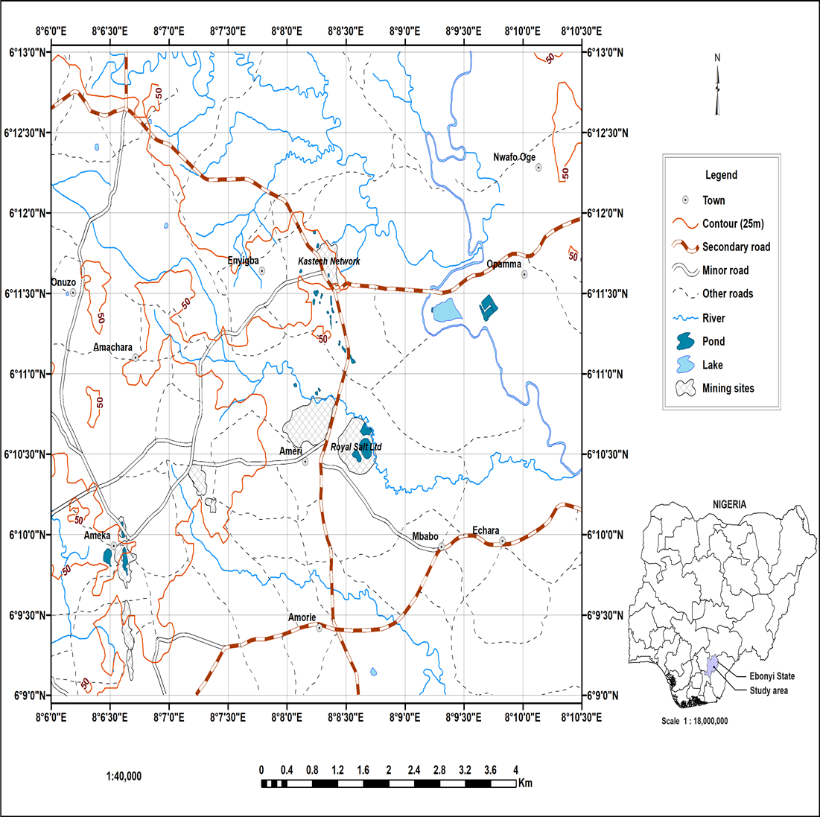
Fig. 1: Location map of the study area
Geology of the study area
The Enyigba lead-zinc deposits are situated within the Abakaliki Anticlinorium, which forms part of the Lower Benue Trough of Southeastern Nigeria. The Benue Trough is a Cretaceous sedimentary basin that extends for over 800 km in a northeast-southwest direction, originating from the early Cretaceous rifting associated with the opening of the South Atlantic Ocean (Benkhelil, 1989; Ofoegbu & Onuoha, 1991). The trough represents an aulacogen (failed rift arm) that developed as part of the triple junction system during the separation of the African and South American plates.
The local geology of Enyigba is dominated by sedimentary rocks belonging to the Asu River Group, which is the oldest stratigraphic unit in the Lower Benue Trough. The Asu River Group is of Albian age and consists mainly of dark grey to black shales, siltstones, fine to medium grained sandstones, and thin limestone interbeds (Olade, 1976; Fatoye et al., 2014). These rocks were deposited in a shallow marine to deltaic environment under reducing conditions, which favored the accumulation of organic matter and the subsequent migration of metal bearing fluids.
Structurally, the area is highly deformed due to Cretaceous tectonic activities. It is characterized by faults, folds, joints, and fractures that trend predominantly northeast-southwest. These structures served as pathways for hydrothermal fluid circulation, facilitating the emplacement of lead-zinc mineralization in the host rocks (Obarezi & Nwosu, 2013). The faults are typically high angle normal and strike-slip in nature, consistent with the extensional tectonic regime of the Benue Trough (Benkhelil, 1989).
The mineralization occurs mainly as vein type deposits filling fractures, fissures, and brecciated zones within the shale and sandstone units. The principal ore minerals are galena (PbS) and sphalerite (ZnS), with minor chalcopyrite (CuFeS₂) and pyrite (FeS₂). Common gangue minerals include calcite, quartz, siderite, and barite (Olade & Morton, 1985; Bute et al., 2024). The mineral assemblages and structural controls are typical of Mississippi Valley-Type (MVT) deposits, formed by low temperature (100–200°C) hydrothermal fluids in carbonate and clastic sedimentary rocks (Leach et al., 2010).
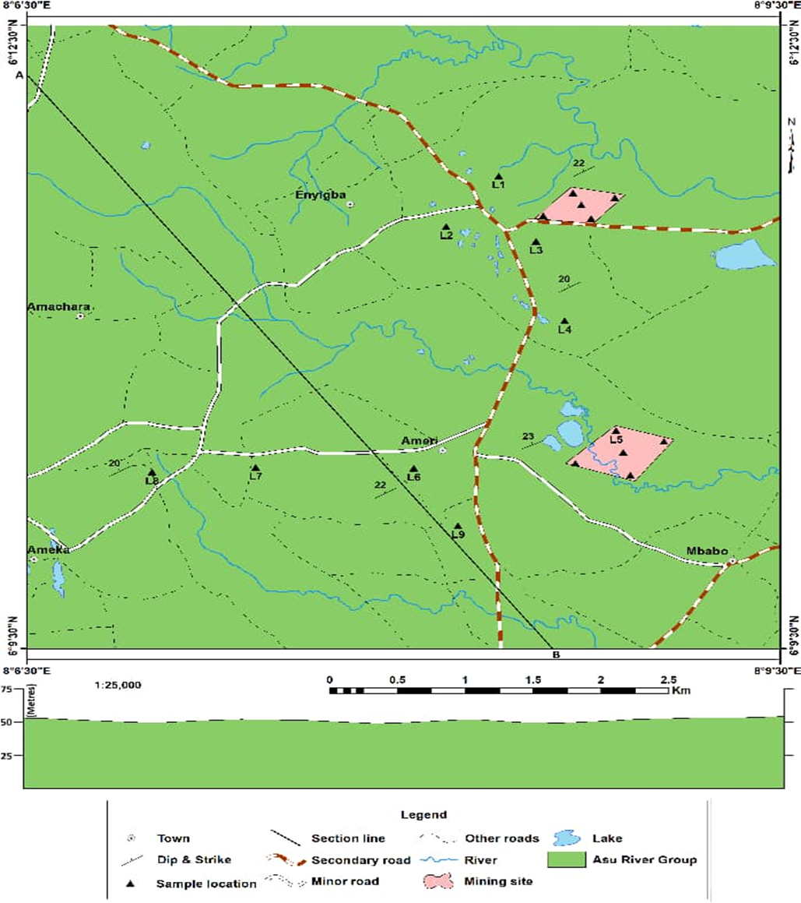
Fig. 2: Geology ma of the study area showing the sampling points (in pink).
- METHODOLOGY
This study employed a combined geological mapping and geochemical analysis approach to investigate the grade and distribution of lead-zinc mineralization in Enyigba and its environs. The methodology was designed to integrate field based geological observations with laboratory based analytical techniques to achieve a comprehensive understanding of the area’s mineralization pattern. The approach followed standard protocols used in mineral exploration and environmental geochemistry (Boyle, 1979; Rollinson, 2014).
Detailed geological mapping was conducted across the Enyigba-Ameka-Ameri axis to identify lithological units, mineralized zones, and structural features such as faults, joints, and veins. A topographic base map (1:25,000 scale) was used to record field data, while a Brunton compass was employed for measuring orientations of fractures, veins, and bedding planes. GPS coordinates were recorded using a Garmin GPSMAP 64s to georeference all sampling points and structural features.
A total of ten representative samples of mineralized rocks were collected from two key locations within the Enyigba area. Samples were extracted at an average depth of 1.2 meters (approximately 4 feet) using a hand auger to minimize surface contamination. Each sample was labeled, sealed in polythene bags, and transported to the laboratory for geochemical analysis. In the laboratory, samples were air dried and oven dried at 105°C for 12 hours to remove moisture. Dried samples were then crushed and pulverized to a particle size of <75 µm using an agate mortar and pestle to avoid contamination. The pulverized samples were homogenized, split into two portions, and stored in airtight containers for subsequent analyses.
Two analytical methods were employed to ensure accuracy and reproducibility of results: X-ray Fluorescence (XRF) Analysis and Wet Chemical Analysis. The first set of samples was analyzed using a Bruker S1 TITAN 600 portable X-ray fluorescence spectrometer, which provides rapid, non destructive determination of elemental composition. Calibration was performed using certified reference materials to ensure analytical precision. The XRF technique was selected due to its high sensitivity and suitability for multi-element detection in geological materials (Beckhoff et al., 2006).
The second set of samples was subjected to wet chemical analysis for validation of XRF results. Approximately 0.5 g of each powdered sample was digested in Aqua Regia (HCl:HNO₃ = 3:1) and filtered. The filtrate was analyzed for lead and zinc using EDTA titration and atomic absorption spectrophotometry (AAS) techniques, following procedures outlined by the American Society for Testing and Materials (ASTM D3682–13). Results were expressed in weight percentage (wt%). Duplicate analyses were conducted to check analytical reproducibility, and the relative standard deviation (RSD) of replicate results was maintained below 5%, indicating high analytical reliability (Rollinson, 2014).

RESULTS AND DISCUSSION
The results of the geochemical analyses of lead-zinc samples from Enyigba and its environs are presented in Table 1. Ten (10) representative samples collected from two mineralized locations (L1 and L2) were analyzed using X-ray fluorescence (XRF) and wet chemical methods.

Table 1. Geochemical composition of Pb and Zn in ore samples from Enyigba.
Sample ID | Location | Pb (wt%) | Zn (wt%) | Remarks
E1 | L1 | 1.93 | 1.31 | Low-grade vein exposure
E2 | L1 | 3.42 | 2.10 | Moderately mineralized zone
E3 | L1 | 4.25 | 2.36 | Pb-dominant vein
E4 | L1 | 5.25 | 2.60 | Highly mineralized galena vein
E5 | L1 | 1.93 | 1.72 | Disseminated sphalerite zone
E6 | L2 | 1.13 | 1.76 | Marginally mineralized outcrop
E7 | L2 | 3.50 | 2.84 | Zn-rich section
E8 | L2 | 3.80 | 3.06 | Moderate mineralization
E9 | L2 | 4.20 | 3.45 | High Zn enrichment
E10 | L2 | 4.50 | 3.96 | Deep vein with galena-sphalerite assemblage
Minimum |  | 1.13 | 1.31
Maximum |  | 5.25 | 3.96
Mean |  | 3.31 | 2.50
Standard Deviation |  | 1.30 | 0.82
The mean lead (Pb) content of 3.31 wt% and zinc (Zn) content of 2.50 wt% indicate significant mineralization within the area. The Pb-Zn ratios suggest metal zonation, with Pb enrichment concentrated in central vein systems and Zn enrichment toward peripheral zones-an established pattern in Mississippi Valley-Type (MVT) deposits (Leach et al., 2010; Bute et al., 2024).

Distribution and Zonation
The results show a distinct variation in Pb and Zn concentrations across the two sampling locations. Location 1 (L1) exhibits higher Pb values (up to 5.25 wt%), while Location 2 (L2) shows relatively higher Zn contents (up to 3.96 wt%). This pattern suggests paragenetic differentiation during ore formation, where Pb-rich minerals precipitated earlier, and Zn-rich minerals formed in later, cooler hydrothermal phases (Olade, 1976; Olade & Morton, 1985). This Pb-Zn zonation is consistent with findings from other parts of the Lower Benue Trough, such as Ishiagu, Ameri, and Abakaliki, where similar metal zoning has been reported (Fatoye et al., 2014). The trend also aligns with the classical MVT model, where galena tends to dominate the central or higher temperature zones, while sphalerite and barite become more abundant in distal, cooler settings (Leach et al., 2010; Robb, 2005).
The results were further compared with global averages for Mississippi Valley-Type (MVT) deposits and with other Pb-Zn occurrences within the Lower Benue Trough, such as Ishiagu and Ameri, to evaluate the economic significance of the Enyigba mineralization. The average grades recorded in this study are comparable with other Nigerian and international Pb-Zn deposits (Table 2).
Table 2. Comparison of Pb-Zn grades from Enyigba and related deposits.
Deposit/Location | Pb (wt%) | Zn (wt%) | Reference
Enyigba (This study) | 3.31 | 2.50 | Present study
Ishiagu, SE Nigeria | 2.90 | 2.10 | Fatoye et al. (2014)
Ameka, SE Nigeria | 4.00 | 2.70 | Obarezi & Nwosu (2013)
Benue Valley (avg.) | 3.20 | 2.30 | Olade (1976)
Tri-State District, USA | 3.50 | 2.00 | Leach et al. (2010)
The lead and zinc concentrations obtained from this study are consistent with values reported from other lead–zinc mineralized areas within the Lower Benue Trough and similar deposits globally. The average lead content of 3.31 wt% and zinc content of 2.50 wt% in the Enyigba samples closely resemble the grades recorded at Ishiagu, where Fatoye et al. (2014) reported average values of 2.90 wt% Pb and 2.10 wt% Zn, and at Ameri, where Edegbai et al. (2022) documented 3.10 wt% Pb and 2.40 wt% Zn. Likewise, Obarezi and Nwosu (2013) recorded slightly higher concentrations at Ameka, with 4.00 wt% Pb and 2.70 wt% Zn, while Olade (1976) noted an average of 3.20 wt% Pb and 2.30 wt% Zn for the broader Benue Valley deposits.

Fig. 3: Bar chart showing the comparison of Pb-Zn grades from Enyigba and related deposits.
When compared with global Mississippi Valley-Type (MVT) deposits such as those of the Tri-State District in the United States, which typically average around 3.50 wt% Pb and 2.00 wt% Zn (Leach et al., 2010), the Enyigba results fall within a comparable range. This similarity reinforces the classification of the Enyigba mineralization as a Mississippi Valley-Type system, characterized by low temperature hydrothermal deposition of lead and zinc within carbonate and shale host rocks. Overall, the comparative analysis confirms that the Enyigba ores are economically significant and geochemically consistent with both regional and international MVT-type Pb-Zn deposits (Bute et al., 2024; Leach et al., 2010).

Economic Implications
Although the grades obtained are moderate, they are economically viable for small to medium scale mining, particularly given the shallow depth of occurrence (approximately 1.2 m). The mineralization’s proximity to established infrastructure and industrial centers (e.g., Royal Salt Limited and NIGERCEM) further enhances its development potential. Moreover, based on previous findings by Obasi and Akudinobi (2020), deeper drilling in Enyigba has revealed higher sulfide concentrations, suggesting that grades may increase at depth, where oxisdation effects are minimized. Therefore, the near surface ore zones evaluated in this study likely represent weathered caps of more extensive primary sulfide deposits.

Genetic and Environmental Implications
The observed metal concentrations and zoning pattern imply that mineralization occurred through hydrothermal replacement processes, controlled by fractures and faults within the Asu River Group sediments. These structural conduits facilitated the upward migration of metal bearing saline brines, which precipitated Pb and Zn sulfides upon encountering favorable chemical traps such as carbonate lenses (Olade, 1976).
However, the high concentration of Pb, even at shallow depths, raises environmental concerns. Elevated Pb levels have been detected in surrounding soils and groundwater, as noted by Anike et al. (2009) and Obasi & Akudinobi (2021), emphasizing the need for regulated mining and remediation programs to mitigate ecological and health impacts.
- CONCLUSION
This study examined the geology and geochemical characteristics of lead-zinc mineralization within the Enyigba district. Through a combination of field mapping and geochemical analysis, the research established that mineralization in the area is strongly controlled by fractures, faults, and lithological variations within the Albian Asu River Group. These structures acted as pathways for metal bearing hydrothermal fluids that precipitated galena (PbS) and sphalerite (ZnS) within shale and sandstone host rocks, forming vein-type deposits typical of Mississippi Valley-Type (MVT) systems.
Geochemical results revealed lead contents ranging from 1.13 to 5.25 wt% (mean = 3.31 wt%) and zinc contents from 1.31 to 3.96 wt% (mean = 2.50 wt%), indicating moderate to high grade mineralization. The observed metal distribution shows a distinct Pb-Zn zonation pattern, suggesting successive hydrothermal phases with lead precipitating under higher temperature conditions and zinc under relatively cooler regimes. Comparisons with similar deposits at Ishiagu, Ameri, Ameka, and other parts of the Lower Benue Trough confirm that the Enyigba ores share comparable grade ranges and mineral assemblages, reinforcing their classification as MVT-type deposits of significant economic value.
The findings demonstrate that the Enyigba area possesses commercially viable Pb-Zn resources, particularly suitable for small to medium scale extraction given their shallow depth and good accessibility. Nevertheless, evidence of lead enrichment at surface levels also points to potential environmental and health risks if mining is conducted without proper management.
It is therefore concluded that the Enyigba Pb-Zn mineralization offers substantial economic potential but requires integrated exploration, environmental, and policy frameworks to ensure sustainable exploitation. Further geophysical surveys, drilling, and geostatistical modeling are recommended to delineate ore continuity at depth and enhance reserve estimation. Additionally, environmental monitoring and community awareness programs should be instituted to mitigate possible contamination of soils and groundwater.

Disclaimer (Artificial intelligence)
Author(s) hereby declare that NO generative AI technologies such as Large Language Models (ChatGPT, COPILOT, etc.) and text-to-image generators have been used during the writing or editing of this manuscript.

REFERENCES
- Beckhoff, B., Kanngießer, B., Langhoff, N., Wedell, R., & Wolff, H. (Eds.). (2006). Handbook of practical X-ray fluorescence analysis. Springer.
- Benkhelil, J. (1989). The origin and evolution of the Cretaceous Benue Trough (Nigeria). Journal of African Earth Sciences, 8(2), 251–282.
- Boyle, R. W. (1979). The geochemistry of gold and its deposits. Geological Survey of Canada Bulletin 280.
- Bute, S. I., Zhou, J. X., Luo, K., & Peter, R. T. (2024). Lead–zinc–barite deposits in the Nigerian Benue Trough: Deposit classification and genetic model. Ore Geology Reviews, 166, 105947. https://doi.org/10.1016/j.oregeorev.2024.105947
- Fatoye, F. B., Ibitomi, M. A., & Omada, J. I. (2014). Lead–zinc–barite mineralization in the Benue Trough. Advances in Applied Science Research, 5(2), 86–92.
- Guilbert, J. M., & Park, C. F. (1986). The geology of ore deposits (2nd ed.). Waveland Press.
- Leach, D. L., Bradley, D. C., Huston, D., & Pisarevsky, S. A. (2010). Sediment-hosted lead–zinc deposits: A global perspective. Economic Geology, 105(3), 593–625. https://doi.org/10.2113/gsecongeo.105.3.593
- Nwachukwu, S. O. (1972). The tectonic evolution of the southern portion of the Benue Trough, Nigeria. Geological Magazine, 109(5), 411–419. https://doi.org/10.1017/S0016756800045559
- Obarezi, J. E., & Nwosu, J. I. (2013). Structural controls of Pb–Zn mineralization in Enyigba district, Southeastern Nigeria. Journal of Geology and Mining Research, 5(4), 10–18. https://doi.org/10.5897/JGMR2013.0199
- Ofoegbu, C. O., & Onuoha, K. M. (1991). A review of the geology of the Benue Trough, Nigeria. In C. O. Ofoegbu (Ed.), The Benue Trough: Structure and evolution (pp. 3–26). Vieweg+Teubner Verlag.
- Olade, M. A. (1976). On the genesis of lead–zinc deposits in Nigeria’s Benue Rift (Aulacogen). Journal of Mining and Geology, 13, 20–27.
- Olade, M. A., & Morton, R. D. (1985). Origin of lead–zinc mineralization in the Southern Benue Trough, Nigeria: Fluid inclusion and trace element studies. Mineralium Deposita, 20(1), 76–80. https://doi.org/10.1007/BF00204567
- Robb, L. (2005). Introduction to ore-forming processes. Blackwell Publishing.
- Rollinson, H. R. (2014). Using geochemical data: Evaluation, presentation, interpretation (2nd ed.). Routledge.
- World Health Organization. (2022). WHO guidelines for drinking water quality (5th ed.). World Health Organization Press.
- Plant, J. A., Breward, N., Simpson, P. R., & Slater, D. (1990). Regional geochemistry and the identification of metallogenic provinces: examples from lead-zinc-barium, tin-uranium and gold deposits. Journal of Geochemical Exploration, 39(1-2), 195-224. https://www.sciencedirect.com/science/article/pii/037567429090074K
- Lavery, N. G., Leach, D. L., & Saunders, J. A. (1994). Lithogeochemical investigations applied to exploration for sediment-hosted lead-zinc deposits. In Sediment-Hosted Zn-Pb Ores (pp. 393-428). Berlin, Heidelberg: Springer Berlin Heidelberg. https://link.springer.com/chapter/10.1007/978-3-662-03054-7_20
- Ezeh, H., & Anike, O. (2010). The preliminary assessment of the pollution status of streams and artificial lakes created by mining in the mining district of Enyigba, south eastern Nigeria, and their consequences. Global Journal of Environmental Sciences, 8(1). https://doi.org/10.4314/gjes.v8i1.50823
- Obasi, P. N., & Akudinobi, B. B. (2020). Potential Health Risk and Levels of Heavy Metals in Water Resources of Lead-Zinc Mining Communities of Abakaliki, Southeast Nigeria. Applied Water Science, 10, Article No. 184.
https://doi.org/10.1007/s13201-020-01233-z

