Integration of Remote Sensing, Lithologic and Geoelectric Parameters for Groundwater Potential Evaluation using VIKOR and Fuzzy-VIKOR Models: A Case Study from Basement Terrain in Southwestern Nigeria

Abstract
In response to escalating water demands resulting from rapid population growth and extensive development, the Federal University of Technology, Akure (FUTA), has acquired a new site, Eleyewo, along the Akure-Owo Expressway. This study aims to comprehensively assess Eleyewo's groundwater potential, essential for current and future water resource planning. Our methodology combines remote sensing, geological analysis, and geophysical techniques, including geoelectric sounding. We examine eight critical groundwater potential conditioning factors (GWPCF), such as topography, lithology, and aquifer properties. Geoelectric sounding reveals four subsurface layers with varying resistivity and thickness. We assign weights to GWPCFs using VIKOR and Fuzzy-VIKOR methods, and rank them to prioritize their influence. Employing ArcGIS, we create groundwater potentiality maps, categorizing the area into five potential classes: very high, high, moderate, low, and very low. Validation using receiver operating characteristic curves area under the curve (ROC_AUC) demonstrated robust prediction accuracy: 69 % and 73 % for VIKOR and Fuzzy VIKOR-produced maps. In conclusion, this research provides critical insights into Eleyewo's groundwater potential and offers a cost-effective, replicable methodology applicable to similar geological terrains, contributing to sustainable groundwater resource management.
Keywords: Groundwater; Geophysics; VIKOR; Fuzzy–VIKOR;Potential Mapping
- Introduction
The importance of groundwater as a supply for a country’s socioeconomic growth is enormous, as it remains the most sought water sources in many areas due to underdevelopment of surface water. Therefore, the need for successful groundwater exploration planning and management for local and regional groundwater productivity mapping in the field of groundwater hydrology cannot be underestimated. Recent population explosion and the concomitant increasing water demand has imposed significant stress on the existing inadequate water scheme based solely on individual exploration exercises. Consequently, it became very expedient to expand the existing water scheme by carrying out detailed groundwater exploration involving subsurface characterization leading to groundwater potential mapping.
Groundwater occurrence in any rock presupposes the satisfaction of two factors: adequate porosity and permeability. Sedimentary rocks exhibit these properties due to their mode of occurrence and emplacement. Sedimentary deposits maintain primary porosity that determines their storage and permeability to a great extent [1, 2, 3, 4, 5]which tends to make them exhibit good aquifer potential as compared to basement complex aquifers. The crystalline nature of the basement complex’s metamorphic and igneous rocks satisfies none of these requirements. Basement complex rocks are therefore considered poor aquifers due to their low primary porosity and permeability, necessary for the accumulation of groundwater [6, 7]. The complexities of groundwater occurrence in a basement complex terrain which can be attributed to the occurrence of primary porosity in the underlying rock have been emphasized [8, 9, 10]. The occurrence of groundwater in a basement complex terrain can be attributed to the degree of weathering and fracturing as well as the materials that make up the weathered zone. The complex interrelationship between geology, post-emplacement, tectonic history, weathering process, aquifer types and groundwater flow pattern therefore plays an important role in groundwater potential in a basement complex [8, 10, 11, 12, 13 14]. The occurrence and distribution of groundwater in crystalline units are influenced by a variety of factors including the existence and development of integrated fracture system, fracturing intensity, nature and type of fillings in the joint aperture, depth, extent, weathering pattern and thickness. Taking into account the limited and winding characteristics of groundwater reservoirs in the basement complex, the optimum potential of the aquifer network can only be extracted through a well-coordinated hydro-geophysical and geological investigation. Geo-electrical techniques are powerful tools and play a vital role in groundwater investigations particularly in delineating the aquifer structure in complex geological environments. By combining data on hydrogeological surface characteristics with information obtained from geo-electrical investigations, the subsurface characteristics and details of aquifer morphology can thus be described. The hydrogeological significance of each geo-electric parameter used to model groundwater potential will then be a function of its contribution to the occurrence of groundwater. In other words, theoretical modeling of groundwater is a spatial analysis problem involving a broad range of multiple evaluation criteria.
Several experts have evaluated those criteria which involves aquifer resistivity and thickness for future groundwater evaluation [15, 16]. In order to produce a high-precision groundwater distribution map, the effects of all the important geo-electrical parameters have to be integrated [15]. The use of the multi-criteria decision analysis (MCDA) in the field of hydrogeology is comparatively new [16]. The advantage of the approach is its ability to carry out a systemic analysis and to combine specific criteria/factors to model the target. The most commonly used MCDA method is the analytical hierarchical process (AHP) approach [15, 16, 17, 18]. Many factors such as lithology, drainage pattern, lineament density and geo-electric parameters (thickness, resistivity, transverse resistance, coefficient of anisotropy) are believed to influence groundwater potential [15, 17, 19]. The invention of geographic information system (GIS) has made possible spatial distribution mapping and integration of different data sets. Its applicability in the field of hydrogeology has been widely explored [13, 17, 19, 20, 21, 22, 23, 24, 25]. Their works have shown the effectiveness of GIS to carry out MCDA prediction models in environmental decision-making processes.
The problem of acute water shortage especially in a typical basement complex environment like the study area is a global phenomenon due to the fact that water occurs in pocket of places where there are fissured and fractured rocks. The study area is a new site acquired by the Federal University of Technology Akure (FUTA) to house her medical students and staff. It is therefore necessary to characterize the site into different groundwater potential zones so that appropriate sites or locations for groundwater development can be identified.
In order to create a robust groundwater potential prediction model with enhanced reliability and precision for the study, the important parameters that can contribute to groundwater occurrence in the area must be incorporated.
These are done using several knowledge-driven MCDA models [36, 37]. However, imprecision and noise are often introduced into the weighting process especially when dealing with numerous factors or criteria. By adopting VIKOR and fuzzy VIKOR models which can manage the complexity and uncertainties of numerous criteria, this problem may be successful handled. These models have been less utilized in the domain of groundwater studies especially in a typical basement complex environment like the study area. Furthermore, the distinct differences in the use of different models and their fuzzified extensions necessitate this study to use VIKOR and Fuzzy VIKOR to determine the groundwater potential of the study area.
It is on this premise that a comparative study of groundwater potential of FUTA new site was done using VIKOR and fuzzy VIKOR models.
  - Location and geology of the study area
The study area is located along Akure-Benin expressway. It is bounded by two settlements; Ilu Abo and Bolorunduro. It is located about few kilometers to the Northeast of Akure in South-Western Nigeria. It located about 3 km from the north of Akure, the state capital within Latitudes 7°16′ 13″ and 7° 16′ 54″N and Longitudes 5° 18′ 45″ and 5°19′55″E. The area is connected by huge footpaths that are easily accessible for motorists and a minor tarred road. The investigated area is located within the tropical rain forest belt of southwestern Nigeria. The zone is characterized by raining season which starts in April and end in October while the dry season starts in November and end in March. The annual rainfall ranges from 1000 - 1500 mm. The annual temperature varies from 25 to 28°C [10, 26]. The local geology of the study area (Figure 1) consists of two major lithological units. These are Migmatite-gneiss and quartzite. The Migmatite-gneiss covers the largest part of the study area (Figure 2). It is observed that it occurs in the north, west, central, and south extending to the eastern part of the study area. Quartzite occurs mostly in the southeastern part of the study area. Quartzite occurs mainly as bands within the Migmatite-gneiss.

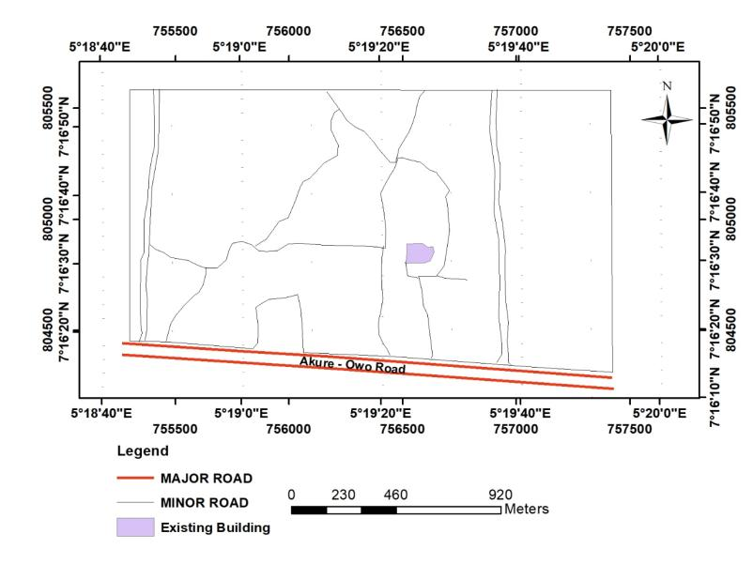Figure 1: Base map of the study area

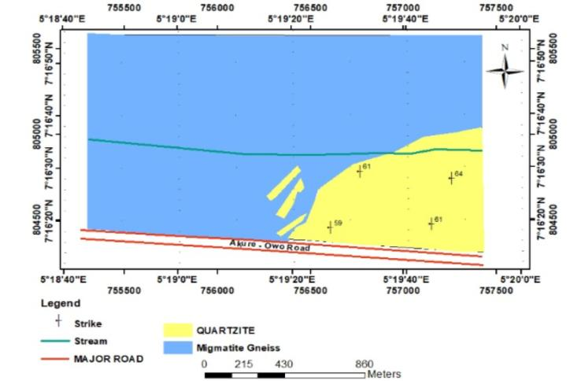
Figure 2: Geological map of the study area
- Methodology
A Digital Elevation Model (DEM) with a spatial resolution of 15 meters was acquired from the United States Geological Survey (USGS) website (https://asterweb.jpl.nasa.gov/gdem.asp, last accessed on 20 November 2019. This DEM data was then imported into the ArcGIS 10.7 environment, which offers a variety of spatial tools for generating groundwater conditioning factors from DEMs. In this particular study, the focus was on extracting slope information from the DEM. The investigation employed the electrical method, specifically utilizing the Vertical Electrical Sounding (VES) technique with the Schlumberger array. Within the study area, a total of thirty (30) VES points were occupied (Figure 3). The VES technique involves measuring vertical variations in the apparent resistivity of the ground with a fixed center of the array. The survey was conducted by gradually increasing the electrode spacing while maintaining a fixed center of the array. The Schlumberger array was employed with a maximum half current electrode spacing (AB/2) of 100 m. The collected VES data underwent manual processing, involving plotting the apparent resistivity data against the distance (half the current electrode spacing AB/2) on bi-logarithmic paper. The sounding curves were subsequently quantitatively interpreted using the partial curve matching method[27, 28, 29]. In this method, each generated curve was matched segment by segment. It is crucial to ensure that the axes of both the field curves and the model resistivity curves (Schlumberger) remain parallel during this process. This interpretation method is grounded in the principle of superposition or replacement resistivity, ultimately yielding layer resistivity and thickness values.
To refine these initial layer parameters (resistivity and thickness values), a computer algorithm, specifically WinRESIST version 1.0 [30] was applied through iterations. The final iterated layer parameters (resistivity and thickness) were then utilized for subsequent analyses. Four-second order geoelectric parameters were also derived from the initial geoelectric parameters using the following five (5) relationships;
  - Longitudinal Conductance (S);
S = $\sum{\frac{h_{i}}{ρ_{i}}}$ = $\frac{h_{1}}{ρ_{1}}+\frac{h_{2}}{ρ_{2}}+\frac{h_{3}}{ρ_{3}}+…\frac{h_{n}}{ρ_{n}}$[28, 29] (1)
Where,
$h_{i}$is layer thickness
$ρ_{i}$is layer resistivity
  - Transverse Resistance (T);
T = $\sum{h_{i}ρ_{i}}$ = $h_{1}ρ_{1}+h_{2}ρ_{2}+h_{3}ρ_{3}+…+h_{n}ρ_{n}$[28, 29] (2)
Where,
$h_{i}$is layer thickness
$ρ_{i}$is layer resistiviy
  - Longitudinal Resistivity ($ρ_{L})$;
$ρ_{L}$ = $T/{S }$ [28, 29] (3)
Where,
T is Total layer thickness
Sis Total longitudinal conductance
  - Coefficient of anisotropy;
$T$ = $T/{S }$ [28, 29] (4)
Where,
$ρ_{t}$is transverse resistance
$ρ_{l}$is longitudinal conductance
  - Transmissivity;
$T=Km$[28, 29] (4)
Equation 4 can also be expressed as,
$T=Sm$[28, 29] (5)
Where,
$T$istransmissivity
$K$isthe hydraulic conductivity
$m$issaturation thickness of the aquifer
Sis aquifer unit longitudinal conductance

3 Multicriteria Decision Analysis
A Multi-Criteria Evaluation of VIKOR and Fuzzy-VIKOR approach was employed to model groundwater potential. The influencing factor used for the prediction (overburden thickness, aquifer layer resistivity, aquifer layer thickness, transverse resistance, longitudinal conductance, and coefficient of anisotropy) was classified and rated. A knowledge-based VIKOR and Fuzzy-VIKOR classification was employed.

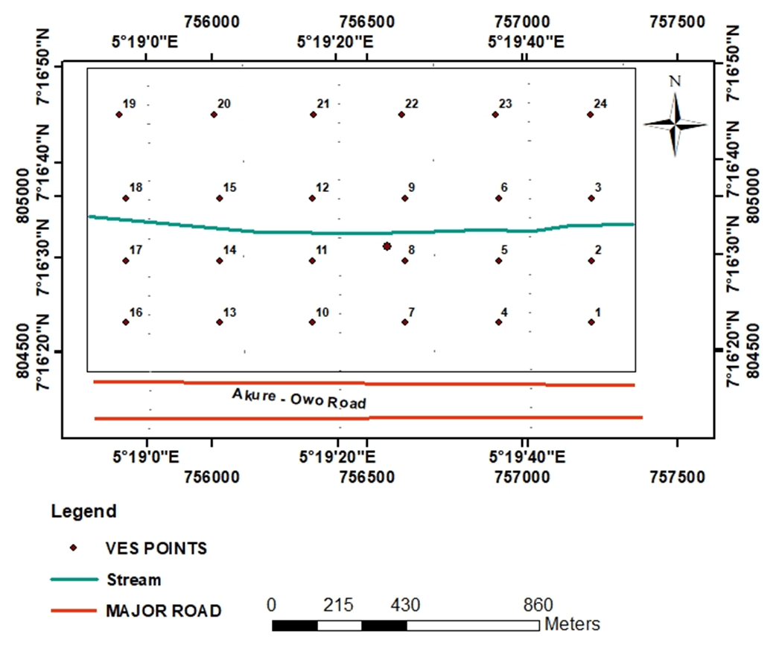
Figure 3: Data acquisition map of the study area

3.1 Procedure for determination of VIKOR
VIKOR (VlseKriterijumskaOptimizacija I KompromisnoResenje) is a multi-criteria decision-making method used to rank and select alternatives based on multiple criteria [31]. It aims to find a compromise solution that considers both the best and worst attributes of each alternative. Here are the mathematical equations and procedural steps for VIKOR[31]:
Step 1: Define the Problem Identify the alternatives (options or choices) and the criteria (factors) that will be used to evaluate and compare the alternatives.
Step 2: Normalize the Data
Normalize the criteria values to ensure that they are on the same scale. This is typically done using a linear normalization method:
$x_{ij}^{*}=\frac{x_{ij}-min⁡(x_{j})}{\max{x_{j}-min⁡(x_{j})}}$ (6)

Where,

$x_{ij}$is the original value of alternative for criterion
$x_{ij}^{*}$is the normalized value of alternative i for criterion
$min⁡(x_{j})$is the minimum value of criterion j
max$(x_{j})$ is the maximum value of criterion j
Step 3: Calculate the Weighted Normalized Decision Matrix
Assign weights to the criteria based on their relative importance. Create a weighted normalized decision matrix:
$R_{ij}=w_{j} . x_{ij}^{*}$ (7)

Where,

$R_{ij}$is the weighted normalized value of alternative $i$ for criterion $j$

$w_{j}$is the weight of criterion $j$

$x_{ij}^{*}$is the normalized value of alternative $i$ for criterion $j$

Step 4: Calculate the "S" and "R" Rankings

Calculate the "S" and "R" rankings for each alternative using the weighted normalized decision matrix:
$S_{i}\sum_{j=1}^{m}{R_{ij}}$ (8)
$R_{i}=\sum_{j=1}^{m}{{(R}_{ij}-}S_{i})$ (9)
Where,
$S_{i}$is the "S" ranking score of alternative$i$
$R_{i}$is the "R" ranking score of alternative$i$
$m$is the number of criteria
Step 5: Calculate the "Q" Ranking
Calculate the "Q" ranking score for each alternative, which considers both the "S" and "R" scores:$Q_{i}=\frac{v∙(R_{i}-R_{min})}{(R_{max}-R_{min})}$ + ($1-v$) $∙\frac{v∙(S_{i}-S_{min})}{(S_{max}-S_{min})}$ (10)
Where,
$Q_{i}$is the "Q" ranking score of alternative$i$
$v$is the weight of the "R" score (0 ≤ $v$ ≤ 1)
$R_{max} and R_{min}$are the minimum and maximum "R" scores among all alternatives

$S_{max} and S_{min}$are the minimum and maximum "S" scores among all alternatives

Step 6: Rank the Alternatives
Rank the alternatives based on their "Q" scores. The alternative with the highest "Q" score is the most preferred compromise solution.
It's important to note that the choice of $v$ in Step 5 allows you to control the trade-off between the "S" and "R" rankings. If $v$ is close to 1, more emphasis is placed on the worst attributes ("R" ranking). If $v$ is close to 0, more emphasis is placed on the best attributes ("S" ranking). The choice of $v$ should reflect the decision makers’ preferences and priorities.

3.2 Procedure for the Determination of Fuzzy-VIKOR
The steps involved in Fuzzy-Vikor are shown in the steps below
Step One: Determining linguistic Variables.
The first step inthe fuzzyVIKOR method isto determinethe linguistic variables; Linguistic terms transformed into fuzzy numbers are used by the experts to rate each linguistic variable. Linguistic terms are qualitative words or phrases of a natural language that reflect the subjective view of an expert about the criteria per each alternative under consideration.
Step 2: Determining importance weight of criteria
For the evaluation of factors controlling groundwater potentiality, decision makers are supposed to have different importance weights. To determine the importance weight of each criterion, the decision makers rate each criterion using the linguistic terms in Table 1. This is expressed in Equation 11 as a vector
W᷈:W᷈ = [W᷈_{1,}W᷈₂…..,W᷈_{n}] j = 1, 2,…..n (11)
Where, w᷈_{j}represents the weight of the jth criterion based on the linguistic preference assigned by a decision maker. Each weight W᷈j = [W᷈_{J1}, W᷈_{J2}, W᷈_{J3}] is expressed as a TFN. These preferences signify the importance attributed to a criterion by a decision maker.
The study uses the graded mean integration method to aggregate the decision makers’ opinions. The fuzzy importance weight W_{J} for criterion C_{J} is computed as:
WJ = (W_{J1},W_{J2},W_{J3}) where W_{J1} = mink {W_{JK1}}, W_{J2} = 1$1/k\sum_{k=1}^{k}{wjk2}$ (12)
W = Max {W} for i =1, 2…, m; j=1,2, …n

Table 1: Linguistic Scale for the importance of criteria [31]
Linguistic terms | Triangular fuzzy number
Very Low (VL) | (0.0,0.1,0.3)
Low (L) | (0.1,0.3,0.5)
Medium (M) | (0.3,0.5,0.7)
High (H) | (0.5,0.7,0.9)
Very High (VH) | (0.7,0.9,1.0)

Step 3: Constructing the fuzzy decision matrix
Consider a group of k decision-makers (D_{1,} D₂, D₃, …..D_{K}) presented with m alternatives (A₁,A₂,…,A_{m}) against n set of criteria (C₁,C₂,….,C_{n}) in a typical MCDM problem. A fuzzy multi-criteria decision-making is formally expressed as:
C1 C2 C3
D = A1 X₁₁ X₁₂ X_{1n}
A2 X₂₁ X₂₂ X_{2n} I = 1, 2…., m; j = 1, 2,….n 8
A3 X₃₁ X₃₂ X_{3n}

An X_{m1} X_{m2}X_{mn}

Where, X_{mn} is the rating of alternative A_{m} with respect to criterion C_{j.}
Note that for a decision maker k,X᷈^{k}_{IJ}= (a^{k}_{ij},b^{k}_{ij},c^{k}_{ij}) is a TFN. Similarly, as in step 2, the graded mean integration method is used to aggregate the opinions of the decision makers concerning the ratings of the alternatives (websites). This is formally expressed as X᷈^{k}_{IJ}= (a^{k}_{ij},b^{k}_{ij},c^{k}_{ij})where a_{ij} = min_{k} {a^{k}_{ij}}, b_{ij} = 1/k $\sum_{k=1}^{k}{bkij}$,c_{ij} = max_{k} {c^{k}_{ij}} i =1,2,…..,m;
j =1,2,…n 9
Step 4: Fuzzy best value f*_{i} and fuzzy worst value f_{i}
The fuzzy best value f*_{i} = (a*_{I}, b*_{I}, c*_{I} ) and the fuzzy worst values
f⁰_{i} = (a⁰_{i,} b⁰_{i,} c⁰_{i}) are computed respectively using Eq. 8 and 9 below;
f᷈᷈᷈*i = max f᷈_{ij}, f᷈⁰_{i} = min a᷈_{ij,} for i Є B 10
f᷈*i = max f᷈_{ij}, f᷈⁰_{i} = min a᷈_{ij,} for i Є C 11
Where B is the benefit criteria and C, the cost criteria.
Step 5: Normalized fuzzy difference d᷈_{ij}
To obtain the fuzzy difference d᷈_{ij} it is computed as below
d᷈_{ij}= (f᷈*_{i} – x᷈_{ij}) / (c*_{i} – a⁰i) for i Є B 12
d᷈_{ij}= (f᷈*_{i} – x᷈_{ij}) / (c*_{i} – a⁰i) for i Є C 13
Where B is the benefit criteria and C, the cost criteria
Step 6: Computing separation Measures S᷈_{J} and R᷈_{J}
The next step computes the separation S᷈_{J} of alternative A_{j}from the fuzzy best value f*_{i.} Similarly, the separation of R᷈_{J} of alternative A_{j}from the fuzzy worst value f᷈*_{i} is also computed. These are respectively measured using equation
S᷈_{J} = $\sum_{i=1}^{n}{(w᷈j} ⊗d᷈ij)$ 14
R᷈j = max_{i} (w᷈j⊗d᷈ij) 15
Where S᷈_{J} = (Saj, Sbj, Scjis a fuzzy weighted sum of the separation measure of f*i similarly, Rj = (Rª_{j}, R^{b}_{j}, R^{c}_{j}) is a fuzzy MAX which refers to the separation measure of A_{j} from the worst value f⁰i where W_{j} is the importance weight of criterion C_{j}
Step 7: Computing the value of Q_{j}
The value Q᷈j = (a_{j}, b_{j}, c_{j}) expressed in a triangular fuzzy number is computed as following:
Q᷈j = v(S᷈_{j} – S᷈*) / (S^{0c} – S^{*a}) ⊗(1-v)(R᷈_{j} - R᷈*) / (R^{0c} – R^{*a}) 16
Where S* = MIN_{j}S᷈_{j}, S^{0c} = MAX_{j}S_{j}^{c}, R᷈* = MIN_{j}R᷈_{j}
R0c = MAXjRjc and v(v = n+1/2n) is taken as a weight for the strategy of ‘’majority criteria” (or maximum utility), where 1-v represents the weight of the individual regret. The best values of
S and R, are S᷈* and R᷈*respectively.
Step 8:Defuzifying S᷈_{J,} R᷈_{j,} Q᷈j
In fuzzy logic, defuzzification is the process of converting the fuzzy numbers into crisp values. The defuzzification is computed by locating the Best Non fuzzy Performance (BNP). A range of defuzzification methods such as Center of Area (COA), mean of maximum and weighted average method can be used. The defuzzification process converts S᷈_{J,} R᷈_{j,} Q᷈j into crisp values S , R and Q.
Step 9: Ranking the alternatives
This step ranks the alternatives by sorting the values of S , R and Q in descending order resulting in three ranking lists {A}_{S} ,{R}_{S} and {Q}_{S} respectively. The index Q_{i} is the separation measure of A_{i} from the best alternative. Consequently, the smaller Q_{i}, the better the alternative.
Step 10: Proposing a Compromise solution
A compromised solution is proposed at this stage where alternative (A⁽¹⁾ ) is the best ranked by the measure Q (minimum) if the following two conditions are satisfied:
[Condition 1] : Acceptable advantage:
Q(A⁽²⁾-Q(A⁽¹⁾ ) ≥ DQ 17
where A⁽²⁾ represents the alternative with second position in the ranking list {A}Q. Additionally, the threshold, DQ = 1/(n-1)
where n indicates the number of feasible alternatives.
[Condition 2]: Acceptable stability in decision-making:
The alternative A⁽¹⁾ must be the best ranked by S or/and R. Here if one of these conditions is not satisfied, then a set of compromise solution is proposed consisting of:
1. Alternatives A⁽¹⁾ and A⁽²⁾ if only condition 2 is not satisfied, or
2. Alternatives A⁽¹⁾ , A⁽²⁾ …, A^{(M)} if condition 1 is not satisfied, then A^{(M)} is determined by the relationQ(A^{(M)})-QA⁽¹⁾$≤$DQ for maximum M(the positions of these alternatives are in “closeness”).
3.3 Groundwater Potential Map
The ranks of the groundwater conditioning factors derived from the VIKOR and Fuzzy-VIKOR models respectively were normalized to determine the weights of the conditioning factors. The groundwater potential index was thereafter generated by using the weighted linear combination technique as shown in Eqs. 18 to
$GWPI= \sum_{i=1}^{n}{{Aw}_{i}{Ay}_{i}}$ 18
Where $A$ is the conditioning factor, $w$ is the calculated weight and $y$ is the rank of the conditioning factor.
$GWPI= Li\left(w\right)Li\left(y\right)+Ar\left(w\right)Ar\left(y\right)+ At\left(w\right)At\left(y\right)+ Ot\left(w\right)Ot\left(y\right)+ Lc\left(w\right)Lc\left(y\right)+ Tr\left(w\right)Tr\left(y\right)+ C\left(w\right)C\left(y\right)+S\left(w\right)S\left(y\right)$ 19
Where, $Li$ is lithology, $Ar$ is aquifer resistivity, $At$ is aquifer thickness, $Ot$ is overburden thickness, $Lc$ is longitudinal conductance, $Tr$ is transverse resistance, $C$ is coefficient of anisotropy and $S$ is slope.
The groundwater potential index was then interpolated using the inverse distance weighted (IDW) method, a Geostatistical Wizard module in ArcMap 10.3, to generate the groundwater potential map for the study area.

3.4 Validation of Predicted Models
In order to test the efficacy of the predicted model, validation was done on the groundwater potential model of the study area by using transmissivity data obtained from the study area. Comparison between the transmissivity data and the groundwater potential map was achieved by determining the percentage of correlation.

Figure 4: Methodology flowchart

- Results and Discussion
4.1 Remote Sensing
4.1.1 Slope
The slope map, derived from the ASTER GLOBAL DEM image (Figure 5), was categorized into five distinct slope classes based on the soil terrain model developed by the European Commission in 1995. These slope classes are as follows: 0 - 2.884 (representing flat terrain), 2.884 - 5.165 (undulating terrain), 5.165 - 7.648 (rolling terrain), 7.648- 10.532 (moderately steep terrain), and 10.532 - 17.107 (steep terrain).
In areas characterized by flat slopes, surface runoff is minimal, and there exists a significant capacity for water infiltration. Water tends to accumulate and remain in these areas for extended durations. This condition is conducive to groundwater recharge, as it allows ample time for precipitation and other water sources to penetrate the ground, replenishing the groundwater reservoir. Similarly, undulating terrain, akin to flat areas, permits relatively slow surface water movement and encourages increased infiltration. While undulating areas may experience slightly higher runoff compared to flat regions, they still support groundwater recharge. Rolling terrain exhibits a slightly steeper slope, resulting in somewhat faster surface runoff compared to flatter areas. Nevertheless, groundwater potential remains relatively favorable in rolling areas due to the slope's insufficient steepness to significantly impede infiltration. Conversely, in moderately steep areas, the slope becomes more pronounced, leading to an increase in surface runoff. Although groundwater recharge remains possible, it may be somewhat reduced compared to flatter regions. Steep slopes are characterized by rapid surface runoff and limited water infiltration. In these areas, groundwater potential is generally low, as the steep slope hinders effective percolation of water into the ground.
Overall, the study area predominantly features flat to undulating slopes, resulting in minimal runoff and high levels of infiltration. These conditions facilitate water retention for extended periods, favoring groundwater recharge and mitigating the risk of contamination migration. Consequently, the slope map of the study area indicates that groundwater in most of the region is relatively vulnerable to groundwater contamination.

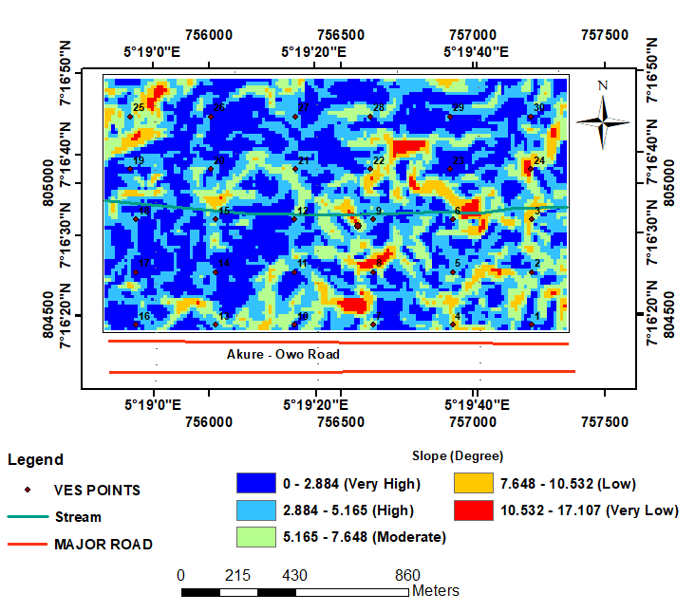
Figure 5: The Slope map of the study area

4.2 Geological Method
4.2.1 Lithology
The lithology map (Figure 6) provides a visualization of fuzzy scores associated with different lithology types, illustrating their relevance to groundwater potential within the study area. Fuzzy scores in this map range from 0.624 - 0.024. Regions with moderate to high fuzzy scores, prominently found in the southeastern portion of the study area, exhibit values around 0.602. This correlation is linked to the prevalence of Quartzite lithology. Quartzite is known for its high porosity and permeability, attributes that stem from its susceptibility to shearing during past tectonic activities. Consequently, these shearing events create voids that facilitate the accumulation and retention of groundwater. Conversely, areas in the northern and western perimeters of the study area display low fuzzy scores, specifically at 0.024. This signifies reduced contributions to groundwater occurrence and corresponds to the presence of Migmatite gneiss lithology. Migmatite gneiss has limited groundwater potential due to its low porosity and permeability characteristics. Consequently, regions with low fuzzy scores in the northern and western sectors may indicate poor groundwater potential unless geological structures are present to facilitate subsurface water migration and storage. These findings are consistent with prior research findings (Shaban et al., 2006; Magesh et al., 2012; Adeyemo et al., 2023; Adiat et al., 2024).

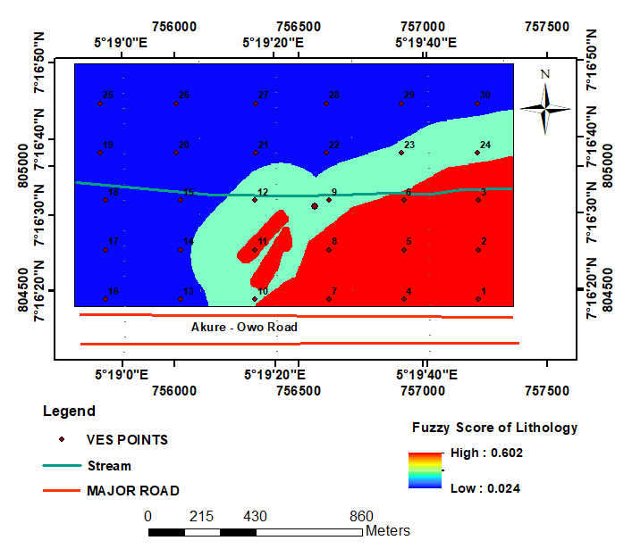

Figure 6: Fuzzy score lithology map of the study area

4.3 Geoelectric Sounding Results
Five geoelectric soundingcurve types were delineated across the study area. They consist of A, H, AA, AK and HA curve types. Three to four geoelectric layers were delineated in the area. The geoelectric layers consisted of topsoil, weathered layer, weathered basement and the presumed fresh bedrock. The layers ’resistivity varyrespectively from 15 - 1268 Ωm, 17 - 247 Ωm, 117 - 7,781 Ωmand 517 - 6,822 in the topsoil, weathered layer, weathered basement and the presumed fresh bedrock. The layers thickness values range from 0.4 and 1.9 m, 1.3 meters to 18.8 m and 2.8 meters to 10.6 m in the upper three layers respectively (Table 2).

Table 2: Summary of the geoelectric sounding results
VES NO | Easting (m) | Northing (m) | Resistivity  ρ₁/ρ₂/…./ρ_{n}(Ωm) | Thickness  h₁/h₂/…./h_{n} (m) | Curve Type
1 | 757223 | 804464 | 98/37/1441 | 0.8/10.9 | H
2 | 757223 | 804664 | 102/22/309/8434 | 0.4/1.5/8 | HA
3 | 757223 | 804864 | 1268/30/253/3762 | 0.9/3.4/4.5 | HA
4 | 756923 | 804464 | 22/91/773/6822 | 1.2/3.0/3.5 | AA
5 | 756923 | 804664 | 272/017/480/943 | 0.7/2.4/4.8 | HA
6 | 756923 | 804864 | 111/19/351/831 | 0.7/2.9/7 | HA
7 | 756623 | 804464 | 259/38/363/3297 | 0.4/2.6/3.3 | HA
8 | 756623 | 804664 | 788/23/117/3962 | 1.0/2.5/2.8 | HA
9 | 756623 | 804864 | 223/68/224/3391 | 1.2/5.9/4.9 | HA
10 | 756323 | 804464 | 125/24/181/1725 | 0.7/5.2/4.7 | HA
11 | 756323 | 804664 | 141/33/204/826 | 0.5/6.5.7.8 | HA
12 | 756323 | 804864 | 15/290/1105/203 | 1.3/3.1/10.6 | AK
13 | 756023 | 804464 | 34/152/1285 | 1.0/18.8 | A
14 | 756023 | 804664 | 628/20/970/4337 | 0.7/2.1/5.7 | HA
15 | 756023 | 804864 | 73/65/700 | 0.8/7 | H
16 | 755723 | 804464 | 62/138/3067 | 0.8/10.3 | A
17 | 755723 | 804664 | 48/55/603 | 0.8/14.9 | A
18 | 755723 | 804864 | 309/200/252/3319 | 1.2/5.5/7.2 | HA
19 | 755700 | 805054 | 39/231/2168 | 1.2/4.2 | A
20 | 756006 | 805054 | 23/258/7781 | 1.6/3.9 | A
21 | 756327 | 805054 | 101/26/357/517 | 0.4/1.7/10.0 | HA
22 | 756612 | 805054 | 560/43/371/3827 | 0.9/3.7/4.2 | HA
23 | 756912 | 805054 | 251/80/2359 | 0.8/7.6 | H
24 | 757218 | 805054 | 692/59/238/ 1755 | 0.6/8.5/7.4 | HA
25 | 755700 | 805254 | 811/37/387/3654 | 0.9/3.3/4.2 | HA
26 | 756006 | 805254 | 78/161/1206 | 1.1/13.3 | A
27 | 756327 | 805254 | 53/179/1179 | 0.8/18.1 | A
28 | 756612 | 805254 | 523/52/319/1797 | 0.9/9.3/7.2 | HA
29 | 756912 | 805254 | 558/58/777 | 1.3/14.3 | H
30 | 757218 | 805254 | 439/53/1168 | 1.4/10.4 | H

4.3.1 Aquifer Resistivity Map
The aquifer resistivity across the study area exhibits a range from 37 - 970 Ωm, as illustrated in Figure 7. This variation categorizes the area into five distinct resistivity zones: low, very low, moderate, high, and very high. The very low resistivity zone is characterized by resistivity values falling within the range of 37 - 150 Ωm. This zone is localized in pockets at various compass points within the study area, including the western, southwestern, southern, southeastern, and northeastern regions. Conversely, the study area, in general, is predominated by the low resistivity zone, where resistivity values range from 151 - 362 Ωm. This area is considered to be of high groundwater potential, as lower resistivity values correspond to higher conductivity. The moderate groundwater potential zone have resistivity zone encompasses resistivity values ranging from 363 - 595 Ωm. This zone is observed as pockets in the northern, northwestern, southwestern, and southeastern parts of the study area, indicating a moderate potential for groundwater accumulation. In contrast, the high and very high resistivity regions exhibit resistivity values ranging from 587 - 783 Ωm and 784 - 970 Ωm, respectively. These regions are primarily situated in the southwestern and eastern portions of the study area. Such high resistivity values suggest zones of low groundwater potential in these areas [11, 14].
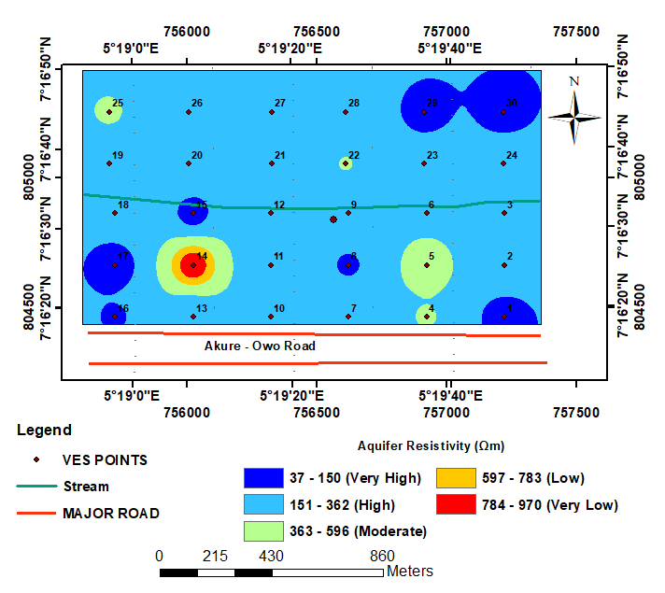
Figure 7: Aquifer resistivity map of the study area

4.3.2 Aquifer Thickness Map
Figure 8 displays the aquifer thickness map within the study area, featuring a range of aquifer layer thicknesses spanning from 2.8 - 18.8 m. These thickness values categorize the aquifer layer into five distinct thickness zones: very low, low, medium, high, and very high. The very low thickness zone encompasses areas where the aquifer layer ranges from 2.8 - 6.03 m in thickness. It is predominantly located in the southern region, extending northward, with additional pockets in the eastern and western parts of the study area. The low thickness zone exhibits aquifer layer thicknesses ranging from 6.04 - 9.19 m. This zone is prominently found in the northern, eastern, southern and north-southern regions of the study area.
Moving to the moderate thickness zone, this layer is observed in the northeastern to northwestern regions, with pockets in the southwestern and southeastern areas, featuring thicknesses ranging from 9.20 - 12.39 m. The thick aquifer layer zone and central parts of the study area. Lastly, the very thick aquifer layer zone is identified in pockets located in the southwestern, northern, and central parts of the study area, with thicknesses ranging from 15.60 - 18.8 m. This zone signifies high groundwater potential due to its substantial aquifer thickness. It is important to note that there is a direct correlation between aquifer thickness and groundwater potential, where greater thicknesses indicate a higher potential for groundwater resources [14].

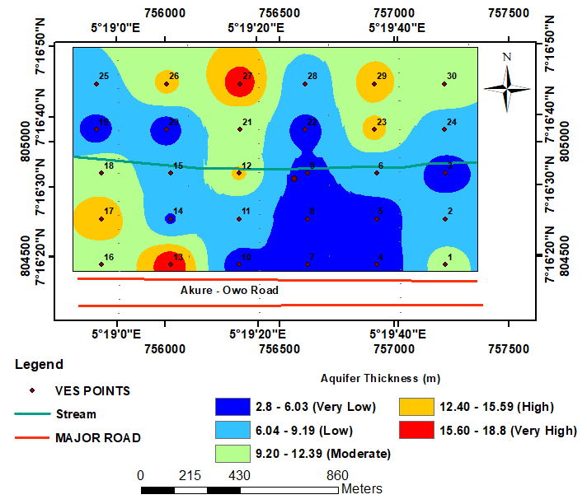
Figure 8: Aquifer thickness map of the study area
4.3.3 Overburden Thickness
The presents overburden thickness map, provides valuable insights into the spatial distribution of overburden thickness throughout the study area (Figure 9). The map classifies overburden thickness into five distinct zones: very low (5.4 - 8.28 m), low (8.29 - 11.16 m), moderate (11.17 - 14.03 m), high (14.04 - 16.91 m), and very high (16.92 - 19.79 m) based on predetermined class intervals.
Areas with very low overburden thickness are relatively small occupying pockets of locations in the study area, while low overburden thickness is predominantly observed in the southeastern, northwestern, southwestern, and north-central parts of the study area. These regions have a limited thickness of overlying material, suggesting that the bedrock or geological formations beneath are relatively close to the surface. In such areas, groundwater storage capacity is restricted, and the potential for significant groundwater resources is minimal. Low overburden thickness is predominantly observed in several parts of the study area, including the southeastern, northwestern, southwestern, and north-central regions. While the thickness of overlying material is still relatively modest, it indicates slightly more depth compared to the very low class. Groundwater potential in these areas may be somewhat improved compared to very low overburden thickness areas, but it remains relatively limited. In contrast, moderate overburden thickness is concentrated in the southwestern area, extending towards the northwestern part of the study area. This suggests that there is a thicker layer of overlying material in these regions, which can potentially provide more space for groundwater storage. Moderate overburden thickness areas may offer better groundwater potential compared to the lower classes. The high overburden thickness zone is prominent in the northern region, with additional pockets in the southwestern, northwestern, and northeastern parts of the study area. In these areas, the overburden is notably thicker, indicating a greater potential for groundwater storage. Higher overburden thickness typically translates to better groundwater potential, as there is more room for water to accumulate and be stored within the subsurface.
Lastly, very high overburden thickness areas are identified as pockets in the northern and southwestern portions of the study area. These areas encompass a range of thickness values, signifying favorable conditions for groundwater storage. Very high overburden thickness areas are likely to have the most significant groundwater potential within the study area [11, 13, 14].
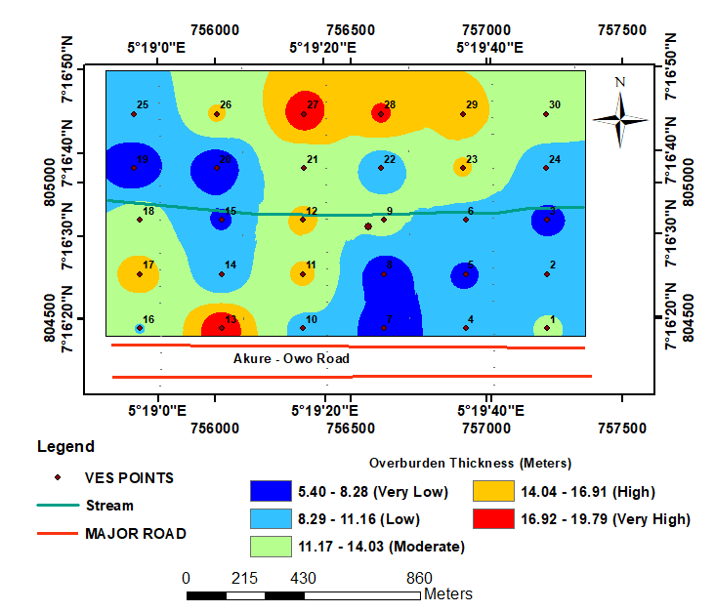
Figure 9: Overburden thickness map of the study area

4.3.4 Longitudinal unit conductance
The total longitudinal unit conductance (S) is calculated as the summation of the thickness divided by the resistivity of the geoelectric layers at each VES location. The values for longitudinal conductance in the study area as shown in (Figure 10) generally range from 0.0049 - 0.295 mhos. To categorize the longitudinal resistance across the study area, it was classified into five classes: very low, low, moderate, high, and very high, as depicted in Figure 10. The very low longitudinal conductance, which ranges from 0.049 - 0.098 mhos, is primarily observed as pockets in the western, southwestern, northwestern, and northeastern parts of the study area. These areas are indicative of high groundwater potential since longitudinal conductance is inversely proportional to groundwater potential. The low longitudinal conductance, characterized by a conductivity range of 0.099 - 0.147 mhos, dominates the study area. It is found in the southwestern, northwestern, northern, northeastern, southern, southeastern, and central regions of the study area.
Moving to the moderate longitudinal conductance, this class is identified in the northwestern, southwestern, southern, eastern, southeastern, and northeastern parts of the study area, with values ranging from 0.148 - 0.196 mhos. The high longitudinal conductance zone is observed as pockets in the southern, southwestern, southeastern, northwestern, and northeastern parts of the study area, with values ranging from 0.197 - 0.245 mhos.
Finally, the very high longitudinal conductance class is characterized by values ranging from 0.246 - 0.295 mhos. It is found in pockets in the southeastern, southwestern, and northeastern regions of the study area. However, it's important to note that these high and very high classes are indicative of areas with typically low groundwater potential as observed in the studies of [34, 35]

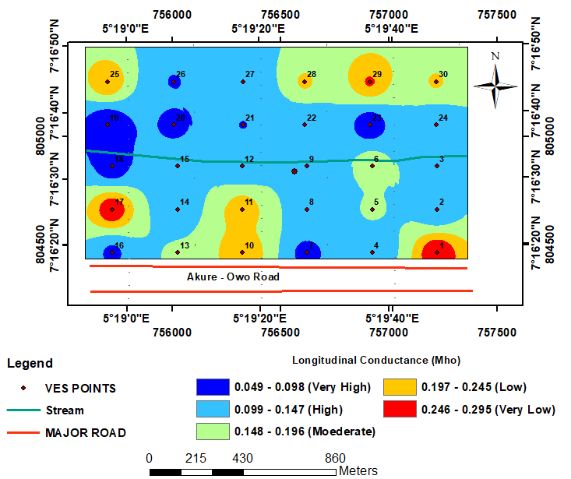
Figure 10: Longitudinal conductance map of the study area

4.3.5 Transverse Resistance Map
The transverse resistance map(Figure 11)indicated that the spatial distribution of transverse resistance values across the study arearrangedfrom 477 - 12637 Ωm. Transverse resistance[32] is a critical parameter closely related to hydraulic properties of the aquifer. In thetransverse resistance map (Figure 11), the study area was categorizedinto five distinct zones, each representing varying degrees of transverse resistance: very low, low, medium, high, and very high. The very low transverse resistance region is characterized by values ranging from 477 -2909 Ωm. This predominates the southwestern, southeastern, eastern, northeastern, and northwestern parts of the study area. Very low transverse resistance signifies limited hindrance to groundwater and electric current flow. In such areas, groundwater may have a higher potential for accumulation and storage due to the ease with which it can move laterally through the subsurface. Thus, these areas may exhibit more favorable groundwater accumulation potential. The low transverse resistance regions are primarily observed in the southwestern region, extending towards the central and northern parts of the study area. Additionally, pockets of low transverse resistance are found in the northeastern area, with values ranging from 2910 - 5340 Ωm. While not as favorable as very low transverse resistance areas, low transverse resistance still indicates relatively good lateral groundwater flow and accumulation potential. These areas may have moderate groundwater potential. The moderate transverse resistance zone features values ranging from 5341 - 7772 Ωm and is concentrated in pockets in the southwestern and central parts of the study area.

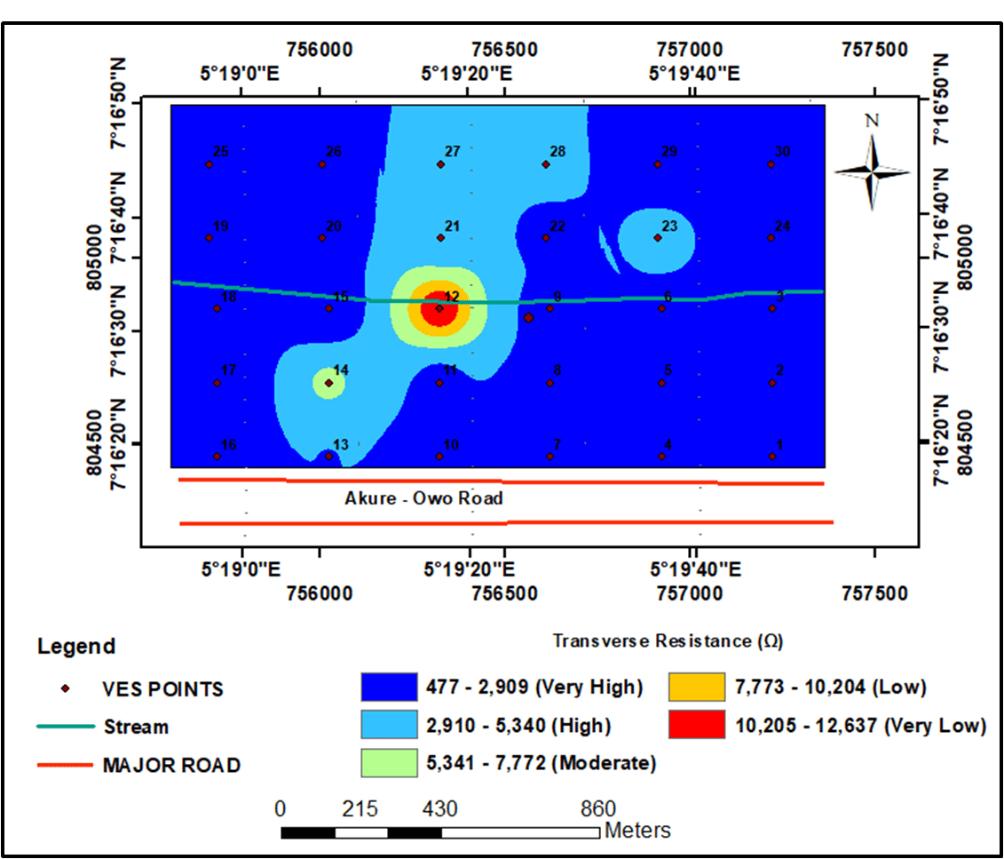
Figure 11: Transverse Resistance Map of the Study Area

4.3.6 Coefficient of Anisotropy
The coefficient of anisotropy values in the investigated area exhibits a range from 1.001 - 3.037. To better understand these values, they have been categorized into five distinct classes: very low (1.001 - 1.408), low (1.409 - 1.815), moderate (1.816 - 2.223), high (2.224 - 2.630), and very high (2.631 - 3.037), as shown in Figure 11.
Regions characterized by a very low coefficient of anisotropy (1.001 - 1.408) are predominantly located in the northeastern, northwestern, and southwestern areas, with pockets of occurrence in the central and southeastern parts of the study area. These regions indicate poor groundwater potential. A very low coefficient of anisotropy suggests that the aquifer is relatively isotropic, meaning that groundwater flow is relatively uniform in all directions. However, in this case, it corresponds to poor groundwater potential, likely due to other hydrogeological factors. The low coefficient of anisotropy values (1.409 - 1.815) is distributed across the entire study area, covering a significant portion. While these areas have a slightly higher anisotropy compared to the very low class, they are still classified as having relatively poor groundwater potential. This suggests that the groundwater flow may not be as uniform, but other factors limit groundwater availability. Moving to the moderate coefficient of anisotropy values (1.816 - 2.223), these are primarily observed trending from the southeastern to the eastern part of the study area, with pockets in the southwestern and central regions. These areas indicate groundwater potential that falls into a moderate range. A moderate coefficient of anisotropy suggests that the aquifer has some degree of anisotropy, meaning that groundwater flow may be more directional. While not as poor as the lower classes, groundwater potential may still be somewhat limited. The high coefficient of anisotropy values (2.224 - 2.630) is found as pockets in the southeastern and southwestern parts of the study area. Areas with high anisotropy indicate relatively better groundwater potential compared to the lower classes. A high coefficient of anisotropy suggests that the aquifer has a pronounced anisotropic nature, with groundwater flow being more directional. This can enhance groundwater availability to some extent as observed in the studies of [14, 34].
Lastly, very high coefficient of anisotropy values (2.631 - 3.037) occurs in few places at the southeastern region of the study area. These areas, characterized by very high anisotropy, are classified as having poor groundwater potential. Despite having very high anisotropy, these areas are still associated with poor groundwater potential. This indicates that other factors are significantly limiting groundwater availability, possibly outweighing the influence of anisotropy.
The coefficient of anisotropy values provides important insights into the anisotropic nature of the aquifer and its potential impact on groundwater availability. In this context, higher values are associated with poorer groundwater potential.
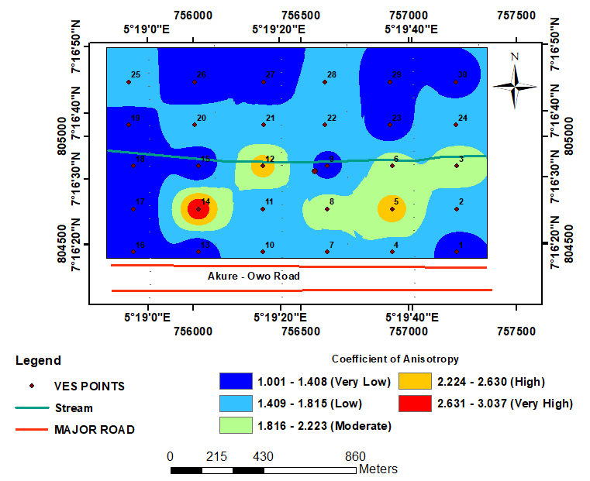
Figure 12: Coefficient of anisotropy map of the study area

4.4 Groundwater Potential (GWP) Maps

4.4.1 Groundwater potential maps derived from VIKOR and Fuzzy-VIKOR models
Groundwater potential maps (Figures 12 and 13) for the study area was generated based on the computed results (Table 3). The two groundwater potential maps (Figures 12 and 13) were generated using the VIKOR and Fuzzy-VIKOR models respectively. The maps were classified into distinct groundwater potential zones using the Natural Breaks Approach [33]. The spatial variation of the groundwater potential index across the study area is categorized into five zones: very low, low, moderate, high, and very high. The VIKOR GWP map (Figure 12), shows that a significant portion of the southeastern region of the study area falls within the moderate to very high groundwater potential zones. Some pockets of moderate to high GWP zones occur in the southern and southwestern parts of the study area. Conversely, the low and very low groundwater potential zones are identified in the northeastern, northwestern, and southwestern parts of the study area. The Fuzzy-VIKOR GWP map (Figure 13) exhibits a similar pattern, with most of the southeastern region falling within the moderate to very high groundwater potential zones, along with pockets of places in the southern and southwestern parts. The low and very low groundwater potential zones are likewise identified in the northeastern, northwestern, and southwestern parts of the study area.
In conclusion, it is evident that the Groundwater Potential Conditioning Factors (GPCFs) have had a substantial impact on the final groundwater potentiality model (GPM) map generated using the VIKOR and Fuzzy-VIKOR models. These models provide a comprehensive understanding of groundwater potential across the study area, aiding in effective groundwater resource management and assessment.
Table 3.Weight assignment for groundwater potential conditioning factors
Parameters | Weight (VIKOR) | Weight (Fuzzy-VIKOR)
Slope | 0.0953 | 0.0215
Lithology | 0.3745 | 0.3270
Overburden thickness | 0.0255 | 0.0350
Aquifer resistivity | 0.1980 | 0.2490
Aquifer thickness | 0.0932 | 0.0675
Longitudinal conductance | 0.0468 | 0.0239
Transverse Resistance | 0.0061 | 0.0479
Coefficient of anisotropy | 0.1606 | 0.2282

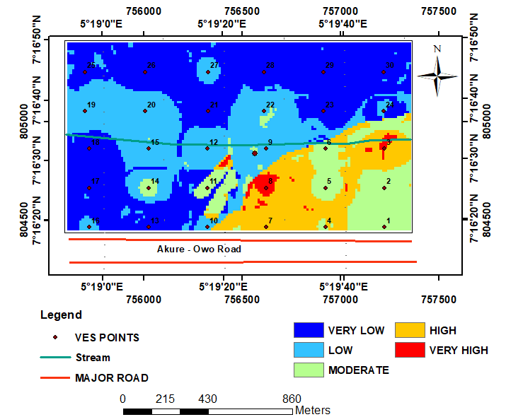
Figure 13: Groundwater potential model map of the study area (VIKOR)
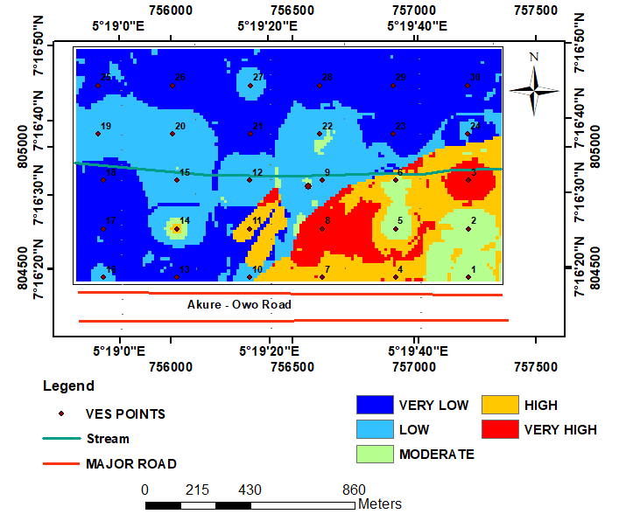
Figure 14: Groundwater potential model map of the study area (Fuzzy-VIKOR)

Validation of the groundwater potential model maps
To assess the accuracy of the fuzzy-VIKOR and VIKOR models, the receiver operating characteristic (ROC) curve was utilized. The quantitative validation of the groundwater potential map produced from the fuzzy-VIKOR model using the ROC analysis yielded a prediction rate of 0.73, corresponding to a prediction accuracy of 73 % (Fig. 15). In the same vein, the qualitative validation of the groundwater potential map produced from the VIKOR model using the ROC analysis yielded a prediction rate of 0.69, corresponding to a prediction accuracy of 69 % (Fig. 16). These results highlight the enhanced reliability and precision of the GPMs when using the VIKOR and Fuzzy-VIKOR algorithms to delineate areas with high groundwater potential. The results further showed that the Fuzzy-VIKOR model outperformed the VIKOR model because it takes into account the fuzziness of geological occurrences and natural phenomenon which the VIKOR model does not.
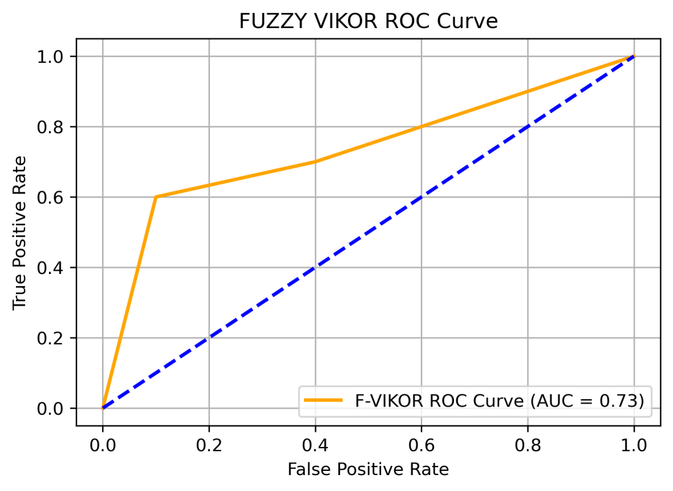
Figure 15: Qualitative validation using receiver operating characteristic – area under the curve (ROC-AUC) for groundwater potential map from Fuzzy-VIKOR model
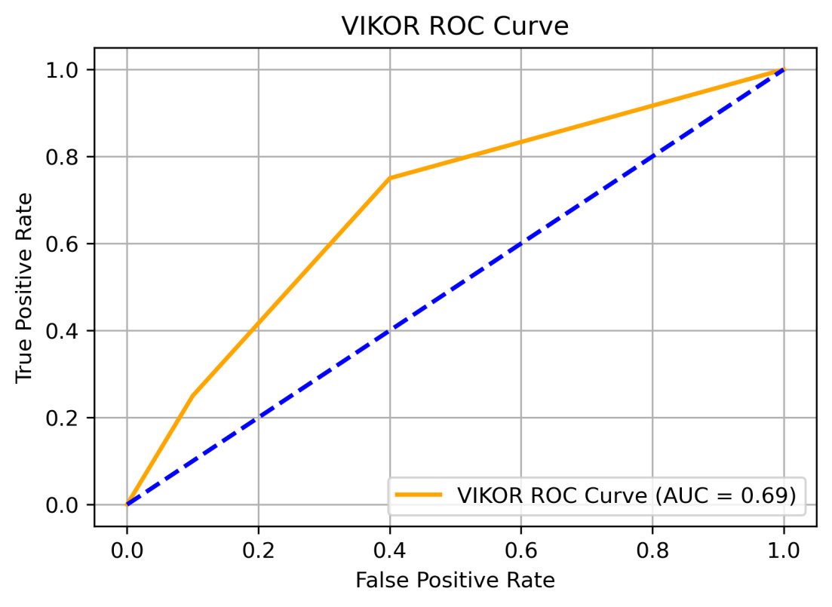
Figure 16: Qualitative validation using receiver operating characteristic – area under the curve (ROC-AUC) for groundwater potential map from VIKOR model

- Conclusion
Geophysical investigations, incorporating remote sensing data, geological, and geoelectric sounding parameters, were integrated to assess groundwater potential within a newly acquired site by the Federal University of Technology Akure (FUTA). This study showcases the application of objective-based multi-criteria decision analysis (MCDA) techniques for evaluating geophysical parameters lithology and remote sensing parameter for groundwater potential assessment.
The study employed the VIKOR and Fuzzy-VIKOR methods to assign weights to groundwater potential conditioning factors, including overburden thickness, aquifer layer resistivity, aquifer layer thickness, transverse resistance, longitudinal conductance, and coefficient of anisotropy.
The outcomes of the VIKOR and Fuzzy-VIKOR weighting methods indicated that lithology and aquifer resistivity had the greatest influence on the groundwater potential of the study area, while transverse resistance and slope had the least impact. Geospatial tools within the ArcGIS environment were employed to create groundwater potentiality maps using weighted linear combination techniques, enabling the modeling of the study area.
Furthermore, a comparative analysis was conducted on the generated groundwater potentiality maps, serving as a validation tool. The results revealed a correlation between the produced maps and the transmissivity map, thus validating the accuracy of the groundwater potentiality maps through qualitative means. Consequently, this study can provide valuable guidance for decision-making in the field of hydrology regarding the management of groundwater resources within the study area.
This study has been able to establish the reliability of VKOR and F-VIKOR MCDA techniques vis-à-vis there performance when applied to subsurface geo-parameters for groundwater resources mapping and management. Further study should be carried out using borehole data for validation. This could not be achieved in this course of this study, due to limitation in acquisition of borehole data.
Finally, principles of artificial intelligence could be applied in future research in the domain of groundwater resource management, this is because of their high accuracy prediction rates. Past research has shown how well and almost perfect their accuracy of prediction can be, and the result could prove extremely useful and important to the field in broader fashion.
DISCLAIMER (ARTIFICIAL INTELLIGENCE)
Author(s) hereby declare that NO generative AI technologies such as Large Language Models (ChatGPT, COPILOT, etc.) and text-to-image generators have been used during writing or editing of this manuscript

COMPETING INTERESTS
Authors have declared that no competing interests exist.

References
- Asfahani, J. (2007). Geoelectrical investigation for characterizing the hydrogeological conditions in semi-arid region in Khanasser valley, Syria. Journal of Arid Environments, 68(1), 31-52.
- Nasiri, H., Boloorani, A. D., Sabokbar, H. A. F., Jafari, H. R., Hamzeh, M., and Rafii, Y. (2013). Determining the most suitable areas for artificial groundwater recharge via an integrated PROMETHEE II-AHP method in GIS environment (case study: Garabaygan Basin, Iran). Environmental Monitoring and Assessment, 185, 707-718.
- Al-Abadi A.M. & Shahid S., (2016). Spatial mapping of artesian zone at Iraqi southern desert using a GIS-based random forest machine learning model. Model. Earth Syst. Environ. 2:96.
- Raviraj, A., Kuruppath, N. & Kannan, B. (2017). Identification of potential groundwater recharge zones using remote sensing and geographical information system in Amaravathy basin. J Remote Sens GIS, 6(4), 1-10.
- Akinlalu, A.A. & Afolabi, D.O. (2018). Borehole depth determination to freshwater and well design using geophysical logs in coastal regions of Lagos, Southwestern Nigeria. Applied Water Science 8: 152. 1 – 17. https://doi.org/10.1007/s13201-018-0798-3
- Olorunfemi, M. O., Ojo, J. S. & Akintunde, O.M. (1999). “Hydro-geophysical evaluation of the groundwater potential of the Akure metropolis, Southwestern Nigeria”. Journal of Mining and Geology Vol. 35(2) 1999, pp. 207-228.
- Ojo, J. S., Olorunfemi, M. O., Akintorinwa, O. J., Bayode, S., Omosuyi, G. O., &Akinluyi, F. O. (2015). GIS integrated geomorphological, geological and geoelectrical assessment of the groundwater potential of Akure Metropolis, southwest Nigeria. J Earth SciGeotechEng, 5(14), 85-101.
- Omosuyi, G.O. (2010). Geoelectric assessment of groundwater prospect and vulnerability of overburden aquifer at Idanre, southwestern Nigeria.Ozean J. Appl. Sci., 3(1): 19-28
- Adeyemo, I. A., Omosuyi, G. O., Ojo, B. T. & Adekunle, A. (2017): Groundwater Potential Evaluation in a Typical Basement Complex Environment Using GRT Index- A Case Study of Ipinsa-Okeodu Area, Near Akure, Nigeria. Journal of Geoscience and Environment Protection (GEP), Scientific Research Publishing Vol.5, No. 3, pp. 240 - 251, https://doi.org/10.4236/gep.2017.53017.
- Omosuyi, G. O., Oshodi, D. R., Sanusi, S. O. & Adeyemo, I. A. (2021). Groundwater potential evaluation using geoelectrical and analytical hierarchy process modeling techniques in Akure-Owode, southwestern Nigeria. Modeling Earth Systems and Environment, 7, 145-158.
- Adiat, K.A.N., Ajayi, O.F., Akinlalu, A.A. & Tijani, I.B. (2020). Prediction of groundwater level in basement complex terrain using artificial neural network: a case of Ijebu– Ijesa, southwestern Nigeria. Journal of Applied Water Science. 10:8. https://doi.org/10.1007/s13201- 019-1094-6.
- Abe, S. J., Adeyemo, I. A. & Abosede-brown, O. J. (2023): Geophysical Approach for Groundwater Resource Assessment: A Case Study of Oda Community Akure, Southwestern Nigeria. Advances in Geological and Geotechnical Engineering Research. Volume 5, Issue 4, pp 59 - 69. https://doi. org/10.30564/agger.v5i4.5978.
- Adeyemo, I. A.,Adegoke, A. A., Ojo O. B. & Oluwafemi, T. O. (2023): Integration of Elevation, Lithology and Geoelectric Parameters Using Analytical Hierarchy Process for Groundwater Potential Evaluation in Part of Akure Metropolis, Southwestern Nigeria. Science Domain International, Asian Journal of Geological Research. Article No AJOGER.106432, Volume 6, Issue 3, pp 189 - 203.
- Adiat, K. A. N., Kolawole, A. O., Adeyemo, I. A., Akinlalu, A. A. & Afolabi, D. O. (2024). Assessment of Groundwater Resources from Geophysical ad Remote Sensing Data in a Basement Complex Environment Using Fuzzy-TOPSIS Algorithm. Results in Earth Sciences, 2(2024) 100034. pp 1-16. htpp://doi.org/10.1016/j.rines.2024.100034
- Adiat, K.A.N., Nawawi, M.N.M. &Abdullah, K. (2013). Application of multicriteria decision analysis to geoelectric and geologic parameters for spatial prediction of groundwater resources potential and aquifer evaluation. Journal of Pure and Applied Geophysics 170:453-471. https://doi.org/10.1007/s00024- 012-0501-9.
- Mogaji, K. A. & Omobude, O. B. (2017). Modeling of geoelectric parameters for assessing groundwater potentiality in a multifaceted geologic terrain, Ipinsa Southwest, Nigeria–A GIS-based GODT approach. NRIAG Journal of Astronomy and Geophysics, 6(2), 434-451.
- Mogaji, K.A. & Lim, H.S. (2017) Development of groundwater favourability map using GIS-based driven data mining models: an approach for effective groundwater resource management. Geocarto International. doi:10.1080/10106049.2016.1273400.
- Akinlalu, A.A., Afolabi, D.O. & Sanusi, S.O. (2024). Knowledge–driven fuzzy AHP model for orogenic gold prospecting in a typical schist belt environment: a mineral system approach. Earth Systems andEnvironment.https://doi.org/10.1007/s41748-024-00382-4.
- Akinlalu, A. A., Adegbuyiro, A., Adiat, K. A. N., Akeredolu, B. E., & Lateef, W. Y. (2017). Application of multi-criteria decision analysis in prediction of groundwater resources potential: A case of Oke-Ana, Ilesa area southwestern, Nigeria. NRIAG Journal of Astronomy and Geophysics, 6(2017), 184–200.
- Meijerink, A. M., Bannert, D., Batelaan, O., Lubczynski, M. W. &Pointet, T. (2007). Remote Sensing Applications to Groundwater (Vol. 16). Paris: Unesco.
- Manap, M. A., Sulaiman, W. N. A., Ramli, M. F., Pradhan B. &Surip N. (2011). A knowledge-driven GIS modeling technique for groundwater potential mapping at the Upper Langat Basin, Malaysia. Arab J Geosci.https://doi:10.1007/s12517-011-0469-2
- Mogaji, K. A., Aboyeji, O. S. &Omosuyi, G. O. (2011). Mapping of lineaments for groundwater targeting in the basement complex region of Ondo State, Nigeria, using remote sensing and geographic information system (GIS) techniques. International Journal of Water Resources and Environmental Engineering, 3(7), 150-160.
- Adiat, K.A.N., Nawawi, M.N.M. & Abdullah, K. (2012). Assessing the accuracy of GIS-based elementary multi criteria decision analysis as a spatial prediction tool - A case of predicting potential zones of sustainable ground water resources. J Hydrol 440-441:75-89.
- Nampak, H., Pradlan, B. & Abd Manap, M. (2014). Application of GIS based data driven evidential belief function model to predict groundwater potential zonation. Jounral of Hydrology,Vol. 513, 283 – 300. https://doi.org/10.1016/j.jhydrol.2014.02.053.
- Singh, P., Gupta, A. & Singh, M. (2014). Hydrological inferences from watershed analysis for water resource management using remote sensing and GIS techniques. The Egyptian Journal of Remote Sensing and Space Science, Vol. 1 (2). 111–121. https://doi.org/10.1016/j.ejrs.2014.09.003.
- Adegbola, A. A., and Adewoye, A. O. (2012). On Investigating Pollution of Groundwater Atenda Abattoir Waste, Ogbomoso, Nigeria. International Journal of Engineering and Technology, Vol. 2. No. 9, Pp. 1569-1585.
- Keller, G. V., and Frischknecht, F. C. (1966). Electrical Methods in Geophysical Prospecting, Pergamon Press Inc., 3 rd Edition, Oxford.
- Zohdy AAR, Eaton GP, Mabey DR. (1974).Application of Surface Geophysics to Ground-Water Investigations, In Techniques of Water-Resources Investigations of the United States Geological Survey. Book 2, Chapter D1. 63p.
- Koefoed, O. (1979). Resistivity sounding on an earth model containing transition layers with linear change of resistivity with depth. Geophysical Prospecting, 27(4), 862-868.
- Vander Velpen BPA. (2004). Window RESIST Software Version 1.0. ITC, IT-RSG/GSD, Delft, Netherlands.
- Chezgi, J. & Soheili, E. (2021). Application of TOPSIS and VIKOR decision making models in site selection of flood spreading projects in arid and semi-arid region (Persian). Desert Manag. Journ. 2021; 8(16):169-82.
- Ejepu, J.S., Jimoh, M.O., Abdullahi, S. et al. (2024). Geoelectric analysis for groundwater potential assessment and aquifer protection in a part of Shango, North-Central Nigeria. Discov Water 4, 33. https://doi.org/10.1007/s43832-024-00091-z.
- Jenks G. F. (1967). The data model concept in statistical mapping, International Yearbook of Cartography, 7, 186–190.
- Kayode, M.O., K.A.N Adiat, W.B Tomori, E.A Okoronkwo, and D.O. Afolabi. (2024). Aquifer Vulnerability Assessment of Groundwater in a Basement Complex Geology Using Fuzzy Analytical Hierarchy Process”. Asian Journal of Geological Research 7 (3):331-50. https://journalajoger.com/index.php/AJOGER/article/view/175.
- Akintorinwa O.J, Atitebi M.O, Akinlalu A.A. (2020). Hydrogeophysical and aquifer vulnerability zonation of a typical basement complex terrain: A case study of Odode Idanre southwestern Nigeria. Heliyon. 6(8).
- Kouamou Njifen, S. R., Enyegue A Nyam, F. M., Bikoro, M. B. A., Ngouokouo, A. T., & Tabod, C. T. (2023). Modeling groundwater potential zones in the Kribi-Campo region, South Cameroon using geospatial techniques and statistical models. Modeling Earth Systems and Environment, 9(1), 913-935.
- Njifen, S. R. K., Nyam, F. M. E. A., Fossi, D. H., Bikoro, M. B. A., Tchikangoua, A. N., & Tabod, C. T. (2024). Groundwater potential mapping and mineralization assessment in Campo aquifers, Cameroon using AHP and multivariate statistical analysis. Environment, Development and Sustainability, 26(6), 16095-16127.

