Systematic Review Article: (Mainly for bio-medical journals)
Magnesium, its properties and therapeutic uses: A literatures Review
Abstract
Magnesium is found in most places. It can be found in water, food, and in the middle of chlorophyll in plants. It is the fourth most prevalent element in the human body. It also regulates many body functions such as key enzymatic processes, metabolism, and protein synthesis. Unlike most nutrients, magnesium deficiency is rare due to biochemical adjustments and most often magnesium is in short supply. It is a mineral necessary to maintain healthy nerves, muscles, blood sugar levels, bones, and even aids in enzymatic processes of the body. Not having enough magnesium in the diet can significantly increase the risk of developing a heart attack, stroke, diabetes, and even osteoporosis. Magnesium deficiency may manifest as symptoms such as muscle weakness, fatigue, tremors, and irregular heartbeat. It is insulin-sensitive and found mostly in soft tissue. Also, the bone matrix, which is the soft structure inside bones, has protein and magnesium which helps to cushion bones and aids in resisting osteoporosis. Severely lacking magnesium can lead to numbness, muscle cramps, and even irregular heartbeats. Foods such as legumes, nuts, whole grains, and green leafy vegetables are rich in magnesium. Magnesium rich food boosts overall health. Requirement of magnesium varies from person to person depending on age, gender, and stage of lifetime.
Keywords: Magnesium , Osteoporosis ,Health , Depression, Asthma

Introduction
Magnesium (Mg) has atomic number 12 and is an alkaline earth metal (Group 2) of the periodic table. The name magnesium is derived from) magnesia(,region in Asia Minor where magnesium compounds were found in 1763 AD. Nehemiah Jr. was able to separate magnesium sulfate from Hydrological minerals in the Somme region of England, In 1868 AD, Davy was able to isolate magnesium and extract it through electrolysis(1). Magnesium is a metal that is difficult to extract or obtain. This is due to the high ability of magnesium to combine with other elements, and the difficulty of extracting it. A chemically active metal that does not exist free in nature but in the form of compounds. It burns with an intense white flame, forming stable magnesium oxide (MgO) and an oxide layer that protects it from reacting with the inner layers. Magnesium oxide is a light lead powder. It reacts with water to produce magnesium hydroxide explosively. It has a crystalline structure similar to that of NaCl (2,3).

-Physical and chemical properties of magnesium
Magnesium is a silver-colored solid that is one-third lighter than aluminum and has low strength and hardness It reacts with water and moisture in the air
-The most important compounds of magnesium and its salts.
There are many compounds and salts of magnesium that are used in all medical,
military, and industrial fields, including: MgF2, MgCl₂, Mg3(PO4)2, MgSO₄, MgS, MgCO3, Mg(NO₃)₂, MgI₂, and Mg(OH)

- Foods containing Mg
Many foods that we consume as part of our diet already have it, milk and dairy products fortified with magnesium are also available. With respect to magnesium, which can be obtained from green vegetables such as nuts, seeds, spinach, whole grains, legumes and fortified cereals, nourished milk and dairy products are also available in reasonable amounts. Thus, with respect to magnesium, the recommended amounts can be obtained from fortified foods and cereals (4).
-Magnesium doses
As it is shown in the table, at all ages the body requires magnesium. Magnesium is needed to enable the body to perform many vital functions like mauntaining muscle and nerve functions, controlling blood sugar and blood pressure, forming proteins, bones, and DNA, as well as inésur basically every body system, it needs magnesium .Magnesium intake is also dependent on gender and age, below is the average recommended intake in milligrams (mg) per day for each age group.

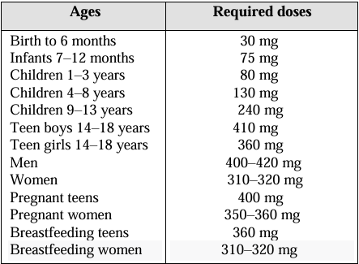

Table(1) Magnesium doses(110)

-Uses of Magnesium
1.Mg is used in the manufacture of mixtures and in the preparation of pyrotechnic materials due to the intense light generated by It is burning.
2.It is used with some metals to form alloys that have good mechanical properties and are used in the manufacture of aircraft and ship parts.
3.Mg is used in flash photographic lamps, as well as in the dental industry.
4.It is used in the formation of underground canal networks, and magnesium oxide is used as a heat-reflecting material Earth's interior.
5. Magnesium enables plants to capture the necessary solar energy for photosynthesis, which is conducted by chlorophyll (a green pigment with magnesium at its center, comprising 6.7% magnesium). It is also important in activating certain enzymes that are responsible for respiration, for DNA biogenesis, and for metabolic processes involving phosphates. It escorts such phosphate compounds in the whole plant. Magnesium helps in the movement of carbohydrates (sugars and starches), helps in the formation of fats and is important in cell division and growth.. (5,6,7,8,9).

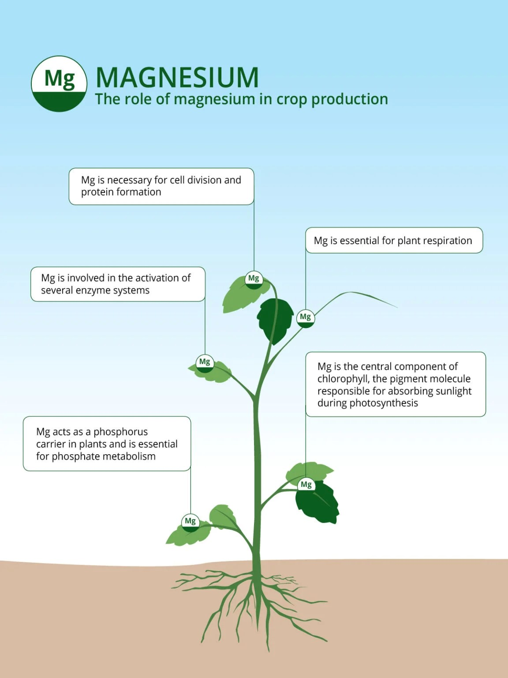
Figure(1) Magnesium is required to help plants(10)
6.In the medical fields: Magnesium has great importance in the health field, as its deficiency in the human body causes many health problems, including “asthma, depression, high blood pressure, diabetes, irregular heartbeat, and osteoporosis(11,12,13,14,15).
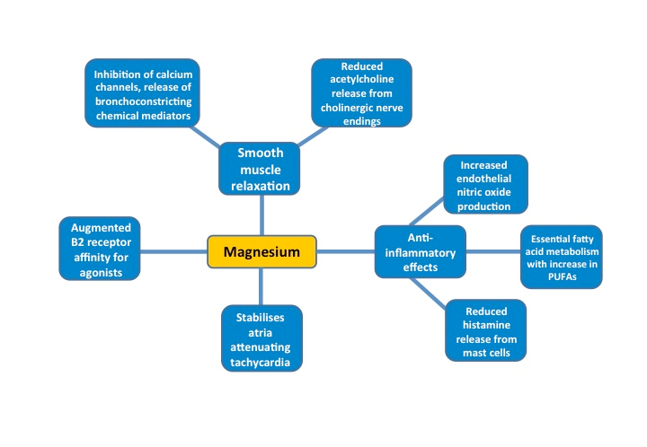
Figure(2)Magnesium in the health field
-Asthma
Asthma is a chronic disease that affects humans. Magnesium is important because it is one of the most abundant elements in the body. (15,16) . It is used to treat asthma due to its muscle dilatation effect, by reversing bronchospasm(17,18,19). In blood tests performed on adult asthma patients, some studies have found low magnesium levels. Other studies have not confirmed these results. (20,21,22) including adult patients. Magnesium levels in children with asthma have not been published yet(23,24). Magnesium deficiency can be associated with the risk of asthma exacerbation, and blood magnesium supplementation can predict therapeutic response. However, it is an ion found inside cells, and its levels do not reflect intracellular results or total body stores.(25,26,27,28). It was found that its intracellular concentration is lower in biodegradation and returns until it is controlled, while its plasma level remains below. Because the formula does not represent the body's deficiency, but rather starts from the beginning of the serum magnesium level to enhance the effectiveness of the treatment(29).

-Depression
Magnesium is far from a passive participant in the body—it plays a vital role in neural signaling(30).This connection has drawn attention to its involvement in a range of neurological conditions, involving migraines, Alzheimer’s disease, Parkinson’s disease, and attention deficit hyperactivity disorder. Recently, growing research interest has focused on magnesium’s impact on depression, largely owing to its interaction with non-selective ionotropic NMDA channels in the brain(31,32).

These NMDA channels, which are activated by the neurotransmitter glutamate, are essential for neurotransmission and neuroplasticity. As such, magnesium is implicated in processes like learning, memory, and regulation of mood. When glutamate activates these channels, it triggers the influx of sodium and calcium ions into neurons. The entry of sodium depolarizes the cell, which then accelerates calcium’s influx(33,34). This increased intracellular calcium can activate various enzymatic pathways—including protein kinases and nitric oxide synthesis—that are believed to play an important role in the pathophysiology of depression.

Importantly, magnesium acts as a natural calcium channel blocker at NMDA receptors. By inhibiting calcium entry into the neuron, magnesium helps prevent the cascade of enzymatic activity that could contribute to depressive states(35). In sum, magnesium’s regulatory effect on NMDA channels underscores its potential significance in brain health and the management of certain neurological disorders(36).
-High blood pressure
Magnesium is good for people with high blood pressure. Several factors may help to demonstrate the relationship between blood pressure and magnesium, containing its anti-inflammatory role and its effects on vascular permeability, vascular development, vascular inflammation, oxidative stress, chronic inflammation, muscle metabolism, vascular remodeling, muscle recovery, endothelial function and functional decline (37,38,39,40). High blood pressure increases the risk of coronary heart disease and stroke, and the effects of magnesium on systolic and diastolic blood pressure were not consistent across trials of magnesium supplements. (41).
Mg2+ indicates the localization of prostacyclin in the tissue space. No hematopoietic cells or platelets, or Mg2+ induces release of prostacyclin into plasma. O powder of nitric oxide Mg2+ also affects vascular endothelial cells through two effects of nitric oxide (NO). which is a vasodilator secreted by endothelial cells from endothelial NO synthase (eNOS) and L-arginine. In cultured endothelial cells, none of the activities were threefold higher than in cultured cells without high control (42,43).
-Diabetes
Diabetes is a worldwide epidemic. Patients suffer from high blood sugar levels and different problems. It is caused by the insulin resistance or harm to beta cells. The magnesium is a nutrient participated in the breakdown of glucose and insulin action. Studies have confirmed that many diabetic patients suffer from magnesium deficiency (44). Because Mg is a cofactor in many enzymatic reactions, magnesium deficiency is a common cause of many diseases. As diabetes progresses, magnesium affects not only insulin sensitivity but also glycolysis. Therefore, magnesium deficiency increases insulin sensitivity and increases the risk of diabetes (45,46). It is an essential cation in the body that catalyzes about three hundred enzymatic processes in the body like protein synthesis and blood sugar regulation (47). Mg content in the body of a normal adult is about 1000 mmol (21–28 g), and the magnesium in the blood ranges from 0.75 to 0.96 mmol/L. Bone is where most Mg is stored, and the remainder, Mg can freely exchange Between outside the cell and intracellular fluids to preserve Serum magnesium equilibrium. At the same time, the recommended daily amount of magnesium for adults is (4.5 mg/kg/day), But it varies between people ( 48,49). Mg plays has an important role in protecting the negative charge of the ATP phosphate group, which is a component of the Mg-ATP complex. The complex contributes to the breakdown of glucose in complete phosphorylation reactions. and, In turn, it affects glucose analysis in two ways. The first is its effect on insulin senastion. When magnesium concentration is very a little, it will interfere with insulin receptor phosphorylation mediated by tyrosine kinase, preventing insulin from signaling sufficiently for glucose uptake (50,51). The second way is that during the breakdown of glucose, magnesium affects hexokinase and phosphofructokinase, as indicated in Figure 3. Hexokinase breaks down glucose into glucose-6-phosphate using a phosphate group and ATP, while phosphofructokinase utilize fructose-6-phosphate to produce fructose-1,6-bisphosphate. Both Operations require the participation of magnesium. If serum magnesium concentration is very low, glycolysis is inhibited, preventing glucose from being In the liver, it is reserved as glycogen. or from entering the tricarboxylic acid cycle for power production. This results in diabetes due to elevated blood glucose levels. (52,53).
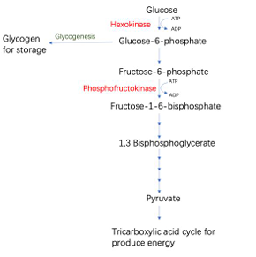
Figure (3): Glycolysis process.

The kinases that affect magnesium are shown in red. This is the storage site for glucose, which is broken down to produce energy or enters the tricarboxylic acid cycle. Most important causes of magnesium deficiency in type 2 diabetes are low magnesium intake and/or increased urinary magnesium loss, which appears to be maintained by magnesium absorption and retention (54,55). Plasma magnesium levels are associated with the development of type 2 diabetes in the general population (56). Type 2 diabetes is usually associated with renal calcium and magnesium loss (57), although the mechanism for this suggestion has not yet been fully elucidated (58). Both hyperinsulinemia and hyperglycemia can rise urinary magnesium excretion. During fasting, an inverse correlation was observed between urinary magnesium excretion and blood glucose levels with serum magnesium levels. Therefore, high blood glucose reduces tubular magnesium reabsorption (59). Good metabolic control is linked with reduced urinary magnesium loss. Li and colleagues Renal magnesium transporters were found to increase. in mice with streptozotocin-induced diabetes. This alteration was reversed with insulin administration. Hyperinsulinemia and insulin resistance may affect magnesium transport (60,61,62)..

-Irregular heartbeat
Magnesium deficiency in the body remains less polarized for a short period due to the accumulation of nitrogen oxide inside the cells, which indicates the presence of an important oxide( + -) pump. Thus this change eventually becomes cardiac dysrhythmia. It is recognized to be an essential cofactor For the job of enzymes in mitochondria. also, adjust the reaction and proton diversity settings(63,64). This substance plays a diverse role in cardiovascular diseases at both the cellular and biochemical levels. Magnesium diphosphate activates ATPase, which plays a role in biological activities and serves as an energy source for the Na+-K+ pump. In this pump, deficiencies of specific nutrients are selected from the body's Na+-K+ activity, resulting in increased cellular oxidation and consequent alteration (65,66,67). Cation selection in the exchange of potassium and sodium for protons is largely dependent on the magnesium. Therefore, magnesium protects against potassium loss. Intracellular magnesium deficiency can lead to increased calcium and intracellular sodium, thereby increasing the likelihood of For the work of enzymes in mitochondria, increased fatty acid and lipid permeability, and increased intravascular coagulation (68,69). Magnesium deficiency also leads to an exaggerated Reaction to immune stress and oxidative stress through the activation of neuroendocrine pathways. This inflammatory reaction provides the basis for atherogenic reaction in lipoprotein metabolism, thrombosis,flaw in endothelial cells and high blood pressure, and thus plays the role in the pathogenesis of metabolic syndrome and cardiovascular disease. (70,71).
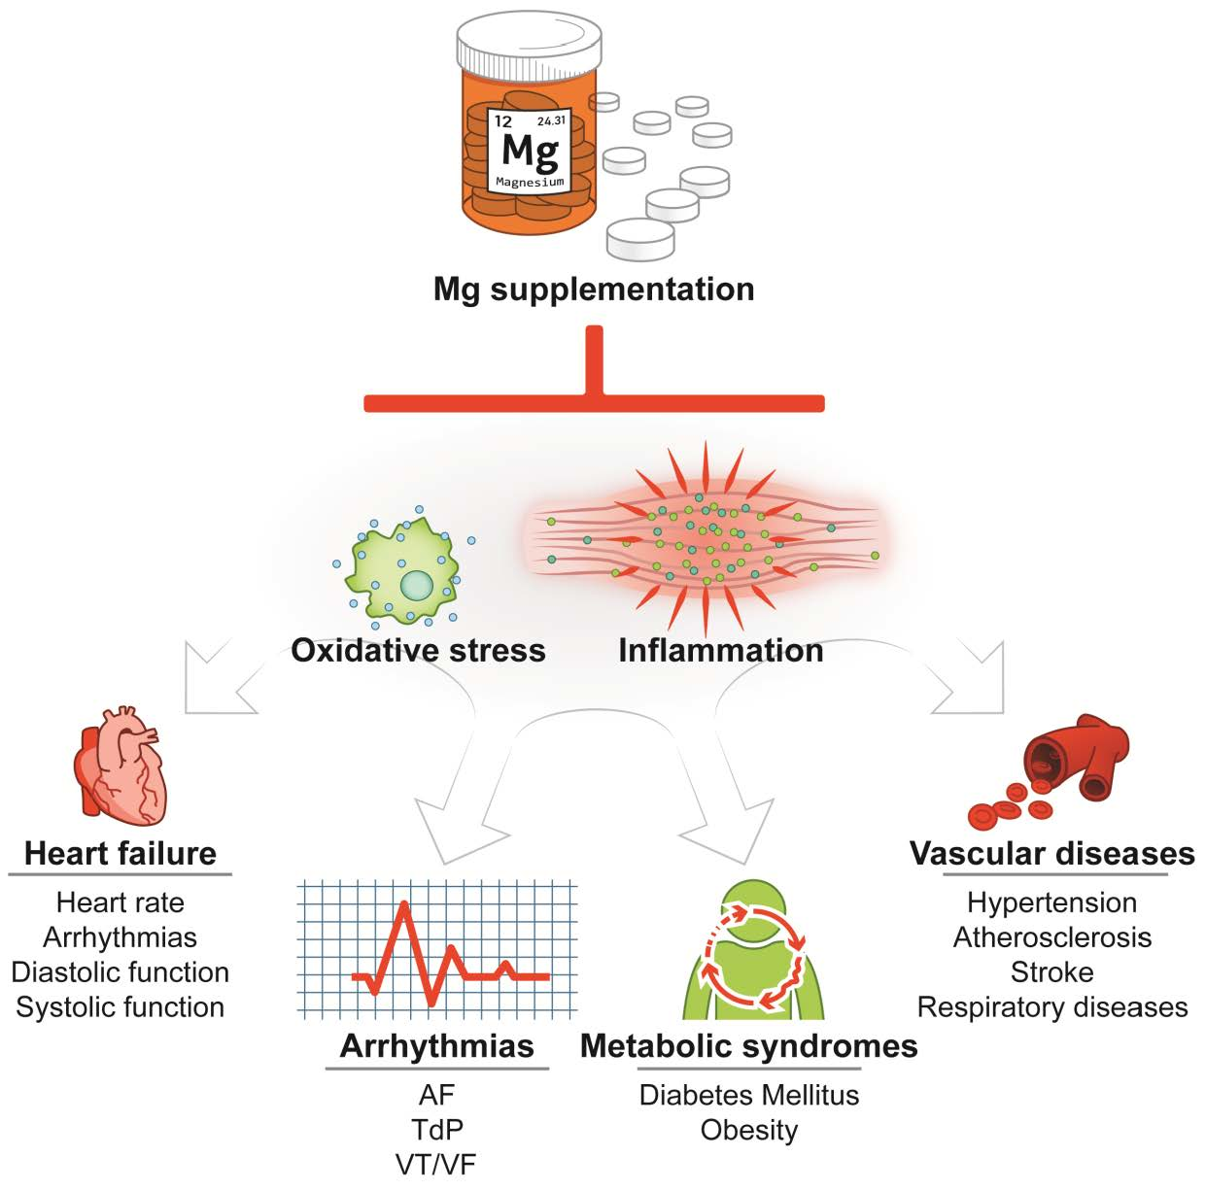
Figure(4)Magnesium and health heart

-Osteoporosis
Osteoporosis is disease defined by absence of bone mass resulting from significant deterioration of bone structure (72). Physiologically, bone remodeling occurs continuously During the sequential interactions between cells that mainly contribute to bone resorption .osteoblasts include mineralization and bone fashioning. Osteoporosis is caused by Disequilibrium between resorption and bone precipitation. This leads to loss of bone mass in the future and, consequently, an increased risk of fractures, particularly spine fractures and hip, which are linked by severe ache and efforts , impairment, until death. (73,74)
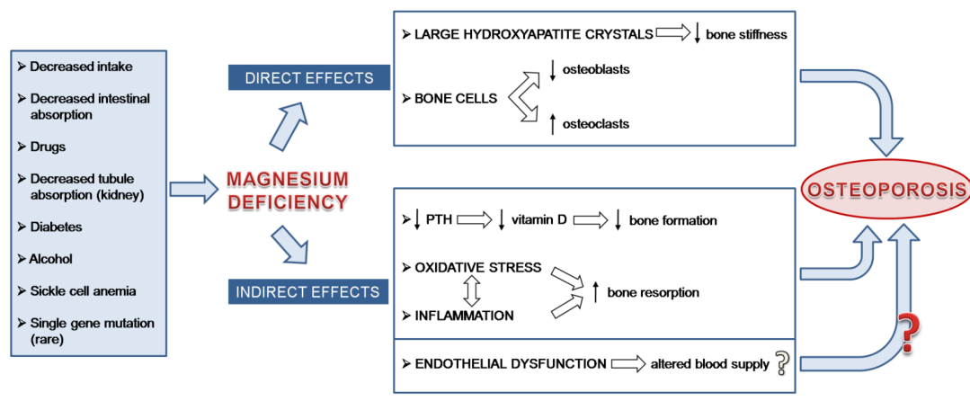
Figure(5) Magnesium deficiency and Osteoporosis
The skeleton contains 60% of the total magnesium, with a third of the magnesium being present in the hydroxyapatite surface of cortical bone, or in the moistening layer close to the crystal (75). It maintains the physiological concentrations of cations outside the cell. acts as a reservoir for exchangeable magnesium (76). Bone surface magnesium levels are correlated with serum Mg concentration. Surface magnesium levels increase with magnesium supplementation in chronic kidney disease (77). Most magnesium is likely deposited in bone as part of apatite crystals and is released after bone resorption. This element plays a Structural function in crystals and is necessary for. Intracellular magnesium is necessary for many physiological processes. initial, it forms the basis for ATP, the primary energy total living cells, guaranty osteoblasts and osteoclasts source in cells. It also serves as a cofactor for hundreds of enzymes participatory in the synthesis of lipids, nucleic acids, proteins. Due to its positive charge, magnesium hold down cell membranes. It as well acts against calcium (9) and acts as a signal converter (78,79). Therefore, It is not unexpected that changing magnesium balance influences cell and tissue function (80).

Mechanisms describing the effects of magnesium deficiency on bones include:
(i) Low magnesium can have a direct effect bones by changing constructing of apatite crystals and, consequently, bone cells. The women with osteoporosis who possess been shown to be magnesium deficient have bigger and finer organized crystals in spongy bone compared to controls, whereas In women who use hormone replacement therapy, magnesium levels in bones are increased and associated with a lower crystal index (81). That is, when the crystals are large, the bones are unable to bear normal loads.
(ii) There exists a connection between magnesium deficiency and low parathyroid hormone levels, as well as between internal organ resistance to parathyroid hormone and low vitamin D (82,83). Interestingly, many postmenopausal women with vitamin D deficiency and parathyroid hormone deficiency also suffer from magnesium deficiency, and magnesium supplements correct these biochemical abnormalities (84). Furthermore, magnesium supplements in children with magnesium deficiency and diabetes modify 1,25(OH)2-vitamin D levels (85).
(iii) Magnesium deficiency is associated with mild inflammation (86,87), and inflammatory cytokines incentivize bone remodeling and osteoporosis (88).
(iv) Magnesium lack leads to Disorder dysfunction (89), and endothelial health is important for bone health (90). Therefore, it can be speculated that osteoporosis can be regarded a vascular disease affecting bone.
(v) There is guide that adults who follow a Western diet develop littal-grade acidity, that increases with age. In recent years, it has been proposed that the increased acidity of this diet plays a pathophysiological role in osteoporosis. Metabolic acids have been shown to decalcify bone, thereby inhibiting osteoblast function, stimulating osteoclast function, and impairing bone mineralization (91). A neutral diet get better bone structure and bone mineral content (92). The effects of magnesium on the skeleton are owing to ability act as a barrier against the acidmanufacture, in a Western-style dietb (93).
There is proof that magnesium has skeletal benefits. A study in Women's Health indicated that postmenopausal women with low magnesium intake had a higher incidence of carpus fractures (94). These findings are consistent with some statement showing that low magnesium levels may interfere with bone metabolism and parathyroid job, thus convey impaired bone mineralization.

Conversely, height magnesium levels in bone inhibit the formation of hydroxyapatite crystals by contest with calcium and tieing to pyrophosphate to shape a soluble salt that is not hydrolyzed by enzymes (95). This condition contributes to renal skeletal dysplasia and enervated bone disease (96). Serum magnesium levels are frequently elevated and are associated with mineralization defects in individuals undergoing dialysis and in patients with chronic renal failure. (97). Other interesting subject have examined preterm baby with osteoporosis secondary to mothers who had preterm births (98,99,100). Because Mg is an antagonist of calcium (101), excessive Mg concentrations alter the calcium/Mg ratio, thus impairing cell function and causing osteocyte differentiation and mineralization (102).
In general, optimal magnesium levels may be necessary to ensure bone homeostasis. Therefore, further studies are needed on the effects of in vitro and in vivo magnesium focus on bone metabolism and formation to give guidance for proper nutrition and the appropriate use of magnesium supplements (103,104).
Conclusion
This research paper focuses on magnesium, highlighting its importance to the body and explaining that both excess and deficiency can cause various health problems, as can levels exceeding the normal range.

Disclaimer (Artificial intelligence)
Option 1:
Author(s) hereby declare that NO generative AI technologies such as Large Language Models (ChatGPT, COPILOT, etc.) and text-to-image generators have been used during the writing or editing of this manuscript.
Option 2:
Author(s) hereby declare that generative AI technologies such as Large Language Models, etc. have been used during the writing or editing of manuscripts. This explanation will include the name, version, model, and source of the generative AI technology and as well as all input prompts provided to the generative AI technology
Details of the AI usage are given below:
1. Option 1:
NO generative AI technologies such as Large Language Models (ChatGPT, COPILOT, etc.) and text-to-image generators have been used during the writing or editing of this manuscript
2.
3.

References
1-Romani, A.M. Cellular magnesium homeostasis. Arch. Biochem. Biophys. (2011), 512, 1–23.
2-De Baaij, J.H.F.; Hoenderop, J.G.J.; Bindels, R.J.M. Magnesium in Man: Implications for Health and Disease. Physiol. Rev. (2015), 95, 1–46.

3- Ismail Y, Ismail AA, Ismail AAA .The underestimated problem of
using serum magnesium measurements to exclude magnesium deficiency
in adults; a health warning is needed for “normal” results. Clin Chem Lab
Med.(2010), 48: 323-327.
4- Emmanuel A. Adomako and Alan S.L. Yu, Magnesium Disorders: Core Curriculum , Vol 83 | Iss 6 | June 2024.
5-Cakmak, I. Magnesium in crop production, food quality and human health. Crop and Pasture Science.(2015), v. 66, n. 12, p. i–ii, DOI: 10.1071/CPv66n12
6-CAKMAK, I.; KIRKBY, E. A. Role of magnesium in carbon partitioning and alleviating photooxidative damage. Physiologia Plantarum.(2008), v. 133, n. 4, p. 692-704, DOI: 10.1111/j.1399-3054.2007.01042.x.
7-CAKMAK, I.; MARSCHNER, H. Magnesium deficiency and high light intensity enhance activities of superoxide dismutase, ascorbate peroxidase, and glutathione reductase in bean leaves. Plant Physiology. (1992), v. 98, n. 4, p. 1222-1227. DOI: 10.1104/pp.98.4.1222.
8- CAKMAK, I.; YAZICI, A. M. Magnesium: a forgotten element in crop production. Better Crops with Plant Food.(2010), v. 94, n. 2, p. 23-25.
9- Lenz, H. N., Dombinov, V., Dreistein, J., Reinhard, M. R., Gebert, M., and Knoop, V. Magnesium deficiency phenotypes upon multiple knockout of Arabidopsis thaliana MRS2 clade B genes can be ameliorated by concomitantly reduced calcium supply. Plant Cell Physiol. (2013),54, 1118–1131. doi: 10.1093/pcp/pct062.
10- Mengutay, M., Ceylan, Y., Kutman, U.B. and Cakmak, I: Adequate magnesium nutrition mitigates adverse effects of heat stress on maize and wheat. Plant Soil.(2013), 368:57–72.
11-Parikh M, Webb ST. Cations: potassium, calcium, and magnesium. Continuing Education in Anaesthesia, Critical Care & Pain. (2012), May 2:mks020.
12- Rossiter D. Editor. South African Medicines Formulary (SAMF). 9th ed. Cape Town: Health and Medical Publishing Group,( 2010).
13- Saris NE, Mervaala E, Karppanen H, Khawaja JA, Lewenstam A. Magnesium: an update on physiological, clinical and analytical aspects. Clinica chimica acta. (2000), Apr 30;294(1):1-26.
14- Linus Pauling Institute. Micronutrient Information Center: Magnesium [homepage on the internet] c2016. Available from: http://lpi.oregonstate.edu/mic/minerals/magnesium Accessed on 23rd of March (2016).
15- Gröber U, Schmidt J, Kisters K. Magnesium in Prevention and Therapy. Nutrients.( 2015) Sep 23;7(9):8199-226. 8. Long S, Romani AM. Role of cellular magnesium in human diseases. Austin journal of nutrition and food sciences.
( 2014) Nov 18;2(10).
16- Masoli M, Fabian D, Holt S, Beasley R. Global Initiative for Asthma (GINA) Program. The global burden of asthma: executive summary of the GINA dissemination committee report. Allergy. (2004), 59: 469-78.
17- Bayram I, Güneşer-Kendirli S, Yilmaz M, Altintaş DU, Alparslan N, Bingöl-Karakoç G. The prevalence of asthma and allergic diseases in children of school age in Adana in southern Turkey. Turk J Pediatr .(2004), 46: 221-5.
18- Saraçlar Y, Sekerel BE, Kalayci O, Cetinkaya F, Adalioğlu G, Tuncer A. Prevalence of asthma symptoms in school children in Ankara, Turkey. Respir Med. (1998), 92: 203-7.
19- Ece A, Ceylan A, Saraçlar Y, Saka G, Gürkan F, Haspolat K. Prevalence of asthma and other allergic disorders among schoolchildren in Diyarbakir, Turkey. Turk J Pediatr .(2001), 43: 286-92.
20 Ghizal Fatima , Andrej Dzupina , Hekmat B Alhmadi , Aminat Magomedova , Zainab Siddiqui , Ammar Mehdi , Najah Hadi 13, 2024) Magnesium Matters: A Comprehensive Review of Its Vital Role in Health and
Diseases. Cureus13,2024, 16(10): e71392. DOI 10.7759/cureus.713921.,
21- De Valk HW, Kok PT, Struyvenberg A, van Rijn HJ, Haalboom JR, Kreukniet J,. Extracellular and intracellular magnesium concentrations in asthmatic patients. Eur Respir J.( 1993); 6: 1122-5.
22-Falkner D, Glauser J, Allen M. Serum magnesium levels in asthmatic patients during acute exacerbations of asthma. Am J Emerg Med (1992); 10: 1-3.
23-Gönlügür U, Erdoğan İ, Özdemir L, Akkurt İ, Aker A. Electrolyte disturbances in exacerbations of asthma and COPD. İzmir Chest Hospital Journal (2003); 17: 7-10.
24- Deveci F, Turgut T, Kırkıl G, Muz MH. Electrolyte levels in patients with chronic stable asthma. Solunum( 2003); 5: 93-9.
25-Britton J, Pavord I, Richards K, Wisniewski A, Knox A, Lewis S, Tattersfield A, Weiss S. Dietary magnesium, lung function, wheezing, and airway hyperreactivity in a random adult population sample. Lancet. (1994),344:357–362. doi: 10.1016/s0140-6736(94)91399-4.
26-McLean RM. Magnesium and its therapeutic uses: a review. Am J Med. (1994),96:63–76. doi: 10.1016/0002-9343(94)90117-1.
27-Kazaks AG, Uriu-Adams JY, Albertson TE, Shenoy SF, Stern JS. Effect of oral magnesium supplementation on measures of airway resistance and subjective assessment of asthma control and quality of life in men and women with mild to moderate asthma: a randomized placebo controlled trial. J Asthma.( 2010),47:
83–92.
28-Gontijo-Amaral C, Ribeiro MA, Gontijo LS, Condino-Neto A, Ribeiro JD. Oral magnesium supplementation in asthmatic children: a double-blind randomized placebo-controlled trial. Eur J Clin Nutr. (2007),61:54–60. doi: 10.1038/sj.ejcn.1602475.
29-Zervas E, Papatheodorou G, Psathakis K, Panagou P, Georgatou N, Loukides S. Reduced intracellular Mg concentrations in patients with acute asthma. Chest. (2003),123:113–118. doi: 10.1378/chest.123.1.113.
30-Jacka FN, Overland S, Stewart R, Tell GS, Bjelland I, Mykletun A. Association between magnesium intake and depression and anxiety in community-dwelling adults: the Hordaland Health Study. Aust N Z J Psychiatry.( 2009), 43(1):45–52.
31-Huang JH, Lu YF, Cheng FC, Lee JN, Tsai LC. Correlation of magnesium intake with metabolic parameters, depression and physical activity in elderly type 2 diabetes patients: a cross-sectional study. Nutrition J. (2012), 11(1):41.
32- Tarleton EK, Littenberg B. Magnesium intake and depression in adults. J Am Board Fam Med.( 2015), 28 (2):249–56
33-Yary T, Lehto SM, Tolmunen T, Tuomainen T-P, Kauhanen J, Voutilainen S, et al. Dietary magnesium intake and the incidence of depression: a 20-year follow-u-p study. J Affect Disord.( 2016), 193:94–8.
34- Eby GA, Eby KL. Rapid recovery from major depression using magnesium treatment. Med Hypotheses. (2006), 67(2):362–70. https://doi.org/https://doi.org/10.1016/j.mehy.
35- Derom ML, Martinez-Gonzalez MA, Sayon-Orea Mdel C, Bes-Rastrollo M, Beunza JJ, Sanchez-Villegas A. Magnesium intake is not related to depression risk in Spanish university graduates. J Nutrition. (2012), 142(6):1053–9.
36-Barragan-Rodriguez L, Rodriguez-Moran M, Guerrero-Romero F. Efficacy and safety of oral magnesium supplementation in the treatment of depression in the elderly with type 2 diabetes: a randomized, equivalent trial. Magnes Res. (2008), 21(4):218–23.
37- Jelicks LA, Gupta RK. Intracellular free magnesium and high energy phosphates in the perfused normotensive and spontaneously hypertensive rat heart. A 31P NMR study. Am J Hypertens. (1991),4(2 pt 1):131–136.
38- Mizushima S, Cappuccio FP, Nichols R, Elliott P. Dietary magnesium intake and blood pressure: a qualitative overview of the observational studies. J Hum Hypertens. (1998),12:447–453.
39- Fuchs, F. D., and Whelton, P. K. High blood pressure and cardiovascular disease. Hypertension.(2020), 75, 285–292.
40-Gamboa, A., Shibao, C., Diedrich, A., Choi, L., Pohar, B., Jordan, J., Contribution of endothelial nitric oxide to blood pressure in humans. Hypertension.(2007), 49, 170–177.
41-Gröber, U.; Schmidt, J.; Kisters, K. Magnesium in prevention and therapy. Nutrients.( 2015), 7, 8199–8226.
42-Blackfan, K.; Hamilton, B. Uremia in acute glomerular nephritis: The cause and treatment in children. Med. Surg. J. (1925), 193, 617–628
43-Resnick, L.M.; Laragh, J.H.; Sealey, J.E.; Alderman, M.H. Divalent cations in essential hypertension. relations between serum ionized calcium, magnesium, and plasma renin activity. N. Engl. J. Med. (1983), 309, 888–891.
44-Dong J. Y., Xun P., He K., et al. Magnesium intake and risk of type 2 diabetes: meta-analysis of prospective cohort studies. Diabetes Care.( 2011), 34(9): 2116-2122.
45- WA E. LDerawi, Naser I. A., Taleb M. H., et al. The Effects of Oral Magnesium Supplementation on Glycemic Response among Type 2 Diabetes Patients. Nutrients. (2018), 11(1): 44.
46- Prevention. Centers for Disease Control and. All About Your A1C. (2021). www.cdc.gov/diabetes/basics/type2.html.
47- Swaminathan R. Magnesium metabolism and its disorders. Clin Biochem Rev. (2003), 24(2): 47-66.
48-Solati M., Ouspid E., Hosseini S., et al. Oral magnesium supplementation in type II diabetic patients. Med J Islam Repub Iran. (2014), 28: 67.
49- Navarrete-Cortes A., Ble-Castillo J. L., Guerrero-Romero F., No effect of magnesium supplementation on metabolic control and insulin sensitivity in type 2 diabetic patients with normomagnesemia. Magnes Res.( 2014), 27(2): 48-56.
50- Sadeghian Mehdi, Azadbakht Leila, Khalili Noushin, Oral Magnesium Supplementation Improved Lipid Profile but Increased Insulin Resistance in Patients with Diabetic Nephropathy: a Double-Blind Randomized Controlled Clinical Trial. Biological Trace Element Research.( 2020), 193(1): 23-35.
51- Shahbah D., Hassan T., Morsy S., et al. Oral magnesium supplementation improves glycemic control and lipid profile in children with type 1 diabetes and hypomagnesaemia. Medicine (Baltimore).( 2017), 96(11): e6352.
52- Guerrero-Romero F., Simental-Mendía L. E., Hernández-Ronquillo G., Oral magnesium supplementation improves glycaemic status in subjects with prediabetes and hypomagnesaemia: A double-blind placebo-controlled randomized trial. Diabetes Metab.( 2015), 41(3): 202-207.
53 -Mooren F. C., Krüger K., Völker K.,. Oral magnesium supplementation reduces insulin resistance in non-diabetic subjects - a double-blind, placebo-controlled, randomized trial. Diabetes Obes Metab. (2011), 13(3): 281-284 .
54- Günther T. Magnesium in bone and the magnesium load test. Magnes Res. (2011); 24: 223-224
55- Barbagallo M, Dominguez LJ, Galioto A, Ferlisi A, Cani C, Malfa L, Pineo A, Busardo’ A, Paolisso G. Role of magnesium in insulin action, diabetes and cardio-metabolic syndrome X. Mol Aspects Med.( 2003), 24: 39-52
56- Kao WH, Folsom AR, Nieto FJ, Mo JP, Watson RL, Brancati FL. Serum and dietary magnesium and the risk for type 2 diabetes mellitus: the Atherosclerosis Risk in Communities Study. Arch Intern Med .(1999), 159: 2151-2159
57C-T Lee 1, Y-H H Lien, L-W Lai, J-B Chen, C-R Lin, H-C Chen, Increased renal calcium and magnesium transporter abundance in streptozotocin-induced diabetes mellitus, 2006 May;69(10):1786-91. doi: 10.1038/sj.ki.5000344.
58- Djurhuus MS, Skøtt P, Hother-Nielson O, Klitgaard NA, BeckNielsen H. Insulin increases renal magnesium excretion: a possible cause of magnesium depletion in hyperinsulinaemic states. Diabet Med (1995),12: 664-669
59- Lee CT, Lien YH, Lai LW, Chen JB, Lin CR, Chen HC. Increased renal calcium and magnesium transporter abundance in streptozotocin-induced diabetes mellitus. Kidney Int. (2006), 69: 1786-1791
60- Saris NE, Mervaala E, Karppanen H, Khawaja JA, Lewenstam A. Magnesium. An update on physiological, clinical and analytical aspects. Clin Chim Act. (2000), 294: 1-26
61- Weglicki WB. Hypomagnesemia and inflammation: clinical and basic aspects. Annu Rev Nutr. (2012),32: 55-71
62- Barbagallo M, Dominguez LJ. Magnesium and aging. Curr Pharm Des. (2010), 16: 832-839.
63- Purvis JR, Movahed A. Magnesium disorders and cardiovascular diseases. Clin Cardiol .(1992),15:556–68. 10.1002/clc.4960150804
64 D.Fiorentini , C. Cappadone , G. Farruggia , C. Prata, Magnesium: Biochemistry, Nutrition, Detection, and Social Impact of Diseases Linked to Its Deficiency, 2021 Mar 30;13(4):1136. doi: 10.3390/nu13041136
65- B. Cordeiro , C. Fontes , J.Meyer-Fernandes, Molecular Basis of Na, K–ATPase Regulation of Diseases: Hormone and FXYD2 Interactions, 2024, 25(24), 13398; https://doi.org/10.3390/ijms252413398
66-Hans-Jürgen Apell 1, Tanja Hitzler 1, Grischa Schreiber, Modulation of the Na,K-ATPase by Magnesium Ions, 2017 Feb 21;56(7):1005-1016. doi: 10.1021
67- Weglicki WB, Phillips TM. Pathobiology of magnesium deficiency: a cytokine/neurogenic inflammation hypothesis. Am J Physiol .(1992),263:R734–R737. 10.1152/ajpregu.
68- Marier JR. Magnesium content of the food supply in the modern-day world. Magnesium .(1986),5:1–8.
69- Lichton IJ. Dietary intake levels and requirements of Mg and Ca for different segments of the U.S. population. Magnesium .(1989),8:117–23.
70-Mazur A, Maier JA, Rock E, et al. Magnesium and the inflammatory response: potential physiopathological implications. Arch Biochem Biophys.( 2007),458:48–56.
71- Whang R, Ryder KW. Frequency of hypomagnesemia and hypermagnesemia. Requested vs routine. JAMA .(1990),263:3063–4
72- Rachner, T.D.; Khosla, S.; Hofbauer, L.C. Osteoporosis: Now and the future. Lancet. (2011), 377, 1276–1287.
73-Nieves, J.W. Osteoporosis: The role of micronutrients. Am. J. Clin. Nutr.( 2005), 81, 1232S–1239S.
74- Ström, O.; Borgström, F.; Kanis, J.A.; Compston, J.; Cooper, C.; McCloskey, E.V.; Jönsson, B. Osteoporosis: Burden, health care provision and opportunities in the EU: A report prepared in collaboration with the International Osteoporosis Foundation (IOF) and the European Federation of Pharmaceutical Industry Associations (EFPIA). Arch.Osteoporos. (2011), 6, 59–155
75-Jahnen-Dechent, W.; Ketteler, M. Magnesium basics. Clin. Kidney J. (2012), 5, i3–i14.
76-Alfrey, A.C.; Miller, N.L. Bone magnesium pools in uremia. J. Clin. Investig. (1973), 52, 3019–3027.
77-Cunningham, J.; Rodriguez, M.; Messa, P. Magnesium in chronic kidney disease Stages 3 and 4 and in dialysis patients. Clin. Kidney J. (2012), 5, i39–i51.
78-Iseri, L.T.; French, J.H. Magnesium: Nature’s physiologic calcium blocker. Am. Heart J. (1984), 108, 188–193.
79-Li, F.Y.; Chaigne-Delalande, B.; Kanellopoulou, C.; Davis, J.C.; Matthews, H.F.; Douek, D.C.; Cohen, J.I.; Uzel, G.; Su, H.C.; Lenardo, M.J. Second messenger role for Mg²⁺ revealed by human T-cell immunodeficiency. Nature.( 2011), 475, 471–476.
80-Rude, R.K.; Singer, F.R.; Gruber, H.E. Skeletal and hormonal effects of magnesium deficiency. J. Am. Coll.Nutr. (2009), 28, 131–141.
81-Matias, C.N.; Santos, D.A.; Monteiro, C.P.; Vasco, A.M.; Baptista, F.; Sardinha, L.B.; Laires, M.J.; Silva, A.M. Magnesium intake mediates the association between bone mineral density and lean soft tissue in elite swimmers. Magnes. Res. (2012), 25, 120–125.
82-Cohen, L.; Kitzes, R. Infrared spectroscopy and magnesium content of bone mineral in osteoporotic women. Isr. J. Med. Sci. (1981), 17, 1123–1125.
83-Rude, R.K.; Adams, J.S.; Ryzen, E.; Endres, D.B.; Niimi, H.; Horst, R.L.; Haddad, J.G.; Singer, F.R. Low serum concentrations of 1,25-dihydroxyvitamin D in human magnesium deficiency. J. Clin. Endocrinol. Metab. (1985), 61, 933–940.
84-Sahota, O.; Mundey, M.K.; San, P.; Godber, I.M.; Hosking, D.J. Vitamin D insufficiency and the blunted PTH response in established osteoporosis: The role of magnesium deficiency. Osteoporos. Int. (2006), 17, 1013–1021.
85-Saggese, G.; Federico, G.; Bertelloni, S.; Baroncelli, G.I.; Calisti, L. Hypomagnesemia and the parathyroid hormone-vitamin D endocrine system in children with insulin-dependent diabetes mellitus: Effects of Mg administration. J. Pediatr. (1991), 118, 220–225.
86-Maier, J.A. Endothelial cells and magnesium: Implications in atherosclerosis. Clin. Sci. Lond. ( 2012), 122, 397–407.
87-Warburton, D.E.; Nicol, C.W.; Gatto, S.N.; Bredin, S.S. Cardiovascular disease and osteoporosis: Balancing risk management. Vasc. Health Risk Manag. (2007), 3, 673–689.
88-Arnett, T.R. Extracellular pH regulates bone cell function. J. Nutr. (2008), 138, 415S–418S.
89-Jehle, S.; Hulter, H.N.; Krapf, R. Effect of potassium citrate on bone density, microarchitecture, and fracture risk in healthy older adults without osteoporosis: A randomized controlled trial. J. Clin. Endocrinol. Metab. (2013), 98, 207–217.

90-Weng, L.; Webster, T.J. Nanostructured magnesium has fewer detrimental effects on osteoblast function. Int. J. Nanomed. (2013), 8, 1773–1781.

91-Navarro-González, J.F.; Mora-Fernández, C.; García-Pérez, J. Clinical implications of disordered magnesium homeostasis in chronic renal failure and dialysis. Semin. Dial.( 2009), 22, 37–44.
92-Yokoyama, K.; Takahashi, N.; Yada, Y.; Yasunori, K.; Kawamata, R.; Uehara, R.; Kono, Y.; Honma, Y.; Momoi, M.Y. Prolonged maternal magnesium administration and bone metabolism in neonates. Early Hum. Dev. (2010), 86, 187–191.
93-Kaplan, W.; Haymond, M.W.; Karaviti, L.P. Osteopenic effects of MgSO4 in multiple pregnancies. J. Pediatr. Endocrinol. Metab. (2006), 19, 1225–1230.
94-Leidi, M.; Dellera, F.; Mariotti, M.; Maier, J.A. High magnesium inhibits human osteoblast differentiation in vitro. Magnes. Res. (2011), 24, 1–6.

95-Song, C.H.; Barrett-Connor, E.; Chung, J.H.; Kim, S.H.; Kim, K.S. Associations of calcium and magnesium in serum and hair with bone mineral density in premenopausal women. Biol. Trace Elem. Res. (2007), 118, 1–9.

96-Clevers, H. Wnt/beta-catenin signaling in development and disease. Cell. (2006), 127, 469–480.

97-Albisetti, W.; Giarratana, L.S.; Viganò, C.; Castiglioni, S.; Maier, J.A. Sclerostin: A novel player regulating bone mass in inflammation? Eur. J. Inflamm. (2013). in press.

98-Yang, C.; Yuan, G.; Zhang, J.; Tang, Z.; Zhang, X.; Dai, K. Effects of magnesium alloys extracts on adult human bone marrow-derived stromal cell viability and osteogenic differentiation. Biomed. Mater.( 2010), 5.

99-Bonewald, L.F. The amazing osteocyte. J. BoneMiner. Res. (2011), 26, 229–238.

100-Cunningham, J.; Rodriguez, M.; Messa, P. Magnesium in chronic kidney disease Stages 3 and 4 and in dialysis patients. Clin. Kidney J. (2012), 5, i39–i51.

101-Iseri, L.T.; French, J.H. Magnesium: Nature’s physiologic calcium blocker. Am. Heart J. (1984), 108, 188–193.

102-Li, F.Y.; Chaigne-Delalande, B.; Kanellopoulou, C.; Davis, J.C.; Matthews, H.F.; Douek, D.C.; Cohen, J.I.; Uzel, G.; Su, H.C.; Lenardo, M.J. Second messenger role for Mg2+ revealed by human T-cell immunodeficiency. Nature. (2011), 475, 471–476.

103-Rude, R.K.; Singer, F.R.; Gruber, H.E. Skeletal and hormonal effects of magnesium deficiency. J. Am. Coll.Nutr. (2009), 28, 131–141.

104- D.Fiorentini,C. Cappadone,G. Farruggia ,C. Prata, Magnesium: Biochemistry, Nutrition, Detection, and Social Impact of Diseases Linked to Its Deficiency, , 2021, 13(4), 1136; https://doi.org/10.3390/nu13041136

