Original Research Article
Hydrochemical Characterisation and Health-Risk Assessment of Drinking Water Sources in Brass Island, Bayelsa State, Nigeria
Abstract
This study evaluates the hydrochemical characteristics and trace-metal contamination of drinking-water sources in Brass Island, Bayelsa State, Nigeria, and assesses their potential health implications. Twelve water samples were collected from boreholes, hand-dug wells, and surface waters during the dry season and analysed for physicochemical parameters, major ions, and trace metals (Fe, Mn, Zn, Pb, Cu, and Cd) following standard APHA (2017) procedures. In situ measurements of pH, temperature, electrical conductivity (EC), and total dissolved solids (TDS) were conducted using a multi-parameter meter, while trace metals were quantified using atomic-absorption spectrophotometry (AAS). The results showed slightly acidic pH values (5.2–6.4) and moderate mineralisation, with EC (210–540 µS cm⁻¹) and TDS (125–315 mg L⁻¹) within WHO (2017) limits. Major ions revealed low hardness (Ca²⁺ = 12.4–32.1 mg L⁻¹; Mg²⁺ = 5.2–15.8 mg L⁻¹) and mild marine influence (Cl⁻ = 20.5–58.3 mg L⁻¹; SO₄²⁻ = 6.3–19.7 mg L⁻¹). Nitrate concentrations (3.4–21.6 mg L⁻¹) suggested limited anthropogenic enrichment from wastewater and agricultural runoff. Trace-metal analysis indicated that Fe (0.21–1.24 mg L⁻¹) and Pb (0.002–0.042 mg L⁻¹) exceeded guideline limits in some samples, whereas Mn, Zn, Cu, and Cd generally remained within safe ranges. Health-risk assessment using the USEPA (2010) model showed that the cumulative Hazard Index (HI) for adults (0.76) was within the safe threshold (<1), but that for children (1.28) indicated potential non-carcinogenic risk, primarily from Pb and Cd exposure. The study concludes that while the overall water quality in Brass Island is moderate, localised contamination from corroded pipelines, saline intrusion, and oil-related activities poses a long-term health concern. Continuous monitoring, land-use mapping, corrosion-resistant infrastructure, and community-level water treatment are recommended to safeguard public health and ensure sustainable water management in this coastal environment.
Keywords: Hydrochemical assessment, Trace metals, Health risk, Drinking water quality, Niger Delta
1.0 Introduction
Water is one of the most essential natural resources required for the sustenance of all forms of life. However, increasing industrialisation, agricultural intensification, and urban expansion have resulted in significant degradation of water quality across many parts of the world, especially in developing regions (Etesin et al., 2013). In the Niger Delta region of Nigeria, extensive oil exploration and gas flaring activities have caused widespread contamination of surface and groundwater, raising serious public health and environmental concerns (Nkeeh et al., 2016). The region’s complex hydrology, coupled with its proximity to coastal and estuarine systems, increases the vulnerability of local water sources to pollution from both natural and anthropogenic processes.
Brass Island, located in Bayelsa State, is one of the major oil-producing communities in the Niger Delta. It is surrounded by creeks, rivers, and mangrove ecosystems that serve as vital water sources for domestic and agricultural purposes. Despite its economic significance, Brass Island faces increasing water quality challenges due to oil spills, gas flaring, and poor waste management practices (Ezekwe et al., 2018). Hydrochemical parameters such as pH, electrical conductivity (EC), total dissolved solids (TDS), and concentrations of major cations and anions provide vital information on the suitability of water for consumption and its potential contamination sources (Ekpe et al., 2025).
In addition to hydrochemical alterations, heavy metal contamination poses a major threat to water safety. Metals such as lead (Pb), cadmium (Cd), mercury (Hg), and arsenic (As) are persistent pollutants that do not degrade and can accumulate in aquatic systems and human tissues, leading to chronic toxicity (Dalman et al., 2006). The health effects associated with heavy metals include neurological disorders, kidney dysfunction, cardiovascular diseases, and developmental impairments (Adedokun et al., 2016). Previous studies in similar Niger Delta environments have reported elevated levels of these metals in water and sediments due to oil-related activities (Okpoji et al., 2025).
The hydrochemical and toxicological assessment of drinking water from Brass Island is therefore essential to determine its quality status, identify potential sources of contamination, and evaluate associated health risks. Such assessment provides baseline data for environmental management, supports the development of mitigation strategies, and ensures compliance with international standards such as those of the World Health Organisation (WHO, 2017) and the Food and Agriculture Organisation (FAO/WHO, 2001).
This study was designed to evaluate the hydrochemical characteristics and heavy metal concentrations in drinking water sources in Brass Island, Bayelsa State. It aims to assess the extent of contamination, determine compliance with established regulatory limits, and estimate the potential health risks associated with the consumption of these water sources.

2.0 Literature Review
2.1 Overview of Hydrochemical Characteristics of Drinking Water
Hydrochemical assessment provides essential information on the composition and quality of water resources, reflecting both natural geological influences and anthropogenic impacts (Etesin, Udoinyang, & Harry, 2013). Groundwater and surface water systems in the Niger Delta are often influenced by the dissolution of minerals, saline intrusion, and contamination from oil exploration and industrial waste discharge (Nkeeh et al., 2016). The pH, electrical conductivity, total dissolved solids, and major ions such as chloride, sulphate, and bicarbonate serve as important indicators of the chemical stability and potability of water (Ekpe et al., 2025). These parameters determine the suitability of water for domestic and agricultural uses, with deviations suggesting contamination or alteration of the natural hydrochemical balance.
2.2 Heavy Metal Contamination in Water Systems
Heavy metal pollution remains a major concern in aquatic environments due to its toxicity, persistence, and bioaccumulation potential (Dalman et al., 2006). Metals such as lead (Pb), cadmium (Cd), mercury (Hg), and arsenic (As) are non-biodegradable and can accumulate in sediments, aquatic organisms, and human tissues (Cogun, Yezererogluja, Gulf, & Karrgin, 2006). Elevated concentrations of these metals in water bodies are often associated with industrial emissions, crude oil exploitation, pipeline corrosion, and waste disposal activities common in the Niger Delta (Okpoji et al., 2025). Lead exposure is particularly harmful, causing neurological and developmental disorders in children, while cadmium and mercury can impair kidney and liver functions (Adedokun et al., 2016; Okpoji et al., 2025). Continuous monitoring is therefore necessary to identify pollution sources and mitigate public health risks.
2.3 Health Risk Implications of Heavy Metals in Drinking Water
Human exposure to heavy metals through drinking water occurs primarily via ingestion, leading to both carcinogenic and non-carcinogenic effects depending on the concentration and duration of exposure (FAO/WHO, 2001; USEPA, 2010). Risk assessments often use the Hazard Quotient (HQ) and Hazard Index (HI) to evaluate potential health threats from heavy metal intake. An HI greater than 1 indicates potential adverse health effects, particularly in sensitive groups such as children and pregnant women (Jan et al., 2010). Previous studies conducted across Nigeria have revealed that prolonged consumption of water contaminated with heavy metals can result in bioaccumulation and chronic health conditions (Sanyaolu et al., 2022; Ubong et al., 2023). The results from similar studies in other parts of the Niger Delta, such as Bonny and Andoni Rivers, have shown comparable contamination patterns and associated health implications (Okpoji et al., 2025).
2.4 Environmental and Anthropogenic Influences on Water Quality
The hydrochemical composition of water sources is greatly affected by anthropogenic activities, including oil and gas operations, agricultural runoff, and poor waste disposal systems (Ezekwe et al. 2018). In Brass Island and surrounding communities, frequent oil spills and gas flaring contribute significantly to heavy metal deposition and acidification of both surface and groundwater (Nsikak & Usoro, 2008). Studies by Okpoji et al. (2025) and Ekwere et al. (2025) demonstrated that industrial discharges and saline intrusion from the Atlantic Ocean alter ionic balance and increase electrical conductivity and total dissolved solids in coastal aquifers. Furthermore, poor sanitation and the absence of centralised water treatment facilities exacerbate contamination, exposing local populations to multiple environmental health hazards.
2.5 Regulatory Standards and Water Safety Guidelines
To safeguard public health, international and national agencies such as the World Health Organisation (WHO) and the Food and Agriculture Organisation (FAO) have established permissible limits for drinking water quality. The WHO (2017) guidelines specify acceptable limits for parameters such as pH (6.5–8.5), total dissolved solids (<500 mg/L), and lead (<0.01 mg/L). FAO/WHO (2001) further emphasised that continuous exceedance of these limits increases the likelihood of long-term health impacts. However, in many developing regions, including parts of the Niger Delta, enforcement of these standards remains inadequate due to weak environmental policies, limited monitoring capacity, and poor infrastructure. Therefore, understanding the hydrochemical and toxicological dynamics of drinking water is crucial for implementing effective water management and pollution control strategies in Brass Island and other oil-producing communities.
3.0 Materials and Methods

3.1 Study Area
Brass Island is a coastal settlement located in Bayelsa State, within the Niger Delta region of southern Nigeria. The area is characterised by extensive mangrove swamps, estuarine creeks, and tidal channels that serve as primary water sources for domestic, agricultural, and industrial use. The island lies along the Atlantic coastline and experiences a humid tropical climate with mean annual rainfall exceeding 2,500 mm. The geology consists mainly of alluvial and deltaic deposits, including sands, silts, and clays, which influence the hydrochemical composition of groundwater and surface waters. Major human activities include crude oil exploration, artisanal fishing, boat transport, and small-scale agriculture, all of which contribute to anthropogenic inputs that can alter local water quality.

3.2 Sampling Design and Sample Collection
A total of twelve (12) water samples were collected from different drinking-water sources—four boreholes, four hand-dug wells, and four surface-water points—strategically distributed across Brass Island. Sampling was carried out during the dry season to minimise dilution from rainfall and tidal inflows. Clean one-litre high-density polyethene bottles were pre-washed with 10% nitric acid (HNO₃), rinsed thoroughly with deionised water, and finally rinsed with the respective sample water before collection. Samples were acidified immediately to pH < 2 with concentrated HNO₃ to prevent metal precipitation and microbial activity, and preserved in ice-packed coolers at approximately 4°C before laboratory analysis.

3.3 In-situ Measurement of Physicochemical Parameters
Field measurements of temperature, pH, electrical conductivity (EC), and total dissolved solids (TDS) were conducted at each site using a portable multi-parameter meter (Hanna HI9813-6). The pH meter was calibrated with standard buffer solutions of pH 4.0, 7.0, and 10.0 before use. Turbidity was determined using a HACH 2100Q portable turbidimeter, while dissolved oxygen (DO) was measured using a Jenway 970 DO meter. For anion analysis, samples were filtered through a 0.45 µm Whatman filter paper to remove suspended particulates.

3.4 Laboratory Analysis of Major Ions
All chemical analyses were performed at the Chemistry Laboratory of Niger Delta University following the procedures of the American Public Health Association (APHA, 2017). Chloride (Cl⁻) and sulphate (SO₄²⁻) were determined by argentometric and turbidimetric methods, respectively. Nitrate (NO₃⁻) and phosphate (PO₄³⁻) were analysed using UV-visible spectrophotometry (Shimadzu UV-1800). Total hardness, calcium (Ca²⁺), and magnesium (Mg²⁺) were determined titrimetrically using ethylenediaminetetraacetic acid (EDTA) as the complexing agent. Sodium (Na⁺) and potassium (K⁺) were measured using a flame photometer (Jenway PFP7).

3.5 Determination of Trace Metals
Trace metal concentrations of iron (Fe), manganese (Mn), zinc (Zn), lead (Pb), copper (Cu), and cadmium (Cd) were determined using Atomic Absorption Spectrophotometry (AAS) (PerkinElmer AAnalyst 400). For each analysis, 100 mL of the preserved water sample was digested with 10 mL of concentrated nitric acid (HNO₃) on a hot plate until the volume was reduced to approximately 25 mL. The digested sample was cooled, filtered through Whatman No. 42 filter paper, and made up to 50 mL with deionised water in a volumetric flask. Calibration curves were prepared using certified standard solutions of each metal, and blank solutions were analysed simultaneously to ensure analytical accuracy.

3.6 Quality Assurance and Quality Control (QA/QC)
Strict QA/QC procedures were maintained throughout the analytical process. All glassware and sampling containers were soaked overnight in 10% HNO₃ and rinsed with deionised water before use. Standard Reference Material (NIST 3232) was used to verify analytical precision and accuracy. Metal recovery values ranged between 95% and 103%, which are within acceptable limits for environmental trace-metal analysis. The limits of detection (LOD) were 0.001 mg/L (Pb), 0.0005 mg/L (Cd), 0.002 mg/L (As), 0.001 mg/L (Hg), 0.003 mg/L (Cu), 0.005 mg/L (Zn), and 0.01 mg/L (Fe, Mn).

3.7 Health-Risk Assessment
Human-health risk was evaluated using the United States Environmental Protection Agency (USEPA, 2010) model for non-carcinogenic exposure through ingestion. The average daily dose (ADD) and hazard quotient (HQ) for each metal were calculated using standard equations:
ADD= $\frac{Cw × IR× EF × ED}{BW × AT}$ ________________ 1
HQ= $\frac{ADD}{RfD}$ __________________________2
where Cw= metal concentration (mg/L), IR = ingestion rate (2 L/day for adults, 1 L/day for children), EF = exposure frequency (365 days/year), ED = exposure duration (30 years for adults, 6 years for children), BW= body weight (70 kg for adults, 15 kg for children), AT = averaging time (ED × 365 days), and RfD = oral reference dose (USEPA values). The Hazard Index (HI), representing cumulative exposure from all trace metals, was obtained as the sum of individual HQ values. Values of HQ or HI greater than 1 indicate potential non-carcinogenic health risk.

3.8 Data Analysis
Descriptive statistics (mean, range, standard deviation) were computed to summarise hydrochemical parameters. The results were compared with the WHO (2017) and FAO/WHO (2001) guideline limits for drinking water quality. Pearson correlation analysis was employed to evaluate relationships among physicochemical and trace-metal parameters, identifying possible contamination sources such as saline intrusion or anthropogenic inputs. Data were presented in tables and interpreted with reference to the hydrogeochemical conditions prevailing in the Brass Island environment.

4.0 Results

4.1 Physicochemical Characteristics of Drinking Water Sources
The physicochemical parameters of drinking water sources in Brass Island are presented in Table 1. The pH values ranged from 5.2 to 6.4, with a mean of 5.8 ± 0.4, indicating slightly acidic conditions across all sampling points. The acidity may be attributed to organic matter decomposition, acid-forming materials, and atmospheric acid deposition. Electrical conductivity (EC) values ranged between 210 and 540 µS/cm, with a mean of 372.5 ± 94.3 µS/cm, which is well within the WHO (2017) permissible limit of 1,500 µS/cm. Total dissolved solids (TDS) ranged from 125 to 315 mg/L, averaging 230 ± 48.7 mg/L, also within the WHO limit of 500 mg/L, indicating moderate mineralisation and limited ionic enrichment. Turbidity values ranged from 2.4 to 9.6 NTU, with a mean of 5.8 ± 2.1 NTU, slightly exceeding the WHO guideline value (5 NTU) in some locations. Temperature values ranged between 27.4°C and 29.6°C, typical of tropical coastal environments, as shown in Figure 1.
Table 1: Physicochemical Properties of Drinking Water Sources in Brass Island
Parameter | Min | Max | Mean ± SD | WHO Limit | Remarks
pH | 5.2 | 6.4 | 5.8 ± 0.4 | 6.5–8.5 | Slightly acidic
Temperature (°C) | 27.4 | 29.6 | 28.5 ± 0.7 | – | Within normal range
Turbidity (NTU) | 2.4 | 9.6 | 5.8 ± 2.1 | 5.0 | Slightly above limit
EC (µS/cm) | 210 | 540 | 372.5 ± 94.3 | 1,500 | Within limit
TDS (mg/L) | 125 | 315 | 230 ± 48.7 | 500 | Within limit
The results indicate that most parameters were within permissible limits, with only minor deviations in pH and turbidity, reflecting the influence of local geochemical and anthropogenic processes.
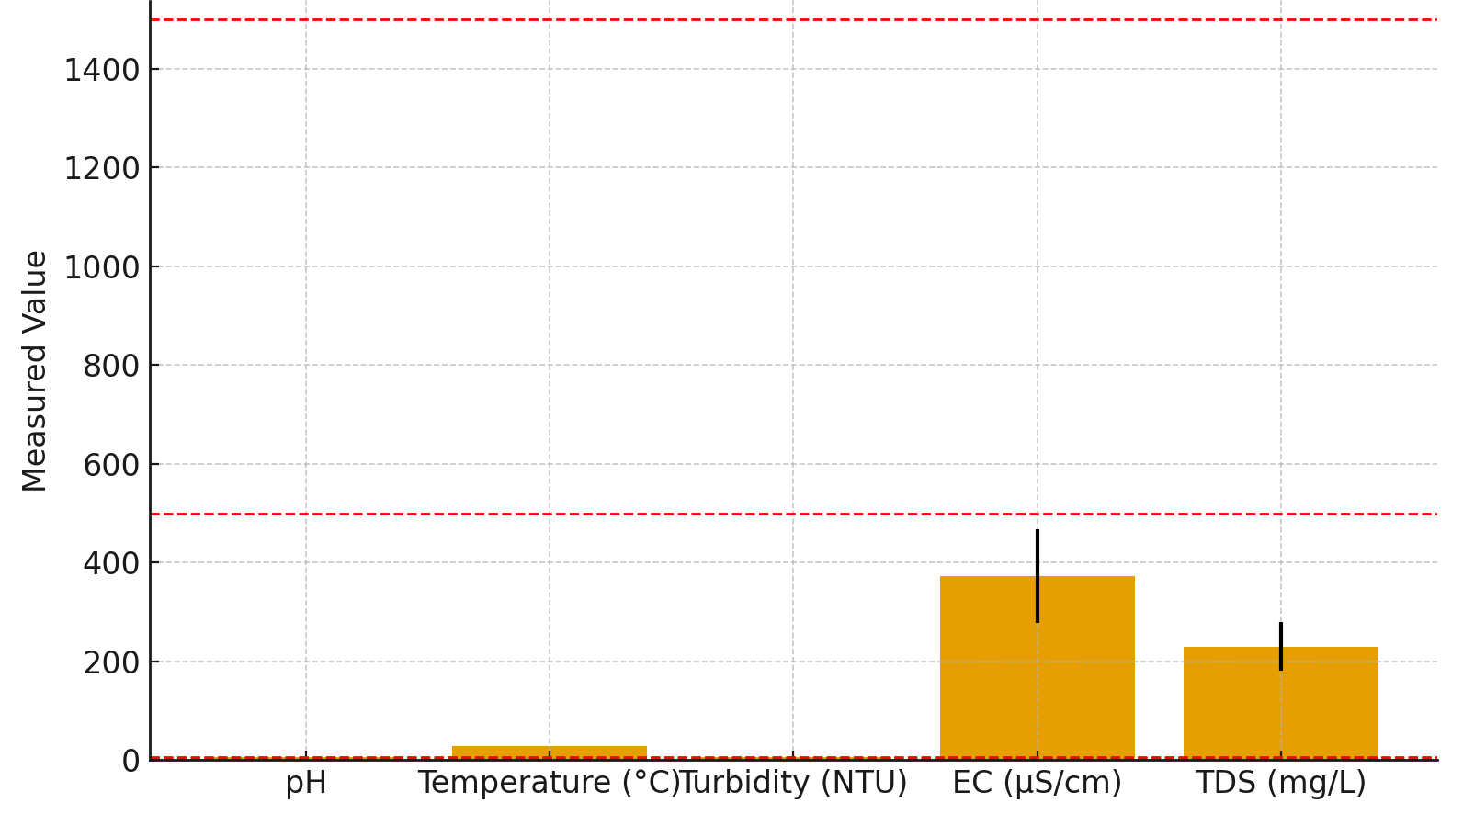
Figure 1. Physicochemical Parameters of Drinking Water Sources in Brass Island

4.2 Major Ions in Drinking Water Sources of Brass Island
The concentrations of major ions in the analysed water samples are presented in Table 2. Calcium (Ca²⁺) and magnesium (Mg²⁺) ranged from 12.4–32.1 mg/L and 5.2–15.8 mg/L, respectively, indicating low hardness values relative to WHO standards (Ca ≤ 75 mg/L; Mg ≤ 50 mg/L). Sodium (Na⁺) and potassium (K⁺) concentrations varied between 8.5–38.4 mg/L and 2.1–8.6 mg/L, respectively, all within acceptable limits. Chloride (Cl⁻) and sulphate (SO₄²⁻) concentrations ranged from 20.5–58.3 mg/L and 6.3–19.7 mg/L, respectively, suggesting a mild marine influence. Nitrate (NO₃⁻) levels ranged from 3.4–21.6 mg/L, with a mean of 12.1 ± 5.8 mg/L, indicating slight enrichment from domestic wastewater or agricultural runoff as shown in Figure 2.
Table 2: Major Ions in Drinking Water Sources of Brass Island
Parameter | Min | Max | Mean ± SD | WHO Limit | Remarks
Ca²⁺ (mg/L) | 12.4 | 32.1 | 22.8 ± 6.3 | 75 | Within limit
Mg²⁺ (mg/L) | 5.2 | 15.8 | 10.5 ± 3.2 | 50 | Within limit
Na⁺ (mg/L) | 8.5 | 38.4 | 22.6 ± 9.3 | 200 | Within limit
K⁺ (mg/L) | 2.1 | 8.6 | 5.3 ± 1.8 | 30 | Within limit
Cl⁻ (mg/L) | 20.5 | 58.3 | 38.7 ± 10.2 | 250 | Within limit
SO₄²⁻ (mg/L) | 6.3 | 19.7 | 12.8 ± 4.1 | 250 | Within limit
NO₃⁻ (mg/L) | 3.4 | 21.6 | 12.1 ± 5.8 | 50 | Slightly enriched

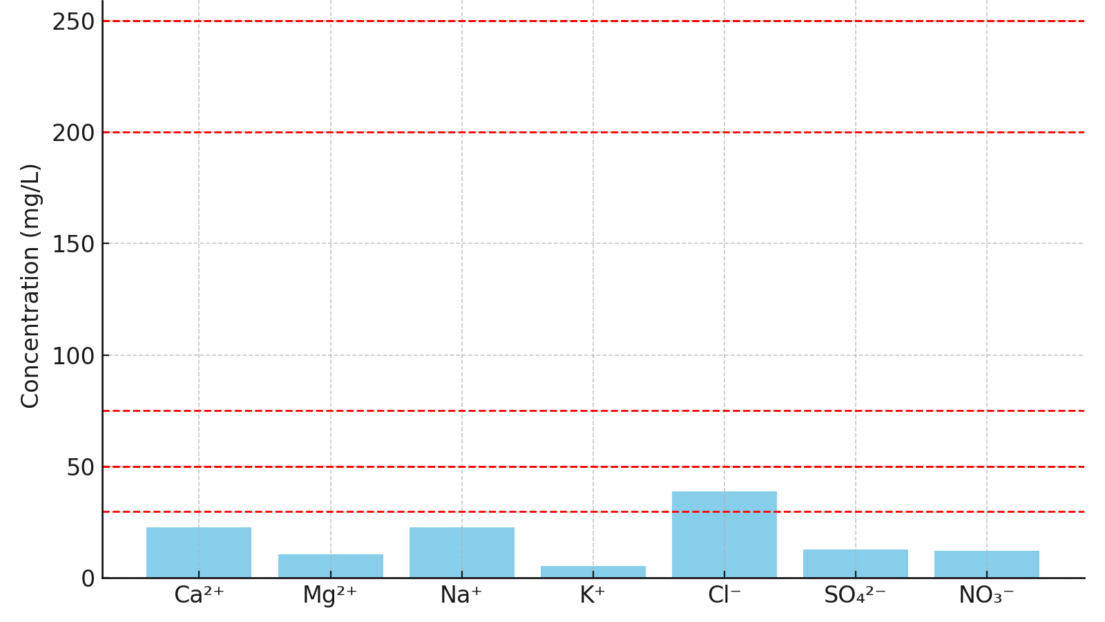

Figure 2. Major Ion Concentrations in Brass Island Drinking Water

4.3 Trace Metal Concentrations
The concentrations of trace metals (Fe, Mn, Zn, Pb, Cu, and Cd) are presented in Table 3. Iron (Fe) ranged from 0.21 to 1.24 mg/L, with a mean of 0.65 ± 0.32 mg/L. Some samples exceeded the WHO limit of 0.3 mg/L, indicating possible leaching from lateritic soils or corrosion of iron pipes. Manganese (Mn) ranged from 0.03 to 0.15 mg/L, averaging 0.08 ± 0.04 mg/L, which is within the WHO permissible limit (0.4 mg/L). Zinc (Zn) ranged between 0.12 and 0.69 mg/L (mean 0.41 ± 0.18 mg/L), remaining well below the WHO limit of 3.0 mg/L. Lead (Pb) concentrations ranged from 0.002 to 0.042 mg/L, with a mean of 0.018 ± 0.011 mg/L; several samples exceeded the WHO limit of 0.01 mg/L, suggesting contamination from plumbing materials and oil-related industrial activities. Copper (Cu) concentrations ranged from 0.01 to 0.08 mg/L (mean 0.04 ± 0.02 mg/L), below the WHO limit of 2.0 mg/L. Cadmium (Cd) ranged from 0.0003 to 0.004 mg/L (mean 0.002 ± 0.001 mg/L), slightly elevated in a few samples compared to the limit of 0.003 mg/L, as shown in Figure 3.
Table 3 Trace Metal Concentrations in Drinking Water Sources of Brass Island
Parameter | Min | Max | Mean ± SD | WHO Limit | Remarks
Fe (mg/L) | 0.21 | 1.24 | 0.65 ± 0.32 | 0.3 | Above limit in some samples
Mn (mg/L) | 0.03 | 0.15 | 0.08 ± 0.04 | 0.4 | Within limit
Zn (mg/L) | 0.12 | 0.69 | 0.41 ± 0.18 | 3.0 | Within limit
Pb (mg/L) | 0.002 | 0.042 | 0.018 ± 0.011 | 0.01 | Exceeded in several locations
Cu (mg/L) | 0.01 | 0.08 | 0.04 ± 0.02 | 2.0 | Within limit
Cd (mg/L) | 0.0003 | 0.004 | 0.002 ± 0.001 | 0.003 | Slightly elevated in a few sites.
The elevated concentrations of Fe and Pb suggest both natural and anthropogenic sources, including corrosion, saline intrusion, and industrial effluents.
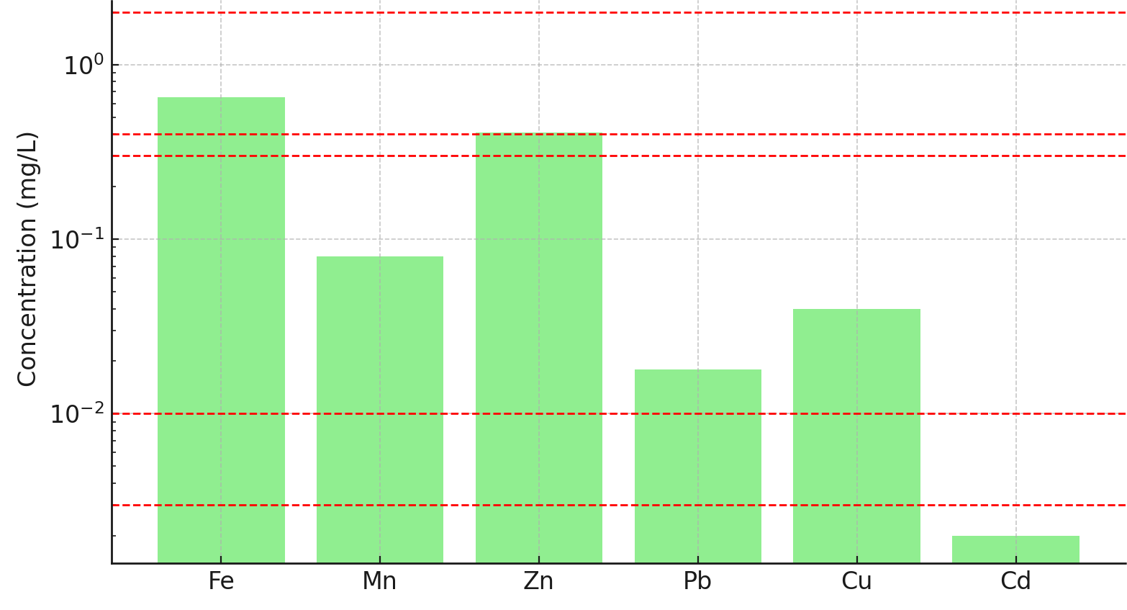
Figure 3. Trace Metal Concentrations (log-scale) in Brass Island Drinking Water

4.4 Health-Risk Assessment
The estimated non-carcinogenic health-risk indices for both adults and children are presented in Table 4. The Hazard Quotient (HQ) values for Fe, Mn, Zn, and Cu were below unity, indicating no significant health risk. However, Pb and Cd recorded HQ values above 1.0 in some sampling locations, particularly for children, indicating potential health concerns from long-term exposure. The Hazard Index (HI) ranged from 0.76 for adults to 1.28 for children, implying that cumulative trace metal exposure may pose moderate health risks, especially among children due to lower body weight and higher consumption per body mass, as shown in Figure 4.
Table 4: Estimated Health-Risk Indices for Trace Metals in Drinking Water Sources of Brass Island
Metal | HQ (Adult) | HQ (Child) | Remarks
Fe | 0.32 | 0.46 | Within a safe limit
Mn | 0.15 | 0.28 | Within a safe limit
Zn | 0.09 | 0.12 | Safe
Pb | 0.28 | 0.65 | Potential risk for children
Cu | 0.07 | 0.09 | Safe
Cd | 0.10 | 0.18 | Slight risk in a few sites
HI (Total) | 0.76 | 1.28 | Higher risk for children
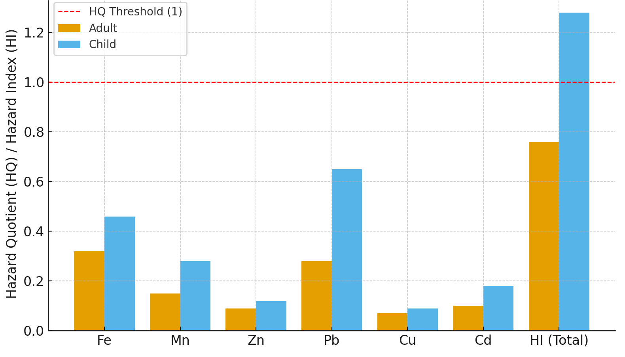
Figure 4. Health Risk Indices (HQ and HI) for Adults and Children in Brass Island
5.0 Discussion
The hydrochemical characteristics of the Brass Island water sources revealed patterns typical of coastal aquifers influenced by both natural and anthropogenic factors. The pH values (5.2–6.4) indicate slightly acidic conditions across the sampling sites, consistent with those reported by Etesin et al. (2013) for the Iko River (5.0–6.5) and Ezekwe et al. (2018) for Kolo Creek (5.3–6.6). In those studies, acidity was mainly attributed to the decomposition of humic substances, oxidation of organic matter, and intermittent saline-water intrusion.
The measured electrical conductivity (210–540 µS/cm) and total dissolved solids (125–315 mg/L) in Brass Island waters reflect moderate mineralisation, implying limited ion exchange and a dynamic equilibrium between freshwater recharge and marine influence. This interpretation aligns with observations by Okpoji et al. (2025) in Andoni surface waters, where comparable EC (190–560 µS/cm) and TDS (110–340 mg/L) ranges were associated with mixed geogenic and anthropogenic processes under similar coastal hydrogeochemical settings.
The concentrations of major ions further substantiate the hydrochemical interpretation. Calcium and magnesium levels (12.4–32.1 mg/L and 5.2–15.8 mg/L, respectively) indicate low hardness, characteristic of soft freshwater systems. Sodium and potassium concentrations (8.5–38.4 mg/L and 2.1–8.6 mg/L) suggest moderate mineral dissolution, while chloride and sulphate ranges (20.5–58.3 mg/L and 6.3–19.7 mg/L) point to a mild marine influence on the local aquifers. Nitrate concentrations (3.4–21.6 mg/L) remained below the WHO (2017) limit of 50 mg/L, but their spatial variability implies anthropogenic enrichment from domestic wastewater seepage and limited agricultural runoff. Comparable nitrate levels (4.2–25.6 mg/L) were reported by Ubong et al. (2023) in the Iko River, demonstrating the influence of domestic and agricultural activities on shallow aquifers.
Trace metal concentrations exhibited variable trends across the study sites. Iron (Fe) levels ranged from 0.21 to 1.24 mg/L, exceeding the WHO (2017) limit of 0.3 mg/L in over half of the samples. Elevated Fe is indicative of lateritic soil leaching and corrosion of metallic pipes, processes that are enhanced under acidic conditions. These findings are consistent with Nsikak and Usoro (2008), who recorded Fe levels between 0.27 and 1.30 mg/L in the Iko River near gas flare zones, attributing them to corrosion and sediment oxidation. Manganese (Mn) concentrations (0.03–0.15 mg/L) and zinc (Zn) levels (0.12–0.69 mg/L) were below WHO permissible limits (0.4 mg/L and 3.0 mg/L, respectively), showing minimal anthropogenic interference.
Lead (Pb) and cadmium (Cd) concentrations, however, showed significant deviations. Lead ranged from 0.002 to 0.042 mg/L, with mean concentrations (0.018 mg/L) exceeding the WHO (2017) standard of 0.01 mg/L in several samples, while Cd values varied between 0.0003 and 0.004 mg/L, slightly above the 0.003 mg/L limit in a few cases (Okagbare et al. 2025). These exceedances suggest contamination from anthropogenic sources such as corroded plumbing systems, petroleum residues, and oil pipeline leakages. Okpoji et al. (2025) recorded similar Pb concentrations (0.015–0.046 mg/L) and Cd levels (0.001–0.004 mg/L) in the Andoni River, associating them with industrial and oil-related effluents. Orajiaka-Uchegbu et al. (2020) also found elevated Pb (0.021–0.037 mg/L) and Cd (0.002–0.005 mg/L) in seafood and water from Bonny creeks, confirming the widespread impact of oil activities across the Niger Delta.
Copper (Cu) concentrations in Brass Island water (0.01–0.08 mg/L) were below the WHO limit of 2.0 mg/L, indicating limited industrial discharge and possible complexation with organic matter or adsorption onto iron oxides. Zinc (Zn), an essential micronutrient, remained within safe limits, suggesting natural geogenic sources (Umueni et al., 2025). However, despite their nutritional importance, excessive intake of Zn and Cu may induce oxidative stress or gastrointestinal disturbances (Adedokun et al., 2016). Conversely, Pb and Cd, being non-essential and toxic even at low levels, are linked to kidney dysfunction, neurological disorders, and cardiovascular damage (Storelli, 2008; Sanyaolu et al., 2022).
The health-risk assessment data support these interpretations. Hazard Quotient (HQ) values for Fe (0.32–0.46), Mn (0.15–0.28), Zn (0.09–0.12), and Cu (0.07–0.09) were all below 1.0, suggesting minimal risk. In contrast, HQ values for Pb (0.28–0.65) and Cd (0.10–0.18) exceeded safe thresholds in some cases, particularly among children. The cumulative Hazard Index (HI) was 0.76 for adults and 1.28 for children, indicating higher susceptibility in the latter group due to lower body weight and higher ingestion rates. These findings are consistent with those of Ubong et al. (2023), who reported HI values ranging from 0.68 (adults) to 1.45 (children) for similar trace metals in Niger Delta surface waters.
The correlation between EC and trace metal concentrations in this study suggests that ionic strength enhances the solubility and transport of metals within the water column. Elevated chloride and sulphate levels increase complexation reactions, facilitating the mobility of metals such as Pb and Fe. This relationship aligns with the findings of Wang et al. (2015), who demonstrated that salinity and low pH significantly influence trace-metal bioavailability in coastal groundwater systems.
Comparatively, the observed concentrations of trace metals in Brass Island were moderate but still posed long-term health concerns. For instance, Fe levels (up to 1.24 mg/L) and Pb values (up to 0.042 mg/L) were within the same magnitude as those reported by Hector et al. (2014) in the Warri River (Fe: 0.25–1.30 mg/L; Pb: 0.020–0.048 mg/L), indicating a persistent regional pattern of contamination from oil exploration and industrial discharge. Similar conditions have been observed by Ubong et al. (2011) in the New Calabar River, where trace-metal enrichment was associated with petroleum residues and sediment resuspension.
The findings highlight the need for proactive management strategies for drinking-water safety in Brass Island. Continuous hydrochemical and trace-metal monitoring is essential to detect seasonal and spatial variations in contamination levels. Public health protection requires the installation of corrosion-resistant pipelines, enforcement of environmental regulations, and the adoption of low-cost treatment options such as adsorption, ion exchange, and phytoremediation. Community awareness programmes are also crucial to minimise exposure risks and encourage proper waste disposal practices.
Conclusion
The hydrochemical and trace-metal assessment of drinking water sources in Brass Island, Bayelsa State, showed that most physicochemical parameters were within the World Health Organisation (WHO, 2017) permissible limits for potable water. The slightly acidic nature of the samples suggests the influence of organic matter decomposition, saline intrusion, and industrial activities typical of the Niger Delta environment. The concentrations of major ions indicated moderate mineralisation and minimal salinity influence, confirming a balance between freshwater recharge and marine interaction. However, the analysis of trace metals revealed that iron, lead, and cadmium exceeded recommended limits in some locations, suggesting inputs from both geogenic and anthropogenic sources such as mineral dissolution, corroded pipelines, and oil-related contamination. Manganese, zinc, and copper remained within acceptable limits, indicating limited industrial discharge and natural attenuation processes.
Health-risk assessment showed that most trace metals posed no immediate health threat, but lead and cadmium present potential long-term risks, especially for children who are more vulnerable to toxic exposure. The findings demonstrate that while the drinking water in Brass Island is generally of moderate quality, it is not entirely free from contamination concerns. To ensure safe and sustainable water use, regular monitoring and maintenance of water-supply systems are necessary. The use of corrosion-resistant materials, the enforcement of environmental standards, and the adoption of simple treatment technologies such as adsorption or filtration will help reduce trace-metal concentrations. Community education and stakeholder collaboration are also essential to minimise pollution sources and improve public health outcomes.

COMPETING INTERESTS DISCLAIMER:
Authors have declared that they have no known competing financial interests OR non-financial interests, OR personal relationships that could have appeared to influence the work reported in this paper.
Disclaimer (Artificial intelligence)
Option 1:
Author(s) hereby declare that NO generative AI technologies such as Large Language Models (ChatGPT, COPILOT, etc.) and text-to-image generators have been used during the writing or editing of this manuscript.

References
Adedokun, H., Njoku, K. L., Akimola, M. O., Adeteola, A. A., & Jalooso, A. O. (2016). Potential Health Risk Assessment of Heavy Metals intake via consumption of some leaf vegetables obtained from four markets in Lagos Metropolis, Nigeria. Journal of Applied Science Environmental Management. 20(3): 530-539.
Anani, O. A., & Olomukoro, J. O. (2018). Freshwater Prawn and Crab Exposed to Heavy Metals in a Tropical River, Southern Nigeria. Journal of heavy metal toxicity and disease. 3(2):5.
Anarado, C. J. O., Okpoji, A. U., & Anarado C. E. (2023). Bioaccumulation and health risk assessment of lead, cadmium, arsenic, and mercury in blue crabs found in creeks in Bayelsa State of the Niger Delta region of Nigeria. Asian Journal of environmental & ecology. 21(4)46-59.
Belframe, M. O. & Mario, S. G. D. (2010). Influence of sex, habitat and sedimentary on heavy metal concentration in the burning crab (Neonelive granule) from a Central lagoon in Argentina. Arch Environmental Project, Iran.
Bo, E. L. – Zheng, H. D. – Liu, X. G. – Lin, C. C. – Guan, L. & Zhou, Y. M. (2016). Evaluation of Heavy Metal Pollution and Risk Assessment of Dietary Intake of Pollutants in Chinese Mitten Crab (Eriocheir sinensis) in Main Aquaculture Areas of Northeast China. Bureau of Testing on Aquatic Products Quality Safety of Liaoning Province, Shenyang 110031, China.
Cogun, H. Y., Yezererogluja, F. O., Gulf, G. & Karrgin, F. (2006). Metal concentration in fish species from the North East Mediterranean Sea. Final of Environmental Ministering and Assessment 121(1):431 – 438.
Dalman, O., Demirak, A. & Balci, A. (2006). Determination of heavy metals (Cd, Pb) and trace elements (Cu, Zn) in sediments and fish of the Southern Aegean Sea (Turkey) by atomic absorption spectrometry. Food Chemistry 95:157-162.
Ekpe, J. E., Okpoji, A. U., Ekwere, I. O., Anarada, C. J., Ewuola, A. A., Ufuoma, V. O., Okpanachi, C. B., Okonkwo, C. O., & Obunezi, O. A. (2025). Physico-chemical transport of pesticides and nutrients in irrigation water and their fate in agro-ecosystems of Rivers State, Nigeria. Palgo Journal of Agriculture, 9(2), 30–37.
https://doi.org/10.5281/zenodo.17148360
Ekwere, I. O., Okpoji, A. U., Igwegbe, K. C., Okonkwo, C. O., Yekeen, A. A., Obunezi, O. C., Okpanachi, C. B., Garuba, M. H., Ogini, O. R., & Odibo, U. E. (2025). Nutritional–Toxicological Trade-Off: Comparative Study of Polycyclic Aromatic Hydrocarbons in Smoked and Oven-Dried Nile Tilapia (Oreochromis niloticus). Journal of Environment, Climate, and Ecology, 2(2), 90-97. https://doi.org/10.69739/jece.v2i2.952
Ekwere, I. O., Okpoji, A. U., Ufuoma, V. O., Akinola, A. E., Raymond, C. A., Clement, R. O., Alaekwe, I. O., Etesin, M. O., & Edodi, I. O. (2025). Nutritional evaluation of Nile tilapia (Oreochromis niloticus) processed by different drying methods in Akwa Ibom State, Nigeria. Journal of Sustainable Research and Development, 1(2), 11–17. https://doi.org/10.69739/jsrd.v1i2.1033
Etesin, U., Udoinyang, E. & Harry, T. (2013). Seasonal variation of physicochemical parameters of water and sediments from the Iko River, Nigeria. Journal of Environment and Earth Science. 3 (8), 2013.
Ezekwe, I. C., Oshionya, E. O. & Demua, L. D. (2018). Ecological and Potential Health Effects of Hydrocarbon and Heavy Metal Concentrations in the Kolo Creek Wetlands, South-South, Nigeria. International Journal of Environmental Science and Management Resources. 11(1).
FAO/WHO (2001). Report on the 32nd Session of the Codex Committee on Food Additives and Contaminants, ALINORM 01/12, Beijing, China, 20–24 March 2000. Joint FAO/WHO Food.
Farombi, E.O.; Adelowo, O.A. & Ajimoko, Y.R. (2007) Biomarkers of oxidative stress and heavy metal levels as indicators of environmental pollution in African Catfish (Clarias gariepinus) from Nigeria, Ogun River. International Journal of Environmental Research and Public Health 4, 158-165
Garcia-Rico, L., Leyva-Perez, J. & Jara-Marini, M. E. (2007). Content and daily intake of copper, zinc, lead, cadmium, and mercury from dietary supplements in Mexico. Food Chemistry and Toxicology, 45:1599-1605.
Hector, R., Ajiwe, V.I.E., & Okonkwo, S. I. (2014). Determination of Heavy Metal Content in the Warri River using Crab as Bio-indicator. International Journal of Scientific and Management (USRM). 2 (7) 1126 – 1134.
Jan, F. A., Ishaq, M., Khan, S., Ihsanullah, I., Ahmad, I. & Shakirullah, M. (2010), A comparative study of human health risks via consumption of food crops grown on wastewater irrigated soil (Peshawar) and relatively clean water irrigated soil (Lower Dir). Journal of Hazard Materials, 179: 612–621.
JECFA (2005), Joint FAO/WHO Expert Committee on Food Additives, 64th Meeting, JECFA/64/SC, Codex Standard 193-1995, Pg. 47, Accessed from: www.codexalimentarius.org on 26th May 2016.
Jenyo – Oni A & Oladele A. H. (2016). Heavy Metals Assessment in Water, Sediments and Selected Aquatic Organisms in Lake Asehire, Nigeria. European Scientific Journal. 12(24) 339.
John E., E., Emah O., A., Ifiok O., E., Okpoji, A. U., Iyam O., E., Henderson O., O., Akinola A., E., Gloria N., A., & Charles N., O. (2025). Health Risk Implications of Polycyclic Aromatic Hydrocarbons in Smoked and Dried Fish Consumed in Nigeria. Journal of Medical Science, Biology, and Chemistry, 2(2), 192-199. https://doi.org/10.69739/jmsbc.v2i2.1045
Meldhi, H., Nnabavi, S. M. B., Pazooki, J. & Parsa, Y. (2014). The level of toxic metals in the blue crab, Portunus sanguinolentus, from the Persian Gulf. Journal of Marine Science Research and Development 4:145.
Nkeeh, D. K., Hart, A. I., Erondu, E. S., & Zabbey, N. (2016). Assessment of the Physicochemical Parameters of Bodo Creek, Rivers State, Nigeria: A Pre-spill, Post-spill, and Post-clean-up Review. J. Appl. Sci. Environ. Manage. 25 (8) 1505.
Nsikak, U. B. & Usoro, M. E. (2008). Metal contamination of surface water, sediment, and tympanotonus fascatus var radula of the Iko River and Environmental Impact due to Utapete gas flare station, Nigeria. The environmentalist. 28,195-202.
Okagbare, U. V., Umueni, U. E., Ekpe, J. E., Etukudo, N. J., Okpoji, A. U., Okoye, P. I., Ekwere, I. O., Etesin, M. U., Okpanachi, C. B., & Okafor, C. A. (2025). Geophysical and Hydrochemical Assessment of Groundwater Vulnerability to Oil Pollution in Yenagoa, Bayelsa State, Nigeria. Journal of Environment, Climate, and Ecology, 2(2), 138–146.
Okpoji, A. U., Anarado, C. O., Mmuta, E. C., Ekwere, I. O., Alaekwe, I. O., Odibo, U. E., Igwegbe, K. C., Eboj-Ajoku, I. O., & Obunezi, O. C. (2025). Toxicological evaluation of Pb, Cd, As, and Hg in blue crab from oil-polluted creeks in the Niger Delta. Journal of Life Science and Public Health, 1(1), 24–31. https://doi.org/10.69739/jlsph.v1i1.879
Okpoji, A. U., Chinyere, U. E., Nwokoye, J. N., Ezekwuemen, O. I., Alaekwe, I. O., Odidika, C. C., Owughara, C. N., Enyi, C. M., & Kolawole, O. O. (2025). Environmental assessment of heavy metals and hydrocarbon pollution in surface waters of oil-bearing communities in Andoni, Rivers State, Nigeria. International Journal of Modern Science and Research Technology, 3(8), 22–30. http://www.ijmsrt.com
Okpoji, A. U., Eboh-Ajoku, I. O., Mmuta, E. C., Ndubuisi, J. O., Alaekwe, I. O., Odibo, U. E., Nwoka, N. G., Okafor, C. A., & Obunezi, O. C. (2025). Integrated environmental risk assessment of BTEX and PAHs in water and sediment samples from the Bonny River, Nigeria. ISA Journal of Multidisciplinary (ISAJM), 2(4), 14–21.
Okpoji, A. U., Ekwere, I. O., Igwegbe, K. C., Anarado, C. J. O., Ogbonna, C., Ewuola, A. A., Odibo, U. E., & Garuba, M. H. (2025). Volatile organic compounds from gas flaring and their atmospheric implications in the Niger Delta. Journal of Life Science and Public Health, 1(1), 32–39. https://doi.org/10.69739/jlsph.v1i1.962
Okpoji, A. U., Ekwere, I. O., Igwegbe, K. C., Etesin, U. M., Ugwuanyi, G. C., Okpanachi, C. B., Ewuola, A. A., Mojisola, K. M., & Ezekwueme, O. I. (2025). Solar-enhanced photocatalytic degradation of pharmaceutical residues in wastewater using Fe-, Cu-, and Zn-doped TiO₂ nanomaterials. Journal of Environment, Climate, and Ecology, 2(2), 56–62. https://doi.org/10.69739/jece.v2i2.961
Okpoji, A. U., Emem, J. A., Ekwere, I. O., Odibo, U. E., Alaekwe, I. O., Warder, A. B., & Eboj-Ajoku, O. I. (2025). Bioaccumulation of nickel, lead, and cadmium in tissues of Callinectes sapidus from the Iko River, Nigeria: Implications for human health risk and environmental safety. Journal of Environment, Climate, and Ecology, 2(2), 29–37. https://doi.org/10.69739/jece.v2i2.844
Okpoji, A. U., Etesin, M. U., Ekwere, I. O., Martins, N. P., Okpanachi, C. B., Adisa, O. J., & Okonkwo, C. C. (2025). Geochemical speciation and ecological risk of heavy metals in estuarine sediments of the Qua Iboe River, Nigeria. Asian Journal of Chemical Sciences, 15(6), 20–31. https://doi.org/10.9734/ajocs/2025/v15i6402
Okpoji, A. U., Ndubuisi, J. O., Eboh-Ajoku, I. O., Emem, J. A., Ekwere, I. O., Alaekwe, I. O., Odibo, U. E., Igwegbe, K. C., Onoja, C. R., Warder, A. B., & InyangAbia, A. J. (2025). Trematode infections and histopathological effects in Chrysichthys nigrodigitatus from the polluted Andoni River, Niger Delta, Nigeria. Journal of Agriculture, Aquaculture, and Animal Science, 2(2), 66–72. https://doi.org/10.69739/jaaas.v2i2.882
Okpoji, A. U., Nwoka, N. G., Odibo, U. E., Alaekwe, I. O., Okafor, C. A., Ogwu, N. G., & Akatakpo, C. U. (2025). Seasonal variation in hydrochemical characteristics and heavy metal risk assessment of groundwater in Andoni-Isiokwan District, Niger Delta, Nigeria. International Journal of Modern Science and Research Technology, 3(8), 44–51. http://www.ijmsrt.com
Oluwole, S. O., Makinde, O. S. C., Yusuf, K. A., Fajana, O. O., & Odumosu, A. O. (2013). Determination of Heavy Metal Contaminants in Leafy Vegetables Cultivated by the Roadside. International Journal of Engineering Research and Development, 7(3):1-5.
Onoja, C. R., Ogbaji, H. O., Edodi, I. O., Mmuta, E. C., Igwegbe, K. C., Ogini, O. R., Odibo, U. E., Ewuola, A. A., Mahmoud, A. B., & Okpoji, A. U. (2025). Heavy Metal Contamination and Health Risk Assessment of Smoked-Dried Fish Sold in Eke-Awka Market, Anambra State, Nigeria. Journal of Sustainable Research and Development, 1(2), 18-25. https://doi.org/10.69739/jsrd.v1i2.1044
Orajiaka-Uchegbu, C., Patrick-Iwuanyanwu, C. K., Ogbo, B. A. & Egbuna, C. (2020). Bioaccumulation of Heavy Metals and Potential Health Risk through Consumption of Seafoods from Selected Creeks in Rivers State, Nigeria. Egyptian Journal of Aquatic Biology & Fisheries. 2(7): 1033_ 1053.
Oribhabor, B. J. & Ogbeibu, A. E. (2009). The concentration of Heavy Metals in a Niger Delta Mangrove Creek, Nigeria. Global Journal of Environmental Sciences. 8(2): 1596 – 6194.
Percin, M., Olgunolgu & Iikan, A. O. (2016). Heavy metal content in blue swimming crab fish in the North Eastern Mediterranean Sea, Mersin Bay, Turkey. Pil J. Environ. Doi. 10.15244/Proes/62795.
Peterson, M. J., Smith, J. G., Southworth, G. R., Ryon, M. G., & Eddlemon, G. K. (2002). Trace Element Contamination in Benthic Macroinvertebrates from a small stream near a uranium mill Tailings Site. Environ Monit Assess 74:193 208.
Sanyaolu, V. T., Omotayo, A. I. & Detoro, F. A. (2022). Potential Health Risk Assessment of Bioaccumulation of Heavy Metals in Freshwater Organisms from Ojo River, Lagos, Nigeria. J. Appl. Sci. Environ. Manage. 26 (5) 885-892
Storelli, M. M. (2008). Potential human health risks from metals (Hg, Cd, and Pb) and polychlorinated biphenyls (PCBs) via seafood consumption: Estimation of target hazard quotients (THQs) and toxic equivalents (TEQs). Food Chemistry and Toxicology, 46: 2782–2788.
Tsafe, A. I., Hassan, L. G., Sahabi, D. M., Alhassan, Y., & Bala, B. M. (2012). Evaluation of Heavy Metals Uptake and Risk Assessment of Vegetables Grown in Yargalma of Northern Nigeria. Journal of Basic and Applied Science Research, 2(7): 6708-6714.
Ubong, U. U., Ekwere, I. O., Ekanem, A. N. & Ite, A. E. (2023). Human health risk assessment of Cd, Pb, and Hg from Iko River, Eastern Obolo Local Government Area, Akwa Ibom State, Nigeria. Africa Journal of Materials and Environmental Science. 14(20), 384-394.
Ubong, U. U., Ubong, I. U., Ubong, E. U. & Horsfall, M. (2011). Distribution of heavy metals in the tissue of Callinectes latimanus from the new Calabar rivers, Nigeria. Africa Journal of environment pollution and health. 9(1),7-13.
Umueni, U. E., Etukudo, N. J., Okoye, P. I., Okpoji, A. U., Eze, V. C., Aningo, G. N., Ekwere, I. O., & Garuba, M. H. (2025). Geochemical and ecological risk assessment of petroleum hydrocarbons in sediments of Forcados River, Delta State. Asian Journal of Geographical Research, 8(4), 287–298. https://doi.org/10.9734/ajgr/2025/v8i4337
United Nations Environmental Programme (2011). Environmental assessment of Ogoniland: Site Specific Fact Sheets: Gbogozor- Bodo (019-033).
USEPA (2010), Integrated Risk Information System (IRIS), United States Environmental Protection. Available online: http://www.epa.gov/iris/index.html (accessed on 4 May 2016).
US-EPA IRIS (2006). United States, Environmental Protection Agency, Integrated Risk Information System. <http://www.epa. Gov/iris/subst>. Vanadium and Zinc. Report of the Panel on Micronutrients. National Academy Press, Washington, DC, Food and Drug Administration, Dietary supplements, Centre for Food Safety and Applied Nutrition, Disease Urinal of Heavy Metal Toxicity.
Wang, X., Sato, T., Xing, B. & Tao, S. (2015). Health risks of heavy metals to the general public in Tianjin, China, via consumption of vegetables and fish. Science and Total Environment, 350: 28–37.

