Electrochemical and sono-electrochemical treatments of wastewater containing paracetamol in the presence of chloride

Original Research Article

ABSTRACT

One of the major problems we face is water pollution caused by pharmaceutical products, particularly paracetamol (PCM). This leads to an increasingly high mortality rate due to various diseases caused by these pollutants. The use of effective treatment methods for the degradation of these pollutants is essential. To this end, we studied the influence of chloride on the electrochemical and sono-electrochemical treatment of paracetamol using a boron-doped diamond (BDD) electrode. During this study, the concentration of paracetamol was monitored by differential pulse voltammetry. Studies characterizing this electrode have shown its quasi-metallic nature and its ability to detect trace amounts of paracetamol. In addition, after 1.5 hours of treatment, degradation rates of 65%, 90%, and 96% were determined in the presence of 0 mM and 100 mM chloride for electrochemistry and 100 mM chloride for sono-electrochemistry, respectively. It is therefore clear that chloride contribute to the paracetamol degradation, given the above results. These results highlight the potential of sono-electrochemical treatment as a sustainable and efficient approach for the remediation of pharmaceutical pollutants in wastewater. Our future work will focus on the development of highly sensitive and economically accessible detection methods.

Keywords: Paracetamol, Electrochemistry, Sono-electrochemistry, Chloride, Degradation, wastewater

1. INTRODUCTION

The quality of aquatic environments today is fragile, degraded by numerous pollutants resulting from liquid effluent discharges, rainwater runoff from polluted surfaces, leaching from contaminated soils, and many other human activities that release toxic substances into the environment (Placide et al. 2016, Adeshina et Abdul 2025, Tudi et al. 2025, Yuxiao et al. 2025). PCM, one of the most widely administered and therefore abundantly synthesized drugs, is no exception to these pollutants, which are enemies of the aquatic environment and, consequently, of the health of living beings (Pourkodee et al. 2025). Indeed, over time, paracetamol breaks down into other toxic products that cause health problems (Wu et al. 2012). Faced with this alarming situation, the scientific community has focused much of its research on developing effective techniques to purify surface water and thereby reduce the mortality rate linked to the presence of paracetamol, among other substances (Koné et al. 2024, Kambiré et al. 2024, Kambiré et al. 2022a). The first methods to emerge were known as conventional methods. However, these water treatment methods generate other secondary problems, such as the additional use of chemical reagents, the generation of by-products, and the production of sludge, which is difficult to manage (Sadia et al. 2020). To solve this problem, advanced oxidation processes (AOPs), which produce hydroxyl radicals HO• (a powerful non-selective oxidant Eo (H₂O/OH•) = 2.81 V/SHE), are emerging as an alternative solution, used either before or after conventional treatments depending on the circumstances. These methods are cleaner and highly effective (Kambiré et al. 2022a, Marc et al. 2004).

Electrochemical water treatment involves a process of electron transfer at the interface between the electrolyte solution containing the pollutant and an electrode with characteristics appropriate for the intended purpose. During this treatment, radical species resulting from the electrochemical decomposition of water are involved in this oxidation (Kambiré et al. 2022b, Appia et al. 2016, Kouadio et al. 2021). In sonochemistry, acoustic waves are propagated in the solution to be treated (Maria et al. 2025). Cavitation bubbles are formed, which then grow and implode when they reach their maximum size. The temperature inside these bubbles is extremely high (several thousand Kelvins and a pressure of several hundred bars). They are the site of numerous chemical reactions that lead to the formation of highly reactive radical species. Consequently, the oxidation of pollutants takes place either by radical attacks (at the heart of the solution), by pyrolysis (inside the bubble), or by both at the same time (bubble/solution interface) (Maria et al. 2025).

In this study, we set ourselves the objective of investigating the influence of chloride on the treatment of wastewater containing PCM using electrochemical and sono-electrochemical methods on a boron-doped diamond electrode (BDD). The influence of chloride will be studied because the majority of wastewater in our economic capital (Abidjan), the largest city in our country, contains ions. The presence of chloride is linked to the presence of the sea and the Ebrié lagoon (Ahoulé et al. 2017).

2. material and methods

2.1. Chemicals

Pollutant to be degraded in our study, namely PCM, was synthesized in the Bailly-Creat laboratory in France and purchased in pharmacies in Abidjan. In addition, the chloride used in the treatment of our wastewater come from potassium chloride manufactured by PANREAC. Sulfuric acid (96%) and iron (II) sulfate (99%) were supplied by PANREAC. Boric acid (99.50%) and orthophosphoric acid (85%) were obtained from EMSURE. Iron(III) ammonium sulfate (98%) and acetic acid were supplied by MERCK and EMPARTA, respectively. All solutions were protected from light and used within 24 hours to prevent decomposition. Double-distilled water was used to prepare the supporting electrolytes.

2.2. Electrochemical measurements

A computer-controlled Autolab Potentiostat from ECHOCHEMIE (PGSTAT 20) (GPES software) used for computerized data acquisition enabled us to perform cyclic voltammetry (CV) and differential pulse voltammetry (DPV) measurements. Glass electrochemical cell consisted of a reference electrode (mercury sulfate electrode (MSE)), a coiled platinum wire as the counter electrode, and a boron-doped diamond electrode (BDD) as the working electrode. For preparative electrolysis, BDD was used as the anode and zirconium plate as the cathode. These two electrodes of 16 cm² each were separated by 2 cm, what delimited the cell-volume to 32 cm³. The solution was recirculated using a mini peristaltic pump of the Watson Marlow 505U type. The flow rate of the solution was 2.7 mL s^{-1.} Fabrimex 141 type voltage generator allowed to keep the current constant during the electrolysis. Batch mode setup was used for electrolysis.

Treatment of our synthetic wastewater using sonochemistry and sonoelectrochemistry was made possible by a 35 kHz US tank. It consists of three piezoelectric transducers that generate waves; as these waves propagate through the system, they contribute to the mineralization of the pollutant.

All pH values were measured with a pH meter (HI2211). All measurements were taken at 25°C.

3 results and discussion

3.1 Characterization of the electrode

3.1.1 Physical characterization of the electrode

BDD electrode used to carry out this work was characterized using scanning electron microscopy. The image obtained is shown in Fig. 1. This figure shows micrometer sized crystals oriented randomly with predominantly cubic and triangular faces. This shows that BDD has a polycrystalline structure because its characteristics are those of a material with a polycrystalline structure (Kambiré et al. 2021).

The grains are strongly bonded to each other and the crystals range in size from 0.3 to 0.6 μm.

Fig. 1. SEM image of the BDD anode surface

3.1.2 Electrochemical characterization of the electrode

Influence of the iron (III) ammonium sulfate/iron (II) sulfate (IAS/IS) couple concentration on the behavior of the BDD, with a view to obtaining information on the surface condition and quality of the electrode, was studied. We used a 0.3 M sulfuric acid solution as the supporting solution to record cyclic voltamograms (CV). The results obtained are shown in Fig. 2a.

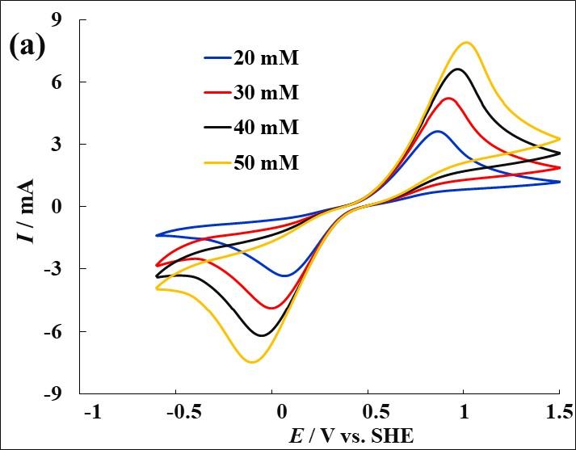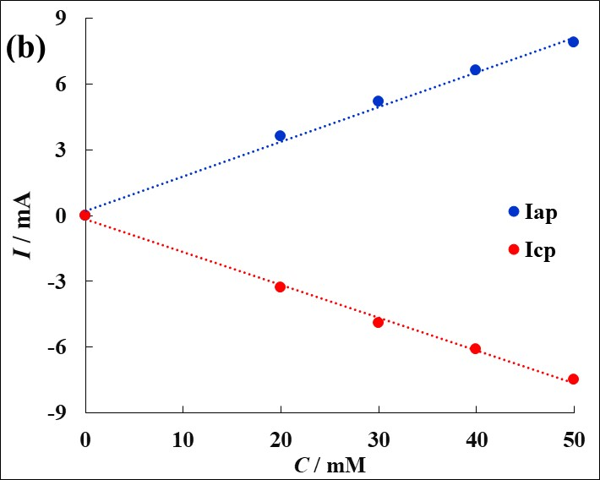

Fig. 2. CV of the influence of IAS/IS concentration (a) and curves of anodic and cathodic peak currents as a function of IAS/IS concentration (b); V = 50 mV/s; pH = 0.6

In this figure, we note that the peak current increases with the concentration of redox species. Anodic and cathodic peaks observed correspond to the oxidation and reduction of the redox couples considered. The peaks observed are typical for such redox couples on good electronic conductors (Fernández et al. 2014). In addition, the anodic and cathodic peak currents were determined and plotted as a function of the concentration of redox species (Fig. 2b). The curves obtained for the two couples (Fig. 2b) are straight lines passing through the origin. We can deduce that the oxidation and reduction of re-dox species are responsible for the appearance of these peaks. These straight lines relating to the anodic and cathodic peak currents have the same slope of 0.1 × 10⁻³ A.mM⁻¹ with R² = 0.996 for the IAS/IS couple. It follows that boron-doped diamond has properties similar to those of metal electrodes (Gnamba et al. 2015), particularly in terms of electron transfer. This quasi-metallic character of diamond is due to its boron doping.

Voltammograms were recorded at different scan rates in the presence of a portion of iron(III) ammonium sulfate/iron(II) sulfate couple. Fig. 3a shows the voltammograms obtained. Anodic and cathodic peaks related to the oxidation and reduction of the IAS/IS couple are observed. These peak currents increase with the scan rate.

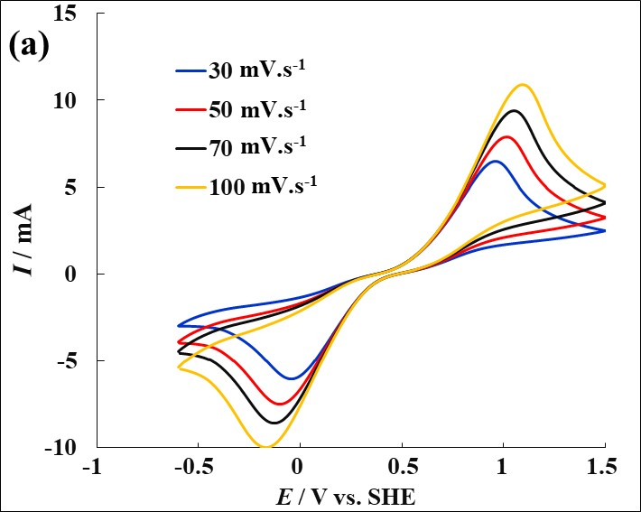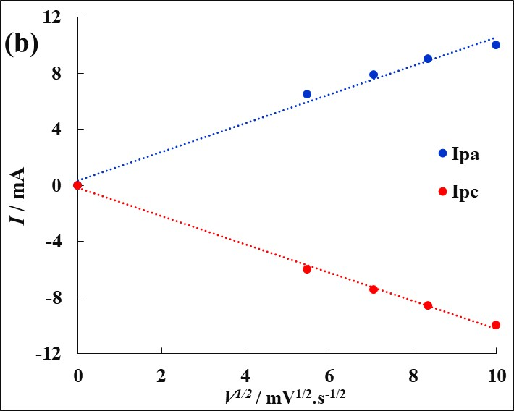

Fig. 3. Voltammetric curve showing the influence of scan rate in the presence of IAS/IS (a) and trend curves for anodic and cathodic peak currents as a function of the scan rates square root (b); C (IAS/IS) = 50 mM
Fig. 3b shows the trend curves for the anodic and cathodic peak currents as a function of the square root of the scan rates. The curves obtained are straight lines with virtually identical slopes in absolute terms. In fact, the slopes associated with the two lines are equal to 0.0011 A.s^{1/2}V^{-1/2}. The linearity between the peak current and the scan rate square root in potential indicates that the redox kinetics at the electrode are controlled by diffusion (Kambire et al. 2015a).

We studied the electrochemical behavior of BDD in 0.3 M sulfuric acid. The results obtained are shown in Fig. 4 in a potential range from -1.75 V/SHE to 3.25 V/SHE. The voltammetric measurements were performed at a potential scan rate of 50 mV/s. This figure shows hydrogen evolvement starting at -1.03 V and oxygen evolvement at 2.34 V. The range between the start of hydrogen evolvement and that of oxygen evolvement is called the electrode's electroactivity range. In this environment, the electrode's electroactivity range is approximately 3.37 V. The current is virtually zero. This electrode response shows that there is no change in the surface of this electrode. There is no formation of surface oxide, attesting to the inert nature and therefore the high resistance of this material to acid corrosion. The high potential noted for oxygen evolvement could be explained by the very slow kinetics of the water decomposition reaction on the BDD responsible for oxygen evolvement (Kambire et al. 2015b, Kambire et al. 2015c).

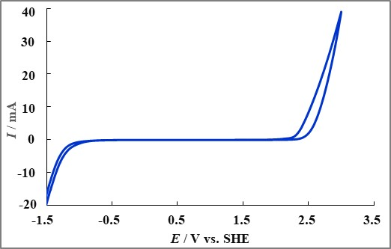

Fig. 4. CV in 0.3 M H₂SO₄; V = 50 mV/s

3.2 Voltammetric study of paracetamol oxidation

3.2.1 Influence of chloride

Fig. 5 shows the influence of chloride concentration on BDD behavior. It can be seen that the kinetics of chlorine evolution become increasingly rapid as the chloride concentration increases. Furthermore, a study of the initial chlorine evolvement potential for a current intensity of 2 mA was conducted, indicating a decrease in potential as the chloride concentration increases, as shown in the box in Fig. 5. Indeed, for concentrations of 0, 25, 50, and 100 mM chloride, the release potentials obtained are 2, 1.53, 1.49, and 1.4 V, respectively. According to these results, PCM can undergo direct oxidation at the electrode surface by direct electron exchange and/or indirect oxidation via species resulting from the oxidation of Cl⁻ to Cl₂ or other redox species formed in situ. In fact, direct and indirect electro-oxidation via hydroxyl radicals occurs according to voltammetric studies conducted in the absence of chloride. The following mechanisms may occur during electrolysis in the presence of chloride (Appia et al. 2016, Kambiré et al. 2020). In a first step, Cl⁻ is oxidized to chlorine on the surface of the BDD according to equation 1.

2Cl⁻ → Cl₂ + 2e- (1)

The second step is the formation of hypochlorous acid (HClO) (equation 2)

Cl₂ + H₂O → HClO + Cl⁻ + H⁺ (2)

HClO undergoes dissociation into hypochlorite ions and hydrogen ions (equation 3)

HClO → ClO⁻ + H⁺ (3)

Next, indirect oxidation of PCM by hypochlorite ions takes place either near the electrode surface or within the solution.

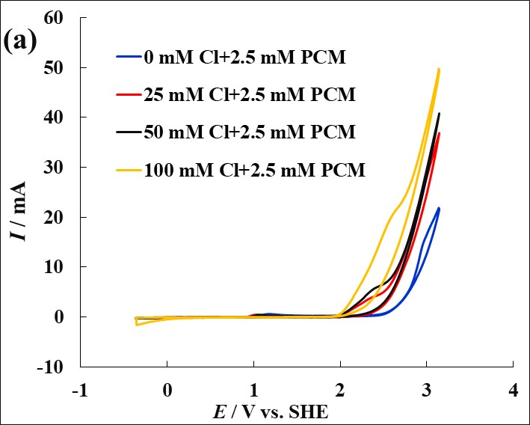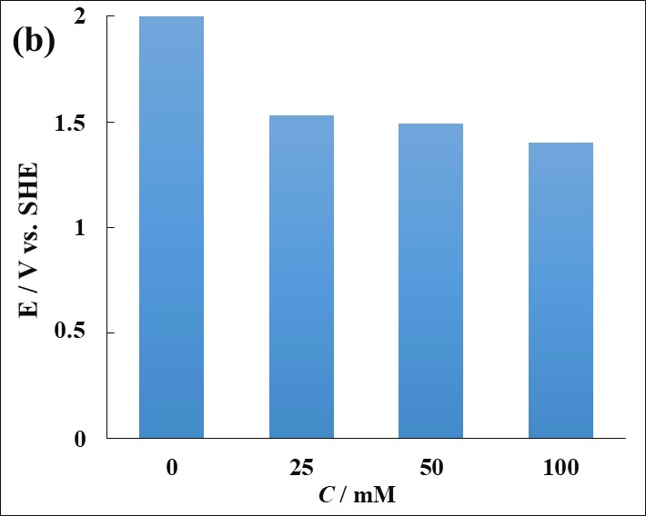

Fig. 5. Influence of Cl⁻ on the behavior of BDD in the presence of PCM (2.5 mM) (a); Cl₂ evolution release potentials for I = 2 mA (b); V = 50 mV/s; pH = 0.57

3.2.2 Effect of pH

H⁺ content of surrounding waters is linked to their composition in organic and inorganic compounds. Depending on the hydrogen potential value associated with any given water, its treatment by electrochemical methods may or may not be favored. We therefore decided to study the influence of this parameter on the electrochemical oxidation of paracetamol in the presence of chloride. Figure 6 illustrates the results obtained following an investigation into the impact of pH on PCM oxidation in the presence of 50 mM chloride. It shows a slow oxidation kinetics for pH values of 2, 3.5, and 6.5 compared to pH 0.67. In fact, the hypochlorous acid formed during the electrochemical reaction of chloride, which is supposed to contribute to the PCM oxidation, will react with the HO⁻ resulting from the addition of NaOH to increase the pH to 6.5. This leads to a decrease in the amount of oxidative species, hence the observation made above. From these results, it should be noted that chloride is more involved in the oxidation of organic compounds in a very acidic environment than in a less acidic environment.

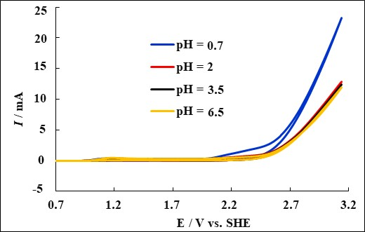

Fig. 6. Influence of pH combined with that of chloride (50 mM) on the behavior of BDD in the presence of PCM (2.5 mM); V = 50 mV/s

3.3. Analytical method

The analytical technique used to carry out our work is differential pulse voltammetry (DPV). In order to determine the change in PCM concentration in our water to be treated by electrolysis, we produced a calibration curve in a 0.04M Britton Robinson (B-R) buffer solution. The optimized conditions used were determined in our previous work (Kouadio et al. 2021). Fig. 7a highlights the curves obtained by DPV in a 0.04 M Britton Robinson buffer solution. In this figure, the peak potentials associated with each concentration are equal. In fact, the peak currents evolve in a perfectly linear fashion with the PCM concentration in the B-R buffer solution, as shown in Fig. 7b. Thus, we obtain a straight line passing through the origin of the axes with the equation I = 0.8615 C + 2.7177 associated with a determination coefficient of 0.999. Furthermore, calculating the detection limit (DL) and quantification limit (QL) in PCM by applying equations 4 and 5 gives 0.167 and 0.559 µM, respectively.

DL = 3 x σ (4)

QL = 10 x σ (5)

Where σ: Standard deviation.

B-R buffer solution is therefore a good analyte for monitoring PCM concentration during electrolysis. Furthermore, these results are consistent with those corresponding to trace detection (Ersin et Silah 2020, Bottari et al. 2020).

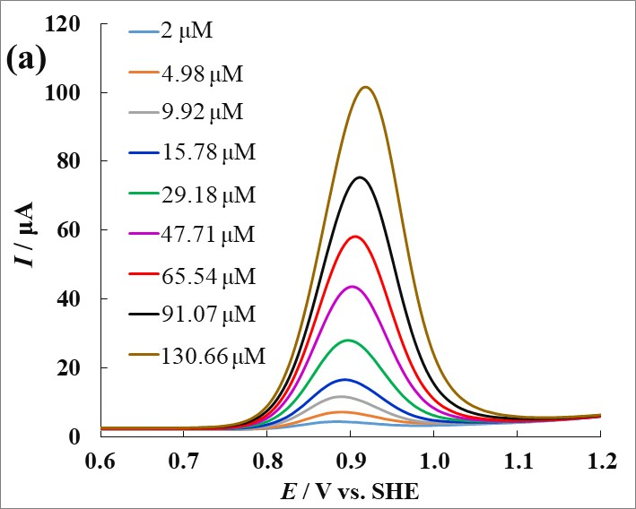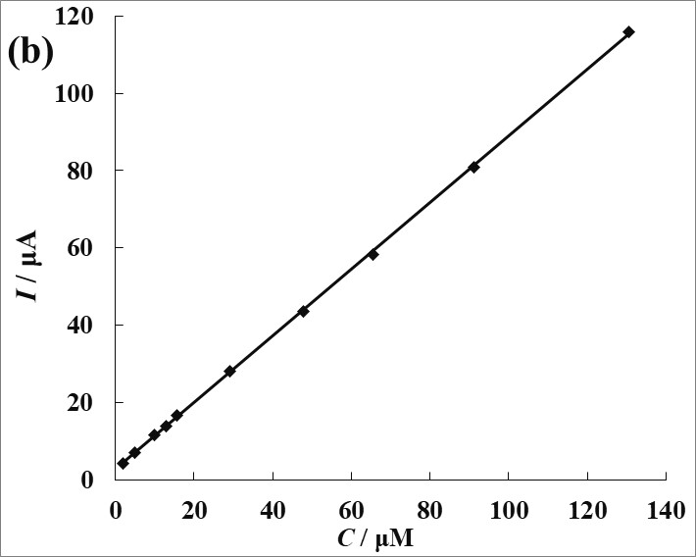

Fig. 7. DPV for different concentrations of PCM in a B-R solution (0.04 M) (a); Calibration curve of PCM in a B-R buffer solution (0.04 M) (b)

3.4 Treatment of wastewater containing chloride

This section discusses the treatment of wastewater containing PCM using electrochemical and sono-electrochemical methods on a BDD electrode, both in the presence and absence of chloride. The analytical technique used to carry out our work is differential pulse voltammetry (DPV).

3.4.1 Electrochemical treatment

The effect of chloride concentration was investigated on PCM oxidation at a concentration of 10 mM in 0.3 M sulfuric acid at 70 mA/cm². The curves obtained by DPV are associated with PCM oxidation peaks that decrease during treatment, as shown in Fig. 8. This oxidation increases with chloride concentration.

The analysis of these results led us to Fig. 9, which highlights the influence of chloride concentration on PCM oxidation. We note in this figure an increase in the mineralization kinetics of PCM as the chloride concentration increases. Furthermore, the oxidation rates associated with each concentration were determined, yielding the following values: 65%, 78%, 84%, and 90% for 0, 10, 50, and 100 mM chloride, respectively. This can be explained by the presence of chloride in the solution, which improves the PCM oxidation (Villanueva-Rodríguez 2012).

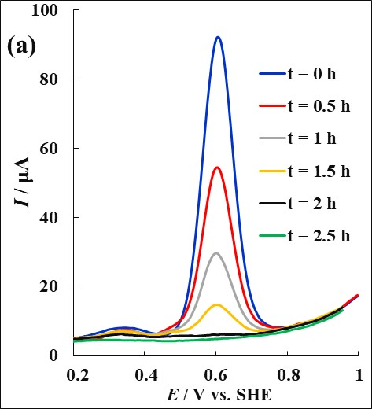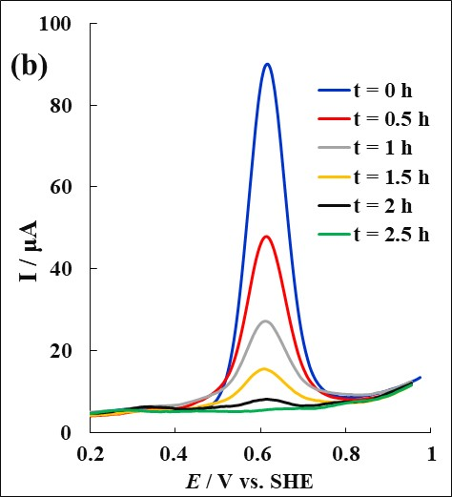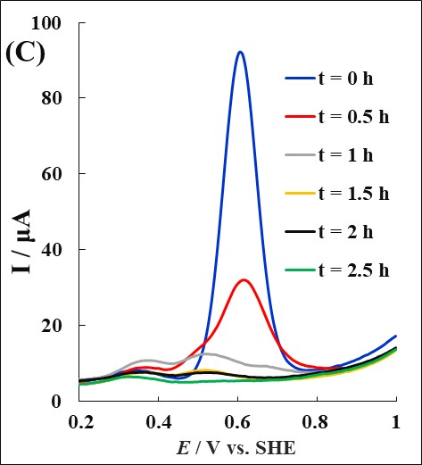

Fig. 8. PCM Electrolysis (10 mM) in sulfuric acid (0.3 M) in the presence of chloride (10 mM) (a); 50 mM (b); 100 mM (c); j = 70 mA/cm²

The analysis of these results led us to Fig. 9, which highlights the influence of chloride concentration on PCM oxidation. We note in this figure an increase in the mineralization kinetics of PCM as the chloride concentration increases. Furthermore, the oxidation rates associated with each concentration were determined, yielding the following values: 65%, 78%, 84%, and 90% for 0, 10, 50, and 100 mM chloride, respectively. This can be explained by the presence of chloride in the solution, which improves the PCM oxidation (Villanueva-Rodríguez 2012).

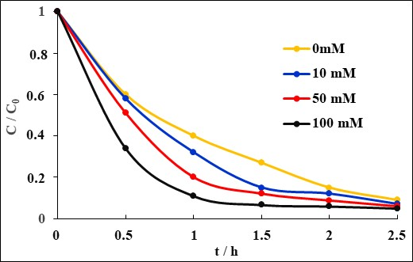

Fig. 9. Influence of chloride concentration on the electrolytic oxidation of PCM (10 mM) in sulfuric acid (0.3 M); j = 70 mA/cm²

3.4.2 Sono-electrochemical treatment

PCM electrolysis was also performed by combining sono-electrochemistry and the action of chloride in order to optimize PCM oxidation. This resulted in Fig. 10, which shows the DPV curves associated with the electrochemical (a) and sono-electrochemical (b) treatment of PCM in the presence of 100 mM chloride. This figure shows a low peak current intensity for PCM in the sono-electrochemical treatment compared to the electrochemical treatment after 0.5 h.

From these results, we were able to determine the evolution of the PCM concentration during electrolysis, as shown in Fig. 11. This figure shows that the oxidation kinetics of the sono-electrochemical treatment are faster than those associated with electrochemistry. In order to obtain a range of information on this oxidation in the presence of chloride, we determined, after 1.5 hours of treatment, oxidation rates of 65%, 90%, and 96% respectively for electrochemistry, electrochemistry in the presence of chloride, and sono-electrochemistry in the presence of chloride. These results can be explained by the fact that, in addition to the production of oxidative species such as hypochlorous ions and chlorine, we also have the production of other oxidative species resulting from sonochemistry. At this level, we also note that with sono-electrochemistry, the fraction of current applied is greater, as illustrated in Fig. 12.

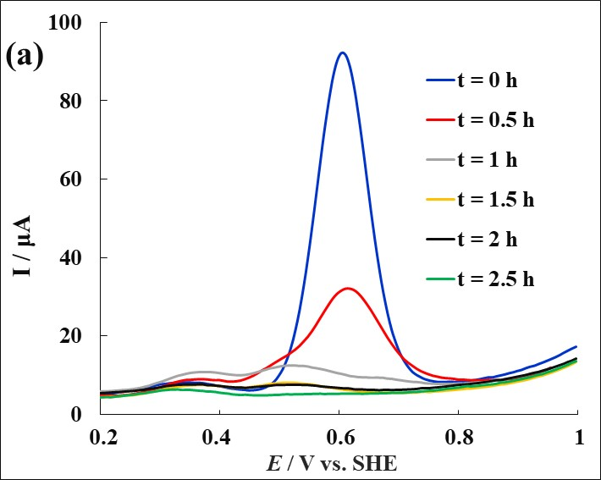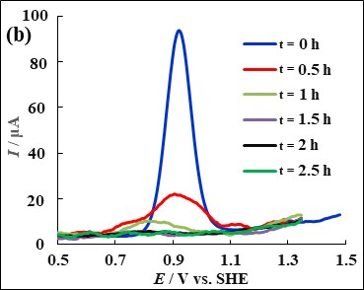

Fig. 10. DPV curves of electrochemical (a) and sono-electrochemical (b) oxidation of PCM (10 mM) in the presence of chloride (100 mM); j = 70 mA/cm²; N = 35 kHz; D = 2.7 mL/s

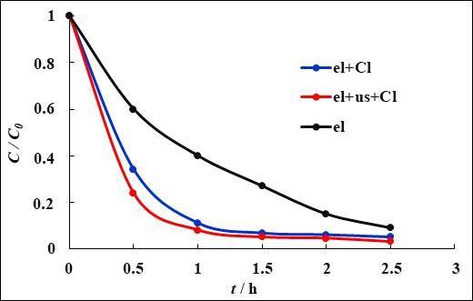

Fig. 11. Evolution of PCM concentration during electrochemical and sono-electrochemical oxidation in the presence of chloride (100 mM); j = 70 mA/cm²; N = 35 KHz; D = 2.7 mL/s; j = 70mA/cm²; N = 35 KHz; D = 2.7 mL/s

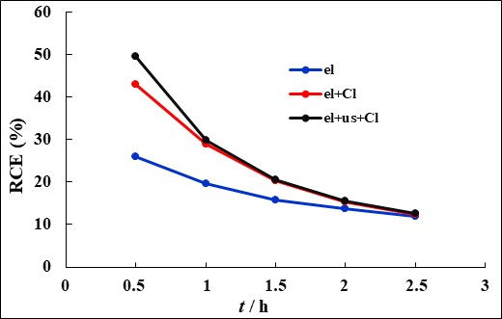

Fig. 12. Effect of sonochemistry on the evolution of current yield as a function of treatment time for a solution containing 10 mM PCM and 100 mM Cl⁻; Anode: DDB (63 cm²) and cathode: Zr. j = 70 mA cm². V = 250 mL

4. Conclusion

Characterization of the electrode (BDD) showed that it has a quasi-metallic character due to its boron doping. The redox kinetics at the electrode are controlled by diffusion. There is no surface oxide formation, attesting to the inert character and high resistance of the electrode to acid corrosion. The electrode has a quasi-metallic character and is capable of detecting trace amounts of paracetamol. In addition, it has been shown that the electrode can be used to effectively oxidize paracetamol. After 1.5 hours of treatment, the oxidation rates were 65% and 90% for electrochemistry, 96% for electrochemistry in the presence of 100 mM chloride and sono-electrochemistry in the presence of 100 mM chloride, respectively. This demonstrated that chloride contribute to improving the oxidation rate of pollutants using these methods. It should also be noted that combining electrochemical and sono-chemical methods significantly improves the oxidation rate of PCM. Looking ahead, we plan to use sono-electrochemistry for the treatment of real wastewater.

DISCLAIMER (ARTIFICIAL INTELLIGENCE)

Author(s) hereby declare that NO generative AI technologies such as Large Language Models (ChatGPT, COPILOT, etc) and text-to-image generators have been used during writing or editing of this manuscript.

References

Adeshina, T.A. & Abdul, R.M.K. (2025). Ephesus of, Numerical exploration of sewage dispersion into a channel conveying water: Considering filtration and biodegradation as treatment mechanisms. International Communications in Heat and Mass Transfer, 163, 108690

Ahoulé, D.G., Ohou-Yao, M.J.A., Yapo, O.B., Gnagne, A.E.J.E.Y. & Mambo, V. (2017). Caractérisation hydrochimique de la nappe phréatique de la ville d’Abidjan : cas des communes d’Abobo, d’Attécoubé, de Koumassi et de Yopougon. Journal de la Société Ouest-Africaine de Chimie, 044, 51 – 57

Appia, F.T.A., Gnamba, C.Q.-M., Kambiré, O., Berté, M., Sadia, S.P., Sanogo, I. & Ouattara, L. (2016). Electrochemical Oxidation of Amoxicillin in Its Commercial Formulation on Thermally Prepared RuO₂/Ti. Journal of Electrochemical Science and Technology, 7 (1) 82-89

Bottari, F., Moro, G., Sleegers, N., Florea, A., Cowen, T., Piletsky, S., Nuijs, AV, ALNK & Wael, K.D. (2020). Electropolymerized o-phenylenediamine on graphite promoting the electrochemical detection of nafcillin. Electroanalysis, 32, 135-141

Ersin, D. & Silah, H. (2020). Development of a new analytical method for determination of veterinary drug oxyclozanide by electrochemical sensor and its application to pharmaceutical formulation. Chemosensors, 8(2), 25

Fernández, M.L., Pintelon, R. & Hubin, A. (2014). A new modeling method for determining electrochemical parameters from LSV experiment using the stochastic noise. Journal of Electroanalytical Chemistry, 720, 147-155

Gnamba, C.Q., Appia, F.T.A., Loba, E.M.H., Sanogo, I. & Ouattara, L. (2015). Electrochemical Oxidation of Amoxicillin in Its Pharmaceutical Formulation at Boron Doped Diamond (BDD) Electrode. Journal of Electrochemical Science and Engineering, 5, 129-143

Kambire, O., Pohan, L.A.G., Appia, F.T.A. & Ouattara, L. (2015a). Anodic Oxidation of Chlorides on Platinum Modified by Metallic Oxides. Int. J. Pure Appl. Sci. Technol., 27(1), 27-43

Kambire, O., Appia, F.T.A. & Ouattara, L. (2015b). Oxygen and chlorine evolution on ruthenium dioxide modified by platinum in acid solutions. Revue Ivoirienne des Sciences et Technologie, 25, 21 – 33.

Kambire, O., Pohan, L.A.G., Appia, F.T.A., Gnamba, C.Q.-M., Kondro, K.H. & Ouattara, L. (2015c). Influence of various metallic oxides on the kinetic of the oxygen evolution reaction on platinum electrodes. Journal of Electrochemical Science and Engineering. 5(2), 79-91.

Kambiré, O., Pohan, L.A.G., Sadia, S.P., Kouadio, K.E. & Ouattara, L. (2020). Voltammetric study of formic acid oxidation via active chlorine on IrO₂/Ti and RuO₂/Ti electrodes. Mediterranean Journal of Chemistry, 10(8), 799-808
Kambiré, O., Alloko, K.S.P., Pohan, L.A.G., Koffi, K.S. & Ouattara, L. (2021). Electrooxidation of the Paracetamol on Boron Doped Diamond Anode Modified by Gold Particles. International Research Journal of Pure & Applied Chemistry, 22(4): 23-35.

Kambiré, O., Abollé, A., Kouakou, A.R., Koffi, A.E., Koffi, K.S., Kouadio, K.E., Kimou, K.J., Koné, S. & Ouattara, L. (2022a). Oxidation of rhodamine B using the Fenton process: optimization, kinetics and inorganic ions studies. Journal de la Société Ouest-Africaine de Chimie, 051, 45 – 55.

Kambiré, O., Pohan, L.A.G., Konan, K.F., Mohamed, B., Gnamba, C.Q.-M. & Lassiné, O. (2022b). Behavior of boron-doped diamond anode on methyl orange oxidation, Journal of Materials and Environmental Science. J. Mater. Environ. Sci., 13(11) 1264-1277

Kambiré, O., Manouan, W.M.R., Kouyaté, A., Kouakou, Y.U., Berté, M., Gnamba, C.Q.-M., Koffi, K.S. & Kimou, K.J. (2024). Degradation of Amoxicillin in Water by Fenton, Photo-fenton and Photocatalysis Using Copper Oxide. Asian Journal of Chemical Sciences, 14 (6) 84-97

Koné, Y.T., Abollé, A., Kambiré, O., Koffi, K.S., Kouadio, K.E. & Kimou, K.J. (2024). Removal of methyl orange in Aqueous Media using two clays from Côte d'Ivoire. Mediterranean Journal of Chemistry, 2024, 15(1), 44-55

Kouadio, K.E., Kambiré, O., Koffi, K.S. & Ouattara, L. (2021). Electrochemical oxidation of paracetamol on boron-doped diamond electrode: analytical performance and paracetamol degradation. Journal of Electrochemical Science and Engineering, 11(2) 71-86

Marc, P.-T., Verónica, G.-M., Miguel, A.B., Jaime, G. & Santiago E. (2004). Degradation of chlorophenols by means of advanced oxidation processes: a general review. Applied Catalysis B: Environmental, 47(4) 219-256

Maria, S., Rashamn, R. & Asmat, A. (2025). Chapter 1 - Fundamentals of acoustic cavitation, ultrasound-assisted processes, and sonochemistry. Modeling and Simulation of Sono-Processes, 3-17

Placide, S.S., Mohamed, B., Hélène, L.E.M., Auguste, A.F.T., Quand-Meme, G.C., Sanogo, I. & Ouattara, L. (2016). Assessment of the Physico chemical and Microbiological Parameters of a Teaching Hospital’s Wastewaters in Abidjan in Côte d’Ivoire. Journal of Water Resource and Protection, 8, 1251-1265

Pourkodee, D., Christina, R.J., Renuka, D.D., Muthukrishnan, R.M. & Sailatha E. (2025). Sustainable Solutions: ZnO Nanoparticles for Enhanced Photocatalytic Treatment of Paracetamol and Diclofenac. Water Air Soil Pollut 236, 309

Sadia, S.P., Berte, M. & Ouattara, L. (2020). Removal of antibiotics containing simulated wastewater by biological-photochemical process. Rev. Ivoir. Sci. Technol., 35, 111 – 120.

Tudi, M., Yang, L., Li, W., Wei, B., Gu, L., Yu, J., Li, H., Xue, Y., Wang, F., Li, L., Yu, Q.J., Ruan, H.D. & Connell, D. (2025). Simulating the effects of drip and flood irrigation on the leaching, migration, and redistribution of heavy metals in contaminated soil. Eco-toxicology and Environmental Safety, 294, 118057
Villanueva-Rodríguez, M. (2012). Characterization of ferrate ion electrogeneration in acidic media by voltammetry and scanning electrochemical microscopy. Assessment of its reactivity on 2,4-dichlorophenoxyacetic acid degradation. Electrochimica Acta, 64, 196– 204.

Wu, S., Zhang, L. & Chen, J. (2012). Paracetamol in the environment and its degrada-tion by microorganisms. Appl Microbiol Biotechnol, 96, 875–884 (2012).

Yuxiao, J., Chao, H., Aoyu, Z., Huiyang, Q., Benyi, C. & Jian, X. (2025) Effectiveness of various chemical leaching systems in the remediation of chromium-contaminated soil and their impact on chromium speciation, Journal of Environmental Sciences, 157, 77-89

