Assessing Aquaponic Performance in Himachal Pradesh

ABSTRACT
Aquaponics, an integrated system that combines hydroponics and aquaculture, provides a sustainable method of producing food by effectively recycling nutrients and conserving water. Coriandrum sativum, Spinacia oleracea, Chenopodium album, and Common Carp (Cyprinus carpio) and Grass Carp (Ctenopharyngodon idella) were supported by nutrient film technique (NFT) pipes in the aquaponic system. Temperature (16.33 ± 4.90 °C), pH (7.60 ± 0.21), dissolved oxygen (6.59 ± 0.16 mg/L), and ammonia (0.0017 ± 0.0007 mg/L) all stayed within ideal values in aquaponics, indicating efficient nutrient cycling and stable environmental conditions. While modest correlations for ammonia and nitrite demonstrated better nitrogen management in aquaponics, strong positive correlations (R² > 0.89) for pH, EC, DO, alkalinity, and nitrate showed comparable stability across aquaponic and pond systems. With net weight improvements of 113.45 g and 141.3 g and FCR values of 2.68 and 3.34, respectively, C. carpio and C. idella demonstrated noteworthy fish development. When compared to field cultivation (35.01 cm), aquaponics considerably increased plant growth, especially for C. album (44.5 cm). These results show that in temperate Himalayan circumstances, aquaponics maintains superior water quality, promotes fish growth, and increases vegetable yield. According to the study's findings, aquaponics is a practical, resource-efficient, and climate-resilient substitute for traditional farming and aquaculture systems in areas with limited water and land. Current research exhibits potential of aquaponics as a sustainable farming method which further enhances water efficiency and food security amidst global land constrains.
Keywords: Aquaponics; Fish growth; Plant yield; Nutrient film technique (NFT); Sustainable aquaculture.

1.INTRODUCTION
Aquaponics: A Sustainable Food Production Method
Aquaponics combines hydroponics and aquaculture to create a mutually beneficial system. Fish produce waste that serves as nutrients for plants, while plants purify the water for the fish. Aquaponics offers a promising solution for sustainable food production, promoting efficient resource use and minimizing environmental harm. This method serves as an environmentally sustainable alternative to conventional aquaculture and agriculture by maximizing resource efficiency, minimizing environmental impact, and reducing water consumption. (Azad, 2015; Roe and Midmore, 2008).
Aquaponics has drawn interest worldwide as a climate-resilient method of ensuring food security, especially in areas where land and water are scarce. It offers the twin advantages of producing fish and vegetables in a closed-loop system and permits year-round growing. Aquaponics' increasing popularity has led to comparisons with conventional pond systems to determine how well it maintains water quality, fosters fish growth, and increases plant productivity (Azad et al., 2016).
Unfortunately, climatic variations, land constrains, depleted soils and rising input costs is affecting the agriculture scenario of Himachal Pradesh. Aquaponics presents prospective benefits because of its controlled nutrient recycling and water conservation in Himachal Pradesh, where aquaculture is an increasing livelihood alternative. Even though they are well-established, traditional pond systems can encounter problems such as fertilizer buildup, oxygen depletion, and water loss from seepage and evaporation. According to Roe and Midmore (2008) and Azad (2015), investigations comparing aquaponic and pond systems are therefore essential to determining the relative effectiveness and sustainability of both techniques under local conditions.
Previous research has demonstrated that, due to their continuous water filtration and recirculation, aquaponic systems tend to maintain more stable physicochemical parameters—such as temperature, pH, and dissolved oxygen (DO)—compared to conventional pond systems.Additionally, these systems ensure reduced nitrite and ammonia accumulation, thereby improving fish growth and survival rates (Azad et al., 2016).Furthermore, the availability of nitrate-rich water promotes rapid plant growth and enhances overall productivity.
To confirm these advantages in temperate Himalayan circumstances, where temperature swings and water sources are different from those in tropical areas, local assessments are necessary. In order to assess the relative sustainability and efficiency of aquaponic and pond systems in Palampur, Himachal Pradesh, the current study will compare them with an emphasis on water quality metrics, fish development performance, and vegetable output.
2. MATERIALS AND METHODS
This study was conducted at Sri Sai University, Palampur, where a specially designed handmade aquaponics system was developed and implemented to investigate the research questions.
2.1Experimental Design
The aquaponics setup comprised twin tanks: one stocked with Common Carp (Cyprinus carpio) and the other with Grass Carp (Ctenopharyngodon idella). Water circulation was maintained using suitable pumps, while trickling filters ensured filtration and water treatment. Nutrient Film Technique (NFT) pipes were used to support plant growth and maximize nutrient uptake, creating a self-sustaining aquaponics ecosystem. For the aquaponic setup (Fig. 3), a circular fibre-reinforced plastic (FRP) tank with a water-holding capacity of 750 L was used. The FRP tank measured 0.9 m in height. Water from the fish culture tank was continuously circulated over the trickling filter bed. A pump (VarSky Heavy Duty 0.25 HP, manufactured by Peerzada and Co.) was employed, featuring a volumetric flow rate (Q<sub>max</sub>) of 1100 L h⁻¹, a head (H<sub>max</sub>) of 1.85 m, and a power consumption of 22 W.
The trickling filter was constructed using gravel (10–25 mm in diameter) placed inside a plastic bucket. Water from the fish tank was piped into the filter bed, then channelled to the Nutrient Film Technique (NFT) pipes. The water flowing through the NFT system was subsequently returned to the fish tank, thereby maintaining a continuous recirculating system.

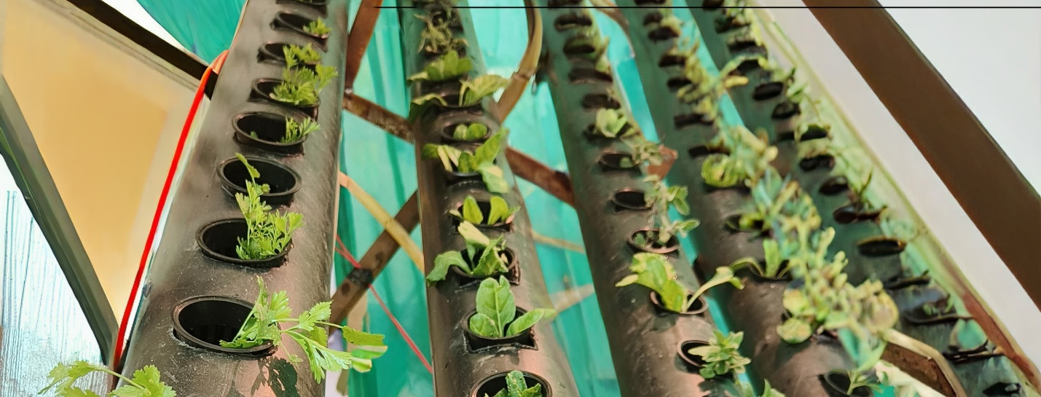
Fig.1: Plants in NFT
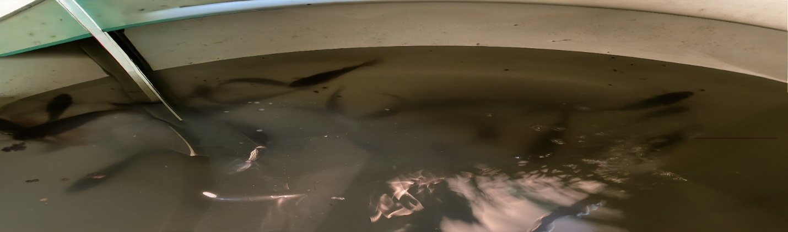
Fig. 2: Fishes in tank
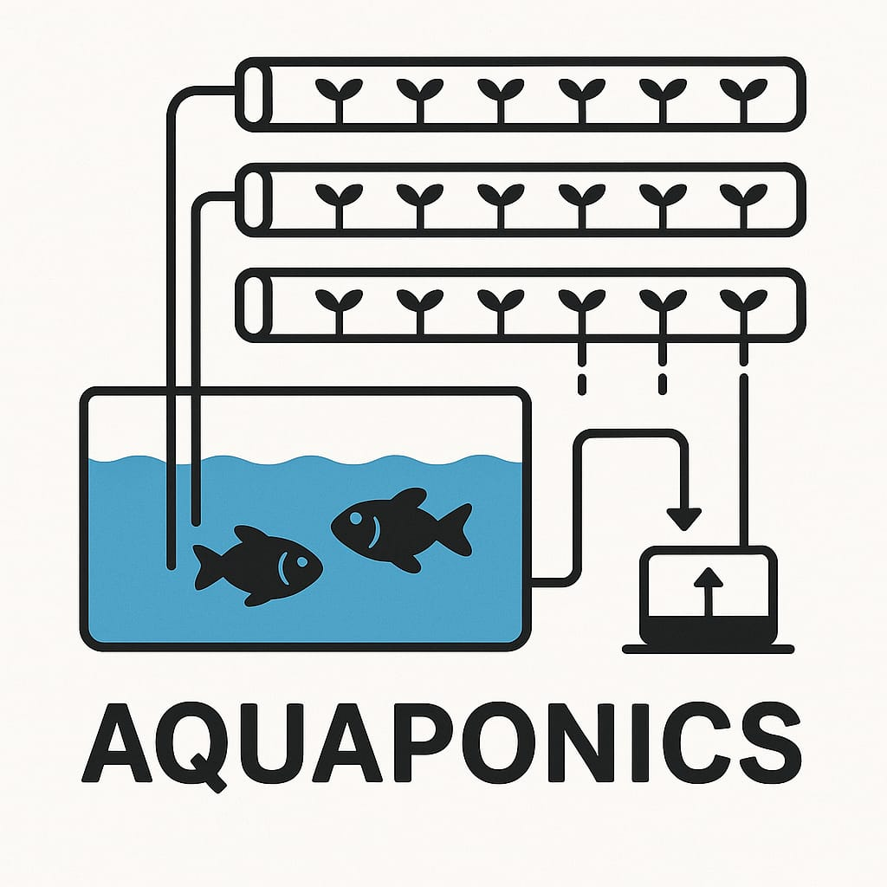
Fig. 3: Aquaponics setup

2.2Fish Used in Experiment
Each tank was stocked with 50 fingerlings of either Cyprinus carpio or Ctenophayngodon idella were sourced from Arjun fish farm, Palampur, HimachalPradesh, with an average length of 9.8±0.87 cm

.2.3Fish Diet
Fish were fed a commercial floating feed (Acuastar 42 Carat Gold Standard, ABIS Exports, India) at 7% of body weight, twice.
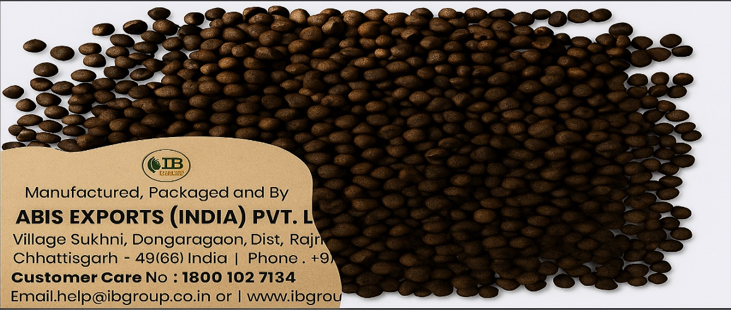
Fig. 4: Feed given to fishes

2.4Plants in Experimental Setup
NFT pipes were populated with the following plants 10 days after germination:
Table 1: Plants Used in Experiment
Botanical Name | Common Name | Local Name
Coriandrum sativum | Coriander | Dhania
Spinacia oleracea | Spinach | Palak
Chenopodium album | White Goosefoot | Bathua saag
Control: Soil-based plots (3 × 2 m²) cultivated the same plant species under standard agronomic practices without aquaponic inputs.

2.5Fish Growth Measurement
Growth performance was evaluated using:
- Length growth (cm): Final length – Initial length
- Weight growth (g): Final weight – Initial weight
- Specific Growth Rate (SGR %): [(ln Wt – ln Wo)/t] × 100
- Feed Conversion Ratio (FCR): Total feed / Weight gain

2.6Plant Growth Measurement
Plant growth was measured as length increase (cm): Final length – Initial length.

2.7Water Quality Protocols
Water quality monitoring was conducted twice a week to ensure optimal conditions in the tank. The water quality parameters were assessed by using modified conventional APHA (2005) procedures.

- Temperature: Measured with thermometer (±0.1°C)
- pH: Standardized digital pH meter
- Electrical Conductivity (EC): Digital conductivity meter, μS/cm
- Dissolved Oxygen (DO): Winkler titration method
- Total Alkalinity: Titration with 0.01 N HCl using phenolphthalein and methyl orange indicators
- Ammonia: Nesslerization method, optical density at 410 nm
- Nitrite: Sulphanilamide and aromatic amine reagents, absorbance at 543 nm
- Nitrate: Phenoldisulphonic acid method, absorbance at 410 nm

2.8Data Analysis
Fish and plant growth metrics, along with water quality parameters, were compiled, analyzed, and presented graphically using Microsoft Excel 365.

3.RESULTS
3.1Water Quality in Aquaponics and Pond System
With an average temperature of 16.33 ± 4.90 °C, pH of 7.60 ± 0.21, dissolved oxygen of 6.59 ± 0.16 mg/L, electrical conductivity of 157.15 ± 3.20 µS/cm, and alkalinity of 114.28 ± 7.04 mg/L, the aquaponic system maintained consistent and positive water quality characteristics. Fish health and efficient nutrient cycling were supported by ammonia (0.0017 ± 0.0007 mg/L), nitrate (0.060 ± 0.014 mg/L), and nitrite (0.045 ± 0.009 mg/L) being within optimum values. The average water temperature in the pond system was 16.55 ± 5.50 °C, the pH was slightly lower at 7.12 ± 0.44, and the dissolved oxygen was higher at 7.70 ± 0.58 mg/L. EC (178.8 ± 8.07 µS/cm) and alkalinity (120.9 ± 3.61 mg/L) were slightly higher than in aquaponics; ammonia (0.0022 ± 0.0018 mg/L), nitrate (0.059 ± 0.015 mg/L), and nitrite (0.042 ± 0.010 mg/L) were all kept within safe limits(Table 2).
Table 2: Average Values of water parameters in aquaponic setup and pond system recorded during the experiment
S.No. | Parameters | Average Value | Average  Value | Standard Value
01 | Air temperature (°C) | 19.22±25.63
02 | Water temperature (°C) | 16.33±4.90 | 16.55±5.50 | 15-30 °C (Anita and Pooja, 2013)
03 | pH | 7.60±0.21 | 7.12±0.44 | 7.5-9 (Zou et al., 2016)
04 | Dissolved oxygen (DO) (mg/l) | 6.59±0.16 | 7.70±0.58 | >5 mg/l (Masser et al.,1999)
05 | Electrical conductivity (uS/cm) | 157.15±3.201 | 178.8±8.07 | 100-2000 uS/cm (Stone and Thomforde, 2004)
06 | Alkalinity (mg/l) | 114.28±7.04 | 120.9±3.61 | 5-200 mg/l (Eissa et al.,2015).
07 | Ammonia (mg/I) | 0.0017±0.0007 | 0.0022±0.0018 | <1 mg/l (Nijhof and Bovendeur, 1990)
08 | Nitrate (mg/l) | 0.060±0.014 | 0.059±0.015 | 0.1 mg/l (Rakocy et al.,2000)
09 | Nitrite (mg/I) | 0.045±0.009 | 0.042±0.010 | 0.1 mg/l (Rakocy et al.,2006)

3.2Correlation Between Systems
Strong positive correlations (R² > 0.89) were observed for pH, EC, DO, alkalinity, and nitrate. Weak correlations were found for ammonia (R² = 0.02) and nitrite (R² = 0.00), indicating different nitrogen cycling processes (Table 3).

Table 3: Comparison results of Aquaponics and Pond parameters
Parameters | R² | Correlation strength | Interpretation
Water temperature (°C) | 0.63 | Moderate correlation | Aquaponics and pond temps somewhat aligned, but with noticeable variation
Ph | 0.93 | Very strong correlation | Excellent predictive alignment between systems.
Dissolved oxygen (DO) (mg/l) | 0.89 | Strong correlation | Good correlation, though slightly lower than pH/Alk/Nitrate.
Electrical conductivity (uS/cm) | 0.97 | Excellent correlation | EC shows the strongest relationship of all parameters.
Alkalinity (mg/l) | 0.93 | Very strong correlation | High consistency across both setups.
Ammonia (mg/I) | 0.02 | No correlation | Essentially no predictive relationship present.
Nitrate (mg/l) | 0.93 | Very strong correlation | Strong linear relationship
Nitrite (mg/I) | 0.00 | No correlation | No linear correlation detected.

3.3Fish Growth Performance
Significant improvements in length and weight were observed in the growth performance of various fish species during the study period, indicating the efficacy of the feeding schedules and rearing circumstances. In Tank 1, Cyprinus carpio's net length increased by 7.04 cm, from 15.24 ± 0.058 cm to 22.28 ± 0.22 cm; in Tank 2, Ctenopharyngodon idella's net length increased by 7.8 cm, from 17.11 ± 0.11 cm to 24.91 ± 0.086 cm. According to weight gain analysis, under the corresponding conditions, Cyprinus carpio gained 113.45 g and Ctenopharyngodon idella gained 141.3 g. These findings underscored the significance of customized management techniques in aquaculture by highlighting species-specific reactions to environmental and nutritional variables. Regular monitoring of length and weight served as a reliable indicator of health and productivity offering valuable insights for optimizing future system designs and feeding protocols (Table 4).

Table 4: Weight and Length gain of fish during this experiment
Fish Species  →  No. of  Weeks ↓ | Cyprinus carpio (Tank – 1) |  | Ctenapharyngodon idella (Tank - 2)
Fish Species  →  No. of  Weeks ↓ | Net length gain  (cm) | Net weight gain  (g) | Net length gain  (cm) | Net weight gain  (g)
Initial weight | 15.24±0.058 | 45.457±0.4314 | 17.11±0.113 | 55.7±0.3872
1-2 weeks | 16.33±0.212 | 52.49±1.3536 | 18.30±0.264 | 63.9±0.2943
3-4 weeks | 17.07±0.266 | 60.29±0.57997 | 19.12±0.243 | 73.5±0.34156
5-6 weeks | 17.83±0.229 | 69.35±0.64743 | 19.91±0.244 | 84.5±0.3559
7-8 weeks | 18.57±0.241 | 79.55±0.64355 | 20.70±0.242 | 97.057±0.59681
9-10 weeks | 19.32±0.231 | 91.505±0.61228 | 21.49±0.244 | 111.45±0.3994
11-12 weeks | 20.06±0.227 | 104.82±0.7674 | 22.31±0.285 | 128.53±0.5099
13-14 weeks | 20.79±0.237 | 120.362±0.63429 | 22.07±0.243 | 148.5±0.5099
15-16 weeks | 21.58±0.181 | 138.13±0.7229 | 23.87±0.243 | 170.75±0.5563
17-18 weeks | 22.28±0.226 | 159.5±0.565 | 24.91±0.086 | 197±0.7937
Net gain | 7.04 | 113.45 | 7.8 | 141.3

3.4Assessment of Specific Growth Rate and Food Conversion Ratio
Under controlled experimental settings, the evaluation of Specific Growth Rate (SGR) and Food Conversion Ratio (FCR) offered thorough insights into the feed utilization and growth efficiency of Cyprinus carpio and Ctenopharyngodon idella. In Tank 1, Cyprinus carpio showed an SGR of 0.0098 and an FCR of 2.68, indicating modest growth efficiency and comparatively successful feed conversion. On the other hand, in Tank 2, Ctenopharyngodon idella showed a somewhat higher SGR of 0.0100 but a less desirable FCR of 3.34, indicating faster development but lower feed efficiency. Growth performance and economical feed use must be balanced, as demonstrated by the interaction between SGR and FCR and the species-specific metabolic and nutritional responses. These findings underscored the importance of selecting species not only based on growth potential but also on their feed conversion efficiency to enhance the sustainability and profitability of aquaculture operations (Table 5).

Table 5: SGR and FCR during this experiment
Fish Species →  No. of  Weeks ↓ | Cyprinus carpio (Tank 1) |  | Ctenopharyngodon idella (Tank – 2)
Fish Species →  No. of  Weeks ↓ | SGR FCR |  | SGR FCR
1-2 weeks | 1.31 | 2.5 | 1.15 | 3.2
3-4 weeks | 1.14 | 2.6 | 1.07 | 3.25
5-6 weeks | 1.07 | 2.7 | 1.23 | 3.3
7-8 weeks | 1.00 | 2.65 | 1.32 | 3.4
9-10 weeks | 1.51 | 2.8 | 1.00 | 3.35
11-12 weeks | 1.23 | 2.75 | 1.41 | 3.5
13-14 weeks | 1.41 | 2.9 | 1.64 | 3.15
15-16 weeks | 1.73 | 2.75 | 1.51 | 3.6
17-18 weeks | 1.62 | 2.57 | 1.71 | 3.31
Average | 0.0098 | 2.68 | 0.0100 | 3.34

3.5PLANT GROWTH PERFORMANCE
Tank 1 Coriandrum sativum, Spinacia oleracea, and Chenopodium album reached 40.35 cm, 23.43 cm and 43.19 cm respectively, Tank 2 showed similar growth. In contrast, the same plants in soil-based cultivation grew to 38.34 cm, 18.88 cm and 35.01 cm respectively, confirming superior performance in aquaponic systems (Table 6).

TABLE 6: PLANT LENGTH GAIN DURING EXPERIMENT (Tank 1,2 and Field )

 | TANK – 1 |  |  | TANK – 2 |  |  | FIELD
Plant  Species  No. →  of weeks  ↓ | Coriandrum  sativum | Spinacia  oleracea | Chenopodium  album | Coriandrum  sativum | Spinacia  oleracea | Chenopodium  album | Coriandrum  sativum | Spinacia  oleracea | Chenopodium  album
Initial height | 1.26±0.15 | 1.37±0.06 | 1.37±0.06 | 1.25±0.16 | 1.38±0.07 | 1.39±0.06 | 1.26±0.14 | 1.22±0.05 | 1.29±0.06
7 days | 1.77±0.20 | 1.76±0.19 | 2.10±0.37 | 1.75±0.18 | 1.79±0.17 | 2.16±0.37 | 1.72±0.18 | 1.45±0.03 | 1.76±0.13
21 days | 6.03±0.70 | 7.01±0.27 | 7.57±0.26 | 6.04±0.67 | 7.04±0.27 | 7.62±0.26 | 5.75±0.13 | 4.68±0.24 | 4.26±006
35 days  (1st harvest) | 14.71±0.20 | 17.5±0.28 | 16.55±0.25 | 14.72±0.20 | 17.66±0.21 | 16.60±0.22 | 13.7±0.14 | 10.0±0.08 | 8.33±0.14
56 days  (2nd harvest) | 21.6±0.29 | 15.4±0.32 | 14.7±0.13 | 21.6±0.28 | 15.6±0.31 | 14.7±0.12 | 19.5±0.31 | 14.7±0.12 | 16.2±0.08
77 days  (Slow growth) | 24.5±0.29 | 14.0±0.41 | 21.5±0.30 | 24.4±0.27 | 14.1±0.45 | 21.6±0.24 | 20.3±0.15 | 16.7±0.16 | 24.4±0.24
105 days | 39.5±0.36 | 18.3±0.51 | 29.4±0.38 | 39.6±0.36 | 18.4±0.47 | 29.7±0.31 | 31.6±0.19 | 18.6±0.24 | 32.2±0.11
126 days  (full maturity) | 41.6±02.9 | 24.8±0.17 | 44.5±0.27 | 41.6±0.24 | 24.6±0.23 | 44.7±0.20 | 39.7±0.14 | 20.1±0.14 | 36.3±0.22
Net length gain | 40.35 | 23.43 | 43.19 | 40.39 | 23.3 | 43.32 | 38.34 | 18.88 | 35.01

3.6Comparative Analysis of Plant species
The comparative analysis of plant species growth under aquaponics and field conditions revealed a consistent trend of enhanced development within the aquaponic environment. Chenopodium album exhibited the most pronounced difference with a substantial height increase of approximately 9 cm compared to its field counterpart highlighted the benefits of continuous nutrient availability and optimal water conditions in the aquaponic system. Similarly, Coriandrum sativum thrived slightly better in aquaponics, suggesting that even moderately demanding crops respond positively to the system's balanced ecological setup. Although Spinacia oleracea displayed the least variation in height its improved performance in aquaponics still underscored the system’s efficiency in supporting diverse plant types. Overall, the data affirmed aquaponics as a promising alternative to conventional agriculture capable of boosting plant productivity through resource-efficient and environmentally controlled cultivation practices (Fig. 5).

Fig. 5: Comparison of plant growth in Aquaponics Tanks and Field

4.DISCUSSION
The findings of this study indicate that aquaponic systems outperform traditional pond and field methods in sustaining optimal water parameters, facilitating better fish growth, and enhancing overall plant yield. Throughout the experimental period, key water parameters in the aquaponic system—such as pH (7.4–7.9), electrical conductivity (153.9–162.8 µS/cm), dissolved oxygen (6.59 ± 0.16 mg/L), and alkalinity (114.28 ± 7.04 mg/L)—remained within optimal ranges for aquaculture and plant cultivation. These findings aligned with the recommended standards for recirculating aquaculture systems and highlighted aquaponics’ capability to regulate water conditions through natural filtration and nutrient cycling (Rakocy et al., 2006; Boyd,2015). The pH range, although slightly higher than ideal for plants remained within the tolerable limits for both fish and flora thereby ensuring system sustainability (Sharma et al., 2025).
In terms of fish performance, Cyprinus carpio and Ctenopharyngodon idella both showed steady growth throughout the 18-week experimental period Ctenopharyngodon idella attained a higher net weight gain (141.3 g) and SGR (0.0100), while Cyprinus carpio demonstrated more efficient feed utilization with a lower FCR of 2.68 compared to 3.34. These results indicate species-specific metabolic efficiencies and suggested that carp particularly Cyprinus carpio may be more economically viable for aquaponic systems due to their better feed conversion ratio.
Plant performance also significantly favored the aquaponic system over field-based cultivation. Among the tested species, Chenopodium album exhibited the highest growth, reaching an average of 44.5 cm in aquaponic tanks compared to 35.01 cm in field conditions. Coriandrum sativum followed with growth of ~41.6 cm in aquaponics versus 38.34 cm in the field, while Spinacia oleracea although showed the least difference still performed better in aquaponics (23.43 cm vs. 18.88 cm). This enhanced growth can be attributed to the consistent nutrient supply, stable water pH, and minimized environmental stresses in aquaponic systems (Somerville et al., 2014; Delaide et al., 2017). The selection of leafy vegetables, which are known for their rapid growth and high nutrient uptake efficiency, further contributed to these outcomes (Endut et al., 2010; Rakocy et al., 2006).
The correlation analysis between aquaponics and pond systems revealed interesting insights. Strong positive correlations were observed for most physicochemical parameters such as pH (R² = 0.93), EC (R² = 0.97), DO (R² = 0.89), alkalinity (R² = 0.93), and nitrate (R² = 0.93), indicating consistent system performance in these aspects. However, negligible correlations were seen for ammonia (R² = 0.02) and nitrite (R² = 0.00), reflecting the more efficient nitrogen cycling and microbial activity in aquaponics, likely due to the presence of biofilters and plant uptake (Lennard & Leonard, 2006; Endut et al., 2010). This variation emphasized the importance of microbial-driven transformations in maintaining water quality and underscores aquaponics’ advantage in managing nitrogenous waste more effectively than conventional pond systems (Rakocy et al., 2006; Roe & Midmore, 2008). These results aligned with recent studies that show aquaponic systems promote more stable microbial nitrification communities, which improve nitrogen cycling and lessen the buildup of harmful substances (Palm et al., 2022).
Moreover, regular monitoring of fish weight and plant height provided valuable insights into health, system efficiency, and overall productivity. This real-time data allowed for proactive adjustments in feeding and management strategies, helping to maintain optimal conditions and improve outcomes (Tidwell & Coyle, 2007; Sallenave, 2016). The enhanced plant and fish performance observed in the integrated setup confirmed the mutual benefits derived from nutrient cycling and biological symbiosis, a core principle of aquaponics.
Finally, the study contributed to the growing body of evidence supporting aquaponics as a viable solution for sustainable food production, especially in water-stressed or land-limited regions such as Himachal Pradesh. National reports and international studies (Goddek et al., 2015; Love et al., 2015) have acknowledged aquaponics for its potential to reduce water usage by over 90%, recycle waste, and meet the increasing demand for fresh, locally produced food. According to recent research, aquaponic systems have shown increased nutrient cycling efficiency through optimized microbial communities (Palm et al., 2022), scalability for both urban and rural food systems (Goddek et al., 2023) and resilience to climate variability. The study's strong performance on biological and environmental criteria supports the idea that aquaponics should be used more widely in integrated land-use planning and sustainable agricultural policy.

5.CONCLUSION
The current study validated the aquaponic system's efficacy and sustainability as an integrated fish and plant production approach. With the exception of ammonia and nitrite, which demonstrated the improved nitrogen management in aquaponics, key water quality measurements stayed within ideal ranges and demonstrated substantial relationships between aquaponics and pond systems. Fish species with healthy growth were Ctenopharyngodon idella and Cyprinus carpio, with Cyprinus carpio demonstrating superior feed efficiency. Certain plant species, such as Coriandrum sativum and Chenopodium album, performed better than those cultivated in the field, highlighting the advantages of nutrient-rich, controlled conditions.
These results encouraged the use of aquaponics, especially in areas like Himachal Pradesh where conventional farming is becoming less viable as a result of urbanization and declining arable land.

COMPETING INTERESTS DISCLAIMER:
Authors have declared that they have no known competing financial interests OR non-financial interests OR personal relationships that could have appeared to influence the work reported in this paper.

ETHICS STATEMENT
All procedures involving fish handling and care complied with institutional and national ethical standards.

Disclaimer (Artificial intelligence)
Option 1:
Author(s) hereby declare that NO generative AI technologies such as Large Language Models (ChatGPT, COPILOT, etc.) and text-to-image generators have been used during the writing or editing of this manuscript.

REFERENCES
Anita, R. & Pooja, M. (2013). Physico-chemical analysis of fish pond water quality in relation to fish growth. International Journal of Environmental Science, 3(4), 1234–1240.
APHA (2005) Standard Methods for the Examination of Water and Wastewater. 21st Edition, American Public Health Association/American Water Works Association/Water Environment Federation, Washington DC.
Azad, A.K. (2015). Comparative performance of aquaponic and pond culture systems for fish and vegetable production. International Journal of Aquatic Science, 6(2), 45–54.
Azad, A.K., Hasan, M.R. & Rahman, M.S. (2016). Assessment of water quality parameters and fish growth in aquaponic and pond systems. Aquaculture Research, 47(8), 2453–2463.
Boyd, C.E. (2015). Water Quality: An Introduction (3rd ed.). Springer, New York.
Delaide, B., Goddek, S., Gott, J., Soyeurt, H. & Jijakli, M.H. (2017). Lettuce (Lactuca sativa L. var. Sucrine) growth performance in complemented aquaponic solution outperforms hydroponics. Water, 9(3), 156.
Eissa, M.A., Ghanem, M.H. & El-Naggar, A.M. (2015). Water quality and fish performance under different alkalinity levels in recirculating aquaculture systems. Egyptian Journal of Aquatic Research, 41(3), 233–239.
Endut, A., Jusoh, A., Ali, N., Wan Nik, W.B. & Hassan, A. (2010). A study on the optimal hydraulic loading rate and plant ratios in recirculating aquaponic systems. Bioresource Technology, 101(5), 1511–1517.
Goddek, S., Delaide, B., Mankasingh, U., Ragnarsdottir, K.V., Jijakli, M.H. & Thorarinsdottir, R. (2015). Challenges of sustainable and commercial aquaponics. Sustainability, 7(4), 4199–4224.
Goddek, S., Joyce, A., Kotzen, B. & Burnell, G.M. (2023). Aquaponics Food Production Systems: Combined Aquaculture and Hydroponic Production Technologies for the Future. Springer, Cham.
Lennard, W.A. & Leonard, B.V. (2006). A comparison of three different hydroponic subsystems (gravel bed, floating and nutrient film technique) in an aquaponic test system. Aquaculture International, 14(6), 539–550.
Love, D.C., Fry, J.P., Genello, L., Hill, E.S., Frederick, J.A., Li, X. & Semmens, K. (2015). An international survey of aquaponics practitioners. PLoS ONE, 9(7), e102662.
Masser, M.P., Rakocy, J.E. & Losordo, T.M. (1999). Recirculating Aquaculture Tank Production Systems: Management of Recirculating Systems. SRAC Publication No. 452.
Nijhof, M. & Bovendeur, J. (1990). Fixed film nitrification characteristics at high ammonia loading rates in airlift reactors. Aquacultural Engineering, 9(3), 237–254.
Palm, H.W., Strauch, S.M. & Goddek, S. (2022). The role of microbial communities in aquaponic nutrient cycling. Aquaculture Reports, 25, 101273.
Rakocy, J.E., Bailey, D.S., Shultz, R.C. & Thoman, E.S. (2000). Update on tilapia and vegetable production in the UVI aquaponic system. In: New Dimensions on Farmed Tilapia: Proceedings of the Fifth International Symposium on Tilapia in Aquaculture, Rio de Janeiro, Brazil, 624–632.
Rakocy, J.E., Masser, M.P. & Losordo, T.M. (2006). Recirculating Aquaculture Tank Production Systems: Aquaponics—Integrating Fish and Plant Culture. SRAC Publication No. 454.
Roe, S.C. & Midmore, D.J. (2008). Sustainable aquaponics: An evaluation of the environmental impact of integrated fish and plant production systems. Aquaculture International, 16(6), 447–458.
Sallenave, R. (2016). Understanding and Maintaining Dissolved Oxygen in Aquaculture Ponds. New Mexico State University, Guide A-129.
Sharma, M., Verma, T., & Sharma, A. (2025). Aquaponic innovations: Optimizing carp growth in polyculture tank with plant diversity in Himachal Pradesh. Indian Journal of Animal Sciences, 95(4), 344–347.
Somerville, C., Cohen, M., Pantanella, E., Stankus, A. & Lovatelli, A. (2014). Small-scale Aquaponic Food Production: Integrated Fish and Plant Farming. FAO Fisheries and Aquaculture Technical Paper No. 589. Rome: FAO.
Stone, N.M. & Thomforde, H.K. (2004). Understanding Your Fish Pond Water Analysis Report. University of Arkansas Cooperative Extension Service, FSA 9090.
Tidwell, J.H. & Coyle, S.D. (2007). Aquaculture production systems. In: Tidwell, J.H. (Ed.), Aquaculture Production Systems. Wiley-Blackwell, Ames, IA, pp. 1–30.
Zou, Y., Hu, Z., Zhang, J., Xie, H., Guimbaud, C. & Fang, Y. (2016). Effect of pH on nitrogen transformations in media-based aquaponics. Bioresource Technology, 210, 81–87.

