Original Research Article
Electrolyzed Silver Nanoparticles from Aegle marmelos Leaf Extract: A Comparative Study of Antibacterial Potential

ABSTRACT
Aims: To synthesise and characterise silver nanoparticles (AgNPs) using Aegle marmelos leaf extract and evaluate their antibacterial efficacy against selected pathogenic bacteria.
Study Design: Experimental laboratory-based comparative study.
Place and Duration of Study: Department of Biotechnology, Dr D.Y. Patil College of Arts, Commerce and Science, Pimpri, Pune, India, conducted between January 2024 and June 2025.
Methodology: AgNPs were synthesised via green synthesis using Aegle marmelos leaf extract, followed by electrolysis to enhance nanoparticle stability and antibacterial activity. Characterisation was performed using UV-Visible spectroscopy, Fourier-transform infrared spectroscopy (FTIR), and zeta potential analysis. Antibacterial efficacy was assessed using the disc diffusion method against Escherichia coli. The zone of inhibition was measured and compared across treatments, including AgNPs, electrolyzed AgNPs (E-AgNPs), silver nitrate (AgNO₃), and a standard antibiotic, such as Penicillin and Ampicillin.
Results: Electrolyzed AgNPs (E-AgNPs) showed enhanced antibacterial activity compared to non-electrolyzed AgNPs and AgNO₃. The highest zone of inhibition was observed for the combination of ampicillin with E-AgNPs (29 mm), followed by standalone E-AgNPs (12 mm) and conventionally synthesized AgNPs (11 mm). Notably, electrolyzed AgNO₃ also exhibited comparable activity (11 mm), while non-electrolyzed AgNO₃ showed minimal inhibition (2 mm). UV-Visible spectra confirmed nanoparticle formation with a peak at 430 nm. FTIR analysis indicated the presence of functional groups responsible for reduction and stabilization. Zeta potential measurements revealed improved stability of E-AgNPs (−26 to −28 mV) compared to non-electrolyzed AgNPs (−20 to −25 mV), indicating enhanced electrostatic repulsion and reduced aggregation. In contrast, AgNO₃ exhibited a nearly neutral zeta potential (−7.4 mV), confirming its instability.
Conclusion: Electrolysis enhanced the stability and antibacterial efficacy of green-synthesized AgNPs. Even electrolyzed AgNO₃ showed comparable activity. The strongest effect was seen with E-AgNPs combined with antibiotics, indicating synergy. This eco-friendly dual approach shows promise for future antimicrobial applications.

Keywords: Aegle marmelos, green synthesis, Antibacterial activity, Pathogenic bacteria, UV-Visible spectroscopy, FTIR analysis, Zeta potential, diffusion method
- INTRODUCTION
The emergence of antimicrobial resistance (AMR) has become a pressing global health concern, as conventional antibiotics are increasingly ineffective against bacterial infections (Solanki et al. 2022). Since the discovery of penicillin in 1928, antibiotics have been the cornerstone of infection management(Tan and Tatsumura 2015).However, as reported by the World Health Organization (WHO), drug-resistant infections are now responsible for thousands of deaths each year and contribute to prolonged hospitalizations, escalating healthcare costs, and increased mortality. Such infections lead to prolonged hospitalisations, increased healthcare costs, and higher mortality rates (Allel et al. 2024). Furthermore, global mortality associated with antibiotic-resistant infections is projected to rise significantly in the coming years, posing a major threat to public health worldwide (Chinemerem Nwobodo et al. 2022).
Bacteria employ multiple mechanisms to develop resistance. Spontaneous mutations may alter antibiotic target sites, thereby reducing drug efficacy (Mancuso et al. 2021). In addition, bacteria readily acquire resistance genes through horizontal gene transfer mechanisms such as plasmids, transposons, and bacteriophages, which facilitate the rapid dissemination of resistance traits within microbial communities(Tao et al. 2022). Efflux pumps provide another defence strategy by actively expelling antibiotics from the cell, lowering intracellular drug concentrations, and contributing to multidrug resistance (Gaurav et al. 2023). Furthermore, many bacteria form biofilms—complex, self-produced extracellular matrices—that act as protective barriers against both antimicrobial agents and host immune responses. (Sinha, Aggarwal, and Singh 2024). Collectively, these adaptive mechanisms enhance bacterial survival under antibiotic pressure and accelerate the global crisis of antimicrobial resistance.
Nanotechnology has gained prominence as a promising approach to overcoming AMR. Nanoparticles possess unique physicochemical properties—small size, high surface area, and enhanced reactivity—that make them effective antimicrobial agents. Among these, silver nanoparticles (AgNPs) are especially noteworthy for their broad-spectrum antibacterial activity, mediated through multiple mechanisms such as membrane disruption, protein denaturation, and reactive oxygen species (ROS) generation (Habibi-Pirkoohi and Soleimani 2016; Yin et al. 2020). These diverse modes of action make it difficult for bacteria to develop resistance against AgNPs. Furthermore, AgNPs can act synergistically with conventional antibiotics, allowing lower drug dosages while maintaining strong antibacterial efficacy (Vazquez-Muñoz et al. 2019)
Despite these advantages, challenges remain. Conventional chemical methods for nanoparticle synthesis often involve toxic reagents and generate environmental concerns. To address this, green synthesis using plant extracts has emerged as a sustainable alternative, providing both reducing and stabilising agents for nanoparticle formation (Vanlalveni et al. 2021) . Aegle marmelos (Bael), a medicinal plant with known antimicrobial properties, represents an attractive candidate for eco-friendly nanoparticle production (Rama et al. 2023). However, green-synthesised nanoparticles may still face limitations in terms of stability and uniformity (Saxena et al. 2025, Kiran and Vimala 2025).
Electrolysis has been introduced as an additional step to overcome these drawbacks. By enhancing surface charge and purity, electrolysis reduces agglomeration and improves nanoparticle stability, which in turn enhances antibacterial activity (Raisanen et al. 2022). This dual approach—combining green synthesis with electrolysis—offers an effective and environmentally friendly strategy for developing potent antimicrobial agents.
The present study, therefore, aimed to synthesise AgNPs using Aegle marmelos leaf extract and subsequently enhance their stability and activity through electrolysis. A comparative evaluation was carried out between electrolyzed AgNPs and conventionally or green-synthesized AgNPs to assess differences in their antibacterial efficacy against selected pathogenic bacteria. By integrating green synthesis with electrochemical processing, this work highlights a sustainable and effective approach for developing nanomaterials with superior antimicrobial properties to address the growing challenge of AMR.

2. MATERIALS AND METHODS

2.1 Preparation of Plant Extract
Fresh Aegle marmelos leaves were collected locally, washed thoroughly with distilled water to remove surface impurities, and chopped into small pieces. Approximately 10 g of the leaves were boiled in 100 mL of distilled water for 10 minutes. The extract was filtered using Whatman No. 1 filter paper and stored at 4°C for further use.

2.2 Synthesis of Silver Nanoparticles
1 mM aqueous solution of silver nitrate (AgNO₃) was prepared and used for the synthesis of AgNPs. 90 mL of AgNO3 and 10 mL of aqueous extract of the plant were mixed and stirred at 70°C. The prepared Aegle marmelos leaf extract of 10 mL was added to the AgNO₃ solution under continuous stirring. A visible color change from transparent to yellowish-brown indicated the formation of silver nanoparticles (AgNPs). The solution was cooled and stored in amber bottles for characterization.

2.3 Electrolysis of Silver Nanoparticles
To enhance the stability and surface activity of the synthesized AgNPs, electrolysis was performed using a standard electrolysis unit using graphite electrodes positioned 12 cm apart, under controlled voltage of 8-volt. The nanoparticle solution was subjected to electrolysis for 10, and 20 minutes. Samples from the two electrodes were collected at each interval and labelled accordingly as E-AgNPs (Electrolyzed AgNPs). These were stored at 4°C until further analysis.

2.4 Characterization of Nanoparticles

UV–Visible spectrophotometry was employed to monitor the synthesis of silver nanoparticles (AgNPs) and electrolyzed silver nanoparticles (E-AgNPs) using LABINDIA® analytical UV3200 UV spectrophotometer (India). The nanoparticle solutions were scanned using a UV–Visible spectrophotometer across the wavelength range of 300–700 nm. Spectral data were recorded to detect the characteristic Surface Plasmon Resonance (SPR) band, which serves as an indicator of nanoparticle formation. All measurements were performed under ambient conditions, and the spectra were analyzed to confirm the optical properties of the synthesized nanoparticles.

2.4.2 Zeta Potential and Particle Size Analysis

The colloidal stability and size distribution of the synthesized nanoparticles were evaluated using a zeta potential and particle size analyzer. Samples of electrolyzed silver nanoparticles (E-AgNPs) were prepared and introduced into the instrument following standard protocols. Zeta potential measurements were recorded to determine the surface charge and predict the dispersion behavior of the nanoparticles. Particle size analysis was conducted to assess the uniformity and average diameter of the nanoparticle population.

2.4.3 Fourier Transform Infrared Spectroscopy (FTIR)

FTIR spectroscopy was employed to identify the functional groups involved in the reduction and stabilization of silver nanoparticles. Centrifuged colloidal samples were mixed with potassium bromide (KBr) and pressed into pellets. Spectral data were collected in the range of 4000–400 cm⁻¹ using an FTIR spectrometer. The resulting spectra were analyzed to detect characteristic peaks corresponding to phytochemical constituents from the Aegle marmelos leaf extract, which act as reducing and capping agents during nanoparticle synthesis.

2.5.1 Preparation of Bacterial Culture

Escherichia coli was obtained from laboratory stock cultures and used for antibacterial testing. The strain was grown in nutrient broth and incubated at 37 °C for 24 hours. The resulting culture was adjusted to a 0.5 McFarland standard (approximately 1.5 × 10⁸ CFU/mL) to ensure uniform bacterial density for all assays.

2.5.2 Disc Diffusion Method
Mueller–Hinton Agar plates were prepared and inoculated with bacterial suspensions using sterile cotton swabs. Sterile paper discs (6 mm diameter) were impregnated with 20 µL of AgNPs, E-AgNPs, AgNO₃ solution, and standard antibiotics. The discs were placed on the agar surface and incubated at 37°C for 24 hours. Zones of inhibition were measured in millimeters to evaluate antibacterial efficacy.

2.5.3 Comparative Analysis
The antibacterial activity of E-AgNPs was compared with that of non-electrolyzed AgNPs, AgNO₃, and standard antibiotics. All experiments were conducted in triplicate to ensure reproducibility and statistical reliability.
3.0 Results and Discussion
3.1 Synthesis and Visual Observation
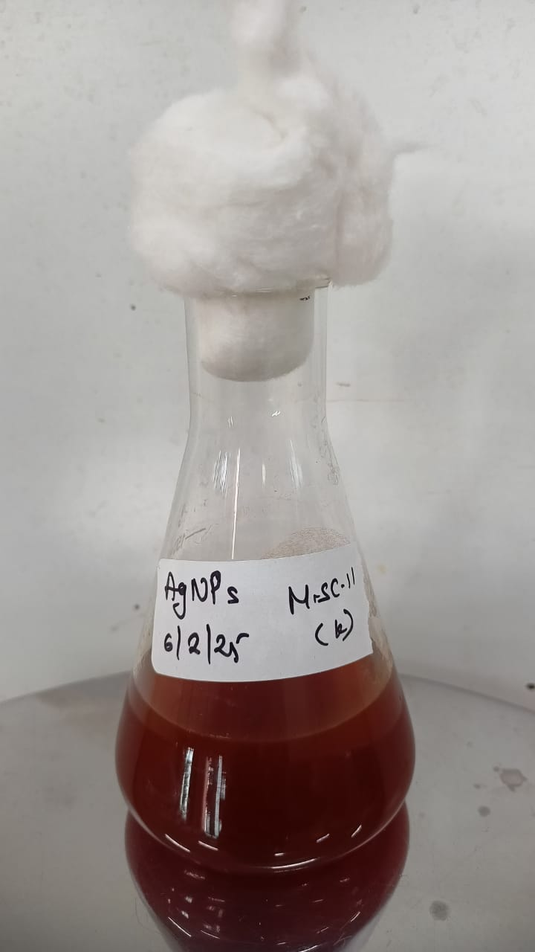
The synthesis of silver nanoparticles (AgNPs) was visually confirmed by a distinct color change of the AgNO₃ solution from pale yellow to brown upon addition of Aegle marmelos leaf extract, which is characteristic of nanoparticle formation due to surface plasmon resonance (SPR). Electrolyzed AgNPs (E-AgNPs) displayed a darker, more stable dispersion, suggesting improved uniformity and stability of the colloid.

Figure 1: AgNPs synthesized from Aegle marmelos
3.2 UV–Visible Spectroscopy
UV–Visible spectral analysis of the synthesized AgNPs revealed a prominent surface plasmon resonance (SPR) band at 430 nm, confirming nanoparticle formation. The narrow peak suggests a relatively monodispersed particle distribution. These findings are consistent with previous reports, where Aegle marmelos-derived AgNPs exhibited SPR peaks between 420 and 450 nm (Rama et al., 2023). The observed peak also aligns with other green-synthesized AgNPs, where SPR typically appears in the 400–450 nm range depending on particle size and capping agents (Vanlalveni et al., 2021). UV–Visual analysis was performed only for non-electrolyzed AgNPs in this study.
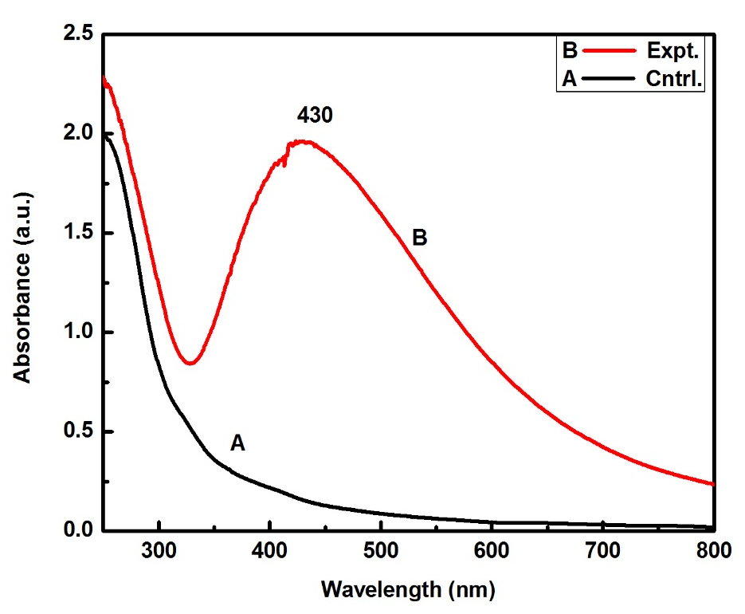
Figure 2: UV–Vis absorption spectrum of silver nanoparticles (AgNPs) synthesized using Aegle marmelos
3.3 Zeta Potential and Particle Size Analysis
Dynamic light scattering (DLS) and zeta potential measurements further supported the influence of electrolysis on nanoparticle stability (Table 1). For all measurements, samples were dispersed in distilled water and diluted 1:10 (v/v) to minimize multiple scattering effects. Non-electrolyzed AgNPs exhibited an average size of ~67 nm with zeta potentials ranging from −20 to −25 mV, indicating moderate colloidal stability. Electrolyzed AgNPs showed slightly larger mean sizes (~71 nm for 10 min and ~81 nm for 20 min), which may reflect enhanced surface restructuring or phytochemical capping rather than agglomeration. Importantly, their more negative zeta potentials (−26.7 to −27.5 mV) suggest stronger electrostatic repulsion and improved dispersion. According to Malvern guidelines and recent studies, zeta potential values more negative than −25 mV typically indicate good colloidal stability due to sufficient repulsive forces between particles (Kiran and Vimala 2025; Malvern Instruments 2025; Rebecca et al. 2023). The AgNO₃ control displayed the largest particle size (~157 nm) and a near-neutral zeta potential (−7.4 mV), confirming its poor stability and high aggregation tendency.

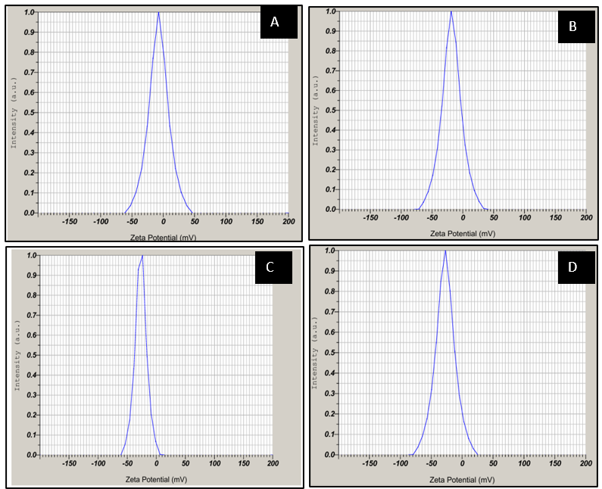

Figure 3: Size and zeta potential of A) AgNO3, B) Electrolyzed AgNO3, C) AgNP, D) Electrolzyed AgNP

Such values are comparable to other reports of plant-mediated AgNPs, which generally fall in the 10–150 nm range with zeta potentials between −20 and −30 mV (Vanlalveni et al., 2021). Importantly, our electrolyzed samples consistently showed greater stability than non-electrolyzed AgNPs, supporting earlier studies where electrochemical treatments increased nanoparticle surface charge and stability (Raisanen et al., 2022). Since more negative zeta values (>25 mV) are considered a threshold for good colloidal stability (Panzade et al., 2016), the results confirm that electrolysis contributes improved dispersion.
Sample | Mean Size (nm) | PDI | Zeta Potential (mV)
AgNO₃ (control) | ~157 | 0.703 | −7.4
AgNPs | ~67 | 0.934 | −20 to −25
E-AgNPs (10 min) | ~71 | 0.311 | −26.7
E-AgNPs (20 min) | ~81 | 0.377 | −27.5

Table 1: Size and Zeta potential of different samples

3.4 Fourier Transform Infrared (FTIR) Spectroscopy
FTIR analysis revealed functional groups from Aegle marmelos extract that acted as reducing and stabilizing agents. A broad band between 3657–3524 cm⁻¹ corresponded to O–H stretching vibrations of polyphenols and hydroxyl-bearing compounds. Strong peaks in the 1706–1603 cm⁻¹ region (amide I, C=O stretching) and the 1550–1507 cm⁻¹ region (amide II, N–H bending and C–N stretching) indicated the role of proteins and carbonyl compounds in capping the nanoparticles. Peaks near 1380 cm⁻¹ and 1217–1242 cm⁻¹ were associated with C–N and C–O stretching from phenolics and amines. Finally, sharp signals below 700 cm⁻¹ (686, 473, 457, 443, 418, and 410 cm⁻¹) were assigned to Ag–O and Ag–N vibrations, directly confirming the interaction of silver with plant-derived ligands.
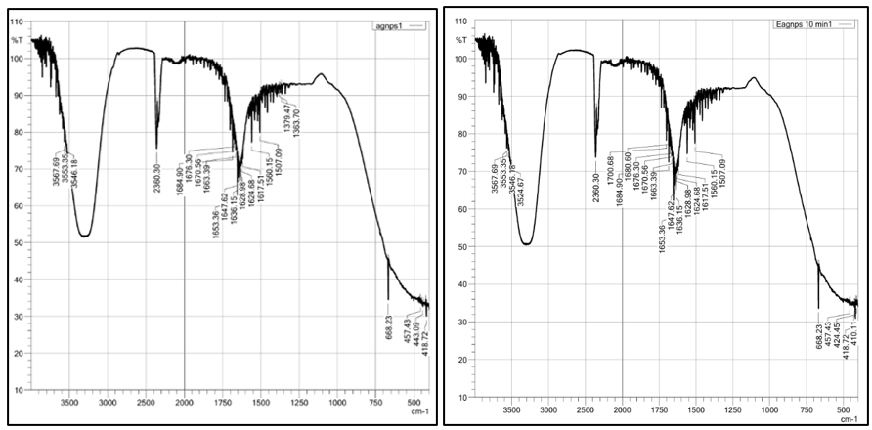
Figure 4: FTIR spectra of AgNPs and Electrolyzed AgNP
These are consistent with previous studies on Aegle marmelos-derived AgNPs, where FTIR confirmed hydroxyl, carbonyl, and amine groups as key biomolecules in nanoparticle stabilization (Rama et al., 2023). Electrolyzed samples showed sharper, better-defined bands in the fingerprint region, indicating stronger binding and cleaner surfaces — similar to reports that electrochemical treatments enhance nanoparticle surface interactions and stability (Raisanen et al., 2022)
3.5 Antibacterial Activity
The antibacterial efficacy of the synthesized silver nanoparticles (AgNPs), their electrolyzed forms (E-AgNPs and E-AgNO₃), and a standard antibiotic, ampicillin and pencillin was quantitatively assessed by measuring the zones of inhibition against the test bacterium E. coli. The results are summarized in Table 2.

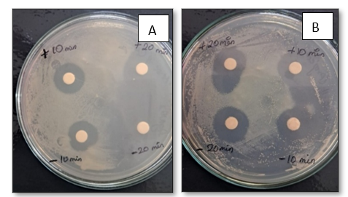

Figure 5: Zone of inhibition of electrolyzed AgNPs against E. coli, measured after 10- and 20-minute electrolysis intervals using samples collected from both electrodes. (+ indicating Anode and, – indicating Cathode)

Sample | +10 min | −10 min | +20 min | −20 min
E-AgNP | 12 mm | 12 mm | 12 mm | 12 mm
E-AgNO3 | 11 mm | 11 mm | 11 mm | 11 mm

Table 2: Zone of Inhibition (in mm) of Electrolyzed silver nanoparticles and electrolyzed silver nitrate (+ indicating samples collected from anode and – indicating samples collected from cathode)
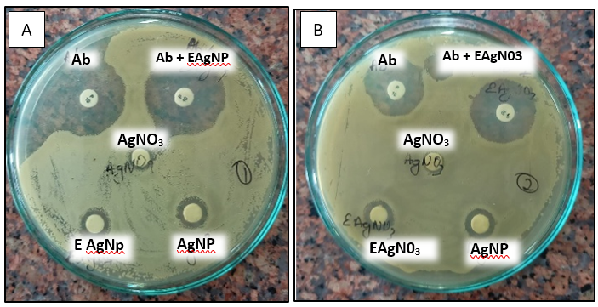

Figure 6: Zone of Inhibition (in mm) against E. coli, A) Showing for AgNP and Electrolyzed AgNP B) Showing AgNO3 and Electrolyzed AgNO3 along with Standard antibiotic ampicillin and combination treatments with electrolyzed and non-electrolyzed samples.
(Ab- Antibiotic, E-AgNP- Electrolyzed Silver nanoparticle, E-AgNO3- Electrolyzed silver nitrate)

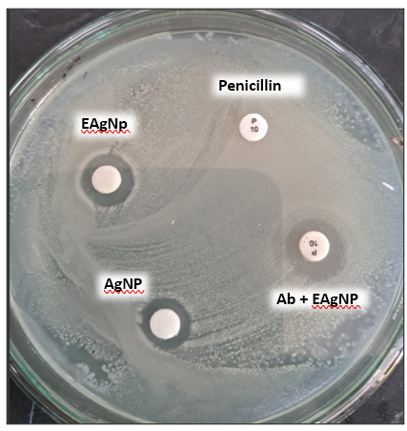

Figure 7: Antibacterial activity of various treatments against Escherichia coli on nutrient agar plates. Zones of inhibition around discs containing (i) Penicillin (P10), (ii) Electrolyzed silver nanoparticles (E-AgNPs), (iii) Chemically synthesized silver nanoparticles (AgNPs), and (iv) a combination of Penicillin and E-AgNPs (Ab + E-AgNPs).

Figure 8: Antibiogram of silver nanoparticles and electrolyzed variants against E. coli.

Values (expressed in Mean ± SD)
AgNPs – Silver nanoparticles Ab + AgNPs – Antibiotic + Silver nanoparticles
Ab – Antibiotic AgNO3- Silver nitrate
E-AgNPs- Electrolysed silver nanoparticles E-AgNO3- Electrolysed silver nitrate
Ab+AgNO3- Antibiotic+ silver nitrate

The antibacterial assay revealed that all silver-based formulations exhibited measurable zones of inhibition against Escherichia coli, with notable differences in efficacy. Ampicillin (Ab) produced the largest zone at 28 mm, while the combination of Ab with electrolyzed AgNPs (Ab + E-AgNPs) showed a slightly enhanced effect at 29 mm, indicating a synergistic interaction. Among the nanoparticle treatments, electrolyzed AgNPs (E-AgNPs) demonstrated superior activity with a 12 mm zone, as compared to conventionally synthesized AgNPs (11 mm). Interestingly, non-electrolyzed AgNO₃ showed minimal antibacterial effect (2 mm), whereas its electrolyzed form (E-AgNO₃) achieved a comparable zone of 11 mm, suggesting that electrochemical activation can enhance antimicrobial potency. Electrolysis enhances the efficacy of AgNPs, and electrolysis of AgNO₃ can yield results comparable to those obtained through nanoparticle synthesis. Notably, both electrolyzed solutions collected from the anode and cathode compartments exhibited identical zones of inhibition, possibly due to the absence of a separating membrane—an aspect that warrants further investigation. The strongest antibacterial response was observed when E-AgNPs were combined with antibiotics, highlighting the potential of synergistic approaches in combating microbial resistance.
Based on our observations, it is hypothesized that the enhanced antibacterial effect of electrolyzed silver nanoparticles (E-AgNPs) may be attributed to the increased reactivity induced by the electrolysis process. This process could lead to the formation of reactive silver ions and surface radicals that interact more efficiently with bacterial membranes, causing structural damage, protein denaturation, and oxidative stress. While this mechanism has not been experimentally confirmed in the present study, it is proposed as a plausible explanation based on the literature and our findings
Conclusions
The combined results confirm that green synthesis using Aegle marmelos extract successfully produces AgNPs with properties consistent with previous reports, while the addition of an electrolysis step increased stability and antibacterial efficacy. The UV–Vis, DLS/zeta, FTIR, and antibacterial results all align with earlier green-synthesis studies, but the novelty of this work lies in demonstrating that electrolysis enhances nanoparticle quality and biological performance. This dual strategy of plant-mediated reduction followed by electrochemical stabilization offers a sustainable and effective approach to developing next-generation antimicrobial agents.
Characterization confirmed uniform particle formation, the involvement of phytochemicals in capping and stabilization, and improved surface interactions after electrolysis. The findings demonstrate that electrolysis substantially improves the antibacterial efficacy of silver-based formulations, particularly green-synthesized AgNPs. Moreover, electrolysis of AgNO₃ can yield antimicrobial activity comparable to AgNPs, highlighting its potential. The synergistic combination of antibiotics with E-AgNPs produced the most pronounced antibacterial effect, underscoring the promise of integrated approaches in combating microbial resistance. The enhanced antibacterial efficacy of electrolyzed AgNPs may be influenced by factors such as reduced particle size, increased negative surface charge, and potential biomolecule–metal interactions. These characteristics are hypothesized to contribute to membrane disruption, oxidative stress induction, and interference with microbial metabolism. However, these mechanisms were not directly investigated in the present study and warrant further exploration to establish definitive causal relationships.
By combining green chemistry principles with electrochemical processing, this approach provides an environmentally friendly and biologically potent route for nanoparticle production. While further investigation on cytotoxicity, mechanistic pathways, and in vivo validation is necessary, the present findings establish a strong foundation for using electrolyzed silver nanoparticles in applications ranging from wound healing and coatings to drug delivery and infection control.

Disclaimer (Artificial intelligence)
The author(s) declare that generative AI technology was used solely for language assistance during the writing and editing of this manuscript. The AI tool used was Microsoft Copilot, developed by Microsoft, which provided support in refining grammar, improving clarity, and formatting scientific content. No AI-generated content was used without author verification and approval.
Details of the AI usage are given below:
1.Name and Source of AI Technology: Microsoft Copilot, developed by Microsoft Corporation.
2.Purpose of Use: The AI was used exclusively for language assistance, including grammar correction, sentence restructuring, and formatting of scientific content.

REFERENCES
Allel, Kasim, Anne Peters, Hassan Haghparast-Bidgoli, Maria Spencer-Sandino, Jose Conejeros, Patricia Garcia, Koen B. Pouwels, Laith Yakob, Jose M. Munita, and Eduardo A. Undurraga. 2024. “Excess Burden of Antibiotic-Resistant Bloodstream Infections: Evidence from a Multicentre Retrospective Cohort Study in Chile, 2018–2022.” Lancet Regional Health - Americas 40 (December). Elsevier Ltd: 100943. doi:10.1016/J.LANA.2024.100943.
Chinemerem Nwobodo, David, Malachy Chigozie Ugwu, Clement Oliseloke Anie, Mushtak T.S. Al-Ouqaili, Joseph Chinedu Ikem, Uchenna Victor Chigozie, and Morteza Saki. 2022. “Antibiotic Resistance: The Challenges and Some Emerging Strategies for Tackling a Global Menace.” Journal of Clinical Laboratory Analysis 36 (9). J Clin Lab Anal. doi:10.1002/JCLA.24655.
Gaurav, Amit, Perwez Bakht, Mahak Saini, Shivam Pandey, and Ranjana Pathania. 2023. “Role of Bacterial Efflux Pumps in Antibiotic Resistance, Virulence, and Strategies to Discover Novel Efflux Pump Inhibitors.” Microbiology 169 (5). Microbiology Society: 001333. doi:10.1099/MIC.0.001333.
Habibi-Pirkoohi, Maziar, and Mohammad Soleimani. 2016. “Antimicrobial Effect of Silver Nanoparticles on Staphylococcus Aureus.” Galen Medical Journal 5 (4). Salvia Medical Sciences Ltd. doi:10.31661/GMJ.V5I4.684.
Jain, Mahima, and Malyaj Das. 2024. “Size and Zeta Potential Characterization of Chemically Synthesized Silver Nanoparticles.” Power System Journal 48 (4): 465–472.
Kiran, Pillala Sai, and Y. Vimala. 2025. “Green Synthesis of Silver Nanoparticles Using Aegle Marmelos Fruit Extract: Characterisation, Antimicrobial, Cytotoxic and Antioxidant Activities.” International Journal of Environmental Sciences, 465–476. https://doi.org/10.64252/mk1mny16.
Malvern Instruments. 2025. Zeta Potential: Introduction and Measurement Principles. Malvern Panalytical
Mancuso, Giuseppe, Angelina Midiri, Elisabetta Gerace, and Carmelo Biondo. 2021. “Bacterial Antibiotic Resistance: The Most Critical Pathogens.” Pathogens 10 (10). MDPI: 1310. doi:10.3390/PATHOGENS10101310/S1.
Panzade, Prasad, Shalini Thakkar, and Santosh Wanjale. 2016. “Green Synthesis of Gold Nanoparticles Using Colchicum autumnale and Its Characterization.” International Journal of Advanced Research 4 (4): 596–607. doi:10.21474/IJAR01/257.
Raisanen, Astrid L., Chelsea M. Mueller, Subhajyoti Chaudhuri, George C. Schatz, and Mark J. Kushner. 2022. “A Reaction Mechanism for Plasma Electrolysis of AgNO3 Forming Silver Nanoclusters and Nanoparticles.” Journal of Applied Physics 132 (20). AIP Publishing. doi:10.1063/5.0127568.
Rama, P., P. Mariselvi, R. Sundaram, and K. Muthu. 2023. “Eco-Friendly Green Synthesis of Silver Nanoparticles from Aegle Marmelos Leaf Extract and Their Antimicrobial, Antioxidant, Anticancer and Photocatalytic Degradation Activity.” Heliyon 9 (6). Elsevier: e16277. doi:10.1016/J.HELIYON.2023.E16277.
Rebecca, Mfon et al. 2023. “Synthesis, Characterisation and Zeta Potential of Silver Nanoparticles.” ResearchGate.
Saxena, Richa, Shreya Kotnala, S. C. Bhatt, Manish Uniyal, B. S. Rawat, P. Negi, and Manoj K. Riyal. 2025. “A Review on Green Synthesis of Nanoparticles toward Sustainable Environment.” Sustainable Chemistry for Climate Action 6 (June). Elsevier: 100071. doi:10.1016/J.SCCA.2025.100071.
Sinha, Shweta, Shifu Aggarwal, and Durg Vijai Singh. 2024. “Efflux Pumps: Gatekeepers of Antibiotic Resistance in Staphylococcus Aureus Biofilms.” Microbial Cell 11 (1). Shared Science Publishers OG: 368. doi:10.15698/MIC2024.11.839.
Solanki, Renu, Shailly Anand, Mugdha Anand, Prateek Kumar, Munendra Kumar, and Monisha Khanna Kapur. 2022. “Antibiotic Resistance: A Global Health Crisis.” Microsphere 1 (1). PhixGen Pvt. Ltd.: 3–11. doi:10.59118/NLKD4831.
Tan, Siang Yong, and Yvonne Tatsumura. 2015. “Alexander Fleming (1881–1955): Discoverer of Penicillin.” Singapore Medical Journal 56 (7). Singapore Medical Association: 366. doi:10.11622/SMEDJ.2015105.
Tao, Shuan, Huimin Chen, Na Li, Tong Wang, and Wei Liang. 2022. “The Spread of Antibiotic Resistance Genes In Vivo Model.” The Canadian Journal of Infectious Diseases & Medical Microbiology = Journal Canadien Des Maladies Infectieuses et de La Microbiologie Médicale 2022. Hindawi Limited: 3348695. doi:10.1155/2022/3348695.
Vanlalveni, Chhangte, Samuel Lallianrawna, Ayushi Biswas, Manickam Selvaraj, Bishwajit Changmai, and Samuel Lalthazuala Rokhum. 2021. “Green Synthesis of Silver Nanoparticles Using Plant Extracts and Their Antimicrobial Activities: A Review of Recent Literature.” RSC Advances 11 (5). The Royal Society of Chemistry: 2804–37. doi:10.1039/D0RA09941D.
Vazquez-Muñoz, R., A. Meza-Villezcas, P. G.J. Fournier, E. Soria-Castro, K. Juarez-Moreno, A. L. Gallego-Hernández, N. Bogdanchikova, R. Vazquez-Duhalt, and A. Huerta-Saquero. 2019. “Enhancement of Antibiotics Antimicrobial Activity Due to the Silver Nanoparticles Impact on the Cell Membrane.” PLOS ONE 14 (11). Public Library of Science: e0224904. doi:10.1371/JOURNAL.PONE.0224904.
Yin, Iris Xiaoxue, Jing Zhang, Irene Shuping Zhao, May Lei Mei, Quanli Li, and Chun Hung Chu. 2020. “The Antibacterial Mechanism of Silver Nanoparticles and Its Application in Dentistry.” International Journal of Nanomedicine 15. Int J Nanomedicine: 2555–62. doi:10.2147/IJN.S246764.

