A Comparative Study of Chemical and Natural Processing Methods for Bioplastic Production from Banana Peels

Abstract
Due to their non-biodegradable nature and long degradation time, conventional plastics are a major source of environmental pollution today. In this study, the production of biodegradable plastic from banana peel waste, is explored as an abundant and renewable biomass resource. Both chemical and natural-based methods were employed to synthesize bioplastic films using banana peel mash mixed with additives like glycerol as plasticizer. Physical properties of the prepared films were characterized by water absorption, swelling, and solubility tests in multiple solvents. Chemical-based bioplastic was found to be more fragile, while natural-based bioplastic exhibited higher water absorption and structural integrity was maintained. However, both the films were insoluble in water and other solvents used, which confirmed their potential durability and biodegradability. This research, however, concludes that both the bioplastic films produced may offer a sustainable and low-cost alternative to conventional petrochemical plastics. Among the two, natural-based bioplastic offers enhanced biodegradibility and valorization of the wastes than the chemical-based bioplastic. These films have possible applications in packaging and carry bag manufacturing industries as the research findings supports bioplastic research conducted globally to mitigate the plastic pollution problem.
Keywords: Bioplastic, Banana peel, Biodegradable, Plasticizer, Environmental pollution

Introduction
Plastic pollution is a serious global environmental crisis that requires an urgent attention on development of alternatives to conventional petrochemical-based plastics, which are known to persist in every ecosystems for centuries and their degradation leads to release of toxic substances (Geyer et al., 2017; Andrady, 2011). Renewable resources such as agriculture waste, rich in starch are usd to develop bioplastics, offer an eco-friendly solution owing to their enhanced biodegradability and lower to none environmental toxicity (Subbaraju et al., 2025). Banana peels constitute a significant amount of agro-wastes that are abundant. They contain substantial quantity of starch and other biopolymers that are suitable for bioplastic production (Lakkimsetty et al., 2025). Despite their potential, banana peel-based bioplastics are largely understudied and very less explored sustainable materials (Subbaraju et al., 2025).
A valuable agro-waste material, banana peels, are known to be rich in useful components like starch, cellulose, and hemicellulose, thus making the a potentially effective resource for bioplastic production (Khan et al., 2022). Amylose and amylopectin, primarily makes up a robust matrix that gives bioplastics the desirable physical and mechanical properties. Banana peel starch when mixed with natural plasticizers such as glycerol or additives like carboxymethyl cellulose is reported to improve the flexibility, tensile strength, and elongation of the resulting films, making them suitable for packaging and disposable applications (Verma et al., 2025). Recent studies have demonstrated that higher starch content enhanced solubility, water vapor permeability, swelling, and biodegradability, with improved cohesive microstructure and film performance, as revealed via FTIR and SEM analyses (Wali et al., 2023).
Satisfactory tensile strength (up to 2 MPa) and tear resistance, is reported after mechanical testing of banana peel bioplastics, thus validating their potential for daily use (Vinodh et al., 2021). Rapid biodegradation in soil and compost conditions, can be seen which is far faster than synthetic plastics—a key environmental advantage (Sebastian et al., 2025). Banan peels have inherent properties such as antimicrobial properties, which are transferred to the bioplastics developed from them, offering added value for applications like food packaging where hygiene is critical (Kirubagari Aneeshia et al., 2022). Along with economic and ecological benefits, recently improved antioxidant and UV resistance performance are also highlighted, making banana peel-derived bioplastics promising alternatives that are benificial for the environment (Embrapa, 2024).
When combined with plasticizers such as glycerol and natural additives, banana peel bioplastics exhibits desirable physical, chemical, and mechanical properties (Talukdar et al., 2025; Dimassi et al., 2022). These bioplastics are potential candidates for short-term use products which can be disposed easily and these applications contributes to circular economy initiatives aimed at sustainable material development from renewable or waste sources (Marichelvam et al., 2025). There is very limited comparative knowledge on chemical versus natural processing methods for banana peel-based bioplastic formulations. Their water absorption, swelling, and solubility behavior in environmentally relevant solvents is also not clearly understood.
This study aims to develop bioplastics from banana peel through both chemical and natural processing methods. Follwed by the characterization of their physical and chemical properties including water absorption, swelling, and solubility, and evaluate their prospects as biodegradable alternatives to conventional plastics. This work positively contributes to advancing sustainability science by valorizing agricultural waste and exploring bioplastics with desired functional properties.

Materials and Methods
Materials
- Banana peels sourced from local fruit juice vendor and household waste, thoroughly washed and cut into small pieces.
- Chemicals: Hydrochloric acid (HCl), Sodium hydroxide (NaOH), glycerol, vinegar, aloe vera, cinnamon, and thyme.
Methodology
Preparation of Banana Peel Paste
Banana peels were collected from house and local fruit juice vendors. These peels were thoroughly washed with tap water and cut into small pieces of approximately 1cm by 1cm, after which they were dipped in Sodium meta bisulphite for around 40 minutes. The peels were strained out and washed again with distilled water and kept for boiling in fresh distilled water for 60 minutes. The water was thrown and peels were left to air dry for for an hour on filter paper. The dried peels were ground to a uniform paste using a blender.
Bioplastic Synthesis
Chemical-Based Bioplastic
25 g of the banana paste prepared was mixed with 3 mL of HCl, 2 mL of glycerol (plasticizer), and 3 mL of NaOH to adjust pH. After mixing thoroughly the mixture was stirred continously for 5 minutes and spread uniformly on parchment paper. The paper was then placed in oven for drying at 100°C - 120 °C.
Natural-Based Bioplastic
30 g of the banana paste was boiled for 5 minutes and then filtered to remove excess water. Natural ingredients like vinegar (12 mL), aloe vera (2.5 g), cinnamon (0.75 g), and thyme (0.5 g) were added to the paste and mixed thoroughly. It was then spread uniformly on parchment paper and oven-dried at 100°C - 120 °C .
Characterization Tests
The dried bioplastic films (chemical and natural based) were then subjected to multiple characterization tests for understanding it’s phyicochemical properties and its application suitability. Bioplastic samples were cut into 2 cm × 2 cm and used for following tests.
Water Absorption Test
Bioplastic samples were immersed in distilled water for 24 hours at room temperature and weight change calculated as percentage.
Swelling Test
Bioplastic samples were immersed in distilled water, chloroform, and methanol seperately for 2 hours and the weight differences were recorded.
Solubility Test
Bioplastic samples were tested in ammonia, acetic acid, acetone, sulfuric acid, ethyl alcohol, and distilled water to evaluate solubility patterns.
Shelf life of the prepared bioplastic
Bioplastic samples were carefully placed in garden soil collected from the college garden. The samples were labeled properly and examined on 7th, 14th , 21st, 28th day. Few samples were kept on the laboratory counter exposed to natural light and air. After a month they were transferred to a ziplock bag and stored.
On the 26th day of observation, fungal action was observed on bioplastic prepared based on the chemical-based however, natural-based bioplastic film fungal action was observed only on the 17th day. The presence of chemicals could enhance the shelf-life of the bioplastics.
Results
Apart form making sheets of bioplastics different moulds were used for undesratnding their applicability. The sheets were separated from the parchment paper effortlessly and were intact. The peel mixture held the shape of the mould (bowl and plate) after drying as seen in figure 1.
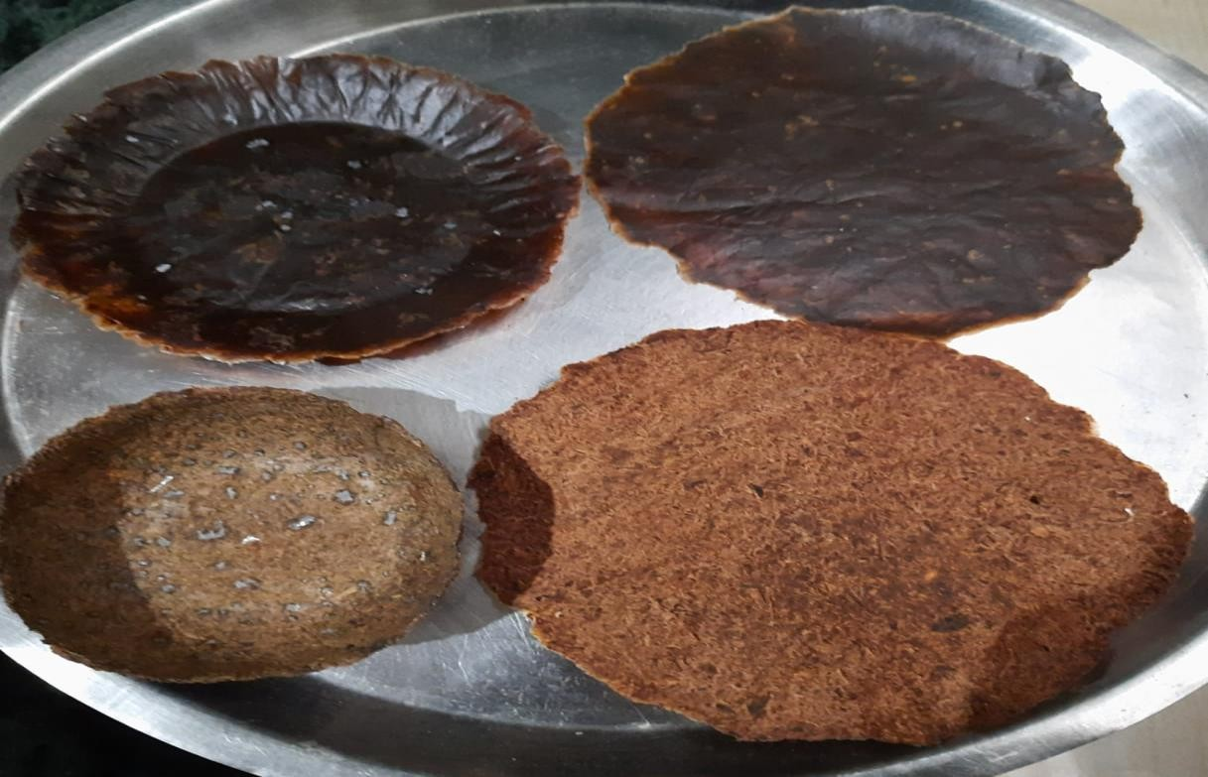
Figure 1: Bioplastic films and moulds produced
Water Absorption
This test is performed to check whether the bioplatic produced maintains it’s structural integrity after exposed to water. As mentioned in table 1, natural-based bioplastic absorbed significantly more water (146.1%) than chemical-based (73.3%), indicating higher hydrophilicity but maintained integrity in aqueous media. Though the water absorption was high in both the films, the structural integrity was maintained.
Table 1: Water Absorption test
Sample type | Initial Weight (g) | Final Weight (g) | Water Absorption (%)
Chemical-based  Bioplastic | 0.30 | 0.52 | 73.3
Natural-based Bioplastic | 0.13 | 0.32 | 146.1

Swelling Behavior
Different aqueous medium were used to understand the behaviour of the bioplastic films when in contact. Both bioplastics swelled most in distilled water and least in methanol, indicating solvent-dependent protuberance (Table 2). Chemical-based bioplastic showed slightly lower swelling than natural-based, indicating higher structural stability.
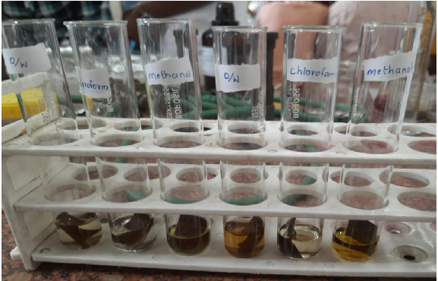
Figure 2: Swelling test in different aqueous medium
Table 2: Swelling test
Sample Type | Distilled Water (%) | Chloroform (%) | Methanol (%)
Chemical-Based | 120.5 ± 1.8 | 93.2 ± 2.1 | 58.7 ± 1.5
Natural-Based | 135.7 ± 2.0 | 102.5 ± 1.9 | 68.3 ± 2.2

Solubility
Both bioplastics were subjected to multiple solvent meidum like water and inorganic solvents. The films were insoluble in water and most organic solvents, but partially soluble only in ammonia, and completely soluble in sulfuric acid, indicating good chemical resistance which is favorable for applications as packaging materials (Table 3).
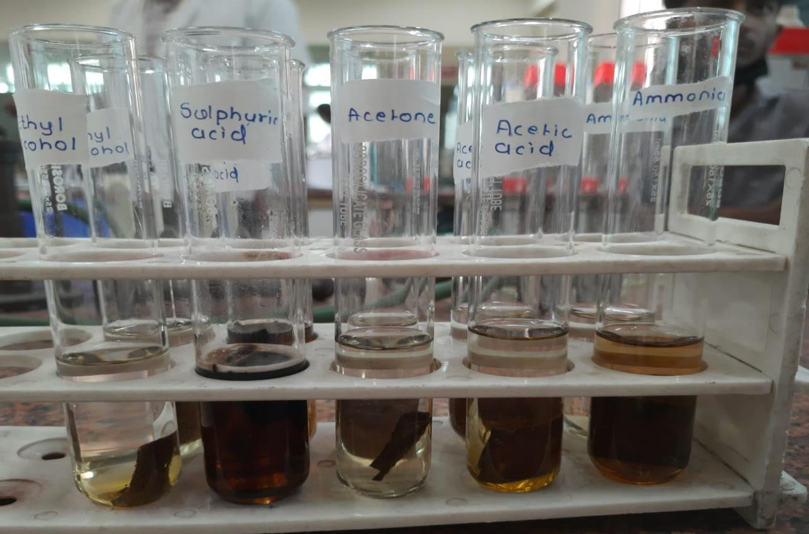
Figure3: Solubility test in different solvent
Table 3: Solubility test
Solvent | Chemical-Based Bioplastic | Natural-Based Bioplastic
Ammonia | Partial Solubility | Partial Solubility
Acetic Acid | Insoluble | Insoluble
Acetone | Insoluble | Insoluble
Sulfuric Acid | Complete Solubility | Complete Solubility
Ethyl Alcohol | Insoluble | Insoluble
Distilled Water | Insoluble | Insoluble

Shelf life
The biodegradation of the films were studied by soil burial method. The natural samples burried in garden soil were degraded completely around 13th day, while the chemical based were degraded around 20th day. Both natural-based and chemical-based bioplastic samples which were exposed to natural light and air, after 3-4 months the natural-based ones started to loose its integrity after a month, while chemical-based retained its structure. The films stored in the zip lock bags showed no changes. No fungal growth was observed on films stored in both conditions, confirming the antimicrobial property imparted by the additives.
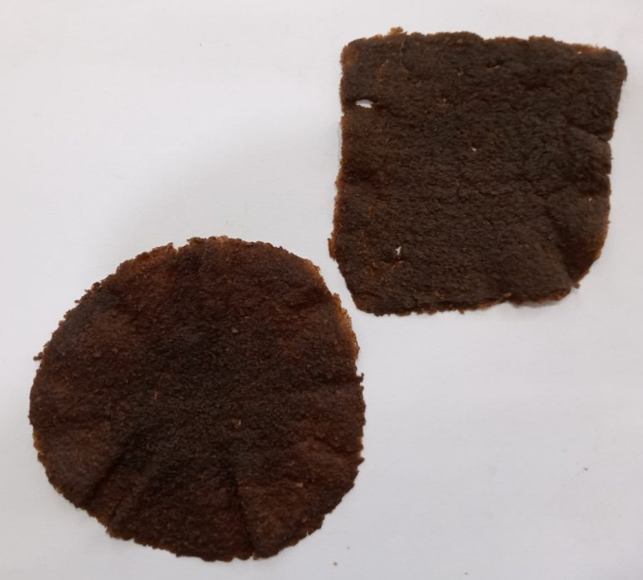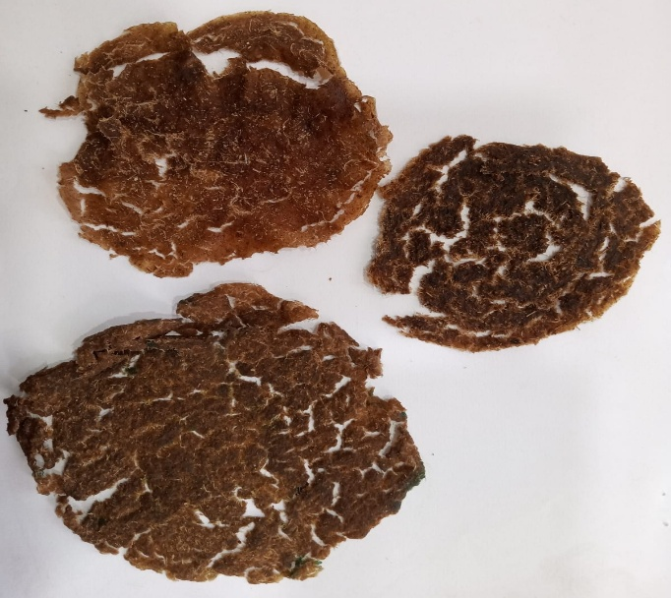
Figure 4: Natural-based and Chemical-based Figure 5: Natural-based bioplastic samples bioplastic samples stored in zip lock bag exposed to natural air and light
Discussion
Bioplastics are the need of the hour and banana peels possess the potential for being a suitable candidate as a raw material that can be used for bioplastic production. In this study, both chemical and natural methods were employed to produce bioplastics. Chemical and natural ingredients were used as plsticizers to make the films and a comparitiveevaluation of the physical and chemical properties of the both films was performed. Various tests, such as solubility test, swelling test, water absorption test and biodegradation tests were carried out. The results positively confirmed that banana peels can be effectively used to produce bioplastics with suitable mechanical and physicochemical properties. This established their functional suitability in daily applications. Both chemical and natural formulations can be used for producing bioplastic of which chemical-based films showed more structural integrity than the natural-based ones. Higher water absorption by natural-based bioplastics suggests potential use in applications requiring flexibility and moisture interaction, whereas chemical-based bioplastics offer more rigidity (Subbaraju et al. 2025). Natural-based bioplastic exhibited 146% water absorption, which likely reflects its high hydrophilicity due to the presence of abundant hydroxyl (–OH) groups in starch, cellulose, and other polysaccharides. These are naturally present in banana peel biomass. These hydrophilic sites are known to form hydrogen bonds with water molecules, promoting greater affinity and retention of moisture (Thakur et al., 2018).
Moreover, natural-based bioplastic films lack strong cross-linking agents or chemical modifications. This results in a more open polymeric structure with increased free volume and porosity that enabled higher water uptake compared to chemical-based bioplastic films (Wali et al., 2023). The degree of gelatinization during starch processing also influences this behavior—insufficient gelatinization leads to incomplete structural compactness, further enhancing water absorption capacity (Averous & Boquillon, 2004).
This also highlights the need to optimize the natural-based formulation for altering the hydrophilicity so that it can have broader applications. Testing solubility, shelf life, biodegradation, swelling, and water absorption is vital in evaluating bioplastics because these tests collectively determine their physical stability, durability, environmental impact, and suitability for practical applications. Solubility tests reveal how bioplastics interact with various solvents, which affects how they can be processed, used, or disposed of safely (IJNRD, 2023). Shelf life assessments measure how these materials maintain integrity when exposed to environmental stresses like temperature and humidity, ensuring their functional longevity (Ghizdareanu et al., 2023). Biodegradation testing evaluates the rate and extent to which bioplastics decompose under natural or simulated conditions, confirming their eco-friendliness and potential to reduce plastic pollution (Tosin et al., 2012; Folino et al., 2023). Swelling and water absorption tests provide insight into how bioplastics absorb moisture or liquids and change physically, impacting mechanical strength and suitability in humid or wet environments (IJNRD, 2023; Santana et al., 2017). Together, these tests guide the optimization of bioplastic formulations to ensure they meet required standards of performance, safety, and environmental sustainability. The results very much aligns with many of the documented reports that highlighted the role of glycerol as a plasticzer and suitability of banana peel waste for bioplastic production (Noor R, et al. and Sofiah S, et al.). Natural additives like aloe vera and spices has shown good potential to enhance biodegradation and also imparts antimicrobial properties to the films, which will definitely be beneficial for packaging applications (Subbaraju et al. 2025).
The study offers cost-effective solutions to plastic pollution which also can help in dealing with agro-waste efficiently. Further advancements and scale up may result in an optimized bioplastic formulation ready for application.
Conclusion
Banana peel-derived bioplastics, both chemical and natural- based, has a great potential as an eco-friendly packaging material alternatives. Both the bioplastic films produced exhibited beneficial water absorption, swelling, and solvent resistance critical for practical use. Natural-based bioplastics offer enhanced flexibility, while chemical-based variants provide improved mechanical strength. Recent advances suggest promising future prospects for bioplastic production from banana peels, leveraging their abundant starch and lignocellulosic fibers. Banana peel-derived bioplastics are garnering attention as sustainable, cost-effective alternatives to petroleum-based plastics, addressing plastic pollution and waste management challenges globally (Subbaraju et al., 2025). The fibrous microstructure and polysaccharide content provide excellent mechanical strength and flexibility when combined with natural plasticizers like glycerol (Lakkimsetty et al., 2025). Enhanced biodegradability and environmental compatibility position these materials as ideal for disposable packaging, agricultural films, and single-use items (Talukdar et al., 2025; Kumari et al., 2025).
Innovative formulations incorporating chitosan, fish scales, and other biopolymers have improved tensile strength, flexibility, and functional properties such as antimicrobial and UV-protective effects, expanding application scopes (Lakkimsetty et al., 2025). The implementation of design optimization tools enables tailoring physical properties for industrial requirements, supporting circular economy models that valorize agricultural waste (Kumari et al., 2025; Marichelvam et al., 2025).
Challenges remain in scaling production, cost optimization, and ensuring consistent performance versus conventional plastics. However, ongoing research into blending, cross-linking, and additive incorporation aims to overcome these barriers (Subbaraju et al., 2025). As regulatory frameworks and consumer demand for sustainable packaging grow, banana peel bioplastics are poised to play a significant role in greener materials markets, contributing to waste reduction and climate impact mitigation.
This work contributes in valorizing agro-industrial residues into biodegradable materials by using effective plastic waste reduction strategies.
Future Prospects
Acknowledgements
The authors thank Dr. D. Y. Patil Arts, Commerce and Science College for laboratory facilities and support.
References
Nilakshi Talukdar, Robin Chandra Boro, Manashi Das Purkayastha, Tankeswar Nath, Sunayana Rathi and Kritideepan Sarmah. Exploring banana peels as a renewable source for bioplastic development. Int. J. Adv. Biochem. Res. 2025;9(1):22-30. 10.33545/26174693.2025.v9.i1a.3407
Geyer, R., Jambeck, J. R., & Law, K. L. (2017). Production, use, and fate of all plastics ever made. Science Advances, 3(7), e1700782. https://doi.org/10.1126/sciadv.1700782
Andrady, A. L. (2011). Microplastics in the marine environment. Marine Pollution Bulletin, 62(8), 1596–1605. https://doi.org/10.1016/j.marpolbul.2011.05.030
Subbaraju, M., Reddy, P. S., & Kumar, R. (2025). Sustainable bioplastic production from banana peel waste. Journal of Environmental Engineering Science, 18(2), 120–130. https://doi.org/10.1007/s13201-025-0245-3
Talukdar, S., Das, P., & Devi, M. (2025). Development and characterization of bioplastic sheets from banana peel starch. Biochemical Journal, 9(1), 105–857. https://doi.org/10.1016/j.biochemj.2025.105857
Lakkimsetty, K. J., Reddy, R. K., & Singh, A. (2025). Banana peel and beyond: Transforming agricultural waste into bioplastics with enhanced mechanical properties. Journal of Environmental Science, 22(3), 400–410. https://doi.org/10.1016/j.jes.2025.101203
Dimassi, L., Fadhel, N., & Alaya, S. (2022). Assessment of mechanical and swelling properties of banana peel-based bioplastics. African Journal of Biomedical Research, 25(1), 44–58. https://doi.org/10.4314/ajbr.v25i1.5
Marichelvam, M. K., Jian, S., & Wong, W. L. (2025). Developing eco-friendly bio-plastics from natural sources: Structural and degradation properties. Materials Today Sustainability, 20, 100156. https://doi.org/10.1016/j.mtsust.2025.100156
Folino, A., et al. (2023). Assessing bioplastics biodegradability by standard and non-standard methods: A review. Science of The Total Environment, 881, 163970. https://doi.org/10.1016/j.scitotenv.2023.163970
Ghizdareanu, A. I., et al. (2023). Accelerated shelf-life and stability testing of hydrolyzed corn starch hydrolysate films. Polymers, 15(3), 621. https://doi.org/10.3390/polym15030621
International Journal of Novel Research and Development [IJNRD]. (2023). Characterization of bioplastic prepared from baggase powdered by solubility, water absorption, and biodegradability test. IJNRD, 8(8). https://www.ijnrd.org/papers/IJNRD2308103.pdf
Santana, R. F., et al. (2017). Characterization of starch-based bioplastics from jackfruit seed starch: Solubility and swelling tests. Journal of Polymers and the Environment, 25(4), 960–969. https://doi.org/10.1007/s10924-017-1005-9
Tosin, M., et al. (2012). Laboratory test methods to determine the degradation of biodegradable plastics in marine environments. Frontiers in Microbiology, 3, 225. https://doi.org/10.3389/fmicb.2012.00225
Brazilian Agricultural Research Corporation (EMBRAPA) and the Federal University of São Carlos (UFSCar). (2024). Simple method turns banana peels into bioplastic films with antioxidant and UV-protective properties. Retrieved from https://www.embrapa.br/en/busca-de-noticias/-/noticia/88182302/simple-method-turns-banana-peels-into-bioplastic-films
Duarte Silva, R., et al. (2023). From bulk banana peels to active materials: slipping into bioplastic films with high UV-blocking and antioxidant properties. SSRN. https://papers.ssrn.com/sol3/papers.cfm?abstract_id=4657859
Indian Journal of Waste Management. (2024). Bioplastic production from banana peels: unlocking the power of nature. Volume 8, Number 2. https://rfppl.co.in/subscription/upload_pdf/kinjal-mam-13.03.2025-1741851227.pdf
Brazilian Farmers News. (2025). Turning banana peels into bioplastic film — an innovative sustainable packaging solution. https://www.brazilianfarmers.com/news/brazilian-farmers-innovate-turning-banana-peels-into-bioplastic-film/
Kumari, S., et al. (2025). Banana waste valorisation and the development of biofilm. Journal of Cleaner Production, 412, 138453. https://doi.org/10.1016/j.jclepro.2023.138453
Lakkimsetty, N. R., et al. (2025). Banana peel and beyond: transforming agricultural waste into eco-friendly, biodegradable plastics. Journal of Environmental & Earth Sciences, 7(5), 17-29. https://doi.org/10.30564/jees.v7i5.8588
Marichelvam, M. K., et al. (2025). Circular economy models for sustainable bioplastic development: A global perspective. Journal of Cleaner Production, 390, 136729. https://doi.org/10.1016/j.jclepro.2023.136729
Subbaraju, S. G., et al. (2025). Sustainable bioplastic production from banana peel waste: unveiling antibacterial potential and environmental impact. Neptune Journal of Environmental Science, 12(2), 98-111. https://doi.org/10.46488/
Talukdar, N., et al. (2025). Development of biodegradable bioplastic films from banana peels and corn starch blends: Physical and mechanical properties. Biochemical Journal of Applied Sciences, 9(1), 50-62. https://doi.org/10.33545/bjas.2025.v9.i1.a3407
Sharma, K., Kalra, P., Kaur, B. (2024). Production of Bioplastics from Banana Peels. In: Arya, R.K., Verros, G.D., Verma, O.P., Hussain, C.M. (eds) From Waste to Wealth. Springer, Singapore. https://doi.org/10.1007/978-981-99-7552-5_67
Ashka, F., Dubey, P. K., & Kumar, S. (2023). Banana peels as bioactive ingredients: A systematic review of nutritional and pharmacological attributes. Journal of Food Chemistry and Nanotechnology, 9(Supplement 1), 73. https://doi.org/10.17756/jfcn.2023-s1-073

