Original Research Article

Improvement in the water quality of the Ganesh idol immersed Indrayani River in the presence of AgNPs immobilised in sodium alginate beads

.
ABSTRACT

Nowadays, water pollution is a serious problem, but after the Ganesh festival, it becomes a serious problem because of the immersion Ganesh idol in the River water. It affects the pH of water, the level of dissolved oxygen, and increases the hardness of water and significantly affecting aquatic life. The government has suggested many solutions for that, for example, providing separate tanks for the immersion of the Ganesh Idol. But later, what we do with that water, are we giving proper treatment to that water? Because that water also contains some amount of POP, toxic chemicals, and metal ions.
This study investigates the impact of Ganesh idol immersion on the water quality of the Indrayani River at Alandi, Pune, during the period of August 2024 to January 2025. Key physicochemical parameters—pH, dissolved oxygen (DO), biological oxygen demand (BOD), chemical oxygen demand (COD), and total hardness—were analysed before and after idol immersion. The results indicated a marked deterioration in water quality, with significant increases in BOD, COD, and hardness levels, and a sharp decline in DO. Additionally, silver nanoparticles (AgNPs) were tested for their antimicrobial potential in treating contaminated samples. AgNPs-treated samples showed reduced microbial growth and improved water quality parameters, confirming their potential as an eco-friendly purification tool. The study highlights the urgent need for sustainable immersion practices and the exploration of nanotechnology-based interventions for safeguarding aquatic ecosystems.

Keywords: Ganesh Idol immersion, silver nanoparticles , Biological Oxygen Demand , Chemical Oxygen Demand, dissolved oxygen

1. INTRODUCTION

All the Festivals are crucial because they encourage us to get away from our normal lives. They allow us to get away from the daily stresses and worries related to our food, shelter, and money. Indian culture places a lot of emphasis on festivals, which serve as a platform for communicating our beliefs and feelings. even though every town has its unique celebrations. Festivals are an excellent way to bring people from a variety of cultures, beliefs, and origins together to celebrate in a way that encourages harmony, unity, and togetherness (Pote, 2023; Narwani, 2023). Ganpati festival is one of the most important festivals in Maharashtra, but along with joy and enjoyment, it also invites the tremendous pollution of water bodies, which primarily affects aquatic life and water quality. Immersion of idols in rivers causes heavy metal pollution, which damages the ecosystem by killing fish, destroying plants by blocking the natural flow of water, etc. It also pollutes drinking water and affects the fertility of the land nearby. After immersion of idols in the rivers, decomposition takes place, which results in eutrophication of the water bodies. Every year in India, idol immersion plays a crucial role in the pollution of the water bodies (Maiti et al., 2021). This causes a kind of domino effect in which species depending on water bodies get affected and must face sevier ecological damage within a span of only a few days, and creates lots of problems for aquatic animals too.
If we trace the root cause of this damage, we can conclude that the idols contain various organic and inorganic chemicals. As immersion of idols takes place in water bodies concentration of these chemicals exceeds the permissible level as far as pollution standards are concerned. The materials that have been used in the preparation of these idols comprise paints and other decorative products. It also includes harmful contaminants like mercury, lead, and cadmium (Yigam & Bharti, 2025). Nowadays these idols are made up of POP which is nothing but gypsum or Calcium Sulphate. Solubility of gypsum is only 0.26g per liter, so when lots of idols are immersed in a small pond, it gets accumulated in that water body (1).
Ganesh idols are often decorated with toxic paints thatcontain heavy metals such as lead and mercury, which seep into the water after the idol immersion, and add to the acidic level of water, which is not good for the environment and marine life. It can also cause several diseases in humans (2).
Water quality is critical to ecological balance and public health. However, cultural and religious activities often contribute significantly to river pollution in India. Ganesh Chaturthi, a widely celebrated festival, involves large-scale idol immersion in rivers such as the Indrayani, leading to the release of heavy metals, paints, and non-biodegradable materials. Previous studies have reported severe ecological consequences, including decreased dissolved oxygen, increased heavy metal concentrations, and biodiversity loss (3).
In response to growing concerns, researchers have explored advanced treatment methods. Silver nanoparticles (AgNPs) are of particular interest due to their antimicrobial and catalytic activities, showing potential for removing heavy metals and organic contaminants (3 and 4).
This study aims to: Assess the changes in water quality of the Indrayani River before and after idol immersion as well as after the treatment of immobilized AgNPs, Evaluate the antimicrobial efficacy of silver nanoparticles in improving water quality, and suggest sustainable approaches for mitigating immersion-related pollution.

2. MATERIALS AND METHODOLOGY

Sodium alginate, CaCl2, AgNO₃, NaOH, Manganese Sulfate and alkaline potassium iodide, HgSO_{4,} potassium dichromate, Sulphuric acid, ferrous ammonium sulphate, Ferroin indicator, Eriochrome black indicator, all have been purchased from Hi Media Pvt. Ltd.

2.1 Preparation of sodium alginate-AgNPs beads:
Sodium alginate (2%) beads and Fagopyrum esculentum starch, 5 mM silver nanoparticles were mixed, and the drop-by-drop addition into 2N NaOH with the help of a syringe, and kept on a stirrer for the cross-linking of the silver nanoparticles for 1h.

2.2 Water Testing
The Indrayani River originates near Lonavala and flows through pilgrimage centers Dehu and Alandi. Samples were collected from Indrayani Ghat, Alandi (18.677901, 73.893817), before and after idol immersion.

Physical parameters
Temperature
Water sample collected from the tap, before immersion of Ganpati idol, and after immersion of Ganpati idol Indrayani River. Ensured the thermometer is cleaned and undamaged. The bulb of the thermometer was immersed in the liquid without touching the container’s sides or bottom. The thermometer was kept in the container until the reading stabilized (usually 30 seconds to 1 minute. The temperature was read at eye level, aligning with the top of the liquid column inside.
Temperature is a physical quantity that expresses the degree of hotness or coldness of a substance or environment. It reflects the average kinetic energy of the particles in a substance:
- Higher temperature = particles move faster.
- Lower temperature = particles move more slowly.
pH
Calibrated pH was used for pH checking of water. The electrode of pH was rinsed with DW to avoid contamination. The electrode was immersed in every collected sample of tap water, before immersion of Ganpati idol and after immersion of Ganpati idol, Indrayani River water, and gently stirred and waited for the reading to stabilize. The pH value was recorded, which was displayed on the meter.

Dissolved Oxygen
BOD bottles were filled with all collected samples (tap water, before immersion of Ganpati idol and after immersion of Ganpati idol, Indrayani River water) without any air bubbles and sealed immediately. Manganese Sulfate (2 mL) and alkaline potassium iodide solution (2 mL) were added to the sample. Samples were mixed thoroughly by stopper the bottle tightly and inverting several times. If oxygen is present, brown precipitate will form and let it settle down the precipitate forming a clear zone above. Finally, concentrated sulfuric Acid (2 mL) was added to dissolve the precipitate. Mix thoroughly. Iodine equivalent to DO is now in solution.
The above samples were titrated against a standard sodium thiosulfate solution until the color changed from yellow to pale straw. Starch indicator was added – the solution turns blue. Titration was continued with dropwise addition until the blue color disappeared (end point).
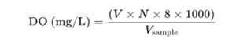
Biological Oxygen Demand (BOD)

BOD bottles were filled with all collected samples (tap water, before immersion of Ganpati idol and after immersion of Ganpati idol, Indrayani River water) without any air bubbles and sealed immediately. Manganese Sulfate (2 mL) and alkaline potassium iodide solution (2 mL) were added to the sample. Samples were mixed thoroughly by stopping the bottle tightly and inverting several times. If oxygen is present, brown precipitate will form, and let it settle down the precipitate forming a clear zone above. Finally, concentrated sulfuric Acid (2 mL) was added to dissolve the precipitate. Mix thoroughly, Iodine equivalent to DO is now in solution. All BOD bottles were kept in the BOD incubator for 5days of incubation. After incubation, the above samples were titrated against standard sodium thiosulfate solution until the color changed from yellow to pale straw. Starch indicator was added – the solution turns blue. Titration was continued with dropwise addition until the blue color disappeared (end point).
Chemical Oxygen Demand (COD)
Test for Chemical Oxygen Demand: Collected water samples (10 mL) were taken in a round-bottom flask with some porcelain pieces to prevent the solution from bumping into the flask. During the heating of sample 1mL of mercury sulphate (HgSO₄) solution was added to the flask and mixed. In the above mixture, 5 mL of potassium dichromate (K2Cr2O7) solution was added. Finally, 15 ml silver sulphate sulphuric acid solution was added dropwise or carefully. The reflex condenser was connected, and the digestion of the content was performed using a hot plate for 2 hours. After digestion, the flask was cooled and rinsed with 25 ml of distilled water collecting in same flask.
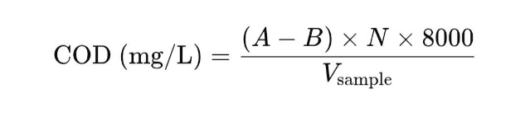
Ferroin indicator was added to the flask and titrated against 0.025 M ferrous ammonium sulphate solution to the endpoint. Blank preparation was prepared in the same manner as the sample, using distilled water instead of the sample.

Total Hardness
Total hardness is caused mainly by the presence of calcium (Ca²⁺) and magnesium (Mg²⁺) ions in water. It is expressed in mg/L as CaCO₃. Collected water samples (50 mL) (tap water, before immersion of Ganpati idol, and after immersion of Ganpati idol Indrayani River water) were pipette out into a clean conical flask. Followed by the addition of 2 mL of pH 10 buffer solution to maintain alkaline conditions. 2–3 drops of Eriochrome Black T (EBT) indicator was added. Solution turns wine red in the presence of Ca²⁺ and Mg²⁺ ions. Finally, samples were titrated against a 0.01 M EDTA solution and titrated until the color changed from wine red to blue (end point).
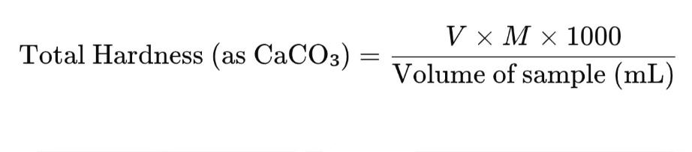
Antimicrobial Treatment
Cell viability checked using the colony count method:::
The antibacterial activity of the collected water samples, tap water, before immersion of Ganpati idol, and after immersion of Ganpati idol, Indrayani River water, Sodium alginate AgNPs beads (Na-AL AgNPs beads) treated water was investigated with the help of cell viability test using colony count method as follows: 10µL sample from the collected water sample spread on LB agar plates. The plates were incubated for 24 h at 37 ⁰C. Bacterial count was calculated by counting colonies on all plates.

3. results and discussion

this study investigates how water quality is disturbed because of not improper dissolution of the Ganpati Idol. Earlier, there was only one idol in the whole society, but now complete culture has completely changed. Each house is curious about Ganpati Sthapana, but this way, we are only responsible for the disturbance of the environment. This Ganpati idol immersion in river water affects the quality of water and indirectly impacts on environment and life. It releases chemicals, metals into water, and decreases the dissolved oxygen and increases the hardness of water.

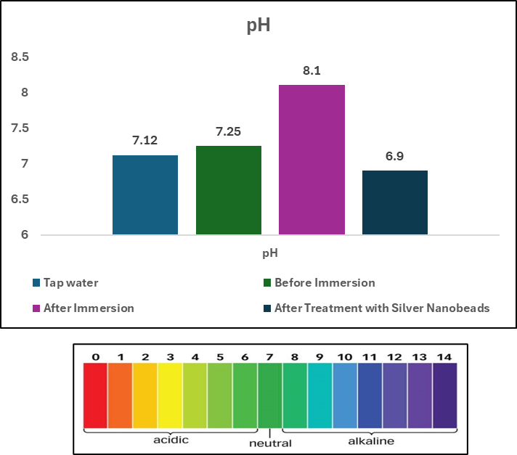

Figure 1: pH of all collected water samples

pH stands for “potential of hydrogen” and measures how acidic or basic (alkaline) a solution is. It is a scale from 0 to 14. As per the pH scale and figure 1, the pH of tap water is 7.12, which counts as a neutral pH, and about the water sample, which is collected before the Ganesh idol immersion, is 7.25. On the other hand, the pH of water, which is collected after the immersion, 8.1 showing slightly alkaline properties. The immersion of the Ganesh idol affects the physiological parameters of water, and it indirectly shows an effect on aquatic life. It has a negative impact on aquatic animals.

Temperature:

Figure 2: Temperature of all collected water samples

Temperature is one important physical parameter that directly influences some chemical reactions in the aquatic ecosystem. Low temperature favored the dissolution of dissolved oxygen. Warm water is more susceptible to Eutrophication a build-up of nutrients and possible algal Blooms, because photosynthesis and bacterial decomposition both works faster at higher temperature.
Immersion of the Ganesh idol is not affecting the temperature parameter of water as compared to before immersion. The temperature showed a very slight increase (Figure 2).

Dissolved oxygen
Dissolved oxygen in groundwater refers to the concentration of free oxygen molecules available for aquatic life and geochemical processes, typically measured in mg/L. The dissolved oxygen of collected samples of water drastically reduced after immersion of the Ganesh idol in the river. Low DO suggests the high organic content and can lead to anaerobic conditions. But after the treatment with Na-Al-AgNPs beads showed level on dissolved oxygen increased the level of DO to 4.2 (Figure 3) as compared to the immersed water of the river.
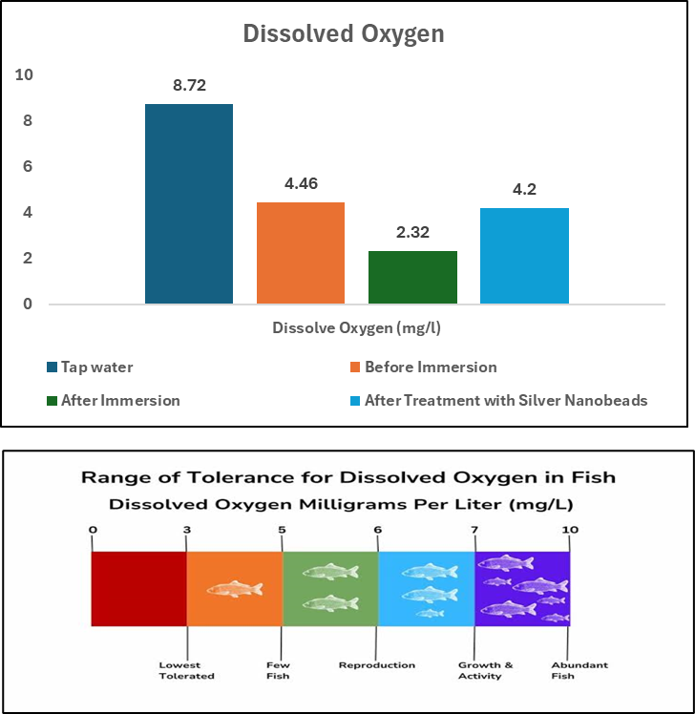

Figure 3: Dissolved Oxygen of all collected water samples

Biological Oxygen Demand

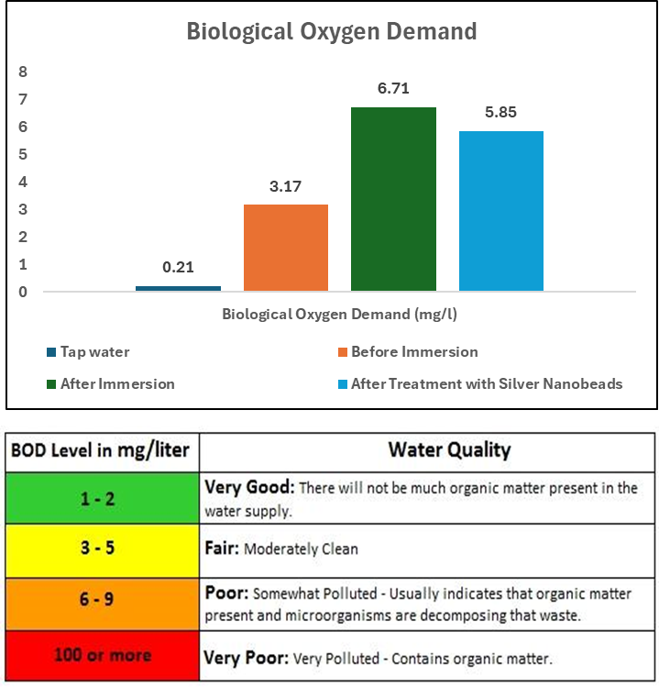

Figure 4: Biological Oxygen Demand of all collected water samples

As seen in Figure 4, immersion of the Ganesh idol in river water showed a significant effect on the BOD level of the water. BOD of water indicates how much the water quality is clean as well of the sustainability of aquatic life under water. As the BOD level increases, water quality decreases, and the sustainability of aquatic life is in danger. After the treatment of Na-AL-AgNPs beads slight increase in BOD was observed. AgNPs bead treatment is safe to clean the water's organic content to maintain the life of the water.

Chemical Oxygen Demand

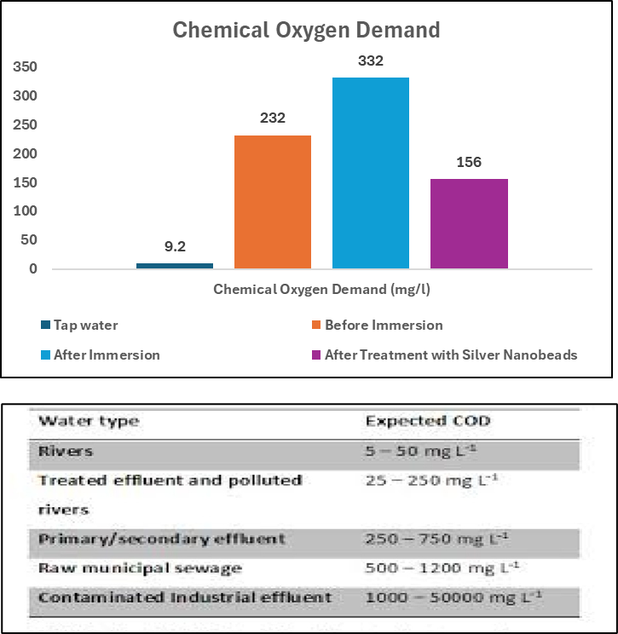

Figure 5: Chemical Oxygen Demand of all collected water samples

BIS (Bureau of Indian Standards) sets permissible limits for various water quality parameters, including COD (Chemical Oxygen Demand), which is a measure of the amount of oxygen required to oxidize organic and inorganic matter in water. So, the COD value of the water sample before immersion is 232 mg/L, and after immersion, the value comes to 332 mg/L which is considered as primary/secondary effluent as per the standard chart. As seen in the Figure 5, Ganesh idol immersed water treated with Na-Al-AgNPs beads and observed that the COD of water decreased. AgNPs are helping in the maintenance of the COD of water.

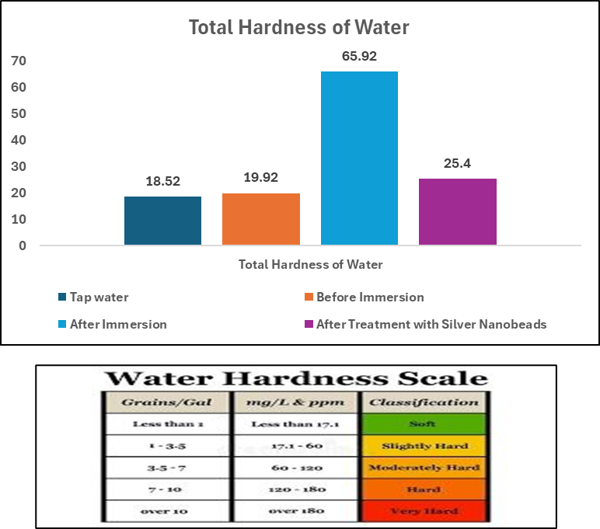

Figure 6: Total hardness of all collected water samples

The total hardness of tap water is 18.52 mg/L considered slightly hard. Water that is before immersion of Ganesh, is at 19.52 mg/L. As per chart below, it is slightly hard. Total hardness of water, which is after immersion of Ganesh idol, is 65.92 mg/L, which is considered as moderately hard water. This immersed Ganesh Idol water treated with Na-Al-AgNPs beads, and it is seen that the hardness of the water decreased.

Antimicrobial activity of all collected and treated water samples
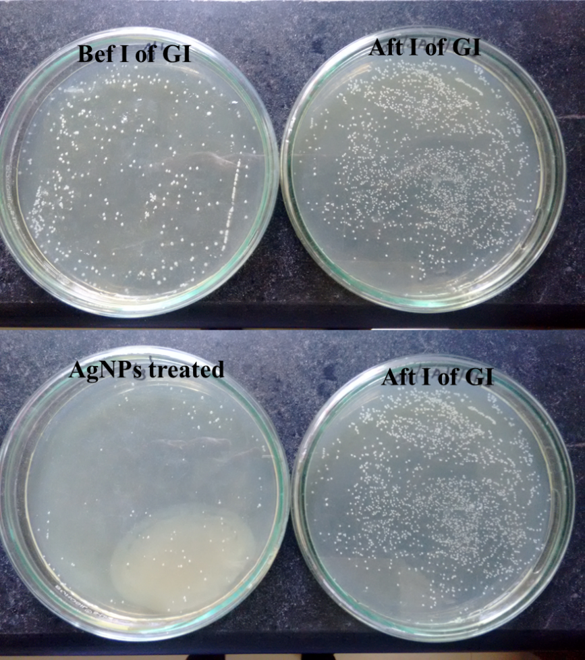

Figure 7: Antibacterial activity of all collected water against E.Coli
Before I of GI- Before immersion of Ganpati Idol, Aft I of GI- After immersion of Ganpati Idol, AgNPs treated- Na-Al-AgNPs beads treated water

Bacterial growth was observed in all collected water samples, as well as Na-Al-AgNPs bead-treated water, which included Ganpati Idol immersed water. As seen in Figure 6, before immersion of the Ganpati idol, Indrayani River showed moderate bacterial growth on LB plates, and after immersion of the Ganpati Idol, Indrayani River water showed a significant increase in bacterial growth that concludes water is contamination is increasing. But as observed in the above figure, bacterial contamination of the Ganesh Idol immersed water was reducing after the treatment of Na-Al-AgNPs beads for a minimum of 5 days. This result concludes the antibacterial activity of silver nanoparticles.

4. Conclusion

The study demonstrates that Ganesh idol immersion significantly deteriorates Indrayani River water quality by increasing BOD, COD, and hardness while reducing DO levels. Silver nanoparticles exhibited strong antimicrobial properties and effectively improved water quality parameters in laboratory conditions.
It is also important to note that extended exposure to silver nanoparticles may cause toxicity due to ion release, as observed after 5 days in treated water samples. Hence, while AgNPs are promising in short-term microbial reduction, their safe application requires strict monitoring and regulatory evaluation before large-scale use.

Disclaimer (Artificial intelligence)

Option 1:

Author(s) hereby declare that NO generative AI technologies such as Large Language Models (ChatGPT, COPILOT, etc.) and text-to-image generators have been used during the writing or editing of this manuscript.

Option 2:

Author(s) hereby declare that generative AI technologies such as Large Language Models, etc. have been used during the writing or editing of manuscripts. This explanation will include the name, version, model, and source of the generative AI technology and as well as all input prompts provided to the generative AI technology

Details of the AI usage are given below:
1.
2.
3.

References
- Banerjee, A., et al. (2021). Silver-based nanocomposites for festival water pollution treatment. Environmental Nanotechnology, Monitoring & Management, 16, 100344.
- Patil, P. N., & Ghole, V. S. (2005). Idol immersion activities cause pollution of water bodies. Environmental Science and Engineering, 47(4), 247–251.
- Ahmed, S., Saifullah, Ahmad, M., Swami, B. L., & Ikram, S. (2016). Green synthesis of silver nanoparticles using Azadirachta indica aqueous leaf extract. Journal of Radiation Research and Applied Sciences, 9(1), 1–7.
- Rai, M., Yadav, A., & Gade, A. (2009). Silver nanoparticles as a new generation of antimicrobials. Biotechnology Advances, 27(1), 76–83.
- Singh, R., Gautam, N., Mishra, A., & Gupta, R. (2016). Heavy metals and living systems: An overview. Indian Journal of Pharmacology, 43(3), 246–253.
- Pote, R. T. (2023). A study on the beneficial economic effects of festivals on the Indian economy. International Journal of Advance Research in Multidisciplinary, 1(2), 01‑04. Narwani, D. (2023). A study on digital donation platforms and innovative fundraising strategies: Empowering Ganpati mandals in Mumbai. Humanities and Social Science Studies, 12(2), 29–[88-94].
- Maiti, M., Chaudhuri, S., & Biswas, A. (2021). Activities of idol immersion leads to heavy metal contamination in river Hooghly in and around the city of Kolkata. Journal of the indian chemical society, 98(11), 100223.
- Yigam, J., & Bharti, A. (2025). Mitigating river pollution during Indian festivals: The efficacy of artificial idol immersion ponds as a sustainable solution. SSRG International Journal of Civil Engineering, 12(2), 31–41.

