Original Research Article
Stature and Sex Estimation Using Anthropometric Parameters in the Yoruba Ethnic Group of Nigeria
Abstract
Background: Anthropometry, a part of anthropology and forensic science, uses measurements to study human remains and identify unique biological traits. Estimating a person's height and sex from various body measurements was part of building a biological profile in forensic work.
Aim: The study aimed to develop a stature estimation model using specific linear anthropometric parameters from the Yoruba ethnic group of Nigeria, with an emphasis on their application in the forensic context.
Method: A total of 400 subjects, (200 females and 200 males) between the ages of 18-40 years were recruited for the study. Standardized anthropometric techniques were used to measure the sitting height, sitting shoulder height, sitting knee height, sitting popliteal height, sitting hip breadth, and shoulder breadth. Data analysis was done using a statistical package for social sciences version 23. Discriminant and multivariate regression were used to estimate sex and stature. A probability less than 0.05 (p<0.05) was considered statistically significant and 95% was denoted as confidence level.
Result: The study shows that males have higher anthropometric values than females. The multivariate regression among the sexes to estimate stature using sitting height, sitting shoulder height, sitting knee height, sitting popliteal height, sitting hip breadth, and shoulder breadth shows (R=0.91, SEE= 3.50), the stature predictive power of male was (R= 0.83, SEM=3.64) and female stature (R= 0.86, SEM=3.09). The estimation for sex shows overall significance (X²=312.93, ƛ= 0.45, p<0.05).
Conclusion: The study identified significant sexual dimorphism in sitting height, shoulder height, knee height, popliteal height, hip breadth, and shoulder breadth. The anthropometric parameters were good predictors of the sexes.
Keywords: Forensics; Stature; Sex; Yoruba Biological Profile.

1.0 INTRODUCTION
Anthropometry, which falls under anthropological research and forensic medicine, uses the metric approach to measure human remains to determine unique biological profiles [1]. Numerous human body parts are frequently found at the crime scene in both man-made and natural disasters, such as bomb explosions, traffic accidents, train collisions, plane crashes, or homicide cases [2]. Natural disasters include earthquakes, floods, tsunamis, and floods. Identification has always been challenging for specialists in such circumstances.
When assessing a population's physical attributes, one of the most crucial factors is its stature which is essential in identifying a person in medico-legal situations, industrial human body fitting design, furniture manufacture [3], etc. Amputations, fractures, scoliosis, paralysis, discomfort, and spinal and limb abnormalities are among the factors that might make it difficult to assess stature directly; in these situations, body segments are utilized to estimate a person's standing. Therefore, several studies have examined a variety of bodily parts, such as arm length [4], arm span [5], radial and ulnar height [6], sitting popliteal height [7], shoulder breadth [8], forearm-hand length [9], foot length [10], hand length [11], and tibia length [12], to predict an individual's stature.
Sexual dimorphism on the shoulder breadth, sitting shoulder height, and knee height verified that anthropometric characteristics were good predictors of the sexes in a study by Fawehinmi et al. [13] on stature and sex estimate among the Igbo ethnic group in Nigeria. According to research by Özer et al. [14], knee height shows a highly accurate measure of stature in Turkish adults. In a study on the estimation of stature and sex from measurements of shoulder breadth, shoulder height, popliteal height, and knee height in a Bangladeshi population, Yeasmin et al. [7] discovered there was a good correlation between stature and those measurements.
However, some currently available literature frequently ignores the significance of alternative measurements of stature estimation on the sitting height, sitting shoulder height, sitting popliteal height, sitting knee height, sitting hip breadth, and shoulder breadth. For this reason, this study will focus on estimating the stature and sex of the Yoruba ethnic group using sitting height, sitting shoulder height, sitting popliteal height, sitting knee height, shoulder breadth, and sitting hip breadth.

MATERIALS AND METHODS
2.1 Study Design
The anthropometric value of Yoruba in Nigeria was measured using a cross-sectional descriptive research method. Four hundred subjects (200 males) and (200 females) between the ages of 18 and 40 made up the population. The study frame was at Lead City University at Ibadan, where the subjects were selected using a multi-stage random proportionate sampling approach.
2.2 Selection Criteria
Inclusion Criteria
Only subjects whose parents and grandparents are from the Indigen of Yoruba were selected for the study. The study also recruited subjects whose ages ranged from 18-40 years.
Exclusion Criteria
Subjects who did not meet all these inclusion criteria were omitted from the study, and those with abnormalities in hand morphology or stature were excluded.
2.2.1 Anthropometric landmarks
The study used some anthropometric variable measures (stature, sitting height, sitting shoulder height, sitting popliteal height, sitting knee height, sitting hip breadth, and shoulder breadth), and these variables are defined as follows;
2.2.2. Stature
This was measured with a ZT-160 Goodcare stadiometer. The subject stood erect and barefoot on the stadiometer's level platform, with the back of their heads, shoulder blades, buttocks, and heels touching the bar. Subjects were advised to relax with their arms by their sides. Care was taken to avoid sagging [13].

2.2.3. Sitting Height
The subject assumes an upright posture, placing hands on his or her thighs, arms hanging at the sides, and the head in the franc fort plane. A manufactured mega-size caliper was measured from the seat surface to the head’s vertex with the head compressed [13].
2.2.4. Sitting shoulder height
Sitting shoulder height was measured as the vertical distance from the top of the shoulder’s acromion process to the participant’s sitting surface and was measured with a mega-size caliper [13].
2.2.5. Sitting Popliteal height
The popliteal space is the vertical distance, measured at 90⁰ degrees of knee flexion, between the foot resting surface and the posterior surface of the knee. With their thighs fully supported and the sitting surface extending as far into the hollow of their knee as feasible, the student sits perfectly upright, their lower legs hanging loosely. The measuring mega-size caliper made of wood was used to determine the distance to the front edge of the seating surface. The measurement is required to calculate the seat height [7].
2.2.6. Sitting knee height
Sitting knee height was measured in the sitting posture as the vertical distance from the top of the knee-cap to the foot resting surface while the knee flexed at 90◦ angles and was measured with a mega-size caliper [7].
2.2.7. Shoulder breadth
This was measured using a mega-size caliper. Shoulder breadth was measured from the horizontal length of the left to the right acromial process of the shoulders [13].
2.2.8. Sitting Hip Breadth
This is the greatest horizontal separation between the hips when seated. To select the seat width, you must know the width of your hips when sitting. The mega-size caliper made of wood was used to measure it [22].
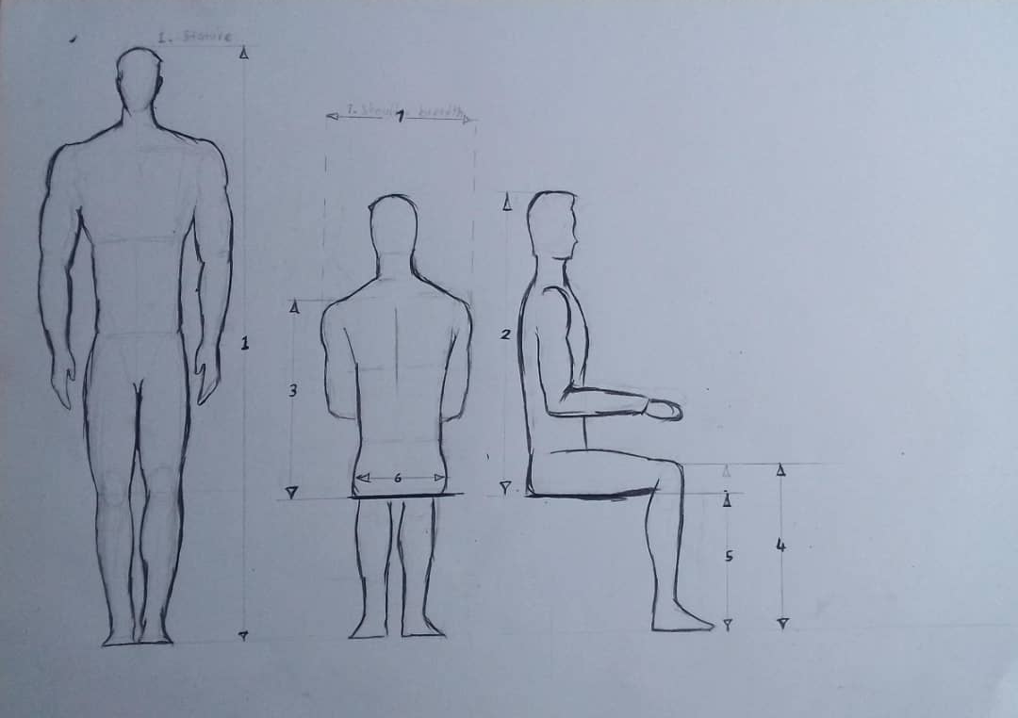
Fig.1 Anthropometric measurement: 1- Stature, 2- Sitting Height, 3- Sitting Shoulder Height, 4- Sitting Knee Height, 5- Sitting Popliteal Height, 6- Sitting Hip Breadth, and 7- Shoulder Breadth

2.3 Method of Data Collection
A semi-constructive descriptive questionnaire and a personal interview were used to gather the sociodemographic data for the Yoruba of Nigeria. This ensured that the subjects met the inclusion criteria and were fit to participate in the study. The sitting height, sitting shoulder height, sitting popliteal height, sitting knee height, sitting hip breadth, and shoulder breadth were measured using a mega-size caliper, adopting the appropriate anatomical landmarks. The standing height was measured from the vertex of the head to the sole in an upright position using a ZT-160 Goodcare stadiometer. Data readings were recorded and preserved by the authors.
  - Method of Data Analysis
Data obtained were subjected to statistical analysis using the International Business Machine of Statistical Package for Social Science (IBM version 25). The results obtained were presented in the table as mean ± standard deviation. T-test was used as an inferential statistic to evaluate sexual and asymmetry differences. Discriminant and linear regression were used to estimate sex and stature. A probability less than 0.05 (p<0.05) was considered statistically significant and 95% was denoted as confidence level.
- Result
The present study encompassed four hundred subjects of Yoruba indigenes between the ages of 18-40 years. The descriptive comparison between the subjects showed that all subjects had an average stature of 170.52±8.29cm, sitting height of 85.11±4.14cm, sitting shoulder height of 59.49±30.32cm, sitting knee height of 54.13±3.16cm, sitting popliteal height of 44.33±4.01cm, sitting hip breadth of 34.07±15.32 and shoulder breadth of 37.45±4.72 respectively (Table 1). The inference has shown there were sexual differences in stature, sitting height, sitting shoulder height, sitting knee height, sitting popliteal height, sitting hip breadth, and shoulder breadth (Table 2). Table 3, shows the multivariate regression analysis for estimating stature in all subjects using sitting height, sitting shoulder height, sitting knee height, sitting popliteal height, sitting hip breadth, and shoulder breadth in the Yoruba was statistically significant across the parameters, from the Collinearity statistics (VIF) which is a statistical concept that describes when predictor variables in a regression model are correlated with each other have shown that the parameters (S, SH, SSH, SKH, SPH, SHB, and SB) are good predictors for stature (VIF<2). The standard error of estimation (SEE) has shown the accuracy of the prediction (SEE< 1). Table 4 shows multivariate regression analysis for males which shows that it has a strong significant value (p<0.05) to stature estimation in males and its accuracy of the prediction across the parameters was observed to be high (SEE<1) and equally shows that the collinearity of the parameters further indicated that the parameters are good predictors of stature (VIF<2). Table 5, among the females, our results indicate a similar finding to the males showing that the overall prediction was significant (p<0.05) with a high level of accuracy (SEE<1) of the parameters to stature estimation. However, the collinearity of the parameters to stature estimation has shown that the parameters are good predictors for stature (VIF<2). Table 6, a summary of multivariate regression of stature estimation among all subjects shows that the model demonstrated high predictive accuracy, with a correlation coefficient of 0.91 and an error margin of 3.50 cm. Comparison between the males and the females has shown that genders have a better prediction of stature with a correlation coefficient of 0.83 and error margin of 3.64 in males and in females stature with a correlation coefficient of 0.86 and error margin of 3.09 which shows the statistical variability.
Table 7, shows the discriminant analysis using the stature to classify sex with sitting height, sitting shoulder height, sitting knee height, sitting popliteal height, sitting hip breadth, and shoulder breadth. The overall chi-square test shows a significant value (X²=312.93, ƛ= 0.45), canonical correlation = 0.74, df= 7, and p<0.05). The sexual centroid displayed that the male was 1.09 while the female was -1.09. The Canonical Discriminant Coefficient is a coefficient in a linear combination of variables that is used to discriminate between groups which shows -21.16+(S)=0.09+(SH)-0.01(SSH) 0.04+(SKH)0.09+(SPH)-0.01+(SHB)-0.18+(SB)0.12across the sex while for specificity and validity, the discriminant classification coefficient model for;
Male=-466.66+(S)3.72+(SH)0.36(SSH)2.72+(SKH0.68+(SPH)-0.81+(SHB)1.42+(SB)0.93 while
Female=-420.22(S)3.52+(SH)0.39(SSH)2.62+(SKH)0.47+(SPH)-0.80+(SHB)1.82+(SB)0.65
- Discussion
The current study estimates the stature and sex estimation from sitting height, sitting shoulder height, sitting knee height, sitting popliteal height, sitting hip breadth, and shoulder breadth among the Yoruba ethnic group of Nigeria. This study found higher anthropometric dimensions of stature, sitting height, sitting shoulder height, sitting knee height, sitting popliteal height, sitting hip breadth, and shoulder breadth in males than females. According to the study's findings, the average height difference between males and females is largely caused by biological and hereditary variables. During puberty, testosterone is a major factor in encouraging bone growth. Men typically have larger levels of growth hormones than women, which help them build more muscle and bone. Several genes affect height, and males usually inherit characteristics that make them more likely to be tall, thus genetics also plays a significant part [24]. The sexual variance seen in this study is consistent with past studies conducted in a variety of populations that identified substantial (p<0.05) differences between males and females by Fawehinmi et al., [13], Oghenemavwe et al., [3], Chuau et al., [15], Sageghi et al., [16] and Fryar et al., [23].
Moreover, this current study shows the strong correlation coefficient of sex between stature, sitting height, sitting shoulder height, sitting knee height, sitting popliteal height, sitting hip breadth, and shoulder breadth (R=0.91, SEE= 3.50) and this would be reliable for predicting human stature. However, when comparing the sex using anthropometric parameters, the finding shows that male stature (R= 0.83 SEM=3.64) has better perdition using sitting height, sitting shoulder height, sitting knee height, sitting popliteal height, sitting hip breadth, and shoulder breadth as well as the female’s (R= 0.86, SEM=3.09), This may be attributed to the fact that during going through adolescence, the male usually produces a lot more testosterone, which encourages growth spurts and helps them build longer bones and a larger body than female. The findings of this study agree with the findings of Yeasmin et al., [7], Asadujjaman [17], Asadujjaman [18], Fatmah, [19], and Maleki and Shariatpanahi [20]. Our study showed the stature model for males, S=44.53+(SH)0.81(SSH)0.03+(SKH)0.98+(SPH)0.28+(SHB)-0.32+(SB)0.05, and females, S=38.68+(SH)0.56(SSH)0.07+(SKH)1.32+(SPH)0.38+(SHB)-0.11+(SB)0.08.
Sexual discrimination was also explored to classify sex (male and female) using sitting height, sitting shoulder height, sitting knee height, sitting popliteal height, sitting hip breadth, and shoulder breadth. The findings of this study showed that the stature estimation using sitting height, sitting shoulder height, sitting knee height, sitting popliteal height, sitting hip breadth and shoulder breadth was significant (X²=312.93, ƛ= 0.45, p<0.05). Where the sex centroid shows that applying the discriminant model 𝑆𝑒𝑥= 28.34+(SB)0.11+(SSH)0.02+(SKH)0.1-21.16+(S)=0.09+(SH)-0.01(SSH) 0.04+(SKH)0.09+(SPH)-0.01+(SHB)-0.18+(SB)0.12, with the study parameters, a positive resultant value from 0 to 1.09 predicts males and from 0 to -1.09 predicts females. The findings have shown that group membership of the males was 88% and females was 86% were correctly predicted which account for 87% of the total sexes were correctly classified. Our findings agree with the work of Yeasmin et al., [7] and Armah et al., [21] in the Bangladeshi and Ghanaian populations showing that the sex estimation accuracy varied from "78%" to "97%" for consistency and accuracy.
The study has shown similarities and differences in sex and stature estimation using sitting height, sitting shoulder height, sitting knee height, sitting popliteal height, sitting hip breadth, and shoulder breadth among the population. These differences could be attributed to factors like environmental factors, race factors, and body composition. This implies that climate, cultural norms, nutrition and physical activity, genetic ancestry and sociocultural context, introduce variations in sex.
5. CONCLUSION
The study assessed the sexual dimorphism of sitting height, sitting shoulder height, sitting knee height, sitting popliteal height, sitting hip breadth, and shoulder breadth. The results indicate that the anthropometric measurements of males and females differ in sitting height, sitting shoulder height, sitting knee height, sitting popliteal height, sitting hip breadth, and shoulder breadth. In estimating stature between the sexes, the anthropometric characteristics of sitting height, sitting shoulder height, sitting knee height, sitting popliteal height, sitting hip breadth, and shoulder breadth were effective predictors of the sexes. Ergonomics, anthropology, and forensic anatomists will all benefit from this information. There is a need for future research to incorporate advanced imaging techniques or expand the age range to include adolescents and older adults in other parts of Nigeria and the African population.
ETHICAL APPROVAL AND CONSENT
Ethical approval was obtained from the Research Ethics Committee of the University of Port Harcourt, Port Harcourt, Nigeria (UPHCEREMAD/REC/MM/91/046). All subjects were adequately informed about the study procedure, and they gave their consent to participate. The authors recorded and preserved data readings.
Table 1. Descriptive Statistics of the Yoruba Subjects
Parameters | N | Minimum | Maximum | Mean | Std. Deviation
S (cm) | 400 | 150.00 | 193.00 | 170.5160 | 8.29653
SH (cm) | 400 | 75.00 | 99.50 | 85.1055 | 4.14087
SSH (cm) | 400 | 49.00 | 660.00 | 59.4905 | 30.31817
SKH (cm) | 400 | 43.20 | 66.20 | 54.1333 | 3.16089
SPH (cm) | 400 | 37.00 | 94.00 | 44.3272 | 4.01082
SHB (cm) | 400 | 27.10 | 334.00 | 34.0710 | 15.31771
SB (cm) | 400 | 4.30 | 71.00 | 37.4475 | 4.72560
S= Stature, SH= Sitting Height, SSH= Sitting Shoulder height, SKH=Sitting Knee Height, SPH= Sitting Popliteal Height, SHB=Sitting Hip Breadth, SB= Shoulder Breadth
Table 2. Sexual Differences of the Yoruba Subjects
Parameters | Male | Female | T-test | P-value | Inference
S (cm) | 175.89±6.41 | 165.28±6.02 | 17.045 | 0.00 | S
SH (cm) | 86.88±3.71 | 83.32±3.76 | 9.506 | 0.00 | S
SSH (cm) | 59.27±3.71 | 56.70±3.19 | 7.595 | 0.00 | S
SKH (cm) | 56.01±2.69 | 52.30±2.39 | 14.560 | 0.00 | S
SPH (cm) | 46.25±4.30 | 42.40±2.50 | 10.930 | 0.00 | S
SHB (cm) | 32.64±2.21 | 34.10±3.36 | -5.114 | 0.00 | S
SB (cm) | 39.47±3.82 | 35.43±3.05 | 11.387 | 0.00 | S
S= Stature, SH= Sitting Height, SSH= Sitting Shoulder height, SKH=Sitting Knee Height, SPH= Sitting Popliteal Height, SHB=Sitting Hip Breadth, SB= Shoulder Breadth
Table 3. Multivariate Regression of Stature Estimation in all Subject
Model | Unstandardized Coefficients |  | Standardized  Coefficient | t | Sig. | Collinearity Statistics
 | B | Std. Error | Beta |  |  | Tolerance | VIF
(constant) | 30.596 | 4.166 |  | 7.344 | .000*
SH (cm) | .744 | .062 | .377 | 12.050 | .000* | .471 | 2.124
SSH (cm) | .004 | .058 | .002 | .070 | .944 | .691 | 1.448
SKH (cm) | 1.247 | .086 | .481 | 14.543 | .000* | .421 | 2.373
SPH (cm) | .325 | .060 | .160 | 5.405 | .000* | .529 | 1.892
SHB (cm) | -.304 | .064 | -.109 | -4.745 | .000* | .867 | 1.153
SB (cm) | .125 | .051 | .061 | 2.431 | .016 | .738 | 1.355
SH= Sitting Height, SSH= Sitting Shoulder height, SKH=Sitting Knee Height, SPH= Sitting Popliteal Height, SHB=Sitting Hip Breadth, *= Significant
Table 4. Multivariate Regression of Stature Estimation in Male Subjects
Model | Unstandardized Coefficients |  | Standardized  Coefficient | t | Sig. | Collinearity Statistics
 | B | Std. Error | Beta |  |  | Tolerance | VIF
(constant) | 44.534 | 6.937 |  | 6.420 | .000*
SH (cm) | .807 | .101 | .468 | 8.022 | .000* | .478 | 2.093
SSH (cm) | .034 | .095 | .019 | .353 | .724 | .575 | 1.738
SKH (cm) | .979 | .123 | .411 | 7.985 | .000* | .614 | 1.630
SPH (cm) | .283 | .071 | .190 | 4.002 | .000* | .723 | 1.384
SHB (cm) | -.324 | .132 | -.112 | -2.458 | .015 | .781 | 1.280
SB (cm) | .050 | .072 | .030 | .687 | .493 | .871 | 1.148
SH= Sitting Height, SSH= Sitting Shoulder height, SKH=Sitting Knee Height, SPH= Sitting Popliteal Height, SHB=Sitting Hip Breadth, *= Significant
Table 5. Multivariate Regression of Stature Estimation in Female Subjects
Model | Unstandardized Coefficients |  | Standardized  Coefficient | t | Sig. | Collinearity Statistics
 | B | Std. Error | Beta |  |  | Tolerance | VIF
(constant) | 38.689 | 6.362 |  | 6.081 | .000*
SH (cm) | .561 | .076 | .350 | 7.369 | .000* | .586 | 1.706
SSH (cm) | -.069 | .072 | -.037 | -.962 | .337 | .910 | 1.098
SKH (cm) | 1.316 | .134 | .524 | 9.843 | .000* | .468 | 2.136
SPH (cm) | .376 | .120 | .156 | 3.137 | .002 | .533 | 1.875
SHB (cm) | -.114 | .076 | -.064 | -1.495 | .137 | .727 | 1.375
SB (cm) | .083 | .078 | .042 | 1.065 | .288 | .841 | 1.190
SH= Sitting Height, SSH= Sitting Shoulder height, SKH=Sitting Knee Height, SPH= Sitting Popliteal Height, SHB=Sitting Hip Breadth, *= Significant
Table 6. Summary of Multivariate Regression Model of Stature Estimation of the Yoruba Subjects
Subjects | Multivariate model | R | R Square | Std. Error of the Estimate | Sig. F Change
All | S=30.59+(SH)0.74(SSH)0.04+(SKH)1.25+(SPH)0.33+(SHB)-0.30+(SB)0.13 | 0.905 | 0.819 | 3.5032 | 0.00*
Male | S=44.53+(SH)0.81(SSH)0.03+(SKH)0.98+(SPH)0.28+(SHB)-0.32+(SB)0.05 | 0.829 | 0.687 | 3.6450 | 0.00*
female | S=38.68+(SH)0.56(SSH)0.07+(SKH)1.32+(SPH)0.38+(SHB)-0.11+(SB)0.08 | 0.863 | 0.744 | 3.0957 | 0.00*
S= Stature, SH= Sitting Height, SSH= Sitting Shoulder height, SKH=Sitting Knee Height, SPH= Sitting Popliteal Height, SHB=Sitting Hip Breadth, *= Significant

Table 7. Sex Discriminant Function of all Anthropometric parameters in Yoruba Ethnic Group
Eigenvalue | Canonical Correlation | Wilks’ Lambda | Chi-Square | df |  | Sig.
1.21 | 0.74 | 0.45 | 312.934 | 7 |  | 0.000*
Sex centroid  Male = 1.09  Female = -1.09 |  | Canonical Discriminant Coefficient
 |  | -21.16+(S)=0.09+(SH)-0.01(SSH) 0.04+(SKH)0.09+(SPH)-0.01+(SHB)-0.18+(SB)0.12
Classification Coefficient |  |  | Predicted Group Membership
Male=-466.66+(S)3.72+(SH)0.36(SSH)2.72+(SKH0.68+(SPH)-0.81+(SHB)1.42+(SB)0.93 |  |  | Male |  | Female
 |  |  | 176 |  | 24
Female=-420.22(S)3.52+(SH)0.39(SSH)2.62+(SKH)0.47+(SPH)-0.80+(SHB)1.82+(SB)0.65 |  |  | 28 |  | 172
 |  |  | 88% |  | 12
 |  |  | 14 |  | 86%
S= Stature, SH= Sitting Height, SSH= Sitting Shoulder height, SKH=Sitting Knee Height, SPH= Sitting Popliteal Height, SHB=Sitting Hip Breadth, *= Significant, 87.0% of original group cases correctly classified
Fig 2: The diagram showing the Scatterplot or Regression line to Demonstrate the Relationship between Anthropometric Parameters and Stature
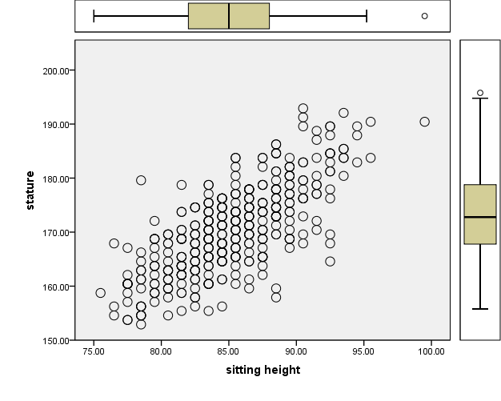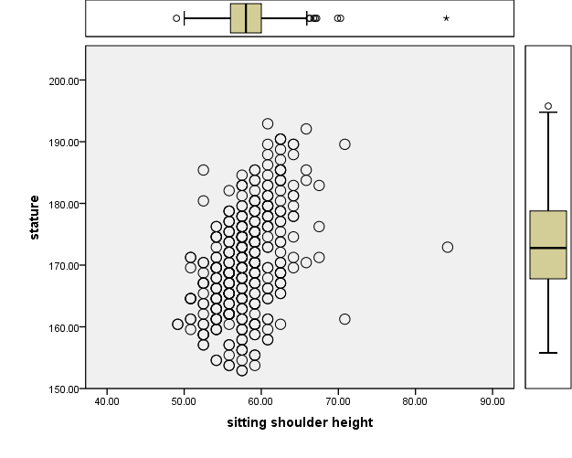

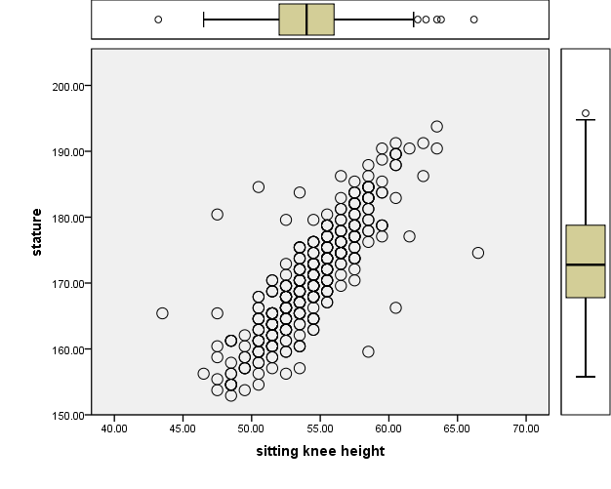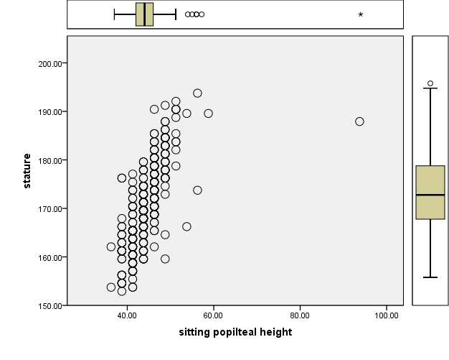

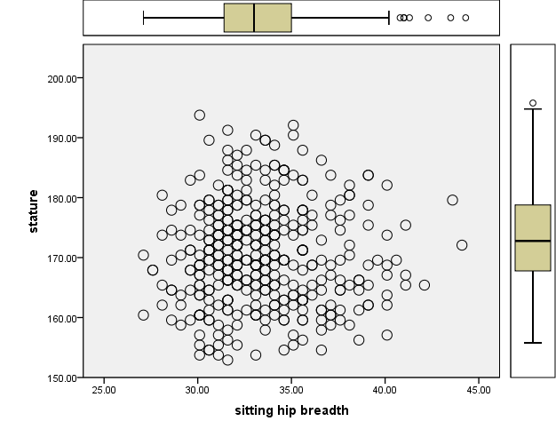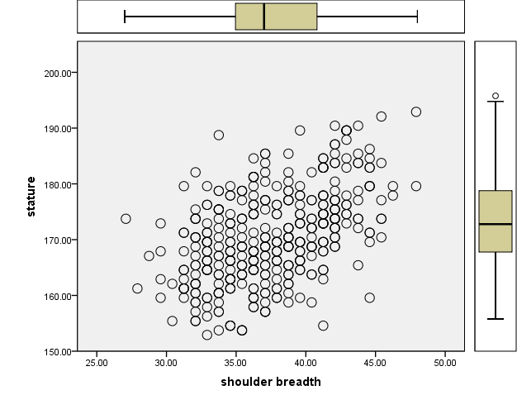
Disclaimer (Artificial intelligence)
Author(s) hereby declare that NO generative AI technologies such as Large Language Models (ChatGPT, COPILOT, etc.) and text-to-image generators have been used during the writing or editing of this manuscript.

Reference
- Irozulike FC, Uchechukwu CG, Nwofor PN, Filima PL, Selekekeme TB. Assessment of Earlobe Patterns and Ear Shapes in Hausa Ethnic Group of Nigeria: Implications for Forensic and Clinical Applications. Asian Journal of Medical Principles and Clinical Practice. 2024 Dec 12:502-8.
- Lessig R, Prinz M. Mass Disaster Victim Identification. Handbook of Forensic Medicine. 2022 Jun 27;1:291-309.
- Oghenemavwe LE, Okoh PD, Irozulike FC, Amadi MA. Multivariate Regression Model for Stature Estimation from Arm Span, Horizontal Fingertip Reach and Foot Length of Igbo Ethnic Group of Nigeria. Journal of Complementary and Alternative Medical Research. 2024;25(8):112-7.
- Oghenemavwe LE, Fawehinmi HB, Okoh PD, Nwofor PN, Asiwe N. Does Upper Arm Length, Arm Span, and Foot Length Serve as Good Predictors for Stature? A Cross-Sectional Study among Northern Nigerians. The foot.;5:10.
- Sultana R, Anwar S, Islam S. Estimation of Stature from Arm Span: A Prospective Study Among Medical Students of Rangpur Medical College. Journal of Rangpur Medical College. 2022 Nov 3;7(2):47-51.
- Pithiya G, Mahida DK, Patel A. Estimation of stature from ulna and hand length in Gujarati population. International Journal of Medical Toxicology & Legal Medicine. 2022;25(3and4):229-35.
- Yeasmin N, Asadujjaman M, Islam MR, Hasan MR. Stature and sex estimation from shoulder breadth, shoulder height, popliteal height, and knee height measurements in a Bangladeshi population. Forensic Science International: Reports. 2022 Jul 1;5:100258.
- Saptaputra SK, Kurniawidjaja LM, Susilowati IH, Pratomo H. Ergonomic sofa design to support kangaroo mother care in Indonesia. Journal of Neonatal Nursing. 2021 Dec 1;27(6):471-5.
- Roli OI, Chukubueze OO, Mike IN. Determination of Sex and Stature from Percutaneous Anthropometric Dimensions of the Upper Arm and Forearm Bones in an Adult Nigerian Population in Lagos. Forensic Res. 2022;13(6):1-9.
- Oghenemavwe LE, Egwede OB. Estimation of living stature from foot dimensions in uturu indigenes of Abia state, Nigeria. European Journal of Medical and Health Sciences. 2022 Feb 10;4(1):67-71.
- Chandran M. Estimation of Stature from Hand Dimensions. Indian Journal of Forensic Medicine & Toxicology. 2021 Apr 1;15(2).
- Mulu A, Sisay B. Estimation of Stature from Arm Span, Arm Length and Tibial Length among Adolescents of Aged 15-18 in Addis Ababa, Ethiopia. Ethiopian Journal of Health Sciences. 2021 Sep 1;31(5).
- Fawehinmi HB, Oghenemavwe LE, Okoh PD, Ebieto CE, Irozulike FC, Asiwe N. Stature and Sex Estimation Using Some Linear Anthropometric Parameters: A Cross-Sectional Study of the Igbo Ethnic Group of Nigeria.
- Özer BK, Gültekin T, Sağir M. Estimation of stature in Turkish adults usinig knee height. Anthropologischer Anzeiger. 2007 Jun 1:213-22.
- Chuan TK, Hartono M, Kumar N. Anthropometry of the Singaporean and Indonesian populations. International Journal of Industrial Ergonomics. 2010 Nov 1;40(6):757-66.
- Sadeghi F, Mazloumi A, Kazemi Z. An anthropometric data bank for the Iranian working population with ethnic diversity. Applied Ergonomics. 2015 May 1;48:95-103.
- Asadujjaman M, Billal MM, Sarkar MR, Rabbani MG. The estimation of different body dimensions from stature in Bangladeshi male population. Hum Fact Ergon J. 2017;2(3):1-6.
- Asadujjaman M, Billal MM, Sarkar MR, Rabbani MG. Determination of Different Body Dimensions from Stature in Bangladeshi Female. Proceedings of IMEOM 2017 Dhaka.:121.
- Fatmah F. Predictive equations for estimation of stature from knee height, arm span, and sitting height in Indonesian Javanese elderly people. Int J Med Med Sci. 2009;1(10):456-61.
- Maleki S M, Shariatpanahi Z V. Estimation of Stature in Iranian Adults Using Knee Height. Malaysian Journal of Nutrition. 2017 Jan 1;23(1).
- Armah C, Abaidoo CS, Tetteh J, Diby T, Atuahene OO, Darko N, Appiah AK. A preliminary anthropometric study of height and sex determination using percutaneous humeral and tibial lengths. AustrAliAn JournAl of forensic sciences. 2018 Jul 4;50(4):396-402.
- Fidelis OP, Ogunlade B. Anthropometric perspective to classroom furniture ergonomics and the need for standards in Nigerian schools. Work. 2022 Jan 1;72(1):279-89.
- Fryar CD, Gu Q, Ogden CL, Flegal KM. Anthropometric reference data for children and adults; United States, 2011-2014.
- Mills EG, Yang L, Nielsen MF, Kassem M, Dhillo WS, Comninos AN. The relationship between bone and reproductive hormones beyond estrogens and androgens. Endocrine Reviews. 2021 Dec 1;42(6):691-719.

