Whether Vaginal Misoprostol Has Better Outcome than Intra Cervical Catheterization for Cervical ripening in Intra Uterine Fetal Death

Abstract
Background:
Intrauterine fetal death (IUFD) is one of the most distressing obstetric complications, necessitating timely and safe induction of labor to prevent maternal morbidity. Effective cervical ripening is crucial to ensure successful induction and reduce complications. Both vaginal misoprostol and intracervical Foley’s catheterization are widely used for this purpose; however, their relative efficacy and safety in IUFD cases remain under evaluation.
Objective: To compare the efficacy and safety of vaginal misoprostol versus intracervical Foley’s catheterization for cervical ripening in cases of intrauterine fetal death (IUFD) between 28 weeks and full-term gestation.
Methodology: This randomized clinical trial was conducted at the Department of Obstetrics and Gynaecology, Sir Salimullah Medical College and Mitford Hospital, Dhaka, from May 2023 to January 2024. A total of 108 women diagnosed with IUFD were enrolled and randomly assigned into two groups: Group A received vaginal misoprostol (25 µg every 6 hours for 24 hours), and Group B underwent intracervical Foley’s catheterization for 24 hours. Primary outcomes included initiation-to-cervical ripening time and cervical ripening-to-delivery time, while secondary outcomes assessed oxytocin augmentation, duration of augmentation, and complications.
Results: The mean initiation-to-cervical ripening time was significantly shorter in the misoprostol group compared to the Foley’s catheter group (11.53 ± 6.59 hours vs. 16.0 ± 8.99 hours; p = 0.005). However, no significant difference was found in the cervical ripening-to-delivery interval (p = 0.120). The need for oxytocin augmentation was markedly lower in the misoprostol group (40.7%) than in the catheter group (83.3%) (p < 0.001), with a shorter augmentation duration (5.78 ± 2.30 vs. 8.30 ± 4.46 hours; p = 0.014). Both methods were well tolerated, with minimal hyperstimulation and no cases of uterine rupture. Postpartum hemorrhage occurred more frequently in the catheter group (18.5%) than in the misoprostol group (5.6%) (p = 0.038).
Conclusion: Vaginal misoprostol demonstrated greater efficacy in cervical ripening compared to intracervical Foley’s catheterization, achieving faster cervical readiness and requiring less oxytocin augmentation with comparable safety. Hence, vaginal misoprostol (25 µg every 6 hours) may be considered a superior and reliable method for cervical ripening in IUFD cases.
Keywords: Intrauterine fetal death, cervical ripening, vaginal misoprostol, intracervical Foley’s catheter, oxytocin augmentation, labor induction.
Introduction
Intrauterine fetal death (IUFD) remains one of the most distressing obstetric complications, posing both emotional and clinical challenges for patients and healthcare providers. Defined as the death of a fetus after the age of viability but before birth, IUFD necessitates the induction of labor to evacuate the uterus safely and prevent maternal complications such as coagulopathy or infection. ¹⁻³ The effectiveness and safety of cervical ripening methods play a pivotal role in determining the duration and comfort of the induction process, as well as minimizing maternal morbidity.
Cervical ripening can be achieved through both mechanical and pharmacological means. Among mechanical methods, intracervical catheterization (commonly using a Foley catheter) has been widely employed due to its simplicity, low cost, and favorable safety profile. ⁴⁻⁵ The catheter exerts direct mechanical pressure on the cervix, stimulating the release of endogenous prostaglandins and promoting cervical dilation. ⁶ However, this method often requires prolonged induction times and may be less effective in women with an unripe cervix.
Pharmacological methods, particularly those involving prostaglandin analogues like misoprostol, have gained popularity in recent years. Misoprostol, a synthetic prostaglandin E₁ analogue, is effective in stimulating uterine contractions and promoting cervical ripening. ⁶⁻⁷ It can be administered via various routes, including vaginal, oral, or sublingual, with vaginal administration demonstrating high bioavailability and a favorable response in inducing labor. However, concerns remain regarding the risk of uterine hyperstimulation, gastrointestinal side effects, and dosing variability.
In cases of IUFD, where fetal distress is not a concern, vaginal misoprostol presents an attractive option due to its potency and ease of administration. Several studies have compared misoprostol with mechanical methods, reporting varying results in terms of induction-to-delivery interval, maternal satisfaction, and complication rates. ⁸ Nonetheless, there remains a lack of consensus on which method provides a more efficient and safer outcome specifically in the context of IUFD, particularly in resource-limited settings.
Objective
Therefore, this study aims to evaluate whether vaginal misoprostol offers a better outcome than intracervical catheterization for cervical ripening in cases of intrauterine fetal death.
Methodology

Study Design
This was a randomized clinical trial.

Place of Study
The study was conducted in the Department of Obstetrics and Gynaecology, Sir Salimullah Medical College and Mitford Hospital (SSMCMH), Dhaka.

Study Period
The study was carried out over a period of nine months, from May 2023 to January 2024.

Study Sample
Participants were randomly divided into two groups by lottery based on the method of cervical ripening used:
- Group A: Vaginal misoprostol tablet (25 micrograms) administered every 6 hours for 24 hours.
- Group B: Intracervical Foley’s catheterization maintained for 24 hours.

Sample Size
The calculated sample size was 95 participants per group (n ≈ 95). However, due to time constraints, 54 participants were included in each group, resulting in a total of 108 participants.

Inclusion Criteria
- Age ≥ 18 years
- Diagnosed cases of IUFD (within 7 days of diagnosis) with gestational age ≥ 28 weeks up to term
- Singleton pregnancy with cephalic presentation
- Bishop’s Score < 6

Exclusion Criteria
- Previous lower segment cesarean section (LSCS) or uterine scar
- Multiple pregnancy
- Placenta previa
- Contraindication to misoprostol
- Macrosomic fetus (estimated fetal weight ≥ 4 kg)
  - Duration and total dose of oxytocin augmentation
  - Complications (uterine hyperstimulation, uterine rupture, postpartum hemorrhage, retained placenta)

Study Procedure
Ethical approval was obtained from the Ethical Review Committee (ERC) of SSMCMH prior to study initiation. Eligible participants were selected according to the inclusion and exclusion criteria. After explaining the objectives and procedures, written informed consent was obtained from each participant.
A semi-structured questionnaire was used to record socio-demographic and obstetric data. Bishop’s scoring was performed, and participants with a score < 6 were randomized into Group A or Group B through a block randomization process, with 60 participants initially allocated to each group.
In Group A, vaginal misoprostol tablets (25 µg) were administered every 6 hours for a maximum of 24 hours (FIGO, 2017). If Bishop’s score improved to >6 within 24 hours, the time to ripening was recorded. Lack of improvement after the fourth dose was considered a failure.
In Group B, an 18F Foley’s catheter was inserted into the endocervical canal under direct visualization using a speculum. After passing the internal os, the balloon was inflated with 50 mL of sterile water and taped to the inner thigh to maintain traction. The catheter remained for 24 hours or until spontaneous expulsion occurred.
If either method failed to ripen the cervix within 24 hours, an additional method was employed. Once the Bishop’s score exceeded 6, labor was augmented with an oxytocin infusion (5 IU in 500 mL Ringer’s lactate), titrated according to uterine activity.
In both groups, the following were recorded:
- Initiation-to-ripening interval
- Ripening-to-delivery interval
- Need for additional methods
- Oxytocin use (dose and duration)
- Complications (uterine hyperstimulation, rupture, PPH, retained placenta)
All collected data were securely stored and later entered into SPSS version 26 for analysis.

Data Analysis
Collected data were checked for completeness, consistency, and accuracy prior to analysis. Twelve cases were excluded due to incomplete data or complications, resulting in 108 valid cases for analysis. Data were analyzed using SPSS version 26 (IBM Corp., Armonk, NY).
Categorical variables were expressed as frequencies and percentages, while continuous variables were summarized as mean ± standard deviation. Chi-square or Fisher’s exact tests were used for categorical comparisons, and Student’s t-test was used to compare means between groups. A p-value < 0.05 was considered statistically significant.
Results
Table-1 shows the comparison of demographic characteristics between Group A (received vaginal misoprostol) and Group B (received intracervical catheterization). Among participants aged less than 30 years, 74.1% belonged to Group A and 79.6% belonged to Group B, while among those aged over 30 years, 25.9% were in Group A and 20.4% were in Group B. The mean age in Group A was 26.1± 5.61years and in Group B, it was 25.0±5.2 years.

Table-1: Comparison of demographic characteristics between Group A and Group B (N=108)
Variables | Group A (Experiment group)  (n=54) | Group B (Control group)  (n=54) | p-value
Age group (years)
<30 | 40 (74.1%) | 43 (79.6%) | 0.273
>30 | 14 (25.9%) | 11 (20.4%) | 0.273
Total | 54(100.0%) | 54 (100.0%) | 0.273
Mean±SD | 26.1±5.61 | 25.0±5.2 | 0.273
Data were expressed as frequency and percentage and mean±SD
Unpaired student t-test and Chi-square test was performed to compare between two groups,
p<0.05 considered as a level of significance.
Group A: Vaginal misoprostol tablet (25 microgram) 6 hourly for 24 hours
Group B: Intracervical Foley’s catheterization for 24 hours

The analysis demonstrates a statistically significant difference in the initiation-to-cervical ripening time between the two groups (p = 0.005). In Group A, the mean initiation-to-cervical ripening time was 11.53 ± 6.59, while in Group B, it was 16.0 ± 8.99. However, there was no significant difference in the cervical ripening-to-delivery time between the groups (p = 0.120). In Group A, the mean cervical ripening-to-delivery time was 7.54±12.3, and in Group B, it was 10.61 ± 7.14.

Figure-1: Bar diagram showing the comparison of initiation-to-cervical ripening time and cervical ripening-to-delivery time between Group A and Group B

The analysis reveals that the need for additional methods was observed in 11.1% of participants in Group A and 16.7% in Group B, with no significant difference noted (p = 0.404). However, augmentation with oxytocin was significantly higher in Group B (83.3%) compared to Group A (40.7%) (p<0.001). Regarding the duration of augmentation, Group B had a significantly longer duration (8.30 ± 4.46) compared to Group A (5.78 ± 2.30) (p=0.014). Additionally, although not statistically significant, there was a slight difference in the amount of oxytocin administered between the two groups, with Group A receiving a mean of 10.43 ± 2.09 units and Group B receiving 9.82 ± 1.19 units (p = 0.128).

Table-2: Distribution of the study participants by secondary outcome between Group A and Group B (N=108)

Secondary outcome | Group A (Experiment group)  (n=54)  Mean±SD | Group B (Control group)  (n=54)  Mean±SD | p-value
Need for additional methods | 6(11.1%) | 9(16.7%) | 0.404
Augmentation with oxytocin | 22(40.7%) | 45(83.3%) | <0.001
Duration of augmentation (hours) | 5.78±2.30 | 8.30±4.46 | 0.014
Amount of oxytocin (10 IU in 1000 ml Ringer’s lactate solution) | 10.43±2.09 | 9.82±1.19 | 0.128
Mode of delivery
Cesarean delivery | 0(0.0%) | 0(0.0%) | -
Vaginal delivery | 54(100.0%) | 54(100.0%)

Data were expressed as mean±SD and frequency (%)
Unpaired student t-test and Chi-square test was performed to compare between two groups,
p<0.05 considered as a level of significance.
Group A: Vaginal misoprostol tablet (25 microgram) 6 hourly for 24 hours
Group B: Intracervical Foley’s catheterization for 24 hours

The analysis reveals that the occurrence of hyperstimulation was minimal in both groups, with 3.7% in Group A and 1.9% in Group B, showing no significant difference (p = 0.558). No cases of uterine rupture were reported in either group. However, the incidence of postpartum hemorrhage was significantly higher in Group B (18.5%) compared to Group A (5.6%) (p=0.038). Conversely, the occurrence of retained placenta was slightly higher in Group A (1.9%) compared to Group B (0%), but this difference was not statistically significant (p = 0.315).

Figure-2: Bar diagram showing the complications in Group A and Group B.

In the correlation analysis of initial Bishop score with age, parity, duration of augmentation, amount of oxytocin, and cervical ripening time among participants undergoing cervical ripening methods for intrauterine fetal death, varying degrees of correlation were observed in both Group A (vaginal misoprostol) and Group B (intracervical catheterization). In Group A, the initial Bishop score showed a positive correlation with age (+0.365, p=0.007), parity (r=+0.322, p = 0.017), while in Group B, a similar positive correlation with age (r=+0.395, p=0.003) and parity (r=+0.370, p = 0.006). No significant correlations were observed between the initial Bishop score and duration of augmentation or amount of oxytocin in either group. Cervical ripening time showed no significant correlation with the initial Bishop score in either Group A or Group B.

Table-3: Correlation of Initial Bishop score with age, parity, duration of augmentation, amount of oxytocin and cervical ripening time (n=108)

Bishop score with | Group A (Experiment group)  (n=54) |  | Group B  (Control group)  (n=54)
Bishop score with | r-value | p-value | r-value | p-value
Age | +0.365 | 0.007 | +0.395 | 0.003
Parity | +0.322 | 0.017 | +0.370 | 0.006
Duration of augmentation (hours) | -0.179 | 0.414 | +0.133 | 0.384
Amount of oxytocin | +0.045 | 0.837 | +0.145 | 0.343
Cervical repining time | -0.155 | 0.266 | -0.023 | 0.870
p-value obtained by Pearson’s correlation test, p<0.05 was considered as a level of significant

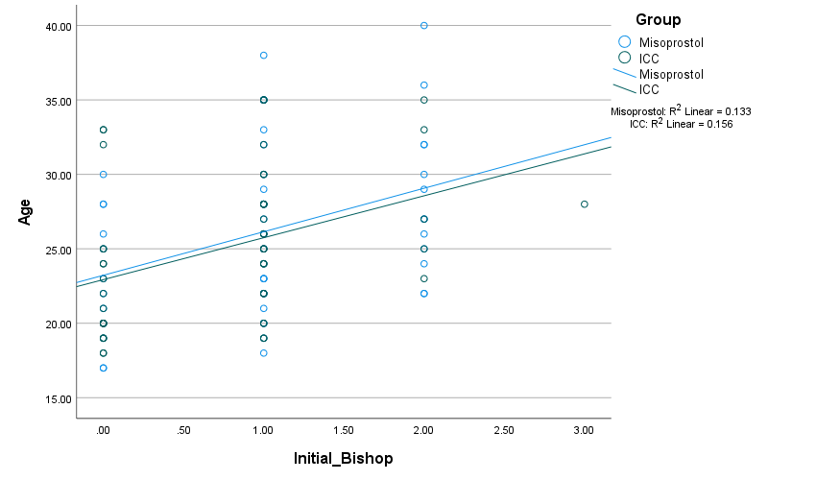

Figure-3: Scatter diagram showing the correlation of initial Bishop score with age

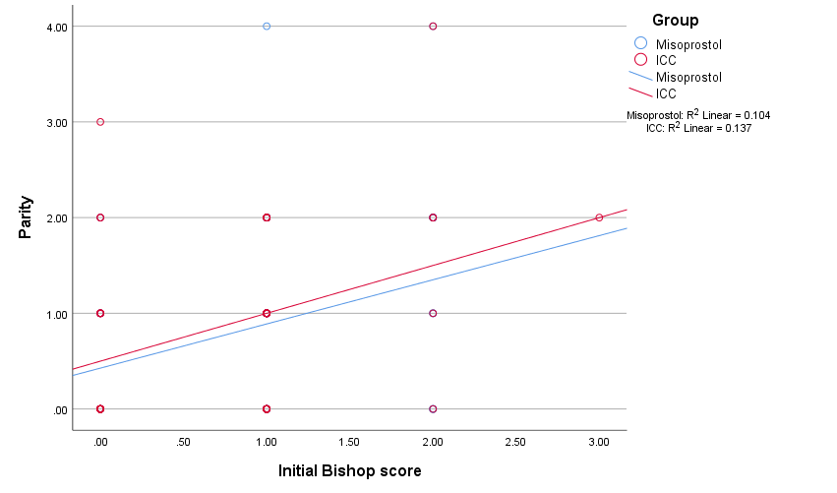

Figure-4: Scatter diagram showing the correlation of initial Bishop score with parity
Discussion
The present study compared the efficacy and safety of vaginal misoprostol with intracervical Foley’s catheterization for cervical ripening in cases of intrauterine fetal death (IUFD) between 28 weeks and full-term gestation. The socio-demographic characteristics of both groups were comparable, with the majority of participants below 30 years of age and primarily housewives. This demographic pattern aligns with the studies conducted, who reported similar findings in South Asian populations, reflecting the reproductive profile and health-seeking behaviors of women in developing countries. ⁹ The lack of significant difference in demographic parameters between the two groups indicates that the observed outcomes were not influenced by baseline population characteristics, thereby ensuring internal validity of the study results.
A significant finding of this study was the shorter initiation-to-cervical ripening time observed in the misoprostol group compared to the Foley’s catheter group (11.53 ± 6.59 hours vs. 16.0 ± 8.99 hours; p = 0.005). This observation is consistent with the results of several studies who demonstrated that vaginal misoprostol acts more rapidly on cervical tissues through prostaglandin E1 receptor activation, leading to biochemical softening and mechanical dilation. ¹⁰⁻¹¹ Other studies also reported similar findings, noting that misoprostol leads to a shorter induction-to-delivery interval compared to mechanical methods. ¹² The shorter ripening time in the present study supports the pharmacologic advantage of misoprostol, which directly affects cervical collagen metabolism, unlike Foley’s catheterization, which relies on endogenous prostaglandin release.
Although the initiation-to-ripening interval was shorter with misoprostol, the cervical ripening-to-delivery time did not differ significantly between the two groups (7.54 ± 12.3 hours vs. 10.61 ± 7.14 hours; p = 0.120). This finding is consistent with other study who found that once adequate cervical ripening is achieved, the progression of labor is primarily influenced by uterine contractility and maternal factors such as parity and Bishop score, rather than the initial induction method. ¹³ This suggests that while misoprostol offers a faster onset of cervical ripening, the total time to delivery may be comparable when both methods achieve effective cervical readiness.
The need for oxytocin augmentation was significantly lower in the misoprostol group (40.7%) compared to the Foley’s catheter group (83.3%) (p < 0.001), which is similar to the findings of where pharmacologic methods reduced the requirement for additional uterotonic support. The reduced oxytocin requirement in the misoprostol group underscores its uterotonic efficacy and ability to maintain sustained contractions. ¹¹ In contrast, mechanical methods often require supplementary oxytocin to initiate or strengthen uterine activity, leading to prolonged augmentation duration as observed in this study (5.78 ± 2.30 vs. 8.30 ± 4.46 hours; p = 0.014).
Regarding complications, the present study found that uterine hyperstimulation was rare in both groups, and no cases of uterine rupture occurred. However, postpartum hemorrhage (PPH) was significantly higher in the Foley’s catheter group (18.5%) compared to the misoprostol group (5.6%) (p = 0.038). This finding differs slightly from other study who reported no significant difference in PPH incidence between the two methods. ¹⁰ The higher PPH rate in the catheter group may be attributed to prolonged labor duration and increased oxytocin exposure, which can contribute to uterine atony. Retained placenta rates were minimal and comparable between groups, suggesting both methods are safe when used under proper supervision.
Correlation analysis revealed a positive association between the initial Bishop score and both age and parity in both groups, aligning with other study who observed that multiparity and higher maternal age favorably influence cervical readiness. ⁹ No significant correlation was found between Bishop score and oxytocin requirement or augmentation duration, indicating that the efficacy of cervical ripening is more closely linked to cervical condition than uterotonic dosage.
Conclusion
Based on our study findings, vaginal misoprostol proved to be a more effective method for cervical ripening in cases of intrauterine fetal death compared to intracervical Foley’s catheterization. It achieved a significantly shorter initiation-to-cervical ripening time and required less oxytocin augmentation with a shorter duration of augmentation. Both methods were equally safe, with no cases of uterine rupture and minimal maternal complications, although postpartum hemorrhage was more frequent in the catheter group. Therefore, vaginal misoprostol (25 µg every 6 hours) can be considered a superior and reliable option for cervical ripening in IUFD cases, providing faster results with fewer interventions and comparable safety outcomes.

Disclaimer (Artificial intelligence)
Option 1:
Author(s) hereby declare that NO generative AI technologies such as Large Language Models (ChatGPT, COPILOT, etc.) and text-to-image generators have been used during the writing or editing of this manuscript.

Reference:
- Palareti, G., Legnani, C., Cosmi, B., Antonucci, E., Erba, N., Poli, D., et al., 2016. Comparison between different D-Dimer cutoff values to assess the individual risk of recurrent venous thromboembolism: Analysis of results obtained in the DULCIS study. International Journal of Laboratory Hematology, 38(1), 42–49.
- Panda, S., Jha, V. & Singh, S., 2013. Role of Combination OF Mifepristone and Misoprostol Verses Misoprostol alone in Induction of Labour in Late Intrauterin Fetal Death: A Prospective Study. Journal of family & reproductive health, 7(4), 177–179.
- Roudsari, F.V., Ayati, S., Ghasemi, M., Mofrad, M.H., Shakeri, M.T., Farshidi, F. and Shahabian, M., 2011. Comparison of vaginal misoprostol with foley catheter for cervical ripening and induction of labor. Iranian journal of pharmaceutical research: IJPR, 10(1), p.149.
- Sciscione, A.C., Nguyen, L., Manley, J., Pollock, M., Maas, B. and Colmorgen, G., 2001. A randomized comparison of transcervical Foley catheter to intravaginal misoprostol for preinduction cervical ripening. Obstetrics & Gynecology, 97(4), pp.603-607.
- Hoda, A., Noor, N., Parveen, S., Ali, M. & Kulsoom, U.K., 2021. A Prospective Comparative Study of Mifepristone and Misoprostol vs Misoprostol Alone for Induction of Labor in Intrauterine Fetal Death. Journal of SAFOG, 13(6), 355–358.
- Hofmeyr, G.J., Gülmezoglu, A.M. and Pileggi, C., 2010. Vaginal misoprostol for cervical ripening and induction of labour. Cochrane Database of Systematic Reviews, (10): 1-10.
- Lemmers, M., Verschoor, M.A., Kim, B.V., Hickey, M., Vazquez, J.C., Mol, B.W.J., et al., 2019. Medical treatment for early fetal death (less than 24 weeks). Cochrane Database of Systematic Reviews, 2019(6): 1-12.
- MacDorman, M.F. & Gregory, E.C.W., 2015. Fetal and perinatal mortality: United States, 2013. National Vital Statistics Reports, 64(8), 1–24.
- Mahajan, P., Sharma, N. and Sharma, P., 2020. Study to compare the effectiveness of intravaginal misoprostol alone with combined use of intravaginal misoprostol and intracervical foley's catheter for termination of mid trimester pregnancy. International Journal of Reproduction, Contraception, Obstetrics and Gynecology, 9(6), pp.2560-2566.
- Mahajan, P., Sharma, N. and Sharma, P., 2020. Study to compare the effectiveness of intravaginal misoprostol alone with combined use of intravaginal misoprostol and intracervical foley's catheter for termination of mid trimester pregnancy. International Journal of Reproduction, Contraception, Obstetrics and Gynecology, 9(6), pp.2560-2566.
- Nazneen, S., Sultana, F. and Nahaer, K., 2012. Intravaginal Misoprostol versus Transcervical Foley Catheter for Pre-Induction Cervical Ripening and their Outcome-A Comparative Study. Bangladesh Journal of Obstetrics & Gynaecology, 27(2), pp.72-78.
- Misoprostol in Termination of Mid-Trimester Abortion. Evidence Based Women's Health Journal, 11(2), pp.141-145.
- Eigbefoh, J.E., Okonkwo, C.A., Okogbo, F. and Okogbenin, S., 2007. A comparison of two methods of pre-labour cervical ripening following intrauterine fetal death. Tropical Journal of Obstetrics and Gynaecology, 24(1), pp.46-51.

