Early puerperal complications following emergency caesarean section
Abstract
Background: The puerperium is the period of adjustment after delivery when the anatomic and physiologic changes of pregnancy are reversed to the normal non pregnant state. There are so many complications in early puerperium which was predominant in surgical intervention. Due to lack of maternity care in early postoperative period maternal mortality and morbidities in developing countries is still higher than the developed countries.
Objective: To find out the common complication encountered during 7 days following emergency caesarean section.
Material and Methods: It was a Prospective observational type of study carried out in the Department of Obstetrics & Gynaecology in Dhaka Medical College, Dhaka during the period of January 2013 to June 2013. Total 300 pregnant women were included who underwent emergency caesarian section. Sample interval was 2700\300= 9. In first 9 patient lottery method was done and 8ᵗʰ patient was taken for the case, the next number was 8+9=17ᵗʰ and in this way 300 patients were selected. Data were collected in predesigned data collection sheet and data were analyzed using statistical package for social science (SPSS).
Result: This study found that most of the patients were in 20–30 years in age group. Most of the population in my study group belongs to para 1 to 2 (54%). Most predisposing factors were lower socioeconomic status (32%), no antenatal check-up (32%). Common complications in early puerperal period were wound infection (61.66%), sepsis (19%), UTI (44.20%), RTI (32.70%), thrombosis (7.69%), thrombophlebitis (9.62%), PPH (9.66%) and eclampsia (19.20%). There was no maternal mortality within the study period.
Conclusion: Infectious state was the major morbidity in early puerperium following caesarean section because many of the study subjects had already developed associated risk factors for which emergency surgery indicated. So, the magnitude of morbidities were also quite high in this study. Public health awareness, the education of primary health workers and improvement of socioeconomic circumstances can also help to improve maternal and neonatal prognosis.
Keywords: Puerperium, Caesarean section, Postoperative complications, Maternal morbidity, Infection

Introduction
“The puerperium is the period of adjustment after delivery when the anatomic and physiologic changes of pregnancy are reversed and the body returns to the normal non-pregnant state. The postpartum period or puerperium, generally lasts 6 weeks”.¹
This period are divided are 3 parts first one immediate puerperium, which lasts 24 hours just after delivery. Next early puerperium which lasts 7 days. The following days up to 6 weeks called remote puerperium. There are so many complications in early puerperium which was predominant in surgical intervention.²
“Inspite of tremendous importance of postpartum period for both mother and baby, this aspect of maternity care has not received much attention than pregnancy and delivery. When a healthy pregnant woman with no obstetric or medical risk factors goes into spontaneous labour, she may anticipate a normal delivery, but still 580,000 women in the world die from pregnancy and child birth related complications each year. Maternal mortality in developing countries is 100 times higher than the developed countries”.³
“Only 21 % mothers of Bangladesh gets skilled birth attendants during their delivery like doctors, paramedics and trained traditional birth attendants (TBA). About eighty percent delivery occurs at home, of which 80% birth is assisted by relatives and untrained TBAS”.⁴
“Caesarean section is the most common performed operation in obstetric practice. The term denotes the delivery of fetus placenta and membrane through an incision in the abdominal and uterine wall. Caesarean section is of two types elective and emergency”.⁵ “Most of the abnormalities of puerperium are related to operation or to the indications for which the operation is done, so complications are more following emergency sections rather than elective procedure”. ² “Due to illiteracy, ignorance, early marriage, lack of antenatal care, failure to seek family planning advice- number of emergency caesarean sections is more than elective caesarean sections in our country”.⁶
“Puerperal infection is a leading cause of maternal death, accounting for up to 16% of cases of mortality. It causes at least 75,000 maternal deaths worldwide per year, most of which occur in developing countries”.⁷ Puerperal infection may occur in the genital tract, wound, breast, lungs or blood vessels. Important risk factors for it include: status, poor nutrition, first birth, anaemia, features of the delivery process (such as prolonged rupture of membrane, prolonged labour, repeated vaginal examination during labour etc).⁸
“Most of the abnormalities of puerperium are related either to operation or to the indication for which the operation is done. So complication are more following emergency section rather elective procedure”.⁹
This study evaluates the prevalence of early puerperal complication by reviewing the puerperal cases in early post-partum period. The study also focuses the specific type of early postpartum complication and the risk factors associated with complications of early puerperium and what measure are taken to reduce the complications of early puerperium in emergency caesarean section.
Objective
General Objective:
To identify the common complication following emergency caesarean section.
Specific Objective:
- To find out the common complication encountered during 7 days following
- To detect the predisposing factors for development of complication.

Methodology
Study design: Prospective Observational Study.
Place of study: Obstetrics and Gynae department of Dhaka Medical College Hospital, Dhaka.
Period of study: Six months (January 2013 to June 2013)
Study population: All the pregnant women who underwent caesarean section (emergency) in Dhaka Medical College Hospital.
Sampling: Systematic random sampling.
Sample size: It was seen that average 15 patient underwent emergency caesarean section per day in above hospital. So 450 patients were operated per months and 2700 patients in six months.

Sample Size estimation:
n=d2Z2pq​
Here, Z value= 1.96 at 5% level of significant
p=Prevalence (.6166)
q=(1-p) i.e. (1-.6166)
d=Acceptable error (.05 or 5% or ±0.05 margin)
So, n = 363.26
For the convenience of study 300 patients were selected.

Inclusion criteria:
- All parturient both primi and multi who delivered by caesarean section on an emergency basis were included for this study (It is important to mention that only maternal complications were included in this study).
- Complications developed within 7 days after caesarean section were included.
Exclusion criteria:
- Patient with known medical diseases.
- Patient who delivered outside the hospital.
- Patient with a history of infection prior to caesarean section.
- Patient underwent elective caesarean section.

Methods:
Data was collected using a structured questionnaire (research instrument) containing all the variables of interest. The questionnaire was finalized following pretesting. After taking informed consent eligible patient, her history was taken with particular scrutiny of menstrual and obstetrical history. Physical examination was performed and complications and fetal outcome were evaluated. Maternal outcome was determined by mother's generalized condition with complication during and after caesarean section. Fetal outcome was detected by APGAR score at birth and duration of nursery stay. Data analysis was done by using statistical package for social science (SPSS) software 16. The test statistics used are descriptive statistics as appropriate. It is extremely important that the data was authentic and of high standard. The patient who were early puerperium after the emergency Caesarean section in Dhaka Medical
College Hospital were the target of data collection. Collected data was checked and edited if needed. Ethical approval for this study was obtained from the Ethical Review Committee of the Department of Obstetrics and Gynaecology, Dhaka Medical College, Dhaka, Bangladesh. All participants were informed in detail about the purpose, procedures, potential risks, and benefits of the study. Written informed consent was obtained from each participant prior to data collection. Confidentiality and anonymity of all participants were strictly maintained throughout the research process.

Results and Discussion:

Table 1: Distribution of cases according to socio-economic status (n=300)
Socio-economic Status | No. of Patients | Percentage (%)
Poor | 96 | 32
Lower middle class | 93 | 31
Middle class | 111 | 37
Table 1 shows that most of the cases belongs to middle class (37%).
Definition of Class:
  - Poor class: monthly income approximately 3000 tk to 6000 tk
  - Lower middle class: monthly income approximately 6000 tk to 12000 tk
  - Middle class: monthly income approximately more than 12000 tk

Table 2: Distribution of early puerperal complications among study participants.
Complication | No. of Patients | Percentage (%)
Wound infection | 185 | 61.7
Urinary tract infection | 133 | 44.3
Mastitis | 115 | 38.3
Puerperal sepsis | 57 | 19.0
Postpartum eclampsia | 58 | 19.3
PPH | 29 | 9.7
Thrombophlebitis | 29 | 9.7
Thromboembolism | 23 | 7.7

Table-2 shows the overall complications in early puerperal period in my study where wound infection, UTI & mastitis are common.

Table 3: Distribution of cases according to parity (n=300) presented in clean tabular format:
Parity | No. of Patients | Percentage (%)
Para 1 to 2 | 162 | 54
Para 3 to 5 | 114 | 38
Para > 5 | 24 | 8

According to parity (Table-3) most of the population in my study group belongs to para I to 2(54%).

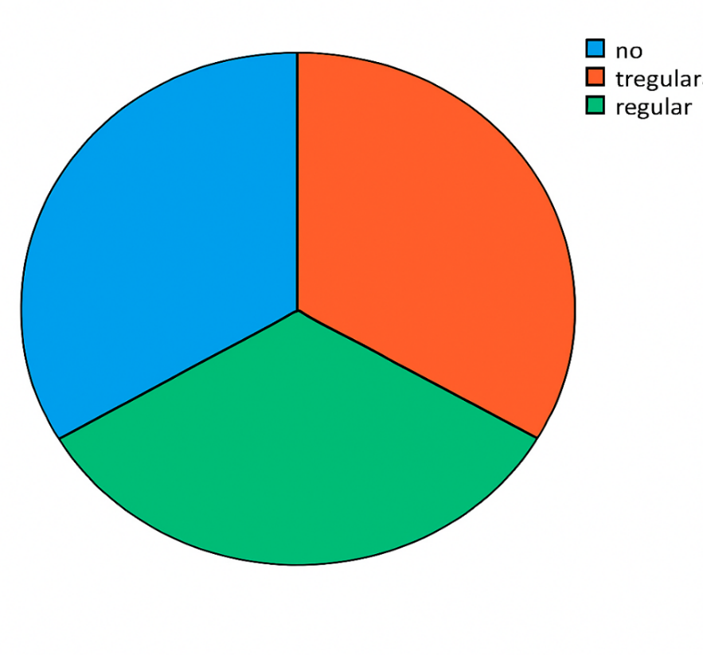
Irregular

32%
34%

34%
Figure: 1: Distribution of cases according to antenatal care (N 300)
Figure-1 shows the ante-natal check-up status. Majority of patients in study group attained ante-natal check-up regularly or irregularly (34%). But it is not very less (32%), who didn’t attain antenatal checkup.

Table 4 Distribution of cases according to wound infection (n=300) presented in a clean tabular format, followed by the accompanying text:

Table 4: Distribution of Cases According to Wound Infection (n=300)
Surgical Wound Infection | No. of Patients | Percentage (%)
Present | 185 | 61.66
Absent | 115 | 38.33

Most common complication was wound infection and 185 patients (61.66%) developed wound infection (Table-4).

Table 5: Distribution of Cases According to Puerperal Sepsis (n=300)
Puerperal Sepsis | No. of Patients | Percentage (%)
Absent | 243 | 81
Present | 57 | 19

Fifty-seven patients developed puerperal sepsis after emergency caesarian operation in my study population. That was 19 percent of study population (Table- 5).

Table 6: Distribution of cases according to UTI (n=300
UTI | No. of Patients | Percentage (%)
Absent | 167 | 55.7
Present | 133 | 44.3

Incidence of urinary tract infection (UTI) was 133 after emergency caesarian operation of my study population which was 44.20 percent of study population (n=300).

Table 7: Distribution of Cases According to Postoperative Thrombophlebitis (n=300)
Postoperative Thrombophlebitis | No. of Patients | Percentage (%)
No | 271 | 90.33
Yes | 29 | 9.66

Table-7 shows number of patients who developed postoperative thrombophlebitis after emergency caesarian section of my study group. There were twenty-nine (09.62%) patients who developed such complications out of total population (300).

Table 8: Distribution of Cases According to PPH (n=300)
Secondary PPH | No. of Patients | Percentage (%)
No | 271 | 90.33
Yes | 29 | 9.66

Post-partum haemorrhage (PPH) is a major complication after both emergency or routine caesarian operation. Twenty-nine patients developed such complication which was 9.66% of total population (Table-8).

Table 9: Distribution of Cases According to Postoperative Eclampsia (n=300)
Postoperative Eclampsia | No. of Patients | Percentage (%)
No | 242 | 80.7
Yes | 58 | 19.3

Table-9 shows development of post-operative eclampsia after emergency caesarian section of my study population. Fifty-eight patients developed such grave complication which was 19.20 percent of total morbidities (n=300).

In this study, Table-I is showing the prevalence of early puerperal morbidities encountered in patients who underwent emergency caesarean section and it was found that prevalence of wound infection is more (61.66%) and next prevalence was UTI (44.20%). These findings were consistent with findings of others in our country which are described subsequently in this discussion.¹⁰
In this study most of the patients belonged to para 1-2(Table-II). This observation is almost similar to the findings of Akter T (in DMCH & Mitford hospital during March, 2004 to August, 2004)¹¹ and also similar to the findings of Akter M (in ICMH during May, 2010 to October, 2010).
In this study, the incidence of wound infection and puerperal sepsis were quite high in comparison to many studies of developed world where the incidence were 61.66% and 19% respectively. This was similar to the observation of Akter M (in ICMH during May,2010 to October,2010) and findings were 66.67% and 26.67% respectively.¹²
Incidence of urinary tract infection (UTI) was 133 after emergency caesarian operation of my study population which was 44.20 percent of total complications. Gerber B et al shown that UTI was significantly more frequent in such cases (54.5%).¹³ Findings were similar to the study of Akter M (in ICMH during May, 2010 to October, 2010).
Postpartum haemorrhage (PPH) is a major complication after both emergency or routine caesarian operation. Twenty-nine patients developed such complication which was 9.66% of total population. A study of Alamgir S.N shown in her study ("Evaluation of Early Postpartum complications following delivery in a tertiary level Hospital", MMCH,2010) similar findings. This complication due to prolong labour, APH, anaemia, multiple pregnancy, and previous PPH.¹⁴
In this study shows the development of postoperative eclampsia after emergency caesarian section of my study population. Fifty-eight patients developed such grave complication which was 19.20 percent of total morbidities.¹⁵ Though proper precaution were taken, this situation could not avoided due to pre-existing eclampsia, improper resuscitation due to lack of time but managed successfully with adequate resuscitation, proper consultation and intensive care management when needed.

Conclusion
In the present study, a total of 100 patients were analyzed who underwent caesarean section in Dhaka medical college hospital, Dhaka with an aim to evaluate the common complications encountered among the early post caesarean puerperal patients and to detect the patients at risk of developing complications. The magnitude of morbidities was found to be fifteen percent (15%). The study concluded that infectious state was the major morbidity in early puerperium following caesarean section because many of the study subjects had already developed associated risk factors such as chorioamnionitis, prolonged rupture of membrane, obstructed labour, prolonged labour and most of them underwent caesarean section due to emergency indication. So, the magnitude of morbidities was also quite high in this study.

Ethical Approval and Consent:
Ethical approval for this study was obtained from the Ethical Review Committee of the Department of Obstetrics and Gynaecology, Dhaka Medical College, Dhaka, Bangladesh. All participants were informed in detail about the purpose, procedures, potential risks, and benefits of the study. Written informed consent was obtained from each participant prior to data collection.

Disclaimer (Artificial intelligence)
Option 1:
Author(s) hereby declare that NO generative AI technologies such as Large Language Models (ChatGPT, COPILOT, etc.) and text-to-image generators have been used during the writing or editing of this manuscript.
Option 2:
Author(s) hereby declare that generative AI technologies such as Large Language Models, etc. have been used during the writing or editing of manuscripts. This explanation will include the name, version, model, and source of the generative AI technology and as well as all input prompts provided to the generative AI technology
Details of the AI usage are given below:
1.
2.
3.

Reference:
- Dutta DC. Normal Puerperium. In: Text Book of Obstetrics including Perinatology and Contraception.7ᵗʰ Edition. New Central Book Agency(P) Ltd.2005: 145-154.
- Dutta DC. Complication of the third stage of labour. In: Text Book of Obstetrics including Perinatology and Contraception.7ᵗʰ Edition. New Central Book Agency (P) Ltd.2005: 411-422.
- Post partum care of the mother and newborn: A practical guide. Department of Reproductive Health & Research(RHR), WHO 1998.
- Zainur RZ, Loh KY. Postpartum morbidity -what we can do. Med J Malaysia, 2006; 61(5):651-6.
- Lipscomb Kim, Novy MJ. The Normal Puerperium. In: Decherrmney Alan H, Nathan L. In: Current Obstetrics & Gynaecology & Treatment. 10ᵗʰ Edition. Lange Medical Book/McGraw-Hill, Medical Publishing Division.2004:234-258.
- Care and service provision in the post-partum period-Post partum care of mother and new born: A practical guide. Department of Reproductive Health & Research (RHR), WHO.
- Kapernick PS, Poggi SBH. Postpartum Haemorrhage & the Abnormal Puerperium. In: DeCherrmney Alan H, Nathan L.In: Current Obstetrics & Gynaecology Diagnosis & Treatment.10ᵗʰ Edition. Lange Medical Books/McGrew - Hill, Medical Publishing Division.2004:531-552.
- Post partum complication. Journal of Obs.&Gynae INDIA, 1994, Volume7, Page 10.
- Lipscomb Kim, Novy MJ. The Normal Puerperium. In: Decherrmney Alan H, Nathan L. In: Current Obstetrics & Gynaecology & Treatment. 10ᵗʰ Edition. Lange Medical Book/McGraw-Hill, Medical Publishing Division.2004:234-258.
- Puerperial genital infection. Post partum care of the mother and newborn: A practical guide. Department of Reproductive Health & Research (RHR),WHO 1998.
- Akter T. Early Puerperal Complications- A prospective clinical study on saesarean deliveries in Dhaka Medical College Hospital and Mitford Hospital(Dissertation),BCPS library (3556),2004:41-44.
- Akter M. A Study on Early Puerperal Complications following Caesarean Section(Dissertation),Institute of Child & Mother Health, Matuail, Dhaka, Bangladesh.2010,37-40.
- Gerber B. Schmidt H. Ohde A. Diagnosis of urinary tract infection in puerperium, Universitals-Fravenklinik, Rochkoch. 1999 September:54(9).
- Alamgir S.N .Evaluation of Early Postpartum complications following delivery in a tertiary level Hospital. MMCH (Dissertation), 2010:36-41.
- Akter, H.H., M.E.E.K. Chowdhury and A.Sen, 1986. A cross-sectional study on maternal morbidity in Bangladesh. BIRPERHT, Dhaka. Bangladesh.

