Can a Cost-Effective In-House Ovum Pick-Up Medium Support Efficient Bovine IVEP?

Abstract:

AAssisted reproductive technologies (ART) such as ovum pick-up (OPU) and in-vitro embryo production (IVEP) can substantially enhance bovine genetics and productivity, yet the high cost of commercial media restricts their wider use by smallholder farmers. This study developed and evaluated a economical in-house OPU medium for bovine IVEP. Over 1193 OPU-IVEP sessions in 92 donor cows, we compared an in-house medium with a commercial OPU medium. The in-house formulation, based on EmXcell embryo flushing medium supplemented with a zwitterionic buffer and sodium heparin, was assessed for oocyte recovery, cleavage rate and blastocyst yield. Data were analysed using one-way ANOVA; differences between groups were not statistically significant (p > 0.05) for any parameter. Mean blastocyst rate was 21.88% in the in-house group versus 19.85% in the control, indicating a numerically higher output that, while not statistically different, could translate into a meaningful increase in embryo numbers when applied at scale in routine programs. Overall, the in-house medium supported oocyte recovery, cleavage and blastocyst development at a level comparable to the commercial product while substantially reducing media costs. This approach has the potential to lower the economic barrier to ART and thereby improve access for resource-limited and smallholder dairy producers. Future work should include multi-farm field validation, evaluation across breeds and production systems, and long-term monitoring of pregnancy and calf performance.

Keywords: Assisted Reproductive Technologies (ART), Ovum Pick-Up (OPU), Bovine Reproduction, Cost-Effective Media

INTRODUCTION
Assisted Reproductive Technologies (ART), including Ovum Pick-Up (OPU), In-Vitro Embryo Production (IVEP), and Embryo Transfer (ET), have emerged as powerful tools in the enhancement of livestock breeding. These technologies offer significant benefits by increasing reproductive efficiency, improving genetic traits, and enabling the propagation of desirable livestock characteristics on a large scale. The precision and control provided by ART techniques have revolutionized traditional breeding methods, leading to improved livestock productivity and contributing to the agricultural economy.
Despite these clear advantages, the adoption of ART remains limited in many regions, especially outside of more developed agricultural sectors. Several factors contribute to this, including the high costs associated with the technology, the requirement for specialized skills and equipment, and a lack of awareness or understanding among farmers ¹. The prohibitive costs, particularly of the media required for these procedures, act as a significant barrier. Marginal farmers, who represent a large proportion of the global farming community, often find the costs unsustainable, limiting the widespread adoption of these technologies ².
The media used in ART, particularly during the OPU process, is crucial for the success of the procedures. The media's role in maintaining the quality of oocytes and supporting subsequent embryo development cannot be overstated. High-quality media formulations are essential for ensuring high cleavage rates, blastocyst formation, and overall embryo production efficiency ^{3.} However, the high cost of these media significantly impacts the overall expense of ART, making it less accessible to a broader population of farmers. The need for a cost-effective alternative is therefore critical for expanding the reach of ART.

Several commercially available media are widely used in the OPU process. Products from companies such as Minitube, Vetoquinol, and MOFA are commonly employed due to their reliable composition and efficacy. These media typically include a balanced mix of salts, amino acids, and proteins designed to mimic the natural environment of oocytes. For instance, these media often contain a zwitterion buffer like HEPES to maintain stable pH levels, along with antibiotics to prevent contamination ⁴. While effective, the cost associated with these media continues to be a challenge, particularly for farmers in resource-limited settings ⁵.
Given the high costs of existing commercial media, Emxcell presents itself as a viable in-house alternative. Emxcell is compositionally similar to the optimal media required for maintaining oocyte viability during the OPU process. It includes essential salts, a zwitterion buffer, and antibiotics, providing a stable environment for oocytes. Additionally, heparin is being added as an anti-clotting agent to prevent coagulation during the OPU process, ensuring that the oocytes remain in an optimal environment. This addition is crucial for maintaining the fluidity and consistency of the media, which is essential for the effective handling and preservation of oocytes during aspiration and transport ⁶. The use of Emxcell could potentially reduce the overall cost of the OPU-IVEP-ET cycle while maintaining or even improving the efficiency of embryo production processes. This makes it a promising candidate for broader adoption in cost-sensitive contexts.
The objective of this research is to rigorously evaluate the efficacy of Emxcell, both as a standalone media and in combination with other formulations, in maintaining oocyte quality and supporting embryo production. The goal is to develop a economical, sustainable efficient alternative to commercially available OPU media, making ART more accessible to a broader range of farmers. This research seeks to provide a scientifically validated, practical solution that can enhance the adoption of ART in regions where cost is a significant barrier.

MATERIALS AND METHODS

This study was conducted at the OPU-IVEP-ET facility of National Dairy Development Board, Anand, India (NDDB). Donor cows (n=92) housed in the farm of OPU-IVEP-ET facility of NDDB are used in the study. Total 1193 OPU sessions were conducted during the study period, with 700 using commercial OPU media and 493 using in-house OPU media. Ninety-two donor cows were housed at the NDDB farm facilities
Formulation of in-house and commercial OPU Media
On the day of OPU, the media was prepared to achieve a final heparin concentration of 50 µg/mL. This was done by diluting 1 mL of injectable heparin (Troyhep, 1000 units heparin/mL, equivalent to 2 mg/mL) in 40 mL of EmXcell medium. The addition of heparin to the medium is crucial for preventing coagulation during the OPU process, ensuring that the oocytes remain in an optimal environment.
Commercial media for OPU was sourced from IVF Biosciences, UK. A total 700 OPUs were performed using commercial OPU media and 493 OPUs using in-house OPU media.
Ovum pick-up and in vitro embryo production (OPU-IVEP)
A total of 1193 OPU-IVEP cycles were performed in the donors following already standardised procedure in the facility [7-10]. Briefly, the donors were aspirated using an ultrasound-guided transvaginal aspiration device under epidural anesthesia. The ovaries were evaluated for the number of follicles and corpus luteum in non-stimulated donors. All follicles of 3 mm or above were aspirated into a 50 ml collection tube containing pre-warmed OPU media. After aspiration of both ovaries, the collection tube was immediately sealed and sent to the laboratory for searching.

Cumulus-oocyte complexes (COCs) were retrieved from the aspirated solution and selected based on quality criteria ¹⁰. Oocytes of grades 1, 2, and 3 were washed in IVM media before shifting to pre-equilibrated IVM media drops. The selected oocytes were then incubated in an environment with 5% CO₂ at 38.5°C and more than 90% relative humidity for approximately 22–24 hours to facilitate maturation. After maturation, the oocytes were washed with IVF media and transferred to pre-equilibrated IVF media drops. Preselected frozen semen doses were prepared for fertilisation through a two-step centrifugation process, viz. initially at 2000 x g for 5 minutes in the Isolate® gradient, followed by resuspension in IVF media, and a second centrifugation at 500 x g for 5 minutes. The resultant sperm pallet was used for fertilising the drops with oocytes and incubated for 18 hours in an environment with 5% CO₂ at 38.5°C and more than 90% relative humidity.
Following fertilisation, presumptive zygotes were denuded carefully by removing all surrounding cumulus cells using a denuding pipette. The zygotes were then sequentially washed in wash media and pre-equilibrated in vitro culture (IVC) medium. Finally, they were transferred to pre-equilibrated IVC media drops and incubated in a mixed gas bench-top incubator at 5% CO₂, 5% O_{2,} 90% N_{2,} 38.5°C, and >90% RH for seven days from the date of IVF.
Cleavage rates were recorded 72 hours post-IVF, reflecting the percentage of embryos that had successfully divided into 8–16 cells. Blastocyst rates were determined on day seven post-IVF, indicating the proportion of cultured oocytes that developed into blastocysts. Embryos were evaluated for grade and stage according to International Embryo Technology Society (IETS) guidelines¹¹. Embryos at the blastocyst and expanded blastocyst stages of development were considered in the study. Embryos were graded from Code 1 to Code 4 based on their quality as per IETS guidelines, and only embryos of grade 1 were used in the present study.

Cleavage and Blastocyst Rate:
Cleavage Rate: This metric, recorded after 72 hours from the IVF, reflects the percentage of embryos that have successfully divided into 8-16 cells, signifying early development.
Blastocyst Rate: Determined on day 7 from the day of IVF, this indicates the proportion of cultured oocytes that have developed into blastocysts, the advanced stage embryos suitable for transfer. It is calculated by dividing the total number of blastocysts by the total number of oocytes kept for IVC.

Statistical Analysis:
Standard statistical analysis was performed using R (RStudio Version 2024.04.1+748). Descriptive statistics (mean ± standard error of the mean, SEM) were calculated for oocyte recovery per OPU, cleavage rate and blastocyst rate for both the commercial (Group A) and in-house (Group B) media. Differences between groups were evaluated using a one-way analysis of variance (ANOVA) with a general linear model, and a p-value < 0.05 was considered statistically significant. No statistically significant differences (p > 0.05) were detected between the two media for any of the parameters analysed.

RESULTS
Oocyte Recovery
The average number of oocytes retrieved per OPU session was slightly higher in Group B compared to Group A. However, this difference was not statistically significant (p>0.05). The mean number of oocytes retrieved per OPU session was 12.12 ± 3.23 for the control group and 17.0 ± 3.7 for the trial group.
Cleavage Rate
Group B demonstrated a higher overall cleavage rate compared to Group A. Despite this trend, the difference between the groups was not statistically significant (p>0.05). The mean cleavage rate for the control group, representing the percentage of embryos that successfully divided into 8-16 cells, was 50.8 ± 14.9, while the trial group had a mean cleavage rate of 57.1 ± 9.8.
Blastocyst Rate
The total blastocyst rate, encompassing early, expanded, and hatched blastocysts, was comparable between the two groups. The mean blastocyst rate, indicating the proportion of cultured oocytes that developed into blastocysts by day 7, was 19.8 ± 6.6 for the control group and 21.8 ± 6.2 for the trial group, with no statistically significant difference (p > 0.05), indicating that the two groups were comparable.
Interpretation
The trial group demonstrated slightly higher mean values in oocyte retrieval, cleavage rates, and blastocyst development compared to the control group, although these differences were not statistically significant. No statistically significant differences were observed between the control and trial groups for oocyte characteristics (p = 0.12), cleavage rates (p = 0.18), blastocysts per OPU (p = 0.08), or blastocyst rates (p = 0.42)(Figure 1)
.

DISCUSSION
The findings of this study demonstrate that the in-house developed OPU media is a viable and cost-effective alternative to commercially available OPU media for bovine IVEP. The performance metrics, including oocyte quality, cleavage rates, blastocyst formation, and overall embryo production efficiency, showed no significant differences between the two media types. This suggests that the in-house media can effectively support the various stages of embryo development.
One of the primary objectives of this study was to address the high costs associated with OPU-IVEP-ET cycles by developing a more affordable media solution. The results indicate that the in-house media can reduce costs significantly without compromising the efficacy of the IVEP process ¹² By lowering the entry barrier, more farmers can adopt these techniques, potentially leading to widespread improvements in livestock productivity and genetic quality ¹³.
The mean number of oocytes per OPU session was comparable between the in-house and commercial media groups, indicating that the initial quality and viability of oocytes were not affected by the media used. Cleavage rates were slightly lower for the in-house media, but this difference was not statistically significant. Importantly, the mean blastocyst rate and the mean number of embryos per OPU session were higher for the in-house media, suggesting that the developed media supports later stages of embryo development at least as well as the commercial media.
The effectiveness of the in-house media can be attributed to its carefully selected components. The in-house media was developed using commercially available Zwitter ion buffer and EmXcell Embryo Flushing media (IMV Technologies), with sodium heparin added externally ¹⁴. The EmXcell medium is specifically designed to support embryo viability and development, providing a balanced composition of electrolytes, energy substrates, and buffering agents that mimic the physiological conditions of the oviduct. The inclusion of Zwitter ion buffer helps maintain pH stability during the OPU process, which is crucial for preserving oocyte integrity ¹⁵.
Sodium heparin, added at a concentration of 1250 IU per 50 ml of EmXcell media, plays a critical role in preventing blood clotting during the aspiration process. This heparin is sourced from injectable human medicine, which is not only low-cost but also readily available. Its anticoagulant properties ensure that the oocytes are not exposed to blood clots, which can be detrimental to their quality and subsequent development. This combination of components creates a supportive environment that closely matches the natural conditions, contributing to the effective performance observed with the in-house media.
The similar performance of the in-house media can be attributed to the synergistic effects of its components. The Zwitter ion buffer and EmXcell Embryo Flushing media create a stable and supportive environment for oocyte maintenance and development ¹⁶. The presence of sodium heparin ensures that the oocytes are not exposed to blood clots, which can impair their quality and developmental potential. This optimal combination of buffering agents, electrolytes, and anticoagulants appears to provide an environment conducive to oocyte health and embryo development.
The success of the in-house media in this study opens up several avenues for future research. Further studies could focus on fine-tuning the media composition to enhance specific developmental stages or to adapt it for use with different bovine breeds. Additionally, long-term studies on the reproductive outcomes and health of offspring produced using this media would provide valuable insights into its overall efficacy and safety.
From a practical standpoint, the adoption of in-house media could lead to significant cost savings for farmers and breeding facilities. This, in turn, could increase the adoption rate of ART, leading to improved herd genetics and productivity. The ability to produce high-quality embryos in a economical sustainable manner is a critical step towards sustainable and profitable livestock farming ^{17, 18.}
CONCLUSION
This study demonstrates that the in-house developed OPU media is an efficient alternative to commercially available media for bovine IVEP. It supports comparable rates of oocyte retrieval, cleavage, and blastocyst formation while potentially reducing the overall cost of the OPU-IVEP-ET cycle. These findings highlight the viability of the in-house media for use in assisted reproductive technologies in livestock breeding. Our lab is focusing on further fine-tuning this media to optimize its performance and explore its broader applications to enhance reproductive efficiency and genetic improvement in cattle. Future research should focus on field validation across different herds and breeds and on long-term reproductive outcomes to further optimise and generalise this in-house OPU medium.

Author(s) hereby declare that NO generative AI technologies such as Large Language Models (ChatGPT, COPILOT, etc.) and text-to-image generators have been used during the writing or editing of this manuscript.

REFERENCES:
- Food and Agriculture Organization of the United Nations. (2020). Livestock and animal genetics. FAO.

- Galli, C., Duchi, R., Crotti, G., Turini, P., Ponderato, N., & Colleoni, S. (2003). Bovine embryo technologies. Reproduction in Domestic Animals, 38, 173–177.

- Bo, G. A., Mapletoft, R. J., Pierson, R. A., & Thundathil, J. C. (1995). Ovarian follicular wave emergence in cattle: Physiological and practical implications. Theriogenology, 43, 23–35.

- Lonergan, P., O'Kearney-Flynn, M., & Boland, M. P. (1999). Effect of protein supplementation and presence of an antioxidant on the development of bovine zygotes in synthetic oviduct fluid medium under high or low oxygen tension. Theriogenology, 51(8), 1565-1576.

- Fair, T. (2003). Follicular oocyte growth and acquisition of developmental competence. Animal Reproduction Science, 78(3–4), 203–216. https://doi.org/10.1016/S0378-4320(03)00091-5

- Bharti, A. V., Layek, S. S., Raj, S., Gorani, S., & Doultani, S. (2022). Vitrification of bovine in vitro-produced embryos: Can it replace slow freezing in bovines? Reproduction, Fertility and Development, 35(2), 146. https://doi.org/10.1071/RDv35n2Ab41

- Doultani, S., Layek, S. S., Karuppanasamy, K., Raj, S., Gorani, S., & Patil, S. P. (2022). Replacing ovum pickup media for in vitro embryo production in cattle: Quest to reduce the cost of production of embryos. Reproduction, Fertility and Development, 35(2), 186. https://doi.org/10.1071/RDv35n2Ab118

- Layek, S. S., Gorani, S., Karuppanasamy, K., Patil, S. P., Raj, S., Raval, K. B., Doultani, S., & Sharma, P. (2023). Production and transfer of bovine embryos through the hub-and-spoke model: An innovative model to promote embryo transfer technology. Reproduction, Fertility and Development, 36(2), 156. https://doi.org/10.1071/RDv36n2Ab14

- Patil, S. P., Layek, S. S., Karuppanasamy, K. K., Doultani, S., Raj, S., Raval, K. B., Sharma, P., & Gorani, S. (2023). The use of recombinant human follicle-stimulating hormone in comparison to pituitary-derived follicle-stimulating hormone prior to ovum pickup in vitro embryo production in cattle. Reproduction, Fertility and Development, 36(2), 271. https://doi.org/10.1071/RDv36n2Ab230

- International Embryo Technology Society. (2022). Manual of the International Embryo Transfer Society (5th ed.).

- Tauer, L. W., & Mishra, A. K. (2006). Dairy farm cost efficiency. Journal of Dairy Science, 89(12), 4937–4943. https://doi.org/10.3168/jds.S0022-0302(06)72544-9

- Lamb, G. C., Mercadante, V. R. G., Henry, D. D., Dahlen, C. R., Larson, J. E., & DiLorenzo, N. (2016). Invited review: Advantages of current and future reproductive technologies for beef cattle production. The Professional Animal Scientist, 32(2), 162–174. https://doi.org/10.15232/pas.2015-01455

- Nelson, L. D., & Nelson, C. F. (2001). Handling and culture of bovine embryos: Survey of media used by 26 embryo transfer companies in the USA. Theriogenology, 56, 529–536.

- Common media, buffers and stock solutions. (1999). Current Protocols in Immunology, 34, A.2A.1–A.2A.8.

- IMV Technologies. (2019). EmXcell embryo flushing media [Product information]. IMV Technologies. https://www.imv-technologies.com/product/em-xcell

- Bedasa, S., Kebede, A., & Abraha, B. (2017). Review on reproductive biotechnology and its role in dairy cattle production and health. Report and Opinion, 9(3), 60–70. https://doi.org/10.7537/marsroj090317.10

- Ribeiro, E. S., Galvão, K. N., Thatcher, W. W., & Santos, J. E. P. (2012). Economic aspects of applying reproductive technologies to dairy herds. Animal Reproduction, 9(3), 370–387.

- Lamb, G. C., Mercadante, V. R. G., Henry, D. D., Dahlen, C. R., Larson, J. E., & DiLorenzo, N. (2016). Advantages of current and future reproductive technologies for beef cattle production. Journal of Animal Science, 94, 2456–2470.

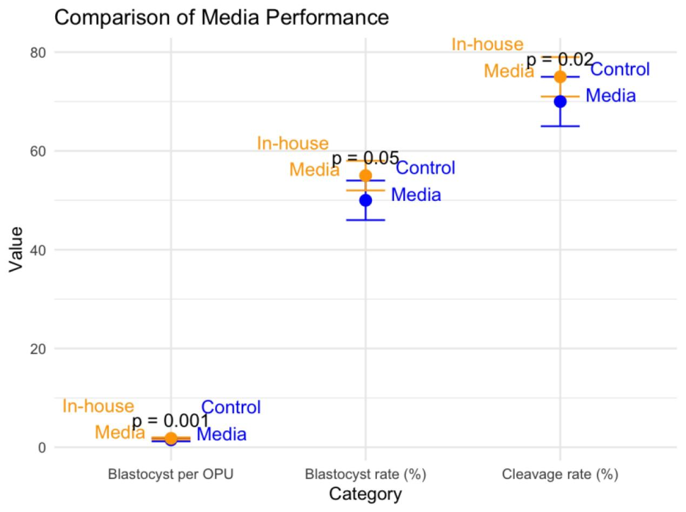

Figure 1: Comparison of In-house Media and Control Media for parameters like blastocyst per OPU, Blastocyst rate (%) and cleavage rate (%)

