ASSESSMENT OF ADOLESCENTS KNOWLEDGE OF SEXUALITY EDUCATION, MENSTRUAL HYGIENE AND UTILIZATION OF YOUTH FRIENDLY SERVICES IN ONDO STATE

ABSTRACT
Adolescents face heightened risks related to sexual and reproductive health (SRH) due to early sexual debut, limited knowledge, stigma, and poor access to youth-friendly health services (YFHS). This cross-sectional study assessed awareness, knowledge, and utilization of SRH services among secondary school students in Ondo State, Nigeria. A total of 221 students from four schools—Babcock University High School (BUHS), Wexford College, CAC Grammar School, and Impact High School—were surveyed using a structured questionnaire. Data were analysed using descriptive statistics and regression analysis. Findings indicate that awareness of sexuality education (34%) and drug abuse (35%) were low, awareness of youth-friendly services was considerably lower at 4% in some schools. Utilization of youth-friendly clinics was also minimal. Misconceptions about HIV transmission persisted, including beliefs about casual contact. The findings underscore significant gaps between awareness and service utilization, highlighting structural, sociocultural, and stigma-related barriers. The study recommends intensified awareness creation, improved methods of implementation rather than just integration of SRH education into school curricula, and improved availability of adolescent-friendly health services.
Keywords: adolescents, sexual and reproductive health, awareness, Nigeria, youth-friendly services, Ondo State
INTRODUCTION
Adolescence is a pivotal stage of life marked by significant biological, psychological, and social transitions. During this period, individuals often experiment with behaviours that may expose them to sexual and reproductive health (SRH) risks, including unintended pregnancies, sexually transmitted infections (STIs), and HIV/AIDS (World Health Organization [WHO], 2021). Globally, adolescents account for a disproportionate share of new HIV infections and other preventable health burdens, particularly in sub-Saharan Africa, where poverty, stigma, and inadequate access to adolescent-friendly services persist (Adeleke et al., 2020).
In Nigeria, SRH challenges are particularly pronounced. Studies report an increase in early sexual debut, low contraceptive use, and widespread misconceptions about HIV and STI transmission (Ajibola & Mary, 2025; Osunmakinwa et al., 2022; Olutade-Babatunde et al, 2024). For example, Osunmakinwa et al. (2022) found that nearly 20% of in-school adolescents in Akure, Ondo State had engaged in sexual intercourse, with more than a third initiating sex before age 12. Such early initiation increases exposure to negative outcomes, including unsafe abortions, school dropout, and gender-based violence.
Awareness creation and the provision of adolescent and youth-friendly health services (YFHS) are vital strategies for reducing SRH risks (UNESCO, 2018). Research shows that while many Nigerian adolescents demonstrate some awareness of SRH topics, their actual utilization of available health services is often very limited (Eneji, Odey, & Adinya, 2025). The reasons include stigma, confidentiality concerns, and provider bias, which discourage young people from seeking care (Uwakwe, 2025).
Evidence also indicates that school-based interventions can improve adolescents’ SRH knowledge and shape health-seeking behaviors. For instance, Olatoye et al (2025) reported that adolescents in Ife Central who had greater access to structured sex education demonstrated higher levels of correct knowledge, though misconceptions persisted. Similarly, Akpong et al (2025) emphasized that integrating sexuality education with healthy lifestyle promotion reinforced safer choices among secondary school students.
Despite the importance of these interventions, limited empirical evidence exists on the awareness and utilization of YFHS among secondary school students in Ondo State. This study was therefore designed to fill that gap. It assessed the awareness, knowledge, and health-seeking behaviours of students from four secondary schools in the state, with the aim of identifying gaps and generating evidence for policy and programmatic interventions.
METHODS
Study Area
This study was conducted in Ondo State, located in southwestern Nigeria. The state has a population characterized by a mix of urban and rural settlements and represents a setting where adolescents face diverse health challenges. Prior research in the region highlights early sexual debut, low contraceptive uptake, and poor utilization of youth-friendly services (Osunmakinwa et al., 2022).
Study Design and Population
A descriptive cross-sectional design was adopted. The study population comprised adolescents aged 10–19 years attending four secondary schools: Babcock University High School (BUHS), CAC Grammar School (CACGS), Impact High School, and Wexford College. These schools were selected using a random sampling approach to ensure diversity in socioeconomic and cultural backgrounds.
Sample Size Determination
The sample size was determined using Cochran’s formula for finite populations, with the following assumptions:
- 95% confidence level
- 5% margin of error
- 20% estimated prevalence of prior sexual activity among adolescents, based on previous research in Akure (Osunmakinwa et al., 2022).
Cochran’s formula sample size $n_{0}$:
$$n_{0}=\frac{Z^{2} p(1-p)}{e^{2}}$$Where:
$Z$= z-score for the confidence level (95% → 1.96)
$p$= estimated prevalence (0.20)
$e$= margin of error (0.05)
$$Z^{2}={1.96}^{2}=3.8416$$
$$p(1-p)=0.20×0.80=0.16$$
$$e^{2}={0.05}^{2}=0.0025$$

$$n_{0}=\frac{3.8416×0.16}{0.0025}=\frac{0.614656}{0.0025}=245.8624$$

Data Collection
Data were collected using a pre-tested, self-administered questionnaire. The questionnaire was divided into Sociodemographic characteristics, Awareness of SRH issues (e.g., STIs, HIV/AIDS, sexuality education, drug abuse, youth-friendly services), Utilization of YFHS (e.g., visits to clinics, use of contraceptives, participation in health clubs), and Protective behaviours (e.g., self-prevention against sexual abuse, menstrual hygiene practices). A total of 221 students participated in the study.

Data Analysis
Responses were collated, coded, and entered into Microsoft Excel, then exported to Epi-Info version 7 for statistical analysis. Analysis included: Descriptive statistics (Frequencies and percentages summarized awareness and utilization rates), Cross-tabulations to compare awareness and behaviour across schools, Graphical presentation (Pie charts, bar charts, and tables were used for data visualization)
RESULTS
Respondents’ Distribution Across Schools
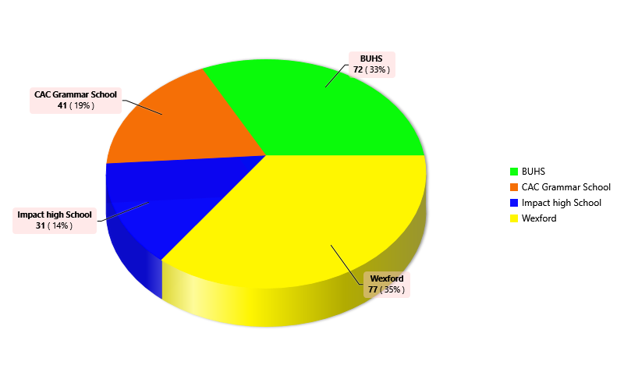
Figure 1: Respondents’ Distribution Across Secondary Schools
Table 1: Respondents awareness of Family life and Health Education
Variable | School
Variable | BUHS | CACGS | Impact | Wexford
Heard of family life and HIV | 55(32.35) | 31(18.24) | 31(18.24) | 53(31.18)
Heard of Life building skills | 48(29.63) | 31(19.14) | 28(17.28) | 55(33.95)
Heard of Sexuality education | 66(33) | 36(18) | 30(15) | 68(34)
Heard of Internet addiction | 58(36.25) | 16(10) | 30(18.75) | 56(35)
Heard of Drug abuse | 69(35.03) | 32(16.24) | 30(15.23) | 66(33.5)
Heard of Youth friendly services | 25(28.41) | 19(21.59) | 13(14.77) | 31(35.23)
Ever visited Youth friendly clinic | 14(56) | 7(28) | 1(4) | 3(12)
Major sources of values
Family | 62(32.98) | 26(13.83) | 29(15.43) | 71(37.77)
Community | 26(23.01) | 22(19.47) | 21(18.58) | 44(38.94)
Peer groups | 20(21.98) | 22(24.18) | 15(16.48) | 34(37.36)
School environment | 32(30.48) | 9(8.57) | 24(22.86) | 40(38.1)
Places of worship | 33(35.48) | 6(6.45) | 20(21.51) | 34(36.56)
Type of self esteem
High self esteem | 49(31.61) | 19(12.26) | 27(17.42) | 60(38.71)
Moderate | 15(24.19) | 20(32.26) | 7(11.29) | 20(32.26)
Low | 41(32.28) | 15(11.81) | 25(19.69) | 46(36.22)
Up | 15(36.59) | 9(21.95) | 3(7.32) | 14(34.15)

Table 2: Respondents’ awareness of Sexual and Reproductive Health
Variable | School
Variable | BUHS | CACGS | Impact | Wexford
Types of STIs
Chlamydia | 7(38.89) | 3(16.67) | 0(0) | 8(44.44)
Gonorrhea | 37(27.41) | 16(11.85) | 24(17.78) | 58(42.96)
Herpes | 5(16.13) | 1(3.23) | 12(38.71) | 13(41.94)
HIV/AIDS | 57(34.76) | 23(14.02) | 26(15.85) | 58(35.37)
Trichomoniasis | 10(34.48) | 2(6.9) | 2(6.9) | 15(51.72)
Signs and symptoms of AIDS
Prolonged cough | 17(26.98) | 14(22.22) | 16(25.4) | 16(25.4)
Prolonged diarrhea | 14(26.42) | 8(15.09) | 14(26.42) | 17(32.08)
Unexplained weight loss | 43(29.86) | 24(16.67) | 25(17.36) | 52(36.11)
Loss of appetite | 45(31.69) | 16(11.28) | 26(18.31) | 58(40.85)
Rashes | 10(26.32) | 3(7.89) | 14(36.84) | 11(28.95)
Modes of HIV Transmission
Unprotected sex | 55(28.21) | 39(20) | 29(14.87) | 72(36.92)
Handshake with infected person | 6(46.15) | 3(23.08) | 1(7.69) | 3(23.08)
Eating with infected person | 3(21.43) | 3(21.43) | 3(21.43) | 5(35.71)
Sleeping on same bed with infected person | 8(40) | 2(10) | 0(0) | 10(50)
Mother to child | 43(31.85) | 21(15.56) | 22(16.3) | 49(36.3)
Modes of STIs/HIV transmission
Abstinence | 26(29.21) | 11(12.36) | 19(21.35) | 33(37.08)
Avoid sharing sharps | 61(33.89) | 28(15.56) | 27(15) | 64(35.56)
Insisting on screened blood for transfusion | 34(31.48) | 19(17.59) | 20(18.52) | 35(32.41)

Table 3: Respondents’ sexual, reproductive health, and menstrual hygiene practices
Variable | School
Variable | BUHS | CACGS | Impact | Wexford
Ever been treated for STI | 3(50) | 1(16.67) | 2(33.33) | 0(0)
Ever used contraceptive | 2(66.67) | 0(0) | 0(0) | 1(33.33)
Ever prevented self from sexual abuse | 33(44.59) | 18(24.32) | 5(6.76) | 18(24.32)
Ever been treated on minor ailments | 22(25.29) | 16(18.39) | 19(21.84) | 30(34.48)
School has sick bay | 58(29.44) | 38(19.29) | 28(14.21) | 73(37.06)
School has health club | 29(32.22) | 31(34.44) | 6(6.67) | 24(26.67)
Peer education done by school health club members | 30(37.5) | 29(36.25) | 7(8.75) | 14(17.5)
Method of menstrual hygiene during menses
Clothe | 0(0) | 1(100) | 0(0) | 0(0)
Sanitary pad | 26(22.22) | 31(26.5) | 15(12.82) | 45(38.46)
Tissue paper | 1(100) | 0(0) | 0(0) | 0(0)
Total | 27(22.69) | 32(26.89) | 15(12.61) | 45(37.82)

Figure 2: Knowledge of STI/HIV
DISCUSSION
The result show that adolescent awareness of sexual and reproductive health (SRH) issues among secondary school students in Ondo State was high, but the utilization of youth-friendly services was strikingly low.
Awareness of sexuality education varies with 33% of BUHS students, 18% of CACGS, 15% of Impact, and 34% of Wexford reporting knowledge of it (Table 1). Similarly, awareness of HIV and family life education was above 30% in BUHS and Wexford, but just 18% in CACGS and Impact. While certain schools had successfully integrated family life and sexuality education into their curriculum, others lagged. These findings are consistent with Olatoye et al., 2025, who observed that adolescents exposed to formalized sexuality education curricula had significantly higher knowledge of HIV prevention. Omode et al., (2022) revealed that overall implementation quality sexuality education was moderate and stronger in urban schools while pointing out teachers’ lack of adequate training and limited teaching resources, particularly in rural areas as a limiting factor in effective delivery of the curriculum. Government and school management will have to do more in ensuring sexuality education is institutionalize across schools and implementation is monitored to produce desired results.
Similar to studies by Mensah and Enumah (2025), who found that awareness of drug-related risks is often higher than that of reproductive health issues because of the visible effects of drug misuse in communities, the results in this study shows less than 50% of sampled school students are aware of drug related risks, similar to that of reproductive health indicating more has to be done for the success of national anti-drug campaigns. Awareness of youth-friendly services was much lower, the paradox between high situation awareness and low clue of available supportive services has been emphasized by Eneji et al. (2025), who showed that even when schools establish health clubs or linkages to youth-friendly clinics, students remain unaware of how to access them.
More concerning is the service utilization of youth friendly services with only 14% of BUHS students, 7% of CACGS, 4% of Impact, and 12% of Wexford indicting ever visited a youth-friendly clinic. Osonuga et al. (2025) and Ladi-Akinyemi et al. (2024) reported similar result and attributed service utilization failure to barriers such as lack of confidentiality, stigma, and negative provider attitudes. In Plateau State, Envuladu (2025) described how adolescents reported fear of being judged by health workers, which limited their willingness to visit facilities. With the understanding that these should be youth friendly centres where such barriers were already removed, the low utilization figures in Ondo State thus underscore a structural failure: awareness campaigns have not translated into meaningful service uptake.
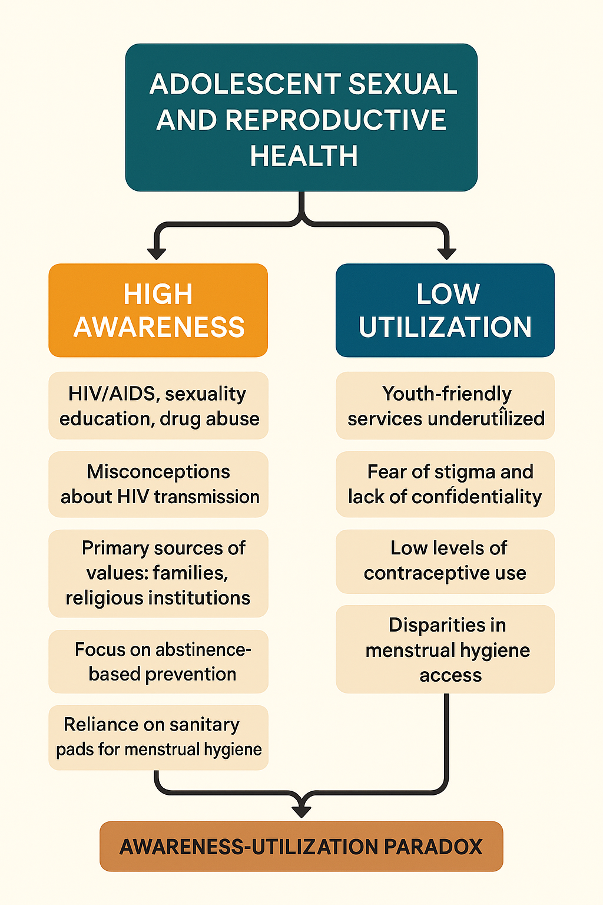
Figure 3: Awareness – Utilization paradox for health services (ChatGPT 5.0)

The families (about 33% at BUHS and 38% at Wexford) and places of worship (35% at BUHS and 37% at Wexford) remain the dominant influences shaping adolescent behaviour. This shows that adolescents are more influenced by families and religious institutions than by school curricula. Without family and religious involvement, schools alone cannot counter the silence around sexuality in many Nigerian households (Dung et al., 2025). Community-based organizations can bridge this gap by collaborating with families and religious leaders to deliver SRH information in culturally sensitive ways (Chukelu, 2025).
The result also show that self-esteem was unevenly distributed. High self-esteem was reported by 38.7% of Wexford respondents compared to 31.6% in BUHS and just 12.3% in CACGS. Low self-esteem was also common, with 36% in Wexford and 32% in BUHS reporting it. This pattern suggests polarization, where some adolescents feel empowered while others are vulnerable. Research has shown that self-esteem strongly influences health-seeking behavior. Akpong et al. (2025) noted that adolescents with low self-esteem were more likely to succumb to sexual coercion or fail to insist on condom use. Thus, health programming must integrate life skills building into health clubs and other reproductive health interventions to empower adolescents to act on the knowledge they acquire.
Gonorrhoea was the most widely recognized STI, followed by HIV/AIDS (Table 2). Knowledge of other STIs such as chlamydia and herpes were not consistent or completely unknown among students in some schools. This trend was documented by Okolie et al. (2024) where HIV dominates the discourse while other STIs remain underrepresented. If this trend remains unchanged, adolescents may overlook other infections, delay diagnosis and treatment and contributing to complications such as infertility.
Though students have been treated for STIs (Table 3) which indicate prevalence of unprotected sexual activity among students, contraceptive use among students remains low. These low utilization figures is a global pattern that have been noticed in West Africa (Mensah and Enumah 2025), adolescent contraceptive uptake remains constrained by stigma, gender norms, and limited availability of adolescent-friendly providers.
While adolescents are exposed to SRH messages and demonstrate a level awareness, misconceptions persist leading to failure to utilize available services. This paradox mirrors findings from across Nigeria and West Africa (Eneji et al., 2025; Chukelu 2025). These consistencies across regions highlight a systemic problem, awareness campaigns are not sufficient to drive utilization unless they are complemented by structural reforms in service delivery, cultural/community engagement, improved teacher training, equitable resource distribution, stronger supervision, and adolescent empowerment (Baird et al., 2024; Omode et al., 2022).
Conclusion
Adolescence is a critical developmental window, and gaps in SRH knowledge and practice have lifelong consequences, from unplanned pregnancies to HIV infection and drug related harm. This study shows that awareness program has not delivered desired behavioural change and promote adolescent friendly service utilization in secondary schools. Programming must shift focus from simply raising awareness to ensuring that awareness translates into action. This will require scaling up peer education, strengthening youth-friendly services, engaging families and religious leaders, and addressing stigma and confidentiality concerns. Without such holistic interventions, low utilization will persist, undermining adolescent health outcomes.
Consent
As per international standards, parental written consent has been collected and preserved by the author(s).

Disclaimer (Artificial intelligence)
Author(s) hereby declares that generative AI technologies ChatGPT 5.0 text – to – image generator has been used during the writing or editing of manuscripts.
Details of the AI usage are given below:
1. Words of Figure 3 “Awareness – Utilization paradox for health services” was developed in a table format on Microsoft word document
2. The table was fed into ChatGPT 5.0 with the following prompts
Use the information on the attached table to produce an infographic on awareness and utilization paradox. Do not add or remove any of the words on the table, just produce a simple infographic.
3.The output was downloaded and included in the manuscript as ‘figure 3’
REFERENCES
- Ajibola, I., & Mary, A. I. (2025). Sexual behaviours, contraceptive knowledge, and determinants among undergraduate students in a private university in Southwest Nigeria. African Journal of Health Education, 17(2), 112–128. https://scholar.google.com/scholar?hl=en&as_sdt=0%2C5&q=Ajibola%2C+I.%2C+%26+Mary%2C+A.+I.+%282025%29.+Sexual+behaviours%2C+contraceptive+knowledge%2C+and+determinants+among+undergraduate+students+in+a+private+university+in+Southwest+Nigeria.+African+Journal+of+Health+Education%2C+17%282%29%2C+112%E2%80%93128.&btnG=
- Akpong, B. A., Modey, S., Okang, M., & Agianipe, O. (2025). Sex education and adoption of healthy lifestyle among secondary school students in Cross River State, Nigeria. ResearchGate Preprint. https://www.researchgate.net/profile/Uzoigwe-Chukwudi/publication/393137403_Sex_Education_and_Adoption_of_Healthy_Lifestyle_among_Secondary_School_Students_in_Ogoja_Education_Zone_of_Cross_River_State_Nigeria/links/68612985e9b6c13c89e519e1/Sex-Education-and-Adoption-of-Healthy-Lifestyle-among-Secondary-School-Students-in-Ogoja-Education-Zone-of-Cross-River-State-Nigeria.pdf
- Baird, S., Das, S., Luckenbill, S., Oakley, E., & Banati, P. (2024). Accelerating well-being for adolescents through transformative public policy: A framework for action. Journal of Adolescent Health, 75(4S), S37–S46. https://www.jahonline.org/article/S1054-139X(24)00169-1/fulltext
- Chinenye-Julius, A., Olaosebikan, D., Oduyoye, O., & Okafor, N. (2021). Assessing The Knowledge, Perception, and Utilization of Youth Friendly Health Services Amongst Adolescents in Selected Secondary Schools in Lagos State. Euro Afro Studies International Journal, 3(7), 19-28. https://www.researchgate.net/profile/Omobola-Oduyoye/publication/355911374_Assessing_The_Knowledge_Perception_and_Utilization_of_Youth_Friendly_Health_Services_Amongst_Adolescents_in_Selected_Secondary_Schools_in_Lagos_State_Euro_Afro_Studies_International_JournalR_EASIJCOM/links/6183e2083c987366c326b614/Assessing-The-Knowledge-Perception-and-Utilization-of-Youth-Friendly-Health-Services-Amongst-Adolescents-in-Selected-Secondary-Schools-in-Lagos-State-Euro-Afro-Studies-International-JournalR-EASIJCOM.pdf
- Chukelu, C. N. (2025). Evaluating the role of community-based organizations in adolescent sexual and reproductive health education and early pregnancy prevention in Makoko, Yaba. Journal of Research in Adult and Continuing Education. https://journals.unizik.edu.ng/joriace/article/view/6300
- Dung, D. G., Samuel, M. M., & Yashim, U. H. (2022). Socio-cultural determinants of adolescents’ sexual and reproductive behaviour in Kefi Local Government Area, Nasarawa State, Nigeria. Wukari International Studies Journal, 6(2), 1–26. https://www.researchgate.net/profile/Mamman-Matthew-Samuel/publication/388890503_SOCIO-CULTURAL_DETERMINANTS_OF_ADOLESCENTS_SEXUAL_AND_REPRODUCTIVE_BEHAVIOUR_IN_KEFFI_LOCAL_GOVERNMENT_AREA_NASARAWA_STATE-NIGERIA/links/67abd0d74c479b26c9ddea39/SOCIO-CULTURAL-DETERMINANTS-OF-ADOLESCENTS-SEXUAL-AND-REPRODUCTIVE-BEHAVIOUR-IN-KEFFI-LOCAL-GOVERNMENT-AREA-NASARAWA-STATE-NIGERIA.pdf
- Eneji, R. I., Odey, S. A., & Adinya, O. J. (2025). Accessibility of youth-friendly sexual and reproductive health services to secondary school adolescents in Southern Cross River, Nigeria. Educational Research and Reviews, 9(3), 41–60. https://ideas.repec.org/a/ajp/edwast/v9y2025i3p41-60id5113.html
- Envuladu, E. A. (2025). Responding to adolescent sexual and reproductive health care needs: The complexities in Plateau State, Nigeria. Utrecht University Research Portal. https://research-portal.uu.nl/en/publications/responding-to-adolescent-sexual-and-reproductive-health-care-need
- Ladi-Akinyemi, T., Balogun, M., Welch, S., & Emmanuel, G. (2024). Barriers to integration and implementation of adolescent and youth-friendly health services in Southwest Nigeria: A mixed method study. Research Square. https://scholar.google.com/scholar?hl=en&as_sdt=0%2C5&q=Ladi-Akinyemi%2C+T.%2C+Balogun%2C+M.%2C+Welch%2C+S.%2C+%26+Emmanuel%2C+G.+%282024%29.+Barriers+to+integration+and+implementation+of+adolescent+and+youth-friendly+health+services+in+Southwest+Nigeria%3A+A+mixed+method+study.+Research+Square.&btnG=
- Mensah, L. S., & Enumah, C. C. (2025). Global patterns and challenges in teen contraceptive use: A systematic review. International Journal of Research and Reports in Public Health. https://hal.science/hal-05234554/
- Okolie, E. A., Bassey, P. E., & Ike, F. N. (2024). Knowledge, attitudes, and practices towards youth-friendly SRH service delivery in Calabar Metropolis, South-South Nigeria. BioSocial Health Journal. https://scholar.google.com/scholar?hl=en&as_sdt=0%2C5&q=Okolie%2C+E.+A.%2C+Bassey%2C+P.+E.%2C+%26+Ike%2C+F.+N.+%282024%29.+Knowledge%2C+attitudes%2C+and+practices+towards+youth-friendly+SRH+service+delivery+in+Calabar+Metropolis%2C+South-South+Nigeria.+BioSocial+Health+Journal&btnG=
- Olatoye, A. A., Olowokere, A. E., Bolarinwa, O. O., & Olatoye, A. M. (2025). Knowledge and behaviours of adolescents on sexual and reproductive health and rights in selected secondary high schools in Ife Central Local Government Area, Nigeria. Asian Journal of Research in Nursing and Health, 8(1), 40–52. https://hal.science/hal-05046588/
- Olutade-Babatunde, O., van der Kwaak, A., Bet-ini, N. C., & Keshinro, M. I. (2024). A critical review of factors affecting health-seeking behavior among adolescent mothers in Nigeria: Towards inclusive and targeted interventions. Medtigo Journal, 2(4). https://journal.medtigo.com/a-critical-review-of-factors-affecting-health-seeking-behavior-among-adolescent-mothers-in-nigeria-towards-inclusive-and-targeted-interventions/
- Omode, P. K., Sekoni, O. O., & Adebayo, A. M. (2022). Quality of implementation of Family Life and HIV Education in secondary schools in rural and urban areas of Ondo State, Nigeria. Nigerian Journal of Child and Adolescent Health, 5(1). https://www.researchgate.net/profile/Paulinus-Omode/publication/394047405_QUALITY_OF_IMPLEMENTATION_OF_FAMILY_LIFE_AND_HIV_EDUCATION_IN_SECONDARY_SCHOOLS_IN_RURAL_AND_URBAN_AREAS_OF_ONDO_STATE_NIGERIA/links/6886c0030786937984552a38/QUALITY-OF-IMPLEMENTATION-OF-FAMILY-LIFE-AND-HIV-EDUCATION-IN-SECONDARY-SCHOOLS-IN-RURAL-AND-URBAN-AREAS-OF-ONDO-STATE-NIGERIA.pdf
- Osonuga, A. A., Osonuga, R., Akinloye, E., & Oluwaferanmi, A. (2025). Factors predisposing to teenage pregnancy among female secondary school students in Southwest Nigeria. African Journal of Health, Nursing and Midwifery, 8(1), 88–103. https://abjournals.org/ajhnm/wp-content/uploads/sites/18/journal/published_paper/volume-8/issue-1/AJHNM_JPMIFAIM.pdf
- Osunmakinwa, O., Olugbenga-Bello, A., Ibirongbe, D., & Adebimpe, O. (2022). Knowledge, age at sexual debut and sexual behaviour of secondary school adolescents in Akure, Ondo State, Nigeria. Wes J Med Biomed Sci, 3(3–4), 1–15. https://wjmbs.com.ng/index.php/wjmbs/article/view/98
- UNESCO (2018). International Technical Guidance on Sexuality Education: An Evidence-Informed Approach. Paris: UNESCO. https://www.unfpa.org/sites/default/files/pub-pdf/ITGSE.pdf
- Uwakwe, C. E. (2025). Sociocultural and psychological influences on premarital sexual behaviour among Nigerian university students. International Research Journal of Sociology, Psychology, and Anthropology, 2(4). https://aydenjournals.com/index.php/IRJSPA/article/download/1000/1004
- World Health Organization. (2021). Global health estimates: Adolescent health. Geneva: WHO. https://www.who.int/health-topics/adolescent-health

