Association between serum homocysteine levels and gestational diabetes mellitus
Abstract
Background: Gestational diabetes mellitus (GDM) is a prevalent metabolic condition during pregnancy, linked to negative outcomes for both mother and fetus. Homocysteine (Hcy), a sulfur-based amino acid, has been associated with insulin resistance, endothelial impairment, and oxidative stress. Increased maternal homocysteine levels might play a role in the onset of GDM, yet the evidence varies among different populations.
Objective: To assess the association between serum homocysteine levels and gestational diabetes mellitus in pregnant women and evaluate its potential as a predictive biomarker.
Methods: This case-control study was conducted at the Department of Obstetrics & Gynecology, Sir Salimullah Medical College Mitford Hospital over 12 months. Eighty pregnant women in their second or third trimester were enrolled, comprising 40 GDM cases (Group A) and 40 gestational-age- and BMI-matched controls without GDM (Group B). Serum homocysteine levels were measured using chemiluminescent microparticle immunoassay (CMIA). Statistical analysis included independent samples t-test, chi-square test, Pearson’s correlation, and odds ratio calculation, with p < 0.05 considered significant.
Results: Mean serum homocysteine levels were significantly higher in the GDM group compared to controls (11.7 ± 5.2 µmol/L vs. 5.5 ± 1.4 µmol/L, p < 0.001). Women with homocysteine levels >6.38 µmol/L were 2.31 times more likely to develop GDM (95% CI: 1.591–3.351). Serum homocysteine was positively correlated with both fasting (r = 0.610, p < 0.001) and 2-hour postprandial glucose levels (r = 0.632, p < 0.001). Baseline characteristics, including age, trimester, and gravida status, were similar between groups.
Conclusion: Elevated serum homocysteine levels are significantly associated with GDM and correlate positively with maternal glucose levels. Hyperhomocysteinemia may serve as an independent risk factor for GDM, and monitoring homocysteine could facilitate early identification and management of at-risk pregnant women, potentially improving maternal and fetal outcomes.
Keywords: Gestational diabetes mellitus, serum homocysteine, hyperhomocysteinemia
Introduction
“Gestational diabetes mellitus (GDM) is defined as glucose intolerance that is first recognized during pregnancy, with prevalence rates ranging from 5% to 20% worldwide, depending on the population studied and diagnostic criteria used. GDM poses significant short- and long-term health risks for both mother and offspring, including preeclampsia, macrosomia, neonatal hypoglycemia, and an increased lifetime risk of type 2 diabetes mellitus”. ¹⁻² Early identification of women at risk is critical for timely intervention and improved maternal-fetal outcomes.
“Homocysteine (Hcy) is a sulfur-containing amino acid produced during methionine metabolism. Elevated serum homocysteine levels, or hyperhomocysteinemia, have been implicated in endothelial dysfunction, oxidative stress, and vascular inflammation. These pathophysiological mechanisms are closely associated with insulin resistance, a central feature of type 2 diabetes and GDM. Consequently, homocysteine has emerged as a potential biomarker linking metabolic disturbances and adverse pregnancy outcomes”.³
“Several studies have reported a positive association between elevated maternal homocysteine levels and the development of GDM. Hyperhomocysteinemia may impair pancreatic β-cell function and exacerbate insulin resistance, thereby contributing to hyperglycemia during pregnancy.” ⁴⁻⁵ “Additionally, high homocysteine levels have been linked to placental dysfunction, oxidative stress, and pro-inflammatory states, which further increase the risk of GDM and associated complications such as preterm birth and preeclampsia”^{11,12}.
“Despite growing evidence, the relationship between serum homocysteine levels and GDM remains inconsistent across populations. Some studies have found significantly higher homocysteine levels in women with GDM compared to healthy pregnant women, while others have reported no significant difference, suggesting that genetic, dietary, and environmental factors may modulate this association. These inconsistencies highlight the need for further investigation, particularly in specific populations where GDM prevalence is rising due to lifestyle and nutritional transitions”.⁶
Understanding the association between serum homocysteine levels and GDM is clinically important. Identifying elevated homocysteine as an early biomarker could facilitate risk stratification, timely screening, and targeted interventions, such as dietary supplementation with folate, vitamin B6, and B12, which are known to regulate homocysteine metabolism. Early management may reduce the incidence of maternal and fetal complications associated with GDM.
Objective
To assess the association between serum homocysteine levels and gestational diabetes mellitus in pregnant women and evaluate its potential as a predictive biomarker.
Methodology
This was a case-control study conducted over a 12-month period in the Department of Obstetrics & Gynecology, Sir Salimullah Medical College Mitford Hospital. A total of 80 pregnant women were enrolled, divided equally into two groups: Group A included 40 pregnant mothers diagnosed with gestational diabetes mellitus (GDM), while Group B consisted of 40 pregnant mothers without GDM, matched for gestational age and BMI. Participants were selected using purposive sampling to ensure adherence to inclusion and exclusion criteria.
The age range of participants in both groups was 18–42 years, with similar mean ages across cases and controls. Baseline characteristics such as education, occupation, residence, and monthly family income were recorded through face-to-face interviews. Physical examinations were performed, including measurement of height, weight, BMI, and vital signs such as blood pressure and pulse rate. All participants were singleton pregnancies within their second or third trimester.
Blood samples were collected from the antecubital vein under aseptic conditions, and serum homocysteine levels were measured using a chemiluminescent microparticle immunoassay (CMIA) on the ARCHITECT i System. The assay involved reduction of bound homocysteine, enzymatic conversion to S-adenosyl homocysteine, and subsequent quantification via chemiluminescence. Normal homocysteine levels in the laboratory ranged from 4–15 µmol/L.
The mean serum homocysteine level was significantly higher in the GDM group compared to the control group, indicating a potential association between elevated homocysteine and the development of gestational diabetes.
Collected data were entered into SPSS version 26. Quantitative variables, such as serum homocysteine levels and fasting glucose, were expressed as mean ± standard deviation and compared using the independent samples t-test. Categorical variables were analyzed with the chi-square test. Pearson’s correlation coefficient was applied to assess the relationship between serum homocysteine and fasting glucose levels. Additionally, odds ratios were calculated to evaluate the strength of association between elevated homocysteine and GDM. A p-value of <0.05 was considered statistically significant.
Analysis revealed that pregnant women with GDM had significantly higher mean serum homocysteine levels than women without GDM. A positive correlation was observed between homocysteine levels and fasting blood glucose, suggesting that elevated homocysteine may be linked to impaired glucose metabolism during pregnancy. The odds ratio analysis further demonstrated that women with higher homocysteine levels were at increased risk of developing GDM compared to women with normal levels.

Results
In Case group, 67.5% of the women were 18 to 28 years of age followed by 20% were 29 to 39 years and 12.5% were 40 or above years of age. In Control group, 62.5% of the women were 18 to 28 years of age followed by 22.5% were 29 to 39 years and 15% were 40 or above years of age. Mean age of the cases and controls was 27.5±7.5 years and 27.8±8 years accordingly.

Table-1: Distribution of the participants according to Age group (n=80)
Age group  (Years) | Case (n=40) | Control (n=40) | p-value
18 to 28 | 27 (67.5) | 25 (62.5) | 0.896*
29 to 39 | 8 (20) | 9 (22.5) | 0.896*
40 and above | 5 (12.5) | 6 (15) | 0.896*

In both case and control group majority of the women had 3rd trimester pregnancy (77.5% vs 75%) and multi gravida (55% vs 60%). In case group 12.5% and in control group 2.5% had family history of DM. Mean gestational age of the baby was 30.6±3.8 weeks and 30.7±4.2 weeks in case and control group accordingly. Obstetric history of the pregnant women of both groups were statistically similar.
Table-2: Distribution of the participants according to obstetric history (n=80)
Obstetric history | Case (n=40) | Control (n=40) | p-value
Trimester of pregnancy
2nd trimester | 9 (22.5) | 10 (25) | 1.00*
3rd trimester | 31 (77.5) | 30 (75) | 1.00*
Gravida
Primi | 18 (45) | 16 (40) | 0.821*
Multi | 22 (55) | 24 (60) | 0.821*
Family history of DM | 5 (12.5) | 1 (2.5) | 0.201**
Gestational age (weeks) | 30.6±3.8 | 30.7±4.2 | 0.846***

Serum homocysteine level in case group was 11.7±5.2 µmol/l and in Control group was 5.5±1.4 µmol/l. Serum homocysteine level was significantly higher in case group in comparison to control group.
Table-3: Distribution of the participants according to serum homocysteine level (n=80)
 | Case (n=40) | Control (n=40) | p-value*
Serum homocysteine level (µmol/l) | 11.7±5.2 | 5.5±1.4 | <0.001
Range | 5.86-22.2 | 4.01-10.1

Among the case group, 8 participants (11.1%) had serum homocysteine levels ≤6.38 µmol/l, while 32 participants (81.8%) exhibited levels >6.38 µmol/l. In contrast, the control group showed a significantly higher proportion of participants (36, 88.9%) with levels ≤6.38 µmol/l and only 4 participants (18.2%) with levels >6.38 µmol/l. Participants in the case group are approximately 2.31 times more likely to have GMD compared those in the control group.
Table-4: Odds ratio and 95% CI for GDM according to Serum homocysteine level among pregnant women (n=80)
Serum homocysteine level (µmol/l) | Case  (n=40) | Control  (n=40) | x² | p-value | df | OR (95% CI)
≤6.38 | 8 (11.1) | 36 (88.9) | 39.596 | <0.001 | 1 | 2.309 (1.591-3.351)
>6.38 | 32 (81.8) | 4 (18.2)
p-value was determined by Chi-square test. Data presentation with frequency (%).
Case= Pregnant mother with GDM
Control= Pregnant women without GDM

Serum homocysteine level was positively correlated with serum glucose level and this finding showed statistically significant.
Table-5: Correlation of serum homocysteine level with serum glucose level of the pregnant women (n=80)
 | Correlation coefficient (r) | p-value*
Serum homocysteine level vs Fasting serum glucose level | 0.610 | <0.001
Serum homocysteine level vs 2 hrs after serum glucose | 0.632 | <0.001
*p-value was calculated by Pearson correlation test.
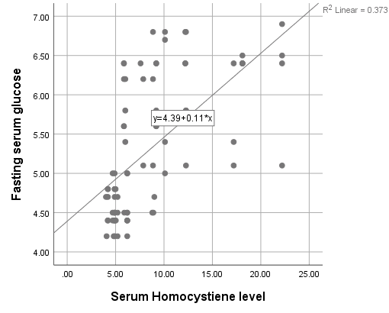
(µmol/L)

Figure-1: Scattered plot showing correlation of serum homocysteine level with fasting serum glucose level of the pregnant women (n=80)
Serum homocysteine level was positively correlated with fasting serum glucose level (r=0.610).

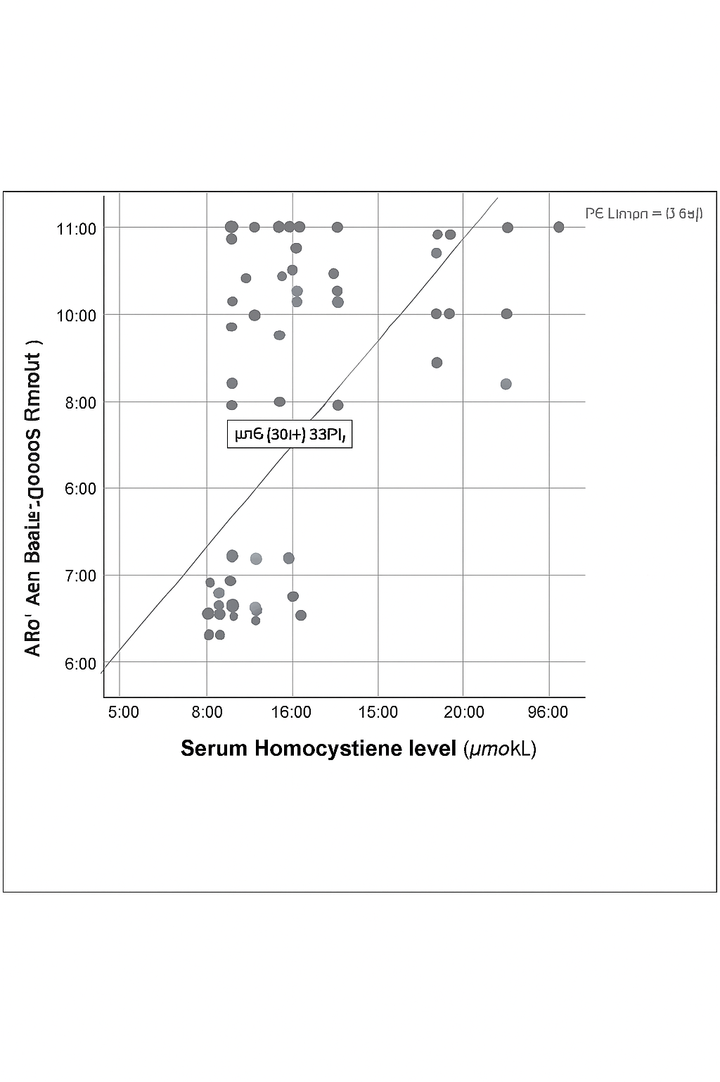

Figure-2: Scattered plot showing correlation of serum homocysteine level with 2hrs after serum glucose level of the pregnant women (n=80)
Serum homocysteine level was positively correlated with 2 hrs after serum glucose level (r=0.632).

Discussion
In this study, the mean age of pregnant women with GDM was 27.5 ± 7.5 years, which was comparable to the control group (27.8 ± 8 years). Age distribution and obstetric characteristics, including trimester of pregnancy and gravida status, were similar between cases and controls, suggesting that these factors were not confounding variables in the assessment of serum homocysteine levels. This aligns with previous studies, which reported comparable age distributions in GDM and non-GDM pregnant women, indicating that maternal age within the studied range may not significantly influence the development of GDM in this population. ⁷
“A notable finding in our study was the significantly higher serum homocysteine levels in women with GDM (11.7 ± 5.2 µmol/L) compared to controls (5.5 ± 1.4 µmol/L, p < 0.001). This is consistent with earlier research who also observed elevated homocysteine levels in GDM patients, suggesting a potential role of hyperhomocysteinemia in impaired glucose metabolism during pregnancy.” ⁸ The higher homocysteine levels in GDM may contribute to endothelial dysfunction and oxidative stress, which are known to influence insulin resistance and pancreatic β-cell function.
“Our odds ratio analysis demonstrated that pregnant women with serum homocysteine levels >6.38 µmol/L were approximately 2.31 times more likely to develop GDM compared to those with lower levels. This supports the hypothesis that elevated homocysteine is an independent risk factor for GDM, as suggested by studies who reported that hyperhomocysteinemia increased the risk of GDM by 2–3 times in various populations. These findings reinforce the importance of monitoring homocysteine levels as part of early risk assessment in pregnancy”.⁹
“Furthermore, a positive correlation was observed between serum homocysteine levels and fasting as well as 2-hour postprandial glucose levels (r = 0.610 and r = 0.632, respectively; p < 0.001). This indicates a significant association between hyperhomocysteinemia and impaired glucose regulation. Similar findings have been reported who found that homocysteine was positively associated with fasting and postprandial glucose levels in pregnant women, suggesting that elevated homocysteine may exacerbate insulin resistance and contribute to hyperglycemia in GDM”.¹⁰
Overall, our findings highlight a strong association between elevated serum homocysteine levels and GDM. These results emphasize the potential utility of homocysteine as a biomarker for early identification of women at risk of GDM. Considering the consistent evidence from previous studies, interventions aimed at reducing homocysteine levels through nutritional supplementation (e.g., folate, vitamin B12) or lifestyle modification may represent a promising approach to mitigating GDM risk and improving maternal-fetal outcomes.
Conclusion
In conclusion, this study demonstrates that pregnant women with gestational diabetes mellitus have significantly higher serum homocysteine levels compared to those without GDM, and elevated homocysteine is positively correlated with both fasting and 2-hour postprandial glucose levels. Women with homocysteine levels above 6.38 µmol/L were over twice as likely to develop GDM, indicating that hyperhomocysteinemia may serve as an important independent risk factor. These findings suggest that monitoring and managing serum homocysteine levels could play a valuable role in early identification and prevention of GDM, ultimately contributing to improved maternal and fetal outcomes.
Ethical approval AND consent
Ethical approval for the study was obtained from the Ethical Review Committee and the Research Review Committee of Sir Salimullah Medical College. Written informed consent was obtained from all participants after explaining the study objectives, procedures, and confidentiality assurances in the local language. Participants were informed of their right to withdraw at any time without affecting their medical care, and no financial incentives were provided.
Disclaimer (Artificial intelligence)
Option 1:
Author(s) hereby declare that NO generative AI technologies such as Large Language Models (ChatGPT, COPILOT, etc.) and text-to-image generators have been used during the writing or editing of this manuscript.
Option 2:
Author(s) hereby declare that generative AI technologies such as Large Language Models, etc. have been used during the writing or editing of manuscripts. This explanation will include the name, version, model, and source of the generative AI technology and as well as all input prompts provided to the generative AI technology
Details of the AI usage are given below:
1.
2.
3.

Reference:
- Adnan, M. & Aasim, M., 2024. Prevalence of gestational diabetes mellitus in Pakistan: a systematic review and meta-analysis. BMC Pregnancy and Childbirth, 24(1), 108–119.
- Alatab, S., Fakhrzadeh, H., Sharifi, F., Mirarefin, M., Badamchizadeh, Z., Ghaderpanahi, M., et al., 2013. Correlation of serum homocysteine and previous history of gestational diabetes mellitus. Journal of Diabetes & Metabolic Disorders, 12(1), 34–39.
- Alfadhli, E., 2015. Gestational diabetes mellitus. Saudi Medical Journal, 36(4), 399–406.
- Amiri, F.N., Faramarzi, M., Bakhtiari, A. & Omidvar, S., 2021. Risk Factors for Gestational Diabetes Mellitus: A Case-Control Study. American Journal of Lifestyle Medicine, 15(2), 184–190.
- Azzini, E., Ruggeri, S. & Polito, A., 2020. Homocysteine: Its Possible Emerging Role in At-Risk Population Groups. International Journal of Molecular Sciences, 21(4), 1–27.
- Begum, R., Roy, S. & Banik, S., 2022. The prevalence of gestational diabetes mellitus in Bangladesh: a systematic review and meta-analysis. International Journal of Diabetes in Developing Countries, 42(4), 606–613.
- Begum, S.A., Khalil, I., Mandal, C.K., Hasan, M.M. & Kawsar, M.A., 2016. Folic acid deficiency related to hyperhomocystinemia has less correlation with Gestational Diabetes Mellitus (GDM). Update Dental College Journal, 6(1), 1–7.
- Behboudi-Gandevani, S., Amiri, M., Bidhendi Yarandi, R. & Ramezani Tehrani, F., 2019. The impact of diagnostic criteria for gestational diabetes on its prevalence: A systematic review and meta-analysis. Diabetology and Metabolic Syndrome, 11(1), 1–18.
- Carpenter, M.W., 2007. Gestational Diabetes, Pregnancy Hypertension, and Late Vascular Disease. Diabetes Care, 30, 1–5.
- Chakraborty, A. & Yadav, S., 2024. Prevalence and determinants of gestational diabetes mellitus among pregnant women in India: an analysis of National Family Health Survey Data. BMC Women’s Health, 24(1), 147–158.
- Chen, Y., Li, C., Lei, Y., & Zhang, F. (2024). Effects of glycated serum protein, homocysteine, and cystatin-C levels on pregnancy outcomes in patients with gestational diabetes mellitus. Pakistan Journal of Medical Sciences, 40(4), 572.
- Nessa, M., Das, T. R., Jahan, E., & Khan, M. M. U. R. (2024). Association of Serum Homocysteine with Gestational Diabetes Mellitus (GDM): A Case-Control Study. Bangabandhu Sheikh Mujib Medical College Journal, 3(1), 32-37.

