Global Research Landscape and Knowledge Evolution of Early Warning Systems in Natural Disaster Management

Abstract
The comprehensive approach to bibliometric analysis examines global research on Early Warning Systems (EWS) in relation to disaster management from 2001 to 2024, with data retrieved from the Web of Science and Scopus databases. The Bibliometrix R package is the tool that is used to examine publication trends, influential sources, country-level contributions, collaboration networks, and thematic evolution to map the intellectual and structural development of the field. It helps to reveal a steady and exponential growth in publications, particularly after 2015, coinciding with the adoption of the Sendai Framework for Disaster Risk Reduction (2015–2030). China takes the lead in research productivity with the largest share of publications followed by Italy, the United States, Australia, and Canada that have higher citation impact and international visibility. Natural Hazards, Landslides, and the International Journal of Disaster Risk Reduction are identified as the top research outlets and the developing conceptual basis in the field is comprised of keywords associated with “early warning system,” “disaster management,” “floods,” “risk assessment,” and, “climate change." The thematic and factorial analyses depicted early warning systems, climate change, and disaster management as well-developed motor themes, while emerging themes in the research literature included machine learning, resilience, and Internet of Things (IoT) based warning models. Additionally, the international collaboration network suggests a dual-core pattern with China leading in South-South partnerships, and Europe anchoring research networks in the West. The authors highlight that EWS research has developed as a multidisciplinary and globally located compendium of early warning system science, that connects technology innovation, environmental science with policy-developed frameworks, to improve resilience to disasters. Findings from this study suggest the importance of strengthening cross-regional collaboration, strengthening open data integration and developing AI- and IoT-enabled early warning systems to build more adaptive and climate-resilient societies.
Keywords; Bibliometrics, Disaster Management, Early Warning System, Risk Reduction, Technological Innovation
1. Introduction
Worldwide efforts like the Common Alerting Protocol have been instrumental in harmonising the warning data that allows media outlets and cell phone broadcasters to issue warnings (Motsumi and Nemakonde 2025). Early Warning Systems (EWS) in disaster risk reduction are very crucial for hazard monitoring and preparedness activities in both communities and government organisations (Šakić Trogrlić et al. 2022; Esposito et al., 2022). The concept of EWS refers to 'a system that is physically integrated with activities of hazard monitoring, prediction, and forecast, risk communication, preparedness, and disaster risk assessment, which permits immediate reaction to lower risks associated with disasters prior to the occurrence of risky ​‍​‌‍​‍‌​‍​‌‍​‍‌events’ (Pescaroli, Dryhurst, & Karagiannis, 2025). It plays a vital role in minimising the impacts by using advanced technologies, including AI, GIS, remote sensing, and satellite monitoring, to deliver timely and accurate forecasts (Olaoye and Egon 2024). The real challenge lies in bridging communication and participation gaps to ensure timely and inclusive disaster response. This helps in creating awareness among communities and enhances public preparedness (Kelman and Glantz 2014). The technological progress happening at the local and global levels addresses the gaps and ways of equitable access, which will be effective and sometimes inclusive (Sahana et al. 2023). An effective Early Warning System is significant in improving preparedness in situations like floods, landslides, earthquakes and also building resilience in Vulnerable regions (A. Clarkson Otuogha, 2024). The early warning system (EWS) is the most significant one, according to the World Health Organisation (WHO) in crisis management (Khankeh, et al. 2023). There is a recent study in coastal central Vietnam that examined the effectiveness of community based early warning systems in enhancing disaster preparedness and addressing the gaps in technical capacity. This portrays the need for empowerment for local risk management (Pham, Thieken, and Bubeck 2024).It is evident that for improving the real time monitoring and decision making during events mostly depend on the geographic information and digital earth technologies (Konečný & Reinhardt, 2010). The​‍​‌‍​‍‌​‍​‌‍​‍‌ majority of the progress in the prediction of catastrophes is due to the use of Artificial Intelligence (AI) and Machine Learning (ML). Research shows that AI scrutinises past and environmental data in order to make EWSs more efficient in disaster management (Faiaz and Nawar 2025). Disaster Management always faces challenges in data integration and coordinated responses, even having advanced technologies like IoT, GIS, and machine learning, the need for a unified and interdisciplinary approach always exists (Khan et al., 2023). The technological and empirical gaps remain as a central part as the vast majority of EWS operate on localised and limited their scalability, data processing capabilities, and potential for widespread access (Agbehadji et al. 2023). Even when the technical monitoring and prediction tools highly getting better, their effectiveness is often defeated by the lack of public trust in government agencies and the exclusion of local communities from the plans and operations of such systems. The effectiveness of any EWS relies on merging technological innovation with local knowledge and active participation are put first to build trust and ensure that warnings are not just sent, but also acted upon(Aprianti et al. 2025). The affordable tools like NOAA weather radios, combined with public awareness efforts, always stay for the effectiveness of disaster preparedness (Collins and Kapucu 2008). The weak link between global policies and local actions has occurred because of the ineffectiveness of early warning systems. For example, despite having global progress under the Sendai Risk Reduction Framework, the implementation gaps create such inclusiveness (Rokhideh, Fearnley, and Budimir 2025). It is always the informal social networks that ensure the timely dissemination of early warnings, sometimes being a compensating approach for the formal top-down systems in disaster communication (Raphela and Ekeke 2025). Bangladesh, Indonesia, and the Hindu Kush Himalayas demonstrate that community based EWS enhance resilience when local knowledge and institutional support are integrated, which reduces the climate risk and strengthens global resilience (Islam et al. 2025). So it is very evident that such critical EWS components, including automatic 24-hour monitoring systems, use of colour codes, and tracking warning signals, help in improving overall disaster response capability (Zaboli, Malmoon, and Seyedin 2013).
1.1 Objectives of the Study
- To analyse the temporal growth and publication trends in global research on Early Warning Systems (EWS) within the field of disaster management from 2001 to 2024.
- To identify the most influential journals, authors, and affiliations in the EWS research domain.
- To examine international collaboration patterns and research networks among countries and institutions.
- To analyse the conceptual and thematic structure of EWS research through keyword co-occurrence, thematic mapping, and factorial analysis, identifying core, emerging, niche, and declining research themes.
- To trace the thematic evolution of research topics about early warning systems over time.
1.2 Rationale of the Study
In an era of increasing climatic extremes and rapid environmental change, Early Warning Systems (EWS) have become a cornerstone of disaster risk reduction (DRR) and climate resilience. Effective early warning means effective disaster response (Mannan, et al., 2021). Over the past two decades, research on EWS has expanded significantly, driven by technological advancements in remote sensing, artificial intelligence, geospatial analytics, and sensor networks, as well as by policy frameworks such as the Hyogo Framework for Action (2005–2015) and the Sendai Framework for Disaster Risk Reduction (2015–2030) (Haque, et al., 2024). Most existing reviews focus on specific hazards such as floods, earthquakes, or landslides or on regional implementations of EWS, leaving a knowledge gap in understanding the broader intellectual and geographical landscape of the field (Albahri , et al., 2024). The existing gap in EWS research between 2001 and 2024 is addressed through this study. The data source includes Web of Science and Scopus, aims to elucidate the evolution of the field from traditional hazard-based approaches to multi-hazard, data-driven, and climate-integrated early warning systems.
The rationale for this research lies in its potential to synthesise dispersed knowledge, identify global research leaders, and highlight emerging trends and gaps that can inform future studies and policymaking. By mapping the intellectual structure and collaborative networks of EWS research, the study contributes to a deeper understanding of how scientific knowledge supports global efforts toward resilient, adaptive, and technology-enabled disaster management systems.
2. Methodology
Bibliometric analysis systematically examines the global research landscape at the intersection of Artificial Intelligence (AI) and Disaster Management, reflecting an emerging and interdisciplinary domain of increasing academic and policy relevance. Bibliometric analysis is a quantitative research method that uses statistical and network-based techniques to evaluate the structure, performance, and evolution of a scientific field (Adarsh & Sulthana, 2025).
A timespan of 24 years from 2000–2024 is a long-term view on the field’s development across multiple phases of technological and methodological advancement. The dataset comprised a total of 2749 documents retrieved from the Web of Science and Scopus databases, ensuring comprehensive coverage of peer-reviewed journals, conference proceedings, and scholarly publications relevant to the topic from 759 multidisciplinary sources (Fig. 1).
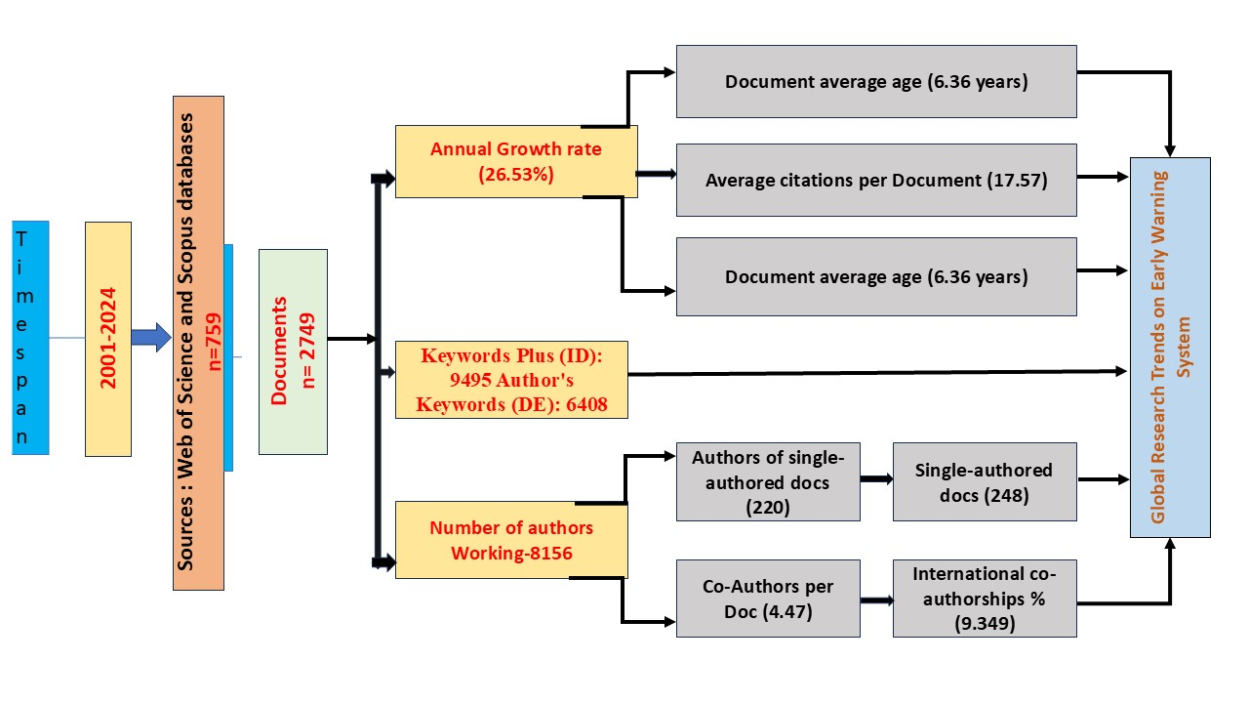
Fig 1; Methodology Chart
The search strategy was designed using a dual-topic query approach to comprehensively capture literature relevant to the study’s scope. Research articles were retrieved from both the Web of Science (WoS) and Scopus databases using well-defined and validated search queries (as detailed below). To ensure data integrity and prevent duplication, the merged dataset was processed in RStudio, where duplicate records across the two databases were systematically detected and removed using the Bibliometrix package’s data-cleaning functions. This preprocessing step ensured that the final dataset represented a unique and accurate collection of publications for subsequent analysis.
Querry; =("early warning system*" OR "early warning systems" OR "early warning systems ews" OR "disaster early warning" OR "multi-hazard early warning" OR "hazard early warning" OR "warning and alert system*" OR "risk early warning" OR "EWS") AND=("disaster" OR "disaster management" OR "disaster risk reduction" OR "disaster preparedness" OR "hazard management" OR "risk management") AND=("natural disaster*" OR "hydrometeorological disaster*" OR "climate disaster*" OR "flood*" OR "earthquake*" OR "landslide*" OR "cyclone*" OR "tsunami*" OR "drought*" OR "volcanic eruption*" OR "storm*" OR "avalanche*" OR "forest fire*" OR "wildfire*" OR "bush fire*") NOT =("industrial accident*" OR "industrial disaster*" OR "factory explosion*" OR "chemical disaster*" OR "nuclear disaster*" OR "technological disaster*" OR "workplace safety*" OR "disease outbreak*" OR "health")
3. Data Analysis
The study employed Biblioshiny, a web-based interface of the Bibliometrix R package (Aria and Cuccurullo 2017). Biblioshiny enables both quantitative and qualitative exploration of large bibliographic datasets through integrated analytical and visualisation tools. The intellectual structure and thematic evolution of the field is analysed using Descriptive analysis, Co-Occurrence analysis, Thematic Mapping, Thematic evolution analysis, Factorial Analysis and Collaboration Network Analysis.
3.1 Annual Scientific Production
In 2001, only two articles were published on the topic, marking the nascent phase of scholarly attention toward early warning mechanisms. Publication activity remained relatively low and stable until 2004, after which a sharp rise was observed beginning in 2005 (22 articles). This surge corresponds with the Hyogo Framework for Action (2005–2015), which placed significant emphasis on strengthening early warning capacities as a cornerstone of disaster risk reduction.
The publication output showed a steady increase from 2006 to 2012, rising from 19 to 71 articles annually, indicating a phase of gradual academic consolidation in the field. The year 2013 marks a notable milestone with 111 publications, almost doubling the average of the previous years. A second major spike is observed after 2015, coinciding with the adoption of the Sendai Framework for Disaster Risk Reduction (2015–2030) and the Sustainable Development Goals (SDGs), particularly SDG 13: Climate Action. These global frameworks likely catalysed scholarly focus on multi-hazard early warning systems and community-based disaster preparedness. The number of annual publications increased from 99 to 212 between 2015 and 2020, and this trend has accelerated further in recent years. The data for 2021–2024 shows an unprecedented expansion, with output rising from 226 to 448 publications, more than double within four years. The growth pattern indicates that research on Early Warning Systems has evolved from an emerging niche to a core domain within disaster studies, aligning closely with international policy frameworks and technological advancements in remote sensing, GIS, and real-time data analytics.
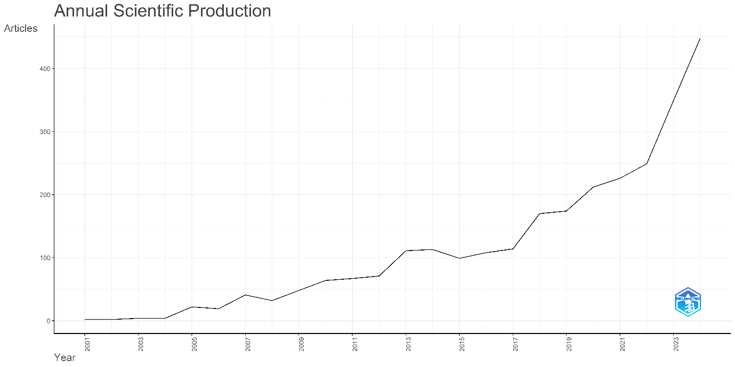
Fig. 2 Annual scientific production (all figures in this paper, except Fig.6 has been prepared using Biblioshiny (Aria and Cuccurullo, 2017)).
3.2 Citation Impact and Scholarly Influence
Citation trends often reflect both the scientific maturity of a field and the timeliness or policy relevance of its research outputs. The early studies (2001–2004) received modest citations, with averages ranging from 8.5 to 16.0 citations per article. The period between 2005 to 2009 witnessed a substantial increase, coinciding with the global policy momentum following the 2004 Indian Ocean Tsunami and the adoption of the Hyogo Framework for Action (2005–2015). During this period, articles published in 2006 and 2007 achieved particularly high visibility, averaging 36.37 and 50.88 citations per article, respectively, among the highest in the dataset. The citation averages remained relatively stable during 2010 to 2016, fluctuating between 27 and 30 citations per article, suggesting a phase of consolidation and steady academic engagement with EWS-related themes. Notably, studies from 2013 (28.95) and 2014 (27.45) continued to receive sustained attention, likely due to their focus on technological innovation and risk communication strategies that aligned with global disaster resilience frameworks. A gradual decline in mean citations is observed from 2018 onward, dropping from 20.08 in 2018 to 4.10 in 2024. The citation trajectory suggests that while early foundational studies in the 2000s achieved enduring academic influence, the recent decade (2015–2024) represents a period of dynamic growth and diversification, with emerging themes expected to shape future citations and research impact.
3.3 Most Relevant Sources
The distribution of publications across sources indicates a concentration of scholarly output in specialised journals that focus on natural hazards, risk reduction, and geoscientific applications. Among all sources, the journal Natural Hazards emerges as the most prolific contributor, publishing 102 articles. This underscores its long-standing prominence as a platform for research on hazard assessment, risk mitigation, and early warning technologies. The International Journal of Disaster Risk Reduction ranks second, contributing 70 articles, reflecting its critical role in promoting interdisciplinary research that integrates policy, preparedness, and resilience frameworks particularly relevant in the post-Sendai Framework era.
The IOP Conference Series: Earth and Environmental Science occupy the third position with 64 publications, highlighting the increasing participation of conference proceedings as venues for disseminating applied, technology-oriented EWS research. Similarly, Natural Hazards and Earth System Sciences and Landslides follow with 58 and 46 publications, respectively, emphasizing the geophysical and slope-related disaster dimensions of early warning research. Journals such as the Journal of Natural Disasters (45 articles) and Water (Switzerland) (45 articles) demonstrate the field’s diversification, particularly in hydrological and flood-based early warning systems. Other sources, including AIP Conference Proceedings (28 articles), Water (25 articles), and Frontiers in Earth Science (24 articles), further illustrate the interdisciplinary and globally distributed nature of EWS research.
The publication landscape shows that the research on Early Warning Systems is largely concentrated in disaster-specific and environmental science journals, reflecting both the technical and applied dimensions of the field. The growing inclusion of open-access and multidisciplinary journals such as Frontiers in Earth Science and Water (Switzerland) also points to an increasing trend toward open dissemination and cross-disciplinary integration in recent years.
3.4 Core Sources by Bradford’s Law
Bradford’s Law applied in the study, a relatively small set of core journals contributes a disproportionately large share of the total publications, followed by a broader set of sources with progressively fewer articles. The core zone includes a handful of highly productive journals such as Natural Hazards, International Journal of Disaster Risk Reduction, IOP Conference Series: Earth and Environmental Science, Natural Hazards and Earth System Sciences, and Landslides (Fig.3). These journals form the “nucleus” of publication activity, together accounting for the largest concentration of research outputs on Early Warning Systems
The steep slope in the initial segment of the curve reflects the dominance of a few specialised journals, while the gradual flattening toward the tail indicates a long distribution of peripheral sources that occasionally publish related articles. This pattern confirms that research on EWS, though expanding in scope, remains anchored within a concentrated cluster of high-impact, disaster-oriented journals. The presence of conference proceedings such as AIP Conference Proceedings and IOP Conference Series: Earth and Environmental Science within the core zone also signifies a growing emphasis on technological and applied research dissemination. The Bradford distribution underscores that EWS research exhibits a semi-concentrated publication pattern, where a few journals serve as key hubs for global knowledge exchange, while many others contribute at lower but consistent frequencies (Bradford, S. C., 1934).
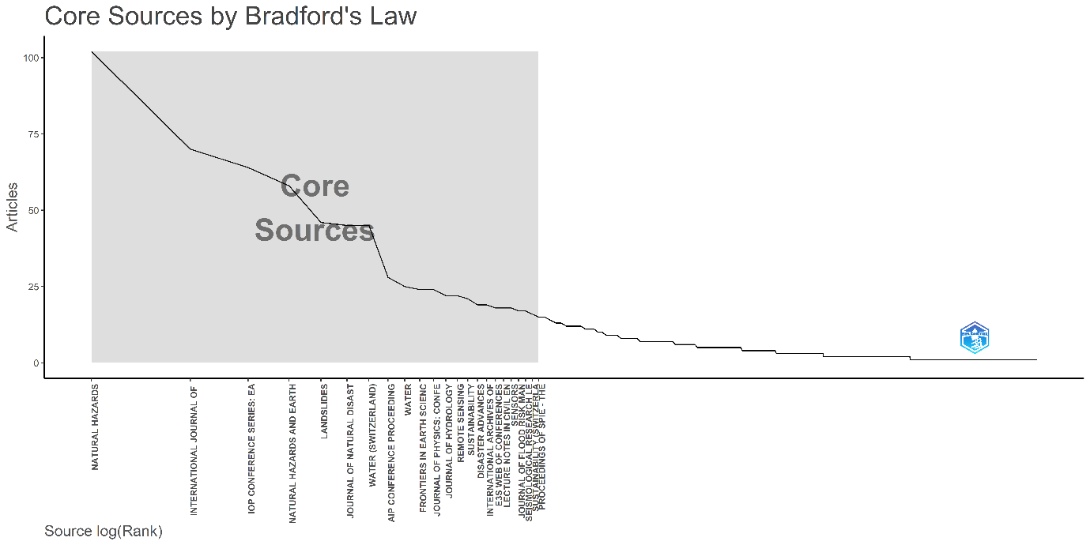
Fig 3. Core Sources Identified by Bradford’s Law for Publications on Early Warning Systems . The shaded region highlights the “core zone” of journals contributing the majority of publications in the dataset.
3.4.1 Sources’ Local Impact
The local source impact highlights the journals that have contributed most significantly to advancing research on Early Warning Systems (EWS), as reflected by their h-index, total citations (TC), and publication history (PY_start). Among these, the journal Natural Hazards ranks as the most influential source, with an h-index of 31 and 3,021 citations since 2001, underscoring its long-standing role in publishing foundational studies on disaster risk reduction, hazard modelling, and warning technologies. Natural Hazards and Earth System Sciences follows with an h-index of 27 and 1,925 citations, indicating its prominence in disseminating research on multi-hazard systems and earth science-based early warning approaches.
The journal Landslides (h-index 25, TC = 2,817) demonstrates substantial influence, reflecting the critical role of landslide-related research within the broader EWS framework, particularly in regions prone to slope instability. Similarly, the International Journal of Disaster Risk Reduction (h-index 24, TC = 1,653) has emerged as a key platform since 2013, contributing significantly to the policy and governance dimensions of early warning and disaster preparedness. The IOP Conference Series: Earth and Environmental Science (h-index 24, TC = 2,689) also shows strong local impact, serving as a hub for the dissemination of applied and conference-driven research related to geohazards and environmental monitoring.
Newer multidisciplinary journals such as Water (Switzerland) (h-index 20, TC = 1,044), Journal of Hydrology (h-index 15, TC = 1,258), and Remote Sensing (h-index 14, TC = 495) highlight the growing integration of hydrological, climatic, and remote sensing methodologies into EWS research. Likewise, Sensors (h-index 12, TC = 519) reflects the recent technological focus on sensor networks and real-time hazard detection systems, while Coastal Engineering (h-index 11, TC = 527) represents a specialised but influential domain addressing coastal and tsunami early warning applications.
This pattern underscores the interdisciplinary nature and growing technological orientation of EWS research, spanning from traditional hazard analysis to data-driven and sensor-based early warning systems.
3.5 Most Relevant Authors
The author productivity analysis highlights the key contributors to global research on Early Warning Systems (EWS) within the disaster management domain. Among all contributors, Liu Y emerges as the most productive author, with 42 publications and a fractionalized contribution of 8.47. This indicates a consistent and significant involvement in EWS-related research, likely across multiple collaborative projects. Following closely, Li Y (40 publications; fractionalized 8.15) and Wang Y (36 publications; fractionalized 8.09) represent other highly active scholars in the field.
The predominance of authors such as Li J (34 publications), Wang J (33 publications), and Wang H (31 publications) underscores the strong research footprint from East Asian institutions, particularly China a trend consistent with recent global bibliometric patterns in disaster management and climate adaptation studies. This regional prominence may be attributed to China’s extensive national initiatives in multi-hazard early warning systems and climate resilience frameworks.
Authors including Wang L, Zhang Y, Wang X, and Li H each contributed between 26 and 31 articles, demonstrating a dense collaborative network among research teams focusing on technological, hydrometeorological, and risk-based components of EWS development. The author distribution suggests a high degree of concentration among a limited number of prolific contributors, which aligns with Lotka’s Law indicating that a small proportion of authors produce a disproportionately large share of the literature.
3.6 Author Productivity and Lotka’s Law
Lotka’s Law was applied to the bibliometric dataset (Fig.4), which postulates that the number of authors making n contributions is about 1/n² of those making a single contribution, implying that a small number of authors are responsible for a large share of publications, while the majority contribute only once or twice (Lotka, 1926). As shown in Fig.4, the productivity curve reveals a steep decline in author frequency with increasing publication count. Approximately 80% of the authors contributed only one or two papers, whereas a very small fraction (<5%) produced more than ten publications. This pattern closely aligns with Lotka’s theoretical distribution, indicating a highly skewed authorship pattern typical of specialised and maturing scientific domains.
The fit between observed and theoretical distributions confirms that author productivity within this domain adheres to Lotka’s inverse-square law, signifying a mature yet hierarchically structured research ecosystem. The author productivity analysis indicates a consolidated research network, characterised by a small nucleus of prolific researchers and a large supporting base of contributors. This reflects the evolving interdisciplinary nature of EWS research, which increasingly integrates expertise from geography, climatology, remote sensing, computer science, and risk governance.
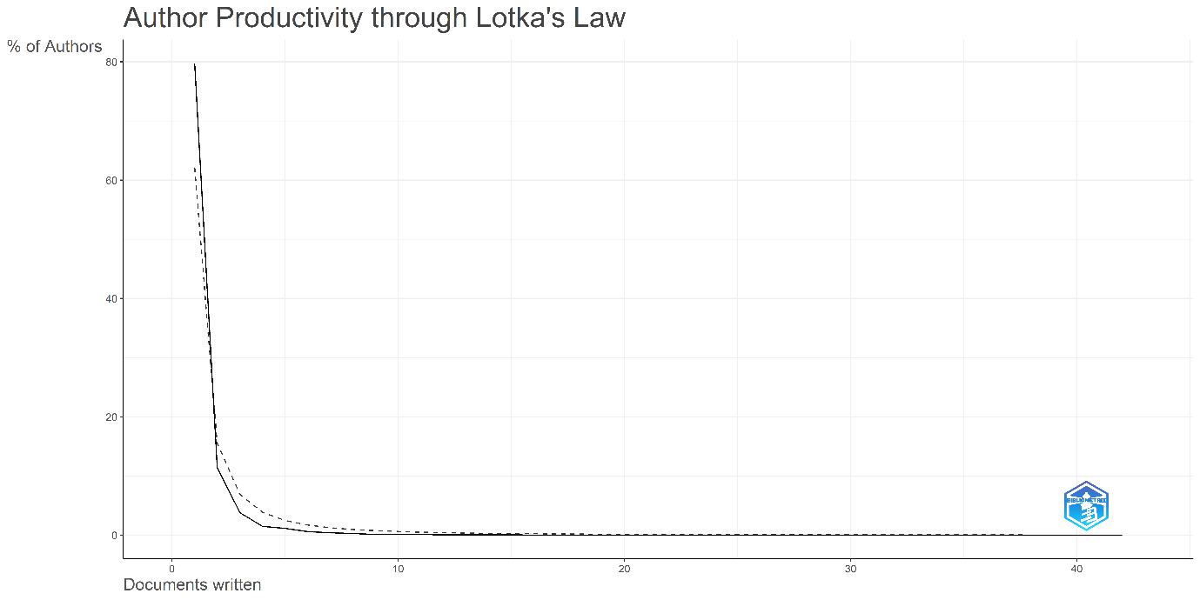
Fig.4. Author Productivity Distribution Following Lotka’s Law (2001–2024).
3.7 Most Relevant Affiliations
A clear dominance of Asian research institutions, particularly from China, Indonesia, Taiwan, and India, reflecting the geographic regions most vulnerable to natural and hydrometeorological disasters. The Chinese Academy of Sciences ranks as the most productive institution, contributing 87 publications, demonstrating its pivotal role in advancing research on multi-hazard early warning systems, climate risk assessment, and geospatial analytics. Following closely, the China University of Geosciences accounts for 70 publications, reinforcing China’s leading position in disaster risk science and technological applications for hazard monitoring.
Southeast Asia also shows substantial institutional representation, led by Universitas Gadjah Mada (55 articles) and Institut Teknologi Bandung (39 articles) in Indonesia. These universities have been instrumental in developing community-based early warning models and regional flood and landslide warning frameworks, reflecting strong national research programs aligned with disaster risk reduction priorities in the ASEAN region. Other major contributors include China University of Mining and Technology (44 publications) and National Taiwan University (44 publications), both known for their integration of engineering, geoscience, and remote sensing technologies into EWS design and implementation. The Chengdu University of Technology (39 articles) and Universitas Syiah Kuala (36 articles) also demonstrate growing engagement in hazard monitoring and post-disaster recovery research.
India’s presence is represented by the Indian Institute of Technology Roorkee (IIT Roorkee), with 30 publications, emphasizing its contributions to hydrological early warning systems, flood modelling, and disaster preparedness frameworks within South Asia. The small portion of publications categorized as “Not Reported” (25 articles) likely reflects incomplete metadata within certain indexed records. The institutional distribution reveals a strong regional concentration of expertise within Asia, consistent with the high exposure of these regions to multi-hazard risks. The prominence of Asian institutions underscores the growing leadership of Global South research networks in addressing early warning and disaster resilience challenges bridging technological innovation with community-based adaptation and policy relevance.
3.8 Countries’ Scientific Production
Global scientific production related to EWS reveals striking geographical disparities driven by national research priorities, funding capacities, and hazard exposure. China leads with a total of 1,081 publications, reflecting long-term investment in disaster risk reduction, multi-hazard monitoring, and geospatial technology integration. A strong institutional network, with the Chinese Academy of Sciences at the forefront, allows for large-scale output; however, the majority of single-country publications indicate limited international collaboration and a mostly domestic focus of research. The United States comes second with 333 publications, typified by technological innovation and interdisciplinary approaches that combine climate science, data analytics, and remote sensing. Its research has shown high collaboration and citation impact. India follows with 280 publications, and Indonesia with 266, with a general interest in floods and landslides in relation to community-based EWS that parallel national disaster management frameworks such as the NDMP of India, 2016, and Indonesia's BNPB initiatives. Italy (186), Germany (134), and the United Kingdom (160) hold their lead in research quality and international collaboration, particularly in the fields of flood, landslide, and multi-hazard risk assessment. The Netherlands is noted for its specialization in flood management and active delta resilience, while Japan has a lead in earthquake and tsunami early warning research and Australia leads in bushfires.
EWS research has assumed a dual nature: while Asia dominates in volume, with China, India, and Indonesia acting as regional leaders, international collaboration and high-impact studies are driven by Western nations, particularly the USA, UK, Germany, and Italy. This reflects the country’s technological strengths with contextual expertise from hazard-prone regions of the developing world.
3.8.1 Most Cited Countries
The​‍​‌‍​‍‌​‍​‌‍​‍‌ evaluation of the citation performance of the Early Warning System (EWS) research is based on the analysis of the scientific impact and the visibility of the different countries that contributed to the research. While the volume of publications is a reflection of the productivity of research, citation metrics are an indicator of the influence that the studies have had on the global scholarship and disaster policy frameworks. In fact, there are considerable differences between the countries that are leading in the number of publications and those that have the highest rates of citations. China is the country that has the highest number of citations, i.e. 9,984 and its average number of citations per article is 13.7. However, a good part of China's research is geared towards local applications and, therefore, Chen's work has a relatively low international visibility. Meanwhile, countries such as Italy, with a total of 4,984 citations and an average of 41.9 citations per article, can boast of significant world influence, the hallmark of which is the scientific soundness in the hydrological and geotechnical studies. The USA is also a country that is strongly cited and can be described as a leader in climate-driven applications and technological innovation, as it has a total of 4,956 citations and an average of 38.4 per article. Australia is the country that has the most expertise in bushfire and flood systems, as it has attained 3,370 citations; on the other hand, Canada has an impressive average of 41.2 citations, although it has fewer publications. Countries from the Europe and Asia-Pacific region are, for instance, Germany, Japan, and the UK, can be reliable sources of technology and cooperation as they have solid citation rates. However, India, with the publication output of 9.9 and citations per article of 5.0 and Indonesia, respectively, have not been able to attain higher citation averages, which indicates that they are still facing challenges in research recognition at the global level. The scene reveals a dyadic situation of the kind that the case of China can be, i.e. the country puts more emphasis on the quantity of work, whereas Italy, the USA, Australia, and Canada are intellectual leaders in the interaction between scientific productivity and visibility in EWS research through high citation and collaborative ​‍​‌‍​‍‌​‍​‌‍​‍‌research.

3.9 Most Global Cited Documents
An examination of the most cited publications in Early Warning System (EWS) research highlights a group of highly influential studies that have significantly shaped the field’s theoretical, methodological, and technological development. The most cited paper, Amani et al. (2020), published in the IEEE Journal of Selected Topics in Applied Earth Observations and Remote Sensing, received 640 citations and focuses on the application of remote sensing and machine learning techniques for hazard monitoring, underscoring the increasing integration of artificial intelligence in disaster management research. Wilhite (2007), published in Water Resources Management and cited 607 times, presents foundational insights into drought management and risk mitigation frameworks, making it a cornerstone reference for climate-related early warning research.
Segoni et al. (2018) in Landslides (462 citations) advanced the understanding of landslide early warning systems through geotechnical modeling, while Kryvasheyeu et al. (2016) in Science Advances (444 citations) demonstrated the use of social media data for real-time disaster response—illustrating the growing interdisciplinarity of EWS research. Similarly, Borga et al. (2014) in the Journal of Hydrology (354 citations) and Najafi et al. (2013) in Transportation Research Part E (351 citations) contributed to hydrological forecasting and logistic resilience modeling, respectively, expanding the practical scope of early warning research.
McNally et al. (2017) in Scientific Data (348 citations) emphasized open-access environmental datasets for drought monitoring, while Pendergrass et al. (2020) in Nature Climate Change (345 citations) linked EWS development to climate change adaptation strategies. Foundational conceptual works by Basher (2006) in Philosophical Transactions of the Royal Society A (297 citations) and Thieken et al. (2007) in Hydrological Sciences Journal (292 citations) provided early frameworks for multi-hazard risk assessment and flood risk communication.
These highly cited papers collectively demonstrate the evolution from traditional hazard-specific systems to data-driven, AI-enhanced, and community-centred early warning frameworks, reflecting the interdisciplinary maturity of EWS research over the past two decades.
3.10 Keyword Co-occurrence and Conceptual Structure
The evaluation of author and index keywords provides a detailed understanding of the conceptual landscape and thematic evolution within Early Warning System (EWS) research. The frequency of keyword occurrences reflects the dominant research priorities, evolving themes, and methodological approaches that define the field. The keyword “early warning system” appears 1,270 times, establishing it as the undisputed central theme and intellectual core of the research field. This prevalence confirms that the literature is heavily centred on the development, optimisation, and integration of multi-hazard early warning mechanisms across diverse geographical and hazard contexts. The related term “early warning”, which occurs 328 times, reinforces the emphasis on system components and operational frameworks, indicating that a considerable portion of studies address the design, functionality, and performance evaluation of early warning infrastructures.

Fig. 5 Thematic concentration of the literature and the interconnections between hazard-specific studies, risk reduction strategies, and technological innovations
After​‍​‌‍​‍‌​‍​‌‍​‍‌ the keyword “disaster”, which was used 594 times, the words “disaster management” appear prominently in the text with 386 references. The two concepts that have been merged establish a strong disciplinary link between early warning research and the broader field of disaster risk reduction (DRR). The frequent co-occurrence of these terms signifies that early warning systems are increasingly conceptualised not merely as technological tools but as integral components of holistic disaster management frameworks that encompass preparedness, response, and resilience-building. Also, “disaster prevention” with 305 mentions is a clear sign that the research conducted is in line with the latest worldwide frameworks of DRR, such as the Sendai Framework for Disaster Risk Reduction (2015–2030), which advocates for the implementation of risk-informed and anticipatory actions.
Moreover, the presence of hazard-specific keywords at the top of the list is indicative of the field's practical and applied orientation. Among various specific hazard types, the words “floods” (340 occurrences) and “landslide/landslides” (273 and 269 occurrences, respectively) are leading the way, thereby implicitly pointing out that a significant part of the research has been conducted in the area of hydrometeorological and geophysical disaster risks. Due to the high frequency of these disasters, their destructive power, and the possibility of their early detection by means of geospatial and sensor-based technology, they have become the subject of intensive research. The frequent use of the term “risk assessment” (311 occurrences) shows that concerted efforts are underway to combine the use of quantitative risk modelling and vulnerability assessment in the development of early warning systems; hence, an integrated approach to hazard monitoring and decision support is embraced.
The word “China” is the most geographically indicative term with 216 appearances, and it implies the country's significant influence not only as a place for conducting research but also as a contributor to global EWS literature. The statement goes in line with China being in the lead in terms of publication output and the country's growing commitment to the development of early warning technologies and disaster risk governance. From the perspective of the keyword analysis, it seems that research on EWS is primarily centred on risk assessment, hazard-specific warning systems, and integrated disaster management approaches. The major thematic focus moves the discussion away from the use of single-event-based models for warning towards the employment of multi-hazard, community-centred, and data-driven early warning frameworks. The implication of this using-the-field-concepts change is the growing maturity of the discipline, where the significance of early warning systems extends beyond technical solutions to their role as indispensable elements of a comprehensive, resilience-oriented disaster risk governance ​‍​‌‍​‍‌​‍​‌‍​‍‌paradigm.
3.11 Trend Topics
The​‍​‌‍​‍‌​‍​‌‍​‍‌ temporal analysis of research topics within the Early Warning Systems (EWS) domain from 2001 to 2024 uncovers changes in the primary focus of EWS scholarship over time. The later phases display topics of EWS research that also reflect technological advancements and the influence of the disaster risk reduction (DRR) community's priorities worldwide. In the interval between 2007 and 2015, leading-edge topics such as "disasters," "disaster management," "risk assessment," and "early warning systems" formed a core conceptual network that corresponded with the position of global initiatives like the Hyogo Framework for Action in enhancing early warning capacities for disaster preparedness. Consequently, this period characterised studies with a strong regional focus that raised the record level of scientific knowledge concerning hazard mapping and institutional preparedness in Central Europe and Asia. The years 2016-2020 were marked by a dramatic expansion of topics influenced by the Sendai Framework for Disaster Risk Reduction and the Sustainable Development Goals, especially SDG 13: Climate Action. Keywords such as "early warning" and "disaster management" notably increased in research publications in that period, indicating the transition toward multi-hazard and community-based disaster management frameworks. The transition also emphasised EWS as a crucial element of risk-informed governance and resilience planning.
The research from the middle to the late 2010s showed that the development was especially evident in the case of "tsunamis" and the respective warning systems, which were related to the growing concern about the coastal management problems after the 2004 Indian Ocean Tsunami's tenth anniversary. The interval from 2020 to 2023 is characterised by an apparent shift to technology-focused research in EWS, with the substantial increase of the terms "machine learning," "deep learning," and "Internet of Things (IoT)" being the most notable features of this period. This suggests the development of intelligent early warning systems that extensively use artificial intelligence and big data analytics, thus moving beyond the traditional modelling approach to adaptive and predictive frameworks. Besides that, the expanding use of "GIS" points to the indispensable role of geospatial technologies in risk assessment and decision-making processes. It is also an indication that the recognition of the interdependence of long-term climate variability and short-term hazard forecasting is a must for effective disaster risk reduction.
The thematic focus has evolved from mere warning dissemination and event detection towards the production of intelligent, multi-hazard systems that can be instrumental in building adaptive and climate-resilient societies. Such a trajectory unveils the varied and ever-changing EWS topography, characterised by the interplay of data science, geospatial intelligence, and policy-driven risk ​‍​‌‍​‍‌​‍​‌‍​‍‌management.
3.12 Co-occurrence Network
The​‍​‌‍​‍‌​‍​‌‍​‍‌ co-occurrence network analysis charts the underlying intellectual and thematic structures of the worldwide research on Early Warning Systems (EWS). In the present study, keywords from titles and abstracts of the records from Scopus and Web of Science are considered as the nodes, while the edges represent the number of times that the keywords co-occurrence have been found in the same documents. The Walk trap community detection algorithm was applied to the network for the identification of dense subgraphs, which can be considered as the EWS research thematic clusters of different levels. The examination identifies the four main thematic clusters that indicate the specific aspects of the EWS research. The green cluster is largely associated with flood-related research. It includes the terms such as “floods,” “flooding,” “flash flood,” “storms,” “rain,” “flood forecasting,” and “climate change.” The coupling between climate change and flood-related words reveals that a major thematic link exists between the hydrometeorological hazards and climate variability, thus reflecting that more attention is paid to extreme precipitation events and proactive flood risk management under changing climatic conditions. Thus, this cluster points to the importance of both forecasting hydrological models and the utilization of the adaptive flood control methods.
The red cluster features landslides, hazard assessment, and risk evaluation, with the main terms such as “landslides,” “risk,” “hazard management,” and particularly “machine learning.” The inclusion of this term suggests the emergence of a research trajectory that is mainly focused on the use of computational intelligence and predictive technologies integration for slope stability and risk analysis. This thematic area indicates that the researchers are moving away from traditional deterministic models and leaning towards data-centric and probabilistic approaches for understanding landslide risks, which is in line with the rise of AI-driven methods in geohazard monitoring.
The blue cluster, returning to the themes of disaster management and the use of technology, is composed of terms like “disasters,” “disaster management,” “early warning system,” and “internet of things.” The “early warning system” being a prominent feature in this cluster, as is demonstrated by its high node degree, is therefore the intellectual center of the EWS research domain. The terms “remote sensing,” “IoT,” and “forecasting” being coupled together point to the growing utilization of sensor technologies, big data analysis, and automation in the process of early warning system development. This cluster illustrates the commingling of technological innovation with the implementation of the adaptive disaster management policies that are in line with the contemporary global disaster risk reduction (DRR) agendas.
The purple cluster is associated with seismic hazards and the early warning systems for tsunamis. It is characterised by the presence of terms such as “earthquake” and “tsunami.” The particularity of this cluster indicates that EWS is a mature research area that has been attracting attention after the major seismic events in Asia and the Pacific. This, in turn, emphasises the necessity of real-time monitoring, the very quick warning spreading, and the response actions to lessen the damage caused by seismic and tsunami incidents. The compactness of this cluster may imply that it is still a specialised one; however, its methodological advancements have had a significant impact on the general framework of the early warning research.
The top three nodes of this network that have the most connections and the greatest influence are “early warning system,” “disasters,” and “floods.” Their dominance points out a convergence of literature revolving around the topics of disaster preparedness, early warning, and risk mitigation strategies. Consequently, the co-occurrence network is a good example of a carefully planned and interconnected research system wherein the themes of specific hazards merge with the broader issues of climate change, vulnerability assessment, and the application of machine learning, thereby confirming the transition of the Early Warning Systems into a multifaceted and technologically integrated research frontier. It also reveals EWS as an interdisciplinary research field encompassing natural sciences, engineering, geoinformatics, and social sciences aimed at the improvement of the warning systems' ​‍​‌‍​‍‌​‍​‌‍​‍‌efficacy.
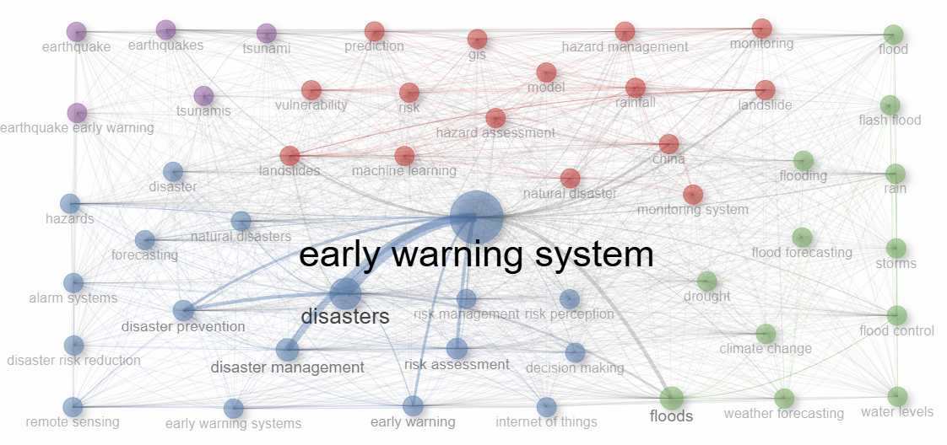
Fig.6 Co-Occurrence network
3.13 Thematic Map
The thematic map analysis provides a strategic visualization of the intellectual structure of research on Early Warning Systems (EWS) by plotting the main themes based on two key metrics: centrality and density. Centrality represents the relevance or importance of a theme within the global research network, reflecting the extent to which it interacts with other themes, while density indicates the degree of internal development or specialization of the theme. Together, these parameters allow the identification of research domains that are well-established and central, specialized but peripheral, foundational but underdeveloped, or emerging and evolving. The map is divided into four quadrants: motor themes, niche themes, basic themes, and emerging or declining themes, each representing a distinct role in the conceptual development of the field.
The motor themes, which are shown in the upper-right quadrant, are regarded as the major factors that propel the field forward. The cluster gathers the works of Mokkenstorm (2021), Zhang (2023), and Rahardjo (2023), which are very influential and concentrate on technological innovation, predictive analytics, and multi-hazard system design. Besides, the Climate Change cluster is pointed out there as well, underlining its coupling with the disaster forecasting systems with the main contributions from the Journal of Engineering and Technological Science, Water, and Atmosphere. This reflects the field's double commitment, on the one hand, to technology-driven early warning and, on the other hand, to the climate-induced hazards tackled through the integration of risk management.
The Disaster Management theme, which is next to the motor themes, is the basic themes one and is located near the border with the motor themes, indicating its fundamental nature and continuous change. The articles written by Abraham (2020), Anshori (2022), and Tang (2011) that are published in appropriate journals and have a great influence highlight the computational and hydrological methods, which aim at disaster response and mitigation; thus, they present the technical innovations and governance-oriented perspectives as two sides of the same coin.
Local themes from the lower-right quadrant, the basic themes area, consist of clusters with high centrality but lower density, such as Vulnerability and Hazard Management. The Vulnerability cluster deals with the susceptibility and resilience of communities, being backed by empirical studies of Yakubu (2020), Xu (2015), and Nahayo (2017). The Hazard Management cluster brings together research on the operational facets of early warning systems. Journal of Disaster Research-derived studies that bridge technological monitoring and institutional responses underpin this. The niche themes, which are in the upper-left quadrant, are characterised by high density and low centrality, and they are best represented by the Coal Mines and Deformation clusters. The researchers in these fields, who focus on topics such as geological and industrial risk management, are proving the maturity of their work, but they are still confined to narrower disciplinary areas.
Lastly, the lower-left quadrant covers the emerging or declining themes that have both low centrality and density. Among these, the most significant are Time-Series Analysis and Resilience, which indicate possible new areas of research. The works on Time-Series Analysis show the developments in the prediction of temporal hazards, whereas the Resilience cluster points to the adoption of management methods that are based on the system's ability to adjust to changes, and recent articles published in leading journals support this notion. Besides, there are other clusters like Volcanic Eruption, Model, and Machine Learning that also position themselves in this area, with time-series analysis and machine learning being likely future integration as methodologies evolve.
Firstly, these thematic clusters represent the complicated and changing nature of EWS research. This reveals a landscape that is able to maintain a balance between consolidated themes and invested investigations as well as methodological advances. In addition, the thematic map serves as an instrument for the comprehensive appraisal of the intellectual landscape of Early Warning System research. The obtained results showcase that the implementation of early warning systems, management of disasters, and climate change are the main themes that boosts the field, while the vulnerability and hazard management themes serve as the base supporting the further development of the research. On the other hand, the specialised topics, e.g., coal mines and deformation, are indicative of the depth and expertise within the field, while concepts like machine learning and resilience represent the innovative breakthroughs that potentially lead to the subsequent phase of evolution. Lastly, these ideas collectively demonstrate that research into EWS is a complicated and layered field that is continually evolving, and it can strike a balance between the technologically and policy-wise validated sub-themes and the rapidly developing data-driven innovations that are a result of the increasing interconnection between disaster science, climate adaptation, and computational ​‍​‌‍​‍‌​‍​‌‍​‍‌intelligence.
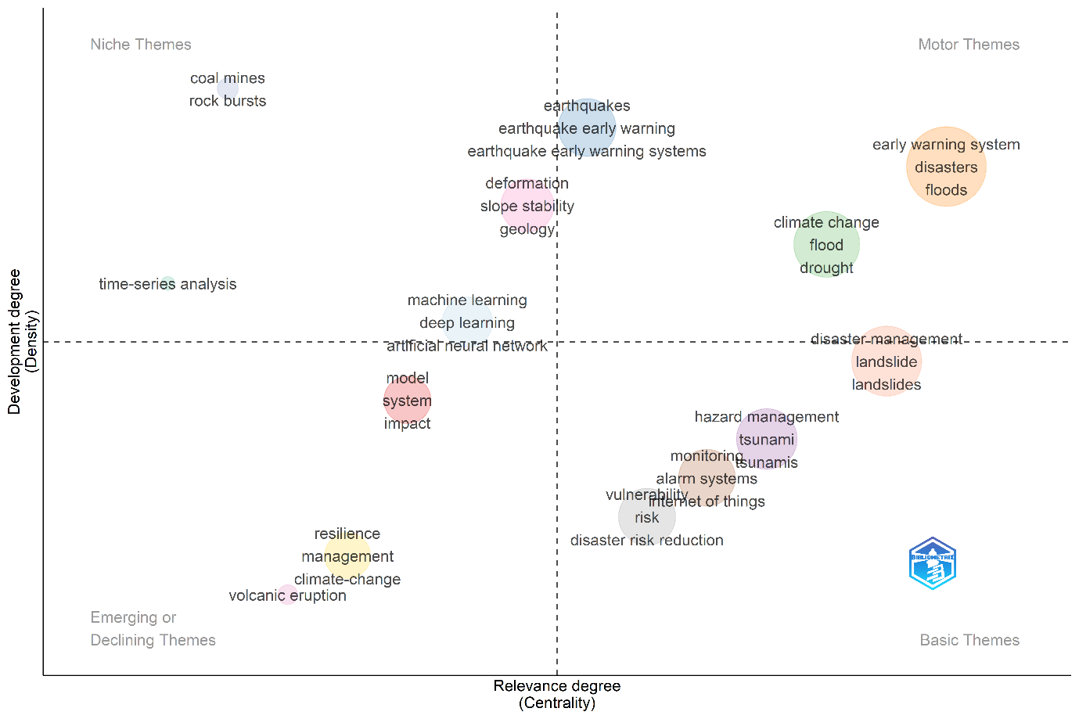
Fig.7: Strategic visualisation of the intellectual structure of research on Early Warning Systems (EWS) by plotting the main themes based on two key metrics: centrality and density
3.14 Thematic Evolution and Temporal Shifts in Research Focus
The keyword field (KW_Merged) captures single-word terms (Ngrams = 1) without stemming, meaning that similar terms such as “early warning” and “early warnings” are treated as distinct entities. While this enhances granularity, it can slightly affect cluster density and coherence
The Sankey diagram effectively captures the temporal progression of research topics across three distinct phases: 2001–2009, 2010–2019, and 2020–2024. During the first phase (2001–2009), research was characterised by a broad and foundational focus. The dominant motor themes “disasters” and “disaster prevention” reflect a period when the scientific community concentrated on developing general frameworks for disaster mitigation, influenced by global events such as the adoption of the Hyogo Framework for Action (2005–2015). At this stage, niche themes such as “aerial photography,” “South America,” and “object extraction” suggest the use of early geospatial and remote sensing methods for hazard analysis, while foundational but less developed areas like “alarm systems” and “risk modelling” occupied the basic theme quadrant.
The​‍​‌‍​‍‌​‍​‌‍​‍‌ second phase (2010-2019) represents a major shift of research focus to system based and technology-oriented areas. The emphasis of the research moves strongly to "early warning system," "disasters," "floods," and "disaster management," which show that the focus of the work has shifted towards proactive preparedness rather than reactive response. The change in focus mirrors the worldwide attention to multi-hazard early warning system initiatives, the use of remote sensing technologies, and the compatibility of international frameworks such as the Sendai Framework for Disaster Risk Reduction (2015-2030) with the local disaster management systems. The basic topics like "monitoring," "landslide," "tsunami," "rain," and "earthquake" found in this decade denote the deepening of hazard-specific studies that are supported by quantitative risk modelling. The identification of "crisis management" as a niche theme and the references to "Java" and the "Greater Sunda Islands" as the local areas suggest that the research is getting more regionalised, especially in Southeast Asia, which is a region highly exposed to disasters. The topics that were once new and now are declining such as "risk," "model," and "vulnerability," started to move towards more significant conceptual integration, thus creating a space for the research maturity of risk-based early warning in the following period.
The last phase (2020–2024) unveils a far-reaching thematic change and a variety of themes, which is mostly attributed to the progress made in the fields of data science, artificial intelligence, and climate research. The motor themes "climate change," "disasters," "early warning system," "earthquake early warning," "disaster management," and "drought" represent the harmonisation of climate adaptation, technological innovation, and multi-hazard management. The fact that "climate change" and "adaptation" are the main themes is indicative of a paradigm change from mere hazard monitoring to integrated climate-resilient early warning systems. The term "earthquake early warning" is there to show that the technological innovations for real-time seismic monitoring and the automated response system are still ongoing. The basic themes, such as "earthquake events" and "landslides", continue to be pivotal while now having stronger connections with machine learning and geological modelling, which serves as evidence of the methodological advancement being an ongoing process. Niche themes such as "geology" and "geological analysis" point to further specialisation, while emerging topics like "adaptive capacity" and "resilience" show that the research community is opening up to social and ecological aspects in what used to be purely technical disaster research. The topics that were prominent in the past and have been fading gradually over the years, among them "aerial photography," "agricultural drought," and "decision support systems," are now absorbed by broader data-driven frameworks that are characterised by an emphasis on automation, interoperability, and predictive analytics.
Several themes across all times have been continuous and conceptually stable, especially "early warning systems," "disasters," "earthquakes," and "vulnerability." These concepts that have been around for decades are the pillars that form the core intellectual structure of the field. Nonetheless, their changing relationships signify that the field has been progressively refined, e.g. "vulnerability" has evolved from general exposure analysis to the incorporation of adaptive capacity and resilience studies, whereas "early warning systems" have broadened from being mere technological constructs to multi-sectoral frameworks involving social, environmental, and governance components.
The strategic maps corresponding to different periods depict this temporal change as well. It could be observed from the first period (2001–2009) that the themes of high-centrality but low-density like "disaster prevention" and "alarm systems", were prevailing, indicating the establishment of the concepts that were interconnected but not yet fully developed. In the middle period (2010–2019), these had turned into denser and more cohesive clusters such as "early warning systems," "disaster management," and "floods," which is indicative of a more mature and integrated research structure. The present period (2020-2024) sees the words "climate change," "adaptation," "resilience," and "machine learning" coming into the motor themes quadrant (upper-right), which reveals that EWS research is now characterised by strong interdisciplinary integration, thus combining environmental sciences, data analytics, and risk ​‍​‌‍​‍‌​‍​‌‍​‍‌governance. The thematic evolution analysis reveals a clear conceptual trajectory in Early Warning System research from broad disaster prevention studies to highly specialised, technologically advanced, and climate-responsive frameworks.
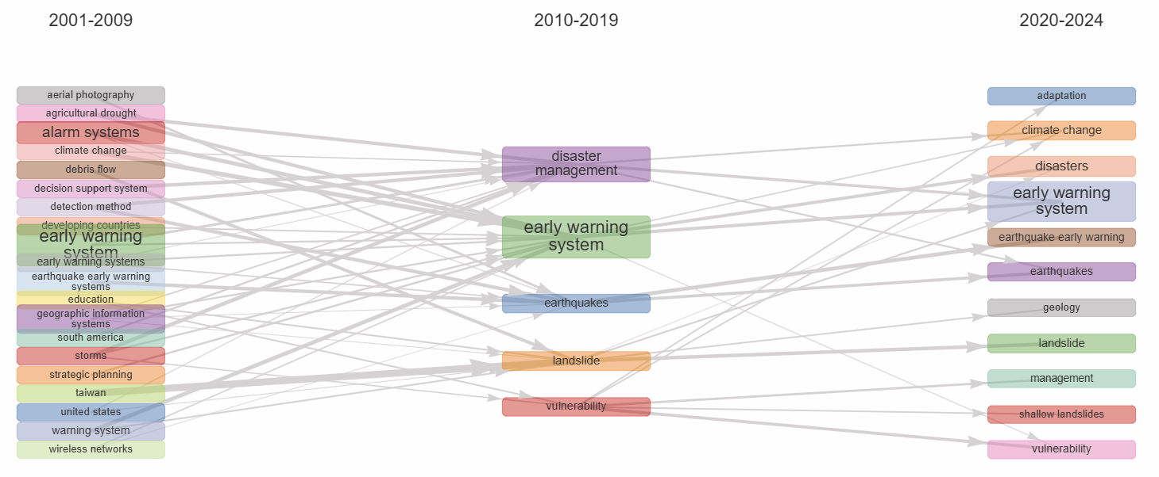
Fig.8 The thematic evolution analysis provides a longitudinal view of research themes in Early Warning Systems (EWS) have evolved over time
3.15 Factorial Analysis of Keyword Associations
The factorial analysis, performed using Multiple Correspondence Analysis (MCA) on the merged keyword dataset, provides a detailed visualisation of the conceptual relationships among dominant research themes in Early Warning System (EWS) literature. MCA is particularly suited for examining categorical variables such as keywords, as it identifies latent dimensions that explain how themes co-occur and diverge within the research field. In this analysis, Dimension 1 explains 42.23% of the total variance, while Dimension 2 accounts for 18.13%, together capturing more than half of the structural variability in the dataset. This indicates that Dimension 1 represents the principal axis of differentiation among major research directions, while Dimension 2 adds further nuance to the conceptual structure.
The MCA biplot reveals five major thematic clusters, each corresponding to a distinct body of research within the EWS domain. The earthquake/tsunami cluster, positioned toward the bottom left of the plot, includes keywords such as “earthquake,” “earthquake early warning,” “earthquakes,” and “tsunamis.” This grouping represents a well-defined subfield focusing on seismic hazard prediction and tsunami early warning systems. Its position on the negative end of both axes suggests a degree of thematic separation from broader disaster management studies, reflecting the specialised and technically oriented nature of seismic research. Adjacent to this lies the landslide/hazard management cluster, incorporating terms like “landslide,” “hazard assessment,” “hazard management,” “risk,” “model,” and “disaster risk reduction.” This cluster reflects integrated research that bridges geophysical hazard assessment with risk mitigation and modelling strategies, highlighting how landslide studies increasingly engage with quantitative modelling and decision-support systems.
At the centre of the factorial map, a general disaster and risk management cluster forms the conceptual core of the field. It includes high-frequency and cross-cutting terms such as “disasters,” “natural disasters,” “hazards,” “monitoring,” “remote sensing,” “risk assessment,” “risk management,” and “early warning system.” The proximity of these terms indicates their role as connecting concepts that unify hazard-specific research with overarching frameworks of disaster governance and technological monitoring. This cluster demonstrates the interdisciplinary nature of EWS research, blending engineering, environmental science, geoinformatics, and social risk management perspectives.
Toward the top-right quadrant, a distinct flood-related cluster emerges, characterised by keywords such as “flood,” “floods,” “flood forecasting,” “flooding,” “water levels,” “rain,” and “rainfall.” This cluster emphasises hydrometeorological hazards and the development of predictive and operational models for flood management. Its strong internal cohesion and position along the positive side of Dimension 1 suggest that flood research forms a highly developed yet thematically separate strand within the EWS literature. Closely connected to this group is a smaller forecasting cluster, comprising keywords such as “forecasting” and “weather forecasting control.” This indicates an additional area of specialisation focused on predictive analytics, early alerts, and control systems applied to disaster monitoring.
Interpretation of the factorial dimensions offers further insights into the semantic organisation of the research field. Dimension 1 (42.23%) differentiates primarily between specific hazard-based research on the left (e.g., earthquakes, landslides) and hydrometeorological and management-oriented studies on the right (e.g., flood forecasting, disaster management, risk control). This suggests that the primary axis captures the division between geophysical and meteorological disaster paradigms. Dimension 2 (18.13%) differentiates vertically between preventive approaches (such as hazard management and flood forecasting) at the top and reactive strategies (such as earthquakes and disaster response) at the bottom. The positioning of terms like “flood forecasting” and “earthquake” at the extreme ends of the axes indicates that these concepts are key definers of thematic boundaries, while more generic terms such as “early warning system” and “risk management” occupy central positions, symbolising their integrative role in connecting diverse research streams.
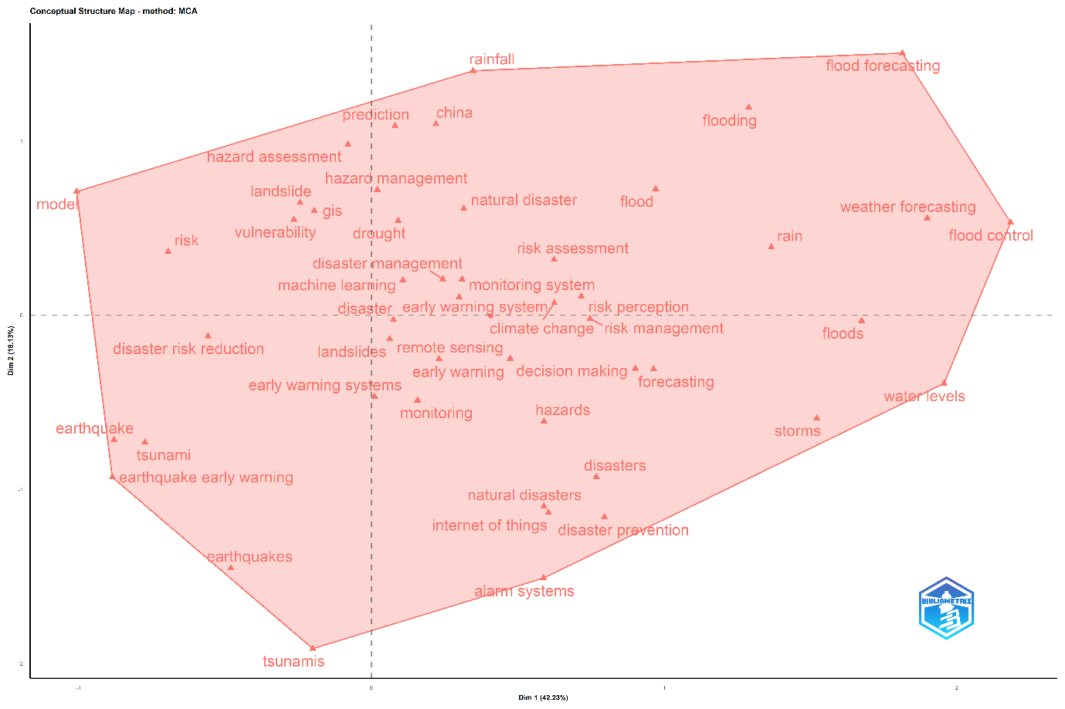
Fig.9 The factorial analysis, performed using Multiple Correspondence Analysis (MCA)
By​‍​‌‍​‍‌​‍​‌‍​‍‌ using a factorial structure, the research landscape that is thematically diverse but conceptually cohesive has been revealed. The clearly defined separation between the earthquake/tsunami and flood-related clusters indicates that these hazards are being studied separately most of the time. This is because they have different data requirements, spatial scales, and modelling approaches. It makes one wonder whether a wider methodological cross-fertilisation could be of help in the field, especially in the transfer of forecasting techniques and sensor technologies from one hazard type to another. The dominance of clusters focused on risk assessment and risk management indicates that governance and mitigation frameworks are at the core of disaster research, which is confirmed by the centrality of these clusters. Also, the appearance of forecasting and modelling clusters is a sign of the growing impact of data analytics and computational techniques.
The location of the keyword 'China' near the terms of hazard management and flood in this factorial space is quite surprising. This location indicates that not only is the geographical concentration of EWS research in China, but also that the country is putting a lot of emphasis on hydrological and flood early warning systems. To sum up, one should not forget that due to dataset merging, the lack of cited reference linkages may hide the deeper bibliographic relationships between authors or institutions; nevertheless, the MCA is still a strong indication of semantic linkages and thematic differentiation in the field.
The factorial analysis reveals that research on Early Warning Systems is organised in such a way that it revolves around a combination of specialised knowledge of hazards and general frameworks of disaster management, which are brought together by the central idea of risk-informed early warning. The physical distance between clusters is indicative of both the thematic maturity and methodological specialisation of the field. It also shows how the field is able to integrate the geophysical, hydrological, and managerial aspects of single interdisciplinary research ​‍​‌‍​‍‌​‍​‌‍​‍‌ecosystem.

3.16 International Collaboration Network
The​‍​‌‍​‍‌​‍​‌‍​‍‌ examination of the international collaboration network for the early warning system (EWS) research identified a core–periphery structure. The core consists of countries dominating the collaboration, while the periphery includes those countries remaining marginal. China is the country that comes out on top as the most influential and interconnected node, which demonstrates its role as a global hub in disaster management and early warning studies. The extent of partnerships of China, as indicated by its high degree of centrality, is considerable and diverse. This is in line with China’s dominance in publication output and its increasing involvement in scientific diplomacy, climate resilience, and hazard monitoring. Two prominent clusters were recognised through the Walktrap algorithm. The first (blue) cluster containing China as the central point has the Asian countries like India, Korea, Japan, Indonesia, and Thailand as its members and African countries like Nigeria, Kenya, and South Africa, as well as Latin American countries such as Mexico. Besides regional hazard contexts and the Belt and Road and climate adaptation programs, this group points to South–South collaborations. The second (red) cluster is mainly composed of Europe-led countries like the UK, Germany, Spain, Italy, and Switzerland and has extensions to the Americas (Canada, Brazil, Argentina) and the Middle East (Turkey, Iran, Egypt). The close co-authorship ties between China-India, UK-Germany, Italy-Spain, and USA-Australia, which can be explained by both regional proximity and thematic collaboration, are also reflected in the network.
The peripheral countries, for example, Iraq, are narrowly connected and this weak connection is a reflection of the unbalanced participation and disparities in research infrastructural development. The overall network reveals a dual-core model with China at the forefront of collaborations across the Global South and Europe, thus playing a major role in Western partnerships. By pointing out this structure, it underlines not only the increasing democratisation of disaster research but also the growing importance of co-operation at the cross-regional level to address the common challenges of climate change, risk governance, and multi-hazard early warning systems. As the ties between Asian, African, and European networks get stronger, knowledge exchange, innovation, and policy integration in global EWS research may also be further ​‍​‌‍​‍‌​‍​‌‍​‍‌developed.
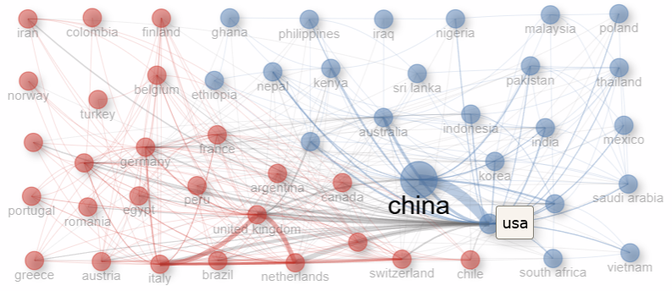

Fig.10 Representation of International Collaboration Network

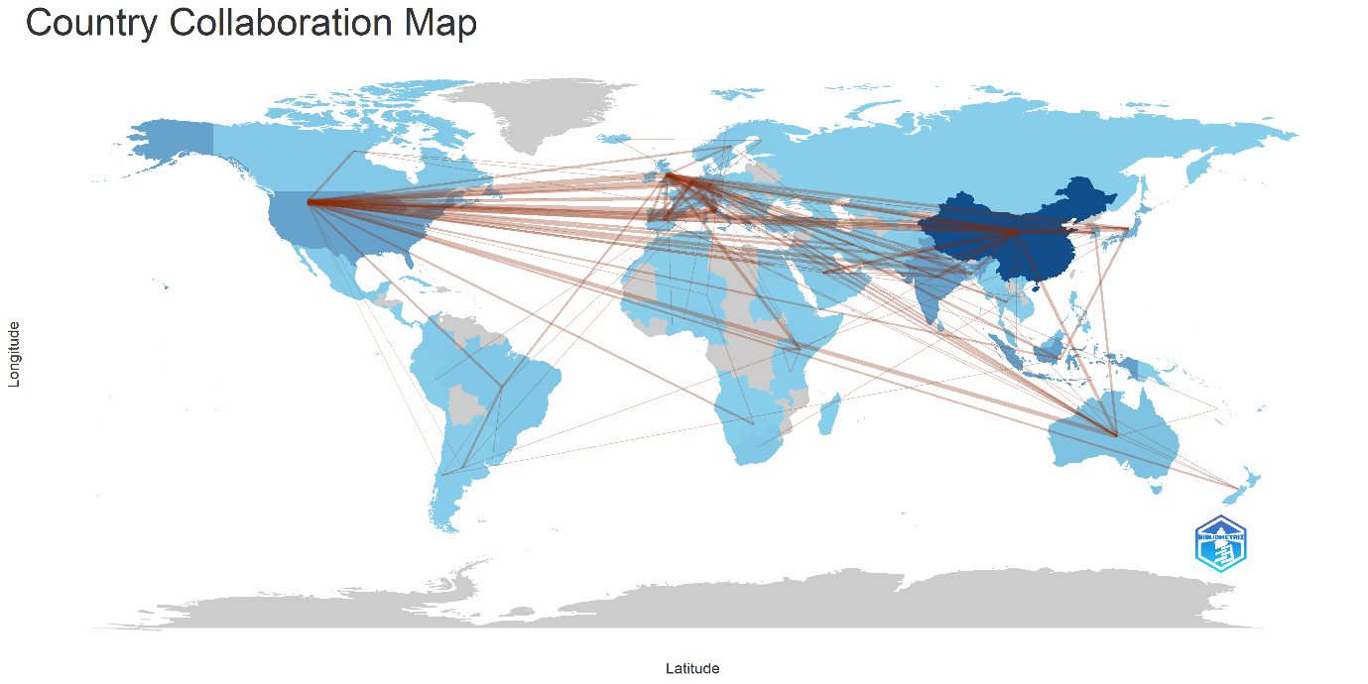
Fig.11 Country Collaboration Map
4. Conclusion
Global warming and the heightened number of extreme weather events have led to the increase in both the frequency and severity of natural disasters. Hence, saving lives and preserving the economy are the main reasons why it becomes indispensable to invest in the research of natural hazards and disaster risks. Precise hazard related information is at the core of both EWSs and good forecasting, and the latter becomes more accurate when several models are used ​‍​‌‍​‍‌​‍​‌‍​‍‌together (Chovanec, et al., 2025). The analysis of global research on EWS in disaster management highlights that EWS research has grown consistently, especially after 2015, mirroring the Sendai Framework for Disaster Risk Reduction and growing concern about climate-related disasters. The leadership of China in publication output, supported by strong institutional networks, while Italy, the United States, Australia, and Canada have the highest citation impact, supported by methodological innovations and collaboration. Upcoming contributors such as India and Indonesia reflect an emerging capacity in disaster preparedness. Core journals include Natural Hazards, the International Journal of Disaster Risk Reduction, Remote Sensing, and Sensors, reflecting the shift toward sensor-based early warning systems. Core topics identified include "early warning systems," "disaster management," and "risk assessment," while "machine learning," "deep learning," and "climate change" represent emerging areas. The changing themes signify a shift from conventional hazard research to sophisticated data analytics and climate adaptation strategies. This analysis points out the emerging dual core structure of global research on EWSs, with China becoming a hub in South-South collaboration and Europe/North America in the West. While international collaborations have increased, the unequal intensity of these activities demonstrates that further integration between developed and developing research systems could occur. It also identified that EWS research has become an interdisciplinary enterprise fusing technology, environmental science, and disaster policy into an active field. The study concludes that future research will be advanced through an increase in cross-regional collaboration, open data sharing, and AI and IoT-enabled models that incorporate social vulnerability assessments to foster adaptive, inclusive, disaster-resilient societies.
5. ACKNOWLEDGEMENTS
This study is not funded by any organisation or individual.
6. Declaration of competing interest
The authors have no relevant financial or non-financial interests to disclose.
7. AUTHORS’ CONTRIBUTIONS
Adarsh T: Conceptualization, data collection (WoS & Scopus), data cleaning, primary bibliometric analysis, visualization, interpretation of results, writing original draft. Neenu S Pillai: Methodology support, software assistance (VOSviewer/Bibliometrix), validation, writing review & editing. Suresh S: Literature support, preparation of tables and figures, proofreading, and contribution to the discussion section.Balu M: Supervision, project administration, critical revision of the manuscript, final approval. All authors read and approved the final manuscript
8. Data availability
This study is based on bibliometric data retrieved from the Scopus and Web of Science databases. Due to licensing restrictions of the databases, the full datasets cannot be shared publicly; however, processed data and analytical outputs used in the study are available from the corresponding author upon reasonable request.
9. Ai- Assistant Disclosure
No AI tool was used for data analysis, interpretation, or drawing of conclusions. All responsibility for the content rests with the authors.
10. Reference
Adarsh T., and Haneena Sulthana K.P (2025). Trends and insights in Nature-Based Solutions: A bibliometric study. Journal of Disaster Studies and Climate Resilience, 1(1):22–34. https://doi.org/10.64866/j.ijdscr.2025.10003
Albahri , A.S. , Yahya Layth Khaleel, Mustafa Abdulfattah Habeeb, Reem D Ismael, Qabas A Hameed, Muhammet Deveci, Raad Z Homod , O.S. Albahri, A.H. Alamoodi , and Laith Alzubaidi. (2024). "A systematic review of trustworthy artificial intelligence applications in natural disasters." Computers and Electrical Engineering 118 (B) https://doi.org/10.1016/j.compeleceng.2024.109409.
Agbehadji Israel Edem, Tafadzwanashe Mabhaudhi, Joel Botai, and Muthoni Masinde (2023). “A Systematic Review of Existing Early Warning Systems’ Challenges and Opportunities in Cloud Computing Early Warning Systems.” Climate 11(9). doi:10.3390/cli11090188.
Aprianti, Evi, Suharman Hamzah, Mokhamad Nur Cahyadi, Deni Kusumawardani, Nurrohmat Widjajanti, . Musdalifah, and Siti Chaerani Fatimah Apdin (2025). “The Systematic Disaster Management Approach to Assessing Early Warning Systems in South Sulawesi: A Review.” Engineering, Technology & Applied Science Research 15(4): 24305–10. doi:10.48084/etasr.9794.
Aria, M., & Cuccurullo, C. (2017). Bibliometrix: An R-tool for comprehensive science mapping analysis. Journal of Informetrics, 11(4), 959–975. https://doi.org/10.1016/j.joi.2017.08.007
Bradford, S. C. (1934). Sources of information on specific subjects. Engineering: An Illustrated Weekly Journal, 137, 85–86.
Chovanec, D, B Kollár, B Halúsková, J Kubás, M Pawęska, and J Ristvej (2025). "A Component-Based Approach to Early Warning Systems: A Theoretical Model." Applied Sciences (MDPI) 15. doi: https://doi.org/10.3390/app15063218.
Clarkson Otuogha (2024). “Disaster Risk Reduction through Early Warning Systems.” World Journal of Advanced Research and Reviews 23(3): 177–86. doi:10.30574/wjarr.2024.23.3.2521.
Collins, Matthew L., and Naim Kapucu (2008). “Early Warning Systems and Disaster Preparedness and Response in Local Government.” Disaster Prevention and Management: An International Journal 17(5): 587–600. doi:10.1108/09653560810918621.
Esposito, M., Palma, L., Belli, A., Sabbatini, L., & Pierleoni, P. (2022). Recent advances in internet of things solutions for early warning systems: A review. Sensors, 22(6), 2124.
Faiaz, Md. Abrar , and Nowshin Nawar (2025). "AI-Driven Disaster Warning System: Integrating Predictive Data with LLM for Contextualized Guideline Generation." NSysS '24: Proceedings of the 11th International Conference on Networking, Systems, and Security. 247-253. doi:https://doi.org/10.1145/3704522.3704549.
Haque, Anisul , Shampa, Marin Akter, Md. Manjurul Hussain, Md. Rayhanur Rahman, Mashfiqus Salehin, and Munsur Rahman (2024). "An integrated risk-based early warning system to increase community resilience against disaster." Progress in Disaster Science 21. doi:https://doi.org/10.1016/j.pdisas.2023.100310
Islam, Md Mujahidul, Mehedi Hasan, Md Saju Mia, Abdullah Al Masud, and Abu Reza Md Towfiqul Islam (2025). “Early Warning Systems in Climate Risk Management: Roles and Implementations in Eradicating Barriers and Overcoming Challenges.” Natural Hazards Research. doi:10.1016/j.nhres.2025.01.007.
Kelman, Ilan, and Michael H Glantz (2014). “Early Warning Systems Defined.” National Library of Medicine 27: 89–108. doi:10.1007/978-94-017-8598-35.
Khan, Saad Mazhar, Imran Shafi, Wasi Haider Butt, Isabel de la Torre Diez, Miguel Angel López Flores, Juan Castanedo Galán, and Imran Ashraf (2023). “A Systematic Review of Disaster Management Systems: Approaches, Challenges, and Future Directions.” Land 12(8). doi:10.3390/land12081514.
Khankeh, Hamid Reza , Mehdi Rahgozar , Hedayat Jafari , Vahid Delshad , and Fahimeh Ghasemi Charati (2023). "Effect of early warning system on the preparedness of hospitals in emergencies and disasters: A quasi-experimental study." Journal of Nursing Reports in Clinical Practice 1 (3). doi:https://doi.org/10.32598/JNRCP.23.39
Konečný, Milan, and Wolfgang Reinhardt (2010). “Early Warning and Disaster Management: The Importance of Geographic Information (Part A).” International Journal of Digital Earth 3(3): 217–20. doi:10.1080/17538947.2010.508884.
Lotka, A. J. (1926). The frequency distribution of scientific productivity. Journal of the Washington Academy of Sciences, 16(12), 317–323.
Mannan, Sushmita , Dewan Mohammad Enamul Haque, and Netai Chandra Dey Sarker (2021). "A study on national DRR policy in alignment with the SFDRR: Identifying the scopes of improvement for Bangladesh." Progress in Disaster Science 12. https://doi.org/10.1016/j.pdisas.2021.100206.
Motsumi, Masego M , and Livhuwani D Nemakonde (2025). "Indigenous early warning indicators for improving natural hazard predictions." JAMBA: Journal of Disaster Risk Studies (NLM) 17 (1): 1754. doi:10.4102/jamba.v17i1.1754.
Olaoye, Favour, and Axel Egon. (2024). Early Warning Systems for Natural Disasters. https://www.researchgate.net/publication/383565185.
Pescaroli, Gianluca, Sarah Dryhurst, and Georgios Marios Karagiannis (2025). "Bridging gaps in research and practice for early warning systems: new datasets for public response." Frontiers in Communication 10. https://doi.org/10.3389/fcomm.2025.1451800.
Pham, Thi Dieu My, Annegret H. Thieken, and Philip Bubeck. 2024. “Community-Based Early Warning Systems in a Changing Climate: An Empirical Evaluation from Coastal Central Vietnam.” Climate and Development 16(8): 673–84. doi:10.1080/17565529.2024.2307398.
Raphela, Tlou D., and N. Ekeke (2025). “Resilience and the Dissemination of Flood Disaster Early Warning Messages in a Township in South Africa.” Frontiers in Communication 10. doi:10.3389/fcomm.2025.1503016.
Rokhideh, Maryam, Carina Fearnley, and Mirianna Budimir (2025). “Multi-Hazard Early Warning Systems in the Sendai Framework for Disaster Risk Reduction: Achievements, Gaps, and Future Directions.” International Journal of Disaster Risk Science 16(1): 103–16. doi:10.1007/s13753-025-00622-9.
Sahana, Mehebub, Priyank Pravin Patel, Sufia Rehman, Md Hibjur Rahaman, Md Masroor, Kashif Imdad, and Haroon Sajjad (2023). “Assessing the Effectiveness of Existing Early Warning Systems and Emergency Preparedness towards Reducing Cyclone-Induced Losses in the Sundarban Biosphere Region, India.” International Journal of Disaster Risk Reduction 90. doi:10.1016/j.ijdrr.2023.103645.
Šakić Trogrlić, Robert, Marc van den Homberg, Mirianna Budimir, Colin McQuistan, Alison Sneddon, and Brian Golding (2022). “Early Warning Systems and Their Role in Disaster Risk Reduction.” In Towards the “Perfect” Weather Warning: Bridging Disciplinary Gaps through Partnership and Communication, Springer International Publishing, 11–46. doi:10.1007/978-3-030-98989-7_2.
Zaboli, Rouhollah, Zainab Malmoon, and SeyedHesam Seyedin (2013). “Early Warning System for Disasters within Health Organizations: A Mandatory System for Developing Countries.” National Library of Medicine 3(2): 261–68. doi:10.5681/hpp.2013.030.

