Analysis of Seasonal Cropping Pattern in the Charlands of Nalbari District,Assam Using Multi-temporal Satellite Imagery Data

Abstract
In the present paper, an attempt has been made to analyze seasonal changes in the cropping pattern of the Charlands of Nalbari district. Data related to crop types and cropped area for one agricultural year(2023-2024) were acquired from the satellite based cropping pattern map of three different seasons, i.e, Kharif, Rabi and Zaid seasons. Required primary data were collected through the interview method. The results of the study revealed that a wide variety of crops have been grown in the Rabi season compared to the other two seasons. It has been found that maize is the major crop for both Rabi and Zaid seasons where as jute is another one type of fiber crops which is cultivated in 60.7% area in kharif season. Again, rice or summer paddy is the second most cultivated crop during Zaid season, which occupies 46.9% of the total cropped area. Overall study highlights how farmers in Charlands have optimized land use across seasons, demonstrating high agricultural resilience and productivity under challenging ecological conditions.
Keywords: seasonal cropping pattern, Satellite data, Charlands, cropped type, agricultural resilience
Introduction:
A cropping pattern means the proportion of land under different crops in a particular period of time (Singha, J, & Dhillon, S.S., 2004). It is the most important aspect of the development of the agricultural economy of a particular area. However, the cropping pattern is a dynamic concept as it changes over space and time. It is extensively influenced by physical and nonphysical factors. Depending on the regional variation, the impact of these factors also varies. Farmers of any region have their own choice to implement alternative plans to grow crops to maximize their production per unit (Kumar, B., et al.,2025). Because it has a negative impact if the same cropping pattern is continued for a long duration in the same area. Optimal management of crops requires detailed information on when and where a particular crop is being planted. Updated information on the cultivation area and their seasonal dynamics helps to address such ever growing issues that can facilitate a batter crop management plan such as timely crop seed supply ,fertilizer supply ,training and capacity building of farmers to improve productivity etc(Sathishumar ,M. et al ,2024).The high resolution multi spectral satellite maps are best tools for collecting such type of data. Thus, an efficient cropping pattern ensures the greatest efficiency of land fertilizers, irrigation systems and other agricultural inputs.
Char Lands, the granaries of Assam, which were the main hub of the agricultural revolution, are a very important depositional feature found in the Brahmaputra River system (Nath, R.K. 2021). The soil appears to be different from the other areas as it is undergoing a slow soil-forming process. Thus, the cropping pattern also differs from the other landscapes. The char area of Nalbari district, comprising 42 major and tiny chars, also exhibits such conditions where 61% of people are directly engaged in agricultural activities. In the case of other parts, rice and other crops are cultivated equally for three different seasons (Kharif, Rabi, and Zaid) in a complete agricultural year (July to June), but it will be slightly different in char areas as most of the agricultural lands are inundated during summer. So jute is extensively cultivated in this season. Varieties of green vegetables are grown in both the rabi and zaid seasons, and are in high demand all over the markets in our state. Thus, the cropping intensity (201%) and crop productivity are very high in this area compared to other areas. For detailed analysis, the cropping pattern map of the three seasons, i. e, Kharif, Rabi and Zaid seasons has been prepared from satellite imagery on the GIS environment (fig 3,4,5).
Study Area:
The study area is located in the southern part of the Barkhetri Block of the Nalbari district, where the Brahmaputra River creates around 42 major and tinny chars covering a total geographical area of 26153.36 hectare (Barkhetri Revenue Circle,2011).The geographical extension of the study area is 26⁰ 10 / 15// N to 26⁰15 /50 // N and 91 ⁰10 /50 // E to 91⁰33 /20 //E (fig 1). It is surrounded by the mainland of Nalbari district, Barpeta and Kamrup districts in north, west, east, and south, respectively. The base map of char lands in Nalbari district, which has been prepared from the LANDSAT 8 satellite imagery for 2024 reveals that, at present, the numbers has slightly decreased compared to the previous data due to the Fluvio -geomorphological impact of the Brahmaputra River. It shows 36 chars covering a total geographical area of 11,996 hectares.
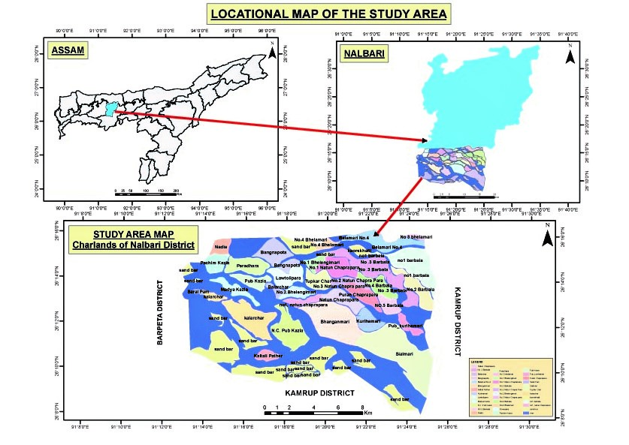
figure 1: The Study Area

Objective:
- To analyze the seasonal cropping pattern in Charlands of Nalbari district.
Methodology:
For the analysis of cropping patterns, multi-temporal satellite imagery from Landsat 8 OLI (30m resolution) was acquired for the three cropping seasons (Kharif, Rabi, and Zaid). Band 3 (green), 4 (red), and band 5 (NIR) were primarily used for crop monitoring of the charlands in Nalbari district. Primary field survey data (GIS points) were used for training and validation. These data were collected during the peak growing periods for each seasonal crop over one complete agricultural year (June 2023–July 2024). Generally, GPS points for main crops like maize, paddy, jute, pulses, oilseeds, and sunhemp were collected, and this data was used to categorize the crops applying the supervised classification method (Fig.2). Then Kappa coefficients were calculated to assess classification reliability. Finally, cropping pattern maps have been generated, and the results were interpreted with the help of area data for each crop.
Temporal Satellite imagery (Landsat-8)
Zaid season
(april,2024)
Kharif season
(september,2023)
)

Rabi season (December,2023)

Preprocessing of satellite data

Identification of crop classes(based on collected training samples)
)

Input the training samples to classify the image into crop categories
Supervised classification

Analyzed area under each crop classes
Preparation of Season wise cropping pattern map

Accuracy Assessment
(Kappa coefficient, above 80%)

Figure2. flow chart of methodology used

Results and Discussion:
The cropping pattern of the Charlands in Nalbari district (2023-2024) showed remarkable variations in the cropped types and cropped area for three different seasons. For a detailed analysis, the cropping pattern maps of the three seasons, i.e., Kharif, Rabi, and Zaid seasons, have been prepared from the satellite imagery on a GIS environment (fig 3,4,5), and the data were presented in table 1.
Table 1 makes it clear that the farmers of charlands in Nalbari district cultivated three different varieties of crops like Sali paddy(Oryza sativa), dhanisha(Sesbania aculeata), and jute(Corchorus) during the Kharif seasons(fig 3). Sowing of the Kharif season generally begins with the onset of the monsoon in mid-June, and the harvesting period starts at the end of September. Jute is cultivated widely in those char areas located near the main river because abundant water supply is needed for soaking the harvested stalks to extract fiber (Islam, M.M., et al., 2018). It is dominated in the southern part of Bhangnamari char, Sialmari char, Kalarchar, Bangnapota char, Pub Kazia char, and Kurihamari char covering an area of 5245.59 ha (60.7%) of the total cropped area. The fertile alluvial soil, warm, humid climatic conditions, the requirement of low input costs, high yielding capacity, flood resilience characteristics, and high market demand are the major factors that attract farmers to cultivate these fiber crops widely in the study area (Kalita, M. Ch., 2023). Moreover, Sali paddy also stands as the second major crop, which is predominant in the central part of the permanent chars like Bhangnamari, Kurihamari, Pub Kazia, and Barbala. It covers an area of 1754.32 hectares (20.3%) of the total cropped area. Farmers prefer these elevated, older and flood free portions of the chars because they retain enough soil moisture and have fertile soil, which helps the crop grow well. Sometimes they faces many problems like flood risk, soil erosion, poor irrigation, and uncertain yield which making it a high risk farming practice. Therefore, only 20.3% areas were put under the Sali paddy cultivation. In contrast, the low –lying and newly formed chars remain under water for longer periods or have sandy soil, so they are not fit for Sali paddy. Instead, those areas are used for other short duration crops after the flood recede. Danicha (Sesbania aculeata), a type of green manure crop, is also cultivated in small patches of the newly formed chars or sandy areas like Balarchar, Tupkar char, and Bangnapota char occupied 1635.86 hectares areas (18.9%)to the total cropped area. It is a fast growing leguminous plants that farmers often grow before planting cereals crop which helps to enrich soil with nitrogen because its roots have special bacteria that fix nitrogen from the air . When the plant is ploughed back into the soil after 45-60 days of growth, it adds organic matter, improves soil structure, and increases soil fertility. Thus, it is highly beneficial for flood-prone and poor-nutrient soil because it helps reclaim sandy soils, making them more productive for the next crop. However, the younger dhanicha plants were used as green fodder for cattle, goats and buffaloes .And the woody stems of mature dhanicha plants could be used as fuel wood and also to make ropes and mats in the study area.
After the floodwaters recede, char land soils become very fertile, allowing for the production of a variety of rabi crops with the help of irrigation. This season starts from November-December and ends in January-February, depending on the crops. Five types of crops have been identified from the cropping pattern map of the rabi season, 2023(fig 4). These are cereals, oilseeds, pulses, vegetables, and green manure crops. Generally maize (Zea mays )and wheat(Triticum) are the common cereal crops cultivated each and every charlands.
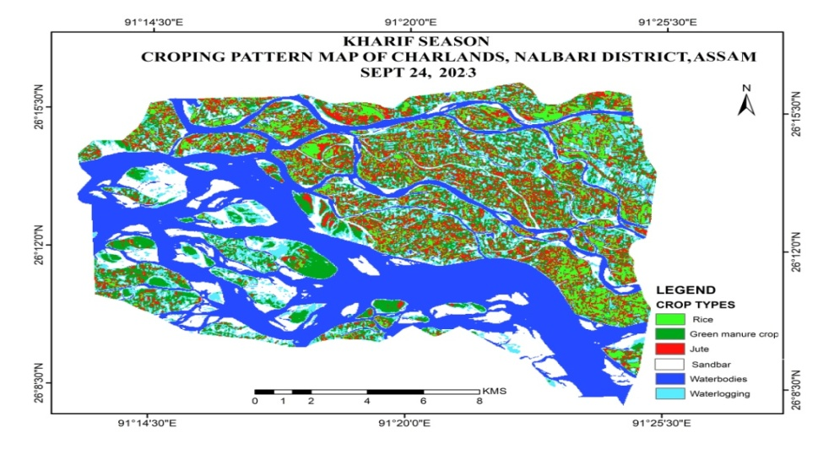
figure 3: Seasonal cropping pattern map of Kharif season (2023-2024)
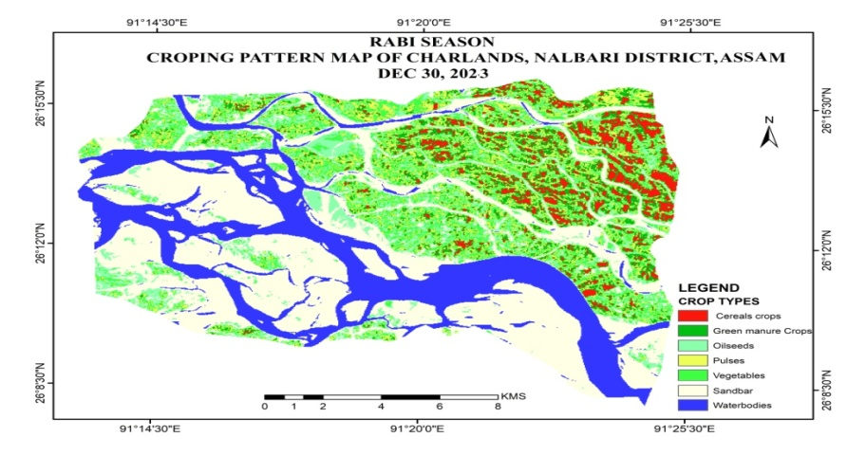
Figure 4: Seasonal cropping pattern map of Rabi season (2023-2024)
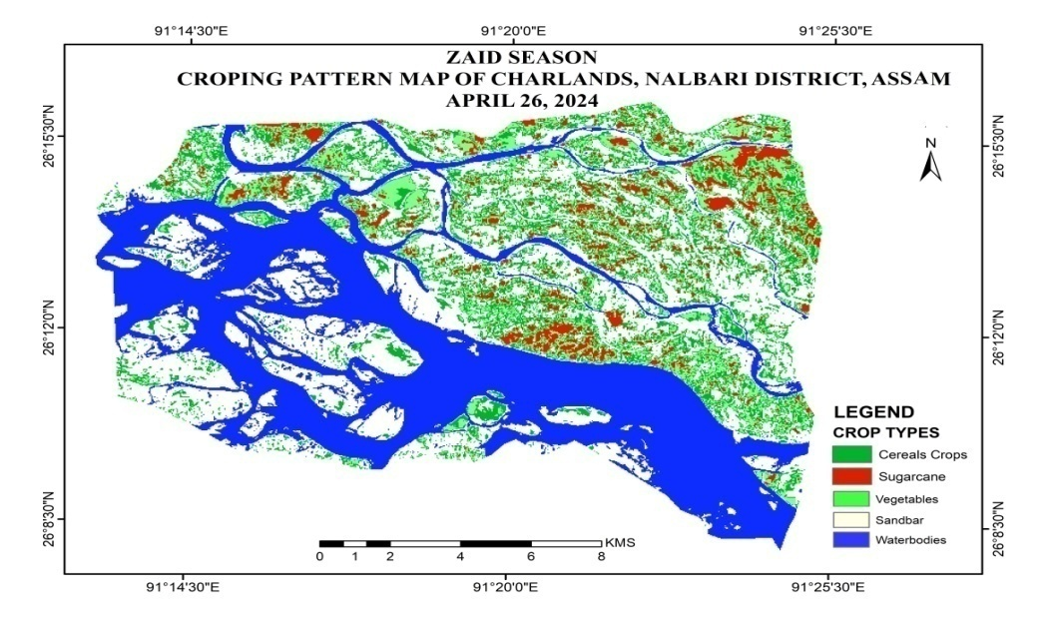
Figure 5: Seasonal cropping pattern map of Zabi season (2023-2024)
. Maize occupied 2096.85 ha area (20.9%) to the total cropped area and a very little portion occupied by wheat . Maize crops are now being increasingly grown in place of summer rice in the study area. During the time of the field investigation, local people stated that the climate resilience characteristic, lower input costs, high productivity, and high market demand are the main reasons which attract farmers to choose maize as a major crop for both rabi and zaid seasons. Maize can grow in a wide range of soils and climates, from sandy Charlands to fertile Charlands. It tolerates dry conditioned better than rice , making it suitable for post flood or ranifed condition. Rabi maize generally gives higher production (50/60 quintals per hectare) then zaid maize(35/40 quintals per hectare). This crop provides good livelihood option for the farmers of the study area where other crops often fail due to flood or drought. Zaid maize are basically use as a fodder crops. Again, Oilseed crops such as rapeseed(Brassica napus L.), mustard(Brassica nigra), sesame(Sesamum indicum L), linseed(Linum usitatissimum L.), and groundnut(Arachis hypogaea L.) are widely practiced in the chars of Chaprapara, Kalarchar, Kurihamari, Balarchar and Bhangnamari which covers an area of 2289.04 ha (22.8%). Other important major pulse crops, such as black gram (Vigna mungo), pigeon pea (Cajanus cajan), pea (Pisum sativum), and lentil (Vicia lens), occupied 1241.73ha (12.04%). These types of leguminous plants have a unique ability to fix atmospheric nitrogen in the soil. Therefore, pulse seeds are sown immediately after the harvesting of any major crops like rice and maize in the study area. Among the five verities of crops , different types of vegetables including spices occupied maximum area i.e. 2525.21 ha (25.3%). Spices like chili(Capsicum frutescens), capsicum, black papers(Piper nigrum), ajwain(Apiaceae) etc. area cultivated which have a high demand in the international market and can contribute to rural income and poverty alleviation (Sharma, M. P., et al., 2011).On the other way, one of most important low input cost crops, Sunhump (Crotalaria juncea), such type of the green manure crops are cultivated in the eastern and north eastern part of the study area which occupies an area of 1857.52 ha (18.56%). After the cultivation of cereal crops this types of crops has been cultivated in Charlands because it enriches poor soil, prevents soil erosion, fits short growing periods and provides useful by-products . it also controls exotic weeds by releasing certain chemicals from its roots and decaying leaves. During this season, most of the crops are cultivated using the multiple cropping system, except maize and oilseed crops (Barua, C.R., & Singha, M.G., 2020). Zaid crops are sown at the beginning of February and harvested at the end of May. This season is characterized by short-duration crops suited to residual soil moisture and pre- monsoon rains (Deka, N., & Bhagabati, A.K., 2017). Three varieties of crops have been identified from the cropping pattern map of the Zaid season, 2024(fig 5). These are cereals (rice or summer paddy and maize), sugarcane, and vegetables. Among these, cereals crops rice covers 3170.43 ha (46.9%) of the area, and a very small portion, i.e., 1204.77 ha (17.83%), is covered by sugarcane cultivation. During this season Summer paddy is extensively cultivated in each and every Charlands. It is possible in such types of dry sandy soil only because of Proper inputs of fertilizers and highly uses of irrigation facilities.Various means of irrigation like Shallow Tube Well, River Lift Irrigation, pump set ,solar Irrigation ,Sprinkler irrigation etc are facilities are available in the whole study area. Without irrigation no one can grow crops in rabi and zaid seasons .Major vegetables like cucumber(Cucumis sativus), Bitter gourd (Momordica charantia),Pumpkin( Cucurbita peopo) etc are cultivated in 2382.07 ha(35.25%) area. It requires warm weather and moderate irrigation , both to which suit the sandy well drained soils. Since these crops grow quickly and so they helps farmers earn money before monsoon season arrives. Moreover the vegetables fetch good prices in the market due to high summer demand. It remains an effective way to utilize fallow land, maintain soil health and improve the livelihood of people living in such type of fragile ecosystems of charlands. The Charlands located in the eastern, south eastern and southern parts like Barbala, Bhangnamari, kalarchar, Sialmari and Kurihamari chars are widely practiced the Zaid vegetables compared to other .Overall the distribution of seasonal cropping pattern in the Charlands highlights a balanced and intensive cropping system where land is cultivated almost throughout the year. Among the three different seasons Rabi crops occupy the largest share (39.5%)of the total cultivated land ,indicating that winter cultivation is more prominent and farmers make good use of residual soil moisture and irrigation facilities during this season. Kharif crop covers about 33.9% showing the importance monsoon dependent farming ,while zaid crops account for 26.7%,reflecting the farmer’s effort to utilize the land even during short summer period between Rabi and Kharif.
Table:1. Seasonal cropped area,2023-2024 (Source Landsat 8)

seasons | kharif |  |  | Rabi |  |  |  |  |  |  |  |  | zaid
Crops | Rice(Sali paddy) | Jute | Green manure crop(Dhanicha | Cereals( maize) | Oil seeds |  | pulses | vegetables |  |  | Green manure crop(Sunhump) |  | Cereals(Summer paddy) |  | Sugarcane |  | vegetables
Area (in hectare) | 1754.32 | 5245.59 | 1635.86 | 2096.85 | 2289.04 |  | 1241.73 | 2525.21 |  |  | 1857.52 |  | 3170.43 |  | 1204.77 |  | 2382.07  1204.77
Total area (in hectare) | 8635.5  (33.9%) |  |  | 10010.45(39.5%) |  |  |  |  |  |  |  |  | 6757.27(26.7%)
Percentage (%) | 20.3 | 60.7 | 18.9 | 20.9 | 22.8 | 12.4 |  |  | 25.3 | 22.31 |  | 18.56 |  | 46.9 |  | 17.83 |  | 35.25
.

Conclusion:
The study shows that the Charlands of Nalbari district are agriculturally advanced compared to mainland’s, because of farmers there have developed a highly diversified and seasonally cropping pattern. This adaptability is due to unique environmental conditions of char areas like fertile alluvial soils, seasonal flooding and access to both rainwater and residual soil moisture. Jute, Sali paddy, summer paddy, and maize have been found to be major crops, covering an area of 60.7%, 20.3%, 46.9%, and 20.9%, respectively. Among this crops jute emerges as the most dominant kharif crop cultivated in the southern part of Bhangnamari char, Sialmari char, Kalarchar, Bangnapota char, Pub Kazia char, and Kurihamari char. Sail paddy also practiced in more permanent chars. High-value maize crops considered as climate –resilient crop with good market demand is grown extensively in both rabi and zaidseasons. The farmers integrate green manure crops ( sunhemp and dhaincha), and leguminous crops( black gram, pigeon pea, pea, and lentil) to restore soil nutrients, especially nitrogen , and improve long term soil fertility . During rabi seasons, they adopted multiple cropping systems for maximize income from the same plot of land within a single season .. From this analysis, we have found the following major cropping rotation:
  - Jute-Sali paddy-maize
  - Jute/Dhanisa - oil seeds - Maize
  - Sali paddy- pulses- summer paddy.
  - Jute –Sunhemp -Vegetables
  - Jute–Maize–Maize
These pattern reflect a high cropping intensity, strong market orientation and sustainable practices that balance productivity with environmental conservation. The diversity of crops also buffer farmers against climate risks , market price fluctuation and seasonal uncertainties.

References
Barua, C.R., and Singha, M.G. (2020): Agricultural Practices and Sustainability among the Char Inhabitants of Sipajhar Development Block of Darrang District, Assam, IJCRT, vol. 8, ISSN 2320-2882
Deka,N., & Bhagabati, A.K. (2017): Dynamics of Agroecosystems in Brahmaputra valley, Assam (India), Journal of Agroforestry and Environment, ISSN 1995-6983,
Islam, M.M., et al. (2018): Jute Fiber Yield and Economics in Charland Areas of Bangladesh, Research in Agriculture and Veterinary Sciences, vol. 2, pp-59-65.
Kalita,M.C. (2023): Sustainable Agricultural Practices in Rural Areas (Char Area) of Assam,IJRAW,ISSN 2583-1615
Kumar, B., et al. (2025): Spatial Analysis of Cropping Patterns Using Digital Image Processing: A Case Study of Sirsa District, Haryana, IOSR-JAGG, ISSN: 2321–0982.Volume 13, PP 10-20
Mishra,B. ,et al (2023): High-resolution mapping of seasonal crop pattern using sentinel imagery in mountainous region of Nepal: a semi-automatic approach, Geomatic vol 3(2) ,pp 312-327.
Nath, R.K. (2021): Socio-economic Status of the Farming Community of Char Area of Dhubri District, Assam, AJAEES, ISSN: 2320-7027, PP 14-20
Singh,J., & Dhillon,S.S. (2004): AgriculturalGeography, Tata Mc Garo-Hill publishing company Ltd., New Delhi
Sharma,M.P., et al (2011): Cropping System Analysis Using Remote Sensing and GIS: A Block Level Study of Kurukshetra District,ARPN, ISSN 1990-6145, vol. 6
Sathishumar ,M. et al (2024):Dynamic of Cropping Pattern Changes in Selected Block of Virudunagar District,India,IJECC,ISSN:2581-8627,vol.14,pp 278-282

