Short Research Article
Analysis of Smoked Catfish (Clarias sp.) Product Development in Indonesia

.
ABSTRACT

Aims: This study aimed to analyze the development of smoked catfish (Clarias sp.) products in Indonesia from the aspects of processing, packaging, and marketing to identify innovations that enhance product quality and competitiveness.
Study design: A descriptive–comparative design was applied using a qualitative survey approach supported by marketplace observations and literature analysis.
Place and Duration of Study: The study was conducted in Indonesia by collecting and analyzing secondary data from scientific journals, research reports, and credible online sources between September and November 2025.
Methodology: Secondary data related to the development of smoked catfish products were obtained through literature review and marketplace observation. Data were analyzed descriptively to identify innovation patterns and comparatively to examine differences in processing, packaging, and marketing practices implemented by producers and MSMEs in Indonesia.
Results: The findings revealed significant development in smoked catfish processing, packaging, and marketing. In processing, the adoption of liquid smoke and electric smoking technology improved product quality, efficiency, and environmental sustainability. In packaging, innovations such as vacuum-sealed, tin, and retort pouch packaging enhanced product hygiene, durability, and consumer appeal. In marketing, the transition from traditional offline sales to digital-based strategies through online marketplaces and social media expanded market reach and strengthened MSME competitiveness.
Conclusion: Continuous innovation in processing technology, packaging, and marketing is crucial to improve product quality and competitiveness, while also supporting sustainable growth and economic resilience in Indonesia’s fish processing sector.

Keywords: smoked catfish, product development, processing technology, packaging innovation, MSME, marketing strategy

1. INTRODUCTION

Product development is the process of designing, manufacturing, and launching new products, or improving existing products so that they can be reintroduced to the market with better value and competitiveness. The development of processed fishery products plays an important role not only in producing products that are more practical and in line with consumer preferences, but also in increasing the economic value of fishery products, which are often not optimally utilized (Junianto et al., 2025).

The objectives of new product development include: (a) meeting new needs while strengthening the company's reputation as an innovator by introducing products that are more modern than previous products; and (b) maintaining competitiveness against existing products by offering new types of satisfaction to consumers. This can be done by adding to existing product lines or revising old products to better suit market needs (Kotler & Keller, 2008).

Product development provides opportunities for companies to continue to grow and adapt to market changes. Through the creation of new products or improvements to existing products, companies can attract new consumers, expand their market share, and increase their revenue and competitiveness. The success of a product development can be measured through several key indicators, including increased company profits, improved product quality and customer satisfaction, production cost efficiency that leads to increased profits, simplified production processes that reduce the time required, and the ability to reduce overall development costs.

One of the fishery products that has undergone development is smoked catfish (Clarias sp.). Smoked catfish is a processed catfish product that is preserved through a smoking process using specific types of firewood, resulting in a distinctive aroma, savory taste, and a drier, longer-lasting texture. This smoking process not only serves as a natural preservation method but also enhances the flavor of the fish, making it ready to be consumed directly as a side dish or used as an ingredient in various dishes.

As a traditional processed product, smoked catfish has undergone various adaptations and developments, both in terms of the processes and technologies used, as well as packaging and marketing, which have kept it well-known and consumed by the public to this day. Therefore, this study aims to analyze the development of smoked catfish products in Indonesia, specifically looking at the forms of development that have been carried out, from the aspects of process, packaging, to existing marketing.

2. methodology

This study employed a survey method of scientific articles relevant to the topic of smoked catfish (Clarias sp.) product development in Indonesia. The data used in this study were obtained from secondary sources, including recent national and international journal articles, research reports, credible online publications, and marketplace platforms that display smoked catfish products and their characteristics. The selection of literature was based on relevance, publication year (2013–2025), and scientific credibility.

The data obtained were analyzed using a descriptive–comparative approach. A comparative study is conducted to compare the similarities and differences between two or more facts or characteristics of the studied objects within a specific analytical framework. Therefore, in this study, descriptive–comparative analysis was carried out by describing the findings from previous studies and marketplace observations related to the development of smoked catfish products, and then comparing them based on three main aspects: processing, packaging, and marketing.

In addition, direct observations of marketplace activities and product displays were conducted to validate the literature findings and to capture real-time developments in product innovation, packaging design, and marketing approaches within Indonesia’s fish processing sector

3. results and discussion

3.1 Processing

Smoking is a traditional fish processing method that aims to extend shelf life and give a distinctive flavor to fishery products. This process utilizes heat and chemical compounds from wood or organic material smoke to produce a natural preservative effect. In addition to extending shelf life, smoking also increases the added value and competitiveness of fish products, especially catfish (Clarias sp.), which is widely cultivated in Indonesia. Along with technological developments and market demand, the catfish smoking process continues to undergo innovation and development to produce products with better quality, efficiency, and environmental friendliness, each innovation having its own distinct characteristics. As shown in Table 1. and Figure 1. which illustrate the differences in the processing methods for smoked catfish and what distinguishes them.

Table 1. Development of Smoked Catfish Processing
Comparative Aspects | Regular smoking | Liquid Smoke | Electric Smoke
Source of Smoke | Direct burning of wood, charcoal, coconut husks, or organic waste (e.g., jengkol wood) in an open stove. | Condensation of biomass pyrolysis (such as coconut shells or rice husks) into liquid | Electric heating elements that vaporize wood powder or pellets, producing controlled smoke without open combustion
Process | Fish is placed on a rack over direct heat; heat and smoke circulate naturally, typically using a temperature range of 65–80°C for 3–5 hours depending on the desired texture and color of the product | 40 ml of liquid smoke concentration within 36 hours of cooking at 65 °C | Smoking in an electric cabinet (60–80°C) for 3–6 hours with automatic temperature control and smoke circulation
Physical Quality | The dark brown color is uneven; the aroma is strong but can be too intense. High moisture content (up to 40-50%) if not optimal. | intact, brittle, and shiny appearance with a brownish-yellow color | Even golden brown color, dense texture


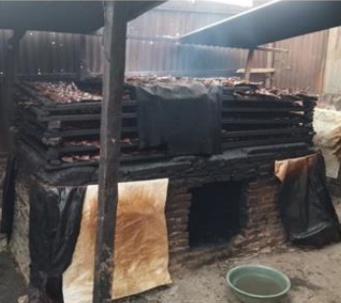
Figure 1. Simple Smoking, Liquid Smoke, and Electric Smoking
Source: Asmara et al., 2025
One form of development in the catfish smoking process is the modification of the fuel used. Asmara et al, (2024) researched the effect of charcoal and coconut husk fuel on the quality of smoked catfish and found that a combination of the two heat sources produced a more attractive color, stronger aroma, and lower moisture content compared to using either fuel alone. This shows that the choice of fuel has a significant effect on the final quality of smoked fish.

Another study developed traditional smoking into modern methods such as smoking with liquid smoke. Liquid smoke is the condensation of wood containing phenols, organic acids, and carbonyls. These three compounds play a role in improving the properties of smoked fish products, namely antimicrobial and antioxidant properties. Research by Filho et al., (2021) shows that liquid smoking of catfish produces processed products that are easier to handle and control than traditional methods, with good physical, chemical, and microbiological stability for up to 60 days of storage at cold temperatures.

Furthermore, electric smoking has emerged as the latest method that utilizes electric heating elements to precisely control the temperature and smoke circulation, often combined with electric smoke generators to avoid dependence on fossil fuels. This process operates at a temperature of 60–80°C for 3–6 hours, producing smoked catfish with even heat distribution and a stable moisture content of less than 12%, as well as a yield of up to 77%. Sirait & Saputra (2020) developed a cabinet-type electric smoking device that reduces PAH by up to 50% compared to traditional methods, while maintaining the distinctive taste and aroma through smoke from wood chips. Research by Royani et al. (2015) shows that electric smoking of catfish produces a pH value of 5.8–6.0 and a protein content of 27–29%, with 30% higher energy efficiency than conventional ovens.

The development of modern drying equipment has also been carried out to improve efficiency and maintain fish quality. For example, the rotary cage-tray fish dryer with a dual heating system (charcoal and gas) has been proven to increase drying efficiency by up to 71.8% and reduce fish moisture content to 10.5%, which is significantly better than traditional dryers. Furthermore, the optimization of fish drying not only enhances energy efficiency but also improves sensory attributes such as color, taste, and aroma of the final product. This rotary cage-tray fish dryer is also suitable for small and medium-scale enterprises (SMEs), making it a promising innovation for sustainable fish processing.

The smoking method used in the process of grilled catfish greatly influences the resulting taste. This finding is consistent with the study by Setiawan et al. (2022), which reported that the duration of smoking affects the flavor and the level of panelists’ preference for smoked catfish. This occurs due to several factors, such as the smoking method and the type of wood used during the process, both of which play crucial roles in determining the final taste of the product (Essumang et al., 2013).
Smoking leads to the absorption of phenolic and carbonyl compounds from the smoke into the fish flesh. These compounds play an important role in providing the distinctive smoky flavor and masking the fishy odor typically found in freshwater fish such as catfish. Based on observations, consumers generally prefer smoked catfish with a savory, slightly salty taste and a characteristic smoky aroma. In addition, the freshness of the catfish significantly influences the flavor produced during smoking. Fresh catfish produce a pleasant, savory, and slightly sweet taste with a distinct smoky aroma, while non-fresh catfish tend to produce an unpleasant flavor accompanied by a slightly bitter aftertaste caused by protein degradation prior to processing.

3.2 Packaging

Packaging is an important factor in the food industry because it can affect consumer health. The main purpose of packaging is generally to protect products from damage caused by external factors, as well as to maintain their quality and nutritional value, thereby extending shelf life. In addition, packaging serves as a means of communication with consumers, aiming to attract their interest in purchasing the product. Nowadays, packaging is also expected to be environmentally friendly, actively protect the product (active packaging), and intelligently provide information about the product’s condition (intelligent packaging).

According to Ermawati (2019), labels on packaging should include details such as the product name, trademark (if any), ingredient composition, net weight, manufacturer’s name, distributor’s name (if any), health department registration number, production code, and expiration date. Table 2. shows the development in the packaging of smoked catfish products, from simple plastic containers to the more commonly used vacuum-sealed plastic packaging.

Table 2. Development of Smoked Catfish Packaging
Type | Image | Description
Plastic Container |  | The packaging is inexpensive and easy to use, featuring a product identification label; however, it tends to be easily damaged, offers limited protection, and provides only minimal product information.
Vacuum-sealed | 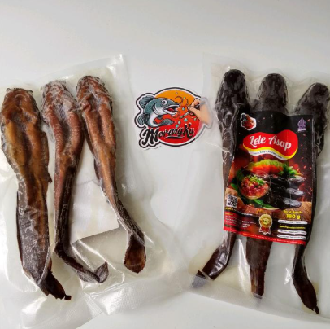 | The packaging helps maintain hygiene, extend product shelf life, and provide product identification along with additional information labels; however, it requires a high initial investment for vacuum equipment.
Cardbox Packaging | 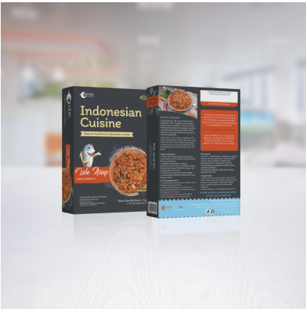 | The packaging helps maintain hygiene, extend product shelf life, and provide product identification and additional information; however, it incurs a higher cost because primary packaging is required before the product is placed in a box
Tin Packaging | 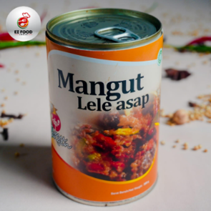 | The packaging offers protection against damage, maintains hygiene, extends product shelf life, provides product identification and additional information, and demonstrates high durability; however, it is relatively expensive.
Standing Up Pouch | 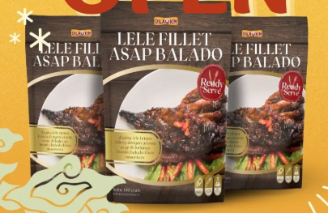 | The packaging ensures high hygiene, extends product shelf life, provides product identification and additional information, and is aesthetically appealing; however, its durability is relatively low.

Based on its shape and size, cardboard packaging is the most preferred type for smoked fish products. The second most preferred is plastic packaging, followed by cans. Good packaging provides better market opportunities both domestically and internationally. In the local market, products with attractive and hygienic packaging have a better chance of being sold in supermarkets and modern retail stores. Packaging that meets international standards also opens up greater export opportunities. This finding is consistent with the case of Candra Ayu sagon products, whose sales increased significantly following improvements in packaging design. Initially, the product was sold in clear plastic packaging with only a logo sticker. However, after being developed into jar and standing pouch packaging with more complete labeling, product profits rose by up to 4,900%.

Furthermore, previous research revealed that the application of modern packaging technology, such as the retort pouch, substantially enhances the shelf life and maintains the sterility of smoked catfish products without compromising taste or texture. A study conducted at the Packaging Technology Center, Indonesian Institute of Sciences (BTPBA–LIPI), Gunungkidul, demonstrated that smoked catfish packaged using retort pouches remained stable for up to two months at room temperature while retaining sensory and nutritional quality that meets the Indonesian National Standard (SNI) for smoked fish products. This packaging method is recognized as efficient, cost-effective, and highly applicable for small and medium enterprises.

3.3 Marketing

Marketing activities for smoked fish often face various challenges that can hinder smooth distribution and sales processes. One of the main reasons for the low effectiveness of this product’s marketing is the high level of competition among business actors in the same field (Sofyan & Zainuddin, 2024). Before entering the market, producers need to fully understand market conditions, especially regarding target consumers and demand levels, in order to determine appropriate marketing steps and strategies that fit market needs. Therefore, the success of a smoked fish business is not only determined by production capacity but also by marketing strategies that can attract consumers and strengthen the business position in the market.

In the context of traditional smoked fish marketing, the sales location is an important aspect. Businesses located close to traditional markets and supermarkets can distribute products more easily and gain faster consumer acceptance. Offline marketing is usually carried out by participating in bazaars or by consigning products to souvenir shops so that smoked catfish products become better known and more accepted by consumers. A comparison between traditional and modern marketing systems is presented in Table 3.

Table 3. Development of Smoked Catfish Marketing
Marketing Aspect | Past (Traditional Marketing) | Present (Digital Marketing)
Marketing Concept | Based on traditional marketing mix elements such as pricing, distribution, and promotion conducted manually. | Applies an integrated marketing approach using digital tools, customer engagement, and online branding strategies (Sofyan & Zainuddin, 2024).
Distribution and Sales System | Sales conducted through offline channels such as traditional markets, bazaars, and souvenir shops. | Distribution and promotion carried out via digital platforms such as websites, MSME marketplaces, Tokopedia, and Shopee.
Consumer Reach and Market Scope | Limited consumer reach, focusing on local customers in surrounding areas. | Expanded reach to national and even international markets without geographical barriers.
Marketing Innovation | Product innovation focused mainly on packaging and maintaining product quality. | Marketing innovation includes creative online strategies, digital branding, and product differentiation to enhance competitiveness
Competition and Business Positioning | Faced with local competition among small producers in the same region. | Faces higher competition at the national level, requiring innovative and adaptive marketing strategies to strengthen business positioning (Sofyan & Zainuddin, 2024).

However, technological development and changes in consumer behavior have driven a shift from offline to online marketing systems. Nowadays, smoked catfish entrepreneurs have started promoting their products through various digital platforms such as websites, MSME marketplaces, Tokopedia, and Shopee, which allow products to reach a wider range of consumers without geographical limits. As technology and consumer behavior have evolved, marketing strategies for smoked catfish have undergone significant transformation.
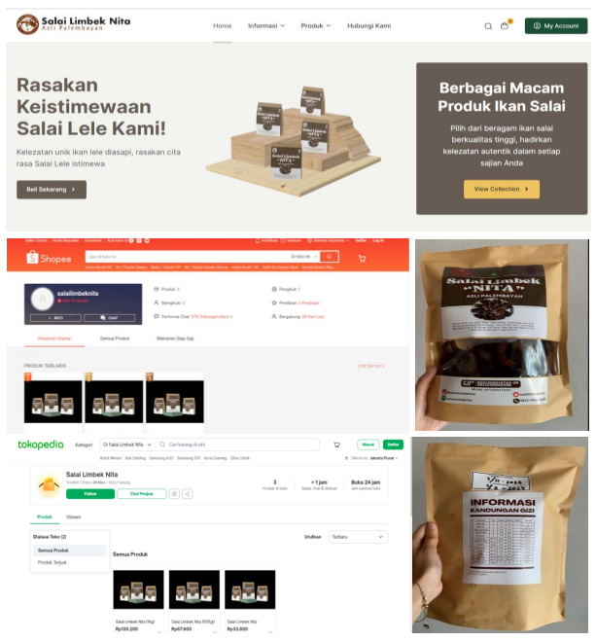
Figure 2. Digital Marketing
Source: Darmayanti et al., 2024

As illustrated in Figure 2, digital marketing serves as an effective form of marketing innovation that enhances the competitiveness of smoked catfish products. Marketing innovation has become an important factor in improving competitiveness in the midst of tight competition. This innovation can take the form of creating new ideas in marketing strategies so that the product has more value compared to competitors. Through marketing innovation, companies can also introduce new products, improve the quality of existing products, and expand market share so that smoked catfish products become more widely recognized.

4. Conclusion

The development of smoked catfish products in Indonesia has undergone significant progress in terms of processing, packaging, and marketing. The modernization of smoking technology, such as the use of liquid and electric smoking, enhances product quality, extends shelf life, and reduces environmental impact. In packaging, innovations from traditional plastic containers to vacuum, tin, cardbox and standing pouch types improve product durability, hygiene, and consumer appeal. Furthermore, the shift from traditional to digital marketing strategies expands market reach and increases business competitiveness for MSMEs. Overall, continuous innovation in production and marketing is crucial for optimizing product quality, supporting MSME growth, and promoting sustainable development within Indonesia’s fishery processing sector.

5. DISCLAIMER

The author(s) hereby declare that generative AI technologies such as large Language Models (ChatGPT by OpenAI) were used only for language translation purposes, specifically to convert the manuscript text from Bahasa Indonesia to English. No AI tools were used to generate, analyze, interpret, or modify the research content, data, or scientific arguments presented in this manuscript. The authors have thoroughly reviewed and verified all translated text for accuracy and context.
Details of the AI usage are as follows:
- Tool used: ChatGPT (OpenAI)
- Purpose: translation from Bahasa Indonesia to English only
- Extent of use: limited to linguistic conversion and grammatical refinement without altering scientific meaning or interpretation

References

Asmara, S., Kuncoro, S., & Amalia, A. C. (2024). Making smoked catfish (Clarias gariepinus) using wood charcoal and coconut fiber at various concentrations. Journal of Agricultural Biosystem Engineering, (In press).

Ermawati, E. (2019). Assistance with the role and function of product packaging in the marketing world of Yosowilangun Lor Village. Empowerment Society, 2(2), 15–23.

Essumang, D.K., D.K. Dodoo & J.K. Adjei. 2013. Effect of Smoke Generation Sources and Smoke Curing Duration on the Levels of Polycyclic Aromatic Hydrocarbons (PAHs) in Different Suites of Fish. Food and Chemical Toxicology (58): 86–94.
Filho, P. R. C. de O., de Araújo, I. B., Raúl, L. J., Maciel, M. I. S., Shinohara, N. K. S., & Gloria, M. B. A. (2021). Stability of refrigerated traditional and liquid smoked catfish (Sciades herzbergii) sausages. Journal of Food Science, 86(7), 2939 – 2948. https://doi.org/10.1111/1750-3841.15811

Junianto, J., Viola, I., Majida, L. M., & Lavintanza, M. C. (2025). Analysis of processed fishery product development in the dim sum industry: A case study of Dimsum Boss. Bhakti Persada: Jurnal Aplikasi IPTEKS, 11(1), 32–37. https://doi.org/10.31940/bp.v11i1.32-37
Kotler, P., & Keller, K. L. (2008). Marketing Management. Jakarta: Prenhallindo.
Osi, O., Precious, O., Irtwang, S. V., & Nathaniel, I. (2025a). Innovative Design and Performance Evaluation of a Dual-Heated Rotary Cage-Tray System Fish Dryer for Enhanced Preservation. 9(4), 1736 – 1744. https://doi.org/10.64388/IREV9I4-1711612-8331

Royani, D. S., Marasabessy, I., Santoso, J., & Nurimala, M. (2015). Engineering of a cabinet-type fish smoking apparatus (oven model). Journal of Food Technology Applications, 4(2), 74–78.

Sirait, J., & Saputra, S. H. (2020). Fish smoking apparatus technology and smoked fish quality. Indonesian Journal of Industrial Research, 12(2), 220–229.

Sofyan, S., & Zainuddin, M. Z. (2024). Smoked fish marketing strategy for the Pokhlashar Medudulu business in Basule Village, Lasolo District, North Konawe Regency. Sutra Journal of Economy and Business, 5(1), 189–200.

Setiawan, A., Triandita, N., & Yuliani, H. (2022). Organoleptic Test Profile and Moisture Content of Smoked Catfish in Gampong Pasie Pinang, West Aceh Regency. Journal of Social Technology, 2(5), 418–424.

