Original Research Article

Comprehensive Assessment of Fish Availability Across Seasons at Kismayo Landing Sites

ABSTRACT
This study looks at the Comprehensive Assessment of Fish Availability Across Seasons at Kismayo Landing Sites, considering seasonal changes and what they mean for local fishing. We gathered info by watching landings at Kibora Fish Landing Site and Kismayo Fish Market, and by talking to local fishers and market people. We wrote down the Somali, English, and scientific names of fish and shellfish species and noted when they were available during the year. We found that 19 pelagic species, like tunas (Thunnus albacares, Thunnus obesus), mackerels (Scomberomorus guttatus), and wahoo (Acanthocybium solandri), were more common from October to December and February to April. On the other hand, demersal and reef-related species, such as seabream (Acanthopagrus berda) and spinefoot fish (Siganus sutor), as well as shellfish like lobsters (Panulirus spp.) and mangrove crabs (Scylla serrata), were around all year. This gives a reliable source of food and income for coastal communities. Seasonal ups and downs in pelagic fish supply affected how much fishing was done, what gear was used, and how the market worked. These results show that we need fisheries management plans that consider seasonal shifts. This will help protect marine resources for the future while keeping the fishing communities in Kismayo fed and financially stable.
Keywords: Fish Market Trends in Kismayo, Seasonal Variation in Fish Species, Assessing Fish Availability, Identifying Fish Species, and Fisheries Management Practices.

INTRODUCTION
The relationship between environmental conditions and seasonal fluctuations in fish communities surrounding a coastal island was examined. Researchers discovered 72 fish species across 40 families and 23 orders in the Seto Inland Sea of Western Japan, illustrating the region's significant biodiversity (Nhat et al., 2024). Turkey has the longest seasonal fishing prohibition in the Mediterranean. Industrial fishing is not allowed from April 15 to September 1 every year (Yıldız et al., 2020). This moratorium is aimed at conserving important spawning times and promoting long-term management of fisheries(Yıldız et al., 2020).
Certain fishing grounds consistently exhibit higher productivity for both Norway lobster and European hake. Although landings vary greatly between harbours, only a few consistently account for a significant share of the catch, with the Pomo/Jabuka Pit area emerging as a particularly important site for both species (Russo et al., 2018)
This study provides the first assessment of historical landing patterns for 21 fish taxa and evaluates recent population trends for 27 commercially important fish species in the lower La Plata Basin, Argentina(Scarabotti et al., 2021).
The Noakhali Science and Technology University lab looked at samples taken from the landing site. Researchers recorded 32 fish species, 4 prawn species, and 1 shrimp species from 22 families during the investigation. The Engraulidae and Palaemonidae families had the most species, with four each. 24 fish were not threatened (NO), 3 were critically endangered (CR), and 10 did not have enough data (DD). (Chakraborty et al., 2020). The fact that some species are not very common shows that fish biodiversity is going down, both in the area and across the country. The study also looked at overall trends in how fish are sold in the area (Chakraborty et al., 2020).
Research in Bangladesh found 237 fish landing centres and 5,440 marketplaces. Chittagong had the most landing centres, while Dhaka had the most markets. The fish distribution network included 6,219 arotdars, 39,506 paikers, and 122,922 retailers. Most of the landing facilities (around 84.7%) are open all year, while the rest (15.3%) are only open at certain times of the year (Rahman et al., 2013).
The research analysed seasonal fluctuations in the distribution of fish species and their conservation status over three seasons—summer, autumn, and winter—from September 2017 to August 2018 (Imran et al., 2023). Researchers found 64 different types of fish, which belong to 25 genera and 24 families. These fish belong to 10 different orders. The order Cypriniformes had the highest species, making up 42% of all species. Other orders that added to species diversity were Siluriformes (22%), Perciformes (16%), Channiformes (6%), and Clupeiformes (5%) (Imran et al., 2023). However, Cypriniformes were the most dominant of the species that were found. The study also showed that 14 species (18.88%) are at risk of extinction, with 6.25% being vulnerable, 12.5% being endangered, and 3.12% being severely endangered according to the IUCN Red List (Imran et al., 2023).
India is one of the top fishing countries in the Indian Ocean, and almost 1,000 species of commercial marine fish have been overfished (Setiadi M Noor, Iin Solihin, Retno Muninggar, 2024). Regular and thorough evaluations of these stocks are essential for fostering sustainable fisheries management and responsible fishing. The results of this study looked at 135 stocks from 70 species using monthly length-frequency data. They found that 91.1% of the stocks they looked at had a healthy biomass. Some stocks were found to be sustainable, while others were found to be overfished (Setiadi M Noor, Iin Solihin, Retno Muninggar, 2024).From August 2016 to December 2024, a local fish purchaser in Sut Pa Nu Village, adjacent to the estuary, compiled data on the monthly fish catch. Over eight years, researchers identified 30 distinct species of fish across 19 families. The three predominant species—Hilsa shad, Pama croaker, and Mango fish—constituted 54% of the entire annual catch and 76% of the overall economic value (Yıldız et al., 2020). The research examined the local ecological knowledge of fishermen, obtained through interviews, and contrasted it with accurate data on variations in fish catch rates (CPUE) during the northeast (NE) and southeast (SE) monsoons. The perspectives of the fishers aligned with the catch figures, indicating that the NE monsoon often yields higher catch rates than the SE monsoon. However, at two landing sites (Nyamisati and Shangani), the fishermen's perceptions varied, as they reported heightened catches during the SE monsoon (Silas et al., 2023).
The typical volume of fish exchanged in Kenya varied according to the seasons when lake fishing is most active, specifically from January to March and from August to October. In contrast, the amount of fish traded in Uganda changed from week to week throughout the year, depending on the average price of fish (Aura et al., 2019). The EFMIS project showed that sharing information through ICT platforms can make fish trade more efficient and fair by showing smaller sales margins.
This assessment of fish market data is valuable for shaping fish trade policies and for the sustainable management of fisheries and ecosystems in rural and peri-urban areas (Aura et al., 2019)
Moreover, this estimation does not consider the landings (number of individuals) overlooked by observers at the study locations, which could be significant (weighted means ranging from 17.3 to 33.9%) (Temple et al., 2019). In summary, the findings clearly indicate that the landings of elasmobranch species from SSF are probably notably underreported in the fisheries statistics for the SWIO region. The extent of underreporting varied by country (Temple et al., 2019).
The results of this research show that demersal species, including scavengers, rabbitfish, snappers, and parrotfish, are the most prevalent in the marine catch, accounting for 50% of the overall landings of marine and coastal fish pelagic species, which encompass mullets, bonito, cavalla jacks, mackerel, kingfish, and sailfish, made up 28%, while the remaining 22% consisted of elasmobranchs, crustaceans, and mollusks. (Aloo, P.A. Munga, C. Kimani, E. Ndegwa, 2014).
This research presents, for the first time, the species variety, population density, and length-weight correlation of groupers within the inshore artisanal fisheries of Kenya. Data were collected from the catches of artisanal fishermen along the southern coast of Kenya from February to July 2007 (Agembe et al., 2010). A total of 37 species from six genera—Aanyperodon, Cephalopholis, Dermatolepis, Epinephelus, Plectropomus, and Variola—were recorded in the fishermen's landings (Agembe et al., 2010)
This research examines the diversity and numbers of fish species at various landing sites in the Upper Benue River Basin located in Taraba State, Nigeria. Fish were collected every month for six months (from February to August 2022) at the Mayo-Renewo and Lau landing sites using different fishing techniques, including traps, gillnets, and hook and line. A total of 6,519 fish specimens representing 26 species across 22 families were documented, with the most prevalent species in Mayo-Renewo being Tilapia galilaeus, Distichodus rostratus, and Alestes macroplepidotus, while Clarias gariepinus, Heterotis niloticus, and Alestes macroplepidotus were the most frequently found in the other location. Lau (David.
The data indicate that a majority of fish reproduce throughout the year in these tropical waters, as we did not observe significant seasonal trends; all locations exhibited a high relative abundance of larvae from demersal spawning fish, suggesting that many species relocate to coastal areas for spawning (Ngisiange et al., 2024). Primary productivity and dissolved oxygen levels, influenced by hydrodynamic conditions, are positively associated with fish larvae productivity in both Kenya and Tanzania (Ngisiange et al., 2024). These results imply that the presence of both resident and transient fish larvae in seagrass meadows is influenced by strong hydrodynamic and tidal processes that move fish larvae across neighbouring habitats (Ngisiange et al., 2024).
Seasonal collections were primarily composed of fewer than 10 small estuarine forage species, such as Anchoa mitchilli, Menidia spp., Floridichthys carpio, and Lucania parva, which were found in high numbers throughout the year(Tremain & Adams, 1995). They identified significant seasonal variations in abundance for several rarer or transient species collected from shallow-water habitats, including Brevoortia spp(Tremain & Adams, 1995)., Trachinotus falcatus, Caranx hippos, Cynoscion nebulosus, and Leiostomus xanthurus, as well as species from lagoon-basin habitats like Micropogonias undulatus and Diapterus auratus(Tremain & Adams, 1995). Estimates of species richness and abundance were positively associated with water temperature, peaking during the summer or fall and dipping to their lowest levels in winter. (Tremain & Adams, 1995)
The findings indicated that the most prevalent fish species along the Mogadishu coast were pelagic fish that inhabit the surface and those found at the bottom(Farah, 2023). The primary pelagic species identified included Yellowfin Tuna, Skipjack Tuna, Kawakawa Tuna, mackerels, billfishes, and Mahimahi(Farah, 2023). This category also encompasses fish species found in both inshore and offshore areas, such as certain Jack fish and shark species. Conversely, the leading demersal fish included spine-foot fish, emperors, seabreams, red snappers, parrot fish, surgeons, as well as a few types of snappers and groupers. Therefore, these fish represent the key species observed throughout the Somali coast (Farah, 2023).

Objective
- Identify the fish species available at Kismayo landing sites throughout the year.
- Analyse the seasonal patterns of fish abundance and their implications for local fishing practices.

MATERIALS AND METHODS

Study Design
This study employed a descriptive research approach, integrating quantitative and qualitative methodologies to assess the availability of fish and shellfish in Kismayo landing sites. We obtained data via an observational survey, structured interviews with local fishers and market participants and direct measurements.

Study Sites and Time:
Study Sites and Time: The data were collected from the Kibora Fish Landing Site and the Kismayo Fish Market from January to December 2024. People went to these areas twice a month to see how things changed with the seasons.

Date collection
For data collection, fish and shellfish were identified by their Somali, English, and scientific names.
The count of individual fish and shellfish species landed was recorded.
Interviews and direct observation provided insight into fishing tools and boats.
We talked to experienced fishers to find more about the local ecology, including seasonal abundance, species behaviour, and fishing tactics.

Date analysis
We used Microsoft Excel (2021) to sort and look at the data. We used descriptive statistics, including frequency and percentage, to characterise the composition of species and their availability throughout the year. Graphs, tables, and seasonal charts depict how fish and shellfish landings change from season to season.

Study location
The current investigation in Kismayo, Somalia, will be conducted at two primary landing sites:

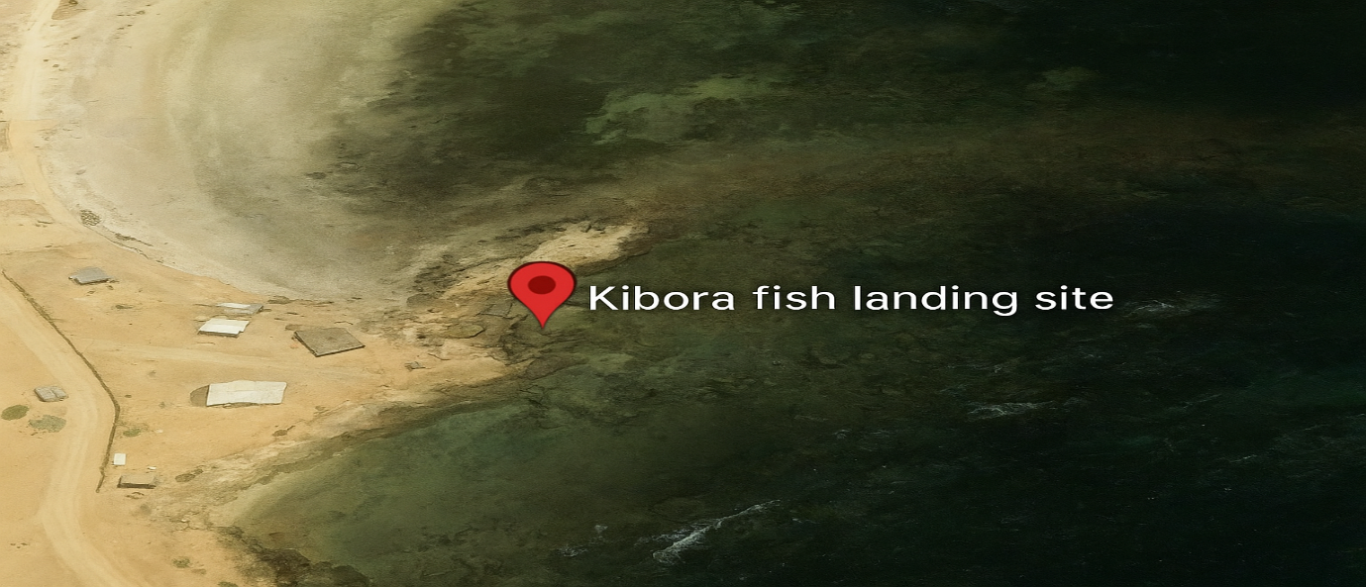

Fig. 1: This figure shows the Kibora Fish Landing Site, which is an important place in Kismayo where the research was done. This place is an important area for fishing in the area, and the study included interviews that took place here.

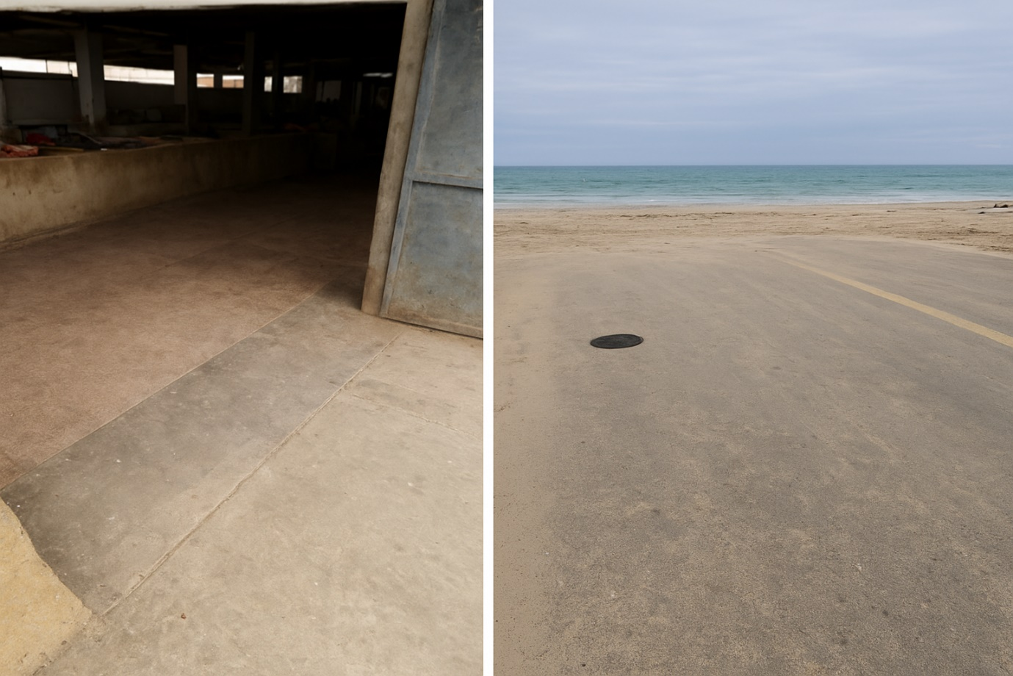

Figure 2: This figure shows a part of the Kismayo Fish Market, which is an important place for buying and selling fish in the area. Many types of fish and shellfish are traded at the market, which serves as a main nexus for this trade. We did observations and interviews in this area to learn more about the availability of species, seasonal patterns, and how the market works.
RESULT AND DISCUSSION

RESULT
Table 1: Common Commercial Pelagic Fish Found on the Kismayo landing site
This table enumerates prevalent pelagic fish species located off the Kismayo coast, including their Somali and English nomenclature, scientific classifications, and seasonal availability. These fish are predominantly seasonal, with availability fluctuating from October to early December and again from February to April, contingent upon local environmental conditions and migratory patterns.

Somali Name | English Name | Scientific Name | Availability | Seasonal availability
Dhiigloow | Kawakawa Tuna | Thynnus affine | Seasonal | From October to Early December and from the end of February to April.
Saynab | Spotted mackerel | Scomberomorus guttatus | Seasonal | from October to Early December and from early March to Early June
Yuumbi | Spanish mackerel | Scomberomorus commerson | Seasonal | from October to November and from the end of February to April.
Jeedar | Yellow-fin Tuna | Thunnus albacares | Seasonal | From October to Early December and from the end of February to April.
Sanuuro | Skipjack Tuna | Katsuwonus pelamis | Seasonal | from October to Early December and from the end of February to April.
Gaxash | Jacks | Carangidae | Seasonal | from October to Early December and from the end of February to April.
Jabto | Talang Queenfish | Scomberoides commersonnianus | Seasonal | from October to Early December and from the end of February to April.
Shaamshuutar | Striped Bonito Tuna | Sarda orientalis | Seasonal | from October to Early December and from early February to April.
Booraay | Bullet Tuna | Auxis rochei | Seasonal | from October to Early December and from early February to April.
Daanberi | Billfishes | Xiphidae & Istiophoridae | Seasonal | from October to Early December and from the end of February to April
Dooldool | Ladyfish | Elops machnata |  | From October to Early December and from early February to April.
Fuluus | Mahi-mahi | Coryphaena hippurus | Seasonal | from October to early December and from early February to April.
Yuumbi Baxreed | Wahoo | Acanthocybium solandari | Seasonal | from October to early December and from February to April.
Ilwayn | Bigeye Tuna | Thunnus obesus | Seasonal | from October to early December and from early February to April.
Saynuub | Longtail tuna | Thynnus tonggol | Seasonal | from October to Early December and from early February to April.
Sulsuul | Black marlin | Istiompax indica | Seasonal | from October to early December and from February to April.
Faras | Sailfish | Istiophorus | Seasonal | from October to early December and from early February to April.
Garabdiir | Frigate tuna | Auxis thazard | Seasonal | from October to early December and from early February to April.
Wayanbuura | Swordfish | Xiphias gladius | Seasonal | from October to early December and from early February to April.

Figure 3: The figure summarises the prevalent commercial pelagic fish species located around the Kismayo Coast. It indicates that these fish species are accessible from October to November and again from February to April, with a total of 19 species..

Table 2: Common Commercial reef-associated or demersal Fish Found in the Kismayo landing site.
This category encompasses reef-associated and demersal fish species that are present year-round along the Kismayo coast. These species are essential to the coastal ecology and are perpetually present year-round.
Somali Name | English Name | Scientific Name | Availability
Saanfiid | Spinefoot Fish | Siganus sutor | Year-round
Tartabo | Seabream | Acanthopagrus berda | Year-round
Dhuubaani | Emperors | Lethrinidae | Year-round
Jeerjeer | Slit-eye Shark | Loxodon macrorhinus | Year-round
Gaduudow | Snappers | Lutjanidae | Year-round
Madaxgoys | Parrotfishes | Scaridae | Year-round
Kaxan | Surgeons | Acanthuridae | Year-round
Qashir weyne | Groupers | Epinephilinae | Year-round

Table 3: Common Commercial shellfish found in the Kismayo landing site
This table enumerates the prevalent shellfish species located along the Kismayo coast, all of which are accessible throughout the year. These species are essential to the local marine ecosystem and sustain the region's commercial fishing endeavours.
Somali name | English name | Scientific name | Availability
Carsaanyo/ Abu maqas | Mangrove craps | Scylla serranta | Year-round
Aar-goosato | Painted lobster | Panulirus versicolor | Year-round
Aar-goosato | Ornate Tropical Rock Lobster | Panulirus ornatus | Year-round
Aar-goosato | Flathead Slipper Lobster | Thenus orientalis | Year-round
Sanaani | Cuttlefish | Sepia officinalis | Year-round

The pie chart 1: details the makeup of common commercial species at the Kismayo landing site. Pelagic fish, like tuna, mackerel, and billfish, are the largest group. Then come reef and demersal fish, such as groupers and snappers, while shellfish, like crabs, lobsters, shrimps, and cuttlefish, are the smallest group there.

DISCUSSION

Discussion on Fish and Shellfish Availability at Kismayo Landing Sites
The Mogadishu coast is home to both pelagic species that occupy the top and those that dwell at the bottom. The principal pelagic species identified were Yellowfin Tuna, Skipjack Tuna, Kawakawa Tuna, mackerels, billfishes, and Mahimahi. This category includes fish species inhabiting both inshore and offshore regions, such as specific Jack fish and shark species. In contrast, the predominant demersal fish comprised spine-foot fish, emperors, seabreams, red snappers, parrot fish, and surgeons, along with other varieties of snappers and groupers. Consequently, these fish signify the principal species identified throughout the Somali coast (Farah, 2023). Pelagic Fish Species in Kismayo. The species, comprising Tunas (Thunnus affinis, Thunnus albacares), Mackerels (Scomberomorus guttatus), and Wahoo (Acanthocybium solandri), are seasonal, occurring from October to early December and from February to April. Their migratory habits are influenced by environmental conditions, and their prevalence during certain times bolsters both commercial and subsistence fishing. This research in the Upper Benue River Basin, Nigeria, recorded 6,519 fish specimens from 26 species across 22 families over a duration of six months. Mayo-Renewo had species like Tilapia galilaeus, while Lau had species like Clarias gariepinus (David et al., 2025). Reef-associated and Demersal Fish Species, such as Spinefoot Fish (Siganus sutor), Seabream (Acanthopagrus berda), and Snappers (Lutjanidae), are present throughout the year. These species inhabit the ocean floor or are adjacent to coral reefs, and their persistent presence guarantees a reliable supply of fish for local markets. Species of Shellfish: Shellfish include Mangrove Crabs (Scylla serranta), Lobsters (Panulirus versicolor), and Cuttlefish (Sepia officinalis) are accessible throughout the year.

Analyse the seasonal patterns of fish abundance and their implications for local fishing practices.
In general, coastal fish populations show seasonal variations that depend on ocean temperature, currents, and food availability. These temporal changes significantly influence local fishing, which depends both on the species potentially present and the season.
Ichthyologic Species Changes with the Seasons
Pelagic Fish: Tunas, Mackerels, and Wahoo are available during different periods of the year. Most of them can be found from October to early December and again from February to April of every year, due to weather conditions that include the temperature of the water and prey availability, which affects the way they migrate.
Implications: Local fishing communities have to tailor their operations to this seasonality by concentrating their fishing activities at the time when abundance in the sea is assured. This could mean very busy months during this period, and possibly higher costs as well, depending on where the more valuable species is available.
Craft and gear in Kismayo Somalia
The fishing crafts includes medium sized boat (VOLVO) used in Kismayo which can access deeper offshore waters where these migratory fish are abundant like tuna and tuna like species and sardine
The pelagic species are usually targeted with purse seines , longlines and trawl nets .

Reef-Associated and Demersal Fish: Spinefoot Fish, Seabream, and Snappers are available all year round and are often less affected by migration patterns. They are found in areas continuous to coral reefs or the seabed and provide a constant supply throughout the year.
Year-round species give local fishermen a dependable and steady source of income, as they are less dependent on seasonal fisheries. These are species that guarantee dependable fishing operations to meet the requirement of a steady local market supply.
Impacts on Regional Fishing Techniques
Angling Methods: Seasonal fluctuations often determine the type of fishing gear used and the methods employed. Trawlers, longlines, or purse seines are used for pelagic fish during the height of their migratory phases. Gillnets or traps are mostly used for demersal species. The gear used affects the species taken, and fishing methods may be adjusted according to seasonal abundance.
Frequency and Intensity of Angling: The intensity of fishing is influenced by seasonal peaks, which correspond to increased pelagic fish availability. For example, fishermen may work longer hours or more frequently to take full advantage of the higher catches. However, during the species-specific off-seasons, fishing may dwindle or switch to other fish species, such as those from reef resources.
Market and Economic Implications: Seasonal surpluses may bring about fluctuations in the prices of fish. During the season of plenty of pelagic fish, prices may fall because of oversupply. In the off-season, prices for such species may rise to very high levels, thereby giving a greater return to those fishermen who have storage or preservation methods. Perennial species, such as reef fish and shellfish, may allow stabilisation of prices throughout the year.

CONCLUSION

This study indicates the seasonal variation in the availability of fish at Kismayo landing sites, and their significance to traditional fishing methods. Seasonal abundance of pelagic fish influences fishing effort, but the year-round availability of demersal species and shellfish ensures income and food security for the local community. You need seasonal information to develop sustainable fishing methods that protect fish populations while ensuring market demand is met. This intelligent management and response to these cycles can ensure the sustainability of local fisheries for a long-term ecological and economic benefit to the area.

Recommendation
This study proposes the following recommendations to enhance sustainable fisheries management and the welfare of local fishing communities in Kismayo:
Management of Seasonal Fisheries: Formulate management measures that account for seasonal variations in pelagic fish supply to avert overfishing during peak periods.
Promote sustainable fishing practices by advocating for selective fishing gear and tactics to reduce bycatch and safeguard reef-associated species.
Establish systematic and regular oversight of fish landings to guarantee accurate data for policymaking and resource management: Community Engagement: Incorporate Local Ecological Knowledge (LEK) from experienced fishermen into management plans to ensure that strategies are practical and culturally pertinent.
Capacity Building: Execute training and awareness programs for fishermen on sustainable practices, fish preservation, and market management to enhance ecological and economic outcomes.

CONSENT
All study participants gave their written consent to participate. The journal editors can review a copy of the consent form if needed.

ETHICAL APPROVAL
This study received approval from the Ethical Review Committee, and all methods adhered to the Declaration of Helsinki guidelines.
Disclaimer (Artificial intelligence)
Option 1:
Author(s) hereby declare that NO generative AI technologies such as Large Language Models (ChatGPT, COPILOT, etc.) and text-to-image generators have been used during the writing or editing of this manuscript.
Option 2:
Author(s) hereby declare that generative AI technologies such as Large Language Models, etc. have been used during the writing or editing of manuscripts. This explanation will include the name, version, model, and source of the generative AI technology and as well as all input prompts provided to the generative AI technology
Details of the AI usage are given below:
1.
2.
3.

REFERENCE
Agembe, S., Mlewa, C. M., & Kaunda-Arara, B. (2010). Catch Composition, Abundance, and Length-Weight Relationships of Groupers (Pisces: Serranidae) from Inshore Waters of Kenya. Western Indian Ocean J. Mar. Sci, 9(1), 91–102. http://www.redlist.org
Aloo, P.A., Munga, C., Kimani, E., Ndegwa, S. (2014). A Study of the Status and Potential of the Marine Fisheries Resources in Kenya. International Journal of Marine Science, 4(January 2014), 219–226. https://doi.org/10.5376/ijms.2014.04.0063
Aura, C. M., Nyamweya, C. S., Njiru, J. M., Odoli, C., Musa, S., Ogari, Z., Abila, R., Okeyo, R., & Oketch, R. (2019). Using fish landing sites and markets information towards quantification of the blue economy to enhance fisheries management. Fisheries Management and Ecology, 26(2), 141–152. https://doi.org/10.1111/fme.12334
Chakraborty, S., Saha, D., Dey, S. C., & Yasmin, R. (2020). Monitoring of Fish and Shellfish Biodiversity and Marketing Channels in Fish Landing Centre, Noakhali, Bangladesh. Current Journal of Applied Science and Technology, 39(43), 11–27. https://doi.org/10.9734/cjast/2020/v39i4331136
David, D. L., Godwin, C. O., Garkida, D. M., & Emmanuel, A. (2025). I k a i l a l. 3(1), 225–249.
Farah, L. I. (2023). Analysis of the Most Common Commercial Fish Species Found in Mogadishu Fen ve Ziraat Bilimleri Bildiri Kitabı 2. December 2020.
Imran, M. F., Habib, A. S., & Hossain, M. N. (2023). Seasonal variation and fish assemblage at Hakaluki Haor, Moulvibazar, Bangladesh. International Journal of Fisheries and Aquatic Studies, 11(3), 17–27. https://doi.org/10.22271/fish.2023.v11.i3a.2803
Ngisiange, N., Tarimo, B., Daudi, L., Mwangi, S., Malesa, F., George, R., Kyewalyanga, M. S., Gullström, M., Osore, M., Mwaluma, J., & Winder, M. (2024). Seasonal fish larvae abundance and composition in seagrass habitats of coastal East Africa. Scientific Reports, 14(1), 1–14. https://doi.org/10.1038/s41598-024-62012-3
Nhat, N. H., Saito, M., Hamada, M., & Onodera, S. I. (2024). Evaluation of the Effects of Environmental Factors on Seasonal Variations in Fish Diversity on a Coastal Island in Western Japan. Environments - MDPI, 11(3). https://doi.org/10.3390/environments11030060
Rahman, M., Khatun, S., Hossain, M. B., Hassan, M. N., & Nowsad, A. K. M. (2013). Present scenario of landing and distribution of fish in Bangladesh. Pakistan Journal of Biological Sciences, 16(22), 1488–1495. https://doi.org/10.3923/pjbs.2013.1488.1495
Russo, T., Morello, E. B., Parisi, A., Scarcella, G., Angelini, S., Labanchi, L., Martinelli, M., D’Andrea, L., Santojanni, A., Arneri, E., & Cataudella, S. (2018). A model combining landings and VMS data to estimate landings by fishing ground and harbour. Fisheries Research, 199(October), 218–230. https://doi.org/10.1016/j.fishres.2017.11.002
Scarabotti, P. A., Lucifora, L. O., Espínola, L. A., Rabuffetti, A. P., Liotta, J., Mantinian, J. E., Roux, J. P., Silva, N., Balboni, L., Vargas, F., Demonte, L. D., & Sánchez, S. (2021). Long-term trends of fishery landings and target fish populations in the lower La Plata basin. Neotropical Ichthyology, 19(3), 1–31. https://doi.org/10.1590/1982-0224-2021-0013
Setiadi M Noor, Iin Solihin, Retno Muninggar. (2024). Facility Performance Evaluation at Fish Landing Port (PPI) Binuangeun Banten, Indonesia: What strategies can be applied? Dandao Xuebao/Journal of Ballistics, 36(1), 24–36. https://doi.org/10.52783/dxjb.v36.134
Silas, M. O., Semba, M. L., Mgeleka, S. S., Van Well, L., Linderholm, H. W., & Gullström, M. (2023). Using fishers’ local ecological knowledge for management of small-scale fisheries in data-poor regions: Comparing seasonal interview and field observation records in East Africa. Fisheries Research, 264(August). https://doi.org/10.1016/j.fishres.2023.106721
Temple, A. J., Wambiji, N., Poonian, C. N. S., Jiddawi, N., Stead, S. M., Kiszka, J. J., & Berggren, P. (2019). Marine megafauna catch in the southwestern Indian Ocean small-scale fisheries from landings data. Biological Conservation, 230(December 2018), 113–121. https://doi.org/10.1016/j.biocon.2018.12.024
Tremain, D. M., & Adams, D. H. (1995). Seasonal Variations in Species Diversity, Abundance, and Composition of Fish Communities in the Northern Indian River Lagoon, Florida. Bulletin of’ Marine Science, 57(1), 171–192.
Yıldız, T., Ulman, A., & Demirel, N. (2020). A comparison of market landings during fish spawning seasons to better understand the effectiveness of the temporal fishery closure in Turkey. Ocean and Coastal Management, 198(April). https://doi.org/10.1016/j.ocecoaman.2020.105353

